Original Research Article
PREVALENCE OF SUBCLINICAL MASTITIS IN DAIRY CATTLE IN AND AROUND MHOW, MADHYA PRADESH

Abstract
Subclinical mastitis (SCM) is a prevalent and economically significant disease affecting dairy cattle worldwide. This study aimed to assess the prevalence for SCM in lactating cows across organized and unorganized dairy farms in Mhow, Madhya Pradesh, India. A total of 500 cows, representing non-descript, cross-bred and exotic breeds were screened using the California Mastitis Test (CMT), somatic cell count (SCC) and milk pH analysis. The results indicated an overall SCM prevalence of 33.40% at the animal level and 14.25% at the quarter level. The highest prevalence was observed in cows aged 5-7 years (41.94%) and cross-bred cows (39.04%). Seasonal variations significantly influenced SCM occurrence with the highest prevalence recorded during the rainy season (45.50%). Right hind quarters were most frequently affected (16.66%). Cows in unorganized farms exhibited a higher prevalence (38.88%) compared to those in organized farms (26.95%). CMT results categorized 46.26% of positive cases as moderate (2+), while SCC levels were significantly elevated in affected cows (11.18 × 10⁵ cells/ml). Additionally, milk pH was higher in SCM-affected cows (7.00) compared to healthy controls (6.50).
Keyword – subclinical mastitis, prevalence, CMT, SCC, cattle, Staphylococcus spp.
- INTRODUCTION
Mastitis is a disease of high influence on animal welfare as well as on the economy among bovine diseases. It unpleasantly affects the lucrative benefits of animal producers/farmers and leads to a large production loss in the dairy sector worldwide (Sharun et al., 2021). Bovine mastitis is a multifactorial inflammatory disease that depends on a combination of animal, environmental, and pathogen-related factors (Campos et al., 2022). The etiological agents of mastitis are divided into two groups: contagious and environmental. Contagious pathogens usually live in the udder or teat skin and are transferred to the teat during milking, then grow and spread through the mammary gland. On the other hand, environmental agents survive in the cow's surroundings and enter the udder through the teat canal either by force (e.g. during milking, by capillary action, insertion of antibiotic tubes or insertion of teat canulae) or by passive penetration of the teat canal immediately after milking (Lopes et al., 2020). The major mastitis-inducing bacteria include Staphylococcus aureus, Mycoplasma spp., Streptococcus uberis, Streptococcus dysagalactiae, coliform bacteria, and other Gram-negative bacteria such as E. coli and Klebsiella pneumoniae (El-Sayed & Kamel, 2021). Due to its ability to provide a wide range of virulence factors that contribute to bacterial invasion, Staphylococcus aureus is still considered one of the most common etiologic agents (Lopes et al., 2020).
Bovine mastitis can be classified into three classes according to the inflammation degree: clinical, subclinical, and chronic (Kabelitz et al., 2021). Clinical mastitis is characterized by visible abnormalities of cow and milk, which is not the case for subclinical mastitis. In subclinical cases, only the milk yield and somatic cell count are altered.
Diagnosis of mastitis is the major obligation of the dairy industry for clean milk production, not only for economic motives and public health apprehensions but also concerning animal welfare. The conventional methods are relatively inexpensive, easy, rapidly available, and field applicable, but usually non-specific. The advanced tests are costly, requiring technical skill and classy infrastructure and amenities, but usually precise for different forms of mastitis.
2. MATERIAL AND METHODS
2.1 Location and Place of Work
The research work was conducted at the Department of Veterinary Medicine, College of Veterinary Science and Animal Husbandry, Mhow in and around the surrounding areas of Mhow (M.P.). The research work was carried out from October, 2023 – September, 2024.
2.2 Selection of Animal
For this study, 500 pregnant cattle belonging to non-descript, cross-bred and exotic breeds were screened by California Mastitis Test (CMT), Somatic Cell Count (SCC) and pH in organized and unorganized dairy farms for prevalence study.
2.3 California Mastitis Test (CMT)
The California Mastitis Test (CMT) was used for screening lactating dairy cattle as a Cow Side Test to confirm positive subclinical mastitis (SCM) milk samples on the spot. A white plastic paddle containing four shallow cups were used. Foremilk from each quarter was drawn into separate cups of a four-cup plastic paddle and an equal quantity of commercial CMT reagent was added to each cup. The paddle was rotated to mix and within 10 to 15 seconds, changes in color and gel formation were observed. Milk from a healthy quarter remained liquid and flowed freely. In cases of a moderate reaction, the gel formed was fragile, breaking into small masses or clumps. In samples with a strong reaction, a gelatinous mass formed that stuck together as the paddle was rotated. The CMT was scored as described by Constable et al. (2017).
Table 01: CMT Scoring system based on the gel formation
CMT Score | Interpretation | Observations
0 | Negative | The mixture remains fluid without thickening or gel formation
1 | Trace | A slight slime formation is observed. This reaction is most noticeable when the paddle is rocked from side to side
2 | +/ weak | Distinct slime formation occurs immediately after mixing solutions. This slime may dissipate over time. When the paddle is swirled, fluid does not form a peripheral mass and the surface of the solution does not become convex or “domed up.”
3 | ++/distinct positive | Distinct slime formation occurs immediately after mixing solutions when the paddle is swirled the fluid forms a peripheral mass and the bottom of the cup is exposed
4 | +++/strong positive | Distinct slime formation occurs immediately after mixing solutions. This slime may dissipate over time. When the paddle is swirled the surface of the solution becomes convex or domed up. Near to clinical mastitis.

2.4 Milk pH
Estimation of the pH was done by dipping the tip of the pH paper in the milk sample and the result was recorded.
2.5 Sample Collection
The dairy farms were physically inspected for cleanliness. The udders and every individual teat were examined clinically. Each of the teat ends was manually examined for alterations such as wounds, scars, patent teat orifice and ease of milking. The udders were also examined to ascertain abnormalities in the form of inflammatory swelling, fibrosis, etc. The milk of the cattle was examined for clots or flakes, pus, discoloration, consistency and blood staining.
2.6 Processing of Milk Sample
2.6.1 Somatic Cell Count (SCC)
The somatic cell count in the SCM milk was performed to assess the degree of infection in the respective quarters. The SCC was performed with the Modified Newmans stain as per the procedure described by Harmon (2001). The smear of milk for SCC was prepared within one hour of its collection to minimize the disintegration of leukocytes. Each milk sample was uniformly mixed by gentle shaking of the vials and the milk (0.01 ml) was spread with a sterilized bacteriological loop, over a one cm rectangular area on a clean micro slide. The milk smear from the test sample was stained by a modified Newmans stain. A total of 30 fields were counted under the oil immersion lens and an average number of cells per field was worked out. The average number of cells was multiplied by the multiplication factor of the microscope to obtain the number of cells per ml of milk.
The values obtained were expressed as × 10⁵ cells/ml of milk. The milk samples containing SCC range of 0-2 lakhs cells/ml were considered negative for SCM and cell count > 2 lakh to 50 lakhs considered as sub clinically infected and >50 lakhs as clinical mastitis.
    - Isolation and Identification of Staphylococcus Spp.
- Isolation of Bacteria
All positive milk samples for subclinical mastitis were processed for the isolation and identification of Staphylococcus spp. according to the procedure described by Barrow and Feltham (1993). CMT positive milk samples were enriched by incubating aerobically in BHI broth at 37°C for 12-18 hours. Subsequently, the growth from BHI broth was inoculated using the streak plate method on Mannitol salt- agar and incubated at 37°C for 18-20 hours under aerobic conditions. The suspected Staphylococcus spp. was identified and characterized based on colonial, and grams staining.
- Gram’s staining: A clean microscope slide was prepared and a loopful of water was placed in the centre. Using an inoculating needle, a minute amount of bacterial culture was aseptically collected and mixed into the water drop spreading it over an area of approximately 1/2 inch. The slide was then left to air dry before being heat-fixed by passing it through a Bunsen burner flame three times to ensure adherence of the bacteria and cell preservation. The heat-fixed smear was then placed on a staining rack and covered with crystal violet stain for one minute. Afterward, it was gently rinsed with tap water and drained. Gram’s iodine was applied to the smear and allowed to react for one minute before another water rinse. Decolorization was performed using absolute ethyl alcohol followed by an immediate water rinse to prevent excessive decolorization. The smear was then counterstained with safranin washed again with tap water and gently blotted dry. Upon microscopic examination under an oil immersion lens, Gram-positive cocci were observed, appearing as violet-colored cells arranged in grape-like clusters.
- RESULTS AND DISCUSSION
3.1 Prevalence
The objective of the present study was to evaluate and determine the prevalence of subclinical mastitis (SCM) in cows. For this purpose, 500 lactating cows of various breeds, including non-descript, cross-breed and exotic breeds, were screened using the California Mastitis Test (CMT), Somatic cell count (SCC) and milk pH. These cows were obtained from both organized and unorganized dairy farms, Veterinary Clinical Complex, College of Veterinary Science and Animal Husbandry, Mhow, as well as surrounding areas of Mhow, Madhya Pradesh (M.P.).
The study revealed an overall prevalence of 33.40% (167 out of 500) at the animal level and 14.25% (268 out of 1880) at the quarter level. This type of study has also been conducted in various other areas and results are in agreement with; Birhanu et al. (2017), Bhuiyan et al. (2020), Mourya et al. (2020), Savita et al. (2020), Belay et al. (2022), Pandey et al. (2022), Tiwari et al. (2022), Kumar et al. (2023) and Patel et al. (2023).Early intervention at the subclinical stage of mastitis is vital to prevent its progression to clinical mastitis, which can lead to significant economic losses. Factors such as management practices, animal age, milk yield, and hygiene influence its occurrence. The rise in subclinical mastitis is linked to issues like contaminated milking machines, poor housing, inadequate sanitation, and improper animal handling.
Table 02: Prevalence of subclinical mastitis in cows
Particulars | Number screened | Number positives | Prevalence (%)
Total number of animals | 500 | 167 | 33.40
Total number of quarters | 1880 (120 blind teats) | 268 | 14.25

3.1.1 California mastitis test (CMT) grading in SCM
The California Mastitis Test (CMT) was conducted on 500 lactating cows in the current study, revealing that 33.4% (167 out of 500) exhibited positive results and 14.25% (268 out of 1880) at the quarter level. Among the cows affected by subclinical mastitis (SCM), the California Mastitis Test (CMT) scores were distributed as follows: 1+ was observed in 35.82% (96 out of 268 quarters), 2+ in 46.26% (124 out of 268 quarters) and 3+ in 17.91% (48 out of 268 quarters).
The California Mastitis Test (CMT) is a simple, highly sensitive on-site method used to detect subclinical mastitis (SCM) in cows by measuring somatic cell counts in milk. Variations in CMT results during study can be attributed to factors like breed, milk production, age, lactation stage, parity, farm management, hygiene, environment, and causative agents. The test detects leukocytes in milk, forming a gel or viscous mass when SCM milk with high cell counts reacts with sodium lauryl sulfate. The alkaline nature of mastitis milk enhances this reaction. CMT is considered one of the most efficient and immediate field tests for SCM detection. This statement is in favour with the studies of Amritha Priya et al. (2021), Raghavendran et al. (2020), Rahularaj et al. (2020), Ali et al. (2021), Alkhouly et al. (2023), Jesse et al. (2023), Pramod et al. (2023), Anueyiagu et al. (2024) and Stanek et al. (2024). As it is based on somatic cells, this method has limitations (e.g., false positives in cows in the postpartum period or immediately before drying off).
Table 03: Prevalence of subclinical mastitis based on grades of CMT reaction
CMT score | No. of affected quarters for SCM  (n= 268) | Per cent (%)
1+ | 96 | 35.82
2+ | 124 | 46.26
3+ | 48 | 17.91
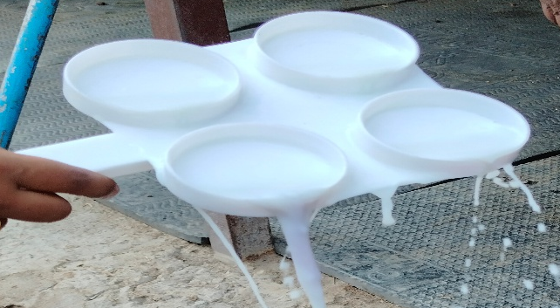
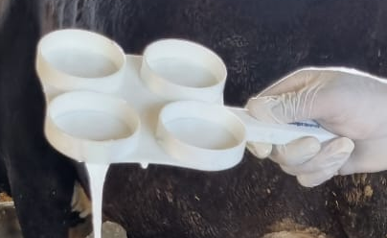
Figure 1: Cup showing the gel formation of (a) CMT score 2 and (b) CMT score 3 plus
with positive SCM milk

3.1.2 Age-wise
The prevalence of subclinical mastitis (SCM) in lactating cows varied significantly by age, with the highest rate observed in cows aged >5-7 years, affecting 41.94% (112 out of 267). Cows aged above 7 years showed a prevalence of 25.53% (24 out of 94), while those in the 3–5 years age group had the lowest prevalence, at 22.30% (31 out of 139). The age-related differences in SCM prevalence were statistically significant (p<0.05). This finding aligns closely with the results of Maheswari et al. (2016), Mourya et al. (2020), Raghavendran et al. (2020), Pandey et al. (2022), Tiwari et al. (2022), Patel et al. (2023) and Sharma et al. (2023). Cattle aged between 5 to 7 years are typically in their 3rd to 5th lactation, a period characterized by increased milk production and heightened stress, which makes cattle more susceptible to infections. Younger cattle are less likely to develop subclinical mastitis because of their stronger innate immune response. In contrast, older cattle, which are milked less frequently and produce lower milk yields, undergo minimal handling, potentially lowering the risk of infection. Similarly, Tiwari et al. (2022) found that cows aged between 4 to 8 years were more prone to subclinical mastitis compared to cows in other age groups, likely due to the weakening of sphincter muscles, deterioration of the canal, and udder tissue as the animal ages.
3.1.3 Breed-wise
The study revealed that the highest prevalence of SCM was observed in crossbreed cows, with 39.04% (123 out of 315 cows). This was followed by descript breeds, which showed a prevalence of 25.25% (14 out of 55 cows). The lowest prevalence was found in nondescript breeds at 23.07% (30 out of 130 cows). The data indicated a statistically significant (p<0.05) effect of breed on the prevalence of SCM. Findings are in support with the Shaikh et al. (2019), Mgonja et al. (2023) and Rajkumar et al. (2024). The increased prevalence of mastitis in crossbred cows can be attributed to factors such as higher milk production, lower immunity, larger udder size, and the genetic traits of their teat canal muscles and keratin, which make them more prone to infections. In contrast, non-descript breeds are more resistant to mastitis, though they generally produce less milk than crossbred cows.
3.1.4 Season- wise
The analysis of season-wise prevalence of subclinical mastitis (SCM) in the summer was relatively low at 20.57% (36 out of 175). However, this increased to 34.81% (55 out of 158) during winter and peaked in the rainy season with a striking 45.50% (76 out of 167). These results highlight a statistically significant seasonal influence on SCM prevalence. These findings are in accordance with the findings of Malek et al. (2013), Sharma et al. (2016), Sinha et al. (2019), and Ali et al. (2021). The high humidity levels during the rainy season can promote the growth of pathogenic agents. Deficiencies in nutrients like selenium and vitamin E can also lead to a higher incidence of mastitis. Additionally, cows may experience stress from temperature fluctuations, which can weaken their immune systems, making them more vulnerable to infections. However, this study was contrast with Ranjan et al. (2011) and Navaneethan et al. (2023) they found higher incidence of mastitis in winter and summer season.
3.1.5 Quarter wise
The study found that the prevalence of subclinical mastitis (SCM) was highest in the right hind quarter, with an infection rate of 16.66% (83 out of 498 quarters). This was followed by the left hind quarter at 14.17% (73 out of 515 quarters), the right fore quarter at 13.42% (58 out of 432 quarters) and the left fore quarter, which had the lowest occurrence at 12.41% (54 out of 435 quarters). Additionally, the right side exhibited a prevalence of 15.16% (141 out of 930 quarters), while the left side had a lower prevalence of 13.36% (127 out of 950 quarters). The quarter-wise prevalence revealed a non-significant variation in prevalence among the different quarters. Findings of El-kholy et al. (2018), Raghavendran et al. (2020), Singh et al. (2021), and Kabir et al. (2022) also support results of study. The prevalence of SCM in different quarters can vary significantly throughout the year, influenced by factors such as environmental conditions, cow physiology, and management practices. The hindquarters, which are most frequently exposed to dung and urine, show the highest infection rates of SCM compared to the other quarters. On the contrary Savita et al. (2020) and Kumar et al. (2023) reported that high prevalence in right quarters than left quarters.
3.1.6 Organized and unorganized dairy farms
The analysis of subclinical mastitis (SCM) prevalence based on organized and unorganized dairy farms revealed notable differences. Cows in organized farms had a prevalence of 26.95% (62 out of 230) in compared to unorganised farms 38.88 % (105 out of 270), While there is a clear disparity in prevalence rates, the results had statistical significance. Results are in agreement with Maheshwari et al. (2016) and Mourya et al. (2020), Poor hygiene, management practice, awareness, milking method, bedding and types of housing were responsible for the higher prevalence of SCM in unorganized sectors as compared to organized dairy sectors.
Table 04: Prevalence of Subclinical Mastitis in Cattle
Variable | Number | No. positive | Prevalence (%) | P | Χ²
Age group (Years) |  |  |  | 0.00 | 19.08
3-5 | 139 | 31 | 22.30
>5-7 | 267 | 112 | 41.94
>7 | 94 | 24 | 25.53
Breeds |  |  |  | 0.00 | 12.30
Exotic breed | 55 | 14 | 25.25
Cross breed | 315 | 123 | 39.04
Non- descriptive breed | 130 | 30 | 23.07
Season |  |  |  | 0.00 | 24.09
Summer | 175 | 36 | 20.57
Winter | 158 | 55 | 34.81
Rainy | 167 | 76 | 45.50
Quarters position |  |  |  | 0.28 | 3.83
Right fore | 432 | 58 | 13.42
Right hind | 498 | 83 | 16.66
Left fore | 435 | 54 | 12.41
Left hind | 515 | 73 | 14.17
Rearing pattern |  |  |  | 0.004 | 7.94
Organised | 230 | 62 | 26.95
Unorganised | 270 | 105 | 38.88

3.2 Milk pH
In apparently healthy cows, the average milk pH was 6.50 ± 0.00. However, in cows with subclinical mastitis (SCM), the mean milk pH significantly increased to 7.00 ± 0.00 when compared to the control group.
These findings are in agreement with Patil et al. (2014), Mourya et al. (2020), Palii et al. (2020), Rathaur et al. (2020), Ali et al. (2021), Saleem et al. (2021) and Alkhouly et al. (2023). Subclinical mastitis (SCM), damage to the blood-milk barrier causes the release of extracellular fluid components into the alveolar lumen, reducing milk secretion. These components from the inflamed quarters mix with the milk, leading to an increase in pH. This pH rise may result from the enhanced permeability of the membrane, allowing salts and various ions to leak into the milk. Additionally, the higher concentration of milk leukocytes in SCM can also contribute to the increased pH. Kandeel et al. (2019) also stated that an increase in milk pH in quarters with SCM is primarily due to an increase in the difference between the concentration of the main strong cation in milk (sodium) and the concentration of the main strong anions in milk (chloride and casein).
3.3 Somatic cell count (SCC)
Among apparently healthy cows, the mean somatic cell count (SCC) was recorded at 1.25±0.32x10⁵ cells/ml. Conversely, cows with subclinical mastitis (SCM) showed a significantly increased mean SCC of 11.18±0.58x10⁵ cells/ml, reflecting a pronounced difference from the control group.
Besides intramammary infection (IMI), somatic cell count (SCC) in bovine milk can fluctuate based on factors like lactation stage, age, breed, stress, and management practices. A rise in SCC indicates an inflammatory response triggered by bacterial infection in the mammary gland, acting as a defense mechanism. SCC levels are directly linked to the severity of the infection, as a diagnostic tool for SCM it is also proved by Amritha Priya et al. (2019), Rahularaj et al. (2020), Jesse et al. (2023) and Stanek et al. (2024).
Table 05: Quarter-Wise milk profile analysis in subclinical mastitis
Parameters | Healthy control (n= 60) | Subclinical mastitis (n=268)
Ph | 6.50^{A}±0.00 | 7.00^{B}±0.00
SCC (10⁵ cells/ml) | 1.25^{A}±0.32 | 11.18^{B}±0.58
Means bearing different superscripts differ significantly (p˂0.05)
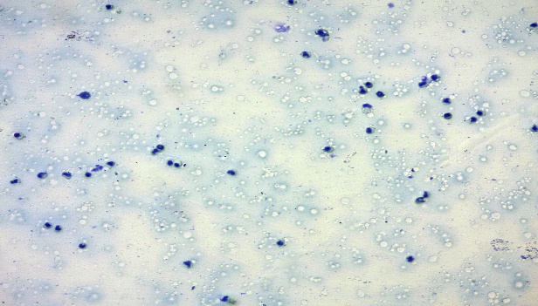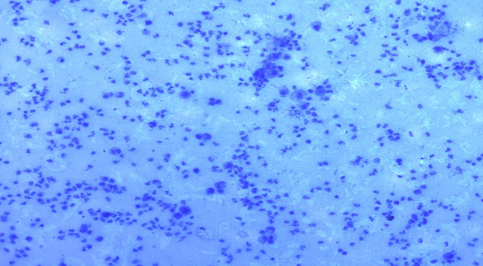
Figure 2: Staining of milk smear with Modified Newman’s stain
(a) Somatic cell in normal milk (Modified Newman’s stain; 20X)
(b) Somatic cell in SCM milk (Modified Newman’s stain; 20X)
3.4 Microbial culture and identification
A total of 1880 milk samples from functional quarters of lactating cows were screened for udder health status. 268 milk samples were found positive by the California Mastitis Test (CMT), SCC and pH. Bacterial isolation and identification were done by using primary and selective media. Among these, 173 samples were identified as positive for Staphylococcus spp., based on primary isolation on nutrient agar (creamish yellow colony), colour changes on Mannitol Salt Agar (yellow colonies), colony morphology (Gram-positive violet cocci arranged in grape-like clusters).

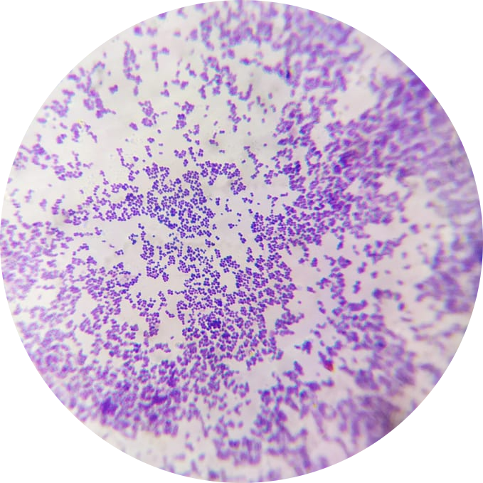
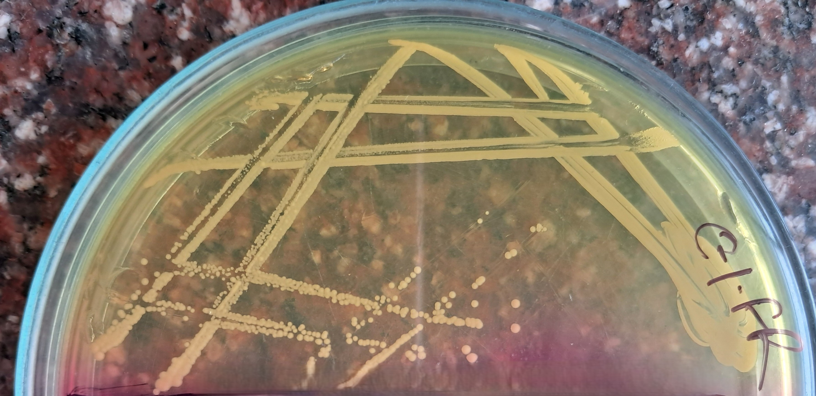
a
b
Figure 03 Yellow colored colonies of Staphylococcus on Mannitol salt agar (b) Smear from pure colony showing Gram positive cocci in branches (100x)
4. CONCLUSION
This study reveals a high prevalence of subclinical mastitis (SCM) in dairy cattle, particularly among crossbred cows, older animals and those kept in unorganized farms. Several factors, including age, breed, seasonal changes and farm management practices, contribute to the occurrence of SCM. The highest prevalence was found in cows aged >5-7 years, during the rainy season and in farms with less structured management, highlighting the impact of environmental and hygiene conditions. Effective diagnosis of SCM was achieved using the California Mastitis Test (CMT), milk pH measurement and Somatic Cell Count (SCC). Results showed that affected cows had a higher milk pH and significantly elevated SCC levels. The most frequently isolated pathogen was Staphylococcus spp., indicating the need for targeted control measures.

References
Adkins, P. R., Middleton, J. R., Fox, L. K., Pighetti, K., & Petersson-Wolfe, C. (2017). Laboratory handbook on bovine mastitis, 3rd edn. National Mastitis Council, pp 26.
Ali, A., Maqbool, I., Ayaz, A., Mir, M. R., & Ganie, S. A. (2021). Ability of Diagnostic Tests to Predict Subclinical Mastitis and Intramammary Infections in Quarters from Lactating Dairy Cows. Research Journal of Agricultural Sciences, 12, 1982-1986.
Ali, T., Kamran, Raziq, A., Wazir, I., Ullah, R., Shah, P., Ali, M. I., Han, B., & Liu, G. (2021). Prevalence of mastitis pathogens and antimicrobial susceptibility of isolates from cattle and buffaloes in northwest of Pakistan. Frontiers in Veterinary Science, 8: 746755.
Alkhouly, I. N., Moustafa, A. A., Abou El Roos, N. A., & Kandeel, S. A. (2023). Evaluation and Comparison of four screening tests against Milk culture for detection of subclinical mastitis in lactating cattle and Buffalo in Egypt. Journal of Applied Veterinary Sciences, 8(3), 67-74.
Amritha Priya, M. G., Vijayakumar, K., & Vinodkumar, K. (2021). screening of sub-clinical mastitis in dairy cows of organised farms using three diagnostic tests. Journal of Veterinary and Animal Sciences, 52(1), 73-76.
Anueyiagu, K. N., Simon, M., Torjir, M. M., Kojah, F., & Madu, V. O. (2024). Evaluation of Three (3) Techniques in the Diagnosis of Subclinical Mastitis with Antibiotic Resistance of in Nigeria. Folia Veterinaria, 68(1), 46-53.
Barrow, G. I. and Feltham, R. K. A. (1993). Manual for the identification of medical bacteria. Cowan and Steels: 3rd Cambridge, UK.
Belay, N., Mohammed, N., & Seyoum, W. (2022). Bovine mastitis: prevalence, risk factors, and bacterial pathogens isolated in lactating cows in Gamo zone, southern Ethiopia. Veterinary Medicine: Research and Reports, 9-19.
Bhuiyan, M. U., Shahadat, H. M., Chakma, S. S., Islam, F., Islam, R., Islam, T., & Mahfuz, S. (2020). Prevalence of subclinical mastitis of dairy cows in Bijoynagar Upazila under Brahmanbaria District of Bangladesh. Advances in Animal and Veterinary Sciences, 8(4), 364-369.
Birhanu, M., Leta, S., Mamo, G., & Tesfaye, S. (2017). Prevalence of bovine subclinical mastitis and isolation of its major causes in Bishoftu Town, Ethiopia. BMC research notes, 10, 1-6.
Campos, B., Pickering, A. C., Rocha, L. S., Aguilar, A. P., Fabres-Klein, M. H., de Oliveira Mendes, T. A., Fitzgerald, J. R., & de Oliveira Barros Ribon, A. (2022). Diversity and pathogenesis of Staphylococcus aureus from bovine mastitis: current understanding and future perspectives. BMC Veterinary Research, 18(1),
Constable, P.D., Hinchcliff, K.W., Done, S.H. and Grunberg, W. (2017). A textbook of the disease of Cattle, Horses, Sheep, Pigs and Goats. 11th Edn. Elsevier, 1: 1904-1948.
El-Kholy, M.A., Hassan,M.G., Zeinhom, A. M. M.& El-Klawy, M. A. A. M. (2018). Detection of subclinical mastitis in a dairy farm in Beni-Suef city, Egypt. Assiut Veterinary Medical Journal, 64 (157): 18-24.
El-Sayed, A., & Kamel, M. (2021). Bovine mastitis prevention and control in the post-antibiotic era. Tropical Animal Health and Production, 53(2). https://doi.org/10.1007/s11250-021-02680-9
Gomes, F., & Henriques, M. (2016). Control of bovine mastitis: old and recent therapeutic approaches. Current microbiology, 72, 377-382.
Harmon, B. (2001). Somatic cell counts: A primer. National Mastitis Council Annual Meeting Proceedings, 3–9.
Jesse, F., Bitrus, A., Peter, I., Chung, E., & Tukiran, N. (2023). Clinical and Subclinical Mastitis in Ruminants: A Review of Etiological Agents, Diagnosis, Clinical Management and Risk Factors. Journal of Research in Veterinary Sciences, 1, 51-65.
Kabelitz, T., Aubry, E., van Vorst, K., Amon, T., & Fulde, M. (2021). The role of streptococcus spp. In bovine mastitis. Microorganisms, 9(7), 1–21. https://doi.org/10.3390/microorganisms9071497
Kabir, A., Al Amin, M., Rahman, M. M., Alam, M. E., Haque, M. H., & Rahman, M. M. (2022). Trends of Occurrence and Therapy of Subclinical Mastitis in Lactating Cows at the Northern Part of Bangladesh. European Journal of Veterinary Medicine, 2(3), 9-14.
Kandeel, S. A., Megahed, A. A., Ebeid, M. H., & Constable, P. D. (2019). Ability of milk pH to predict subclinical mastitis and intramammary infection in quarters from lactating dairy cattle. Journal of dairy science, 102(2), 1417-1427.
Kumar, R., Thakur, A., & Sharma, A. (2023). Comparative prevalence assessment of subclinical mastitis in two crossbred dairy cow herds using the California mastitis test. Journal of Dairy, Veterinary and Animal Research, 12(2), 98–102.
Lopes, T. S., Fontoura, P. S., Oliveira, A., Rizzo, F. A., Silveira, S., & Streck, A. F. (2020). Use of plant extracts and essential oils in the control of bovine mastitis. Research in Veterinary Science, 131, 186–193. https://doi.org/10.1016/j.rvsc.2020.04.025
Maheshwari, P., Shukla, P. C., Rao, M. L. V., & Shukla, S. N. (2016). Occurrence of subclinical mastitis in cattle in and around Jabalpur, Madhya Pradesh. Haryana Veterinarian, 55(2), 160–162.
Malek dos Reis, C. B., Barreiro, J. R., Mestieri, L., Porcionato, M. A. D. F., & dos Santos, M. V. (2013). Effect of somatic cell count and mastitis pathogens on milk composition in Gyr cows. BMC veterinary research, 9, 1-7.
Mgonja, F. R., Charles, M. M., & Katakweba, A. S. (2023). Prevalence of subclinical mastitis and associated risk factors in dairy cattle from institution farms in Morogoro municipality. World Journal of Veterinary Science, 4(1), 1020.
Mourya, A., Shukla, P. C., Gupta, D. K., Sharma, R. K., Nayak, A., Singh, B., & Pradhan, S. (2020). Prevalence of subclinical mastitis in cows in and around Jabalpur, Madhya Pradesh. Journal of Entomology and Zoology Studies, 8(4), 40–44.
Navaneethan, R., Saravanan, S., & Suresh, P. (2023). Causal association of epidemiological factors with the incidence of bovine clinical and subclinical mastitis. Indian Journal of Animal Health, 62(1), 230–235.
Palii, А. P., Ulko, Y. S., Bogomolov, O. O., Kis-Korkishchenko, L. V., Kambur, M. D., Zamaziy, A. A., & Paliy, A. P. (2020). Species composition of microbiota of cows udder and raw milk quality at mastitis. Ukrainian Journal of Ecology, 10(4), 78–85.
Pandey, M., Das, D. P., Panda, S. K., Patra, R. C., Jena, G. R., Samal, L., & Das, B. C. (2022). Prevalence and pathological studies of sub-clinical mastitis in bovines. The Pharma Innovation Journal, 11(11), 831–835.
Patel, B. R., Vagh, A. A., Vala, K. B., & Patel, A. C. (2023). Prevalence of subclinical mastitis in Gir cows in and around Junagadh district of Gujarat. The Indian Journal of Veterinary Sciences and Biotechnology, 19(4), 50–54.
Patil, N. A., Kasaralikar, V. R., Ravikanth, K., & Thakur, A. (2014). Shivi Maini Mastidip Liquid: A herbal post-milking teat dip for prevention and control of subclinical mastitis in bovines. History, 7(23), 23–27.
Pramod, K. S., Bhat, M. N., Ramesh, P. T., & Paramesha, S. C. (2023). Prevalence of subclinical mastitis in dairy cattle in Devanahalli taluk. The Pharma Innovation Journal, 12(7), 1567–1570.
Raghavendran, V. B., Rajasokkapan, S., & Prabhu, R. (2020). Prevalence of sub-clinical mastitis in lactating cows in Thoothukudi district. The Pharma Innovation Journal, 9(7), 16–18.
Rahularaj, R., Deshapriya, R. M. C., & Ranasinghe, R. M. S. B. K. (2020). Relationship among Nagase enzyme activity, CMT score, and somatic cell count in milk of crossbred dairy cows with sub-clinical mastitis in North-Western Province of Sri Lanka. Tropical Agricultural Research, 31(4), 26.
Rajkumar, S., Anandhi, M., Shivasharanappa, N., Narnaware, S. D., Rajkumar, R. S., & Udharwar, S. V. (2024). Prevalence of subclinical mastitis, associated risk factors, and pathogens in dairy cattle of West Coastal India. The Indian Journal of Veterinary Sciences and Biotechnology, 20(5), 97–101.
Ranjan, R., Gupta, M. K., & Singh, K. K. (2011). Study of bovine mastitis in different climatic conditions in Jharkhand, India. Veterinary World, 4(5), 205–208.
Rathaur, A., Prakash, V., Yamini, S., Yadav, S. P., & Singh, S. J. (2020). Effect of low-cost herbal combination and tri-sodium citrate treatment in subclinical mastitis-affected crossbred dairy cows. The Pharma Innovation Journal, 9(5), 132–135.
Saleem, H. D., Razooqi, M. A., & Gharban, H. A. J. (2021). Cumulative effect of subclinical mastitis on immunological and biochemical parameters in cow milk. Archives of Razi Institute, 76(6), 1629.
Savita, A. P., Nayak, T. C., Chahar, A., Kachhawa, J. P., & Gupta, S. R. (2020). Prevalence of subclinical mastitis in cattle in and around Bikaner district of Rajasthan. Journal of Entomology and Zoology Studies, 8(1), 1124–1127.
Shaikh, S. R., Digraskar, S. U., Siddiqui, M. F., Borikar, S. T., Rajurkar, S. R., & Suryawanshi, P. R. (2019). Epidemiological studies of mastitis in cows reared under different management systems in and around Parbhani. The Pharma Innovation Journal, 8(2), 1–5.
Sharma, A., Sharma, S., Singh, N., Pal, R. S., & Nanda, B. (2016). Effect of non-genetic factors on somatic cell count in Tharparkar cows under the hot arid region of the Thar desert area. Journal of Animal Research, 6(6), 1001.
Sharma, D., Kaniamuthan, S., Manimaran, A., Kumaresan, A., Sivaram, M., Rajendran, D., & Banu, S. (2023). Seasonal, physiological, and bacteriological risk factors for subclinical mastitis in dairy cows maintained under different farming conditions. Journal of Dairy Research, 90(2), 164–172.
Sharun, K., Dhama, K., Tiwari, R., Gugjoo, M. B., Iqbal Yatoo, M., Patel, S. K., Pathak, M., Karthik, K., Khurana, S. K., Singh, R., Puvvala, B., Amarpal, Singh, R., Singh, K. P., & Chaicumpa, W. (2021). Advances in therapeutic and managemental approaches of bovine mastitis: a comprehensive review. Veterinary Quarterly, 41(1), 107–136. https://doi.org/10.1080/01652176.2021.1882713
Singh, K., Mishra, K. K., Shrivastava, N., Jha, A. K., & Ranjan, R. (2021). Epidemiological studies on subclinical mastitis in dairy cows of Rewa District of Madhya Pradesh. International Journal of Livestock Research, 11, 58–64.
Sinha, R., Sinha, B., Kumari, R., M. R., V., Verma, A., & Gupta, I. D. (2019). Effect of season, stage of lactation, parity, and level of milk production on incidence of clinical mastitis in Karan Fries and Sahiwal cows. Biological Rhythm Research, 52(4), 593–602.
Stanek, P., Zolkiewski, P., & Janus, E. (2024). A review on mastitis in dairy cows research: Current status and future perspectives. Agriculture, 14(8), 1292.
Tiwari, B. B., Subedi, D., Bhandari, S., Shrestha, P., Pathak, C. R., Chandran, D., & Dhama, K. (2022). Prevalence and risk factors of Staphylococcal subclinical mastitis in dairy animals of Chitwan, Nepal. Journal of Pure and Applied Microbiology, 16(2), 1–12.

