**Mechanism and Modulation of Photoreceptor Dynamics in Plant Light Sensing**

**Abstract**

Light serves as the main environmental cue for plants, and they use photoreceptors to detect and respond to variations in light intensity. Plants can maximize growth, development, and survival by use of photoreceptor proteins, which include phytochromes, cryptochromes, and phototropins. These proteins mediate responses to red, blue, and UV light. Such photoreceptors go through conformational changes upon absorbing light, which trigger signalling cascades and gene expression alterations. A key aspect of this process is the dynamic regulation of photoreceptor activity, ensuring that plants can fine-tune their responses to fluctuating light conditions. Mechanisms such as receptor degradation, reversible phosphorylation, nuclear translocation, and interactions with other signalling proteins modulate photoreceptor function, contributing to the precise control of downstream responses. Plants are able to adapt variations in light levels and seasons because environmental factors have an impact on photoreceptor dynamics, including light intensity, duration, and wavelength composition. Also, recent research has highlighted the control of photoreceptor stability and signalling efficacy by post-translational modifications and protein-protein interactions. Recognizing these dynamic mechanisms is crucial for comprehending how plants integrate connection between light signals and other environmental indicators, like water supply and temperature. Modulating photoreceptor dynamics presents opportunities for improving crop productivity and resilience. By unravelling the molecular underpinnings of light sensing, scientists can potentially manipulate photoreceptor activity to optimize growth in suboptimal light environments, providing strategies for agricultural sustainability in the context of climate change. This review examines the latest developments in plant light sensing mechanisms and photoreceptor dynamics regulation, as well as the wider implications for plant biology.

Graphical Abstract

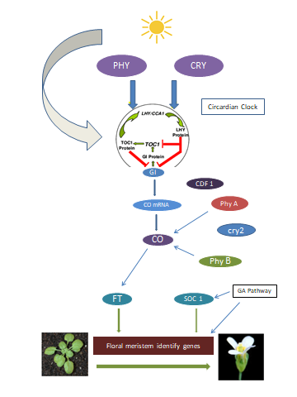

**Light as environmental cue**

**Activate Photoreceptors**

**Conformational changes in photoreceptors**

**Signaling pathway activate**

**Dynamic regulation mechanism**

**Abiotic stress**

**Growth and Development**

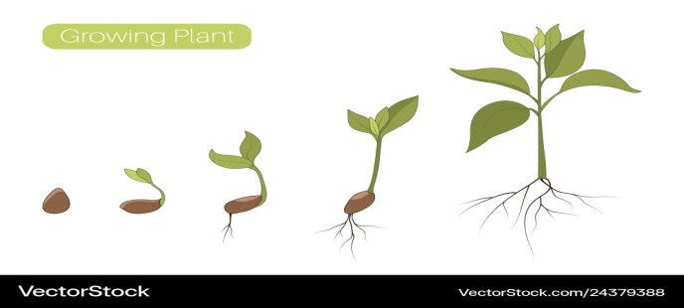

**Keywords:** *Photoreceptors, Cryptochrome, Light sensing, post-translational modifications.*

**Introduction**

Light perception and response are highly developed systems in plants, and they are essential to their expansion and maturation. In addition to providing photosynthesis with energy, light also acts as a signal that controls several physiological functions. Specialized proteins known as photoreceptors, which recognize various light wavelengths and adjust plant behaviour accordingly, are responsible for coordinating these processes. The three primary groups of photoreceptors are UVR8 (responsive to UV-B light), phytochromes (responsive to red and far-red light), and cryptochromes and phototropins (sensitive to blue and UV-A light). Each of these photoreceptor’s changes in conformation in response to light, initiating a series of downstream signal transduction pathways that control the development and growth of plants, and stress responses (1, 2). Chromophores affixed to the photoreceptor proteins absorb photons as part of the method by which these photoreceptors perceive light. For instance, phytochromes can change in between two states of conformation, the Pr (inactive, red-absorbing form) and the Pfr (active, far-red-absorbing form), which can influence the activity of regulatory proteins and transcription factors (3). On the other hand, flavoproteins called cryptochromes absorb blue light and then go through redox reactions that change the expression of genes linked to stomatal opening, stem elongation, and circadian rhythms (4). Phytochrome-Interacting Factors (PIFs), for example, interacting proteins that, in the absence of light, act as transcriptional repressors and are removed. These and other factors can affect phytochrome signalling (5). Furthermore, post-translational changes like phosphorylation and ubiquitination regulate photoreceptor stability and activity, enabling plants to react to their surroundings in a dynamic manner (6). Gaining insight into how photoreceptor dynamics are modulated is essential for increasing agricultural production since adjusting these pathways can improve plant growth, stress tolerance, and yield in situations where light levels are not ideal (7). Future research in this field aims to comprehend the interactions among several photoreceptor signalling pathways and other environmental cues, like temperature and biotic stress.

**Photoreceptor classes and their functional dynamics**

It has been known since ages how light has played an essential function in the development and growth of plants. A clear elucidation of the importance of light can be obtained from the book by Darwin with his son Francis “*The power of movements in plant*”. This study highlights how important light is to the growth of plants, including the behaviours of leaf movement such as epinasty and hyponasty, as well as stem bending in response to strong lateral light, a phenomenon known as phototropism. The ordered control of light on the plant growth, photomorphogenesis, is governed by three photoreceptor families-

* the red (R) and far-red (FR) light-absorbing phytochromes
* the UV-A/blue light-absorbing cryptochromes
* phototropins (8)

Each of these photoreceptors undergoes conformational changes when light is absorbed, triggering a sequence of chemical events that regulate plant responses. The dynamics of these photoreceptors and how different regulatory systems regulate their activity will be covered in this review.

**1.1 Phytochromes: Perception of Red and Far-Red Light**

Phytochromes (PHY) serve as sensors for red (R, λ max ∼660nm) and far-red (FR, λ max ∼730nm) light. Five phytochromes are present in the commonly used model plant Arabidopsis thaliana (phyA–phyE) (9, 10). They manifest as two 125 kDa monomers that operate as functional dimers, each holding a linear tetrapyrrol chromophore that gives the molecule light sensitivity. Red light (R) perception causes phytochromes to change from their synthetically produced in between the physiologically active (Pfr) and inactive (Pr) forms (11). There is no domain identified in phytochromes for binding to DNA but different parts of the genome have been identified to bind to protein complexes containing phyB revealing that there is a direct step where light modification gene transcription.

|  |  |
| --- | --- |
| **Type I phytochrome** | **Type II phytochrome** |
| phy A | phy B  phy C  phy D  phy E |
| Photo labile | Photo stable |

Phytochrome B (phyB) is a light-activated protein that moves into the nucleus and separates into liquid and liquid phases to produce a molecular condensate known as a photobody. This photobody is primarily composed of phyB, which serves as the scaffold, and is associated with at least 37 client proteins. These proteins represent a range of functional categories, with a significant presence of transcription regulators (12). The primary client proteins can be classified into several functional categories, including kinases, Pfr stabilizers, phosphatases, photoreceptors, splicing factors, transcription regulators, and ubiquitin E3 ligase complexes (13). The secondary clients can be grouped into three functional categories: chaperone, kinase, and transcription regulator. These phytochromes participate in germination responses, flowering induction, shade avoidance, and seedling growth; however, when phyA or phyB are present, their actions are less evident (14).

**1.2 Cryptochromes: Blue and UV-A Light Sensors**

Cryptochromes are among the first photoreceptors to emerge in plants, and they are present across all significant evolutionary lineages, comprising humans, microbes, algae, terrestrial plants, and sponges (15). Blue light responses were found to exist in cryptogams, and at the time, it was unclear what chemical components made up blue light receptors. This gave rise to the word "cryptochrome."Senger, H. Most plant cryptochromes consist of a C-terminal extension that has little to do with photolyase and an N-terminal photolase related (PHR) domain that is homologous to DNA photolyase in sequence. The cryptochrome PHR domain is responsible for binding chromophores. Conversely, the C-terminal extension is essential for nuclear/cytosolic trafficking and protein-protein interactions. Through modulating light-dependent processes such seedling photomorphogenesis, blooming timing, and stomatal opening, the circadian clock, growth, and development of plants are all regulated by cryptochromes. They aid in the control of circadian cycles in animals and have been connected to magnetoreception, the ability of living things to detect the magnetic fields of the Earth. In response to light, cryptochromes work with other signaling pathways and proteins to modify gene expression, which affects the biological clock and other physiological reactions (16, 17). Cryptochromes are key regulators of light-dependent and circadian activities because their flavin adenine dinucleotide (FAD) chromophore absorbs blue light. In response to light absorption, cryptochrome experiences a conformational shift that triggers its signaling function, ultimately resulting in the inhibition of the crucial photomorphogenesis repressor, ubiquitin ligase COP1. Cryptochromes mediate light responses by stabilizing transcription factors such as HY5, which in turn promotes chlorophyll synthesis and leaf growth. By interacting with other signaling molecules like COP1 and phytochromes, its activation in plants affects processes including seedling development, flowering, and photomorphogenesis. Cryptochromes play an important part in the circadian clock of animals by controlling the transcription of clock genes and preserving internal biological cycles. Furthermore, some species' cryptochromes might be involved in magnetoreception, a process in which they use radical-pair interactions to react to geomagnetic fields (18). There are three distinct types of cryptochromes encoded in the Arabidopsis genome: Cry1, Cry2, and Cry3. Under blue light, CRY 1 is more stable than CRY 2, while CRY 2 deteriorates (19).

**1.3 Phototropins: Blue light and Phototropism**

With a molecular weight of 120 kDa, the flavoprotein phototropin controls light-induced responses to blue, UVA, and even green light. With the ability to phosphorylate its own serine and threonine residues, this protein performs the function of a serine-threonine Kinase. Phototropins Phot1 and Phot2, two distinct kinds, are included within the genome of Arabidopsis. Phot1 influences the growth of the hypocotyls and cotyledons. At higher light intensities, the hypocotyl in the phot1 mutant retains a phototropic response, but does not exhibit phototropism under low-intensity blue light (20).

Phototropins possess two primary domains:

1. **N-terminal LOV (Light, Oxygen, or Voltage) domains**:

* These are two flavin mononucleotide (FMN)-binding domains (LOV1 and LOV2), responsible for light sensing. Blue light absorption by FMN in these domains induces alterations in the protein's structure, which in turn cause signalling processes downstream.
  + LOV domains are homologous to the PAS (Per-Arnt-Sim) domain superfamily, which is involved in various sensory functions in organisms (21).

1. **C-terminal Serine/Threonine Kinase domain**: This kinase domain becomes active in response to light, initiating phosphorylation cascades that result in physiological responses such as phototropism. The activation of the kinase domain follows light-induced conformational modifications to the LOV domains.

Phototropins also have regions that connect the LOV and kinase domains, known as Jα helices. The Jα helix in the LOV2 domain acts as a regulatory switch; it unfolds when the light is turned on, this is a crucial phase in transmitting the signal to the kinase domain, leading to activation of the protein's enzymatic activity (22).

1. **Modulation of Photoreceptor activity:** Temperature and light levels that are outside of their ideal range are detrimental to plant health. Throughout their evolutionary history, plants have developed complex systems for detecting variations in temperature and light, which gives them warning signs to steer clear of hazardous environments. Using these signals, plants modify their body form and metabolism to withstand unfavourable conditions and minimize damage. We refer to these processes as thermo- and photo-morphogenesis. Green leaves' photosynthetic pigments and other structures absorb a significant amount of intercepted energy between 400 and 700 nm, despite the fact that part of the incoming light can either be transmitted or reflected. Therefore, whatever the amount of light, plants can sense a very shallow light gradient (23). The Arabidopsis plant has facilitated the identification of the molecular constituents of light perception and the auxin signaling pathways implicated in phototropism (24, 25). In Arabidopsis, phototropin blue light receptors control both root and hypocotyl phototropism (26). Conversely, because of light-mediated increases in protein quantity, phot2's activity in hypocotyl phototropism is limited to elevated levels of light (27, 28). UV RESISTANCE LOCUS 8 (UVR8), a recently discovered plant UV-B photoreceptor, mediates this phototropin-independent response (29). It's possible that the mechanism of growth behind UVR8-dependent hypocotyl phototropism is different from that of phototropin-mediated processes that cause hypocotyl curvature towards the blue light (30).

Green wavebands may influence some plant functions even in the absence of known photosensors, despite the fact that the precise receptors are still unknown. The fact that green-light effects usually counter the actions of red- or blue-light-regulated plant activities is one of their shared characteristics (31). According to plant whispering, using green wavebands can have an impact on pigmentation and may be crucial for controlling plant height. Regardless of how high the overall rate of fluence increased, the dry mass was lower in plants grown under visible light with a green component. Green light reveres cryptochrome activation, but other reactions seem to function on their own. It was demonstrated that green light altered the growth, thickness, and stomatal conductance of leaves (32). Green light was demonstrated to prevent blue- light-induced opening of the stomata, therefore the decrease in the stomatal conductance could be partially responsible for this effect (33). Green light-induced symptoms of shadow avoidance may be the cause of the influence on leaf size (34). Studies conducted in 2004 by Folta have demonstrated that green wavebands accelerate early stem growth and reduce the accumulation of chloroplast transcripts (35). Green wavebands generally have an opposite effect to red and blue light, with their effects being most noticeable at low flow rates. Because the green-sensing systems may lessen the impacts of cryptochromes without influencing the flux generated by blue light through phototropins, they may also be beneficial in regulating plant characteristics. These wavelengths may be helpful in counteracting the effects of blue light, which can alter crop plants' growth, elongation, and colouring.

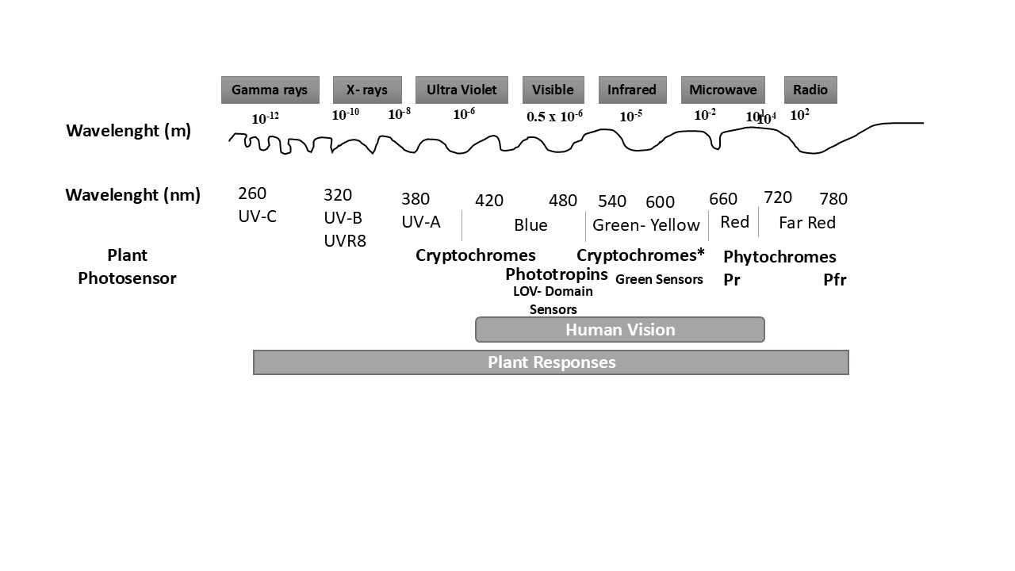

**Fig.1.** The proportionate arrangement of electromagnetic radiation and the precise wavelengths at which plant photosensors respond (36)

**2.1Post-Translational Modifications:** Plant photoreceptors identify the photons in the incoming light by using chromophores. Phytochrome receptors for red and far-red lights are correlated with phytochromobillin tetrapyrole ring, which has the ability to react to red and far-red light by isomerizing, thereby inducing modifications within the composition of proteins (37). According to (38) phytochromes in their active Pfr form translocate between the cytoplasm and the nucleus, where it can directly engage with PIFs (PHYTOCHROME INTERACTING FACTORS) family of basichelix-loop-helix transcription factors to start light-regulated gene production. Phytochromes primarily accomplish their goal by producing different biochemical changes to the PIFs' transcription factors (39). Among these early responses are sequestration, phosphorylation, poly-ubiquitylation, and ultimately decline in the PIFs through the 26S proteasome-mediated degradation pathway (40, 41). Phosphorylation is a widely used PTM that regulates the function of photoreceptors. The three primary classes of plant photoreceptors—phototropins, phytochromes, and cryptochromes—are regulated by phosphorylation processes. To activate phototropin 1 (PHOT1) in reaction to blue light, for instance, specific serine residues in PHOTIN must be phosphorylated. Phototropism, chloroplast movement, and stomatal opening are all caused by signaling cascades that are initiated by the phosphorylation event in plants in response to light (42). Similar to this, phosphorylation changes the nuclear localization and interactions of phytochromes, which are light-sensitive red/far-red light sensors (43). Another significant PTM that controls the function of photoreceptors by regulating their turnover and destruction is ubiquitination. In reaction to light signals, ubiquitin ligases target photoreceptors like phytochromes for proteasomal destruction.

This ensures that light responses are strictly regulated and stopped when needed. According to (44) PHYTOCHROME INTERACTING FACTOR 3 (PIF3), for instance, engages in interaction with phytochromes that is ubiquitinated and destroyed under light, enabling the transition between light and dark developmental programs. By altering photoreceptor stability and interactions with other proteins, sumoylation and S-nitrosylation also regulate photoreceptor activity. It has been observed that SUMO-paired photoreceptors modify light signaling pathways, which impacts the plant's capacity to react to different light wavelengths (45). In a similar vein, photoreceptor function can be modulated by S-nitrosylation of certain cysteine residues through changes in protein-protein interactions or stability in varying environmental conditions (46).

**2.2Light-Dependent Nuclear import and Subcellular Localization:** Plants respond to different light conditions by regulating gene expression, and one important regulatory mechanism for this process is photoreceptors' light-dependent nuclear import. When a light gets absorbed, photoreceptors—including phytochromes, cryptochromes, and phototropins— undergo structural alterations that result their relocation from the nucleus to the cytoplasm. This process is reliant on particular light wavelengths and is strictly regulated. Phytochromes, for instance, sense red and far-red light and are brought into the nucleus to interact with transcription factors, such as PHYTOCHROME INTERACTING FACTORs (PIFs), where they affect the transcription of genes that respond to light. Plants are able to adjust their developmental processes, such as seed germination, blooming, and shade avoidance, in response to environmental light cues because to this spatial control of photoreceptor activity (47, 48).

Apart from nuclear import, subcellular localization of photoreceptors is essential for adjusting photoreceptor activity. Various photoreceptors relocate to different cell compartments based on the type of light and how well they are functioning. For example, blue light-absorbing proteins called cryptochromes can act in the nucleus or cytoplasm, mediating responses to photomorphogenesis and circadian rhythms (49). Moreover, phytochromes are sensitive to post-translational changes such phosphorylation, which further affects their location and function. In reaction to light exposure, they also move back and forth between the cytoplasm and the nucleus (50). Plants can better optimize their growth and development in variable surroundings because of their ability to precisely control subcellular localization and nuclear import, which synchronizes their photoreceptive signals with appropriate physiological responses (51)

**2.3 Interaction with other Signalling Pathways:** Certain light wavelengths can be detected by photoreceptors, including phytochromes, cryptochromes, and phototropins, which then translate those wavelengths into physiological responses that are paired with stress- and hormone-signaling pathways. The primary light sources that phytochromes (phyA, phyB) respond to both far-red and red lights. These light sources start signaling cascades that affect gene expression, morphogenesis, and photoperiodic blooming. Gibberellins (GAs), brassinosteroids (BRs), and auxins interact with phytochromes to modulate responses such as shade avoidance, hypocotyl elongation, and seed germination. For example, under darkened conditions, phyB prevents excessive growth by suppressing GA signaling and lowering DELLA breakdown (52). This interaction illustrates how photoreceptors process light and regulate hormones to accurately control plant development under various light situations. In addition to sensing blue and UV-A light, cryptochromes (cry1, cry2) interact with other signaling molecules including auxins and abscisic acid (ABA) to control stomatal aperture, photomorphogenesis, and stress responses. Furthermore, it has been shown that cry1 contributes to the preservation of plant architecture by preventing hypocotyl expansion in blue light circumstances by decreasing auxin signalling (53). Reactive oxygen species (ROS) and calcium signaling pathways are interacting with phototropins, which are mainly engaged in phototropism and chloroplast mobility. For instance, the sensing of blue light by phototropin causes the creation of ROS and an influx of calcium, which in turn activates MAP kinase cascades and controls the activation of genes and growth responses (54)

PhyA is primarily responsible for the early (~1 h after irradiation) modifications to the molecular gene expression, while phyB is incharge of the longer-lasting changes in gene expression brought on by light (55). The "inactivation of the negative factors and activation of the positive factors" of light signaling pathways that can be used to conceptualize the process of de-etiolation mediated by photoreceptors. Together, the two main negative regulators in the dark—PIFs and COP1/SPA E3 ligase—block the expression of genes controlled by light. Positively influencing transcription factors through light signaling pathways are broken down by the COP1/SPA E3 ligase complex, which is operational at night (56). PIFs block light signals in the absence of light by collaborating with COP1/SPA (57). Both phytochromes and cryptochromes interact with PIFs (phytochromes and cryptochromes) and CIBs (cryptochromes alone) to control their functions when exposed to light. Furthermore, phytcohromes and cryptochromes interact with the COP1/SPA complex to render it inactive, which stabilizes the HY5 transcription factor, which has the ability to target almost 9000 genes (58).

Activated phytochromes are primarily accountable forlarge transcriptional alterations, as they both destabilize and stabilize the aforementioned transcription factors. Accordingly, a number of studies proposed post-transcriptional phytochrome modulation during de-etiolation. A little over 7% of the annotated Arabidopsis genome possesses alternate splicing depending on phytochrome and red light (59). In particular, it was discovered that SFPS, a phytochrome-associated splicing factor, operates under splicing activities mediated by red light (60). This discovery suggests that the photoreceptor plays a potential role in translational regulation. Alternative choices of promoters by phytochromes, as reported in an intriguing study (61), ultimately led to the synthesis of unique protein isoforms with various subcellular locations. Phytochromes have an interestingly opposing effect on two separate tissues during early light perception: they allow cotyledon cell expansion while inhibiting hypocotyl cell expansion. So, when it comes to cell proliferation in cotyledons and hypocotyls, phytochromes might act in two different ways (62). This may suggest that separate light signaling pathways exist in various tissues, resulting in entirely different physiological outcomes in various tissues.

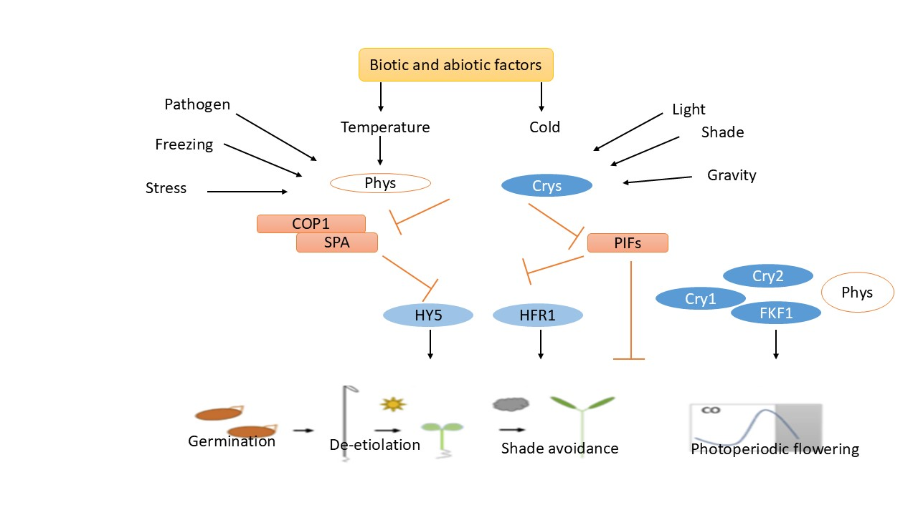

**Fig: 2.** Convergence on photoreceptors of various environmental signals. Phytochromes directly sense two things: temperature and ambient light. The coordination of photoreceptors enables plants to react to various stimuli, including biotic and abiotic stressors, gravitropism, and different developmental phases. Photoreceptors share a number of molecular components such as PIFs (PHYTOCHROME INTERACTINF FACTORS), HY5, HFR1, and the E3 ligase COP1-SPA complex, which are critical signaling components. Deactivating PIFs and COP1-SPA, two negative regulators of light signaling, allows photoreceptors to respond to light signals by inducing notable changes in gene expression. Master transcription factors target a huge number of genes in the Arabidopsis genome, and photoreceptors stabilize these transcription factors. Among them are HY5 and HFR1. Eventually, the increased plant growth and fitness brought about by these photoreceptor-mediated regulation increases grain and biomass production in agriculture. (63)

**2.4 Circadian Rhythms and Photoreceptor Function:** Plants are sessile organisms whose growth and development are mostly controlled by environmental stimuli, especially light. Photoreceptors and the circadian clock work together to help plants anticipate and adjust to daily and seasonal variations in light conditions. This interaction is a crucial part of the regulatory process. Plants use their circadian rhythms to control physiological processes like stomatal opening, photosynthesis, and flowering. Photoreceptors include phytochromes, which react to red and far-red light, cryptochromes, which respond to blue light, and phototropins, which are involved in phototropic responses (64).

These 24-hour cycles of self-sustaining, endogenous oscillations—also referred to as circadian rhythms—are triggered by outside light stimuli. When photoreceptors detect light in their environment, they transmit signals to the circadian rhythm. According to Franklin and Quail (65), this synchronization enables the plant to control its actions in advance of dawn and sunset, improving its capacity to maximize light absorption and energy use. Research has indicated that the period and amplitude of circadian rhythms can be influenced by light quality, quantity, and duration, indicating the close connection between internal clock systems and light perception (66). In A. thaliana, the GI, a component of the clock, initiates photoperiodic flowering. This GI binds to the CO promoter to start CO expression. Location determines when leaves bloom, and GI controls leaf senescence. In the link between flowering and leaf senescence that develops a plant's productivity and fitness, GI frequently acts as a mediator. The ELF 4 has a direct connection to the GI and prevents the GI from interacting with the ORE 1 promoter (67). The regulatory network's conclusion controls the transcription of CO, and CO mRNA is rapidly extracted after the night. After then, CO ceases to assemble at dusk as a result of protein degradation brought on by the interaction with SUPPRESSOR OF PHYA-105 1 (SPA 1) and CONSTITUTIVE PHOTOMORPHOGENESIS 1 (COP 1) (68). Photoactivated CRYPTOCHROME 2 (CRY 2) forms a complex molecule with COP 1 and SPA 1 that prevents CO from degrading (69). Moreover, floral activators CO and FT are regulated by GI through their formation of a blue light-dependent complex with FKF1 (FLAVIN-BINDING, KELCH REPEAT, F-BOX 1) (70). According to (71), the GI-FKF1 complex breaks down CYCLING FIRST DOF FACTOR (1), a protein that inhibits CO and FT transcription. According to (71), the activation of FT expression in LDs is controlled by CO protein levels, which are maintained by FKF1 at the end of the extended photoperiod.

Additionally, light controls the amount of CO protein, thus red and blue light, respectively, have larger CO levels. Conversely, blue and far-red light help to maintain CO stability. This regulation facilitates the accumulation of CO protein levels in the LDs' evening, which enhances the floral signal. In connection to the light that triggers gene expression, CRY and PHY are translocate to the nucleus, where they mediate the clock entrainment with the light. According to Roden and Ingle (72), several defense genes are regulated by the circadian clock and PHY function.

Deficits in PHY A/B cause plants to express PRR to be completely reduced; this indicates that the defensive signaling pathway is required (73). Plant defense is active during the day rather than at night, according to (74). They have also used stomata and a pressure inoculum in Pseudomonas syringae (P. syringae) leaves to redirect the plant's natural defensive mechanism. The plant's resistance to several diseases and pests is decreased by the clock's rhythmicity; this impact is amplified when the endogenous clock interacts with defense hormones like Jasmonic Acid and Salicylic Acid (75).

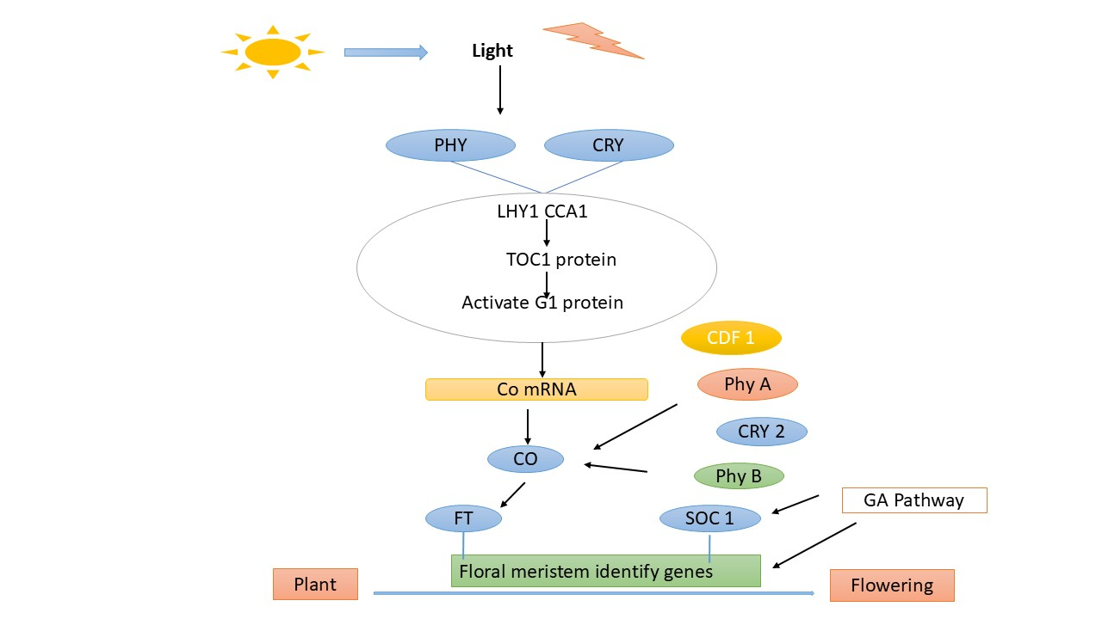

**Fig: 3.** Diagram illustrating the photoperiodic flowering pathway. The phytochromes and cryptochromes that synchronize the circadian rhythm are sensitive to light. The clock controls CO expression, while GI controls CO mRNA levels, which control blooming. Activated CO protein first promotes blooming by triggering the way in which the genes regulating the floral meristem identity are expressed is determined by the expression of the floral integrators FT and SOC1 (76)

**3. Evolutionary Insights and Ecological Significance**

Photoreceptors are specialized proteins that have evolved to sense and convert light into cellular signals, playing a key role in the adaptability and survival of organisms. Their evolutionary history extends back more than 600 million years, with distinct types emerging in different lineages, such as opsins in animals and phytotropins, cryptochromes, and phytochromes in plants. These photoreceptors evolved independently through gene duplication and functional specialization, adapting to diverse environmental light conditions. In plants, photoreceptors control essential functions like seed germination, flowering, and phototropism, allowing plants to optimize their growth in changing light environments (77). In animals, opsins show remarkable adaptations, with species in low-light habitats developing highly sensitive vision, while many terrestrial animals have evolved colour vision for tasks like foraging and social communication. The relationship between photoreceptors and ecological pressures highlights their evolutionary importance, shaping species diversity and survival strategies.

**3.1 Evolution of photoreceptors**

Photoreceptors are essential for plants to survive in the short term, additionally; they impact long-term evolutionary pathways and raise the diversity of species. When plants initially began to inhabit a certain area, they brought their photoreceptors with them, leaving the surrounding area mostly desolate and evenly lighted during the day. In this early period, plants likely used photoreceptors to regulate the production of advantageous compounds like antioxidants and UV-protectants, aiding their adaptation to harsh conditions, while also controlling reproductive timing and chloroplast movement (78). As light gradients emerged beneath plant canopies and pigments altered the light spectrum, plants diversified into both shaded and open environments. This required a broad array of photoreceptors to increase their chances of success in various settings (79). Ferns and bryophytes, for example, varied underneath the protection of seed plants (80), leading to the diversification of photoreceptor families as well. Gene duplication led to the evolution of the phototropic and phytochrome families in particular, leading to disparate paralogs that react differently to different types or intensities of light (81). Light signals control plant growth through a process called photomorphogenesis. Three primary types of photoreceptors are involved in this process: phytochromes, which absorb red (R) and far-red (FR) light, and cryptochromes and phytotropins, that absorb blue and UV-A light (82).

**3.2 Photoreceptor Adaptation to Environmental Stress**

In plants, light is an essential environmental indication that affects multiple aspects of growth, including seed germination, carbon uptake, elongation of stem, leaf shape, and blooming. Thus, a plant's health and performance depend on its capacity to recognize and evaluate light quality. There are three primary kinds of photoreceptors that regulate how plants react to light (83). Also, helping plants to up cope with a variety of abiotic stressors are these photoreceptors.

**a) Drought Stress**

Phytochrome contributes to stress regulation due to drought during the light-dormant seed germination process (84). Furthermore, abscisic acid (ABA), the main signaling chemical used by plants during drought, interacts with phytochromes (85). Research by Sawada *et al*. (83) demonstrated that phytochromes can reduce the gene expressions associated with ABA metabolism. The dehydration experiments revealed that the *Nicotiana plumbaginifolia* pewl mutant, which is devoid of a functional phytochrome, exhibited notably greater levels of ABA and superior water retention in contrast to the natural type (86). These findings may explain the heightened vulnerability to excessive pigmentation (hp) mutants in *Solanum lycopersicum*, which are known to exhibit disproportionate reactions to light and increased vulnerability to drought stress (87, 88). Various photoreceptors, such as phytochromes, are involved in the transduction of light signals and regulate a wide range of reactions. Moreover, the phytochrome-deficient Solanum lycopersicum aurea (au) mutant did not exhibit any alteration in transpiration rates during drought situations (89), suggesting that different species may respond differently to phytochrome signaling in response to drought stress.

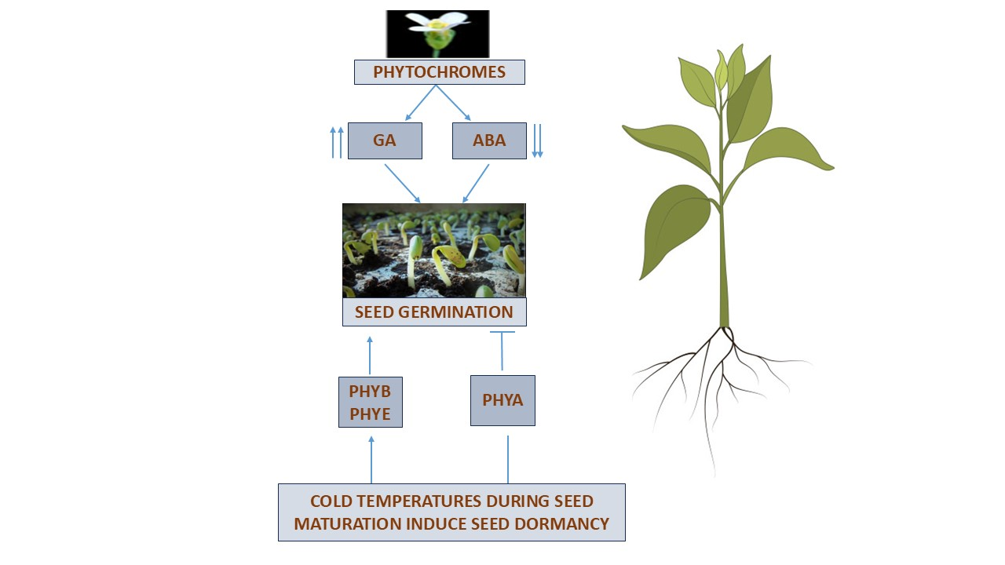**Fig: 4.** The way phytochromes react to changes in temperature and moisture levels indicates when seeds will sprout. Phytochromes facilitate germination by inwardly decreasing the stress hormone abscisic acid (ABA) and increasing gibberellic acid (GA). When seeds are mature, low temperatures induce dormancy. That is to say, phyA aids in maintaining cold-induced dormancy, but phyB is essential for breaking it.

**b) Salt Stress**

Osmotic effects of salt stress and drought can trigger a same signaling pathway (90). Furthermore, it has been demonstrated that cryptochromes (crys) have an impact on how the body reacts to salt stress through ionic actions. Xu *et al*. (91) found when exposed to severe salt stress, transgenic Arabidopsis lines overexpressing TaCRY1a and TaCRY2 from Triticum aestivum showed enhanced sensitivity in comparison to the watered control (120 mM NaCl). While salt stress negatively impacted germination in wild-type (WT) plants, the effect was even more detrimental within the transgenic lines. More remarkably, TaCRY1a overexpression in plants revealed the increased salt sensitivity than those overexpressing TaCRY2. Additionally, real-time PCR analysis demonstrated that the TaCRY2 transcript levels in the roots of Arabidopsis subjected to salt stress (250 mM NaCl) increased considerably after 12 hours of stress induction throughout a 28-hour period. Notably, it was found that salt stress may also activate TaCRY1a transcription after a 24-hour exposure to the stressor.

**c) Temperature Stress**

Temperature stress leads to significant metabolic damage in plants, influencing enzymatic activities and protein stability in particular (92). Recent reviews have emphasized changes in the controlling systems of reactive oxygen species (ROS) and various pathways during heat stress, indicating a strong association with downstream heat shock proteins (HSPs) (93). In this context, the transcription profile of HSPs is significantly influenced by cryptochromes (crys) (94), offering a fresh viewpoint on how blue light photoreceptors react to high temperatures. According to one study, cry1 reduces auxin biosynthesis to aid Arabidopsis seedlings in acclimating to the heat, which results in noticeable morphological alterations (95). Moreover, CRY1 interacts with gene promoters under high temperature in a manner dependent on PHYTOCHROME-INTERACTING FACTOR 4 (PIF4), which is necessary for blue light-dependent signal transduction. These genes include flavin-binding monooxygenase family protein (YUC8), indole-3-acetic acid inducible 19 (IAA19), and indole-3-acetic acid inducible 29 (IAA29). On the other side, regulatory components like COP1, HY5, and Z-box aid in Arabidopsis' ability to withstand cold stress (96); Z-box functions as a regulatory cis-element in the promoters of responsive genes, such as the HY5 transcription factor (97). However, it is clear that the control over temperature responses in plants caused by crys remains largely unexplored field, requiring more thorough investigation.

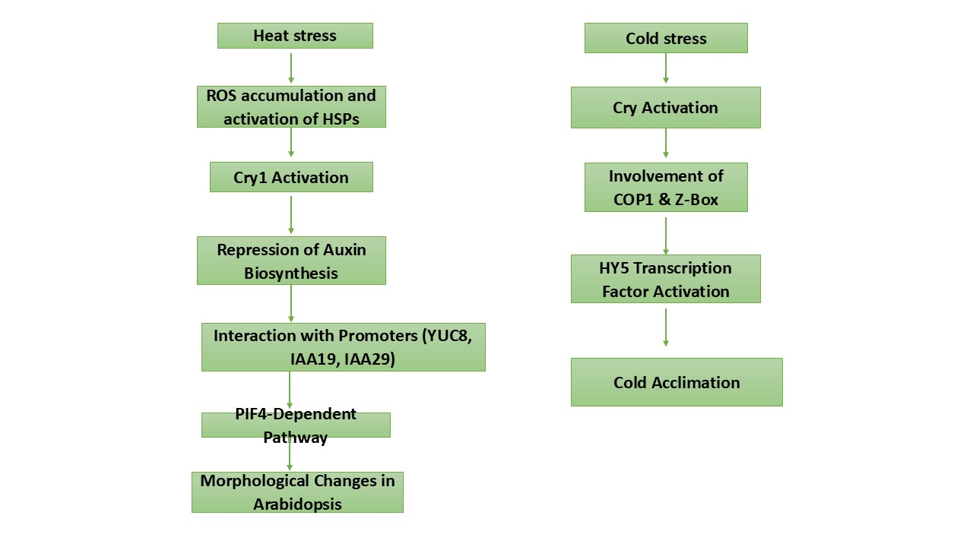

**Fig: 5.** This flowchart shows the interconnected pathways for heat and cold stress, indicating how key molecules and proteins interact in response to temperature variations.

**d) Light Stress**

Phytochrome-mediated responses to high-light stress play a critical role in plant acclimation, particularly by adjusting light perception and signal transduction pathways. Red/far-red light receptors called phytochromes control a number of physiological functions, such as stress tolerance and light adaptation. Under high-light conditions, phytochrome signaling triggers a series of protective mechanisms to prevent photodamage (98). It has emphasized the function of phytochromes, especially Phytochrome B (phyB), in balancing energy dissipation and photoprotection. PhyB interacts with key transcription factors, including PHYTOCHROME-INTERACTING FACTORS (PIFs), to regulate genes linked to photosynthesis during high-light exposure (99). This response leads to adjustments in chloroplast function and gene expression to optimize light energy use, while also initiating photoprotective mechanisms such as non-photochemical quenching (NPQ) and activation of antioxidant pathways to minimize reactive oxygen species (ROS) damage. Moreover, studies have revealed that phyB influences stomatal conductance and regulates photomorphogenic development under high-light stress, contributing to water use efficiency and the avoidance of excess light energy. This regulating system is necessary for plants to develop and survive in environments with variable light levels (100). Thus, phytochromes, particularly phy B, are integral in helping plants acclimate to high-light environments by modulating stress responses and protecting the photosynthetic machinery from photodamage (101).

A crucial mechanism that guarantees seedling survival in their early developmental phases is the photoprotection resulting from the buildup of anthocyanins in the hypocotyls and cotyledons (102). Given the importance of ammonia-lyase phenylalanine (PAL) (103) and chalcone synthase (CHS) (104) in the anthocyanin biosynthesis pathway, it is likely that phytochrome contributes to these responses (105). Nevertheless, it is still unclear how phytochromes function during the induction of anthocyanins after being exposed to UV-B light. While persistent red light resulted in significantly improved anthocyanin production when Zea mays coleoptiles are exposed to UV-B, It was demonstrated that in *Sinapis alba*, phytochrome-mediated anthocyanin production was prevented by UV-B rays (106). Since UV-B light treatment modifies certain sets in addition to R and FR light therapy, the genetic specifics of this signaling are intricate, despite the fact that these experiments have helped to clarify phytochrome's involvement in the transmission of UV-B light signals (107).

**4. Conclusion:** Ultimately, photoreceptor dynamics play a vital function in giving plants permission to sense and adapt changing light levels, which in turn allows them to maximize their chances of survival and growth. Because complex systems control the activity of photoreceptors, plants can adjust how they react to variations in the amount, kind, and duration of light. These mechanisms include protein degradation, phosphorylation, and interactions with signalling molecules. Moreover, the numerous interactions between light signalling pathways and environmental factors like temperature and water availability complicate the regulation of photoreceptors. Understanding the molecular processes underlying photoreceptor modulation has recently led to new discoveries on how plants combine light signals with other environmental cues to better adapt to changing conditions. Improving crop production and resilience by adjusting these pathways presents interesting prospects, especially in light of climate change and less-than-ideal growing conditions. To fully utilize plant light-sensing mechanisms and create sustainable farming methods, more research in this field is necessary.

**5. References:**

1. Briggs WR, Olney MA. Photoreceptors in plant photomorphogenesis to date. Current Opinion in Plant Biology. 2001; 4(5): 421-426. https://doi.org/10.1104/pp.125.1.85
2. Quail PH. Phytochrome photosensory signaling networks. Nature Reviews Molecular Cell Biology. 2002; 3(2): 85-93. <https://doi.org/10.1038/nrm728>
3. Rockwell NC, Su YS, Lagarias JC. Phytochrome structure and signaling mechanisms. Annu. Rev. Plant Biol. 2006; 57(1): 837-858. https://doi.org/10.1146/annurev.arplant.56.032604.144208
4. Liu H, Liu B, Zhao C, Pepper M, Lin C. The action mechanisms of plant cryptochromes. Trends in Plant Science. 2011; 16(12): 684-691. https://doi.org/10.1016%2Fj.tplants.2011.09.002
5. Leivar P, Monte E. PIFs: systems integrators in plant development. Plant Cell. 2014; 26(1): 56-78. https://doi.org/10.1105/tpc.113.120857
6. Li J, Li G, Quail PH. The F-box protein EBF1 mediates degradation of EIN3 to regulate ethylene responses in Arabidopsis. The Plant Cell. 2010; 22(6): 1859-1872.
7. Chen B, Feder ME, Kang L. Evolution of heat-shock protein expression underlying adaptive responses to environmental stress. Molecular Ecology. 2018; 27: 3040–3054. doi: 10.1111/mec.14769
8. Schäfer E, Nagy F, editors. Photomorphogenesis in plants and bacteria: function and signal transduction mechanisms. Springer Science & Business Media; 2006 Jun 11.
9. Quail PH. Phytochrome photosensory signaling networks. Nature Reviews Molecular Cell Biology. 2002; 3(2): 85-93. https://doi.org/10.1038/nrm728
10. Bae G, Choi G. Decoding of light signals by plant phytochromes and their interacting proteins. Annual Revision Plant Biology. 2008; 59(1): 281-311. https://doi.org/10.1146/annurev.arplant.59.032607.092859
11. Rockwell NC, Su YS, Lagarias JC. Phytochrome structure and signaling mechanisms. Annu. Rev. Plant Biol. 2006; 57(1): 837-858. https://doi.org/10.1146/annurev.arplant.56.032604.144208
12. Chen D, Lyu M, Kou X, Li J, Yang Z, Gao L, Li Y, Fan LM, Shi H, Zhong S. Integration of light and temperature sensing by liquid-liquid phase separation of phytochrome B. Molecular Cell. 2022; 82(16): 3015-3029. https://doi.org/10.1016/j.molcel.2022.05.026
13. Kim C, Kwon Y, Jeong J, Kang M, Lee GS, Moon JH, Lee HJ, Park YI, Choi G. Phytochrome B photobodies are comprised of phytochrome B and its primary and secondary interacting proteins. Nature Communications. 2023; 14(1):1708. https://doi.org/10.1038/s41467-023-37421-z
14. Aukerman MJ, Hirschfeld M, Wester L, Weaver M, Clack T, Amasino RM, Sharrock RA. A deletion in the PHYD gene of the Arabidopsis Wassilewskija ecotype defines a role for phytochrome D in red/far-red light sensing. The Plant Cell. 1997; 9(8):1317-1326. https://doi.org/10.1105/tpc.9.8.1317
15. Cashmore AR, Jarillo JA, Wu YJ, Liu D. Cryptochromes: blue light receptors for plants and animals. Science 1999; 284(5415): 760-765. https://doi.org/10.1126/science.284.5415.760
16. Chaves I, Pokorny R, Byrdin M, Hoang N, Ritz T, Brettel K, Essen LO, Horst GT, Batschauer A, Ahmad M. The cryptochromes: blue light photoreceptors in plants and animals. Annual review of plant biology. 2011; 62(1): 335-364. https://doi.org/10.1146/annurev-arplant-042110-103759
17. Ozturk N. Phylogeny of the cryptochrome photolyase family and the origins of circadian photoreception in animals. Genome Biology and Evolution. 2017; 9(7): 1687-1699. DOI: 10.1111/php.12676
18. Hoang N, Schleicher E, Kacprzak S, Bouly JP, Picot M, Wu W, Berndt A, Wolf E, Bittl R, Ahmad M. Human and Drosophila cryptochromes are light activated by flavin photoreduction in living cells. PLoS biology. 2008; 6(7): 160. https://doi.org/10.1371/journal.pbio.0060160
19. Ahmad M, Jarillo JA, Cashmore AR. Chimeric proteins between cry1 and cry2 Arabidopsis blue light photoreceptors indicates overlapping functions and varying protein stability. The Plant Cell. 1998; 10(2):197-207. https://doi.org/10.1105/tpc.10.2.197
20. Chen B, Feder ME, Kang L. Evolution of heat-shock protein expression underlying adaptive responses to environmental stress. Molecular Ecology. 2018; 27: 3040–3054. doi: 10.1111/mec.14769
21. Christie JM. Phototropin Blue-Light Receptors. Annual Review of Plant Biology. 2007; 58: 21-45. doi: 10.1146/annurev.arplant.58.032806.103951
22. Briggs WR, Christie JM. 2002. Phototropins 1 and 2: versatile plant blue-light receptors. Trends in plant science. 2002; 7(5): 204-210. https://doi.org/10.1016/S1360-1385(02)02245-8
23. Briggs WR. Phototropism: some history, some puzzles, and a look ahead. Plant Physiology. 2014; 164: 13–23. <https://doi.org/10.1104/pp.113.230573>
24. Vandenbussche F, Straeten D. Differential accumulation of elongated hypocotyl5 correlates with hypocotyl bending to ultraviolet-B light. Plant Physiology. 2014; 166: 40–43. https://doi.org/10.1104/pp.114.244582
25. Liscum E, Askinosie SK, Leuchtman DL, Morrow J, Willenburg KT, Coats DR. Phototropism: growing towards an understanding of plant movement. Plant Cell. 2014; 26: 38–55. https://doi.org/10.1105/tpc.113.119727
26. Sakai T, Haga K. Molecular genetic analysis of phototropism in Arabidopsis. Plant Cell Physiology. 2012; 53: 1517–1534. <https://doi.org/10.1093/pcp/pcs111>
27. Kutschera U, Briggs WR. Root phototropism: from dogma to the mechanism of blue light perception. Planta. 2012; 235: 443–452. DOI 10.1007/s00425-012-1597-y
28. Sakai T, Kagawa T, Kasahara M, Swartz TE, Christie JM, Briggs WR, Wada M, Okada K. Arabidopsis nph1 and npl1: blue light receptors that mediate both phototropism and chloroplast relocation. Proceeding National Academic Science. 2001; 98: 6969–6974. <https://doi.org/10.1073/pnas.101137598>
29. Briggs WR, Olney MA. Photoreceptors in plant photomorphogenesis to date. Current Opinion in Plant Biology. 2001; 4(5): 421-426. https://doi.org/10.1104/pp.125.1.85
30. Vandenbussche F, Tilbrook K, Fierro AC, Marchal K, Poelman D, Van Der Straeten D, Ulm R. Photoreceptor-mediated bending towards UV-B in Arabidopsis. Molecular Plant.2014; 7: 1041–1052. https://doi.org/10.1093/mp/ssu039
31. Wang Y, Folta KM. Contributions of green light to plant growth and development. American journal of botany. 2013; 100(1):70-8. https://doi.org/10.3732/ajb.1200354
32. Kim HH, Goins GD, Wheeler RM, Sager JC. Green-light supplementation for enhanced lettuce growth under red-and blue-light-emitting diodes. HortScience. 2004; 39(7):1617-22. https://doi.org/10.21273/HORTSCI.39.7.1617
33. Frechilla S, Talbott LD, Bogomolni RA, Zeiger E. Reversal of blue light-stimulated stomatal opening by green light. Plant Cell Physiol. 2000; 41:171–176. https://doi.org/10.1093/pcp/41.2.171
34. Zhang T, Maruhnich SA, Folta KM. Green light induces shade avoidance symptoms. Plant physiology. 2011; 157(3):1528-36. https://doi.org/10.1104/pp.111.180661
35. Dhingra A, Bies DH, Lehner KR, Folta KM. Green light adjusts the plastid transcriptome during early photomorphogenic development. Plant Physiology. 2006; 142:1256–1266.https://doi.org/10.1104/pp.106.088351
36. Folta KM, Carvalho SD. Photoreceptors and control of horticultural plant traits. HortScience. 2015; 50(9): 1274-1280. <https://doi.org/10.21273/HORTSCI.50.9.1274>
37. Bae G, Choi G. Decoding of light signals by plant phytochromes and their interacting proteins. Annual Revision Plant Biology. 2008; 59(1): 281-311. https://doi.org/10.1146/annurev.arplant.59.032607.092859
38. Bae G, Choi G. Decoding of light signals by plant phytochromes and their interacting proteins. Annual Revision Plant Biology. 2008; 59(1): 281-311. https://doi.org/10.1146/annurev.arplant.59.032607.092859
39. Paik I, Kathare PK, Kim JI, Huq E. Expanding roles of PIFs in signal integration from multiple processes. Molecular plant. 2017; 10(8):1035-46. http://dx.doi.org/10.1016/j.molp.2017.07.002
40. Kim HH, Goins GD, Wheeler RM, Sager JC. Green-light supplementation for enhanced lettuce growth under red-and blue-light-emitting diodes. HortScience. 2004; 39(7):1617-22. https://doi.org/10.21273/HORTSCI.39.7.1617
41. Bae G, Choi G. Decoding of light signals by plant phytochromes and their interacting proteins. Annual Revision Plant Biology. 2008; 59(1): 281-311. https://doi.org/10.1146/annurev.arplant.59.032607.092859
42. Christie JM, Blackwood L, Petersen J, Sullivan S. Plant flavoprotein photoreceptors. Plant and Cell Physiology. 2015; 56(3): 401–413. https://doi.org/10.1093/pcp/pcu196
43. Liu H, Liu B, Zhao C, Pepper M, Lin C. The action mechanisms of plant cryptochromes. Trends in Plant Science. 2011; 16(12): 684-691. https://doi.org/10.1016%2Fj.tplants.2011.09.002
44. Al-Sady B, Ni W, Kircher S, Schafer E, Quail PH. Photoactivated phytochrome induces rapid PIF3 phosphorylation prior to proteasome-mediated degradation. Molecular Cell. 2006; 23(3): 439–446. DOI 10.1016/j.molcel.2006.06.011
45. Lois LM, Lima CD, Chua NH. Small ubiquitin-like modifier modulates abscisic acid signaling in Arabidopsis. Plant Cell. 2003; 15(6): 1347–1359. https://doi.org/10.1105/tpc.009902
46. Yun BW, Feechan A, Yin M, Saidi NB, Le Bihan T, Yu M, Loake GJ. S-nitrosylation of NADPH oxidase regulates cell death in plant immunity. Nature, 2011; 478(7368): 264–268. https://doi.org/10.1038/nature10427
47. Chen M, Chory J, Fankhauser C. Light signal transduction in higher plants. Annual Review of Genetics. 2004; 38: 87-117.https://doi.org/10.1146/annurev.genet.38.072902.092259
48. Franklin KA, Quail PH. Phytochrome functions in Arabidopsis development. Journal of Experimental Botany. 2010; 61(1): 11–24. https://doi.org/10.1093/jxb/erp304
49. Yu X, Klejnot J, Zhao X, Shalitin D, Maymon M, Yang H, Lee J, Liu X, Lin C. Arabidopsis cryptochrome 2 completes its post-translational life cycle in the nucleus. Plant Cell. 2010; 19(3): 696-710. <https://doi.org/10.1105/tpc.107.053017>
50. Ni W, Xu SL, Tepperman JM, Stanley DJ, Maltby DA, Gross JD, Burlingame AL, Wang ZY, Quail PH. A mutually assured destruction mechanism attenuates light signaling in Arabidopsis. Science. 2017; 344(6188):1160-4. https://doi.org/10.1126/science.1250778
51. Possart A, Hiltbrunner A. An evolutionarily conserved signaling mechanism mediates far-red light responses in land plants. Plant Cell. 2013; 25(3): 1022-1035. <https://doi.org/10.1105/tpc.112.104331>
52. Achard P, Cheng H, De Grauwe L, Decat J, Schoutteten H, Moritz T, Van Der Straeten D, Peng J, Harberd NP. Integration of plant responses to environmentally activated phytohormonal signals. Trends in Plant Science. 2007; 12(10): 481-488. https://doi.org/10.1126/science.1118642
53. Chory J. Light signal transduction: an infinite spectrum of possibilities. Plant Journal. 2010; 61(6): 982-991. https://doi.org/10.1111/j.1365-313X.2009.04105.x
54. Galvez-Valdivieso G, Mullineaux PM. The role of reactive oxygen species in signalling from chloroplasts to the nucleus. Physiological Plantarum. 2010; 138(4): 430-439. https://doi.org/10.1111/j.1399-3054.2009.01331.x
55. Tepperman JM, Hwang YS, Quail PH. PhyA dominates in transduction of red‐light signals to rapidly responding genes at the initiation of Arabidopsis seedling de‐etiolation. The Plant Journal. 2006; 48(5):728-42. https://doi.org/10.1111/j.1365-313X.2006.02914.x
56. Chen B, Feder ME, Kang L. Evolution of heat-shock protein expression underlying adaptive responses to environmental stress. Molecular Ecology. 2018; 27: 3040–3054. doi: 10.1111/mec.14769
57. Rockwell NC, Su YS, Lagarias JC. Phytochrome structure and signaling mechanisms. Annu. Rev. Plant Biol. 2006; 57(1): 837-858. https://doi.org/10.1146/annurev.arplant.56.032604.144208
58. Rockwell NC, Su YS, Lagarias JC. Phytochrome structure and signaling mechanisms. Annu. Rev. Plant Biol. 2006; 57(1): 837-858. https://doi.org/10.1146/annurev.arplant.56.032604.144208
59. Shikata H, Hanada K, Ushijima T, Nakashima M, Suzuki Y, Matsushita T. Phytochrome controls alternative splicing to mediate light responses in Arabidopsis. Proceedings of the National Academy of Sciences. 2014; 111(52):18781-6. https://doi.org/10.1073/pnas.1407147112
60. Xin R, Zhu L, Salomé PA, Mancini E, Marshall CM, Harmon FG, Yanovsky MJ, Weigel D, Huq E. SPF45-related splicing factor for phytochrome signaling promotes photomorphogenesis by regulating pre-mRNA splicing in Arabidopsis. Proceedings of the National Academy of Sciences. 2017; 114(33):18-27. https://doi.org/10.1073/pnas.1706379114
61. Ushijima T, Hanada K, Gotoh E, Yamori W, Kodama Y, Tanaka H, Kusano M, Fukushima A, Tokizawa M, Yamamoto YY, Tada Y. Light controls protein localization through phytochrome-mediated alternative promoter selection. Cell. 2017; 171(6):1316-25. https://doi.org/10.1016/j.cell.2017.10.018
62. Oh S, Warnasooriya SN, Montgomery BL. Downstream effectors of light-and phytochrome-dependent regulation of hypocotyl elongation in Arabidopsis thaliana. Plant Molecular Biology. 2013; 81: 627-40. https://doi.org/10.1007/s11103-013-0029-0
63. Paik I, Huq E. Plant photoreceptors: Multi-functional sensory proteins and their signaling networks. In Seminars in cell & developmental biology. Academic Press. 2019; 92: 114-121. https://doi.org/10.1016/j.semcdb.2019.03.007
64. Kim YJ, Koo Y J, Han YJ. Integration of light and circadian signals by phytochromes and cryptochromes in plants. Journal of Integrative Plant Biology. 2021; 63(5): 887–903.
65. Franklin KA, Quail PH. Phytochrome functions in Arabidopsis development. Journal of Experimental Botany. 2010; 61(1): 11–24. <https://doi.org/10.1093/jxb/erp304>
66. Endo, M., Shimizu, H., & Araki, T. (2016). Circadian rhythms in plants: physiological and molecular mechanisms. Genes to Cells, 21(3), 265–278.
67. Kim C, Kim SJ, Jeong J, Park E, Oh E, Park YI, Lim PO, Choi G. High ambient temperature accelerates leaf senescence via phytochrome-interacting factor 4 and 5 in Arabidopsis. Molecules and cells. 2020; 43(7):645-61. <https://doi.org/10.14348/molcells.2020.0117>
68. Jang S, Marchal V, Panigrahi KC, Wenkel S, Soppe W, Deng XW, Valverde F, Coupland G. Arabidopsis COP1 shapes the temporal pattern of CO accumulation conferring a photoperiodic flowering response. The EMBO journal. 2008; 27(8): 1277-88. https://doi.org/10.1038/emboj.2008.68
69. Zuo Z, Liu H, Liu B, Liu X, Lin C. Blue light dependent interaction of CRY2 with SPA1 regulates COP1 activity and floral initiation in *Arabidopsis*. Current Biology. 2011; 21: 841–847. http://dx.doi.org/10.1016/j.cub.2011.03.048
70. Sawa M, Kay SA. GIGANTEA directly activates FLOWERING LOCUS T in Arabidopsis thaliana. Proceeding National Academic Science*.* 2011; 108: 11698–11703. https://doi.org/10.1073/pnas.1106771108
71. Song YH, Smith RW, Millar AJ, Imaizumi T. FKF1 conveys timing information for CONSTANS stabilization in photoperiodic flowering. Science. 2012; 336: 1045–1049. <https://doi.org/10.1126/science.1219644>
72. Roden LC, Ingle RA. Lights, rhythms, infection: the role of light and the circadian clock in determining the outcome of plant–pathogen interactions. Plant Cell. 2009; 21: 2546–2552. https://doi.org/10.1105/tpc.109.069922
73. Butt GR, Qayyum ZA, Jones MA. (2020). Plant Defence Mechanisms Are Modulated by the Circadian System. Biology. 2020; 9: 454.https://doi.org/10.3390/biology9120454
74. Griebel T, Zeier J. Light regulation and daytime dependency of inducible plant defenses in Arabidopsis: phytochrome signaling controls systemic acquired resistance rather than local defense. Plant Physiol*.* 2008; 147: 790–801. https://doi.org/10.1104/pp.108.119503
75. Ingle RA, Stoker C, Stone W, Adams N, Smith R, Grant M. Jasmonate signalling drives time-of-day differences in susceptibility of *Arabidopsis* to the fungal pathogen Botrytis cinerea. Plant Journal.2015; 84: 937–948. https://doi.org/10.1111/tpj.13050
76. Thornber SE. Molecular characterisation of the day neutral flowering (dnf) mutant in Arabidopsis thaliana (Doctoral dissertation, University of Warwick). 2008.
77. Christie JM. Phototropin Blue-Light Receptors. Annual Review of Plant Biology. 2007; 58: 21-45. doi: 10.1146/annurev.arplant.58.032806.103951
78. Mathews S. Phytochrome-mediated development in land plants: red light sensing evolves to meet the challenges of changing light environments. Molecular Ecology. 2006; 15: 3483–3503. doi:10.1111/j.1365-294X.2006.03051.x
79. Laenen B, Shaw B, Schneider H, Goffinet B, Paradis E, Desamore A, Heinrichs J, Villarreal JC, Gradstein SR, McDaniel SF, Long DG, Forrest LL, Hollingsworth ML, Crandall-Stotler B, Davis EC, Engel J, Von Konrat M, Cooper ED, Patino J, Cox CJ, Vanderpoorten A, Shaw AJ. Extant diversity of bryophytes emerged from successive post-Mesozoic diversification bursts. National Communication. 2014; 5:5134. doi:10.1038/ncomms6134
80. Galvao VC, Fankhauser C. Sensing the light environment in plants: photoreceptors and early signaling steps. Curr Opin Neurobiology. 2015; 34: 46–53. doi:10.1016/j.conb.2015.01.013
81. Schafer E, Nagy F, editors. Photomorphogenesis in plants and bacteria: function and signal transduction mechanisms. Springer Science & Business Media. 2006.
82. Chen B, Feder ME, Kang L. Evolution of heat-shock protein expression underlying adaptive responses to environmental stress. Molecular Ecology. 2018; 27: 3040–3054. doi: 10.1111/mec.14769
83. Mollard FPO, Insausti P. Soil moisture conditions affect the sensitivity of Bromus catharticus dormant seeds to light and the emergence pattern of seedlings. Seed Science Research. 2009; 19: 81– 89. https://doi.org/10.1017/S0960258509301087
84. Carvalho RF, Quecini V, Peres LEP. Hormonal modulation of photomorphogenesis-controlled anthocyanin accumulation in tomato (*Solanum lycopersicum* L. cv Micro-Tom) hypocotyls: Physiological and genetic studies. Plant Science.2010; 178: 258–264. https://doi.org/10.1016/j.plantsci.2010.01.013
85. Sawada Y, Aoki M, Nakaminami K, Mitsuhashi W, Tatematsu K, Kushiro T, Koshiba T, Kamiya Y, Inoue Y, Nambara E, Toyomasu T. Phytochrome-and gibberellin-mediated regulation of abscisic acid metabolism during germination of photoblastic lettuce seeds. Plant physiology 2008; 146(3): 1386-1396. https://doi.org/10.1104/pp.107.115162
86. Galpaz N, Wang Q, Menda N, Zamir D, Hirschberg J. Abscisic acid deficiency in the tomato mutant high-pigment 3 leading to increased plastid number and higher fruit lycopene content. Plant Journal. 2008; 53: 717–730.https://doi.org/10.1111/j.1365-313X.2007.03362.x
87. Galpaz N, Wang Q, Menda N, Zamir D, Hirschberg J. Abscisic acid deficiency in the tomato mutant high-pigment 3 leading to increased plastid number and higher fruit lycopene content. Plant Journal. 2008; 53: 717–730.https://doi.org/10.1111/j.1365-313X.2007.03362.x
88. Carvalho RF, Takaki M, Azevedo RA (2011) Plant pigments: The many faces of light perception. Acta Plant Physiology. 2011; 33: 241–248. DOI 10.1007/s11738-010-0533-7
89. Biehler K, Haupt S, Beckmann J, Fock H, Becker TW. Simultaneous CO2- and 16O2/18O2-gas exchange and fluorescence measurements indicate differences in light energy dissipation between the wild type and the phytochrome-deficient aurea mutant of tomato during water stress. Journal Experimental Botany. 1997;48: 1439–1449. https://doi.org/10.1093/jxb/48.7.1439
90. Chaves MM, Flexas J, Pinheiro C. Photosynthesis under drought and salt stress: regulation mechanisms from whole plant to cell. Annual of Botany. 2009; 103: 551–560. doi: 10.1093/aob/mcn125
91. Xu P, Xiang Y, Zhu H, Xu H, Zhang Z, Zhang C, Zhang L, Ma Z. Wheat cryptochromes: subcellular localization and involvement in photomorphogenesis and osmotic stress responses. Plant Physiology. 2009; 149(2):760-74. doi: 10.1104/pp.108.132217
92. Szymanska R, Slesak I, Orzechowska A, Kruk J. Physiological and biochemical responses to high light and temperature stress in plants. Environmental Experiment Botany. 2017; 139: 165–177. doi: 10.1016/j.envexpbot.2017.05.002
93. Chen B, Feder ME, Kang L. Evolution of heat-shock protein expression underlying adaptive responses to environmental stress. Molecular Ecology. 2018; 27: 3040–3054. doi: 10.1111/mec.14769
94. Yang Y, Li Y, Li X, Guo X, Xiao X, Tang D, Liu X. Comparative proteomics analysis of light responses in cryptochrome1‐304 and Columbia wild‐type 4 of Arabidopsis thaliana. Acta Biochimica et Biophysica Sinica. 2008; (1): 27-37. doi: 10.1111/j.1745-7270.2008.00367.x
95. Ma D, Li X, Guo Y, Chu J, Fang S, Yan C. Cryptochrome 1 interacts with PIF4 to regulate high temperature-mediated hypocotyl elongation in response to blue light. Proceeding of National Academic Science. 2016; 113: 224–229. doi: 10.1073/pnas.1511437113
96. Catala R, Medina J, Salinas J. Integration of low temperature and light signaling during cold acclimation response in Arabidopsis. Proceedings of the National Academy of Sciences. 2011; 108: 16475–16480. doi: 10.1073/pnas.1107161108
97. Yadav V, Mallappa C, Gangappa SN, Bhatia S, Chattopadhyay S. A basic helix-loop-helix transcription factor in Arabidopsis, MYC2, acts as a repressor of blue light–mediated photomorphogenic growth. The Plant Cell. 2005; 17(7):1953-66. doi: 10.1105/tpc.105.03 2060
98. Kim C, Kim SJ, Jeong J, Park E, Oh E, Park YI, Lim PO, Choi G. High ambient temperature accelerates leaf senescence via phytochrome-interacting factor 4 and 5 in Arabidopsis. Molecules and cells. 2020; 43(7):645-61. https://doi.org/10.14348/molcells.2020.0117
99. Legris M, Ince YC, Fankhauser C. Molecular mechanisms underlying phytochrome-controlled morphogenesis in plants. Nature Reviews Molecular Cell Biology. 2019; 20(10): 624-637. https://doi.org/10.1038/s41580-019-0148-y
100. Jung JH, Domijan M, Klose C, Biswas S, Ezer D, Gao M, Wigge PA. Phytochromes function as thermosensors in Arabidopsis. Science. 2019; 363(6422):277-280. <https://doi.org/10.1126/science.aav7531>
101. Franklin KA, Quail PH. Phytochrome functions in *Arabidopsis* development. Journal of Experimental Botany. 2020; 71(1): 21-29. <https://doi.org/10.1093/jxb/erz431>
102. Chalker-Scott L. Environmental significance of anthocyanins in plant stress responses. Photochemical Photobiology. 1999; 70: 1–9.https://doi.org/10.1111/j.1751-1097.1999.tb01944.x
103. Alokam S, Li Y, Li W, Chinnappa CC, Reid DM. Photoregulation of phenylalanine ammonia-lyase (PAL) and chalcone synthase (CHS) in the accumulation of anthocyanin in alpine and prairie ecotypes of Stellaria longipes under varied R/FR. Physiology Plant. 2002; 116: 531–538. https://doi.org/10.1034/j.1399-3054.2002.1160412.x
104. Franklin KA, Quail PH. Phytochrome functions in *Arabidopsis* development. Journal of Experimental Botany. 2020; 71(1): 21-29. https://doi.org/10.1093/jxb/erz431
105. Carvalho RF, Takaki M, Azevedo RA (2011) Plant pigments: The many faces of light perception. Acta Plant Physiology. 2011; 33: 241–248. DOI 10.1007/s11738-010-0533-7
106. Carvalho RF, Quecini V, Peres LEP. Hormonal modulation of photomorphogenesis-controlled anthocyanin accumulation in tomato (*Solanum lycopersicum* L. cv Micro-Tom) hypocotyls: Physiological and genetic studies. Plant Science.2010; 178: 258–264. https://doi.org/10.1016/j.plantsci.2010.01.013
107. Jung JH, Domijan M, Klose C, Biswas S, Ezer D, Gao M, Wigge PA. Phytochromes function as thermosensors in Arabidopsis. Science. 2019; 363(6422):277-280. <https://doi.org/10.1126/science.aav7531>