Influence of food intensity on growth parameters and survival of *Coptodon guineensis* Günther, 1862 juveniles raised at the Layo Aquaculture Experimental Station (Ivory Coast)

ABSTRACT

|  |
| --- |
| A study was conducted from June 3 to August 26, 2024, at the Layo Aquaculture experimental Station, in order to assess the influence of three diets on the growth and survival parameters of *Coptodon guineensis* juveniles. The overall objective of this trial is to contribute to the improvement of fish farming production techniques. Thus, 150 individuals with an initial average weight of 4.84±1.52 g and an initial average length of 60.36±6.31 mm were divided into three batches (batch 1, batch 2, batch 3) tested in duplicate, in 50-liter happas at a density of 0.5 individuals/L. Fish were rationed at rates of 10%, 20% and 30% of biomass for batches 1, 2 and 3 respectively, using a commercial "Koudijs" feed. On a weekly basis, physico-chemical parameters were measured between 07:00 and 07:30; ten individuals, selected at random by happa, were weighed and measured individually. At the end of the experiment, all surviving individuals per batch were counted. Results showed values of 28.13 ± 0.31°C, 6.30 ± 0.26 mg/l and 7.03 ± 0.21 respectively for temperature, dissolved oxygen and pH. These values were in line with recommended standards for Tilapia. At zootechnical level, fish from batch 2 (20%) achieved higher growth (Aw: 10.54 ± 1.40 g; Al: 77.34 ± 3.05 mm; ADG: 0.81 ± 0.2 g/d) and survival (76.00±11.31%) performances than other batches. The ADG, weight CV and survival rates of batch 2 were significantly higher (p<0.05) than those of batches 1 and 3. In short, fish farmers should opt for the 20% rationing rate. Looking ahead, it would be interesting to extend the duration of the experiment beyond one month to observe the long-term influence of feeding intensity on the zootechnical parameters of this species. |

*Keywords: Feeding, Coptodon guineensis; Happas; Growth; Survival rate.*

1. INTRODUCTION

In Côte d'Ivoire, annual national fish requirements are estimated at 654,836 tonnes, with local production estimated at 102,000 tonnes (with only 4% attributed to fish farming), while annual per capita consumption is estimated at 25.6 kg **[1]** . To make up for this deficit, the State encourages imports of around 80% of its annual fish requirements. In order to reduce them, the Ivorian Government adopted for the period 2014-2020, the Strategic Plan for the Development of Livestock, Fisheries and Aquaculture (PSDEPA, 2014-2020) with the aim of producing 200,000 tonnes of farmed fish in 2020 **[2]**. In view of the insufficient results in terms of animal production, the Ivorian state has set up a new National Policy for the Development of Livestock, Fisheries and Aquaculture (PONADEPA) for the period 2022-2026. The aim is to strengthen the livestock, fisheries and aquaculture sectors in order to reduce the country's dependence on external supplies of animal proteins **[3].**

On the aquaculture front, structures such as the Oceanological Research Center (ORC) have been set up to help improve farming techniques, optimize production systems and develop new varieties of fish adapted to local conditions **[4]** . These include tilapia (*Oreochromis niloticus* and *Sarotherodon melanotheron*), catfish (*Heterobranchus longifilis* and *Clarias gariepinus*) and jawfish (*Chrysischthys nigrodigitatus*), all of which are subject of farming and several studies **[5, 6, 7, 8, 9]** in Côte d'Ivoire. However, fish farming in Côte d'Ivoire still faces many difficulties which prevent it from really taking off. These include the availability of feed resources (quantity and quality), the environment (quality of the fish's living environment and stocking density), the seasons, and the availability of fry. Indeed, numerous studies **[6, 7, 10, 11]** have shown that one of the major difficulties in fish farming is the availability of feed. While most of these studies have concerned the species mentioned above, few have focused on the tilapia *Coptodon guineensis*, which is present in Ivorian lagoons.

For this reason, the current study entitled "Influence of feeding intensity on growth and survival parameters of *Coptodon guineensis* Günther, 1862 juveniles reared at the Layo Aquaculture and Experimental Station (Côte d'Ivoire)" was initiated. Its overall aim is to help improve fish farming techniques for this species.

2. material and methods

**2.1 Study area**

The present study was conducted from June 3 to August 26, 2024, at the Layo Aquaculture Experimental Station (Fig. 1). This ORC research station is located 40 km from Abidjan, on the Abidjan-Dabou road.

**2.2** **Material**

**2.2.1 Biological material**

The biological animal material was the species *Coptodon guineensis* with an initial average weight of 4.84±1.52g and an initial average length of 60.36±6.31 mm (Fig. 2A). The juveniles came from the pens of the Layo aquaculture station

The biological plant material (Fig. 2B) was a commercial Koudijs feed in granulated form (diameter 1 mm) and containing 35% crude protein.

**2.1.2 Technical equipment**

The technical equipment was as follows:

- a landing net with handle to catch juveniles;

- rubber buckets to transport juveniles during sampling;

- a balance (Fisher Scientific brand) for weighing the sampled fish;

- a camera to take pictures ;

- plastic jars for food preservation;

- multi-parameter for measuring pH, dissolved oxygen and temperature;

- an ichthyometer to measure fish size

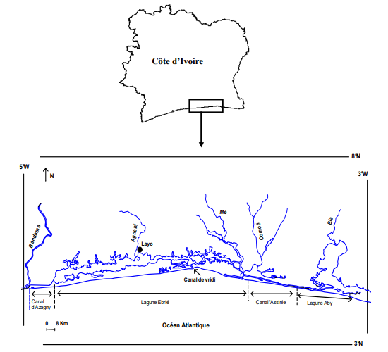

**Fig. 1. Geographical location of the Ebrié lagoon and location of the Layo Aquaculture Experimental Station (Sylla *et al.*, 2009)** **[12]**

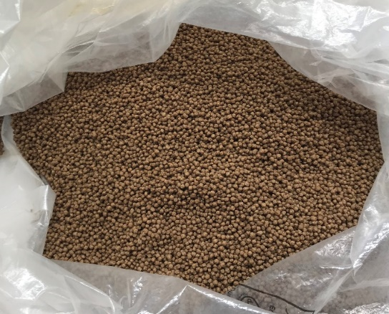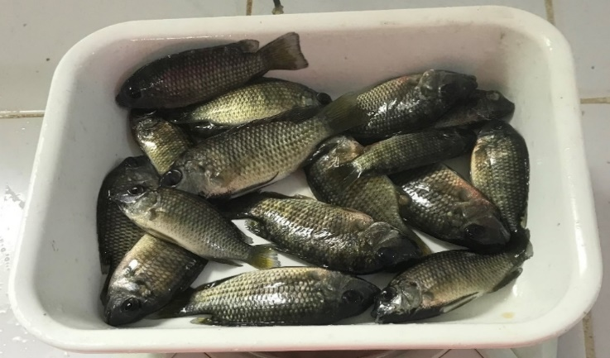

**Fig. 2A. *C. guineensis* juveniles Fig. 2B.** Koudijs **feed**

**Fig. 2. Biological materials used**

**2.3 Methods**

**2.2.1 Installing the happas**

Six identical net happas (1.5 mm mesh), each with an average volume of 50 liters, were installed in two rows of three happas in a previously tended fish pond. Each happa was held in place by four Chinese bamboo stakes, driven firmly into the ground (Fig. 3).

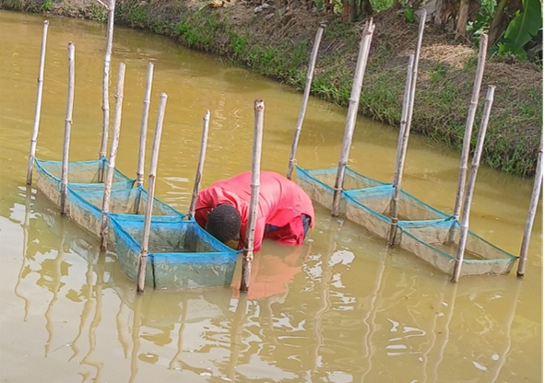

**Fig. 3. Experimental Happas installed**

**2.2.2 Creation of experimental batches**

One hundred and fifty (150) juveniles of *Coptodon guineensis* were divided into three batches (tested in duplicate) of 50 individuals each. The stocking density was 0.5 individuals/L water. Batches 1, 2 and 3 were respectively rationed at 10%, 20% and 30% of the biomass of the individuals in the corresponding batch.

**2.2.3 Breeding management**

*2.2.3.1 Feeding*

The fish were fed a granulated Koudijs feed. The daily ration was calculated taking into account the biomass of the fish in each batch. A readjustment of the ration was made every week after the control fisheries. The feed was distributed manually at 07:30, 12:30 and 16:30, i.e. three times a day

*2.2.3.3 Measuring physico-chemical parameters of farm water*

During this phase, Temperature, Dissolved Oxygen and pH were recorded weekly, between 07:00 and 07:30. The technique consisted in immersing the multi-parameter probe in the happas. It was then switched on. Finally, once the device had stabilized, the various values displayed on the screen were recorded.

*2.2.3.4 Sampling*

To carry out this operation, 10 individuals from each happa were taken at random. These were then weighed using a precision balance and measured using an ichthyometer to monitor fish growth. Dead fish per batch were recorded. At the end of the experiment, the fish were weighed, measured individually and counted by batch.

**2.2.4 Zootechnical parameters studied**

The parameters calculated were

**Average weight of juveniles (AW)**

It is determined by the ratio of the sum of the weights of the individuals in the same batch to their number, according to the following formula :

AW (g) = Sum of the weights of the individuals weighed / Total number of subjects weighed

**Average juvenile length (AL)**

It is determined by dividing the sum of the lengths of individuals in the same batch by their number, using the following formula:

AL (cm) = Sum of lengths of individuals measured / Total number of individuals measured

**Average daily gain (ADG)**

ADG (g/d) = (Faw - Iaw) / t,

Faw: final average weight (g), Iaw: initial average weight (g) and t: rearing time (d).

**Coefficient of Variation (CV)**

It is used to check the weight and size uniformity of juveniles.

CV (%) = (100 x Standard deviation) / Average weight

**Condition factor (K)**

It reflects the overweight of poisons and it is determined by the following formula:

K = (100 x Tw) / Tl3 ; Tw = total weight of fish (g) and Tl = total length of fish (cm).

**Survival rate (SR)**

It is calculated as the ratio of the final number of fish to the initial number.

SR (%) = 100 x Fn / In where In: initial number of fish at loading and Fn: final number of fish.

**2.2.5 Data processing and analysis**

The data collected was processed using a computerized tool. Values were expressed as average ± standard deviation. Excel version 2016 was used to enter and organize the data, and to produce the graphs. Some results were subjected to a one-way analysis of variance (ANOVA) using STATISTICA 7.1 software. The significance threshold was 5%. The result obtained was significant if p is less than 0.05 and non-significant if p is greater than 0.05.

3. results

**3.1 Water physicochemical parameters**

Temperatures ranged from 27.80°C (Batch 1) to 28.40°C (Batch 3), with an average of 28.13 ± 0.31 °C. Batch 2 showed an intermediate value (28.20°C). The average temperature remained relatively stable during this study.

Dissolved oxygen levels also showed little change over time. The lowest value (6.10 mg/L) was observed in Batch 3, while the highest value (6.60 mg/L) was recorded in Batch 1, with an Overall Average of 6.30 ± 0.26 mg/L.

With regard to pH, the values obtained fluctuated between 6.80 (Batch 2) and 7.20 (Batch 1). The calculated average was 7.03 ± 0.21.

**3.2 Zootechnical parameters**

**3.2.1 Growth in weight**

The evolution of the average weight of reared individuals is shown in fig. 4.

During the first two weeks, the average weight per batch increased gradually. It rose from 4.84 ± 1.52 to 7.62 ± 0.1 g for the 10% ration, to 8.69 ± 0.08 g for the 20% ration and to 7.95 ± 0.59 g for the 30% ration.

From the second week rearing to the end of the experiment, growth was relatively stable compared with the first 14 days. The average weight of juveniles increased from 7.62 ± 0.1 g to 10.01 ± 0.74 g for the 10% ration, from 8.69 ± 0.08 g to 10.54 ± 1.40 g for the 20% ration and from 7.95 ± 0.59 g to 9.38 ± 0.06 g for the 30% ration

At the end of the experiment, weight growth was highest in subjects fed with 20% ration, followed by the 10% ration. The 30% ration came last. However, no significant difference (p>0.05) was found between juvenile weights.

**3.2.2 Growth in length**

Juvenile length growth was also upward throughout the test period on all feed rations (Fig. 5)

From the beginning to the end of the experiment, fish size increased from 60.36 ± 6.31 to 74.865 ± 0.71 mm for the 10% ration, to 77.34 ± 3.05 mm for the 20% ration and to 75.85 ± 2.62 mm for the 30% ration. However, a relatively low growth in length was observed in all batches after the second week of rearing.

At the end of the experiment, the highest total length was observed in juveniles fed with 20% ration as for weight, followed by the 30% ration. The 10% ration came last.

However, the results were not significantly different for the 3 rations (p>0.05).

**Fig. 4. Variations in average mass of juvenile *Coptodon guineensis*** **according to feeding intensity and rearing duration.**

**Fig. 5. Variations in average length** **of juveniles of** ***Coptodon guineensis* according to feeding intensity and rearing duration.**

**3.2.3 Average daily gain (ADG)**

Over the course of the experiment, the general observation was the progressive decrease in ADG values in all batches, from 0.18 ± 0.02 g/d (batch 1), 0.36 ± 0.09 g/d (batch 2) and 0.29 ± 0.01 g/d (batch 3) at the start of the trial to 0.11 ± 0.01 g/d (batch 1), 0.13 ± 0.05 g/d (batch 2) and 0.09 ± 0.03 g/d (batch) at the end of the experiment.

Over the entire duration of the trial, the highest ADG was also observed in individuals fed with 20% ration (0.81 ± 0.2 g/d), followed by batch 1 (0.74 ± 0.1 g/d). Subjects fed with 30% ration occupied last place (Table 1).

Statistically, all ADGs were significantly different (p<0.05).

**3.2.4 Coefficient of Variation (CV)**

The Coefficient of Variation of the average weight was lower for the 10% ration (23.28 ± 6.21%) and higher for fish fed with 20% ration (29.76 ± 5.8%). The 30% ration showed intermediate CV value. The CV value of batch 2 (20% ration) was significantly higher (p<0.05) than those of the other rations (Table 1). However, all CV values were below 30%.

**3.2.5 Condition factor (K)**

The condition factors determined at the end of the experiment are shown in Table 1. The highest K value was obtained with the 20% ration, followed by the 30% ration. The K of batch 1 came last. However, no significant difference was observed between the recorded values, whatever the ration rate (p>0.05).

**3.2.6 Survival rate (SR)**

The highest Survival Rate (76.00 ± 11.31%) was recorded in individuals on the 20% ration, while the lowest rate (68.00 ± 00%) was observed in those on the 30% ration. The survival rate obtained at the 10% ration level showed an intermediate value (Table 1). The SR calculated for the 20% ration was significantly higher (p<0.05) than for batches 1 and 3.

**Table 1. Variations in growth and survival parameters of *Coptodon guineensis* juveniles as a function of feeding intensity.**

|  |  |  |  |  |
| --- | --- | --- | --- | --- |
| **Rations** | **ADG (mg/d)** | **CV WEIGHT (%)** | **K (%)** | **SR (%)** |
| **Batch 1 (10%)** | 0,74 ± 0,1a | 23.28 ± 6.21a 2.01±0.63a 70.00 ± 8.48a | | |
| **Batch 2 (20%)** | 0,81 ± 0,2b | 29.76 ± 5.8b 2.22 ± 0.12a 76.00 ± 11.31b | | |
| **Batch 3 (30%)** | 0,65 ± 0,01c | 24.38 ± 4.67a 2.1 ± 0.13a 68.00 ± 00a | | |

Values with the same alphabetical letters in the same column are not significantly different at the 0.05 threshold

**4. discussion**

The physico-chemical parameters (temperature, dissolved oxygen and pH) of the water are important factors influencing fish survival and growth **[13]**. In this experiment, the values recorded varied only slightly. The average temperature recorded in the happas ranged from 27.80 to 28.40°C, with average of 28.13 ± 0.31°C. It fell within the ranges of 24.1 to 29°C; 26 to 32°C and 27.2°C to 30.7°C obtained respectively by **[14, 15, 16]**.

Dissolved oxygen results ranged from 6.10 to 6.60 mg/L, with an average of 6.30 ± 0.26 mg/L. According to **[15]**, dissolved oxygen levels, greater than 3.5 mg/L are good levels of dissolved oxygen in the rearing environment.

In terms of pH, the data collected ranged from 6.80 to 7.20, giving an average of 7.03 ± 0.21. This result is in line with those of **[16]**, who observed pH values in the 6 - 9 range in their study of *Oreochromis niloticus* (Linnaeus, 1758) and *Sarotherodon melanotheron* Rüppell, 1852 tilapias. The average values recorded for physico-chemical parameters are comparable to those of **[4]** , who obtained 28.98 ± 1.21°C, 6.82 ± 0.92 mg/L and 6.94 ± 0.77 respectively for temperature, oxygen level below and pH, during their experiment on *Sarotherodon melanotheron* Rüppell, 1852 larvae at the Layo Aquaculture Station.

All values were within recommended standards for tilapia. These values certainly favored fish growth and survival. Indeed, good pond preparation, good happa maintenance and constant renewal of the rearing water can provide the right environment for good growth performance in fish.

Relative to weight and length, the fish showed upward growth for all three rations. This result can be explained by the fact that the feed and the conditioning environment were favorable to the fish. According to **[4]**, a good quality of feed correlated with the positive effect of the rearing environment results in good fish growth. During the first two weeks, the weight increase of the juveniles was more rapid. This could be explained by the fact that the fish did not encounter problems adapting to the rearing environment, nor to the feed. This result is contrary to that of **[4]**, who showed that the slow growth of *S. melanotheron* larvae at the start of rearing was due to the fact that they were not yet accustomed to the feed and their new environment (adaptation time). This observation is shared by **[17]**, who have shown that periods of low initial growth are due to acclimatization. On the other hand, from D14 to the end of the experiment, the fish weakly expressed their growth potential in weight and size. This may be linked to the stress caused by the heavy rains at this time of year, which did not allow the fish to take full advantage of the feed they were given. At the end of the trial, weight and length growth were better in individuals fed at the 20% ration rate (batch 2). This could be justified by the fact that this ration would be optimal for rearing *C. guineensis* juveniles. Furthermore, the weight growth of fish in batch 3 remained below that of batch 2 until the end of the experiment. This observation could be due to the fact that beyond a certain level of rationing rate, further increases in the ration lead to wastage without any proportional increase in growth. Our results corroborate those of **[18]**, who showed that optimal rationing levels exist to maximize growth without wasting feed. Studies by **[19]** have also noted that higher rationing rates can lead to poor nutrient utilization and increased metabolic waste, which could affect water quality, growth and fish health.

As for the ADG, a progressive decrease in the values recorded was observed. This could be explained by the inability of the fish to take full advantage of their ration due to the heavy rains during the study period. This rationale is in line with that of **[20]**, who pointed out that higher rationing rates may initially induce faster growth, but this may diminish as food resources become limited, eventually leading to stabilization or reduced weight gains in the long term.

The results showed a better performance of the individuals in the batch fed at the 20% rate. Our results are in line with the observations of **[21, 22]** who showed that young fish have better growth and ADG with a moderate rationing rate compared with rates that are too low or too high.

Juvenile survival rates ranged from 68% to 76%. They were below the 80% described by **[22]** as a good survival rate. These values were also lower than those of **[4]**, who obtained survival rates ranging from 98.67% to 100%, in their study on tilapia *Sarotherodon melanotheron* reared in happas. These low results are likely to be explained by the stress undergone by the fish during sampling and/or heavy rains.

5. Conclusion

The rations tested had a positive impact on the growth and survival of *C. guineensis* juveniles. However, subjects fed with 20% ration showed the strongest growth in weight and length, and the best values for ADG and survival rate. Growth was homogeneous in all batches. Looking ahead, it would be interesting to extend the duration of the experiment beyond one month to observe the long-term influence of rations on the zootechnical parameters of this species. Other ration rates and rearing structures could be tested.

References

1. MIRAH. Yearbook of fisheries and aquaculture statistics. Aquaculture and Fisheries Department (AFD). 2019 ; p.30.

2. MIRAH. Strategic Plan for the Development of Livestock, Fisheries and Aquaculture in Côte d'Ivoire (PSDEPA 2014-2020). Tome 1: Diagnostic-Strategy of Development-Orientations. Ministry of Animal and fisheries ressources, Abidjan, Côte d'Ivoire. 2014 ; p.102.

3 MIRAH. National policy for the development of livestock, fisheries and aquaculture (PONADEPA 2022- 2026) _ Strategy SNRSPV Final report. 2022 ; p.178.

4. N'dri KM, Agnissan AJ-P, Alla YL, Tano K, Adepo BAC, Yao K. Impact of Rationing on Growth Parameters (Length-weight) and Survival of *Sarotherodon melanotheron* Rüppell, 1852 Larvae at the Layo Aquaculture Experimental Station in Côte d’Ivoire. J. Adv. Biol. Biotechnol, 2024a; 27(12): 499-508. DOI: <https://doi.org/10.9734/jabb/2024/v27i121798>

5 Koumi AR. Substitution of fish meal by soybean meal in the diet of *Heterobranchus longifilis* Valenciennes, 1840, *Sarotherodon melanotheron* Rüppell, 1852 and *Oreochromis niloticus* (Linné, 1758): Influence on the quality of the rearing environment, growth and nutritional value of the fish. PhD thesis in food science and technology, Abobo-Adjamé University. 2010 ; p.180.

6 Alla YL, Blé MC, Atsé BC, Koné T. Effect of three diets on growth and survival rates of African catfish *Heterobranchus bidorsalis* larvae. The Israeli Journal of Aquaculture-Bamidgeh, IIC. 2011 ; 63 : 35-39.

7 Atsé BC, Koffi KM, Konan KJ, N'dri KM. Effects of rationing rate and sorting frequency on growth, larval survival and cannibalism in the catfish *Heterobranchus longifilis* Valenciennes, 1840. Journal of Applied Biosciences. 2012 ; 59 : 4358-365.

8 N'dri KM, Alla YL, Diaby M Diomandé D. Effect of circuit type on growth performances and survival of *Clarias gariepinus* catfish fry in hatchery. International Journal of Current Research., 2023; 15(10), pp.26312-26315.

9. N'dri KM, Alla YL, Diaby M, Za Bi SDR, Tano K. Diomandé D. Effect of Three Commercial Feeds on the Growth and Survival of Juvenile Jawfish (*Chrysichthys Nigrodigitatus*) Reared in Happas at the Layo Experimental Aquaculture Station (Dabou, Côte d'Ivoire). Sch Acad J Biosci,, 2024b; 12(8): 251-257. DOI: <https://doi.org/10.36347/sajb.2024.v12i08.003>

10. N'dri KM, Yao K, Ibo GJ. Continental fish farming in the Gontougo region (Côte d'Ivoire): Characterization and socioeconomic aspects. Tropicultura. 2016; 34(3): 300-312.

11. N'dri KM, Brou GKG, Yao KP, Diomandé D. Characterization of fish farming in the Poro region (Northern Ivory Coast). International Journal of Biological and Chemical Sciences. 2021 ; 15(3) : 76-98.

12. Sylla S, Atsé BC, Kouassi NJ. Reproductive strategy of the Carangidae *Trachinotus teraia* Cuvier, 1832 in the Ebrié Lagoon (Côte d'Ivoire). Sciences et Nature. 2009; 6(1): 83-94.

13. Imorou Toko I, Bachabi SF-X, Houndji AMB, Fiogbe ED, Kestemont P. Water quality and productivity of the traditional aquaculture system (whedos) in Oueme delta (Benin). International Journal of Biological and Chemical Sciences. 2013; 7(3): 1298 -1312.

14. Diabagate Y, bamba Y, brou KJL, N'zue KR, Ouattara A. Effects of local feeds containing copra and cotton cakes on pond production performance of juvenile tilapia *Oreochromis niloticus* (Linnaeus, 1758) "Brazil strain". Life and earth Sciences, Agronomy. 2024; 11(2) : 14-22.

15. Diabagate Y, Bamba Y, Zie B, Ouattara A. Pond production of merchantable tilapia *Oreochromis niloticus* (Linnaeus, 1758) "Brazil strain" fed with agricultural residues in combination with copra and cotton cakes. Afrique SCIENCE. 2023; 22(2) : 1-16

16. Amoussou TO, Toguyeni A, Imorou TI, Chikou A, Youssao A, Karim I. Biological and zootechnical characteristics of African tilapias *Oreochromis niloticus* (Linnaeus, 1758) and Sarotherodon melanotheron Rüppell, 1852: a review. Int. J. Biol. Chem. Sci. 2016; 10(4): 1869-1887.

17. Baras E, Jobling M. Dynamics of growth in fish: An ecological perspective. In: Hart, P. J. B., & Reynolds, J. D. (Eds.), Fish and Fisheries Series. 2002; vol 22. Springer, Dordrecht, 257 p.

18. Tacon AGJ, Metian M. Feed Matters: Satisfying the Feed Demand of Aquaculture. In: Holmer, M., Black, K., Duarte, C. M., Marbà, N., & Karakassis, I. (Eds.), Aquaculture in the Ecosystem. Springer, Dordrecht. 2008; pp. 179-200

19. Yao AH, Koumi AR, Nobah KSC, Atsé BC, Kouamelan EP. Evaluation of the competitivenesś of fish farming systems practiced in Côte d'Ivoire: management, feeding and production. International Journal of Biological and Chemical Sciences. 2016 ; 10(3): 1086-1097.

20 Santos, AM, Saunier GY, Shah N, Islam N. Rationing effects on growth and survival of marine organisms. In: Proceedings of the 5th International Conference on Aquaculture. 20-25 March 2015, Honolulu, Hawaii. 2015; pp. 455-460.

21. Shoko AP, Limbu SM, Mzighani SI. Effects of physicochemical parameters on tilapia growth and survival. Journal of Aquaculture Research and Development. 2016; 47(5): 321-330.

22. Gangbé L, Dessouassi E, Houndonougbo PK, Brahim AA, Djimènou D, Agadjihouedé H. Trophic regime of the giant freshwater shrimp *Macrobrachium vollenhoveni* (Herklots, 1857) in the lower Oueme valley in Southern Benin. Int. J Biol. Sci. 2022; 4(1): 37-45.