Comparative Analysis of Treated and Untreated Industrial Effluents on Cerebellar Architecture in Wistar Rats

ABSTRACT
Background: Industrial effluents contain hazardous contaminants that pose significant risks to environmental and public health, including neurotoxicity. This study aimed to evaluate the histopathological effects of treated and untreated industrial effluents from Notore Chemicals and Petrochemical Industry and Port Harcourt Refinery and Petrochemical Company Limited on the cerebellar cortex of Wistar rats. Methods: Forty male Wistar rats were randomly assigned into five groups and administered 100% effluent via oral gavage for 28 days. Histological analyses were conducted on days 3 and 28 to assess structural changes in the cerebellar cortex. Results: Results on day 3 showed varying degrees of neuronal degeneration, vacuolation, pyknosis, and karyorrhexis, with untreated effluents causing more severe neurotoxic effects. By day 28, progressive neurodegeneration and vascular congestion were observed, indicating worsening toxicity over time. Conclusion: These findings highlight the potential neurotoxic risks of industrial effluents, emphasizing the need for stricter waste management regulations to mitigate long-term neurological impairments.
Keywords: Industrial effluents, Neurotoxicity, Cerebellar cortex, Histopathology, Wistar rats, Environmental pollution

INTRODUCTION
Industrial effluents, particularly petroleum refinery effluents (PREs), are complex wastewaters generated during the extraction of crude oil and the production of fuels, lubricants, and other petroleum-based products (Singh & Shikha, 2019; Singh et al., 2023). These effluents contain hazardous pollutants such as hydrocarbons, ammonia, heavy metals, sulfides, and phenols, which vary in composition depending on the feedstock and refinery processes like distillation and thermal cracking (Wake, 2005; Erakhrumen, 2015). Globally, the discharge of untreated or inadequately treated industrial effluents has become a significant environmental and public health concern. For instance, the World Health Organization (WHO) estimates that over 80% of wastewater generated globally is discharged into the environment without adequate treatment, contributing to the contamination of water bodies and posing severe risks to ecosystems and human health (Lin et al., 2022).
In Nigeria, particularly in the Niger Delta region, petroleum industries produce and discharge effluents on a daily basis, often indiscriminately. The Port Harcourt Refining Company (PHRC), operational since 1962, discharges effluents into the Okrika Creek, contaminating surface and groundwater systems (Osin et al., 2017; Ndem et al., 2019; Suku et al., 2023). These effluents contain toxicants such as polycyclic aromatic hydrocarbons (PAHs), phenols, and heavy metals, which accumulate in aquatic systems due to inefficient treatment (Davletgildeeva & Kuznetsov, 2024). Similarly, NOTORE Fertilizer Plant, located along the Okrika Creek, generates effluents rich in ammonia, urea, phosphate compounds, and heavy metals, further exacerbating pollution in the region (Obire et al., 2008). Despite their economic importance, these industries have historically neglected the ecological and health consequences of effluent discharge, leading to widespread environmental degradation and public health risks.
The indiscriminate discharge of industrial effluents has been linked to various health conditions, including neurological disorders. The brain, as the central organ of the nervous system, is particularly vulnerable to environmental toxins due to its high metabolic activity and lipid-rich composition (Kim et al., 2020). Heavy metals such as lead, cadmium, and mercury, as well as organic pollutants like PAHs, have been shown to cross the blood-brain barrier, leading to oxidative stress, neuroinflammation, and neuronal damage (Ijomone et al., 2020). The cerebellum, a critical brain region responsible for motor coordination, balance, and cognitive functions, is especially susceptible to toxic insults (Sathyanesan et al., 2019; Mastrangelo et al., 2024). Damage to the cerebellar architecture can result in motor deficits, cognitive impairments, and developmental disorders, underscoring the importance of studying its vulnerability to environmental pollutants (Stoodley, 2016; Sathyanesan et al., 2019).
Despite growing evidence linking industrial effluents to adverse health outcomes, there is a paucity of research using animal models to examine the effects of these effluents on the brain, particularly in the short and long term. Animal models, such as Wistar rats, provide a valuable tool for understanding the neurotoxic effects of environmental pollutants, as they allow for controlled exposure studies and detailed histological and biochemical analyses (Domínguez-Oliva, 2023). However, few studies have investigated the comparative effects of treated and untreated industrial effluents on cerebellar architecture, leaving a critical gap in our understanding of their neurotoxic potential.
This study bridges this gap by investigating the effects of treated and untreated industrial effluents on the cerebellar architecture of Wistar rats. By comparing the histological and biochemical changes induced by these effluents, this research aims to provide evidence-based insights into the neurotoxic effects of industrial pollutants. The findings will contribute to a better understanding of the health risks associated with effluent exposure and inform policies aimed at improving effluent treatment and regulation, ultimately safeguarding public health and the environment.
MATERIALS AND METHODS
Sample sites
Notore Chemicals and Petrochemical Industry, formerly known as the National Fertilizer Company of Nigeria (NAFCON), is one of the largest nitrogenous fertilizer production facilities in Nigeria. Located at Onne, near Port Harcourt in Rivers State, the company plays a vital role in the agricultural sector by manufacturing fertilizers such as urea, ammonium nitrate, and other agrochemical products. Since its establishment in 1987, Notore has been instrumental in boosting agricultural productivity in Nigeria and across West Africa. However, Notore Chemicals’ proximity to the Okirika Creek raises significant environmental concerns. The plant discharges industrial effluents containing ammonia, urea, phosphate compounds, and other hazardous chemicals directly into the creek. Studies have shown that fertilizer plant effluents can contribute to water pollution, eutrophication, and toxicity to aquatic life due to high levels of nitrogen and phosphorus (Obire et al., 2008; Akinnawo, 2023). The presence of heavy metals, oil, and grease in these discharges further exacerbates ecological degradation. Given these environmental risks, it was necessary to collect effluent samples from Notore Chemicals for our study to evaluate the potential impact of these pollutants on surrounding water bodies and communities.
The Port Harcourt Refinery and Petrochemical Company Limited (PHRC) is a key player in Nigeria’s oil and gas sector. Established in 1962, the refinery is operated by the Nigerian National Petroleum Corporation (NNPC) and consists of two refining plants with a combined processing capacity of approximately 210,000 barrels per day. PHRC is responsible for refining crude oil into various petroleum products such as gasoline, diesel, kerosene, lubricants, and petrochemical feedstocks. The refinery is located in Alesa-Eleme, Rivers State, and has long been associated with environmental pollution due to the discharge of petroleum refinery effluents (PREs) into nearby water bodies, particularly the Okrika River system. These effluents contain hydrocarbons, heavy metals, phenols, sulfides, and polycyclic aromatic hydrocarbons (PAHs), all of which pose serious risks to aquatic ecosystems and human health. Continuous discharge of untreated or partially treated effluents can lead to the accumulation of toxic substances in water and sediment, affecting biodiversity and potentially contaminating drinking water sources for local communities. Effluents from PHRC were collected for our study to assess their health effect on the lungs, to provide evidence of the harm constituted by these effluents to humans.
Experimental Animals
Experimental animals used for this study were purchased and maintained at the Animal House of Biomedical Research Center of the University of Port Harcourt, Choba, Rivers State, Nigeria. A total of 40 male Wistar rats (Mus musculs) were used. The age of animals were 4-6 months, and they weighed 154 grams. Rats were kept for one week for acclimatization before being used in the experiments. They were divided into groups, and each group was housed in separate transparent plastic cages with stainless steel cover lids. The animals were maintained at a temperature of 20-25°C, and they had free excess to food (standard pellets by Eastern Premier Mills, Calabar) and water throughout the experimental work.
Effluent Collection and Preservation
Treated and untreated effluent samples were collected from the discharge points of Notore Chemicals and Petrochemical Industry and Port Harcourt Refinery and Petrochemical Company Limited in Rivers State. The treated effluent from Notore Chemicals and Petrochemical Industry was obtained at its discharge point in Ipokiri Community, Okrika Local Government Area, where it flows into the Okoro River, while the untreated effluent was collected from the utility plant of the same facility in Onne, Eleme Local Government Area. Similarly, the treated effluent from Port Harcourt Refinery and Petrochemical Company Limited was collected at its discharge point in Ekerekana Community, Okrika, while the untreated effluent was obtained from its discharge point in Eleme. All effluent samples were collected in amber bottles and stored in a refrigerator for preservation before use.
Effluent Dosing
Experimental animals were administered 100% effluent samples, with each animal receiving 10 mL per kg of body weight (2 mL) of either treated or untreated effluent via oral gavage daily for the duration of the study. The dosing was adjusted based on individual body weight to ensure accuracy and ethical compliance. The effluents were administered orally via gavage for a duration of 28 days.
Experimental Design
The 40 adult male Wistar rats were randomly assigned into five groups, with eight animals per group, as shown in the table below;
Table 1. Experimental design
Group | Identification | Rats | Treatment/Exposure
Group 1 | Control | 8 | Fed with rat feed and water throughout the study period.
Group 2 | Untreated Refinery Effluent | 8 | Fed with untreated refinery effluent.
Group 3 | Treated Refinery Effluent | 8 | Fed with treated refinery effluent.
Group 4 | Treated Notore Effluent | 8 | Fed with treated Notore effluent.
Group 5 | Untreated Notore Effluent | 8 | Fed with untreated Notore effluent.

Sample Collection
Experimental animals were sacrificed on days 3 and 28 following effluent administration to assess both acute (short-term) and chronic (long-term) effects of the effluents. The rats were anesthetized using diethyl ether before sacrifice, and their brain tissues were carefully extracted. The brain tissues were then fixed in 10% buffered formal saline at room temperature for histological examination.
Histological examination
The cerebellar cortex was histologically examined following standard tissue processing protocols. The brain tissues were trimmed to a thickness of 2–4 mm to ensure optimal penetration of the fixative. Standard histological techniques, as described by Baker (1945) and Isirima and Uahomo (2023), were employed, including fixation, dehydration, clearing, impregnation, embedding, sectioning, and staining with hematoxylin and eosin (H&E), followed by final mounting. The processed cerebellar sections were observed under a digital brightfield microscope (OMAX 40x-200X 3MP Digital Microscope, USA), and photomicrographs were captured at 100X and 400X magnifications to assess structural alterations.
Method of Data Analysis
Since no numerical data were generated in this study, the analysis was based on qualitative histological assessment. The histological slides were examined under a light microscope to evaluate tissue architecture, cellular integrity, and morphological changes in the lung samples. Observations were compared across experimental groups to identify structural alterations resulting from effluent exposure. Representative photomicrographs were captured for documentation and interpretation of findings.
Ethics Approval
The study was carried out in adherence to ethical guidelines set by the National Institute of Health (NIH) for the ethical treatment of animals in research. The study was approved by the Research Ethics Committee of the University of Port Harcourt, Rivers State, Nigeria before commencement of the study.
RESULTS
Cytoarchitecture of the Cerebellar Cortex 3 Days After Effluent Administration
Histological analysis of the cerebellar cortex on day 3 post-exposure revealed distinct differences between the control and experimental groups. The control group exhibited normal cytoarchitecture with well-preserved molecular, Purkinje, and granular cell layers, indicating the absence of structural damage. In contrast, all groups exposed to industrial effluents, both treated and untreated, showed varying degrees of neuronal degeneration (DN), vacuolation (V), pyknosis (P), and karyorrhexis, suggesting early signs of neurotoxicity. The untreated refinery and Notore effluent groups exhibited more severe neurodegenerative changes, including widespread vacuolation and increased neuronal damage, compared to their treated counterparts, implying that untreated effluents contain higher concentrations of neurotoxic contaminants. Although the treated effluents also induced neuronal damage, the observed alterations were relatively less severe, indicating partial mitigation of toxicity. These findings suggest that even short-term exposure to industrial effluents can compromise neuronal integrity, with untreated effluents posing a greater neurotoxic threat to cerebellar function.
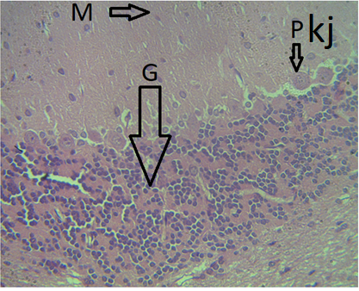 | 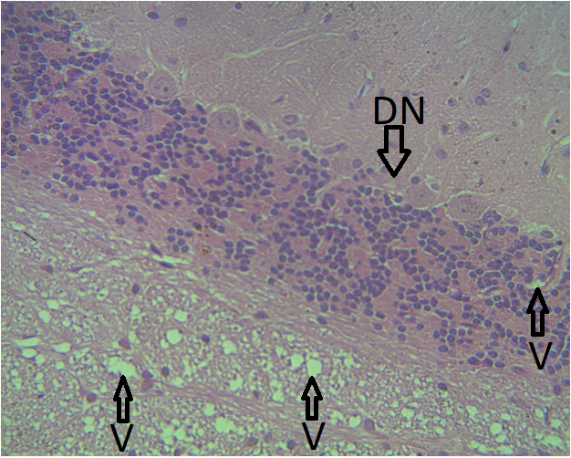
Group 1A (Control) | Group 2A (untreated refinery effluent)
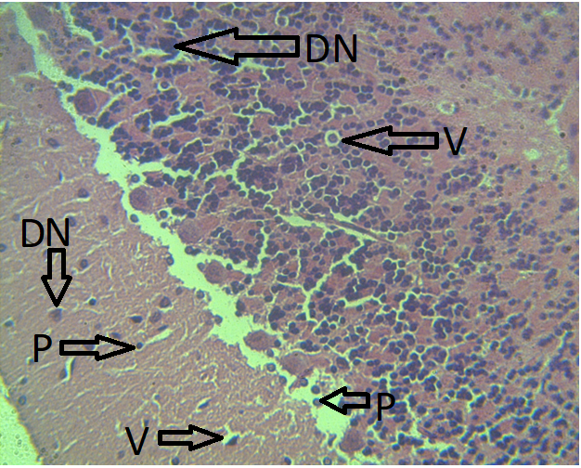 | 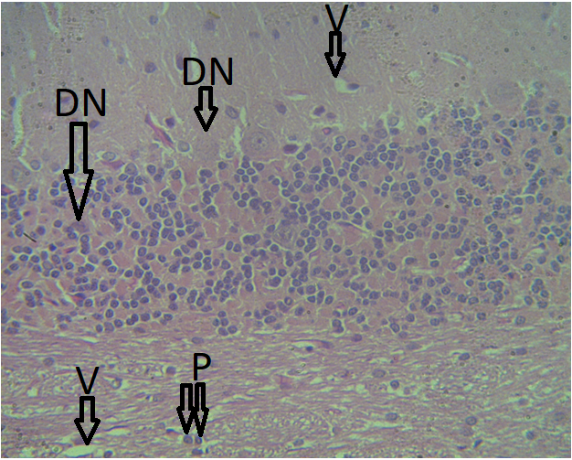
Group 3A (treated refinery effluent) | Group 4A (treated Notore effluent)
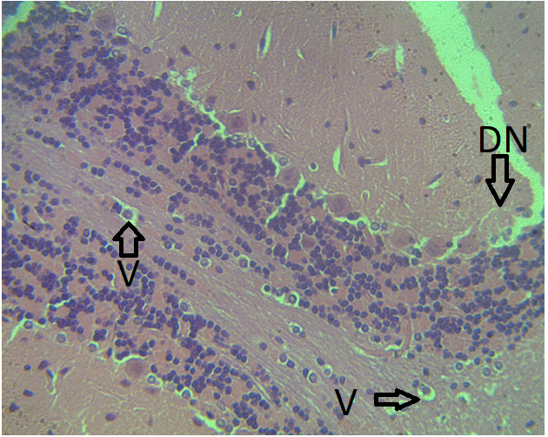
Group 5A (untreated Notore effluent)

Figure 1. Photomicrograph of Cerebellar Cortex of experimental animals on day 3. Group 1A (control) showing the normal cytoarchitecture of the cerebellar tissue, with clearly defined molecular, Purkinje, and granular cell layers. Tissue exhibits normal microstructure. Group 2A administered untreated refinery effluent showing degeneration of neurons (DN), vacuolation (V), pyknosis (P), and karyorrhexis. Distortion of cellular microstructure is indicated. Group 3A administered treated refinery effluent showing degeneration of neurons, vacuolation, pyknosis, and karyorrhexis, with moderate tissue distortion. Group 4A administered treated Notore effluent showing similar degenerative changes, including vacuolation and neuronal degeneration, with evidence of structural disorganization. Group 5A administered untreated Notore effluent showing severe neuronal degeneration, vacuolation, pyknosis, and extensive tissue disruption. The presence of karyorrhexis and increased vacuolation indicate significant neurotoxic damage. Magnification: H & E, X400.

Cytoarchitecture of the Cerebellar Cortex 28 Days After Effluent Administration
Histological evaluation of the cerebellar cortex on day 28 post-exposure revealed progressive neurodegenerative changes in the experimental groups compared to the control. The control group exhibited normal cytoarchitecture with well-preserved molecular, Purkinje, and granular cell layers, indicating the absence of structural damage. In contrast, all effluent-exposed groups displayed marked neuronal degeneration (DN), vacuolation (V), pyknosis (P), and karyorrhexis, with the severity of alterations increasing over time. The untreated refinery and Notore effluent groups exhibited extensive neurodegeneration, with pronounced congestion of blood vessels (CBV), suggesting heightened inflammatory responses and disrupted neuronal function. Similarly, the treated effluent groups also showed significant neuronal degeneration and vascular congestion, though less severe than their untreated counterparts, indicating partial mitigation of toxicity. The progressive damage observed over 28 days suggests that prolonged exposure to industrial effluents exacerbates neuronal deterioration, with untreated effluents posing a greater neurotoxic risk, potentially leading to irreversible cerebellar dysfunction.

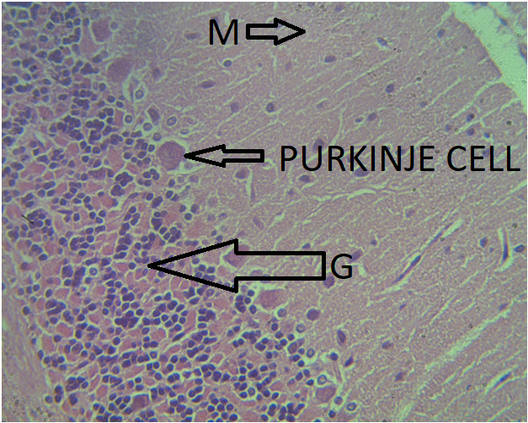 | 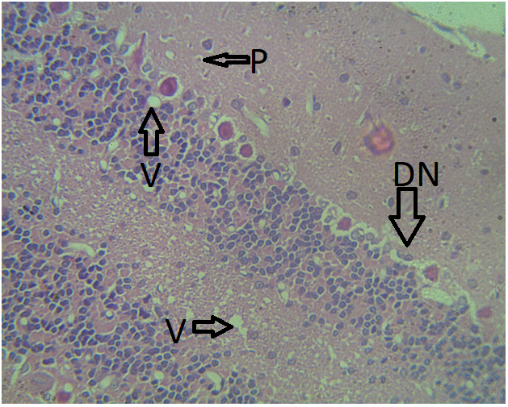
Group 1B (Control) | Group 2B (untreated refinery effluent)
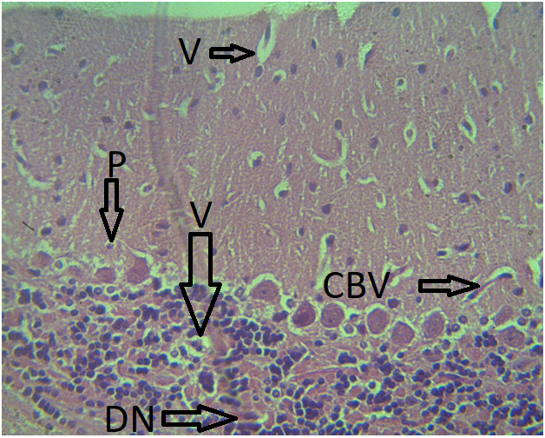 | 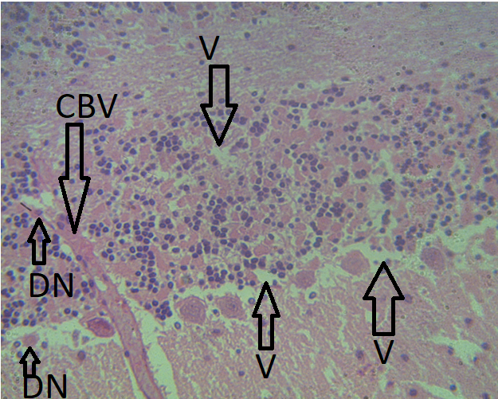
Group 3B (treated refinery effluent) | Group 4B (treated Notore effluent)
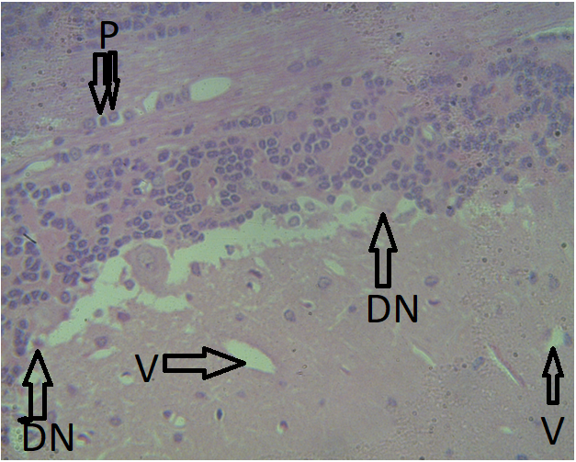
Group 5B (untreated Notore effluent)

Figure 2. Photomicrograph of Cerebellar Cortex of experimental animals on day 28. Group 1B (control) showing normal cytoarchitecture of the cerebellar cortex, with well-defined molecular, Purkinje, and granular cell layers. Tissue exhibits normal microstructure. Group 2B administered untreated refinery effluent showing severe degeneration of neurons (DN), vacuolation (V), pyknosis (P), and karyorrhexis, indicating progressive neurotoxic damage. Group 3B administered treated refinery effluent showing moderate neuronal degeneration, vacuolation, pyknosis, karyorrhexis, and congestion of blood vessels (CBV), suggesting sustained but relatively reduced toxicity compared to untreated effluents. Group 4B administered treated Notore effluent showing similar degenerative changes, including vacuolation, neuronal degeneration, pyknosis, and congestion of blood vessels, indicating persistent structural damage. Group 5B administered untreated Notore effluent showing severe neuronal degeneration, extensive vacuolation, pyknosis, karyorrhexis, and marked congestion of blood vessels, highlighting the significant neurotoxic impact of prolonged exposure. Magnification: H & E, X400.

DISCUSSION
The cerebellum plays a crucial role in motor coordination, balance, and cognitive functions, making it highly sensitive to neurotoxic insults. Environmental pollutants, particularly industrial effluents, contain a complex mixture of heavy metals, organic compounds, and other toxic substances that have been implicated in various neurological disorders (Webb et al., 2018). Exposure to these pollutants, whether treated or untreated, can disrupt normal neuronal function, leading to progressive neurodegeneration. Numerous studies have linked industrial effluents to oxidative stress, inflammation, and cellular toxicity in different regions of the brain, but limited attention has been given to their specific impact on cerebellar cytoarchitecture (Costa et al., 2020; Kuntić et al., 2024; Roy & D'Angiulli, 2024). Understanding these effects is critical, as cerebellar damage can manifest in motor deficits, cognitive impairment, and other neurodevelopmental abnormalities.
The findings from the present study highlight the short-term impact of industrial effluent exposure on cerebellar integrity. Histological analysis at three days post-exposure revealed distinct differences between the control and experimental groups. The control group displayed normal cerebellar cytoarchitecture with well-preserved molecular, Purkinje, and granular cell layers, indicating the absence of structural damage. In contrast, all groups exposed to industrial effluents, whether treated or untreated, exhibited varying degrees of neuronal degeneration, vacuolation, pyknosis, and karyorrhexis, suggesting early signs of neurotoxicity. The untreated refinery and Notore effluent groups showed more severe neurodegenerative changes, including widespread vacuolation and increased neuronal damage compared to their treated counterparts. This suggests that untreated effluents contain a higher concentration of neurotoxic contaminants, which may include heavy metals, polycyclic aromatic hydrocarbons, and other persistent organic pollutants known to induce oxidative stress and neuronal apoptosis (Tchounwou et al., 2012; Shetty et al., 2023). Although the treated effluents also caused neuronal damage, the relatively milder alterations observed suggest some degree of detoxification, likely due to the partial removal of toxic substances during treatment. However, the persistence of neuronal alterations despite treatment highlights the inadequacy of conventional treatment methods in completely eliminating neurotoxic components.
These findings align with previous studies that have demonstrated the neurotoxic effects of industrial pollutants. For instance, heavy metals such as lead, mercury, and cadmium, commonly found in effluents, have been reported to induce neuronal degeneration by generating reactive oxygen species (ROS), disrupting mitochondrial function, and triggering inflammatory cascades (Anyanwu et al., 2018; Azeh Engwa et al., 2019; Balali-Mood et al., 2021; Ogbeide & Henry, 2024). Additionally, organic pollutants such as polychlorinated biphenyls (PCBs) and pesticides have been implicated in cerebellar dysfunction by interfering with neurotransmission and promoting neuroinflammation (Pessah et al., 2019; Yadav et al., 2022). Given that early signs of neurotoxicity were already evident within three days, these findings emphasize the rapid onset of cerebellar damage following effluent exposure. This raises concerns about the potential long-term effects, particularly with prolonged or repeated exposure.
Studying the long-term effects of neurotoxic substances is essential for understanding the progressive nature of neuronal damage and its implications for neurological health. Short-term exposure may trigger initial signs of toxicity, but prolonged exposure could exacerbate neuronal degeneration, leading to irreversible damage and functional deficits (Chen et al., 2019). The findings from the 28-day post-exposure assessment provide critical insights into the progressive nature of effluent-induced neurotoxicity. Histological evaluation revealed worsening neurodegenerative changes in the experimental groups, with more pronounced neuronal degeneration, vacuolation, pyknosis, and karyorrhexis compared to the three-day assessment. Additionally, the presence of extensive vascular congestion in the untreated refinery and Notore effluent groups suggests a heightened inflammatory response and compromised blood-brain barrier integrity, which may further exacerbate neuronal injury.
The worsening cerebellar damage observed over time highlights the cumulative impact of toxicant exposure. The untreated effluents induced more severe neurodegenerative changes, likely due to the sustained presence of heavy metals and other neurotoxic agents that were not effectively removed through treatment. However, it is noteworthy that even the treated effluents caused significant neuronal alterations, indicating that current treatment processes may not be sufficient to fully neutralize neurotoxic contaminants. Previous research has demonstrated that chronic exposure to industrial pollutants can lead to persistent oxidative stress, neuroinflammation, and impaired neuronal regeneration, all of which contribute to long-term neurodegenerative disorders (Chin-Chan et al., 2015; Nabi & Tabassum, 2022). The progressive damage observed in this study supports these findings and highlights the potential risk of developing severe neurological conditions with continued exposure.
The broader implications of these findings are significant, as they suggest that industrial effluents pose a serious threat to neurological health, particularly in communities situated near industrial discharge sites. The fact that both treated and untreated effluents induced cerebellar damage calls for a critical review of existing wastewater treatment protocols to enhance the removal of neurotoxic pollutants. Given the importance of the cerebellum in motor and cognitive functions, prolonged exposure to contaminated water sources could contribute to an increased prevalence of movement disorders, cognitive decline, and other neurodevelopmental abnormalities. This underscores the urgent need for stricter environmental regulations, improved effluent treatment technologies, and continuous monitoring of industrial waste discharge.
Future research should focus on elucidating the specific neurotoxic components responsible for cerebellar damage, as well as investigating potential protective interventions to mitigate these effects. Longitudinal studies assessing behavioral and functional outcomes following chronic exposure would provide deeper insights into the long-term neurological consequences of effluent contamination. Additionally, exploring alternative treatment strategies such as advanced filtration techniques, bioremediation, and nanotechnology-based detoxification methods could offer more effective solutions for minimizing the neurotoxic impact of industrial effluents.
CONCLUSION
Our study demonstrates that exposure to industrial effluents, especially untreated ones, leads to significant neurodegenerative changes in the cerebellar cortex, with severity increasing over time. This finding calls for stringent regulations and enhanced treatment protocols to eliminate neurotoxic substances from industrial discharges, thereby safeguarding environmental and public health.

REFERENCES
Akinnawo, S. O. (2023). Eutrophication: Causes, consequences, physical, chemical, and biological techniques for mitigation strategies. Environmental Challenges, 12, 100733. https://doi.org/10.1016/j.envc.2023.100733
Anyanwu, B. O., Ezejiofor, A. N., Igweze, Z. N., & Orisakwe, O. E. (2018). Heavy Metal Mixture Exposure and Effects in Developing Nations: An Update. Toxics, 6(4), 65. https://doi.org/10.3390/toxics6040065
Azeh Engwa, G., Udoka Ferdinand, P., Nweke Nwalo, F., & N. Unachukwu, M. (2019). Mechanism and Health Effects of Heavy Metal Toxicity in Humans. IntechOpen. https://doi.org/10.5772/intechopen.82511
Baker, J. R. (1945). Cytological technique (2nd ed.). Methuen.
Balali-Mood, M., Naseri, K., Tahergorabi, Z., Khazdair, M. R., & Sadeghi, M. (2021). Toxic Mechanisms of Five Heavy Metals: Mercury, Lead, Chromium, Cadmium, and Arsenic. Frontiers in pharmacology, 12, 643972. https://doi.org/10.3389/fphar.2021.643972
Chen, N. N., Zhao, D. J., Sun, Y. X., Wang, D. D., & Ni, H. (2019). Long-Term Effects of Zinc Deficiency and Zinc Supplementation on Developmental Seizure-Induced Brain Damage and the Underlying GPR39/ZnT-3 and MBP Expression in the Hippocampus. Frontiers in neuroscience, 13, 920. https://doi.org/10.3389/fnins.2019.00920
Chin-Chan, M., Navarro-Yepes, J., & Quintanilla-Vega, B. (2015). Environmental pollutants as risk factors for neurodegenerative disorders: Alzheimer and Parkinson diseases. Frontiers in cellular neuroscience, 9, 124. https://doi.org/10.3389/fncel.2015.00124
Costa, L. G., Cole, T. B., Dao, K., Chang, Y. C., Coburn, J., & Garrick, J. M. (2020). Effects of air pollution on the nervous system and its possible role in neurodevelopmental and neurodegenerative disorders. Pharmacology & therapeutics, 210, 107523. https://doi.org/10.1016/j.pharmthera.2020.107523
Davletgildeeva, A. T., & Kuznetsov, N. A. (2024). Bioremediation of Polycyclic Aromatic Hydrocarbons by Means of Bacteria and Bacterial Enzymes. Microorganisms, 12(9), 1814. https://doi.org/10.3390/microorganisms12091814
Domínguez-Oliva, A., Hernández-Ávalos, I., Martínez-Burnes, J., Olmos-Hernández, A., Verduzco-Mendoza, A., & Mota-Rojas, D. (2023). The Importance of Animal Models in Biomedical Research: Current Insights and Applications. Animals, 13(7), 1223. https://doi.org/10.3390/ani13071223
Erakhrumen, A. A. (2015). Concentrations of heavy metals in untreated produced water from a crude oil production platform in Niger-Delta, Nigeria. Journal of Research in Forestry, Wildlife and Environment, 7(1), 89–101.
Ijomone, O. M., Ijomone, O. K., Iroegbu, J. D., Ifenatuoha, C. W., Olung, N. F., & Aschner, M. (2020). Epigenetic influence of environmentally neurotoxic metals. Neurotoxicology, 81, 51–65. https://doi.org/10.1016/j.neuro.2020.08.005
Isirima, J. C., & Uahomo, P. O. (2023). Acalypha wilkesiana exhibits antihyperglycemic potentials and ameliorates damages to pancreas and spleen of diabetic rat model. Saudi Journal of Biomedical Research, 8(7), 83–94.
Kim, H., Kim, W. H., Kim, Y. Y., & Park, H. Y. (2020). Air Pollution and Central Nervous System Disease: A Review of the Impact of Fine Particulate Matter on Neurological Disorders. Frontiers in public health, 8, 575330. https://doi.org/10.3389/fpubh.2020.575330
Kuntić, M., Hahad, O., Münzel, T., & Daiber, A. (2024). Crosstalk between Oxidative Stress and Inflammation Caused by Noise and Air Pollution—Implications for Neurodegenerative Diseases. Antioxidants, 13(3), 266. https://doi.org/10.3390/antiox13030266
Lin, L., Yang, H., & Xu, X. (2022). Effects of water pollution on human health and disease heterogeneity: A review. Frontiers in Environmental Science, 10, 880246. https://doi.org/10.3389/fenvs.2022.880246
Mastrangelo, S., Peruzzi, L., Guido, A., Iuvone, L., Attinà, G., Romano, A., Maurizi, P., Chieffo, D. P. R., & Ruggiero, A. (2024). The Role of the Cerebellum in Advanced Cognitive Processes in Children. Biomedicines, 12(8), 1707. https://doi.org/10.3390/biomedicines12081707
Nabi, M., & Tabassum, N. (2022). Role of Environmental Toxicants on Neurodegenerative Disorders. Frontiers in toxicology, 4, 837579. https://doi.org/10.3389/ftox.2022.837579
Ndem, B. E., Unuafe, B. O., & Egbe, J. E. (2019). Economic impacts of effluent composition of a process industry on the receiving environment: A study of Port Harcourt Refining Company. Advance Journal of Economics and Marketing Research, 4(3), 48–60. https://www.iaspub.org.uk/AJEMR/
Obire, O., Ogan, A., & Okigbo, R. N. (2008). Impact of fertilizer plant effluent on water quality. International Journal of Environmental Science and Technology, 5(1), 107–118.
Ogbeide, O., & Henry, B. (2024). Addressing heavy metal pollution in Nigeria: Evaluating policies, assessing impacts, and enhancing remediation strategies. Journal of Applied Sciences and Environmental Management, 28(4), 1007–1051.
Osin, O. A., Yu, T., & Lin, S. (2017). Oil refinery wastewater treatment in the Niger Delta, Nigeria: current practices, challenges, and recommendations. Environmental science and pollution research international, 24(28), 22730–22740. https://doi.org/10.1007/s11356-017-0009-z
Pessah, I. N., Lein, P. J., Seegal, R. F., & Sagiv, S. K. (2019). Neurotoxicity of polychlorinated biphenyls and related organohalogens. Acta neuropathologica, 138(3), 363–387. https://doi.org/10.1007/s00401-019-01978-1
Roy, R., & D'Angiulli, A. (2024). Air pollution and neurological diseases, current state highlights. Frontiers in neuroscience, 18, 1351721. https://doi.org/10.3389/fnins.2024.1351721
Sathyanesan, A., Zhou, J., Scafidi, J., Heck, D. H., Sillitoe, R. V., & Gallo, V. (2019). Emerging connections between cerebellar development, behaviour and complex brain disorders. Nature reviews. Neuroscience, 20(5), 298–313. https://doi.org/10.1038/s41583-019-0152-2
Shetty, S. S., D, D., S, H., Sonkusare, S., Naik, P. B., Kumari N, S., & Madhyastha, H. (2023). Environmental pollutants and their effects on human health. Heliyon, 9(9), e19496. https://doi.org/10.1016/j.heliyon.2023.e19496
Singh, B., Mishra, R. K., Kumar, P., & Arif, Z. (2023). Assessment of organic pollutants in petroleum refinery wastewater by LC-MS analyzer. Water-Energy Nexus, 6, 167–176. https://doi.org/10.1016/j.wen.2023.10.004
Singh, S., Shikha (2019). Treatment and Recycling of Wastewater from Oil Refinery/Petroleum Industry. In: Singh, R., Singh, R. (eds) Advances in Biological Treatment of Industrial Waste Water and their Recycling for a Sustainable Future. Applied Environmental Science and Engineering for a Sustainable Future. Springer, Singapore. https://doi.org/10.1007/978-981-13-1468-1_10
Stoodley C. J. (2016). The Cerebellum and Neurodevelopmental Disorders. Cerebellum (London, England), 15(1), 34–37. https://doi.org/10.1007/s12311-015-0715-3
Suku, P. G., Ugwoha, E., Orikpete, O. F., & Ewim, D. R. E. (2023). The Socio-Economic and Environmental Impacts of Petroleum Refinery Operations in the Niger Delta Region. The Journal of Engineering and Exact Sciences, 9(11), 18333. https://doi.org/10.18540/jcecvl9iss11pp18333
Tchounwou, P. B., Yedjou, C. G., Patlolla, A. K., & Sutton, D. J. (2012). Heavy metal toxicity and the environment. Experientia supplementum (2012), 101, 133–164. https://doi.org/10.1007/978-3-7643-8340-4_6
Wake, H. (2005). Oil refineries: A review of their ecological impacts on the aquatic environment. Estuarine, Coastal and Shelf Science, 62(1–2), 131–140. https://doi.org/10.1016/j.ecss.2004.08.013
Webb, E., Moon, J., Dyrszka, L., Rodriguez, B., Cox, C., Patisaul, H., … London, E. (2018). Neurodevelopmental and neurological effects of chemicals associated with unconventional oil and natural gas operations and their potential effects on infants and children. Reviews on Environmental Health, 33(1), 3–29. https://doi.org/10.1515/reveh-2017-0008
Yadav, A., Verhaegen, S., Filis, P., Domanska, D., Lyle, R., Sundaram, A. Y. M., Leithaug, M., Østby, G. C., Aleksandersen, M., Berntsen, H. F., Zimmer, K. E., Fowler, P. A., Paulsen, R. E., & Ropstad, E. (2022). Exposure to a human relevant mixture of persistent organic pollutants or to perfluorooctane sulfonic acid alone dysregulates the developing cerebellum of chicken embryo. Environment International, 166, 107379. https://doi.org/10.1016/j.envint.2022.107379

