***Short Research Article***

**Survey of gastrointestinal parasites in domestic cats in Morogoro, Tanzania: emerging zoonotic species.**

**ABSTRACT**

**Background and Aims:** Gastrointestinal (GIT) parasites of domestic cats are routinely diagnosed and significantly pose potential zoonotic agents. We aimed at investigating the main GIT parasites in domestic cats.

**Study design:** This is a cross-sectional study design.

**Place and Duration of Study:** The current study was conducted at selected urban regions of Morogoro, Tanzania between March and December, 2022.

**Methodology**: A total of 120 apparently healthy cats fecal swabs were collected and GIT parasites eggs were processed by egg concentration procedures.

**Results:** Out of 120 fecal swabs tested, 59 (49.2%: 95% CI=40.1–58.2) were found infected with 5 different parasites. The parasites detected were, *Ancylostoma tubaeforme* 27.5% (95% CI=19.4%–35.6%), *Uncinaria stenocephala* 20% (95% CI=12.7%–27.3%), *Taenia taeniaeformis* 17.5% (95% CI=10.6%–24.4%) and 7.5% (95% CI=2.7%–12.3%) each for *Physaloptera* spp. and *Toxocara cati*.

**Conclusion:** The presence of GIT parasites especially of zoonotic potential such as hookworms, *Uncinaria stenocephala* and roundworms, *Toxocara cati* in domestic cats are of great significance. Therefore, the control and treatment of parasites in cats are necessary in order to minimize the source and transmission of zoonotic diseases.

*Key words****:*** *domestic cats; gastrointestinal parasites; zoonoses; Tanzania*

**1. INTRODUCTION**

Domestic cats are important pet that is well adapted to human kind for social and emotional supports. Importantly, in most of developing countries including Tanzania besides of being pets, cats are used to control rodents within and outside human settlements (Njuguna et al., 2017). Parasitic diseases play significant role in feline medicine and research in these fields provides avenues to safeguard the health of domestic cats and indirectly contributes to the health of humans. For example, in spite of being important and close to humans, domestic cats play vital role in the spread of parasitic zoonoses.

Domestic cats are good reservoir host for several species of gastrointestinal tract (GIT) parasites that can spread to humans and pose health risk. The most important parasites common between humans and cats includes *Toxoplasma gondii*, *Toxocara cati*, *Ancylostoma* spp., *Echi­nococcus granulosus*, *Taenia taeniaeformis*, *Giardia duodenalis*, and *Entamoeba histolytica* (Souza et al., 2023, Karimi et al., 2022, Rojekittikhun et al., 2014, Zanzani et al., 2014). While many studies have been conducted worldwide to investigate the intestinal parasites infecting cats, little information is known about feline GIT parasites and their zoonotic implications in Africa (Abbas et al., 2022). In Tanzania, very scarce data are available about the parasites of cats. It is known that cats and dogs share some intestinal parasites that can cause serious disease in humans, including hookworms, *Trichuris*, *Cryptosporidium* and *Giardia*. Therefore, investigating the whole status of these parasites in dogs and cats is essential to understand how dogs and cats contribute to the epidemiology of these zoonotic parasites in a given locality (Abbas et al., 2022). One study conducted in Katavi, Arusha, and Rukwa regions of Tanzania in stray dogs found high prevalence of *Ancylostoma* spp. (49%) and moderate prevalence ranging from 2.4% to 8.8% of *Ascaris*, *Echinococcus*, and *Toxocara* spp. (Kidima 2019). Similarly, a study by Makene et al., (1996) carried out in Morogoro, Tanzania found that majority of dogs had high infection rate by *Ancylostoma* spp. (72%) followed by *Toxocara* (16%) and *Toxascaris* spp. (5%). These data suggest that dogs in Tanzania contribute to the transmission of zoonotic parasites and therefore domestic cats can significantly represent the similar situation.

The objective of the present study was to identify the main GIT parasites in domestic cats in Morogoro region, Tanzania by statistically evaluating the coproparasitological results.

**2. MATERIALS AND METHODS**

**2.1 Study area**

The study was carried out in Morogoro region, in the Morogoro Urban district (Fig. 1) from March 2022 to December 2022. Morogoro region is situated between 5°58’ and 10°0’ S and 35°25’ and 35° 30’ E. The following wards were randomly selected in the district; Bigwa, Boma, Chamwino, Kingo, Mafiga, Magadu and Mji Mpya. The criteria for inclusion in the study were number of domestic cats and owners for each ward (personal communication with livestock officers), cooperation of ward livestock officers, as well as cat owners to participate in the study.

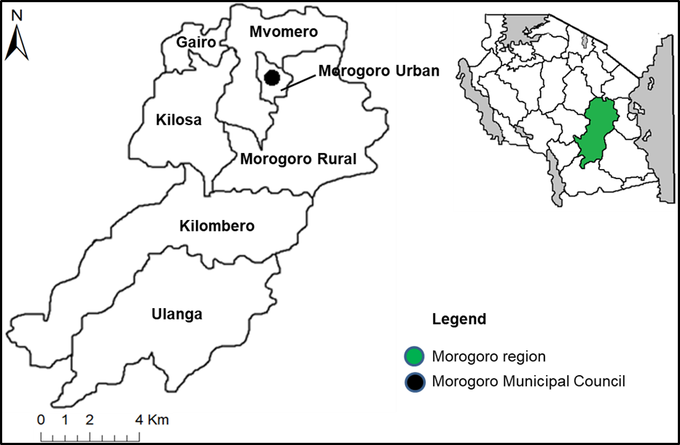

**Fig. 1. Map of Morogoro region showing the study area**

**2.2 Study design, sample size and study animals**

We conducted a cross-sectional study to provide baseline information about main GIT parasites in domestic cats of varying age and sex. Majority of cats were owned and lived both indoors and outdoors at different times of the day. A total of 120 domestic cats were available and fecal/rectal swabs were collected in each cat. Cats were classified according to age as young cats (≤12 months) or adults (>12 months).

**2.3 Samples collection, processing and examination**

Fecal samples were collected from the cats through a direct rectal cotton swab. The swabs were then transferred into pre-labeled clean specimen bottles and transported to the parasitological laboratory of the Department of Microbiology, Parasitology and Biotechnology, SUA within 24 hour of collection. All stool samples were initially examined macroscopically for the detection of tapeworm proglottids or nematodes. Later, the samples were processed for egg concentration by modified Kato-katz technique as described by (Sowemimo 2012), and observed under a binocular microscope at 100× magnification. Parasites eggs and cysts were identified based on structural and morphometric features (Soulsby 1982).

**2.4 Epidemiological data collection**

Demographic and clinical data including age, sex, husbandry type (single or multiple), housing (household or outdoor), presence of disease clinical signs, behavior and ownership (owned or sheltered) were obtained from the owners or caregiver by a questionnaire.

**2.5 Data analysis**

Data was entered into Microsoft Excel (Microsoft, USA) and exported to Minitab Version 21.0 for Windows (Minitab Inc., Shanghai, China) for analysis. Prevalence was determined as the number of infected cats divided by the total number of sampled cats. Data were presented in form of tables.

**3. RESULTS**

**3.1 Characteristics of cats**

All cats were sourced and sampled within households (Table 1). All sampled cats were intact based on sex and reproductive status data. Majority of cats receive no veterinary care and owners do not deworm them.

**Table 1.** **Characteristics of domestic cats sampled in Morogoro Municipal Council, Tanzania**

|  |  |  |  |  |
| --- | --- | --- | --- | --- |
| Variable | |  | | Total, n (%) |
| Sex | Male | | 54 (45.0) | |
| Female | | 66 (55.0) | |
| Age | ≤12 months | | 28 (23.3) | |
| >12 months | | 92 (76.7) | |
| Household type | Single cat | | 80 (66.7) | |
| Multi-cat | | 40 (33.3) | |
| Life style | Household | | 18 (15.0) | |
| Outdoor | | 102 (85.0) | |
| Behavior | Non-aggressive | | 113 (94.2) | |
| Aggressive | | 7 (5.8) | |
| Ownership | Owned | | 109 (90.8) | |
| Shelter | | 11 (9.2) | |

**3.2 Prevalence and richness of parasites in sampled cats**

Out of the 120 cat stool samples, five GIT parasites were identified (Fig. 2). The prevalence of the helminthes ranged from 7.5% to 27.5% with highest infection rate observed for hookworms, *Ancylostoma tubaeforme*, 27.5% (95% CI = 19.4%–35.6%) and *Uncinaria stenocephala*, 20% (95% CI = 12.7%–27.3%), followed by *Taenia taeniaeformis,* 17.5% (95% CI = 10.6%–24.4%) and 7.5% (95% CI = 2.7%–12.3%) each for *Physaloptera* spp. and *Toxocara cati*.

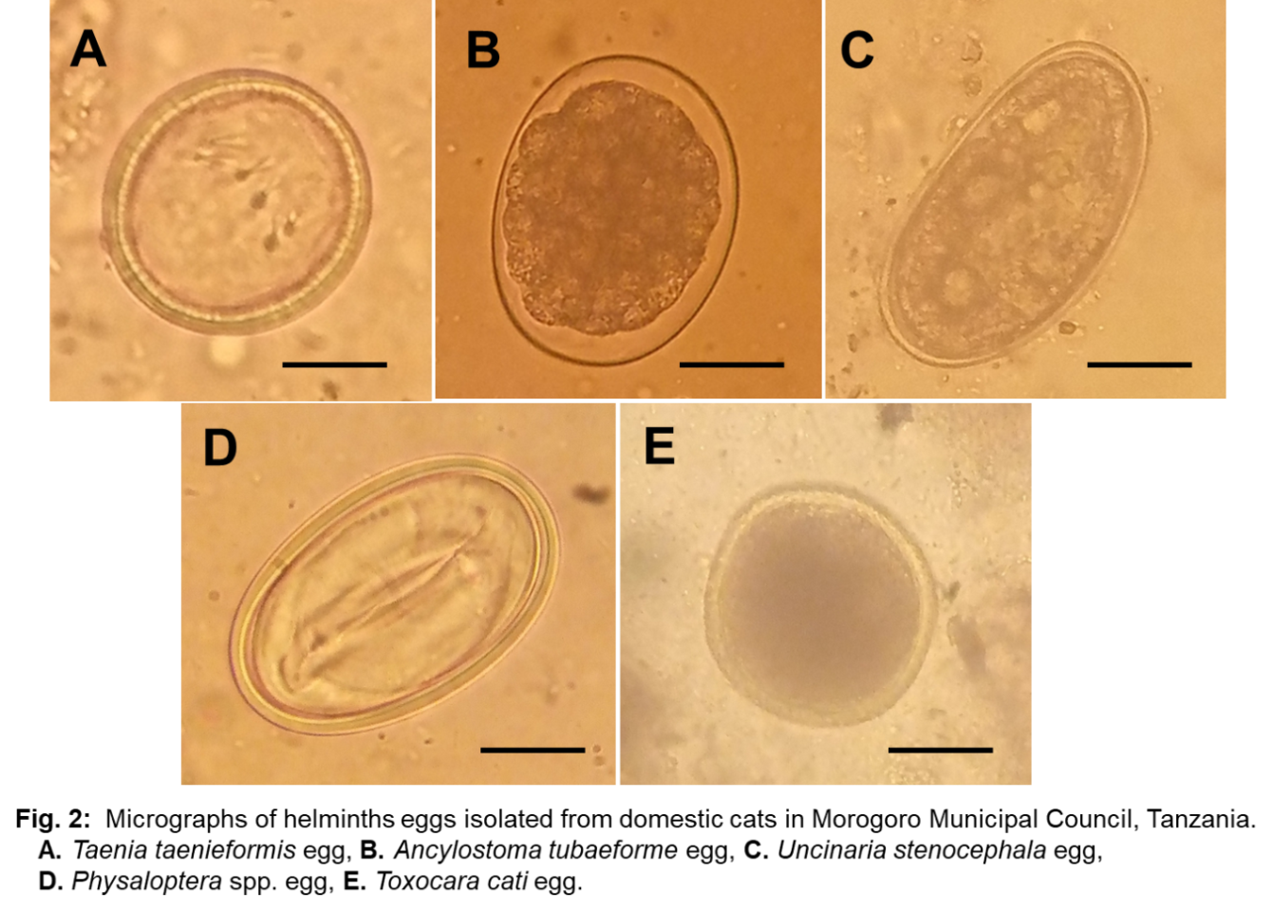

Interestingly, some cats showed obviously worm infestation in their vomit (Fig. 3). Table 2 represents the prevalence of GIT parasites in cats by individual features and management.

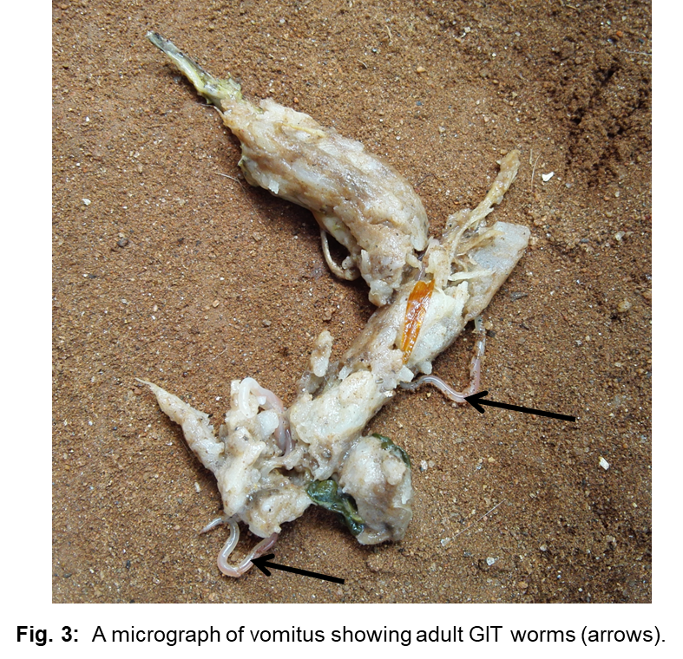

**Table 2.** **Prevalence (%) and 95% CI (min–max) of GIT parasites in cats by individual features and management**

|  |  |  |  |  |  |  |  |  |
| --- | --- | --- | --- | --- | --- | --- | --- | --- |
| Parasites | Sex | | Age | | Housing | | Husbandry | |
| **Male** | **Female** | **≤12 months** | **>12 months** | **Household** | **Outdoor** | **Single** | **Multiple** |
|  | (n = 54) | (n = 66) | (n = 28) | (n = 92) | (n = 18) | (n = 102) | (n = 80) | (n = 40) |
| *Taenia taeniaeformis* | 19  (8–29) | 17  (7–26) | 21  (5–38) | 16  (9–24) | 11  (0–27) | 19  (11–26) | 14  (6–21) | 25  (11–39) |
| *Ancylostoma tubaeforme* | 26  (14–38) | 29  (18–40) | 32  (14–51) | 26  (17–35) | 17  (0–36) | 29  (20–38) | 26  (16–36) | 30  (15–45) |
| *Uncinaria stenocephala* | 17  (6–27) | 23  (12–33) | 29  (11–46) | 17  (9–25) | 22  (1–44) | 19  (12–27) | 20  (11–29) | 20  (7–33) |
| *Physaloptera* sp. | 9  (1–17) | 6  (0–12) | 4  (0–11) | 9  (3–15) | 6  (0–17) | 8  (3–13) | 8  (2–13) | 8  (0–16) |
| *Toxocara catii* | 2  (0–6) | 12  (4–20) | 11  (0–23) | 7  (1–12) | 6  (0–17) | 8  (3–13) | 9  (2–15) | 5  (0–12) |

*(CI) 95%: confidence interval of the prevalence*

The percentage of cats excreting at least one species of helminth was 49.2% (95% CI = 40.1–58.2). No GIT parasite eggs were detected in half of the sampled cats (50.8%; *n* = 61). Triple and quadruple (each 2.5%; *n* =3) infections were detected in equal rates (Table 3).

**Table 3.** **Number of gastrointestinal parasites found in 120 cats**

|  |  |  |
| --- | --- | --- |
| Number of parasite species per cat | Number infected | % of infected cats |
| One species | 31 | 26 |
| Two species | 22 | 18 |
| Three species | 3 | 2.5 |
| Four species | 3 | 2.5 |
| No infection | 61 | 50.8 |

**4. DISCUSSION**

The prevalence of GIT parasites in cats can vary due to several reasons including, geographical region (tempera­ture and humidity), seasonal variation, behaviors and habits of the local animal populations and the type of population of cat either being stray, feral, shelter, or household (Khademvatan et al., 2014). Studies reporting GIT parasites infecting domestic cats in Tanzania are limited. The present study is the first to report GIT parasites in domestic cats from Morogoro Municipal council, Tanzania, and an overall prevalence (49.2%) was determined. This prevalence is consistent with what have been reported from cats in various regions of Africa and elsewhere for example 47.4% in Italy (Zanzani et al., 2014), 47.7% in Iraq (Al-Aredhi 2015), and 52.4% in Egypt (Abbas et al., 2022). On the other hand studies conducted in different countries indicate high prevalence of GIT parasites in cats. These regions showed prevalence of 73.2% in Kenya (Njuguna et al., 2017), 85.5% in Nigeria (Sowemimo 2012), 86.4% in Iran (Khademvatan et al., 2014), and 91% in Egypt (Khalafalla 2011).

In the present study, the most frequent isolated species of parasites was hookworms, *Ancylostoma tubaeforme* (27.5%) and *Uncinaria stenocephala* (20%) making a total prevalence of 47.5%. Our findings are consistent with results from a survey on cats from Goiás, Brazil by Souza et al., (2023) indicating the most prevalent parasites were *Ancylostoma* spp. (29.53%), and another study in Nakhon Nayok Province, Thailand found hookworm parasites were most common helminth in dogs and cats, 30.6% and 34.7% respectively (Rojekittikhun et al., 2014). Although Sowemimo (2012) reported relatively high prevalence of hookworm species (57.0%) than our current study but they found that the species was the most frequently observed parasite in cats in Nigeria.

The cestode species *Taenia taeniaeformis* was found at relatively medium prevalence (17.5%) which is comparable to previous studies in Spain, 22.4% (Millán & Casanova 2009) and Iran, 18.6% (Khademvatan et al., 2014).

*Toxocara cati* is a well-known zoonotic parasite that can infect people and cause visceral and ocular larva migrants, specifically in children (Amissah-Reynolds & Ofori 2023). It is documented that *Toxocara* spp. is the most commonly encountered endoparasite of cats. Our findings reported the prevalence of 7.5% among the sampled cats indicating relative low infection rate as compared to majority of previous studies with prevalence ranging from 20.0% to 48.5% (Njuguna et al., 2017, Abbas et al., 2022, Sowemimo 2012, Al-Aredhi 2015, Amissah-Reynolds & Ofori 2023, Mircean et al., 2010, Nagamori et al., 2018).

*Physaloptera* spp. was another nematode species encountered in sampled cats with a prevalence of 7.5% which is consistent with reports from Egypt, 2.1% (Abbas et al., 2022), Qatar, 6.6% (Abu-Madi et al., 2008), and Iran, 7.1% (Khademvatan et al., 2014) but considerably lower than the prevalence of 27% in Nigeria (Sowemimo 2012) and 44.4% from India (Borthakur & Mukharjee 2011).

**5. CONCLUSION AND RECOMMENDATION**

The results of the present study indicated that the prevalence of GIT parasites especially of zoonotic potential such as hookworms, *Uncinaria stenocephala* and roundworms, *Toxocara cati* in domestic cats are of great significance because they can cause contamination of the environment by excreting eggs that lead to infecting humans through soil or water. More importantly these cats were friendly to people and they were sampled within households. Therefore, the control and treatment of parasites in cats are necessary in order to minimize the source and transmission of zoonotic diseases.

The main limitation of our study was that the use of rectal swabs to collect feces is usually associated with low parasite recovery rate during detection and this may significantly affect the prevalence data. Therefore the findings reported here may suggest that high prevalence could have been achieved if alternative method to collect bulk feces would have been used.

In conclusion, the current study has identified two species of intestinal parasites which causes important disease in cats and are of zoonotic implication. The study recommends that the animal healthcare practitioners in collaboration with cat owners in the study area should work together to advocate effective control strategies including routine deworming, ensuring cats do not defecate within household premises and children playing grounds.

**DISLAIMER (ARTIFICIAL INTELLIGENCE)**

Author(s) hereby declare that NO generative AI technologies such as Large Language Models (ChatGPT, COPILOT, etc) and text-to-image generators have been used during writing or editing of manuscripts*.*

**ETHICAL APPROVAL**

The study was approved by the Scientific Ethics Committee of the Directorate of Postgraduate Studies, Research, Technology Transfer and Consultancy at Sokoine University of Agriculture (SUA) in accordance with the SUA Code of Conduct for Research Ethics (2012). The approval number was SUA/DPRTC/R/186/VOL.IV. Informed consent to conduct this research was obtained from the cat’s owners after explaining to them the aims of the study and methodology to be applied.

**REFERENCES**

Abbas, I., Al-Araby, M., Elmishmishy, B., & El-Alfy, E. S. (2022). Gastrointestinal parasites of cats in Egypt: high prevalence high zoonotic risk. *BMC Veterinary Research*,18(1), 420.

Abu-Madi, M. A., Pal, P., Al-Thani, A., & Lewis, J. W. (2008). Descriptive epidemiology of intestinal helminth parasites from stray cat populations in Qatar. *Journal of Helminthology*,82(1), 59-68.

Al-Aredhi, H. S. (2015). Prevalence of gastrointestinal parasites in domestic cats (*Felis catus*) in Al-Diwaniya province/Iraq. *International Journal of Current Microbiology and Applied Sciences*, 4, 166-171.

Amissah-Reynolds, P. K, & Ofori, S. A. (2023). Preliminary survey of feline intestinal parasites in Ghana. *Asian Journal of Applied Microbiol*ogy, 10, 1-9.

Borthakur, S. K, & Mukharjee, S. N. (2011). Gastrointestinal helminthes in stray cats (*Felis catus*) from Aizawl, Mizoram, India. *Southeast Asian Journal of Tropical Medicine and Public Health*, 42, 255-258.

Karimi, P., Shafaghi-Sisi, S., Meamar, A. R., Nasiri, G., & Razmjou, E. (2022). Prevalence and Molecular Characterization of *Toxoplasma gondii* and *Toxocara cati* Among Stray and Household Cats and Cat Owners in Tehran, Iran. *Frontier in Veterinary Sciences*, 9, 927185.

Khademvatan, S., Abdizadeh, R., Rahim, F., Hashemitabar, M., Ghasemi, M., & Tavalla, M. (2014). Stray cats gastrointestinal parasites and its association with public health in ahvaz city, South Western of Iran. *Jundishapur Journal of Microbiology*,7(8), e11079.

Khalafalla, R. E. (2011). A survey study on gastrointestinal parasites of stray cats in northern region of Nile delta, Egypt. *PLoS One*, 6, e20283.

Kidima W. (2019). Prevalence of Zoonotic Parasites in Stray Dogs in Rural Communities, Tanzania. *Tanzania Journal of Science* 45(1)**,** 93-100.

Makene, V. W., Muhairwa, A. P., Mtambo, M. M. A., Kusiluka, L. J. M., Kambarage, D. M., & Maeda, G. E. (1996). Prevalence of Canine Gastrointestinal Parasites in Morogoro, Tanzania. *Journal of Applied Animal Research*, 10, 149-153.

Millán, J., & Casanova, J. C. (2009). High prevalence of helminth parasites in feral cats in Majorca Island (Spain). *Parasitology Research*, 106: 183-188.

Mircean, V., Titilincu, A., & Vasile, C. (2010). Prevalence of endoparasites in household cat (*Felis catus*) populations from Transylvania (Romania) and association with risk factors. *Veterinary Parasitology*, 171, 163-166.

Nagamori, Y., Payton, M. E., Duncan-Decocq, R., & Johnson, E. M. (2018). Fecal survey of parasites in free-roaming cats in northcentral Oklahoma, United States. *Veterinary Parasitology and Regular Study Reports*,14, 50-53.

Njuguna, N. A., Kagira, J. M, Karanja, M. S, Mutharia, N. M., & Maina W. N. (2017). Prevalence of *Toxoplasma gondii* and other Gastrointestinal Parasites in Domestic Cats from Households in Thika Region, Kenya. *Biomedical Research International*, 7615810.

Rojekittikhun, W., Chaisiri, K., Mahittikorn, A., Pubampen, S., Sa-Nguankiat, S., Kusolsuk, T., Maipanich, W., Udonsom, R., & Mori, H. (2014). Gastrointestinal parasites of dogs and cats in a refuge in Nakhon Nayok, Thailand. *Southeast Asian J Trop Med Public Health*, 45(1), 31-39.

Soulsby, E. J. L. (1982). Helminths, Arthropoda, and Protozoa of domesticated animals. 7th Ed. London: Baillier, Tindal and Cassel.

Souza, J. B. B., Silva, Z. M. A., Alves-Ribeiro, B. S., Moraes, I. S., Alves-Sobrinho, A. V., Saturnino, K. C., Ferraz, H. T., Machado, M. R. F., Braga, ĺ. A., & Ramos, D. G. S. (2023). Prevalence of Intestinal Parasites, Risk Factors and Zoonotic Aspects in Dog and Cat Populations from Goiás, Brazil. *Veterinary Sciences*, 10, 492.

Sowemimo, O., A. (2012). Prevalence and intensity of gastrointestinal parasites of domestic cats in Ode–Irele and Oyo communities, Southwest Nigeria. *Journal of Parasitology and Vector Biology,* 4(1), 7-13.

Zanzani, S. A., Gazzonis, A. L., Scarpa, P., Berrilli, F., & Manfredi, M. T. (2014). Intestinal parasites of owned dogs and cats from metropolitan and micropolitan areas: prevalence, zoonotic risks, and pet owner awareness in northern Italy. *Biomedical Research International*, 696508.