*Case report*

Bridging Gaps, Enhancing Smile: A Multidisciplinary Approach

.

ABSTRACT

|  |
| --- |
| **Introduction:** Dental aesthetics significantly influence facial harmony and self-confidence. Gingival hyperpigmentation, high labial frenum attachment, midline diastema, and asymmetrical gingival zenith are common aesthetic concerns. Addressing these issues requires a multidisciplinary treatment approach combining periodontal surgical interventions and restorative procedures.  **Objective:** This case report is aimed to evaluate the effectiveness of a comprehensive treatment plan involving frenectomy, gingival depigmentation, gingivoplasty, and veneer placement to enhance dental aesthetics and smile harmony.  **Methodology:** A 22-year-old female patient presented with gingival hyperpigmentation, papilla penetrating labial frenum with midline diastema, and asymmetrical gingival zenith in upper anterior teeth region. The treatment plan included:  Frenectomy using the paralleling technique to address the high frenum attachment.  Gingival depigmentation using a scalpel technique combined with Vitamin E gel and platelet-rich fibrin (PRF) membrane application on contralateral quadrant to accelerate healing and less discomfort. Healing assessments were conducted at 15 and 45 days post-treatment using methylene blue staining and the Landry healing index.  Gingivoplasty to achieve symmetrical gingival zenith followed by veneer placement with digital impressions, 3D-printed mock-ups, and lithium disilicate restorations for diastema closure.  **Conclusion:** The multidisciplinary approach effectively enhanced the patient's dental aesthetics, achieving successful diastema closure, normal color and contour of gingiva. This comprehensive approach enhanced the patient's smile, reinforcing the value of tailored treatment strategies in achieving optimal periodontal health and aesthetics. |

*Keywords: Platelet rich fibrin membrane, Vitamin E, Diastema closure, Gingival zenith correction, Gingival depigmentation*

1. INTRODUCTION

Dental aesthetics play a vital role in an individual’s overall facial harmony and self-confidence. One of the most expressive and universally recognized gestures is a smile, which reflects genuine joy and enhances facial expression. A beautiful smile is a result of three primary factors: competent lips, the shape, size, and alignment of teeth in the arch, and healthy gingival color and architecture (Malhotra et al., 2011). The gingival display, color, form and symmetry of zenith contribute significantly to the aesthetics of a smile. In different populations, the normal gingival color varies; for instance, it appears coral pink in the British population and pale pink in the Indian population. This coloration depends largely on skin pigmentation and underlying pigments such as melanin, hemoglobin, and keratin, with melanin exerting the most influence. Excess melanin deposition leads to gingival pigmentation, manifesting in shades ranging from blackish, bluish, to brownish, which may be of aesthetic concern to patients (Mahesh et al., 2012).

To address gingival hyperpigmentation, a procedure known as depigmentation is performed. Various surgical techniques for gingival depigmentation include scalpel surgery, cryosurgery, electrosurgery, lasers, and radiosurgery. Alternatively, treatments such as free gingival grafts, acellular dermal matrix allografts, and plasma therapy can help to mask pigmentation. Non-invasive approaches, including formulations containing kojic acid, placental extract, and vitamin C derivatives, are also gaining popularity for their melanin-reducing properties (Mari et al., 2022). The choice of treatment depends on factors such as severity, the intended purpose, clinician expertise, and available armamentarium.

To promote wound healing and improve patient outcomes, agents such as vitamin E, vitamin C, and platelet-rich fibrin (PRF) membranes may be used (Debnath et al., 2018). Vitamin E enhances collagen synthesis, which is crucial for the structural integrity of healing tissues. (Bansal et al., 2016) Additionally, it plays a role in immune function and inflammatory regulation, aiding in the transition from the inflammatory phase to the proliferative phase of wound healing, where new tissue formation occurs (Malhotra et al., 2011). These properties make vitamin E particularly beneficial for wounds resulting from gingival depigmentation (Sanadi et al., 2015). Similarly, PRF membranes act as bioactive scaffolds, facilitating wound healing by gradually releasing growth factors that promote cell proliferation, migration, and angiogenesis (Gill et al., 1998). These growth factors, including platelet-derived growth factors (PDGFs), stimulate fibroblast and endothelial cell activity, enhancing tissue regeneration (Singer et al., 1999).

Another crucial aspect of dental aesthetics is the management of midline diastema which is defined as the space greater than 0.5 mm between the proximal surfaces of adjacent central incisors. While midline diastema is often a normal occurrence during the mixed dentition phase, it may persist due to factors such as high labial frenal attachment, mesiodens, or pathologic migration resulting from periodontal disease. Among these, an abnormal frenum attachment, particularly the papillary or papilla-penetrating labial frenum, is a frequent etiological factor (Korkut et al., 2016).

Treatment of high frenum attachment involves a surgical procedure known as frenectomy or frenotomy, depending on the level of attachment. In cases where the frenum is causing excessive tension on the gingiva and contributing to diastema, frenectomy is performed using scalpel, laser, or electrosurgical techniques. This procedure excises the frenum, reducing its pull on the gingiva and facilitating orthodontic or restorative diastema closure. In instances where the diastema is due to an underlying pathology, such as a supernumerary tooth (mesiodens), extraction and subsequent space management are necessary to achieve optimal results.

In conclusion, dental aesthetics extend beyond tooth alignment to encompass gingival health, hyperpigmentation management, and the correction of anomalies such as high frenum attachment, midline diastema and asymmetrical zenith correction followed by restorative procedures. Through advanced surgical and restorative procedures**,** clinicians can enhance the smile’s overall harmony, boosting patient confidence and improving oral health.

2. CASE PRESENTATION

A 22-year-old systemically healthy female patient visited the department of periodontology with a chief complaint of brownish discoloration of gums (Figure 1). She also complained of spacing between her two front teeth in upper anterior teeth region and uneven gingival margin. Intraoral examination revealed hyper pigmentation of gingiva extending from molar of one side to the contralateral side along with a papillary penetrating maxillary frenal attachment consequently leading to the presence of a midline diastema and asymmetrical gingival zenith of maxillary central incisors. The treatment plan that was formulated encompassed,

* Frenectomy i.r.t 11and 21.
* Gingival Depigmentation i.r.t 13,12,11,21,22,23.
* Gingivoplasty i.r.t 12,11,21,22.
* Prosthetic rehabilitation using veneers i.r.t 12,11,21,22.

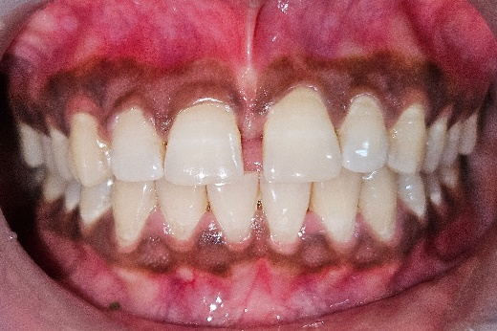

Figure : Pre-operative view

**2.1 Preoperative protocol**

Before performing the surgical procedure, the entire treatment plan was thoroughly explained to the patient, and informed written consent was obtained. The preoperative protocol comprised of Phase I therapy, wherein professional mechanical plaque removal was carried out, followed by Phase IV maintenance therapy.

**2.2 Frenectomy**

After Phase I evaluation, frenectomy was planned using paralleling technique (**Abullais et al., 2016**). 2% lignocaine with epinephrine (1:80000) local anesthetic was administered at the surgical sites. The frenum was retracted, and two parallel incisions were made along its ridge using a number 15 blade. After the initial incision, the frenum was excised by making releasing incisions at both its upper and lower margins (Figure 2 (b)), followed by a deep dissection to eliminate all the muscle fiber attachments. The incision was extended onto the palatal aspect to excise the frenum in entirety (Figure 2 (c)). Interrupted sutures were taken using 4-0 Vicryl to achieve healing via primary intention (Figure 2 (d)) and periodontal pack was applied. Suture removal was done after 7 days. The patient was instructed not to brush on the surgical area and to rinse the mouth using chlorhexidine gluconate (0.2%) mouthwash twice daily for 14 days.

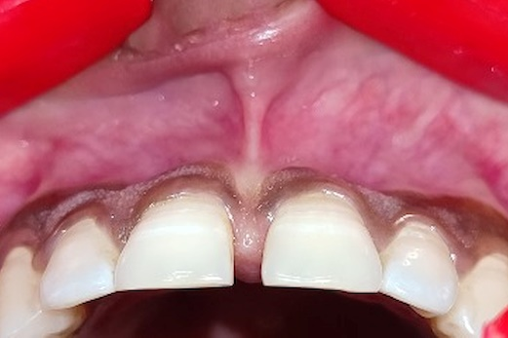 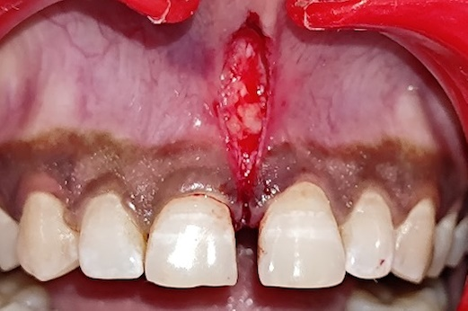

(a) (b)

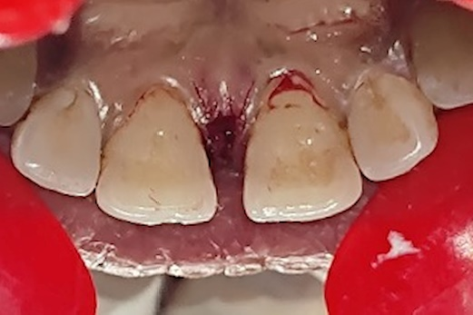 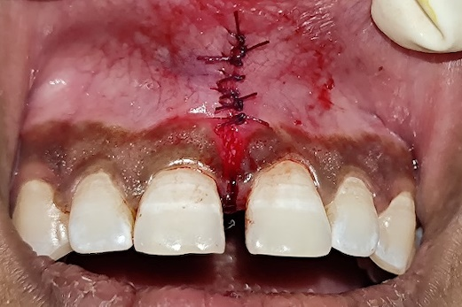

(c) (d)

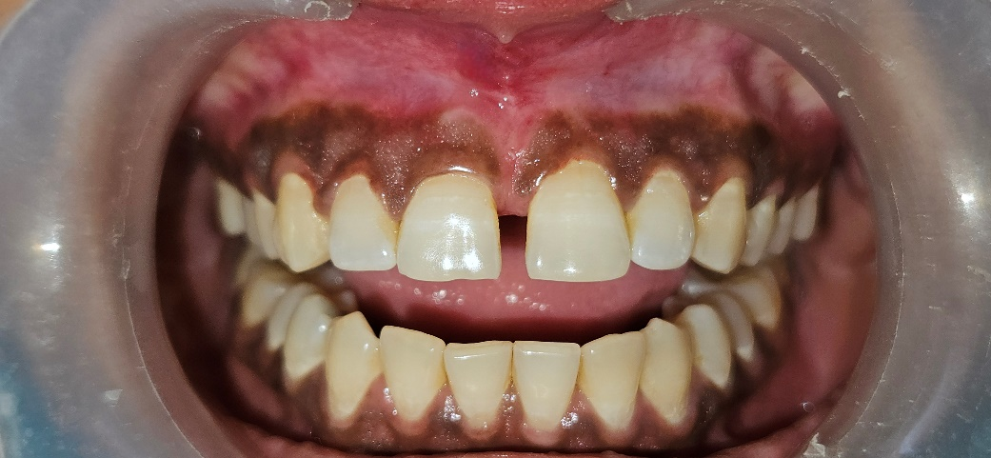

(e)

**Figure 2 : Paralleling technique frenectomy.** (a) Preoperative, (b) Excision of frenum, (c) Palatal View, (d) Primary closure obtained by suturing and (e) 7day Follow up.

## **2.3 Gingival Depigmentation**

After achieving adequate healing of frenectomy, gingival depigmentation was planned. For preparation of the PRF membrane, 10 ml of blood was drawn from the antecubital fossa, transferred to test tubes without anticoagulant, and centrifuged immediately in the REMI4 (*R‐4C, REMI Laboratory Instruments, Mumbai, India) centrifugation machine at 2700 rpm for 12 min. (**Chokroun et al., 2001**). A membrane of uniform thickness was then formed by placing the PRF clot under pressure in the PRF box.

A 2% lignocaine with epinephrine (1:80000) local anesthetic was administered at the surgical sites, and scalpel-based depigmentation was performed until complete deepithelialization from the marginal gingiva to the mucogingival junction was achieved. On the right side, vitamin E gel was applied, followed by the immediate placement of Abgel, which was secured with sutures. On the left side, an L-PRF membrane was sutured in place, followed by the application of tin foil and a periodontal pack on both the sides. Post-operative instructions given.

 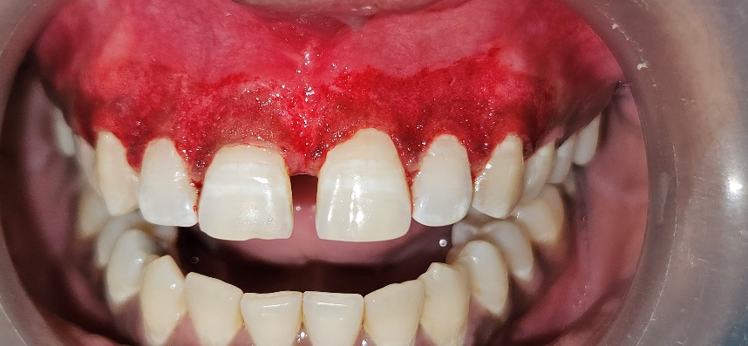

(a) (b)

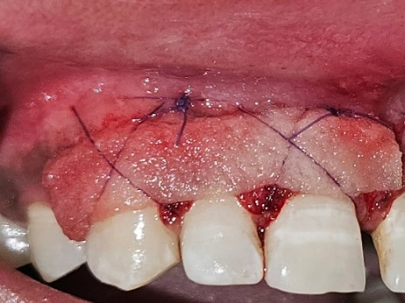 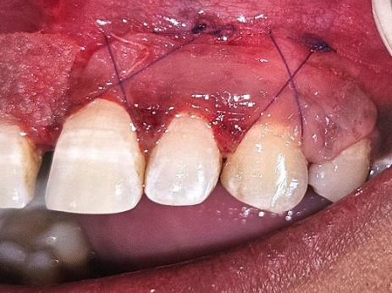

(c) (d)

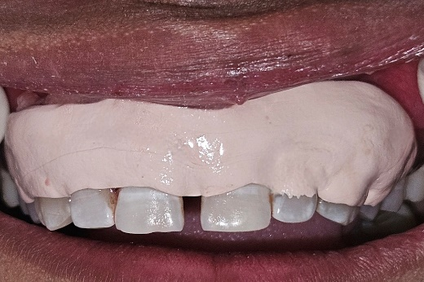 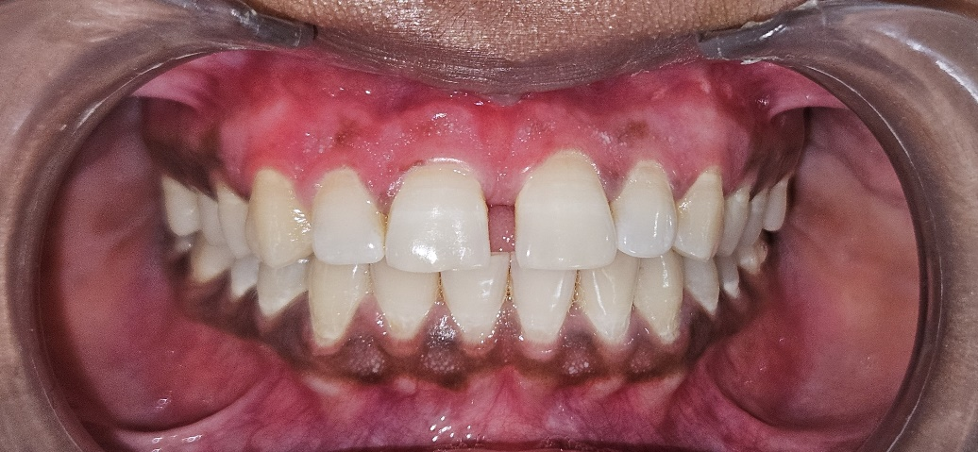

(e) (f)

**Figure 3 : Gingival Depigmentation.** (a)Pre-operative (b) Removal of epithelial cells, (c) application of vitamin E followed by abgel, (d) placement of PRF membrane, (e) Periodontal Pack, and (f) Follow up at 45th day.

### **2.3.1 Epithelialization test to evaluate healing**

The patient was recalled after 14 days, for removal of pack. The epithelialization test with 1% methylene blue was done at 15th and 45th day. The healing index (**Landry et al. 1988)** was recorded at 15th and 45th day. Epithelialization score at 15th day (Figure 6 (a)) was 2 and at 45th day (Figure 6 (b)) was 4. Healing Score at 15th day was 3 and at 45th day was 5. This indicates, better healing was achieved where the vitamin E was applied.

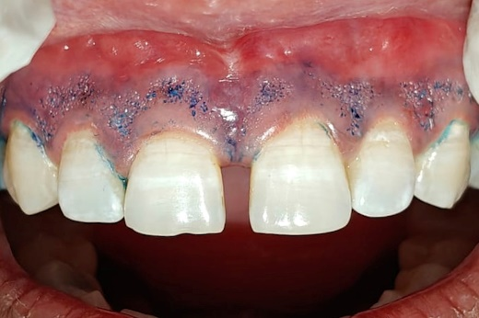 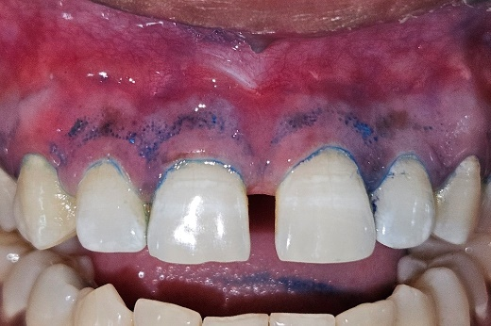

(a) (b)

**Figure 4: Epithelialization test.** (a) At 15th day and (b) At 45th day

## **2.4 Gingivoplasty**

After adequate healing of gingival depigmentation, gingivoplasty and veneers were planned (Figure 5b). A 2% lignocaine local anesthetic with epinephrine (1:80,000) was administered at the surgical sites related to maxillary incisors. The gingival contour was marked with the marker. An external bevel incision was made using a scalpel, followed by removal of the excised gingival tissue (Figure 5c). Periodontal pack was given. Post-operative instructions given.

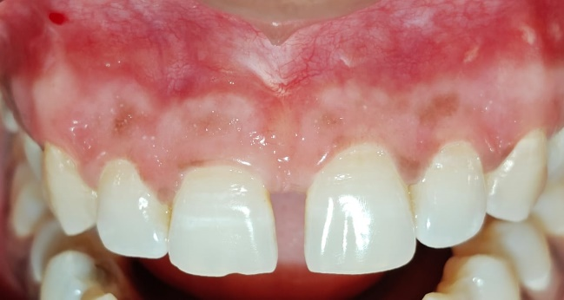 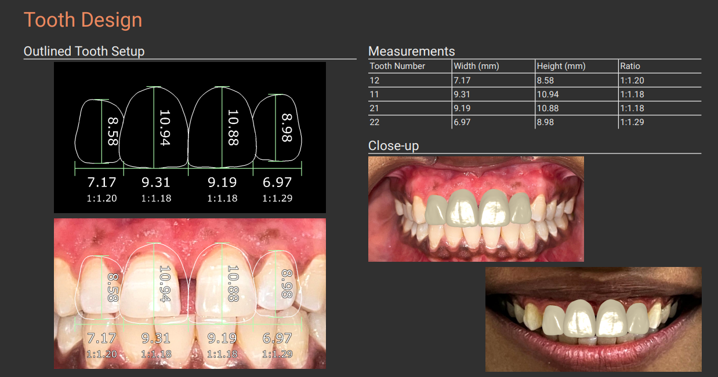

(a) (b)

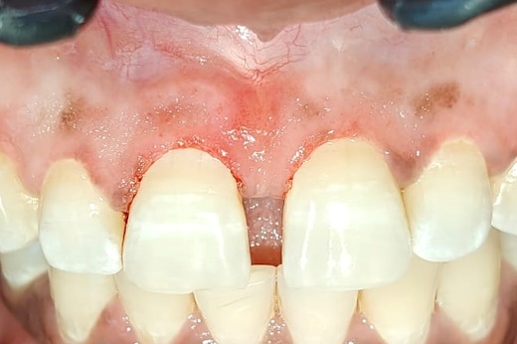

(c)

**Figure 5 : Gingivoplasty.** (a) Pre-operative view, (b) Digital planning for veneers and (c) Immediate Post-operative view.

## **2.5 Veneers**

The veneers were planned, beginning with a thorough consultation and treatment planning. Digital impressions are then obtained to facilitate precise digital planning using EXOCAD Smile Creator software, followed by the fabrication of a 3D-printed mock-up for trial and patient approval. Tooth preparation involves creating 0.4mm depth grooves on teeth 12, 11, 21, and 22, followed by the careful removal of a thin enamel layer (0.5-1mm) and the establishment of a chamfer finish line. Post-preparation Digital impressions (Figure 6 (a)) are recorded to fabricate custom veneers, and temporization with bis-acryl resin material is carried out to protect the prepared teeth. The digital design of the veneers is then created using CAD software, and a stereolithographic (3D-printed) master cast is fabricated for enhanced accuracy. A 3D-printed pattern trial (Figure 6 (b)) is conducted to assess the fit, color, and aesthetics before finalizing the prosthesis.

The final lithium disilicate E.max (Figure 6 (c)) veneers undergo surface treatment with 9% HF gel for etching and Monobond N silane coupling agent for bonding preparation. The prepared teeth are acid-etched with 37% phosphoric acid, rinsed, and dried. Multilink N Primer A/B is applied to promote adhesion, followed by the application of Multilink translucent resin cement. The veneers are then positioned, tacked, and the cement margins light-cured for 20 seconds to ensure secure bonding. Once the excess cement is removed, the veneers are polished to achieve a smooth, natural finish. Post-procedure care instructions are given, and follow-up visits are scheduled to monitor the outcome and ensure long-term success.

 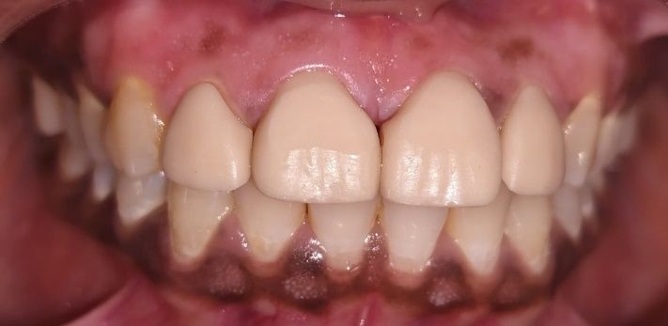

(a) (b)

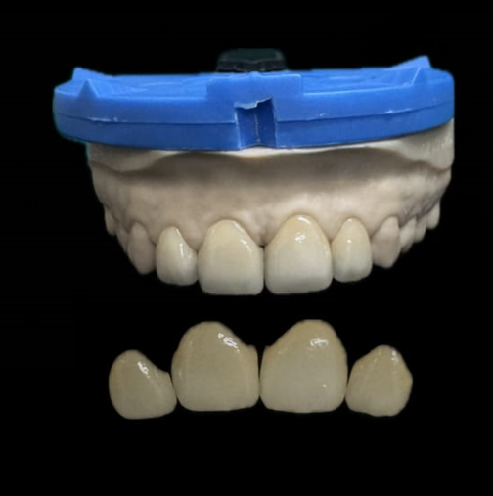 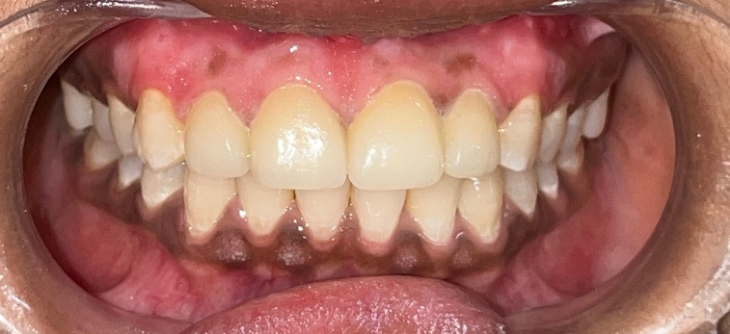

(c) (d)

**Figure 6: Veneer Placement.** (a) Post-Preparation Digital impression (b) 3D Printed Pattern trial (c) Final Prosthesis and (d) Final prosthesis in placement.

3. results and discussion

The scalpel gingival depigmentation technique was chosen due to its proven effectiveness, affordability, and faster healing process. The scalpel method, also known as the split-thickness epithelial excision technique, is widely recognized for its precision in removing the pigmented epithelial layer, resulting in improved gingival aesthetics. This technique is preferred for its faster healing time compared to other methods and its low recurrence rate, making it an effective choice for immediate esthetic improvement​ (Mari et al., 2022).

To assess the healing process, an epithelialization test with 1% methylene blue was conducted on the 15th and 45th day, confirming uneventful healing. The gingiva was uniform pink in color, free from excessive pigmentation. Additionally, the use of vitamin E facilitated accelerated healing and minimized postoperative discomfort, proving to be a non-invasive alternative to PRF membranes.

Aishwarya Kale et al. (2023) conducted study, demonstrating that PRF membranes and 0.2% HA gel contribute to faster healing of depigmented gingival wounds. Similarly, Ritu Agrawal et al. (2024) evaluated the effects of Vitamin E and C application, concluding that Vitamin E led to improved healing and pain reduction post-depigmentation.

The paralleling technique was selected for the frenectomy procedure due to its precision and favorable postoperative outcomes. This method involves making two parallel incisions along the frenum ridge, ensuring controlled removal of muscle fibers while minimizing trauma to surrounding tissues. Studies by Abullias et al. (2016) and Riwan et al. (2018) have shown that the paralleling technique significantly reduces post-operative pain, enhances patient comfort, and improves speech function compared to conventional frenectomy techniques. Additionally, this approach promotes better healing by enabling primary closure, minimizing scar formation, and reducing the risk of recurrence.

Gingivoplasty was performed on the upper anterior teeth to reshape the gingival contours, correcting the gingival zenith and achieving a symmetrical gingival margin. The gingival zenith, which is the most apical point of the gingival contour, plays a crucial role in maintaining smile symmetry and balance(Pawar et al.,2011). Proper positioning of the gingival zenith aligns the axial inclination of the teeth, ensuring a harmonious and natural esthetic outcome. This correction not only improved the visual appeal of the smile but also contributed to optimal dental proportions.

Following the surgical procedures, laminate veneer restorations were placed to close the diastema, providing excellent shade matching and shape correction. The patient expressed high satisfaction with the aesthetic and functional improvements. The integration of periodontal surgical and restorative procedures significantly enhanced the overall smile aesthetics, demonstrating the effectiveness of a comprehensive treatment approach in addressing esthetic concerns.

4. Conclusion

The integration of surgical interventions such as depigmentation, frenectomy, gingivoplasty, and veneer placement successfully addressed both aesthetic concerns and functional issues. This comprehensive approach enhanced the patient's smile, reinforcing the value of tailored treatment strategies in achieving optimal periodontal health and aesthetics. Overall, the report underscores the importance of individualized treatment planning and a multidisciplinary approach to enhance dental aesthetics.

References

Abullais, S. S., Dani, N., Ningappa, P., Golvankar, K., Chavan, A., Malgaonkar, N., et al. (2016). Paralleling technique for frenectomy and oral hygiene evaluation after frenectomy. Journal of Indian Society of Periodontology, 20(1), 28.

Agrawal, R., Chauhan, S., Sinha, A., Sharma, S., Singh, G., & Garg, A. (2024). Effect of vitamin E versus vitamin C application on wound healing in the gingival depigmentation procedure: A split-mouth clinical comparative study. Dental Medicine Research, 12(2), 65.

Bansal, M., Kumar, A., Puri, K., Khatri, M., Gupta, G., & Vij, H. (2016). Clinical and histologic evaluation of platelet-rich fibrin accelerated epithelization of gingival wound. Journal of Cutaneous and Aesthetic Surgery, 9(3), 196–200.

Debnath, K., & Chatterjee, A. (2018). Clinical and histological evaluation on application of platelet concentrates on depigmented gingival epithelium. Journal of Indian Society of Periodontology, 22(2), 150–157.

Gill, D. (1998). Angiogenic modulation. Journal of Wound Care, 7(8), 411–414.

Kale, A.M., Sethi, K.S., Mahale, S.A., Karde, P.A., Kale, L.M., & Choudhary, S.H. (2023). Comparative analysis of platelet-rich fibrin membrane and 0.2% hyaluronic acid gel on healing following gingival depigmentation procedure. Journal of Indian Society of Periodontology, 27(6), 636–41.

Korkut, B., Yanikoglu, F., & Tagtekin, D. (2016). Direct midline diastema closure with composite layering technique: A one-year follow-up. Case Reports in Dentistry, 2016, 6810984.

Mahesh, H. V., Harish, M. R., Shashikumar, B. M., & Ramya, K. S. (2012). Gingival pigmentation reduction: A novel therapeutic modality. Journal of Cutaneous and Aesthetic Surgery, 5(2), 137.

Malhotra, S., Khuller, N., Sharma, N., & Basavaraj, P. (2011). Gingival esthetics by depigmentation. Journal of Indian Association of Public Health Dentistry, 9(Suppl 2), S611–S615.

Mari, R., Nath, A. R., Peter, M. R., Vyloppillil, R., Balakrishnan, B., & Suresh, R. (2022). Periodontal approaches to esthetic dentistry: A review on current trends. Journal of Contemporary Dental Practice, 23(2), 251–267. <https://doi.org/10.5005/jp-journals-10024-3254>

Pawar, B., Mishra, P., Banga, P., & Marawar, P. P. (2011). Gingival zenith and its role in redefining esthetics: A clinical study. Journal of Indian Society of Periodontology, 15(2), 135.

Rizwan, D., Sanadi, M., & Singh, U. (2018). Cyanoacrylate vs. vitamin E application after laser depigmentation: A clinical study. IOSR Journal of Dental and Medical Sciences, 17(1), 41–48.

Sanadi, R. M., Doshi, M., & Ambulgekar, J. R. (2015). Gingival depigmentation for an aesthetic smile: A case report. International Journal of Multidisciplinary Studies, 1(3), 1–5.

Singer, A. J., & Clark, R. A. (1999). Cutaneous wound healing. New England Journal of Medicine, 341(10), 738–746.