**Case report**

**Restoration of endodontically treated teeth with fiber reinforced direct composite resin: A case series**

**ABSTRACT**

Restoration of badly broken endodontically treated teeth (ETT) presents a significant challenge in dentistry. Traditional approaches typically involve posts, crowns, or indirect restorations.

However, the use of fiber-reinforced composite resin (FRC) for direct restorations has gained traction due to its ability to provide structural support while maintaining a more conservative treatment approach.

This case series highlights three instances where FRC was employed to restore endodontically treated anterior and posterior teeth. It focuses on stress-reduced direct composite restorations using the "wallpapering technique," which offers a viable alternative to full-coverage indirect restorations for patients under 18 years of age. The restorations were performed using a combination of continuous glass fiber (Interlig, Angelus), discontinuous short fiber-reinforced composite (EverX Posterior, GC), and nanohybrid composite resin (Tetric N Ceram, Ivoclar).

Keywords: Endodontically treated teeth, fiber-reinforced composite, wallpapering technique

**INTRODUCTION**

Traditionally, restoring structurally compromised endodontically treated teeth involved using a combination of prefabricated or custom-made metallic post and cores along with full-coverage restorations [1]. However, this approach often required the removal of a significant amount of healthy coronal and radicular tooth structure, thereby increasing the risk of root perforation or fracture [2].

Tooth-colored fiber posts, introduced in the 1990s, offer several advantages over traditional metal posts. They provide improved aesthetics, bond effectively to tooth structure, and have a modulus of elasticity similar to dentin. However, they still require dentin preparation to fit within the canal [3].

Recently, fiber reinforcement systems have been developed to enhance the durability and damage tolerance of resin-bonded composites (RBC). These systems conform to the root canal walls without necessitating additional enlargement following endodontic treatment [4]. With a modulus of elasticity comparable to dentin, they are designed to form a monobloc dentin-post-core system, ensuring even distribution of forces along the entire root [5].

Interlig **(**Angelus, Brazil) is a Braided, continuous glass fiber with high flexural strength. These resin pre-impregnated fibers are easy to adapt to the cavity walls without requiring additional preparation of the fiber.

EverX posterior (GC Corporation, Tokyo, Japan) is a resin based material designed to be used as dentin replacement. The manufacturer claims that everX posterior’s short discontinuous and randomly oriented glass fibers structure reinforces restorations in large cavities by avoiding crack formation through the restoration, which is considered to be the main cause of composite failures.

This case series highlights the effective use of fibers in creating stress-reduced direct composite restorations for structurally compromised endodontically treated teeth, enhancing both durability and functional integrity.

**PRESENTATION OF CASE**

**Case no. 1**

A 16-year-old male patient presented to the department of conservative dentistry and endodontics at Sri Hasanamba dental college and hospital, Hassan with a root canal treated upper left maxillary first molar. A permanent restoration was planned using fiber reinforced composite until he attains the age of 18 years. Temporary restoration was removed and rubber dam isolation was achieved. Etching was done using 37% phosphoric acid (3M Scotchbond Multi-Purpose Etchant, USA), 5th gen bonding agent (3M Adper Single Bond 2, USA) was applied and light cured. 2 pieces of required length of Interlig glass fiber **(**Angelus, Brazil) was cut and embedded in to a layer of flowable composite (Tetric N Flow, Ivoclar) on the walls of the cavity according to ‘wallpapering technique’ (Figure 1A) [6]. Rest of the cavity was built with nanohybrid composite resin (Tetric N Ceram, Ivoclar) using incremental technique. Occlusion was checked, Finishing and polishing were done and postoperative radiograph was taken (Figure 1B).

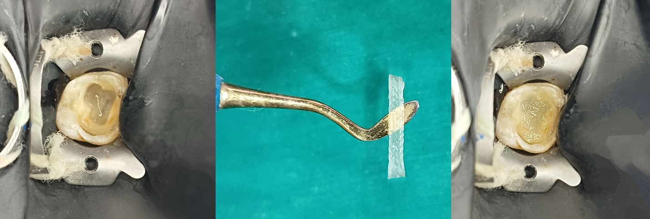

Figure 1A: Incorporation of glass fiber according to ‘wallpapering technique’

Figure 1B: case 1 post-op

**Case no. 2**

A 14-year-old female patient presented to the department with a root canal treated lower right mandibular first molar. After achieving rubber dam isolation, etching and bonding steps were done. Fiber reinforcement protocols were followed as described in case 1. Additionally, a layer of short fiber reinforced composite resin (EverX Posterior, GC) was placed on the floor (Figure 2A). Rest of the cavity was built with nanohybrid composite using incremental technique. Occlusion was checked, Finishing and polishing were done and postoperative radiograph was taken (Figure 2B).

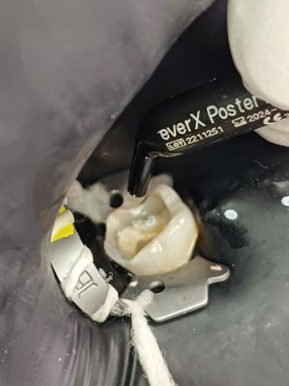Figure 2A: Incorporation of short fiber reinforced composite resin

Figure 2B: case 2 post-op

**Case no. 3**

A 14-year-old female patient presented to the department with a fractured nonvital upper right lateral incisor (Figure 3A). Root canal treatment was done and recalled for permanent restoration. After achieving rubber dam isolation, coronal 3-4 mm GP was removed. Etching and bonding steps were done. Palatal wall was built using mylar strip. Interlig glass fibers were incorporated into the space created by removal of GP (Figure 3B) and crown structure was built using nanohybrid composite resin. Final finishing and polishing of the restoration were completed and postoperative radiograph was taken (Figure 3C).

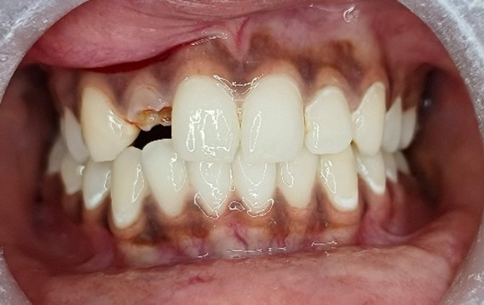

Figure 3A: case 3 pre-op

Figure 3B: Glass fiber incorporation

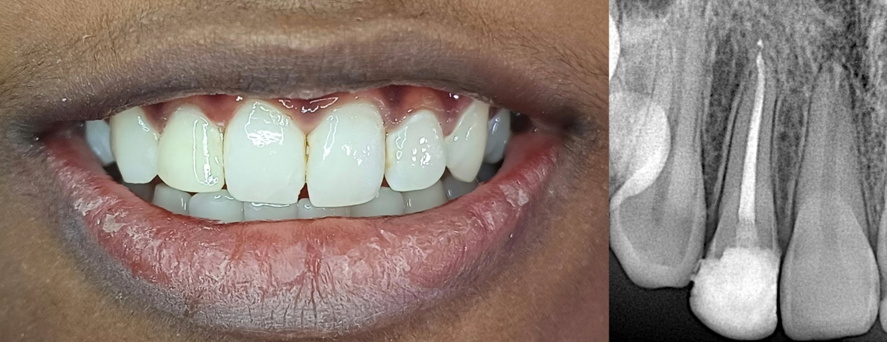

Figure 3C: case 3 post- op

**FOLLOW UP FINDINGS**

Despite being used to restore structurally compromised molars and an anterior tooth, the direct fiber-reinforced composite resin restorations showed promising clinical performance at the six-month follow-up (Figure 4).

Figure 4: sixth month followup

**DISCUSSION**

Advancements in dental composite resins now enable their use in stress-bearing areas of the mouth. The integration of modern filler systems and innovative monomer designs has significantly enhanced the physical properties of composite restorations [7,8]. However, volumetric shrinkage during monomer polymerization remains a challenge, limiting their long-term clinical durability [9].

When a composite resin is bonded to a hard dentinal substrate, volumetric shrinkage generates stresses at the restoration-tooth interface. If these stresses exceed the adhesive strength of the bonding system, marginal gaps may form, resulting in leakage and eventual bond failure. Conversely, if the polymerization stresses remain below the adhesive strength, they are transferred to the tooth structure, potentially causing cuspal deflection and leading to the fracture of either the restoration or the tooth itself [10,11].

To overcome the inherent limitations of resin-bonded composites (RBCs), incorporating fibers with resin composite has emerged as a promising approach for restoring structurally compromised endodontically treated teeth (ETT).

Fiber-reinforced composite (FRC) restorations optimize stress distribution at the restoration-tooth interface, significantly enhancing the mechanical properties of resin-bonded composites (RBCs). The incorporation of fibers increases fracture toughness and flexural strength, while their interconnected design serves as a crack-arresting mechanism, effectively preventing failure [12].

Another effective strategy for reducing shrinkage stress is the use of flowable composite resins as an elastic intermediate layer. This layer acts as a stress absorber, mitigating polymerization shrinkage from the overlying resin composite and minimizing stress at the tooth-restoration interface, ultimately enhancing bond durability and restoration longevity [13].

Belli et al [14] reported that positioning fibers against the dentinal wall significantly enhances fracture strength while minimizing cusp movement. Furthermore, fibers play a crucial role in reducing the C-factor and improving microtensile bond strength.

The wallpapering technique, as described by S. Deliperi et al [6] involves placing fibers circumferentially in contact with the vertical walls, enabling them to absorb lateral forces generated during occlusal loading. This technique not only reduces the risk of failure but also ensures that, in the event of a failure, the damage remains non-catastrophic and is often repairable.

Fibers possess the ability to modify stress by creating a monoblock effect, which helps distribute the stress along the long axis of the tooth [15]. Additionally, they can prevent crack formation by transferring stress from the polymer matrix to the fibers [16,17].

EverX posterior is a material having multidirectional and discontinuous fibers which help to increase the load-bearing capacity, act as a dentin substitute, prevent the crack formation and increase its strength [18,19].

Researchers have recommended the incremental layering technique for composite buildup to reduce polymerization shrinkage stresses and cuspal deflection. Compared to the bulk technique, incremental layering offers superior shrinkage control, as it allows for a more complete degree of cure and progressively reduces the amount of bonded cavity surface at each layer, resulting in lower stress buildup [20].

Based on these findings, there has been a paradigm shift in the restorative approach for endodontically treated teeth. Clinicians are moving away from invasive, non-bonded techniques toward minimally invasive, adhesive, postless, and crownless restorations, prioritizing tooth preservation and biomechanical integrity [21]. Soares et al[22] highlighted the effectiveness of the fiber reinforcement technique in managing structurally compromised teeth, employing a crownless and postless approach, with promising results observed over a 20-month follow-up period. Further, Castro Klenner & Lazari[21] presented a case of minimally invasive postless approach by the use of fiber reinforcement approach in badly broken endodontically treated teeth.

Similarly, in our case 3, traditional post and core were avoided considering the patient's age (14 years). Moreover, posts do not enhance the strength of endodontically treated teeth and are mainly employed for retaining the coronal restoration [23]. Post preparation can compromise healthy tooth structure and carries an increased risk of root perforation.

At the six-month follow-up visit, no signs of recurrent caries, chipping, or fracture were observed. However, further in vitro and long-term clinical studies are needed to fully support this treatment approach.

**CONCLUSIONS**

Effective use of fiber-reinforced composite resin in restoring endodontically treated teeth can potentially eliminate the need for traditional post-and-core or full-coverage restorations, postponing the need for more invasive indirect alternatives.

**CONSENT**

Written informed consent was obtained from the parents/guardians of the patients for publication of this case report and accompanying images

**DISCLAIMER (ARTIFICIAL INTELLIGENCE)**

Author(s) hereby declare that generative AI technology ‘Grammer checker’ has been used during the editing of manuscript.

Details of the AI usage are given below:

1.Quillbot v17.0.4

**COMPETING INTERESTS**

No potential conflict of interest relevant to this article was reported.

**REFERENCES**

1. Shillingburg HT, Hobo S, Whitsett LD, Jacobi R, Brackett SE. Fundamentals of fixed prosthodontics. Chicago: Quintessence; 1997.
2. Fuss Z, Lustig J, Katz A, Tamse A. An evaluation of endodontically treated vertical root fractured teeth: impact of operative procedures. J Endod. 2001;27(1):46-8. doi:10.1097/00004770-200101000-00011.
3. Qualtrough AJ, Mannocci F. Tooth-colored post systems: a review. Oper Dent. 2003;28(1):86-91.
4. Eskitascioglu G, Belli S. Use of bondable reinforcement fiber for post-and-core buildup in an endodontically treated tooth: a case report. Quintessence Int. 2002;33(7):549-51.
5. Newman MP, Yaman P, Dennison J, Rafter M, Billy E. Fracture resistance of endodontically treated teeth restored with composite posts. J Prosthet Dent. 2003;89(4):360-7. doi:10.1067/mpr.2003.50.
6. Deliperi S, Alleman D, Rudo D. Stress-reduced direct composites for the restoration of structurally compromised teeth: fiber design according to the “wallpapering” technique. Oper Dent. 2017;42(3):233-43. doi:10.2341/16-105-T.
7. Ástvaldsdóttir Á, Dagerhamn J, van Dijken JW, et al. Longevity of posterior resin composite restorations in adults – a systematic review. J Dent. 2015;43(8):934-54. doi:10.1016/j.jdent.2015.04.006.
8. da Veiga AM, Cunha AC, Ferreira DM, et al. Longevity of direct and indirect resin composite restorations in permanent posterior teeth: a systematic review and meta-analysis. J Dent. 2016;54:1-12. doi:10.1016/j.jdent.2016.09.003.
9. Song YX, Inoue K. Linear shrinkage of photo-activated composite resins during setting. J Oral Rehabil. 2001;28(4):335-41. doi:10.1046/j.1365-2842.2001.00666.x.
10. Braga RR, Ballester RY, Ferracane JL. Factors involved in the development of polymerization shrinkage stress in resin-composites: a systematic review. Dent Mater. 2005;21(10):962-70. doi:10.1016/j.dental.2005.04.018.
11. Giachetti L, Scaminaci Russo D, Bambi C, Grandini R. A review of polymerization shrinkage stress: current techniques for posterior direct resin restorations. J Contemp Dent Pract. 2006;7(4):79-88.
12. Sadr A, Bakhtiari B, Hayashi J, et al. Effects of fiber reinforcement on adaptation and bond strength of a bulk-fill composite in deep preparations. Dent Mater. 2020;36(4):527-34. doi:10.1016/j.dental.2020.01.017.
13. Mantri SP, Mantri SS. Management of shrinkage stresses in direct restorative light-cured composites: a review. J Esthet Restor Dent. 2013;25(5):305-13. doi:10.1111/jerd.12044.
14. Belli S, Cobankara FK, Eraslan O, Eskitascioglu G, Karbhari V. The effect of fiber insertion on fracture resistance of endodontically treated molars with MOD cavity and reattached fractured lingual cusps. J Biomed Mater Res B Appl Biomater. 2006;79(1):35-41. doi:10.1002/jbm.b.30519.
15. Ayna B, Celenk S, Atakul F, Uysal E. Three-year clinical evaluation of endodontically treated anterior teeth restored with a polyethylene fibre-reinforced composite. Aust Dent J. 2009;54(2):136-40. doi:10.1111/j.1834-7819.2009.01106.x.
16. Garoushi S, Vallittu PK, Lassila LV. Direct restoration of severely damaged incisors using short fiber-reinforced composite resin. J Dent. 2007;35(9):731-6. doi:10.1016/j.jdent.2007.05.001.
17. Garoushi S, Vallittu PK, Lassila LV. Short glass fiber reinforced restorative composite resin with semi-interpenetrating polymer network matrix. Dent Mater. 2007;23(11):1356-62. doi:10.1016/j.dental.2006.10.013.
18. Vallittu PK. High-aspect ratio fillers: fiber-reinforced composites and their anisotropic properties. Dent Mater. 2015;31(1):1-7. doi:10.1016/j.dental.2014.05.002.
19. Tekçe N, Pala K, Tuncer S, Demirci M, Serim ME. Influence of polymerisation method and type of fibre on fracture strength of endodontically treated teeth. Aust Endod J. 2017;43(3):115-22. doi:10.1111/aej.12185.
20. Park J, Chang J, Ferracane J, Lee IB. How should composite be layered to reduce shrinkage stress: incremental or bulk filling? Dent Mater. 2008;24(11):1501-5. doi:10.1016/j.dental.2008.03.013.
21. Castro Klenner JA, Lazari-Carvalho PC, Labarca Galecio TF, de Carvalho MA. A 1-year follow-up case report of a biomimetic no post/no crown fiber-reinforced restoration of a structurally compromised tooth. Int J Adv Eng Res Sci. 2022;9(4):17-23. doi:10.22161/ijaers.94.1
22. Soares R, de Ataide IN, Fernandes M, Lambor R. Fibre reinforcement in a structurally compromised endodontically treated molar: a case report. Restor Dent Endod. 2016;41(2):143-7. doi:10.5395/rde.2016.41.2.143.
23. Stockton LW, Lavelle CL, Suzuki M. Are posts mandatory for the restoration of endodontically treated teeth? Dent Traumatol. 1998;14(2):59-63. doi:10.1111/j.1600-9657.1998.tb00810.x.