**IMPACT OF ROOT SYSTEMS ON SOIL STRUCTURE AND HYDRAULIC PROPERTIES: A REVIEW OF MECHANISMS AND EFFECTS**

**ABSTRACT**

Root systems are fundamental to soil health, influencing its structure and hydraulic properties through complex biophysical and biochemical mechanisms. This review examines the role of root architecture, root exudates, and root-induced mechanical effects in shaping soil porosity, aggregation, and water retention. Fine roots enhance microporosity, improving water retention, while coarse roots contribute to macroporosity and water infiltration. Root exudates serve as natural binders, stabilizing aggregates and fostering microbial activity, which further enhances soil structure. Additionally, root growth and decay create biopores, promoting water infiltration, drainage, and nutrient redistribution. These interactions significantly affect soil hydraulic conductivity, water-holding capacity, and erosion resistance, which are critical for sustainable agriculture and ecosystem resilience. By synthesizing current research, this review highlights strategies for leveraging root traits to optimize soil management practices and mitigate the impacts of environmental challenges such as water scarcity and soil degradation.

**Keyword:** Soil structure, Root systems, Hydraulic properties, Root exudates

**INTRODUCTION**

Root systems play a pivotal role in shaping soil structure and influencing its hydraulic properties, significantly impacting terrestrial ecosystems and agricultural productivity. As integral components of the soil-plant interface, roots contribute to soil aggregation, porosity, and water retention while mediating critical processes like nutrient cycling and carbon sequestration. The dynamic interactions between roots and soil involve both biophysical and biochemical mechanisms. Biophysically, root growth and penetration create voids and channels that enhance soil aeration and water infiltration. Simultaneously, root exudates, composed of organic compounds; act as binding agents, stabilizing soil aggregates and improving its structural integrity. Biochemically, roots interact with microbial communities to form symbiotic relationships, which further contribute to the formation and maintenance of soil structure. The hydraulic properties of soil, including water holding capacity, permeability, and infiltration rates, are also profoundly influenced by root systems. Root architecture, depth, and density determine the distribution of water within the soil profile, influencing its availability for plant growth. In natural ecosystems, diverse root systems enhance soil heterogeneity, promoting resilience against erosion and compaction. In agricultural systems, understanding the impact of roots on soil hydraulic properties is essential for optimizing irrigation strategies and mitigating waterlogging or drought stress. However, the influence of root systems on soil is not uniform, as factors such as plant species, soil type, and environmental conditions play a critical role in determining outcomes. This review explores the mechanisms through which root systems affect soil structure and hydraulic properties, focusing on their ecological and agronomic implications. By synthesizing current research, this paper aims to provide a comprehensive understanding of root-soil interactions and highlight strategies for harnessing root traits to improve soil health and sustainability in the face of global environmental challenges.(1)(2)

**THE PHYSICAL MECHANISMS BY WHICH ROOTS INFLUENCE SOIL STRUCTURE**

Roots influence soil structure through several physical mechanisms that modify its texture, porosity, and stability. Root architecture, including length, thickness, and branching patterns, directly impacts how roots interact with soil particles. As roots grow, they exert mechanical pressure, rearranging soil particles and forming stable aggregates. This process, known as root-induced compaction, enhances soil cohesion while creating micro- and macropores that facilitate air and water movement. Additionally, roots penetrate soil layers, forming channels or biopores that persist even after root decay. These biopores act as conduits for water infiltration and drainage, improving the soil's hydraulic conductivity. Fine roots contribute to microporosity, which retains water for plant uptake, while coarse roots increase macroporosity, promoting deeper water penetration. This balance between pore sizes is critical for maintaining soil moisture and preventing waterlogging or erosion. Roots also enhance aggregate stability by physically binding soil particles. Fibrous root systems, commonly found in grasses, are particularly effective at holding the soil together, reducing susceptibility to erosion. Over time, the physical modifications made by roots not only improve soil structure but also support sustainable plant growth by creating an environment conducive to nutrient and water availability. These mechanisms highlight the integral role of roots in maintaining soil health and functionality.

**THE CHEMICAL AND BIOLOGICAL INTERACTIONS BETWEEN ROOTS AND SOIL**

The complex chemical and biological interactions between soil and roots have a major influence on soil structure, fertility, and ecosystem function. The discharge of sugars, amino acids, organic acids, polysaccharides, and other organic substances into the rhizosphere by means of root exudates is a key process. Microbes in the soil get their energy from these exudates, which increases their activity and variety. Mycorrhizal fungi, for example, create glomalin and other microbial byproducts that improve soil aggregation and stability. For nitrogen cycling to take place, the soil and roots must interact chemically. Chelating nutrients makes them more accessible to plants, and organic acids produced by roots may do just that. For instance, in soils where iron is insufficient, root exudates may increase the availability of the element and mobilize phosphorus from insoluble forms. For example, Rhizobia fix nitrogen in legumes, which enriches the rhizosphere with nutrients and promotes symbiotic partnerships. From a biological perspective, roots support a web of relationships with actinomycetes, fungus, and bacteria in the soil. Particularly beneficial are mycorrhizal relationships, which increase nutrient and water intake and enhance soil structure by means of fungal hyphae that lengthen root systems. Roots that break down also provide organic matter, which improves soil fertility and its ability to retain water. Soil health and plant development are greatly influenced by these chemical and biological interactions.

**ROOT SYSTEMS’ ROLE IN ECOSYSTEMS**

* The shape and function of root systems impact their surroundings and promote microbial development and activity, which are crucial contributions to ecosystems.
* The nutrient cycling of carbon, nitrogen, and phosphorus is one way in which roots impact biogeochemistry. They have a major role in reducing soil carbon emissions as well.
* Soil hydraulic uplift is enhanced by roots, which also increase soil structure, stability, and water-holding capacity. Bedrock weathering is another process in which they aid in soil formation.

Ecosystems, air, and ground are all impacted by roots. There are real-world applications for a better understanding of root systems in the design of agricultural and forest management systems. Thanks to advancements in technology, we now know more about root systems and how they work, which has allowed us to study activities occurring below ground. Learn the current state of knowledge on the function of roots in ecosystems.(3)

**IMPORTANT ROOT SYSTEMS TRAITS**

The way plants and ecosystems work is affected by a variety of root features, both physiological and structural.(3)

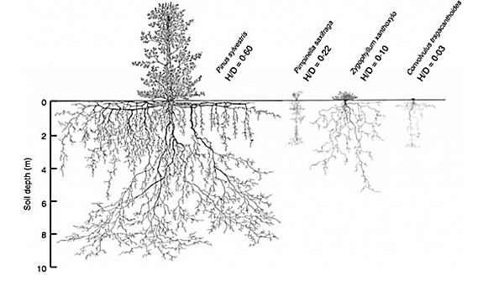

Figure 1: “Drawings of the above- and below-ground extension of the species Pinus sylvestris, Pimpinella saxifrage, Zygophullum xanthoxylo, and Convolvulus tragacanthoides. H/D is the ratio of the above-ground plant height divided by the maximum rooting depth (MRD)” Source: <https://academic.oup.com/aob/article/118/4/621/2196536>)

The crucial structural traits are discussed below:

* Root type: The Hubbard Brook Ecosystem research found that out of the total root biomass, 56% consists of large roots with a diameter more than 1 cm and 10% of fine roots with a diameter less than 2 mm.
* Root length and mass fraction: Although deeper roots (>10 cm) become frequent in bigger trees, the majority of root biomass is located in shallower soil depths between 0-20 cm; for instance, 83% in temperate woods. Soils may be more than 1 to 1.5 meters deep, even though the typical depth is 0-30 cm and the area where root investigations are conducted falls outside of this range.
* Root branching or architecture: For soil aggregation and competitive fighting, higher localized branching is beneficial. A lower branching density is more conducive to resource discovery.
* Age: Root biomass, the ratio of roots to shoots, and the percentage of roots that are bigger all rise with the age of a forest.(4)

Physiological traits of importance are:

* Root exudation composition and rate
* [Root respiration](https://cid-inc.com/blog/root-respiration-importance-and-applications/)
* Nutrient absorption
* Root enzymatic action

Anatomical features such as root persistence and turnover, as well as biotic interactions with bacteria and mycorrhizae, are also crucial; fine roots typically endure for around 1.5 years. Nonetheless, 20% of roots have a lifespan of more than three years. Researching the anatomy, physiology, and functions of root systems used to involve laborious procedures. But minirhizotrons like the CI-600 In-Situ Root Imager and the CI-602 Narrow Gauge Root Imager can assess several root attributes more efficiently, accurately, quickly, and without damaging the roots. The ability of roots to absorb water and nutrients, to anchor plants, and to store surplus carbs and nutrients is influenced by their characteristics. As we'll see later on, this controls how much of an impact the roots have on their environment .(5)

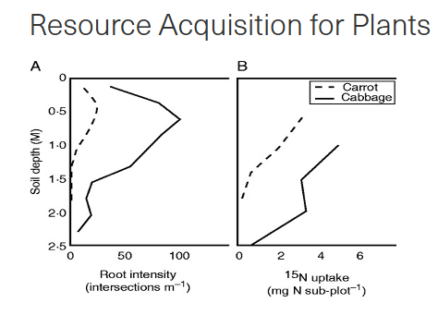

*Figure 2: “Average deep rooting and nutrient uptake in annual crops (n = 4). (A) Root intensity; (B) plant 15N for carrot and cabbage,”*

*Source:* [*https://academic.oup.com/aob/article/118/4/621/2196536*](https://academic.oup.com/aob/article/118/4/621/2196536)*)*

### MECHANISMS OF ROOT INFLUENCE ON SOIL STRUCTURE

Soil structure is significantly impacted by the ever-changing dynamics of plant root interactions with soil. The structure, chemical secretions, mechanical stress, and post-decay characteristics, such as biopores, of roots all have a role. These processes improve soil health and plant development by altering the soil's physical and chemical characteristics.(6)(7)

#### 1. Root Architecture

Root architecture refers to the spatial arrangement, morphology, and distribution of roots in the soil. This physical structure plays a pivotal role in determining soil porosity and aggregate stability.(8)

**Fine Roots and Microporosity:** Fine roots, typically less than 2 mm in diameter, significantly enhance soil microporosity. These roots increase the availability of small pores that retain water and nutrients, which are essential for plant uptake. The dense network of fine roots creates a matrix that binds soil particles together, promoting microaggregate formation. This process is particularly important in sandy soils, where fine roots help to stabilize loose particles and improve water retention.

**Coarse Roots and Macroporosity:** In contrast, coarse roots, such as those in trees and large shrubs, influence macroporosity by creating larger voids in the soil. These macropores facilitate preferential flow pathways, enabling rapid water infiltration and drainage. This feature is critical in clayey soils, which are prone to compaction and poor permeability. The interaction of fine and coarse roots within a root system ensures a balance between water retention and drainage, contributing to the overall health of the soil.

**Branching Patterns and Root Depth:** The branching patterns and depth of roots further dictate their influence on soil structure. Shallow, lateral roots enhance surface soil stability, reducing erosion and crusting, while deep taproots penetrate compacted layers, improving subsoil porosity. Such diversity in root architecture optimizes soil properties across different horizons, ensuring a resilient soil system.

#### 2. Root Exudates

Root exudates, a mixture of organic compounds released by roots into the surrounding soil, play a crucial role in soil aggregation. These exudates include polysaccharides, organic acids, amino acids, and phenolic compounds, all of which have distinct functions in modifying soil structure.(9)

**Polysaccharides as Binding Agents :** Polysaccharides, a key component of root exudates, act as natural adhesives that bind soil particles together into stable aggregates. These compounds increase the cohesiveness of soil, reducing the risk of erosion and compaction. Stable aggregates also improve water infiltration and retention, creating a balanced environment for microbial activity and plant growth.

**Organic Acids and Nutrient Mobilization:** Organic acids, such as citric and malic acids, contribute to soil structure by chelating soil particles and enhancing the solubility of minerals. This process not only improves soil aggregation but also facilitates the mobilization of nutrients like phosphorus and iron, making them more accessible to plants.

**Microbial Stimulation:** Root exudates serve as energy sources for soil microorganisms, particularly bacteria and fungi, which further contribute to soil structure. For example, mycorrhizal fungi produce glomalin, a protein that strengthens soil aggregates. This symbiotic relationship between roots and microbes amplifies the impact of exudates on soil health and structure.

### ****Table 1: Chemical Influence of Root Exudates on Soil****

|  |  |  |
| --- | --- | --- |
| **Root Exudate** | **Function** | **Impact on Soil Structure** |
| Polysaccharides | Bind soil particles. | Enhance aggregate stability. |
| Organic Acids | Chelate nutrients and dissolve minerals. | Promote aggregation and nutrient mobility. |
| Phenolic Compounds | Stimulate microbial activity. | Improve soil organic matter. |
| Amino Acids | Serve as microbial energy sources. | Boost microbial diversity and activity. |

#### 3. Root-Induced Soil Compression

As roots grow and expand, they exert mechanical pressure on the surrounding soil. This process, known as root-induced soil compression, alters the arrangement of soil particles, impacting bulk density and porosity.(10)

**Mechanical Rearrangement:** Roots displace soil particles as they penetrate, compacting loose soil and creating a more stable structure. This compression increases the bulk density of the soil, particularly in sandy or loose-textured soils, where root-induced compaction can enhance stability and water retention. However, excessive compression in clayey soils may reduce porosity and impede root growth, highlighting the need for a balance in root-induced mechanical effects.

**Fracturing of Soil Layers:** In compacted soils or hardpans, roots can create fractures that improve soil permeability and porosity, this is especially important in agricultural fields where machinery-induced compaction is prevalent. Root growth through compacted layers not only enhances soil aeration and water infiltration but also promotes the establishment of other roots in deeper layers, improving overall plant performance.

#### 4. Biopores

Biopores are the channels left behind in the soil after root decay. These voids serve as critical conduits for water and air movement, playing an essential role in enhancing soil hydraulic properties and structure.

**Water Infiltration and Drainage:** Biopores significantly improve water infiltration by providing preferential flow pathways. In soils prone to surface crusting or compaction, biopores allow water to bypass resistant layers, reducing surface runoff and erosion. These channels also enhance drainage in poorly aerated soils, preventing waterlogging and promoting root respiration.

**Nutrient Redistribution:** As biopores form, they create pathways for nutrient redistribution within the soil profile. These channels allow organic matter, microorganisms, and dissolved nutrients to move vertically and horizontally, enriching the soil's nutrient content.

**Habitat for Microorganisms:** Biopores serve as habitats for a variety of soil microorganisms, including bacteria, fungi, and earthworms. These organisms contribute to the decomposition of organic matter, further enhancing soil structure and fertility. The interaction between biopores and microbial communities creates a self-sustaining cycle of soil improvement.(11)

**Root Regrowth:** New roots often regrow into existing biopores, taking advantage of the reduced resistance to penetration. This process accelerates plant establishment and growth, particularly in challenging soil conditions. The reuse of biopores ensures the continued enhancement of soil properties, contributing to long-term soil health and productivity.

Picture 1

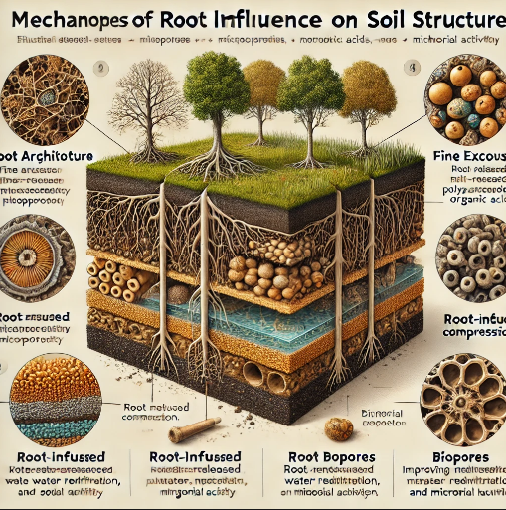

### IMPACT ON HYDRAULIC PROPERTIES

The impact of root systems on the hydraulic properties of soil is profound and multifaceted, influencing water infiltration, retention, hydraulic conductivity, and erosion control. These mechanisms are critical for maintaining soil health, supporting plant growth, and managing water resources sustainably.(12) “

**Water Infiltration:** Root systems play a key role in improving water infiltration by creating macropores and root channels as they grow and penetrate the soil. These macropores provide pathways for water to move into deeper soil layers, enhancing infiltration rates and reducing surface runoff. Dense and fibrous root networks minimize the formation of surface crusts, which typically act as a barrier to water infiltration. For instance, plants with fine root systems effectively break up compacted soil surfaces, allowing water to percolate through the soil profile more efficiently. Enhanced infiltration not only supports plant hydration but also reduces the risk of water stagnation and flooding, particularly in agricultural landscapes.

**Water Retention:** Roots significantly contribute to water retention within the rhizosphere by stabilizing soil aggregates. Soil aggregates, formed with the help of root exudates and microbial activity, trap water molecules and reduce water loss through evaporation. Organic compounds released by roots, such as polysaccharides and mucilage, increase the soil's organic matter content, which has a direct impact on its water-holding capacity. Soils enriched with organic matter exhibit better moisture retention, ensuring a steady supply of water for plant uptake during dry periods. This function is especially crucial in arid and semi-arid regions, where water scarcity is a persistent challenge.

**Hydraulic Conductivity:** Root systems influence hydraulic conductivity by altering the continuity and connectivity of soil pores. The growth and decay of roots create networks of macropores that facilitate water movement through the soil. However, the type and density of roots determine the extent of this influence. Deep-rooted plants, such as trees, enhance vertical water movement, while fibrous roots improve lateral conductivity, ensuring uniform water distribution.

**Erosion Control:** Roots play a vital role in erosion control by anchoring soil particles and reducing surface runoff. The physical presence of roots binds soil, preventing it from being washed away by rain or wind. Additionally, the root canopy reduces the impact of raindrops on the soil surface, minimizing dislodgment. By mitigating soil erosion, root systems help maintain soil structure, fertility, and water retention capacity, thereby supporting long-term soil sustainability. Collectively, these root-mediated processes highlight the importance of understanding and leveraging root systems to enhance soil hydraulic properties, mitigate water stress, and promote sustainable land use practices.(13)

**DIFFERENT ROOT STRUCTURES AFFECT SOIL**

The root's architecture determines the manner in which the root modifies the soil. Given that plants grow in soil, it stands to reason that soils must be ideal growing conditions, don't you think? In that case, the vast majority of us are completely mistaken. There isn't much love in the dirt for plant life. It does not provide a plant with all of its requirements without condition. Actually, the soil probably wouldn't grow many plants if it remained undisturbed. The immense amount of soil alteration that plants undergo for the sole purpose of increasing their survival prospects is evidence of this. Soil is changed by plants. Yes, it is true. They put forth a lot of effort, and it serves their purposes. Along with weather, relief/topography, parent material, and time, organisms (which obviously include plants) are one of the five components that make up soil. Plants have a profound effect on soil chemistry, biology, and physical properties. This blog post primarily considers the physical aspect by looking at the effects of root architecture on soil.(14)

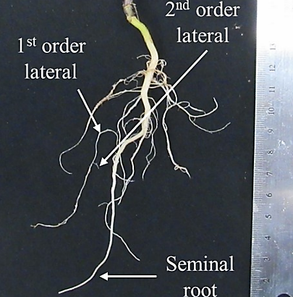

*Figure 3:*A mustard root with single taproot system and root orders

Root architecture describes the structure of the roots. Root order distribution, root number, root thickness, root length, root depth, and branching angle are all variables that may be included in the phrase. The root systems of many plants are uniquely designed. The general design of a plant species may reveal a lot about its survival strategy, while alterations to that architecture can reveal a lot about the particular pressures to which that plant is subject. Many factors lead researchers to "go down the rabbit hole" while studying roots. Even in our highly sophisticated age, they remain a big mystery since they are the invisible half of the plants. To what extent they serve our needs and what advantages we can reap from a deeper comprehension of them are mysteries to us. We do know that plants acquire resources mostly via their roots, that numerous complex chemical compounds are released into the soil by plants that impact carbon storage and other soil organisms, and that soil is transformed as a result of plant-soil interactions. “

And they look cool.

The idea of root order provides a good jumping off point for exploring root architecture. Here we see a young mustard plant that has been dug out from the field, its roots cleaned of dirt. Central roots, often called main or seminal roots, are the biggest. A first-order lateral root is one that divides out from the main root system. The term "second order lateral" is used to describe a root that originates from a first order lateral. The production of the very fine root hairs that optimize surface area to volume for the absorption of water and nutrients often begins in relatively tiny roots, so this may continue, but generally not too far.(15)

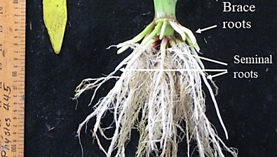

*Figure 4:*Corn root system with fibrous root system featuring brace roots and multiple seminal roots

The notion that the fibrous root system and the tap root system are the two most fundamental kinds of root architecture is another fundamental concept. The tap root system is shown by the mustard plant in the image above. It consists of a single, prominent root that grows downward and from which all the other roots branch out. More seminal roots and often the absence of a distinct main root characterize a fibrous root system, like that of maize plants. The roots don't originate in the ground, but rather sprout from the stem. A taproot is a kind of root system that allows a plant to reach nutrients and water that are deeper in the soil. Fibrous roots are a method of acquiring nutrients that are not easily moved by emphasizing the investigation of soil near the surface and increasing total interaction with soil particles.

various plants physically alter soil in various ways depending on factors such as the depth to which they penetrate, the area of soil they primarily investigate, and the lateral reach of their root systems. Various physical disturbances in the soil, such macro channels, voids, and aggregate development from decaying tissue and root exudates, are caused by the architecture's distribution. Soil water infiltration and retention are impacted by all of these factors. In addition, compared to plant tissues found above ground, lignin is far more abundant in root tissue. Among the components of plant residue, lignin has the longest half-life. Soil channels and voids may take on a variety of configurations due to the varied spatial patterns in which roots can deposit carbon.

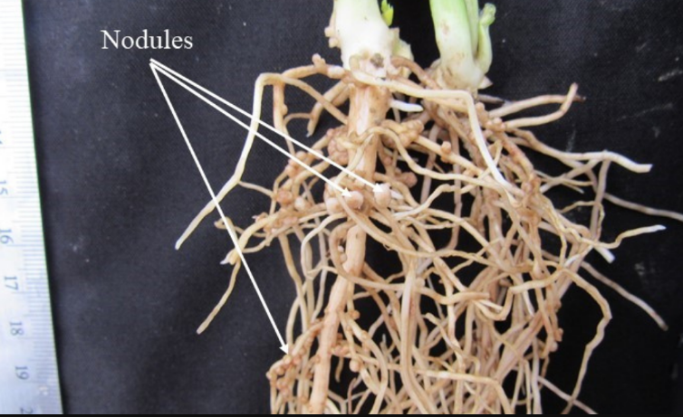

*Figure 5:*Nodules formed on the roots of a Fava Bean plant. These structures are necessary to protect the anaerobic activity of nitrogen fixing bacteria, which form a mutualistic symbiosis with the plant.

Obviously, more architectural variation results from alterations and specializations within these two main systems. Examples of plant structures with taproot systems include potatoes and carrots, which serve to store nourishment for the plant. The creation or removal of these structures causes the soil to develop bigger single voids. The onion's fibrous root structure is topped by a cluster of underground leaves. Legumes also produce structures called nodules, which are homes to bacteria that fix nitrogen.

Plants are able to express their root systems to their maximum potential in soils that have enough tilth*. Consequently, correct tilth is both contributed to and maintained by the root architecture of a plant. Hopefully, you can make out how various building designs will alter the ground physically. Please take the time to learn more about the fascinating anatomy, physiology, and aesthetics of plant root systems.

## IMPORTANCE OF THE PHYSICAL PROPERTIES OF THE SOIL

Soil sustainability and agricultural output are highly dependent on soil physical qualities. Both the roots' and the soil's capacity to absorb and supply the soil solution determine the pace and quantity of water, oxygen, and nutrient absorption by plants. Low hydraulic conductivity is one soil property that may restrict root access to water and oxygen, which in turn reduces crop yields.

### Soil structure: An essential physical component of soil that regulates or controls the movement and retention of biota, gasses, water, and solutes in both natural and agricultural ecosystems is soil structure. An essential component of soil productivity, soil structure also acts as a constraint on agricultural yields. Soil structure governs a multitude of soil activities. Soil organic matter (SOM) and nutrient dynamics, gaseous exchanges, root penetration, water retention/infiltration, and erosion susceptibility are all regulated by it. Soil structure is one of the most prominent soil physical features because of the significant impact it has on edaphic conditions and the surrounding environment. A granular medium's "structure" is its texture and the relative placement of its solid particles and empty spaces. A hierarchical structure is often seen in soils. In other words, "first-order aggregates" are formed when primary mineral particles, sometimes in combination with organic substances, come together in microscopic clusters. These come together to create bigger groups called "second-order aggregates." Soil aggregate size increases with each subsequent layer, reflecting the hierarchical nature of aggregates in soils. Yet, in soil science, the word "structure" usually means more than just the geometric arrangement of particles; it also implies bonding processes. Soil aggregates and their structure are both aided by organic matter, which functions like cement. Loams, clays, and other soils with medium to fine textures would be almost gas and fluid impermeable if they lacked hierarchical structure. In coarse-textured soils in particular, the impact of soil organic carbon on aggregation is stronger. Soil structure is thus important for environmental transfer of gasses, water, and solutes as well as for making soil an ideal habitat for plant and animal life. Soil structure is shown via the formation of aggregates, which are the end product of particle reorganization, flocculation, and cementation. One of the most important factors in soil structural stability is organic matter. However, excessive cultivation without sufficient plant biomass production is gradually depleting it in agricultural soils. There is a growing consensus that agricultural and soil activities contribute to soil degradation, which manifests as a decrease in soil structure. For soils to support plant development and other forms of life, it is crucial to maintain ideal soil physical conditions. Root development is stunted due to insufficient water and air circulation caused by poorly structured soil, which in turn limits plants' ability to absorb and use water and nutrients. The ability of roots to reach deeper layers of soil is also influenced by its structure. (16)

### Aggregate stability: Soils that are rich in organic matter are less likely to compress easily because their aggregates are smaller, stronger, and more stable. Soil erosion and compaction are two of the many negative outcomes that might occur in an agroecosystem when aggregate stability is improved. Soil organic carbon (SOC) content—and more specifically, the proportion of labile SOC, also known as "particulate organic matter" due to its relatively rapid cycling in the soil—has a crucial impact on soil structure quality. Soil structure and nutrient provision are both aided by soluble organic matter. An proper management of organic additions may promote aggregate stability, a keystone feature in soil physical fertility concerns, and maintain an acceptable soil structure. Potential benefits of this agronomic process include increased microbial activity, root development, water retention, and gas exchange via improved pore space. Surface aggregate stability is most impacted by rainfall exposure (drop impact and runoff). When it rains, the soil aggregates break down more easily and the soil becomes more erodible. This is especially true in bare soil, which includes land that has had crop residues either removed or mixed into it by plowing. Reduced water penetration rate, increased danger of soil erosion, and loss of important topsoil may result from aggregate deterioration, which can cause surface sealing and crust development. Aggregate disintegration and surface crusting are more likely to occur in soils with a high silt concentration and a low organic matter level. When added to topsoil, organic matter both prevents erosion and encourages mineral particle agglomeration. (17)

### Soil compaction: Reduced biological activity in soil and soil productivity for agricultural and forest crops are environmental implications of soil compaction, a kind of physical deterioration. Densifying and distorting soil by compaction decreases total and air-filled porosity and permeability, increases strength, partially destroys soil structure, and induces numerous changes in soil fabric and many properties. It is common practice to use total porosity, pore size distribution, bulk density, and penetration resistance as indicators to measure soil compaction. These variables likely have a negative correlation with root development and rooting depth because soil compaction hinders root growth. More importantly, these characteristics are associated with the flow of water, the availability of water for plants, and the exchange of gases in the soil.

### Porosity: One of the most important measures of soil quality is porosity. Characterizing it is crucial for determining the effects of organic matter addition to soil systems. When bigger pores are lost and smaller holes are gained, porosity is reduced. Soil porosity and pore size distribution describe the empty space in a soil, which is the volume of the soil that is not filled with solids. The fundamental nature of the pore space controls essential features of almost all soil processes, including the circulation of fluids (air, water, etc.), the movement and reactivity of chemicals, and the residency of biotas (roots, etc.). Convention dictates that fluid pockets completely encased in solid material are not considered part of the pore space definition. Therefore, the soil's porous space is thought of as one continuous region. Typically, its fluid routes are twisted, sometimes narrow, and often densely interconnected. Soils with porosity have an obvious and essential link between their storage capacity and the circulation of water. Soil water behavior is defined by various factors, including but not limited to the total number of pores as well as their form, size, and distribution. From an agronomic perspective, the size distribution controls the transport of water and energy into and out of the soil, as well as its capacity to store water, as well as its proximity to plants, the air, and other soil zones. Soil amendments made from agricultural waste help keep the porosity in two ways: first, when the waste is ligneous and resistant to biodegradation; and second, after the initial organic matter is transformed into humic substances, aggregates are formed, and the soil structure is improved. (18)

### Bulk density: Soil bulk density, also known as dry bulk density (BD), is a key predictor of soil structure. Determining this density relies on sampling undisturbed soil and does not need specialized knowledge or costly equipment. The bulk density (BD) of soil is determined by dividing its dry mass of solids by its volume. In order to determine the porosity of soil, one must know the bulk and particle densities. Knowing or estimating the particle density value allows one to determine porosity from BD. The edaphic structural circumstances determine the variation of this physical attribute, which is dynamic. Soil biota, plants, and mechanical techniques (such as animal trampling, agricultural equipment, weather, seasons, etc.) may also alter it. The bulk density of soil is a good measure of its porosity, compaction, productivity, and quality. The primary use of BD is in the estimation of soil compaction. As BD increased, we observed a decline in root mass, root diameter, and root length density. Nevertheless, the understanding of BD in relation to soil functions is contingent upon the kind of soil, particularly its texture and the amount of soil organic matter (SOM).

### Hydraulic conductivity: Soil bulk density, also known as dry bulk density (BD), is a key predictor of soil structure. Determining this density relies on sampling undisturbed soil and does not need specialized knowledge or costly equipment. The bulk density (BD) of soil is determined by dividing its dry mass of solids by its volume. In order to determine the porosity of soil, one must know the bulk and particle densities. Knowing or estimating the particle density value allows one to determine porosity from BD. The edaphic structural circumstances determine the variation of this physical attribute, which is dynamic. Soil biota, plants, and mechanical techniques (such as animal trampling, agricultural equipment, weather, seasons, etc.) may also alter it. The bulk density of soil is a good measure of its porosity, compaction, productivity, and quality. The primary use of BD is in the estimation of soil compaction. As BD increased, we observed a decline in root mass, root diameter, and root length density. Nevertheless, the understanding of BD in relation to soil functions is contingent upon the kind of soil, particularly its texture and the amount of soil organic matter (SOM). (19)

### Water holding capacity: The term "water holding capacity" describes how much water soil can retain. So, this storage is important because it allows plants to have access to water. Soil organic content, texture, and structure, in conjunction with environmental factors like temperature and isolation, establish a soil's water-retention ability. Crop yields in dry and semiarid regions that rely on rainfed agriculture are highly dependent on the soil's water-holding ability. Most importantly, the rate of infiltration and evaporation dictate how much water the soil can hold. How quickly water penetrates and leaves soil depends on a number of surface factors. Because of its influence on the porous space—the form, volume, and continuity of the pores—tillage is the most efficient method for altering the surface properties of the soil. Another soil feature that affects water balance is surface roughness, which increases the storage capacity in soil depressions. Tillage, plant life, soil type, and amount of rainfall all have a role on the surface roughness of agricultural soils. There is evidence that using garbage as a surface cover might decrease water evaporation from exposed soil, which means that plants may have access to more water. Because the ground is not exposed to the sun's rays, the air is cooler, and there is more resistance to the movement of water vapor as a result of the reduced wind speed, this decrease occurs. But you also need to find out how it affects water circulation in the soil profile. For agricultural soils, its effective functioning in the arable layer is crucial. Because of the need of accurately predicting how water will behave in relation to infiltration, storage capacity, and soil loss, hydraulic conductivity measurements are becoming more important.

### Examples of the use of agricultural wastes and the effects on some physical properties

As previously mentioned, several processes including the transformation of organic matter, gas exchange, root development, and water flow in soil are influenced by the physical qualities of soils, namely their porosity. We need to ensure that our soil management practices enable us to keep soil porosity at sufficient levels, as this property is being significantly changed in the European Union and developing nations as a result of compaction and the depletion of organic matter. A sustainable option to enhance the physical attributes is to employ plant wastes as soil supplements; however, the efficacy of this approach depends on considering the waste's specific features. The pace of mineralization of the waste, once it is in the soil, depends on factors like the degree of lignification, the C/N ratio, and the surrounding environment. Due to their high water content, the remnants of fresh vegetables, such as tomatoes (C/N = 12) and onions (C/N = 15), degrade rapidly, altering the organic matter composition of the soil. Nevertheless, there are lignified residues with high carbon-to-nitrogen ratios (C/N ≥ 105), such as rice or wheat scraps, which decompose more slowly and thus alter soil physical qualities for a longer period of time. Cereal straw and palm tree leaves are examples of this second kind of trash. Both have a high lignin content and may be utilized to alter the soil's physical qualities including hydraulic conductivity, porosity, and bulk density following a conditioning process that includes drying and crushing.(20)

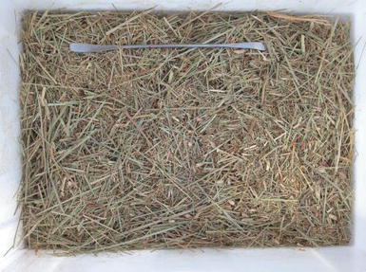

Figure 6: **Palm tree leaves.**

While their overall organic matter (as measured by loss on ignition) content is comparable, the mass, particle, and density of these agricultural wastes are distinct.”

**Table 2: Density and total organic matter in the wastes**

|  |  |  |
| --- | --- | --- |
|  | Palm tree leaves | Hay straw |
| Bulk density (kg/m3) | 84 | 29 |
| Particle density (kg/m3) | 870 | 405 |
| Organic matter (%) | 93.2 | 94.8 |

In accordance with UNE-EN13040:2008 and the soil analysis procedures of SSSA-ASA, cylinders comparable to those used to determine organic material densities were utilized for laboratory studies. Soil density and porosity were also altered by the agricultural wastes tested, which included air-dried palm tree leaves and hay straw chopped to a length of around 4 cm.

### ****Table 3: Root Architecture and Its Impact on Soil Properties****

|  |  |  |
| --- | --- | --- |
| **Root Type** | **Impact on Soil** | **Examples** |
| Fine Roots (<2 mm) | Enhance microporosity and water retention. | Grasses, cereals |
| Coarse Roots (>2 mm) | Create macropores, improve drainage. | Trees, shrubs |
| Shallow Roots | Stabilize surface soil and reduce erosion. | Turfgrass, ground covers |
| Deep Taproots | Break compacted layers, increase porosity. | Alfalfa, carrots |

**CONCLUSION**

The complex biophysical, biochemical, and biological processes by which root systems shape soil structure and hydraulic characteristics are crucial. Ecosystem health, agricultural production, and sustainable land management are greatly affected by the root-soil interactions, which in turn affect soil aggregation, porosity, hydraulic conductivity, and water retention. Root exudates, biopores, fine and coarse roots, and the soil itself all work together to keep the soil's physical qualities stable and promote microbial and plant development. In order to address soil health concerns, it is necessary to understand the varied properties of root systems, including architecture, depth, branching, and exudate composition. Soil erosion, compaction, and nutrient depletion may be reduced and water management optimized by taking use of these characteristics. Sustainable practices may be achieved in agricultural systems by using root-focused solutions. This is especially important in light of climate change and resource restrictions. Soil management may be enhanced by the development of root-based techniques, the improvement of root monitoring technologies, and the investigation of species-specific root effects. The future of our soil and ecosystems depend on our capacity to tap into the power of root systems.

**REFERENCES**

1. Eze S, Dougill AJ, Banwart SA, Hermans TDG, Ligowe IS, Thierfelder C. Impacts of conservation agriculture on soil structure and hydraulic properties of Malawian agricultural systems. Soil Tillage Res. 2020;

2. Galdos M V., Brown E, Rosolem CA, Pires LF, Hallett PD, Mooney SJ. Brachiaria species influence nitrate transport in soil by modifying soil structure with their root system. Sci Rep. 2020;

3. Hudek C, Putinica C, Otten W, De Baets S. Functional root trait-based classification of cover crops to improve soil physical properties. Eur J Soil Sci. 2022;

4. Lucas M, Santiago JP, Chen J, Guber A, Kravchenko A. The soil pore structure encountered by roots affects plant-derived carbon inputs and fate. New Phytol. 2023;

5. Bergmann J, Ryo M, Prati D, Hempel S, Rillig MC. Root traits are more than analogues of leaf traits: the case for diaspore mass. New Phytol. 2017;

6. Bronick CJ, Lal R. Soil structure and management: A review. Geoderma. 2005.

7. Bapir B, Abrahamczyk L, Wichtmann T, Prada-Sarmiento LF. Soil-structure interaction: A state-of-the-art review of modeling techniques and studies on seismic response of building structures. Frontiers in Built Environment. 2023.

8. Del Bianco M, Kepinski S. Building a future with root architecture. J Exp Bot. 2018;

9. Vives-Peris V, de Ollas C, Gómez-Cadenas A, Pérez-Clemente RM. Root exudates: from plant to rhizosphere and beyond. Plant Cell Reports. 2020.

10. Oleghe E, Naveed M, Baggs EM, Hallett PD. Plant exudates improve the mechanical conditions for root penetration through compacted soils. Plant Soil. 2017;

11. Or D, Keller T, Schlesinger WH. Natural and managed soil structure: On the fragile scaffolding for soil functioning. Soil Tillage Res. 2021;

12. Blanco-Canqui H, Wienhold BJ, Jin VL, Schmer MR, Kibet LC. Long-term tillage impact on soil hydraulic properties. Soil Tillage Res. 2017;

13. Leuther F, Schlüter S. Impact of freeze-thaw cycles on soil structure and soil hydraulic properties. SOIL. 2021;

14. Passioura JB. Soil structure and plant growth. Aust J Soil Res. 1991;

15. Czarnes S, Hallett PD, Bengough AG, Young IM. Root‐ and microbial‐derived mucilages affect soil structure and water transport. Eur J Soil Sci. 2000;

16. Höper H, Alabouvette C. Importance of physical and chemical soil properties in the suppressiveness of soils to plant diseases. Eur J Soil Biol. 1996;

17. Geris J, Verrot L, Gao L, Peng X, Oyesiku-Blakemore J, Smith JU, et al. Importance of short-term temporal variability in soil physical properties for soil water modelling under different tillage practices. Soil Tillage Res. 2021;

18. Glinski J, Lipiec J. Soil physical conditions and plant roots. Soil Physical Conditions and Plant Roots. 2018.

19. GENG D li, LI L, YANG Y sen, MA F wang, GUAN Q mei. Factors affecting hydraulic conductivity and methods to measure in plants. Journal of Integrative Agriculture. 2022.

20. Miyamoto N, Steudle E, Hirasawa T, Lafitte R. Hydraulic conductivity of rice roots. J Exp Bot. 2001;