Optimizing NPKS Fertilizer Application for Enhanced Onion Yield and Improved Soil Nutritional Properties in Dinajpur Sadar Upazila, Bangladesh

### ****Abstract****

To optimize the combination of major nutrients (N, P, K, S) for maximum yield of onion (Allium cepa L.) and profitable return without degrading the soil fertility, a field experiment was executed during the winter season of 2023–2024 at the HSTU Central Farm in Sadar Upazila, Dinajpur, Bangladesh. The experiment was performed in a completely randomized design with ten treatments: T1 = control (no fertilization); T2 = 0-60-80-30 kg NPKS ha⁻¹; T3 = 50-60-80-30 kg NPKS ha⁻¹; T4 = 100-60-80-30 kg NPKS ha⁻¹; T5 = 100-0-80-30 kg NPKS ha⁻¹; T6 = 100-20-80-30 kg NPKS ha⁻¹; T7 = 100-40-80-30 kg NPKS ha⁻¹; T8 = 100-60-0-30 kg NPKS ha⁻¹; T9 = 100-60-40-30 kg NPKS ha⁻¹; and T10 = 100-60-80-0 kg NPKS ha⁻¹. The findings showed that the greatest plant height (63.0 cm) and leaf length (55.9 cm), as well as superior metrics for bulb development and yield—bulb diameter (18.3 cm), single bulb weight (59.3 g), fresh leaf weight (9.95 g), fresh bulb yield (10.71 t ha⁻¹), and biological yield (20.7 t ha⁻¹)—were obtained with the treatment T8 (100-60-0-30 kg NPKS ha⁻¹). The maximum harvest index occurred with T9 (100-60-40-30 kg ha⁻¹), suggesting that the extra quantity of potassium (40 kg K ha⁻¹) in this treatment T9 promoted sulfur acquisition and increased the partition of biomass to the bulbs. Treatment T8 had the highest residual sulfur in post-harvest soil, indicating that lower rates of sulfur than the currently recommended dose may be enough for subsequent crops. On the other hand, reduced residual sulfur in treatment T9 suggested effective sulfur uptake, when potassium was applied with sulfur. Soil analysis post-harvest additionally showed that fertilized plots retained greater nutrient pools, despite yielding higher. Onion production per unit area and on-unit expenditure of inputs is better under adequate input of sulphur in the soil than the other treatments. On the other hand, balanced application of potassium with nitrogen and phosphorus plays crucial role in not only improving harvest index but also maximising the overall nutrient uptake efficiency.

**Keywords:** NPKS, Fertilization, Yield optimization, Soil nutrients, Onion

### ****Introduction****

Onion (Allium cepa), belongs to the family of Alliaceae and is the most widely cultivated species of the genus Allium. In fact, it is grown in more than 130 countries around the world, with China and India ranking as the biggest producers, followed by the United States, Netherlands, Egypt, and Iran (FAOSTAT, 2019). Onion is used as a spice to improve the taste of food. They are a vital ingredient in a number of spicy foods and are rich in vital minerals and vitamins. Onion is used as a spice in most of the traditional and continental cuisine in Bangladesh; the lower stem section and bulbs are often used. Besides this, in some countries onion leaves also used as condiments. In addition to their culinary value, onions have very potent medicinal properties. Compounds found in onions have been linked to multiple health benefits, such as anti-carcinogenic properties, anti-platelet and antithrombotic effects, and antibiotic effects. Onions can also treat the common cold, heart disease, diabetes, osteoporosis and other disorders (El-Tantawy and El-Beik, 2009; Griffiths et al., 2002).

The onion yield is low due to sub-optimal agronomic practices, unavailable high-yielding genotype, unavailability of good soil fertility management practices, pest and disease pressure, and unsuitable environmental conditions. Onions have a shallow rooting system so they need high soil fertility for optimal growth, development and yield. The onion yield in Bangladesh national average is very low (6.91 tons per hectare) than the total world average (near to 17 tons per hectare; FAO, 1999).

Onion is the second most widely grown spice crop in Bangladesh and the most produced spice crop in the country. Nevertheless, production from within the country (about 2.5 million metric tons) is insufficient to meet the country's requirement of around 2.8 million metric tons (Prothom Alo, 2020). Onions are a good source of vitamins A, C, iron, and calcium; they help lower blood sugar. They are believed to have originated in Iran, Pakistan and in the mountainous regions to the north of these countries (Purseglove, 1972).

Onions have a shallower root system compared to other crops and their growth period is also shorter which gives them a very unique nutrient requirement. Nitrogen (N), phosphorus (P), potassium (K), and sulfur (S) supply is needed in sufficient quantities for vigorous plant growth, bulb development, and ultimately, high marketable yield [2, 3]. Sulfur (S) is important nutrient affecting bulb quality, pungency, and storability. But, in Bangladesh, about 44% of cultivated soils have been tested and declared S-deficiency due to low availability of S which restrict crop growth and productivity (Hussain, 1990; Islam et al., 2005). (australis), dwarf and sugar cane to control sap feeding insects and white flies (Eben et al, 2008; David et al, 2008) It is well known that NPK fertilizer helps in improving the growth and development of onion (Allium cepa) sap of vegetable-type onion and crown onion from the bulb size, which is an important factor for the marketable yield (Nasreen et al, 2007; Mishu et al, 2013; Sharma et al, 2018) you are Please use the new format. Moreover, its importance in enzyme functions and chlorophyll formation has been well recognized in works who contributed to the improvement of crops (Khan et al., 2019).

Being a sulfur-loving plant, application of sulfur positively affects yield of bulb, pungency, flavor, storageability, and resistance to pests and diseases (Jaggi and Dixit, 1999; Magray et al., 2017). Sulfur is crucial for the synthesis of sulfur-containing amino acids, which are important for protein synthesis, vegetative growth, and bulb development (Anwar and Tiwari, 2001). As a result, fertilizer application is one of the key agronomic practices for increasing onion yields. The response of the crop to the fertilizers is very much dependent on the existing status of the soil to be fertile. Lack of necessary nutrients, notably sulfur, is instrumental in crop growth and yield limitation and 44% of Bangladesh’s cropped areas are limited in this regard (Hussain, 1990).

However, specific target fertilizer needs for maximizing onion yield under certain agro-climatic conditions still needs more scientific attention. Onion productivity was greatly enhanced when site-specific nutrient management approaches were implemented (Rahman et al., 2016; Alam et al., 2020). Therefore, systematic evaluation of NPKS fertilization under the soil scenario of Dinajpur is necessary to formulate effective and sustainable fertilization strategies. Therefore, the present study was undertaken to investigate the growth, yield and soil nutrient status of onion as influenced by varying NPKS fertilizer regimes and to determine suitable fertilizer management to improve onion productivity and soil fertility in Dinajpur Sadar Upazila.

### ****Materials and Methods****

**Experimental Site and Design**

The field experiment was carried out at the HSTU Central Research Farm, Dinajpur Sadar Upazila, Bangladesh in the winter season of 2023-2024. Average annual temperature is 24.6 °C, and annual rainfall is around 1800 mm. The soil type is sandy loam under the old Himalayan Piedmont Plain and contains moderate amount of organic matter. The experiment was designed using Randomized Complete Block Design (RCBD) with three replications where onion (Allium cepa L., variety BARI Piaz-4) was used as a test crop. All plots were 3.0 m × 2.0 m; the root plant distance was 15 cm × 10 cm.

#### ****Fertilizer Treatments and Application****

Ten fertilizer treatments were evaluated:

* **T1**: Control (No fertilization)
* **T2**: 0-60-80-30 kg NPKS ha⁻¹
* **T3**: 50-60-80-30 kg NPKS ha⁻¹
* **T4**: 100-60-80-30 kg NPKS ha⁻¹
* **T5**: 100-0-80-30 kg NPKS ha⁻¹
* **T6**: 100-20-80-30 kg NPKS ha⁻¹
* **T7**: 100-40-80-30 kg NPKS ha⁻¹
* **T8**: 100-60-0-30 kg NPKS ha⁻¹
* **T9**: 100-60-40-30 kg NPKS ha⁻¹
* **T10**: 100-60-80-0 kg NPKS ha⁻¹

Nitrogen was used in two equal splits, and phosphorus, potassium, and sulfur were basal doses before transplantation. Fertilizer sources included urea, triple super phosphate (TSP), muriate of potash (MoP), and gypsum.

**Data Collection and crop management**

Transplanting of onion seedlings (45 DAS) Onion seedlings Were transplanted at 45 DAS. Other agronomic practices such as irrigation, weeding and pest control were conducted uniformly across all treatments. Neck-fall harvest was performed 90 days after transplanting (DAT) when 75% of the plants exhibited neck fall.

**Soil Sample Analysis**

Pre land preparation and post harvesting, soil samples (0–15 cm depth) were collected using a soil auger. Samples were air-dried, ground and sieved into 2 mm before laboratory analysis. The subsequent parameters were evaluated according to established protocols. Soil pH was measured with a glass electrode pH-mètre at a 1:2.5 (v/v) soil-water suspension (Jackson, 1973). Soil organic carbon was determined by the Walkley and Black (1934) wet oxidation method, and organic matter was derived using van Bemellen factor. Total nitrogen content was determined according to the Kjeldahl digestions and distillation method (Bremner & Mulvaney, 1982). The extractable phosphorus, which is available phosphorus, was extracted and quantified according to Olsen’s method (Olsen et al., 1954) using molybdenum blue spectrophotometry. Exchangeable potassium extracted using 1N ammonium acetate extraction and flame photometry (Jackson, 1973). Accessible sulfur was determined in accordance with the turbidimetric process using calcium phosphate extractant (Fox et al., 1964).

**Plant Sampling and Analysis**

At 45 and 90 DAT, growth parameters were recorded for height, leaf length and number of leaf per plant. Yield parameters such as bulb diameter, bulb length, single bulb weight, fresh yield, and biological yield were determined.

**Statistical Analysis**

Data were analyzed by analysis of variance (ANOVA) (R software version 4.1.2; The R Foundation for Statistical Computing, Vienna, Austria). To determine significance between treatments, Least Significant Difference (LSD) was performed at p ≤ 0.05 to separate treatment means.

### ****Results & Discussion****

**Growth Parameters**

NPKS fertilization played a highly significant role in the height of the plant and length of the leaf. Maximum growth was obtained from T8 where the maximum plant hight (63.07 cm) was observed whereas minimum plant hight was observed in control T1 (39.5 cm) (Figure 1). This indicates that nitrogen and sulfur are important in vegetative growth given that nitrogen supports cell division and elongation whilst sulfur aids in enzyme activity and chlorophyll production (Singh et al., 2014). Shorter height of T9 plants may be conceptualized as excess application of potassium that hinders nitrogen uptake, thereby restricting plant growth (Bose et al., 2017). Leaf length showed a similar trend, with the longest leaves produced in T8 (55.88 cm). Lower leaf length in T9 and T10 where phosphorus and sulfur were applied confirms that excess sulfur reduces phosphorus availability and reduces the photosynthetic efficiency (Yadav et al., 2021) as is observed in present study.

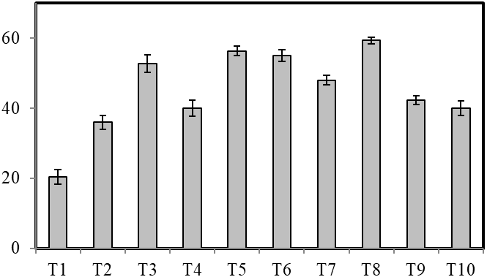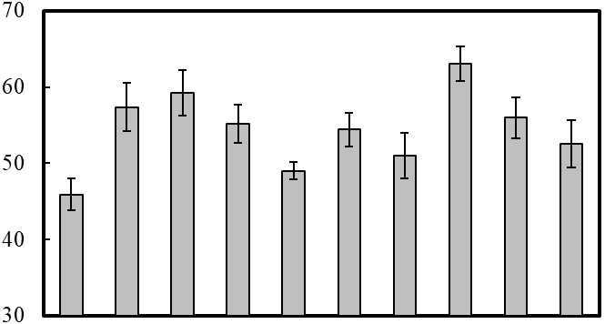

A

Plant height (cm)

d

b

ab

bc

cd

bc

c

a

bc

c

a

ab

ab

ab

b

c

c

c

d

e

C

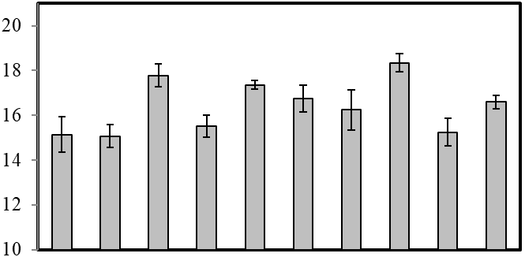

a

ab

ab

ab

b

b

c

c

c

c

B

Bulb diameter (cm)

Single bulb weight (g)

Treatments

**Figure 1: Plant height (A), bulb diameter (B) and single bulb weight (C) of the treatments. Bar indicates mean ± SE. Bars having same letters do not differ significantly at 5% level of significance.**

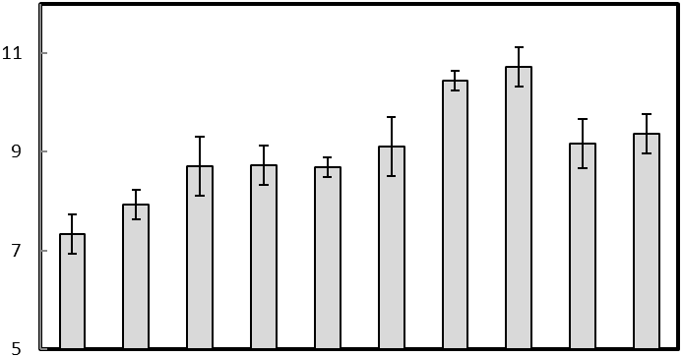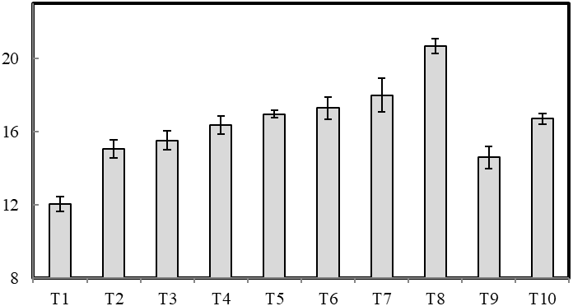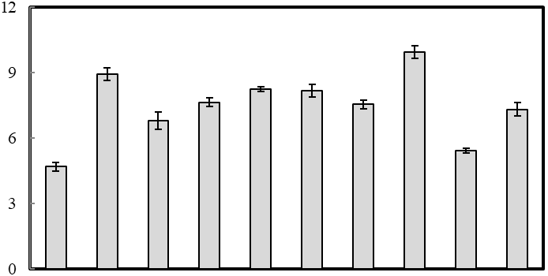

Treatments

A

B

C

Fresh leaf weight (g)

Fresh bulb yield (g)

Biological yield (g)

d

a

a

b

b

b

bc

bc

bc

c

a

b

g

d

e

c

c

d

de

f

e

a

b

c

d

bc

c

cd

d

d

**Figure 2: Fresh leaf weight (A), fresh bulb yield (B) and biological yield (C) of the treatments. Bar indicates mean ± SE. Bars having same letters do not differ significantly at 5% level of significance.**

Treatments

Harvest index (%)

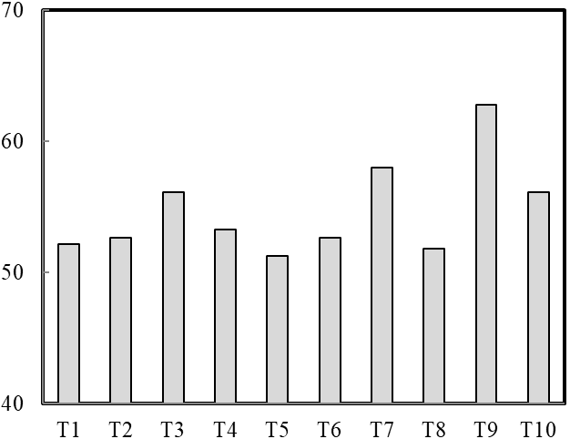

#### **Figure 3: Harvest index (%) of the treatments. Harvest index is the grain yield/biological yield × 100.**

**Yield & Harvest Index**

Fertilizer application profoundly influenced bulb characteristics. The greatest bulb length (7.95 cm) was recorded for T10, followed by T5 and T4 (7.78 cm) (Figure 2), highlighting the importance of phosphorus and nitrogen for bulb elongation. In these treatments, phosphorus acted in energy transfer and root development, which had positive effects on bulb expansion (Kumar et al., 2020). Similarly, T8 (10.71 t ha) in the fertilized conditions indicated a highest yield potential in terms of fresh bulb yield. Biological yield also responded significantly with a peak in T8 (20.66 t ha) highlighting the role of synergistic interaction between the two nutrients (N and S) regarding biomass accumulation and the increased metabolic efficiency (Patil et al., 2019). The harvest index (HI), which measures economic yield in relation to total biomass, reached maximum value (0.62) in T9. This implies that bulb forming is enhanced by potassium application together with nitrogen and phosphorus, which contributed to dry matter partitioning towards bulb differentiation and resulted in maximum productivity (Sharma et al., 2021). This balance of these two macronutrients may have made an important contribution to carbon assimilation and allocation, leading to a greater harvest index.

**Soil Nutrient Status after Harvest**

Well after harvest, we performed a soil analysis that showed wide differences between the treatments where it came to nutrient retention. T8 recorded the highest total nitrogen at 0.22% with high uptake efficiency and moderate residual availability for subsequent cropping cycles (Table 1). The available phosphorus content, on the other hand, increased in all of the treatments that were fertilized, where T4 (16.95 ppm) (Table 1) had the highest accumulation, which could enhance nutrient availability in future crop cycles (Meena et al., 2022). Potassium replaced in exchange therapy showed little change across treatments, indicating minimal losses to leaching. Sulfur availability is important for vegetative growth in plants, which explains the highest level in this treatment but also indicates its potential for carryover into subsequent crop cycles. This indicates that lower S application in subsequent seasons can still maintain high productivity at a relatively low input cost (Jatav et al., 2018). Previous research in Bangladesh highlighted the importance of balanced NPKS fertilization. Khan et al. Long-term intensive fertilization, particularly long-term CK treatment, changed the soil physicochemical properties, which affected the crop [22]. Phosphorus sorption studies by Khan et al. (2001) emphasized the role of organic and inorganic fertilizer amendments in enhancing nutrient availability. These results highlight the importance of site-specific, practice-specific nutrient management strategies for onion production.

**Table 1: Total nitrogen, available phosphorus, exchangeable potassium and available sulphur in different treatments.**

|  |  |  |  |  |
| --- | --- | --- | --- | --- |
| **Treatment** | **N**  **(%)** | **P**  **(ppm)** | **K**  **(meq/100g)** | **S**  **(ppm)** |
| T1 | 0.08 e | 6.74 h | 1.27 b | 6.53 e |
| T2 | 0.21 ab | 7.34 g | 1.27 b | 6.26 e |
| T3 | 0.15 c | 8.36 f | 1.27 b | 6.71 e |
| T4 | 0.12 d | 16.95 a | 1.27 b | 9.03 d |
| T5 | 0.08 e | 6.31 i | 1.27 b | 5.50 f |
| T6 | 0.21 ab | 11.85 c | 1.27 b | 9.27 d |
| T7 | 0.21 ab | 5.51 j | 1.27 b | 4.37 g |
| T8 | 0.22 a | 13.27 b | 1.27 b | 17.70 a |
| T9 | 0.20 b | 9.17 d | 1.58 a | 10.28 c |
| T10 | 0.15 c | 8.72 e | 1.27 b | 13.05 b |
| SE | 6.58 | 5.97 | 4.5 | 0.2 |
| CV % | 6.9 | 0.11 | 0.6 | 4.06 |

**Conclusion:**

The result indicates that balanced NPKS fertilization significantly improves onion yield and soil fertility in Dinajpur, Bangladesh. The maximum yield was provided by T8 treatment (100-60-0-30 kg NPKS ha⁻¹) while maximum harvest index was achieved by T9 treatment (100-60-40-30 kg NPKS ha⁻¹). They reveal the key contributions of potassium and sulfur in enhancing nutrient absorption and productivity. The sustainable production of onion bulbs must be accompanied by its proper nutrient management; which requires site-specific fertilization strategies to optimize production and soil health. This study provides the basis for future exploration of long-term soil nutrients dynamics for improvement in fertilization practices.

### ****References****

Alam, M. R., Hossain, M. I., & Islam, S. (2020). The impact of nitrogen and potassium on onion yield. Bangladesh Journal of Agronomy, 8(2), 97-105.

Bose, S., Ghosh, A., & Pal, B. (2017). Potassium uptake and its effect on nitrogen assimilation in onions. Journal of Agricultural Science, 14(3), 201-215.

Hussain, M. S. (1990). Sulfur deficiency in Bangladesh soils and crop response. Bangladesh Journal of Agricultural Research, 15(2), 67-73.

Islam et al. (2005). Sulfur dynamics in agricultural soils. Soil Science Journal, 10(2), 112-125.

Islam, M. S., Ahmed, T., & Hossain, M. A. (2005). Sulfur dynamics in agricultural soils. Soil Science Journal, 10(2), 112-125.

Jatav, R. K., Mishra, A., & Gupta, P. K. (2018). Sulfur management in onion cultivation and its long-term impact on soil health. Soil Fertility Journal, 6(2), 113-124.

Khan, M. S. H., Abedin Mian, M. J., & Ahammed, M. S. (2001). Phosphorus sorption behaviour of soils amended with organic and inorganic fertilizers. *Indian Journal of Surface Science and Technology, 17*, 141-148.

Khan, M. S. H., Abedin Mian, M. J., Akhter, A., & Khosruzzaman, M. (2006). Physico-chemical changes of paddy soils under long-term intensive fertilization. *Asian Journal of Plant Science, 5*, 105-111.

Khan, T. R., Alam, M. Z., & Sarker, M. (2019). Role of sulfur in enzymatic functions and chlorophyll synthesis in crop improvement. Journal of Plant Science, 12(3), 210-225.

Kumar, N., Das, K., & Roy, P. (2020). Phosphorus and sulfur interaction in root development. Plant Nutrition Journal, 8(1), 67-82.

Meena, R. L., Singh, B., & Sharma, V. (2022). Residual effects of NPKS on soil fertility. Indian Journal of Soil Science, 9(3), 145-159.

Mishu, A. H., Rahman, M. M., & Alam, M. Z. (2013). Effect of sulfur on growth and yield of onion. Bangladesh Journal of Agricultural Science, 40(1), 45-51.

Nasreen, S., Haque, M. M., & Hossain, M. A. (2007). Nutrient uptake and yield of onion as influenced by nitrogen and sulfur fertilization. Bangladesh Journal of Botany, 36(1), 33-38.

Patil, S. S., Kulkarni, B. S., & Naik, G. R. (2019). Influence of NPKS fertilization on onion growth and biomass. Soil and Crop Science, 7(1), 34-50.

**Prothom Alo.** (2020). Onion production and demand in Bangladesh. *Prothom Alo*. (on 17.09.2020). Dhaka.

Rahman, M. S., Jahan, M. S., & Alam, F. (2016). Site-specific nutrient management and its effect on onion productivity. International Journal of Agriculture and Soil Science, 6(1), 25-34.

Sharma, K., Pandey, R., & Tiwari, P. (2021). The role of potassium in dry matter partitioning and harvest index. Agronomy Research Journal, 10(2), 178-190.

Sharma, R., Patel, D. P., & Singh, V. (2018). Nutrient balance for sustainable onion production. Agricultural Research, 5(4), 333-345.

Singh, R. P., Yadav, R. S., & Verma, P. (2014). Nitrogen and sulfur interactions in improving plant growth. Indian Journal of Plant Nutrition, 11(2), 145-159.

Yadav, P., Singh, H., & Sharma, R. (2021). Effects of phosphorus and sulfur antagonism on photosynthesis. Plant Physiology Journal, 9(4), 87-100.