***Original Research Article***

**A note on the typification of *Myrsine semiserrata* Wall. (Primulaceae)**

**ABSTRACT**

*Myrsine semiserrata* was described by Wallich in Roxburgh’s Flora Indica based on the materials collected by him from Nepal. The species was first collected by Wallich while he was travelling through different parts of Nepal. Herbarium specimens were studied from different herbaria across the globe. In the country different herbaria like ARUN, ASSAM, BSD, CAL, DD, Llyod Botanic Garden herbarium, Guwahati University herbarium were visited to record the morphological variations present in the species. This work deals with detailed morphological study and also all the available materials collected by Wallich is studied and explained. A lectotype has been selected here for *M. semiserrata*.

*Keywords: India, Lectotype, morph-variation, Nepal, polygamodioeceous.*

**1. INTRODUCTION**

The genus *Myrsine* was first described by Linnaeus (1753) in Species Plantarum based on the species *Myrsine africana* from Ethiopia. In world it is represented by 282 species (POWO, 2025) and in India the genus has 7 species (Roy & Pramanik, 2020). In India it is distributed in Himalayas, North-eastern states and in peninsular India. Among the 7 species known so far from the country, 2 of them are found only in Himalayas and in north-east, 4 species are known from Peninsular India and the rest single species is found occurring in both the regions.

*Myrsine semiserrata* was described by Wallich in Roxburgh’s Flora Indica (1824). The species was first collected by Wallich while he was travelling through different parts of Nepal. Later it was reported from south east and south-central China, Indo-China, Myanmar, Nepal, Pakistan, Thailand, Tibet and India. From India it is reported from states of north-east, Darjeeling and Sikkim Himalayas and Uttarakhand. The species is a shrub with shiny serrated leaves and fascicle inflorescence with polygamodioeceous flowers. As the species is distributed in India through the Himalayas and north east, it has a wide range of foliar characters which is often confused by workers leading to mis-identification. In recent times Liao & al. (2015) identified such a problem regarding the identity of *Myrsine semiserrata* and *Xylosma fasciculiflora* S.S. Laiof Salicaceae where the herbarium materials tagged with *Xylosma fasciculiflora* were actually specimens of *Myrsine semiserrata*. Thus, the species was reduced under the synonymy of *Myrsine semiserrata* (Liao & al., 2015). Thus, to avoid more complexities within the group the species was studied in detail.

While studying the genus *Myrsine* for the Flora of India Project, a search for the type of *Myrsine semiserrata* was conducted in relevant herbaria. This could find multiple original materials deposited in different herbaria of the world. Thus, typification of the name *Myrsine semiserrata* has been addressed here along with taxonomic treatment, description, phenology, distribution and image of the type material selected here as lectotype, for better understanding of the species.

**2. MATERIAL AND METHODS**

Herbarium specimens were studied from different herbaria across the globe. In the country different herbaria like ARUN, ASSAM, BSD, CAL, DD, Llyod Botanic Garden herbarium, Guwahati University herbarium were visited to record the morphological variations present in the species. Dissections were done for detailed study. Different online herbarium databases like E, K, P, BM, HUH, LE, NYBG were contacted and the materials found were studied. Field visits were conducted to Uttarakhand, Darjeeling, Sikkim, Meghalaya, Arunachal Pradesh to find the species in its natural habitat.

3. results and discussion

After studying a wide range of specimens from different herbaria across the globe the following taxonomic account was prepared for *Myrsine semiserrata*.

**Taxonomic Treatment:**

**Myrsine semiserrata** Wall. in Roxb., Fl. Ind. 2: 293. 1824; A. DC. in DC., Prodr. 8: 93. 1844; C.B. Clarke in Hook.f., Fl. Brit. India 3: 511. 1882; Mez in Pflanzenr. (Engler) Myrsin. 236. Heft. 9: 339. 1902; Kanjilal & al., Fl. Assam 3: 166. 1939; Raizada & H.O. Saxena, Fl. Mussoorie 1: 415. 1978; N.P. Balakr., Fl. Jowai 1: 288. 1981; K.K. Khanna, Dicot. Pl. Uttar Pradesh: 230. 1999; Giri & al., Mat. Fl. Arunachal Pradesh 2: 126. 2008; Sinha & al., Fl. Mizoram 2: 42. 2012; S.S. Dash & P. Singh, Fl. Kurung Kumey Dist. 455. 2017; Roy & Pramanik in S.S. Dash & A.A. Mao, Flowering Pl. India, an Annotated Chckl. 2: 54. 2020. **Type:** Lectotype (designated here): Nepal, Legi, 1821, *Wallich* 2295 (K000639665!) [Digital Image]. **Residual syntypes:** Nepal, 1821, *Wallich* 2295 (K001115585!, K001115586!, K001115587!, P00463821!, P00463823!, P00463822!). *Myrsine subspinosa* D. Don, Prodr. Fl. Nepal.: 147. 1825. *Myrsine acuminata* Royle, Ill. Bot. Himal. Mts.: 265. 1835. *Myrsine khasyana* Kurz, J. Asiat. Soc. Bengal, Pt. 2, Nat. Hist. 46: 21. 1877.

Bushy shrubs with spreading porrect branching; branches terete, lenticillate, glabrous, young shoot hairy, punctate. Leaves alternate, simple, petiolate; petioles c. 1 cm long, slender, stout, sometimes lamina continuing as frill upto petiole, glabrous; lamina 3.8 – 13.3 × 1 – 4.6 cm, lanceolate, base attenuate, margin 3/4th serrated on both sides or half of lamina serrated, rarely serrated on one side or reduced to single serration, sometimes entire, apex attenuate, mid vein distinct, secondary veins round up at sub-marginal region (brochidodromous), vein endings enter serrations, punctations throughout on the dorsal surface, at margin in continuous line, on mi-rib dorsally, glabrous on both sides. Inflorescence axillary fascicle, sessile or very shortly peduncled. Flowers bracteate; bract 1, ovate, margin entire, sparsely hairy with subulate hairs; pedicellate; pedicels slender, 0.6 – 1 cm long, tetramerous, polygamodioecious, light green. Sepals 4, gamosepalous at base, c. 1 mm long, ovate, apex acute, margin entire, rarely with orange glandular hairs with elliptic head, glabrous on both surfaces, punctate; punctations globose, black, present throughout the sepals. Petals 4, lobes free, c. 2 mm long, elliptic or oblong, apex obtuse, margin entire, sparsely hairy at apex; hairs glandular with elliptic orange head, punctate; punctations globose, black, present near apex, sometimes at middle in smaller size, greenish white. Stamens 4, epipetalous, c. 1.2 mm long, anthers bi-celled, oblong, dorsifixed, dehisced longitudinally, filaments flattened, flap-like. Ovary ovoid, c. 2.3 mm, glabrous, style columnar, glabrous, stigma fimbriate. Male flowers: petals recurve to expose stamens; stamens elliptic, dorsifixed, small beak present at the apex, filament flattened, flap-like. Ovary rudimentary, style and stigma not differentiated, forming flattened sausage shaped structure. Fruits globose, stigma persistent, initially pink to mauve, changing to blue and finally black when ripe.

**Flowering & Fruiting:** February – September or almost throughout the year.

**Distribution:** INDIA: Arunachal Pradesh, Assam, Manipur, Meghalaya, Nagaland, Sikkim, Uttarakhand, Uttar Pradesh, West Bengal. BHUTAN, CHINA, NEPAL, MYANMAR, PAKISTAN, TIBET, VIETNAM.

**Specimens examined:** India: **Arunachal Pradesh:** Lohit, Douliang to Jamliang, 23.11.57, *Rolla Seshagiri Rao* 10785 (CAL); NEFA, Thungri, 5.4.1957, *G. Panigrahi* 6515 (CAL); Kameng, Jabrang to Thergri, 5.4.1957, *G. Panigrahi* 6470 (CAL); Kameng, Sissini, 29.03.1957, *G. Panigrahi* 6264 (CAL); Bomdila camp, way to Dirang gung, 13.04.1957, *G. Panigrahi* 6882 (CAL); Rupa to Jegaon, 9.4.1957, *G. Panigrahi* 6693 (CAL); Tirap, Noglo, 26.06.1961, *D.B. Deb* 26326 (CAL); Talley Valley, 23.4.85, *Dr. K. Haridasan* 2013 (ARUN); Lohit District, 16.11.83, *K. Haridasan* 0099 (ARUN). **Assam:** Puipounji, 1893, *G. Mann* 277222 (CAL); E. Bengal, s.d., *Griffith* 3539 (MH). **Manipur**: Imphal, 11.02.54, *D.B. Deb* 1834 (CAL); Kabru hill, 19.12.53, *D.B. Deb* 1496 (CAL); Mao, 02.1881, *George Watt* 6128, 6142 (CAL); Karong, 02.1882, *George Watt* 6057 (CAL). **Meghalaya**: Jowai, October1892, *Dr. King's collector* 277238 (CAL); Shillong, 20.03.1892, *D. Prain* 277137 (CAL); Shillong, 20.03.1892, *D. Prain* 277137 (CAL); Shillong peak, 22.12.1957, *G.K. Deka* 3951 (CAL); Pynursla, 04.11.38, *K. Biswas* 4052 (CAL); Dawki, 26.11.56, *G. Panigrahi* 4543 (CAL); Shillong-Jowai road, March 1892, *D. Prain* 277219 (CAL); Cherrapunji, August 1878, *Geo Gallatly* 571 (CAL); K & J Hills dist., Mawsmai, 5.1.1959, *G. K. Deka* 18120 (CAL); Shillong peak, 15.07.1913, *Upendranath Kanjilal* 2307(CAL); Shillong, 04.1890, *H. Collett* 277239 (CAL); K & J Hills, Cherra, 4233 ft., 15.11.1967, *Akbar Carlson* 21190 (ASSAM); K & J Hills, Mausmai, 13.9.1931, *P.C. Kanjilal* 9483 (ASSAM). **Nagaland**: Kohima to Nevhema, 22.05.1895, *G. Watt* 11631(CAL); Naga hills, Shanshak, December 1907, *A. Meebold* 7043 (CAL); Japoo, Naga hills, May 1895, *G. Watt* 11469 (CAL). **Sikkim**: Sikkim Himalaya, s.d., *G. King* 277227 (CAL); Sikkim Himalaya, 1881, *Griffith* 3540 (CAL); Rungbee, 10.03.1871, *C.B. Clarke* 13969D (CAL); Sikkim Himalaya, Choong thang, May 1885, *G. King's collector* 277217 (CAL); Dumthang, April 1877, *J.L. Lister* 277264 (CAL); Sikkim, Sumsing, s.d., *J.S. Gamble* 277282A (CAL); Sikkim, s.d., *Herb. Ind. Or. Hook. f. & Thomson* 58 (CAL); Sikkim, s.d., *Rolla Seshagiri Rao* 206 (CAL); Cheongtong, 16.09.1892, *G.A. Gammie* 1244 (CAL); Sikkim, Boldum, 10.11.75, *Dongboo* 277287 (CAL); Sikkim, Rungpo, 04.04.1881, *G. King s.n.* (CAL); East Sikkim, Takchi forest, 15.12.1981, *B. Krishna* 2106 (BSHC); North Sikkim, Lachung to Chungthang, 16.9.1988, *S. Kumar and S. Singh* 9782 (BSHC); West Sikkim, Hilley R.F., 11.5.95, *P. Singh and S.K. Rai* 17032 (BSHC). **Uttarakhand**: Naini Tal, April, *R. Strachey, J.E. Winterbottom* 2 (CAL); Deota forest, Tehri Garhwal, 08.05.99, *J.F. Duthie* 22541 (CAL); Kumaon, Kaluna, 9.7.1913, *N. Gill* 579 (CAL); Bhalnety, 27.01.1913, *N. Gill* 552 (CAL); N.W. Himalaya, 1877, *Duthie* 65 (CAL); Naini Tal, 27.06.65, *J.F. Duthie* 277227A (CAL); Mussoorie, 17.12.1956, *G.S. Puri* 10784 (CAL); Almora Dist., Binsar, 2250m, 21.10.1975, *S.N. Vohra* 58130 (BSD); Garhwal, Lansdowne, 2000m, 24.2.1960, *J.N. Vohra* 10683 (BSD); Almora, Debra, 8500ft, 18.10.1975, *B.M. Wadhwa* 57704 (BSD); Mussoorie, 2000m, 3.4.1966, *C.L. Malhotra* 36829 (BSD); Below Mussoorie, Jan 1900, *U. Kanjilal s.n*. (DD); Nainital divn., Patwadunga, 5000ft, 20.4.25, *A.E. Osmaston* 1251 (DD); Nainital, Haldwani divn., June 1937, *H.G. Champion* 6110 (DD); Dehradun, Chakrata, 2430m, 14.4.1922, *R.N. Parker* 59 (DD); East Almora, Ramganga valley, 4000ft, 14.1.32, *A.E. Osmaston* 1481 (DD). **Uttar Pradesh:** Uttar Pradesh, 4.5.1916, *R.S. Hole* 8 (CAL). **West Bengal:** Darjeeling, Mungpoo, 11.1.1909, *Kari (native collector)* 97(CAL); Darjeeling, 14.02.77, *J.S. Gamble* 2500B (CAL); Labah, 07.04.08, *Rhomoo* 166 (CAL); Darjeeling, Llyod Botanic Garden, 05.1903, *G.H. Cave* 6 (CAL); Darjeeling, Rungbee, 25.08.1869, *C.B. Clarke* 8828C(CAL); Chos pokri to Tongloo, 13.04.1881, *G. Watt* 7010 (CAL); Darjeeling, Manebhanjan, 30.4.2016, *Rijupalika Roy* 62029 (CAL).

**Note on taxonomy:**

The species *Myrsine semiserrata* is highly polymorphic and bears a wide range of variation which led to many species and infra-specific taxa. At times it is difficult to distinguish between the forms present. Leaf characters are highly variable which can range from serrated to entire margin, shinny to coriaceous leaves. Pedicel length may vary to minute to very long and distinct ones. Wallich collected the specimens from different locations of Nepal and found these highly variable characters. He placed all these morph-variations under a single species which has been followed in the present account.

The specimens found at Meghalaya were not with much shiny leaves and were broadly lanceolate, pedicels distinct but not as long as type material. In Darjeeling Himalayas also, the plants have broader lanceolate leaves, bisexual flowers with exposed fimbriate stigma. While the specimens from assam have leaves narrowly lanceolate, shinny, pedicels quite long which is similar to the description in the protologue. Specimens of Brahmaputra valley have shiny leaves but pedicels of intermediate length (Fig. 1). Thus, after studying specimens from different locations across its distributional range in the country, it is evident that *Myrsine semiserrata* has a wide range of characters and all its forms should be treated as a single species.

**Note on typification:**

The species was described by Wallich based on his own collections and observations in different locations (Chundragiri, Sheopore, Western boundary of Nepal) of Nepal. Thus, quite a number of specimens were found deposited in different herbaria across the world.

**K000639665!:** This specimen holds the label of Wallich with catalogue number 2295. It was collected from Legi in Nepal in the year 1821, long before the species was described. Thus, this specimen is considered to be one of the original materials. This specimen has two twigs, one with fruit and other with long pedicelled flowers.

**K000756359!:** The specimen has been identified as a type specimen of *Pilogyne kerii* Gagnep, a synonym of *Myrsine semiserrata*. Additionally, it has been labelled as lectotype but this specimen does not constitute the original material as it was not collected by Wallich from the type locality.

**K001115585!:** The specimen has Wallich’s own handwriting and was collected from ‘Nepolia’ in 1821. It also has the number 2295 written on it. So, it is also considered as one of the type materials. The twig has flowers with medium length pedicels.

**K001115586!:** This specimen is another original material collected by Wallich from Nepal in the same year with the same number, but the twig is in fruiting.

**K001115587!:** This specimen consists of a twig with flowers having very short pedicel length. It has Wallich’s own handwriting inscribing ‘Nepolia, 1821’ and the number ‘2295’. Thus, it is also considered as a type material.

**K001115587!:** This specimen was collected by Wallich from Sylhet. A label attached mentions that it was collected from ‘Cherra Poonji’ on Dec 1829 which is a post-dated collection. Thus, although it has the number ‘2295’ but it can not be considered as a type material due to its collection locality and time.

**HUH00025567!:** The specimen was collected by Wallich from Nepal in the year 1830. It also mentions the same collection number ‘2295’. But as the specimen was a post-dated collection, it cannot be considered as a part of the original collection.

**NYBG00016423! & NYBG00016424!:** This herbarium sheet has two barcodes attached to it. Barcode 00016423 represents a specimen in fruiting which was collected by J.D. Hooker and Thomson & Thomson from Sylhet much later the species was described. Another barcode 00016424 represents two twigs in flowering and the herbarium label suggests that they were collected from two different localities, Mt. Sylhet and Nepal. But, it is difficult to confirm which specimen was collected from Nepal and should be considered as a part of the original material.

**Mus. Botan. Stockholm 09-44574! & 09-44575!:** The herbarium sheet possesses two barcode numbers. Herb. No. S 09-44575 represents the collection by J.D. Hooker and Thomson & Thomson. Thus, not considered as type material. Herb. No. S 09-44574 represents a flowering twig and label with ‘Wallich’ and number ‘2295’. Thus, it is considered as an original material.

**P00463821! & P00463823!:** Both these specimens deposited at Paris herbaria is definitely a part of the original material as it has same label that clearly mentions the locality as Nepal and was collected by Wallich against the number 2295.

**P00463822!:** This specimen is also a part of the original material as the label suggests the specimen was collected from Nepal and bears the number 2295.

**E00273963! & E00273965!:** These specimens deposited at Royal Botanic Garden Edinburgh leave the only clue with the number 2295. But, it can neither be confirmed whether the specimens were collected from the type locality nor there is mention of any collection date. Thus, it is not confirmed as a type material.

After studying the available materials collected by Wallich, it is evident that the number 2295 holds quite a number of collections of Wallich but that can be grouped into two depending on the collection locality. Some specimens were collected from Nepal and some were collected from Sylhet or Meghalaya. This has been followed by herbarium curators & staff and thus some specimens are tagged with newer labels having ‘2295.1’ for specimens collected from Nepal and ‘2295.2’ for specimens collected from other locality (even sometimes 2295A or 2295B). Accounting this, type materials were segregated and the specimen with both flower and fruiting twig collected from Legi of Nepal (K000639665!) (Fig. 2) has been designated here as the lectotype for *Myrsine semiserrata* (Art. 9.3, 9.11, 9.12, Turland & al., 2018).

4. Conclusion

*Myrsine semiserrata* is a wide spread species along the northern boundary of the country. Due to its wide distribution, it possesses varied range of characters. A detailed description of the species accounts this variation thus helping in proper identification of the species. Furthermore, Wallich had collected quite a number of specimens from different localities of Nepal and allied regions while describing the species. Thus, the original materials were segregated before typifying the name and finally a lectotype has been selected here.

**REFERENCES**

Liao, S., He, Li., Shang, Ce and Zhang, Z. (2015). Lectotypification and identity of *Xylosma fasciculiflora* (Salicaceae). *Taxon* 64(2): 378 – 381.

Linnaeus, C. (1753). Species Planterum. Tomus 1: 196. Laurentius Salvius.

POWO. (2025). Plants of the world Online. Facilitated by the Royal Botanic Gardens, Kew Published on the Internet; <https://powo.science.kew.org/> Retrieved on 02 March, 2025. Retrieved 02 March 2025."

Roxburgh, W. (1824). *Flora Indica* Vol. 2: 293. Mission Press, Serampore.

Roy, R. & Pramanik, A. (2020). Myrsinaceae. In Dash, S.S. & Mao, A.A. (Eds.). Flowering Plants of India, an annotated checklist (Dicotyledons) Vol. 2: 54. Botanical Survey of India.

Turland, N. J., Wiersema, J. H., Barrie, F. R., Greuter, W., Hawksworth, D. L., Herendeen, P. S., Knapp, S., Kusber, W.-H., Li, D.-Z., Marhold, K., May, T. W., McNeill, J., Monro, A. M., Prado, J., Price, M. J. & Smith, G. F. (eds.) (2018): International Code of Nomenclature for algae, fungi, and plants (Shenzhen Code) adopted by the Nineteenth International Botanical Congress Shenzhen, China, July 2017. Regnum Vegetabile 159. Glashütten: Koeltz Botanical Books. DOI <https://doi.org/10.12705/Code.2018>

**Fig. 1:** *Myrsine semiserrata*: A. plant with long pedicillate flowers, B. plant with short pedicillate male flowers, C. Fruits, D. Change in colour in fruit with maturity, E. Flowers with fimbriate stigma, F. plant with shiny narrow lanceolate leaves.

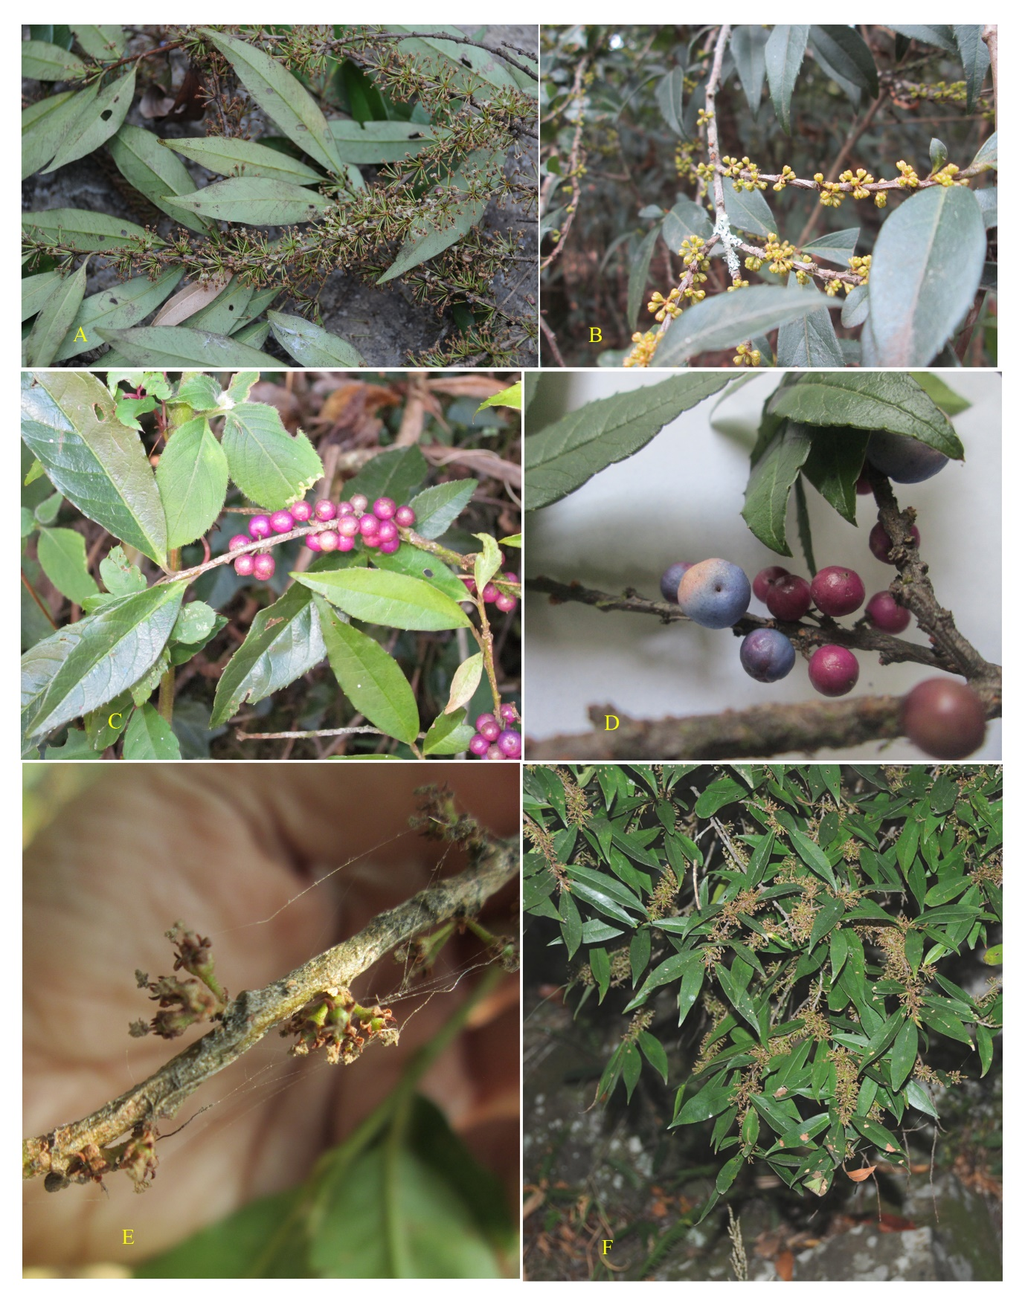

**Fig. 2:** Lectotype of *Myrsine semiserrata*

