Original Research Article

Effects of motorized tillage on soil physico-chemical properties in the Senegal River valley

ABSTRACT
In Senegal, one of the major problems facing agriculture is the pronounced loss of soil fertility due, among other things, to the combined effects of sustained exploitation, poor soil management and a lack of mastery of agricultural machinery operating techniques and conditions. The aim of this study is to contribute to a better understanding of the effects of motorized tillage on the soil. To this end, the first step was to optimize the tractor-tool linkage by means of 3 adjustment workshops. Subsequently, a complete block experimental set-up with a single factor, motorized tillage, was set up for 2 successive years. This work was carried out in 2 modes: minimum tillage and conventional tillage. Soil samples were taken from each plot before tillage and after harvest at the 0-30 cm horizon for physical and chemical analysis. The results show that the soils at the 2 sites have a clayey texture. Structural stability varied significantly from one year to the next (p<2e-16). The Lab 40 treatment at the Lampsar site, with a value of around 6.3, showed the highest stability. Soil bulk density varied significantly (p<2e-16) from site to site and from year to year. The Off10 treatment in the second year at the Lampsar site, with a value of around 1.7 g/cm3, had the highest density. This could explain the high penetration resistance observed on the same treatment (1180 N). Organic matter (OM), CEC and C/N ratio varied significantly from year to year and site to site (p<0.05). pH remained more or less the same, always below 7.
Keywords: motorized tillage, bulk density, penetration resistance, organic matter, soil
- INTRODUCTION
Agriculture is a key sector for Africa's development despite yields that remain well below potential and only 56% of the international average (FAO, 2019). In Senegal, agriculture occupies an important place in the country's development strategy; in 2020, rice production was 1,156,307 tonnes on a sown area of 315,217 hectares with a yield of 3,668 kg.ha-1 (ANSD, 2020). This production only covers 30% of local consumption needs, estimated at 90 kg/capita/year, and therefore remains insufficient (GRDR, 2015). With a view to increasing agricultural production, several programs have been rolled out, including the Programme d'accélération de la cadence de l'agriculture sénégalaise (PRACAS), whose objective was to boost rice production to 1,080,000 tonnes by 2017, based on the development of irrigated areas and agricultural motorization at a total cost of over 123 million euros (SECK, 2014). Performance has been encouraging, particularly in terms of rice production, with an increase in agricultural GDP of 9.1% (ANSD, 2020). Despite sustained dynamism, the agricultural sector is encountering difficulties linked, among other things, to a lack of modernization in the production system, particularly in terms of farm mechanization.
The adoption of motorized agricultural machinery is not without consequences for soil conservation. The intensification of farming coupled with the emergence and use of increasingly heavy machinery is accentuating the effects of agricultural soil degradation. The motorization of rice production has led to increased erosion and land degradation, threatening the sustainability of the production system (AMARA, 2007). The causes of land degradation due to the adoption of motorization are multiple and can be attributed to the non-conformity of equipment, the lack of control over the use of these motorized tools and associated techniques on the soil, and the effect of these machines on soil properties (Sarr, 2013 ; Ndiaye, 2021). Motorized ploughing is commonly practiced on arable plots to increase the size of fields and crop yields,
despite the adverse consequences on soil quality and, ultimately, production (Dahou et al., 2018). However, reasoned motorization in line with agroecological practices appears to be a sustainable alternative to reduce not only the drudgery of tillage but also the soil degradation that ensues (Sarr, 2013). It should be noted that, since independence, Senegal has been implementing policies, plans and programs aimed at improving performance with, in particular, agricultural mechanization, which could help reduce food imports (Sarr, 2013). The effects of motorized rice cultivation on soil quality in the Senegal River valley remain poorly understood. This is the background to the present study, which aims to contribute to a better understanding of the effects of machinery use on soil physical properties.
- MATERIAL AND METHODS
  - Presentation of the study area
The study was carried out at two sites : Lampsar and Ndiaye mberess, located in the Senegal River valley, Dagana department, Saint-Louis region, in an area characterized by hydro-agricultural developments with an irrigated rice-growing system (figure 1).
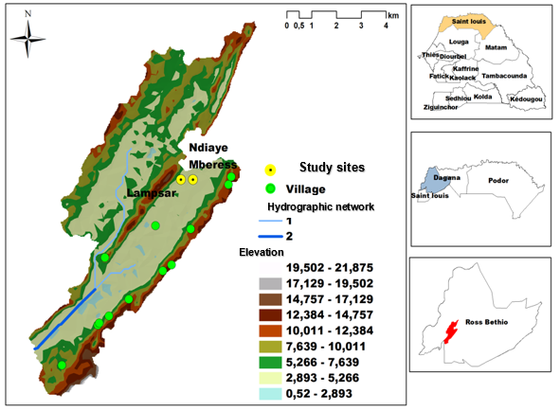
Figure1. Map of the experimental area
The soils at the sites are eutric fluvisols, brown or founded (figure 2).
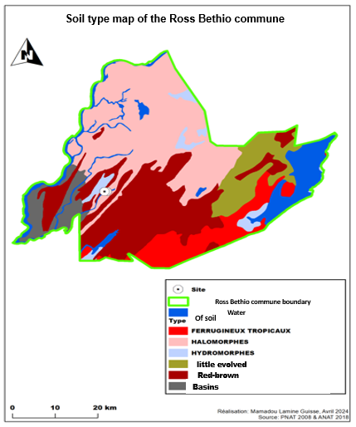
Figure 2. Map showing location of experimental sites by soil type
  - Farm machinery
Two types of agricultural implements attached to a 125 hp tractor were used in this study: a disc sprayer for minimum tillage or offsetting on shallow horizons 5 to 15 cm deep, and a reversible trisoc plough for conventional tillage or ploughing on deeper horizons 20 to 40 cm deep (figure 3).
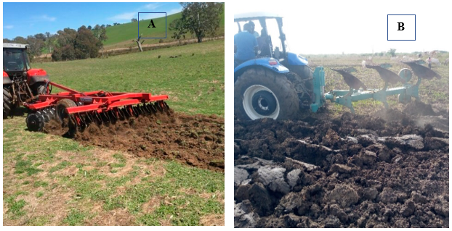
Figure 3. Farm equipment used for soil cultivation : tractor-offset (A); tractor-plough (B)
  - Plant material
The Sahel 108 variety, widely grown in Senegal and Mauritania and suitable for irrigated cultivation, was chosen. Sahel 108 was targeted for its short cycle, which allows double cropping in the dry season. The Sahel 108 variety is characterized by a sowing-epiaison cycle of 76 days in winter and 86 days in the hot counter-season; maturity of 105 days in winter and 117 days in the hot counter-season, good resistance to lodging, low ginning and a potential yield of 10 t. ha-1. Production increases by almost 11% in the rainy season (WARDA, 1998).
  - Experimental setup
An experimental set-up with motorized tillage as the sole factor was set up at 2 sites (Ndiaye Mbéress and Lampsar). Two tillage methods were selected: offsetage and ploughing. Offsetage or minimum tillage consisted in working the soil at the surface without turning it over. Deep tillage, with turning, is ploughing. Both methods were carried out on unit plots measuring 10 m x 10 m at 3 depths, with offsetage at 5, 10 and 15 cm and ploughing at 20, 30 and 40 cm respectively. The work carried out at these depths represents treatments 2*3 = 6, with 3 treatments per modality, off5, Off10, Off15 for offsetage and lab20, lab30, lab40 for ploughing. These treatments were repeated 4 times per site over 2 consecutive years, i.e. 6*4 = 24 unit plots per site and per year. Random blocks were set up for each work modality, within which treatments were applied at random (figure 39). Sub-blocks and treatments were spaced 1m apart to limit external influences from one plot to another. The total surface area of the blocks was 0.48 ha, i.e. 0.24 ha for each site.
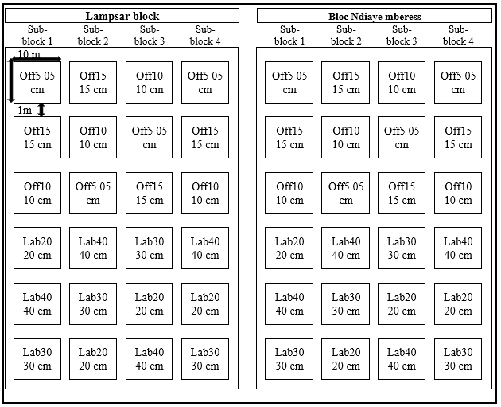
Figure 4. Diagram of the complete block experimental set-up
  - Conducting the trial
    - Optimisation de l’ensemble tracteur-outil
To ensure efficient use of the tractor-tool combination, test work was carried out on both sites, and data on the depth and width of the tilled surface, forward speed and grip were collected in the field in order to calculate the optimum setting for the tractor-tool combination. The implements used in this study leave a relatively flat bottom.
      - Depth of surface worked
A stake is driven into the ploughed soil until it reaches the firm, unworked bottom of the soil. The part of the stake driven in is then measured, and the average represents the depth of the tilled surface. A total of five (5) stakes were used, enabling five measurements to be taken. This enabled us to verify the consistency of the depth of the tilled surface.
      - The width of the worked surface
It is measured by placing stakes immediately after the passage of the tractor hitched to the tool, at a fixed distance from the boundary between worked and unworked land. Several measurements are taken and the average is calculated, representing the width of the worked surface.
      - Working speed
It was evaluated by calculating the time required to plough a strip of land of a predetermined length in a single pass. The length of this 50 m strip is marked by stakes placed in the field.
      - Grip
Grip is an important indicator of work efficiency and quality. It was determined by calculating the distances covered by the tractor over a 10-minute period on the hard surface (not working in the windscreen) and in the field.
Grip, S, is then calculated by applying the following formula :

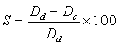 (1)
Grip is expressed as a percentage (%).
S= (604-270) /604=55.29% therefore grip S= 55.29%.
All this data was then used to calculate and optimize the tractor-implement combination by determining the balance of the tractor alone, the tractor with the sprayer for depths of 5, 10 and 15 cm, and the tractor with the plough for depths of 20, 30 and 40 cm.
    - Semis
Broadcast sowing was carried out manually, at a water depth of 5 cm, at a rate of 80 to 120 kg.ha-1 , i.e. an average of 100 kg.ha-1. Thus, for each experimental unit, 1kg of certified seed of the sahel 108 variety was used. It should be noted that the seeds were first soaked in water for 24 hours to lift dormancy.
    - Irrigation
Water management in the plots followed the method adopted by SAED (Lage et al. 1996) in the Senegal River valley, which takes into account the development phases of the rice plants : a 5 cm layer of water during the vegetative phase ; a 10 cm layer of water during the reproductive phase; and finally total drainage of the plot at the doughy stage, leaving a dry soil for rice maturation. The method has been adapted to allow herbicide application as well as urea application.
    - Fertilization
Fertilization was carried out in two ways: as bottom dressing and as top dressing. The base manure consisted of 100 kg.ha-1 of ammonium phosphate (DAP) 18-46-0, with a composition of 18% nitrogen and 46% phosphorus, applied during tillage, i.e. 1 kg of DAP per experimental unit (SAED, 2001). For cover dressing, urea was applied in three applications averaging 275Kg.ha-1. Each treatment unit received a dose of 2.75Kg of urea. The following proportions were applied during the study: 40% as the first application (at the start of tillering), i.e. 1.1Kg per experimental unit; 40% as the second application (at panicle initiation), i.e. 1.1Kg per experimental unit; and 20% as the third application (at bolting), i.e. 0.55Kg per experimental unit.
    - Phytosanitary treatments
To control weeds, rice plots were treated on the 40th day after sowing with systemic herbicides such as Propanil at a dose of 8 to 10 l.ha-1 combined with Weedone at a dose of 11 l.ha-1 (SAED, 2001).
    - Soil sample collection
Soil samples were collected using a soil auger from the 0-30 cm horizon for all treatments. In each plot, the Z-sampling method (Fabrizzi et al., 2005), which consists of taking samples at the four corners and in the middle of the sampling area, was adopted to obtain a composite sample per plot for physical and chemical analysis.
A direct-reading dynamic penetrometer was used to qualitatively assess resistance and check soil compaction.
Hydraulic conductivity was measured using double-ring infiltrometers (Fabrizzi et al., 2005). These are thin-walled open cylinders, one 60 cm and the other 30 cm in diameter, inserted into the soil at a depth of 5 cm. Water is infiltrated into the soil using the constant or descending head technique. This is done manually, which enabled us to take several measurements at the same time.
For bulk density, the cylinder (C) method was used (Yoro et al., 1990). Soil samples were collected using cylinders sunk to a depth of 10 cm in three samplings for each treatment before tillage and after harvest, for a total of 3*24*2 = 144 samples per site. Accessories for scoring and conditioning the samples were also used.
  - Studied parameters
    - Physical parameters
      - Grain size
Granulometry was determined for all soil samples using Robinson's method, based on the sedimentation rate of the different particles, sand, silt and clay (Fabrizzi et al., 2005).
      - Structural stability
Soil structural stability, which is an indicator of the cohesion of soil aggregates and therefore expresses the ability of soil aggregates to resist disintegration, was assessed by determining the silt, clay and organic matter content of soils. The battance index (Ib), which reflects this structural stability, was then calculated by applying the Rémy and Marin-Laflèche (1974) formula, with two variants depending on pH.
The following formula (A) applies to soils with a pH above 7.
$I_{b}=\frac{\left(1,5*\%fine silts\right)+(0,75*\%coarse silts)}{\%clay+(10*\%organic matter)}-\left(0,2*\left(pH-7\right)\right);if pH>7$(2)
Formula (B) is used for soils with a pH below 7.

$$I_{b}=\frac{\left(1,5*\%fine silts\right)+(0,75*\%coarse silts)}{\%clay+(10*\%organic matter)};if pH<7 (3)$$
In this study, given that ph <7, formula (3) was used.
      - Apparent density
Bulk density is the mass of a unit volume of soil at 105º C. This volume includes both solids and pores (Alongo et al. 2013). In this study it was determined by applying the following formula :
$$da=\frac{m_{s}}{V} (4)$$
With :
da: bulk density,
ms: mass of dry soil,
V: total volume (related)
      - Penetration resistance
The resistance of the soil to the insertion of a standardized tool has been evaluated using a needle penetrometer. The rod of the penetrometer is driven into the ground to a depth of around 30 cm, exerting constant pressure, and the value indicated by the needle is read off.
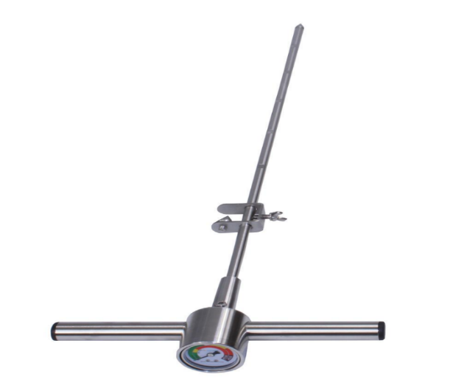
Figure 5. Needle Penetrometer
      - Hydraulic conductivity
Hydraulic conductivity K, which expresses the infiltration capacity of water in the soil per unit area and time, was determined by applying Darcy's law; it is expressed in m.s-1 (Lanoix, 2017). The double-ring device was installed to assess soil infiltrability.
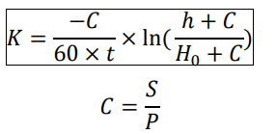
K = Permeability in m/s
(5)
C = Coefficient in m
S = Central ring cross-section in m² P = Perimeter of central ring in m
P = Perimeter of central ring in m
H0 = water level height at t = 0
h = water level at time t of measurement in m
t = time of measurement in min
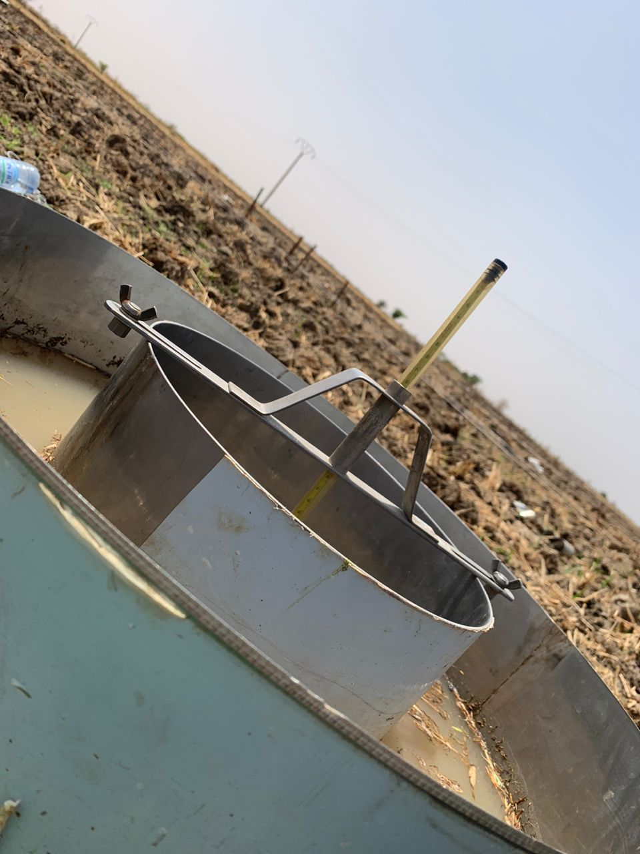
Figure 6. Measuring water infiltration with the double ring
    - Chemical parameters
      - Hydrogen potential (pH)
The hydrogen potential, pH, of the soils was determined by mixing the soil with water at a ratio of 1/2.5, i.e. 10 g of soil mixed with 25 ml of distilled water (GLOBE, 2005). The mixture was then read using an electronic pH meter.
      - Electrical conductivity
Conductivity measurement is used to assess the salinity level of water or soil. Soil is mixed with distilled water at a ratio of 1/5. The supernatant is then collected and its electrical conductivity determined using a direct-measuring conductivity meter (Montoroi, 1997). EC is expressed in micro-Siemens per centimeter (µS/cm) or milli-Siemens/cm (mS/cm).
      - Carbon and organic matter
Carbon is determined by the modified BLACK & WAKLEY method (1934). Organic carbon is oxidized with a mixture of 1N potassium dichromate (K2Cr2O7) and concentrated sulfuric acid (H2SO4) d=1.84. Carbon is determined by spectrophotometer at 600 nm.
The organic matter (OM) content of the soil is then calculated on the basis of the carbon content of the soil by applying the following (Hodomihou et al., 2011).
MO % = C % x 1,72 (6)
The coefficient 1.72 corresponds to the average proportion of C in soil OM.
OM: organic matter
%C: organic carbon rate
      - Total nitrogen by Kjeldhal method
Nitrogen mineralization was carried out in the presence of concentrated sulfuric acid (H2SO4 to 18N), salicylic acid (C7H6O3), hydrogen peroxide (H2O2) and selenium powder as catalyst. This mineralization transforms nitrogen into ammonium ion (NH4+), which is then determined using a spectrophotometer at wavelength 660 nm (Thermo Scientific Genesys 20).
      - Assimilable phosphorus (P Olsen modified according to Dabin)
The 1954 Olsen test was applied. The method involves extraction using a solution of sodium bicarbonate (NaHCO3) and ammonium fluoride (NH4F) buffered to pH 8.5 to dissolve the phosphates. As the pH of the extraction solution is very high, part of the organic matter is hydrolyzed, releasing organic phosphorus. The extracted phosphorus is determined by colorimetry at 810 nm.
      - Cation exchange capacity and exchangeable bases
Cation Exchange Capacity (CEC) is a measure of the soil's cation-fixing capacity. It measures the total number of sites available for cation exchange (negatively charged sites on the soil's adsorbent complex). The higher the CEC, the more cations will be stored by the soil. This is a soil's fertility reservoir (Tech et bio, 2015). So to determine CEC, the soil sample is leached by an ammonium acetate solution. So add 3 times 15 ml of 1M ammonium acetate by collecting the percolate in 50 ml volumetric flasks, then top up with 1M ammonium acetate for the determination of exchangeable cations (Na, K, Ca, Mg) and trace elements (Zn, Br, Cu, Fe) by flame atomic absorption spectrometry (FAS).
The amount of ammonium retained by the soil after washing out the excess ammonium acetate is an estimate of the cation exchange capacity (CEC). The ammonium retained is released by percolation and is determined by Spectrophotometer.
  - Statistical data analysis
Excel spreadsheets were used for data processing. Data were then analyzed using R software version 4.4.1. Where analyses of variance revealed differences between means, the 5% Newman-Keuls test was applied to compare means.
- RESULTS
  - Optimization
    - Setting Workshop1 : Study of tractor balance alone
Analysis of Table 1 shows that the ground reaction on the front axle is of the order of 1996.7 daN and that of the tractor's rear axle is 2873.3 daN. The distance between the tractor's front axle and the center of gravity is 1.54m, and between the rear axle and the center of gravity is 1.077m.
Table 1. Study of tractor equilibrium Alone
Results Workshop 1
Ground reaction on the front axle A_{2/1} (daN) | Ground reaction on the rear axle B_{2/1} (daN) | Distance from front axle to center of gravity L₁ (m) | Distance between rear axle and center of gravity L₂ (m)
1996,7 | 2873,3 | 1,54993 | 1,077

    - Setting Workshop 2 : Study of the tractor-plough assembly
Figure 7 shows that the plough's working surface increases with ploughing depth. Thus, the highest ploughed area is found in the Lab40 treatment, followed by the Lab30 treatment.

Figure 7. Variation in work surface depending on treatment
Table 2 shows that the total weight of the tractor/plow combination is around 1100 daN, with a distance between the weight carrier and the front axle of 0.8m, a penetration resistance of 75 N/dm2, a working width of 121.92 cm and a rolling coefficient of 12%. The tractor's ploughing speed was around 5 km/h.
Table 2. Setting diagram data for workshop 2
Data Workshop 2
Total weight Pt(daN) | Distance between weight door and front axle l₄ p/r A (m) | Penetration resistance (Rp) (N/dm2)) | Penetration resistance (Rp) (Kpa) | Forward speed km/h | Working width (T) (cm) | Rolling coefficient Cr | α (°)
1100 | 0,8 | 75 | 750 | 5 | 121,92 | 12% | 5

Analysis of the results in Table 3 shows that it was not necessary to place front weights on the weight carrier. Thus, the tractor had to be lightened at the rear by -204.8 kg to achieve the correct distribution on the road. However, in working conditions, the load distribution recommended by the manufacturers was respected for the Lab20 and Lab30 treatments, as it varied from 35 to 40% for the front axle and from 60 to 65% for the rear axle, so the adjustment of the tractor-plough linkage was optimal for these treatments. For the Lab40 treatment, the front axle was made heavier to meet the 40-60 distribution required under ploughing conditions.
The power required to pull the plough was around 53.75 hp, i.e. 43% of the tractor's power. If the number of plough bodies had been increased, this power would have represented a much higher percentage of the available power, which would have increased the engine load ratio. Increasing the working speed could also increase traction power, but this would have an impact on ploughing quality (table 3).

Table 3. Results of setup diagrams for Workshop 2
Results Workshop 2
l3 (m) | Depth | Ft | Fr | Woh | Wov | A_{2/1} | B_{2/1} | %A_{2/1} | %B_{2/1}
8,27E-16 | For Lab20cm | 1828,8 | 584,4 | 2413,2 | 211,13 | 1785,57 | 3084,4 | 36,7 | 63,3
P4 (Kg) | For Lab30cm | 2743,2 | 584,4 | 3327,6 | 291,13 | 1705,57 | 3164,4 | 35 | 65
-204,8 | For Lab40cm | 3657,6 | 584,4 | 4242 | 371,13 | 1625,57 | 3244,4 | 33,4 | 66,6

    - Setting Workshop 3: Study of the tractor-offset assembly
Analysis of the results in Table 4 reveals that the weight of the tractor-offset assembly is 2010 daN. The distance between the weight carrier and the front axle, as for ploughing, is 0.8 m, with a penetration resistance of 75 N/dm2 and a tractive power of 70 hp. The rolling coefficient is 12%, with a tractor working speed of 12 km/h.
Table 4. Setting diagram data for workshop 3
Data Workshop 3
Pt(daN) | l₄ p/r A (m) | Penetration resistance (Rp) (N/dm2)) | Traction power (ch) | α (°) | Rolling coefficient Cr
2010 | 0,8 | 75 | 70 | 5 | 12%
Off5 | Off10 | Off15 | Forward speed (Km/h) | α (rad)
5cm | 10cm | 15cm | 12 | 0,0872

Table 5 shows that to ensure safe transport, the tractor had to be weighted at the front with a mass of 67 Kg, so it was impossible to weight two 30Kg inserts. However, the influence of this weight on the load distribution could be negligible, so the tractor-offset assembly without front weight would ensure safe transport. In working conditions, the load distribution recommended by the manufacturers was respected, as it varied from 35% to 40% for the front axle and 60% to 65% for the rear axle. The tractor-offset linkage was therefore optimally adjusted (table 5).

Table 5. Results of setting diagrams for workshop 3
Results Workshop 3
l3 (m) | Pr | Ft | Fr | Woh | Wov | A2/1 | B2/1 | %A2/1 | %B2/1
4,53E-16 | For Off5cm | 1575 | 592,44 | 2167,44 | 189,63 | 1807,07 | 3062,9 | 37,1 | 62,9
P4 (Kg) | For Off10cm | 1575 | 592,44 | 2167,44 | 189,63 | 1807,07 | 3062,9 | 37,1 | 62,9
67 | For Off15cm | 1575 | 592,44 | 2167,44 | 189,63 | 1807,07 | 3062,9 | 37,1 | 62,9

  - Effects of power tillage on soil physical properties
    - Texture
The results show that the texture of the Lampsar and Ndiaye mberess sites is clayey (figure 8).
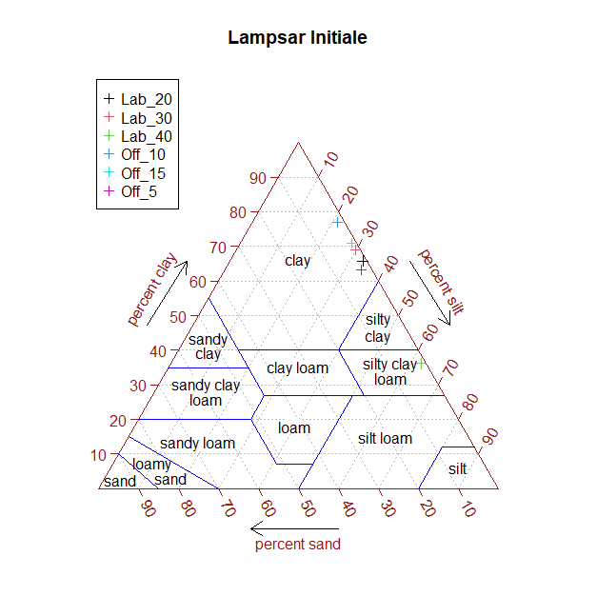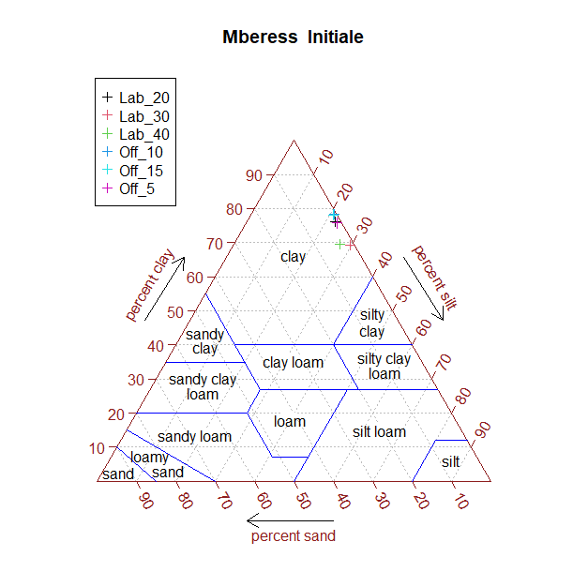
Figure 8. Textural diagram by Lampsar (A) and Ndiaye Mberess (B)
    - Structural stability
Structural stability increases significantly with time (p<2e-16). Structural stability values in both the first and second years of experimentation were significantly (p<2e-16) higher than those recorded in the initial sampling (2.26 at Ndiaye Mberess and 1.5 at Lampsar). There was no significant difference between treatments or between sites (p=0.74). The Lab40 treatment of around 6.3 at the Lampsar site was the most stable in absolute terms (figure 9).

Figure 9. Variation in structural stability as a function of treatment, site and sampling period
*Treatments marked with the same letter are not statistically different at the 5% LSD threshold according to Fisher's test.
3.2.3. Apparent density
Figure 10 shows that the apparent density varies significantly from one site to another and as a function of time (p<2e-16). There was no significant difference (p=0.57) between treatments. The second-year Off10 treatment at the Lampsar site, with a value of around 1.7 g/cm3, had the highest density in absolute terms. However, the results reveal that the lowest apparent density of around 1.2 g/cm3 in absolute value is noted in the first year of experimentation at the Ndiaye Mberess site for the Off5, Off10 and Lab40 treatments, and at the Lampsar site for the Lab30 and Lab40 treatments.

Figure 10. Variation in bulk density by site, treatment and sampling period
*Treatments marked with the same letter are not statistically different at the 5% LSD threshold according to Fisher's test.
3.2.4. Penetration resistance
Penetration resistance decreases significantly from one period to the next (p< 2e-16) and from one site to the next (p=1.12e-05). Thus, the Lampsar site, whose initial value was 1882.6 N, showed a maximum resistance of around 1200 N (Off5) in the first year, compared with 1110 N (Lab30) in the second year of experimentation. As for the Ndiaye Mberess site, initial penetration resistance was 1695.8 N. Treatments Off15, Lab20, Lab30 and Lab40, with a resistance value of around 1100 N, had the highest absolute resistance in the first year. In the second year of experimentation, Lab20 (1000 N) had the highest penetration value on this site. However, no significant difference was observed between treatments (p=0.73). On the other hand, the Off5 treatment at Ndiaye Mberess in the second year had the lowest penetration resistance (750 N) (figure 11).

Figure 11. Variation in Penetration Resistance as a function of treatment, site and sampling period
*Treatments marked with the same letter are not statistically different at the 5% LSD threshold according to Fisher's test.
3.2.5. Hydraulic conductivity
Analysis of figure 12 shows that hydraulic conductivity varies significantly according to site and experimental period (p<2e-16). No significant difference between treatments (p=0.07). The Lab30 treatment at the Lampsar site, with a value of 1.72 E-5 m/s in the first year of experimentation, had the highest conductivity. On the other hand, the lowest conductivity of around 2.42 E-6m/s was recorded in the second year at the Ndiaye Mberess site on the Off15 treatment. It should also be noted that not only did the soils at the Lampsar experimental site have a higher conductivity than those at Ndiaye Mberss, but this parameter, whose initial state at Lampsar and Ndiaye Mberess was around 6e-04 m/s and 4e-04 m/s respectively, decreased from one year to the next, from 1.72 E-5m/s in year 1 to 5 E-6m/s in year 2 of the Lampsar experiment, and from around 5 E-6 m/s in year 1 to 2.42 E-6 m/s in year 2 at the Ndiaye Mberess site.

Figure 12. Variation in hydraulic conductivity by site, treatment and sampling period
*Treatments marked with the same letter are not statistically different at the 5% LSD threshold according to Fisher's test.
3.3. Effects of power tillage on soil chemical properties
3.3.1. Hydrogen potential (pH)
The results show that there was no significant difference between treatments (p=0.09). However, a significant difference was noted between the Lampsar and Ndiaye Mberess sites (p=4e-05), as well as between experimental years (p< 2e-16) (table 6).
3.3.2. Electrical Conductivity (EC)
Electrical conductivity varies significantly between sites (p= 2e-09), and between years (p= 0.001). The highest value was recorded at the Ndiaye Mberess site (1352.5 µs/cm) and at the Lab40 treatment site, with a value equal to 154.4 µs/cm (Table 6).
3.3.3. Carbon (C)
Carbon content is plotted against site, experimental year and treatment. The results show that carbon content varies not only between sites (p=0.003) but also between years (p=0.04) and treatments (p=0.004). The highest content was observed in the second year of experimentation on the Lab20 treatment (1.09%) at the Lampsar site. Similarly, data analysis showed a significant difference between sites and treatments (p= 0.012) and between site and year (p=5e-07). However, no significant differences were observed between year and treatment (p=0.4) or between site, year and treatment (p=0.6) (table 6).
3.3.4. Organic Matter (OM)
Analysis of figure 13 reveals that organic matter increases significantly from one site to another (p=5e-09) and from one period to another (p< 2e-16). On both experimental sites, organic matter on all treatments was higher than the initial amount, which was 0.7% for Lampsar and 1.01% for the Ndiaye Mberess site. However, there was no significant difference between treatments (p=0.12). The Lab20 treatment at the Ndiaye Mberess site, with an organic matter content of around 2.5% in the second year of experimentation, had the highest organic matter content. The lowest amount of organic matter was observed in the first year on the Lab30 treatment (1.1%) at the Lampsar site.

Figure 13. Variation in organic matter as a function of treatment, site and sampling period
*Treatments marked with the same letter are not statistically different at the 5% LSD threshold according to Fisher's test.
3.3.5. Nitrogen N
Analysis of the data showed that nitrogen levels varied between sites (p=2e-05) and between experimental years (p=9e-11). There were no significant differences not only between treatments (p=0.98) but also between sites, years and treatments (p=0.94=). The amount of nitrogen was higher in year 2 of experimentation at the Lampsar site for treatments Off15 and Lab20, Lab30 and Lab40 respectively 0.08 and 0.07% (table 6).
3.3.6. C/N ratio
Figure 14 shows a significant difference between the Lampsar and Ndiaye Mberress sites (p=4e-06), as well as between experimental years (p=4e-07). However, according to the results obtained, no significant difference was noted between treatments (p=0.76). The highest C/N ratio was noted at the Ndiaye Mberess site for the Off15 treatment (20%) in the second year.

Figure 14. Variation in C/N as a function of treatment, site and sampling period
*Treatments marked with the same letter are not statistically different at the 5% LSD threshold according to Fisher's test.
3.3.7. Assimilable phosphorus (Pppm)
Figure 15 shows that phosphorus varies significantly between sites (p=0.0005), years (p=3e-12) and treatments (p=9e-05). Data analysis also reveals a significant difference between sites and year (p=0.007) as well as between sites and treatment (p=0.003). The Lampsar site had the highest phosphorus levels. Similarly, the Lab20 and Lab30 tillage treatments on the Lampsar site had the highest phosphorus levels, at 4.28 and 4.23 ppm respectively in the second year of experimentation. These treatments improved this parameter more in year 2 than in year 1 of experimentation.

Figure 15. Variation in phosphorus as a function of the sampling period, treatments and site
*Treatments marked with the same letter are not statistically different at the 5% LSD threshold according to Fisher's test.
3.3.8. Cation exchange capacity (CEC)
Analysis of Table 6 shows that cation exchange capacity varies significantly from year to year (p=0.03) and from site to site (p<2e-16). The Lab20 and Lab30 treatments have the highest cation exchange capacity, at 76.14 and 74.20 meq/100g respectively. Similarly, the Lampsar site has the highest CEC. CEC is higher in year 2 than in year 1 of experimentation and compared with the initial state.
Table 6. Variation in pH, electrical conductivity, nitrogen and cation exchange capacity as a function of sampling period, treatment and site
Treatments | pH water 1/2,5 |  |  |  | Electrical conductivity CE µs/cm |  |  |  | Nitrogen (N)%
 | Initial | Year 1 | Year 2 | Diff(Year2-Year1) | Initial | Year 1 | Year 2 | Diff(Year2-Year1) | Initial | Year 1 | Year 2 | Diff(Year2-Year1)
 | Ndiaye Mbéress
Off5 | 6,48ª | 5,44^{b} | 5,21^{c} | -0,23 | 571ª | 798,5^{ab} | 811,75^{ab} | 13,25 | 0,03ª | 0,05ª | 0,05^{ab} | 0
Off10 | 6,48ª | 5,50^{b} | 5,52^{b} | 0,02 | 571ª | 842,25^{ab} | 861,25^{ab} | 19 | 0,03ª | 0,06^{ab} | 0,06^{ab} | 0
Off15 | 6,48ª | 5,34^{bc} | 5,37^{bc} | 0,03 | 571ª | 830,75^{ab} | 843^{ab} | 12,25 | 0,03ª | 0,05^{ab} | 0,05^{ab} | 0
Lab20 | 6,48ª | 5,57^{b} | 5,47^{b} | -0,1 | 571ª | 759^{ab} | 789,83^{ab} | 30,83 | 0,03ª | 0,06^{ab} | 0,07ª | 0,01
Lab30 | 6,48ª | 5,76^{b} | 5,41^{b} | -0,35 | 571ª | 584^{b} | 597,45^{b} | 13,45 | 0,03ª | 0,06^{ab} | 0,06^{ab} | 0
Lab40 | 6,48ª | 5,96^{b} | 5,66^{b} | -0,3 | 571ª | 1335,75^{c} | 1352,5ª | 16,75 | 0,03ª | 0,06^{ab} | 0,06^{ab} | 0
 | Lampsar
Off5 | 6,71ª | 5,87^{b} | 5,74^{b} | -0,13 | 270ª | 521,96ª | 380,5^{ab} | -141,46 | 0,05ª | 0,08^{ab} | 0,07^{ab} | -0,01
Off10 | 6,71ª | 6,02^{b} | 5,95^{b} | -0,07 | 270ª | 401,52ª | 366,5^{ab} | -35,02 | 0,05ª | 0,06^{ab} | 0,07^{ab} | 0,01
Off15 | 6,71ª | 6,05^{b} | 5,94^{b} | -0,11 | 270ª | 388,39ª | 324,5ª | -63,89 | 0,05ª | 0,08^{ab} | 0,08^{ab} | 0
Lab20 | 6,71ª | 6,04^{b} | 5,92^{b} | -0,12 | 270ª | 491,78ª | 513,25^{c} | 21,47 | 0,05ª | 0,05ª | 0,07^{ab} | 0,02
Lab30 | 6,71ª | 6,02^{b} | 5,88^{b} | -0,14 | 270ª | 552,6ª | 532,75^{c} | -19,85 | 0,05ª | 0,06^{ab} | 0,07^{ab} | 0,01
Lab40 | 6,71ª | 5,84^{b} | 5,69^{b} | -0,15 | 270ª | 533,72ª | 572,75^{c} | 39,03 | 0,05ª | 0,07^{ab} | 0,07^{ab} | 0
Treatements | CEC (meq/100g) |  |  |  | Carbon %
 | Initial | Year 1 | Year 2 | Diff(Year2-Year1) | Initial | Year1 | Year 2 | Diff(Year2-Year1)
 | Ndiaye Mberess
Off5 | 13,01ª | 15,62^{ab} | 17,04^{ab} | 1,42 | 0,79^{g} | 0,83^{fg} | 0,87^{efg} | 0,04
Off10 | 13,01ª | 17,06^{ab} | 18,26^{ab} | 1,2 | 0,79^{g} | 0,88^{efg} | 0,93^{cde} | 0,05
Off15 | 13,01ª | 21,37^{b} | 21,76ª | 0,39 | 0,79^{g} | 0,9^{def} | 0,94^{cde} | 0,04
Lab20 | 13,01ª | 17,80^{ab} | 17,65^{ab} | -0,15 | 0,79^{g} | 1,01^{abc} | 1,09ª | 0,08
Lab30 | 13,01ª | 17,07^{ab} | 17,54^{ab} | 0,47 | 0,79^{g} | 0,92^{cdef} | 0,98^{bcd} | 0,06
Lab40 | 13,01ª | 11,69ª | 12,27ª | 0,58 | 0,79^{g} | 0,95^{cde} | 1,07^{ab} | 0,12
 | Lampsar
Off5 | 17,12ª | 25,83ª | 79,20ª | 53,37 | 0,9ª | 0,74ª | 0,80ª | 0,06
Off10 | 17,12ª | 22,75ª | 74,45ª | 51,7 | 0,9ª | 0,73ª | 0,74ª | 0,01
Off15 | 17,12ª | 19,13ª | 65,64ª | 46,51 | 0,9ª | 0,85ª | 0,9ª | 0,1
Lab20 | 17,12ª | 23,12ª | 76,14ª | 52,7 | 0,9ª | 0,80ª | 0,91ª | 0,11
Lab30 | 17,12ª | 24,44ª | 74,20ª | 49,76 | 0,9ª | 0,67ª | 0,72ª | 0,05
Lab40 | 17,12ª | 18,32ª | 68,97ª | 50,65 | 0,9ª | 0,78ª | 0,86ª | 0,08
*Values in the same column with identical letters are not statistically different at the 5% threshold, Student-Newman-Keuls (SNK) test.
3.4. Correlation between the physico-chemical properties of the soil at the two sites as a function of treatments
The two axes of the principal component analysis (PCA) explain 84.3% of the variance. Following the axes, figure 16 can be subdivided into three (3) groups. Parameters such as pH, penetration resistance (ER), hydraulic conductivity (CH), bulk density (BD) and C/N ratio, located on the negative side, are more correlated with the reference or initial situation of the experimental areas. Cation exchange capacity (CEC), phosphorus (P) and nitrogen (N), located on the positive side, are correlated with the first year of experimentation, while structural stability, organic matter (OM), electrical conductivity (EC) and carbon (C) are correlated with year 2 of experimentation. In this figure, we can see that cation exchange capacity (CEC), phosphorus, nitrogen, pH, penetration resistance and hydraulic conductivity are more correlated with the Lampsar site. At the same site, cation exchange capacity (CEC), phosphorus and nitrogen are correlated with the Lab20 treatment, while pH, penetration resistance and hydraulic conductivity are correlated with the Lampsar treatment Lab30 and Off10 treatments. For the Ndiaye Mbress experimental site, the apparent density (AD) and C/N ratio parameters are most correlated with the Off15 treatment, while structural stability, organic matter, electrical conductivity and carbon are correlated with the Off5 and Lab40 treatments.
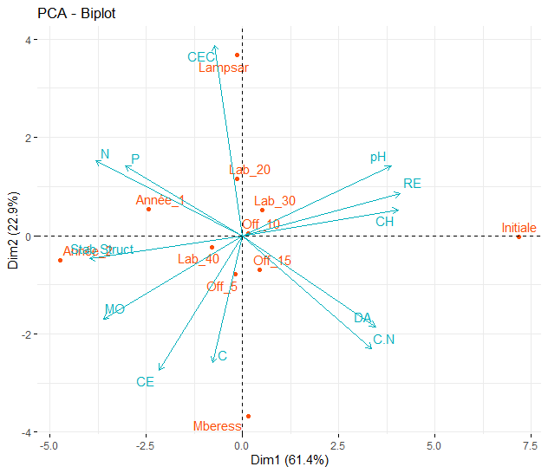
Figure 16. Correlation between soil physico-chemical properties and treatments
- Discussion
  - Optimization
The results of this study show that mastery of agricultural machinery techniques and technology is necessary not only to reduce mechanization costs, but also to preserve the soil and guarantee good tillage in the Senegal River valley. A ballast of the order of 40-60% favours optimum performance from the tractor-implement combination. These results are in line with the work of Léral in 2007, who stipulates that for a 2-wheel drive tractor, the load distribution between front and rear axles should be 30-70%. For old 4-wheel drive tractors, it is 40-60%, and for new 4-wheel drive tractors, 50-50%. Bernard, in his study on the basic rules of tractor use, reveals that the effective weight on the tractor's drive wheels determines the load it can tow or drag at different working speeds on agricultural soil. Depending on the physical condition and degree of compaction of the ground on which the tractor is working, the traction at the drawbar or at the ball joints of the hydraulic hitch varies from 40 to 60% of the weight resting on the wheels (40% with trailed implements such as disc sprayers, 60% for mounted implements such as mounted ploughs). Roca et al. 2019, argue that quantifying all forces and moments between a tractor and an implement, when they are connected by the three-point hitch, is of interest in a number of ways, including optimizing implement design, evaluating tractor settings or applying to precision farming. The tractor's forward speed in ploughing is 5 km/h and in off-tilling 12 km/h. Bernard (2012) states that forward speed modifies efficiency, and therefore results. Thus, ploughing at 4 km/h will be cloddier than at 6 km/h, and a cultivator is only effective above 6-7 km/h. Chehaibi et al. 2003, show that soil cultivation can be optimized by an appropriate choice of plough width (single or multi-body), gearbox ratio or practical forward speed. He adds that working at medium speed was marked by small clods on the surface in small quantities, and large clods at depth beyond the sprayer's zone of action. On the other hand, working at high speed produced fewer small clods and a lot of fine soil on the surface and in the sprayer's working depth. The whole was evenly distributed. However, the strip of land between the zone of action of the sprayer and that of the plough was characterized by the presence of large clods of a smaller size than those obtained when working at slow and medium speeds.
  - Effect of tillage on physical properties
Bulk density is a soil quality indicator that varies with the cultivation techniques adopted. It provides information on soil porosity, which is a major characteristic controlling soil hydrodynamic properties. Its value increases on compacted soils, which affects their quality and reduces porosity (Abdellaoui et al., 2010). The Lampsar and Ndiaye mberess sites show a similar trend of increasing bulk density for some treatments after rice harvesting, with variations depending on the treatments applied. In fact, before tillage, the bulk density of the sites was constant. According to Moussadek et al. (2011), apparent density is higher in semi-direct (no-till) than in semi-conventional (tillage). Fabrizzi et al. (2005) and El Mekkaoui et al. (2023) also show in their work that the apparent density under no-tillage is always higher than under tillage, but that it decreases over time. They also confirm that the value of apparent density is higher under no-tillage in sandy loams. Texture and structural stability also qualify the Lampsar and Ndiaye mberess soils as heavy soils susceptible to capping. The bulk density results are therefore in line with previous studies by Nzeyimana (2003) and Abdellaoui et al. (2010), which show the particular relationship between density and soil physical parameters (texture, porosity, hydraulic conductivity, etc.). Holthusen et al. (2018) support them in the sense that texture influences initial conditions as well as soil response to external loads. For example, silty to clayey soils compact more easily than sandy soils. Surface layers also have a lower density due to the higher organic matter content of the soil. In addition, they noted a much lower bulk density in forest soils than in agricultural soils, as well as high macroporosity. The texture of both sites is silty. They are also characterized by low clay contents and very high capping indices. As a result, the soil structure is highly unstable and susceptible to capping. As they are also heavy soils with hydraulic conductivity values of the order of 10-6, the permeability of these soils is poor. Given that the irrigation system for the plots is gravity-fed (by submersion), these soils are perfectly suited to this system, but not really for farming. They are sensitive to threshing and difficult to work, especially in wet conditions. The increase and decrease in penetration resistance observed for certain treatments during certain periods in correlation with bulk density at the sites is in line with the work of Dechef (2022) on the impact of tillage on the physical, chemical and biological parameters of the soil-plant system in spelt and wheat crops. In his study, he states that penetration resistance is a soil physical parameter that is highly sensitive to hydric variation, texture and soil structure. Fabrizzi et al (2005) also confirm the results in his study of soil water dynamics, physical properties and responses of maize and wheat to minimum-tillage and no-tillage systems in the southern Argentine Pampas. Moraes et al (2013) state in their study that resistance increases the higher the bulk density and the lower the moisture content. However, the permeability of both sites is poor and their retention capacity is quite high. In addition, the plots are managed using gravity irrigation (by submersion) and the soils are heavy and susceptible to capping.
  - Effect of tillage on chemical properties
On the other hand, the organic matter content of Lampsar and Ndiaye mberess is very low. According to Abdellaoui et al (2010), organic matter has a crucial influence on soil physical and chemical properties. Lampsar shows an increasing trend, while Ndiaye mberess shows an almost constant trend between the periods before and after the rice harvest. These results are in line with those of Abdellaoui et al (2010) for the Lampsar site and invalidated at the Ndiaye mberess site. At Lampsar, organic matter values for no-tillage treatments are higher than those for ploughing. At Ndiaye mberess, the organic matter content of ploughing is virtually constant and dominates that of no-till. These results are also confirmed by Nzeyimana (2003). Other authors, such as El Mekkaoui et al (2023), assert that conventional tillage reduces soil organic matter, while no-till increases it. These results could be linked to the way in which the plots are managed, as they are flooded several times a year over a long period. El Mekkaoui et al (2023) assert that the results of no-till (increase in organic matter) depend on the length of time the technique is adopted. However, according to Kalla, 2023, these results on soil organic matter could explain the drop in rice yields observed in the zone in recent years. Disturbance of the surface layer may explain the dynamics of carbon, which evolves in tandem with other elements and is often estimated by modelling approaches such as Tschakert et al., 2004. These results show that soil disturbance affects the distribution and transformation of carbon in the soil, thus influencing soil physico-chemical properties.
- CONCLUSION
At the end of the study, the soil was analyzed to assess its physico-chemical characteristics and determine its capacity to mobilize and supply mineral elements for plant development. In the context of climate change, which is a global phenomenon, it is no longer a question of producing good yields, but also of how to do so sustainably. This study is part of the process of discovering the changes brought about by motorized tillage on the soil. It has shown that to better preserve the soil and reduce the impact of machinery in the area, it is necessary to optimize the tractor-implement linkage. In view of the results obtained, we note that the tractor-plough load should be of the order of 1100 daN with a working width of 121.92 cm and a forward speed of 5 km/h for ploughing. For minimum tillage, the tractor-offset combination is of the order of 2010 daN. The tractor's forward speed when offset is 12 km/h. Structural stability, bulk density and penetration resistance varied significantly (p<2e-16) for the Off5, Off10 and Lab40 offset treatments. These parameters (texture, stability) demonstrate that these soils are unstable and prone to compaction. On the other hand, hydraulic conductivity dropped significantly (p<2e-16), especially for the Off15 and Lab20 treatments at the Ndiaye Mberess site in the second year of experimentation. As for chemical parameters, the results show that organic matter (OM) and the C/N ratio increased significantly (p<0.05), particularly at the Ndiaye Mberes site for the Off15 and Lab20 treatments.
For future studies in this field, it is therefore recommended to :
- Carry out a long-term study of the effects of motorized tillage on the soil. This means monitoring soil parameters over several years (minimum 5 years) and campaigns to build up a good database.
- As these soils are susceptible to capping, they need to be amended with a lot of organic matter to correct soil structure and improve soil fertility.
In the future, it would be interesting to analyze the influence of motorized tillage on the frequency, cover and diversity of herbaceous plants, in order to clarify the soil's behavior with regard to the appearance of weeds.

References
Abdellaoui, Z., Teskrat, H., & Belhadj, A. 2010. Comparative study of the effect of conventional tillage, direct seeding and minimum tillage on the behavior of a durum wheat crop in the subhumid zone. CIHEAM, Mediterranean Options, A no. 96, 2010 ñ IV Mediterranean Direct Seeding Meeting, 18p.
http://om.ciheam.org/article.php?IDPDF=801420
Alingo, S.; Kombele, F. 2013. Evolution of soil bulk density and C/N ratio under exotic and local cassava varieties under natural conditions in KISANGANI (DR Congo). Annals of the Yangambi Faculty of Agricultural Sciences, 2009, special (1). pp.197-214. hal-00877116. 15p.
AMARA. M., 2007. Contribution to the modelling of the Farming Tools - Soil interface; Optimization of the shape and tensile strength of plough bodies and tine tools.PhD thesis in Agronomic Sciences, El-Harrach Algeria, 260 p.
ANCELIN, O., DURANEL, J., DERSIGNY, C., DUPARQUE, A., & FLEUTRY, L. 2008. Momento Soil and Organic Matter.
ANSD. 2020. Annual report on the population of Senegal in 2020. Senegal's National Statistics and Demography Agency (ANSD). 17p
https://www.ansd.sn/node/13980
Berbard. A. 2012. Basic rules of tractor use. New Caledonia Chamber of Agriculture, Agricultural Machinery platform. 55p.
Chehaibi S., Pieters J.G. & Verschoore R.A., 2003. Small-scale motorization and vegetable farms of limited size in the Tunisian Sahel. Part 1: Diagnostic study. Tropicultura, 21, 2, 86-91.
IFV. 2016. Hitch. https://www.matevi-france.com/viticulture/traction/tracteur-interligne/1848-attelage.html
Dahou, M. N., Zokpodo, L.K.B., & Glele Kakai, R. (2018). Impacts of motorized tillage on soil and crop yield: a critical review. Afrique SCIENCE 14(5) (2018) 378 - 389 378 ISSN 1813-548X. http://www.afriquescience.net
Dechef, A. 2022. Impact of tillage on the physical, chemical and biological parameters of the soil-plant system in spelt and wheat crops. Catholic University of Leuven. http://hdl.handle.net/2078.1/thesis:33963
El Mekkaoui, A., Moussadek, R., Mrabet, R., Douaik, A., El Haddadi, R., Bouhlal, O., Elomari, M., Ganoudi, M., Zouahri, A., & Chakiri, S. 2023. Effects of Tillage Systems on the Physical Properties of Soils in a Semi-Arid Region of Morocco. Agriculture, 13(3), Article 3. https://doi.org/10.3390/agriculture13030683
Fabrizzi, K. P., Garcı́a, F. O., Costa, J. L., & Picone, L. I. 2005. Soil water dynamics, physical properties and corn and wheat responses to minimum and no-tillage systems in the southern Pampas of Argentina. Soil and Tillage Research, 81(1), 57‑69. https://doi.org/10.1016/j.still.2004.05.001
FAO. 2019. The state of food and agriculture. Going further in reducing food loss and waste. Rome. License: CC BY-NC-SA 3.0.
IGO. ISBN 978-92-5-131855-3 © FAO 2019. 203p.
FAO. 2007. The State of Food and Agriculture. 39p.
Gravel, A. 2016. Agroecological practices in urban and peri-urban farms for urban food security in sub-Saharan Africa. Sherbrooke University.
GLOBE, 2005. Soil pH measurement protocol. 9 p.
GRDR.2015. The local dimension of the Migration and Development dialectic. CAS FRANCE ‐ SENEGAL. 75p.
Holthusen, D., Brandt, A. A., Reichert, J. M., & Horn, R. 2018. Soil porosity, permeability and static and dynamic strength parameters under native forest/grassland compared to no-tillage cropping. Soil and Tillage Research, 177, 113‑124. https://doi.org/10.1016/j.still.2017.12.003
Hodomihou, R. N.; Agbossou, E. K.; Amadji, G. L.; Nacrao, H. B. 2011. Effects of different doses of rock phosphate on the reduction of iron toxicity in Niaouli lowland soils in southern Benin. Faculty of Agronomic Sciences, University of Abomey-Calavi / Benin. International Journal of Biological and Chemical Sciences. 13 p. http://ajol.info/index.php/ijbcs
Kalla, A. B. 2023. Evaluation of the fertility status of irrigated rice soils in departments of the Senegal River valley: (Dagana, Podor, Matam and Kanél).
Kormawa, P., Mrema, G., Mhlanga, N., Fynn, M. K., Kienzle, J., & Mpagalile, J. 2019. Sustainable agricultural mechanization: strategic framework for Africa. 154p.
Lanoix, M.-L. B. 2017. Characterization of the hydrogeological properties of the flow control layer placed on the experimental waste rock dump at the Lac tio mine. Politechnique school of Montreal.
Lérat, P. 2007. Agricultural machinery: operation and maintenance. Edition TEC et Doc. 2nd edition. Lavoisier collection. ISBN : 978-2-7430-0940-3. 391 p.
Lage, M.: El Mourid, M. 1996. Water requirement and some irrigation management methods at the plot level of irrigated rice (Oriza Sativa L.). Bibliographical review. Regional Center for Agronomic Research Al Awania 94. Septembre 1996. 22p.
Meyer, N. 2016. Monitoring available water for vines: Evaluation of the STICS model in a Languedoc context.
Montoro, J. P. 1997. Electrical conductivity of soil solution and aqueous soil extracts I Application to a dirty acid sulfate soil from Basse-Casamance (SenBgal). Study and Management of Soles 4, 4, pages: 279-298. ORSTOM lle-de-France Center. Surficial formations laboratory. 32, Avenue Henri Varagnat, 931 43 BONDY Cedex. document library ORSTOM Code: B 12719 Ex: 1. 20 p.
Moraes, M. T. de, Debiasi, H., Franchini, J. C., & Silva, V. R. da. 2013. Soil penetration resistance in a rhodic eutrudox affected by machinery traffic and soil water content. Engenharia Agrícola, 33, 748‑757. https://doi.org/10.1590/S0100-69162013000400014
Moussadek, R., Mrabet, R., & Zante, P. 2011. Effects of tillage and residue management on soil properties and water erosion of a Mediterranean Vertisol. . Canadian Journal of Soil Science, 91(627-635), 10.
MURHULA, E. M., KUTANGILA, S. M., BIRHENJIRA, E. M., & MUYISA, S. K. 2019. Hydrogeochemistry and susceptibility to groundwater contamination in the Panzi area, city of Bukavu, DR Congo. ResearchGate, 197‑209. https://www.researchgate.net/figure/Relation-entre-la-permeabilite-et-la-granulometrie-des-sols-RENARD-F-2002_fig4_333114736
Nzeyimana, I. 2003. An evaluation of conventional and no-tillage systems on soil physical conditions. University of Natal.
Peigné, J., Védie, H., Demeusy, J., Gerber, Vian, J. F., Gautronneau, Y., Cannavaccuiolo, M., Aveline, A., Giteau, L. L., & Berry, D. 2009. No-till techniques in organic farming. Agronomic Innovations, 23-32, 10.
Roca, J. ; Comellas, M. ; Pijuan, J. ; Nogués, M. 2019. Development of an easily adaptable three-point hitch dynamometer for agricultural tractors. Analysis of the disruptive effects on the measurements. Soil and Tillage Research. Volume 194, November 2019, 104323. 21p.
SAED. 2001. Riziculture data sheet. Produced with the support of the FAO/GCP/RAF/453/SPA project. 6p.
Sarr, M. S. 2013. Agricultural mechanization and productivity of cereal chains: the case of the groundnut basin. National School of Agriculture (ENSA). 88p.
Seck, P. A. 2014. Program to accelerate the pace of Senegalese agriculture. Teeh and bio. 2015. Cation exchange capacity. Technical data. Drôme Chamber of Agriculture – Tech et Bio 2015. 2 p.
TSCHAKERT P., KHOUMA M., SÈNE M., 2004 Biophysical potential for soil carbon sequestration in agricultural systems of the Old Peanut Basin of Senegal. Journal of Arid Environments, 59 (3) : 511-533.
Yoro, G. Godo, G. 1990. Apparent density measurement methods. Analysis of the dispersion of results within a given horizon. Pedology Laboratory, Agronomy Laboratory. IIRSDA, BP V5I Abidjan, Ivory Coast. 7 p.
https://horizon.documentation.ird.fr/exl-doc/pleins_textes/cahiers/PTP/34142.PDF

.

