**GENETIC DIVERSITY IN CHICKPEA (***Cicer arietinum* L.)

# ABSTRACT

In India, the rabi pulse which holds one of the most important position is Chickpea (*Cicer arietinum* L.) which is a member of Fabaceae family. Chickpea production accounts for the 20% of the total pulse production in world. The present investigation was carried out in Rabi 2019-2020 at Western Section of Birsa Agricultural University Research Farm, Kanke, Ranchi. Total twenty six genotypes of chickpea including four checks (BG 372, KWR 108, KPG 59 and Birsa Chana 3) were taken for present investigation. Observations were recorded on eleven quantitative traits and three qualitative traits under this study. Mahalanobis D2 statistics revealed five clusters. Among the five clusters, cluster I (23genotypes) consisted of maximum genotypes followed by cluster II (4 genotypes) and cluster III, IV, V were mono-genotypic. Based on inter-cluster distances and mean performances of clusters for different traits, the advance breeding line among genotypes belonging to cluster I and IV are expected to produce yield and other yield related traits. On the basis of inter-cluster distance and cluster mean genotypes GNG 1958, GCP 105, JG14, BAUG 15, BAUG 107, BAUG 108, BAUG 109, BAUG 115, BAUG 121, BAUG 123, BAUG 124 and BAUG 129 were found suitable for further hybridization programme. The observations for qualitative characterization on flower colour, seed colour and seed testa texture of thirty chickpea genotypes were recorded as per the guidelines of conduct of test for DUS approved by Protection of Plant Varieties and Farmers' Rights Authority (PPV&FRA).

Keywords: Chickpea, DUS, Genetic Diversity

# INTRODUCTION

The **chickpea** (*Cicer arietinum* L.) is an annual rabi leguminous plant belonging to the family Fabaceae, sub family Fabiodeae. Chickpea (*Cicer arietinum* L.) with a genome size of 732 Mbp is a self- pollinated, diploid (2n = 2x = 16) rabi season pulse crop.

Chickpea has played a major role in realization of Pulse Revolution in India making the country near self-sufficiency in Pulses. There is more than 129% increase in production (11.02 MT) and 32% increase in productivity (1067 kg/ha) of chickpea during 2017-20 as compared to those during 2000-02.This has resulted in an average chickpea availability of 10.90 MT in the country during 2017-19 which signifies more than 80% jump over that during 2000- 02. In 2018 – 19, the total area under chickpea cultivation in the country was 9.44 mha, whereas production was 10.13 mt and yield 1073 kg/ha.

Assessing the genetic diversity of farmed crop plants is vital for selecting relevant genotypes for a hybridization program. With the goal to develop new genetic stocks, each breeding effort must involve genetically diverse parents. D2 statistics is a technique that helps in the recognition of genetically distinct parents for use in hybridization programs. This technique evaluates the force of differentiation at the intra-cluster and inter-cluster levels, which aids in the selection of genetically dissimilar parents for use in hybridization programs.

It is important to define morphological descriptors for different genotypes of chickpea and to analyze their consistency over the years using various genetic tools (Singh et al., 2018) . Plant morphological characteristics have long been acknowledged as the unquestionable descriptors for DUS testing and varietal classification of crop varieties (Joshi et al., 2018)

# MATERIALS AND METHODS

The field experiment was conducted under Department of Geneticsand Plant Breeding at Western section of Birsa Agricultural University, Kanke, Ranchi located at an elevation of 634 meter above mean sea level with 85°18'48.3"East longitude and 23°25'47.3"North latitude during Rabi 2019-2020. Thirty genotypes including four checks (BG 372, KPG 59, KWR 108 and Birsa Chana 3) in the present experiment were used. The genotypes were grown in a Randomized Block Design with three replications in Rabi 2019- 2020. Each genotype were sown in three rows in each replication with a row length of 3m and spacing between row to row and plant to plant was 30 cm and 10cm respectively. The data were recorded on five randomly selected plants of each replication for all characters such as Germination Percentage, Days to 50% flowering, Days to maturity, Plant height, Number of primary branches per plant, Number of pods per plant, Number of seeds per pod, Number of seeds per plant, 100 – seed weight and Yield per plant. The analysis for divergence was done by following Mahalanobis (1936) D2 statistic. Tocher´s method as described by Rao (1952) was followed for cluster formation. The observations for qualitative characterization on flower colour, seed colour and seed testa texture of thirty chickpea genotypes were recorded as per the guidelines of conduct of test for DUS approved by Protection of Plant Varieties and Farmers' Rights Authority (PPV&FRA).

# RESULT AND DISCUSSION

Thirty genotypes in the present study was grouped into five clusters on the basis of Tocher’s method, described by Rao (1952). Among the five, Cluster I was the largest with 23 genotypes followed by Cluster II with 4 genotypes (Table 1 and Figure 1). Cluster III, IV and V were mono genotypic, thus indicating wide diversity from the rest.

It was revealed from the Table 2 and Figure 2, that inter-cluster distances were greater than intra-cluster distances, thus revealing existence of considerable amount of genetic diversity among the genotypes. The smaller values of intra-cluster distances indicated that the genotypes could be closely related in their evolutionary process and may have similar evolutionary factors. Highest intra-cluster distance was recorded in cluster I whereas lowest intra-cluster distance was recorded in cluster III, IV and V (Table 2 and Figure 2). Highest inter-cluster distance was recorded between cluster IV and V with a value of 473.91 followed by cluster III and V (258.44), cluster I and V (183.96), cluster II and IV (158.34), cluster I and IV (134.77), cluster II and V (129.77), cluster II and III (83.76), cluster I and II (80.39), cluster I and III (67.72) and cluster III and IV (46.93) having lowest inter-cluster distance. Therefore, it is suggested that if diverse genotypes from these groups may be used in breeding programme as genotypes belonging to the clusters with maximum inter-cluster distance are genetically more divergent and hybridization between genotypes of divergent clusters are likely to produce wide range of variability with desirable segregants. The minimum inter-cluster distance between cluster III and IV, Cluster I and III and cluster II and III shows genetically less diverse genotypes in these clusters.

Cluster means are also having importance in selection of a genotype as a donor parent for the improvement of a particular trait. It was found that cluster V had highest mean for days to 50% flowering, days to maturity and wilt incidence per cent. Cluster III had highest mean for germination percentage (Table 3). Cluster II had highest mean for 100-seed weight and plant height. Cluster I had highest mean for number of primary branches per plant, number of pods per plant and yield per plant whereas cluster IV had highest mean for number of seeds per pod and number of seeds per plant. To improve any particular trait, donor for hybridization could be selected from respective clusters.

The utility of D2 analysis is enhanced by its application to estimate the relative contribution of various characters to genetic divergence. It was found that 100-seed weight with 49.89% showed maximum contribution towards divergence followed by days to maturity (29.20%) and days to 50% flowering (12.41%). Least contribution was shown by germination percentage and number of seeds per plant (0.23%) whereas no contribution towards divergence was shown by plant height and yield per plant (Table 4). Therefore, selection for such traits may give more emphasis for hybridization programme to create variability and will provide immense scope for the improvement of yield through selection. There are discrepancies in the results which might be due to the different sets of material and also due to the role of environmental variability that were in contrast with the results of Dwevedi and Lal (2009); Ahmad *et al*. (2010); Nimbalkar *et al* (2017), Agrawal *et al* (2018), Balasaheb *et al* (2018), Thakur *et al*. (2018) and Tamvar *et al*. (2019).

**Table-1:Grouping of 30 genotypes into different clusters**

|  |  |  |
| --- | --- | --- |
| **Cluster** | **Number of Entries** | **Entries** |
| **I** | 23 | GNG 1581, KWR 108, PG 186, BG 372, GCP 105,  Birsa Chana 3, BAUG 124, KPG 59, BAUG 15,  BAUG 115, JG 14, BAUG 123, BAUG 125, BAUG  131, JG (2017-49), RKG 13-515, BAUG 132, BAUG  127, BAUG 106, BAUG 126, BAUG 128, BG 3043,  BAUG 130 |
| **II** | 4 | BAUG 116, BAUG 129, BAUG 121, BAUG 107 |
| **III** | 1 | BAUG 109 |
| **IV** | 1 | BAUG 108 |
| **V** | 1 | GNG 1958 |

**Table-2: Average inter and intra cluster distance values among five clusters for 30 genotypes of chickpea**

|  |  |  |  |  |  |
| --- | --- | --- | --- | --- | --- |
|  | **Cluster1** | **Cluster2** | **Cluster3** | **Cluster4** | **Cluster5** |
| **Cluster1** | 34.4 | 80.39 | 67.72 | 134.77 | 183.96 |
| **Cluster2** |  | 25.29 | 83.76 | 158.34 | 129.77 |
| **Cluster3** |  |  | 0 | 46.93 | 258.44 |
| **Cluster4** |  |  |  | 0 | 473.91 |
| **Cluster5** |  |  |  |  | 0 |

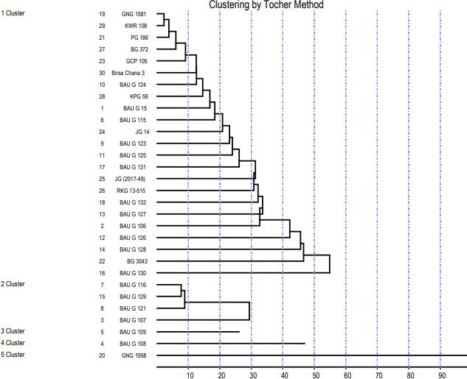

**Figure 1: Figure representing clustering by Tocher’s Method**

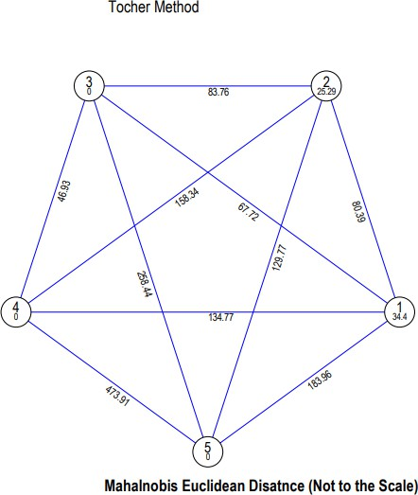

**Figure2: Figure representing inter and intra–cluster distance**

**Table-3: Cluster means of different traits**

|  |  |  |  |  |  |  |  |  |  |  |  |
| --- | --- | --- | --- | --- | --- | --- | --- | --- | --- | --- | --- |
|  | **Germination percentage** | **Days to 50%**  **flowering** | **Days to maturity** | **Plant Height** | **Number of primary branches**  **Per plant** | **Number of pods per**  **Plant** | **Number of seeds per pod** | **Number of seeds per**  **plant** | **100**  **seed**  **weight (g)** | **Wilt incidence percentage** | **Yield/plant (g)** |
| **ClusterI** | 67.46 | 78.61 | 118.06 | 51.84 | 4.22 | 63.91 | 1.45 | 93.52 | 18.08 | 5.11 | 14.70 |
| **ClusterII** | 71.67 | 74.17 | 118.00 | 53.63 | 4.13 | 62.08 | 1.22 | 75.72 | 25.76 | 4.64 | 12.12 |
| **ClusterIII** | 81.67 | 64.00 | 116.00 | 47.87 | 3.67 | 56.67 | 1.20 | 67.73 | 17.33 | 5.73 | 11.33 |
| **ClusterIV** | 76.67 | 62.00 | 102.00 | 52.40 | 4.20 | 61.67 | 1.67 | 102.07 | 17.60 | 6.70 | 16.37 |
| **ClusterV** | 50.00 | 81.00 | 138.00 | 51.47 | 3.80 | 60.67 | 1.20 | 73.00 | 25.53 | 5.83 | 11.47 |

**Table-4:Percent contribution of each trait towards genetic divergence**

|  |  |
| --- | --- |
| **Source** | **Contribution%** |
| Germination% | 0.23% |
| Days to 50%Flowering | 12.41% |
| Days to Maturity | 29.20% |
| Plant Height | 0.00% |
| No. of Primary Branches | 2.07% |
| No. of Pods Per Plant | 0.23% |
| No. of Seeds Per Pod | 0.69% |
| No. of Seeds Per Plant | 0.23% |
| 100 Seed Weight | 49.89% |
| Wilt Incidence Percentage | 5.06% |
| YIELD/PLANT(G) | 0.00% |

# Qualitative traits characterization

The observations for qualitative characterization of thirty chickpea genotypes were recorded as per the guidelines of conduct of test for DUS approved by Protection of Plant Varieties and Farmers' Rights Authority (PPV&FRA) in 2007. On the basis of flower colour the chickpea genotypes were divided into two groups *viz.,* pink and blue (Figure 3). All genotypes were having pink colour flower except for BAUG 106, BAUG 115, BAUG 126, BAUG 130 and KPG 59 which were having blue coloured flower (Table 5). The genotypes were characterized into three groups on the basis of seed colour namely, brown, deep brown and reddish brown (Figure 4). Only BAUG 123 genotype showed reddish brown colour (Table 5). On the basis of seed testa texture, the chickpea genotypes were classified into three groups namely, rough, smooth and tuberculated (Figure 6). Only two genotypes *viz.,* BAUG 128 and RKG 13-515 were recorded for tuberculated seed testa texture. Majority of genotypes (20) were having rough seed testa texture (Table 5). Similar results corroborates with the findings of Joshi and Aggarwal (2016), Gediya *et al*., (2018), Singh *et al* (2018), Adem and Tesso (2019), Kumawat *et al* (2020), Janghel *et al*., (2020) and Nandedkar *et al* (2021).

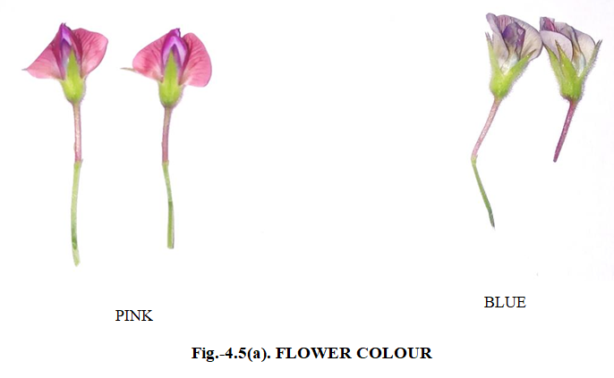

**Figure 3: Flower colour**

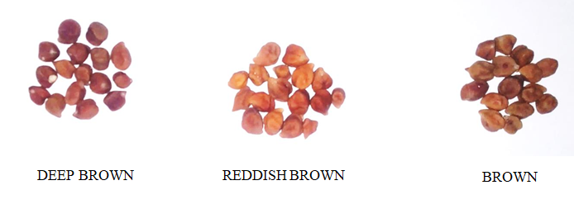

**Figure 4: Seed colour**

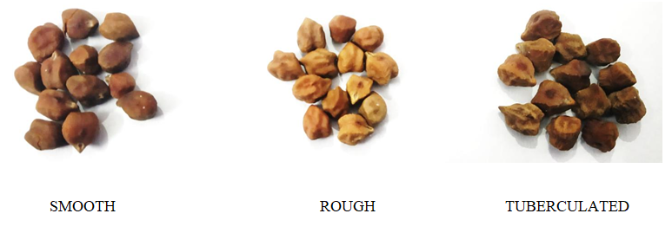

**Figure 5: Seed Testa Texture**

**Table 5: List of Qualitative characters for thirty genotypes**

|  |  |  |  |  |
| --- | --- | --- | --- | --- |
| **SL.NO.** | **ENTRY** | **FLOWER COLOUR** | **SEED COLOUR** | **SEED TESTA TEXTURE** |
| **1** | BAUG 15 | PINK | DEEP BROWN | ROUGH |
| **2** | BAUG 106 | BLUE | BROWN | ROUGH |
| **3** | BAUG 107 | PINK | BROWN | ROUGH |
| **4** | BAUG 108 | PINK | BROWN | ROUGH |
| **5** | BAUG 109 | PINK | DEEP BROWN | ROUGH |
| **6** | BAUG 115 | BLUE | BROWN | SMOOTH |
| **7** | BAUG 116 | PINK | DEEP BROWN | SMOOTH |
| **8** | BAUG 121 | PINK | DEEP BROWN | ROUGH |
| **9** | BAUG 123 | PINK | REDDISH BROWN | SMOOTH |
| **10** | BAUG 124 | PINK | DEEP BROWN | SMOOTH |
| **11** | BAUG 125 | PINK | BROWN | ROUGH |
| **12** | BAUG 126 | BLUE | BROWN | ROUGH |
| **13** | BAUG 127 | PINK | DEEP BROWN | SMOOTH |
| **14** | BAUG 128 | PINK | DEEP BROWN | TUBERCULATED |
| **15** | BAUG 129 | PINK | DEEP BROWN | ROUGH |
| **16** | BAUG 130 | BLUE | BROWN | ROUGH |
| **17** | BAUG 131 | PINK | BROWN | SMOOTH |
| **18** | BAUG 132 | PINK | BROWN | ROUGH |
| **19** | GNG 1581 | PINK | BROWN | ROUGH |
| **20** | GNG 1958 | PINK | DEEP BROWN | ROUGH |
| **21** | PG 186 | PINK | BROWN | ROUGH |
| **22** | BG 3043 | PINK | DEEP BROWN | ROUGH |
| **23** | GCP 105 | PINK | DEEP BROWN | SMOOTH |
| **24** | JG 14 | PINK | DEEP BROWN | ROUGH |
| **25** | JG (2017-49) | PINK | DEEP BROWN | ROUGH |
| **26** | RKG 13-515 | PINK | DEEP BROWN | TUBERCULATED |
| **27** | BG 372 | PINK | BROWN | ROUGH |
| **28** | KPG 59 | BLUE | BROWN | ROUGH |
| **29** | KWR 108 | PINK | BROWN | SMOOTH |
| **30** | Birsa Chana 3 | PINK | BROWN | ROUGH |

# CONCLUSION

On the basis of D2statistics the thirty genotypes were grouped into five clusters with cluster I was having maximum genotypes (23). The inter-cluster distances were greater than intra-cluster distances, thus revealing existence of considerable amount of genetic diversity among the genotypes. The highest inter-cluster distance was recorded between cluster IV and V followed by cluster III and V and cluster I and V. The parents for hybridization could be selected on the basis of their large inter-cluster distance for isolating of useful recombinants in the segregating generations.

In the present study highest contribution towards genetic divergence was found for 100-seed weight followed by days to maturity and days to 50% flowering. Therefore, more emphasis should be given to these traits for selection to create genetic variability.

On the basis of inter-cluster distances, cluster means and *per se* performance observed in the present study the genotypes GNG 1958, GCP 105, JG 14, BAUG 15, BAUG 107, BAUG 108, BAUG 109, BAUG 115, BAUG 121, BAUG 123, BAUG 124 and BAUG 129 were found superior to be suitable for crop improvement.

The morphological DUS descriptors *viz.,* flower colour, seed colour and seed texture were able to distinguish chickpea genotypes distinctively and uniformly and least affected by environmental factors and thus can be used for germplasm characterization in chickpea.

# REFERENCES

Adem, A. and Tesso, B. (2019). Phenotypic Characterization and Assessment of Genetic Diversity for Agro-Morphological Traits of Ethiopian Chickpea (*Cicer arietinum* L.) landraces. *Black Sea Journal of Agriculture*. **2**(3):146-55.

Agrawal, T., Kumar, A., Kumar, S., Kumar, A., Kumar, M., Satyendra and Perween, S. (2018). Assesment of Genetic Diversity in Chickpea (*Cicer arietinum* L.) Germplasm under Normal Sown Condition of Bihar. *International Journal of Current Microbiology and Applied Science.* **7**(4): 3552-3560..

Ahmad, F., Khan, A. I., Awan, F. S., Sadia, B., Sadaqat, H. A. and Bahadur, S. (2010). Genetic diversity of chickpea (*Cicer arietinum* L.) germplasm in Pakistan as revealed by RAPD analysis. *Genetics and Molecular Research*: **9**(3): 1414-1420.

Anonymous. (2007). Guidelines for the Conduct of Test for Distinctiveness, Uniformity and Stability on Chickpea (*Cicer arietinum* L.). Protection of Plant Varieties and Farmers' Rights Authority (PPV & FRA) Government of India. *Plant Variety Journal of India*. **1**(1)

Balasaheb, B. A., Magar, A. S., Gadade, S. B. and Suresh, B.G. (2018). Genetic Diversity studies in Chickpea (*Cicer arietinum* L.) germplasm. *International Journal of Current Microbiology and Applied Science.* **7**(9): 2757-2763.

Dwevedi, K. K. and Lal, G. M. (2009).Assessment of genetic diversity of cultivated chickpea (*Cicer arietinum* L.), *Asian Journal of Agricultural Sciences.***1**(1): 7-8.

Jakhar, D.S., Singh, R. and Kamble, M.S. (2016). Genetic Diversity Studies in Chickpea (*Cicer arietinum*L.)in Kolhapur Region of Maharashtra, *Bangladesh J. Bot.* **45**(3): 459-464.

Joshi, M. A., Aggarwal, D. and Sanyal, A. (2018). Cultivar identification and diversity analysis based on morphological descriptors and image analysis in chickpea (*Cicer arietinum* L.). *Legume Research-An International Journa.***41**(5):647-55.

Joshi, M. A., Aggarwal, D. (2016). Image Analysis as an emerging tool for varietal identification in Chickpea (*Cicer arietinum* L.) varieties. *International Journal of Advanced Technology in Engineering and Science*. **4**(11):2348-7550..

Kumawat, S., Babbar, A., Solanki, R.S., Biswal, M. and Banjarey, P. (2018). Morphological Characterization of Elite Kabuli Chickpea Lines. *Int. J. Curr. Microbiol. App. Sc*. **9**(09): 1241-1250

Mahalanobis, P.(1936).On the generalised distance in statistics. *Proceedings National Institute of Science.* **2**: 49–55.

Nimbalkar, R. D., Katre, Y. Y. and Phad, D.S. (2017). Genetic Diversity in Chickpea (*Cicer arietinum* L.). *BIOINFOLET- A Quarterly Journal of Life Sciences.* **14**(1):60-63.

Nandedkar, K., Saxena, R. R., Dixit, G.P., Rawte, S. and Saxena, R. R. (2021). DUS based Agro-morphological characterization and classification of desi chickpea (*Cicer arietinum* L.). *The Pharma Innovation Journal.* **10**(11):716-722.

Rao, C. R. (1952). Advanced statistical methods in biometrical research. John *Wiley and Sons Inc., New York*. p. 390.

Singh, S., Sasidharan, N. and Kalyanrao. (2018). Assessment of Genetic Diversity in Chickpea (*Cicer arietinum* L.) Through Morphological Characterization. *Plant Archives* **18(**1):167-172.

Tamvar, M. R., Patel, S. R., Patil, S. S., Naik, A. J. and Patel H. N. (2019).Diversity study through D2 analysis in Chickpea *The Pharma Innovation Journal*. **8**(9): 140-143.

Thakur, N. R., Toprope, V. N. and Phanindra, K. S. (2018). Genetic Diversity Analysis in Chickpea (*Cicer arietinum* L*.), International Journal of Current Microbiology and Applied Sciences,* Special Issue-**6** pp: 904-910.