**Assessment of Runoff using HEC-HMS in Ravishankar Sagar Reservoir, Dhamtari, Chhattisgarh, India**

**ABSTRACT**

In various watersheds, a variety of hydrological models were employed to model runoff based on available rainfall, land use, and soil property data. Several scholars employ rainfall-runoff modeling with the HEC-HMS model to evaluate the watershed’s water potential. In this study, HEC-HMS was used to construct a rainfall-runoff model for the catchment of Ravishankar Sagar Reservoir. Daily rainfall and runoff data from the year 2003 to the year 2020 were used to develop the daily model. The hydrological parameters, LULC preparation, soil, and slope maps have all been analysed using ArcGIS to calculate the curve number entered into the HEC-HMS model. Statistical indices have been used to assess each model's performance, including the coefficient of determination (R2), Nash-Sutcliffe efficiency (NSE), percent bias (PBIAS), and RMSE-observations standard deviation (RMSE Std dev) have been used to assess the model's effectiveness. The daily modeling was done with the calibration values of R2 = 0.9159, NSE = 0.910, PBIAS= -8.31% and RMSE Std dev = 0.3, and the validation values of R2 =0.904, NSE = 0.835, PBIAS = -23.33% and RMSE Std dev = 0.4. According to the results, the model is appropriate for hydrological simulations in the catchment of the Ravishankar Sagar Reservoir.

**Keywords:** Rainfall, Runoff, HEC-HMS, LULC, ArcGIS.

1. **INTRODUCTION**

The earth's most valuable natural resource is water. Since human life cannot exist without water (1), it is sometimes referred to as God's gift. When water flows down in defined streams by concentrated small outlets over the ground surface's natural slope, stream flow occurs (2,3).

Practically in every region of the world, water is becoming a scarce resource for agricultural production to meet the demands of urbanization and industry. Operation and management of reservoirs and watersheds should be done with great attention to solve water-related issues. However, in many cases, the quantity and quality of surface runoff have been negatively impacted by inadequate land-use planning and land management techniques brought on by fast development, which has reduced land cover, increased impervious surface area, decreased plant nutrients, and deteriorated river water quality.

A major challenge remains in accurately forecasting how catchment runoff would react to rainfall events (4). Rainfall-runoff models are frequently used to model or forecast potential floods as well as the water levels in rivers and lakes under various boundary conditions (5). For the management of natural resources, hydrological models are crucial and essential tools.

The development of complex hydrological models has advanced significantly in recent decades because of the rapid growth in computational power. However, basic conceptual models have also been developed. Because they can represent hydrological processes in enormous depths by accounting for several associated processes, the complicated physically based and distributed models are a very helpful tool. They can offer comprehensive information regarding the geographic variability of several hydrological cycle components within the catchment because of their distributed nature. Some rainfall-runoff models have a lot of parameters, and the existence of many parameter sets can increase model uncertainty and reduce model performance. Over several decades, many authors have addressed the matter of overparameterization in complex rainfall-runoff models [6,7,8,9]. The advantages of lumped and semi-distributed models over distributed hydrological models include fast computation times, the capacity to use fewer data and parameters than a distributed model and less chance of parameter uncertainty and over-parameterization than more complex models [10,11,12,13,14].

One of the hydrologic models that satisfies these requirements is the Hydrologic Modeling System (HEC-HMS), which has been widely utilized in several studies. To simulate the surface runoff response to precipitation, HEC-HMS is a physically based semi-distributed hydrological model that represents a basin with interconnected hydrologic and hydraulic components. Three fundamental data types are used in the HEC-HMS model: geospatial data (digital elevation model (DEM), soil, and land use and cover); hydrological data (streamflow); and meteorological data (rainfall, temperature, and evapotranspiration). The modeling procedure results in the calculation of inflow hydrographs at the Reservoir’s inlet [15].

To provide valuable information for future planning and management of water resources, this study was carried out to simulate the rainfall-runoff relationship for the catchment of Ravishankar Sagar Reservoir using the HEC-HMS hydrological model. The primary goal of the study was to examine hydrologic responses to precipitation in the context of inadequate data because there are very few meteorological and gauging stations in the country overall and in the Catchment of Ravishankar Sagar Reservoir specifically.

**2. STUDY AREA AND DATA USED**

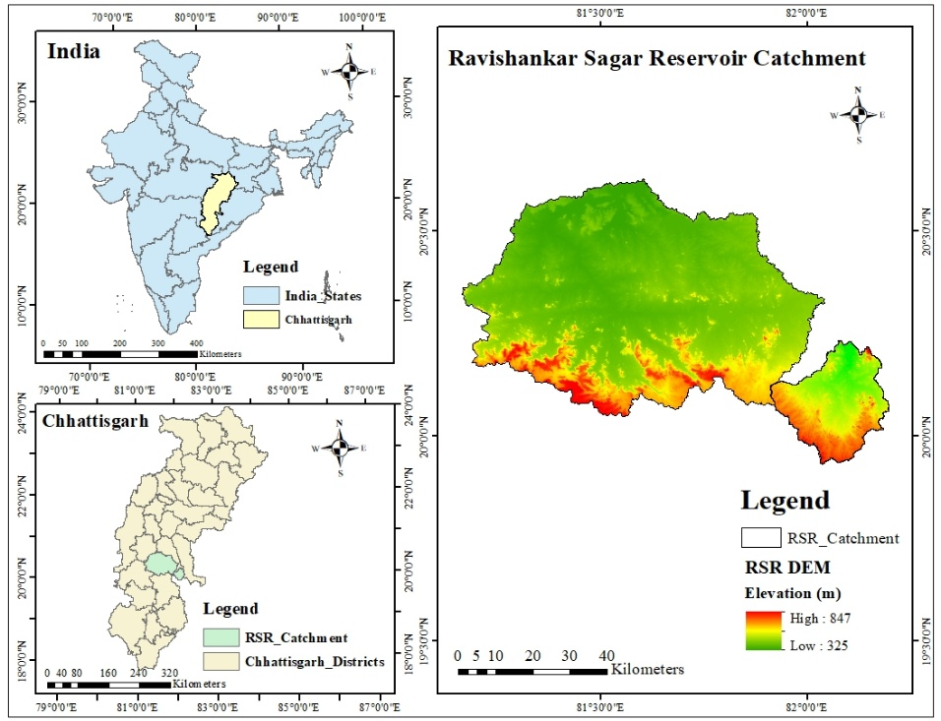One of the biggest storage structures resulting from the construction of the Gangrel Dam in 1978 is the Ravi Shankar Sagar reservoir. It is located in the Dhamtari District of Chhattisgarh, India, in the Mahanadi River Basin. It is one of the major reservoirs accounted in the Mahanadi Reservoir Project (MRP) Complex. It is a multipurpose reservoir that fulfills industrial, municipal, and irrigation needs. Two reservoirs on the Mahanadi Basin that supply water to Ravi Shankar Sagar are Murumsilli and Dhudhawa. Another reservoir of the MRP Complex is Sondhur Reservoir.

Fig. 1 –Index Map of Ravishankar Sagar Reservoir

The reservoir's catchment area is 3670 square kilometers, located within the geographical coordinates of 20°34’ latitude and 81°34’ longitude. Its water spread at FRL is 9540 ha, and its gross storage capacity is 909.3 mcm. The average annual rainfall is 1274.65 mm, and the soil type is clayey and loamy. The study area's location is depicted in Fig. 1.

**2.1 Terrain Data**

The Digital Elevation Model (DEM) digitally represents the topography surface. The 30-meter-resolution FABEM data of the study area is obtained from the (<https://data.bris.ac.uk>) and clipped to the research region (Fig. 2).

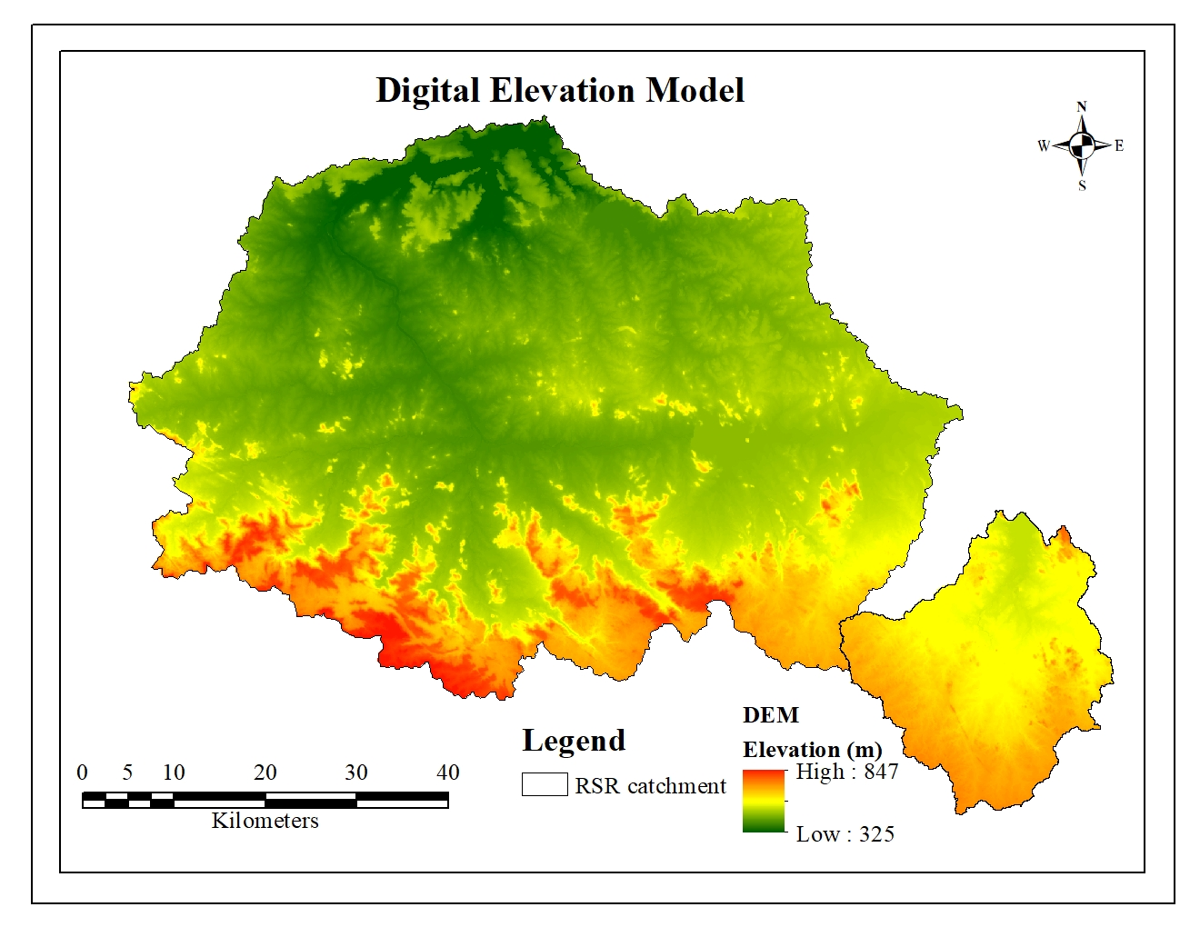

Fig. 2 – DEM Map of RSR Catchment

**2.2 Rainfall Data**

The rainfall season begins in June and ends in September in the study area. In the current study, weighted rainfall data from 2003 to 2020 are generated using the Thiessen Polygon Method, and rainfall data are extracted for the study area using ArcGIS 10.4 software. The India Meteorological Department (IMD) provides daily rainfall data with a spatial resolution of 0.250 x 0.250 on its website (<http://imdpune.gov.in>).

**2.3 Discharge Data**

The State Water Data Center in Raipur (C.G.) provides daily discharge data from 2003 to 2020 at the reservoir's outlet.

**2.4 Soil Data**

The global soil type raster file was downloaded from the website http://www.fao.org/soils-portal/data-hub/soil-maps-and-databases/harmonized-world-soil-database-v12/en/ is one step in the process to obtain the soil types for the Ravishankar Sagar Reservoir’s catchment. After that, the data were exported to Arc Map to transform the raster file into a shape file and clip the research region from the world map of soil types. After that, a symbology was conducted and the final soil map was obtained as shown in Fig. 3.

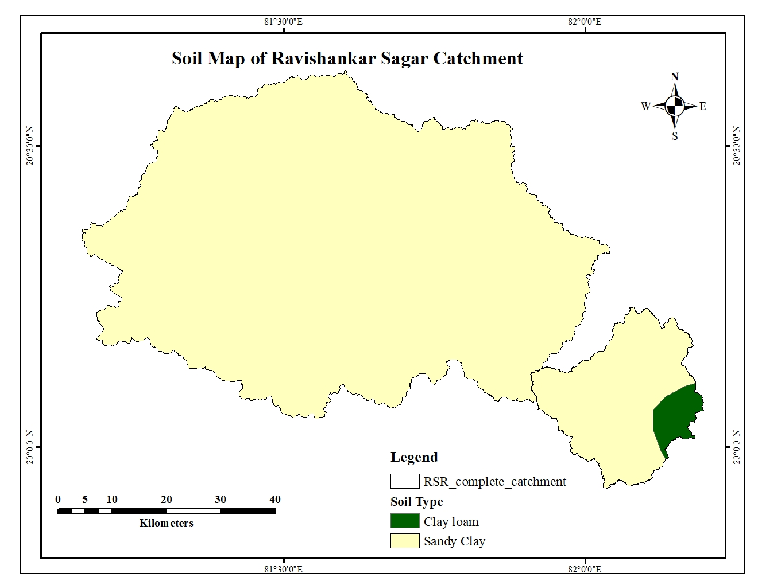

Fig. 3 – Soil Map of RSR Catchment

**2.5 Land Use/Land Cover Data**

The LULC map was created using a 10 m spatial resolution Sentinel 2 satellite picture. The photos were classified using supervised classification, and Google Earth's high imagery was used for verification. Fig. 4 shows the LULC map of the research area.

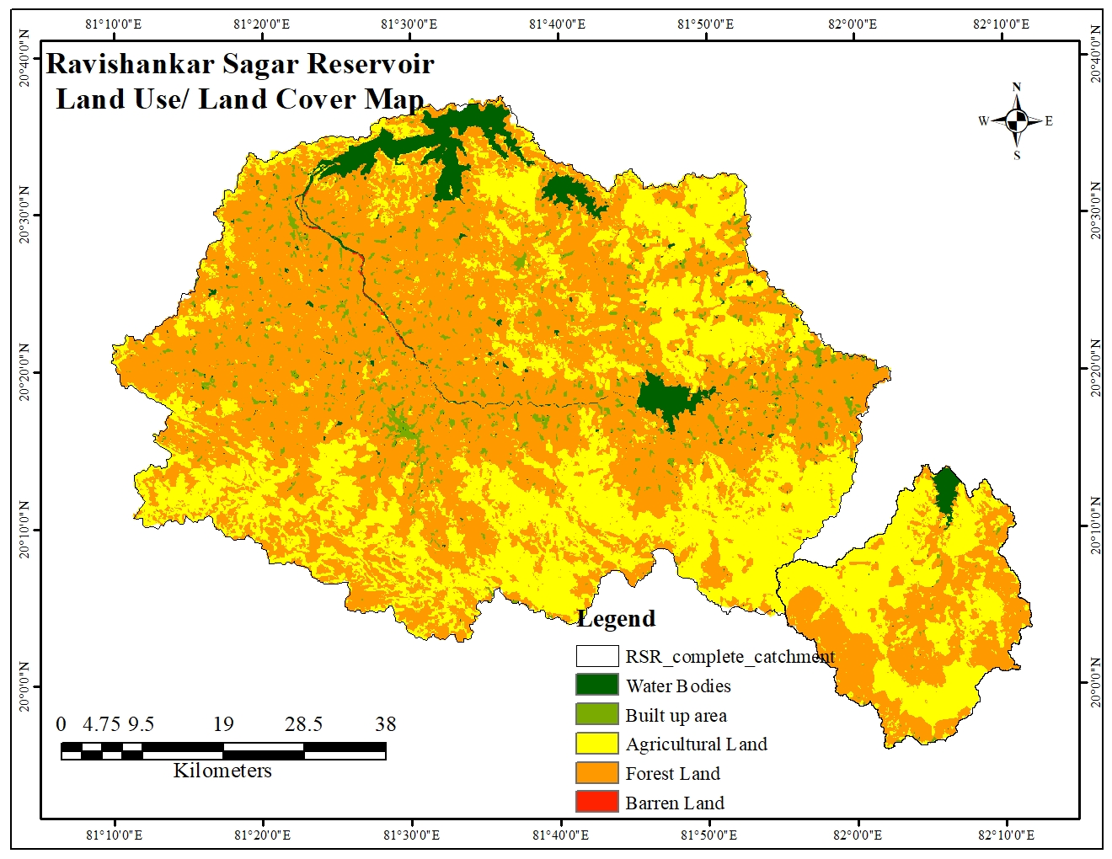

Fig. 4 – Land Use/ Land Cover Map of RSR Catchment

**3. METHODOLOGY**

**3.1 Model Description**

The US Army Corps of Engineers developed the hydrologic modeling system (HEC-HMS), a physically based semi-distributed model, to predict the rainfall-runoff dynamics of watershed systems [16]. This concept is intended to solve the greatest variety of problems by being usable in various geographical locations [17].It is frequently used to model runoff production in major river basins, tiny urban or natural watersheds, and ungauged basins [18,19]. The resulting hydrographs can support reservoir spillway design, flood risk assessment, future urbanization impact, and water resource planning and management [16].

Using HEC-GeoHMS and specifically the DEM of the areas under study, which was sourced from the FABDEM website (<https://data.bris.ac.uk>), the Ravishankar Sagar Reservoir’s hydrologic model was produced. Through a series of processes, HEC-GeoHMS generates an HMS input file that includes several hydrological characteristics in an ArcMap context, as well as the catchment of the area under investigation, a stream network, and sub-basin boundaries. For the catchment of Ravishankar Sagar Reservoir, a HEC-HMS model was created, and simulations using daily rainfall data were conducted.

The HEC-HMS model was created with all 4 reservoirs of the Mahanadi Reservoir Project Complex which were included as reservoirs and their inflow, outflow and routing parameters were inserted respectively ensuring proper linkage between them. The upstream and downstream relationships of all the reservoirs were added to the model. The methods used for all reservoirs are same.

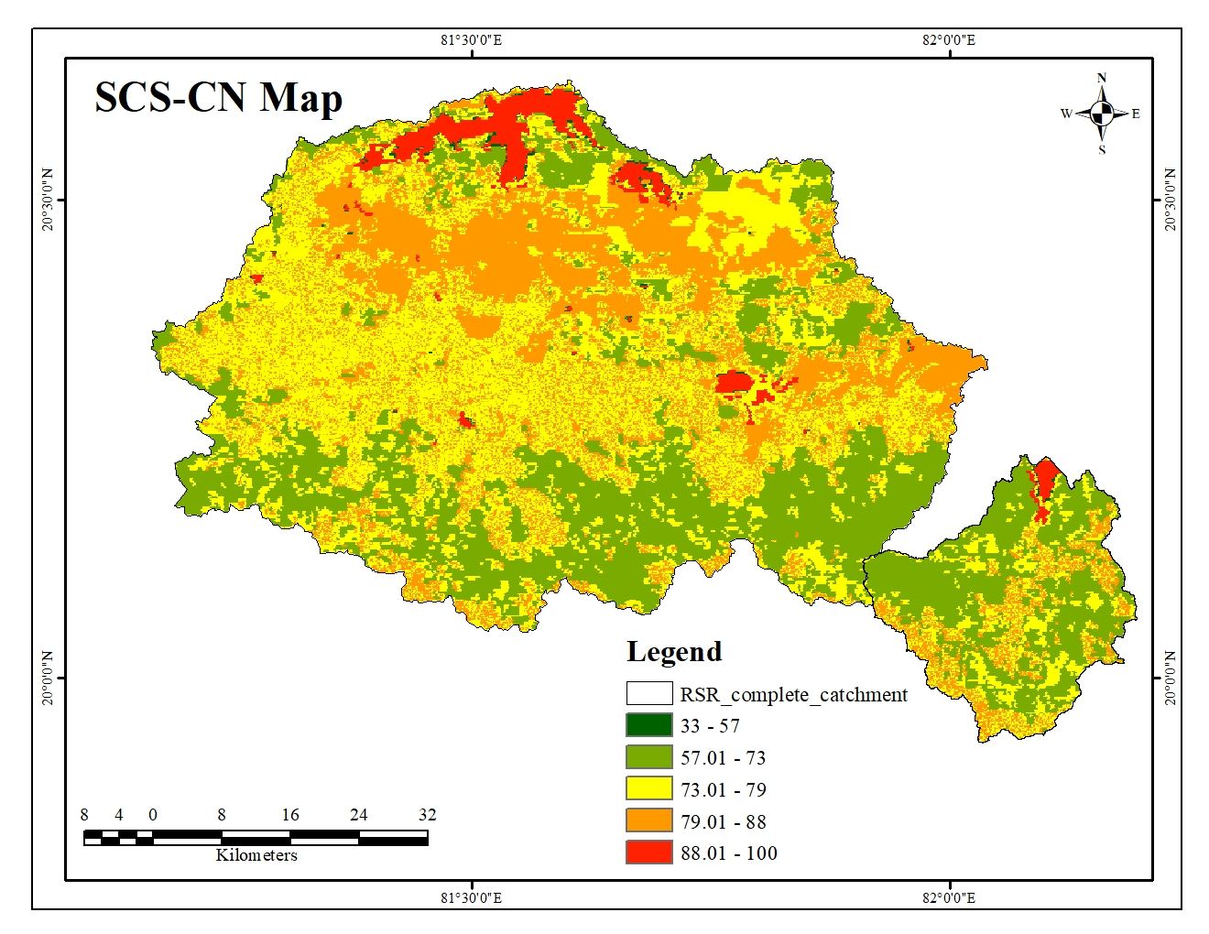

Fig. 5 – SCS-CN Map

LULC and Soil map are used to calculate the curve number. Fig. 5 displays the curve number map of the study area. This study employed the Soil Conservation Service Unit Hydrograph as the transform technique, and the Soil Conservation Service Curve Number (SCS-CN) as a loss method. The basin models, weather models, control simulations, and input data are the four primary parts of the HEC-HMS model. The basin model preserves the physical datasets describing the watershed features, while the meteorological model incorporates precipitation, evapotranspiration, and snowmelt. The start and finish dates and times of a simulation are included in the control specifications. Fig. 6 shows the HEC-HMS modelling process employed in this study.

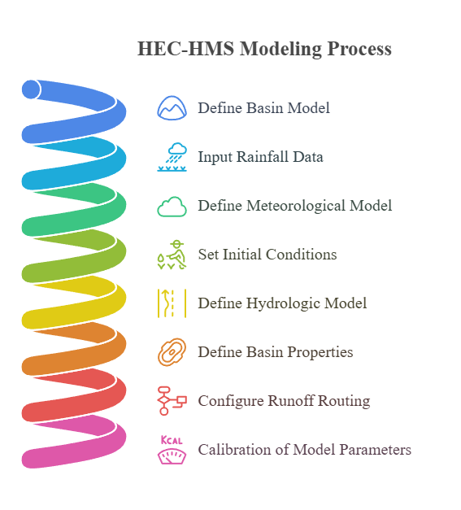Fig. 6 – Flow Chart of HEC-HMS Model

**3.1.1 Loss Method – Soil Conservation Service Curve Number**

The SCS-CN technique considers most of the watershed variables that produce runoff, including antecedent moisture condition, hydrologic soil group, land use, and soil type (Mishra & Singh, 2004). The formula for determining loss by SCS-CN method is

$Q=\frac{{(P-I_{a})}^{2}}{(P-I_{a}+S)}$… (1)

where S is the possible maximum retention, Ia is the initial absorption (mm), P is the precipitation (mm), and Q is the runoff value (mm). A catchment's ability to absorb and hold onto storm precipitation is measured by its potential maximum retention (S). Equation (2) indicates that there will be extra precipitation until the total rainfall exceeds the starting absorption.

$I_{a}=0.2×S$… (2)

Therefore, the total excess over time t is given as

$Q= \frac{{(P-0.2S)}^{2}}{(P+0.8S)}$… (3)

CN values are used to calculate soil retention using the following formula:

$S= \frac{25400}{CN}-254$… (4)

In this study, the values of CN can be obtained for various land uses, treatment, and hydrologic conditions from the standard table found in Technical Release Number 55 (TR-55) [20]. The values of CN range from 100 to 36. A value of 100 is assumed for water bodies and 36 for permeable soils of moderate infiltration rates. The study area's CN map is displayed in Fig. 6.

**3.1.2 Transform Method - Soil Conservation Service Unit Hydrograph Method**

The HEC-HMS transform prediction models simulate the process of excess rainfall and direct runoff within a catchment, converting rainfall excess into point runoff. In this study, the SCS Unit Hydrograph model was applied to transform the excess rainfall into runoff [27].

Using the HEC GeoHMS program, the basin lag time parameter values were computed during data processing and saved in the sub-basin's characteristics table. The values of the basin lag time parameter were computed during data processing using the HEC GeoHMS application and stored in the sub-basin data layer's characteristics table. Equation (5) was used to first calculate the sub-basin’s lag durations in hours, which were subsequently translated to minutes using HEC-HMS.

$Lag= \frac{{(S+1)}^{0.7}L^{0.8}}{1900*Y^{0.5}}$… (5)

Where, L is the catchment's hydraulic length (longest flow path) in feet, Y is the basin slope (%), lag is the basin lag time (hour), and S is the maximum retention (mm) as determined by Equation (4).

**3.1.3 Routing—Muskingum Method**

The channel storage effects lead the flood runoff to lessen as it passes through the channel reach. The HEC-HMS program offered the Muskingum method as a routing model [28].

A common lumped flow routing approach is the Muskingum method. Two parameters, X and K, in this model needed to be calibrated. X is a dimensionless weight that indicates the relative impact of flow on storage levels and it varies between 0 and 0.5. It is reasonable to suppose that the calibration parameters' initial value, which was adjusted during the calibration procedure, was equal to 0.1. The parameter, K, has a value between 1 and 5 hours and a unit of time. It has to do with how long it takes between discharge peaks [29].

K is estimated using Equation (6),

$K= \frac{L}{V_{w}}$… (6)

where L is the reach length and Vw is the flood wave velocity, which is equivalent to 1.5 times the average velocity. The stream gauging locations were used to determine the average velocity. Up until the simulated hydrographs resembled the observed ones, the value of K was also utilized in the calibration procedure within constrained bounds based on Equation (6).

**3.2 Model Performance Evaluations**

Through visual analysis of the simulated and observed hydrographs and statistical indicators including Nash and Sutcliffe efficiency (NSE), coefficient of determination (R2), and the percent bias (PBIAS), the performance evaluation of the HEC-HMS model was carried out by determining the goodness of fit between the observed and simulated stream flow [21].The following formulas were used to determine the NSE, R2, and PBIAS values.

1. **Percent Bias (PBIAS):**

$PBIAS=1- \frac{\sum_{i=1}^{n}{\left(Q_{obs}-Q_{sim}\right)}}{\sum_{i=1}^{n}{Q_{obs}}}×100$… (7)

The simulated and observed flows are denoted by $O_{i}$ and $P_{i}$ respectively.

1. **The Coefficient of correlation (R2):**

… (8)

R2 shows the correlation between the observed data values and the simulated data. The range of R2 is 0 (unacceptable) to 1 (best).

1. **Nash-Sutcliffe efficiencies (NSE):**

$E=1- \frac{\sum_{i=1}^{n}{{(Q_{obs}-Q_{sim})}^{2}}}{\sum_{i=1}^{n}{{(Q_{obs}-{\overline{Q}}_{obs})}^{2}}}×100$… (9)

The range of Nash-Sutcliffe efficiency is -∞ to 1.

In this case, $Q_{obs}$ = observed discharge, $Q_{sim}$ = simulated discharge, ${\overline{Q}}_{obs}$ = mean of observed discharge, ${\overline{Q}}_{sim}$ = mean of simulated discharge. Table 1 displays the general performance ratings of the interpreted results, which served as a guide [22,23,24,25,26].

Table 1 - Performance indicator for various evaluation criteria

|  |  |  |  |
| --- | --- | --- | --- |
| **Performance Rating** | **PBIAS (%)** | **R2** | **NSE** |
| Very good | PBIAS < ±10 | 0.75 to 1 | 0.75 to 1 |
| Good | ±10 < PBIAS < ±15 | 0.65 to 0.75 | 0.65 to 0.75 |
| Satisfactory | ±15 < PBIAS < ±25 | 0.50 to 0.65 | 0.50 to 0.65 |
| Unsatisfactory | PBIAS > ±25 | <0.50 | <0.50 |

1. **RESULTS AND DISCUSSION**

**4.1 Hydrological Parameters**

Important watershed characteristics, including curve number, basin lag time, watershed area, basin slope, potential maximum retention (S), and the initial abstraction from the watershed, were determined, as discussed in the section on methods. Within the study area, the CN value's spatial variance was identified. The CN values in the research area varied, ranging from a minimum of 36 for wooded areas to a maximum of 100 for bodies of water. However, a single CN value is required for each sub-basin in order to simulate rainfall and runoff. Consequently, the weighted CN values for every sub-basin had previously been determined by HEC-GeoHMS. 39.8624 and 74.5296 were determined to be the lowest and greatest weighted curve number values, respectively. Surface runoff will reach the output point more quickly if the basin lag time is less. Table 2 displays the specific watershed features. Runoff generation is directly influenced by the Curve Number value. Higher infiltration rates and less runoff are the outcomes of sub-basins with lower CN values. Sub-basins with higher CN values, on the other hand, have more potential for runoff. Figure 5 shows the spatial distribution of CN. Surface runoff will reach the output point more quickly if the basin lag time is less. The specific features of the watershed are displayed in Table 2.

Table 2 - The specific features of the watershed

|  |  |  |  |  |
| --- | --- | --- | --- | --- |
| **Subbasin** | **Initial Abstraction (mm)** | **Curve Number** | **Impervious (%)** | **Lag time (minutes)** |
| S1 | 49.039 | 50.882 | 0.54555 | 1916.67 |
| S3 | 44.114 | 53.5223 | 0.63096 | 2342.244 |
| S2 | 17.361 | 74.5296 | 0.0887721 | 2242.746 |
| S4 | 43.077 | 54.1132 | 0.31107 | 1496.361 |
| S5 | 25.563 | 66.5245 | 0.0324786 | 801.0968 |
| S6 | 52.171 | 49.3342 | 6.2134 | 2686.407 |
| S7 | 34.847 | 59.3132 | 0.42803 | 2296.479 |
| S8 | 59.029 | 46.2536 | 4.913 | 2055.085 |
| S9 | 51.065 | 49.8699 | 2.5771 | 1575.625 |
| S10 | 20.254 | 71.495 | 0.29322 | 442.8158 |
| S14 | 55.501 | 47.7888 | 2.6505 | 2754.875 |
| S16 | 49.546 | 50.6247 | 1.6288 | 2308.893 |
| S15 | 48.839 | 50.9843 | 1.4195 | 2082.33 |
| S17 | 54.785 | 48.1131 | 4.5915 | 2704.834 |
| S18 | 76.638 | 39.8624 | 2.16 | 2708.623 |
| S19 | 74.916 | 40.4085 | 2.4849 | 4038.821 |
| S20 | 72.763 | 41.1125 | 2.8873 | 3883.345 |
| S21 | 56.29 | 47.4367 | 4.7509 | 4035.114 |
| S22 | 37.45 | 57.5635 | 4.6434 | 2392.644 |
| S11 | 47.289 | 51.7895 | 5.4829 | 3115.064 |
| S12 | 38.702 | 56.7583 | 2.8655 | 2345.72 |
| S13 | 37.66 | 57.4265 | 1.9526 | 2795.806 |
| S23 | 21.325 | 70.4335 | 0.45106 | 1133.59 |

**4.2 Model Simulation Results**

Based on the results, the watershed outlet's maximum daily flow rate has been determined to be 4547.5 m3/s. This specific value has important ramifications for the watershed's overall hydrological processes. The observable rise in water depth as the river moves closer to its outflow indicates a change in the hydrological features throughout the river system, which may have an impact on the flow and quality of water downstream.

**4.3 Model calibration**

In order to ensure a close match between simulated and observed flow data within an acceptable deviation range, the HEC-HMS model's parameters had to be adjusted during calibration (from the year 2003 to the year 2015). This procedure aimed to improve the agreement between the two datasets by improving the model's depiction of the hydrological processes. However, the simulated and observed events' times to peak corresponded, validating the model's accuracy. Peak stream flow values were improved to 4547.5 m3/s for simulated data and 4653.1 m3/s for actual data by iterative calibration changes, demonstrating a significant improvement in model accuracy. Many watershed characteristics, including lag time, curve number, starting abstraction, flood wave traveling time (Muskingum-k), and weighted coefficient of discharge (Muskingum-x), were carefully chosen in order to accomplish this calibration. With special attention to curve number and lag duration, the sensitivity analysis showed that each factor was essential to optimizing the HEC-HMS model. For example, Muskingum-k's initial calculated values ranged from 1:50 to 3:40 h, which were later modified to 1:10 and 3:10 h after calibration.

The calibration procedure comprised calculating and modifying the Muskingum-k values for every reach. This systematic approach ensures that the model faithfully represents the flow dynamics at various watershed segments. Similar to this, a rigorous process of trial and error was used to determine the Muskingum-x values for each reach, which finally led to optimal values of 0.30. A more accurate depiction of the hydrological system results from these meticulous corrections and enhancements, which highlight the care and diligence used in the calibration of the HEC-HMS model. The comparison of the observed and simulated flow hydrographs of the catchment of the Ravishankar Sagar Reservoir at the outlet after the calibration period is shown in Fig. 7.

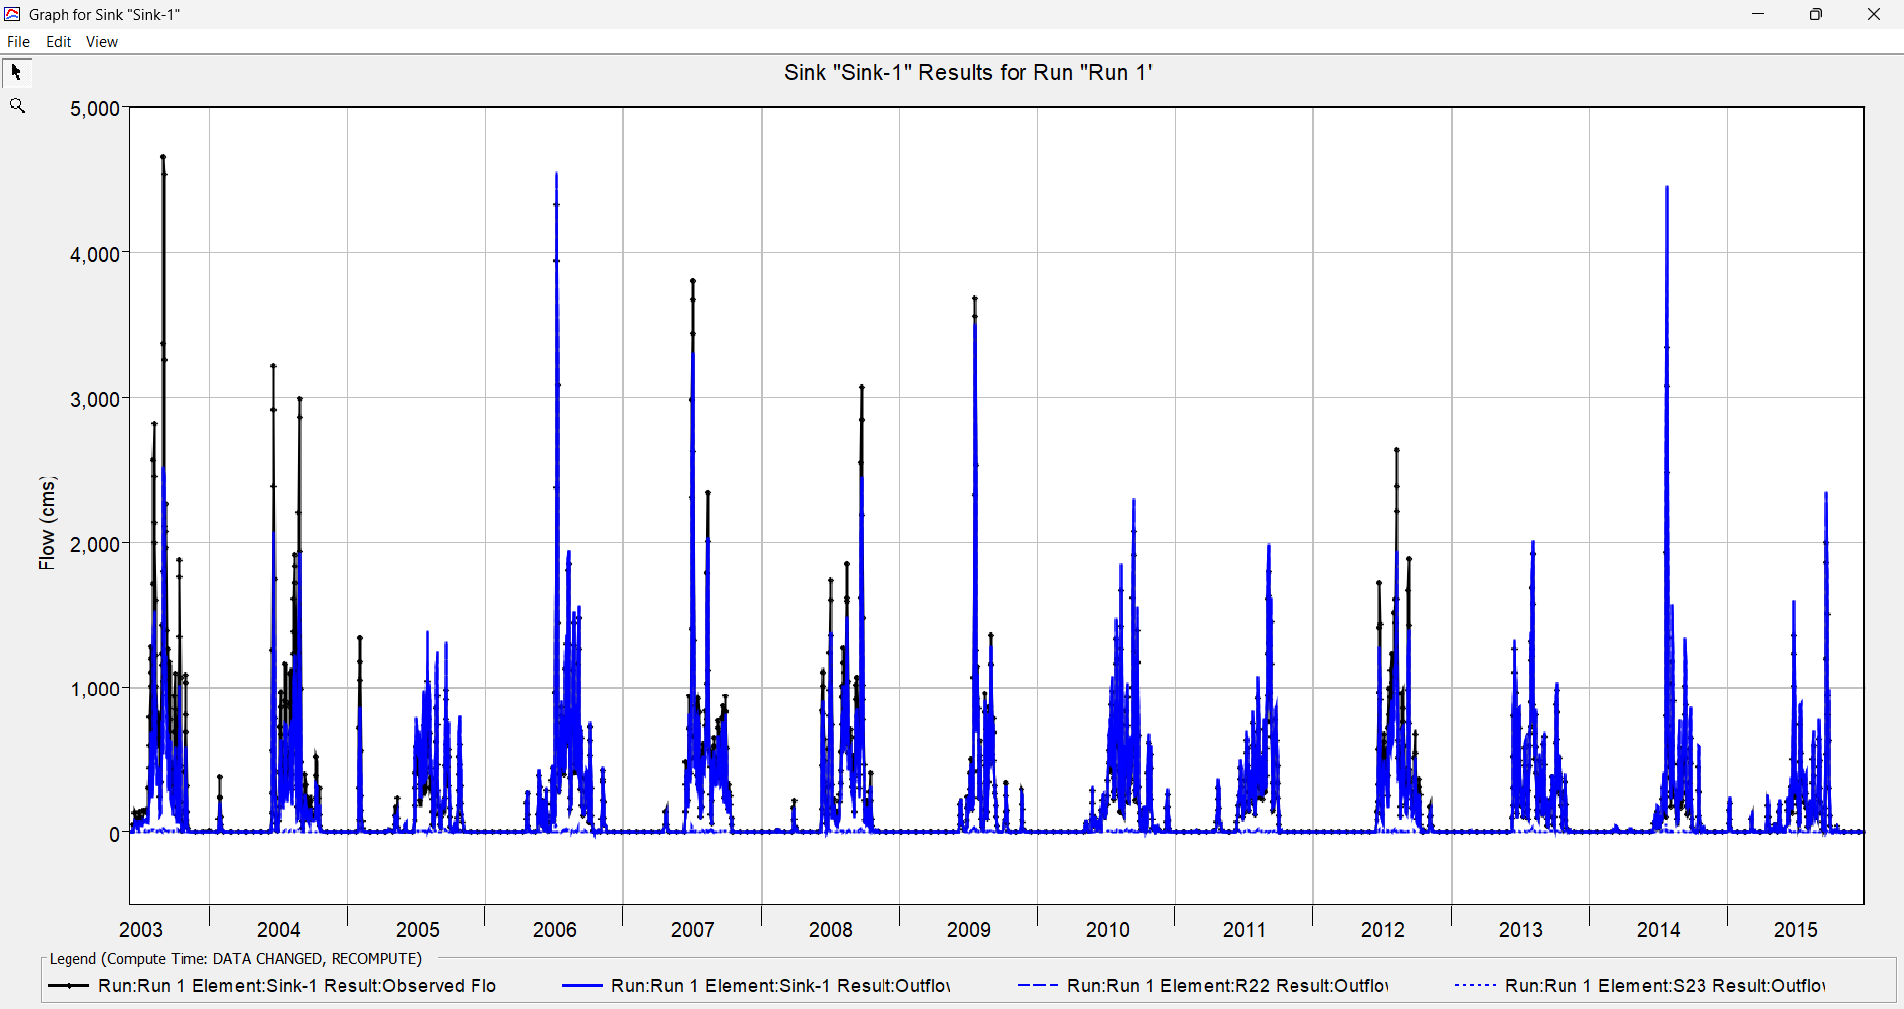

Fig. 7 – Calibration results

Throughout the calibration period, there was a constant pattern in the agreement between the low flow and peak flow of the simulated and observed hydrographs, which was exceptionally strong. Furthermore, as shown in Fig. 8, the scatter plot comparing the simulated and measured stream flow for the same calibration period shows a correlation coefficient (R2) of 0.9159, indicating a strong relationship between the simulated and real observed stream data.

Fig. 8 – Scatter Plot

**4.4 Model validation**

The expected calibration result has been adequately validated, as all statistical error tests were shown to fall within an acceptable range (0.75–1) during the validation procedure, specifically during the calibration phase (from the year 2016 to the year 2020). The low flows and peak flows of the simulated and observed streamflow hydrographs closely coincide, as shown graphically in Fig. 9, exhibiting a continuous trend throughout the validation process.

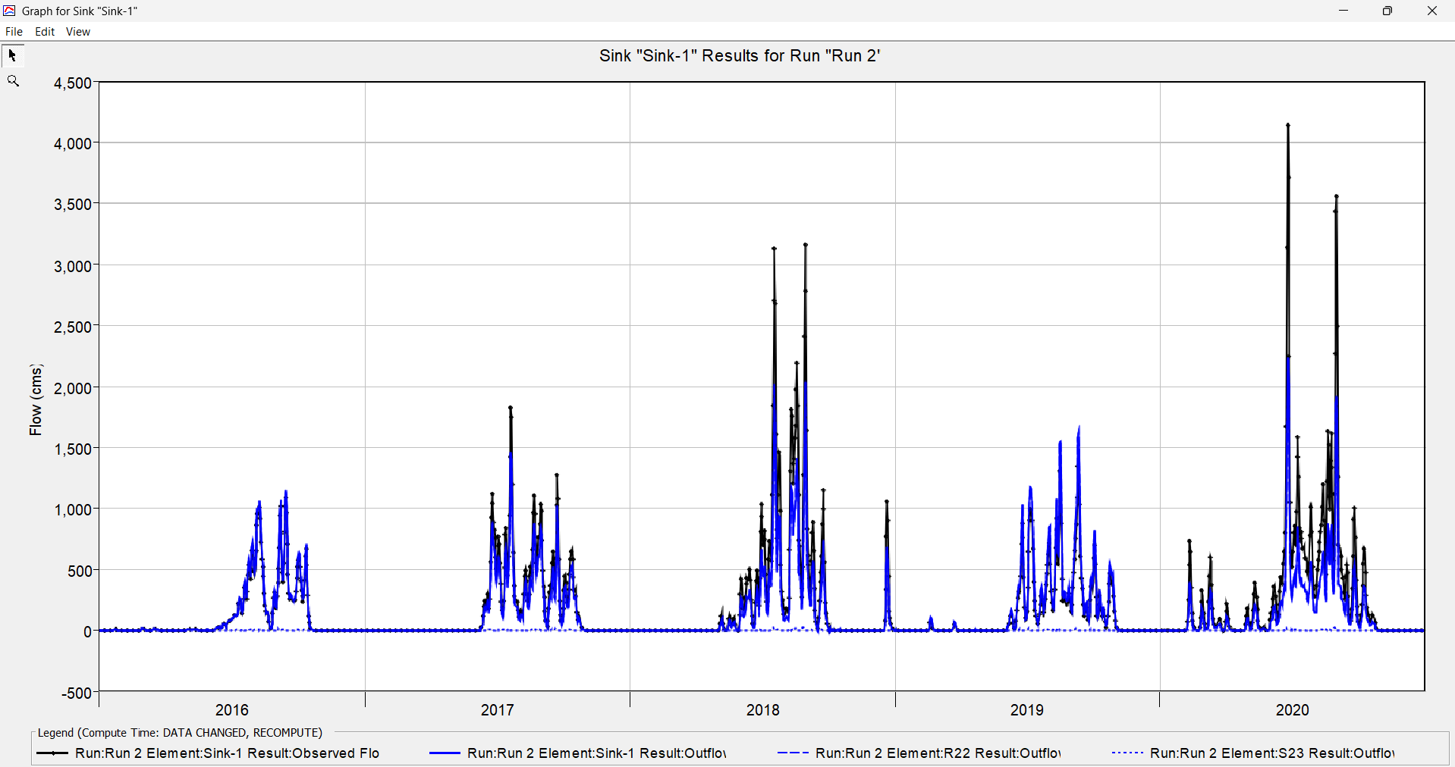

Fig. 9 – Validation Graph

Fig. 10 – Scatter plot

This empirical data clearly indicates that the HEC-HMS model performs well when it comes to reproducing streamflow data in the specified research area. Therefore, it can be concluded that the model has potential for accurately modeling the region's hydrological dynamics. There is a reasonable linear connection between the simulated and observed data during the calibration phase, according to the scatter plot of the measured and simulated flow during the validation period (Fig. 10). A similar pattern to the model calibration period can be seen in the shape and dispersion of the simulated and observed streamflow hydrograph at the watershed's outlet during the validation period.

**4.5 Model performance evaluation**

Nash-Sutcliffe Efficiency (NSE), Root Mean Squared Error (RMSE), and Coefficient of Determination (R2) were used to assess the model's performance. According to Moriasi et al. (2007), who investigated model evaluation recommendations for the systematic quantification of accuracy in Watershed simulations, a very excellent model should have an NSE and R2 value between 0.75 and 1.0 and an RMSE value between 0 and 0.5. According to Schaefli and Gupta (2007), Kashid (2010), and Vaze (2011), a model is deemed to be extremely good if the NSE and R2 values obtained during calibration and validation fall between 0.75 and 1. In the current study, the RMSE values were 0.3 and 0.4 during calibration and validation, respectively, while the NSE and R2 values were both greater than 0.75. A strong connection between the modeled and actual streamflow data was shown by the calibration and validation phase findings. Thus, according to these statistical measures, the HEC-HMS model had an excellent performance grade. The model's effectiveness in reproducing daily streamflow using rainfall data in the research area is suggested by its ability to make accurate predictions during the calibration and validation stages. As a result, the model's performance was judged adequate and thought to be appropriate for forecasting future peak floods under different management scenarios. Furthermore, the observed streamflow data in the research area was accurately replicated by the simulated streamflow data.

1. **CONCLUSION**

In the field of hydrology, rainfall-runoff modeling is very important since it is essential for modeling the complex patterns of watershed response to different rainfall event intensities, which in turn produces flow hydrographs. Flood forecasting and the strategic planning of water resources management both make extensive use of these hydrographs. By modeling surface runoff in the catchment of Ravishankar Sagar Reservoir, the HEC-HMS model was used in the current study, demonstrating the effectiveness and dependability of this computational tool. To enable a thorough and reliable analysis, a number of essential datasets were carefully integrated into the research framework, including soil properties, land use/cover data, hydro-meteorological information, and Digital Elevation Model (DEM) data. In the field of hydrology, rainfall-runoff modeling is very important since it is essential for modeling the complex patterns of watershed response to different rainfall event intensities, which in turn produces flow hydrographs. Flood forecasting and the strategic planning of water resources management both make extensive use of these hydrographs. By modeling runoff in the Ravishankar Sagar Reservoir, the HEC-HMS model was used in the current study, demonstrating the effectiveness and dependability of this computational tool. To enable a thorough and reliable analysis, a number of essential datasets were carefully integrated into the research framework, including soil properties, land use/cover data, hydro-meteorological information, and Digital Elevation Model (DEM) data. Using daily observed streamflow data for 13 years (2003–2015) and 5 years (2016–2020), respectively, the model was calibrated and validated. Curve numbers on the study site range from 30 to 100. Lag time, curve number, initial abstraction, flood travel time (Muskingum-k), and discharge weighting factor (Muskingum-x) are important variables that affect output. The Root Mean Squared Error, Nash-Sutcliffe Efficiency (NSE), and Coefficient of Determination (R2) were used to evaluate the model's effectiveness. During calibration, the values were 0.3, 0.910, and 0.9159, respectively; during validation, they were 0.4, 0.835, and 0.904. These results show the model's strong performance and show that the HEC-HMS model works well for simulating streamflow data in the research area based on rainfall data.

**COMPETING INTERESTS DISCLAIMER**:

Authors have declared that they have no known competing financial interests OR non-financial interests OR personal relationships that could have appeared to influence the work reported in this paper.

**REFERENCES**

1. Abdullah K., 2013. Malaysian Coastal Environment – Planning Development and Management of the Environment in Preparation for the Next Millenium. International Symposium and Exposition on ‘Coastal Environment and Management: Challenges in the New Millenium.’ I, 26.
2. Cunha M. C., Zeferino J. A., Simões N. E. & Saldarriaga J. G., 2016. Optimal location and sizing of storage units in a drainage system. *Environmental Modelling & Software*, 83, 155–166. <https://doi.org/10.1016/j.envsoft.2016.05.015>.
3. Efthimiou N., 2018. Hydrological simulation using the SWAT model: the case of Kalamas River catchment. *Journal of Applied Water Engineering and Research*, 6(3), 210–227. Taylor & Francis. DOI:[10.1080/23249676.2016.1265471](http://dx.doi.org/10.1080/23249676.2016.1265471)
4. McColl C. and Aggett G., 2006. Land-use forecasting and hydrologic model integration for improved land-use decision support, *Journal of Environmental Management*, 84(4), pp 494–512. <https://doi.org/10.1016/j.jenvman.2006.06.023>
5. Jia Y., Zhao H., Niu C., Jiang Y., Gan H., Xing Z., Zhao X. and Zhao Z., 2009. A WebGIS-based system for rainfall-runoff prediction and real-time water resources assessment for Beijing. *Comput. Geosci.,* *35*, 1517–1528. <https://doi.org/10.1016/j.cageo.2008.10.004>
6. Beven K. A., 2006. Manifesto for the equifinality thesis. *J. Hydrol*., 320, 18–30. <https://doi.org/10.1016/j.jhydrol.2005.07.007>
7. Jakeman A.J., and Hornberger G.M., 1993. How much complexity is warranted in a rainfall-runoff model? *Water Resour. Res.*, 29, 2637–2649. <https://doi.org/10.1029/93WR00877>
8. Bergström S., Lindström G., and Pettersson A., 2002. Multi-variable parameter estimation to increase confidence in hydrological modelling. *Hydrol. Process*., 16, 413–421. <https://doi.org/10.1002/hyp.332>
9. Kirchner J.W., 2009. Catchments as simple dynamic systems: Catchment characterization, rainfall-runoff modeling, and doing hydrology back-ward. *Water Resour. Res.*, 45, W02429. <https://doi.org/10.1029/2008WR006912>
10. Đukić V., 2006. Modelling of base flow of the basin of Kolubara river in Serbia. *J. Hydrol.*, 327, 1–12. <https://doi.org/10.1016/j.jhydrol.2005.11.009>
11. Modrick Hansen T., Georgakakos K., 2006. Intercomparison of lumped versus distributed hydrologic model ensemble simulations on operational forecast scales. *J. Hydrol.*, 329, 174–185. <https://doi.org/10.1016/j.jhydrol.2006.02.013>
12. De Vos N.J., Rientjes T.H.M., and Gupta H.V., 2010. Diagnostic evaluation of conceptual rainfall-runoff models using temporal clustering. *Hydrol. Process*., 24, 2840–2850. <https://doi.org/10.1002/hyp.7698>
13. Mendez M. and Calvo-Valverde L., 2016. Development of the HBV-TEC hydrological model. *Procedia Eng.*, 154, 1116–1123. <https://doi.org/10.1016/j.proeng.2016.07.521>
14. Darbandsari P., and Coulibaly P., 2020. Inter-comparison of lumped hydrological models in data-scarce watersheds using different precipitation forcing data sets: Case study of Northern Ontario, Canada.*J. Hydrol. Reg. Stud.*, 31, 100730. <https://doi.org/10.1016/j.proeng.2016.07.521>
15. Yilma Z. L. and Kebede H. H., 2023. Simulation of the rainfall–runoff relationship using an HEC-HMS hydrological model for Dabus Subbasin, Blue Nile Basin, Ethiopia. H2 Open Journal Vol 6 No 3, 331. https://doi.org/[10.2166/h2oj.2023.055](https://doi.org/10.2166/h2oj.2023.055)
16. US Army Corps of Engineers Hydrologic Engineering Centre (USACE) (2000) Hydrologic modeling system: technical reference manual. USACE-HEC, Davis, CA, USA, p 148. https:// www. hec.usace.army.mil/software/hec-hms/documentation/HEC- HMS_Technical % 20Reference% 20Manual_(CPD- 74B). pdf.
17. Scharﬀenberg W. A., 2016. Hydrologic modeling system HEC-HMS: User’s Manual Version 4.2. USACE, Hydrologic Engineering Center, Davis, CA, USA, p 614. <https://www.hec.usace.army.mil/software/hec-hms/documentation/HEC-HMS_>Users_ Manual_4.2.pdf.
18. Fleming M., and Brauer T., 2016. Hydrologic modelling system HEC-HMS quick start guide. [online] Version 4.2. US Army Corps of Engineers, Institute of Water Resources.

https://[www.hec.usace.army.mil/software/hec_hms/documentation/HEC](http://www.hec.usace.army.mil/software/hec_hms/documentation/HEC)_HMS_Quick_Start_Guide_4.2.pdf Accessed 8 Apr 2018.

1. Cuomo A. and Guida D., 2021. Hydro-geomorphologic-based water budget at event time-scale in a Mediterranean Headwater Catchment (Southern Italy). Hydrology 8:20. [https://doi.org/10. 3390/hydrology8010020](https://doi.org/10.%203390/hydrology8010020).
2. Soil Conservation Service. Urban hydrology for small watersheds, Technical Release 55. USDA, Springfield, VA; 1986.
3. Rajput A., 2021. Hydrological Modelling of Banjar River Watershed using HEC-HMS. *Chem Sci Rev Lett.*;10 (37): 81-90. Article cs205201275.

DOI:10.37273/chesci.CS205201275

1. Santhi C., Arnold J.G., Williams J.R., Dugas W.A., Srinivasan R., and Hauck L.M., 2001. Validation of the SWAT model on a large river basin with point and nonpoint sources. *Journal of the American Water Resources Association.* 37(5):1169-1188. Available: <https://doi.org/10.1111/j.17521688.2001.tb03630.x>.
2. Moriasi D.N., Arnold J.G., Liew M.W., Van Bingner R.L., Harmel R.D., and Veith T.L., 2007. Model evaluation guidelines for systematic Quantification of accuracy in. DOI:[10.13031/2013.23153](http://dx.doi.org/10.13031/2013.23153)
3. Moriasi D.N., Gitau M.W., Pai N., and Daggupati P., 2015. Hydrologic and water quality models: Performance measures and evaluation criteria. Transactions of the ASABE. 2015;58(6):1763–1785. Available: <https://doi.org/10.13031/trans.58.10715>.
4. Gebre S.L., 2015. Application of the HEC-HMS model for runoff simulation of Upper Blue Nile River Basin. *Journal of Waste Water Treatment & Analysis*. 06(02). Available: <https://doi.org/10.4172/21577587.1000199>.
5. Ouédraogo W.A.A., Raude J.M., and Gathenya J.M., 2018. Continuous modeling of the Mkurumudzi River catchment in Kenya using the HEC-HMS conceptual model: Calibration, validation, model performance evaluation and sensitivity analysis. *Hydrology*. 5(3). Available: <https://doi.org/10.3390/hydrology5030044>.
6. Hamdan A. N. A., Almuktar S. and Scholz M., 2021. Rainfall-Runoff Modeling Using the HEC-HMS Model for the Al-Adhaim River Catchment, Northern Iraq. *Hydrology*, 8, 58. <https://doi.org/10.3390/hydrology8020058>.
7. McCarthy G.T., 1939. The unit hydrograph and flood routing. In Proceedings of the Conference of North Atlantic Division, US Army Corps of Engineers, New London, CT, USA, pp. 608–609.
8. Din S.U., Khan N.M., Israr M., Nabi H., and Khan M., 2019. Runoff modelling using HEC-HMS for rural watershed. *Development*, 6. DOI:[10.13140/RG.2.2.21207.83364](http://dx.doi.org/10.13140/RG.2.2.21207.83364).