Impact of future climatic conditions on yield of Wheat crop in different growing environments under RCP 4.5 and RCP 8.5 in different wheat growing districts of Chhattisgarh.

Abstract
Climate change is a critical factor influencing global agriculture, particularly wheat production, which is highly sensitive to temperature and precipitation variations. This study examines the projected impact of future climate scenarios (2030-31, 2050-51 and 2070-71) on wheat yield across different growing environments in the wheat-growing districts of Chhattisgarh. The results reveal that the highest yield decline is observed in Mungeli district (-8.5%) in 2030-31, (-11.5%) in 2050-51 and Balodabazar district (-13.8%) in 2070-71 under RCP 4.5. Similarly, under RCP 8.5, the highest yield reductions were recorded in Raigarh and Mungeli districts (-10.3%) in 2030-31, Bilaspur district (-16.0%) in 2050-51 and Mungeli district (-21.3%) in 2070-71. Conversely, Kabirdham and Bemetara districts exhibited the lowest reductions in yield across different years and scenarios.
Keywords: Climate Change, Wheat Yield, DSSAT Model, RCP 4.5 & RCP 8.5, Chhattisgarh, Future Projections.
Introduction
Wheat (Triticum aestivum L.) is a vital cereal which plays a significant role in global food security, contributing substantially to the diet of millions of people worldwide (FAO, 2021). In India, wheat is the second most important staple food crop, cultivated extensively in various agroclimatic regions, including Chhattisgarh. Chhattisgarh produced 317.25 thousand kg of wheat on 245.36 thousand hectares, with an average productivity of 1293 kg/ha (Anonymous, 2024). Wheat cultivation is predominantly under irrigated conditions in rice-based cropping systems. Delays in wheat sowing due to the late harvest of rice varieties result in high temperatures during the grain-filling and ripening phases, contributing to reduced productivity. However, climate change poses a critical threat to wheat production, as increasing temperatures, fluctuating precipitation patterns and elevated CO₂ levels are expected to influence crop growth and yield dynamics (IPCC, 2021). A significant increase in the number of warm days and a decrease in the number of cold days are signs that global warming is speeding up, according to reports from the Intergovernmental Panel on Climate Change (IPCC). According to 21st-century projections, global temperatures could rise by 1.1°C to 2.6°C under the Representative Concentration Pathway (RCP) 4.5 scenario, while they could rise much more under RCP 8.5 (IPCC, 2021). Furthermore, atmospheric CO₂ concentrations are predicted to increase from 350 ppm to approximately 600 ppm, which could directly impact crop physiology, water use efficiency and overall productivity (Lobell et al., 2015).
Temperature is a critical weather parameter impacting wheat yields. Variations in temperature influence grain yield primarily through their effects on phenological development. Winter wheat is particularly vulnerable to high temperatures during reproductive stages. Research has shown that increased night-time temperatures during the reproductive phase can significantly reduce grain filling rates and yield (Al-Khatib and Paulsen, 1984; Zhao et al., 2008; Talukder et al., 2013). A 1°C rise in air temperature can shorten the flowering period by five days (Saini and Nanda, 1987). Where there are notable temperature swings in Central India. Temperature variations have an impact on wheat productivity. For instance, a 1°C rise in temperature during the growing season can drastically lower possible grain yields in Central India but may not have an impact on productivity in North India. Additionally, Chhattisgarh faces the threat of climate change, which may exacerbate the challenges faced by wheat production. Previous studies have shown significant variability in climate impacts across the state, affecting agricultural productivity (Sastri, 2010).
To assess the potential effects of future climate change on wheat production, crop simulation models offer a robust approach. The Decision Support System for Agrotechnology Transfer (DSSAT) was initially developed by an International Network of Researchers, collaborating with the International Benchmark Sites Network for Agrotechnology Transfer (IBSNAT) project (Jones et al., 2003). DSSAT combines crop, soil and weather databases and programs to manage them, with crop models and application programs, to simulate multi-year outcomes of crop management strategies. This research predicts wheat yield in different future climatic conditions under RCP 4.5 & 8.5 for different wheat-growing districts of Chhattisgarh. The study's findings will contribute to adaptive strategies for policymakers, agronomists and farmers, ensuring sustainable wheat production in the face of climatic uncertainties.
Materials and Methods:
1. Study Area and Climatic Conditions
Chhattisgarh state is located between 17° 46 N and 24° 06 N latitude and 80° 15 E and 84° 24 E longitudes. Chhattisgarh is the 10th largest state in India, with an area of 135,194 km². In Chhattisgarh, cropping intensity is 135%. The climate of the state is dry sub- humid type. The Chhattisgarh state has been divided into three agroclimatic zones viz., Chhattisgarh plains, Bastar plateau and Northern hills. Mainely 33 districts of Chhattisgarh. Out of these, 22 districts grow wheat, but only 12 districts i.e., Raipur, Durg, Rajnandgaon, Kabirdham, Raigarh, Bilaspur, Bemetara, Surajpur, Surguja, Balrampur, Balodabazar and Mungeli were selected, where wheat is grown in more than 500 hectares area.
Table 1: Name of districts with latitude and longitude.
S. No. | District | Latitude | Longitude
 | Balarampur | 23.50 °N | 83.50 °E
 | Balodabazar | 21.50 °N | 82.50 °E
 | Bemetara | 21.50 °N | 81.50 °E
 | Bilaspur | 22.50 °N | 82.50 °E
 | Durg | 21.16 °N | 81.42 °E
 | Kabirdham | 22.09 °N | 81.25 °E
 | Mungeli | 22.17 °N | 81.73 °E
 | Raigarh | 21.89 °N | 83.39 °E
 | Raipur | 21.25 °N | 81.62 °E
 | Rajnandgaon | 21.09 °N | 81.03 °E
 | Surajpur | 23.50 °N | 82.82 °E
 | Surguja | 22.94 °N | 83.16 °E
2. Database
2.1 Weather Data:
Daily weather data of the following variables i.e., rainfall, maximum temperature and minimum temperature for future climatic conditions 2030-31, 2050-51 and 2070-71 under RCPs 4.5 & 8.5 has been downloaded from MarkSim weather generator from four different GCM models i.e., GFDL-CM3, GFDL-ESM2M, MICRO, NorESM1-M.
2.2 Soil data:
The soil data of 12 districts (i.e., Raipur, Durg, Rajnandgaon, Kabirdham, Raigarh, Bilaspur, Bemetara, Surajpur, Surguja, Balrampur, Balodabazar, Mungeli) were used for running Crop Simulation Model DSSAT. These data were given by the IMD, New Delhi, under GKMS Project. Soil classification, colour, slope, permeability and drainage class were the required soil data. The soil profile data included upper and lower horizon depths (cm), percentage sand, silt and clay content, bulk density at (1/3 bar), organic carbon, pH in water, aluminum saturation and root abundance information.
2.3 Genetic coefficients:
Table 2: Genetic coefficients of different wheat varieties used in the DSSAT model:
Name of parameters | Definition | Kanchan | HD2967 | CG1013
P1V | Days, optimum vernalizing temperature, required for vernalization. | 17.25 | 16.00 | 17.55
P1D | Photoperiod response (% reduction in rate/10 h drop in pp). | 22.30 | 27.00 | 17.20
P5 | Grain filling (excluding lag) phase duration. | 805.20 | 998.00 | 798.90
G1 | Kernel number per unit canopy weight at anthesis. | 12.68 | 19.00 | 16.25
G2 | Standard kernel size under optimum conditions (mg). | 28.28 | 16.40 | 23.55
G3 | Standard, non-stressed mature tiller wt. (including grain) (g dwt) | 3.00 | 1.30 | 1.48
PHINT | Interval between successive leaf tip appearances. | 60.00 | 60.00 | 60.00

3. Statistical analysis:
3.1 Deviation or error %
Besides the above test criteria, the error % was also calculated in different treatments under study to express the deviation more scientifically.
Error % = $\left[\frac{\left(Simulated-Observed\right)}{Observed}\right]× 100$

Results and Discussions
1. Effect of future climatic conditions (2030-31, 2050-51 and 2070-71) on the production of wheat crop in first growing environment D₁ (30th Nov.) in different wheat growing districts of Chhattisgarh under RCP 4.5 and RCP 8.5.
Fig. 1 revealed that the deviation in the yield of wheat crop ranges between -5.9 to +1.5% in D₁ (30th Nov.) under RCP 4.5 during the year 2030-31. Out of 12 districts, 11 districts i.e., Raipur, Bilaspur, Durg, Raigarh, Rajnandgaon, Ambikapur, Balrampur, Surajpur, Mungeli, Bemetara and Balodabazar reported a reduction in the yield of the wheat crop, but only 1 district i.e., Kabirdham showed an increment (1.5%) in the yield for the year 2030-31 as compared to the current climatic condition. The highest reduction in the yield is to be occur in Mungeli district i.e., -5.9%, followed by Ambikapur district (-5.0%). While, Bemetara and Surajpur districts reported the lowest reduction -1.9% and -2.2%, respectively in the yield of wheat crop in D₁ (30th Nov.) under RCP 4.5. In 2050-51, Only the Kabirdham district showed an increment (0.3%) in the yield of the wheat crop in D₁ (30th Nov.) under RCP 4.5. While, the rest of the other 11 districts i.e., Raipur, Bilaspur, Durg, Raigarh, Rajnandgaon, Ambikapur, Balrampur, Surajpur, Mungeli, Bemetara and Balodabazar reported a reduction in the yield. The highest reduction (-8.9%) would be found in Mungeli district followed by Ambikapur district (-7.1%), respectively. While, Bemetara district showed the lowest reduction (-4.1%) in the yield of wheat crop. Whereas, all 12 districts i.e., Raipur, Bilaspur, Durg, Raigarh, Rajnandgaon, Ambikapur, Balrampur, Surajpur, Mungeli, Kabirdham, Bemetara and Balodabazar showed a reduction in the grain yield of wheat in the first growing environment D₁ (30th Nov.) during the year 2070-71. The highest reduction (-10.1%) would be noticed in the Mungeli district followed by Balodabazar district (-9.7%). While, Kabirdham district showed the lowest reduction (-5.2%) in the grain yield of wheat crop in D₁ (30th Nov.) during the year 2070-71 under RCP 4.5.
Under the RCP 8.5 scenario, the grain yield of wheat is projected to decrease in all 12 districts i.e., Raipur, Bilaspur, Durg, Raigarh, Rajnandgaon, Ambikapur, Balrampur, Surajpur, Mungeli, Kabirdham, Bemetara and Balodabazar. The highest reduction -8.4% would be recorded in Bilaspur district. While, the lowest reduction -3.0% would be noticed in the Kabirdham district in the yield of wheat crop under D₁ (30th Nov.) during the year 2030-31. In 2050-51, the grain yield is to be a decline between -12.9% to -6.8% under D₁ (30th Nov.). The highest reduction (-12.9%) would be recorded in Bilaspur district as compared to current climatic conditions. While, Kabirdham district showed the lowest reduction -6.8% in D₁ (30th Nov.) under RCP 8.5 during the year 2050-51. The yield of wheat crop would be decrease in all 12 districts i.e., Raipur, Bilaspur, Durg, Raigarh, Rajnandgaon, Ambikapur, Balrampur, Surajpur, Mungeli, Kabirdham, Bemetara and Balodabazar of Chhattisgarh in first growing environment (D₁ 30th Nov.) in the year 2070-71 under RCP 8.5. However, Mungeli district reported the highest reduction (-15.9%) in grain yield of wheat crop. While, the lowest reduction (-11.1%) would be observed in the Bemetara district followed by Kabirdham district (-11.5%) in D₁ (30th Nov.) during the year 2070-71 under RCP 8.5.
2. Effect of future climatic conditions (2030-31, 2050-51 and 2070-71) on the production of wheat crop in second growing environment D₂ (10th Dec.) in different wheat growing districts of Chhattisgarh under RCP 4.5 and RCP 8.5.
Fig. 2 revealed that all 12 districts i.e., Raipur, Bilaspur, Durg, Raigarh, Rajnandgaon, Ambikapur, Balrampur, Surajpur, Mungeli, Kabirdham, Bemetara and Balodabazar reported a reduction in the yield of wheat crop under all three future climatic conditions (2030-31, 2050-51 and 2070-71) compared to the current climatic condition. The highest reduction (-7.7%) in the yield is to be occur in Mungeli district followed by Rajnandgaon district (-6.3%). While, Kabirdham district reported the lowest reduction (-1.6%) in the yield of wheat crop in D₂ (10th Dec.) under RCP 4.5. In 2050-51, the highest reduction (-9.7%) would be found in Mungeli district followed by Bilaspur district (-8.8%). Whereas, Kabirdham district showed the lowest reduction (-3.7%) followed by Bemetara district (-5.4) in the yield of wheat crop. The highest reduction (-13.2%) would be noticed in the Balodabazar district followed by Bilaspur district (-11.6%) and Mungeli district (-11.0%), respectively under D₂ (10th Dec.) during the year 2070-71 under RCP 4.5. While Surajpur district showed the lowest reduction (-6.7%) in grain yield of wheat crop.
Under the RCP 8.5 scenario, the grain yield of wheat is projected to decrease in all 12 districts i.e., Raipur, Bilaspur, Durg, Raigarh, Rajnandgaon, Ambikapur, Balrampur, Surajpur, Mungeli, Kabirdham, Bemetara and Balodabazar in the second growing environment D₂ (10th Dec.) under all three future climatic conditions (2030-31, 2050-51 and 2070-71) compared to the current climatic condition. The highest reduction (-9.0%) would be recorded in Bilaspur district. While, the lowest reduction -4.0% in the yield of wheat crop would be noticed in the Bemetara district under D₂ (10th Dec.) during the year 2030-31. The grain yield is to be a decline between -14.0% to -9.1% under D₂ (10th Dec.) during the year 2050-51. The highest reduction (-14.0%) is to be recorded in Bilaspur district followed by Mungeli district (13.2%) as compared to current climatic conditions. While, Bemetara district showed the lowest reduction -9.1% in D₂ (10th Dec.) under RCP 8.5 during the year 2050-51. In 2070-71, Rajnandgaon and Balrampur districts reported the highest reduction (-16.9%) in grain yield of wheat crop. While, the lowest reduction (-12.0%) would be observed in the Bemetara district followed by Kabirdham district (14.2%) in D₂ (10th Dec.) during the year 2070-71 under RCP 8.5.
3. Effect of future climatic conditions (2030-31, 2050-51 and 2070-71) on the production of wheat crop in third growing environment D₃ (20th Dec.) in different wheat growing districts of Chhattisgarh under RCP 4.5 and RCP 8.5.
Fig. 3 revealed that the deviation in yield of wheat crop ranges between -8.5% to -3.2% in D₃ (20th Dec.) under RCP 4.5 in the year 2030-31. All 12 districts reported a reduction in the yield of wheat crop for the year 2030-31 as compared to the current climatic condition. The highest reduction (-8.5%) in the yield is to be occur in Mungeli district followed by Rajnandgaon district (-8.2%). While, Bemetara district reported the lowest reduction (-3.2%) in D₃ (20th Dec.) under RCP 4.5. In 2050-51, the highest reduction (-11.5%) would be found in Mungeli district followed by Rajnandgaon district (-10.6%). Whereas, Kabirdham district showed the lowest reduction (-5.5%) in the yield of wheat crop. The highest reduction (-13.8%) would be noticed in the Balodabazar district followed by Mungeli district (-12.8%). While Bemetara district showed the lowest reduction (-8.2%) in grain yield of wheat crop. All 12 districts i.e., Raipur, Bilaspur, Durg, Raigarh, Rajnandgaon, Ambikapur, Balrampur, Surajpur, Mungeli, Kabirdham, Bemetara and Balodabazar showed a reduction in the grain yield of wheat crop under third growing environment (20th Dec.) in all future climatic conditions 2030-31, 2050-51 and 2070-71.
Under the RCP 8.5 scenario, the grain yield of wheat is projected to decrease in all 12 districts i.e., Raipur, Bilaspur, Durg, Raigarh, Rajnandgaon, Ambikapur, Balrampur, Surajpur, Mungeli, Kabirdham, Bemetara and Balodabazar during the year 2030-31, 2050-51 and 2070-71. The highest reduction (-10.3%) would be recorded in Mungeli and Raigarh districts. While, the lowest reduction (-5.4%) in the yield of wheat crop would be noticed in the Bemetara district under D₃ (20th Dec.) during the year 2030-31. The grain yield is to be a decline between -16.0% to -10.2% under D₃ (20th Dec.) during the year 2050-51. The highest reduction (-16.0%) would be recorded in Bilaspur district as compared to current climatic conditions. While, Surajpur district showed the lowest reduction -10.2% followed by Bemetara district (-10.4) in D₃ (20th Dec.) under RCP 8.5 in the year 2050-51. In 2070-71, Mungeli district reported the highest reduction -21.3% in grain yield of wheat crop. While, the lowest reduction (-15.7%) would be observed in the Bemetara district followed by Raipur district (-16.4%) in D₃ (20th Dec.) during the year 2070-71 under RCP 8.5.
Pramod et al., (2017) found that all three climate change scenarios i.e., 2025, 2050 and 2075 showed a reduction in yield over the baseline at all sites namely Ludhiana, Raipur and Akola except at New Delhi. Whereas, in 2075 at least one among the three models predicted an increase in yield over the baseline at all the sites, except at Raipur. Raipur is the only site where in all the climate scenarios yield decline was projected over baseline yields. The distinct shortening of duration between the anthesis to maturity period at Raipur and Akola might be a result of the projected rise in Tmin at these sites in future climate scenarios.
An increase in temperature reduces the grain yield of wheat by shortening the days to anthesis, grain filling duration and duration of crop growth (Jin et al., 2015). Pandey et al., (2007) quantified that with an increase in temperature by 1-3ºC, the simulated wheat yield declines by 8-31% whereas Kaur and Hundal (2009) reported a reduction of 11-27% in yield in Punjab. Jalota et al., (2014) reported that a reduction in yield from 7.3% to 27.1% in the wheat crop by the end-century period.
Teleubay et al., (2023) reported that the loss of more than 10% of wheat in the arid steppe zone, 7.6% in the small hilly zone, 7.5% in the forest-steppe zone and 6% in the colo steppe zone due to climate change if the modelled RCP 8.5 scenario occurs without any technological modernization and genetic modification. The average wheat yield failure in the North Kazakhstan region accounted for 25.2, 59.5 and 84.7 kg/ha for RCPs 2.6–4.5, 4.5–8.5 and 2.6–8.5, respectively.
Conclusions
The study showed a clear declining trend in wheat yield across all wheat-growing districts in Chhattisgarh under both RCP 4.5 and RCP 8.5 scenarios. The yield reduction is more pronounced under RCP 8.5, with later sowing dates exacerbating the decline. Among the districts, Mungeli, Bilaspur and Balodabazar are expected to experience the most substantial yield reductions, while Kabirdham and Bemetara are projected to have relatively lower declines. This study provides essential insights for policymakers, researchers and farmers to develop climate-resilient strategies and ensure sustainable wheat production in Chhattisgarh under future climatic conditions.

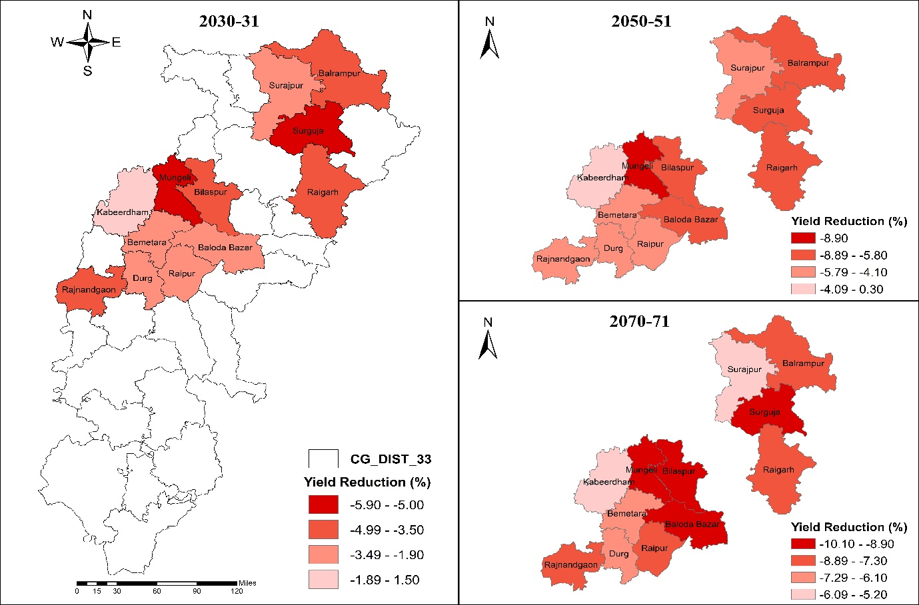
(a)
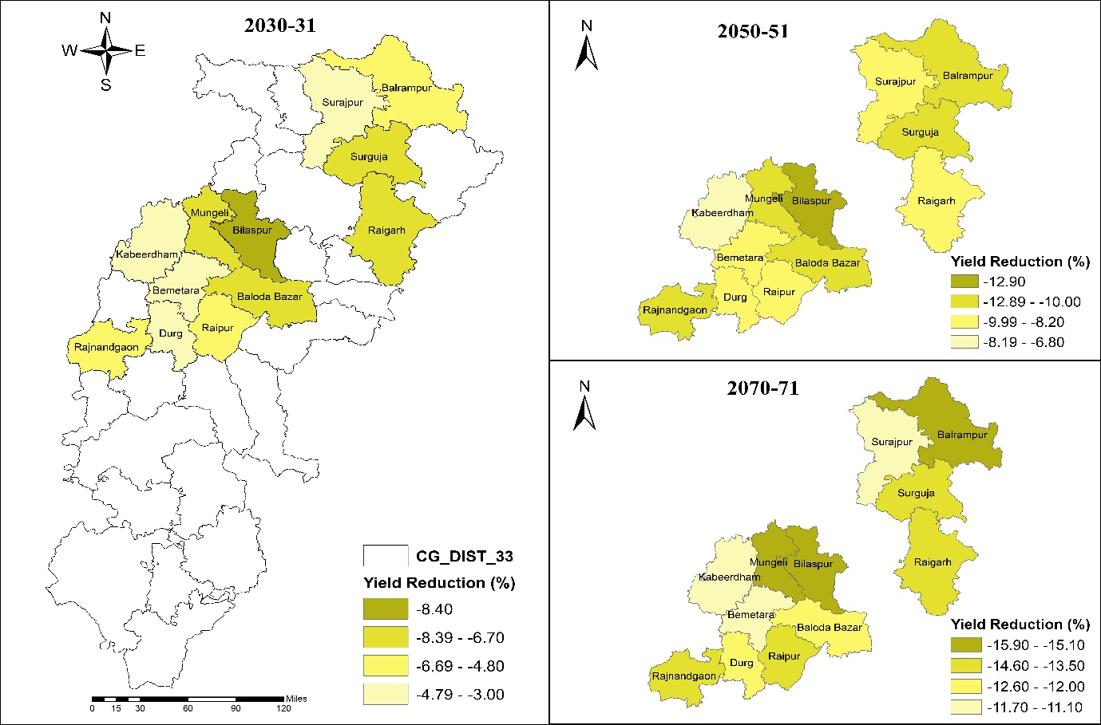
(b)
Fig.1: Effect of future climatic conditions on the production of wheat crop in first growing environment D₁ (30th Nov.) under RCP 4.5 (a) and RCP 8.5 (b) through DSSAT model.
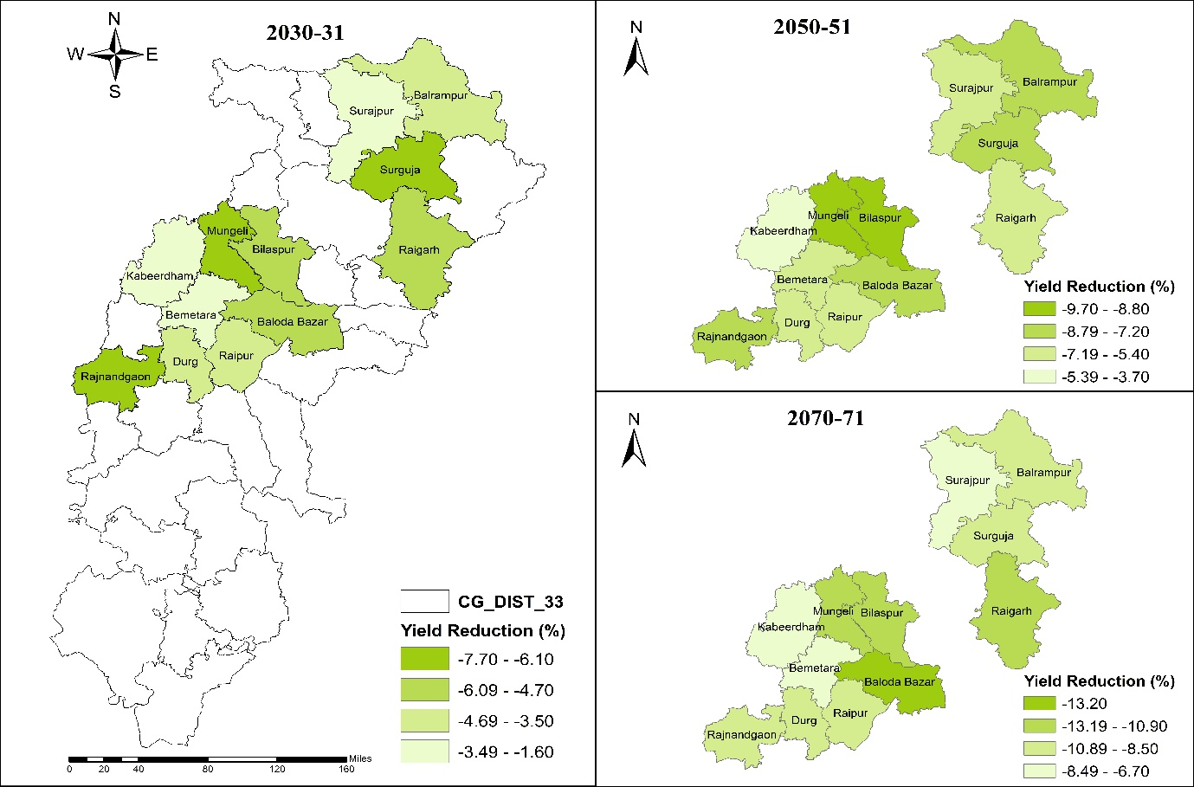
(c)
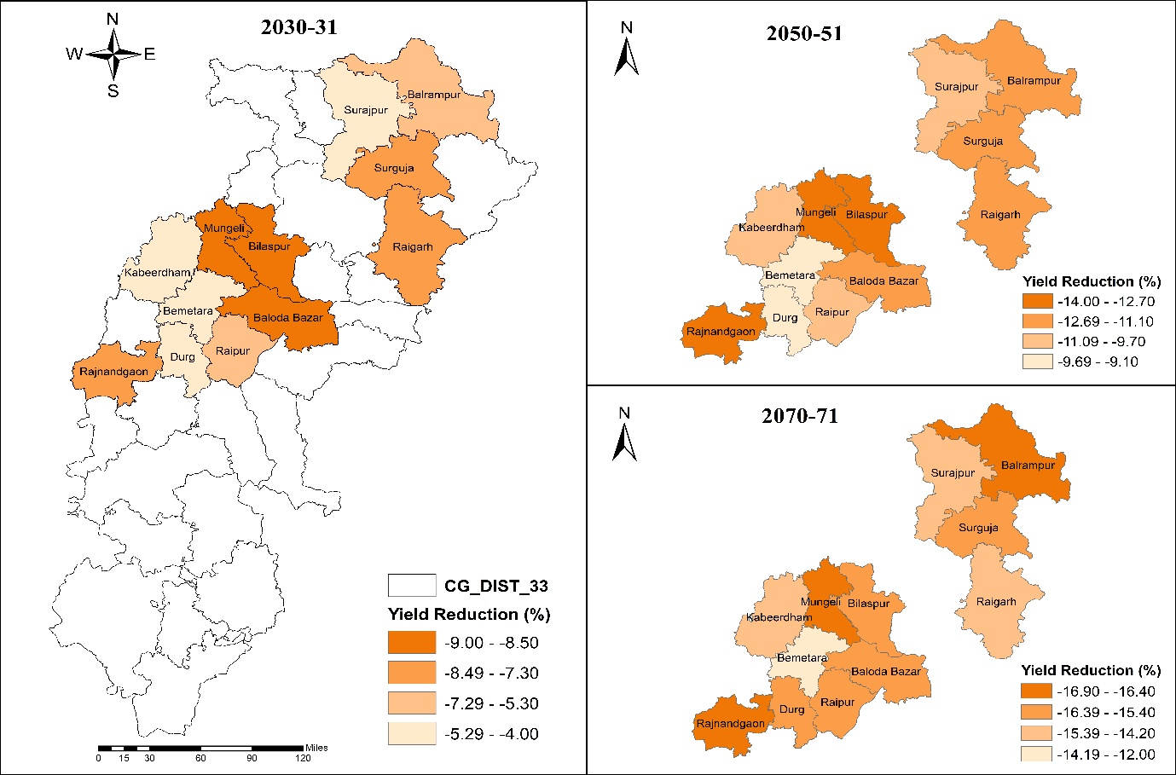
(d)
Fig.2: Effect of future climatic conditions on the production of wheat crop in second growing environment D₂ (10th Dec.) under RCP 4.5 (c) and RCP 8.5 (d) through DSSAT model.
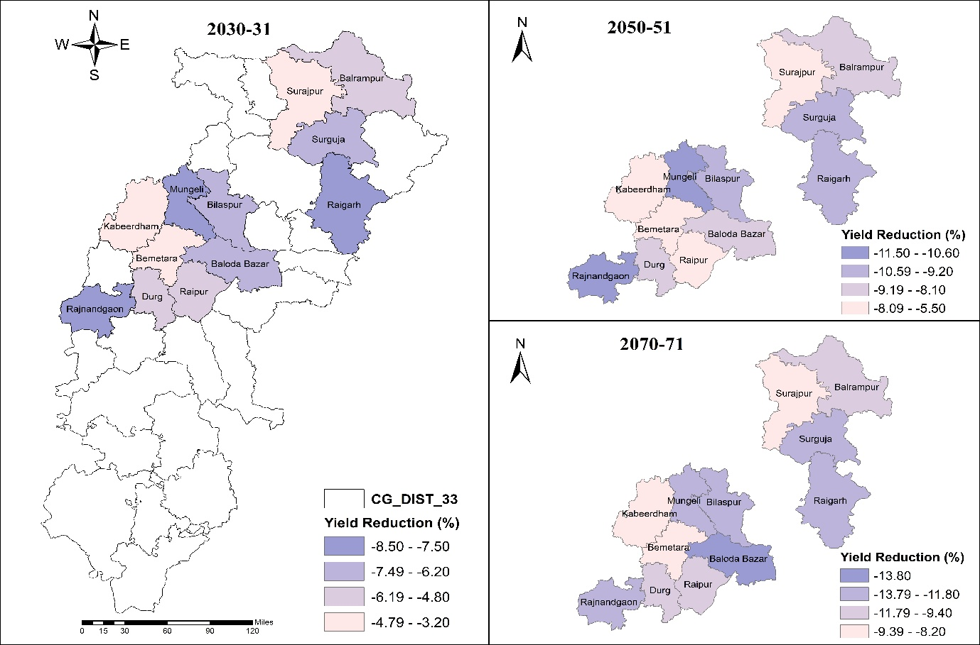
(e)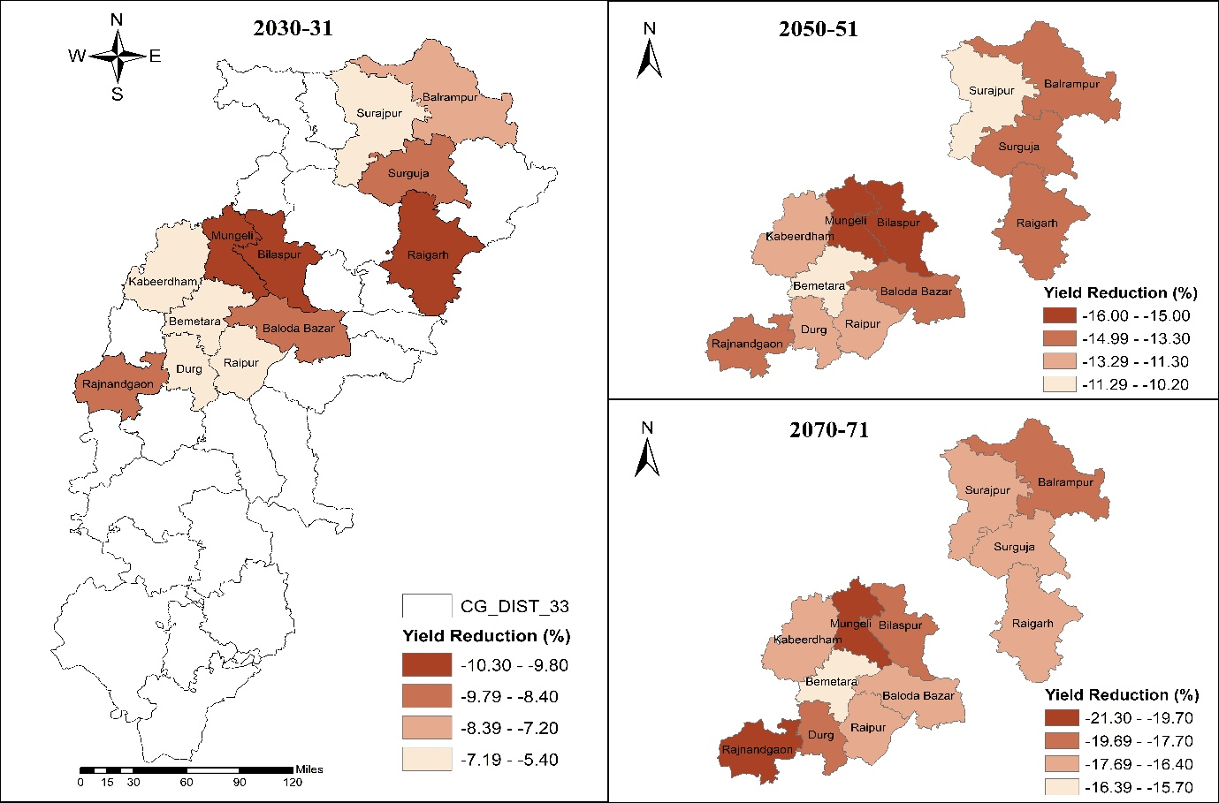
(f)
Fig.3: Effect of future climatic conditions on the production of wheat crop in third growing environment D₃ (20th Dec.) under RCP 4.5 (e) and RCP 8.5 (f) through DSSAT model.

Table 3: Effect of future climatic scenarios (2030-31, 2050-51 and 2070-71) on yield of wheat crop in first growing environment D₁ (30th Nov.) under RCP 4.5 and RCP 8.5 in different wheat growing districts of Chhattisgarh through DSSAT model 4.8.
DISTRICTS | Present | RCP4.5 |  |  |  |  |  | RCP8.5
DISTRICTS | Present | 2030-31 | Red. (%) | 2050-51 | Red. (%) | 2070-71 | Red. (%) | 2030-31 | Red. (%) | 2050-51 | Red. (%) | 2070-71 | Red. (%)
RAIPUR | 3037.0 | 2956.0 | -2.7 | 2892.0 | -4.8 | 2823.0 | -7.7 | 2890.0 | -4.8 | 2788.0 | -8.2 | 2615.0 | -13.9
BILASPUR | 2829.0 | 2704.0 | -4.4 | 2661.0 | -5.9 | 2570.0 | -9.2 | 2592.0 | -8.4 | 2463.0 | -12.9 | 2403.0 | -15.1
DURG | 2838.0 | 2771.0 | -2.4 | 2692.0 | -5.1 | 2652.0 | -6.6 | 2746.0 | -3.2 | 2588.0 | -8.8 | 2479.0 | -12.6
RAIGARH | 3016.7 | 2881.0 | -4.5 | 2843.0 | -5.8 | 2773.0 | -8.1 | 2814.0 | -6.7 | 2735.0 | -9.3 | 2610.0 | -13.5
RAJNANDGAON | 2793.0 | 2683.0 | -3.9 | 2643.0 | -5.4 | 2590.0 | -7.3 | 2634.0 | -5.7 | 2515.0 | -10.0 | 2393.0 | -14.3
AMBIKAPUR | 3026.0 | 2876.0 | -5.0 | 2812.0 | -7.1 | 2758.0 | -8.9 | 2814.0 | -7.0 | 2698.0 | -10.8 | 2585.0 | -14.6
BALRAMPUR | 2799.0 | 2701.0 | -3.5 | 2622.0 | -6.3 | 2582.0 | -7.8 | 2650.0 | -5.3 | 2515.0 | -10.1 | 2365.0 | -15.5
SURAJPUR | 2743.0 | 2684.0 | -2.2 | 2624.0 | -4.3 | 2596.0 | -5.4 | 2641.0 | -3.7 | 2506.0 | -8.6 | 2423.0 | -11.7
MUNGELI | 3027.5 | 2850.0 | -5.9 | 2757.0 | -8.9 | 2723.0 | -10.1 | 2802.0 | -7.4 | 2685.0 | -11.3 | 2546.0 | -15.9
KABIRDHAM | 2776.0 | 2819.0 | 1.5 | 2783.0 | 0.3 | 2633.0 | -5.2 | 2694.0 | -3.0 | 2588.0 | -6.8 | 2457.0 | -11.5
BEMETARA | 2802.0 | 2748.0 | -1.9 | 2686.0 | -4.1 | 2630.0 | -6.1 | 2712.0 | -3.2 | 2563.0 | -8.5 | 2491.0 | -11.1
BALODABAZAR | 2609.0 | 2536.0 | -2.8 | 2449.0 | -6.1 | 2356.0 | -9.7 | 2427.0 | -7.0 | 2346.0 | -10.1 | 2297.0 | -12.0

Table 4: Effect of future climatic scenarios (2030-31, 2050-51 and 2070-71) on yield of wheat crop in second growing environment D₂ (10th Dec.) under RCP 4.5 and RCP 8.5 in different wheat growing districts of Chhattisgarh through DSSAT model 4.8.
DISTRICTS | Present | RCP4.5 |  |  |  |  |  | RCP8.5
DISTRICTS | Present | 2030-31 | Red. (%) | 2050-51 | Red. (%) | 2070-71 | Red. (%) | 2030-31 | Red. (%) | 2050-51 | Red. (%) | 2070-71 | Red. (%)
RAIPUR | 2954.3 | 2839.0 | -3.9 | 2788.0 | -5.6 | 2671.0 | -9.6 | 2797.0 | -5.3 | 2664.0 | -9.8 | 2498.0 | -15.4
BILASPUR | 2714.0 | 2574.0 | -5.2 | 2475.0 | -8.8 | 2399.0 | -11.6 | 2469.0 | -9.0 | 2335.0 | -14.0 | 2273.0 | -16.2
DURG | 2746.0 | 2649.0 | -3.5 | 2559.0 | -6.8 | 2489.0 | -9.4 | 2608.0 | -5.0 | 2492.0 | -9.2 | 2311.0 | -15.8
RAIGARH | 2796.0 | 2638.0 | -5.7 | 2608.0 | -6.7 | 2491.0 | -10.9 | 2592.0 | -7.3 | 2485.0 | -11.1 | 2384.0 | -14.7
RAJNANDGAON | 2710.0 | 2539.0 | -6.3 | 2496.0 | -7.9 | 2436.0 | -10.1 | 2492.0 | -8.0 | 2365.0 | -12.7 | 2251.0 | -16.9
AMBIKAPUR | 2933.0 | 2753.0 | -6.1 | 2703.0 | -7.8 | 2637.0 | -10.1 | 2705.0 | -7.8 | 2587.0 | -11.8 | 2461.0 | -16.1
BALRAMPUR | 2707.0 | 2591.0 | -4.3 | 2511.0 | -7.2 | 2476.0 | -8.5 | 2535.0 | -6.4 | 2389.0 | -11.7 | 2249.0 | -16.9
SURAJPUR | 2681.0 | 2603.0 | -2.9 | 2526.0 | -5.8 | 2501.0 | -6.7 | 2563.0 | -4.4 | 2420.0 | -9.7 | 2283.0 | -14.8
MUNGELI | 2926.0 | 2701.0 | -7.7 | 2641.0 | -9.7 | 2604.0 | -11.0 | 2676.0 | -8.5 | 2540.0 | -13.2 | 2447.0 | -16.4
KABIRDHAM | 2708.0 | 2665.0 | -1.6 | 2609.0 | -3.7 | 2524.0 | -6.8 | 2593.0 | -4.2 | 2442.0 | -9.8 | 2324.0 | -14.2
BEMETARA | 2681.0 | 2613.0 | -2.5 | 2535.0 | -5.4 | 2474.0 | -7.7 | 2575.0 | -4.0 | 2436.0 | -9.1 | 2358.0 | -12.0
BALODABAZAR | 2591.0 | 2470.0 | -4.7 | 2385.0 | -8.0 | 2248.0 | -13.2 | 2367.0 | -8.6 | 2285.0 | -11.8 | 2189.0 | -15.5

Table 5: Effect of future climatic scenarios (2030-31, 2050-51 and 2070-71) on yield of wheat crop in third growing environment D₃ (20th Dec.) under RCP 4.5 and RCP 8.5 in different wheat growing districts of Chhattisgarh through DSSAT model 4.8.
DISTRICTS | Present | RCP4.5 |  |  |  |  |  | RCP8.5
DISTRICTS | Present | 2030-31 | Red. (%) | 2050-51 | Red. (%) | 2070-71 | Red. (%) | 2030-31 | Red. (%) | 2050-51 | Red. (%) | 2070-71 | Red. (%)
RAIPUR | 2804.0 | 2659.0 | -5.2 | 2609.0 | -7.0 | 2504.0 | -10.7 | 2631.0 | -6.2 | 2471.0 | -11.9 | 2344.0 | -16.4
BILASPUR | 2564.0 | 2405.0 | -6.2 | 2328.0 | -9.2 | 2255.0 | -12.1 | 2313.0 | -9.8 | 2153.0 | -16.0 | 2089.0 | -18.5
DURG | 2673.0 | 2546.0 | -4.8 | 2456.0 | -8.1 | 2413.0 | -9.7 | 2516.0 | -5.9 | 2333.0 | -12.7 | 2183.0 | -18.3
RAIGARH | 2674.0 | 2473.0 | -7.5 | 2403.0 | -10.1 | 2358.0 | -11.8 | 2399.0 | -10.3 | 2294.0 | -14.2 | 2216.0 | -17.1
RAJNANDGAON | 2529.0 | 2321.0 | -8.2 | 2261.0 | -10.6 | 2231.0 | -11.8 | 2309.0 | -8.7 | 2173.0 | -14.1 | 2031.0 | -19.7
AMBIKAPUR | 2885.0 | 2678.0 | -7.2 | 2619.0 | -9.2 | 2523.0 | -12.5 | 2644.0 | -8.4 | 2500.0 | -13.3 | 2386.0 | -17.3
BALRAMPUR | 2625.0 | 2494.0 | -5.0 | 2409.0 | -8.2 | 2377.0 | -9.4 | 2435.0 | -7.2 | 2257.0 | -14.0 | 2161.0 | -17.7
SURAJPUR | 2613.0 | 2519.0 | -3.6 | 2430.0 | -7.0 | 2389.0 | -8.6 | 2462.0 | -5.8 | 2347.0 | -10.2 | 2179.0 | -16.6
MUNGELI | 2878.0 | 2632.0 | -8.5 | 2546.0 | -11.5 | 2510.0 | -12.8 | 2582.0 | -10.3 | 2447.0 | -15.0 | 2265.0 | -21.3
KABIRDHAM | 2669.0 | 2581.0 | -3.3 | 2521.0 | -5.5 | 2430.0 | -9.0 | 2507.0 | -6.1 | 2367.0 | -11.3 | 2222.0 | -16.7
BEMETARA | 2589.0 | 2507.0 | -3.2 | 2422.0 | -6.5 | 2377.0 | -8.2 | 2448.0 | -5.4 | 2320.0 | -10.4 | 2182.0 | -15.7
BALODABAZAR | 2439.0 | 2279.0 | -6.6 | 2231.0 | -8.5 | 2102.0 | -13.8 | 2211.0 | -9.3 | 2095.0 | -14.1 | 2029.0 | -16.8

Reference:
Al‐Khatib, K. and Paulsen, G.M. 1984. Mode of high-temperature injury to wheat during grain development. Physiologia Plantarum, 61(3): 363-368.
Anonymous. 2024. Directorate of Agriculture, Govt. of Chhattisgarh, Raipur, 2022-23, Pp.4-5.
FAO (2021). The State of Food Security and Nutrition in the World 2021. Rome: FAO.
FAO, 2022. Production: Crops and livestock products. In: FAOSTAT. Rome. [Cited October 2023]. https://www.fao.org/faostat/en/#data/QCL
IPCC (2021). Climate Change 2021: The Physical Science Basis. Intergovernmental Panel on Climate Change. Cambridge University Press.
Jalota, S.K., Vashisht, B.B., Kaur, H., Kaur, S. and Kaur, P., 2014. Location specific climate change scenario and its impact on rice and wheat in Central Indian Punjab. Agricultural Systems, 131, pp.77-86.
Jin, Z., Ainsworth, E.A., Leakey, A.D.B., & Lobell, D.B. (2015). Temperature increase reduces global yields of major crops in four independent estimates. Proceedings of the National Academy of Sciences, 112(13), 6659-6664.
Jones, J.W., Hoogenboom, G., Porter, C.H., et al. (2003). The DSSAT cropping system model. European Journal of Agronomy, 18(3-4), 235-265.
Lobell, D.B., Schlenker, W., & Costa-Roberts, J. (2015). Climate trends and global crop production since 1980. Science, 333(6042), 616-620.
Pandey, V., Patel, H.R. and Patel, V.J., 2007. Impact assessment of climate change on wheat yield in Gujarat using CERES-wheat model. Journal of Agrometeorology, 9(2), pp.149-157.
Patel, C.B., Singh, R.S., Singh, K.K., Mall, R.K., Yadav, M.K., & Yadav, S.K. (2018). Assessment of climate change impact on wheat crop using MarkSim GCM in Varanasi, Uttar Pradesh. Journal of Agrometeorology, 20(3), 196-203.
Prabhjyot-Kaur, P. & Hundal, S.S. (2009) ‘Effect of inter- and intra-seasonal variations in meteorological parameters on wheat yields in Punjab’, Journal of Agrometeorology, 11(2), pp. 117–124.
Pramod, V.P., Rao, B.B., Ramakrishna, S.S.V.S., Singh, M.M., Patel, N.R., Sandeep, V.M., Rao, V.U.M., Chowdary, P.S., Rao, V.N. and Kumar, P.V. (2017) ‘Impact of projected climate on wheat yield in India and its adaptation strategies’, Journal of Agrometeorology, 19(3), pp. 207–216.
Saini, A.D. and Nanda, R. 1987. Analysis of temperature and photoperiodic response to flowering in wheat. Indian Journal of Agricultural Sciences (India), 57: 351-59.
Sastri, A. S. R. A. S., 2010. Climate change in Indian sub-continent and its impact on agriculture. Nova Acta Leopoldina, 384: 227–240.
Talukder A.S., Mcdonald, M.H.M. and Gill, G.S. 2013. Effect of short-term heat stress prior to flowering and at early grain set on the utilization of water-soluble carbohydrates by wheat genotypes. Field Crops Research, 147: 1-11.
Teleubay, Z., Yermekov, F., Rustembayev, A., Topayev, S., Zhabayev, A., Tokbergenov, I., Garkushina, V., Igilmanov, A., Shelia, V. and Hoogenboom, G., 2023. Comparison of Climate Change Effects on Wheat Production under Different Representative Concentration Pathway Scenarios in North Kazakhstan. Sustainability, 16(1), Pp.293.
Zhao, H., Dai, T., Jiang, D. and Cao, W. 2008. Effects of high temperature on key enzymes involved in starch and protein formation in grains of two wheat cultivars. Journal of Agronomy and Crop Science, 194(1): 47-54.

