# A COMPARATIVE APPROACH OF RAINFALL DATA BETWEEN BISWANATH CHARIALI WEATHER STATION AND NASA POWER

# Abstract

Rainfall data is important in climatic planning and research endeavors. It is imperative that rainfall data be recorded continually because it needs to be accessible at all times. Here, in this study rainfall data were collected from NASA Power and Biswanath Chariali weather station on a monthly and annual basis between 1981 and 2021. The average yearly rainfall as reported by NASA power and the Biswanath Chariali weather station was found to differ significantly. Additionally, the study attempted to analyze the seasonal and annual trends in the rainfall data that were obtained from these two data sources. The analysis showed that the yearly rainfall trend, as measured by NASA power data, is significantly increasing. While evident, the seasonal trend for the pre-, during-, and post-monsoon was not statistically significant. The study has able to notify that NASA Power data could also be considered as a reliable data source over Biswanath Chariali weather station data.

**Keywords:** Rainfall; trend; seasonal; NASA Power; Biswanath Chariali weather station.

# Introduction

The majority of nations, particularly the developing ones, continue to struggle with a lack of meteorological data collected at surface weather stations, despite significant improvements in climate databases in recent decades [1]. Under these circumstances, satellite-provided synthetic meteorological data have emerged as a viable substitute for acquiring extended and uninterrupted data sets, which can be employed to offset inadequate measurement observations [3]. By simulating numerical weather prediction models based on meteorological observations, the reanalysis approach [4] can be used to provide long-term series of atmospheric and land surface variables from atmospheric and sea surface observations. The National Aeronautics and Space Administration Prediction of Worldwide Energy Resources (NASA Power) is one of the many reanalysis datasets that are utilised as sources of climate data, and it has received attention lately. The platform offers information on a number of meteorological factors, including solar fluxes, air temperature, relative humidity, precipitation, wind direction and speed, and soil-related characteristics including moisture in the soil profile and on the surface and root zones [2]. From 1980 to the present, the data is available on an hourly, daily, monthly, and annual time scale; as a result, it is sufficiently accurate for trustworthy measurements of the sun and weather [9]. The availability of this data speeds up and simplifies the completion of technical and scientific research that call for climate data. The majority of satellite reanalysis data in the literature relate to air temperature [10], solar radiation [11], and reference evapo transpiration calculated using the Penman-Monteith method [7-8]. Few research, however, evaluate the performance of data from NASA Power with that of measurements made at surface weather stations under various global climatic circumstances. Research studies focused on trend analysis of meteorological variables [6] and the impact of climate change are noticed in Assam, in northeastern India [5]. However, there are no studies that compare district weather stations and NASA Power data to assess how well the data performs. The prime objective of the present research was to compare Biswanath Chariali district weather station and NASA Power data. This comparative study was undertook to give conclusions regarding reliable use of data from either of the respective two databases. It assess annual and seasonal rainfall data from 1981 to 2021 obtained from the Biswanath Chariali weather station and NASA Power. In order to compare the two data sources, the study attempted to observe yearly and seasonal trend analysis of rainfall data from each one.

# Material and Methods Study area

On the north bank of the Brahmaputra River, the district of Biswanath in Assam spans an area of 1100 square kilometres. On August 15, 2015, it was split off from Sonitpur district and officially constituted a district. The region lies between 26°14'00" and 27°0'00" North longitude and between 92°52'30" and 93°50'0" East longitude.The districts of Lakhimpur on the east, Sonitpur on the east, Arunachal Pradesh on the north, and Golaghat district on the south encircle the district. The district's administrative centre is situated in Biswanath Chariali. The seven development blocks in the district are PubChaiduar, Baghmari, Behali, Biswanath, Sakomatha, Sootea, and Chaiduar. According to the 2011 census, the district has 947 villages and a total rural population of 780567.

There are numerous ethnic clans and tribes residing in the district. The main indigenous tribes in the area include the Mishings, Bodo, Rabha, and Deuri.

# Data

Secondary data were used in the present study. The rainfall data were gathered from two different data records, NASA Power and the Biswanath Chariali weather station, in consideration of the study's objective. Rainfall data were gathered on a monthly and annual basis between 1981 and 2021. The length of the monsoon season before, during, and after was taken into consideration when collecting the monthly data.

The following statistical methods were used in the study are discussed below:

# Mann-Whitney U test

The non-parametric alternative to the independent sample t-test is the Mann-Whitney U test. This non-parametric test compares two sample means from the same population and determines whether or not the two sample means are equal. When the t-test assumptions are not met or the data are ordinal, the Mann-Whitney U test is typically employed.

𝑈 = 𝑛 𝑛

+ 𝑛2(𝑛2+1) − ∑𝑛2

𝑅 (i)

1 2 2

Where,

𝑖=𝑛1+1 𝑖

U = Mann-Whitney U test n1 = Sample size one

n2 = Sample size two

Ri = Rank of the sample size

# Mann-Kendall test

The Mann-Kendall (MK) test is used to determine if the variable of interest has a monotonic upward or decreasing trend over time using statistical analysis. When a variable exhibits a monotonic upward (downward) trend, it indicates a constant increase (reduction) across time, although the trend may or may not be linear. To determine whether the slope of the calculated linear regression line deviates from zero, a parametric linear regression analysis can be substituted with the MK test. The MK test is a non-parametric (distribution-free) test, whereas the regression analysis requires that the residuals from the fitted regression line be regularly distributed.

The MK test tests whether to reject the null hypothesis (𝐻0) and accept the alternative hypothesis (𝐻1), where

𝐻0: No monotonic trend

𝐻1: Monotonic trend is present

The initial assumption of the MK test is that the 𝐻0 is true and that the data must be convincing beyond a reasonable doubt before 𝐻0 is rejected and 𝐻1 is accepted.

# Sen’s slope estimator

Sen created this test first in order to verify statistical linear correlations. In the long-term temporal data, it is employed to compute the magnitude of trends. Due to its insensitivity to data outliers, Sen's slope is seen to be a superior method for identifying linear relationships. The following equation is used to estimate each individual slope:

Qi = 𝑌𝑗−𝑌𝑖

𝑗−1

(ii)

Where *i* = 1 to *n* − 1, *j* = 2 to *n*, *Yj* and *Yi* are data values at time *j* and *i* (*j* > *i*), respectively. If in

the time series, there are *n* values of *Yj*, estimates of the slope will be *N* =𝑛(𝑛−2) . The slope of the

2

Sen estimator is the mean slope of such slopes' *N* values. The Sen's slope is:

𝑌𝑗−𝑌𝑖 𝑖𝑓 𝑛 𝑖𝑠 𝑜𝑑𝑑

𝑄𝑖𝑗

= {

1 (𝑄 𝑁

2 2

+ 𝑄 [

𝑗−1

𝑁+2 2

]) 𝑖𝑓 𝑛 𝑖𝑠 𝑒𝑣𝑒𝑛

- (iii)

# Modified Mann-Kendall test

Serial correlation frequently has an impact on time series data. Modified Mann-Kendall tests can be used for trend detection when autocorrelation is present and the data are not random. To solve the problem of serial correlation in Trend analysis, Hamed and Rao (1998) presented a variance correction approach. After first detrending the data, the rankings of significant serial correlation coefficients are utilised to calculate the effective sample size and correct the inflated (or deflated) variance of the test statistic.

# Results

The descriptive statistics of annual rainfall from 1981-2021 of Biswanath Chariali district station and NASA Power is given as follows:

Table 1: **Descriptive statistics of annual rainfall from 1981-2021 Biswanath Chariali weather station**

|  |  |
| --- | --- |
| **Statistics** | |
| **Mean** | 1923.30 |
| **Median** | 1898.50 |
| **Std. Deviation** | 314.82 |
| **Skewness** | .019 |
| **Kurtosis** | .029 |
| **Minimum** | 1117.0 |
| **Maximum** | 2572.9 |

Table 2: **Descriptive statistics of annual rainfall from 1981-2021 of Biswanath Chariali district collected from NASA Power.**

**Statistics**

|  |  |
| --- | --- |
| **Mean** | 1547.36 |
| **Median** | 1539.84 |
| **Std. Deviation** | 244.13 |
| **Skewness** | -.022 |
| **Kurtosis** | -.617 |
| **Minimum** | 1081.05 |
| **Maximum** | 2056.64 |

**Graphical representation of annual rainfall from 1981-2021 of Biswanath Chariali district**

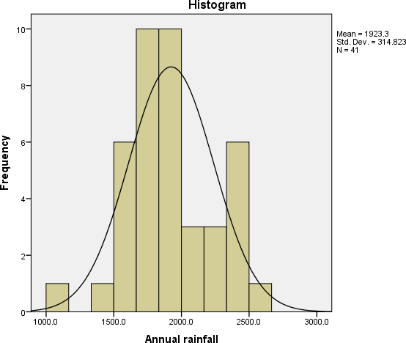

Figure 1: **Histogram of annual rainfall from 1981-2021 from Biswanath Chariali weather station**

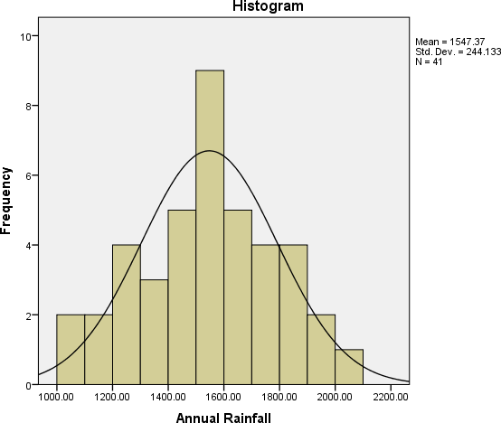

**.**

# Figure 2: Histogram of annual rainfall from 1981-2021 from NASA Power

From the above table 1 and table 2, it is observed that measures of central tendency (mean and median) and measures of dispersion (standard deviation) values differ widely between the two data sources. Further, from the tables, skewness, kurtosis, maximum and minimum values also differ. The histogram and normal curve obtained from NASA Power of Biswanath district annual rainfall is comparatively less skewed than Biswanth chariali weather station.

# Table 3: Summary of Mann Whitney U-test between data sources of Biswanath Chariali district annual rainfall from 1981-2021.

|  |  |  |
| --- | --- | --- |
| **Null Hypothesis** | **P-value** | **Decision** |
| The distribution of annual rainfall of Biswanath Chariali district from 1981-2021 is same across two data sources, | 0.000 | Reject null the null hypothesis. |

* The significance level is 0.05

From the above table 3, it is observed that there is significant difference in distribution of annual rainfall of Biswanath Chariali district from 1981-2021 between NASA Power and Biswanath chariali weather station.

**Graphical representation of annual rainfall from 1981-2021 of Biswanath Chariali district from Biswanath Chariali weather station and NASA Power**

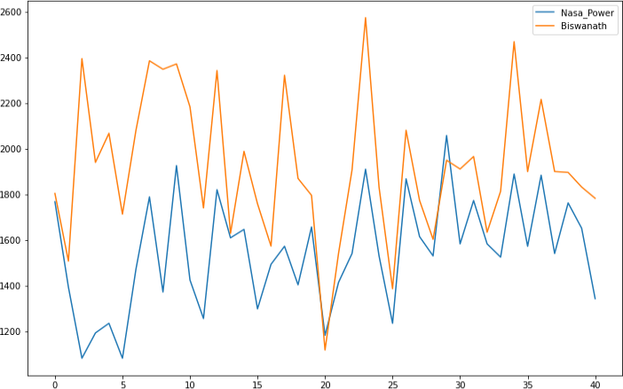

Figure 3: **Annual rainfall from 1981-2021 of Biswanath Chariali district**

Table 4: **Summary of Mann-Kendall Annual Monotonic Trend Analysis of Biswanath Chariali district rainfall from 1981-2021.**

|  |  |  |  |  |
| --- | --- | --- | --- | --- |
| **Data source** | **Kendall rank correlation coefficient** | **Sen’s slope** | **P-value** | **Significance** |
| NASA Power | 0.253 | 7.73 | 0.02 | Significant |
| Biswanath Chariali district Station | -0.078 | -3.80 | 0.479 | Not significant |

* The significance level is 0.05

The yearly rainfall trend analysis summary from the two data sources differs, as can be seen in table 4 above. When comparing the NASA Power data to the Biswanath Chariali weather station, it is possible to see an increasing trend with a positive Sen’s slope value (7.73). The annual rainfall data from Biswanath chariali weather station indicates a negative trend with slope value (-3.80). In contrast to the Biswanath Chariali weather station's p-value of 0.479, the NASA power data source's p-value of 0.02 is significant.

# Table 5: Summary of Modified Mann-Kendall (Hamed-Rao approach) Annual Monotonic Trend Analysis of Biswanath Chariali district rainfall from 1981-2021.

|  |  |  |  |  |
| --- | --- | --- | --- | --- |
| **Data source** | **Kendall rank correlation coefficient** | **Sen’s slope** | **P-value** | **Significance** |

|  |  |  |  |  |
| --- | --- | --- | --- | --- |
| NASA Power | 0.253 | 7.73 | 0.006 | Significant |
| Biswanath Chariali district Station | -0.07 | -3.80 | 0.479 | Not significant |

* The significance level is 0.05

It is evident from table 5 above that the yearly rainfall trend analysis summary from the two data sources differs. Compared to the Biswanath Chariali weather station, the NASA Power data was able to demonstrate a rising trend with a positive Sen’s slope value (7.73). Compared to the p- value (0.479) of the Biswanath Chariali weather station, the p-value (0.006) for the NASA power data source is highly significant.

# Graphical representation of annual rainfall trend from 1981-2021 of Biswanath Chariali district from NASA Power

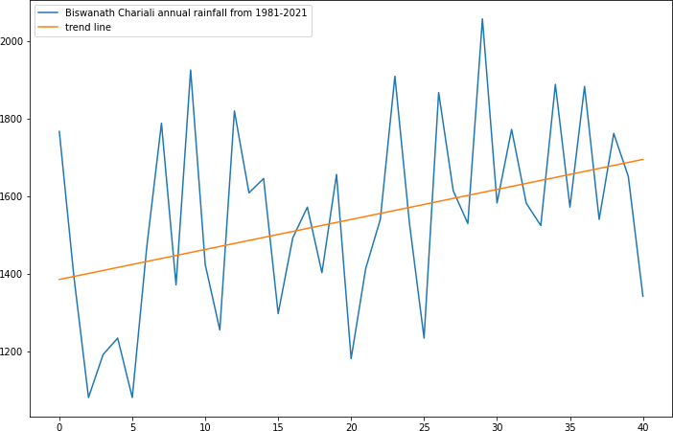

Figure 4: **An Upward trend of annual rainfall from 1981-2021 of Biswanath Chariali district from NASA Power**

Figure 4 above shows that the Biswanath Chariali district's yearly rainfall from 1981 to 2021 was able to show an increasing trend. Seasonal factors have been taken into account in this increasing trend.

# Table 6: Summary of Mann-Kendall Seasonal Monotonic Trend Analysis of Biswanath Chariali district rainfall from 1981-2021.

|  |  |  |  |  |
| --- | --- | --- | --- | --- |
| **Season** | **Data Source** | **P-value** | **Sen’s slope** | **Significance** |
| Pre-monsoon | Biswanath  Chariali Station | 0.74 | 1.04 | Not significant |
| NASA Power | 0.16 | 0.10 | Not significant |

|  |  |  |  |  |
| --- | --- | --- | --- | --- |
| Monsoon | Biswanath Chariali Station | 0.35 | 0.09 | Not significant |
| NASA Power | 0.23 | -2.66 | Not significant |
| Post- monsoon | Biswanath Chariali Station | 0.53 | 0.60 | Not significant |
| NASA Power | 0.81 | 0.11 | Not significant |

* The significance level is 0.05

Table 6 shows that, when it comes to rainfall data from two sources for the Biswanath Chariali district from 1981 to 2021 for the three periods of pre-, monsoon, and post-monsoon, there is no significant monotonic trend. During the pre-monsoon season, the rainfall data from the Biswanath Chariali station exhibit a positive slope value (1.04), indicating a positive trend. Similarly, a positive trend with a slope value of 0.10 is indicated by rainfall data obtained from the NASA Power data source. Throughout the monsoon season, the rainfall data acquired from NASA Power source shows a negative slope value (-2.66), indicating a negative trend. The Biswanath Chariali station shows a positive trend with slope value (0.09), in contrast to NASA Power rainfall data. Additionally, the length of the post-monsoon can be determined by a positive slope value of 0.61 and 0.11 for the Biswanath Chariali weather station and NASA Power rainfall data, respectively.

# Conclusion

This research has statistically examined rainfall data obtained from NASA power and the Biswanath Chariali weather station. The average yearly rainfall from 1981 to 2021 as reported by NASA power and the Biswanath Chariali weather station was found to differ significantly. Additionally, the study attempted to analyse the seasonal and annual trends in the rainfall data that were obtained from these two data sources. The analysis showed that the yearly rainfall trend, as measured by NASA power, is significantly increasing. While evident, the seasonal trend for the pre-, during-, and post-monsoon was not statistically significant. Based on some parametric and trend analysis observations, it comes to notice that NASA Power data could also be considered as a reliable data source over Biswanath Chariali weather stations data.

# Future Prospect

This research work could be used as a preliminary study in evaluation and comparison of performance of data from NASA Power and Biswanath chariali weather station. The study has used only rainfall data for evaluation; it could be generalized to other weather variables. In future, the study could be generalized to other weather stations of Assam.

# Author statement (Disclaimer) –

The contents and views expressed in this research paper/article are the views of the authors and do not necessarily reflect the views of the Assam Agriculture University.

# REFERENCE

1. H. Aboelkhair, M. Morsy, and G. El Afandi, “Assessment of agroclimatology NASA POWER reanalysis datasets for temperature types and relative humidity at 2 m against ground

observations over Egypt,” *Adv. Space Res.*, vol. 64, no. 1, pp. 129–142, 2019. doi: [10.1016/j.asr.2019.03.032.](https://doi.org/10.1016/j.asr.2019.03.032)

1. NASA and National Aeronautics and Space Administration, *Power Data Access Viewer: Prediction of Worldwide Energy Resource*. Available at:.
2. G. C. Rodrigues and R. P. Braga, “Estimation of daily reference evapotranspiration from NASA POWER reanalysis products in a hot summer Mediterranean climate,” *Agronomy*, vol. 11, no. 10, Art.2077, 2021a. doi: [10.3390/agronomy11102077](https://doi.org/10.3390/agronomy11102077).
3. J. Sheffield, G. Goteti, and E. F. Wood, “Development of a 50-year high-resolution global dataset of meteorological forcings for land surface modeling,” *J. Clim.*, vol. 19, no. 13, pp. 3088– 3111, 2006. doi: [10.1175/JCLI3790.1.](https://doi.org/10.1175/jcli3790.1)
4. D. Das, “Changing climate and its impact on Assam, Northeast India,” *Bandung J. Glob. S.*, vol. 2, no. 1, 1–13, 2015. doi: [10.1186/s40728-015-0028-4](https://doi.org/10.1186/s40728-015-0028-4).
5. K. Gogoi and K. N. Rao, “Analysis of rainfall trends over Assam, North East India,” *Curr. World Environ.*, vol. 17, no. 2, pp. 435–446, 2022. doi: [10.12944/CWE.17.2.15](https://doi.org/10.12944/CWE.17.2.15).
6. A. Negm, J. Jabro, and G. Provenzano, “Assessing the suitability of American National Aeronautics and Space Administration (NASA) agro-climatology archive to predict daily meteorological variables and reference evapotranspiration in Sicily, Italy,” *Agric. Forest Meteorol.*, vol. 244/245, pp. 111–121, 2017. doi: [10.1016/j.](https://doi.org/10.1016/j) agrformet.2017.05.022.
7. P. M. Ndiaye et al., “Trend and sensitivity analysis of reference evapotranspiration in the Senegal river basin using NASA meteorological data,” *Water*, vol. 12, no. 7, Art.1957, 2020. doi: [10.3390/w12071957](https://doi.org/10.3390/w12071957).
8. O. A. Marzouk, “Assessment of global warming in Al Buraimi, sultanate of Oman based on statistical analysis of NASA POWER data over 39 years, and testing the reliability of NASA POWER against meteorological measurements,” *Heliyon*, vol. 7, no. 3, p. e06625, 2021. doi: [10.1016/j.heliyon.2021.e06625.](https://doi.org/10.1016/j.heliyon.2021.e06625)
9. F. D. Bender and P. C. Sentelhas, “Solar radiation models and gridded databases to fill gaps in weather series and to project climate change in Brazil,” *Adv. Meteorol.*, vol. 2018, Art.6204382, 2018. doi: [10.1155/2018/6204382.](https://doi.org/10.1155/2018/6204382)
10. A. D. Quansah et al., “Assessment of solar radiation NASA Power and surface weather stations on evapotranspiration estimation 11” Pesqui. Agropec. Bras., Brasília, vol. 58, 2023 DOI: 10.1590/S1678-3921.pab2023.v58.03261 resource from the NASA-POWER reanalysis products for tropical climates in Ghana towards clean energy application [Scientific report], v.12, p. e03261, Art.10684, 2022. doi: [10.1038/s41598-022-14126-9.](https://doi.org/10.1038/s41598-022-14126-9)