Studies on quantitative and qualitative composition of culturable air mycoflora of six different traffic zones of Siliguri ,West Bengal

Abstract:

Study aims to determine quantitative and qualitative composition of Airmycoflora of six different traffic sites (Site:1:Longview , Site:2:Rohini traffic point, Site:3.Darjeeling More, Site:4:Savoke More, Site:5:Matigara Police point, Site:6:NBU Gate 2.)within and outskirt of Siliguri Municipality area.

Portable volumetric bioaerosol sampler, Microbio MB1 was used to monitor the airmycoflora by exposing 10 cm diameter petri plates filled with Rose Bengal Chloramphenicol plates fitted in the sampler at an height of 1.5 meter above ground level. The sampler has an air flow rate of 10–100 l/min. and fixed at 100l/min.

Culturable air borne mycoflora varied among six sites and maximum(2090 Cfu/M³) was recorded from site :6 while minimum airmycoflora represented by 220 cfu/M³ at site 4 . A mean aeromycoflora of 868.33 cfu/M³ was observed in the study. Species diversity of mycoflora varied among sites and represented by six genera, Cladosporium,Rhodotorula spp(Pink yeast) ,Aspergillus flavus,Penicillium spp,Rhizopus spp,Trichoderma spp and sterile colony. Exposure of environmental air borne mycoflora and their risk to human respiratory ailments was discussed in the light of available literature. Mitigation of road side pollution by planting native ,non allergenic non poisonous plants have been suggested for Siliguri Town.

INTRODUCTION:
Air pollution is a major threat to human health ,plant and environment .World wide about 99% of population are exposed to risk of indoor and ambient air pollution (WHO-2022). Air pollution is responsible for premature death of 8.1 million people world wide WHO (2024`). Air pollution can accelerate heart disease, strokes, COPD ,cancer, pneumonia, asthma and IGG mediated allergy .Global SDG agenda 3.9.1 adopted a holistic approach which aims to reduce premature death and illness from house hold and ambient air pollution(WHO 2024).The growing problem of air pollution are identified as obstacles to achieve 17 point SDG goal set by United Nation by 2030(UNEMG(2023).
Global air quality guidelines revised recently by WHO,2021 e.g PM-2.5(5μg/m³/ 24h) and PM-10(15μg/ m³/24h), ozone(100μg/ m³/8hr) nitrogen dioxide(25μg/ m³/24h,sulfur dioxide (40μg/ m³/24h and carbon monoxide(4μg/ m³/24h).( Plate 1a). These pollutant cause adverse impact on human health. Plate .1b.
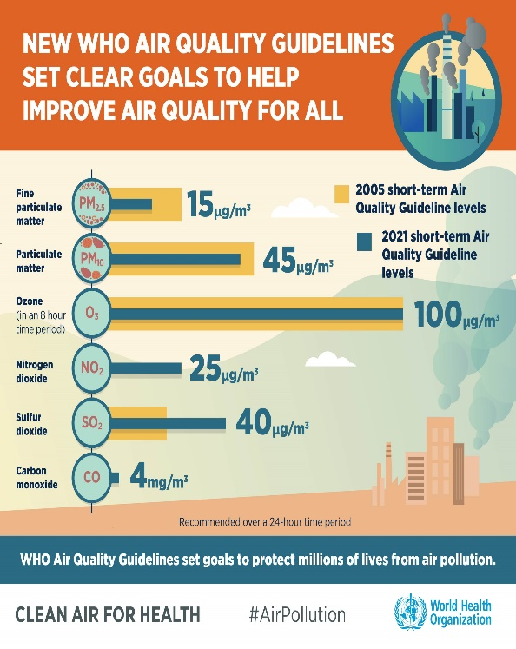 | Pollutants as per WHO(2021)  1.PM-2.5: COPD,Asthma,cancer  2.PM-10; COPD,Asthma,cancer  3. Ozone (O₃):Chest pain,coughing,throat irritation,bronchitis,asthma  4. Nitrogen Oxides(NO2): Pulmonary diseases, impairment of lung function and eye, nose and throat irritations.  5. Sulphur Dioxide(SO2): Affect lung function adversely.  6. Carbon monoxide(CO): Affects the nervous system, dizziness,confusion impairing physical coordination, vision and judgments, creating nausea and headaches, and increasing personal discomfort.
Plate :1.a.Ambient Air Quality parameters (WHO,2021) | 1.b.Pollutant Effect on Human

Traffic related air pollution (TRAP) aggravates ambient air pollution and identified as an emerging problem of post-industrial era mostly in high income countries of the world and is well documented( Baldauf ,2020;Anderson et al 2013; European Environment Agency, (EEA )2007; HEI , 2010 Carlyn et al 2019). Pollution caused by vehicular exhaust emission includes Black carbon(BC),Elemental carbon(C),Carbon monoxide CO),hydrocarbon(HC),Nitrogen oxide(NO_{x}),Nitrogen dioxide(NO₂),particulate matter with diameter less than 10 μ,(PM10),particulate matter with diameter less than 2.5 μ(PM-2.5) and particles with diameter less than (0.1 μ) are known as Ultra fine particles. Human exposure to these pollutants may induce adverse health effects and aggravate preexisting ailments.(HEI ,2010).
Siliguri is located at the banks of Mahananda and Teesta river at the foot hill of the Eastern Himalaya (26.71N -88.43 E) and spread over 260KM². Siliguri shares it border with Bhutan,Nepal,Bangladesh and China. Siliguri is a famous for tea and timber trade and tourisms. It is also known as “Chicken neck” ,gate way to North East India. Core area of Siliguri metro is 41.90 KM² with a population of about 10 lakh. (MoUD ,CDP; 2015) .Hill Kart Road connects the famous hill station Darjeeling. Siliguri now well established as busiest commercial city and supply centre of essentials for neighbouring tea estates.
Bhuimali and Chakraborty, (2018) studied traffic induced pollution status of Siliguri and observed that total vehicle registered in 2013 in Siliguri RTO is around 6,19,694 and annual new registration lie beteem 38,000 - 40,000 vehicles per year since 2020.The number of diesel run commercial and personal four wheelers, good Carriers three wheelers has grown almost 25% in this time. The growth rate of two wheelers was more than 76 % in India during 2004 to 2014 which was higher than any other cities of North Bengal. As a results current air pollution level in Siliguri is high and population are prone to several respiratory diseases including COPD, Cancer, Ischemic Heart Disease due to rapid growth of vehicular traffic. Currently PM2.5 in Siliguri is 1.1 times higher than WHO air quality index.(www.aqi.in .West Bengal.)
Traffic junctions are undoubtedly perceived as crowded places where people are at high risk of developing respiratory ailments , due to their greater exposure to pollutants and human transmitted microbial pathogens. (Levy et al 2010;Zhang et al 2013; Wang et al 2023). There is also appreciable risk of developing cancer of human due to exposure of traffic related air pollution(European Environment Agency ,2023 )A perusal of literature revealed that traffic induced mortality may reach as high as 17.5% in China( Wang et al ,2022).Sjodin et al (1998) showed that slow moving vehicle (13km/h) release 2-4 fold pollutants compared to fast moving vehicle. More over passing vehicle at traffic zone causes dusts,debris, animal faces , and soil from road side to move upwards continuously and resettle spontaneously during low traffic period. Transmission of microbiota of one human body to other may take place by way of active or passive route. Human pathogenic Viruses(Measles,Mumps,Chicken pox,smallpox.bubonic plague,Pneumonic plague,Tuberculosis, Norovirus,Monkey pox, SARS CoV -1 SARS CoV-2,MERS , Avian flu etc),bacteria and fungi may transmit through breathing , talking ,coughing,sneezing , embrassing and handshaking. Kaur and Pandey (2021) reviewed the current air pollution status of few Indian cities and opined that Climate change and air pollution are major threat to human health all over the world. The extreme climate events (high rainfall, extreme temperature, floods, and droughts) are posing human health risks and responsible for 7 Million death annually . Impact of frequent heat waves have led to the elevation in temperature levels causing thermal discomfort and several health issues to urban residents. There is a trend of rise of air pollution levels above the prescribed standards for most of the Indian megacities( Ganguli.et al 2020). Madhual et al 2019 in a recent study at Dehradun observed link of inhalation of PM-10 and excess cancer risk .Khandar and Kosankar(2014) reviewed status of vehicular pollution in Urban India and its health effect and observed that Vehicular emission in major citied in India are contributing 70%,Carbon monoxide ,50% Hydrocarbons,30-40% Nitrogen dioxide ,30% SPM,10% Sulphur dioxide of total air pollution. There is a trend of rise of air pollution levels above the prescribed standards for most of the Indian megacities.
Vehicular emissions have been identified as prominent source of high NO₂ concentrations followed by industries and fuel burning, thereby increasing air pollution in Kolkata (Mondal et al., 2000; Ghosh et al., 2004; ).Bioaerosols (viable microbes,pollen ,algae,plant parts) can occur as clusters attached to fine particle of soil, dust, skin flakes, sand, etc. suspended as PM-2.5 .PM-10 (Xie et al. 2018; Iwasaka et al. 2009).
The historical aspects of National Clean Air Programme has been shown below: Table:1.

INDIAN INITIATIVE: National Clean Air Programme(NCAP-2019)
Historical perspective: modified from Ganguli.et al 2020.
Table: 1
Year | Activities and Action
1974 | Central Pollution Control Board (CPCB) established under the water (prevention and control act)
1981 | CPCB entrusted with the powers and functions under the Air (Prevention and Control of Pollution) 1986 CPCB adds provisions for environment (protection) act April 1994 National ambient air quality standards were introduced
1986 | CPCB adds provisions for environment (protection) act
1994 | National ambient air quality standards were introduced
1997 | MoEFCC prepared an action plan for controlling pollution in Delhi
1998 | Environment Pollution (Prevention & Control) Authority (EPCA) established to address air pollution in the national capital region of Delhi
2003 | Supreme court issued directives to prepare clean air plans for cities - Ahmedabad, Kanpur, Sholapur, Lucknow, Bangalore, Chennai, and Hyderabad to reduce RSPM levels
2009 | CPCB introduced the Comprehensive Environmental Pollution Index as a tool for environmental assessment for environmental assessment on industrial set up
2009 | November 2009 National ambient air quality standards were revised and PM2.5 added to the list January 2014 National air quality index (AQI) methodology was established 2015 CPCB issued directives under Air Act, 1981, for the implementation of 42 action points that includes control and mitigation measures in the major cities including Delhi and the National Capital Region (NCR)
2010 | Establishment of National Green Tribunal under Acts of parliament. It was formed to disposal of cases pertaining to environmental issues. Article 21 of our constitution assures the citizen of India the Right to a healthy environment.
2016 | i.PM2.5 is included for all manual stations under the national ambient monitoring programme (NAMP) December 2016  ii.Graded Response Action Plan (GRAP) established to address air pollution emergencies in NCR Delhi April
2018 | - MoEFCC circulated a draft concept note of National Clean Air Programme (NCAP) with multiple time bound strategies to reduce air pollution.  - 102 non-attainment cities were announced under NCAP  - NGT national green Tribunal ) directed the states and union territories with non-attainment cities under NCAP to prepare action plan.  - EPCA reconstituted with new members from government, academia, and civil society
2019 | i.NCAP - a time-bound national level strategy to tackle increasing air pollution, was launched by MoEFCC  ii.Examination and approval of clean air plans by 3-member central committee was constituted.  iii.
2018-2024 | Addition of 20 new non-attainment cities after NGT’s intervention 2024 NCAP target to reduce PM2.5 pollution in 122 non-attainment cities by 20–30%, compared to 2017 levels

The objectives of the present study was to determine the quantitative and qualitative composition of culturable aero mycoflora and their percentage contribution in six different traffic sites in Siliguri municipal area.

MATERIALS AND METHODS:
i.Study Sites :

Sites | Traffic sites | Location
1 | Longview | Lat :26.84337 ;Long 88.26688
2 | Rohini | Lat :26.801006;Long 88.306787
3 | Darjeeling more | Lat :26.732548;Long 88.408203
4 | Sevoke More | Lat :26.716068;Long 88.422473
5 | Matigara police point | Lat :26.722467;Long 88.381427
6 | NBU Gate 2 | Lat :26.722486;Long 88.38144

ii.Air sampling :

Air sampling was carried out by a portable Microbial sampler, the MicroBio MB1, manufactured and supplied by Cantium Scientific Limited, Dartford Kent, UK on 27th Dec 23.The sampler has an air flow rate of 10–100 l/min. and fixed at 100l/min. The sampler collects viable airborne organisms by drawing a stream of air at a calibrated flow rate through a series of small holes in a metal head. Viable spores, conidia, and hyphal filament particles suspended in an air stream impinge on the surface of a sterile culture medium in a contact plate or Petri dish. The sampler was held at 1.5 meter above ground level as per British Aerobiology Federation 1995.

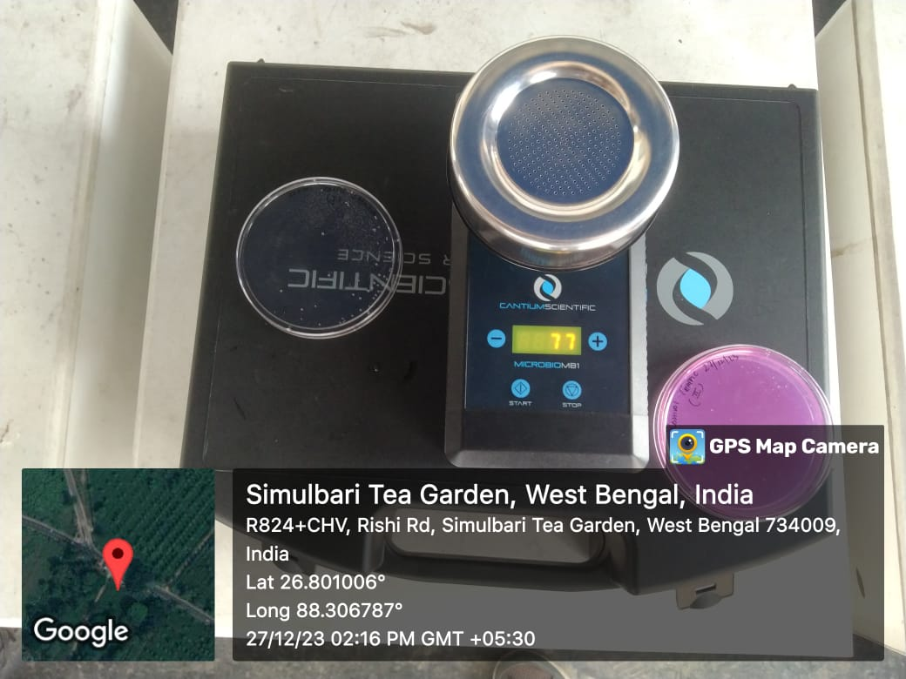
Air sampler MB1.

iii.Nutrient medium : A triplicate disposable sterile Petri plate (8cm dia.) containing Rose Bengal Chloramphenicol agar was used as per Debnath and Tiwari 2022. Plates were sealed after exposure, taken to laboratory and incubated at 30°C in the laboratory for 72 hours and counted after the appearance of fungal colonies.
Quantitative compositions of mycoflora were determined by counting the number of total colonies and percent occurrence of individual taxa was obtained as per following formula .
Percent occurrence of taxa= (Species of mycoflora/Total no of colonies )x100.Fungal population observed under each traffic point was expressed as CFU per cubic meter with the following formulae: CFU/M³ = (NC/VS x1000 l) where NC=No of colonies VS=Volume sampled shown in .(Table 1)The colonies of fungi were examined under low and high magnification using light microscope .later identified with the help of available literature.(Subramanium 1970 ;Burnet and Hunter 1972).
Iv .Identification: Aeromycoflora were identified with the help of available literature (Subramanium 1970 ;Burnet and Hunter 1972).

RESULTS AND DISCUSSION;

Table:2: Quantitative and qualitative composition of air mycoflora of Siliguri Municipal and adjoining area
Fungus species | Site:1  Longview | Site:2  Rohini traffic | Site:3  Darjeeling Moor | Site:4  Savoke Moor | Site:5  Matigara  Police point | Site:6  NBU Gate 2. | Total
Fungus species | 1.4PM (27th Dec2023) | 2.16PM | 2.52PM | 3.12PM | 6.25PM | 6.39PM | Total
Fungus species | Lat :26.84337  Long 88.26688 | Lat :26.801006  Long 88.306787 | Lat :26.732548  Long 88.408203 | Lat :26.716068  Long 88.422473 | Lat :26.722467  Long 88.381427 | Lat :26.722486  Long 88.38144 | Total
Cladosporium spp | 110 | 30 | 40 | 4 | 35 | 200 | 419(80.42)
(Pink yeast)  Rhodotorula spp | 5 | 2 | 5 | 2 | 3 | 5 | 22(4.22)
Aspergillus flavus | 1 | 0 | 10 | 12 | 6 | 0 | 29(5.56)
Penicillium spp | 8 | 2 | 8 | 2 | 5 | 1 | 26(4.99)
Rhizopus spp | 0 | 0 | 0 | 1 | 0 | 1 | 2(0.38)
Trichoderma spp | 0 | 1 | 0 | 0 | 1 | 0 | 2(0.38)
Sterile colony | 4 | 5 | 6 | 1 | 3 | 2 | 21(4.03)
Total | 128(24.56) | 40(7.67) | 69(13.24) | 22(4.22) | 53(10.17) | 209(40.11) | 521(100)
Cfu/M³ | 1280 | 400 | 690 | 220 | 530 | 2090
Mean, Cfu/M³ | 868.33
(*)Figure in the bracket denotes % occurrence.

It was evident from table 2 that a total of 521 colonies of aeromycoflora was recorded belonging to six genera .There were variable sterile colonies in different the sites. Cladosporium spp was found to be the dominant species occupying 80.42% followed by Aspergillus flavus,(5.56%), Penicillium spp(4.99%) and pink yeast Rhodotorula spp(4.22)and Trichoderma (0.38 %). Population of aeromycoflora was Maximum (2090 Cfu/M³ in site 6 (NBU Gate No2) followed by site 1 (1280 Cfu/M³),Site.3 (690 Cfu/M³),site 5 (530 Cfu/M³) and site 4 (220 Cfu/M³). Higher population of air fungi in site 6 NBU gate 2. As compared to site No2,Site .3 ,Site No 4 and Site no 5 , may be attributed to dense green vegetation of NBU campus and higher growth ,development and deposition of litters on soil surface.
Cladosporium spp was established by link and type species is C.herbarum(Pers)Link .There are ten species of Cladosporium spp known from India(C. cladosporiodes,C.herbarum,C.fulvum,C.puccinoides,C.echinulatum,C.zizypus,C.calotropidis,C.macrocarpum,C.variabile,C.claorcephalum.(Subramanium 1970). The genus ‘Aspergillus ‘ has influenced mankind because of its various beneficial and harmful effects. The genus has over 180 species distributed world wide. Trichoderma spp are considered a biocontrol agent and used world wide for control of soil borne plant pathogen and also as plant growth regulator (Sharma et al 2014). Rhodotorula species are common in soil,water, leaf surface,decomposed vegetable matter and comprised of about 46 species(Li . et al 2020).Rhizopus spp is a genus comprised of over 10 species commonly found in tropical and subtropical regions.It is commonly found in association with decomposition of vegetable matter and food items. Penicilium is wide spread in distribution found in indoor and out door environment and comprised of about 300 species. It has been found to be associated with decomposition of plant debris, fruit rots, post harvest crop contradiction and known as plant pathogen and also as human pathogen. Some of the species are used industrially for production of Penicillin .(Samson and Pitt 2000)

Madhwal et al(2020)Studied viable bioaerosol concentration in traffic sites in Dehradun city and found the mean 1962.95 ±651.85CFU/m3 and 1118.95 ± 428.34 CFU/m³ for bacteria and fungi respectively. Qualitatively Aspergillus spp was dominant 27.54% followed by Penicillium (23%), and Cladosporium (14.05%) (fungi), and Micrococcus (25.73%), Staphylococcus (17.98%), and Bacillus (13.8%) (bacteria).
Metiner et al(2021) studied air mycoflora of public conveyances in Istanbul . Highest air mycoflora was observed inside bus 40-660 CFU/m3. The air mycoflora of metro, metrobus and in ferry in Istanbul were 20–400 CFU/m3, 40–360 CFU/m3, and 20–260 CFU/m3 respectively.
Akpeimeh et al (2019) working on aerobiology of dump sites found 195-2994 cfu/m³ of bacteria and 166-1116 cfu/m³ of air fungi in Nigeria.Hoiseini et al (2013) observed aeromycoflora( 14-1095 cfu/m³) in subway station in Tehran.Zuraimi et al(2009) examined air mycoflora (1797.9-3559.8 cfu/m³) of child care centres in Singapore.Hernandez et al (2014) observed air borne bacteria (1-68 cfu/m³) and fungi (6-68 cfu/m³)in subway system of Mexico. Nasir et al (2012)observed air microbes in rural (Bacteria 8031 cfu/m³and Fungi 15790 cfu/m³ ) and urban (bacteria 2788 cfu/m³ and Fungi 16416 cfu/m³)area in Pakisthan.Li et al( 2015)recorded bacteria (497.7-1736.5 cfu/m³) and fungi( 247-1703.9 cfu/m³)in out door environment in China.Abdul Hameed et al (2009)found bacteria (1.414 x10³ cfu/m³) and fungi (5.90x10² cfu/m³)in air of industrial area of Egypt.Srivastava et al ( 2012) recorded bacteria (63.6-338.8 cfu/m³) and fungi (755-1293 cfu/m³) in air of University campus of Delhi. Fairdi et al (2015) found bacteria (300 cfu/m³) in school dormitory and retirement room in Iran. Debnath and Tiwari (2022) studied diurnal variation of aeromycoflora in air over Tea plantation in Terai and observed maximum 2463cfu/M³ at 6AM, followed by 1683 cfu/M³ at 6PM, 1453 cfu/M³ at 12 noon and 1170 cfu/M³ at midnight . Cladopsorium spp represented as dominant species.Ghosh et al (2023)studied air mycoflora of tea seed orchards in Terai region and recorded 180-1580 cfu/M³ with rich species diversity. Hemavathi et al (2014) conducted at five different traffic intersections in Mysore city and observed air borne fungi at higher concentration in K.R. circle and Metropole circle while lower levels were detected in Sub- urban bus stand circle of the five sampling sites. The dominant fungi contributing to these differences were species of Cladosporium, Fusarium, Aspergillus niger, Trichoderma, Saccharomyces and Alternaria.
Permissible quantitative value universally applicable for air borne fungi have not been possible to establish due to wide dynamic geoclimatic and seasonal variation of air borne fungal flora in a given area. However there has been effort all over the world to set a suggested guidelines for setting safe limit of exposure to air borne mycoflora. WHO(1990) recommends >50cfu/M³ for one pathogenic species (i.e toxigenic Aspergillus flavus etc , <150 cfu/M³in mixture , <500cfu/M³ if Cladosporium or other common phylloplane organisms remain present.ACGIS (1989) suggests that ratio of indoor and out door with similar taxa should be less than >1. A list of suggested quantitative standards of indoor mold limits in various industrial settings suggested (Carol et al 1996).

Conclusion and recommendations:
A mean culturable aeromycoflora of 868.33 cfu/M³ was observed in six traffic sites in Siliguri Species diversity of mycoflora varied among sites and represented by six genera, Cladosporium,Rhodotorula spp(Pink yeast) ,Aspergillus flavus,Penicillium spp,Rhizopus spp,Trichoderma spp and sterile colony.
Human induced air pollution has far reaching consequences on productivity of soil, animal and plant biodiversity, agricultural productivity and human pollen and fungal allergy and respiratory ailments. International initiatives on prevention of air pollution agreed upon in international conventions among member countries is in various stages of progress(UNEMG.2023; Baldauf 2020). However air pollution mitigation through growing selected indigenous evergreen plant species is being explored Shrestha et al (2020)identified Cinnamomum camphora, Nerium oleander and Albizzia julibrissin as air pollutant tolerant species in Nepal. Prasath et al (2023) found Mangifera indica, Psidium guava, Annona squamosa, Ficus religiosa as air pollution tolerant plant in urban area of South India.

Recommendation: City development plan for Siliguri Municipal area (MoUD 2015)has provision of planting of trees on road side recommended by Ministry of Urban Development. Mitigation of road side air pollution due to vehicular traffic by planting suitable trees is well documented(Baldauf ,2020; Prasathi et al 2023). However selection plant species or varieties should be done on the following criteria : Non allergenic,short leaf less period,Ever green,Tolerant to air pollution, Crowded leaf and shrubs with shorter woody trunk.Some of the species(Azadirachta indica, Caesalpinia pulcherrima, Peltophorum ferrugineum, Pongamina glabra, Michella champaca, Mimuceps elengi, Leucanea leucocephala, Baugainvilla spectabilis, Cassia fistula are listed by NGT for use in green belts and may be used for road side plantation.Besides some native plants species and their varieties which show increased tolerance to local climatic conditions and air pollution may be selected.

REFERENCE:
1.WHO(2022)WHO Ambient Air quality,databases 34 pp
2.WHO (2024)Air quality,energy and health. Sustainable goals and air pollution.
3.UNEMG(2023)An overview of UN Activities and initiatives related to pollution. Version No.3.2023. 1-90 p
3.Anderson H.R Favarato G and Atkinson R.W(2013) Long term exposure to air pollution and the incidence of asthma :Meta analysis of cohort studies .Air quality Atmosphere and Health 6(1)47-6pp.http://doi.org/10.1007/s11869-011-0144-5.
4.HEI Panel on the Health Effects of Traffic-Related Air Pollution. 2010. Traffic-Related Air Pollution: A Critical Review of the Literature on Emissions, Exposure, and Health Effects. HEI Special Report 17. Health Effects Institute, Boston, MA.
5.British Aerobiology Federation.1995.Airborne pollen and spores: a guide to trapping and counting. Kimberley Clark Ltd,Lark field, U.K.
5.European Environment Agency (2007)Transport contribution to air quality .www.eea.europa .eu/data and maps/indicators .Transport contribution to air quality.
6.MoUD ( 2015) Final Report Siliguri city Development plan2041. Prepared by Ministry of Urban Development. Capacity Building for Urban Development Project . 270pp.
7.Carlyn J. Matz, Marika Egyed, Robyn Hocking, Shayesta Seenundun, Nick Charman1 and Nigel Edmonds1(2019) Human health effects of traffic-related air pollution (TRAP): a scoping review protocol.Matz et al Systematic Reviews (2019) 8:223.https://doi.org/10.1186/s13643-019-1106-
8.Bhuimali, A. and Debasish Chakraborty, (2018). Air Pollution as an Effect of Vehicular pollution in the city of Siliguri & its effect on Health. Journal of Emerging Technologies and Innovative Research (JETIR) w (JETIR) August 2018, Volume 5, Issue 8 .752-757.
9.www.aqi.in Excessed on 28th Jan2025.
10.Levy, J.I .,Jonathan, J ,Buonocore,. Katherine von Stackelberg(2010) Evaluation of the public health impacts of traffic congestion: a health risk assessment. Environmental Health 2010 9:65. doi:10.1186/1476-069X-9-65.
11.Zhang K and Batterman,S (2013) Air pollution and health risk due to vehicular traffic. The Science of The Total Environment 450-451:307-316.DOI:10.1016/j.scitotenv.2013.01.074.
12.Wang P., Ruhan Zhang, Shida Sun, Meng Gao, Bo Zheng, Dan Zhang7,, Yanli Zhang, Gregory R. Carmichael, and Hongliang Zhang(2023)Aggravated air pollution and health burden due to traffic congestion in urban China. Atmos. Chem. Phys., 23, 2983–2996, 2023,;https://doi.org/10.5194/acp-23-2983-2023.
13.Sjoiedin, A.,Persson, K.,Andreasson, K.,Arlander, B.,Galle, B (1998) On road emission factor derived from measurement from traffic tunnel. Int.J.Veh des. 20: (1-4 )147-58.
14.Kaur R and Pandey P (2021) Air Pollution, Climate Change, and Human Health in Indian Cities: A Brief Review. Front. Sustain. Cities 3:705131. doi: 10.3389/frsc.2021.705131.
15.Ganguli.T.,Delvaraj K.L., Gutikunda S.K., (2010) National clean air programme (NCAP) for Indian cities:Review and outlook of clean air action plans. Atmospheric Environments X8(2020) 100096.
16.Khandar C and Kosankar(2014) A review of vehicular pollution in urban India and its effects on human health. Journal of Advanced Laboratory Research in Biology E-ISSN: 0976-7614 Volume 5, Issue 3, July 2014 PP 54-61.
17.Madhuwal S., Vignesh Prabhu., Sangeeta Sundriyal and Vijay Shridha(2020) Ambient bioaerosol distribution and associated health risks at a high traffic density junction at Dehradun city, India . Environ Monit Assess (2020) 192: 196 https://doi.org/10.1007/s10661-020-8158-9.
18.Mondal, R., Sen, G. K., Chatterjee, M., Sen, B. K., and Sen, S. (2000). Ground level concentration of nitrogen oxides (NOx) at some traffic intersection points in Calcutta. Atmosp. Environ. 34, 629–633. doi: 10.1016/S1352-2310(99)0 0216-2.
19.Ghosh, K. M., Paul, R., and Banerjee, S. K. (2004). Assessment of the impacts of vehicular emissions on urban air quality and its management in Indian context: the case of Kolkata (Calcutta). Environ. Sci. Policy 7, 345–351. doi: 10.1016/j.envsci.2004.05.004.
20.Xie, Z., Fan, C., Lu, R., Liu, P., Wang, B., Du, S., et al. (2018). Characteristics of ambient bioaerosols during haze episodes in China: A review. Environmental Pollution, 243, 1930 1942. https://doi.org/10.1016/j.envpol.2018.09.051.
21,Iwasaka, Y., Shi, G. Y., Yamada, M., Kobayashi, F., Kakikawa, M., Maki, T., Naganuma, T., Chen, B., Tobo, Y., & Hong, C. S. (2009). Mixture of Kosa (Asian dust) and bioaerosols detected in the atmosphere over the Kosa particles source regions with balloon borne measurements: Possibility of long-range trans port. Air Quality, Atmosphere and Health, 2(29), 29 38. https://doi.org/10.1007/s11869-009-0031-5.
22.Debnath S and Tiwari A(2022) Quantification of aeromycoflora over tea plantation in Terai,West Bengal. Abstract ,22nd National Conference on Aerobiology. Organised by Deptt of Botany .Waghmare Mahavidyalaya ,Akhada Balapur,21-23 December 2022 page 117.
23,Subramanium C.V(1971) Indian Hyphomycetes .ICAR. New Delhi.
24.Burnet, H. L. and Hunter, B. H. (1972). In Illustrated genera of Fungi imperfecti. Burges Publishing Co., Minneapolis.
25.Sharma P, Sharma M, Raja M and Shanmugam V (2014). Status of Trichoderma research in India. Indian Phytopath 67(1) 1-19.
26.Li ,A et al (2020) Diversity and phylogeny of basidiomycetes yeast from plant leaves and soil..Studies in Mycology 96:17-140 p.
27.Samson R and Pitt J(2000) Integration of modern taxonomic methods for Penicillium and Aspergillus classification. CRC press ISBN 978-9058231598.
28.Metiner. K., Ayse Ilgin Kekec., · Baris Halac., Burcu Onat(2021)Characterization and concentration of airborne fungi in public transport vehicles in Istanbul .Arabian Journal of Geosciences (2021) 14: 2248 https://doi.org/10.1007/s12517-021-08643-6·
29.Akpeimeh, G.F., Fletcher, L. A., and Evans, B.E. (2019). Exposure to bioaerosols at open dumpsites: A case study of bioaerosol exposure from activities at Olusosun open dumpsite, Lagos Nigeria. Waste Management, 89, 37–47. https://doi. org/10.1016/j.wasman.2019.03.058.
30.Hoseini, M., Jabbari, H., Naddafi, K., Nabizadeh, R., Rahbar, M., Yunesian, M., & Jaafari, J. (2013). Concentration and distribution characteristics of airborne fungi in indoor and outdoor air of Tehran subway stations. Aerobiologia, 29(3), 355–363. https://doi.org/10.1007/s10453-012-9285-8,
31.Zuraimi, M. S., Fang, L., Tan, T. K., Chew, F. T., & Tham, K. W. (2009). Airborne fungi in low and high allergic prevalence child care centers. Atmospheric Environment, 43(15), 2391 2400. https://doi.org/10.1016/j.atmosenv.2009.02.004.
32.Hernández-Castillo, O., Mugica-Álvarez, V., Castañeda-Briones, M.T., Murcia, J. M., García-Franco, F., & Falcón Briseño, Y. (2014). Aerobiological study in the Mexico City subway system. Aerobiologia, 30(4), 357–367. https://doi. org/10.1007/s10453-014-9334-6.
33.Nasir, Z. A., Colbeck, I., Sultan, S., & Ahmed, S. (2012). Bioaerosols in residential micro-environments in low income countries: A case study from Pakistan. Environmental Pollution, 168, 15–22. https://doi.org/10.1016/j. envpol.2012.03.047.
34,Nasir, Z.A., Campos, L.C., Christie, N. et al. (2016)Airborne biological hazards and urban transport infrastructure: current challenges and future directions. Environ Sci Pollut Res 23, 15757–15766 (2016). https://doi.org/10.1007/s11356-016-7064-8.
35.Li, Y., Fu, H., Wang, W., Liu, J., Meng, Q., & Wang, W. (2015). Characteristics of bacterial and fungal aerosols during the autumn haze days in Xi’an, China. Atmospheric Environment, 122, 439–447. https://doi.org/10.1016/j. atmosenv.2015.09.070.
36.Abdel Hameed,A.A.,Khoder,M.I.,Yuosra,S., Osman,A.M.,& Ghanem, S. (2009). Diurnal distribution of airborne bacteria and fungi in the atmosphere of Helwan area, Egypt. Science of the Total Environment, 407(24), 6217–6222. https://doi. org/10.1016/j.scitotenv.2009.08.028.
37.Srivastava, A., Singh, M., & Jain, V. K. (2012). Identification and characterization of size-segregated bioaerosols at Jawaharlal Nehru University, New Delhi. Natural Hazards, 60(2), 485 499. .https://doi.org/10.1007/s11069-011-0022-3.
48.Fairdi, S.,Hassanvand,M. S.,Naddafi,K.,Yunesian,M., Nabizadeh, R., Sowlat, M. H., Kashani, H., Gholampour, A., Niazi, S., Zare, A., Nazmara, S., & Alimohammadi, M. (2015). Indoor/outdoor relationships of bioaerosol concen trations in a retirement home and a school dormitory. Environmental Science and Pollution Research, 22(11), 8190–8200. https://doi.org/10.1007/s11356-014-3944-y.
49.Ghosh C.,Mukherjee .S.,Sultana.S., P.Das., Chettri ,V., and S.Debnath(2023) Studies on Air Borne Fungi of Tea Seed Orchard at Gaya Ganga Tea Estate of Darjeeling District, West Bengal . Current Agriculture Research Journal 11, No.(3) 2023, pg. 803-812 .
50.Hemavathi C.,, N.K. Hemanth Kumar, M. Veena.,and Shobha Jagannath(2014)Air borne microorganism at different traffic location of Mysore city.. International Journal of Science, Environment Technology, Vol. 3, No 4, 2014, 1571 – 1574.
51.Baldauf R(2020) Air pollution mitigation through vegetation barrier and green space. In Traffic-Related Air Pollution (2020)Edited by : Haneen Khreis, Mark Nieuwenhuijsen, Josias Zietsman, Tara Ramani .Elsevier press Inc.

52.Prasathi,S., M. Alga Celine Rebellow, Kannan G, and A. Subramana(2023)Assessment of Plants Sensitivity to Air Pollution using Physiological and Biochemical Parameters, Current World Environment, Vol. 18, No. (3) 2023, Pg. 984-991.
53.Shrestha, S., Baral, B., Dhital, N.B. et al. Assessing air pollution tolerance of plant species in vegetation traffic barriers in Kathmandu Valley, Nepal. Sustain Environ Res 31, 3 (2021). https://doi.org/10.1186/s42834-020-00076-2.
54.Carol Y. Rao , Harriet A. Burge & John C.S. Chang (1996) Review of Quantitative Standards and Guidelines for Fungi in Indoor Air, Journal of the Air & Waste Management Association, 46:9, 899-908, DOI: 10.1080/10473289.1996.10467526

