**AN ANALYSIS OF ANNUAL RAINFALL AND TEMPERATURE CHARACTERISTICS IN KIBWEZI WEST SUB-COUNTY OF MAKUENI COUNTY, KENYA**

**Abstract**

Climate variability and change is among the numerous variables that negatively impact the economies of many countries worldwide, especially in Sub-Sahara Africa were over 80% of the population is heavily depended on rain-fed agriculture for their livelihood. Kenya being an agriculture-based economy, rainfall performance remains critical to her social-economic development. This called the need to undertake the study among the ASALs regions of the country, were agriculture is the mainstay economic activity. This study sought to analyze annual rainfall and temperature characteristics in Kibwezi west sub-county of Makueni County, Kenya. The findings showed that between 1993 and 2023 dry conditions were experienced in 61.3% of the period translating to a drought cycle of once after every 2 years, which negatively impacted food security. With a *CV* of 32%, this implied that annual rainfall was less predictable, heightening the Sub-County’s vulnerability to drought. A PCI value of 17.1 showed that annual rainfall was not evenly distributed throughout the year, with most of the months being dry. The linear regression analysis revealed a negative slope value (-0.4) indicating a downward trend. Specifically, this means that for each passing year, annual rainfall decreased by 0.4mm. For annual average temperature trend, there was a generally increasing trend of 0.03 degrees per year. These findings indicated that the sub-county was already experiencing climate change and therefore there is need for development of climate change adaptation strategies to promote food security and enhance community resilience to climate shocks.

**1. Introduction**

The effects of climate change are now being felt globally. There is accumulating evidence of climate change from the ever-increasing greenhouse gas emissions such as the changing rainfall patterns affecting agricultural production thus leading to food insecurity in different parts of the world (Adesete e al., 2023). Climate change and more specifically changes in rainfall and temperature patterns are expected to rise with the increasing global warming leading to unpredictable negative effects in different parts of the world (Mariappan et al., 2023). The frequency of extreme climatic events as well as inter-annual rainfall variability is increasing globally due to climate change (Mohammed et al., 2018). As a result, human systems are bound to suffer from the far-reaching impacts of weather pattern changes as well as the regularity and harshness of life-threatening climatic events (Raimi et al., 2021). Regular and severe climatic events such as drought and floods have far-reaching impacts on the economy. They may lead to food insecurity thus affecting long-term progress as well as the economic welfare of different regions in the world.

In Africa, rainfall and temperature variability is expected to increase with the increasing rate of climate variability as well as the consistency and intensity of life-threatening weather events (Chilunjika & Gumede, 2021). However, there is limited expertise in Africa regarding climate change and extreme weather events (Mushawemhuka et al., 2024). Rural residents have been forced to adapt to climate change effects due to the recurrent droughts that have overwhelmed Africa for years. Omotoso et al. (2023) notes that rainfall variability in terms of intensity and distribution in Sub-Sahara Africa is expected to raise leading to regular droughts, floods, disease epidemics, pests and weeds including other extreme events. With these increased climate-related threats, the future of rain-fed agriculture in Africa remains increasingly hampered.

Floods, droughts and changes in rainfall patterns are the major effects of climate change in Kenya (Nyika, 2022). Policymakers as well as agricultural officers are engaged in debates on the implications of climate variability and change on smallholder rain-fed agriculture in Kenya. Arid and semi-arid lands (ASALs) occupy over 80% of Kenya’s total land mass, Kibwezi West Sub-County included. These areas have suffered from high levels of food insecurity as a result of rainfall variability and climate change-related effects, such as severe and regular droughts. In line with these findings, Kalisa et al. (2020), recommend that the first step in on-farm management should be the characterization of rainfall and temperature changes at the local level. The increasing climate variability and change has remained a major concern to farmers in Kibwezi West Sub-County County. This study therefore, sought to investigate the annual rainfall and temperature characteristics to help farmers predict climatic patterns for proper planning of their farming activities.

# 2. Methodology

# 2.1 Study area

This study was carried out in Kibwezi West Sub-County of Makueni County, Kenya. Makueni County lies within Latitude 1°35' and 3°00' south and Longitude 37°10' and 38°30' east. The area covers 1,184.2 Km² according to the Kenya National Bureau of Statistics (KNBS, 2019). Two distinct rainfall seasons are experienced in the area annually namely: the long rainfall season (March, April and May) and the short rainfall season (October, November and December). The annual rainfall is erratic averaging at 500mm, while temperature ranges between 20.20°C to 35.800°C (Muia et al., 2024). Rain-fed agriculture remains the mainstay economic activity of the people in the Sub-County.

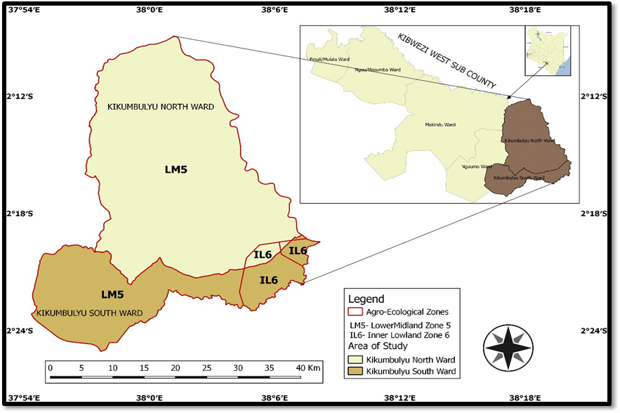

**Figure 1:** Map of Kibwezi West Sub-County

# 2.2 Data collection

The Kenya Meteorological Department provided rainfall and temperature data for the Sub-County between 1993 and 2023.

**2.3 Data analysis**

The study analyzed annual rainfall anomalies and variations, rainfall concentration and rainfall and temperature trends. The Coefficient of variation (C.V) was used to analyze rainfall variations while the Precipitation Concentration index (PCI) analyzed the annual rainfall concentration. For annual rainfall and temperature trend analysis, linear regression was done.

**3. Results and discussion**

**3.1 Annual rainfall anomalies and variations**

Rainfall anomalies are crucial indicator of unusual weather patterns, shedding light on events like droughts or periods of excessive rainfall. Variations on the other hand provide insights into the shifting dynamics of rainfall over time, helping understand how it affects ecosystems, agriculture, and communities. Annual rainfall anomalies were computed by subtracting the long-term mean from annual totals and the results presented in Figure 2.

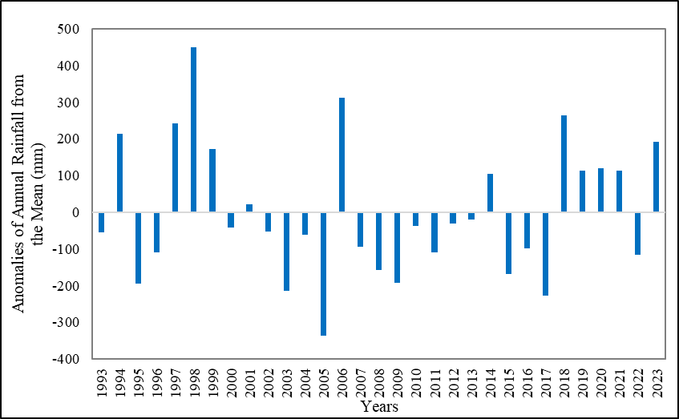

**Figure 2:** Annual Rainfall Anomalies

The area had a long-term rainfall mean of 562.1mm with year-to-year variations (Figure 2). The year 1998 recorded the highest positive anomaly of 448.5mm. This coincided with the El Niño event that led to high rainfall in Kenya (Kotikot et al., 2024). Other years with high positive anomalies included 2006 (310.9mm) and 2018 (264.6mm). The El Niño event of 2006 led to high rainfall in the country while the MAM season in 2018 was the wettest in Kenya in a record 119 years according to Global Precipitation Climatology Centre (Kilavi, 2018). This contributed immensely to the overall above normal annual rains in 2018. Highest negative anomalies were recorded in 2005(336.1mm), 2017(228.5mm) and 2003(214.6mm). This coincided with the La Nina related droughts that Kenya experienced in 2003, 2005 and 2017 (Ondiko et al., 2024). The years 1997 to 1999 were characterized by above normal annual rainfall with a mean (850mm) above the long-term mean. This too coincided with the El Niño related high rainfall that the area experienced during the same period. Below normal rains were experienced between 2002 and 2005 with a mean of 396.3mm which was below the long-term mean. This was followed by a sharp rise in 2006 of 873mm, which coincided with the El Niño related high rainfall in Kenya. These findings support the argument by IPCC (2012) that El Niño and La Nina phenomena are a major cause of rainfall variation in East Africa, with El Niño typically bringing increased rainfall and La Niña associated with droughts.

The longest period of below normal annual total rainfall was experienced between 2007 and 2013 with a slight rise in 2014, followed by below normal rains between 2015 and 2017. According to Ondiko et al. (2024), this is attributed to the Indian Ocean Dipole were low Surface Sea Temperatures experienced in 2005 to 2008 and 2011 to 2016 resulted to droughts in Makueni County, negatively impacting agricultural activities in the area. The last decade (2014-2023) saw a rise in the frequency of above normal annual rainfall (60%) compared to below normal annual rainfall (40%). Further investigations through household surveys confirmed these findings, as participants claimed to have witnessed an increase in the intensity of rainfall in recent years with a reduction in the number of rain days. These findings are consistent with those of Kimutai et al. (2022) who noted an increase in the intensity of rainfall in different parts of Kenya that has resulted to a rise in the frequency of floods and landslides. Similarly, Haret et al. (2021) reveals that between 2000 and 2050 rainfall in Kenya will become more intense and less predictable especially in ASALs.

Climatologically, wet or dry climatic conditions occur when rainfall is above or below the long-term average (Huho, 2017). Based on this definition and with a long-term mean of 562.1mm, between 1993 and 2023 wet episodes occurred in 38.7% of the period while dry conditions were experienced in 61.3% of the same period. This reveals that episodes of drought climatic conditions were more prevalent in the Sub-County than episodes of wet climatic conditions. With 61.3% of the period experiencing drought episodes, this translated to a drought cycle of once after every 2 years which negatively impacted food security.

High year-to-year rainfall variations characterizes the arid and semi-arid regions due to the low and erratic rainfall they experience (Huho, 2017). The coefficient of variation (*CV*) was used to determine variation in annual total rainfall. According to the Australian Bureau of Meteorology (2010), the magnitude of *CV* is classified as follows: less than 20% as less variable, 20% to 30% as moderately variable and more than 30% as highly variable. Omotoso et al. (2023) reveals that a high variation in rainfall leads to floods or drought while consistent rainfall is essential for crop production. The *CV* was calculated as follows.

*CV* = (Standard deviation ÷ Mean) × 100

*=* (179.9 ÷ 562.1) × 100

= 32%

A *CV* of 32% was obtained which implied that annual rainfall amounts fluctuated significantly around the long-term mean therefore being less predictable, heightening the Sub-County’s vulnerability to drought. These findings validate a report by MoALF (2016) that rainfall patterns have become increasingly erratic and unreliable thus increasing drought conditions in Makueni County over the past three decades.

**3.2 Annual rainfall concentration**

To establish the temporal inhomogeneity of annual rainfall for the entire period of study, precipitation concentration index (PCI) was used. Kalisa et al. (2020) notes that a low rainfall concentration is when the PCI value is less than 10, moderate concentration is when the value is between 10 to 20 and a high concentration when the value is above 20. Annual rainfall concentration was computed as follows.

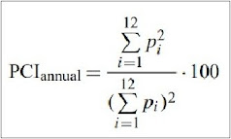

= (54173.39 ÷ 315956.41) × 100

= 17.1

A PCI value of 17.1 was obtained indicating that annual rainfall was moderately concentrated. This suggests that rainfall was not evenly distributed throughout the year. The mean monthly rainfall distribution for the entire period of study was analyzed and results presented in Figure 3.

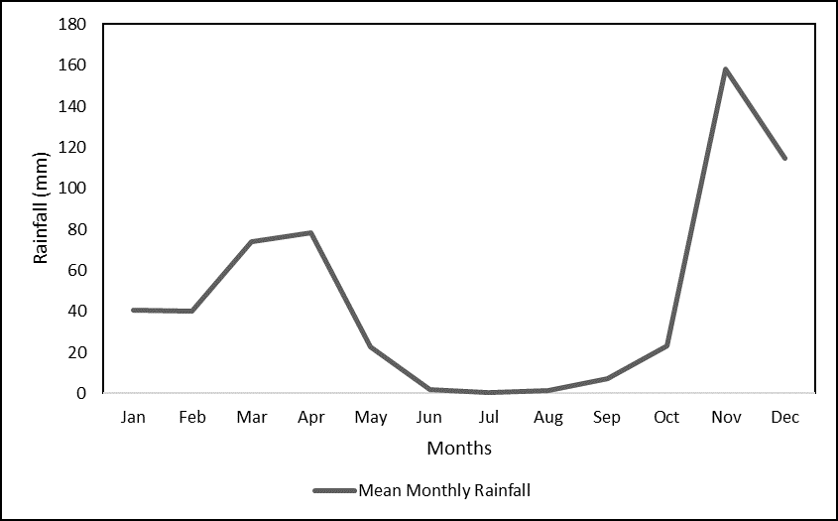

### Figure 3: Mean Monthly Rainfall Distribution

The Months of March, April, November and December had significant rainfall while others like June, July and August experienced relatively little rainfall (Figure 3). The majority of the annual rainfall occurred within 3 to 4 months. This implied that the Sub-County was moderately at risk of extreme dry or wet conditions during the year.

**3.3 Annual rainfall trend**

Trend is the general movement of a series over an extended period of time or the long-term change in the dependent variable over a long period of time. Annual rainfall trend was determined by plotting the changes and patterns of rainfall in the Sub-County over the past three decades (1993-2023). The direction of rainfall over time determined the trend. Analysis of annual rainfall trend was presented in Figure 4.

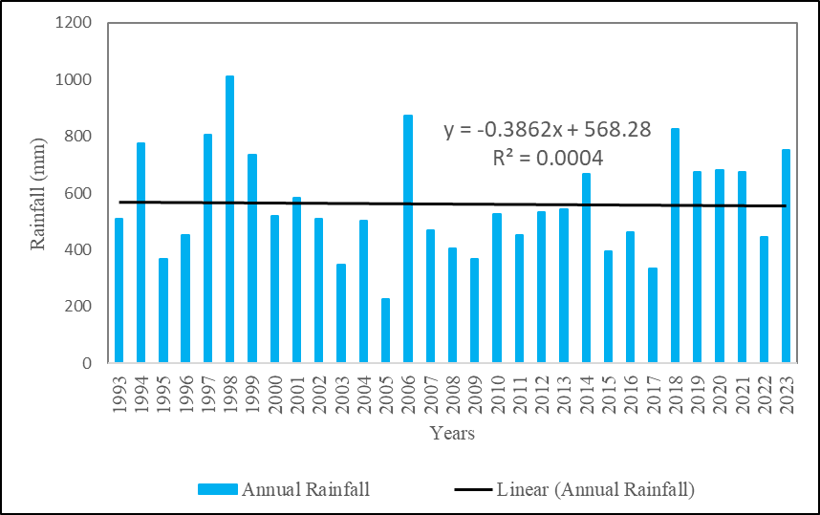

### Figure 4: Annual Rainfall Trend

Data in Figure 4 reveals that the Sub-County experienced a generally declining rainfall trend in the last three decades (1993-2023). The linear regression equation shows a negative slope value (-0.4) indicating a downward trend. Specifically, this means that for each passing year, annual rainfall decreased by 0.4mm. These findings are consistent with those of Recha et al. (2016) and Abuya (2021) who noted a declining annual rainfall in Makueni County over the preceding five decades. While acknowledging the changing rainfall patterns in Makueni County, Muia et al. (2024) noted an increase in the frequency of droughts in the County within the last two decades.

**4. Annual average temperature trend**

Annual average temperature trend in the Sub-County was analyzed and the findings presented in Figure 5.

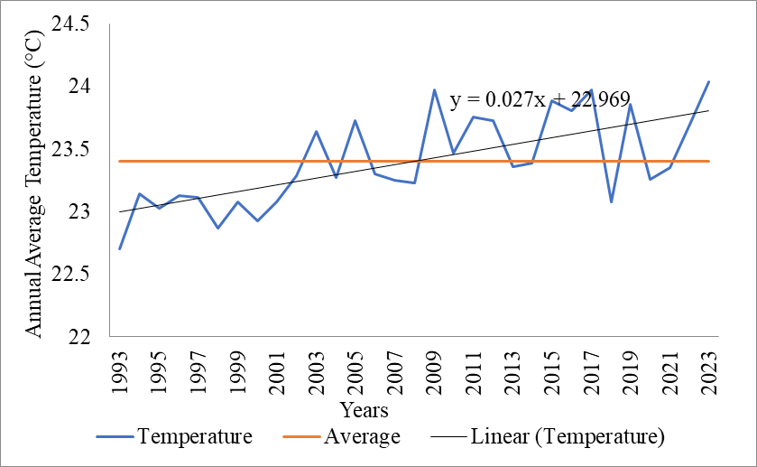

### Figure 5: Annual Average Temperature Trend

Annual average temperature in the Sub-County showed a generally increasing trend (Figure 5). The lowest annual average temperature was recorded in 1993 (22.7°C) and the highest in 2023 (24.0°C). The linear regression equation shows a positive slope of 0.03 signifying that annual average temperature was increasing over time. Specifically, annual temperature was increasing by 0.03 degrees per year.

It is noteworthy that the decade 1993-2002 was characterized by below normal annual average temperatures while from 2003 to 2023 above normal temperatures occurred more frequently (57.1%). The 1993-2002 decade had a mean of 23.0°C, 2003 to 2012 decade a mean of 23.5°C and the 2013-2022 a mean of 23.6°C. This indicated a gradually rising annual average temperatures in the last three decades suggesting that the Sub-County was already experiencing climate change. These findings support reports by IPCC (2021) and WMO (2021) that globally, the last four decades have been successively warmer than any decade that preceded them since 1850. The reports further reveal that a warming trend has been observed in the African continent, with an average increase of approximately +0.30°C per decade from 1991 to 2021. According to Yvonne et al. (2020), in Kenya, the warming trend has been more rapid compared to the global average and this is attributed to increased heat waves and hot days in recent years.

**5. Conclusion**

Comparatively, annual rainfall showed a declining trend while annual average temperature showed an increasing trend. Temperature was increasing by 0.03°C annually while rainfall decreased by 0.4mm annually. This implied that the Sub-County was gradually getting hotter and drier, a clear indicator of a changing climate. In addition, rainfall was concentrated in the months of March, April, November and December with drought climatic conditions occurring more frequently than wet conditions. Interventions such as climate-smart agricultural practices and the growing of drought tolerant traditional high-value crops should be encouraged to increase farmers’ capacity to adapt and grow in the face of increased rainfall variability and more erratic weather patterns.

**6. References**

ABUYA, N. (2021). *Assessing Achievements of Resilient Livelihoods Programme in Increasing Community Capacity to Respond to Climate Related Shocks in Kalawani Location, Makueni County, Kenya* (Doctoral dissertation, Maseno University).

Adesete, A. A., Olanubi, O. E., & Dauda, R. O. (2023). Climate change and food security in selected Sub-Saharan African Countries. *Environment, Development and Sustainability*, *25*(12), 14623-14641.

Australian Bureau of meteorology (2010) Rainfall variability in Australia. [http://www.bom.gov.au/climate/data/index.shtml]

Chilunjika, A., & Gumede, N. (2021). Climate change and human security in Sub-Saharan Africa. *African Renaissance*, *2021*(si1), 13-37.

Haret, A., Huho, J., Mohamed, A., & Golicha, H. (2021). Evaluation of the Impact of County Climate Change Fund on Community Resilience to Climate Change in Garissa County, Kenya. *American Journal of Climatic Studies*, *2*(1), 38-59.

Huho, J. M. (2017). An analysis of rainfall characteristics in Machakos County, Kenya. *IOSR Journal of Environmental Science, Toxicology and Food Technology*, *11*(4), 64-72.

IPCC (2012). Managing the Risks of Extreme Events and Disasters to Advance Climate Change Adaptation. Cambridge, UK and New York, USA: Cambridge University Press. ‌

IPCC. (2021). Climate Change 2021: The Physical Science Basis. Switzerland: Intergovernmental Panel on Cimate Change.

Kalisa, W., Zhang, J., Igbawua, T., Ujoh, F., Ebohon, O. J., Namugize, J. N., & Yao, F. (2020). Spatio-temporal analysis of drought and return periods over the East African region using Standardized Precipitation Index from 1920 to 2016. *Agricultural Water Management*, *237*, 106195.

Kenya National Bureau of Statistics (2019). 2019 Kenya Population and Housing. 2019 vol.1.ISBN:9966-102-09-6.

Kilavi, M., MacLeod, D., Ambani, M., Robbins, J., Dankers, R., Graham, R., ... & Todd, M. C. (2018). Extreme rainfall and flooding over central Kenya including Nairobi city during the long-rains season 2018: causes, predictability, and potential for early warning and actions. *Atmosphere*, *9*(12), 472.

Kimutai, J., New, M., Wolski, P., & Otto, F. (2022). Attribution of the human influence on heavy rainfall associated with flooding events during the 2012, 2016, and 2018 March-April-May seasons in Kenya. *Weather and Climate Extremes*, *38*, 100529.

Kotikot, S. M., Smithwick, E. A., & Greatrex, H. (2024). Observations of enhanced rainfall variability in Kenya, East Africa. *Scientific Reports*, *14*(1), 12915.

Mariappan, S., David Raj, A., Kumar, S., & Chatterjee, U. (2023). Global warming impacts on the environment in the last century. In *Ecological footprints of climate change: Adaptive approaches and sustainability* (pp. 63-93). Cham: Springer International Publishing.

MoALF. (2016). Climate Risk Profile for Makueni.” Kenya County Climate Risk Profile Series. Nairobi: Ministry of Agriculture, Livestock, and Fisheries .

Mohammed, Y., Yimer, F., Tadesse, M., & Tesfaye, K. (2018). Variability and trends of rainfall extreme events in north east highlands of Ethiopia. *Int. J. Hydrol*, *2*(5), 594-605.

Muia, V. K., Opere, A. O., Ndunda, E., & Amwata, D. A. (2024). Rainfall and Temperature Trend Analysis using Mann-Kendall and Sen’s Slope Estimator Test in Makueni County, Kenya. *J. Mater. Environ. Sci., 15 (3), 349*, *367*.

Mushawemhuka, W., Fitchett, J. M., & Hoogendoorn, G. (2024). Climate change and adaptation in the Zimbabwean nature-based tourism industry. *Anatolia*, *35*(1), 97-108.

Nyika, J. M. (2022). Climate change situation in Kenya and measures towards adaptive management in the water sector. In *Research anthology on environmental and societal impacts of climate change* (pp. 1857-1872). IGI Global.

Omotoso, A. B., Letsoalo, S., Olagunju, K. O., Tshwene, C. S., & Omotayo, A. O. (2023). Climate change and variability in sub-Saharan Africa: A systematic review of trends and impacts on agriculture. *Journal of Cleaner Production*, 137487.

Ondiko, J. H., Karanja, A. M., Obulinji, H. W., & Ondimu, K. N. (2024). Influence of Indian Ocean Dipole on Drought Occurrence in Makueni County, Kenya. *Open Access Library Journal*, *11*(7), 1-11.

Raimi, M. O., Vivien, O. T., & Oluwatoyin, O. A. (2021). Creating the healthiest nation: Climate change and environmental health impacts in Nigeria: A narrative review. *Morufu Olalekan Raimi, Tonye Vivien Odubo & Adedoyin*

Recha, J. W., Mati, B. M., Nyasimi, M., Kimeli, P. K., Kinyangi, J. M., & Radeny, M. (2016). Changing rainfall patterns and farmers’ adaptation through soil water management practices in semi-arid eastern Kenya. Arid Land Research and Management 30(3) 229-238.

WMO. (2021). State of the Climate in Africa. Geneva: World Meteorological Organization.

Yvonne, M., Ouma, G., Olago, D., & Opondo, M. (2020). Trends in climate variables (temperature and rainfall) and local perceptions of climate change in Lamu, Kenya. *Geography, Environment, Sustainability*, *13*(3), 102-109.