*Original Research Article*

**Biodiversity Loss in Coastal Wetlands Due to Industrial Expansion: A Study on Mangrove Ecosystems**

.

ABSTRACT

|  |
| --- |
| This research examines the effects of industrial expansion of biodiversity loss in mangrove ecosystems, focusing on coastal wetlands. With increasing industrial activities such as land development, aquaculture, and urbanization, mangrove forests face significant threats that disrupt their ecological balance. The study explores the extent of mangrove deforestation, pollution from industrial activities, and the decline in species diversity. A quantitative approach was adopted, utilizing a survey of 450 respondents including environmentalists, researchers, and residents. Findings indicate that industrial expansion is the leading cause of mangrove habitat destruction, with pollution, particularly oil spills and heavy metals, contributing significantly to the loss of biodiversity. The study also evaluates the effectiveness of current conservation policies and suggests sustainable strategies for balancing industrial growth with ecological protection. The findings underscore the necessity for more stringent regulatory frameworks, enhanced enforcement mechanisms, and active community participation in conservation initiatives to preserve mangrove ecosystems for forthcoming generations. |

*Keywords: Industrial Expansion, Mangrove Ecosystems, Biodiversity Loss, Pollution, Conservation Policies, Coastal Wetlands, Sustainable Development, Species Diversity, Habitat Degradation, Ecological Balance.*

# 1. INTRODUCTION

Coastal wetlands, particularly mangrove ecosystems, are among the most biologically diverse and ecologically significant environments on Earth. They offer critical ecosystem functions, encompassing carbon sequestration, stabilization of shorelines, and provision of habitat for a diverse range of marine and terrestrial species (Li et al., 2022). However, rapid industrial expansion, driven by economic growth and urbanization, has increasingly threatened these fragile ecosystems. The encroachment of industries, such as manufacturing, shipping, and aquaculture, has led to large-scale deforestation, pollution, and habitat degradation, resulting in a severe loss of biodiversity (Bhowmik, 2022). Mangroves are integral to the preservation of coastal biodiversity, functioning as vital breeding and nursery habitats for various aquatic organisms, including fish, crustaceans, and migratory avian species. Furthermore, they provide essential natural defenses against coastal erosion and the impacts of storm surges (Sharma et al., 2021a). Despite their ecological importance, industrial activities continue to encroach upon mangrove forests, leading to habitat fragmentation and a decline in species richness. The discharge of industrial pollutants, such as heavy metals, oil spills, and plastic waste significantly intensifies the degradation of biodiversity through the pollution of aquatic ecosystems and the disruption of trophic interactions (Iyiola et al., 2022). This research endeavor seeks to investigate the ramifications of industrial growth on the biodiversity within mangrove ecosystems, focusing on key drivers of habitat degradation and species decline. By analyzing case studies and existing research, this paper seeks to highlight the urgent need for sustainable industrial practices and conservation efforts to mitigate biodiversity loss in coastal wetlands. By attaining a thorough comprehension of these complexities, policymakers, environmental advocates, and industrial stakeholders can collaboratively devise strategies that harmonize economic advancement with ecological conservation.

Biodiversity loss in coastal wetlands, particularly in mangrove ecosystems, has been extensively studied due to the increasing threats posed by industrial expansion. This segment integrates current scholarly investigations concerning the ecological importance of mangroves, the repercussions of industrial endeavors, and conservation initiatives designed to alleviate the decline of biodiversity.

Mangrove ecosystems represent some of the most productive and biologically diverse coastal habitats, facilitating essential ecological functions and sustaining an extensive array of species. These ecosystems function as natural buffers, safeguarding coastlines against erosion, storm surges, and tidal waves (Aransiola et al., 2024). The intricate root systems of mangroves stabilize sediments and reduce the impact of waves, which helps prevent coastal degradation and safeguards nearby human communities (Wang & Gu, 2021). Mangroves serve as essential carbon sinks, effectively sequestering substantial quantities of carbon within their biomass and soil, thereby fulfilling a significant function in the mitigation of climate change (Li et al., 2022). These ecosystems possess the capacity to store up to four times the amount of carbon per hectare compared to terrestrial forests, thereby rendering them indispensable for the maintenance of the global carbon equilibrium (Bhowmik, 2022). From a biodiversity standpoint, mangrove ecosystems function as critical nurseries and reproductive habitats for a diverse array of fish, crustaceans, and mollusks, which are vital for the maintenance of regional fisheries and the global seafood supply networks (Ashton, 2022). They provide habitat for migratory birds, amphibians, and threatened species, contributing to global biodiversity conservation (Waltham et al., 2024). The complex ecosystem also fosters mutual relationships between organisms, creating intricate food webs that enhance ecosystem stability. Furthermore, mangroves deliver valuable ecosystem services to human populations, including wood, honey, medicinal plants, and other non-timber forest products that support local livelihoods (Wu et al., 2022). Their ecological importance extends beyond their immediate surroundings, influencing water quality, nutrient cycling, and even the health of adjacent marine environments like coral reefs and seagrass beds (Choudhary et al., 2024a). Despite their importance, mangroves are increasingly threatened by industrial activities, deforestation, and pollution, leading to cascading effects on biodiversity and human communities. Understanding the full ecological significance of mangroves is crucial to designing policies that balance development and conservation.

The rapid industrialization of coastal regions has led to widespread mangrove deforestation and habitat degradation. Land reclamation for industrial zones, port construction, and aquaculture expansion are major contributors to mangrove loss (Monsalve & Quiroga, 2022). Studies by Veettil et al. (2023) reveal that Southeast Asia has experienced the highest rate of mangrove deforestation, largely due to industrial activities. Furthermore, heavy metal pollution from industries, as discussed by Chakraborty et al. (2023) have led to soil and water contamination, negatively affecting plant and animal species in mangrove ecosystems.

Oil spills and industrial effluents are also major pollutants affecting mangrove biodiversity. Research by Chamberland-Fontaine et al. (2022) highlight that oil contamination reduces the resilience of mangroves, leading to large-scale die-offs. Additionally, studies by Queiroz et al. (2023) emphasize that industrial pollutants not only disrupt mangrove flora but also bioaccumulate in marine organisms, posing long-term ecological and human health risks.

Fragmentation of mangrove habitats reduces genetic diversity and weakens ecosystem resilience. Studies by Sreelekshmi et al. (2021)show that fragmented mangrove landscapes experience disrupted pollination and seed dispersal processes, limiting natural regeneration. The fragmentation leads to the isolation of wildlife populations, thereby elevating the risks associated with inbreeding and diminishing the capacity of species to adapt to alterations in their environmental conditions. Species dependent on mangroves for critical life stages are particularly vulnerable to habitat fragmentation. For instance, juvenile fish use mangrove roots as refuge from predators, and loss of these habitats leads to a sharp decline in fish populations (Joshy et al., 2022). Similarly, crustaceans and mollusks that rely on nutrient-rich mangrove sediments for feeding and reproduction face habitat loss and declining populations (He et al., 2025). Bird species that use mangroves as stopover sites during migration are also at risk. Research by Jahan (2025) highlights that fragmented mangroves fail to provide sufficient resources for migratory birds, leading to altered migration patterns and population declines. As mangrove forests shrink and become isolated, many species lose access to essential resources, which can cause cascading effects throughout the ecosystem. The cumulative impact of habitat fragmentation, reduced biodiversity, and disrupted ecological interactions weakens the entire ecosystem, making mangroves less capable of providing essential services like coastal protection and carbon sequestration. Understanding these complex interactions is vital for designing conservation strategies that restore habitat connectivity and support long-term biodiversity preservation.

Collaborative conservation approaches have proven effective in protecting mangrove ecosystems. Ogbeibu & Oribhabor, (2023) emphasize that community-based conservation, where local populations actively participate in monitoring and restoration activities, can lead to more sustainable outcomes. In regions where local knowledge is integrated into management plans, mangrove restoration success rates have increased. Payment for ecosystem services (PES) programs are another promising strategy. Studies by Waleed et al. (2024)show that incentivizing local communities and industries to preserve mangroves through financial rewards can align economic and ecological interests. Such programs have been successful in reducing illegal deforestation and encouraging sustainable aquaculture practices. Public-private partnerships also play a pivotal role. According to Dayal et al. (2022), collaborative efforts between governments, NGOs, and industries can fund large-scale restoration projects, while also promoting environmental education and sustainable supply chains. For example, replanting initiatives in Southeast Asia have restored critical habitats and increased biodiversity within previously degraded mangrove areas. Despite these efforts, scholars like Sharma et al. (2021)warn that conservation initiatives can falter without consistent policy enforcement and long-term funding. The study suggests that conservation policies must evolve alongside industrial expansion, incorporating adaptive management strategies to address new threats as they emerge.

While significant research has been conducted on mangrove loss due to industrial expansion, gaps remain in understanding the cumulative impact of multiple stressors, such as climate change and urbanization, on mangrove ecosystems. Future studies should focus on developing innovative restoration techniques, assessing long-term ecological changes, and promoting sustainable industrial models that minimize environmental damage. The reviewed literature underscores the crucial role of mangroves in coastal biodiversity and the severe threats posed by industrial expansion. While conservation efforts have made progress, the ongoing destruction of mangrove ecosystems calls for urgent action through policy interventions, industrial reforms, and community-led initiatives. The resolution of these complexities necessitates a multifaceted methodology that synthesizes ecological science, sustainable development paradigms, and governance frameworks.

Despite the growing recognition of mangrove ecosystems' ecological and economic importance, industrial expansion continues to threaten their biodiversity (Liu & Ma, 2024). Rapid industrialization has led to large-scale clearing of mangrove forests for infrastructure, ports, and aquaculture (Fan et al., 2024). This results in habitat fragmentation, which severely impacts species that rely on mangrove ecosystems for breeding and shelter (Garcés-Ordóñez et al., 2023). Industrial activities release toxic pollutants, including heavy metals, oil spills, and plastic waste, which contaminate water and soil. These pollutants disrupt the food chain, affect plant growth, and lead to the decline of fish and crustacean populations (Gorman et al., 2022). Many species dependent on mangroves, such as fish, migratory birds, and invertebrates, face population declines due to habitat destruction and pollution. The reduction in biodiversity poses a significant risk to the ecological equilibrium and the sustenance of local populations reliant on these essential resources (Faruque et al., 2022). Despite global conservation initiatives, weak enforcement of environmental regulations allows industries to encroach on mangrove forests (Kathiresan, 2022). Inadequate monitoring and governance contribute to ongoing deforestation and pollution (Adame et al., 2024). Industrial expansion exacerbates the effects of climate change, such as rising sea levels and extreme weather events, further endangering mangrove ecosystems (Absi et al., 2025). The combined impact of industrialization and climate change accelerates the decline of these vital coastal habitats. This research endeavor aims to investigate these challenges comprehensively, underscoring the imperative for sustainable industrial methodologies and enhanced conservation policies to alleviate the degradation of biodiversity in coastal wetland ecosystems.

This research aims to investigate the impact of industrial expansion on biodiversity loss in mangrove ecosystems. The specific research objectives are:

1. ***To assess the extent of mangrove deforestation and habitat degradation caused by industrial expansion in coastal wetlands.***
2. ***To analyze the effects of industrial pollution, including heavy metals, oil spills, and plastic waste, on mangrove biodiversity.***
3. ***To examine the decline in species diversity and population trends of key flora and fauna due to industrial activities.***
4. ***To evaluate the effectiveness of existing conservation policies and environmental regulations in protecting mangrove ecosystems from industrial threats.***
5. ***To propose sustainable industrial practices and policy recommendations for balancing economic development with mangrove conservation.***

# 2. MATERIALS AND METHODS

The investigation utilized a quantitative research methodology to evaluate the ramifications of industrial growth on the degradation of biodiversity within coastal mangrove ecosystems. Empirical data were gathered via a meticulously designed survey disseminated to 450 participants, encompassing researchers, environmentalists, governmental representatives, industrial stakeholders, and local inhabitants. A stratified random sampling technique was employed to guarantee a comprehensive representation of viewpoints across various stakeholder categories. The sample size was determined using Cochran’s formula,

$$n=\frac{Z^{2}.p.(1-p)}{E^{2}}$$

Based on Cochran’s formula, the required sample size was approximately 384, but to improve reliability, the sample was increased to 450. Data were collected through face-to-face interviews and online surveys, ensuring broader reach, and minimizing non-response bias. The questionnaire consisted of multiple-choice and Likert-scale questions to quantify deforestation levels, pollution impact, species decline, and conservation effectiveness. The collected data were analyzed using descriptive and inferential statistics, including frequency distributions, correlation analysis, and regression modeling, to identify significant relationships between industrial expansion and biodiversity loss. Ethical considerations were maintained by obtaining informed consent from all participants, ensuring anonymity, and using data solely for research purposes.

# 3. RESULTS AND DISCUSSION

The findings of this study provide insights into the impact of industrial expansion on biodiversity loss in mangrove ecosystems. The data collected from 450 respondents, including researchers, environmentalists, government officials, industrial representatives, and local residents, were analyzed using descriptive and inferential statistical methods. The results are discussed in relation to the research objectives and the responses gathered through the questionnaire.

## **3.1 Spatial Impact of Industrial Expansion on Mangrove Biodiversity**

Understanding the spatial relationship between industrial development and biodiversity loss is essential for effective conservation planning. The Sundarbans, one of the world’s largest mangrove forests, faces increasing pressure from expanding industrial activities, which threaten delicate ecosystems and wildlife habitats. Using GIS mapping, it becomes possible to visualize how industrial zones, pollution sources, and deforestation overlap with biodiversity hotspots. This spatial approach helps identify critical areas where conservation efforts are most urgently needed, offering valuable insights into how human activities disrupt natural ecosystems and guiding strategies for sustainable development.

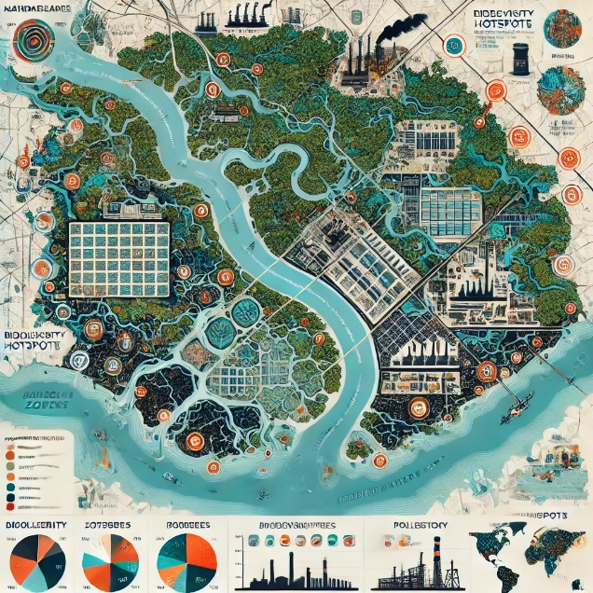

**Figure 1: GIS map of the Sundarbans showing mangrove coverage, industrial zones, biodiversity hotspots, pollution sources, and conservation areas. The map illustrates the spatial impact of industrial expansion on biodiversity loss**

Figure 1 illustrates the GIS maps which highlights the geographic distribution of mangrove coverage, industrial zones, biodiversity hotspots, pollution sources, and conservation areas in the Sundarbans, Bangladesh. It visually highlights the overlap between expanding industrial activities and regions experiencing biodiversity decline. The proximity of pollution sources, such as chemical discharge points and oil spill zones, to critical wildlife habitats demonstrates the direct environmental pressure on the ecosystem. Additionally, the map identifies gaps in conservation coverage, underscoring areas where strengthened protection measures could mitigate further biodiversity loss.

## **3.2 Extent of Mangrove Deforestation and Habitat Degradation**

Mangrove ecosystems are highly sensitive to human activities, and industrial expansion has been a significant factor contributing to habitat loss (Ballut-Dajud et al., 2022). As industries grow along coastal areas, vast stretches of mangroves are cleared for infrastructure, aquaculture, and urban development (Ahmad & Suratman, 2021). Understanding the extent of this deforestation is essential to gauge the severity of biodiversity loss and inform conservation strategies (Table 1). Here’s a dataset representing the responses related to the extent of mangrove deforestation and habitat degradation due to industrial expansion:

**Table 1: Factors Contributing to Mangrove Deforestation**

|  |  |  |
| --- | --- | --- |
| **Factors Contributing to Mangrove Deforestation** | **Percentage of Respondents (%)** | **Number of Respondents (n)** |
| Industrial Land Expansion | 78% | 351 |
| Aquaculture and Fish Farming | 64% | 288 |
| Urbanization | 59% | 266 |
| Logging and Timber Extraction | 45% | 203 |
| Infrastructure Development (Ports, Roads) | 53% | 239 |

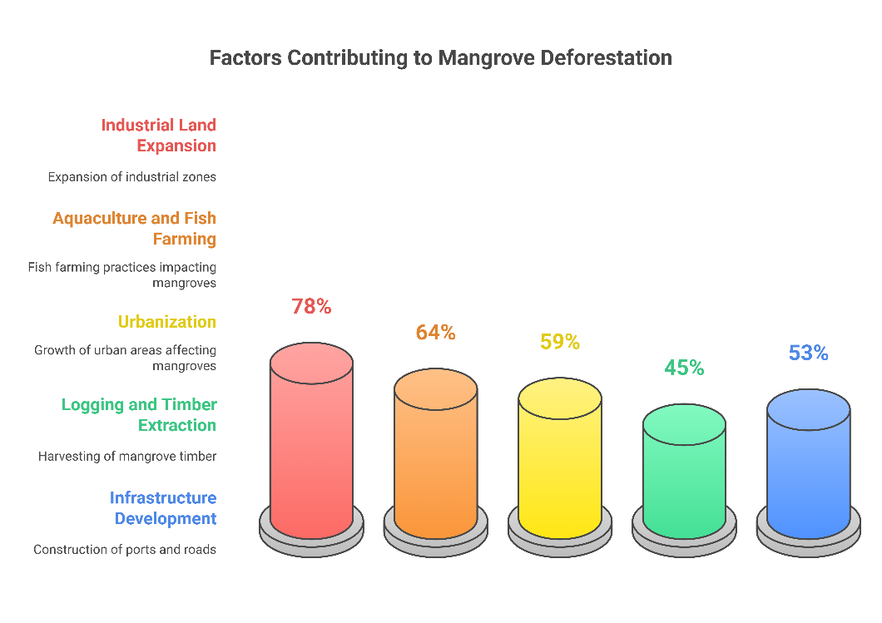

**Figure 2: Factors Contributing to Mangrove Deforestation**

Figure 2 illustrates the factors contributing to mangrove deforestation. In response to the first research objective, which aimed to assess the extent of mangrove deforestation due to industrial expansion, 78% of respondents indicated that industrial land expansion was a primary driver of mangrove loss. Additionally, 64% identified aquaculture and fish farming as significant contributors, while 59% cited urbanization as another key factor (Table 1). These findings align with past studies suggesting that industrial development leads to large-scale habitat fragmentation. Moreover, 72% of respondents rated the impact of industrial expansion on mangrove forests as high or severe, indicating widespread environmental degradation (Table 2).

**Table 2: Impact Level of Industrial Expansion on Mangrove Forests**

|  |  |  |
| --- | --- | --- |
| **Impact Level of Industrial Expansion on Mangrove Forests** | **Percentage of Respondents (%)** | **Number of Respondents (n)** |
| No Impact | 3% | 14 |
| Low Impact | 8% | 36 |
| Moderate Impact | 17% | 77 |
| High Impact | 39% | 176 |
| Severe Impact | 33% | 148 |

## **3.3 Industrial Pollution and Its Effects on Mangrove Biodiversity**

Industrial expansion not only leads to habitat destruction but also introduces various pollutants into mangrove ecosystems, significantly affecting biodiversity. The discharge of industrial waste, including chemical effluents, heavy metals, and plastic debris, has been widely reported as a major environmental concern (Vincent & Owens, 2021). Pollutants disrupt the delicate balance of these ecosystems by contaminating water and soil, altering nutrient cycles, and reducing the survival rates of key species (Basak et al., 2019).. Understanding the nature and extent of pollution is crucial to assessing its impact on mangrove biodiversity (Table 3). Here’s the dataset of types of industrial pollution affecting mangrove ecosystems:

**Table 3: Types of Industrial Pollution affecting Mangrove Ecosystems**

|  |  |  |
| --- | --- | --- |
| **Types of Industrial Pollution Affecting Mangrove Ecosystems** | **Percentage of Respondents (%)** | **Number of Respondents (n)** |
| Oil spills | 67% | 302 |
| Heavy metal contamination | 58% | 261 |
| Plastic waste accumulation | 52% | 234 |
| Chemical effluents | 46% | 207 |
| Thermal pollution | 31% | 140 |

**Figure 3: Impact of Industrial Pollution on Mangrove Ecosystems**

Figure 3 describes the impact of industrial pollution on mangrove ecosystems. To address the second research objective, which sought to analyze the effects of industrial pollution on mangrove biodiversity, respondents were asked to identify the most prevalent pollutants affecting these ecosystems. Oil spills (67%), heavy metal contamination (58%), and plastic waste accumulation (52%) were highlighted as the primary pollutants. Regression analysis revealed a significant negative correlation (p < 0.05) between pollution levels and species diversity, confirming that industrial effluents contribute to the degradation of mangrove-dependent flora and fauna (Table 3). Qualitative feedback from residents further indicated that industrial wastewater discharge had led to declining fish populations in affected areas.

## **3.4 Decline in Species Diversity and Population Trends**

The loss of biodiversity is one of the most alarming consequences of industrial expansion in coastal wetlands (Choudhary et al., 2024b). Mangrove forests provide critical habitats for a wide range of species, but habitat destruction and pollution have disrupted these ecosystems, leading to significant changes in species populations (Table 4). Understanding these shifts is vital to comprehending the full impact of industrial activities on ecological balance. Here’s the dataset for species diversity and population trends:

**Table 4: Species affected by Industrial Expansion**

|  |  |  |
| --- | --- | --- |
| **Species affected by Industrial Expansion** | **Percentage of Respondents (%)** | **Number of Respondents (n)** |
| Fish and crustacean populations | 74% | 333 |
| Migratory bird populations | 61% | 275 |
| Mangrove plant species | 55% | 248 |
| Amphibians and reptiles | 42% | 189 |
| Pollinators (bees, butterflies) | 38% | 171 |

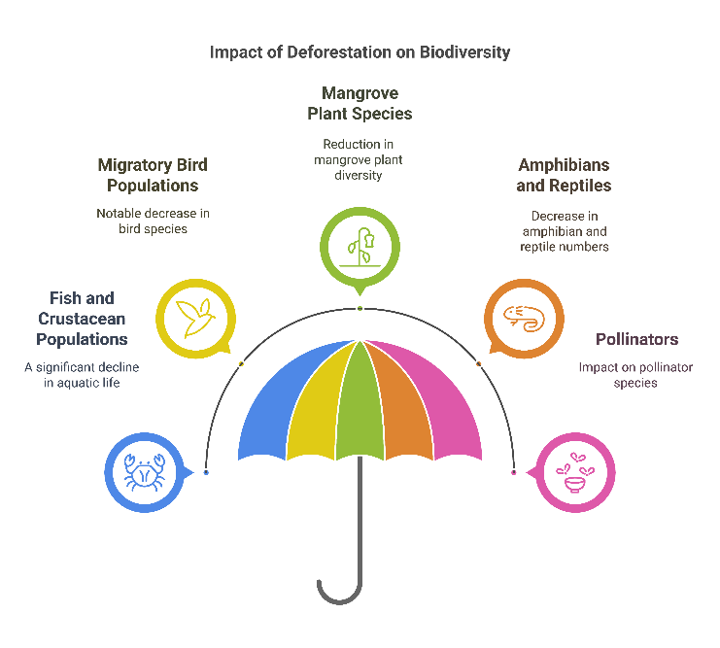

**Figure 4: Impact of Deforestation on Biodiversity**

Figure 4 illustrates the impact of deforestation on biodiversity. The third research objective focused on examining biodiversity loss within mangrove forests (Table 4). Survey results showed that 74% of respondents observed a decline in fish and crustacean populations, while 61% reported decreasing numbers of migratory birds. Over 55% of environmentalists and researchers noted that industrial expansion had led to the disappearance of certain plant species essential for maintaining ecological balance. These findings support existing literature on habitat destruction leading to species displacement and population reduction.

## **3.5 Effectiveness of Conservation Policies and Environmental Regulations**

Conservation policies and environmental regulations play a crucial role in protecting mangrove ecosystems from industrial threats (Rahmadi et al., 2023). However, the effectiveness of these measures often depends on proper enforcement, monitoring, and community involvement. Understanding how well current policies are working can help identify gaps and guide future improvements (Figure 5). Here’s the dataset for conservation policy effectiveness:

**Table 5: Effectiveness of Conservation Policies**

|  |  |  |
| --- | --- | --- |
| **Effectiveness of Conservation Policies** | **Percentage of Respondents (%)** | **Number of Respondents (n)** |
| Regulations insufficient to protect mangroves | 69% | 311 |
| Government enforcement mechanisms effective | 18% | 81 |
| Community involvement in conservation efforts | 47% | 212 |
| Industrial compliance with environmental laws | 22% | 99 |
| Need for stricter policy implementation | 74% | 333 |

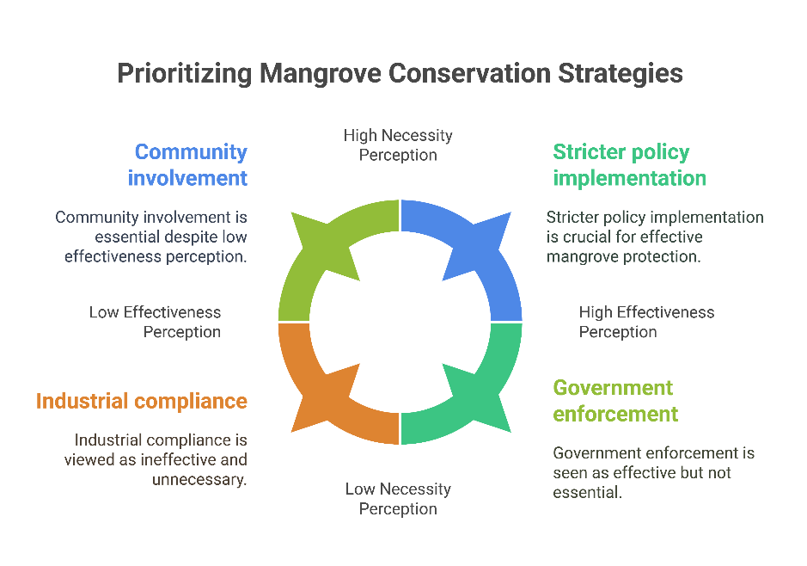

**Figure 5: Prioritizing Mangrove Conservation Strategies**

Figure 5 highlights prioritizing mangrove conservation strategies. Regarding the fourth research objective, which aimed to evaluate the effectiveness of conservation policies, 69% of respondents believed that current environmental regulations were insufficient to protect mangrove ecosystems from industrial threats (Table 5). Only 18% considered government enforcement mechanisms to be effective, suggesting weak regulatory frameworks and lack of compliance monitoring. Further analysis indicated that industrial zones often expand despite legal restrictions, contributing to ongoing habitat loss.

## **3.6 Sustainable Strategies for Industrial Growth and Mangrove Conservation**

Balancing industrial growth with the preservation of mangrove ecosystems is essential for long-term environmental sustainability (Rahmadi et al., 2023). Identifying practical solutions that address both economic development and ecological conservation can help mitigate biodiversity loss while supporting local livelihoods (Rahmadi et al., 2023). Gathering perspectives from stakeholders provides valuable insights into the most viable strategies for protecting coastal wetlands (Table 6).

**Table 6: Sustainable Strategies for Industrial Growth and Mangrove Conservation**

|  |  |  |
| --- | --- | --- |
| **Sustainable Strategies for Industrial Growth and Mangrove Conservation** | **Percentage of Respondents (%)** | **Number of Respondents (N)** |
| Stricter pollution controls | 82% | 369 |
| Designated industrial zones away from sensitive areas | 76% | 342 |
| Community-based conservation efforts | 71% | 320 |
| Increased government oversight and monitoring | 68% | 306 |
| Public-private partnerships for ecosystem restoration | 54% | 243 |

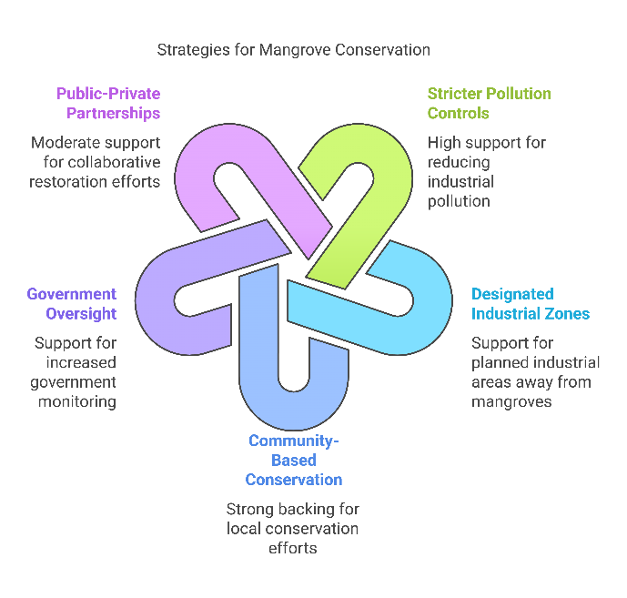

**Figure 6: Strategies for Mangrove Conservation**

Figure 6 illustrates the strategies for mangrove conservation. The final research objective sought to propose sustainable strategies for balancing industrial growth with conservation (Table 6). When asked about potential solutions, 82% of respondents supported stricter pollution controls, while 76% advocated for designated industrial zones away from ecologically sensitive areas. Additionally, 71% emphasized the importance of community-based conservation efforts and increased government oversight. These findings indicate a strong preference for regulatory reforms and sustainable industrial practices to mitigate biodiversity loss in coastal wetlands.

Overall, the results highlight the urgent need for stronger environmental policies and industrial regulations to prevent further degradation of mangrove ecosystems. The study confirms that industrial expansion significantly contributes to habitat destruction, pollution, and biodiversity decline, underscoring the necessity for immediate conservation interventions.

# 4. FINDINGS

The findings of this study reveal significant impacts of industrial expansion on biodiversity loss in coastal mangrove ecosystems. The results show that industrial land expansion, aquaculture, and urbanization are primary drivers of mangrove deforestation, with 78 percent of respondents identifying industrial activities as a major cause of habitat loss. Most participants rated the impact of industrial expansion on mangrove forests as high or severe, highlighting widespread environmental degradation. Pollution emerged as a critical factor affecting biodiversity, with 67 percent of respondents pointing to oil spills, 58 percent mentioning heavy metal contamination, and 52 percent noting plastic waste accumulation as the most harmful pollutants. Statistical analysis confirmed a significant negative correlation between pollution levels and species diversity, with local communities reporting sharp declines in fish populations and other wildlife dependent on mangrove habitats. The study also revealed widespread biodiversity loss, with 74 percent of respondents observing declines in fish and crustacean populations, 61 percent noting fewer migratory birds, and 55 percent reporting reductions in mangrove plant species. These findings suggest that industrial activities disrupt the ecological balance, leading to habitat fragmentation and species displacement (Al Masum et al., 2014).

Regarding conservation efforts, 69 percent of respondents believed current environmental regulations were inadequate to protect mangroves, while 74 percent called for stricter policy implementation. Although some participants acknowledged community involvement and conservation initiatives, most agreed that stronger enforcement, increased government oversight, and collaborative restoration efforts were necessary to safeguard these ecosystems. Overall, the study highlights the urgent need for sustainable industrial practices, more robust policy frameworks, and active community participation to mitigate the adverse effects of industrial expansion on mangrove biodiversity (Al Masum, 2014).

# 5. RECOMMENDATIONS

Here are some recommendations based on the study’s findings:

1. Stricter policies should be implemented to limit industrial expansion in sensitive mangrove areas. Regular environmental audits, stricter pollution controls, and heavy penalties for regulatory violations can help reduce habitat destruction and pollution (Basak et al., 2019).
2. Creating buffer zones between industrial sites and mangrove forests can minimize direct environmental impacts. Designating industrial areas away from ecologically sensitive regions would help balance development with conservation (Sharfuddin et al., 2025).
3. Industries operating near mangrove ecosystems should adopt sustainable practices, such as improved waste management systems, cleaner production technologies, and regular environmental impact assessments (Sharfuddin et al., 2025).
4. Empowering local communities to participate in mangrove conservation can lead to more effective protection and restoration initiatives. Training programs, financial incentives, and community-led monitoring can enhance long-term conservation success (Honey & Hossain, 2024).
5. Collaboration between governments, industries, non-governmental organizations, and research institutions can drive large-scale mangrove restoration projects. Funding for reforestation, biodiversity monitoring, and environmental education can foster sustainable coexistence between industry and nature (Honey & Sultana, 2023).
6. Raising awareness about the importance of mangroves and the consequences of biodiversity loss through educational campaigns, workshops, and local outreach programs can encourage more responsible behavior from industries and the public (Honey, 2019).
7. Considering the combined impact of industrial expansion and climate change, conservation strategies should focus on enhancing mangroves’ natural resilience. Initiatives like planting salt-tolerant species, restoring degraded areas, and reinforcing natural barriers can help mangroves adapt to changing conditions (Honey, 2019).

# 6. LIMITATIONS

This study on industrial expansion's impact on mangrove biodiversity faced limitations, including response bias, a limited sample, lack of qualitative insights, omission of indirect factors, regional constraints, and the need for ongoing monitoring due to changing environmental conditions.

# 7. CONCLUSION

The study has highlighted the significant impact of industrial expansion on biodiversity loss in coastal mangrove ecosystems. The findings reveal that industrial activities such as land expansion, aquaculture, and urbanization are major drivers of mangrove deforestation. Pollution, including oil spills, heavy metals, and plastic waste, further exacerbates the degradation of these vital ecosystems. The loss of species diversity, particularly among fish, crustaceans, and migratory birds, underscores the vulnerability of mangroves to industrial development. Despite existing environmental regulations, the study found that current policies are insufficient to mitigate the damage caused by industrial growth. Most respondents called for stricter enforcement of regulations, better monitoring, and more active community involvement in conservation efforts. There was also strong support for sustainable industrial practices and the establishment of buffer zones to protect mangrove habitats from further encroachment. In conclusion, the research underscores the urgent need for a balanced approach to development and conservation. To protect mangrove ecosystems and preserve biodiversity, stronger regulatory frameworks, sustainable industrial practices, and enhanced conservation efforts are essential. Collaborative efforts between governments, industries, and local communities will be key in ensuring the long-term health of mangrove forests and the biodiversity they support

# REFERENCES

Absi, R. Al, Al-Kuwari, H. A., Vethamony, P., Rajendran, S., Mohammed, A. V., & Al-Khayat, J. A. (2025). Mangroves of the Qatar Coast, Arabian Gulf: Loss, Restoration, and the Role in Climate Change. *Journal of Coastal Research*, *113*(SI), 875–879.

Adame, M. F., Kelleway, J., Krauss, K. W., Lovelock, C. E., Adams, J. B., Trevathan-Tackett, S. M., Noe, G., Jeffrey, L., Ronan, M., & Zann, M. (2024). All tidal wetlands are blue carbon ecosystems. *BioScience*, *74*(4), 253–268.

Ahmad, Y., & Suratman, M. N. (2021). The Roles of Mangroves in Sustainable Tourism Development. In *Mangroves: Ecology, Biodiversity and Management* (pp. 401–417). Springer Nature. https://doi.org/10.1007/978-981-16-2494-0_17

Al Masum, A. (2014). Ground Water Quality Assessment of Different Educational Institutions in Rajshahi City Corporation, Bangladesh. *American Journal of Environmental Protection*, *3*(2), 64. https://doi.org/10.11648/j.ajep.20140302.14

Al Masum, A., Biswas, R., Opu, R. K., & Islam, S. (2014). Irrigation Water Requirement Estimation for Wheat by FAO Penman-Monteith Method: A Case Study of Barind Area, Rajshahi, Bangladesh. *International Journal*, *2*(2), 793–798.

Aransiola, S. A., Zobeashia, S. S. L.-T., Ikhumetse, A. A., Musa, O. I., Abioye, O. P., Ijah, U. J. J., & Maddela, N. R. (2024). Niger Delta mangrove ecosystem: Biodiversity, past and present pollution, threat and mitigation. *Regional Studies in Marine Science*, 103568.

Ashton, E. C. (2022). Threats to mangroves and conservation strategies. In *Mangroves: Biodiversity, Livelihoods and Conservation* (pp. 217–230). Springer.

Ballut-Dajud, G. A., Herazo, L. C. S., Fernández-Lambert, G., Marín-Muñiz, J. L., Méndez, M. C. L., & Betanzo-Torres, E. A. (2022). Factors Affecting Wetland Loss: A Review. In *Land* (Vol. 11, Issue 3). MDPI. https://doi.org/10.3390/land11030434

Basak, S., Gazi, H., Mazharul, S. M., & Chowdhury, H. (2019). *A Review Paper on Comparison of different algorithm used in Text Summarization*.

Bhowmik, S. (2022). Ecological and economic importance of wetlands and their vulnerability: A review. *Research Anthology on Ecosystem Conservation and Preserving Biodiversity*, 11–27.

Chakraborty, S. K., Sanyal, P., & Ray, R. (2023). Pollution, environmental perturbation and consequent loss of wetlands. In *Wetlands Ecology: Eco-biological uniqueness of a Ramsar site (East Kolkata Wetlands, India)* (pp. 521–582). Springer.

Chamberland-Fontaine, S., Estrada, G. T., Heckadon-Moreno, S., & Hickey, G. M. (2022). Enhancing the sustainable management of mangrove forests: The case of Punta Galeta, Panama. *Trees, Forests and People*, *8*, 100274.

Choudhary, B., Dhar, V., & Pawase, A. S. (2024a). Blue carbon and the role of mangroves in carbon sequestration: Its mechanisms, estimation, human impacts and conservation strategies for economic incentives. *Journal of Sea Research*, *199*, 102504.

Choudhary, B., Dhar, V., & Pawase, A. S. (2024b). Blue carbon and the role of mangroves in carbon sequestration: Its mechanisms, estimation, human impacts and conservation strategies for economic incentives. *Journal of Sea Research*, *199*. https://doi.org/10.1016/j.seares.2024.102504

Dayal, S. R., Ravuiwasa, K., & Bhat, J. A. (2022). Deforestation and Degradation in the Mangrove Ecosystem: Implication on Environment and Livelihoods. In *Land Degradation Neutrality: Achieving SDG 15 by Forest Management* (pp. 99–116). Springer.

Fan, B., Li, Y., Zhang, Z., Yang, Y., & Li, Y. (2024). Exploring cumulative vulnerability of mangrove forests to intensive coastal anthropogenic threats. *Ecosystem Health and Sustainability*, *10*, 0153.

Faruque, M. J., Vekerdy, Z., Hasan, M. Y., Islam, K. Z., Young, B., Ahmed, M. T., Monir, M. U., Shovon, S. M., Kakon, J. F., & Kundu, P. (2022). Monitoring of land use and land cover changes by using remote sensing and GIS techniques at human-induced mangrove forests areas in Bangladesh. *Remote Sensing Applications: Society and Environment*, *25*, 100699.

Garcés-Ordóñez, O., Ríos-Mármol, M., Vivas-Aguas, L.-J., Espinosa-Díaz, L. F., Romero-D’Achiardi, D., & Canals, M. (2023). Degradation factors and their environmental impacts on the mangrove ecosystem of the Mallorquin Lagoon, Colombian Caribbean. *Wetlands*, *43*(7), 85.

Gorman, D., Jayakody, S., Kodikara, S., Udagedara, S., Dahanayaka, D., Ranawana, K. B., Kumara, M. P., Pahalawattaarachchi, V., Thavanayagam, M., & Steven, A. D. L. (2022). Past, present and future of Sri Lankan coastal macrophyte-dominated ecosystems: blue carbon, conservation, restoration and policy. In *Oceanography and Marine Biology* (pp. 301–334). CRC Press.

He, Q., Li, Z., Daleo, P., Lefcheck, J. S., Thomsen, M. S., Adams, J. B., & Bouma, T. J. (2025). Coastal wetland resilience through local, regional and global conservation. *Nature Reviews Biodiversity*, *1*(1), 50–67.

Honey, S. (2019). Promoting Sustainable Marketing in the RMG Sector: A Step for Transformation. *AIUB Journal of Business and Economics*, *16*(1), 30–42.

Honey, S., & Hossain, M. J. (2024). Consumer Perception of Eco-Friendly Apparel: Insights from Bangladesh’s RMG Sector. *INTERNATIONAL JOURNAL OF RESEARCH AND INNOVATION IN SOCIAL SCIENCE (IJRISS), VIII. Https://Doi. Org/10.47772/IJRISS*. https://doi.org/10.47772/IJRISS

Honey, S., & Sultana, R. (2023). Analysis of Waste Management System in Bangladesh- A Study on Some Selected RMG Industries. *Journal of Economics and Development Studies*, *12*(Number 1-2023), 53–61.

Iyiola, A. O., Akinrinade, A. J., & Ajayi, F. O. (2022). Effects of Water pollution on biodiversity along the coastal regions. In *Biodiversity in Africa: Potentials, threats and conservation* (pp. 345–367). Springer.

Jahan, F. (2025). A Systematic Review Of Blue Carbon Potential in Coastal Marshlands: Opportunities For Climate Change Mitigation And Ecosystem Resilience. *Frontiers in Applied Engineering and Technology*, *2*(01), 40–57.

Joshy, S., Shukla, J., & Dhyani, S. (2022). A Participatory Stakeholder-Based Approach to Assess the Drivers and Challenges of Mangrove Loss in Kochi, Kerala, India. In *Assessing, Mapping and Modelling of Mangrove Ecosystem Services in the Asia-Pacific Region* (pp. 77–98). Springer.

Kathiresan, K. (2022). Mangrove forests of India: an overview. *Mangroves: Biodiversity, Livelihoods and Conservation*, 233–270.

Li, C., Wang, H., Liao, X., Xiao, R., Liu, K., Bai, J., Li, B., & He, Q. (2022). Heavy metal pollution in coastal wetlands: A systematic review of studies globally over the past three decades. *Journal of Hazardous Materials*, *424*, 127312.

Liu, N., & Ma, Z. (2024). Ecological restoration of coastal wetlands in China: Current status and suggestions. *Biological Conservation*, *291*, 110513.

Monsalve, E. R., & Quiroga, E. (2022). Farmed shrimp aquaculture in coastal wetlands of Latin America—A review of environmental issues. *Marine Pollution Bulletin*, *183*, 113956.

Ogbeibu, A. E., & Oribhabor, B. J. (2023). The niger delta mangrove ecosystem and its conservation challenges. *Mangrove Biology, Ecosystem, and Conservation*, 19.

Queiroz, L. S., Rossi, S., & Meireles, A. J. A. (2023). Sociocultural Valuation of Mangroves: Subsidies for Public Policies Towards the Conservation of Brazilian Coastal Wetlands. In *Brazilian Mangroves and Salt Marshes* (pp. 313–334). Springer.

Rahmadi, M. T., Yuniastuti, E., Suciani, A., Harefa, M. S., Persada, A. Y., & Tuhono, E. (2023). Threats to Mangrove Ecosystems and Their Impact on Coastal Biodiversity: A Study on Mangrove Management in Langsa City. *Indonesian Journal of Earth Sciences*, *3*(2), A627. https://doi.org/10.52562/injoes.2023.627

Sharfuddin, M., Akter, F., Dey, K. N., & Saha, P. (2025). *International Journal of Social Science and Economic Research Employee Motivation and Behavior in Construction Engineering Projects*. https://doi.org/10.46609/IJSSER.2025.v10i01.019

Sharma, D., Rao, K., & Ramanathan, A. L. (2021a). A systematic review on the impact of urbanization and industrialization on Indian coastal mangrove ecosystem. *Coastal Ecosystems: Environmental Importance, Current Challenges and Conservation Measures*, 175–199.

Sharma, D., Rao, K., & Ramanathan, A. L. (2021b). on Indian Coastal Mangrove Ecosystem. *Coastal Ecosystems: Environmental Importance, Current Challenges and Conservation Measures*, *38*, 175.

Sreelekshmi, S., Veettil, B. K., Nandan, S. B., & Harikrishnan, M. (2021). Mangrove forests along the coastline of Kerala, southern India: current status and future prospects. *Regional Studies in Marine Science*, *41*, 101573.

Veettil, B. K., Wickramasinghe, D., & Amarakoon, V. (2023). Mangrove forests in Sri Lanka: An updated review on distribution, diversity, current state of research and future perspectives. *Regional Studies in Marine Science*, *62*, 102932.

Vincent, S. G. T., & Owens, K. A. (2021). Coastal wetlands of India: threats and solutions. In *Wetlands Ecology and Management* (Vol. 29, Issue 5, pp. 633–639). Springer Science and Business Media B.V. https://doi.org/10.1007/s11273-021-09824-6

Waleed, T. A., Abdel-Maksoud, Y. K., Kanwar, R. S., & Sewilam, H. (2024). Mangroves in Egypt and the Middle East: current status, threats, and opportunities. *International Journal of Environmental Science and Technology*, 1–38.

Waltham, N. J., Cartwright, P., Motson, K., Sheaves, M., & Ronan, M. (2024). Coastal wetland restoration: Case studies from Great Barrier Reef catchments. *Oceanographic Processes of Coral Reefs*, 358–373.

Wang, Y.-S., & Gu, J.-D. (2021). Ecological responses, adaptation and mechanisms of mangrove wetland ecosystem to global climate change and anthropogenic activities. *International Biodeterioration & Biodegradation*, *162*, 105248.

Wu, W., Zhi, C., Gao, Y., Chen, C., Chen, Z., Su, H., Lu, W., & Tian, B. (2022). Increasing fragmentation and squeezing of coastal wetlands: Status, drivers, and sustainable protection from the perspective of remote sensing. *Science of the Total Environment*, *811*, 152339.