**AUTOMATIC SPRINKLER IN CONTROLLED ATMOSPHERE**

**ABSTRACT**:

Watering the plant is the most important cultural practice and one of the labour-intensive tasks in daily greenhouse operation. Watering systems ease the burden of getting water to plants when they need it. Knowing when and how much to water is two important aspects of watering process. To make the gardener works easily, the automatic plant watering system is created. There have a various type using automatic watering system that are by using sprinkler system, tube, nozzles and other. This system uses watering sprinkler system because it can water the plants located in the pots. This project uses Arduino board, which consists of ATmega328 Microcontroller. It is programmed in such a way that it will sense the moisture level of the plants and supply the water when required. This type of system is often used for general plant care, as part of caring for small and large gardens. Normally, the plants need to be watered twice daily, morning and evening. So, the microcontroller has to be coded to water the plants in the garden or farms about two times per day. People enjoy plants, their benefits and the feeling related to nurturing them. However, for most people it becomes challenging to keep them healthy and alive. To accommodate this challenge, we have developed a prototype, which makes a plant more self-sufficient, watering itself from a large water tank and providing itself with artificial sunlight. The prototype reports status of its current conditions and also reminds the user to refill the water tank. The system automation is designed to be assistive to the user. We hope that through this prototype people will enjoy having plants without the challenges related to absent or forgetfulness.

**Key words:** Plant Irrigation, Sprinkler Robot, Arduino, Water Pump.

**I. INTRODUCTION**

Providing people all over the world with essential products and sustenance, agriculture is one of the pillars of human civilization. However, this crucial industry faces a significant obstacle because of its heavy reliance on water supplies. As the problem of water scarcity spreads over different areas, the search for the need for farmers to manage water resources sustainably has never been greater. In order to increase crop yields and conserve water, automatic irrigation systems are growing in popularity.

In the modern society is now fully dependent upon technology and the technological approach has brought a revolutionary change in each and every field. This project a multipurpose robot to be used in the battle field. This robotic vehicle is an agricultural machine of a considerable power and great soil clearing capacity. The machine will cultivate the farm by considering particular rows and specific column at fixed distance depending on crop. Moreover, the vehicle can be controlled through Bluetooth using an Android smart phone. The main aim of agricultural robotics is applying robotics technologies on the field of agriculture as well as the agricultural challenges to develop new techniques. Now days, no one can end up the day without using any kind of embedded system products. It makes our human life very robust and makes work comfortable. The 21st century is said to be century of creation, progress, globalization and so much else, but the second side too, that is nothing but 21st century is century of the population, global warming, drought and cloud burst also helpless health factors. Automation in agricultural robotics system has been developed to implement a number of agricultural productions in many countries. Such as picking, harvesting, monitoring, weeding, seeding, fertilizer, irrigation.

These systems can automatically turn on or off irrigation water supplies based on weather and soil moisture levels, which are monitored by sensors. By ensuring that crops receive the appropriate amount of water at the appropriate time, this can help to boost profitability and production. The installation of an automated irrigation system appears to be a viable way to handle the urgent issues of labour efficiency and water conservation in agriculture in this environment. By implementing such cutting-edge technologies, farmers can transform their irrigation methods and greatly increase agricultural productivity and water efficiency.

The overarching goal of this study is to explore how the automatic irrigation system, based on the Arduino Uno, can facilitate resource-efficient farming practices. These systems can automatically turn on or off irrigation water supplies based on weather and soil moisture levels, which are monitored by sensors. By ensuring that crops receive the appropriate amount of water at the appropriate time, this can help to boost profitability and production. The installation of an automated irrigation system appears to be a viable way to handle the urgent issues of labor efficiency and water conservation in agriculture in this environment. Through this project, we delve into the multifaceted benefits of embracing an automatic irrigation system in modern agriculture. As we uncover the potential advantages of water savings, labor optimization, and sustainable farming, we emphasize the transformative impact that this technology can have on the agriculture sector, paving the way towards a more resilient and ecologically responsible future.

**II.LITERATURE REVIEW**

Mathivanan. S, et al., (2023) presented the “Plant Irrigation water Sprinkler Robot”, In this research paper, The pressure category includes Sprinkler and Drip Irrigation System could not meet the needs with presence and monitoring during the growing season. From this literature, we are decided to use advanced Technology in sprinkler Irrigation system to maximize water productivity and minimize costs of keeping farms.

Pavan kumar.C.S et al., (2021). A smart Irrigation system using Arduino This Technology specializes in the proper application of water to in Agriculture Land. Arduino, Relay, Motor, Pump, Bluetooth module are included in this machine. From this literature we have Selected Components such as Arduino, Relay, Motor, Pump, Bluetooth module for operation and controlling the vehicle.

Ahmed hassan et al., (2021) presented the “Design and development of an irrigation mobile robot”. The Arduino UNO framework was used for the development of the control unit with use of ATMEGA328P microcontroller that allowed the machine to use a suitable amount of water that prevent Irrigation. From this literature, we are decided to use ATMEGA328P micro-controller for automatic Water supply.

Sampa Das, et al., (2023). State, the use of Arduino Uno for automatic irrigation systems has been gaining popularity in recent years. This is due to the fact that Arduino Uno is a relatively inexpensive and easy-to use microcontroller that can be programmed to control a variety of components, including soil moisture sensors, water pumps, and valves. One of the most popular applications of Arduino Uno for automatic irrigation systems is in agriculture. In agriculture, automatic irrigation systems can be used to water crops at the optimal time and frequency, which can help to improve crop yields and reduce water waste. The Internet of Things is updating the way we interact with the world around us. This technology is also being used to develop smart irrigation systems that can automatically control the watering of crops based on soil moisture levels, weather conditions, and other factors.

**III. METHODOLOGY**

Problem Identification

Fabrication of the Machine

Collection of Materials

Test Working of the Machine

Final Project

Design of the Model

Literature Survey

**Chart 1- Study protocol**

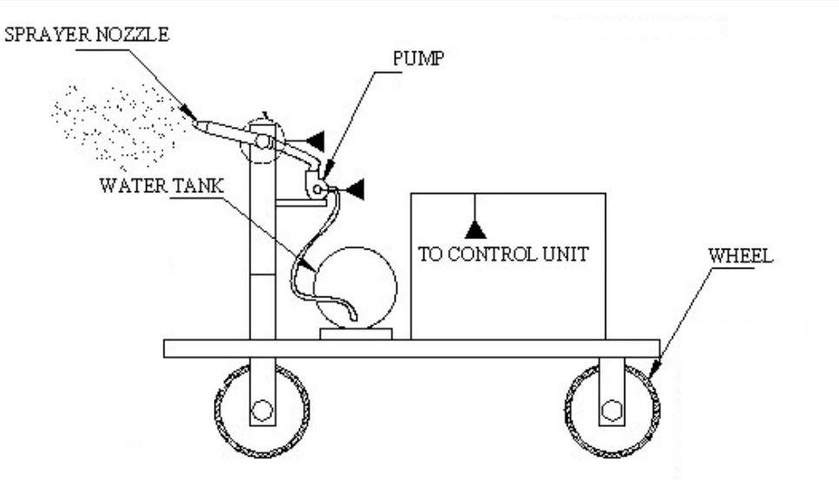**3.1 Design of the Model**

Figure 1: Design of Automatic Sprinkler

**3.2 Collection of Materials**

We collect the materials like Adeno UNO, Battery, DC Motor, HC-05 Bluetooth Module, Relay, Convertor, Water Pump, Sprinkler, Wheel, Water Tank and Connecting wires.

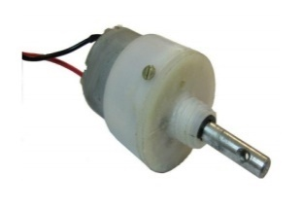**3.2.1.DC Motor**

Figure 2. DC motor

Permanent magnet DC motor responds to both voltage and current. The steady state voltage across a motor determines the motor’s running speed, and the current through its armature windings determines the torque. Apply a voltage and the motor will start running in one direction; reverse the polarity and the direction will be reversed.

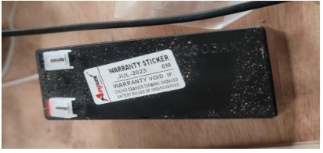**3.2.2. Battery**

Figure 3. Battery

In our project we are using secondary type battery. It is rechargeable type. A battery is one or more electrochemical cells, which store chemical energy and make it available as electric current. There are two types of batteries, primary (disposable) and secondary (rechargeable), both of which convert chemical energy to electrical energy.

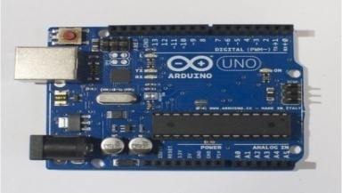**3.2.3. Arduino UNO**

Figure 4. Arduino board

Arduino is a single-board microcontroller to make using electronics in multidisciplinary projects more accessible. The hardware consists of an open-source hardware board designed around an 8-bit Atmel AVR microcontroller, or a 32-bit Atmel ARM.

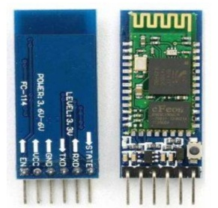**3.2.4. Bluetooth Module**

Figure 5. Bluetooth module

The HC05 bluetooth module is used as UART serial converter module and can easily transfer the UART data through the wireless bluetooth. The Bluetooth module has a Frequency: 2.4GHz ISM band, PIO control and comes with an integrated antenna and edge connector.

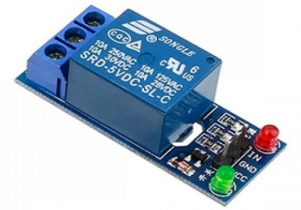**3.2.5. Relay**

Figure 6. Relay

A relay is an electrically operated switch. Current flowing through the coil of the relay creates a magnetic field which attracts a lever and changes the switch contacts. The coil current can be on or off so relays have two switch positions and they are double throw (changeover) switches.

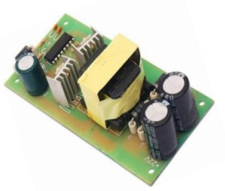**3.2.6. Convertor**

Figure 7. Convertor

A power converter, also known as a power supply or power adapter, serves the function of converting electrical power from one form to another Power converters are often used to convert electrical voltage from one level to another.

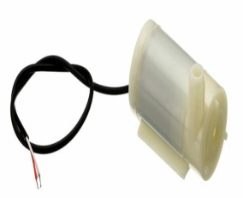**3.2.7. Water Pump**

Figure 8. Water pump

Pump is a device that moves fluids (liquids or gases), or sometimes slurries, by mechanical action. Pumps can be classified into three major groups according to the method they use to move the fluid: direct lift, displacement, and gravity pumps.

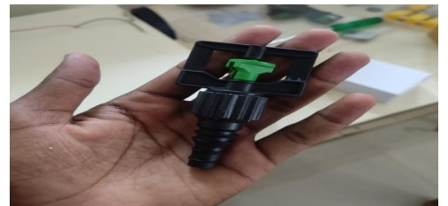**3.2.8. Sprinkler**

Figure 9. Sprinkler

An irrigation sprinkler (also known as a water sprinkler or simply a sprinkler) is a device used to irrigate agricultural crops, lawns, landscapes, golf courses, and other areas. They are also used for cooling and for the control of airborne dust. Sprinkler irrigation is the method of applying water in a controlled manner in way similar to rainfall. The water is distributed through a network that may consist of pumps, valves, pipes and sprinklers.

**3.2.9. Water Tank**

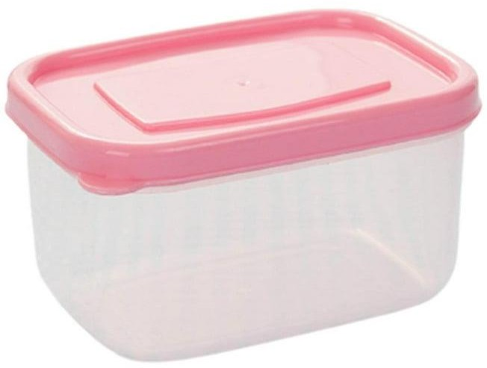A water tank is a container for storing water. The need for a water tank is as old as civilization, to provide storage of water for use in many applications, drinking water, irrigation agriculture, fire suppression, agricultural farming, both for plants and livestock, chemical manufacturing, food preparation as well as many other uses. The tank holds the water about 3.5liters.

### 

### Figure 10. Water Tank

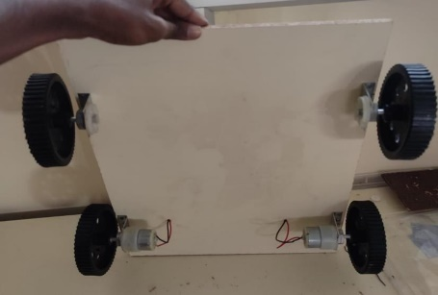**3.2.10. Wheel**

### Figure 11. Wheels

A wheel is a circular device that is capable of rotating on its axis, facilitating movement or transportation or performing labour in machines. A wheel together with an axle overcomes friction by facilitating motion by rolling. In order for wheels to rotate a moment needs to be applied to the wheel about its axis, either by way of gravity or by application of another external force. Common examples are found in transport applications. More generally the term is also used for other circular objects that rotate or turn, such as a Ship's wheel and flywheel.

**3.3. Fabrication of the Machine**

Fabrication of an automatic sprinkler machine involves combining mechanical, electrical and programming components. It involves Designing of frame and assemble the frame. The Sprinkler head is connected to Water Pump through pipe. The Water motor is connected to relay module of 12v power. The Battery(12v) is the power source for all components. The Bluetooth board is connected to Arduino board. A convertor which is connected to battery and relay to convert 12v into 5v. Write a program for the microcontroller to control the system based on sensor inputs. Secure all connections and components. Make any necessary adjustments and finalize the installation.

**3.4. Working of the Machine**

Actually, this consists of a Rover which moves around and sprays pesticides, water etc. Initially the 12v battery is connected with dc motor and a 4channel relay. This 4-channel relay used for forward, backward, right, left motion of rover. And battery also connected with Arduino board, receiver and one channel relay. In Arduino Uno board all functions are programmed. One channel relay used to on off the sprinkler which is placed at tank on the top of the rover. By filling pesticides or water in tank. Then sprinkler should turn on. It sprays it around. Then the rover motion controlled by mobile phone. It sprays wherever the signal is processed manually.

**IV. PROGRAM**

**Programing Language: “C”**

#include <LiquidCrystal.h> int Relay1 = 3;

int Relay2 = 4; int Relay3 = 5; int Relay4 = 6; int Relay5 = 2;

LiquidCrystal lcd(13, 12, 11, 10, 9, 8);

unsigned long previousMillis = 0; // will store last time LED was updated const long interval = 1000;

int ult,tu,tur;

char rcv[100], ip[20], remote_ip[20], remot_number[20]; int temp, mois, y = 0;

char s_val[20], countt, q = 0;

int r = 0, ip_count = 0, ri = 0, rn = 0, i = 150, a = 1, at = 2,att=0,sec,se,secc; int pos = 90,pos1 = 90;

void setup() {

// pinMode(A1, OUTPUT);

// pinMode(A0, INPUT);

pinMode(Relay1, OUTPUT); pinMode(Relay2, OUTPUT); pinMode(Relay3, OUTPUT); pinMode(Relay4, OUTPUT); pinMode(Relay5, OUTPUT);

digitalWrite(Relay1, LOW); digitalWrite(Relay2, LOW); digitalWrite(Relay3, LOW); digitalWrite(Relay4, LOW); digitalWrite(Relay5, HIGH);

// myservo.write(0); lcd.begin(16, 2);

//6 GSM BASEDFLING VOICE CONTROL QUAD COPTER ROBOT WITH WIRELESS VEDIO CAMERA

lcd.setCursor(0, 0); lcd.print(" ");

lcd.setCursor(0, 1); lcd.print(" ");

Serial.begin(9600); lcd.clear(); lcd.setCursor(0, 0);

lcd.print(" STOP ");

//Serial.print("Arduino Received: ");

}

void loop() {

while (Serial.available())

{

unsigned int rec = Serial.read(); s_val[countt] = rec;

if (s_val[0] == '*') { countt++;

}

else {

countt = 0;

}

}

if (countt > 1)

{

countt = 0;

if (s_val[1] == '1' && at==2)

{ //lcd.clear(); lcd.setCursor(0, 0);

lcd.print(" FORWARD "); //Serial.print("up"); digitalWrite(Relay1, LOW);

digitalWrite(Relay2, HIGH); digitalWrite(Relay3, LOW); digitalWrite(Relay4, HIGH);

}

if (s_val[1] == '2' && at==2)

{ //lcd.clear(); lcd.setCursor(0, 0);

lcd.print(" REVERSE "); //Serial.print("up"); digitalWrite(Relay2, LOW);

digitalWrite(Relay1, HIGH); digitalWrite(Relay4, LOW); digitalWrite(Relay3, HIGH);

}

if (s_val[1] == '4' && at==2)

{ //lcd.clear(); lcd.setCursor(0, 0);

lcd.print(" LEFT "); //Serial.print("up"); digitalWrite(Relay1, HIGH);

digitalWrite(Relay2, LOW); digitalWrite(Relay3, LOW); digitalWrite(Relay4, HIGH);

}

if (s_val[1] == '3' && at==2)

{ //lcd.clear(); lcd.setCursor(0, 0);

lcd.print(" RIGHT "); //Serial.print("up"); digitalWrite(Relay1, LOW);

digitalWrite(Relay2, HIGH); digitalWrite(Relay3, HIGH); digitalWrite(Relay4, LOW);

}

if (s_val[1] == '5' )

{ //lcd.clear(); lcd.setCursor(0, 0);

lcd.print(" STOP "); //Serial.print("up"); digitalWrite(Relay1, LOW);

digitalWrite(Relay2, LOW); digitalWrite(Relay3, LOW); digitalWrite(Relay4, LOW);

}

if (s_val[1] == '6' && at==2)

{ //lcd.clear(); digitalWrite(Relay5, LOW);

lcd.setCursor(0, 0);

lcd.print(" PUMP ON "); //Serial.print("up");

}

if (s_val[1] == '7' && at==2)

{ //lcd.clear(); digitalWrite(Relay5, HIGH); lcd.setCursor(0, 0);

lcd.print(" PUMP OFF "); //Serial.print("up");

}

if (s_val[1] == '9')

{ //lcd.clear();

//digitalWrite(Relay6, HIGH); lcd.setCursor(0, 0);

lcd.print(" AUTO MODE ");at=1;secc=0; //Serial.print("up");

}

if (s_val[1] == '8')

{ //lcd.clear();

// digitalWrite(Relay6, LOW); lcd.setCursor(0, 0);

lcd.print(" MANUAL ");at=0; //Serial.print("up");

}

}

if(at==1)

{

digitalWrite(Relay5, LOW);

unsigned long currentMillis = millis();

if (currentMillis - previousMillis >= interval) { previousMillis = currentMillis;

secc++; }

if (secc >= 0 && secc<10)

{

lcd.setCursor(0, 0);

lcd.print(" FORWARD "); //Serial.print("up"); digitalWrite(Relay1, LOW);

digitalWrite(Relay2, HIGH); digitalWrite(Relay3, LOW); digitalWrite(Relay4, HIGH);

}

if (secc >= 10 && secc<14)

{

lcd.setCursor(0, 0);

lcd.print(" RIGHT "); //Serial.print("up"); digitalWrite(Relay1, HIGH);

digitalWrite(Relay2, LOW);

digitalWrite (Relay3, LOW); digitalWrite (Relay4, HIGH);

}

if (secc >= 14 && secc<30)

{

lcd.setCursor(0, 0);

lcd.print(" FORWARD "); //Serial.print("up"); digitalWrite(Relay1, LOW);

digitalWrite(Relay2, HIGH); digitalWrite(Relay3, LOW); digitalWrite(Relay4, HIGH);

}

if(secc>30){secc=0;}

}

if(at==0)

{

digitalWrite(Relay1, LOW); digitalWrite(Relay2, LOW); digitalWrite(Relay3, LOW); digitalWrite(Relay4, LOW); digitalWrite(Relay5, HIGH);at=2;

}

}

**V. RESULT & DICUSSION**

Our project was automatic sprinkler in controlled atmosphere. The controlled atmosphere includes Greenhouse, polyhouse, shade nets, nursery gardens etc., To make the gardener works easily, the automatic plant watering system is created. There have a various type using automatic watering system that are by using sprinkler system, tube, nozzles and other. This system uses watering sprinkler system because it can water the plants located in the pots. This project uses Arduino board, which consists of ATmega328 Microcontroller. It is programmed in such a way that it will sense the moisture level of the plants and supply the water when required. Automatic irrigation systems are convenient, especially for those who travel. If installed and programmed properly, automatic irrigation systems can even save you money and help in water conservation.

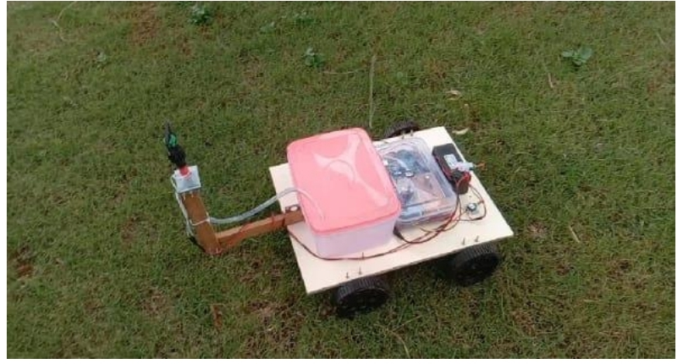  Figure 12. Schematic view of Automatic Sprinkle

**VI. CONCLUSION**

In conclusion, the implementation of an automatic irrigation system using Arduino Uno proves to be a simple yet highly effective method to ensure optimal plant hydration. By employing a moisture sensor to monitor soil moisture levels, this system intelligently activates the water pump only when necessary, minimizing water wastage and promoting sustainable irrigation practices. The ease of building and adapting the system makes it suitable for a wide range of applications, from small-scale gardens to expansive farms and greenhouses. Its efficiency in delivering water precisely to plants when needed not only conserves water but also reduces the overall cost of irrigation, benefiting farmers and gardeners alike. The automatic irrigation system using Arduino Uno emerges as a valuable tool in agriculture, yielding a multitude of advantages. Incorporating automatic irrigation systems into agriculture presents an innovative approach that fosters sustainable practices and resource efficient farming. By enhancing crop yields, conserving water, improving soil health, and optimizing labour, the automatic irrigation system using Arduino Uno stands as a crucial tool in the quest for sustainable and productive agricultural practices. As farmers and gardeners embrace this technology, they not only ensure the well-being of their crops but also play an essential role in safeguarding the planet's precious water resources and promoting a more resilient and thriving agricultural ecosystem. Therefore, the adoption of automatic irrigation systems represents a significant step towards a greener and more food-secure future.

**VII. REFERENCES**

1. S.Mathivanan, Vishnudas.C, SidhinKrishna.M.S, Suraj.R, et al.,2023 “Plant Irrigation water Sprinkler Robot”, International Journal of Engineering & technology, ETEST 2023: Volume 11, Issue 03, ISSN:2278-0181
2. Pavan kumar.C.S, Nainika .A, Chandrashekar.C,et al.,2021 “Review paper on(Robotics in smart farming)”, Advance in Electronic and Electric Engineering, 2021, ISSN 2320-2882: IJCRT 2021, volume
3. Ahmed hassan, Rao, Ateeq rehmeen, Moh Kaabar, Zuhaib Nishtar, et al.,2021“Design and development of an irrigation mobile robot”, IJRA:June 2021, ISSN: 2722-2586, Volume: 10. No 2.
4. Vikethozotsira, gypsy nandi, et al., 2014“Bluetooth technology: Security and its prevention”, IJCCTA:2014, ISSN: 2229-6093, Volume: (5)
5. M.gayathri, Arun.D, A.Ishwariya,et al.,2021 “Smart Irrigation system using IoT”, IJIRMPS 2021: volume 9, Issue 3, ISSN:2349-7300.
6. Anitha, A., Sampath, N., & Jerlin, M. A.et al., (2020, February). Smart irrigation system using Internet of Things. In 2020 International Conference on Emerging Trends in Information Technology and Engineering (icETITE) (pp. 1-7). IEEE.
7. S.M. Wange, sanket, Akshay Pendurkar, pranav, et el., 2018, “Automatic sprinkler system”, IRJET (International Research Journal), vol-5. No 6.
8. González, I., Calderón, A.J., Figueiredo, J., Sousa, J.M.C., et al.,2019. “A Literature Survey on Open Platform Communications (OPC)” Applied to Advanced Industrial Environments. Electronics, vol. 8, pp. 510.
9. Sampa Das,Puja Bose, Sanjugh Guha Thakurata, “Smart Irrigation System Using IOT”, February, 2023.
10. Supachai Puengsungwan, “IoT based Soil Moisture Sensor for Smart Farming”, International Conference on Power, Energy and Innovations, pp. 221- 224, 2020.
11. Abhishek Kumar, Magesh.S, “Automated irrigation system based on soil moisture using arduino”, International Journal of Pure and Applied Mathematics, Volume 116 No. 21, pp. 319-323, 2017.