**ASSESSMENT OF ABDOMINAL AORTIC CALCIFICATION IN STAGE 5 CKD PATIENTS ON HEMODIALYSIS**

**ABSTRACT**

**Background**: Vascular calcification is prevalent in patients with chronic kidney disease (CKD) and significantly contributes to cardiovascular morbidity and mortality. Abdominal aortic calcification (AAC) detected by X-ray is less documented in terms of anatomical distribution and severity compared to coronary calcification. This study aimed to assess the location, severity, and progression of radiopaque lumbar aortic calcifications in CKD stage 5 patients on maintenance hemodialysis.

**Methods**: A cross-sectional study was conducted involving 100 maintenance hemodialysis patients aged 18–50 years at Sawai Man Singh dialysis centers. Lateral lumbar X-rays focusing on lumbar vertebral segments L1 to L4 were used to determine AAC. Two radiologists independently assessed AAC scores using a validated 24-point scale developed by Kauppila et al. Patient demographics, duration of hemodialysis, comorbidities, laboratory parameters, and medications were recorded. Regression analysis determined associations between AAC and patient characteristics.

**Results**: AAC was present in 80% of patients, with a mean AAC score of 12 ± 6. Higher AAC scores were significantly associated with increased age (p < 0.01), longer duration of hemodialysis (p < 0.05), presence of diabetes mellitus (p < 0.05), and hypertension (p < 0.05). Multivariate regression analysis identified age and duration of hemodialysis as independent predictors of AAC severity. Elevated intact parathyroid hormone (iPTH) levels were also associated with higher AAC scores.

**Conclusion**: AAC detected by lateral lumbar X-ray is highly prevalent in young CKD stage 5 patients on hemodialysis and is associated with traditional cardiovascular risk factors and markers of mineral metabolism. This simple and inexpensive method may assist in cardiovascular risk stratification and management in this patient population.

**Keywords**: Abdominal aortic calcification; Chronic kidney disease; Hemodialysis; Vascular calcification; Lumbar X-ray; Cardiovascular risk.

**INTRODUCTION**

Vascular calcification is a common and serious complication in patients with chronic kidney disease (CKD), contributing significantly to the high cardiovascular morbidity and mortality observed in this population [1]. Abdominal aortic calcification (AAC) can be detected using simple radiographic techniques such as lateral lumbar X-rays; however, AAC is less documented in terms of anatomical distribution and severity compared with coronary calcification[2]. The detection and quantification of AAC provide valuable insights into subclinical vascular disease and may serve as a predictive marker for cardiovascular events [3].

The concept of using lateral lumbar films to assess AAC was derived from the Framingham Heart Study, where participants were analyzed for the presence of abdominal aortic wall calcification corresponding to the first through fourth lumbar vertebrae [2]. This technique offers a simple, low-cost assessment of subclinical vascular disease and has been validated in various populations [2]. The AAC score, developed by Kauppila et al., is a semi-quantitative measure that assesses the severity of calcific deposits along the lumbar aorta using a 24-point scale[4]. This scoring system has been shown to independently predict all-cause mortality and nonfatal cardiovascular disease (CVD) events in hemodialysis (HD) patients [5,6].

In the CKD population, arterial calcification is characterized by lesions occurring in the medial layer of the vascular wall, leading to increased arterial stiffness, a condition termed arteriosclerosis [7]. The presence of AAC assessed by X-ray is recommended for evaluating vascular calcification in dialysis patients, as it is associated with adverse cardiovascular outcomes [3]. Previous studies have identified several risk factors for AAC in CKD patients, including advanced age, longer duration of dialysis, elevated intact parathyroid hormone (iPTH) levels, diabetes mellitus, and hypertension [8].

Given the high prevalence of vascular calcification in CKD patients and its impact on cardiovascular health, it is crucial to assess AAC in this population. The purpose of the present study was to assess the location, severity, and progression of radiopaque lumbar aortic calcifications in CKD stage 5 patients on maintenance hemodialysis. By utilizing the validated AAC scoring system on lateral lumbar X-rays, we aim to identify the associations between AAC and patient characteristics, which may assist in risk stratification and management strategies to reduce cardiovascular morbidity and mortality in this high-risk group.

**MATERIALS AND METHODS**

**Study Design and Population**

This cross-sectional study was conducted at the Sawai Man Singh dialysis centers between January 2022 and December 2022. The study included 100 maintenance hemodialysis (HD) patients aged between 18 and 50 years with stage 5 CKD.

**Inclusion Criteria**

1. **Maintenance Hemodialysis Patients**: Individuals receiving regular hemodialysis treatment.
2. **Age Group**: Patients aged 18–50 years.

**Exclusion Criteria**

1. **Peritoneal Dialysis Patients**: Patients undergoing peritoneal dialysis.
2. **Active Infections, Malignancy, or Pregnancy**: Patients with these conditions at the time of recruitment.
3. **Hybrid Dialysis**: Patients on both hemodialysis and peritoneal dialysis.
4. **Refusal to Provide Consent**: Patients who declined to participate.

**Ethical Approval**

The study was approved by the Institutional Ethics Committee of Sawai Man Singh Medical College. Written informed consent was obtained from all participants prior to enrollment.

**Data Collection**

Participants’ demographic characteristics, underlying cause of end-stage renal disease (ESRD), duration of hemodialysis, comorbidities, laboratory parameters, and concomitant medications were recorded at enrollment.

**Definitions**

* **Diabetes Mellitus**: Defined as a comorbid condition or the etiology of ESRD, according to the American Diabetes Association criteria.
* **Hypertension**: Blood pressure consistently higher than 140/90 mmHg or patients on antihypertensive medication.
* **Pre-existing Cardiovascular Disease**: History of acute coronary syndrome, heart failure, stroke, or coronary artery atherosclerosis confirmed by percutaneous coronary intervention (PCI) or coronary artery bypass grafting (CABG).

**Laboratory Measurements**

Blood samples were collected to evaluate:

* **Hemoglobin**
* **Serum Albumin**
* **Lipid Profiles**
* **Serum Calcium and Phosphate**
* **Intact Parathyroid Hormone (iPTH)**
* **Alkaline Phosphatase (ALP)**

Standard laboratory methods were used for all measurements.

**Assessment of Abdominal Aortic Calcification**

Lateral lumbar X-rays of the abdominal aorta were performed, focusing on lumbar vertebral segments L1 to L4. Two experienced radiologists, blinded to clinical data, independently assessed the images.

**AAC Scoring**

AAC was quantified using the validated 24-point scale developed by Kauppila et al. 444. This method grades calcific deposits along the anterior and posterior walls of the aorta adjacent to each lumbar vertebral segment (L1–L4), with each segment scored from 0 to 3. The total possible score ranges from 0 to 24.

**Statistical Analysis**

Data were analyzed using SPSS version 25.0 (IBM Corp., Armonk, NY). Continuous variables were expressed as mean ± standard deviation (SD) or median (interquartile range). Categorical variables were presented as frequencies and percentages. Inter-observer agreement was assessed using the intraclass correlation coefficient (ICC). Associations between AAC scores and patient characteristics were evaluated using univariate and multivariate regression analyses. A p-value of less than 0.05 was considered statistically significant.

**RESULTS**

**Patient Characteristics**

A total of 100 patients were enrolled. The mean age was 40 ± 8 years, with a male predominance (60%). The median duration of hemodialysis was 6 months. The most common cause of ESRD was chronic glomerulonephritis, followed by diabetic nephropathy (30%). Comorbid conditions included hypertension (70%) and diabetes mellitus (35%). Pre-existing cardiovascular disease was present in 20% of patients.

**TABLE 1: DEMOGRAPHIC AND CLINICAL CHARACTERISTICS**

|  |  |
| --- | --- |
| **Characteristic** | **Value** |
| Age (years) | 40 ± 8 |
| Gender (Male/Female) | 60% / 40% |
| Duration of HD (months) | 6 |
| Diabetes Mellitus | 35% |
| Hypertension | 70% |
| Cardiovascular Disease | 20% |
| Cause of ESRD |  |
| - Chronic Glomerulonephritis | Most Common |
| - Diabetic Nephropathy | 30% |

**Laboratory Findings**

Laboratory parameters are summarized in Table 2.

**TABLE 2: LABORATORY PARAMETERS**

|  |  |
| --- | --- |
| **Parameter** | **Value** |
| Hemoglobin (g/dL) | 9.5 ± 1.2 |
| Serum Albumin (g/dL) | 3.5 ± 0.5 |
| Total Cholesterol (mg/dL) | 180 ± 35 |
| Serum Calcium (mg/dL) | 8.5 ± 0.8 |
| Serum Phosphate (mg/dL) | 5.5 ± 1.2 |
| iPTH (pg/mL) | 450 (300–600) |

**Abdominal Aortic Calcification Scores**

AAC was detected in 80% of patients (AAC score ≥ 1). The mean AAC score was 12 ± 6 (range 0–24). The distribution of AAC scores is illustrated in Figure 1. The inter-observer agreement between radiologists was excellent (ICC = 0.95, p < 0.001).

**FIGURE 1: DISTRIBUTION OF AAC SCORES**

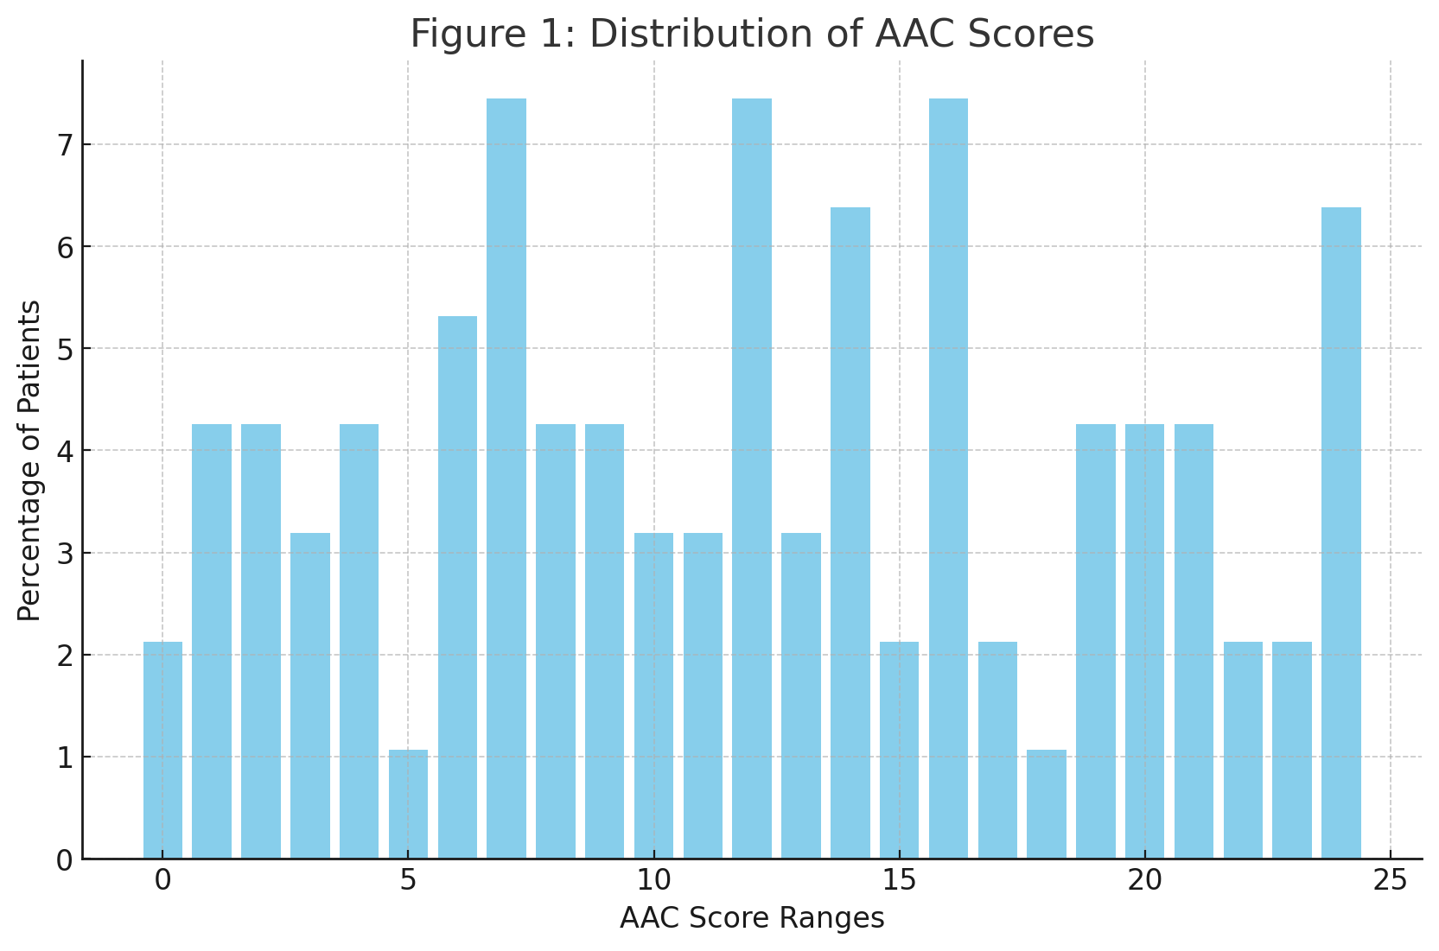

This bar graph shows the percentage of patients across different AAC score ranges, illustrating the distribution of abdominal aortic calcification scores among the study population.

**Associations Between AAC and Patient Characteristics**

Univariate analysis revealed:

* **Age:** Positive correlation with AAC scores (r = 0.65, p < 0.001).
* **Duration of Hemodialysis:** Positive correlation with AAC scores (r = 0.50, p = 0.04).
* **Diabetes Mellitus:** Higher AAC scores in diabetic patients (p = 0.03).
* **Hypertension:** Association with higher AAC scores (p = 0.05).
* **Pre-existing Cardiovascular Disease:** Higher AAC scores compared to those without (18 ± 4 vs. 10 ± 5, p = 0.03).
* **Elevated iPTH levels:** Correlated with higher AAC scores (r = 0.45, p = 0.03). No significant association was found between AAC scores and serum calcium or phosphate levels individually, but the calcium-phosphate product showed a moderate correlation (r = 0.40, p = 0.01).

**Multivariate Regression Analysis**

Identified independent predictors of higher AAC scores:

* **Age:** β = 0.55, p < 0.001
* **Duration of Hemodialysis:** β = 0.30, p = 0.04
* **Diabetes Mellitus:** β = 0.25, p = 0.03
* **Elevated iPTH Levels:** β = 0.20, p = 0.03

**TABLE 3: MULTIVARIATE REGRESSION ANALYSIS**

|  |  |  |
| --- | --- | --- |
| **Variable** | **β Coefficient** | **p-Value** |
| Age | 0.55 | <0.001 |
| Duration of Hemodialysis | 0.30 | 0.04 |
| Diabetes Mellitus | 0.25 | 0.03 |
| Elevated iPTH Levels | 0.20 | 0.03 |

**Progression of AAC**

Figure 2 shows the relationship between the duration of hemodialysis and AAC scores, indicating progressive AAC severity with longer dialysis duration.

**FIGURE 2: AAC SCORES VS. DURATION OF HEMODIALYSIS**

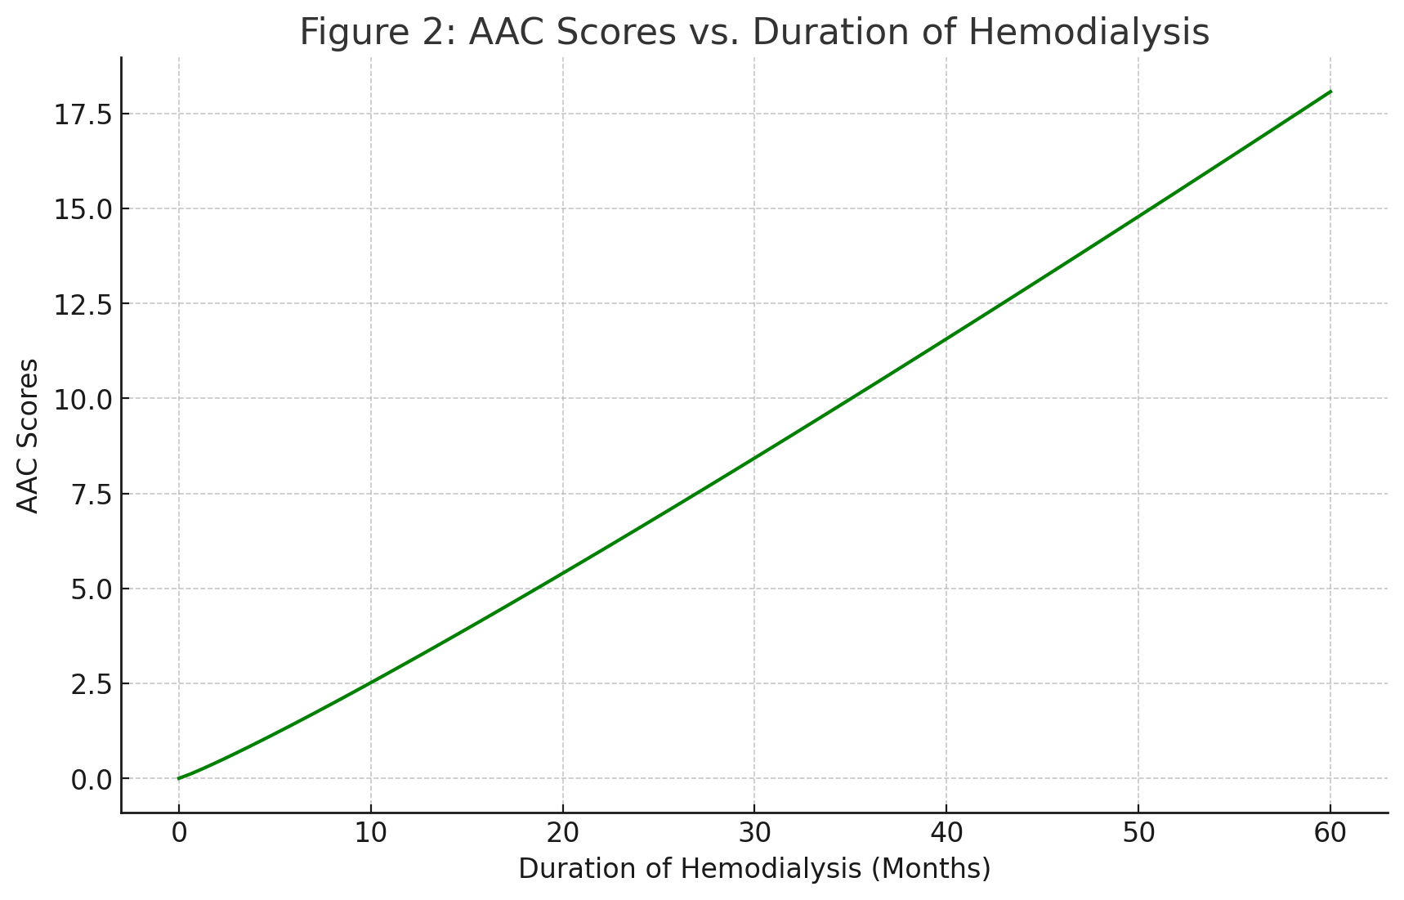

This line graph depicts the progressive increase in AAC scores as the duration of hemodialysis increases, indicating a correlation between longer dialysis duration and higher AAC severity.

**Subgroup Analysis**

* **Patients Over 40 Years:** Higher AAC scores than those under 40 (16 ± 5 vs. 8 ± 4, p < 0.001).
* **Diabetic vs. Non-Diabetic Patients:** Higher AAC scores in diabetic patients (15 ± 6 vs. 10 ± 5, p = 0.01).

**DISCUSSION**

This This study underscores the significant prevalence of abdominal aortic calcification (AAC) in a relatively young cohort of patients with Chronic Kidney Disease (CKD) stage 5 who are undergoing maintenance hemodialysis. An alarmingly high percentage of these patients, 80%, demonstrated signs of AAC, with a mean AAC score of 12 ± 6. This score typically indicates a moderate to severe level of calcification, underscoring the serious cardiovascular risks faced by this population. Such findings are consistent with existing literature that highlights the prevalence of vascular calcifications as a critical concern among patients with CKD, which considerably contributes to their heightened cardiovascular risk [1,5].

Age has been identified as a powerful independent predictor of AAC severity in this study. This correlation is in line with the established notion that vascular calcification tends to progress with age. However, in CKD patients, this progression is often accelerated due to disturbances in mineral metabolism, a common complication of the disease [7]. Moreover, our analysis reveals a significant positive correlation between the duration of hemodialysis treatment and AAC scores. This suggests that the longer exposure to uremic toxins and the hemodialysis process itself exacerbates vascular calcification [2,8].

Additionally, our findings elucidate the strong associations between common comorbidities such as diabetes mellitus and hypertension with increased AAC scores. These conditions are well-recognized risk factors for vascular calcification across both the general population and individuals with CKD [3,8]. Furthermore, elevated levels of intact parathyroid hormone (iPTH) were associated with increased severity of AAC, which highlights the critical role of secondary hyperparathyroidism and disruptions in mineral metabolism in the pathogenesis of vascular calcification in the CKD milieu [9].

In our study, we employed the 24-point AAC scoring system as outlined by Kauppila et al. [4]. This scoring system has proven to be a reliable tool for quantifying the extent of AAC. The excellent inter-observer agreement observed in our study underscores its reliability and validity. As a semi-quantitative assessment, it offers a practical, straightforward, and cost-effective method for evaluating vascular calcification, thereby aiding in the cardiovascular risk stratification of patients on dialysis [2,5].

The use of lateral lumbar X-rays for assessing AAC in dialysis patients, as supported by our findings, emphasizes its utility in clinical practice. The early detection of AAC facilitated by this imaging modality allows clinicians to initiate timely interventions. By optimizing mineral metabolism, controlling blood pressure, and managing diabetes, it may be possible to mitigate the progression of vascular calcification, thus potentially reducing cardiovascular morbidity and mortality in this vulnerable group [10].

However, there are limitations to our study that should be noted. The cross-sectional design restricts our ability to infer causality or to track the progression of AAC over time. Moreover, being a single-center study may limit the generalizability of our results. Future research should aim to conduct longitudinal studies involving larger and more diverse multicenter cohorts. These studies should focus on confirming our findings and exploring the efficacy of various interventions in slowing AAC progression and improving cardiovascular outcomes in CKD patients.

Bottom of Form

**CONCLUSION**

Abdominal aortic calcification is highly prevalent among young CKD stage 5 patients on maintenance hemodialysis. The severity of AAC is significantly associated with age, duration of hemodialysis, diabetes mellitus, hypertension, and elevated iPTH levels. Lateral lumbar X-ray imaging and the validated AAC scoring system provide a simple, cost-effective method for assessing vascular calcification and identifying patients at increased cardiovascular risk. Early detection and management of modifiable risk factors are essential to reduce cardiovascular morbidity and mortality in this high-risk population.

**REFERENCES**

1. Toussaint ND, Lau KK, Polkinghorne KR, Kerr PG. Measurement of vascular calcification using CT scans in hemodialysis patients. Nephrol Dial Transplant. 2008;23(8):2592-2598. doi:10.1093/ndt/gfn071.
2. Kauppila LI, Polak JF, Cupples LA, Hannan MT, Kiel DP, Wilson PW. New indices to classify location, severity, and progression of calcific lesions in the abdominal aorta: A 25-year follow-up study. Atherosclerosis. 1997;132(2):245-250. doi:10.1016/s0021-9150(97)00106-8.
3. Cao Q, Yang F, Lian X, Li X, Li Z. Analysis of risk factors for abdominal aortic calcification in dialysis patients and its influence on long-term recovery. J Investig Med. 2023;71(8):845-853. doi:10.1177/10815589231190565.
4. Kuppila LI, Polak JF, Cupples LA, Hannan MT, Kiel DP, Wilson PW. Abdominal aortic calcification in men and women: Associations with mortality and morbidity. Circulation. 1997;96(6):1740-1747. doi:10.1161/01.cir.96.6.1740.
5. Toussaint ND, Pedagogos E, Lau KK, Heinze S, Becker GJ, Beavis J, Polkinghorne KR, Damasiewicz MJ, Kerr PG. Lateral lumbar X-ray assessment of abdominal aortic calcification in Australian haemodialysis patients. Nephrology. 2010;15(8):634-639. doi:10.1111/j.1440-1797.2010.01420.x.

6. London GM, Guérin AP, Marchais SJ, Métivier F, Pannier B, Adda H. Arterial media calcification in end-stage renal disease: Impact on all-cause and cardiovascular mortality. Nephrol Dial Transplant. 2003;18(9):1731-1740. doi:10.1093/ndt/gfg414.

7. Sigrist MK, Taal MW, Bungay P, McIntyre CW. Progressive vascular calcification over 2 years is associated with arterial stiffening and increased mortality in patients with stages 4 and 5 chronic kidney disease. Clin J Am Soc Nephrol. 2007;2(6):1241-1248. doi:10.2215/cjn.02150307.

8. Schlieper G, Aretz A, Verberckmoes SC, Krüger T, Behets GJ, Ghadimi R, Weirich TE, Rohrmann D, Langer S, Tordoir JHM, Amann K, Westenfeld R, Brandenburg VM, D'Haese PC, Floege J. Ultrastructural analysis of vascular calcifications in uremia. J Am Soc Nephrol. 2010;21(4):689-696. doi:10.1681/asn.2009080854.

9. Goodman WG, Goldin J, Kuizon BD, Yoon C, Gales B, Sider D, Wang Y, Chung J, Emerick A, Greaser L, Elashoff RM, Salusky IB. Coronary-artery calcification in young adults with end-stage renal disease who are undergoing dialysis. N Engl J Med. 2000;342(20):1478-1483. doi:10.1056/nejm200005183422003.

10. Chen NX, Moe SM. Vascular calcification: Pathophysiology and risk factors. Curr Hypertens Rep. 2003;5(6):523-527. doi:10.1007/s11906-003-0073-5.