*Original Research Article*

Evaluation of physico-chemical and biochemical parameters of sugarcane molasses and cashew apple juice from six locations in Côte d'Ivoire

ABSTRACT

|  |
| --- |
| **Background:** Côte d'Ivoire has an underutilized agricultural potential, notably the cashew apple (*Anacardium occidentale L.*) and sugarcane molasses. These by-products, though abundant, represent an untapped potential.  **Aims:** This study analyzes the properties of cashew apple juice (CAJ) and sugarcane molasses (SCM) to assess their valorization potential.  **Methodology:** Cashew apples were sampled from six localities (Yamoussoukro, Dimbokro, Bouake, Mankono, Vavoua, and Korhogo), while the molasses was provided by the SIFCA group. In total, seven samples were prepared: six of CAJ, representing the different localities, and one of SCM. Classical methods were used to analyze the physico-chemical and biochemical parameters of the samples.  **Results:** The results reveal that these agricultural resources possess excellent overall quality in physical, chemical, and biochemical aspects. The pH of CAJ samples falls within a favorable acidic range, oscillating between 4.05 ± 0.02 and 5.00 ± 0.02. The vitamin C content is particularly high in CAJ, ranging from 181.61 ± 0.37 to 188.45 ± 0.64 mg/100 ml, while it is significantly lower in molasses (0.35 ± 0.57 mg/100 ml). Glucose and fructose concentrations are significant in CAJ, with values ranging from 48.82 ± 0.05 to 55.84 ± 0.01 g/l for glucose and 42.79 ± 0.06 to 48.98 ± 0.01 g/l for fructose. Molasses also contains sugars, but in lower amounts (glucose: 26.94 ± 0.02 g/l; fructose: 17.67 ± 0.06 g/l). Total sugars range from 104.76 ± 0.02 to 111.31 ± 0.02 g/l for CAJ and are 59.13 ± 0.03 g/l for molasses. These agro-resources are rich in essential minerals (Ca, Mg, Fe, Na, K, P), with concentrations ranging from 23.77 ± 0.02 to 1203.01 ± 0.03 mg/l for CAJ and from 4.59 ± 0.04 to 5431.35 ± 0.02 mg/l for molasses.  **Conclusion:** This study reveals that the richness in minerals and biochemical compounds of CAJ and SCM offers strong potential for valorization. |

*Keywords****:*** *Cashew apple juice, sugarcane molasses, physico-chemical and biochemical parameters*

1. INTRODUCTION

The cashew tree (Anacardium occidentale L.) belongs to the Anacardiaceae family. It is a tropical tree native to Brazil. It produces two fruits: the cashew nut, which represents the "true fruit," and the cashew apple, the "false fruit" (Lautié *et al*., 2001). The introduction of the cashew tree to the African continent was intended to combat soil erosion. Today, cashew cultivation primarily aims at the production of cashew nuts, which represent a significant source of income for many farmers (Ndiaye *et al*., 2021). In recent decades, cashew nut production in Côte d'Ivoire has seen a substantial increase, placing the country first among producing nations, with an estimated production of 1.2 million tons in 2023 (Lebailly *et al*., 2023). This corresponds to over 9 million tons of cashew apples produced in Côte d'Ivoire. As a reminder, in Côte d'Ivoire, the cashew sector employs approximately four hundred thousand (400,000) producers and represents the third-largest source of foreign exchange in the agricultural sector, after cocoa and rubber (MADR, 2021). However, after the nut harvest, the apples are abandoned in the plantations where they undergo natural decomposition. The underutilization of cashew apples in Côte d'Ivoire is mainly due to the astringency of this fruit and certain ancestral taboos (Soro *et al*., 2012).

Furthermore, another product, namely sugarcane molasses (SCM), undergoes the same treatment as cashew apples. Sugarcane molasses is a viscous residue of a blackish color that comes from the refining of sugarcane juice during sugar production (Palmonari *et al*., 2020). In Côte d'Ivoire, the annual sugarcane production is estimated to average 1.6 million tons, which represents about 150,000 to 180,000 tons of sugar with 68,000 tons of sugarcane molasses (Toure *et al*., 2010). The underutilization or the low interest given to this product (molasses) causes a loss of products with high commercial and technological potential (Toure *et al*., 2010).

Indeed, cashew apples and sugarcane molasses are products that are underutilized in Côte d'Ivoire due to their lack of representation in the national economy and certain ancestral taboos regarding cashew apples (Soro *et al*., 2012). Indeed, in many sub-Saharan African countries, the consumption of milk accompanied by cashew apple juice is considered harmful to health (Soro *et al*., 2012). Cashew apple and sugarcane molasses are agro-resources rich in mineralogical and biochemical compounds (Ouattara *et al*., 2017; Palmonari *et al*., 2020). Regarding cashew apple, it contains important nutrients, including reducing sugars (glucose and fructose), vitamin C, and phenolic compounds that promote its valorization (Honorato *et al*., 2007). Molasses presents the same nutritional characteristics due to its richness in minerals, vitamin B, and carbohydrate and phenolic compounds (Palmonari *et al*., 2020).

The characterization of cashew apple juice and sugarcane molasses is a prerequisite for their valorization. Therefore, the objective of this study is to evaluate the physical, chemical, and biochemical parameters of cashew apple juice and sugarcane molasses for their valorization into other products of economic interest.

2. material and methods

**2.1. Biological Materials and Sampling Areas**

The biological substrates used consisted of cashew apples and sugarcane molasses. The cashew apples came from six (6) localities in Côte d'Ivoire (Yamoussoukro, Dimbokro, Bouake, Mankono, Vavoua, and Korhogo). As for the sugarcane molasses, it was graciously provided by the Sucre Ivoire company of the SIFCA group.

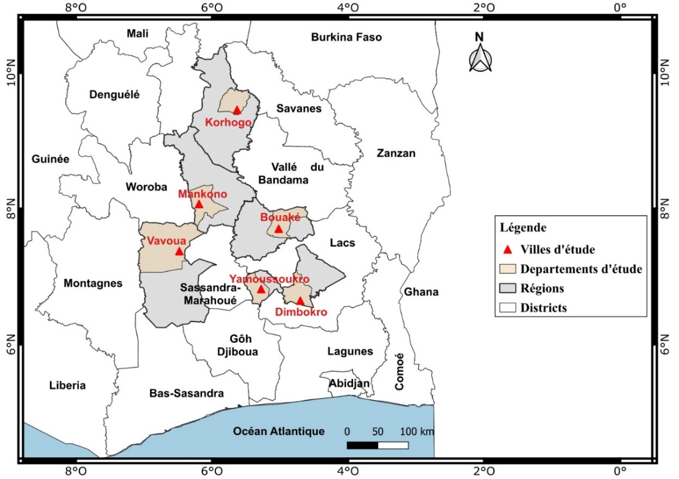

Figure 1 : Cashew apple sampling areas

**2.2. Collection of cashew apples and sugarcane molasses**

Cashew apples were collected from cashew plantations located in six localities in Côte d'Ivoire (Yamoussoukro, Dimbokro, Bouake, Mankono, Vavoua, and Korhogo). The apples were picked directly from the cashew trees (Anacardium occidentale L.), and then the cashew nuts were carefully removed from the apples using nylon threads. These apples were subsequently transported at room temperature in vials, by truck, to the school factory of the Félix Houphouët-Boigny National Polytechnic Institute of Yamoussoukro. These vials were previously washed with bleach water. As for the sugarcane molasses, it was graciously provided by the Sucre Ivoire company of the SIFCA group.

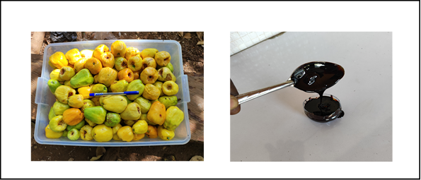

**A**

**B**

**Figure 2** : Cashew apples (A) and Sugarcane molasses (B)

**2.3. Extraction of cashew apple juice**

Once at the factory, the cashew apples are unloaded, then cleaned, thoroughly washed with tap water, and disinfected with water containing bleach (at 100 ppm of active chlorine) for 15 minutes. After 15 minutes of disinfection, they are thoroughly rinsed with tap water, and this was carried out four times in succession. Subsequently, the cashew apples are packed into burlap sacks and placed under the pulp press, whose pressure power is 4.4 kW, for the extraction of cashew apple juice. The juice obtained was then clarified using gelatin (1% v/v) and filtered using a white cloth, and stored at -20°C in a cold room for three (3) days before being characterized. The extraction of cashew apple juice was carried out according to the diagram in Figure 2. As for the sugarcane molasses, it did not undergo any particular treatment before its characterization.

**Figure 2** : Cashew apples (A) and Sugarcane molasses (B)

**Figure 2** : Cashew apples (A) and Sugarcane molasses (B)

**Figure 2** : Cashew apples (A) and Sugarcane molasses (B)

**Figure 2** : Cashew apples (A) and Sugarcane molasses (B)

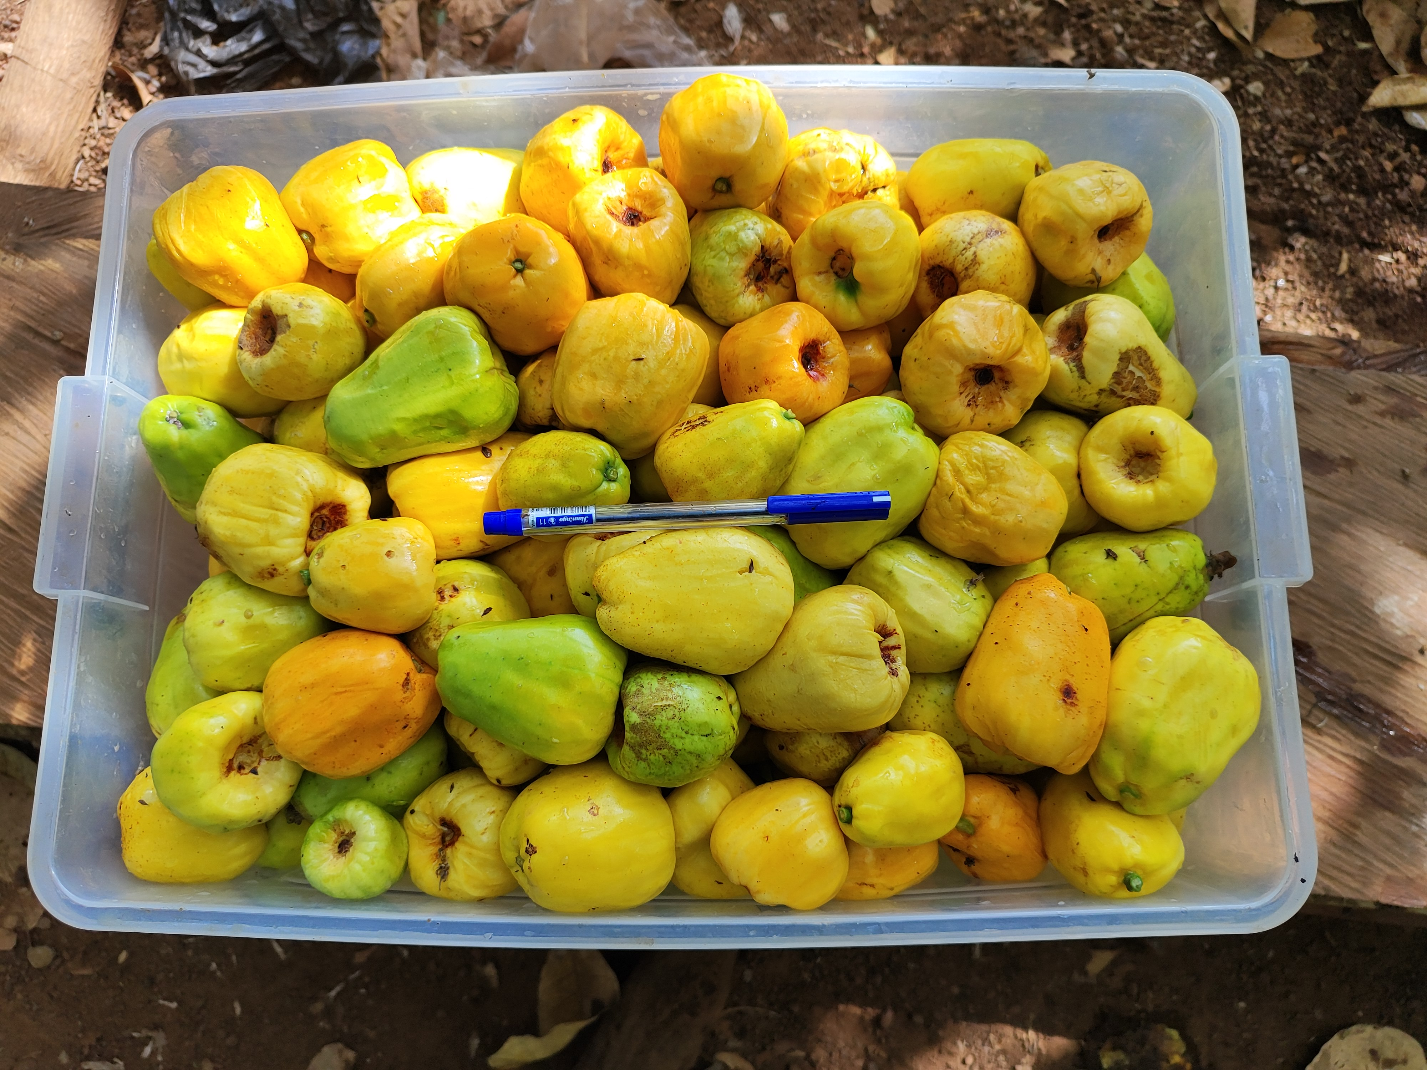 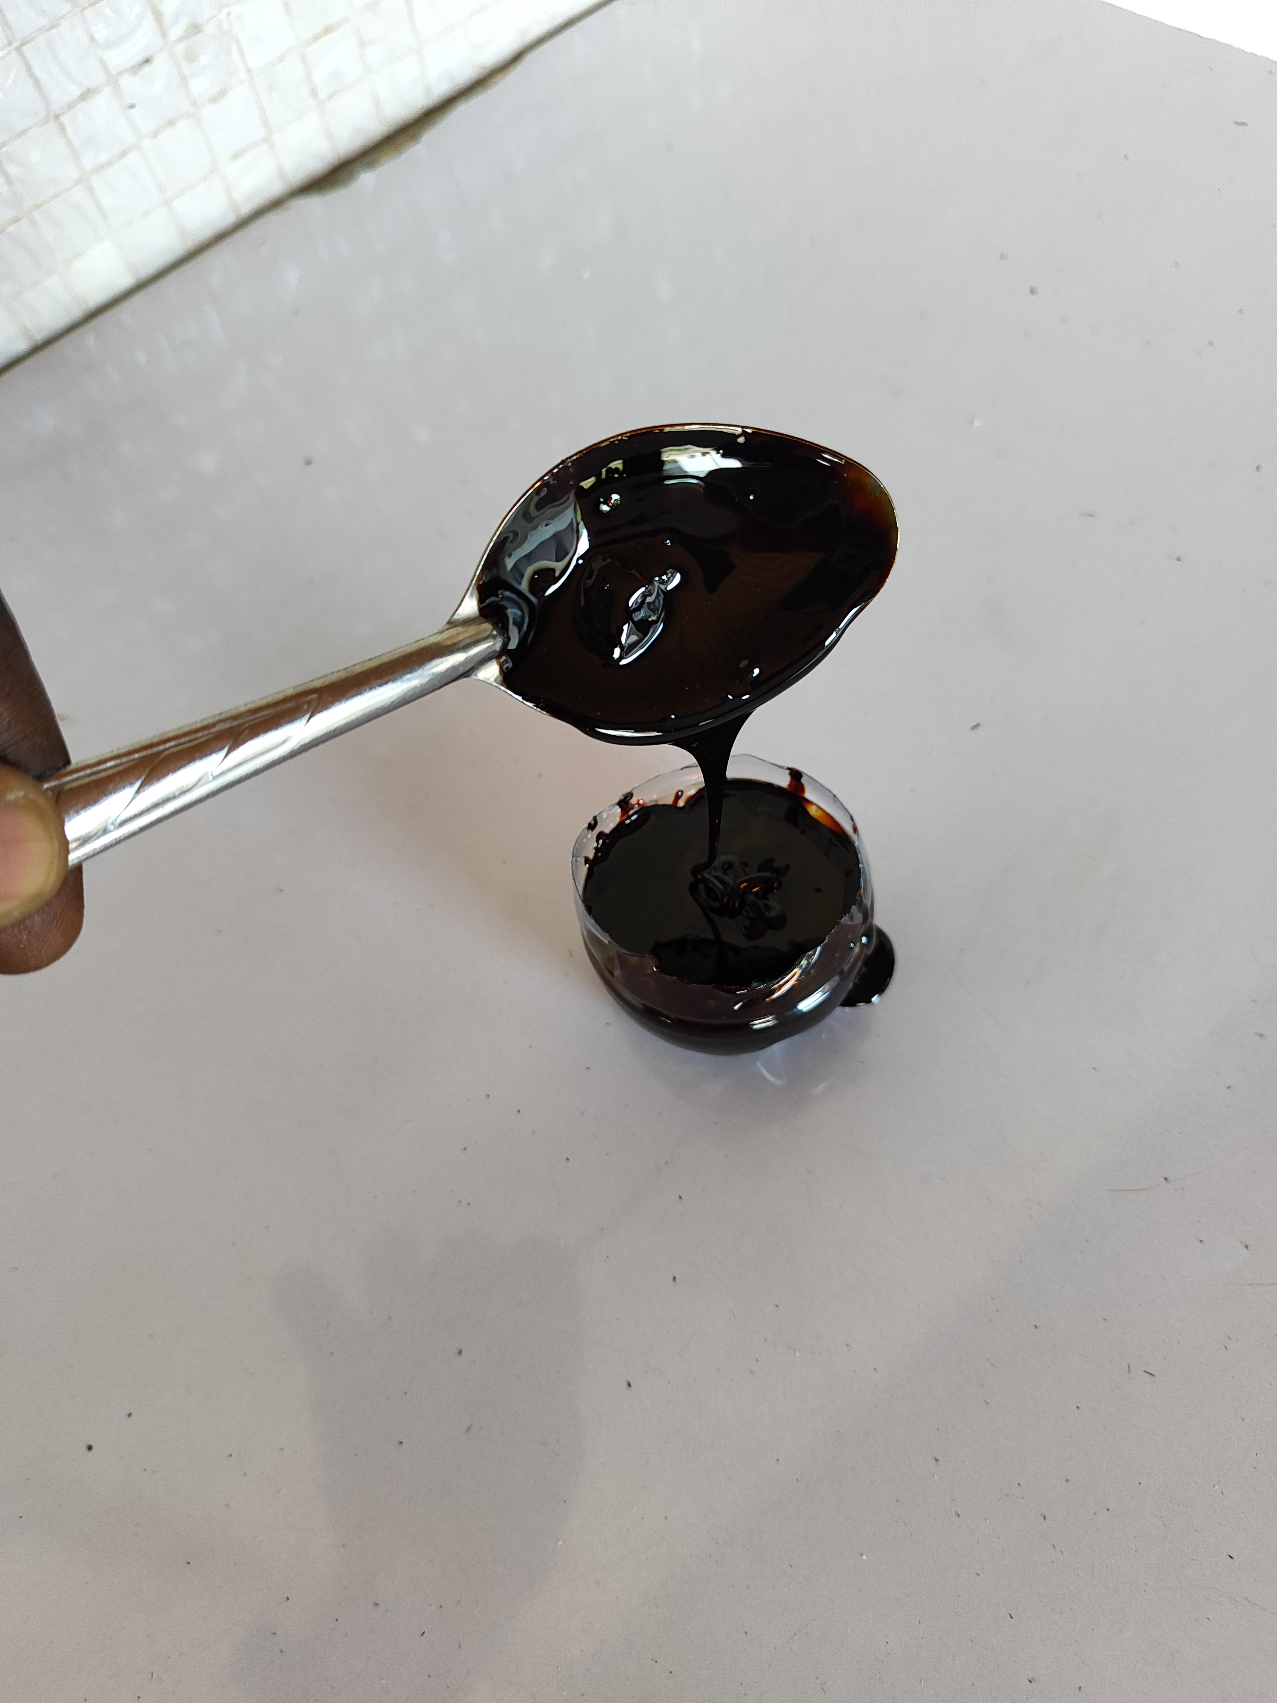

Sorting/Washing

Disinfection/Rinsing

Pressing

Clarification

Filtration

**Figure 3** : Cashew apple juice production diagram

**2.4. Physico-chemical and biochemical characterization of substrates**

For the characterization of the substrates, it is important to note that the tasks were performed three times in succession for each sample.

The pH of the samples was determined by the AOAC (1990) method, based on potentiometry and described by (Askari *et al*., 2012). This consists first of calibrating the pH meter, then immersing the pH meter electrode in the solution (substrate), and the pH value is displayed on the device screen.

The total titratable acidity of the samples was determined by a titrimetric analysis at pH 8.1 with a 0.1N sodium hydroxide (NaOH) solution according to the AOAC (1990) method, described by (Askari *et al*., 2012).

For the determination of total nitrogen, the Kjeldahl method (Lynch *et al*., 2002) was used. The method consists of transforming nitrogenous organic matter into ammonia. This involves first mineralizing the nitrogenous organic matter in the form of ammonium. The degradation of nitrogenous organic matter was carried out using sulfuric acid (0.1N).

The protein content of the samples was determined by the Kjeldahl method (Lynch *et al.*, 2002). This method consists of determining total nitrogen by the Kjeldahl method by first mineralizing the nitrogenous organic matter in the form of ammonium. The degradation of nitrogenous organic matter was carried out using sulfuric acid with selenium as a catalyst. Then, the protein nitrogen conversion coefficient (6.25) was applied to find the protein concentration (QP) of the samples, according to the following relationship:

**(Eq.1)**

*QP = 6.25 × QN*

With, QN: quantity of nitrogen (g/100ml)

Regarding the determination of vitamin C, the method described by (Tillmans *et* *al*., 1932) was used. It is based on the titration of 2,6-dichlorophenol indophenol (2,6-DCPIP), which consists of the reduction of 2,6-DCPIP and the oxidation of ascorbic acid to give dehydroascorbic acid. In practice, 30g of metaphosphoric acid (HPO3) were dissolved in 200 ml of distilled water, then 80ml of acetic acid were added. Subsequently, the resulting solution is made up to 1000 ml with distilled water and stored in the refrigerator at 4°C for 5 days. The quantity of vitamin C, in mg/100 ml, is obtained by the following relationship:



**(Eq.2)**

With,

fd: dilution factor;

P: mass of pressed apples;

Vo: volume of 2,6-DCPIP poured to titrate the vitamin C solution;

Ve: volume of 2,6-DCPIP poured to titrate the supernatant;

Vc: volume of 2,6-DCPIP poured to titrate the metaphosphoric/acetic acid solution.

The determination of reducing sugars (glucose and fructose) was carried out according to the method described by Chanfreau *et al*., (2010). In a test tube containing 1 ml of the sample, 1ml of 3,5-dinitrosalicylic acid (DNS or DNSA) or 2-hydroxy-3,5-dinitrobenzoic acid is added and placed in a water bath at 100°C for 15 minutes. After this step, 10 ml of distilled water are added to the mixture and then vortexed to homogenize. Finally, the tube is placed in the dark in a dark chamber for 50 minutes, followed by reading the optical density (OD) at 540 nm with a JASCO V-530 spectrophotometer against a blank.

The determination of total sugars was carried out according to the method described by (Dubois *et al*., 1952). This method consists of introducing 100 µL of water-soluble sugar extracts into a test tube, then respectively adding 1 ml of phenol (5% w/v), 0.9 ml of distilled water, and 5 ml of concentrated sulfuric acid at 95%. Subsequently, the tubes were mechanically shaken, followed by cooling in a dark chamber. The optical density at 540 nm was read with a JASCO V-530 spectrophotometer against a blank. A standard curve was made from a glucose stock solution (1mg/ml). The total sugar concentration of the samples was determined using the regression line equation from the standard curve.

The determination of minerals in the samples was made possible by the technique of inductively coupled plasma mass spectrometry (Thermo Fisher Scientific Chromatography and Mass Spectrometry Hanna-Kunath-Strasse 11, Bremen, Germany), known as ICP-MS. This consisted of adding 10 ml of hydrochloric acid (0.1 N) to 20 ml of each sample in a 200 ml flask. Then, 20 ml of deionized water were added to the flask to bring the mixture to 50 ml. Subsequently, the mixture underwent filtration using a 0.45 µm syringe filter into test tubes. Finally, 10 ml of each final solution were taken for the determination of minerals in the samples using ICP-MS (Poitevin, 2016).

**2.5. Statistical analysis**

One-way analysis of variance (ANOVA) associated with Duncan's test was performed using STATISTICA version 7.0 software to compare the variables measured on the different samples. Differences were considered significant for P values < 0.05. This software also allowed the calculation of means and standard deviations of the analyzed parameters.

**3. RESULTS AND DISCUSSION**

The key results of the physico-chemical and biochemical parameters of this study are summarized in Tables 1 and 2.

**Table 1** : Physical and chemical parameters of cashew apple juice and sugarcane molasses

|  |  |  |  |  |  |  |  |
| --- | --- | --- | --- | --- | --- | --- | --- |
|  |  |  |  | **Samples** |  |  |  |
| **Parameters** | **CAJ-YAK** | **CAJ-DIM** | **CAJ-BKE** | **CAJ-MKN** | **CAJ-VVA** | **CAJ-KRG** | **SCM** |
| pH | 4.05±0.02a | 4.07±0.02a | 4.08±0.02a | 4.05±0.02a | 4.10±0.01a | 4.08±0.02a | 5.00±0.02b |
| Acidity (g/l) | 2.02±0.01a | 1.97±0.03 a | 2.74±0.32b | 2.93±0.07b | 2.94±0.02b | 2.73±0.15b | 4.13±0.1c |
| Calcium (mg/l) | 178.03±0.07b | 177.76± 0.01b | 178.40±0.03c | 176.95±0.03a | 178.45±0.03c | 177.97±0.02b | 7610.42±0.02d |
| Magnesium (mg/l) | 176.47±0.03d | 175.58±0.01c | 176.99±0.06e | 177.03 ±0.04e | 174.63±0.04b | 176.21±0.03d | 48.79±0.02a |
| Iron (mg/l) | 46.84±0.05c | 45.32±0.02b | 47.44±0.02d | 45.23±0.02b | 47.18±0.03d | 46.47±0.03c | 4.59±0.04a |
| Sodium (mg/l) | 24.05±0.03b | 23.79±0.05a | 24.02±0.04b | 24.13±0.02b | 23.95±0.03a | 23.77±0.02a | 1860.43±0.03c |
| Potassium (mg/l) | 1162.11±0.74a | 1201.12±0.32e | 1177.32±0.04c | 1164.76±0.02b | 1203.01±0.03f | 1197.20±0.03d | 5431.35±0.02g |
| Phosphorus (mg/l) | 172.75±0.24e | 173.45± 0.01f | 167.73±0.02d | 166.83±0.03c | 165.35±0.02b | 162.15±0.02a | 675.91±0.47g |

**Table 2** : Biochemical parameters of cashew apple juice and sugarcane molasses

|  |  |  |  |  |  |  |  |
| --- | --- | --- | --- | --- | --- | --- | --- |
|  |  |  |  | **Samples** |  |  |  |
| **Parameters** | **CAJ-YAK** | **CAJ-DIM** | **CAJ-BKE** | **CAJ-MKN** | **CAJ-VVA** | **CAJ-KRG** | **SCM** |
| Nitrogen (g/100ml) | 0.13±0.33a | 0.14±0.28a | 0.13±0.28a | 0.13±0.05a | 0.12±0.16a | 0.13±0.55a | 0.12±0.06a |
| Protein (g/100ml) | 0.81±0.05b | 0.88±0.07b | 0.81±0.02b | 0.81±0.04b | 0.75±0.06a | 0.81±0.02b | 0.75±0.03a |
| Vitamin C (mg/100ml) | 187.26±0.92e | 185.96±0.32d | 187.10±0.22e | 188.45±0.64f | 181.61±0.37b | 182.59± 0.48c | 0.35±0.57a |
| Glucose (g/l) | 52.02± 0.05d | 51.80±0.03c | 51.72±0.04c | 51.98±0.03c | 48.82±0.05b | 55.84±0.01e | 26.94±0.02a |
| Fructose (g/l) | 42.79±0.06b | 44.91±0.02c | 46.17±0.03e | 45.65±0.05d | 44.89±0.04c | 48.98±0.01f | 17.67±0.06a |
| Total sugars (g/l) | 110.07±0.02e | 105.41±0.03c | 109.02±0.05d | 104.76±0.02b | 110.67±0.55f | 111.31±0.02g | 59.13±0.03a |

Within the same row, mean values with different letters are significantly different; P < 0.05 (Duncan's test).

* CAJ-YAK : Cashew Apple Juice from Yamoussoukro ;
* CAJ-DIM : Cashew Apple Juice from Dimbokro ;
* CAJ-BKE : Cashew Apple Juice from Bouaké ;
* CAJ-MKN : Cashew Apple Juice from Mankono ;
* CAJ-VVA : Cashew Apple Juice from Vavoua ;
* CAJ-KRG : Cashew Apple Juice from Korhogo ;
* SCM : Sugarcane molasses

Table 1 presents the physical and chemical characteristics of cashew apple juice and sugarcane molasses. The analysis of Table 1 shows that all samples are acidic substances with pH values ranging from 4.05 ± 0.02 to 5.00 ± 0.02. This can be explained by varying acidities (from 1.97 ± 0.03 to 4.13 ± 0.1 g/l), which are therefore significantly different. The acidic nature of cashew apple juice could be due to its richness in ascorbic acid and phenolic compounds (flavonoids and condensed tannins). As for molasses, its acidity would be due to the presence of organic acids such as citric acid and malic acid. Similar results were recorded by (Ouattara *et al*., 2017) during studies carried out on various formulations of cashew apple juice on the one hand, and by (Palmonari *et al*., 2020) during analyses performed on the chemical composition of sugarcane and beet molasses on the other hand.

The analysis of the samples reveals that cashew apple juice and sugarcane molasses are rich in minerals such as calcium (Ca), magnesium (Mg), iron (Fe), sodium (Na), potassium (K), and phosphorus (P). In cashew apple juice, sodium is the least represented mineral, with a concentration ranging from 23.77 ± 0.02 to 24.13 ± 0.02 mg/l, while potassium is the most represented mineral, with proportions ranging from 1162.11 ± 0.74 to 1203.01 ± 0.03 mg/l. These values show that there is a significant difference in the mineralogical composition of all cashew apple juice samples. This difference could be due to the different pedoclimatic conditions from which the apples originate, as well as the variety of apples and cultural practices (Adou *et al*., 2012a). These results are in line with those obtained by (Dedehou *et al*., 2015) during studies on the processing of cashew apple juice in Benin. Regarding the mineralogical composition of sugarcane molasses, iron is the lowest element, with a value gravitating around 4.59 ± 0.04 mg/l, while calcium is the most important element, with a concentration of the order of 7610.42 ± 0.02 mg/l. The results also reveal that the mineralogical composition of sugarcane molasses is more significant than that of cashew apple juice. This could be explained by the sugar production method where minerals accumulate in the molasses, while cashew apple juice essentially contains sugars and water (Palmonari *et al*., 2020). The presence of these minerals (Ca, Mg, Fe, Na, K, and P) in cashew apple juice and sugarcane molasses shows that these agro-resources can serve as substrates for lactic fermentations, particularly by intervening in the nutrition of lactobacilli and also stimulating their growth (Tuli *et al*., 1985).

Table 2 presents the biochemical composition of the two substrates. The nitrogen content of all the samples analyzed varies from 0.12 ± 0.06 to 0.14 ± 0.28 g/100ml. This variation observed in the nitrogen content of all the samples is significant according to the results. This difference could be explained by numerous factors, notably by different pedoclimatic conditions of the production areas, and by cultural and ecological techniques (Adou *et al*., 2012b).

The protein content of all samples ranges from 0.75 ± 0.03 to 0.88 ± 0.07 g/100ml. These results show that cashew apple juice and sugarcane molasses are low in protein. For cashew apple juice, several authors have made the same observations (Ouattara *et al*., 2017a; Soro *et al*., 2017; Adou *et al*., 2012c).

The vitamin C content of the cashew apple juice samples varies from 181.61 ± 0.37 to 188.45 ± 0.64 mg/100ml. There is a significant difference in all the cashew apple juice samples. These values are slightly higher than those recorded by (Dedehou *et al*., 2015), where they obtained values between 147.07 and 185.79 mg/100ml. Furthermore, the vitamin C content of sugarcane molasses is approximately 0.35 ± 0.57 mg/100ml, which shows that molasses is low in vitamin C. The results indicate that cashew apple juice is richer in vitamin C compared to sugarcane molasses.

The glucose content of the cashew apple juice samples varies from 48.82 ± 0.05 to 55.84 ± 0.01 g/l, while that of molasses is 26.94 ± 0.02 g/l. There is a significant difference between the glucose contents of the Vavoua (JPC-VVA) and Korhogo (JPC-KRG) samples, while there is no significant difference between the glucose contents of the other samples. Similar results were obtained by (Adou *et al*., 2012b) on cashew apple juice, where they recorded values between 47.20 ± 0.5 and 65.80 ± 0.2 g/l.

The fructose content of the cashew apple juice samples varies from 42.79 ± 0.06 to 48.98 ± 0.01 g/l, and that of sugarcane molasses gravitates around 17.67 ± 0.06 g/l. These values show that there is a significant difference in the fructose content of cashew apple juice and sugarcane molasses. This difference could be due to the pedoclimatic conditions of the different production areas and cultural conditions (Adou *et al*., 2012c). Similar results were recorded by (Palmonari *et al*., 2020; Soro *et al*., 2017b) during studies on the characterization of cane and beet molasses on the one hand, and on cashew apple juice on the other hand.

Regarding the total sugar content, glucose and fructose represent 96 to 98% of cashew apple juice (Soro *et al*., 2012). The total sugar content of cashew apple juice varies from 104.76 ± 0.02 to 111.31 ± 0.02 g/l. There is a significant difference between the total sugar contents of all cashew apple juice samples. Consistent results were obtained by (Adou *et al*., 2012a) during studies on cashew apple juice. As for sugarcane molasses, its total sugar content is approximately 59.13 ± 0.03 g/l. The richness in total sugars of cashew apple juice and sugarcane molasses shows that these substrates need to be valorized into other products of economic interest.

**4. CONCLUSION**

The study of the physico-chemical and biochemical parameters of cashew apple juice and sugarcane molasses is a prerequisite for their valorization into other products of economic interest. The analysis focused on six (6) samples of cashew apples from different cashew nut production areas in Côte d'Ivoire (Yamoussoukro, Dimbokro, Bouake, Mankono, Vavoua, and Korhogo) and one (1) sample of sugarcane molasses provided by the Sucre Ivoire company of the SIFCA group. The results showed good mineralogical and biochemical quality of these two substrates, particularly in vitamin C and carbohydrate compounds. Indeed, the richness in carbohydrates, vitamin C, and minerals of these substrates shows that they can be used as substitutes in human and animal feed. These substrates can also be used in microbial fermentation for the production of biomolecules of interest.

REFERENCES

Anonymous, (2021). Report of the Cotton and Cashew Council of Côte d'Ivoire; Ministry of Agriculture and Rural Development of the Republic of Côte d'Ivoire, Abidjan.

Adou, M., Tetchi, F. A., Gbané, M., Kouassi, K. N., & Amani, N. G. (2012a). Physico-chemical characterization of cashew apple juice (anacardiumouest, L.) from yamoussoukro (ivory coast).

Adou, M., Tetchi, F. A., Gbané, M., Kouassi, K. N., & Amani, N. G. (2012b). Physico-chemical characterization of cashew apple juice (anacardiumouest, l.) from yamoussoukro (Ivory Coast).

Adou, M., Tetchi, F. A., Gbané, M., Kouassi, K. N., & Amani, N. G. G. (2012c). Physicochemical characterization of cashew apple juice (Anacardium occidentale) from Yamoussoukro (Côte d'Ivoire).

Askari, G. A., Kahouadji, A., Khedid, K., Charof, R., & Mennane, Z. (2012). Physicochemical and microbiological characterization of dried figs collected from the markets of Rabat-Salé, Temara, and Casablanca. 7.

Chanfreau, S., Mena, M., Porras-Domínguez, J. R., Ramírez-Gilly, M., Gimeno, M., Roquero, P., Tecante, A., & Bárzana, E. (2010). Enzymatic synthesis of poly-l-lactide and poly-l-lactide-co-glycolide in an ionic liquid. Bioprocess and Biosystems Engineering, 33(5), 629-638. https://doi.org/10.1007/s00449-009-0388-8

Dedehou, E., Dossou, J., & Soumanou, M. (2015). Diagnostic study of cashew apple processing technologies into juice in Benin. International Journal of Biological and Chemical Sciences, 9(1), 371. https://doi.org/10.4314/ijbcs.v9i1.32

Honorato, T. L., Rabelo, M. C., Gonçalves, L. R. B., Pinto, G. A. S., & Rodrigues, S. (2007). Fermentation of cashew apple juice to produce high added value products. World Journal of Microbiology and Biotechnology, 23(10), 1409-1415. https://doi.org/10.1007/s11274-007-9381-z

Lautié, E., Dornier, M., M. de Souza Filho, & Reynes, M. (2001). Cashew tree products: Characteristics, valorization routes and markets. Fruits, 56(4), 235-248. https://doi.org/10.1051/fruits:2001126

Lebailly, P., Lynn, S., and Seri, H. (2023). Analysis of the cashew chain in Côte d’Ivoire. Report for the European Union, DG-INTPA. Value Chain Analysis for Development Project (VCA4D CTR 2017/392-417),. 128 pp.

Lynch, J. M., Barbano, D. M., Fleming, J. R. (2002). Determination of the Total Nitrogen Content of Hard, Semihard, and Processed Cheese by the Kjeldahl Method: Collaborative Study. Journal of AOAC INTERNATIONAL, 85(2), 445-455. https://doi.org/10.1093/jaoac/85.2.445

Michel Dubois, E. F., K. A. Gilles, M. R., J. K. Hamilton, C. W. P., P. A. Rebers, O., & Fred Smith, L. M. F. (1952). Colorimetric Method for Determination of Sugars and Related Substances. International Journal of Biological Macromolecules, 146, 285-289. https://doi.org/10.1016/j.ijbiomac.2019.12.180

Ndiaye, S., Charahabil, M. M., & Diatta, M. (2021). Characteristics of cashew plantations (Anacardium occidentale L.) and economic determinants of farms in Casamance. VertigO. https://doi.org/10.4000/vertigo.28723

Ouattara, G. S., Soro, D., Chatigre, K. O., & Koffi, E. K. (2017a). Physicochemical and sensory characterization of various cashew apple and pineapple juice formulations. International Journal of Biological and Chemical Sciences, 10(6), 2447. https://doi.org/10.4314/ijbcs.v10i6.4

Ouattara, G. S., Soro, D., Chatigre, K. O., & Koffi, E. K. (2017b). Physicochemical and sensory characterization of various cashew apple and pineapple juice formulations. International Journal of Biological and Chemical Sciences, 10(6), 2447. https://doi.org/10.4314/ijbcs.v10i6.4

Palmonari, A., Cavallini, D., Sniffen, C. J., Fernandes, L., Holder, P., Fagioli, L., Fusaro, I., Biagi, G., Formigoni, A., & Mammi, L. (2020). Short communication: Characterization of molasses chemical composition. Journal of Dairy Science, 103(7), 6244-6249. https://doi.org/10.3168/jds.2019-17644

Poitevin, E. (2016). Official Methods for the Determination of Minerals and Trace Elements in Infant Formula and Milk Products: A Review. Journal of AOAC International, 99(1), 42-52. https://doi.org/10.5740/jaoacint.15-0246

Soro, D., Dornier, M., Abreu, F., Assidjo, E., Yao, B., & Reynes, M. (2012). Publications and Communications.

Soro, D., Moctar, C., Kone, Y. K., Assidjo, E. N., Yao, B. K., & Dornier, M. (2017a). Valorization of cashew apple (Anacardium occidentale) and impact of vacuum concentration at different temperatures on juice quality. 19(1).

Soro, D., Moctar, C., Kone, Y. K., Assidjo, E. N., Yao, B. K., & Dornier, M. (2017b). Valorization of cashew apple (Anacardiumouest) and impact of vacuum concentration at different temperatures on juice quality. 19(1).

Tillmans, J., Hirseh, P., & Hirseh, W. (1932.). Das Reduktionsvermiigen pflanzlieher Lebensmittel und seine B e z i e h u n g zum Vitamin C. I. Der reduzierende Stoff des Citronensaftes.

Toure, F.K., Koffi, E., & Agbo, G. N. (2010). Yield-related factors in the cane refinery of the Ferke 1 sugar perimeter in Ivory Coast. African Agronomy, 22(1), 85-95. https://doi.org/10.4314/aga.v22i1.62322

Tuli, A., Sethi, R. P., Khanna, P. K., Marwaha, S. S., & Kennedy, J. F. (1985). Lactic acid production from whey permeate by immobilized Lactobacillus casei. Enzyme and Microbial Technology, 7(4), 164-168. https://doi.org/10.1016/0141-0229(85)90058-4