Development and Manufacturing of High-Quality APIs for Breast Cancer Treatment: Enhancing Efficacy through Personalized Medicine and Regulatory Excellence

.

ABSTRACT

|  |
| --- |
| **Aim:** To discuss the development and manufacturing of high-quality active pharmaceutical ingredients for breast cancer treatment focusing on how their efficiencies can be improved through personalized medicine and regulatory excellence.  **Problem Statement:** Breast cancer is known as the most prominent global menace among women and a foremost source of cancer-related mortality. Orthodox treatments, such as chemotherapy, hormone therapy, small-molecule targeted therapy, radiotherapy and surgery usually fall short of handling the heterogeneity and complexity of definite breast cancer subdivisions causing metastatic progression and drug resistance.  **Significance of Study:** Thus, it is imperative to investigate on innovative therapeutic agents and targets to ameliorate the hardship accorded with breast cancer treatment. Enhancing the efficiencies of developed and manufactured high-quality active pharmaceutical ingredients in treating breast cancer via personalized medicine and regulatory excellence is a promising method to tackle this menace.  **Methodology:** This review article was compiled by conducting online broad google searches to get updated published articles that are related to breast cancer treatment and development of active pharmaceutical ingredients.  **Discussion:** This review article discusses the fundamental principles behind the progression of breast cancer in women. An overview of breast cancer with regarding its stages of development, subdivisions, analysis of incidence and treatment strategies is presented within. The attributes of personalized medicine were stated to include personalized, preventative, predictive and participatory. Consideration was given to the application of genomic technique to drug development.  **Conclusion:** In conclusion, the development and manufacturing of high-quality APIs for breast cancer treatment should be encouraged and its efficiency should be enhanced via personalized medicine and regulatory excellence to ameliorate the menace of breast cancer globally. |

*Keywords: Breast cancer, Personalized medicine, Active pharmaceutical ingredients, Regulatory excellence, Chemotherapy*

1. INTRODUCTION

With reference to the report from the International Agency for Research on Cancer (IARC) published in 2020, breast cancer was tagged as the most dominant malignancy among women [1]. This record makes breast cancer to surpass cancer of the lungs and placed it to be the foremost cancer calling for serious attention around the world. It is usually categorized as either invasive or primary forms into Luminal B, Luminal A, triple-negative breast cancer and HER2 overexpression based on genetic mutations, cellular molecular markers and hormone receptor status. A collection of ailments in which there is alteration in an individual’s breast tissue’s cells such that they divide out of control to generate a lump or mass is called breast cancer. Usually, the symptoms of breast cancer are insignificant when the tumor is extremely tiny and most responsive to treatment. In this case, mammography becomes vital to promptly detect breast cancer. The most prevailing distinctive physical symptom is the formation of lump or a bulge [2]. Despite this, breast cancer can sporadically spread to the lymph nodes even prior when the first breast tumor becomes large enough to be observed below the arm and form an inflammation or a bump. In an ideal case, both women and men are usually affected by breast cancer but it is being experienced more frequently by women. There is urgent need to address breast cancer in some developed nations like United States of America where it was ranked as the most regularly recognized cancer among American women and also placed as the second-leading source of cancer-related casualty for women living in the US behind lung cancer [3].

About 2.3 million new cases of breast cancer are often diagnosed yearly which makes approximately 12 % of the total cancer occurrences. Equally, approximately 685,000 lives of women with breast cancer are often lost yearly. This ranked it as the fifth leading foundation of cancer-related mortality [4]. By 2040, it has been predicted that more than 40 % cases of new breast cancer will be diagnosed which may amount to 3 million annual cases. Also, mortality rates are also anticipated to worsen by greater than 50.0 % totaling one million cases by 2040. Generally, breast cancer takes almost a quarter of cancer cases and records about 16.7% of mortality from cancer in many of the countries. Recent data has categorized the survival rates for women having breast cancer based on age and 91%, 84% and 80% were recorded for 5 years, 10 years and 15 years respectively [2]. This also signifies that 1 in every 8 women will be diagnosed for breast cancer in their entire lifetime. Nonetheless, approximately 3.8 million patients having breast cancer have been predicted to be survivors with women undergoing treatment and those whose treatment have completed to be inclusive [1].

Presently, the adopted treatment modalities entail chemotherapy, radiotherapy, hormonal therapy, targeted medications and surgery in many cases. These are usually augmented by a cumulative application of targeted therapy, immunotherapy and gene therapy. Some of these are localized, mainly focusing on the affected area around the tumor. In targeted therapy, the proteins that influences the proliferation, splitting and migration of the cancer cells is tackled [5]. This is the origin of precision medicine in breast cancer treatment. There is potential of cancer therapies development by researchers aiming at the proteins based on experience and expertise on proteins and DNA variants. Monoclonal antibodies and small-molecule drugs are usually utilized by many targeted therapies. Tumor cells are often recognized by few monoclonal antibodies which makes it easier for the immune system to eradicate them after location. Additionally, cancer cells development is usually strongly impeded by certain monoclonal antibodies.

With these progresses and developments, quality and life expectancy has been significantly enhanced with drastic reduction in mortality rate [6]. For instance, breast cancer prognosis has improved significantly in patients using inhibitors against PDL-1 and PD-1. However, drug resistance and breast cancer recurrence stances substantial challenges especially in the aggressive TNBC subtype which shows lowest responsiveness to targeted and extant hormonal therapies. Subsequently, the recognition of new anticancer agents and therapeutic targets is necessary. Figure 1 presents the various stages of breast cancer identified as T1, T2, T3 and T4 based on the size of the tumor. It also presents information on the subtypes of breast cancer, analysis of breast cancer incidence and treatment strategies [7].

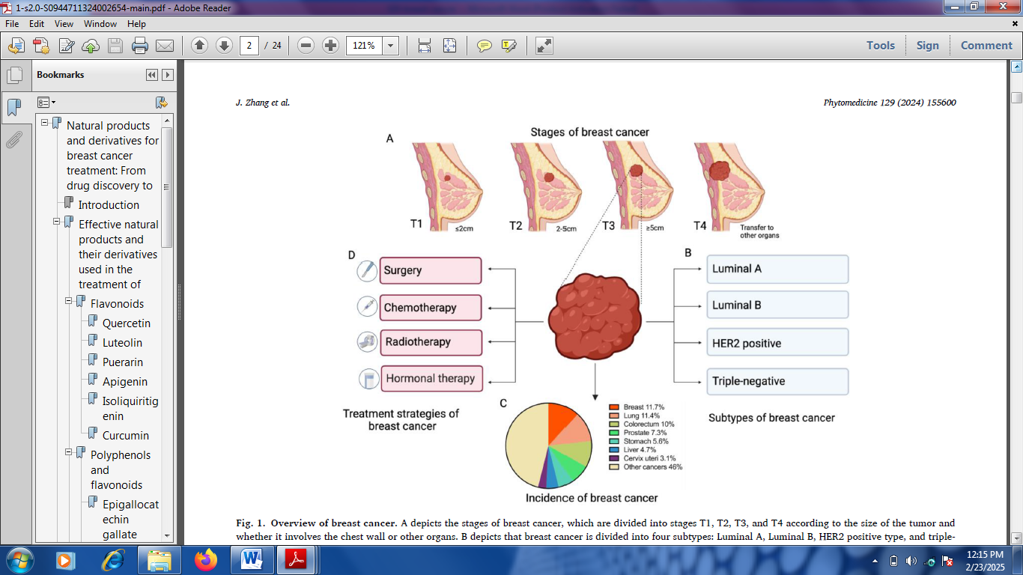

Figure 1: Overview of breast cancer with reference to (a) stages (b) subtypes (c) analysis of incidence and (d) treatment strategies.

Drug development has been the major focus of clinical investigations based on their outcomes and management. More detailed initiatives are now being considered in marketplace to advance the techniques for introducing novel drugs onto the market in order to reduce expenses on drugs ad fasten the development of the product. A product cyclical stages starting from the idea conception via retirement after the development, introduction and sales are best described by the product lifecycle management [8]. The Product Lifecycle Management (PLM) of a typical pharmaceutical drug product is presented in presented in Figure 2 starting from the execution of research via development and post-approval after authorization. This is an eye opener on how to conduct the planning, split the time per phase and concentrate on project management. The organization’s vision for executing the wide product planning together with the management is combined by the PLM. The timeframe for new products marketing is hastened and development costs are also reduced by the PLM [9].

Strategies are usually executed by a business at almost all the stages of the product life cycle while fluctuations are monitored based on the way the market responds to a product. The admission comfortability into the marketplace, market acceptability, consumer preferences changes and industry advancement pace as the major influencing factors for the product life cycle. Consumers usually change their opinions regarding the products they buy when it is easier for rivals to enter markets [10]. Products are susceptible to have reduced life cycles in a swiftly saturated market situation during a product life cycle. Any form of hindrance observed during clinical trials causing delays in their completion is referred to as regulatory challenges. These may ultimately cause elongated time to gain approvals either for marketing or post-marketing modifications. Novel solutions are needed for pharmaceutical industry’s viability maintenance in order to lower the expense and time.

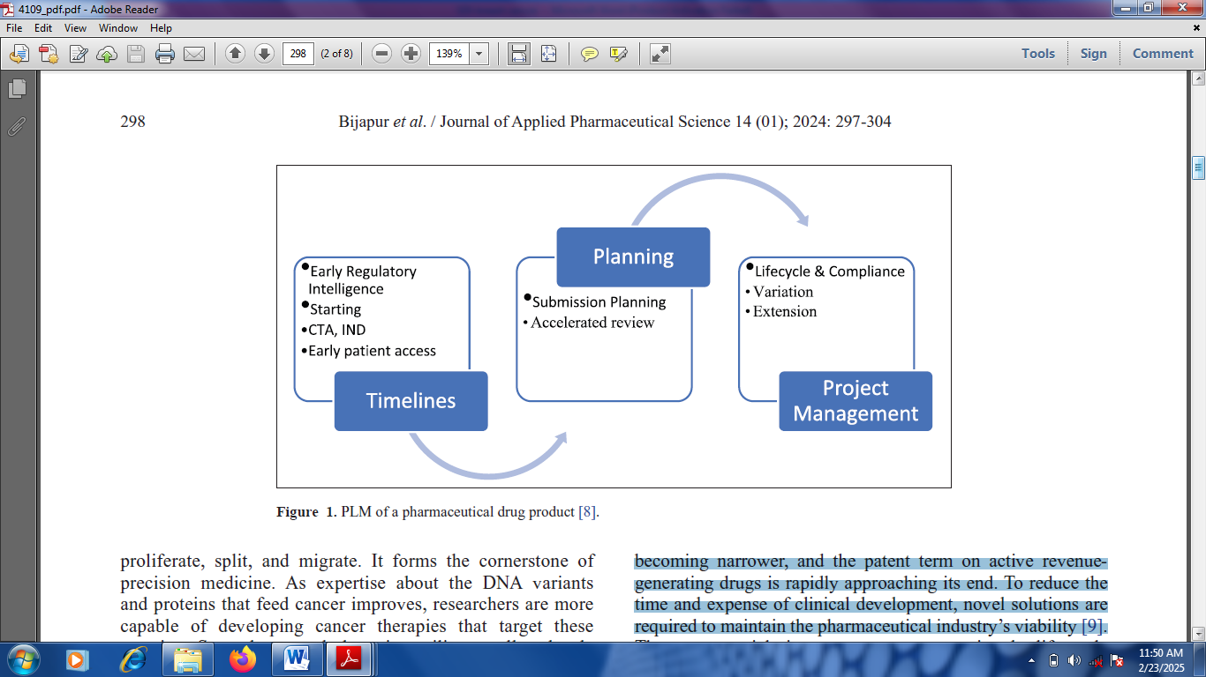

Figure 2: Product lifecycle management of a typical pharmaceutical drug product

It should be noted that the response of patients to cancer therapeutic compounds vary. Current advancements in transcriptomic, high-throughput genomic and proteomic techniques with the improving knowledge of cancers’ molecular mechanisms allow uncovering genes that dock personal variations in drug responses or clinical outcomes [11]. Personalized medicine has transformed the healthcare pattern via the incorporation of personal genetic information which gives room for introduction of new business, modelling of healthcare economic, improvement of drug treatment efficacy and shifting in the technique of medicine practices. Personalized medicine is referred to as the capacity to fragment heterogeneous subdivisions of patients whose response to a therapeutic interference within each subdivision is homogeneous. Maximum options can be made by physicians to optimize the possibility of effective treatment under this new healthcare model. Equally, adverse drug reactions risks can be simultaneously avoided such that the drug discovery process can be improved by scientists while medical devices can be manufactured by pharmaceutical companies in order to facilitate the detection of disease early and also forecast patient prognosis [12].

The principal target of personalized medicine and regulatory excellence is to equip the appropriate treatment to the right person at the right time. The prospective influence of personalized medicine is dependent upon a systematic detection of a novel biomarker from genome-wide candidates that justify dissimilarities across individuals. This review article examines breast cancer development in women. The significance of enhancing the efficiencies of the development and manufacturing of high-quality active pharmaceutical ingredients for breast cancer treatment through personalized medicine and regulatory excellence was thoroughly discussed.

2.0 Personalized Medicine and Regulatory Excellence AS EFFECTIVE TOOLs for Breast Cancer Treatment

Personalized medicine and regulatory excellence have been found as effective tools for breast cancer treatment. The broad impacts and numerous opportunities provided by personalized medicine possess four major attributes which are personalized, preventative, predictive and participatory.

* + 1. ***Personalized***

Personalized medicine incorporates protein profiles or personal genetic to support healthcare at a better personalized level, mostly with the help of currently emerging “-omic” technologies like nutritional metabolomics, proteomics, pharmacogenomics and genomics. Personalized medicine aims at developing things that have positive influences on a patient’s disease for effective treatments and safety purposes for that particular disease. The origin of personalized medicine is the genetic biomarkers which may be particularly linked with a disease condition [6]. The summary of some majorly adopted biomakers in breast cancer is presented in Figure 3. Informtion about a patient’s genetic profile results into adequate therapy or medication to give convineincies for physicians to effectively manage a patient’s disease or predisposition towards it with the help of treatment regimen or proper dose.

* + 1. ***Preventative***

In personalized medicine, the chance to act on the disease via early intervention is offered with the capacity to predict disease presence or risk before the appearance of clinical symptoms. In some cases, preventive intervention can safe life with reference to response to advanced phases of a disease [4]. For instance, there is higher chance for females having genetic mutations in the BRCA2 or BRCA1 genes to develop breast cancer when compared with those in the general female population. Preventive treatment and surveillance can be guided by the accurate test of the breast cancer vulnerability genes with reference to the objective risk measurements like chemoprevention, prophylactic surgery and improved frequency of mammography [13].

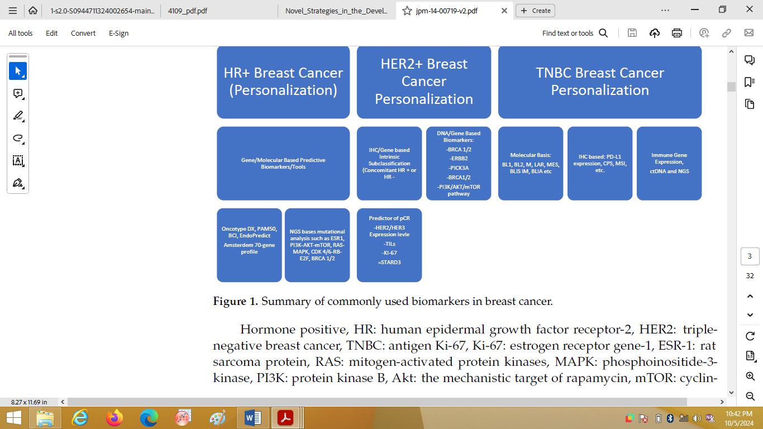

Figure 3: Summaized form of majorly adopted biomarkers in breast cancer

***2.0.3 Predictive***

Personalized medicine allows physicians in the selection of optimum therapies and prevent adverse drug reactions. Molecular diagnostic tools that adopt the use of predictive biomarkers offer valuable information based on genetically arranged subdivisions of patients who could benefit from a particular therapy [14]. For instance, Oncotype DX® (Genomic Health, Redwood City, USA) utilizes a 16-gene signature to know whether women with particular kinds of breast cancer are most likely benefit from chemotherapy. Also, a 70-gene expression profile is utilized by MammaPrint® (Agendia, Amsterdam, the Netherlands) to evaluate the danger of distant metastasis in patients having early-stage breast cancer. Patients can be classified into subdivisions using the sophisticated diagnostic tests in order to inform physicians weather patients require additional aggressive chemotherapy treatment or could be successfully treated using hormone therapy alone [10].

***2.0.4 Participatory***

Personalized medicine could result into a rise in adherence of patient to treatment. Patients are most likely and intending to conform with their treatments when the effectiveness of personalized healthcare is ascertained accustomed with adverse treatment effects minimization [11].

2.1 Drug Development via Genomic Approach

Pharmacogenomics has been identified as an attractive study in oncology as the most chemotherapy agents possessing constricted therapeutic window having harsh drug toxicities that pose to be life-threatening. Despite the developments in adjuvant chemotherapy for breast cancer which have caused marked declines in mortality and recurrence, women are still worried about the long- and short- term toxicities linked with the treatment [15]. Additionally, chemotherapy advancements have exhibited effects which are strongly affecting women having estrogen receptor–negative tumors than those having estrogen receptor–positive tumors. This is a strong indication that some of these can be spared out of chemotherapy. For instance, death risk reduction by 55% (38-69%) was observed in women having estrogen receptor–negative tumors as against 23% (-17% to 49%) reduction in estrogen receptor–positive tumors using dose-dense doxorubicin/cyclophosphamide and subsequently dose-dense paclitaxel (as in INT C9741) in comparison with low-dose cyclophosphamide/doxorubicin/5-fluorouracil [16]. It is thus believable that women having hormone receptor–negative breast cancer are predicted to exhibit positive outcome when the appropriate combination of less toxic and highly effective chemotherapy is given. Nonetheless, if hormonal therapies are given in the right doses, they may be more effective. However, this is subject to taking proper notice of the genetic variants that influence the metabolizing enzymes.

3.0 Manufacturing processes for active pharmaceutical ingredients (APIs)

A beneficial instrument for APIs process validation is the Broadway show’s production time-consuming process which can be useful in preparation ahead for documentation with the Food and Drug Administration (FDA). The route via which the preparation for API manufacturing processes are conducted for commercial purposes can be compared with the estimations of the overlapping integrative process at commercial level [17]. This ascertains the process is vigorous, reproducible and set for manufacturing on commercial supply basis after the process validation has been executed. The commercial manufacturing and process validation should be prepared by the chemical development teams. The late-phase API manufacturing should be the same as the final commercial process which entails critical materials sourcing and verification of their quality.

The manufacturing process performance, each intermediate quality and final API are the major focuses at the API process validation which is conducted at the clinical development late phases. The three major requirements that are necessary for the process evaluation events which allows the preparation of API manufacturing process for commercial inauguration are validation batches, engineering and campaigns to prepare registration [18]. During the registration batches program, consideration can be given to the evaluation of the initial formal scale-up for the planned manufacturing process. Materials are created by this section of process evaluation for the essential formal stability testing which are required for filing the registration. This can be taken for the proposed commercial process. This evaluation is normally executed near the commercial scale stage with the help of the requisite commercial equipment at a site in which commercial manufacturing will hold [19].

There are provisions for necessary process modifications by the FDA in the course of GMP manufacturing production of registration batches with the expectations that they will be absolutely final commercial process representative. A post-action review is usually conducted by the team after the registration batch experience to evaluate the way the process operates and recognize certain aspects that may require additional modifications. The laboratory evaluations and quality process risk assessments should have been separately created as units to evaluate the process parameters for each of the chemical steps controlling the final quality and to set targets within which the operation occurs [20]. With these, the materials sources and their respective critical quality requirements are confirmed. The final assessment for any modifications made within the plant in the course of registration batches is usually conducted in many of the environments. Subsequently, follow-up adjustments resulting from the post-action review, final safety modifications and the well-stated processing parameters are executed. These final assessments are referred to as engineering batches [21].

These different batches should be completely symbolic of the commercial process. They may be adopted eventually for commercial usage if executed in line with the finally formalized chemical process as recorded in the registration filing. This is the formal dress practice that is usually conducted in the presence of a test audience. With reference to the chemical process, every materials controls, physical controls, process variables, batch execution elements and analytical controls must synchronously work together to ascertain the API is acceptable with less errors [3]. The test audience can include the commercial group, quality unit and regulatory affairs group. The confidence in the API acceptability should be instilled by the engineering and registration batches to substantiate that the process is understood and safe, variables are well-defined perfectly, analytical controls are dependable and effective, chemistry and equipment are well-synchronized and the principal outcomes can be forecasted easily [8].

3.1 Challenges AND PROSPECTS in Active Pharmaceutical Ingredient Manufacturing

Active pharmaceutical ingredients (APIs) are front liners at pharmaceutical manufacturing. They are predominantly persistent in personalized medicines and targeted therapies. This is majorly as a result of their potent therapeutic influences at low dosage forms. High-potency APIs have numerous prospects in the area of novel drug development. However, manufacturing and developing effective APIs possess different challenges. The existence of global standard on quality protocols and safety is rare in API production. However, manufacture of pharmaceuticals is experiencing change in regulatory landscape. For instance, the ISPE Guidelines are being followed by many of the companies with reference to certain containment performance [6]. Standard operating procedures (SOPs) which are rigorous in nature should be strictly abided by the companies as a base requirement. These should entail employee training programs, containment strategies, quality systems and many more. More innovative highly potent APIs are now becoming persistent in drug development routines despite the inherent challenges.

Also, highly potent compounds were primarily restricted to oncology research fields as they exhibited limited applicability for drug products outside cancer treatment as a result of their constrained specificity. Transformation in the situation has been observed and innovative drug delivery schemes like antibody-drug conjugates, have opened doors for highly targeted therapies. Remarkable efficiency can now be delivered by them while still curbing some cancer therapies negative effects. Numerous commercial sectors have also amplified this better efficacy. Low amounts of active ingredients can be utilized by companies to produce APIs having higher concentrations of pharmacological activity [15]. By 2028, it is expected that the evolving market would attain $32 billion which is signaling a wider shift toward better fine-tuned and more efficacious treatment regimes [13].

Nonetheless, more emphasis are placed on the containment for the development and manufacturing of APIs. This is a crucial feature to ascertain there is regulatory compliance, environmental protection and personnel safety. The extremely low occupational exposure limits for HPAPIs has shown that exposure to small amounts can lead to harsh health risks to workers. Additionally, the dangers and risks of cross-contamination with other varieties of products cannot be avoided. Isolated manufacturing regions assigned precisely for high-potency products are vital for that handling of APIs [21]. These regions are engineered to the optimum standards to curb hazardous particles migration to non-assigned zones. Stringent facility design, rigorous protocols and specialized equipment are among the components of containment zones in engineering controls. The application of state-of-the-art containment technologies, limitation of personnel movement and planning of well-structured zones strongly indicate the commitment of the industry in order to ensure that the potent compounds in new drug systems for commercial manufacturing are safely handled.

Another challenge is scalability because the early discovery of molecule must transform to a practicable and effective commercial product. Suitable powerful equipment is needed for scaling together with the establishment of strong connections with outsourcing partners. Different batch volumes and manufacturing scales are usually presented by the APIs high value and potency when compared with other ingredients. Smaller batches and fewer volumes are generally required in order to meet the market demand and reduce financial risk associated with batch loss [22]. Outsourcing of API manufacturing can assist manufacturers in overcoming the numerous infrastructural challenges. However, there is more complexity in making this decision. Principal investment in specialized equipment and facilities is needed for in-house manufacturing as well as a pledge to maintain obedience with constantly progressing regulatory standards. The burdens can be reduced via outsourcing to contract development and manufacturing organizations.

The manufacturing of APIs is a sophisticated process by nature which requires a more knowledge on proper handling of the potent substances. Nonetheless, safeguarding intellectual property; assurance and implementation of thorough quality control measures; and compliance with developed regulatory standards are also part of the major challenges associated with API manufacturing. To address this, an in-house research and development can be executed by companies while the commercial production is transferred to the contract manufacturing organizations [23]. On the other hand, the research may be initiated by the contract development and manufacturing organizations in order to enable the company in preparing and opening its manufacturing site. The production chain integrity is becoming increasingly more significant in API production because the right working equipment is needed by different stakeholders. These challenges signify the necessity for clear contractual agreements, careful planning, and reliable outsourcing partner selection when consideration is given to outsourcing for manufacturing of API.

4. Conclusion

The most common cancer amidst women globally as well as in the United States is breast cancer. The optimization of its treatment by clinicians has been aided by histological and molecular differentiation using different therapeutics which are hormonal therapy, immunotherapy, chemotherapy and radiation therapy. The heterogeneity and high invasiveness of breast cancer has tagged it as a significant threat causing problems such as drug resistance and metastasis. However, some limitations have been exhibited by the traditional therapeutic techniques in terms of effective treatment of breast cancer in clinical set-ups. Thus, there is emergency need to create more effective and targeted means of treatment to stop the evolution of this disease. This review article presents an overview of breast cancer with regarding its stages of development, subdivisions, analysis of incidence and treatment strategies. The enhancement of manufactured and developed APIs through personalized medicine and regulatory excellence for breast cancer treatment was discussed. The manufacturing processes for active pharmaceutical ingredients was discussed alongside the accorded challenges and prospects. In conclusion, the efficiencies of the development and manufacturing of high-quality active pharmaceutical ingredients for breast cancer treatment can be improved via personalized medicine and regulatory excellence. However, it is recommended that the application of state-of-the-art containment technologies should be maintained as a signal for industry commitment in order to ascertain that the potent compounds in new drug systems for commercial manufacturing are safely handled.

References

1. Shendge, A.K., Chaudhuri, D., Basu, T., Mandal, N., 2023. A natural flavonoid, apigenin isolated from Clerodendrum viscosum leaves, induces G2/M phase cell cycle arrest and apoptosis in MCF-7 cells through the regulation of p53 and caspase-cascade pathway. Clin. Transl. Oncol. 23, 718–730.

2. Panda, M., Tripathi, S.K., Zengin, G., Biswal, B.K., 2022. Evodiamine as an anticancer agent: a comprehensive review on its therapeutic application, pharmacokinetic, toxicity, and metabolism in various cancers. Cell Biol. Toxicol. https://doi.org/ 10.1007/s10565-022-09772-8.

3. Ouyang, Y., Chen, L., Qian, L., Lin, X., Fan, X., Teng, H., Cao, H., 2023. Fabrication of caseins nanoparticles to improve the stability of cyanidin 3-O-glucoside. Food Chem. 317, 126418.

4. Xiong, R.-G., Huang, S.-Y., Wu, S.-X., Zhou, D.-D., Yang, Z.-J., Saimaiti, A., Zhao, C.-N.,

Shang, A., Zhang, Y.-J., Gan, R.-Y., Li, H.-B., 2022. Anticancer effects and mechanisms of berberine from medicinal herbs: an update review. Molecules. 27, 4523.

5. Wang, J., Man, G.C.W., Chan, T.H., Kwong, J., Wang, C.C., 2024. A prodrug of green tea

polyphenol (-)-epigallocatechin-3-gallate (Pro-EGCG) serves as a novel angiogenesis inhibitor in endometrial cancer. Cancer Lett. 412, 10–20.

6. Tahir, I.M., Rauf, A., Mehboob, H., Sadaf, S., Alam, M.S., Kalsoom, F., Bouyahya, A., El

Allam, A., El Omari, N., Bakrim, S., Akram, M., Raza, S.K., Emran, T.B., Mabkhot, Y. N., Zengin, G., Derkho, M., Natalya, S., Shariati, M.A., 2022. Prognostic significance of programmed death-1 and programmed death ligand-1 proteins in breast cancer. Hum. Antibodies 30, 131–150.

7. Braicu, C., Zanoaga, O., Zimta, A.-A., Tigu, A.B., Kilpatrick, K.L., Bishayee, A., Nabavi, S.

M., Berindan-Neagoe, I., 2022. Natural compounds modulate the crosstalk between apoptosis- and autophagy-regulated signaling pathways: controlling the uncontrolled expansion of tumor cells. Semin. Cancer Biol. 80, 218–236.

8. Cao, D., Zhu, G.-Y., Lu, Y., Yang, A., Chen, D., Huang, H.-J., Peng, S.-X., Chen, L.-W., Li, Y.-W., 2020. Luteolin suppresses epithelial-mesenchymal transition and migration of triple-negative breast cancer cells by inhibiting YAP/TAZ activity. Biomed. PharmacOther. 129, 110462.

9. El Khalki, L., Maire, V., Dubois, T., Zyad, A., 2023. Berberine impairs the survival of triple negative breast cancer cells: cellular and molecular analyses. Molecules. 25, 506.

10. Hashemi, M., Arani, H.Z., Orouei, S., Fallah, S., Ghorbani, A., Khaledabadi, M., Kakavand, A., Tavakolpournegari, A., Saebfar, H., Heidari, H., Salimimoghadam, S., Entezari, M., Taheriazam, A., Hushmandi, K., 2022. EMT mechanism in breast cancer metastasis and drug resistance: revisiting molecular interactions and biological functions. Biomed. Pharmacother. 155, 113774.

11. Imran, M., Aslam Gondal, T., Atif, M., Shahbaz, M., Batool Qaisarani, T., Hanif Mughal, M., Salehi, B., Martorell, M., Sharifi-Rad, J., 2020. Apigenin as an anticancer agent. PhytOther. Res. 34, 1812–1828.

12. Islam, Md.R., Islam, F., Nafady, M.H., Akter, M., Mitra, S., Das, R., Urmee, H., Shohag, S., Akter, A., Chidambaram, K., Alhumaydhi, F.A., Emran, T.B., Cavalu, S., 2022. Natural small molecules in breast cancer treatment: understandings from a therapeutic viewpoint. Molecules. 27, 2165.

13. Farghadani, R., Naidu, R., 2023. The anticancer mechanism of action of selected polyphenols in triple-negative breast cancer (TNBC). Biomed. PharmacOther. 165, 115170.

14. Huang, X., Wang, Y., Yang, W., Dong, J., Li, L., 2022. Regulation of dietary polyphenols on cancer cell pyroptosis and the tumor immune microenvironment. Front. Nutr. 9, 974896.

15. Liao, M., Qin, R., Huang, W., Zhu, H.-P., Peng, F., Han, B., Liu, B., 2022. Targeting regulated cell death (RCD) with small-molecule compounds in triple-negative breast cancer: a revisited perspective from molecular mechanisms to targeted therapies. J. Hematol. Oncol. 15, 44.

16. Khatoon, E., Banik, K., Harsha, C., Sailo, B.L., Thakur, K.K., Khwairakpam, A.D., Vikkurthi, R., Devi, T.B., Gupta, S.C., Kunnumakkara, A.B., 2022. Phytochemicals in cancer cell chemosensitization: current knowledge and future perspectives. Semin. Cancer Biol. 80, 306–339.

17. Shendge, A.K., Chaudhuri, D., Basu, T., Mandal, N., 2024. A natural flavonoid, apigenin

isolated from Clerodendrum viscosum leaves, induces G2/M phase cell cycle arrest and apoptosis in MCF-7 cells through the regulation of p53 and caspase-cascade pathway. Clin. Transl. Oncol. 23, 718–730.

18. Panda, M., Tripathi, S.K., Zengin, G., Biswal, B.K., 2022. Evodiamine as an anticancer agent: a comprehensive review on its therapeutic application, pharmacokinetic, toxicity, and metabolism in various cancers. Cell Biol. Toxicol. https://doi.org/ 10.1007/s10565-022-09772-8.

19. Pham, T.H., Page, Y.L., Percevault, F., Ferri`ere, F., Flouriot, G., Pakdel, F., 2021. Apigenin, a partial antagonist of the estrogen receptor (ER), inhibits ER-positive breast cancer cell proliferation through Akt/FOXM1 signaling. Int. J. Mol. Sci. 22.

20. Xu, J., Zhang, S., Wu, T., Fang, X., Zhao, L., 2022. Discovery of TGFBR1 (ALK5) as a

potential drug target of quercetin glycoside derivatives (QGDs) by reverse molecular docking and molecular dynamics simulation. Biophys. Chem. 281, 106731.

21. Zhang, T., Li, N., Wang, R., Sun, Y., He, X., Lu, X., Chu, L., Sun, K., 2023. Enhanced therapeutic efficacy of doxorubicin against multidrug-resistant breast cancer with reduced cardiotoxicity. Drug Deliv. 30, 2189118.

22. Hsu, P.P., Sabatini, D.M., 2008. Cancer cell metabolism: warburg and beyond. Cell 134,

703–707.

23. Dou, X., Zhou, Z., Ren, R., Xu, M., 2020. Apigenin, flavonoid component isolated from Gentiana veitchiorum flower suppresses the oxidative stress through LDLR-LCAT signaling pathway. Biomed. PharmacOther. 128, 110298.