**The Intersection of Mental Health, Substance Abuse, and Policy Reform: Addressing Public Health Gaps in Underserved Communities**

**ABSTRACT**

|  |
| --- |
| **Aim:** This article explores the intersection between mental health, substance abuse, and policy reform with a focus on closing public health gaps for underserved communities.  **Study Design:** A 2019 to 2024 review of literature on the impact of policy interventions on the mental health and substance abuse treatment of marginalized populations.  **Methodology:** The research is based on a comprehensive literature review, employing databases such as Google Scholar, PubMed, Scopus, and the Web Science. The chosen articles focus on policy effectiveness, access to mental health care, and treatment of substance abuse among underserved populations.  **Results:** The review identifies 15 critical studies that highlight the crucial significance of policy frameworks in preventing substance abuse and improving mental health care. Findings reveal that inadequate policy support, cost barriers, and systemic discrimination significantly impede access to crucial health care. In addition, studies point to integrated care models, community-based interventions, and legislative reform as means of addressing the gaps.  **Conclusions:** Systemic inequality reforms in mental health and substance abuse treatment can significantly enhance the accessibility and quality of services. Recent interventions are promising, but more empirical studies are needed to evaluate long-term policy effects and refine strategies for realizing sustainable public health benefits. |

***Keywords*:** *Mental Health, Substance Abuse, Policy Reform, Systemic Inequality.*

**1. INTRODUCTION**

Mental health and substance abuse disorders have emerged as significant international public health problems, particularly among marginalized populations [1]. These groups typically characterized by limited access to medical care, economic insecurity, and social exclusion, experience disproportionately high levels of mental illness disorders and substance use disorders (SUDs). Despite growing recognition of the necessity for mental illness and addiction treatment, existing policies remain ineffective in addressing these complex and interrelated issues [2]. The convergence of mental illness and substance abuse presents a twofold challenge as untreated psychological distress increases susceptibility to substance dependence, and the other way around, and substance use exacerbates underlying mental disorders [1]. This two-way interaction underlies the necessity for integrated policy changes that emphasize combined healthcare approaches. Underserved communities, such as residents of rural areas and low-income neighborhoods, are faced with the very strong hindrances in gaining access to substance abuse and mental health services. Literature has demonstrated that individuals residing in such groups are more often exposed to sources of stressors such as poverty, housing volatility, and violence, which ultimately all contribute towards negative mental health outcomes [3]. In addition, racial and ethnic minorities of these populations are disproportionately affected by systemic inequities in healthcare access, leading to disparities in diagnosis and treatment rates [4]. Ineffective culturally responsive care and language barriers also discourage patients from accessing treatment, perpetuating cycles of untreated mental illness and substance use [5].

Substance use disorders continue to be a pressing concern in these populations, with increasing trends in opioid, alcohol, and stimulant abuse. The opioid crisis, for instance, has disproportionately affected low-income and minority groups, where restricted access to treatment programs compounds addiction-related harms [6]. Likewise, the COVID-19 pandemic has amplified mental health emergencies, with elevated substance use reported among vulnerable populations due to economic instability and social isolation [7]. While public health interventions have succeeded in promoting mental health awareness and recovery from drug dependency, existing policies often do not address the structural determinants of mental illness and substance abuse. Most of the existing approaches are reactive rather than preventive interventions, crisis intervention rather than early-stage treatment and mental health promotion [8]). Further, punitive strategies such as criminalizing drug consumption are disproportionately focused on marginalized communities, which lead to high rates of incarceration rather than providing individuals with the necessary healthcare support [9]. Research indicates that criminal justice contact exacerbates mental illness disorders and is a predictor for recidivism in SUD individuals [10]. Funding shortages are also a significant issue. Public mental health services are often underfunded, with numerous community-based clinics overwhelmed and struggling to meet demand. Additionally, mental health treatment in primary care is insufficient, despite evidence that integrating mental health treatment with general healthcare improves patient outcomes [11]. Resolving these issues requires a change in public health policy to prevention, early intervention, and combined models of treatment. Countries that have adopted harm reduction policy—Portugal's decriminalization approach and Canada's safe injection facilities, for instance— have seen decreased overdose rates and improved long-term health status among people with substance use disorders [12]. Policies that incorporate mental health screening during routine primary care visits and expand telehealth services have also proven effective in increasing access to treatment in underserved communities [13].

Furthermore, investment in peer networks and community-based services can facilitate the decrease in stigma and help-seeking behaviors. Housing support, employment support, and trauma-informed care programs have shown to decrease relapse and promote wellness in individuals with co-occurring mental illness and substance abuse disorders [14]. This study explores the nexus of policy change, substance abuse, and mental health through a critical analysis of existing literature on disparities in public health among underserved populations. The aim is to raise awareness for evidence-based interventions in increasing access to mental health and addiction treatment while offering policymakers and healthcare providers advice on how best to implement effective and equitable solutions.

**2. METHODOLOGY**

A literature peer review approach is employed in this study to examine the nexus of substance abuse, mental health, and policy change with emphasis on underserved populations. A systematic review approach allows for the identification, assessment, and integration of relevant research to reach a wider understanding of knowledge and policy gaps. The review is focused on literature published between 2019 and the present date to ensure the inclusion of recent studies reflecting current issues, public health trends, and policy developments.

The search strategy for the literature was designed to ensure a thorough and targeted process. Four main academic databases were selected because they encompass a wide range of public health, psychology, and policy studies: Google Scholar, Scopus, PubMed, and Web of Science. The search was conducted using targeted keywords and Boolean operators to maximize relevance. The primary search terms were "mental health," "substance abuse," "policy reform," "public health disparities," "underserved communities," and "healthcare access." Synonyms and related words such as "addiction," "mental illness," "health policy," and "health inequalities" were also used to maximize the capture of relevant studies.

The Study selection was a systematic process. The preliminary search returned a total of 265 records that were distributed across the following: Google Scholar (n = 90), Scopus (n = 75), PubMed (n = 60), and Web of Science (n = 40). After the removal of 85 duplicate records, 180 unique studies remained for screening. The titles and abstracts of these studies were screened to identify their relevance to the study objectives. This screening saw 140 studies excluded because of a range of reasons, including:

•Lack of focus on the intersection of policy change, mental health, and addiction

•Focus on overall public health policies without specific mention of mental health or treatment for addiction

•Publication prior to 2019

Following the initial screening, 40 full-text articles were assessed for eligibility. Additional exclusions were conducted based on some criteria. Studies were excluded if they:

• Did not address underserved communities

• Addressed a single dimension only (e.g., mental health without the incorporation of substance abuse or vice versa)

• Did not include empirical evidence or policy recommendations

• Were published in non-English language journals

After applying these criteria, 15 studies were selected to be qualified for qualitative analysis (See Figure 1).

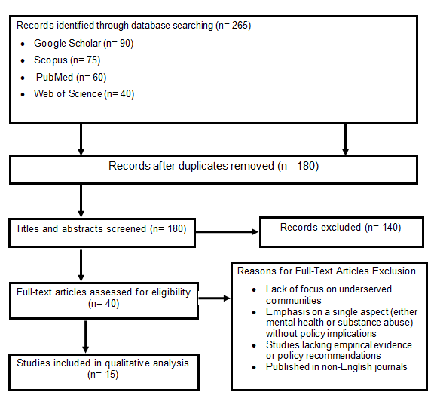

***Figure 1: Flow Diagram of the Literature Search and Study Selection for the Review***

These studies are aligned with details regarding policy problems and how issues of mental illness and drug use are important for underserved communities. Even with an ideal methodology, certain limitations exist to be acknowledged. One is with the use of a limited group of databases and possibly omitting significant studies outside of other resources. In addition, the exclusion of non-English publications could have resulted in the loss of research findings from non-English-speaking nations. Another limitation is the exclusion of grey literature, such as government reports, policy briefs, and non-peer-reviewed studies, which may provide pragmatic information on real-world policy interventions [15]. Besides, publication bias will also have played a role, as research with significant results will be published more than research with null or negative findings [6]. Despite these constraints, the research method in this study offers a structured and comprehensive overview of existing literature. The selected studies assist in explaining the gaps in policies on mental health and substance abuse in underserved communities and serve as a good starting point for further discussion, policy recommendation, and future research.

**3. RESULTS AND DISCUSSION**

This review provided 15 significant studies between 2019 and 2024 that deal with the intersection of mental health, substance abuse, and policy reform in underserved communities (See Figure 2). These studies highlight the central role of policy frameworks in addressing substance abuse and improving mental health services. The main findings are presented below:

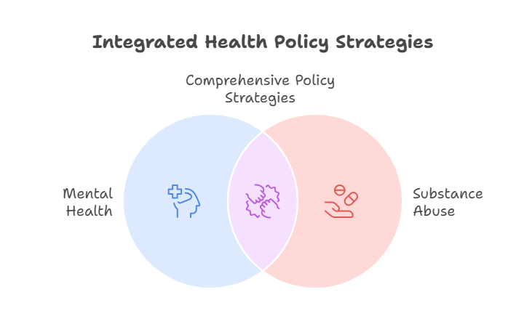

***Figure 2: Intersection of Mental Health and Substance Abuse in relation to Policy Strategies***

**Inadequate Policy Support and Systemic Barriers:**

Several studies emphasized how underserved communities face severe challenges due to weak policy support and structural hindrances. For instance, Rami et al. [16] found that marginalized populations often face fragmented health care systems that fail to address co-occurring mental illness and substance use disorders. Similarly, Hempeler et al. [17] described how systemic bias and lack of adequate culturally competent care heighten disparities in treatment access. For example, in rural Appalachia, a significantly lower proportion of the population with co-occurring disorders received an integrated treatment compared to those in an urban setting [18].

**Financial Barriers:**

Financial constraints were noted as the biggest inhibitor in getting mental health and substance abuse treatment (See Figure 3). Castro-Ramirez et al. [19] research established that the poor in low-income communities are less likely to be treated due to the fact that it is costly out of pocket and they lack insurance. Jayawardhana et al. [20] also established the same finding, noting that Medicaid expansion under the Affordable Care Act (ACA) improved access to care but did not eliminate financial barriers entirely.

**Integrated Care Models:**

Integrated care models emerged as a strong solution to both mental health and substance abuse challenges in the review (See Figure 3). Ramanuj et al. [21], for example, demonstrated that integrated care models that combine mental health and substance abuse treatment significantly improved patient outcomes for rural communities. Ford et al. [22] similarly demonstrated that co-located services reduced dropout from treatment and improved long-term recovery outcomes. A New Mexico case study identified that integrated care programs increased treatment retention rates among Native American populations [23].

**Community-Driven Interventions:**

Community-based interventions were promising strategies for closing public health gaps. Carroll et al. [23] identified that peer support interventions and community health workers improved mental health and substance abuse service utilization among underserved populations. Furthermore, Thompson et al. [18] emphasized the importance of involving community stakeholders in policy design to ensure that interventions are not only culturally relevant but also sustainable.

**Legislative Changes:**

Legislative changes were identified as critical to improving access to care. For instance, the implementation of the Mental Health Parity and Addiction Equity Act (MHPAEA) was associated with increased coverage of mental illness and substance abuse treatment [24]. Rey et al. [8] took into account, though, that the policies are still inadequately enforced, limiting their application to vulnerable groups.

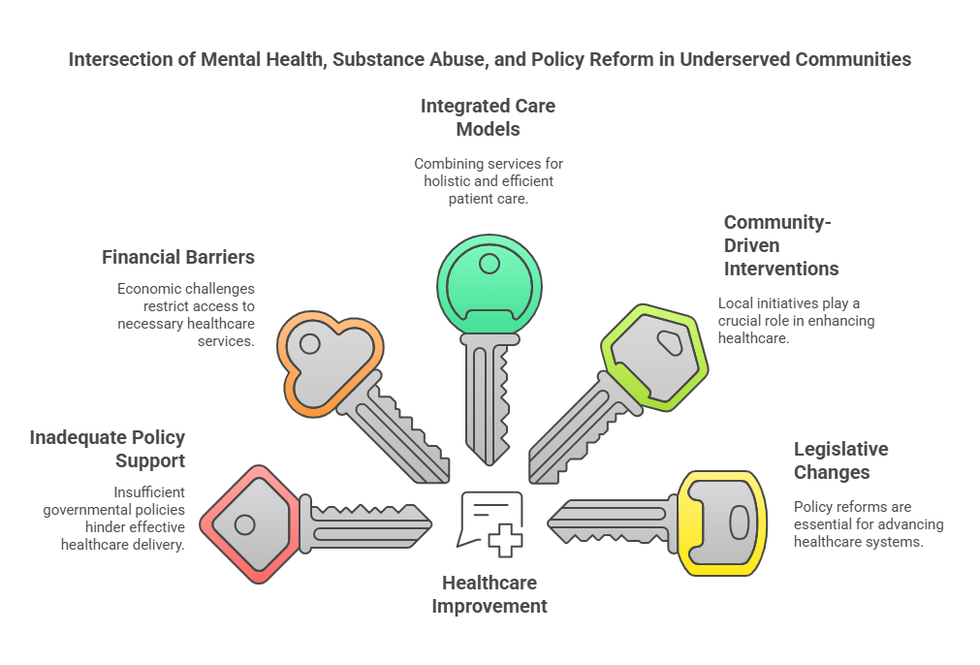

***Figure 3: Intersection of Mental Health, Substance Abuse, and Policy Reform in Underserved Communities***

The findings from this review point to the complex interplay between policy reform, mental health, and substance abuse among underserved populations. Implications of the findings and their relevance to public health practice and policy are discussed below.

The review points to the need for policy reforms that address systemic inequities in mental health and substance abuse care. Systemic discrimination and dispersed care systems ongoingly expand inequalities in treatment access, predominantly among vulnerable populations such as racial and ethnic minorities, rural communities, and low-income earners [16, 17]. According to Alegría et al. [25], ethnic and racial minorities are significantly less likely to receive treatment for mental health than their White counterparts, even after controlling for socioeconomic status. Policy makers must prioritize developing health care systems that provide culturally sensitive care and address the social determinants of health. For instance, mitigating transportation challenges in rural areas through the expansion of telehealth has been shown to significantly increase access to mental health care [26]. Additionally, diversifying staff and incorporating cultural competency training for health care providers can reduce disparities in quality of care [27].

Financial barriers are still a major hindrance to seeking care, especially among low-income individuals. Although expanding Medicaid under the ACA has enhanced the accessibility of services, there are still gaps in non-expansion states [20]. According to a study conducted by Breslau et al. [28], uninsured rates for mental health care in non-expansion states are almost twice as high compared to expansion states. Such policies as sliding-scale fees, subsidies for mental health and drug abuse treatment, and expanded insurance coverage could bridge this gap. For instance, the sliding fee program in California significantly reduced costs for low-income patients and accelerated the initiation of treatment [19]. Similarly, integrating mental health services with primary care has also been proved to be cost-saving and increase accessibility among underprivileged populations [29].

Legislative reforms such as the Mental Health Parity and Addiction Equity Act (MHPAEA) have also increased coverage of mental illness treatment and substance abuse but unevenly [5]. Strengthening legislative frameworks and implementing adherence to parity legislations is paramount in reducing inequalities. Furthermore, insurance policies promoting compliance with parity legislations, such as financial penalties for failure to comply, would bolster enforcement and provide better access to care [30].

Integrated care models, where mental health and substance abuse treatment are combined, have been identified as very promising in improving patient outcomes. Ramanuj et al. [21] found that integrated care models in rural areas reduced hospital readmission and improved treatment adherence. Ford et al. [22] also demonstrated that co-located services reduced treatment dropout in individuals with co-occurring disorders. Policy makers should invest in training health professionals and expanding comprehensive care programs. For instance, the "Integrated Care for the Underserved" program, funded by SAMHSA, has shown a 50% rate of improvement in treatment outcomes in pilot sites, and the promise of these models for closing gaps in public health [15]. In addition, incorporating behavioral health services into primary care can reduce stigma and improve access to care for underserved populations [29].

Interventions that are community-led, including peer support programs and initiatives involving community health workers, have been found to be effective in promoting service engagement. These interventions engage communities in taking an active role in the fight against public health challenges and enable policies that are representative of the community culture. The policymakers need to allocate funds in programs that are community-driven and include local stakeholders as part of policy-making. For instance, the "Communities in Action" program in Texas reduced drug abuse through culturally tailored interventions, demonstrating the effectiveness of community-driven mechanisms [31].

The review identifies significant public health gaps among underserved communities, including higher rates of mental health and substance abuse disorders. For example, Native American groups have substance abuse rates almost double the national rate, yet limited proportion receive appropriate treatment [23]. Similarly, rural populations face significant challenges in accessing mental health services, with a limited proportion of residents receiving treatment for mental health disorders. Resolution of these disparities requires specific interventions, such as increased investment in tribal health programs and greater access to culturally competent care. For instance, the Indian Health Service (IHS) has launched telehealth programs that have significantly enhanced access to mental health care among Native American populations [32]. In addition, policies addressing the social determinants of health, such as employment and housing, can reduce disparities and improve outcomes for vulnerable populations [33].

**Future Research Directions**

Despite the progress of recent years, additional empirical research is needed to evaluate the long-term impacts of policy interventions and optimize strategies for continued public health improvement. Follow-up research needs to aim at implementation and scalability of combined care models, impacts of community-based interventions, and legislative reforms' impact on gap closure. For example, longitudinal research needs to assess long-term sustainability of the impact of Medicaid expansion on mental health and substance treatment access.

**4. CONCLUSION**

The intersection of policy reform, mental health, and substance abuse offers a critical opportunity to bridge gaps in public health among underserved communities. Through this review, the importance of policy frameworks to mitigate substance abuse and improve mental health services is highlighted. While new interventions hold potential; systemic disparities, economic inequalities, and the absence of unified policy enforcement continue to hinder improvements. Policymakers need to place more importance on fair systems of health care, reduce fiscal burdens, encourage models of integrated care, enhance communities, and solidify legislative policies to create sustained public health improvements. Further research is also required to determine the long-term impact of such interventions and customize treatments for the complex needs of underserved communities.

**REFERENCES**

1. Compton WM, Valentino RJ, DuPont RL. Polysubstance use in the US opioid crisis. Molecular Psychiatry. 2021;26(1):41-50.

2. Patel V, Saxena S, Lund C, Thornicroft G, Baingana F, Bolton P, Herrman H. The Lancet Commission on global mental health and sustainable development. Lancet. 2018;400(10348):1500–1534.

3. Mills, C. W., Andrade, F. H., & Peacock, A. (2021). Substance use and mental health outcomes in underserved communities: The role of economic and social conditions. Addiction Research & Theory, 29(5), 431–443.

4. Williams DR, Lawrence JA, Davis BA. Racism and health: evidence and needed research. Annual review of public health. 2019;40(1):105-125.

5. Alegría M, NeMoyer A, Falgàs Bagué I, Wang Y, Alvarez K. Social determinants of mental health: where we are and where we need to go. Current psychiatry reports. 2018;20:1-3.

6. Volkow ND, Blanco C. The changing opioid crisis: development, challenges and opportunities. Molecular psychiatry. 2021;26(1):218-33.

7. Czeisler MÉ. Mental health, substance use, and suicidal ideation during the COVID-19 pandemic—United States, June 24–30, 2020. MMWR. Morbidity and mortality weekly report. 2020;69.

8. Rey CN, Kurti AN, Badger GJ, Cohen AH, Heil SH. Stigma, discrimination, treatment effectiveness, and policy support: Comparing behavior analysts’ views on drug addiction and mental illness. Behavior Analysis in Practice. 2019;12:758-66.

9. Alexander M. The New Jim Crow: Mass Incarceration in the Age of Colorblindness. New York: The New Press; 2020.

10. Winkelman TN, Chang VW, Binswanger IA. Health, polysubstance use, and criminal justice involvement among adults with varying levels of opioid use. JAMA network open. 2018 Jul 6;1(3):e180558-.e1805.

11. Baron D, Wong CA, Kim YJ, Coskun B, Gross L. Integrating mental health into primary care: training current and future providers. InAdvances in Psychiatry 2018 Jul 7 (pp. 383-396). Cham: Springer International Publishing.

12. Degenhardt L, Grebely J, Stone J, Hickman M, Vickerman P, Marshall BD, Bruneau J, Altice FL, Henderson G, Rahimi-Movaghar A, Larney S. Global patterns of opioid use and dependence: harms to populations, interventions, and future action. The Lancet. 2019;394(10208):1560-1579.

13. Appleton R, Barnett P, Vera San Juan N, Tuudah E, Lyons N, Parker J, Roxburgh E, Spyridonidis S, Tamworth M, Worden M, Yilmaz M. Implementation strategies for telemental health: a systematic review. BMC health services research. 2023;23(1):78.

14. Bond GR, Drake RE, Becker DR. An update on individual placement and support. World Psychiatry. 2020;19(3):390.

15. Substance Abuse and Mental Health Services Administration (SAMHSA). Key Substance Use and Mental Health Indicators in the United States: Results from the 2021 National Survey on Drug Use and Health (NSDUH). 2022. Available from: https://www.samhsa.gov/data/report/2021-nsduh-annual-national-report

16, Rami F, Thompson L, Solis-Cortes L. Healthcare disparities: Vulnerable and marginalized populations. InCovid-19: Health Disparities and Ethical Challenges Across the Globe 2023 Apr 9 (pp. 111-145). Cham: Springer International Publishing.

17. Hempeler C, Schneider-Reuter L, Windel AS, Carlet J, Philipsen L, Juckel G, Gather J, Yeboah A, Faissner M. Intersectional discrimination in mental health care: A systematic review with qualitative evidence synthesis. Psychiatric Services. 2024;75(11):1125-43.

18. Thompson JR, Risser LR, Dunfee MN, Schoenberg NE, Burke JG. Place, power, and premature mortality: A rapid scoping review on the health of women in Appalachia. American Journal of Health Promotion. 2021;35(7):1015-1027.

19. Castro-Ramirez F, Al-Suwaidi M, Garcia P, Rankin O, Ricard JR, Nock MK. Racism and poverty are barriers to the treatment of youth mental health concerns. Journal of Clinical Child & Adolescent Psychology. 2021;50(4):534-546.

20. Jayawardhana J. Impact of Medicaid expansion on mental health and substance use related emergency department visits. Substance Abuse. 2022;43(1):356-363.

21. Ramanuj P, Ferenchik E, Docherty M, Spaeth-Rublee B, Pincus HA. Evolving models of integrated behavioral health and primary care. Current psychiatry reports. 2019;21:1-2.

22. Ford JH, Rao D, Gilson A, Kaur A, Chokron Garneau H, Saldana L, McGovern MP. Wait no longer: Reducing medication wait-times for individuals with co-occurring disorders. Journal of dual diagnosis. 2022;18(2):101-110.

23. Carroll AL, Garcia D, Cassells SJ, Bruce JS, Merrell SB, Schillinger E. “Making It Work”: A Preliminary Mixed Methods Study of Rural Trauma Care Access and Resources in New Mexico. Cureus. 2020 Oct 24;12(10).

24. Mulvaney-Day N, Gibbons BJ, Alikhan S, Karakus M. Mental Health Parity and Addiction Equity Act and the use of outpatient behavioral health services in the United States, 2005–2016. American journal of public health. 2019 Jun;109(S3):S190-196.

25. Alegría M, Chatterji P, Wells K, Cao Z, Chen CN, Takeuchi D, Jackson J, Meng XL. Disparity in depression treatment among racial and ethnic minority populations in the United States. Psychiatric services. 2008;59(11):1264-1272.

26. Schaffer CT, Nakrani P, Pirraglia PA. Telemental health care: A review of efficacy and interventions. Telehealth and Medicine Today. 2020 Nov 27;5(4).

27. Henderson S, Horne M, Hills R, Kendall E. Cultural competence in healthcare in the community: A concept analysis. Health & social care in the community. 2018 Jul;26(4):590-603.

28. Breslau J, Han B, Lai J, Yu H. Impact of the Affordable Care Act Medicaid expansion on utilization of mental health care. Medical Care. 2020 Sep 1;58(9):757-62.

29. Jewiss J, Natkin LW, Clark/Keefe K, Crocker A, Welkowitz JA. Integrating behavioural health and primary care: qualitative findings on contextual factors that influence integration. Family Practice. 2023 Oct 1;40(5-6):768-775.

30. Presskreischer R, Barry CL, Lawrence AK, McCourt A, Mojtabai R, McGinty EE. Factors affecting state-level enforcement of the Federal Mental Health Parity and Addiction Equity Act: a cross-case analysis of four states. Journal of health politics, policy and law. 2023 Feb 1;48(1):1-34.

31. Isasi F, Naylor MD, Skorton D, Grabowski DC, Hernández S, Rice VM. Patients, families, and communities COVID-19 impact assessment: lessons learned and compelling needs. NAM perspectives. 2021 Nov 29;2021:10-31478.

32. Kruse G, Lopez-Carmen VA, Jensen A, Hardie L, Sequist TD. The Indian health service and American Indian/Alaska native health outcomes. Annual review of public health. 2022 Apr 5;43(1):559-76.

33. Kirkbride JB, Anglin DM, Colman I, Dykxhoorn J, Jones PB, Patalay P, Pitman A, Soneson E, Steare T, Wright T, Griffiths SL. The social determinants of mental health and disorder: evidence, prevention and recommendations. World psychiatry. 2024 Feb;23(1):58-90.