Enhancing biogas production of livestock manure using desulphurization and de-carboxylation scrubbers.

.

ABSTRACT

|  |
| --- |
| **Aims:** This study was aimed at increasing the quality of CH4 thereby reducing the quantity of H2S and CO2 using the desulphurisation and decarboxylation scrubbers respectively.  **Study design:** This study employed an experimental research design to evaluate the effectiveness of desulphurisation and de-carboxylation scrubbers in enhancing biogas quality by reducing H₂S and CO₂ concentrations.  **Place and Duration of Study:** Waste-to-resource project laboratory of the Department of Environmental Science of the University of Buea, Cameroon between May and July 2023.  **Methodology:** The scrubbers were made up of locally available materials with the desulphurisation scrubber constituting of 20 cm long PVC pipes with a diameter of 0.45 cm and a stopcock at both ends of the pipe making it air tight and contain within its iron fillings mesh with a mass of 25g. While one of the de-carboxylation scrubbers was made up of the same material as desulphurisation but contain within it particle size of 2 mm and mass of 50 g activated carbon and the other consisted of a cylindrical plastic container with a height of 20 cm and diameter of 16 cm, containing 4M Ca(OH)2 (lime water). The different scrubbers were evaluated and optimized and efficiencies calculated for each.  **Results:** Result from the de-carboxylation scrubber showed highest efficiency of CO2 absorption in activated carbon (86.41%) and least in 4M Ca(OH)2 (85.32%). The desulphurization scrubber had an efficiency of 98.93% removal of H2S by the iron fillings. The combination of desulphurization and de-carboxylation scrubbers had an outstanding result in increasing the quality of CH4 produced (0% to 80.8%). It can be concluded from this studies that, Ca(OH)2 and Iron fillings should be connected in series in any biogas outlet stream to enhance biogas production. Also, activated Carbon is discouraged to be used as a scrubber because it produces CO which is a very poisonous gas to human health.  **Conclusion:** This study showed that using iron fillings and Ca(OH)₂ scrubbers significantly improved biogas quality, achieving 80.8% methane purity. Activated carbon is discouraged due to CO production. Future research should explore varying Ca(OH)₂ concentrations and use FTIR, XRD, and SEM analyses to assess activated carbon’s structural changes. This study recommends testing various Ca(OH)₂ concentrations for efficiency and using FTIR, XRD, and SEM to analyze structural and morphological changes in activated carbon before and after use. |

*Keywords: Biogas, Desulphurization Scrubber, De-Carboxylation Scrubber livestock manure*

1. INTRODUCTION

Transitioning to sustainable energy sources has become a global imperative in the face of climate crises, environmental degradation, and increasing energy demands. Biogas, a renewable energy source produced through the anaerobic digestion of organic matter, has emerged as a promising solution for addressing these challenges (IRENA, 2021). Rich in methane (CH₄) and carbon dioxide (CO₂), biogas provides a versatile energy source that can be used for electricity generation, heating, and as a transportation fuel. However, its widespread adoption faces significant technical challenges, particularly the presence of impurities like hydrogen sulfide (H₂S) and excess CO₂, which reduce the energy efficiency and durability of biogas systems. Technologies such as desulphurization and de-carboxylation scrubbers have been developed to overcome these limitations, enhancing the quality and usability of biogas. The demand for cleaner energy solutions has spurred innovation in biogas purification technologies. Hydrogen sulphide, a corrosive and toxic gas, poses a significant challenge to biogas utilization, leading to equipment degradation and environmental harm if not adequately removed (Khoshnevisan *et al*., 2021). Similarly, the high concentration of CO₂ in raw biogas reduces its calorific value, limiting its efficiency as a fuel source. Desulphurization scrubbers efficiently remove H₂S through chemical or biological processes, while de-carboxylation scrubbers reduce CO₂ levels, increasing the methane content and overall energy yield (Angelidaki *et al*., 2018). By integrating these technologies into biogas systems, the global energy sector can significantly improve the viability of biogas as a clean and sustainable energy source.

Africa, with its vast agricultural potential, presents a unique opportunity for biogas production. The continent’s livestock sector generates substantial quantities of manure, a primary feedstock for biogas production. According to the Food and Agriculture Organization (FAO), livestock farming accounts for approximately 30% of agricultural GDP in sub-Saharan Africa, producing millions of tons of manure annually (FAO, 2020). Despite this abundance, the adoption of biogas technology remains limited due to infrastructural, financial, and technical challenges. In addition, there also cultural barriers to the adoption of biogas. Some communities believe that food prepared with other biomass sources like wood tastes better and some consider it icky to use manure to cook.

One of the most significant barriers to biogas adoption in Africa is the quality of the gas produced. Impurities such as H₂S and CO₂ reduce the efficiency and safety of biogas systems, discouraging their use. Introducing desulphurization and de-carboxylation scrubbers could address these issues, enabling end users to harness biogas more effectively. Studies have shown that biogas systems incorporating purification technologies can increase methane content by up to 65%, making the fuel more competitive with conventional energy sources (Mutungwazi *et al*., 2021). Cameroon, considered a leading agricultural nation in Central Africa, exemplifies the untapped potential for biogas production. Livestock farming contributes significantly to the national economy, producing an estimated 5.3 million tons of manure annually (MINEPIA, 2019). However, improper manure management often leads to environmental degradation, including water pollution and greenhouse gas emissions. Biogas production offers a dual benefit of waste management and renewable energy generation, yet its development in Cameroon remains nascent. One of the main challenges facing biogas initiatives in Cameroon is the poor quality of biogas, which limits its adoption and utility. Desulphurization and de-carboxylation scrubbers offer a practical solution to this problem by improving the energy yield and usability of biogas systems. For instance, pilot projects in rural areas have demonstrated the potential of purified biogas to power households, schools, and small businesses (Ndzana *et al*., 2020). Scaling up such initiatives at the national level could significantly enhance energy access while reducing environmental impacts associated with livestock farming.

In the case of Buea, a rapidly urbanizing municipality in Cameroon’s Southwest Region, highlights the opportunities and challenges of biogas adoption. Livestock farming is a common practice in Buea, generating substantial quantities of manure that are often disposed of inefficiently. This practice contributes to environmental pollution and represents a missed opportunity for energy generation. Despite ongoing biogas initiatives, the low quality of gas produced remains a significant barrier to its widespread use. This study sort to Integrating desulphurization and de-carboxylation scrubbers with locally available materials into biogas systems within the Buea municipality and possibility of upscaling which could transform the local energy landscape. This technology with enhanced biogas production would provide a reliable alternative to wood fuel, which is commonly used for cooking and contributes to deforestation. Additionally, improved biogas systems would reduce reliance on expensive imported fuels, fostering energy security at the community level. Local pilot projects have already demonstrated the feasibility of these technologies, with promising results in terms of methane content and system efficiency (Ekane *et al*., 2022).

2. material and methods

**2.1 Experimental set-up desulphurization and decarboxylation scrubbers**

The scrubbers consisted of the desulphurization and decarboxylation scrubbers. There were two different set-ups for the desulphurization unit; each of these scrubbers was made up of 20 cm long PVC pipes with a diameter of 0.45 cm and a stopcock at both ends of the pipe making it air tight. One of the scrubbers contain activated carbon with particle size of 2mm and mass of 50g while the other one contains iron fillings mesh with a mass of 25g.

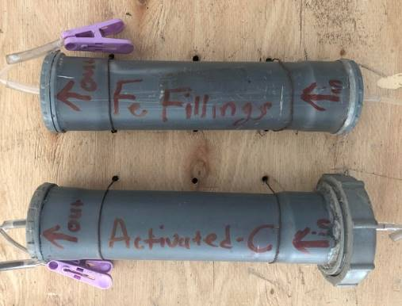

Figure 1: Designed Desulphurization unit

*High Con H2S*

*Low Con H2S*

Iron fillings

*High Con H2S*

*Low Con H2S*

Activated carbon

**PVC Pipes**

Figure 2: Schematic diagram of Desulphurization unit

The other decarboxylation scrubbers consisted of a cylindrical plastic container with a height of 20 cm and diameter of 16 cm. The cylindrical container contained two openings of 1 cm each which serves as an inlet of high concentrated CO2 and the other serves as an outlet of low concentrated CO2. The decarboxylation scrubber contained 4M Ca(OH)2 (lime water)

#### **2.2 Preparation of 4M Ca(OH)2(aq)**.

4M Ca(OH)2(aq) was prepared using the following chemical equation and calculation

 Eq. 1

Ca(OH)2(s) + H2O (l) Ca(OH)2(aq) Eq. 2

4M = Moles/0.75L

Moles = 3 moles.

Moles = Mass/Molar Mass

3 moles = Mass/56

Mass = **168g** of CaO.

168g of CaO was weighed on an electronic mass balance (Kern & Sohn GmbH, Balingen, Germany) and was dissolved in a 250 mL beaker containing 100 mL of distilled water. The mixture was stirred properly using a stirrer and the solution was submerged in a hot water bath in other to fully dissolve the precipitate. The solution was then transferred into a 750 conical flask and beaker raised severally and added to the conical flask. Distilled water was then added to the conical flask up to the 750 mL mark and homogenized to give 4M Ca(OH)2(aq).

20 cm

16 cm

4M Ca(OH)2

Gas bobbles

High Con CO2

Low Con CO2

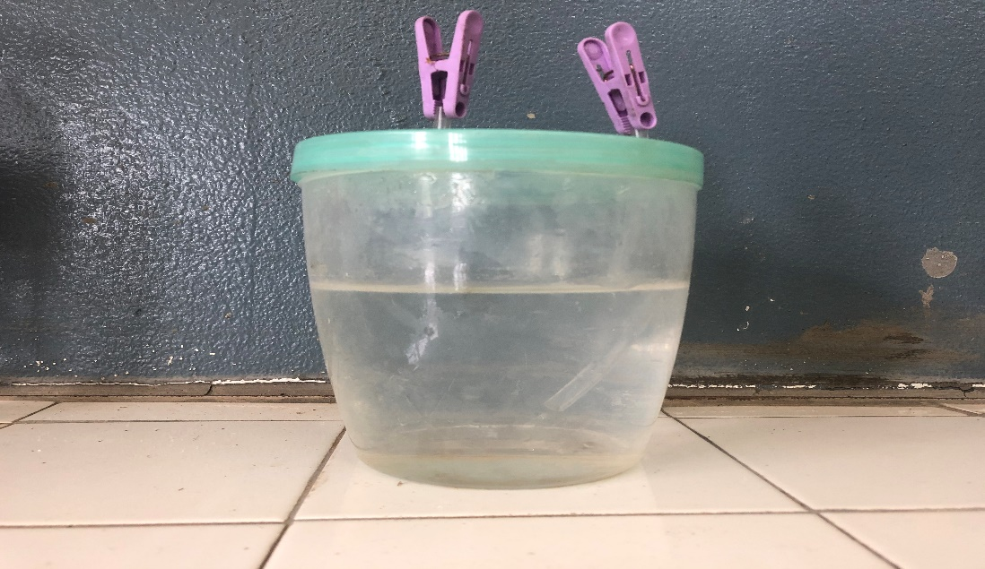

Figure 3: Decarboxylation set-up

Figure 3: Decarboxylation set-up

**Figure 4: Schematic diagram of decarboxylation scrubber**

### **2.3 Evaluation and optimization of Scrubbers**

The evaluation of the scrubbers was based on the outstanding tensile strength and high hardness for desulphurization scrubber and pH resistance and inert nature for decarboxylation scrubber.

The optimization of the scrubbers was design in an air-tight system using high quality superglue and opening tested with foam water (laundry detergent + water) to ensure that there were no leakages. Pressure was also introduce from one end of the openings while the other close and submerged in water to check for leakages. The leakages test was carried out daily for one week before the start of the experiment which gave room for optimization and minimization of leakages.

The efficiency of the scrubbers was calculated using the formula;

Decarboxylation scrubber

Eq. 3



Desulphurization scrubber

Eq. 4



### **2.4 Statistical analysis**

Average and standard deviation was calculated to each treatment and a simple time-series graph was drawn for H2S, CO2 and CH4 concentrations, to show the reduction potential of the scrubbers over time. The efficiency of the scrubbers was calculated and presented on a table. All the analysis was carried out using Microsoft Office Excel (MS Excel) MINITAB version 17.

3. results and discussion

**3.1 Hydrogen sulphide removal using desulphurization scrubber.**

Produced biogas is usually adulterated with impurities (CO2, H2S, NH3, N2, H2, water vapor etc.)which are harmful to thermal conversion systems as they may cause corrosion and fouling, resulting in harmful environmental emissions. H2S and CO2 were removed using locally designed technologies. Hydrogen sulphide (H2S) removed was taken into consideration of its poisonous and corrosive nature, which make regeneration almost impossible, and very expensive to manage, where possible (Olumide *et al.,* 2017). Scrubbing is an operation that removes H2S from raw biogas and as a result, the hydrogen sulphide is converted into dark brownish iron sulphide by the meshed iron fillings as it forms FeS(s), Fig.5.

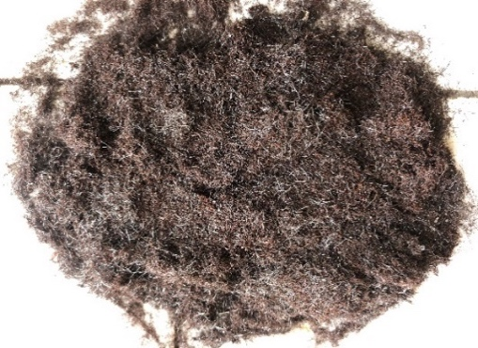

Figure 3: Decarboxylation set-up

a) Meshed iron fillings before absorption b) Meshed iron fillings after absorption

Figure 5: Hydrogen Sulphide Remover (desulphurization scrubber)



H2S con in pre-scrubbed biogas was **8443±153** ppm

H2S con in post-scrubbed biogas was **90.5±92** ppm

Figure 6: Hydrogen Sulphite concentration in biogas treated with iron fillings

H2S concentration at the outlet stream reduced by by 93.29%, absorbing ~ 8352.5 ppm over the entire sampling period giving iron fillings 98.93% efficiency, which makes it an exceptional H2S locally made scrubber as compared to the use of ethanolamine (EA) as proposed by Lasocki *et al.,* (2015) which half the outlet stream, Fig. 6 and table 1. At the beginning of the process, the solvent (meshed iron filling), rapidly and efficiently (100%) absorbed H2S and gradually reduces efficiency over time as very negligible concentration of H2S was seen in the outlet stream of the scrubber, which was higher than that of Mohanakrishnan & Joseph, (2016). This high efficiency of the mesh iron fillings led to the absorption of the rotten eggs smell (H2S) leading to little or no smell of the gas produced from the AD’s.

**Table 1: Efficiency table of locally made purification scrubbers**

|  |  |  |  |  |  |
| --- | --- | --- | --- | --- | --- |
|  | Total CO2_IN (%) | Total CO2_Out (%) | Total  H2S_IN (ppm) | Total H2S_Out (ppm) | Efficiency (%) |
| Activated Carbon | 543.1 | 73.8 | --- | --- | 86.41 |
| 4 M Ca(OH)2 | 543.1 | 79.7 | --- | --- | 85.32 |
| Iron fillings | --- | --- | 8443.0 | 90.5 | 98.93 |

Although there exist different types of H2S removal processes, meshed Iron (iron oxide) used in this research was chosen based on the fact that, it is possible to extend bed life by admitting air, thereby forming elemental Sulphur, and regenerating the iron oxide. Also, the cost construction and management of iron oxide with respect to molecular sieves and other biofilters is relatively low.

Iron oxide is still one of the oldest methods in practice, which remove hydrogen sulphide by forming insoluble iron sulphide and still being regenerated. This regeneration process is highly exothermic.

FeO(s) + H2S(g) FeS(s) + H2O(l) Eq. 5

Purification:

Fe2O3(s) + 3H2S(g) Fe2S3(s) + 3H2O(l) Eq. 6

Limited Oxygen O2 (g) + Fe (s) + H2S (g) → H2O (l) + FeS (s) Eq. 7

FeS(s) + ½O2(g) FeO(s) + S(s)

Regeneration:

Fe2S3(s) + 3/2O2(g) Fe2O3(s) + 3S(s) Eq. 8

Regeneration is possible for a limited number of times (until the surface is covered with natural Sulphur), after which the iron filling has to be renewed. If using one-column system like in the case employed in this study, the regeneration can be applied by injecting 1 – 5% air into the reaction column but loading is limited when compared to a two-column system. In a two-stage system the raw biogas streams through the first column and iron sulphide is generated. In parallel in the second column air is injected and the regeneration takes place.

The purification step is optimal between 25 and 50 °C and since the reaction with iron oxide needs water the production pipe line from the digester to the purifiers was shorten such that the water vapour in the gas stream enters the purifier. However, condensation should be avoided because the iron oxide material (pellets, grains, etc.) will stick together with water reducing the reactive surface (Wellinger & Lindberg, 2000; Chen. *et al* 2022).

**3.2 Carbon dioxide removal using decarboxylation scrubbers.**

Furthermore, the iron oxide removal technology is simple and effective (up to 99.98%). H2S output concentrations <1 ppm (related to 1,000 ppm H2S in the raw gas stream) are possible like in the case of this study during. Its general drawbacks are that the process is highly chemical intensive, the operating cost can be high, and a continuous stream of spend waste material is accumulated. Moreover, it is difficult to automate the regeneration and/or removal phase, and this can be troublesome if the heat from the regeneration is not dissipated properly. The availability of mesh iron fillings is limited in Cameroon but could be substituted by iron fillings gotten through a local knife/cutlass filling unit. The efficiently of iron filling gotten from this sector will be highly based on its small particle sizes which increase surface area for reaction within the desulphurization scrubber.

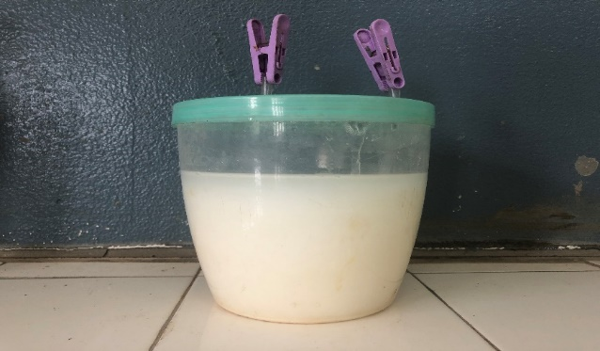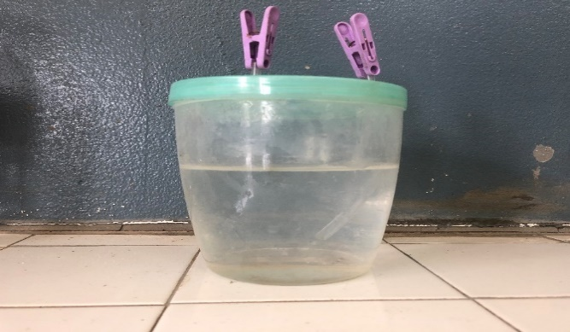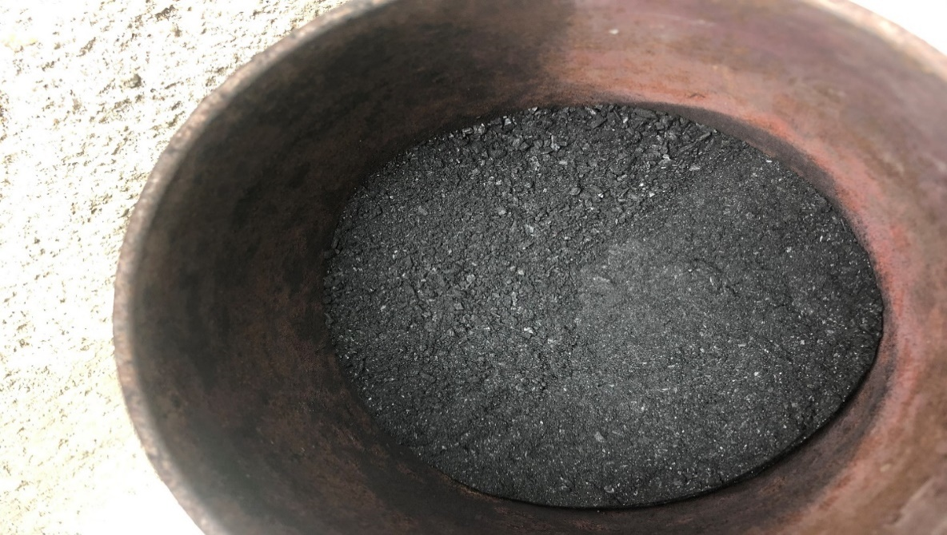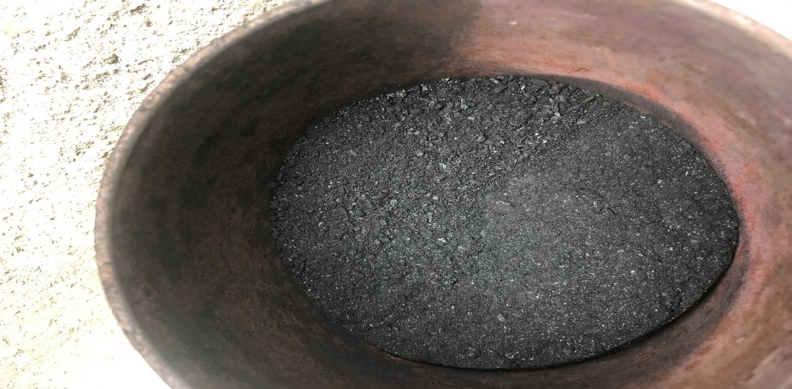

Ca(OH)2(aq) before b) Ca(OH)2(aq) after c) Activated carbon before d) Activated carbon after

Figure 7: Carbon dioxide removal (Decarboxylation scrubber)

CO2 gas is the main competitor to CH4 and its complete elimination from the AD will greatly improve on the quality of the CH4. CO2 removal was carried out using two locally designed scrubbers with an insignificant difference in their absorption pecentages. 4M Ca(OH)2(aq) gradually changes colour from a colourless fluid to cloudy, fig 7(a&b). The change in colour is an indication of the formation of CaCO3(aq) as more CO2 is being absorbed in the solvent Ca(OH)2(aq).

|  |  |  |
| --- | --- | --- |
|  | CO2(g) + Ca(OH)2(aq) CaCO3(s) + H2O(aq) | Eq. 9 |
|  |  |  |

C(s)+ CO2(g) 2CO(g) Eq. 10

4M Ca(OH)2(aq) absorbed 463.4 % of the total CO2 (543.1%)making the system 85.32% efficient which is lower than the result of Mohanakrishnan & Kurian, (2016), who uses a counter current chemical scrubing method with solvent being sodium carbonate (Na2CO3) as a scrubber. like meshed iron fillings, the efficiency reduces over time as more CaCO3(aq) is formed making the solution cloudier, Eq 4. Activated carbon on the other hand appeared coarser and glassy at the beginning and becomes finer and doll grey at the end of the process, due to the breakdown of C by moisture (since C has a high affinity for moisture) and physical absorption either at the surface or at the pore space.



Figure 8: CO2 concentration in biogas treated with Ca(OH)2(aq) and activated Carbon

At the supersaturation stage, the activated C becomes finest and changes colour to brown, Fig 7(c&d). The adsorption event takes place on the surface of the adsorbent including the porous pore surface. Both the size of the pore and gas will affect the adsorption. The pore-size of carbon dioxide adsorption is 0.38 nm which is bigger size compared to methane (0.33 nm) (Bond. & Templeton, 2011; Zhao *et al*., 2019). Similarly, carbon dioxide (44 g/gmole) has higher molecular weight compare to methane (16 g/gmole).

The larger size of carbon dioxide may cause CO2 to be retained and adsorbed on the surface of activated carbon while smaller CH4 will escape leaving activated carbon. The CO2 content in the biogas with respect to flow rate is 3 l/min has higher value compared to 2 l/min. CO2 high flow velocity may cause its flow pressure also high. High pressure will force CO2 to flow together with CH4, and not be held at the surface of adsorbent. This is also consistent with biogas purification using pressure swing adsorption (PSA), which at low operation pressure resulting in higher CH4 content compared to higher operating pressure.



I

II

III

IV

Figure 9: Absorption profile of Activated Carbon, 4M Ca(OH)2(aq) and Iron fillings

The removal of CO2 and H2S by their respective scrubbers and efficiency percentages, was evident in the final yield of methane, Fig 9 and Table 1. The combination of the decarboxylation (activated carbon and 4M Ca(OH)2(aq)) and desulphurization (meshed iron filling) scrubber, had the highest (I) absorption coefficient hence, followed by activated carbon (II), followed by 4M Ca(OH)2(aq) (III) and finally by meshed iron fillings (IV) as indicated in Fig 9.

Activated carbon is ranked the best single absorber, as it increases the quality of CH4 from 0-76% which was quite higher compared to another research which only has methane composition around 0-69% (Essam *et* al., 2018). Activated Carbon is strongly encouraged since it is a physisorption process and can be reversible by simple firing. But it is highly discouraged because of the formation of CO when if not properly handle cause adverse health issues.

4. Conclusion

The study aimed at enhancing biogas quality through the use of purifying scrubbers demonstrated promising results. The highest CO2 absorption efficiency was observed with activated carbon (86.41%), while the lowest was achieved with 4M Ca(OH)2 (85.32%). Notably, the scrubbers also exhibited high efficiency in H2S absorption (98.93%), significantly reducing odors from the produced gas, as confirmed by olfactory testing. Additionally, the integration of multiple purifying chambers led to a substantial improvement in methane quality, increasing its concentration from 0% to 80.8%. These findings underscore the effectiveness of purifying scrubbers in enhancing the overall quality of biogas, particularly in terms of CO2 and H2S reduction, offering a promising approach for optimizing biogas production.

References

IRENA. (2021). *Renewable energy statistics 2021.* Abu Dhabi: IRENA: Renewable energy statistics 2021.

A.B. Rosenani, R. Rovica, P.M. Cheah, & C.T. Lim . (2016). Growth performance and nutrient uptake of oil palm seedling in prenursery stage as influenced by oil palm waste compost in growing media. *Int. J. Agron*, 1-8.

Adhikari BK., Barrington S., Martinez J., & King S. (2009). Effectiveness of three bulking agents for food waste composting. *Waste Manag*, 29:197-203.

Ahn, H. K., Mulbry, W., White, J. W., & Kondrad, S. L. (2011). Pile mixing increases greenhouse gas emissions during composting of dairy manure. *Bioresource Technology, 102(3)*, 2904–2909.

Angelidaki, I., Treu, L., Tsapekos, P., Luo, G., Campanaro, S., Wenzel, H., & Kougias, P. G. . (2018). Biogas upgrading and utilization: Current status and perspectives. *Biotechnology Advances, 36(2)*, 452-466.

Azaizeh, H. (2010). Co-digestion of olive mill wastewater and swine manure using up-flow anaerobic sludge blanket reactor for biogas production. *Journal of Water Resource and Protection*, 2(4), 314-321.

Chen, J., Shen, Z., & Zhang, J. (2022). Effect of water vapor and oxygen partial pressure on oxidation of Fe and Fe–Cr alloys. High Temperature Corrosion of Materials*Springer Science+Business Media, LLC*

D. Thyagarajan, M. Barathi, & R. Sakthivadivu . (2013). Scope of poultry waste utilization . *IOSR J. Agric. Vet. Sci*, 29-35.

D.J. Walker., R. Clemente., & M.P. Bernal. (2004). Contrasting effects of manure and compost on soil pH, heavy metal availability and growth of Chenopodium album L. in a soil contaminated by pyritic mine waste . *Chemosphere*, 215-224.

de Bertoldi M., Vallini G., & Pera A. (1983). The biology of composting: a review. *Waste Manag Res*, 1, 57-76.

Deublein Dieter and Angelika Steinhauser. (2011). *Biogas from Waste and Renewable Resources: An Introduction, 2nd, Revised and Expanded Edition.* John Wiley & Sons.

Diaz LF., Savage GM., Diaz LF., de Bertoldi M., Bidlingmaier W., & Stentiford E. (2007). Factors that affect the process In Compost science and technology. *Amsterdam: Elsevier*, 49-65.

Ekane, M., Tita, M. A., & Ndoh, M. (2022). The potential of biogas technology in Cameroon: Case study of Buea municipality. *Renewable Energy Journal, 19(4)*, 56-67.

Essam Ibrahim Hammad., Mohammad R. Al-Agha., & Yasser El-Nahhal. (2018). Enhancing Biogas Production: Influence of Mixing Cow and Chicken Manures. . *Scientific research publishing*, 389.

FAO. (2020). *State of Food and Agriculture in Africa. Rome: Food and Agriculture Organization of the United Nations.* Rome: FAO.

Fischer D. & Glaser, B. (2012). Synergisms between compost and biochar for sustainable soil amelioration S. Kumar, A. Bharti (Eds.), Management of Organic Waste. *InTech, Rijeka, Croatia*, 167-198.

Gelegenis, J.; Georgakakis, D.; Angelidaki, I.; Christopoulou, N.; and Goumenaki, M. (2006). Optimization of biogas production from olive-oil mill wastewater, by codigesting with diluted poultry-manure. *Applied Energy*, 84(6), 646-663.

Godi NY., Zhengwuvi LB., Adulkadir S. and Kamtu P. (2013). Effect of cow dung variety onbiogas production. *Journal of Mechanical Engineering Research*, 31;5(1):1-4.

Goldemberg J. and Johansson TB. (2004). World energy assessment overview 2004 update. NewYork. *UNDP*, 88.

Goyal S., Dhull SK., & Kapoor KK. (2005). Chemical and biological changes during composting of different organic wastes and assessment of compost maturity. *Bioresour Technol*, 84-91.

Haug, R. T. (1993). The Practical Handbook of Compost Engineering.

J.W.C. Wong, K.F. Mak, N.W. Chan, A. Lam, M. Fang, L.X. Zhou, Q.T. Wu, & X.D. LiaoCo. (2001). Composting of soybean residues and leaves in Hong Kong . *Bioresour. Technol*, 99-106.

K. Wang, C. He, S. You, W. Liu, W. Wang, R. Zhang, H. Qi, & N. Ren . (2015). Transformation of organic matters in animal wastes during composting. *J. Hazard Mater*, 745-753.

Karnchanawong S., Mongkontep T., & Praphunsri K. (2017). Effect of green waste pretreatment by sodium hydroxide and biomass fly ash on composting process. *J Clean Prod*, 14-19.

Khoshnevisan, B., Tsapekos, P., Alvarado-Morales, M., Angelidaki, I., & Zhang, Y. . (2021). Advances in biogas upgrading technologies: From multi-stage reactors to chemical scrubbing. *Renewable and Sustainable Energy Reviews, 146*, 111186.

Kumar, S., Mondal, A. N., Gaikward, S. A., Devotta,. (2004). Qualitative assessment of methane emission inventory from municipal solid waste disposal sites: a case study, Atmos. *Environironment*, 4921–4929.

Kuwahara, F., Sano, Y., Nakayama, A., Nakasaki, K. and Fukazawa, T. (2009). Numerical modeling of a composting process with aeration. *Journal of Porous Media, 12*, 927–938.

Ladanai., Svetlana. and Johan V. (2009). *Global potential of sustainable biomass for energy.* Uppsala: SLU, Institutionen för energi och teknik.

Lasocki, J., Kołodziejczyk, K., & Matuszewska, A. (2015). Laboratory-scale investigation of biogas treatment by removal of hydrogen sulfide and carbon dioxide. *Polish Journal of Environmental Studies, 24(3)*, 1427–1434.

Lin, C. (2008). A negative-pressure aeration system for composting food wastes. *Bioresour. Technol*, 7651-7656.

Lin, Y.P.,Huang, G.H., Lu, H.W. and He, L. (2008). Modelling of substrate degradation and oxygen consumption in waste composting processes. *Waste Management, 28*, 1375–1385.

M. Grube, J.G. Lin, P.H. Lee & S. Kokorevicha. (2006). Evaluation of sewage sludge-based compost by FT-IR spectroscopy. *Geoderma*, 324-333.

Ma, J.; Wambeke, V.M.; Carballa, M.; and Verstraete, W. (2007). Improvement of the anaerobic treatment of potato processing wastewater in a UASB reactor by co-digestion with glycerol. *Biotechnology Letters*, 30(5) 861-867.

Maghanaki, M.M., Ghobadian, B., Najafi, G., & Galogah, R.J. (2013). Potential of Biogas Production in Iran. *Renewable and Sustainable Energy Reviews, 28*, 702-714. Retrieved from https://doi.org/10.1016/j.rser.2013.08.021

Mayur Shirish Jain., Mohit Daga. & Ajay S. Kalamdhad . (2019). Variation in the key indicators during composting of municipal solid organic wastes. *Sustainable Environment Research*, 6.

MINEPIA. (2019). *Annual report on livestock production in Cameroon.* Yaoundé:: Ministry of Livestock, Fisheries and Animal Industries.

Mkhabela MS. & Warman, P. (2005). M.S. Mkhabela, P.R. WarmanThe influence of municipal solid waste compost on yield, soil phosphorus availability and uptake by two vegetable crops grown in a Pugwash sandy loam soil in Nova Scotia Agric. *Ecosyst. Environ*, 57-67.

Mohanakrishnan, L., & Joseph, K. . (2016). Chemical scrubbing for removal of CO₂ from biogas using algae and H₂S using sponge iron. *International Journal of Renewable Energy and Environmental Engineering, 4(2)*, 35–41.

Mutungwazi, A., Matamba, T., & Zimwara, D. (Journal of Energy in Southern Africa, 32(3),). *Enhancing biogas production in Africa: Challenges and opportunities.* 45-59: 2021.

N. Trautmann, T. Richard, & M. Krasny. (1996). The Science and Engineering of Composting. *Cornell. Waste Management Institute, Department of Crop and. Soil Sciences. Cornell University, Ithaca, NY*.

Nakayama, A., Nakasaki, K., Kuwahara, F. and Sano, Y. (2007). A lumped parameter heat transfer analysis for composting processes with aeration. *Transactions of the ASME, 129*, 902–906.

Ndzana, J. E., Ateba, B., & Njomgang, R. (2020). Biogas development in rural Cameroon: A review of challenges and opportunities. *African Journal of Renewable Energy, 7(1)*, 23-34.

Ofoefule, A. U., Okoro, U. C., Onukwuliand, O. D. and Anyanwu, N.C. (2013). Biogas Production from Waste By-products of Ethanol Production: Modeling of Gas Yield with Time. *Physical Review & Research International*, 3(1), 18-27.

Olumide, Awe. W., Minh, D. P., Lyczko, N., Nzihou, A., & Zhao, Y. (2017). Laboratory-scale investigation of the removal of hydrogen sulfide from biogas and air using industrial waste-based sorbents. *Journal of Environmental Chemical Engineering, 5(2)*, 1809–1820.

Pihlatie, M.K., Christiansen, J.R., Aaltonen, H., Korhonen, J.F.J., Nordbo, A., Rasilo, T., Benanti, G., Giebels, M., Helmy, M., Sheehy, J., Jones, S., Juszczak, R. and Klefoth, R. (2013). Comparison of static chambers to measure CH4 emissions from soils. *Agr Forest Meteorol*, 171–172, 124–136.

Q. Li, X.C. Wang, H.H. Zhang, H.L. Shi, T. Hu, & H.H. Ngo . (2013). Characteristics of nitrogen transformation and microbial community in an aerobic composting reactor under two typical temperatures. *Bioresour. Technol*, 270-277.

Rajendran, K., Solmaz, A., and Mohammad, J. T. (2012). Household biogas digesters—A review, 2012. *Energies*, pp. 2911-2942, 5(8).

Rich N., Bharti A. & Kumar S. (2018). Effect of bulking agents and cow dung as inoculant on vegetable waste compost quality. *Bioresour Technol*, 83-90.

Rynk, R. (2000). Fires at composting facilities. *BioCycle Magazine, 41*, 54–58.

S. Kalantari, S. Hatami, M.M. Ardalan, H.A. Alikhani, & M. Shorafa. (2010). The effect of compost and vermicompost of yard leaf manure on growth of corn. *Afr. J. Agric. Res*, 1317-1323.

S. Vigneswaran, J. Kandasamy, & M.A.H. Johir . (2016). Sustainable operation of composting in solid waste management Procedia . *Environ. Sci*, 408-4015.

T. Hernández, C. Chocano, J.L. Moreno, & C. García. (2016). Use of compost as an alternative to conventional inorganic fertilizers in intensive lettuce (Lactuca sativa L.) crops—effects on soil and plant . *Soil Till. Res*, 14-22.

T. Kuba, A. Tschöll, C. Partl, K. Meyer, & H. Insam. (2008). Wood ash admixture to organic wastes improves compost and its performance Agric. *Ecosyst. Environ*, 43-49.

TB, G. J. (2004). World energy assessment overview 2004 update. NewYork: UNDP. P.88. *UNDP*, 88.

Telliard, W. A. (2001). METHOD 1684: Total, fixed, and volatile solids. *U.S. Environmental Protection*.

Varma VS. & Kalamdhad. AS. (2014). Effects of leachate during vegetable waste composting using rotary drum composter. *Environ Eng Res*, 67-73.

Varma VS., Mayur C., & Kalamdhad A. (2014). Effects of bulking agent in composting of vegetable waste and leachate control using rotary drum composter. *Sustain Environ Res*, 45-56.

W.R. Carlile, C. Cattivello, & P. Zaccheo. (2015). Organic growing media: constituents and properties. *Vadose Zone J*, 1-13.

Xue, Q., Chen, Z., & Zhang, Z. (2019). Approaches to mitigation of hydrogen sulfide during anaerobic treatment of wastewater: A review. *Frontiers in Environmental Science, 7*, 79.

Yacob, S.; Shirai, Y.; Hassan, M.A.; Wakisaka, M. and Subash, S. (2006). Start-up operation of semi-anaerobic digester for palm oil mill effluent treatment. *Process Biochemistry*, 41(4), 962-964.

Yamada Y. & Kawase, Y. (2006). Aerobic composting of waste activated sludge: kinetic analysis for microbiological reaction and oxygen consumption. *Waste Manag*, 49-61.

Zhang L. & Sun, X. (2016). Influence of bulking agents on physical, chemical, and microbiological properties during the two-stage composting of green waste. *Waste Manag*, 15-26.

Zhao, J., Qin, Y., Shen, J., Zhou, B., Li, C., & Li, G. (2019). Effects of Pore Structures of Different Maceral Compositions on Methane Adsorption and Diffusion in Anthracite.*Applied Sciences, 9(23)*5130