Original Research Article
Predictive value of Improved and Non-Improved LV Global longitudinal strain in Revascularized Acute Myocardial Infarction Patients

ABSTRACT
Background: Echocardiographic measures predict adverse outcomes in cardiac disease patients including prior ST-segment elevation myocardial infarction (STEMI).
Aim: To assess the association between improved and non-improved global longitudinal strain (GLS) after three months of percutaneous coronary intervention (PCI)-treated acute myocardial infarction (AMI) and clinical outcomes over one year.
Patients and methods: A prospective observational study was conducted at Damietta Cardiology Center (Jan 2022 – June 2023) on 100 patients (44–73 years). They were divided into Group A (improved GLS after revascularized AMI) and Group B (non-improved GLS)
Results: GLS improvement, anterior STEMI, baseline Ejection Fraction (EF%) versus EF% after 3 months, baseline E/e ratio versus E/e ratio after 3 months, maximum Troponin T level, symptoms-to-needle time, and number of implanted stents are statistically significant predictors of Cardiovascular and Cerebrovascular Events (CCVE) occurrence (P<0.05), with an overall prediction accuracy of 92%. However, age, sex, and medical history are not statistically significant predictors of CCVE occurrence (P>0.05).
Baseline (GLS) and GLS after 3 months are statistically significant predictors of CCVE occurrence (P=0.001), with cutoff points of -7.5 and -13.0, respectively. The sensitivity and specificity for predicting CCVE occurrence are 98.4% and 86.0% for baseline GLS, and 100.0% for both sensitivity and specificity for GLS after 3 months.
Conclusion: GLS proved superior to LVEF in predicting CCVE in revascularized AMI, with baseline (-7.5) and 3-month GLS (-13) as key predictors. Improvement correlated with age, prior MI, and inferior STEMI, while non-improvement linked to anterior STEMI.
Key words: STEMI, Troponin, AMI, GLS.

INTRODUCTION
Echocardiographic measures of cardiac structure and function predict adverse outcomes in patients with cardiac diseases including prior ST-segment elevation myocardial infarction (STEMI) (1,2).
Post-STEMI, these patients face a significantly increased risk for heart failure with concomitant high morbidity and mortality (3,4).
In the past decade, new echocardiographic parameters have been introduced and investigated for their prognostic value. Global longitudinal strain (GLS), especially, has proved to add valuable information about prognosis in patients with cardiac disease (5).
Reduced global longitudinal strain (GLS) is a more sensitive
predictor for cardiac events and remodeling than LVEF post-AMI, especially among patients without reduced LVEF (6)
In a study of patients treated with PCI for ST-segment elevation myocardial infarction (STEMI), (7)reported significant improvement of GLS at 3 months and between 3 and 12 months. Left anterior descending artery as culprit vessel, peak cardiac troponin T level and diastolic function were the independent predictors for improvement. (8,9)studied post AMI patients of whom 47% had STEMI and 90% had been treated with PCI. GLS significantly improved during the following 12 months, with independent predictors being initial impairment of LV function, including assessment with GLS, male gender, non-smoking and treatment with beta-blockers. None of these studies, however, explored the association between the improvement or non-improvement of GLS and subsequent composite cardiovascular events (CCVE).
The aim of this work was to explore the association between improved and non improved GLS after 3 months following PCI treated AMI and clinical out -come during follow up for 1 year.

PATIENTS AND METHODS
A prospective observational follow-up study was conducted at the cardiovascular department of Damietta Cardiology Center from January 2022 to June 2023, including 100 patients aged 44 to 73 years. Patients were classified into two groups: Group A, comprising those with improved global longitudinal strain after revascularized acute myocardial infarction, and Group B, consisting of those with non-improved global longitudinal strain after revascularized acute myocardial infarction.
Inclusion criteria: The study included patients presenting with acute myocardial infarction (AMI), including ST-elevation myocardial infarction (STEMI) and non-ST-elevation myocardial infarction (NSTEMI), who had sinus rhythm, good echocardiographic images, a life expectancy of more than one year, were willing to attend the second examination, and were hemodynamically stable.
Exclusion criteria: hemodynamically unstable patients, those with atrial fibrillation or flutter, poor echocardiographic images, a life expectancy of less than one year, or those unwilling to attend the second examination.

Methodology:
medical history assessment, including age, sex, special habits, and ischemic heart disease risk factors such as hypertension, diabetes mellitus, dyslipidemia, and previous myocardial revascularization. Clinical examination included blood pressure measurement and auscultation for gallop, S3, and murmurs. A 12-lead ECG was performed to detect ischemic changes, chamber enlargement, and arrhythmias. Conventional transthoracic echocardiography assessed LV systolic and diastolic function, chamber enlargement, and valvulopathies, while 2D speckle tracking echocardiography measured global longitudinal strain at baseline and three months post-revascularization. Patients were followed for one year to monitor cardiovascular events, including reinfarction, hospitalization for heart failure, angina, ventricular arrhythmias, new-onset atrial fibrillation, stroke/TIA, and death. Transthoracic and 2D speckle tracking echocardiography were performed using the GE Vingmed Ultrasound M5Sc system.
The 2D speckle tracking echocardiography technique: Involved acquiring images from apical four-chamber, two-chamber, and three-chamber views, optimizing gain settings, reducing depth for better visualization, and maintaining a frame rate between 30 and 70 fps. Proper ECG gating was ensured, and images were acquired in breath-hold to minimize artifacts. Image analysis was conducted using dedicated software, beginning with the apical long-axis view to time aortic valve closure. The endocardial border was manually traced, and a region of interest (ROI) was carefully adjusted to exclude echogenic pericardium. The software tracked myocardial speckles frame by frame, generating moving images, strain curves, and segmental/global longitudinal strain (GLS). GLS values were classified as >16% abnormal, 16–18% borderline, and <18% normal. ECG was performed using the Biocare IE-300 system, while coronary angiography and PCI were conducted using Siemens Artis Zee Ceiling and GE IGS520 systems.
Statistical analysis and data interpretation
Data analysis was performed using SPSS version 18. Qualitative data were presented as numbers and percentages, while quantitative data were expressed as median (IQR) or mean ± SD based on normality. Statistical tests included Chi-Square, Fisher’s exact, Mann-Whitney U, paired t-test, and Spearman's correlation. ROC curves assessed sensitivity, specificity, and cut-off points, while binary logistic regression analyzed the impact of multiple variables on outcomes. Significance was set at p<0.05.

RESULTS
Table (1): Demographic Characteristics, Mean Ejection Fraction, and E/e at Baseline and After 3 Months Follow-Up
 | N=100 | %
Age/ years | 58.3±7.33  (44-75)
Sex  Male  Female | 73  27 | 73.0  27.0
TTE | Mean ± SD
Base line EF % | 45.42±8.35
EF% after 3 months | 49.24±9.45
t | 15.08
P value | <0.001*
Basel E/e | 9.99±2.57
E/e after 3 months | 9.40±2.58
t | 8.46
P value | <0.001*
t: Paired t test, *statistically significant
Table (1) shows that mean age of studied cases is 58.3±7.33. Males represent 73% of the cases while females represent 27% and there is statistically significant difference between baseline and after 3 months follow up as regard EF% and E/e (P<0.001) (45.42±8.35 vs 49.24±9.45 and 9.99±2.57 vs 9.40±2.58, respectivel

Table (2): Troponin Levels, Symptoms-to-Needle Time, Number of Implanted Stents, and Incidence of CCVE Among Studied Cases
CCVE | N=100 | %
Recurrent MI  STEMI  NSTEMI | 13  2  11 | 13.0  2.0  11.0
Heart failure hospitalization | 29 | 29.0
VT hospitalization | 13 | 13.0
AP hospitalization | 46 | 46.0
New onset AF | 27 | 27.0
TIA/Stroke hospitalization | 7 | 7.0
Death | 2 | 2.0
Total CCVE events | 1.0(0.0-5.0)
Troponin T max (ng/ml)  Mean ±SD | 23.78±13.38
Symptoms to needle time  Mean ±SD | 23.70±19.67
≤10  >10 | 31  69 | 31.0  69.0
No of stent implanted  Median (range) | 2(1-3)
VT: Ventricular tachycardia, AP: Angina pectoris, AF: Atrial fibrillation, TIA:Transient ischemia attack
Table (2) shows that 13% of the studied cases had recurrent MI, 29% had Heart failure hospitalization, 46% AP hospitalization, 13% VT hospitalization, 27% New onset AF, 7% TIA/Stroke hospitalization and 2% died and mean Troponin is 23.78±13.38, mean symptoms to needle time is 23.70±19.67 and median number of implanted stent among studied cases is 2(1-3).

Table (3): Demographic characteristics according to improvement in GLS.
 | Not improved  (n=36) | Improved  (n=64) | Test of significance | P value
Age/ years  Mean ±SD | 55.89±5.89 | 59.66±7.74 | 2.54 | 0.013*
Sex  Male  Female | 28(77.8)  8(22.2) | 45(70.3)  19(29.7) | 0.651 | 0.420
Used test: Student t test, Chi-Square test, *statistically significant
Table (3) shows that there is statistically significant difference between improved (improvement in GLS) cases and non-improved cases regarding age (P=0.013), where improved cases were older, but there is non-statistically significant difference as regard sex (P=0.42).

Table (4): Relation between CCVE incidence and demographic, clinical and laboratory findings.
 | CCVE |  | Test of significance | P value
 | NO event  N=49 | ≥one event  N=51
GLS  Not improved  Improved | 4(8.2)  45(91.8) | 32(62.7)  19(37.3) | 32.31 | <0.001*
Age/ years | 59.12±7.06 | 57.5±17.56 | 1.11 | 0.273
Sex  Male  Female | 35(71.4)  14(28.6) | 38(74.5)  13(25.5) | 0.120 | 0.729
Medical history  Diabetes mellitus  Hypertension  Smoking  Previous MI | 22(44.9)  29(59.2)  30(61.2)  0 | 27(52.9)  31(60.8)  30(58.8)  16(31.4) | 0.647  0.027  0.06  18.30 | 0.421  0.870  0.806  <0.001*
AMI  NSTEMI  Lateral STEMI  Inferior STEMI  Anterior STEMI | 25(51.0)  3(6.1)  19(38.8)  2(4.1) | 19(37.3)  0  13(25.5)  19(37.3) | 18.67 | <0.001*
TTE  Base line EF %  EF% after 3 months | 50.26±4.31  54.82±4.94 | 40.76±8.66  43.88±9.68 | 6.90  7.07 | <0.001*  <0.001*
Basel E/e  E/e after 3 months | 8.67±1.48  8.10±1.34 | 11.25±2.77  10.65±2.86 | 5.78  5.65 | <0.001*  <0.001*
Troponin T max  (ng/ml) | 16(11-19) | 33(20-42) | 6.01 | <0.001*
Symptoms to needle time  ≤10  >10 | 23(46.9)  26(53.1) | 8(15.7)  43(84.3) | 11.41 | 0.001*
No.of stent implanted | 1(1-1) | 2(2-3) | 8.15 | 0.001*
Used test: Mann Whitney U test, Chi-Square and Fisher exact test, *statistically significant
Table (4) shows that there is statistically significant relation between CCVE incidence and (GLS improvement, Previous MI, STEMI vs NSTEMI, Base line EF % vs EF% after 3 months, Basel E/e vs E/e after 3 months, Troponin T max, Symptoms to needle time and No.of stent implanted) (P<0.05), but there is non-statistically significant relation between CCVE incidence and Diabetes mellitus, Hypertension and Smoking (P>0.05).

Table (5): Predictors of CCVE occurrence among studied cases.
 | Univariate analysis |  | Multivariate analysis
 | P value | COR(95%CI) | P value | AOR(95%CI)
GLS  Not improved  Improved (R) | <0.001* | 18.95(10.88-25.02)  1 | 0.001* | 17.98(10.7-20.1)  1
Age/ years | 0.271 | 0.970(0.918-1.02)
Sex  Male  Female ( R) | 0.729 | 1.17(0.483-2.83)  1
Medical history  Diabetes mellitus  Hypertension  Smoking  Previous MI | 0.422  0.870  0.806  0.998 | 1.38(0.629-3.03)  1.07(0.480-2.38)  0.905(0.406-2.02)  Undefined
AMI  NSTEMI( R)  Lateral STEMI  Inferior STEMI  Anterior STEMI | .999  .824  .002* | 1  .000(undefined)  .900(0.357-2.27)  12.5(9.59-22.35) | 0.01* | 10.15(8.7-13.8)
TTE  Base line EF %  EF% after 3 months | 0.001*  0.001* | 0.818(0.752-0.889)  0.829(0.765-0.898) | 0.001*  0.001* | 0.800(0.722-0.875)  0.822(0.688-0.900)
Basel E/e  E/e after 3 months | 0.001*  0.001* | 1.64(1.32-2.04)  1.66(1.32-2.09) | 0.001*  0.001* | 1.55(1.1-2.1)  1.54(1.10-2.4)
Troponin T max  (ng/ml) | 0.001* | 1.18(1.10-1.25) | 0.001* | 1.58(1.0-3.1)
Symptoms to needle time  ≤10(R)  >10 | 0.001* | 1  4.76(1.86-12.17) | 0.001* | 1  3.77(1.45-10.25)
No.of stent implanted | 0.001* | 13(10.25-15.08) | 0.001* | 12(9.8-14.2)
Overall% Predicted =92%
R: reference, AOR:Adjusted odds ratio , COR:Crude odds ratio
Table (5) shows that (GLS improvement, anterior STEMI, Base line EF % vs EF% after 3 months, Basel E/e vs E/e after 3 months, Troponin T max, Symptoms to needle time and No.of stent implanted) are statistically significant predictors of CCVE occurrence (P<0.05) with Overall Predicted %=92%, but age, sex and medical history are statistically significant predictors of CCVE occurrence (P>0.05).

Table (6): Validity of GLS in predicting CCVE among studied cases
Test Result Variable(s) | Area | P value | Asymptotic 95% Confidence Interval |  | Cut off point | Sensitivity % | Specificity %
Test Result Variable(s) | Area | P value | Lower Bound | Upper Bound | Cut off point | Sensitivity % | Specificity %
GLS.  BASELINE | .995 | .001* | .987 | 1.003 | -7.5 | 98.4 | 86.0
GLS3 | 1.000 | .001* | 1.000 | 1.000 | -13.0 | 100.0 | 100.0
GLS:Global longitudinal strain

Table (6) shows that (GLS.BASE LINE and GLS3) are statistically significant predictors of CCVE occurrence (P=0.001) with Cutoff point (-7.5 and -13.0, respectively), Sensitivity % (98.4 and 100.0, respectively) and Specificity % (86.0 and 100.0, respectively).

CASE PRESENTATION

Case No.1 (improved GLS)
age :55 yrs
sex : male +
: female -

Medical History:
Diabetes mellitus: +
Hypertension: +
Smoking: +
Previous MI: -
ECG: ST segment elevation at anterior leads
Troponin T max: 7 ng/ml
Transthorathic ECHO parameters:
Basal EF:46%
EF after 3 months: 57%
Basal E/e: 8
E/e after 3 months: 7
2d speckle tracking ECHO:
Basal GLS -9%
GLS after 3 months -18%

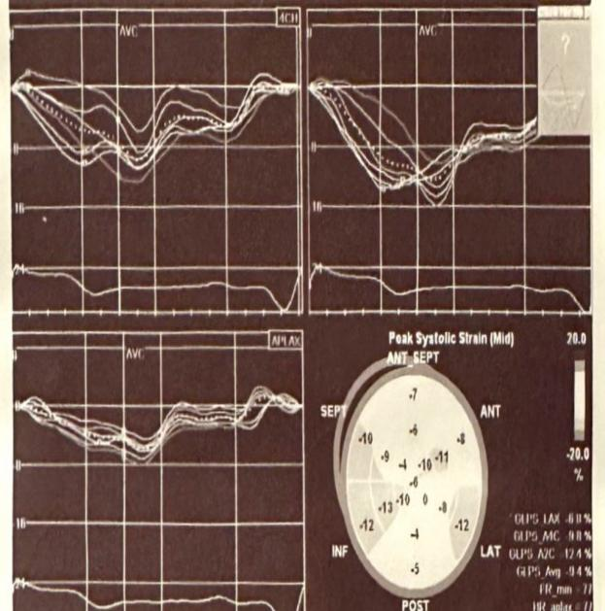  A | 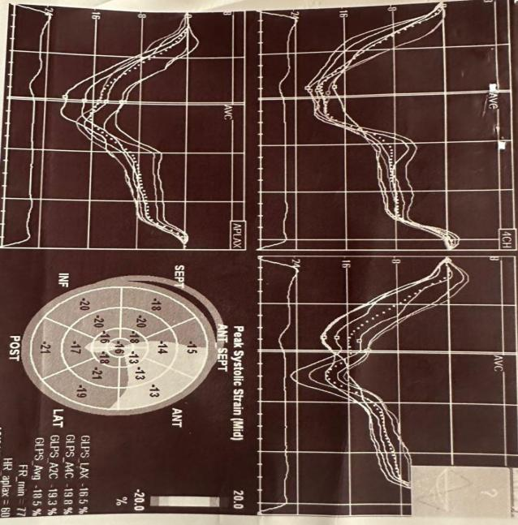  B
Figure (1): (A): basal GLS. (B): GLS3

Symptoms to needle time: 7 hours
Coronary angiography: showed proximal LAD subtotal 99% occlusion
No of stent implanted: 2

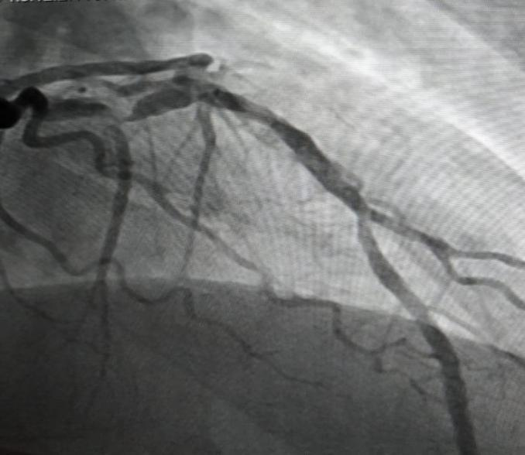 | 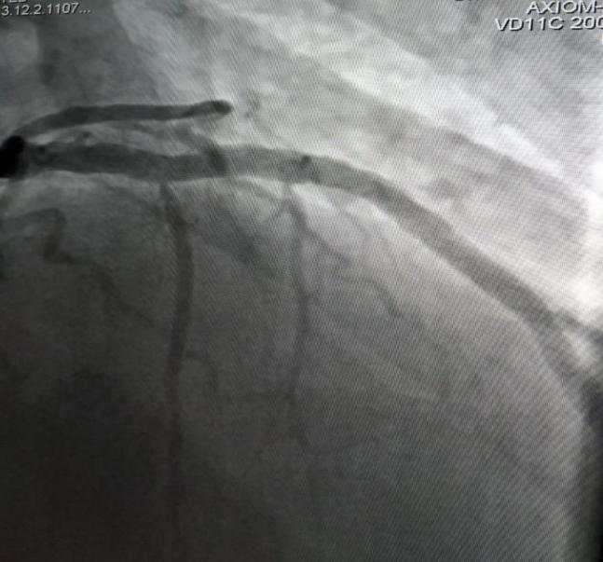
Figure (2)

CCVE:
Reccurent MI -
HF hospitalization -
VT hospitalization -
AP hospitalization -
New onset AF -
TIA/Stroke -
Death -
Total CCVE 0

DISCUSSION
The present study found that mean age of studied cases was 58.3±7.33. Males represented 73% of the cases while females represented 27%. Majority of studied cases were hypertensive and smokers (60%), 49% were diabetic and 16% had Previous MI.
Majority of studied cases had NSTEMI (44%), 32% had Inferior STEMI, 21% Anterior STEMI and 3% had Lateral STEMI.
In harmony, Otterstad et al, (10) aimed to explore if non-improvement of GLS after 3 months was associated with higher risk of subsequent composite cardiovascular events (CCVE). Mean age in the study group was 65 (±10) years, 25% were females and 17% had a previous MI. The percentage of STEMI was 53%, all treated with primary PCI at a median of 4.0 (IQR 3.0) hours after debut of symptoms.
Additionally, the present study showed that there was statistically significant difference between baseline and after 3 months follow up as regard EF% and E/e (P<0.001) (45.42±8.35 vs 49.24±9.45 and 9.99±2.57 vs 9.40±2.58, respectively).
In Antoni et al, (11) study of patients treated with PCI for ST-segment elevation myocardial infarction (STEMI), they reported significant improvement of GLS at 3 months and between 3 and 12 months
Our study shows that mean Troponin is 23.78±13.38, mean symptoms to needle time is 23.70±19.67 and median number of implanted stent among studied cases is 2(1-3).
Our study shows that 13% of the studied cases had recurrent MI, 29% had Heart failure hospitalization, 46% AP hospitalization, 13% VT hospitalization, 27% New onset AF, 7% TIA/Stroke hospitalization and 2% died. Interestingly, the present study showed statistically significant difference between improved (improvement in GLS) cases and non-improved cases regarding age (P=0.013), where improved cases were older, but there is non-statistically significant difference as regard sex (P=0.42).Also, there was statistically significant difference between improved (improvement in GLS) cases and non-improved cases regarding Previous MI (P=0.001), where improved cases had no Previous MI, but there is non-statistically significant difference as regard DM, HTN and smoking (P>0.05).
In disagreement with current findings, Attar et al, (12) showed statistically significant difference between improved (improvement in GLS) cases and non-improved cases regarding age (P=0.008), where improved cases were younger, but, in agreement with current results, there was non-statistically significant difference as regard sex, DM, hyperlipidemia and smoking (P>0.05). (P=0.99).
Specifically, the present study found statistically significant relation between CCVE incidence and (GLS improvement, Previous MI, STEMI vs NSTEMI, Base line EF % vs EF% after 3 months, Basel E/e vs E/e after3 months, Troponin T max, Symptoms to needle time and No.of stent implanted) (P<0.05), but there was non-statistically significant relation between CCVE incidence and Diabetes mellitus, Hypertension and Smoking (P>0.05).Consequently, (GLS improvement, anterior STEMI, Base line EF % vs EF% after 3 months, Basel E/e vs E/e after 3 months, Troponin T max, Symptoms to needle time and No.of stent implanted) were statistically significant predictors of CCVE occurrence (P<0.05) with Overall Predicted %=92%, but age, sex and medical history were non-statistically significant predictors of CCVE occurrence (P>0.05).
In agreement with our findings, Otterstad et al, (10) found that the role of baseline GLS as predictor of CCVE was confirmed for all CCVE, but was not significant in addition there were several important confounders such as baseline LVEF, anterior wall STEMI and, especially, previous AMI, which may have influenced the prognostic role of baseline GLS, as opposed to the findings in most other studies.
The present study showed that (GLS.BASE LINE and GLS3) are statistically significant predictors of CCVE occurrence (P=0.001) with Cutoff point (-7.5 and -13.0, respectively), Sensitivity % (98.4 and 100.0, respectively) and Specificity % (86.0 and 100.0, respectively).Therefore, (GLS.BASE LINE, GLS3, age, Base line EF % vs EF% after 3 months, Basel E/e vs E/e after 3 months, Troponin T max and No.of stent implanted) were statistically significant predictors of total CCVE events (P<0.05), but Symptoms to needle time was non-statistically significant predictors of total CCVE events (P>0.05).
In agreement, Sverre et al, (13) found non-linear association of CCVE with age. The youngest patients (i.e. 40–50 year) seemed to have a significantly higher risk of recurrent CCVE than the middle-aged (i.e. 50–60 and, in part 60–70 years). A possible explanation might be a more severe disease among those who sustain AMI at a younger age, or higher prevalence of unhealthy lifestyle behavior.
Antoni et al, (11) found that left anterior descending artery as culprit vessel, peak cardiac troponin T level and diastolic function were the independent predictors for improvement.
Baron et al, (14) reported that GLS significantly improved during the following 12 months, with independent predictors being initial impairment of LV function, including assessment with GLS, male gender, non-smoking and treatment with beta-blockers.

CONCLUSIONS
This study confirmed that GLS is a more sensitive prognostic factor than LVEF in cardiac diseases. Baseline GLS (-7.5) and GLS after 3 months (-13) predicted CCVE in revascularized AMI patients. GLS improvement was associated with age, previous MI, and inferior STEMI, while non-improvement was linked to anterior STEMI, with no association with NSTEMI, lateral STEMI, DM, HTN, or smoking. Improved GLS cases had higher Troponin T max and more stents implanted, but no difference in symptom-to-needle time.

LIMITATION
This study was limited by a small sample size, single-center design, and reliance on coronary angiography instead of intracoronary ultrasound for stent evaluation. Additionally, LV strain measurements were affected by physiological factors, technical factors, and inter-vendor variability, preventing standardized normal values.

RECOMMENDATIONS
This study, based on a small Egyptian sample, highlights the need for larger studies to strengthen the findings. Although routine repeated GLS measurements are not currently supported, further research is needed to evaluate their clinical value.

CONSENT
All authors declare that ‘written informed consent was obtained from the patients (or other approved parties) for publication of this study and accompanying images. A copy of the written consent is available for review by the Editorial office/Chief Editor/Editorial Board members of this journal.

ETHICAL APPROVAL
All authors hereby declare that all experiments have been examined and approved by the appropriate ethics committee and have therefore been performed in accordance with the ethical standards laid down in the 1964 Declaration of Helsinki.

REFERENCES
- Olsen F J, Jensen J, Pedersen S, et al. (2016): A NOVEL ECHOCARDIOGRAPHIC RISK STRATIFICATION SCHEME FOR PREDICTING HEART FAILURE HOSPITALIZATION AND CARDIOVASCULAR MORTALITY AFTER ST-SEGMENT ELEVATION MYOCARDIAL INFARCTION. Journal of the American College of Cardiology; 67: (13), 480.
- Pecherina, T., Kutikhin, A., Kashtalap, V., Karetnikova, V., Gruzdeva, O., Hryachkova, O.,et al. (2020). Serum and echocardiographic markers may synergistically predict adverse cardiac remodeling after ST-segment elevation myocardial infarction in patients with preserved ejection fraction. Diagnostics, 10(5), 301.
- Members W G, Mozaffarian D, Benjamin E J, et al. (2016): Heart disease and stroke statistics-2016 update: a report from the American Heart Association. Circulation; 133: (4), e38-e360.
- Alnemer, K. A. (2024). In-Hospital Mortality in Patients With Acute Myocardial Infarction: A Literature Overview. Cureus, 16(8).
- Biering-Sørensen T and Solomon S D (2015): Assessing Contractile Function When Ejection Fraction Is Normal. Circulation: Cardiovascular Imaging; 8: (11).
- Potter E and Marwick T H (2018): Assessment of left ventricular function by echocardiography: the case for routinely adding global longitudinal strain to ejection fraction. JACC: Cardiovascular Imaging; 11: (2 Part 1), 260-274.
- Antoni M L, Mollema S A, Atary J Z, et al. (2010a): Time course of global left ventricular strain after acute myocardial infarction. European heart journal; 31: (16), 2006-2013.
- Baron T, Christersson C, Hjorthén G, et al. (2017): Changes in global longitudinal strain and left ventricular ejection fraction during the first year after myocardial infarction: results from a large consecutive cohort. European Heart Journal - Cardiovascular Imaging; 19: (10), 1165-1173.\
- Bendary, A., Tawfeek, W., Mahros, M., & Salem, M. (2018). The predictive value of global longitudinal strain on clinical outcome in patients with ST‐segment elevation myocardial infarction and preserved systolic function. Echocardiography, 35(7), 915-921.
- Otterstad, J. E., Norum, I. B., Ruddox, V., Le, A. C. M., Bendz, B., Munkhaugen, J., et al (2021). Prognostic impact of non-improvement of global longitudinal strain in patients with revascularized acute myocardial infarction. The International Journal of Cardiovascular Imaging, 37(12), 3477-3487.
- Antoni M L, Mollema S A, Delgado V, et al. (2010b): Prognostic importance of strain and strain rate after acute myocardial infarction. European heart journal; 31: (13), 1640-1647.
- Attar, A., Zahed, M., Hosseinpour, A., Azami, P., Kamalpour, J., & Zamirian, M. (2024). Predictive Value of Global Longitudinal Strain on the Recovery of Left Ventricular Function Following ST-Segment Elevation Myocardial Infarction. Shiraz E-Medical Journal, 25(4).
- Sverre, E., Peersen, K., Husebye, E., Gjertsen, E., Gullestad, L., Moum, T., ... & Munkhaugen, J. (2017). Unfavourable risk factor control after coronary events in routine clinical practice. BMC Cardiovascular Disorders, 17, 1-8.
- Baron, T., Christersson, C., Hjorthén, G., Hedin, E. M., & Flachskampf, F. A. (2018). Changes in global longitudinal strain and left ventricular ejection fraction during the first year after myocardial infarction: results from a large consecutive cohort. European Heart Journal-Cardiovascular Imaging, 19(10), 1165-1173.

