Original Research Article

Isolation, Screening and Identification of Biopolymer Producing Bacteria From Vegetable Wastes

ABSTRACT
Plastic materials are causing tremendous damage to the environment. To mitigate synthetic plastics, an exploration for eco-friendly biopolymers emerged as an alternative to plastics synthesized from petrochemicals. Biodegradable plastics such as polyhydroxy butyrate (PHB) and polyhydroxyalkanoates (PHA) are currently used in several synthetic applications similar to biopolymers. The present research was conducted to screen bacteria from vegetable wastes for PHB production. The PHB was produced through bacterial fermentation. Significant PHB-producing bacteria were identified using 16S rRNA sequencing (1200bp) (NCIMRef: 2023/Seq-160), outsourced from NCIM, Pune under CSIR, India. The sequencing report showed that our significant PHB-producing bacterial isolates have 99.93% closest homology to Bacillus cereus. Further, we have deposited this sequence in GenBank (SUB14283541 907R_Seq160_CB4 PP422177, SUB14283541 907R_Seq160_CB4_RC PP422178, SUB14283541 704F_Seq160_CB4 PP422179, and SUB14283541 907RC_704F_Seq160_CB4 PP422180) for further reference and studies. The Bacillus cereus CB 4-derived biopolymer precipitated with acetone has shown a maximum yield of 2.7 gL⁻¹. Further research prospects would focus on the optimisation of biopolymer production and its quality testing on various parameters.
KEYWORDS – Bacillus cereus, Vegetable waste, Biopolymer, PHB, 16S rRNA sequencing, GenBank,

1. INTRODUCTION
Plastic material has become an essential part of human life now this plastic material.
They are used in human life, causing harmful environmental damage and severe issues (Porrier et al., 1995). Since its first introduction in the 1950s, plastic has become an essential and absolute necessity. Research on biopolymers has emerged to clean the environment by mitigating the use of synthetic plastics to protect the environment. Researchers have been looking for alternatives like polymers made from organic materials in an environment-friendly manner, such as bioplastics or biopolymers (Zhang et al., 2018). Biopolymers are an alternative to petrochemical plastics (Anderson & Dawes, 1990; Sudesh et al., 2000). Additionally, biopolymers, including polyhydroxyalkanoates (PHAs), polysaccharides, and extracellular polymeric substances (EPS), are biodegradable substitutes for synthetic plastics and have attracted much attention to the scientific approach to developing stable and rigid biopolymers. Numerous pieces of literature have recently reported Petroleum-based plastic contamination for a decade.
Biopolymers have unique properties and benefits, e.g., high bioavailability, less toxic, biodegradable, stable, and low cost. Over the past decades, there has been rapid growth and success in better understanding biopolymer science and technology, particularly its biological, physicochemical, morphological, and mechanical properties. Biopolymers are generally synthesized when the phosphorous and nitrogen content of the media becomes limited. This causes stress to the bacterial cell, which is then stimulated to produce polymer granules. This stress-induced response occurs during fermentation when nitrogen and phosphorus contents are unavailable, resulting in bioplastic production. Biopolymers are a broad term encompassing any polymer derived from biological sources (Upadhye et al., 2022). This includes natural polymers like cellulose and starch and those produced by living organisms, such as PHB. Biopolymers can have diverse structures and properties depending on their origin.
The bacteria produce PHB to store carbon and energy (Lee et al., 2021). It has gained significant interest due to its biodegradability and potential as a sustainable alternative to traditional plastics. Therefore, PHB falls under the umbrella of biopolymers, but not all biopolymers are PHB. Biopolymers are produced by living organisms under stress (Pittman, 2015), and sometime as storage materials or structural components. Cabbage (Brassica oleracea), a widely cultivated leafy vegetable, has been identified as a potential substrate for isolating biopolymer-producing bacteria due to its diverse microbiota and rich nutrient profile. Bacillus species have been extensively studied in the PHA world since the exploration of poly-β-hydroxybutyrate (PHB) in the cytosol of Bacillus megaterium by the French Lemoigne in 1926 (Lemoigne, 1926). They have a quick production process in under-regulated settings. Further, Mahishi et al. (2003) revealed that the bacterial-based bioplastics derived from Azotobacter, Pseudomonas, Bacillus, Methylobacteria, Archaebacteria, etc., that are easy to degrade under aerobic and anaerobic circumstances. Recently, Mahajan et al. (2024) have reported Cellulosimicrobium cellulans for effective polyhydroxyalkanoate (PHA)‐production.
Some Bacillus species have been reported to produce as much as 90% (w/w) PHAs of dry cells during nutrient imbalance (Madison & Huisman, 1999). Bacillus species are becoming model organisms in industry and academia due to their attribute primarily to their genetic stability (Biedendieck et al., 2007). The major drawback of Bacillus species in PHA production is their sporulating nature. Practically, the sporulation and deposition of PHA granules are provoked by stress factors (Chen, 2010). To overcome the predicament, research on pilot-scale PHB productions by Bacillus cereus in the media that depresses sporulation under acidic pH (Valappil et al., 2007) and potassium deficiency conditions (Wakisaka et al., 1982). These pores-over strategies inhibit spore formation in Bacillus and can enhance PHA's productivity. With the concept mentioned earlier, the present research attempted to isolate, screen, and identify biopolymer-producing bacteria from vegetable wastes.
2. MATERIALS AND METHODS
The rotten leaves of cabbage were collected from a market near D.L.S. P.G. College, Ashok Nagar, Sarkanda, in sterile bags and kept at four °C until used.
2.1. Isolation and Screening of Bacteria for Biopolymer Production
The samples were crushed and serially diluted up to 10⁻⁶. A 0.1 ml of each dilution was placed on Yeast Malt Agar (YMA) consisting of (g L⁻¹) yeast extract 3.0, malt extract 3.0, peptone 5.0, glucose 10.0 and agar 20.0 (Silva et al., 2009) and were incubated for 24 h at 30°C. After incubation, the total colony was counted and expressed as CFU g⁻¹. The pure cultures of each bacterial isolate were streaked on the YMA plate for further work. Bacterial isolates were cultured in YMA at 30°C for two days. The bacterial isolates were screened using Sudan Black-B stain as mentioned by Mostafa et al. (2020) followed by microscopic examination based on the presence and absence of PHB granules.
2.4. Biopolymer production by fermentation
A loopful of bacterial culture from the YMA plates was transferred to YM broth (25 ml) and was incubated at 30°C for 24 hours. This was eventually used as inoculums. The fermentation media comprised (g L⁻¹) yeast extract 3.0, malt extract 3.0, peptone 5.0, glucose 10.0, and agar 20.0 at a pH of 7 with 5% of inoculums. The fermentation was carried out in a shaker incubator for 72 hours at 30°C.
2.5. Separation of biopolymer by Alcoholic method and Acetonic method
The fermented broth was centrifuged at 10000 rpm for 20 min at 15ºC. 10.0 ml of the cell-free supernatant was added to three volumes of ice-cold ethyl alcohol (95%), and then the mixture was kept for 12 h at four °C for PHB precipitation. The PHB was recovered by centrifugation at 10,000 rpm for 30 min at 4°C. The precipitated PHB was washed with ethyl alcohol and then dried in a hot oven at 40°C for 24 h (Salah et al., 2010). Moreover, the same process mentioned above was carried out by replacing alcohol with acetone, and observations were recorded.
2.6. Optimization of biopolymer production
The biopolymer was extracted through the alcoholic and acetonic methods. The optimization parameters viz., pH (6.0, 7.0, and 8.0), temperature (20, 30, and 40), fermentation period (48, 72, and 96 h), and rotation rate (100, 150, and 200 rpm) were optimized at different ranges as per the experimental design to get the maximum possible weight of the biopolymer. Parameter A, Parameter B, and Parameter C were designed as per the literature outcomes to mitigate the repeatability of the research work. We have optimized two methods, viz., alcoholic and acetonic, to extract biopolymer from the fermented broth.
2.7. Biochemical, Colony, and Molecular characterization of bacteria
The bacterial isolates were characterized per the standard protocol outlined in Bergey’s Manual of Systematic Bacteriology (Bergey, 1923). After characterization, the most potential PHB producing bacteria were subjected to 16S RNA sequencing. The pure culture of a significant biopolymer-producing bacterial strain was sent to NCIM, Pune, for sequencing. The Genomic DNA was extracted using a HiPurA Bacterial DNA purification spin column kit (MB505-250PR, HiMedia, India). PCR amplification of bacterial-specific 16s rRNA gene (1500 bp) was carried out by using primers F27 (5 ’AGAGTTTGATCMTGGCTCAG 3’) and 1492R (5’ GGTTACCTTGTTACGACTT 3’) (Jill E. Clarridge, III, 2004). The sequencing reactions were run on a 3500xL Genetic Analyzer (Applied Biosystems, USA). Sequencing files (.ab1) edited using CHROMASLITE (version 1.5) and further analyzed by Basic Local Alignment Search Tool (BLAST) with the closest culture sequence retrieved from the National Centre for Biotechnology Information (NCBI) database that finds regions of local similarity between sequences (Altschul et al., 1990) to compare nucleotide to sequence databases and calculates the statistical significance of matches (Gertz, 2005). The statistical calculation, data processing, and graph generation were done using MS Office Excel for all data observed during the research.
3. RESULTS AND DISCUSSIONS
The bacteria were isolated from rotten cabbage leaves collected from a market near D.L.S. P.G. College, Ashok Nagar, Sarkanda.
3.1. Isolation and Screening of Bacteria for Biopolymer Production
The biopolymer-producing bacteria were isolated from rotten cabbage leaves (Fig 1). We have mentioned the colony and gram stain characteristics of bacterial isolates in Table 1. The bacterial isolates were screened using Sudan Black-B stain followed by microscopic examination based on the presence and absence of PHB granules. Out of 13 bacterial isolates, five bacterial colonies (CB1, CB2, CB3, CB4, and CB5) exhibited biopolymer-producing efficacy. Among them, the high density of PHB granules was noted with CB4, thereby further optimized for PHB production.
Table 1. The morphological and cultural characteristics of bacterial isolates
S. No. | Colony | Shape appearance | Margin | Elevation | Front colour | Back colour | Gram staining
 | CB1 | Circular | Undulate | Umbonate | Honeydew | Honeydew | +
 | CB2 | Irregular | Undulate | Umbonate | Oyster | Oyster | +
 | CB3 | Irregular | Undulate | Umbonate | Oyster | Oyster | +
 | CB4 | Circular | Undulate | Umbonate | Yellowish | Yellowish | +
 | CB5 | Irregular | Undulate | Convex | Yellowish | Yellowish | +

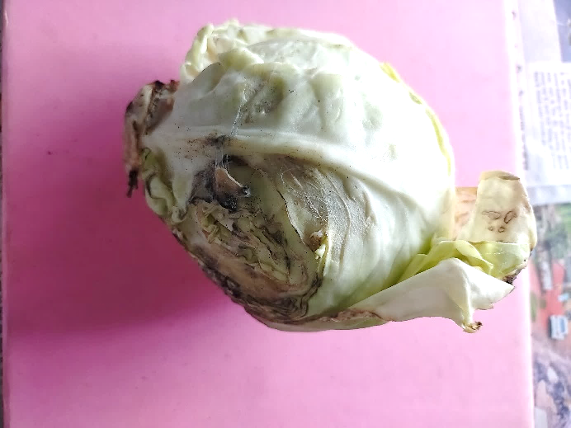 | 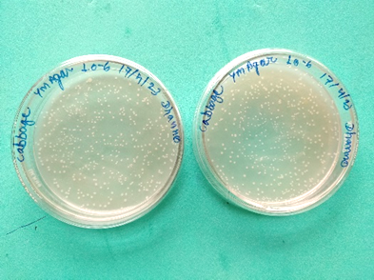
Rotten cabbage (Sample) | Bacterial isolates (Master plates)
Fig 1. Isolation of Biopolymer producing bacteria from cabbage
S.No. | Solvent for extraction | Parameter | Product weight (gL⁻¹)
 | Ethanol (95%) | A* | 0.59
 |  | B# | 0.73
 |  | C^ | 1.03
 | Absolute Acetone | A* | 1.40
 |  | B# | 1.89
 |  | C^ | 2.7
*Parameter A: pH- 6.0; Temperature- 20ºC; Fermentation Time – 48; Rotation – 100 rpm
#Parameter B: pH- 7.0; Temperature- 30ºC; Fermentation Time – 72; Rotation – 150 rpm
^Parameter C: pH- 8.0; Temperature- 40ºC; Fermentation Time – 96; Rotation – 200 rpm
Table 2. Optimization of Alcoholic and acetonic methods for the production of biopolymer using Bacillus cereus

3.2. Optimization of Biopolymer Production By Fermentation
The biopolymer precipitation with ethyl alcohol exhibited the final weight of the biopolymer yield of 1.03 g L⁻¹, while the biopolymer precipitated with acetone showed a maximum yield of 2.7 gL⁻¹ (Table 2, Fig. 3).
3.5. Identification of bacterial using Phenotypic characterization and 16S RNA Sequencing
The potent biopolymer-producing bacteria were primarily evaluated phenotypically using colony, microscopic, and biochemical examination (Table 1 and Table 4). Afterward, the sequencing report revealed that our significant PHB-producing bacterial isolate CB-4 has 99.93% closest homology to Bacillus cereus. NCIM report remarked that the strain showed the closest homology with Bacillus sp. (Closer to B. cereus) ++ Genus/genera was comprised of large number of species, hence 16S rRNA may not resolve species identity (Table 3). Electrophoresis Gel Images: Genomic DNA and PCR Product shown in Fig. 2. Biochemical/phenotypic tests/whole genome sequencing analysis might resolve species-level identity. We have deposited this sequence in GenBank (SUB14283541 907R_Seq160_CB4 PP422177, SUB14283541 907R_Seq160_CB4_RC PP422178, SUB14283541 704F_Seq160_CB4 PP422179, and SUB14283541 907RC_704F_Seq160_CB4 PP422180) for further reference and studies.
Table 3. Result of 16 S RNA Sequecing of CB4 (Seq160 CB4 NC281223 A)

S. No. | Strain | Aim | Primer |  | NCBI BLAST (Type Strain)
1. | Seq160 CB4 NC281223 A | Identification of 16S rRNA gene ++ | 907RC_7 04F (1503bp) |  | Sequence ID: NR 115714  Taxon ID:  Bacillus cereus Identities: 1502/1503(99.93%)  Ref: FEMS Microbiol. Ecol. 60 (2), 341-350 (2007) ++  Sequence ID:  NR 175555  Taxon ID:  Bacillus sanguinis Identities: 1501/1503(99.87%)  Ref: Int J Syst Evol Microbiol 71 (9) (2021)
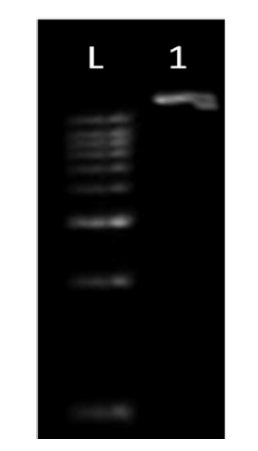 |  |  |  | 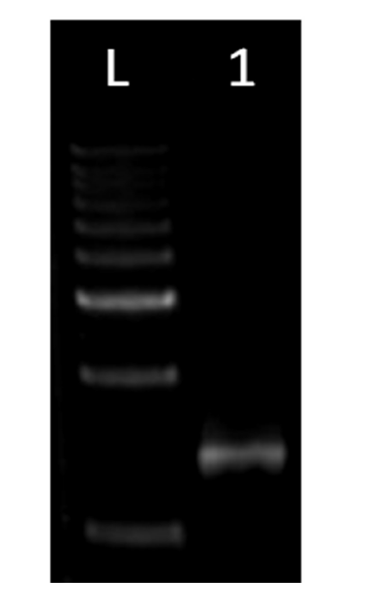
- Genomic DNA  L- Step-up 1 Kb DNA Ladder, Genei  1- Seq160_CB4 |  |  |  | - 16s rRNA PCR Product  L- Step-up 1 Kb DNA Ladder, Genei  1- Seq160_CB4
Fig. 2. Electrophoresis Gel Images: Genomic DNA and PCR Product

A recent article published by Hamdy et al. (2022) reported that Bacillus cereus SH-02 (OM992297) a potent PHB-producing bacterium was isolated from the Dirout channel at Assiut Governorate. Additionally, they reported maximum PHB content and concentration of 3100.799 mg/L and 28.799% respectively with Bacillus cereus SH-02 (OM992297) under optimized conditions. Notably, de Souza and Gupta (2024) stated that the microorganisms belongs to Pseudomonas, Rhodobacter, Rhizobium, Halobacterium, Ralstonia, Spirulina Enterobacter have been widely explored for PHA and PHB. Valappil et al. (2007) reported that Bacillus cereus SPV-derived polymer was found suitable for their potential application in tissue engineering.
This work screened Bacillus cereus (CB4) from decaying cabbage leaves and processed them to assess their biopolymer-producing efficacy. A similar attempt was made by Sivkumar et al. (2013), they studied cauliflower rotten leaves and isolated biopolymer-producing bacteria such as Panteo agglomerans, Bacillus subtilis, Enterobacter sp. and Pseudomonas sp. Additionally, they reported maximum polymer production of 3.17g L⁻¹ with Pseudomonas sp. Recently, Kumar et al. (2020) also isolated Bacillus subtilis and Pseudomonas aeruginosa strains from cabbage leaves, demonstrating their ability to produce PHAs under nitrogen-limited conditions.

Table 4. Biochemical Feature of Bacterial Isolate CB4
Biochemical Examination | Observation
Spore formation | +
Casein hydrolysis | +
Catalase test | +
Citrate utilization | +
Gelatin hydrolysis | +
Glucose fermentation | +
H₂S production | –
Indole test | –
Mannitol fermentation | –
Oxidase test | –
Starch hydrolysis | +
Sucrose fermentation | +
Urease test | +
The extraction of biopolymer-producing bacteria from decaying cabbage leaves underscores the potential of using waste materials for vital bioproducts. This emerged as an economical and readily available substrate for polymer synthesis utilizing bacterial strains. The Ellen MacArthur Foundation (2013) examines the principles of the circular economy, specifically focussing on utilizing cabbage waste as a resource for polymer production through microbial strains.

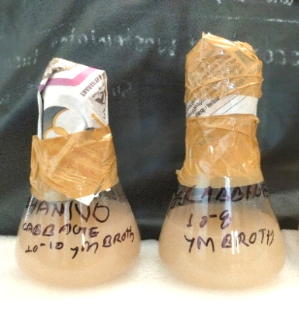 | 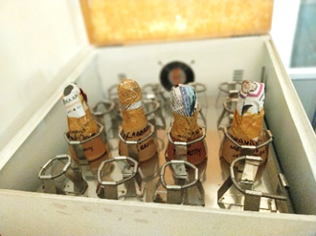
Biopolymer production by Shake flask fermentation
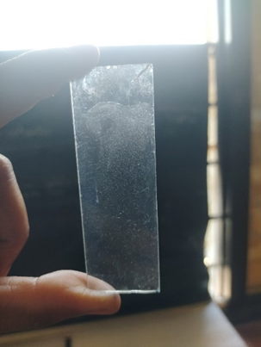 | 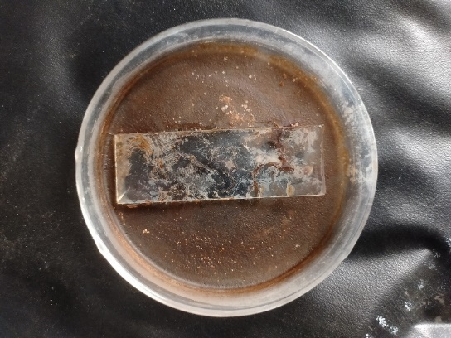
Biopolymer film derived from Alcoholic Method | Biopolymer derived fromAcetonic Method
Fig. 3 Production of Biopolymer using Bacillus cereus CB 4

Further study is necessary to enhance polymer manufacturing with microbial strains at a commercial level. The capacity of these microbes to produce PHAs, EPS, and other biopolymers highlights their potential in tackling environmental and industrial issues. Additional investigation is required to enhance the production techniques that would facilitate sustainable solutions to worldwide plastic pollution.
CONCLUSION
Cabbage is a nutritious and readily accessible agricultural resource, that offers a distinct environment for the isolation of biopolymer-producing bacteria. The current research demonstrated the biopolymer production efficiency of Bacillus cereus (CB4) isolated from decayed cabbage leaves as a substitute for synthetic polymers. Biopolymers are frequently produced by particular microbial communities in reaction to surplus carbon sources or situations of vital nutrient scarcity. Biopolymers captivate the polymer industry owing to their entirely biodegradable characteristics in both aerobic and anaerobic environments, as well as their extensive uses in medicine, pharmaceuticals, agriculture, and food packaging, attributed to their superior biocompatibility and non-toxic properties.
REFERENCES
- Anderson A.J. and Dawes E,A., Occurrence, metabolism, metabolic role, and industrial uses of bacterial polyhydroxyalkanoates. Microbiology Review, 54, 450-472 (1990).
- Bergey D.H., Bergey's manual of determinative bacteriology: a key for the identification of organisms of the class schizomycetes. (Baltimore :The Williams & Wilkins Company) (1923).
- Biedendieck R., Gamer M., Jaensch L., Meyer S., Rohde M., Deckwer W.D. and Jahn D.A., Sucrose inducible promoter system for the intra- and extracellular protein production in B. megaterium. J Biotechnol, 132 (4), 426–430 (2007).
- Chen G.Q., Plastics from bacteria: natural functions and applications, Microbiol Monogr, 14, 17–37 (2010).
- Christopher A.O. and Sylvester O., Characterization and Application of Biopolymer Producing Bacteria for Enhanced Oil Recovery. International Journal of Energy and Environmental Research, 10, 1-14 (2022). https://nopr.niscpr.res.in/jinfo/ijbb/IJBB%2060(02)%20Instruction%20to%20Authors.pdf
- de Souza, F. M., & Gupta, R. K. (2024). Bacteria for bioplastics: Progress, applications, and challenges. ACS Omega, 9(8), 8666–8686. https://doi.org/10.1021/acsomega.3c07372
- Ellen MacArthur Foundation, Towards the Circular Economy: Economic and business rationale for an accelerated transition (2013). https://emf.thirdlight.com/file/24/xTyQj3oxiYNMO1xTFs9xT5LF3C/Towards%20the%20circular%20economy%20Vol%201%3A%20an%20economic%20and%20business%20rationale%20for%20an%20accelerated%20transition.pdf
- Fernández-Marín R., Fernandes S.C.M., Sánchez M.Á.A. and Labidi J., Halochromic and Antioxidant Capacity of Smart Films of Chitosan/Chitin Nanocrystals with Curcuma Oil and Anthocyanins. Food Hydrocoll, 123, 107119 (2022).
- Hamdy S.M., Danial A.W., Gad El-Rab S.M.F., Shoreit A.A.M. and Hesham A.E-L., Production and optimization of bioplastic (Polyhydroxybutyrate) from Bacillus cereus strain SH-02 using response surface methodology. BMC Microbiology 22(1) (2022). https://doi.org/10.1186/s12866-022-02593-z
- Kumar S., Bhardwaj A. and Yadav S., Isolation and characterization of polyhydroxyalkanoate-producing bacteria from agricultural residues. Journal of Applied Microbiology, 129(5), 1051-1061 (2020). https://doi.org/10.1111/jam.14629
- Lee J., Park H.J., Moon M., Lee J.S., Min K., Recent progress and challenges in microbial polyhydroxybutyrate (PHB) production from CO₂ as a sustainable feedstock: A state-of-the-art review. Bioresource Technology, 339, 125616 (2021). https://doi.org/10.1016/j.biortech.2021.125616
- Lemoigne M., Produits de deshydrationet the polymerization de l′acide b-oxybutirique, Bull Soc Chim Biol, 8, 770–7 (1926).
- Madison L.L. and Huisman G.W., Metabolic engineering of poly (3-hydroxyalkanoates): from DNA to plastic, Microbiol Mol Biol Rev, 63 (1), 21–53 (1999).
- Mahajan, M., Gokilalakshmi, S., Balavaishnavi, B., Kamaraj, M., Nithya, T. G., & Govarthanan, M. (2024). Isolation, screening, and characterization of polyhydroxyalkanoate (PHA)‐producing Cellulosimicrobium cellulans: A promising approach for eco‐friendly biopolymer production. Polymers for Advanced Technologies, 35(6). https://doi.org/10.1002/pat.6431
- Mahishi L.H. Tripathi G. and Rawal S.K., Poly–hydroxybutyrate (PHB) Synthesis by recombinant Escherichia coli harbouring, streptomyces aureoficiens phb biosynthesis genes: effects of various carbon and nitrogen sources, Microbio Res, 158, 19–27 (2003).
- Mostafa YS Alrumman SA Otaif KA Alamri SA Mostafa MS & Sahlabji T, Production and Characterization of Bioplastic by Polyhydroxybutyrate Accumulating Erythrobacter aquimaris Isolated from Mangrove Rhizosphere. Molecules 25(1), 179 (2020). https://doi.org/10.3390/molecules25010179.
- Pittmann T., Herstellung von Biokunststoffen aus Stoffströmen einer kommunalen Kläranlage. Dissertation thesis, Institute for Sanitary Engineering, Water Quality and Solid Waste Management, Stuttgart, Germany (2015).
- Porier Y., Nawarath C. and Somerville C., Production of polyhydroxyalkanotes, a family of biodegradable plastics and elastomers in bacterial and plant. Biotechnology 13, 142-150 (1995).
- Salah B.R., Chaari K., Besbes S., Ktari N., Blecker C., Deroanne C. and Attia H., Optimisation of xanthan gum production by palm date (Phoenix dactylifera L.) juice by-products using response surface methodology. Food Chem, 121, 627-633 (2010). https://doi.org/10.1016/j.foodchem.2009.12.077
- Sudesh K Abe H & Doi Y, Structure and properties of polyhydroxy alkanoates, biological polyesters. Polymer Science, 25, 1503 – 1533 (2000).
- Upadhye M.C., Kuchekar M.C., Pujari R.R. and Sable N.U., Biopolymers: A comprehensive review. Research Journal of Science and Technology, 4, 013–018 (2022). https://doi.org/10.53022/oarjst.2022.4.1.0070
- Valappil S.P., Rai R., Bucke C. and Roy I., Polyhydroxyalkanoate biosynthesis in Bacillus cereus SPV under varied limiting conditions and an insight into the bio-synthetic genes involved, J Appl Microbiol, 104 (6), 1624–1635 (2007).
- Wakisaka Y., Masaki E. and Nishimoto Y., Formation of crystalline δ-endotoxin or poly β-hyroxybutyrate acid granules by as porogenous mutants of Bacillus thuringiensis, Appl Environ Microbiol 43 (6), 1473–1480 (1982).
- Zhang J., Shishatskaya E.I., Volova T.G., Ferreira da Silva L. and Chen G.Q., Polyhydroxyalkanoatess (PHAS) for therapeutic applications, Material Science and Engineering, 86, 144–150 (2018).

