Diversity of Inland Fisheries in Pulangi River of Central Mindanao Philippines

.

ABSTRACT

|  |
| --- |
| This study investigated the diversity of inland fish catch along the Pulangi River in Cotabato, Philippines. Sampling was conducted at three municipal sites in the province of Cotabato namely: Carmen; President Roxas; and Matalam. Fish were captured using various methods, including fish traps, gill nets, cast nets and man-push nets.  A total of nine inland fish species were identified: Indian Rohucarp (*Labeo rohita*), Common Carp *(Cyprinus carpio),* Spotted Barb *(Barbose binotatus),*Janitor fish (*Pterygoplichthys disjunctivus*), Banak (*Cestraeus plicatilis*), Giant Gourami *(Osphronemus goramy),*Kasili *(Anguilla marmorata),*Biya *(Glossogobius giuris), and* Tilapia *(Oreochromis niloticus).* Among the caught inland fishes, the Indian Rohucarp exhibits the highest species caught, dominance, abundance, density, and importance values.  The low diversity of fish species observed attributed to factors such as locality, diversity, and other environmental influences such industrial pollution, anthropogenic activities, unsuitable farming, natural disasters, and chemical pollution. |

*Keywords: inland fisheries, fish diversity, dominance, fishing gears, aquatic ecosystems, fishing practices, fish population dynamics*

1. INTRODUCTION

The Philippines, a significant player in global fisheries, relies heavily on both marine and inland resources. While the country is renowned for its marine capture production, ranking 13th worldwide in 2018 (FAO, 2020), inland fisheries, encompassing lakes, rivers, reservoirs, and swamps, contribute significantly to the national economy and food security. These inland waters, covering approximately 406,328 hectares in the Philippines (PSA, 2020), are home to a diverse array of freshwater fish species, including numerous endemic and commercially important species. The "Inland Capture Fisheries Study" focuses on characterizing the inland capture fisheries of the Pulangi River, a major tributary of the Mindanao River. This study is crucial because the Philippines boasts a high level of freshwater fish endemism, with over 65 endemic species (Froese & Pauly, 2022), highlighting the unique nature of these ecosystems and the need for focused conservation efforts. Commercially caught freshwater fish in the Philippines represent a significant source of food and income. The Nile tilapia, common carp, and mudfish are among the top commercially caught species, contributing significantly to the national economy (Philippine Statistics Authority, 2018). However, freshwater fish populations face numerous threats, including pollution, habitat degradation, overharvesting, and invasive species (Darwall et al., 2008). These threats, particularly evident in the Pulangi River, highlight the urgent need for sustainable management practices. While some studies have been conducted on specific rivers, a comprehensive understanding of the Pulangi River's fish diversity, abundance, distribution, and relationships is lacking. This gap in knowledge hinders effective management and conservation efforts. The objectives of this study are to characterize the fish diversity, abundance, distribution, and relationships within the Pulangi River, identify key threats to the sustainability of the Pulangi River's fisheries, and inform the development of sustainable fisheries management and conservation strategies for the Pulangi River. This research will provide valuable findings into the status of the Pulangi River's fisheries, contributing to improved management practices, conservation efforts, and community empowerment. The study is a timely and crucial initiative that will contribute significantly to the understanding and sustainable management of Philippine inland fisheries, ensuring the long-term health of these vital resources and the communities that depend on them.

2. methodology

**Study Area**

The Pulangi River, spanning 320 km in length and encompassing a watershed area of approximately 6,500 km², flows through various cities and municipalities in Bukidnon and Cotabato Province (Izumi, 2021). The study encompassed three distinct sites in Cotabato (Figure 1): the upper stream in the Municipality of President Roxas (Sito Kaminuangan, Brgy. Kisupaan), the midstream in the Municipality of Matalam (Barangay Arakan), Municipality of President Roxas (Sitio Lebpas, Barangay Tuael) and in Barangay Manili, of Carmen Cotabato; and the lower stream located at Sitio Lumayong, Barangay Ugalingan, Carmen Cotabato.

**Data Collection, Sampling and Fish Traps Used**

Prior to data collection, the team diligently obtained all necessary permits and clearances to data collection, the team diligently obtained all necessary permits and clearances from the local government units (LGUs). Fish samples were collected in September and December 2024 with the assistance of local fisherfolks at three distinct sites along the Pulangi River with sampling site in Fig. 1 using a variety of fishing gear and methods: a gill net 5 mm x 7.5 m (Fig. 2), a cast net 12-20 mm. (Fig. 3), a fish trap (Fig 4), and a man-push net (Fig. 5). The collected fish species were identified using information from a fish guide, from MSU-Maguindanao, 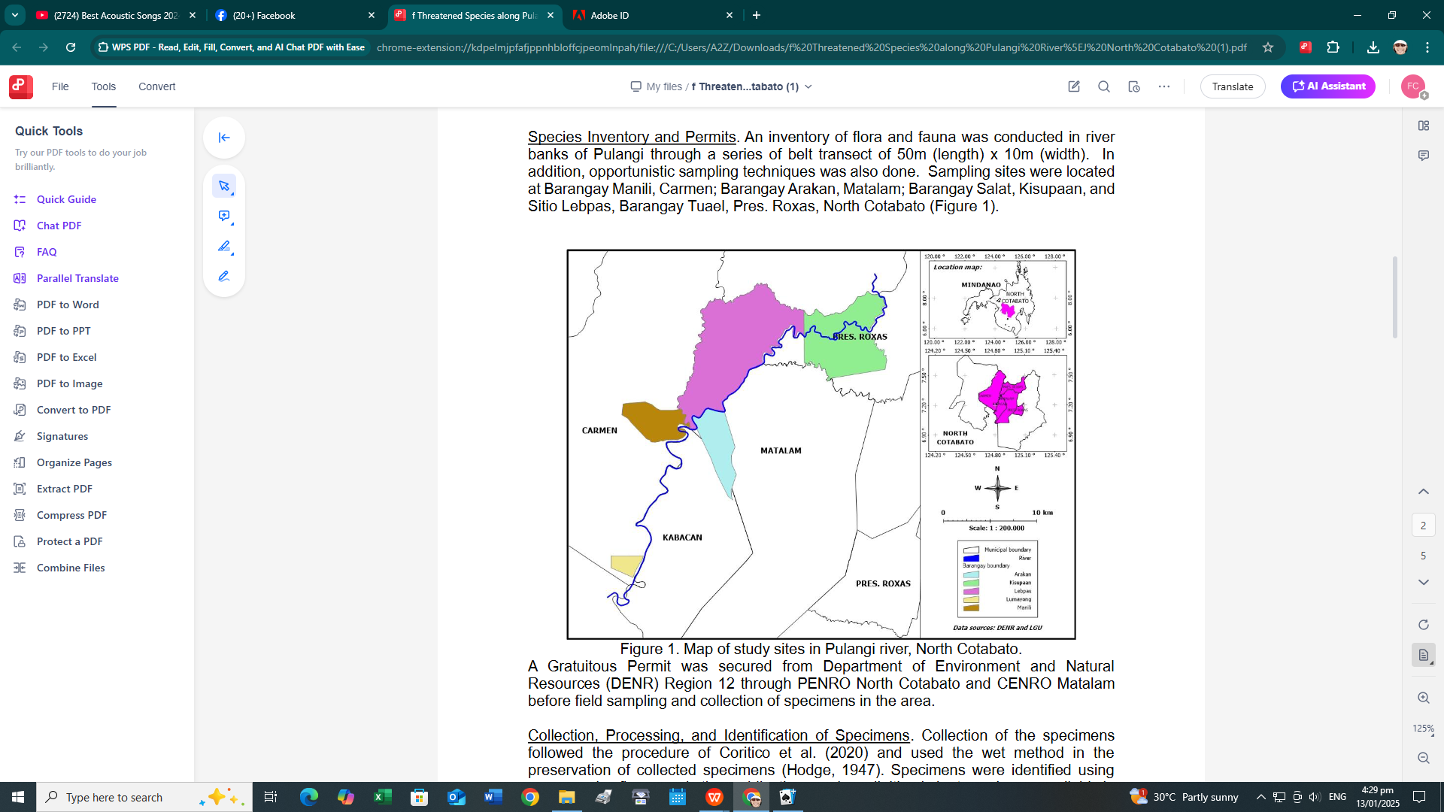ensuring accuracy in our data.

Figure 1. Map showing the study site

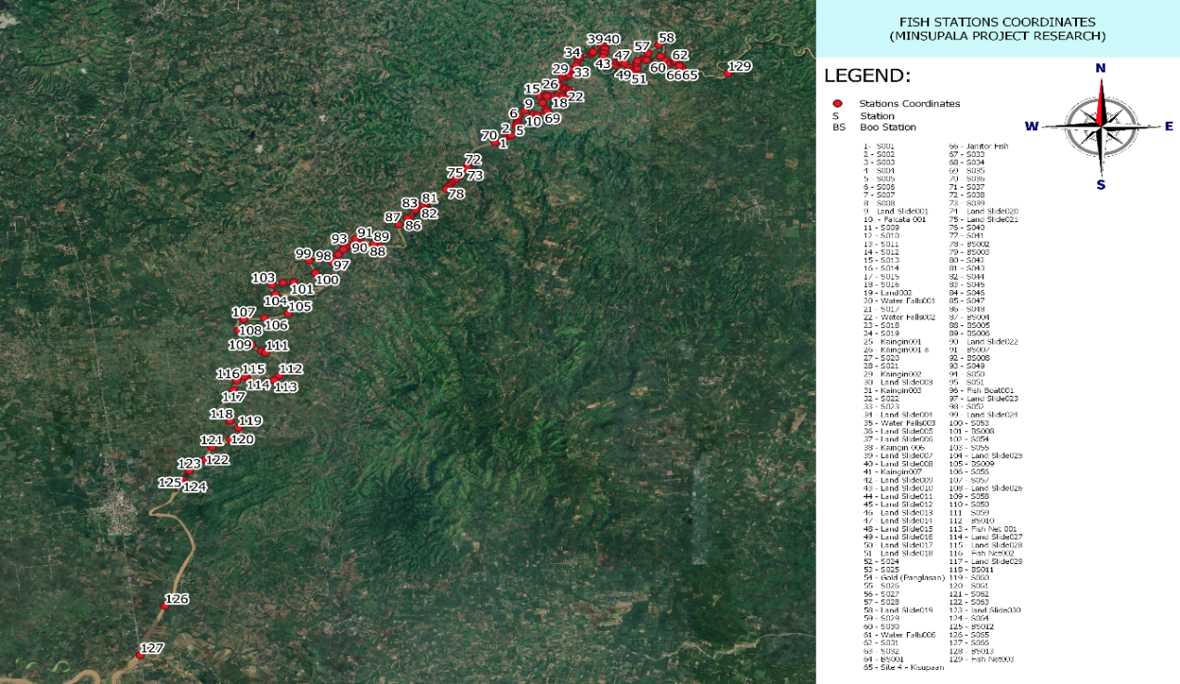

Fig. 2. Coordinates of the Sampling Fish Station

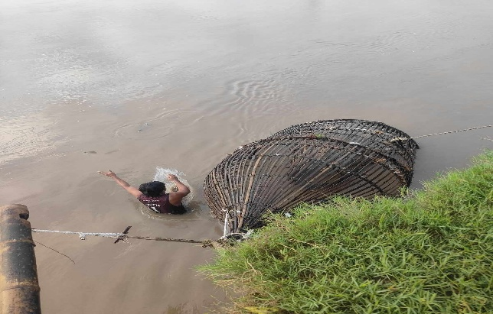

Fig. 3. Gill Net

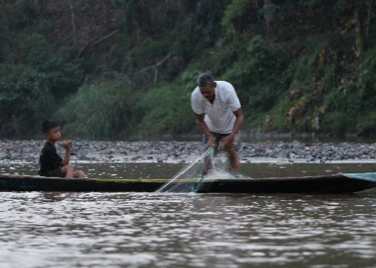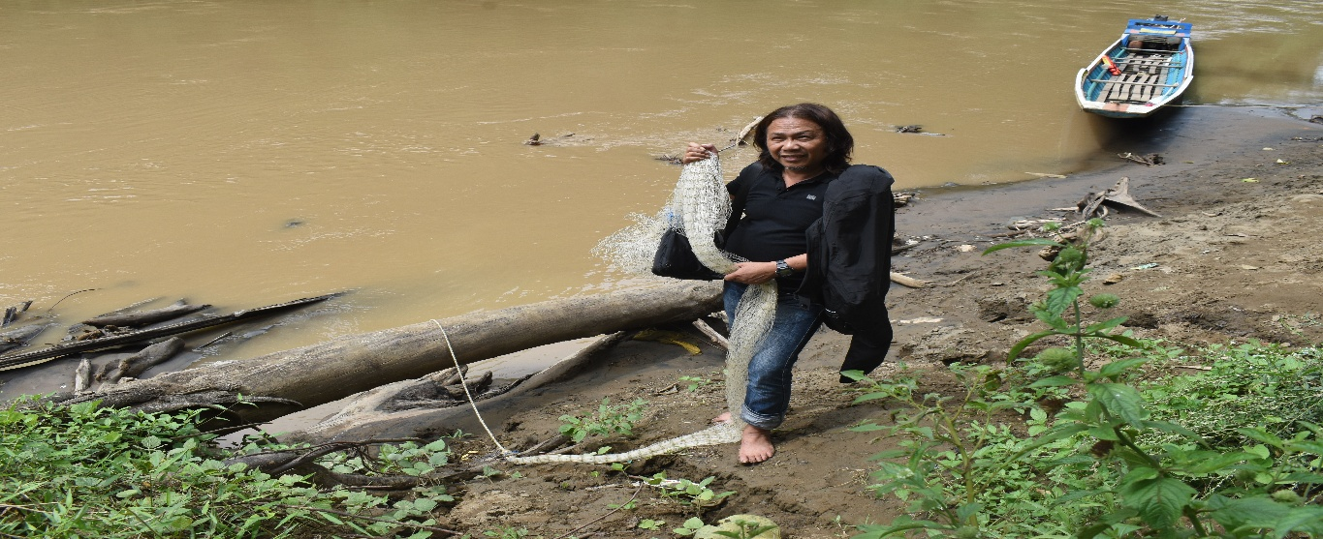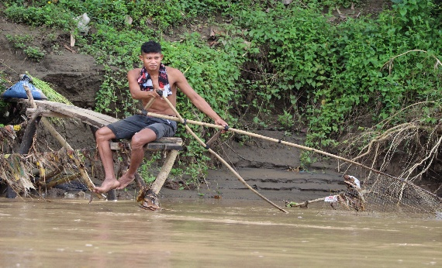

Fig. 6. Man-Push Net

Fig. 4. Cast Net

Fig. 5. Man-Push Net

**Computation of Relative Abundance and Diversity**

The relative abundance of each species was calculated using the formula adopted by Paller et al. which is Relative Abundance (%) = Isi/∑N*si* x 100

Where, Isi = Total Number of individual spp; ∑N*si* = Total Number of species population. The Shannon-Weiner index was used to compute diversity and species evenness which is $H'=\sum_{i=1}^{s}{pi 1n pi}$ where H’ is the species diversity index, *s* is the number of species, and *pi* is the proportion of individuals of each species belonging to the *ith* species of the total number of individuals. Finally, species dominance was calculated using Simpson's index formula (λ). D**= Σni(ni-1)  /  N(N-1)** where: **ni:** The number of organisms that belong to species i, **N:** The total number of organisms

3. results and discussion

**Pulangi Captured Fish**

There were 7 fish families identified based on captured species such as: CYPRINIDAE with 3 species *rohita, carpio, binotatus*) (Fig. 7a - 7c), LOCARIDAE with 1 species *Disjunctivus* (Fig. 8), MUGILIDAE with 1 species. *Plicatilis* (Fig. 9), OSPHRONEMIDAE with 1 species *goramy* (Fig. 10), ANGUILLIDAE with 1 species *marmorata* (Fig. 11)*,* COBIDAE species *giuris* (Fig. 12), and CICHLIDAE with species *niloticus* (Fig. 13).ith species *niloticus* (Fig. 13).

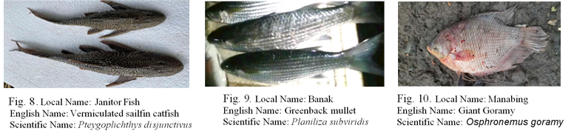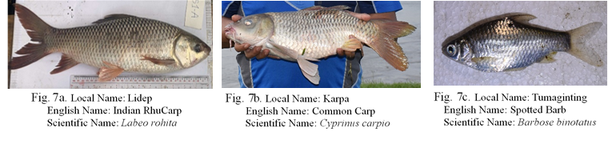

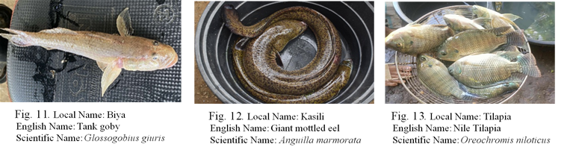

**Relative Abundance and Potential Pairwise Interactions**

Table 1 presents the relative abundance and potential pairwise interactions of various fish species within the sampled ecosystem. The Indian Rohucarp (CYPRINIDAE) dominates the sample with a relative abundance of 58.11%, followed by the Common Carp (12.84%) and Kasili (8.11%). The high relative abundance of Indian Rohucarp suggests it as a keystone species in this ecosystem, potentially influencing the structure and function of the community. The column ni(ni−1)*ni*​(*ni*​−1) represents the potential pairwise interactions within each species, which is highest for Indian Rohucarp (7,310), indicating a high likelihood of intraspecific interactions. This could imply significant competition or social behaviors within this species. In contrast, species like Banak (MUGILIDAE) and Biya (GOBIIDAE) have minimal pairwise interactions due to their low abundance, suggesting limited ecological impact or niche specialization. The total potential interactions (7,982) highlight the overall connectivity within the community, with CYPRINIDAE contributing the most to this metric.

**Table 1**.Relative Abundance and Potential Pairwise Interactions

|  |  |  |  |  |
| --- | --- | --- | --- | --- |
| Family | Species | Sample Size (n) | Relative  Abundance | ni(ni−1)*ni(ni*−1) |
| **CYPRINIDAE** | Indian Rohucarp (*Labeo rohita*) | 86 | 58.11% | 7,310 |
| **CYPRINIDAE** | Common Carp *(Cyprinus carpio)* | 19 | 12.84% | 342 |
| **CYPRINIDAE** | Spotted Barb *(Barbose binotatus)* | 8 | 5.41% | 56 |
| **LORICARIIDAE** | Janitor Fish  *(Pteygoplichthys disjunctivus)* | 8 | 5.41% | 56 |
| **MUGILIDAE** | Banak  (*Planiliza subviridis*) | 1 | 0.68% | 0 |
| **OSPHRONEMIDAE** | Giant Gourami  *(Osphronemus goramy)* | 2 | 1.35% | 2 |
| **ANGUILLIDAE** | Kasili *(Anguilla marmorata)* | 12 | 8.11% | 132 |
| **GOBIIDAE** | Biya *(Glossogobius giuris)* | 2 | 1.35% | 2 |
| **CICHLIDAE** | Tilapia *(Oreochromis niloticus)* | 10 | 6.76% | 90 |
| **Total** |  | **148** | **100%** | **7,982** |

**Density, Relative Density, Frequency, and Importance Value**

Table 2 provides a detailed analysis of species density, relative density, frequency, and importance value (IV). The Indian Rohucarp again stands out with the highest density of 0.581, relative density of 58.11%, and importance value (78.94), reinforcing its ecological dominance. The high frequency (1.000) and relative frequency (20.83%) of Indian Rohucarp indicate its widespread presence across sampling sites, further emphasizing its central role in the ecosystem. The Janitor Fish (LOCARIIDAE) also shows a high frequency (1.000) and relative frequency (20.83%), suggesting it as equally widespread but less abundant, which may reflect its adaptability to different microhabitats. The importance value, which combines relative density and relative frequency, provides a holistic measure of a species' ecological significance. Species like Banak and Giant Gourami, despite their low densities, have moderate importance values (9.01 and 9.68, respectively), indicating they may occupy unique niches or play specialized roles. The total importance value (200.00) reflects the cumulative ecological contributions of all species in the community.

**Table 2.** Density, Relative Density, Frequency, and Importance Value

|  |  |  |  |  |  |  |  |
| --- | --- | --- | --- | --- | --- | --- | --- |
| Family | Species | Total No.  of Sample | Di | RDi | Fi | RFi | IV |
| **CYPRINIDAE** | Indian Rohucarp  (*Labeo rohita*) | 86 | 0.581 | 58.11% | 1.000 | 20.83% | 78.94 |
| **CYPRINIDAE** | Common Carp  *(Cyprinus carpio)* | 19 | 0.128 | 12.84% | 0.600 | 12.50% | 25.34 |
| **CYPRINIDAE** | Spotted Barb  *(Barbose binotatus)* | 8 | 0.054 | 5.41% | 0.200 | 4.17% | 9.58 |
| **LORICARIIDAE** | Janitor Fish  *(Pteygoplichthys isjunctivus)* | 8 | 0.054 | 5.41% | 1.000 | 20.83% | 26.24 |
| **MUGILIDAE** | Banak  (*Planiliza subviridis*) | 1 | 0.007 | 0.68% | 0.400 | 8.33% | 9.01 |
| **OSPHRONEMIDAE** | Giant Gourami  *(Osphronemus goramy)* | 2 | 0.014 | 1.35% | 0.400 | 8.33% | 9.68 |
| **ANGUILLIDAE** | Kasili  *(Anguilla marmorata)* | 12 | 0.081 | 8.11% | 0.600 | 12.50% | 20.61 |
| **GOBIIDAE** | Biya  *(Glossogobius giuris)* | 2 | 0.014 | 1.35% | 0.200 | 4.17% | 5.52 |
| **CICHLIDAE** | Tilapia  *(Oreochromis niloticus)* | 10 | 0.068 | 6.76% | 0.400 | 8.33% | 15.09 |
| **Total** |  | **148** | **1.000** | **100%** | **4.800** | **100%** | **200.00** |

Di *= Density,* RDi *= Relative Density,* Fi *= Frequency,* RFi *= Relative requency,* IV *= Importance Value*

**Species Dominance, Richness, and Diversity**

Table 3 explores species dominance, richness, and diversity using metrics such as Shannon Diversity (H′*H*′). The Indian Rohucarp exhibits the highest species dominance (0.581), consistent with its abundance and importance values from Tables 1 and 2. However, its Shannon Diversity value (0.129) is relatively low, indicating low evenness in its distribution compared to other species. In contrast, the Common Carp, despite its lower dominance (0.128), has a higher Shannon Diversity value (0.132), suggesting a more even distribution within its population. The total Shannon Diversity for the community (0.929) indicates moderate overall diversity, with contributions from all nine species. The species richness (9) reflects the number of distinct species present, while the pi=niN*pi*​=*Nni*​​ values quantify the proportional abundance of each species. The Janitor Fish and Tilapia, for instance, have similar proportional abundances (0.054 and 0.068, respectively) but differ in their Shannon Diversity values (0.124 and 0.104), highlighting variations in their ecological roles and distribution patterns.

**Table 3.** Species Dominance, Richness, and Diversity

|  |  |  |  |  |  |  |
| --- | --- | --- | --- | --- | --- | --- |
| Family | Species | Total No. of  Sample | Species  Dominance | Species  Richness | pi=niNpi=Nni​​ | Shannon  Diversity |
| **CYPRINIDAE** | Indian Rohucarp  (*Labeo rohita*) | 86 | 0.581 | 1 | 0.581 | 0.129 |
| **CYPRINIDAE** | Common Carp  *(Cyprinus carpio)* | 19 | 0.128 | 1 | 0.128 | 0.132 |
| **CYPRINIDAE** | Spotted Barb  *(Barbose binotatus)* | 8 | 0.054 | 1 | 0.054 | 0.085 |
| **LORICARIIDAE** | Janitor Fish  *(Pteygoplichthys disjunctivus)* | 8 | 0.054 | 1 | 0.054 | 0.124 |
| **MUGILIDAE** | Banak  ( *Planiliza subviridis* ) | 1 | 0.007 | 1 | 0.007 | 0.095 |
| **OSPHRONEMIDAE** | Giant Gourami  *(Osphronemus goramy)* | 2 | 0.014 | 1 | 0.014 | 0.081 |
| **ANGUILLIDAE** | Kasili  *(Anguilla marmorata)* | 12 | 0.081 | 1 | 0.081 | 0.082 |
| **GOBIIDAE** | Biya  *(Glossogobius giuris)* | 2 | 0.014 | 1 | 0.014 | 0.097 |
| **CICHLIDAE** | Tilapia *(Oreochromis*  *niloticus)* | 10 | 0.068 | 1 | 0.068 | 0.104 |
| **Total** |  | **148** | **1.000** | **9** | **1.000** | **0.929** |

**The Physicochemical Characteristics of Water in The Pulangi River and its Impact on Fish Life.**

The physicochemical properties of water are essential in influencing the health and sustainability of aquatic environments, especially in sustaining fish populations. The Pulangi River has a confluence of elements indicating it continues to be a conducive habitat for aquatic organisms, however certain localized disturbances may adversely affect fish health.

The physicochemical characteristics of Pulangi River water suggest a predominantly healthy ecosystem conducive to aquatic life, especially fish. The consistent water temperature, near-neutral pH, low total dissolved solids, low electrical conductivity, and elevated dissolved oxygen levels create optimal circumstances for fish survival and growth. The increased turbidity in specific locations poses localized issues, especially in regions with enhanced suspended particles, potentially detrimental to fish health, water quality, and ecosystem stability. Although the river is predominantly unpolluted, localized turbidity concerns indicate that human activities, especially agriculture, may affect water quality. Implementing proactive measures, including enhanced land management to decrease sedimentation and reducing agricultural runoff, would alleviate these issues and ensure the Pulangi River sustains rich aquatic life in the future.

**Key Threats to Fish Population of Pulangi River**

Industrial Pollution. A suspected dumping of molasses by the sugarcane company located upstream in Bukidnon Province Region 10 discharges sugarcane waste in the river, which lead to water contamination, reduced oxygen levels, and harm to aquatic ecosystem.

Anthropogenic Activities. Human activities such as improper waste disposal, deforestation, micro-mining, and open river defecation practices contributed to habitat degradation and water pollution which affects the fish populations.

Unsuitable Farming Practices. Kaingin (slash-and-burn) farming, a traditional farming method causes deforestation, soil erosion/landslide, and sedimentation on the river disrupts aquatic habitats and lower down water quality.

Natural Disaster. Landslide triggered by deforestation and heavy rainfall increased sedimentation in the river, smothering fish habitats and reducing the rivers’ capacity to support aquatic life.

Chemical Pollution. Spraying of agricultural chemicals (Insecticides, pesticides, and herbicides including synthetic fertilizer application in nearby farms lead to runoff into the river, causing toxic contamination and harming fish and other aquatic organisms.

**Conclusion**

The findings presented emphasize the critical ecological functions of various fish species within Pulangi, with the Indian Rohucarp (*Labeo rohita*) identified as a predominant species due to its high relative abundance, density, and significant pairwise interactions. Its dominance exerts a profound influence on community structure and intraspecific dynamics, underscoring its pivotal role in maintaining ecological stability. In contrast, species such as Banak (*Planiliza subviridis*) and Biya (*Glossogobius giuris*), characterized by lower relative abundance and minimal pairwise interactions, exhibit limited ecological influence, reflecting their specialized and niche roles within the school of fish.

Analysis of density, relative density, frequency, and importance value further corroborates the central ecological role of the Indian Rohucarp, while also revealing the adaptive success of other species, such as the Janitor Fish (Pterygoplichthys spp.). Despite its lower abundance, the Janitor Fish demonstrates notable adaptability and extensive distribution across microhabitats, illustrating the ecosystem's capacity to support diverse ecological strategies. Moreover, the species richness and Shannon Diversity indices indicate a moderately diverse ecosystem, with a balance between dominance and diversity. While the Indian Rohucarp exhibits significant species dominance, the ecosystem maintains a relatively equitable distribution of ecological dynamics, ensuring structural stability and functional diversity.

However, the ecological integrity of the Pulangi River and its fisheries faces significant threats that could undermine these dynamics. Industrial pollution, particularly the dumping of molasses by a sugarcane company located upstream, may lead to water contamination, reduced oxygen levels, and harm to aquatic ecosystems. Anthropogenic activities, such as improper waste disposal, deforestation, and unregulated development, contribute to habitat degradation and water pollution, which may negatively affect fish populations. Unsustainable farming practices, including the kaingin (slash-and-burn) system, cause deforestation, soil erosion, and sedimentation in the river, disrupting aquatic habitats and reducing water quality. Natural disasters, such as landslides triggered by deforestation and heavy rainfall, increase sedimentation, smothering fish habitats and reducing the river's capacity to support aquatic life. Additionally, chemical pollution from the spraying of agricultural chemicals, including pesticides, insecticides, herbicides, and synthetic fertilizers, may lead to toxic runoff into the river, harming fish and other aquatic organisms.

**Recommendations**

The following recommendations are need to be addressed to sustain the population of fish in Pulangi river:

1. There is a need to prioritize the protection of the Indian Rohucarp (*Labeo rohita*) due to its ecological importance, while also ensuring the survival of niche species like Banak (*Cestraeus plicatilis*) and Biya (*Glossogobius giuris*) through habitat preservation efforts.
2. It is important to monitor the Janitor Fish (*Pterygoplichthys spp*.) to ensure its adaptability does not lead to ecosystem imbalance.
3. There is a need to encourage farmers to adopt alternatives to kaingin (slash-and-burn) farming, such as agroforestry, by providing training and resources.
4. Efforts should be made to work with upstream industries, such as the sugarcane company, to reduce molasses dumping and adopt cleaner waste management practices.
5. There is a need to establish simple waste collection systems in nearby communities to minimize pollution from improper waste disposal.
6. It is important to encourage farmers to reduce the use of harmful pesticides and fertilizers by promoting organic farming and safer alternatives.
7. There is a need to plant trees and vegetation along riverbanks to reduce erosion and sedimentation caused by deforestation and landslides.
8. Efforts should be made to educate local communities about the importance of the Pulangi River and how their actions can contribute to its protection.
9. There is a need to support small-scale research and regular monitoring of fish populations and water quality to track the health of the ecosystem.
10. It is important to foster cooperation between local governments, communities, and small organizations to develop simple, actionable plans for river conservation.

**References**

An Overview of Inland Capture Fishery Statistics of Southeast Asia. (2024). FAO.org. https://www.fao.org/4/ad070e/ad070e06.htm#fn3

Cequinia, E. V., & Amoroso, V. R. (1998). Aquatic and terrestrial resources assessment for the NPC Pulangi IV Reservoir. In R. B. Edra, E. V. Manalili, & L. C. Darvin (Eds.), *Riverine Resources in the Philippines* (PCAMRD Book Series No. 22/1998, pp. 45-57).

Darwall, W., Smith, K., Allen, D., Sheldon, M., McGregor Reid, G., Clausnitzer, V., & Kalkman, V. (2008). Freshwater biodiversity – a hidden resource under threat. In J. C. Vie, C. Hilton-Taylor, & S. N. Stuart (Eds.), *The 2008 Review of the IUCN Red List of Threatened Species*. IUCN, Gland, Switzerland.

FAO. (2020). *The state of world fisheries and aquaculture 2020: Sustainability in action*. FAO.

Froese, R., & Pauly, D. (Eds.). (2022). *FishBase World Wide Web electronic publication*. www.fishbase.org

Guerrero, R. D. (2014). Impacts of introduced freshwater fishes in the Philippines (1905-2013): A review and recommendations. *Philippine Journal of Science, 143*(1), 49-59.

International Union for the Conservation of Nature. (2018). *The IUCN Red List of Threatened Species*. Available at: www.iucn.redlist.org

Lynch, A. J., Beard, Jr., T. D., Cox, A., Zarnac, Z., Phang, S. C., Arantes, C. C., Brummet, R. E., Cramwinckel, J. F., Gordon, I., Husen, M. A., Liu, J., Nguyen, P. H., & Safari, P. K. (2016). Drivers and synergies in the management of inland fisheries: Searching for sustainable solutions. In W. W. Taylor, D. M. Bartley, C. I. Goddard, N. J. Leonard, & R. Welcomme (Eds.), *Freshwater, fish and the future: Proceedings of the global cross-sectoral conference* (pp. 183-200). Food and Agriculture Organization of the United Nations, Rome; Michigan State University, East Lansing; and American Fisheries Society, Bethesda, Maryland.

Philippine Council for Agriculture, Aquatic and Natural Resources Research and Development. (2012). *Induced spawning and larval rearing of ayun᷈gin (Leiopotherapon plumbeus Kner)*. PCAMRD-DOST, Los Baños, Laguna. 1 p.

Philippine Statistics Authority. (2020). *Fisheries statistics of the Philippines 2017-2019* (Vol. 28). 321 p. (psa.gov.ph)

Pongsri, C. (2015). Sustainable utilization of water resources: Fisheries perspective. Presented at World Water Week, 23-28 August 2015, Stockholm, Sweden.

SEAFDEC. (2017). *Southeast Asian State of Fisheries and Aquaculture 2017*. Southeast Asian Fisheries Development Center, Bangkok, Thailand. 167 pp.

Welcomme, R. L., Cowx, I. G., Coates, D., Bene, C., Funge-Smith, S., Halls, A., & Lorenzen, K. (2010). Inland capture fisheries. *Philosophical Transactions of the Royal Society of London. B, 365*, 2881-2896.