**The assessment of various bee attractants for *Apis* *florea* and their influence on seed yield of niger, *Guizotia abyssinica* (L.f.) Cass. crop**

**Abstract**

A study was conducted at experimental farm of PC Unit Sesame and Niger, College of Agriculture, Jawaharlal Nehru Krishi Vishwa Vidyalaya, Jabalpur, Madhya Pradesh, during *Kharif* 2021. To determine the impact of bee attractants on the attraction of *Apis florea* and their impact on seed yield of niger crop, the experiment was set up using a Randomized Block Design with nine treatments and three replications. Research found that the both at 10% and 50% flowering stage *Apis florea* visit was numerically the highest with rose water 10% (12.83 individual/m2/5min), sugar solution 10% (14.33 individual/m2/5min), respectively. This was followed by flower extract of *Madhuca longifolia* 10% (12.67) and rose water 10% (14.25 individual/m2/5min), respectively. The population of *Apis florea* was received from controlled condition 2.67 and 3.75 individual/m2/5min at 10% and 50% flowering stage, respectively. This was followed by water spray (4.75 and 5.83 individual/m2/5min) at 10% and 50% flowering stage, respectively. The foliar spray of rose water 10%, sugar solution 10% and flower extract of *M. longifolia* 10% solution were found significantly superior over others in respect to record higher seed yield and recorded 6.90q, 6.70 q and 6.30 q/ha seed yield, respectively.

**Keywords:** Rose water, *Apis florea*, flower extract of *Madhuca longifolia* and significantly superior.

**1. Introduction**

Niger [*Guizotia abyssinica* (L. f.) Cass.] is a native of Tropical Africa and belong to the family Asteraceae (Compositae), it is known as lifeline of tribal agriculture and economy in India. It is grown by tribals on marginal and sub-marginal lands with negligible inputs under rainfed conditions(Ranganatha *et al.,* 2009). Niger is produced on an area of 112.8 thousand hectares in India, with a production of 40.3 thousand tonnes and an average productivity of 357.2 kg per hectare. Madhya Pradesh supplies roughly 16.0 thousand hectares of land, with an annual yield of 4.9 thousand tonnes and a seed productivity of 308.8 kg per hectare (Anonymous, 2021-22). It is used as an oilseed crop in India where it provides about 3% of the edible oil requirement of the country (Getinet and Sharma,1996). The niger seed content of quality oil of 32-40% with 18 to 24% protein in the seed, niger oil, is pale yellow with nutty taste and a pleasant odour (Dwarka *et al.,* 2024a,b,c,d,e). The oil and seeds are free from any toxin and oil taste is similar to desi ghee.

Niger is self-incompatible with 100 per cent cross-pollinated crop (Dwarka *et al.,* 2022). Insect pollination not only ensures the increase in seed yields of various cross pollinated crops including niger but also improve their quality. It ensures uniform maturity and early harvest of crops. Provision of bee colonies during the flowering period of crop is a simple but essential input Dwarka *et al.,* (2022). A planned bee pollination programme on national scale significantly contributes in solving the problem of edible oil shortage in the country even at the existing level of land use of oil crops (Mohana Rao *et al.*, 1981). Studies on effect of honey bee pollinators in niger crop indicated that the yield was reduced by 11-78 per cent in the absence of honey bee as well as natural pollinators. An additional income of Rs. 252 to Rs. 2125 including Rs. 1015/ha from honey was estimated through beekeeping with niger over open pollinated crops (Anonymous, 2005). Honey bees are considered as the most effective and ideal pollinators. Success of pollination with help of honey bees depends on their performance to the target crop over other following plants in the vicinity. Commercial and local bee attractants *viz.,* bee line, bee here, bee scent, bee scent plus, fruit boost, Bee-Q, sugar solution, sugarcane juice, jaggery solution, Molasses, etc. are being used to boost the foraging activities of niger in the Jabalpur, Madhya Pradesh Dwarka *et al.,* (2022;2023a,b,c). However, the related studies on use of bee attractants in India are scanty. The conservation and management of insect pollinators is gaining importance day by day. In this regard, the present experiment studies on effect of different bee attractants on attraction of *Apis florea* and their impact on seed yield were studied.

**2. Material and methods**

Jabalpur a city in Madhya Pradesh is situated on the bank of Narmada river geographically located between 22° 49’’ and 24° 8’’ North latitude and 78° 21’’ East longitude and at an altitude of 411.78 m. above the mean sea level. The studies on effect of bee attractants on foraging activities of *Apis florea* in niger crop was conducted in a randomized block design with three replication at experimental farm of PC Unit (ICAR) Sesame and Niger, College of Agriculture, JNKVV, Jabalpur, Madhya Pradesh, during *Kharif* 2021.

**Table. 1: List of attractants**

|  |  |
| --- | --- |
| **Sl. No.** | **Treatments/attractants** |
| 1. | T1- Flower extract of *Madhuca longifolia* 10% |
| 2. | T2 –Juice of *Sachharum officinarum* 10% |
| 3. | T3 -Jaggery solution 10% |
| 4. | T4 -Honey solution 10% |
| 5. | T5 -Fruit extract of *Foenix dactylifera* 10% |
| 6. | T6-Sugar solution 10% |
| 7. | T7 -Rose water (Marketed) 10% |
| 8. | T8 -Water spray. |
| 9. | T9-Control |

The above mentioned attractants were sprayed two times, first at 10% and second at 50% flowering stages. Recommended agronomical package of practices were followed for raising good and healthy crop. From each plot one-meter square area were selected randomly and number of *Apis florea* visited the flowers were recorded. The observations were recorded a day before and 1st, 3rd, 5th and 7th day after first and second spraying and seed yield obtained from different treatments were recorded separately. I got the caught insects verified with the help of Regional Centre, ZSI, Jabalpur, Madhya Pradesh.

**3. Results and discussion**

The results of the present investigation revealed that all the bee attractants sprayed were significantly effect on foraging activities of *Apis florea* in niger crop. They proved superior in recorded parameters over control *i.e.,* unsprayed and without pollinators.

The result revealed that all the treatments were differed significantly to each other in respect to attract the population of *Apis florea*. At 10% flowering stage *Apis florea* visit was numerically highest with rose water 10% (12.83 individual/m2/5min) followed by (12.67 individual/m2/5min) flower extract of *M. longifolia* solution 10% spray and fruit extract of F. dactylifera 10% solution (12.17 individual/m2/5min) while it was lowest on control (2.67individual/m2/5min) followed by water spray (4.75 individual/m2/5min) and 10% honey solution (7.42 individual/m2/5min). At 50% flowering stage the highest population of *Apis florea* was attracted with sugar solution 10% (14.33 individual/m2/5min), rose water 10% (14.25 individual/m2/5min), flower extract of *Madhuca longifolia* 10% (14.17 individual/m2/5min) followed by (12.67 individual/m2/5min) fruit extract of *F. dactylifera* 10% while it was lowest (3.75 individual/m2/5min) on control followed by water spray (5.83 individual/m2/5min) and 10% honey solution spray (10.25 individual/m2/5min). Present findings are also supported by the findings of Singh (2015) who reported that bees were observed that visiting the flowers *Apis florae*. Present findings are corroborated with the findings of Manchare *et al.,* (2019) showed that honey solution 10 per cent flowering has highest (2.32 bees/m2 /min) average ability to attract *Apis cerena indica* towards it followed by jaggery solution 10 per cent (2.16 bees/m2 / min) and molasses 10 per cent (2.04 bees/m2 /min).

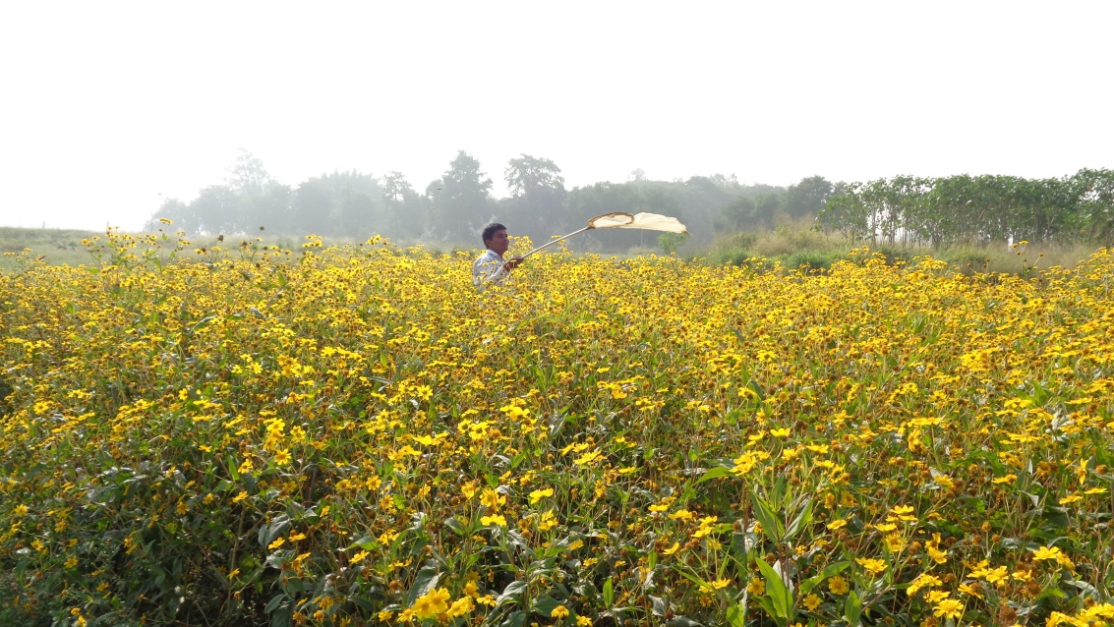

**Plate: 1. Experimental field**

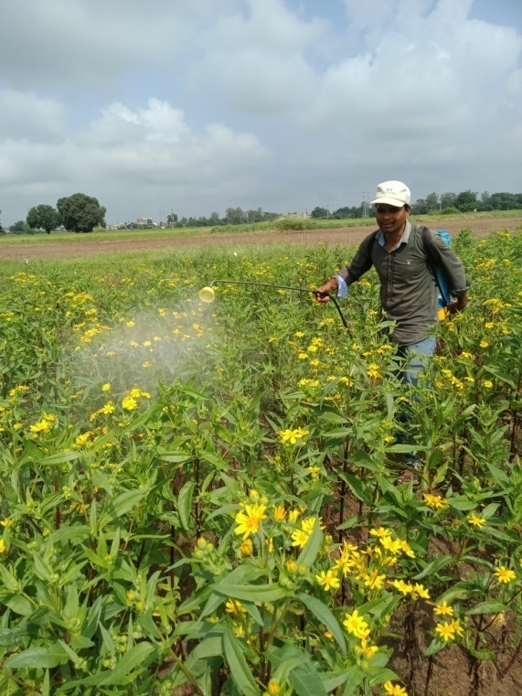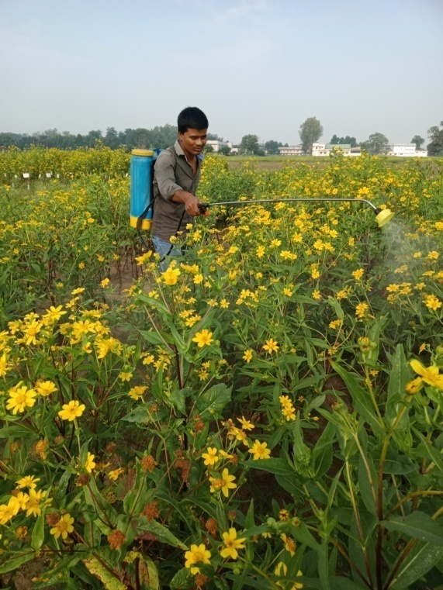

**Plate: 2. 10% flowering stage Plate: 3. 50% flowering stage**

**3.3. Seed yield (q/ha)**

The data of seed yield revealed that all the treatments were differed significantly to each other in respect to record the higher seed yield.The highest seed yield (6.90 q/ha) was recorded with the treatment in which foliar spray of rose water 10%, was applied followed by (6.70 q/ha) sugar solutionr 10 % and (6.30 q/ha) flower extract of *M. dactylifera* spray while the least seed yield (3.15 q/ha) was recorded from the controlled condition followed by (4.40 q/ha) 10% jiggery solution and water spray (4.80 q/ha). These findings corroborated with the findings of Chandrashekhar and Sattigi (2009) they observed that spraying of bee attractant like cacambe (10%) and jaggary solution (10%) were significantly superior in enhancing both quantitative and qualitative parameters of radish seed. These findings are in close conformity with the earlier reports of Dwarka *et al.,* (2022) they reported that highest seed yield (6.90 q/ha) was recorded with the treatment in which foliar spray of flower extract of *Madhuca longifolia* 10%. Similarly Jayaramappa *et al.,* (2011), Dwarka *et al.,* (2023a,b,c).

**4. Conclusion**

From above results it is concluded that for the attraction of *Apis florea*, rose water 10% was the best when sprayed at 10% and 50 % flowering stages, followed by flower extract of *M. longifolia* 10% and fruit extract of *Foenix dactylifera* 10% they attracted comparatively higher number of *Apis florea* and simultaneously recorded higher seed yield over others.

**Table 2: Effect of different attractants on the attraction of little honey bee, *Apis florea* and their impact of seed yield in niger crop *Kharif* 2021.**

|  |  |  |  |  |  |  |  |  |  |  |  |  |  |
| --- | --- | --- | --- | --- | --- | --- | --- | --- | --- | --- | --- | --- | --- |
| **Treatment** | **Population of *Apis florea*/m2/5minutes** | | | | | | | | | | | | **Yield**  **(q/ha)** |
| **1st spray at 10% flowering** | | | | | | **2nd spray at 50% flowering** | | | | | |
| **1DBS** | **Days after spray** | | | | **Mean** | **1DBS** | **Days after spray** | | | | **Mean** |
| **1DAS** | **3DAS** | **5DAS** | **7DAS** | **1DAS** | **3DAS** | **5DAS** | **7DAS** |
| T1-Flower extract of *M. longifolia* 10% | 5.00  (2.34) | 11.00  (3.37) | 18.00  (4.30) | 11.67  (3.48) | 10.00  (3.24) | 12.67  (3.63) | 6.33  (2.61) | 12.33  (3.56) | 18.00  (4.29) | 17.67  (4.26) | 8.67  (3.01) | 14.17  (3.83) | 6.30  (2.61) |
| T2-Juice of *S. officinarum* 10% | 3.67  (2.04) | 9.67  (3.18) | 11.00  (3.35) | 9.33  (3.11) | 7.33  (2.78) | 9.33  (3.13) | 4.33  (2.20) | 11.67  (3.48) | 12.00  (3.52) | 15.67  (4.01) | 10.33  (3.29) | 12.42  (3.59) | 5.82  (2.51) |
| T3-Jaggery solution 10% | 4.00  (2.11) | 12.33  (3.56) | 13.67  (3.74) | 7.67  (2.78) | 6.67  (2.67) | 10.08  (3.24) | 5.00  (2.34) | 13.33  (3.69) | 14.00  (3.80) | 13.33  (3.69) | 9.33  (3.13) | 12.50  (3.60) | 4.40  (2.21) |
| T4-Honey solution 10% | 2.67  (1.77) | 6.33  (2.58) | 11.67  (3.48) | 6.00  (2.40) | 5.67  (2.46) | 7.42  (2.81) | 3.33  (1.95) | 8.00  (2.90) | 11.67  (3.48) | 13.67  (3.72) | 7.67  (2.84) | 10.25  (3.28) | 5.45  (2.44) |
| T5- Fruit extract of *F. dactylifera* 10% | 3.00  (1.86) | 13.67  (3.70) | 15.33  (3.95) | 10.00  (3.24) | 9.67  (3.18) | 12.17  (3.56) | 5.33  (2.40) | 10.33  (3.28) | 13.00  (3.67) | 16.67  (4.14) | 10.67  (3.33) | 12.67  (3.63) | 6.00  (2.55) |
| T6-Sugar solution 10% | 4.33  (2.18) | 10.33  (3.28) | 13.00  (3.66) | 11.00  (3.38) | 11.33  (3.41) | 11.42  (3.45) | 3.00  (1.86) | 14.67  (3.86) | 15.33  (3.98) | 18.33  (4.33) | 9.00  (3.06) | 14.33  (3.85) | 6.70  (2.68) |
| T7-Rose water 10% | 2.00  (1.56) | 14.33  (3.80) | 16.33  (4.10) | 12.33  (3.56) | 8.33  (2.96) | 12.83  (3.65) | 4.00  (2.11) | 15.00  (3.90) | 14.33  (3.82) | 16.00  (4.06) | 11.67  (3.48) | 14.25  (3.84) | 6.90  (2.72) |
| T8-Water spray | 1.67  (1.46) | 5.67  (2.46) | 6.33  (2.60) | 4.67  (2.21) | 2.33  (1.66) | 4.75  (2.28) | 2.33  (1.68) | 6.33  (2.58) | 5.33  (2.40) | 5.67  (2.43) | 6.00  (2.54) | 5.83  (2.51) | 4.80  (2.30) |
| T9-Control | 1.33  (1.34) | 3.00  (1.81) | 4.00  (2.08) | 1.67  (1.35) | 2.00  (1.56) | 2.67  (1.77) | 2.33  (1.68) | 4.33  (2.16) | 3.33  (1.93) | 3.00  (1.82) | 4.33  (2.20) | 3.75  (2.06) | 3.15  (1.92) |
| **SEm±** | 0.14 | 0.29 | 0.26 | 0.34 | 0.21 | 0.10 | 0.12 | 0.29 | 0.23 | 0.26 | 0.19 | 0.09 | 0.03 |
| **CD at 5%** | 0.43 | 0.88 | 0.78 | 1.03 | 0.63 | 0.30 | 0.35 | 0.86 | 0.70 | 0.79 | 0.58 | 0.28 | 0.09 |

*Figures in parenthesis are square root of √ x+0.5

**5. References**

Abrol DP. Foraging behavior of *Apis florea* F. an important pollinator of *Allium cepa* L. Journal of Apicultural Research. 2010;49(4):318-325.

Anonymous. 2005. observations made during “national seminar on strategies for enhancing production and export of sesame and niger” and “annual workshop of AICRP on sesame and niger research workers, 2005”.

Anonymous. 2020-21. 4th Advance Estimate, Agriculture Statistics Division, Directorate of Economics and statistics, New Delhi. Indian Journal of Natural Products and Resources, 2:221-226.

Dwarka, Chadar N, Katara VK , Thakur S, Shukla S, Parveen S, Maneesha and Ahirwar MK. Introduction to Insect Pests of Niger [*Guizotia abyssinica* (L.f.) Cass.] and Their Management: A Review. Journal of Experimental Agriculture International. 2024a;46(11): 835-841.

Dwarka, Ghugal SG, Thakur S, Panday AK. Evaluation of Various Bee Attractants on the Foraging Behavior of Indian Honey Bee (*Apis cerana indica*) and their Impact on the Seed Yield of Niger [*Guizotia abyssinica* (*L.f.*) Cass]. Advances in Research. 2024b;25(6);528-534.

Dwarka, Panday AK , Thakur S , Katara VK , Patel DK and Kurmi JP. Impact of different bee attractants on the attraction of Indian honey bee, *Apis cerana indica* and their impact on seed yield of niger, *Guizotia abyssinica* (L.f.) Cass, crop. Plant Archives. 2024c;24(2); 255-258.

Dwarka, Panday AK , Thakur S and Katara VK. Study on the Effect of Bee Attractants on the Giant Honey Bee, *Apis dorsata* and their Effect on Niger [*Guizotia abyssinica* (L.f.) Cass] Seed Yield Journal of Experimental Agriculture International. 2024d;46(7); 903-908.

Dwarka, Panday AK and Saxena AK. To study the effect of bee attractants on the attraction of giant honey bees (*Apis dorsata*) and their impact on seed yield of Niger (*Guizotia abyssinica*) crop. The Pharma Innovation Journal. 2022;11(12): 866-868.

Dwarka, Panday AK, Saxena AK, Jain S, Marabi RS and Sahu R. Impact of different weather parameters on the population of pollinators visited on Niger flowers. The Pharma Innovation Journal. 2023a;12(7): 619-621.

Dwarka, Panday AK, Saxena AK, Jain S, Sahu R and Marabi RS. The relative abundance of insect pollinators/visitors in Niger (*Guizotia abyssinica*) crop. The Pharma Innovation Journal. 2023b;12(2): 3579-3581.

Dwarka, Panday AK, Tare S, Thakur S, Katara VK. Effect of Bee Attractants on the Attraction of *Apis dorsata* and their Impact on Seed Yield of Niger *Guizotia abyssinica* (L.f.) Cass Crop. Journal of Scientific Research and Reports. 2024e;30(6):420- 426.

Dwarka, Saxena AK, Panday AK, Jain A and Marabi RS. Succession of different insect pollinators on Niger flowers grown under different dates of sowing. The Pharma Innovation Journal. 2023c;12(7): 622-627.

Getinet A and Sharma SM. 1996. Niger, *Guizotia abyssinica (L.f.)* Cass. Promoting the conservation and use of underutilized and neglected crops. Institute of Plant Genetics and Crop Plant Research. International Plant Genetic Resources Institute, Rome.

Jayaramappa Kract V, Pattibhiramaiah M and Bhargava HR. Influence of bee attractants on yield parameters of Ridge gourd (*Luffa acutangulus* L.) (Cucurbitaceae).World Applied Science Journal. 2011;15(4);547-462.

Kalmath BS and Sattigi HN. Effect of different attractants on attracting the bees to onion (*Alium cepa*) crop. Indian Bee Journal. 2002;64(6): 68-71.

Manchare RR, Kulkarni SR and Chormale TS. Effect of bee attractants on foraging activities of Indian bees *Apis cerena indica* in bitter gourd (*Momordica charantia* L.). Journal of Entomology and Zoology Studies. 2019;7(5); 468-472.

Mohana Rao, GM, Lazar M and Suryanarayana MC. Foraging behaviour of honeybees in sesame (*Sesamum indicum* L.). Indian Bee Journal. 1981;43:97-100.

Ranganatha ARG, Tripathi A, Jyotishi A, Paroha S, Deshmukh MR and Shrivastava N. 2009. Strategies to enhance the productivity of sesame, linseed and niger. In: Proceedings of Platinum Jubilee Celebrations*,* UAS,Raichur*.*

Singh RS, Amrendra Pratap B, Singh Singh DV. Abundance and foraging activity of bee visitors to pigeonpea. Progressive Agriculture. 2015;15(1):116- 119.

Venkataramegowda S, Koragandahalli VJ, Menon A and Ruben MC. Use of Bee-attractants in Increasing Crop Productivity in Niger (*Guizotia abyssinica*. L). Braz. Arch. Biol. Technol. 2013;56(3):365-370.