**Original Research Article**

**ANALYSING THE IMPACT OF AWARENESS ON THE MANAGEMENT AND TREATMENT OF HYPERTENSION**

**ABSTRACT**

Hypertension is one of the leading non-communicable diseases worldwide, significantly contributing to cardiovascular complications. Earlier studies have shown that there is a low awareness rate of hypertension among the African populations. This study employs the linear regression model using the generalized linear model (glm) built in RStudio to analyze the relationship between awareness and the management of the disease among individuals in Makurdi Local Government Area of Benue State, North-Central Nigeria. Data was collected from 225 respondents through random sampling using a structured questionnaire. The sample composed of 78% respondents that are either hypertensive or associates with those that are hypertensive. Among the hypertension cases, 11% are directly affected, 40% female and 60% male, which indicates that in every 100 people, 11 individuals could be hypertensive. The study discovered that among the hypertensive population which are mostly 41 – 60 years, 83.5% sought medical advice, 89% experienced certain medical complications and 88.4% developed one or more behavioral changes. From the model analysis, the result revealed that high awareness level influences patients seeking medical attention, while familiarity with the causes and risks of hypertension influences their behavioral changes.

**Keywords:** Hypertension,Awareness, Model, Regression, Non-communicable disease

**1. INTRODUCTION**

Hypertension, also known as high blood pressure, is diagnosed when blood pressure is measured on two different days and the systolic blood pressure readings on both days is greater or equal to 140mm Hg and/or the diastolic blood pressure reading on both days is greater or equal to 90mm Hg. Hypertension is one of the most prevalent non-communicable diseases in West Africa that can be properly managed with good primary care. Effective management is crucial for controlling the disease and preventing complications [7].

One of the major leading risk factors for cardiovascular diseases globally is hypertension, contributing over 10 million deaths annually. As at 2023, an estimated 1.28 billion adults aged 30-79 years worldwide have hypertension with a majority of them living in low- and middle-income countries [1]. Key facts from the world health organization say an estimated 40% of adults with hypertension are not aware that they have the condition.

The world health organization (WHO) shared the significant benefits of early detection, treatment, and self-care of hypertension. They said early detection of the disease can significantly reduce the risk of heart attacks, heart failure, strokes, and kidney failure [6].

An analysis in 2021 among Nigerians with hypertension revealed that only 29% were aware of their hypertension diagnosis, 12% were receiving treatment and as little as 3% had achieved control of the condition [2]. Among elderly Nigerians, a study conducted in Ibadan revealed that about 7,800 of individuals with hypertension were unaware of their condition. Among the minority who were aware, 77.1% had uncontrolled hypertension, even though they reported being on treatment [4].

Improving awareness of hypertension has been identified as one of the major medical and health challenges in its prevention and treatment [5]. In the study carried out to access hypertension knowledge, awareness, and attitude in hypertensive individuals, it was discovered that even though most hypertensive patients were well informed about the meaning of hypertension and its serious implications for their health, they were generally not aware of the important measures responsible for the control of the disease [5].

Hypertension has affected the health and well-being of many individuals. In many instances, they only become aware of the situation when complications arise, causing them to be hospitalized. This study aims to investigate the level of awareness dissemination of the disease and the impact of awareness on the response to treatment and management of the disease.

**2. MATERIALS AND METHODS**

**2.1 Study Site and Population**

In this study, the target group is individuals within Makurdi metropolis. Makurdi is one among the 23 Local Government Areas of Benue State, in the middle belt, North Central of Nigeria. It is the capital city of the State and is located between longitude $8°35’E$ and $8°41’E$ and latitude $7°45’N$ and $9°52’N$ characterized by undulating rolling plain with irregular river valley and ridges with steep slopes [8]. Based on the 2006 census, Makurdi has a total population of 297,398 which amounts to 7.0486 % of the Benue State population [9]. The projection from the 2006 census recorded by the National Population Commission (NPC) shows that Benue State has a total population of 6,141,284 in 2022. Consequently, Makurdi can be said to have a projected population of 432,875 in 2022 [10].

**2.2 Data Collection and Preprocessing**

The study used questionnaire written in English as tool for data collection. The questionnaire is built into four sections; the first section has questions pertaining information on the respondent, the second section is on the health status and awareness level of the respondent, the third section has questions related to sources of awareness and its impact while the fourth section has questions related to barriers to awareness dissemination and possible suggestions for improvement. The questionnaire was administered to individuals directly at different locations within Makurdi metropolis and via the assistance of google forms link. The sample selection is random sampling.

The study succeeded in receiving 225 feedback from the various individuals reached out to with the questionnaire. There were 105 direct feedback and 120 feedback from the google forms. The responses were extracted from the google forms and the hard copy submissions using the Excel spreadsheet and cleansed to remove all forms of amplifiers. The code generated within the RStudio is used for the data analysis to generate the various results obtained.

**2.3 Model Analysis**

Linear regression model is an aspect of mathematics that shows the relationship between the regressor or predictor variable, $x$ and the dependent or response, $y$ variable. It could be simple (having one predictor variable) or multiple (having more than one predictor variable) linear regression. A multiple linear regression model is defined by the equation

$y=β_{0}+β_{1}x_{1}+β_{2}x_{2}+…+β_{n}x_{n}+ϵ$… (1)

where $β_{0}$ is the intercept, $β_{i}$, $i=1,2, …, n$ are the regression coefficients and $ϵ$ is the random error term [11].

The generalized linear modeling (glm) is a development of linear models to accommodate both non-normal response distributions and transformations to linearity in a clean and straightforward way. A generalized linear model may be described in terms of the following sequence of assumptions among others:

* There is a response, $y$  of interest and predictor variables $x_{1}, x_{2}, x_{3},…$ whose values influence the distribution of the response.
* The predictor variables influence the distribution of $y$  only through a single linear function which is called the linear predictor, and takes the expression

$η=β_{1}x_{1}+β_{2}x_{2}+…+β_{n}x_{n}$… (2)

hence $x_{i}$ has no influence on the distribution of $y$ if and only if $β_{i}$ is zero [12].

In the R programming platform, the class of generalized linear models includes *gaussian*, *binomial*, *poisson*, *inverse gaussian* and *gamma* response distributions and also *quasi-likelihood* models where the response distribution is not explicitly specified. In the latter case the *variance function* must be specified as a function of the mean, but in the other cases this function is implied by the response distribution [12].

This research employs the multiple linear regression model using the generalized linear model (glm) built in RStudio to investigate the impact of the occupation, educational and awareness level of hypertensive patients, their ability to identify causes and risks of hypertension and the challenge of accessing information on their responses to treatment and management of the disease.

**3. RESULT AND DISUCSSION**

**3.1 Results from Data Analysis**

The feedback from the samples collected gave 225 respondence with 60% non-hypertensive cases and 40% hypertensive condition. Among the feedback of hypertensive cases, 25 (11%) were directly affected which indicates that in every 100 people, 11 individuals could be hypertensive. This signifies a very high hypertensive case value and therefore calls for interventions. Furthermore, considering the non-hypertensive cases, 15% of these individuals admit total ignorance of the disease.

The pictorial representation of the results extracted from the collection of the hypertensive cases (both those directly and indirectly affected) are captured in Figures 1 to 3. The majority of the respondence are within the age group of 41 – 60 years where 58.2% are male and 41.8% female. The married and singles accounts for 51.6% and 37.4% of the population respectively. Their occupation varied; students (27.5%), self-employed (33%), civil servants (22%), public servants (16.5%) and retirees (1.1%). The various educational levels and their level of awareness regarding hypertension are shown in Figure 1.

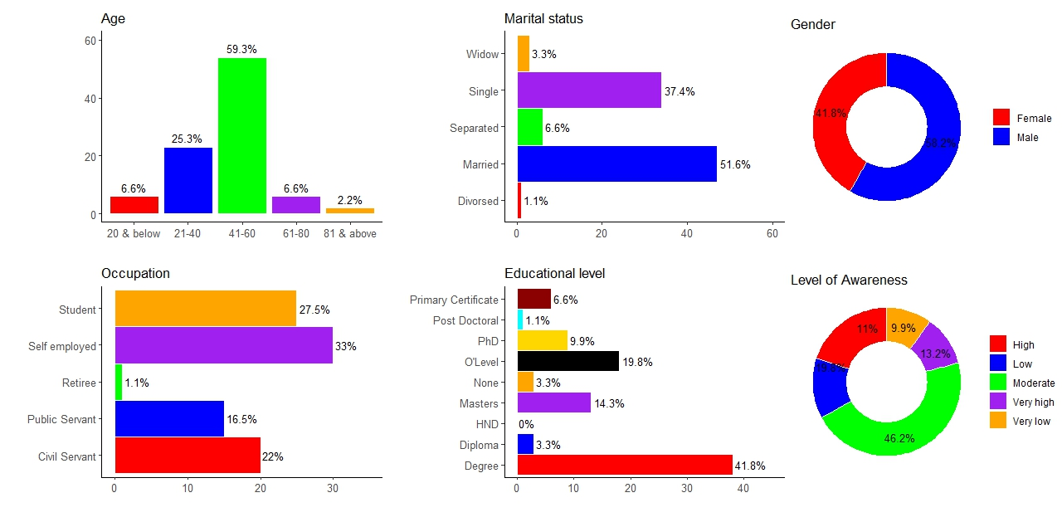

Fig. 1: Showing personal information of those associated with hypertensive cases

3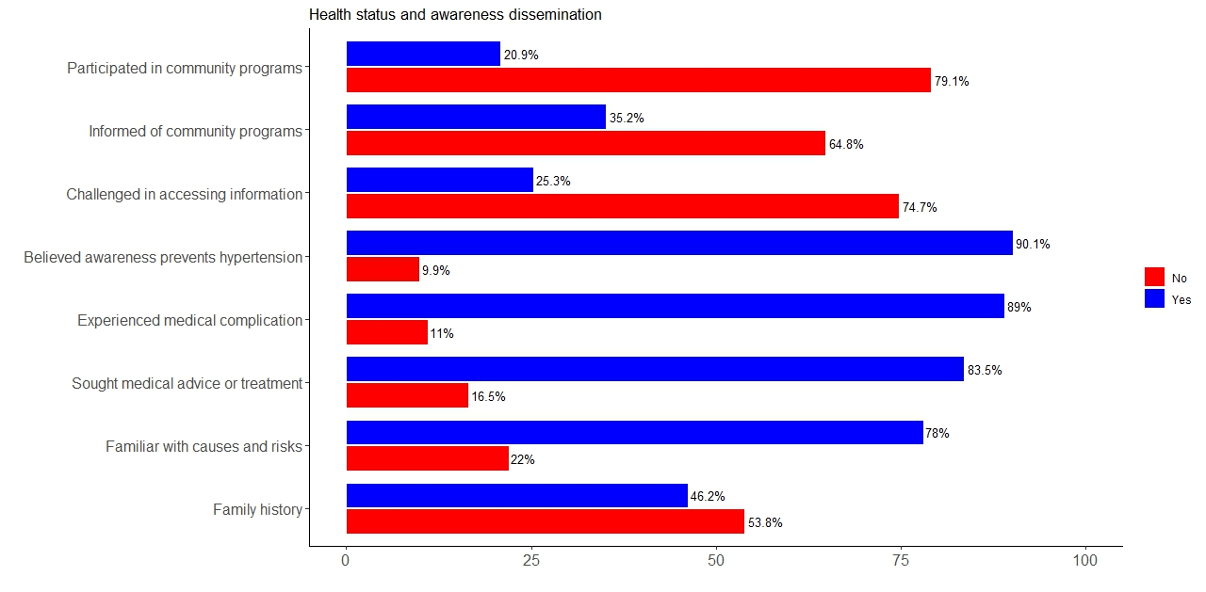

Fig. 2: Showing the health and awareness status of those associated with hypertensive cases

The results in Figures 2 and 3 indicate that 78% of the people with hypertensive cases or their associates are familiar with the causes and risks of hypertension even though only 19.8% of these individuals are very self-confident while 38.5% are partly confident. The study discovered 83.5% of those with hypertensive condition sought medical advice or treatment, though only 38.9% are regular at routine check-up, 57.9% attend occasionally while 3.2% don’t attend at all. In all, 89% of those suffering from hypertension experience medical complications and 88.4% develop one or more behavioral changes as shown in Figure 3.

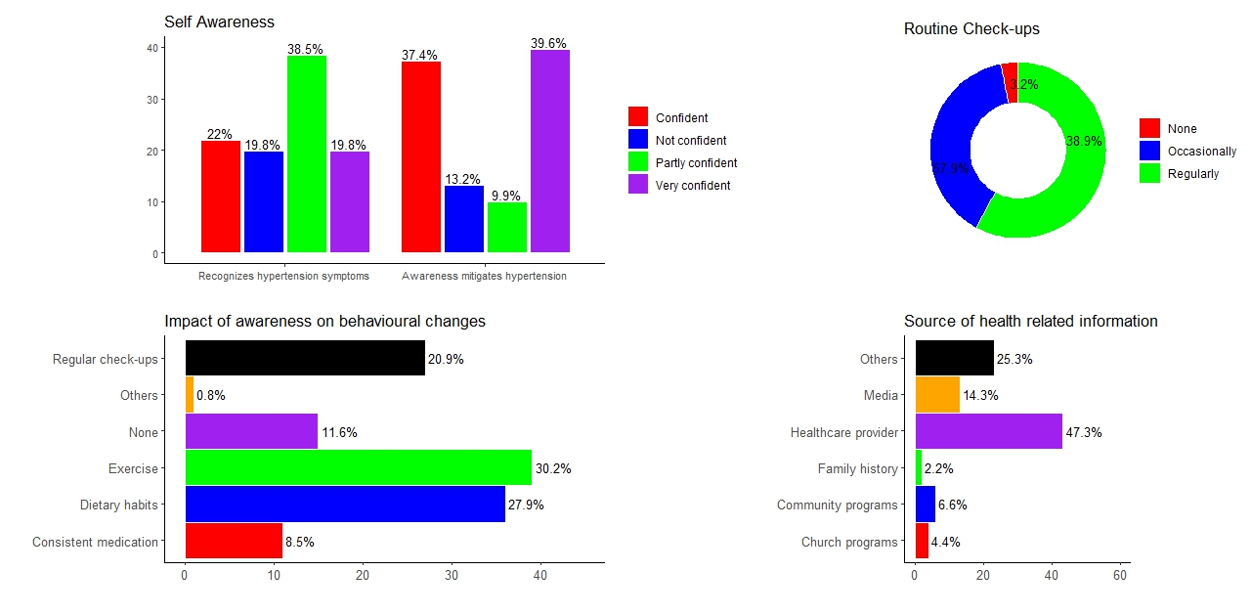

Fig. 3: Showing level of awareness of those associated with hypertensive cases and the impact

In addition, those that are hypertensive were extracted from the collection and analyzed. The results are represented in Figures 4 to 6. Similar to the previous results, 56% of those affected are within the age group of 41 – 60 years with 60% male and 40% female. Those affected are majorly married and single people. They have varied occupations with the following details: students (36%), self-employed (24%), civil servants (20%) and public servants (20%). The percentage of those with O’Level and PhD certificates are 20% each, those with First Degree are 44% while those with Masters are 16%. They possess different levels of awareness as regards hypertension; details are captured in Figure 4.

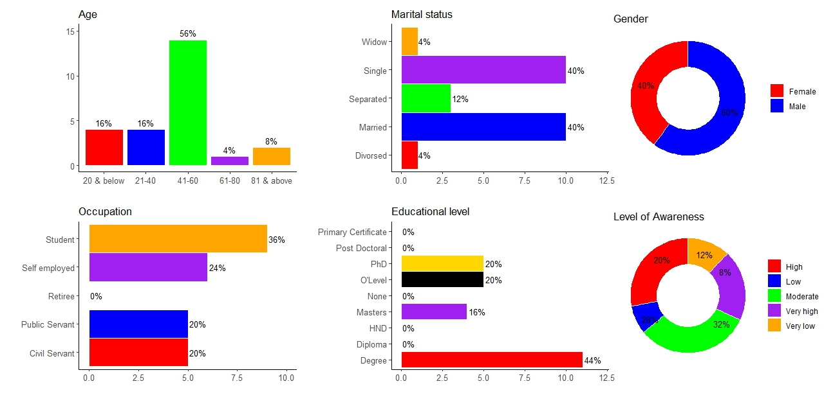

Fig. 4: Showing personal information of individuals with hypertension

Furthermore, it is observed from the results in Figures 5 and 6 that 44% of these patients do have family history of hypertensive cases, 88% are familiar with the causes and risks of hypertension but only 40% are very confident in themselves while 20% are partly confident. The result revealed that a good percentage (90%) of these individuals sought medical advice or treatment, but only 41.6% engage in regular routine check-up, 54.2% attend occasionally while 4.2% did not. Those with medical complications from hypertension are put at 48% and individuals that develop one or more behavioral changes are 95.6% in total (details in Figure 6).

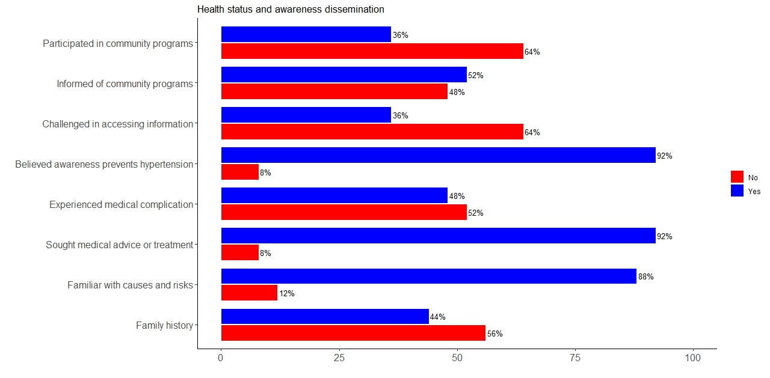

Fig. 5: Showing the health and awareness status of those with hypertensive cases

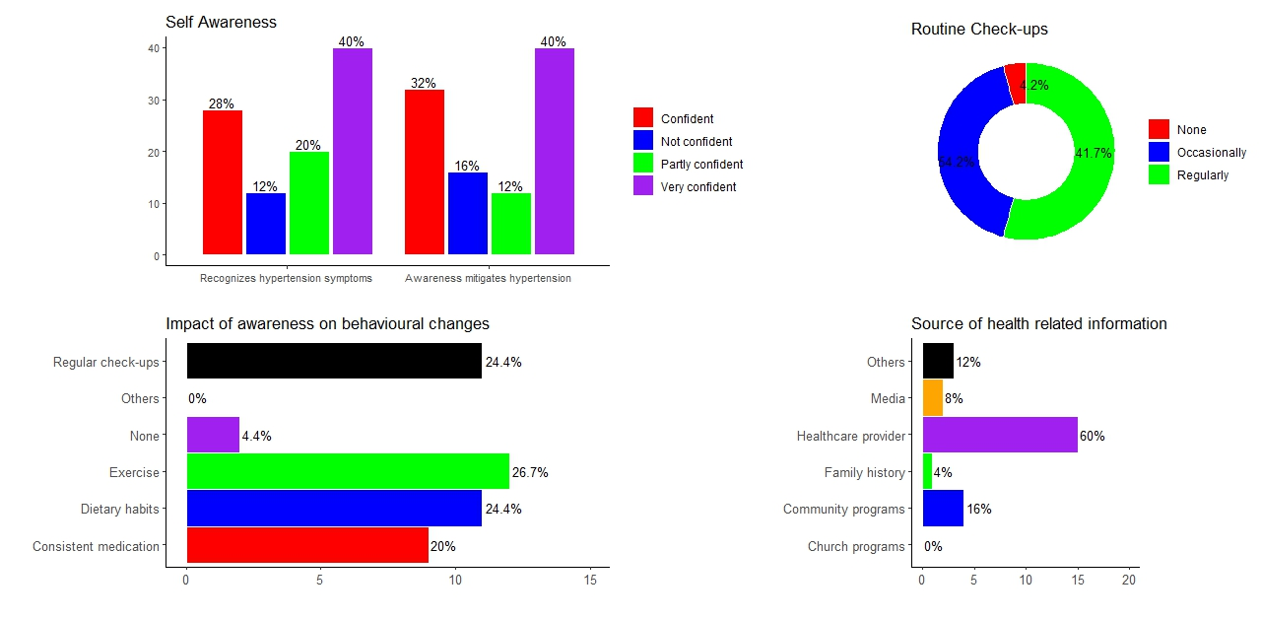

Fig. 6: Showing level of awareness of hypertensive individuals and the impact

**3.2 Results from Linear Regression Model**

In analyzing the impact of awareness on hypertensive patients as regards seeking medical advice or treatment, and their behavioral changes, the study uses the multiple linear regression model defined in eqn. (1) via the RStudio in the R programming platform.

The first scenario considers patients seeking medical advice or treatment as the response variable which depends on the predictors: patients’ occupation, educational level, level of awareness on hypertension, familiarity with the causes and risk of hypertension, and being challenged in accessing information on hypertension. The predictors were ranked as follows:

* Occupation – Students (0), Civil servants (1), Public servants (2) and Self-employed (3)
* Educational level – O’Level (0), Degree (1), Masters (2) and PhD (3)
* Awareness level – Very low (0), Low (1), Moderate (2), High (3), and Very high (4)
* Familiar with causes and risk – No (0), Yes (1)
* Challenged accessing – No (0), Yes (1)

Two model equations were analyzed within the scope of the first scenario. The first has the predictors as occupation, educational level, awareness level, familiarity with causes and risk, and challenge accessing awareness. The result with Akaike's ‘An Information Criterion’ (AIC) of 31.337 as shown in Figure 7(a) indicates that only awareness level (4) has significant impact on patients influencing their action in seeking medical advice or treatment. The second model excludes occupation from the predictors and the outcome indicates AIC of 30.936 and shows that only awareness levels (3) and (4) do have significant impact in influencing patients in seeking medical advice or treatment (see details in Figure 7(b)). Therefore, since the AIC of the second model is less than the first, the formal is considered for analysis.

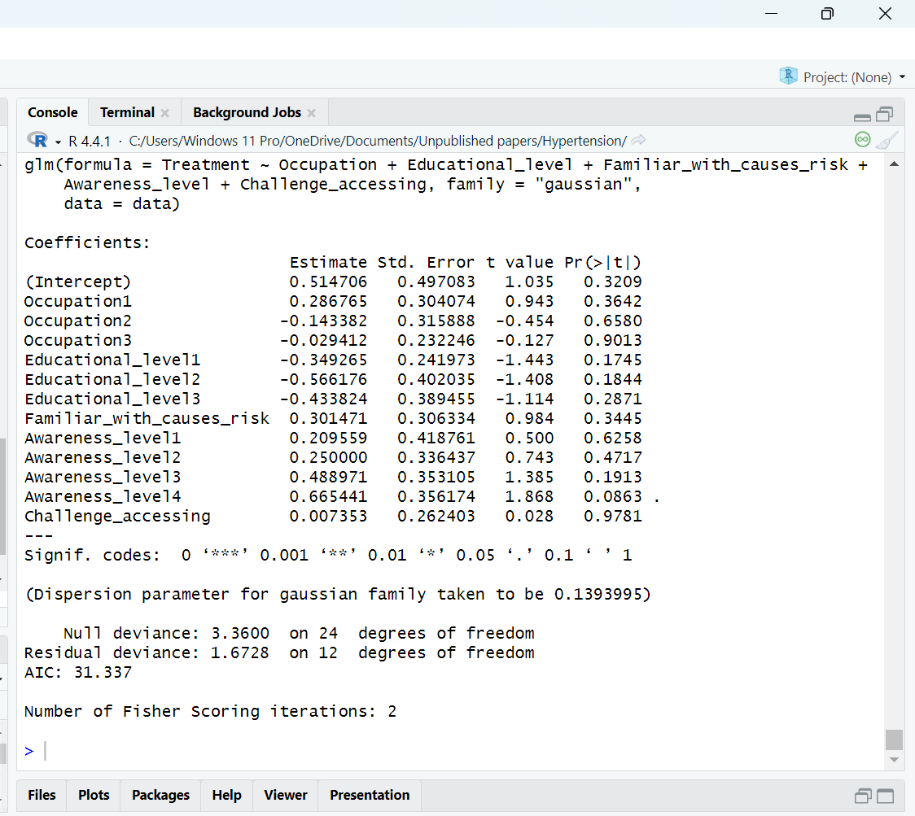 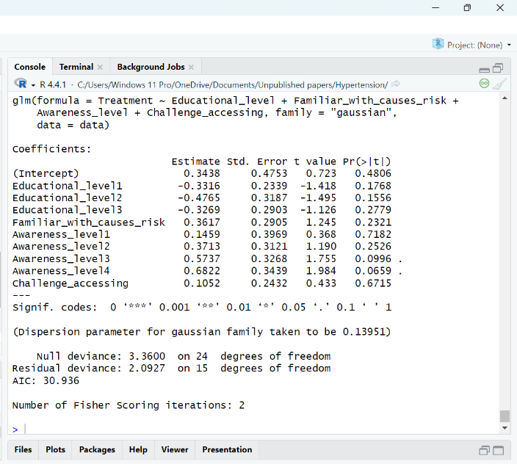

(a) (b)

Fig. 7: Showing the results from the model analysis for medical advice or treatment (a) include all the predictors (b) exclude occupation

Similarly, while investigating behavioral changes, two model equations were also analyzed using same predictors in the first and second model equations for medical treatment respectively. The results from the first and second model equations as seen in Figure 8(a) and (b) indicate AIC of 11.74 and 11.013 respectively and show that only the familiarity of patients with causes and risk of hypertension has significant impact in influencing their behavioral changes. The second model equation is also adopted since it has less AIC value than the first model equation.

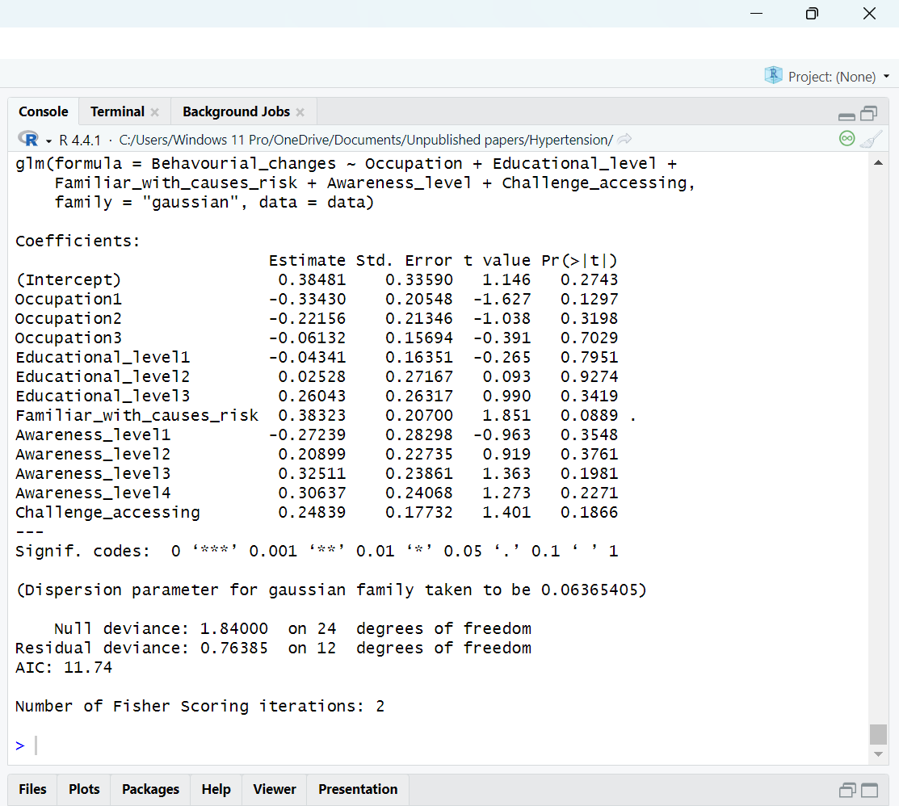 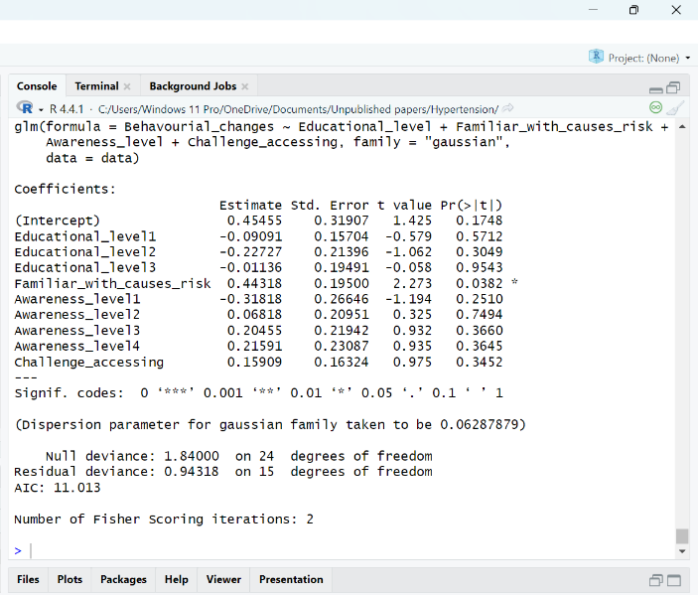

(a) (b)

Fig. 8: Showing the results from the model analysis for behaviorial changes (a) include all the predictors (b) exclude occupation

**4. CONCLUSION AND RECOMMENDATIONS**

In this study, we analyzed the impact of awareness on the management and treatment of hypertension. The analysis reveals that awareness level is a significant predictor for hypertensive individuals to seek medical advice and adapt behavioral changes that can significantly control the disease. However, a notable proportion of individuals are unaware of their condition, which calls for attention to the need for more improved and strategized awareness programs targeted at health education, subsidize and easy access to healthcare. Majority of the respondents advocate for community-based awareness programs to enlighten the masses on hypertension and also the provision of accessible healthcare services and facilities, specially in remote areas, to handle cases of hypertension.

**REFERENCES**

[1] World Health Organization (WHO). Hypertension. 2023. https://www. who.int/news-room/fact-sheets/detail/hypertension . Accessed 15 Jan 2025

[2] Adeloye, D., Owolabi, E. O., Ojji, D. B., Auta, A., Dewan, M. T., Olanrewaju, T. O., ... & Harhay, M. O. (2021). Prevalence, awareness, treatment, and control of hypertension in Nigeria in 1995 and 2020: A systematic analysis of current evidence. *The Journal of clinical hypertension*, *23*(5), 963-977.

[3] Korhonen PE, Kivelä SL, Kautiainen H, Järvenpää S, Kantola I. Health-related quality of life and awareness of hypertension. J Hypertens. 2011 Nov;29(11):2070-4. doi: 10.1097/HJH.0b013e32834bbca7. PMID: 21946696.

[4] Raji YR, Abiona T, Gureje O. Awareness of hypertension and its impact on blood pressure control among elderly nigerians: report from the Ibadan study of aging. Pan Afr Med J. 2017 Jul 13;27:190. doi: 10.11604/pamj.2017.27.190.11682. PMID: 28904715; PMCID: PMC5579467.

[5] Oliveria, S. A., Chen, R. S., McCarthy, B. D., Davis, C. C., & Hill, M. N. (2005). Hypertension knowledge, awareness, and attitudes in a hypertensive population. *Journal of general internal medicine*, *20*(3), 219-225.

[6] World Health Organization. A Global brief on hypertension. Available online at:<http://apps.who.int/iris/bitstream/10665/79059/1/WHO_DCO_WHD_2013.2_eng.pdf> (accessed January 26, 2025)

[7] Amarteyfio, K. N. A. A., Bondzie, E. P. K., Reichenberger, V., Agyepong, I. A., Ansah, E. K., Diarra, A., ... & Antwi, E. (2024). Factors influencing primary care access, utilisation and quality of management for patients living with hypertension in West Africa: a scoping review protocol. *BMJ open*, *14*(1), e077459.

[8] Manyi M, Vajime CG, Imandeh GN, Manyi MM, Imandeh. Seasonal changes of microfilarial infection and infectivity rates in mosquito populations within Makurdi, Benue State, Nigeria. ~ 1 ~ International Journal of Mosquito Research. 2014;1(4):1–09.

[9] Federal Republic of Nigeria, 2006 Population Census, Nigeria. Available from: www.nigerianstat.gov.ng

[10] Nigeria Population Projections and Demographic Indicators: National and States, National Population Commission, Abuja, Nigeria. 2020. Available from: www.population.gov.ng

[11] Montgomer, D. C. & Runger, G. C. (2002). Applied statistics and probability for engineers, third edition. John Wiley & Sons, Inc, USA.

[12] R Core Team (2024). An introduction to R, a language and environment for statistical computing and graphics. Copyright@ 1999 – 2024.