Analysis of Heat and Mass Transfer of Second Grade Fluid Flow with effects of Hall current, viscous dissipation and Chemical reaction

Abstract: This research paper focuses on formulation of mathematical model to examine the impact of thermophoresis on the unsteady flow of a non-Newtonian fluid with heat and mass transfer through a porous medium adjacent to a permeable, infinite vertical plate. The non-Newtonian fluid under consideration follows a second-grade model and is influenced by a uniform, strong magnetic field, incorporating the effects of Hall currents. The problem is described using a system of coupled nonlinear partial differential equations governing continuity, momentum, energy, and concentration. These equations account for various physical effects, including thermal radiation, heat generation, thermal diffusion (Soret effect), viscous dissipation, and chemical reaction. The dimensionless form of these equations is solved numerically as a function of the relevant physical parameters. Numerical solutions for the velocity components u and w, temperature θ, and concentration C are obtained, along with the Nusselt number (Nu) and Sherwood number (Sh). The influence of key physical parameters on these quantities is analyzed and visually represented through graphs and tables.
Keywords: Second-grade fluid, Thermo diffusion, Heat and mass transfer, Viscous dissipation,
Thermophoresis, Hall urrent, Thermal radiation, unsteady

Nonmenclature
P hydrostatic pressure ν kinematic viscosity
$μ$ dynamic viscosity ρ fluid density
$α_{1}$ and $α_{2}$ material constants g gravitational acceleration
$A_{1}$ and $A_{2}$ kinematic Rivlin-Ericksen tensors, $β_{T}$ thermal expansion volumetric coefficient
d/dt material time derivative $β_{c}$ volumetric coefficient of concentration expansion
E* $E^{*}$ electric field vector $T^{*}$ temperature of the fluid
H strength of the magnetic field vector $T_{w}^{*}$ temperature at the plate
$P_{e }$ electron pressure $T_{∞}^{*}$ temperature far away from the plate
$ω_{e}$ frequency of the electron $σ^{*}$ Stefan Boltzmann constant,
$J_{x}^{*}$ and $J_{z}^{*}$ are electric current density $v^{*}$ suction velocity
${ V}_{T}$ thermophoretic velocity $v_{0}$ scale of mean suction velocity
$T_{r}$ reference temperature $α$ viscoelastic parameter
$k_{t}v$ thermophoretic diffusivity $Gr$ Grashof number
${ K}_{n}$ Thermal conductivity of the fluid $Gc$ modified Grashof number
$K_{2}$ chemical reaction parameter $M$ magnetic field parameter
$M$ magnetic parameter $K$ Darcy parameter
$C_{w}^{*}$ dimensional concentration of the solute $Pr$ Prandtl number
$C_{∞}^{*}$ concentration of the solute far from the plate $Nr$ thermal radiation parameter
K permeability of the porous medium $Ec$ Eckert number
Κ thermal conductivity of the medium $∅$ heat source parameter
Cp specific heat at constant pressure $Sc$ Schmidt number
m Hall current parameter $Sr$ Soret Number
$D_{m}$ chemical molecular diffusivity $γ$ non-dimensional chemical reaction
$q_{r}$ is the radiative heat flux, $τ$ thermophoretic parameter.
u(t, y). primary velocity profile w(t, y) secondary velocity profile
$k^{*}$ is the mean absorption coefficient C(t, y) concentration profile

- Introduction
Viscoelastic second-grade fluids flowing through porous media with heat and mass transfer have significant applications in natural and industrial processes, as well as in biomedical sciences. These fluids play a crucial role in geothermal energy extraction, soil science, and drug permeation through human skin. Due to their diverse applications, researchers from various fields—including mathematics, physics, geology, and chemistry—have extensively studied their behavior, particularly under the effects of heat generation/absorption, thermal radiation, chemical reactions, and Hall currents. A comprehensive review of previous studies highlights the depth of research conducted in this area. Piazza (2008) examined thermophoresis, a phenomenon where particles move due to thermal gradients, which has applications in macromolecular fractionation, microfluidic manipulation, and colloidal structure tuning. Chamkha and Issa (2000) investigated the impact of heat generation and thermophoresis on hydromagnetic flow with heat and mass transfer over a flat surface. Alam, Rahman, and Sattar (2007) analyzed the combined effects of thermophoresis and chemical reactions on unsteady free convection and mass transfer past an inclined porous plate in the presence of heat generation/absorption. Similarly, Bhuvanavijaya (2014) studied the thermophoretic effect on convective heat and mass transfer over a vertical porous plate in a rotating system with suction and injection.Further research has explored variations of these effects in different fluid models. Animasaun (2015) investigated free convective heat and mass transfer in a non-Darcian MHD dissipative Casson fluid with thermophoresis, variable viscosity, and thermal conductivity. Das, Jana, and Kundu (2015) analyzed thermophoretic MHD slip flow over a permeable surface, while Fagbade, Falodun, and Boneze (2015) studied Darcy–Forchheimer mixed convection flow in a porous medium under a magnetic field, viscous dissipation, and thermophoresis. Flow over a permeable plate is particularly relevant in geophysics and industrial processes, including nuclear engineering, where strong magnetic fields influence fluid motion.The role of chemical reactions in heat and mass transfer is fundamental in industrial applications such as food processing and polymer production. Eldabe et al. (2015) investigated the Hall effect in third-order fluid flow through a porous medium with heat and mass transfer. Kumar et al. (2016) studied unsteady free convective heat and mass transfer of a Walters-B viscoelastic fluid over a vertical cone, incorporating thermal radiation, thermophoresis, and higher-order chemical reactions. Earlier studies by Eldabe (1986) and Kim (2000) examined unsteady MHD free convective flow over an infinite vertical porous plate with variable suction. Chamkha, Mansour, and Aly (2011) extended this work by including Hall current, thermal radiation, and chemical reaction effects. Vempati and Laxmi-Narayana-Gari (2010) investigated the influence of Soret and Dufour effects on unsteady MHD flow past a porous plate with thermal radiation. Similar studies have focused on unsteady MHD free convection flow in various viscoelastic fluid models. Reddy, Raju, and Reddy (2015) analyzed the unsteady MHD free convection of a Kuvshinski fluid past a vertical porous plate in the presence of a chemical reaction and a heat source/sink. Eldabe, El-Saka, and Fouad (2004) discussed thermal-diffusion and diffusion-thermo effects on mass transfer boundary layer flow in non-Newtonian fluids. Oahimire and Olajuwon (2013) and Reddy et al. (2014) examined the combined effects of Hall current and thermal radiation on unsteady chemically reacting micropolar fluids, later extended by Olajuwon, Oahimire, and Ferdow (2014) to include viscoelastic models.Pandya and Shukla (2016) studied the combined influence of thermophoresis, Dufour effects, Hall current, and radiation on unsteady MHD flow past an inclined plate with viscous dissipation, chemical reaction, and heat generation/absorption. Abbas, Sajid, and Asghar (2007) examined the role of thermal radiation in MHD flow of a second-grade fluid, while Nadeem and Siddiqui (2005) explored unsteady second-grade fluid flow in a rotating system influenced by Hall current. Hayat and Nawaz (2011) analyzed three-dimensional second-grade fluid flow under Hall and ion slip effects. Other significant contributions include Cortell (2007) on mass transfer in second-grade fluid flow over a stretching sheet in a porous medium, and Hayat, Mustafa, and Pop (2010) on heat and mass transfer with Soret and Dufour effects in viscoelastic fluids. Rashidi et al. (2014) and Chaudhary and Jain (2006) investigated Hall current effects on MHD mixed convection flow of a viscoelastic fluid past a vertical porous plate with mass transfer and radiation. Kumar and Chand (2011) examined slip conditions in unsteady MHD flow of a viscoelastic fluid past an infinite porous plate embedded in a porous medium. Sahoo (2013) analyzed heat and mass transfer in MHD viscoelastic fluid flow through a porous medium bounded by an oscillating porous plate in a slip flow regime. Das (2013) studied unsteady two-dimensional viscoelastic fluid flow in a porous channel with radiative heat and mass transfer. More recent studies include Jha et al. (2014) on Soret and Hall current effects on MHD mixed convection of viscoelastic fluids and Das et al. (2016) on thermophoresis and thermal radiation effects in second-grade MHD fluid flow past a semi-infinite stretching sheet with convective surface heat flux. VeeraKrishna and Swarnalathamma (2016) investigated Hall effects on unsteady MHD free convection of a conducting second-grade fluid in a porous medium over an infinite rotating vertical plate with heat source/sink and chemical reactions. Sudhakar et al. (2012) analyzed heat and mass transfer in unsteady free convection of a Walters-B viscoelastic fluid under thermophoresis effects. Nayak and Panda (2013) presented insights into mixed convective MHD flow of second-grade fluid past a vertical infinite plate, incorporating mass transfer, Joule heating, and viscous dissipation. Ahmed (2015) examined Hall current effects on unsteady MHD viscoelastic fluid flow with radiative heat flux and heat sources in a porous medium
While substantial research has been conducted, certain critical aspects remain unexplored. Specifically, the combined effects of thermophoresis, Soret effects, Hall currents, thermal radiation, heat generation, , heat absorption, viscous dissipation and chemical reactions on second-grade fluid flow through porous media with viscous dissipation require further investigation. This study aims to extend the work of Nayak and Panda (2013, 2015) and Nabil (2017) and by addressing these gaps and exploring the interplay of these factors in fluid flow dynamics.
- Model Formulation
From Maxwell’s equations, the divergence equation of magnetic field $∇.B=0 gives B_{y*}=B_{0}$which consider uniform magnetic field and by assuming a very small magnetic Reynolds number. This mean that $\left(R_{em}= μ_{m}σvL ≪1\right)$ the induced magnetic field is neglected in comparison to the applied magnetic field so that $B_{x* }= B_{z* }=0 hence, B= \left(0, B_{0 }, 0\right).$ Here L is the characteristic length and mm is the magnetic permeability. For the description of the thermodynamical or mechanical behavior of non-Newtonian fluids, much work has been devoted to the study of second grade fluids since they are of interest for theory and experiments. For these fluids the Cauchy stress T and the fluid motion are related by Truesdell and Noll (1965):
$T=-PI+{μA}_{1}+α_{1}A_{2}+α_{2}{{A_{2}∇}_{1}}^{2}$ (1)
where, −PI is the indeterminate spherical stress due to the constraint of incompressibility while, P is the hydrostatic pressure, $μ$ is is the dynamic viscosity, $α_{1}$ and $α_{2}$ are material constants and $A_{1}$ and $A_{2}$ are the kinematic Rivlin-Ericksen tensors,
$A_{1}=\left(∇V\right)+{(∇V)}^{T}, A_{2}= \frac{dA_{1}}{dt}+ A_{1}\left(∇V\right)+{(∇V)}^{T}A_{1}$ (2)
here, d/dt is the material time derivative. If the fluid of second grade modeled by Eq. (1) is to be compatible with thermodynamics and is to satisfy the inequality of Clausius–Duhem for all motions and the assumption that the specific Helmholtz free energy of the fluid is a minimum when it is locally at rest, then the coefficients m, a1 and a2 describe the viscosity, visco-elasticity and cross-viscosity respectively and must satisfy:
$μ≥0, α_{1}≥0, α_{1}+α_{2}=0$ (3)
It is necessary to be noted that when $α_{1 }= α_{2}=0$ then, the constitutive equation of second grade fluid is respond to that of viscous fluid. If E* $E^{*}= \left(E_{x}^{*}, E_{y}^{*},E_{z}^{*}\right)$ is the electric field vector then, it equals to zero as not only no polarization voltage is imposed on the flow field but also no energy is added or extracted from the fluid by the electric field. V is velocity vector of the fluid which it’s components are u∗,v∗,w∗. J is the current density vector whose components are $J_{x}^{*}, J_{y}^{*}, J_{z}^{*},$ then the equation of conservation of charge $∇.J=0 gives, J_{y}^{*}=constant,$ this constant equal to zero since, the plate is not conducted. Then from equations of Maxwell, we have:
$∇∧E=$0, $∇∧H=J, ∇.B=0$ (4)
where, H is the strength of the magnetic field vector. The Generalized Ohm’s law is

$J= \frac{σ}{ene} \left[{en}_{e}\left(E+V∧B\right)-\left(J∧B\right)+∇P_{e}\right]$ (5)

Consider strength of the magnetic field to be very large, furthermore, the generalized Ohm’s law can be modified to include Hall current in the absence of electric field and neglecting the ion-slip and thermoelectric pressure for weakly ionized gases, so eq.(5) becomes of the form:
$J= σ\left(V∧B+ \frac{1}{{en}_{e}}∇ P_{e}\right)+ \frac{ω_{e}τ_{e}}{B_{0}} \left(B ∧J\right)$ (6)
where, $P_{e }and ω_{e}$ are electron pressure and frequency of the electron respectively while, $τ_{e}$ te is collision time of it and $n_{e}$ is the number density of electron, s is electrical-conductivity of the fluid. Hence, Hall parameter m define as m = $ω_{e}τ_{e}$wete and it gives rise to the Lorentz force in z-direction which induces a cross flow in that direction. Consequently, the flow field becomes three dimensional,so from above eq. (6):
$J_{x}^{*}= \frac{σB_{0}}{\left(1+m^{2}\right)} \left(mu^{*}- w^{*}\right), J_{z}^{*}= \frac{σB_{0}}{\left(1+m^{2}\right)} \left(u^{*}+mw^{*}\right)$ (7)
where, $J_{x}^{*}$ and $J_{z}^{*}$ are electric current density along x∗-axis and z∗ - axis respectively. Wu and Greif, (1996). Have determined the thermophoretic velocity${ V}_{T}$ as
$V_{T}= \frac{-K_{t}V}{T_{r}}, ∇T=\frac{-K_{t}V}{T_{r}} \frac{∂T}{∂y}$ (8) where, $T_{r}$ is some reference temperature, $k_{t}v$ represents the thermophoretic diffusivity while, $k_{t}$ is coefficient of thermophoresis which ranges in value from 0.2 to 1.2 as indicated by Batchelor and Shen (1985). Also by Talbot, Cheng, Schefer and Willis (1980):
$k_{t}=\frac{2c_{s}\left(\frac{⋋_{g}}{⋋_{p}} +C_{t}K_{n}\right) \left[K_{n}\left(C_{1}+C_{2}\exp^{\frac{-C_{3}}{K_{n}}}\right)\right]}{2\left(1+3C_{m}K_{n}\right) \left(C_{t}K_{n} + \frac{⋋_{g}}{⋋_{p}} + \frac{1}{2}\right)}$ (9)
where, $C_{s},{ C}_{t,}{ C}_{1, }C_{2,} C_{3,}{ C}_{m}$ are constants and $⋋_{g}, ⋋_{p}, { K}_{n}$ are the thermal conductivities of the fluid and diffused particles, Knudsen number respectively. A thermophoretic parameter t can be defined as follows;
$τ= \frac{k_{t }\left(T_{w}- T_{∞}\right)}{T_{r}}$ (10)
typical values of τ are 0.01, 0.05 and 0.1 corresponding to approximate values of $(T_{w} -T_{∞})$equal to 3.15 and 30k for a reference temperature of T_{r} = 300k.Within the above framework, the governing partial differential equations of the flow under the usual Boussinesq approximation are:
The continuity equation:
$\frac{∂v^{*}}{∂y^{*}}=0,$ (11)
The momentum equation in x direction:
$$\frac{∂u^{*}}{∂t^{*}}+v^{*}\frac{∂u^{*}}{∂y^{*}}=v\frac{∂^{2}u^{*}}{∂y^{*2}}+\frac{α_{1}}{ρ}\left(\frac{∂^{3}u^{*}}{∂t^{*}∂y^{*2}}+v^{*}\frac{∂^{3}u^{*}}{∂y^{*3}}\right)+{gβ}_{T} \left(T^{*} -{T^{*}}_{∞}\right)+{gβ}_{c}\left(c^{**}-c_{∞}^{*}\right)$$
$-\frac{σB_{0}^{2}\left(u^{*}+mw^{*}\right)}{ρ\left(1+m^{2}\right)}-\frac{ν}{k}u^{*}$ (12)
The momentum equation in z direction:
$\frac{∂w^{*}}{∂t^{*}}+v^{*}\frac{∂w^{*}}{∂y^{*}}=v\frac{∂^{2}u^{*}}{∂y^{*2}}+\frac{α_{1}}{ρ}\left(\frac{∂^{3}w^{*}}{∂t^{*}∂y^{*2}}+v^{*}\frac{∂^{3}w^{*}}{∂y^{*3}}\right)-\frac{σB_{0}^{2}\left(w^{*}-mu^{*}\right)}{ρ\left(1+m^{2}\right)}-\frac{ν}{k}u^{*}$ (13)
The energy equation:
$\frac{∂T^{*}}{∂t^{*}}+v^{*}\frac{∂T^{*}}{∂y^{*}}=\frac{k}{{ρc}_{ρ}}\frac{∂^{2}T^{*}}{∂y^{*2}}+\frac{α_{1}}{{ρc}_{ρ}}\left(v^{*}\frac{∂u^{*}}{∂y^{*}}\frac{∂^{2}u^{*}}{∂y^{*2}}+\frac{∂w^{*}}{∂y^{*}}\frac{∂^{2}w^{*}}{∂y^{*2}}\right)+\frac{μ}{{ρc}_{ρ}}\left[{\left(\frac{∂u^{*}}{∂y^{*}}\right)}^{2}+{\left(\frac{∂w^{*}}{∂y^{*}}\right)}^{2}\right]=\frac{Q_{0}}{{ρc}_{ρ}}\left(T^{*} -T_{∞}^{*}\right)-\frac{1}{{ρc}_{ρ}}\frac{∂q_{r}}{∂y^{*}}$ (14)
Species concentration equation
$\frac{∂C^{*}}{∂t^{*}}+v^{*}\frac{∂C^{*}}{∂y^{*}}=D_{m}\frac{∂^{2}C^{*}}{∂y^{*2}}-\frac{∂v_{T}\left(C^{*} -C_{∞}^{*}\right)}{∂y^{*}}+\frac{D_{m}k_{T}}{T_{m}}\frac{∂^{2}T^{*}}{∂y^{*2}}-k_{c}\left(C^{*} -C_{∞}^{*}\right)$ (15)
The appropriate boundary conditions for the problem are:
$\left.\begin{aligned}{at y}^{*}=0, { u^{*}=0, w}^{*}=0, T^{*}=T_{∞}^{*}+(1+εe^{iω^{*}t^{*}})(T_{w}^{*} -T_{∞}^{*}) \\ C^{*}=C_{∞}^{*}+(1+εe^{iω^{*}t^{*}})(C_{w}^{*}{-C}_{∞}^{*}) \\ As y→∞, u^{*}→0, \frac{∂u^{*}}{∂y^{*}}→0, w^{*}→0, \frac{∂w^{*}}{∂y^{*}}→0, T^{*}→ T_{∞}^{*}, C^{*}→C_{∞}^{*}\end{aligned}\right\}$ (16)
where, nomenclature in the above equations are: ν is the kinematic viscosity, ρ is the fluid density, g is the gravitational acceleration, $β_{T}$ and $β_{c}$ are thermal expansion volumetric coefficient and volumetric coefficient of concentration expansion respectively. $T^{*}$ , $T_{w}^{*}$and $T_{∞}^{*}$ are denote the dimensional temperature of the fluid, the temperature at the plate and temperature far away from the plate respectively. $C_{w}^{*}$ is the dimensional concentration of the solute, the concentration of the solute at the plate and the concentration of the solute far from the plate are $C_{w}^{*}$and $C_{∞}^{*}$ respectively. k is the permeability of the porous medium, Cp is the specific heat at constant pressure, κ is the thermal conductivity of the medium, m is the Hall current parameter, $D_{m}$ is chemical molecular diffusivity.
The Rosseland approximation for radiation is given by:
$q_{r}=-\frac{4σ^{*}}{3k^{*}}\frac{∂T^{*4}}{∂y^{*}}$ (17)
where, $q_{r}$ is the radiative heat flux, $k^{*}$ is the mean absorption coefficient and $σ^{*}$is the Stefan Boltzmann constant, using Taylor series $T^{*4}$ can be expressed as linear function of temperature in addition to expanding $T^{*4}$about $T_{∞}$and neglecting higher terms, thus
$$T^{*4}≅4T^{*}T_{∞}^{*3}-3T_{∞}^{*4}$$
by substitution from eq.(18) into eq.(17), then eq.(14) become
$\frac{∂T^{*}}{∂t^{*}}+v^{*}\frac{∂T^{*}}{∂y^{*}}=\frac{k}{{ρc}_{ρ}}\frac{∂^{2}T^{*}}{∂y^{*2}}+\frac{α_{1}}{{ρc}_{ρ}}\left(v^{*}\frac{∂u^{*}}{∂y^{*}}\frac{∂^{2}u^{*}}{∂y^{*2}}+\frac{∂w^{*}}{∂y^{*}}\frac{∂^{2}w^{*}}{∂y^{*2}}\right)+\frac{μ}{{ρc}_{ρ}}\left[{\left(\frac{∂u^{*}}{∂y^{*}}\right)}^{2}+{\left(\frac{∂w^{*}}{∂y^{*}}\right)}^{2}\right]=\frac{Q_{0}}{{ρc}_{ρ}}\left(T^{*} -T_{∞}^{*}\right)+\frac{16σ^{*}T_{∞}^{*3}}{3{ρc}_{ρ}k^{*}}\frac{∂^{2}T^{*}}{∂y^{*2}}$ (19)
From eq.(11), it can be seen that $v^{*}$ is either a constant or a function of time. Thus, assuming that the suction velocity to be oscillatory about a non-zero constant mean, one can assume that
$v^{*}=-v_{0}\left(1+ε{Ae}^{iω^{*}t^{*}}\right)$ (20)
where, $v_{0}$ is a scale of mean suction velocity ($v_{0}$ > 0), A is the suction parameter which can be positive real constant while, ε and εA are small less than unity, $w^{*}$ is the frequency of the of oscillation suction velocity. Let us obtain the dimensionless partial differential equations, by using the following non-dimensional variables:
$\left. \begin{aligned}u=\frac{u^{*}}{v_{0}} w=\frac{w^{*}}{v_{0}}, y=\frac{v_{0}y^{*}}{v}, t=\frac{t^{*}v_{0}^{2}}{4v} \\ ω=\frac{4vω^{*}}{v_{0}^{2}}, C=\frac{\left(C^{*} -C_{∞}^{*}\right)}{C_{w}^{*}{-C}_{∞}^{*}}, θ=\frac{\left(T^{*} -T_{∞}^{*}\right)}{T_{w}^{*}{-T}_{∞}^{*}}\end{aligned}\right\}$ (21)
Using the above dimensionless quantities, the system of equations (12, 13, 19) and (15) with boundary conditions (16) can be written in dimensionless form as:
$\frac{1}{4}\frac{∂u}{∂t}-\left(1+εAe^{iωt}\right)\frac{∂u}{∂y}=\frac{∂^{2}u}{∂y^{2}}+α\left[\frac{1}{4}\frac{∂^{3}u}{∂t∂y^{2}}-\left(1+εAe^{iωt}\right)\frac{∂^{3}u}{∂y^{3}}\right]+Grθ +GcC$
$-\frac{M}{1+m^{2}}(u+mw)-\frac{u}{k}$ (22)
$\frac{1}{4}\frac{∂w}{∂t}-\left(1+εAe^{iωt}\right)\frac{∂w}{∂y}=\frac{∂^{2}w}{∂y^{2}}+α\left[\frac{1}{4}\frac{∂^{3}w}{∂t∂y^{2}}- \left(1+εAe^{iωt}\right)\frac{∂^{3}w}{∂y^{3}}\right]$
$-\frac{M}{1+m^{2}}\left(w-mu\right)-\frac{w}{k}$ (23)
$\frac{1}{4} \frac{∂θ}{∂t}-\left(1+εAe^{iωt}\right)\frac{∂θ}{∂y}=\frac{1}{Pr}\left(1+Nr\right)\frac{∂^{2}θ}{∂y^{2}}-Ecα\left(1+εAe^{iωt}\right)\left[\frac{∂u}{∂y} \frac{∂^{2}u}{∂y^{2}}+\frac{∂w}{∂y}\frac{∂^{2}w}{∂y^{2}}\right]+$
$Ec[{\left(\frac{∂u}{∂y}\right)}^{2}+{\left(\frac{∂w}{∂y}\right)}^{2}+∅θ$ (24)
$\frac{1}{4}\frac{∂c}{∂t}- \left(1+εAe^{iωt}\right)\frac{∂C}{∂y}=\frac{1}{Sc}\frac{∂^{2}C}{∂y^{2}}-τ\left(\frac{∂^{2}θ}{∂y^{2}}C+\frac{∂C}{∂y}\frac{∂θ}{∂y}\right)+Sr\frac{∂^{2}C}{∂y^{2}} -γC$ (25)
The relevant corresponding boundary conditions in view of dimensionless form are reduce to:
$\left. \begin{aligned}u=0, w=0, θ=1+εAe^{iωt} \\ C=1+εAe^{iωt} \\ as y →∞, u→0,\frac{∂u}{∂y}→0, w→0, \frac{∂w}{∂y}→0, θ→0, C→0\end{aligned}\right\}$ (26)
The dimensionless numbers are: $α=\frac{α_{1}v_{0}^{2}}{ρv^{2}}$ is the viscoelastic parameter, $Gr={gβ}_{T}\frac{\left(T_{w}^{*} -{T^{*}}_{∞}\right)}{v_{0}^{3}}$ is the Grashof number $Gc=\frac{{gβ}_{c}\left(C_{w}^{*}-c_{∞}^{*}\right)}{v_{0}^{3}}$, is the modified Grashof number, $M=\frac{σB_{0}^{2}v}{ρv_{0}^{2}}$ is the magnetic field parameter, $K=\frac{kv_{0}^{2}}{v^{2}}$ is the Darcy parameter, the Prandtl number $Pr=\frac{μC_{p}}{ϑ}$ that represents the ratio of momentum to thermal diffusivity,$Nr=\frac{16σ^{*}T_{∞}^{*3}}{3ϑk^{*}}$ is the thermal radiation parameter,$Ec=\frac{v_{0}^{2}}{C_{p}\left(T_{w} -T_{∞}\right)}$ is the Eckert number, $∅=\frac{vQ_{0}}{v_{0}^{2}C_{p}}$ is the heat source parameter, the Schmidt number $Sc=\frac{v}{D_{m}}$ that represents the ratio of momentum to mass diffusivity, $Sr=\frac{D_{m}K_{T}}{T_{m}v}\left(\frac{T_{w}^{*}{-T}_{∞}^{*} }{C_{w}^{*}{-C}_{∞}^{*}}\right)$ is Soret (thermal diffusion) parameter, $γ=\frac{k_{c}v}{v_{0}^{2}}$is the non-dimensional chemical reaction parameter and $τ=\frac{K_{T}}{T_{r}}\left(T_{w}^{*}{-T}_{∞}^{*}\right)$ is the thermophoretic parameter.

NUSSELT NUMBER
From the temperature field; the rate of heat transfer between plate and the fluid can be expressed in terms of non-dimensional Nusselt number as
$q_{w}= - ϑ\frac{∂θ}{∂y}= ϑ$where the Nusselt number is given by:
$$Nu={\left.\left(\frac{∂θ}{∂y}\right)\right\rceil }_{y=0}$$
SHERWOOD NUMBER
From the concentration field; the rate of mass transfer between plate and the fluid can be expressed in terms of non-dimensional Sherwood number as
$j_{m}=ρD\frac{∂C}{∂y}= ρDSh$where the Sherwood number is given by:
$$Sh={\left.\left(\frac{∂C}{∂y}\right)\right\rceil }_{y=0}$$

- Numerical Solution
The system of highly partial differential equations (22), (23), (24) and (25) with the boundary conditions (26) are solved by a numerical approach via shooting method with the six-order Runge-Kutta method for different moderate values of the flow, heat and mass transfer parameters. The effective Broyden technique is adopted in order to improve the initial guesses and to satisfy the boundary conditions at infinity. Maple software is used to code and simulate the above numerical procedure.
- Results and Discussion
For the physical significance, a program was designed by using Maple software to simulate the numerical solutions of the system of the partial differential equations which describe our problem after separating time variable. The purpose of these numerical computations to illustrate the influence of various governing physical parameters such as: the viscoelastic parameter α, the Grashof number Gr, the modified Grashof number Gc, the magnetic field parameter M, Hall parameter m, the permeability of the porous medium parameter K, the Eckert number Ec, the heat source parameter φ, Soret (thermal diffusion) parameter Sr, the non-dimensional chemical reaction parameter γ and the thermophoretic parameter τ on the velocities, the temperature and the concentration fields which have been done at the following values:
α= 0.2, m = 0.6, M = 1.5, Gr = 2, K = 1, γ = 1, φ = 0.4, Ec = 0.5, τ= 0.2, Sr = 0.5, ω= 10, t = 1, ωt = $\frac{π}{2}$
The influences of various parameters are graphically presented in Figures (1 − 13).
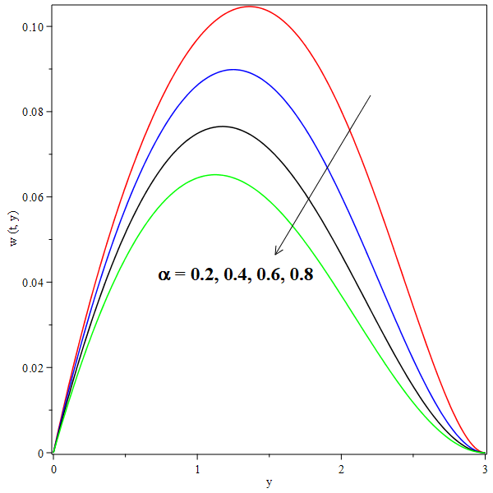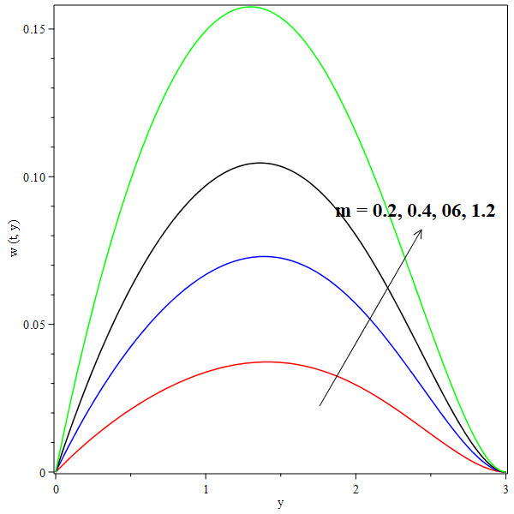
Fig 1: Effect of α on velocity profile w(t, y). Fig 2: Effect of Hall parameter m on w(t, y).
We noticed that by increasing the viscoelastic second grade parameter α, the secondary velocity profile w(t,y) decreases and the same effect happens in the primary velocity u(t,y) .It is observed from the fig 3 that an increase in Hall parameter m leads to a rise in the values of velocities u(t,y) and w(t,y). As well as, u(t,y) and w(t,y) increase with increasing of the magnetic field parameter M as shown in fig 4 below. the reason of this increasing is presence of magnetic field in an electrically conducting fluid that generates a force called the Lorentz force which acts against the flow if the magnetic field is applied in the normal direction.The primary velocity u(t,y) curves increase when the heat source parameter φ increases as seen above.
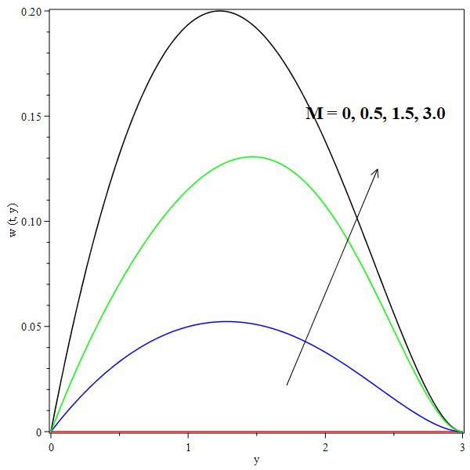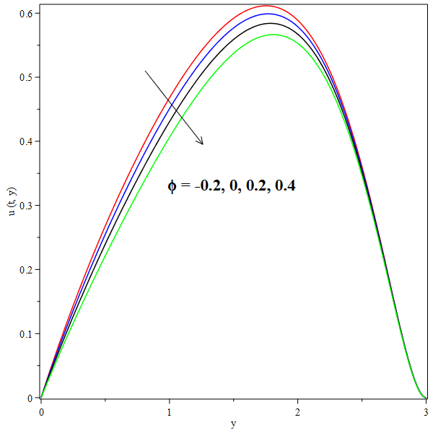
Fig 3: Effect of M on w(t, y). Fig 4: Effect φ on primary u(t, y).
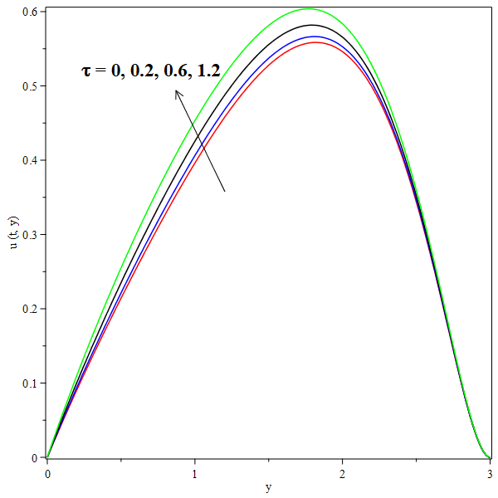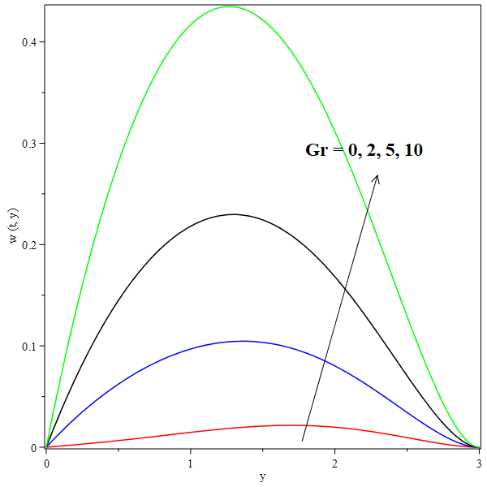
Fig 5: Effect of τ on u(t, y). Fig 6: Effect of Gr on w(t, y).
We notice that u(t,y) decreases with the increasing in thermophoretic parameter τ until u(t,y) becomes convergent decreased curves whenever τ increases. The same simulation of effect τ occurs on w(t,y).
The values of the Grashof number Gr are taken to be positive and negative as they respectively represent symmetric heating of the plate when Gr < 0 and symmetric cooling of the plate when Gr > 0. The primary and secondary velocities increase not only by increasing the Grashof number Gr but also by increasing the modified Grashof number as shown in Fig 6 and Fig 7 respectively. It is seen from the above that w(t,y) increases with increasing of Darcy parameter K
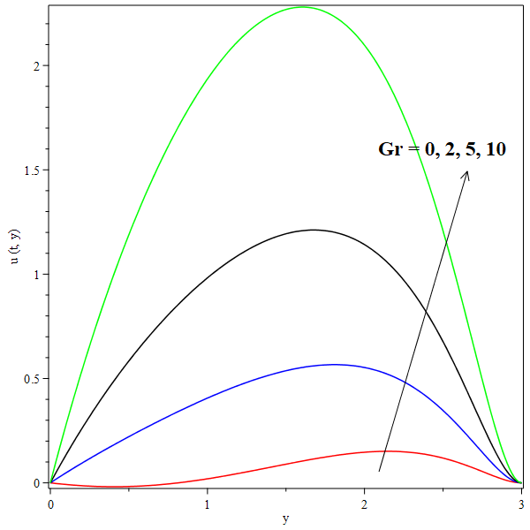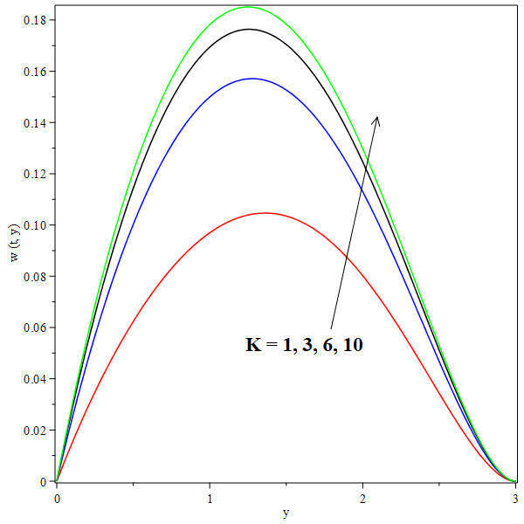
Fig 7: Effect Gr on u(t, y) Fig 8: Effect of K on w(t, y).
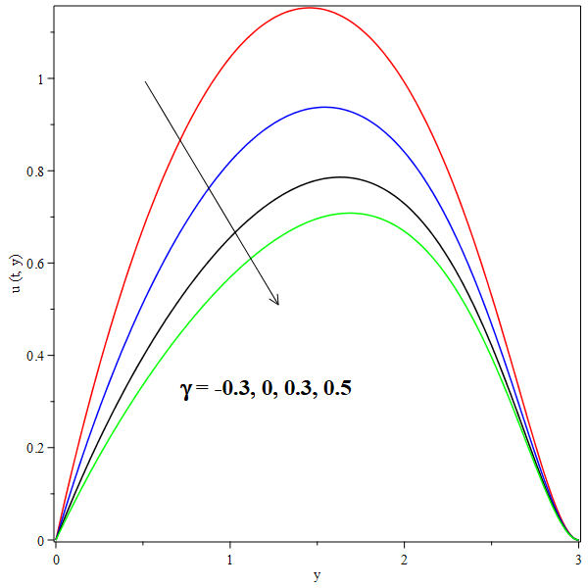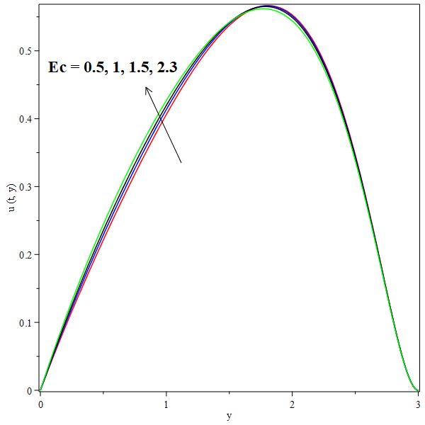
Fig 9: Effect of γ on u(t, y). Fig 10: Effect of Ec on u(t, y).
We notice that u(t,y) increases as the chemical reaction parameter γ increases; this also happens with w(t,y). The effect of increasing Eckert number Ec is to enhance u(t,y) as shown in the fig 10. Higher Eckert number values lead to greater viscous dissipative heat. From the above fig 10 Higher Eckert number values lead to greater viscous dissipative heat. From figures (1–10). We noticed that the secondary velocity w(t,y)and primary velocity u(t,y) increase when the fluid approaches to the plate but they decrease when the fluid is far way from the plate for different values of physical parameters of interest ; this is compatible with physical phenomena.
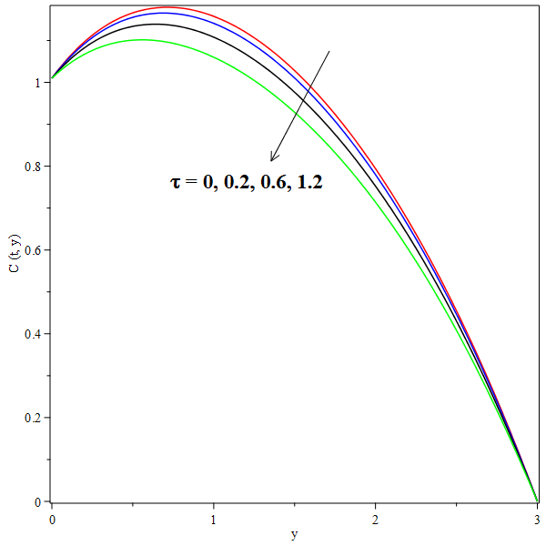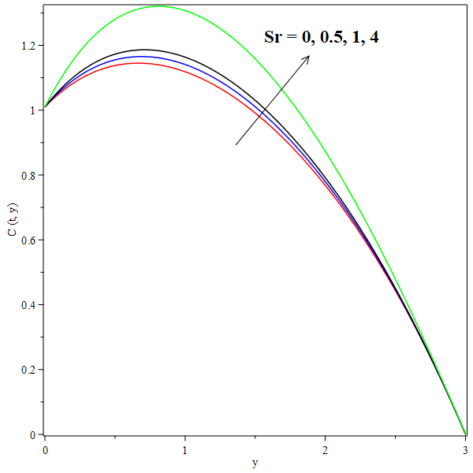
Fig 11: Effect of τ on C(t, y). Fig 12: Effect of Sr on C(t, y).
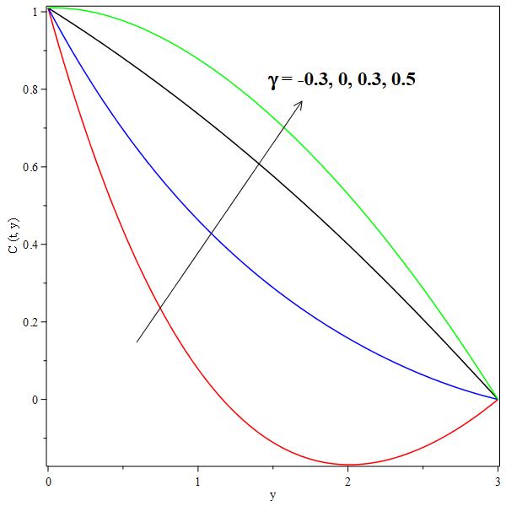
Fig 13: Effect of γ on C(t, y).
An increase in thermophoretic parameter τ leads to decrease in the curves of concentration C(t,y) which tend to quasi linear curves via the continuous increase, especially at value of τ = 1.2 as reflected in Fig 11. We noticed from Fig 12 that the influence of Soret parameter Sr at values of Sr = 0,0.5,1 and 4 on the concentrationprofiles C(t,y) appears in two regions 0 ≤ y < 0.6 and 0.6 < y ≤ 2.5 where these regions approximately intersect at point y = 0.6 at which the effect of Sr on C(t,y) is negligible. The effect of Sr on the first region which locates at 0 ≤ y < 0.6 is clearly observed especially for curves Sr = 0 and Sr = 4; where there are two inflection points such that the critical point that lies at y = 0.4 for the curve Sr = 0 going from increasing to decreasing. While the reversed effect of Sr in that region happens. Within the second region which locates at 0.6 < y ≤ 2.5, it is noticed that the concentration curves C(t,y) decrease with increasing y for all values of Sr then the curves become regressive. The increase in chemical reaction parameter γ at values γ = −0.3,0,0.3,0.5 leads to an increase in concentration distributions C(t,y) and after continuously increasing, the curve becomes quasi linear; then becomes linear at γ = 0.5 as shown in Fig 13

- Conclusion
There is no flow in the Z-axis direction when the magnetic field is absent. An increase in the thermophoretic parameter (τ) leads to a reduction in both primary and secondary velocities, as well as the temperature profile, while enhancing the concentration. The concentration C(t,y) remains independent of the Soret parameter (Sr) at specific values of y within the range 0.6≤y≤0.70.6. However, outside this region, the influence of Sr becomes apparent. An increase in the heat source parameter (ϕ) enhances both primary and secondary velocities, similar to its effect on the temperature profile. Likewise, an increase in the chemical reaction parameter (γ) results in higher velocities and plays a significant role in enhancing concentration. Simultaneous increases in the magnetic parameter (M), thermal radiation parameter (Nr), Eckert number (Ec), second-grade parameter (α), and heat source parameter (ϕ) lead to a reduction in the Nusselt number. Meanwhile, the Sherwood number decreases at the same rate as the increase in Sc, τ, Sr, and γ, but it increases with a rise in the thermophoretic parameter (τ).

REFRENCES
Ahmed, A., Uwanta, I. J and. Sarki, M. N (2015). Hall Current Effects on Unsteady MHD Fluid Flow with Radiative Heat Flux and Heat Source over a Porous Medium. British Journal of Mathematics and Computer Science
Alam, M. S., Rahman, M. M and Sattar, M. A (2007). Effects of Thermophoresis and Chemical Reaction on Unsteady Hydro Magnetic Free Convection and Mass Transfer Flow Past an Impulsively Started Infinite Inclined Porous Plate in the Presence of Heat Generation/Absorption. International Journal of Science and Technology.
Animasaun, I.l, (2015). Effects of Thermophoresis, Variable Viscosity and Thermal Conductivity on Free Convective Heat and Mass Transfer of Non-Darcian MHD Dissipative Casson Fluid Flow with Suction and nth Order of Chemical Reaction. Journal of the Nigerian Mathematical Society.
Bhuvanavijaya, R. (2014). Thermophoretic Effect on Convective Heat and Mass Transfer Flow over a Vertical Porous Plate in a Rotating System with Suction/Injection International Journal of Engineering Sciences and Research Technology
Chamkha, A. J. and Issa, C. (2000). Effects of heat generation/absorption and thermophoresis on hydromagnetic flow with heat and mass transfer over a flat surface. International Journal of Numerical Methods for Heat and Fluid Flow.
Chaudhary, R.C. and Jain, P. (2006). Hall Effect on MHD mixed convection flow of a viscoelastic fluid past an infinite vertical porous plate with mass transfer and radiation. Theoretical and Applied Mechanics
Cortell, R. (2007). MHD flow and mass transfer of an electrically conducting fluid of second grade in a porous medium over a stretching sheet with chemically reactive species Chemical Engineering and Processing
Das, K. Jana, S. and Kundu, P.K. (2015). Thermophoretic MHD slip flow over a permeable surface with variable fluid properties Alexandria Engineering Journal.
Das, U. J.(2013). Viscoelastic Effects on Unsteady Two-Dimensional and Mass Transfer of a Viscoelastic Fluid in a Porous Channel with Radioactive Heat Transfer Engineering.
El-dabe, N.T., Refaie Ali, A., El-shekhipy, A. A. and. Shalaby., G. A (2017). Non-Linear Heat and Mass Transfer of Second Grade Fluid Flow with Hall Currents and Thermophoresis Effects. Appl. Math. Inf. Sci. 11, No. 1, 267-280 (2017) 267. http://dx.doi.org/10.18576/amis/110133
Eldabe, N.T. (1986). Heat and mass transfer in a hydromagnetic flow between two parallel permeable plates. Canadian Journal of Physics
Eldabe, N.T., El-Saka, A.G. and Fouad, A. (2004). Thermal-diffusion and diffusion-thermo effects on mixed free-forced convection and mass transfer boundary layer flow for non-Newtonian fluid with temperature dependent viscosity. Applied Mathematics and Computation.
Fagbade, A. I., Falodun, B.O. and Boneze, C. U. (2015). Influence of Magnetic Field, Viscous Dissipation and Thermophoresis on Darcy-Forcheimer Mixed Convection Flow in Fluid Saturated Porous Media. American Journal of Computational Mathematics.
Hayat, T. Abbas, Z. Sajid, M. and Asghar, S. (2007). The influence of thermal radiation on MHD flow of a second grade fluid. International Journal of Heat and Mass Transfer
Hayat, T. and Nawaz, M. (2011). Soret and Dufour effects on the mixed convection flow of a second grade fluid subject to Hall and ion-slip currents. International Journal for Numerical Methods in Fluids
Hayat, T. Mustafa, M. and Pop, I. (2010). Heat and mass transfer for Soret and Dufour’s effect on mixed convection boundary layer flow over a stretching vertical surface in a porous medium filled with a viscoelastic fluid. Communications in Nonlinear Science and Numerical Simulation
Hayat, T., Nadeem, S. Asghar, S. and Siddiqui, A. M.(2005). Effects of Hall Current On Unsteady Flow Of A Second Grade Fluid In A Rotating System Chemical Engineering Communications.
Jha, A.K., Choudhary, . K. and Sharma, A.(2014). Influence of soret effect on MHD mixed convection flow of visco-elastic fluid past a vertical surface with hall effect. International Journal of Applied Mechanics and Engineering.
K. Das, (2013). Effects of thermophoresis and thermal radiation on MHD mixed convective heat and mass transfer flow. African Mathematical Union and Springer.
Kalidas Das, RamPrakashSharma and AmitSarkar, (2016). Heat and mass transfer of a second grade magnetohydrodynamic fluid over a convectively heated stretching sheet. Journal of Computational Design and Engineering.
Kim, Y. J. (2000). Unsteady MHD Convective Heat Transfer past a Semi-Infinite Vertical Porous Plate with Variable Suction. International Journal of Engineering Science.
Kumar, R. and Chand, K. (2011). Effect of Slip Conditions and Hall Current on Unsteady MHD Flow of a Viscoelastic Fluid Pass an Infinite Vertical Porous Plate through Porous Medium. International Journal of Engineering Science and Technology.
Nabil T. M. Eldabe, Ahmed Y. Ghaly, Sallam N. Sallam, Khaled Elagamy and Yasmeen Younis, (2015). Hall Effect on Peristaltic Flow of Third Order Fluid in a Porous Medium with Heat and Mass Transfer. Journal of Applied Mathematics and Physics.
Nabil T. M. Eldabe, Ahmed Y. Ghaly, Sallam N. Sallam, Khaled Elagamy and Yasmeen Younis, (2015). Hall Effect on Peristaltic Flow of Third Order Fluid in a Porous Medium with Heat and Mass Transfer. Journal of Applied Mathematics and Physics
Nayak, A. and Panda, S.(2013). Mixed Convective MHD Flow of Second Grade Fluid with Viscous Dissipation and Joule Heating Past a Vertical Infinite Plate with Mass Transfer Mathematical Theory and Modeling
Oahimire, J.I., Olajuwon and B.I. (2013). Micropolar Fluid Behavior with Constant Pressure, Permeability, Heat and Mass Transfer. Journal of King Saud University - Engineering Sciences.
Olajuwon, B.I. Oahimire, J.I. and Ferdow, M. (2014). Effect of thermal radiation and Hall current on heat and mass transfer of unsteady MHD flow of a viscoelastic micropolar fluid through a porous medium. International Journal of Engineering Science and Technology
Pandya, N.Shukla and A. K, (2016). Effects of Thermophoresis, Dufour, Hall and Radiation on an Unsteady MHD Flow past an Inclined Plate with Viscous Dissipation, Chemical Reaction and Heat Absorption and Generation. Journal of Applied Fluid Mechanics.
Piazza, R.(2008). Thermophoresis: moving particles with thermal gradients. Soft matter - Royal Society of Chemistry.
Rashidi, M. M., Ali, M., Rostami, B., Rostami, P., and Xie, G. (2015). Heat and mass transfer for MHD viscoelastic fluid flow over a vertical stretching sheet with considering Soret and Dufour effects. Mathematical Problems in Engineering.
Reddy, S.H, .Raju and E. K. Reddy, (2015). Unsteady MHD Free Convection Flow of a Kuvshinski Fluid Past a Vertical Porous Plate in the Presence of Chemical Reaction and Heat Source/Sink. International Journal of Engineering Research in Africa.
Rushi Kumar, B. Sreedhara Rao Gunakala , Sivaraj, R. and VictorM. Job, (2016). Time-dependent hydromagnetic free convection nanofluid flows within a wavy trapezoidal enclosure Special Topics and Reviews in Porous Media: An International Journal DOI: 10.1615/.2016017320
Sahoo, S. N. (2013). Heat and mass transfer effect on MHD flow of a viscoelastic fluid through a porous medium bounded by an oscillating porous plate in slip flow regime. International Journal of Chemical Engineering
Sudhakar, C., Reddy, B., Vasu, N. B and. Prasad, V. R. (2012). Thermophoresis Effect on Unsteady Free Convection Heat and Mass Transfer in a Walters-B Fluid past a Semi Infinite Plate. International Journal of Engineering Research andApplications
Veera Krishna, M.and B.V.Swarnalathamma, (2016). Convective heat and mass transfer on MHD peristaltic flow of Williamson fluid with the effect of inclined magnetic field. IOSR Journal of Mathematics (IOSR-JM).
Vempati, S. R. and Laxmi-Narayana-Gari, A. B. (2010). Soret and Dufour effects on unsteady MHD flow past an infinite vertical porous plate with thermal radiation. Applied Mathematics and Mechanics.

