**INVESTIGATION OF MECHANICAL PROPERTIES OF SORGHUM STEM IN RELATION TO HARVESTING**

**ABSTRACT:**

The mechanical properties of crop are crucial for designing a cutting mechanism for agriculture machinery such as the cutting energy and cutting force etc. This study aims to determine mechanical properties of sorghum stalk. An pendulum impact experimental test rig has been designed for determining cutting energy and cutting force for various stalk diameters (10, 15, 20 and 25 mm) and cutting velocities (4.5, 5.5, 6.5 and 7.5 m/s). The average cutting energy was observed at a minimum of 3.40 J at a blade cutting velocity of 7.5 m/s and a maximum of 26.91J at a blade cutting velocity of 4.5 m/s and a 25 mm sorghum stalk diameter. A maximum cutting force of 1076.53 was recorded at the blade's cutting velocity of 4.5 m/s and 25 mm sorghum stalk diameter, while it was observed minimum 340.7 N at the blade's cutting velocity of 7.5 m/s and 10 mm sorghum stalk diameter. The cutting force decreased as the cutting velocity increased. The findings of this study can serve as a basis for designing effective and cutting mechanism for sorghum.

**Keywords**: Cutting energy, force, Pendulum, Stem, Sorghum, Velocity

**INTRODUCTION**

A basic understanding and determination of mechanical properties is critical for design, development and effective operation of agricultural harvesting machines. Information on the physical and mechanical properties of the plant, as well as the power or energy requirements of the equipment, was extremely useful in determining the design and operating parameters of the harvesting equipment (Persson *et. al*., 1987.

Many researchers have reported that the diameter of the stem, blade velocity and the crop's moisture content had a substantial influence on cutting energy and cutting force. Thus, in order to help in the design and development of cutting mechanism of harvesting machinery, it is critical to examine the effects of blade parameters such as blade cutting speed on the cutting characteristics of the sorghum stalk, namely cutting energy and cutting force. The present study identified essential engineering properties that are helpful and required in the design of cutting mechanism. Researchers developed pendulum-type dynamic testers based on the principle of energy conservation to assess the cutting energy requirements for rice stems (Alizadeh *et al.,* 2011), pigeon pea stems (Dange *et al*., 2011), corn stems (Azadbakht *et al*., 2014), sorghum stalks (Yiljep and Mohammed, 2005), cane stems (Taghijarah *et al*., 2011; Mathanker *et al*., 2015), soybeans (Koloor and Kiani, 2007), chick pea stalk (Sushilendra *et al*., 2016) and wheat stems (Hoseinzadeh *et al.,* 2009).

The cutting elements used in harvester design may be selected by their cutting energy requirement, cutting force and stress applied. (Chakraverty*et al*., 2003). It is vital to determine the cutting energy requirements for appropriate knife design and optimizing operational parameters (Yilmaz *et al*., 2008). Various researchers observed that the materials of the blade (Person, 1987), cutting speed (Veerammanavara, 2022);(McRandal and McNulty, 1978); (Yiljep and Mohammed, 2005); (Taghijarah *et al*., 2011); (Sushilendra *et al*., 2016); (Prasad and Gupta, 1975), blade design and angle (Gupta and Oduori, 1992); Clementson and Hansen, 2008); Ghahraei *et al*., 2011), cutting mechanisms (Miao, 2011) and the diameter of the stem (Veerammanavara, 2022); (Sushilendra *et al*., 2016); Kroes and Harris, 1996) play a significant role in designing energy efficient equipment. A few studies showed that a serrated blade needed 35% less cutting force than a flat blade (Liu *et al*., 2012). The parameters involved in sorghum harvesting include sorghum stalk diameter at bottom, blade cutting velocity and cutting blade, all of which must be considered while determining engineering properties and design of energy efficient equipment. In the view of importance of mechanical properties to design cutting mechanism present investigation has been undertaken to determination of mechanical properties of sorghum stalk in relation to harvesting.

**MATERIAL AND METHODS**

To measure the cutting energy and cutting force needed of the sorghum stalks, a pendulum impact tester was developed, which consisted of a platform, main frame, pendulum arm, pendulum shaft, dial gauge, stalk holding, blade holder, and serrated blade. A main frame of 35x35x5mm (LxWxT) angle iron was developed to provide structural support and stability for the pendulum impact tester's components. The pendulum arm was made of a rectangular mild steel Plate with dimensions of 1050 x 40 x 10 mm (LXWxT). A dial gauge angular scale was marked onto a mild steel sheet with a diameter of 285 mm. A pointer was provided at the top end of the pendulum arm to show the displacement of the pendulum arm before and after sorghum stalk cutting. The sorghum stalk was kept in a stalk holder for cutting. A bench vice was utilized to support the stalk and prevent it from slipping during the experiment at the trails. The stalk holder was set up on a platform. The knife section of the cutter bar was bolted at the lower end of the pendulum arm. The developed pendulum impact tester is as shown in Plate 1.

**Principle of operation of cutting measurement set up**

The pendulum impact tester works on the principle of a compound pendulum, with the long arm hanging from its top end and a knife fastened at the bottom to oscillate in the vertical plane. It was typically moved to one side of the equilibrium position by an angular deflection (θi). When the swinging arm is released, the principle of conservation of energy states that it will oscillate to the other side of the equilibrium line and deflect through an angle θo. Frictional losses and air resistance typically cause θo to be lower than θi. The swinging arm exchanged energy continuously from maximum potential energy (PE=1/2 x mv2) when it was at its extreme position (upswing) before being released to swing down, losing potential energy and gaining kinetic energy to maximum kinetic energy when the arm was at the equilibrium line. The schematic representation of pendulum arm with different position shown in Fig. 1.



Figure 1. Schematic representation of pendulum arm with different positions

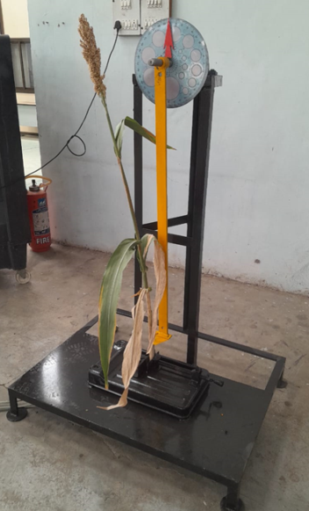

**Plate 1. Cutting energy measurement set up (Pendulum type)**

The stalk held the material to be cut at the point of maximum kinetic energy of the swinging arm. When the arm is released, it speeds up until it collides with and cuts the material in the knife's path. The angle difference before and after cutting will be proportional to the amount of energy utilized to cut the stalk. The energy used by the knife to cut through the stalk determined through recording the swinging pendulum's starting and ending positions. When the pendulum was at rest, the potential energy for every angular location was computed using the following formula (Alizadeh *et al.*, 2011).

PE = WR(Cosθ) … (1)

Where,

PE - potential energy, J

W - weight of pendulum, kg

R - radial length to centre of gravity, m

θ - angular position of the pendulum, radians

**Experimental procedure to determine engineering properties of sorghum stalk**

Thus in present investigation the independent variables *viz.,* serrated type blade, four levels different stalk diameters (10, 15, 20 and 25 mm) and four levels of blade cutting velocity (4.50, 5.51, 6.53 and 7.54 m/s) and response parameters *viz.* cutting energy and cutting force were selected and shown in Table 1. To investigate the engineering properties of sorghum stalk, a laboratory test rig with a pendulum impact tester was developed, as illustrated in Plate 1.

**Table No. 1 List of variables selected for study**

|  |  |  |  |
| --- | --- | --- | --- |
| **Sr. No.** | **Parameters** | **Levels** | **Symbols** |
| A | **Independent** | | |
| 1 | Blade velocity, m/s | 4 (4.50, 5.51, 6.53 and 7.54 m/s) | V1, V2, V3, V4 |
| 2 | Diameter of stem, mm | 4 (10, 15, 20 and 25 mm) | D1, D2, D3, D4 |
| B | **Dependent** | | |
| 3 | Cutting energy, J | --- | Ec |
| 4 | Cutting force, N | --- | Fc |

**Calibration of cutting energy measurement set up**

The energy and force measuring setup was calibrated before beginning to measure cutting energy and force. In calibration processes, the initial and final angles of the swinging pendulum arm were examined with fixed weight. An average of ten output angles observations were made for each corresponding input angles of the swinging arm.

**Experimental procedure**

Mature sorghum plants with varying stalk diameters were randomly picked from sorghum fields in different locations and brought to the laboratory. A digimatic vernier caliper with a resolution of 0.01 mm was used to measure stalk diameters 10 cm above ground level. The same variety of sorghum was utilized throughout the trial to avoid variation in cutting performance. In the experiment, a mature sorghum plant with a stalk diameter of 10 mm was firmly set in the stalk holder to simulate the natural stand of the stem in the field, as illustrated in Plate 1. The holder is situated at the lowest oscillation position, where the equilibrium line is made. The arm's lower end was fitted with a serrated blade, which was then given an adequate angular displacement θi. When released, the arm gained 4.5 m/s as it traveled downwards until it hit maximum speed, which corresponded to the maximum kinetic energy achieved and recorded as θo. The initial angular displacements were fixed and the appropriate cutting velocities were calculated. The tests were repeated three times. The same procedure was performed with a speed of 5.5 m/s, and so on. After completing the test at all four speeds, the same test was carried out with sorghum stalks of 10, 15, 20 and 25 mm in diameter. The experiment was repeated three times for each combination of sorghum stalk diameter, blade speed for cutting energy and cutting force measurement. The averages of the computed cutting energy and cutting force were used to optimize the independent parameters, which were blade cutting velocity and sorghum stalk diameter.

**Blade velocity**

When the blade is released, its initial velocity is zero. However, when it reaches the stem in a vertically downward position, it has the greatest velocity due to physical laws governing the cutting moment. The relation between peripheral velocity (Vc) and the initial angle of a pendulum arm at the impact moment was calculated from the following equation (Koloor and Borgheie, 2006).



Where,

Vc - linear velocity of the blade at cutting point, m/s

- weight of pendulum, N

R - distance between the rotational center and center of gravity, m

I - moment of inertia, kg m2

L - length of pendulum, m.

θ - angle of pendulum at initial position, °

**Cutting energy of sorghum stalk**

The sorghum stalk to be cut was placed at the swinging arm's highest kinetic energy point and held by the stalk holder. When the arm is released from a certain angle, it accelerates until it reaches and cuts the material placed in the knife's cutting path. The angle difference before and after cutting will be proportional to the amount of energy used to cut the sorghum stalk. The energy required to cut a sorghum plant stalk was calculated by the difference between θi and θo. Alizadeh *et al.,* (2011) stated expressions for calculating cutting energy requirements and peripheral knife speed.

$${ E}_{c}=WR\left({\cos{θ}}_{0}-θ_{i}\right) …(3)$$

Where,

Ec - cutting energy, J

W- weight of the pendulum, N

R - radial length to centre of gravity, m

θi - angle of pendulum at initial position,° and

θ0 - angle of pendulum after cutting,°

**Cutting force of sorghum stalk**

Cutting force was computed by measuring cutting energy and dividing it by length, which is same to stalk diameter.

Fc = Ec/D ...(4)

Where,

Fc - cutting force, N

Ec - cutting energy, J

D - diameter of the stem, mm

**Statistical analysis**

Results were analysed using optimal custom design of response surface methodology with the help of Design Expert Software (11.1.2.0).

**RESULT AND DISCUSSION**

It was important to research the effects of blade cutting velocity and sorghum stalk diameter on the cutting properties of sorghum stalks, including cutting energy and cutting force in order to develop an energy efficient cutting mechanism. Prior to determining engineering properties, the pendulum impact tester was calibrated. The pendulum-type cutting energy measurement test rig was calibrated for linearity at different input angles. An average of 5 observations of the output angle was taken without cutting for each input angle. It was found linear as shown in Fig. 2.

**Fig.2 Calibration curve of pendulum type cutting energy measurement setup**

**Effect of input parameters (Blade’s cutting velocity and stalk diameter) on cutting energy requirement for sorghum stalks**

The influence of blade’s cutting velocity and stalk diameter on cutting energy in Sorghum crop stalks was investigated and the findings from the experiments are illustrated in Table 2

**Table 2. Effect of blade cutting velocity and sorghum stalk diameter on cutting energy requirement for sorghum stalk**

|  |  |  |  |  |  |
| --- | --- | --- | --- | --- | --- |
| **Sr. No.** | **Cutting velocity (m/s)** | **Average cutting energy (J)** | | | |
| **Diameter (mm)** | | | |
| **D1(10)** | **D2 (15)** | **D3 (20)** | **D4 (25)** |
| 1 | V1 (4.5) | 8.03 | 15.02 | 20.68 | 26.91 |
| 2 | V2 (5.5) | 6.77 | 12.90 | 17.62 | 24.01 |
| 3 | V2 (6.5) | 5.03 | 10.65 | 15.56 | 19.65 |
| 4 | V3 (7.5) | 3.40 | 6.87 | 10.25 | 13.84 |

Table 2 revealed that the average cutting energy of the sorghum stalk varied with value of the diameter of the sorghum stalk and the cutting velocity of the blade varied from 3.40 to 26.91J. The average cutting energy was observed at a minimum of 3.40 J at a blade cutting velocity of 7.5 m/s and a maximum of 26.91J at a blade cutting velocity of 4.5 m/s and a 25 mm sorghum stalk diameter. Similar results were found by Nandede *et al.,* (2017) they reported that the average cutting energy required to cut sorghum stalks with diameters of 20 mm, 15 mm and less than 15 mm was 13.91, 12.41, and 8.00 J, respectively. According to Rodu and Vlad (2020) cutting energy were needed 32 J to cut the sorghum crop. Similar results were also observed by Veerammanavara *et al.,* (2022). They observed higher cutting energy values of 28.65 J for a 24 mm stalk diameter at a blade cutting velocity of 4.40 m/s and lower cutting energy values of 3.55 J for a 12 mm stalk diameter at a velocity of 7.40 m/s.

Fig. 3 shows the impact of blade cutting velocity and sorghum stalk diameter on cutting energy. These statistics show that for all cutting velocities, the cutting energy increased as the sorghum stalk diameter increased. However, as the cutting blade's velocity increased, the cutting energy for all sorghum stalk diameter decreased. Cutting energy increases with increasing stalk girth, according to similar patterns in the results reported by Blessy *et al.,* (2019). According to Prakash (2003) and Veerammanavara *et al.*, (2022), the cutting energy required to cut sorghum stems with a serrated blade increased continually as the stem's diameter increased. These patterns agreed with those of Nandede *et al.*, (2017) and Mareppa (2017).

When the blade's cutting velocity increases, the cutting energy decreases. This could be because the cutting process is accompanied by strong resistive forces and the stalks become crushed and flattened at low cutting velocities. The resistive forces decreased as the cutting velocity increased and the stalks cut without flattening or crushing. Sorghum stalks have a diameter that increases with stalk thickness, which means the blade must cut through more plant material, increasing the cutting energy needed to cut the stalks. More resistive force cutting is possible because of the stalks' increased cross sectional area. These patterns confirmed the results of Zhang *et al.,* (2019) and Sushilendra *et al.,* (2016). According to Yiljep and Mohammed (2005), the impact force is too small at lower velocities to adequately cut the stalk, thus causing the decrease in cutting energy requirement at knife speeds less than 5 m/s. Sushilendra *et al.*, (2016) found similar results when cutting chickpea stalks. According to several studies (Feller, 1959; Prasad and Gupta, 1975; Mohammed, 1990; Hoseinzadeh *et al.,* 2009), cutting speed has an impact on the energy required to cut wheat stems. Cutting energy will decrease as cutting speed increases. These results are comparable to those of a study by Alizadeh *et al.,* (2011), which found that reducing stalk diameter reduced the cutting energy of rice stems.

**Fig.3. The effect of sorghum stalk diameter and blade cutting velocity on cutting energy requirement for sorghum stalk**

Statistical analysis was performed to assess the significance of variable namely sorghum stalk diameter and blade’s cutting velocity on cutting energy using optimal custom design was analyzed. The analysis of variance (ANOVA) of observed data was performed and depicted in Table 3. The response surface reduced cubic model was fitted to the experimental data and statistical significance for linear, interaction, quadratic and cubic effects were analyzed for cutting energy in various treatment combinations.

The model's adequacy was assessed by using the analysis of variance's (ANOVA) F value and Lack-of-Fit. The model F value of 1199.49 in the ANOVA data set indicates the model was significant (P<0.0001), and the lack-of-fit F-value of 3.39 shows that the cubic model can successfully fit the experimental data. F-values showed that the blade's cutting velocity was the parameter that had the greatest linear influence, after the sorghum stalk diameter.

**Table 3 Analysis of variance (ANOVA) data showing the effect independent variables on cutting energy requirement**

|  |  |  |  |  |  |  |  |  |
| --- | --- | --- | --- | --- | --- | --- | --- | --- |
| **Source** | **Sum of Squares** | | **Df** | **Mean Square** | | **F-value** | **P-value** |  |
| **Model** | 744.08 | | 9 | 82.68 | | 1199.49 | < 0.0001* | significant |
| Cutting Velocity (A) | 11.22 | | 1 | 11.22 | | 162.78 | < 0.0001* |  |
| Stalk diameter (B) | 22.86 | | 1 | 22.86 | | 331.61 | < 0.0001* |  |
| AB | 9.08 | | 1 | 9.08 | | 131.74 | < 0.0001* |  |
| A² | 1.11 | | 1 | 1.11 | | 16.04 | 0.0039* |  |
| B² | 0.0516 | | 1 | 0.0516 | | 0.7485 | 0.4121 |  |
| A²B | 0.3109 | | 1 | 0.3109 | | 4.51 | 0.0664 |  |
| AB² | 0.0004 | | 1 | 0.0004 | | 0.0055 | 0.9425 |  |
| A³ | 0.1123 | | 1 | 0.1123 | | 1.63 | 0.2375 |  |
| B³ | 1.19 | | 1 | 1.19 | | 17.30 | 0.0032* |  |
| Residual | 0.5514 | | 8 | 0.0689 | |  |  |  |
| Lack of fit | 0.3695 | | 3 | 0.1232 | | 3.39 | 0.1112NS | not significant |
| Pure error | 0.1819 | | 5 | 0.0364 | |  |  |  |
| Cor total | 744.63 | | 17 |  | |  |  |  |
| **Fit statistics** | | | | | | | |  |
| Std. dev. =0.2625 | | R² =0.9993 | | | Std. dev. = Standard deviation | | | |
| Mean = 13.30 | | Adjusted R²=0.9984 | | | C.V. = Coefficient of variance | | | |
| C.V. % =1.97 | | Predicted R²=0.9924 | | | * = significant at 5 per cent | | | |
|  | | Adeq precision=121.0584 | | | NS= non- significant | | | |

The model that was developed was adequate for predicting the response, as evidenced by the non-significant lack of fit value. In this case, the linear term blade‘s cutting velocity (A), sorghum stalk diameter (B), interaction of cutting velocity and stalk diameter (AB), quadratic term of blade’s cutting velocity (A²) and cubic term sorghum stalk diameter (BB³) were found to be significant. The results showed linear effects of sorghum stalk diameter on cutting energy (P<0.01) at the 1 percent level of significance. It indicates that increasing the value of the variable increases the response. The cutting velocity exerted a strong influence on cutting energy. Table 3 shows the effect of different cutting velocities, sorghum stalk diameter and their interaction on cutting energy. It was found that individual effects of cutting velocity and sorghum stalk diameter were significant effects on cutting energy. The results were similar to the findings reported by Allameh *et al.,* (2016), who found that blade cutting velocity significantly (P < 0.01). According to Yilmaz *et al.*, (2008), cutting energy was significantly impacted by the crop's plant stem diameter. Cutting energy and stalk diameter were found to be positively correlated by Sushilendra *et al.,* (2016). The interaction term blade’s cutting velocity and sorghum stalk diameter (AB) also had a significant effect on cutting energy.

Using the least squares method, the R2 value was computed and found to be 0.9993, indicating a good model-data fit. The adjusted R2 of 0.9984 and predicted R2 of 0.9924 are in reasonable agreement; that is, the difference is less than 0.2 and the adequate precision ratio (APR) of 121.058 was higher than 4. According to the results, the mathematical models that were designed are satisfactory.

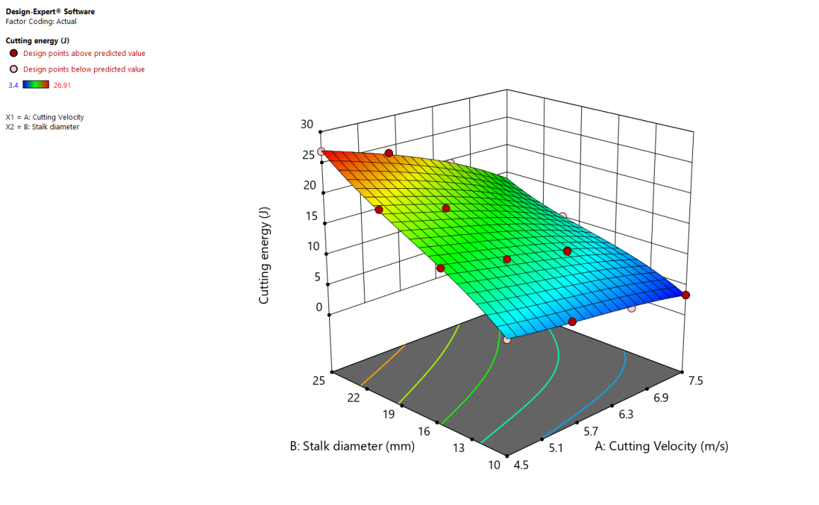

**Fig.4. Effect of cutting velocity and stalk diameter of sorghum on cutting energy requirement for sorghum stalk**

Fig. 4. illustrate the effect of blade cutting velocity and sorghum stalk diameter on the response cutting energy. The cutting energy was found to be decreased with an increase in cutting velocity and increased with increased stalk diameter. Yiljep and Mohamed (2005) found a similar relationship between the cutting energy requirement and knife velocity for sorghum crops, noting that the cutting energy requirement decreased as knife velocity increased. Although Gwani (1986) did not obtain the minimum value for the cutting energy requirement and corresponding knife speed, the result is in agreement with his findings for cutting sorghum and maize stalks. The results for canola stalks were in close accordance with the results reported by Azadbakht *et al.,* (2013). Plant stem diameter was found to be directly correlated with cutting energy requirements (Kathirvel *et al.,* 2009). According to a study's findings, cutting energy increased with stem diameter (Johnson *et al.,* 2012).

**Effect of input parameters (Blade’s cutting velocity and sorghum stalk diameters) on cutting force for sorghum stalks**

The influence of blade’s cutting velocity and stalk diameter on cutting force of sorghum crop stalks was investigated and the findings from the experiments are illustrated in Table 4.

From Table 4, it was clear that the average cutting force required to cut the sorghum stalk varied from 340.17 to 1076.53 N with different blade’s cutting velocity and different sorghum stalk diameters. A maximum cutting force of 1076.53 was recorded at the blade's cutting velocity of 4.5 m/s and 25 mm sorghum stalk diameter, while it was observed minimum 340.7 N at the blade's cutting velocity of 7.5 m/s and 10 mm sorghum stalk diameter. According to Mareppa (2017), the cutting force required to cut sorghum crop stalks varied from 481.40 to 1776.59 N. Similar findings were made by Veerammanavara *et al.,* (2022) who discovered that the cutting force required to cut the sorghum stalks ranged from 435.81 to 1477.92 N.

**Table 4 Effect of blade cutting velocity and sorghum stalk diameter on cutting force for sorghum stalk**

|  |  |  |  |  |  |
| --- | --- | --- | --- | --- | --- |
| **Sr. No.** | **Cutting velocity (m/s)** | **Average cutting force (N)** | | | |
| **Diameter (mm)** | | | |
| **D1(10)** | **D2 (15)** | **D3 (20)** | **D4 (25)** |
| 1 | V1 (4.5) | 803.33 | 1001.11 | 1034.00 | 1076.53 |
| 2 | V2 (5.5) | 676.54 | 860.22 | 880.83 | 960.40 |
| 3 | V2 (6.5) | 502.72 | 710.26 | 778.00 | 786.13 |
| 4 | V3 (7.5) | 340.17 | 458.25 | 512.50 | 553.74 |

The effect of sorghum stalk diameter and blade cutting velocity on cutting force has been presented in Fig.5. It is evident from these figures that the cutting force increased as the sorghum stalk diameter increased for all levels of blade’s cutting velocity. Similar findings were reported by Prakash (2003), Mareppa (2017) and Nandede *et al.,* (2017); they found that the cutting force increased as the sorghum stalk's diameter increased. Sushilendra *et al.*, (2016) found similar results for chickpea stalks. According to Manthesh (2006), cutting force increases with plant stem diameter.

It is evident form Fig. 5 shows that at all cutting velocity levels, the cutting force increased as the diameter of the sorghum crop stalks increased. The cutting force decreased as the cutting velocity increased. This could be because the impact is insufficient at lower velocities to effectively break the stem; therefore, as the cutting velocity drops, the cutting force increases. The resistive forces decreased as the cutting velocity increased and the stalks were chopped without flattening or crushing.

**Fig. 5 Effect of cutting velocity and sorghum stalk diameter on cutting force**

Sorghum stalks require more cutting force to cut because the blade must cut through more plant material when the diameter of the stalks increases due to increased stalk thickness. The plants may have reached full maturity. The cellulose of mature plants became thick and hard, requiring more force to cut as the diameter increased. These trends agreed with the conclusions of Azadbakht *et al.,* (2014) and Dange *et al.,* (2011). For all levels of sorghum stalk diameter, it was observed that the cutting force reduced as the cutting velocity increased. The serrations on the blade have a better crop holding tendency at the time of cutting, which eliminates the slipping of stems during the process of cutting. Pekitkan *et al.,* (2020) and Sushilendra *et al.,* (2020) observed similar findings.

The effect of sorghum stalk diameter and blade’s cutting velocity on cutting force using optimal custom design was analysed. The analysis of variance (ANOVA) of observed data was performed and presented in Table 5. The response surface cubic model was fitted to the experimental data and statistical significance for linear, interaction quadratic and cubic effects were analysed for cutting force in various treatment combinations.

The model adequacy was evaluated using the F value and Lack-of-Fit obtained from the analysis of variance (ANOVA). The ANOVA data set shows a model F value of 289.47 implies that the model was significant (P< 0.0001) and a Lack-of-fit F-value of 3.45 which indicated that the cubic model can be successfully used to fit the experimental data. F-values indicated that the blade’s cutting velocity was the most affecting parameter in a linear way followed by sorghum stalk diameter. The lack of fit value was non-significant, which indicates that the developed model was adequate for predicting the response. In this case linear term blade‘s cutting velocity

**Table 5 Analysis of variance (ANOVA) data showing the effect independent variables on cutting force requirement for sorghum**

|  |  |  |  |  |  |  |  |  |
| --- | --- | --- | --- | --- | --- | --- | --- | --- |
| **Source** | | **Sum of Squares** | **Df** | **Mean Square** | | **F-value** | **P-value** |  |
| **Model** | | 6.383E+05 | 9 | 70919.64 | | 289.47 | < 0.0001* | significant |
| Cutting Velocity (A) | | 35777.14 | 1 | 35777.14 | | 146.03 | < 0.0001* |  |
| Stalk diameter (B) | | 301.39 | 1 | 301.39 | | 1.23 | 0.2996 |  |
| AB | | 464.70 | 1 | 464.70 | | 1.90 | 0.2057 |  |
| A² | | 3135.14 | 1 | 3135.14 | | 12.80 | 0.0072 |  |
| B² | | 13625.55 | 1 | 13625.55 | | 55.62 | < 0.0001 |  |
| A²B | | 352.53 | 1 | 352.53 | | 1.44 | 0.2646 |  |
| AB² | | 7.21 | 1 | 7.21 | | 0.0294 | 0.8681 |  |
| A³ | | 350.35 | 1 | 350.35 | | 1.43 | 0.2660 |  |
| B³ | | 7274.69 | 1 | 7274.69 | | 29.69 | 0.0006 |  |
| Residual | | 1959.97 | 8 | 245.00 | |  |  |  |
| Lack of fit | | 1321.89 | 3 | 440.63 | | 3.45 | 0.1078NS | not significant |
| Pure error | | 638.07 | 5 | 127.61 | |  |  |  |
| Cor total | | 6.402E+05 | 17 |  | |  |  |  |
| **Fit statistics** | | | | | | | |  |
| Std. dev.=15.65 | R² =0.9969 | | | | Std. dev. = Standard deviation | | | |
| Mean = 776.46 | Adjusted R²=0.9935 | | | | C.V. = Coefficient of variance | | | |
| C.V. % =2.02 | Predicted R²=0.9638 | | | | * = significant at 5 per cent | | | |
|  | Adeq precision=63.96 | | | | NS= non- significant | | | |

(A), quadratic term of blade’s cutting velocity (A² and B2) and cubic term sorghum stalk diameter (B³) were found significant. The results showed that linear effects of blade, cutting velocity on cutting force (P<0.01) at 1 per cent level of significance. It indicates that increasing the value of variable increases the response in case of stalk diameter and decreases the responses in case of cutting velocity. According to Yilmaz *et al.,* (2008), cutting force was greatly affected by the crop's plant stem diameter. Cutting force and stalk diameter were found to be positively related by Sushilendra *et al.,* (2016). The cutting velocity exerted strong influence on cutting force of sorghum stalk. Table 5 shows the effect of different cutting velocity, sorghum stalk diameter and their interaction on cutting force. It was found that individual effect of cutting velocity were significant effects on cutting force.

The R2 value was calculated by least square technique and found to be 0.9969 showing good fit of model to data. The predicted R² of 0.9638 is in reasonable agreement with the adjusted R² of 0.9935; i.e. the difference is less than 0.2 and an adequate precision ratio (APR) of 63.96 was higher than 4. Hence, results indicated that designed mathematical models are satisfactory.

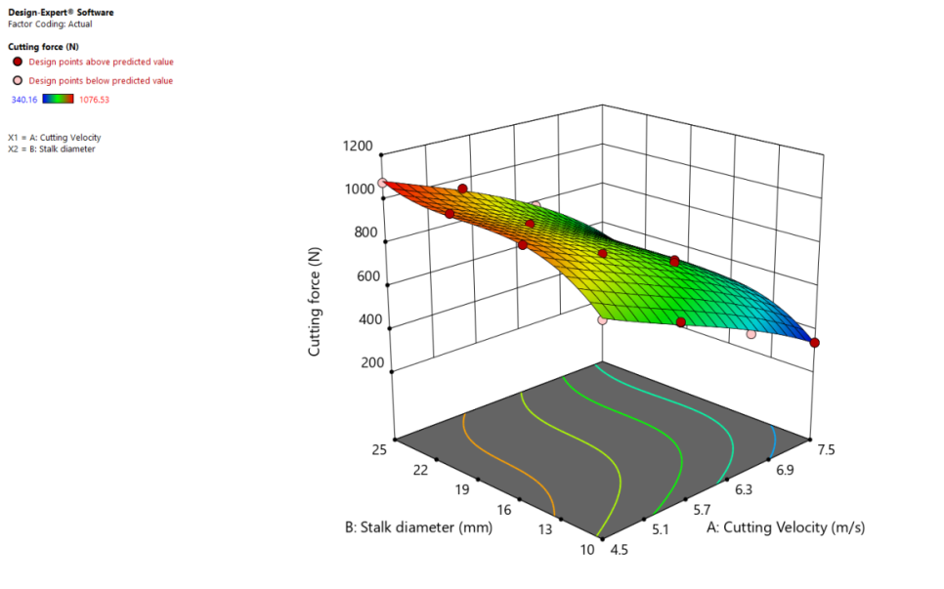

**Fig. 6. Effect of cutting velocity and stalk diameter of sorghum on cutting force for sorghum stalk**

The effect of blade cutting velocity and sorghum stalk diameter on the response cutting force is shown in Fig.6. The cutting force was found to be decreased with increase in cutting velocity and increased with increased stalk diameter.

**CONCLUSIONS**

The following conclusions were made based on the analysis of test results found from the study.

* The average cutting energy of the sorghum stalk varied irrespective value of the diameter of the sorghum stalk and the cutting velocity of the blade varied from 3.40 to 26.91J. The average cutting energy was observed at a minimum of 3.40 J at a blade cutting velocity of 7.5 m/s and a maximum of 26.91J at a blade cutting velocity of 4.5 m/s and a 25 mm sorghum stalk diameter.
* It was found that all blade’s cutting velocities, the cutting energy increased as the sorghum stalk diameter increased. However, as the cutting blade's velocity increased, the cutting energy for all sorghum stalk diameter decreased.
* The average cutting force required to cut the sorghum stalk varied from 340.17 to 1076.53 N with different blade’s cutting velocity and different sorghum stalk diameters. A maximum cutting force of 1076.53 was recorded at the blade's cutting velocity of 4.5 m/s and 25 mm sorghum stalk diameter, while it was observed minimum 340.7 N at the blade's cutting velocity of 7.5 m/s and 10 mm sorghum stalk diameter.
* At all cutting velocity levels, the cutting force increased as the diameter of the sorghum crop stalks increased. The cutting force decreased as the cutting velocity increased.
* It was found that individual effects of cutting velocity and sorghum stalk diameter were significant effects on cutting energy and cutting force.

**REFERANCES**

Alizadeh, M. R., R. A. Fatemeh and A. Dabbaghi, 2011.Cutting energy of rice stem as influenced by internodes position and dimensional characteristics of different varieties. Aust. J. Crop. Sci., 5(6):681-687.

Allameh, A. Y., R. Alizadeh and Mohammed, 2016. Specific cutting energy variations under different rice stem cultivars and blade parameters.Idesia., 34(5): 11-17.

Azadbakht, M., A. A. Rezaei and Z. K.Tamaskani, 2014. Energy requirement for cutting corn stalks. Int. School. Sci. Res. Innov., 8(5): 479-482.

Azadbakht, M., E. Esmaeilzadeh and E. S. Mostafa, 2013.Energy consumption during impact cutting of canola stalk as a function of moisture content and cutting height. J. Saudi Society Agril. Sci., 1-6.

Blessy Dara Rooha, A. Spandana, G. Vennela, P. Ravindrabharathi and Sravan Kumar, 2019.Development and Evaluation of Pendulum Type Impact Shear Test Apparatus. Int. J. Curr. Microbiol. App. Sci., 8(06): 1436-1441.

Chakraverty, A., A. S. Muzumdar, G. S. V. Raghavan and H. S. Ramaswamy, 2003.Handbook of postharvest technology.1stedn., Marcel Dekker Inc., New York.

Clementson C. and A. Hansen, 2008.Pilot study of manual sugarcane harvesting using biomechanical analysis. Transactions of the ASABE, 14(3): 309-320.

Dange, A. R., S. K. Thakare and R. I.Bhaskar, 2011.Cutting energy and force as required for Pigeon pea stems*.* J. Agril. Tech., 7(6): 1485-1493.

Ghahraei, O., D. Ahmad, A. Khalina, H. Suryanto and J. Othman,2011. Cutting tests of Kenaf stems. Transactions of the ASABE, 54(1);51-56.

Gupta, C. and F. Oduori, 1992.Design of the revolving knife-type sugarcane base cutter. Transactions of the ASABE, 35(6);1747-1752.

Gwani, E.S. (1986). Design, fabrication and testing of manually operated sorghum harvester. Unpublished M. Eng.( Agric.) Thesis, Ahmadu Bello University, Zaria.

Hoseinzadeh, B., A. Esehaghbeygi and N. Raghami, 2009. Effect of moisture content, bevel angle and cutting speed on shearing energy of three wheat varieties. World Appl. Sci. Jou., 7(9): 1120-1123.

Johnson, P. C., L. C. Claitmont, K. M. Sunil, E. G. Tony and C. H. Alan, 2012. Cutting energy characteristics of miscanthusxgiganteus stems with varying oblique angle and cutting speed. Bio system Engineering*,* 112(1): 42-48.

Kathirvel, K, S.Thambidurai, D. Ramesh, and D. Manohar Jesudas, 2009. Ergonomics of Self Propelled Power Weeders as Influenced by Forward Speed and Terrain Condition. Agricultural Mechanization in Asia, Africa & Latin America. 40(4):28.

Koloor, R. T. and G. Kiani, 2007.Soybean stem cutting energy and the effects of blade parameter on it. Pakistan Journal of Biological Sciences, 10(9):1532-1535.

Koloor, T. R. and A. Borgheie, 2006.Measuring the static and dynamic cutting force of stems for Iranian rice varieties. J. Agri. Sci. Tech*.,* 8(3): 193-198.

Kroes, S. and Harris H., 1996. Cutting forces and energy during an impact cut of sugarcane stalks. Madrid, Spain: EurAgEng.

Liu, Q., S. Mathanker, Q. Zhang and A. Hansen, 2012.Biomechanical properties of miscanthus stems. Transactions of the ASABE, 55; 1125-1131.

Manthesh, 2006. Development of mini combine harvester for pulse crops. Ph.D. thesis (unpub.) TNAU, Coimbatore.

Mareppa, 2017. Design, refinement and development of reaper cum binder for sorghum and bajra crops. Ph.D. Thesis (unpub.), UAS, Raichur.

Mathanker, S. K., E. G. Tony and C. H. Alan, 2015. Effect of blade oblique angle and cutting speed on cutting energy for energy cane stems.Bio system Engineering, 133:64-70.

McRandal, D. M. and P. B. McNulty, 1978.Impact cutting behaviour of forage crops. International Journal of Agricultural Engineering Research, 23(3):329-338.

Miao, Z., T. Grift, A. Hansen and K. Ting, 2011.Energy requirement for comminution of biomass in relation to particle physical properties. Industrial Crops and Products, 33(2);504-513.

Nandede, B. M., A. K. Raul, D. Singh, M. L. Jadhav and K. R. Solanke, 2017.Effect of blade type, diameter and moisture content of sorghum stalk and earhead on cutting energy. An Int. Ref. Peer Review. Index.Quarter. J. Sci. Agril. Engg.*,* 7(24): 22-29.

Persson, S.,1987. Mechanics of cutting plant material. St Joseph, Michigan 59085, USA.

Pekitkan, F. G., A. Sessiz and R. Esgici, 2020. Effects of blades types on shear force and energy requirement of paddy stem. Int. J. Agril. Environ. Food Sci., 4(3): 376-383.

Prakash, K. V., 2003. Investigation of power tiller operated rotary saw blade type harvester for fodder maize and sorghum. Ph.D. Thesis (Unpub.), TNAU, Coimbatore.

Prasad, J. and Gupta C., 1975. Mechanical properties of maize stalk as related to harvesting. Journal of Agricultural Engineering Research, 21(1);79-87.

Radu, P. and P. Vlad, 2020.Research on optimization of knife approach angle for cutting maize and sorghum stalks. Engineering for Rural Development.,1308-1312.

Sushilendra., M. Veerangouda, M. Anantachar, K. V. Prakash, B. K. Desai and S. N. Vasudevan, 2016. Effect of blade type, cutting velocity and stalk cross sectional area of chickpea stalks on cutting energy, cutting force and specific energy. Int. J. Agril. Sci.,8(53): 2658-2662.

Taghijarah, H., H. Ahmadi, M. Ghahderijani and M. Tavakoli, 2011. Cutting forces and energy during an impact cut of sugarcane stalks. Australian Journal of Crop Science. 5(6):630-634.

Veerammanavara, R., 2022. Design, development and evaluation of sorghum harvester.Ph.D.thesis (unpub.) UAS, Raichur.

Yilmaz, D.,A. I. Kabas, A. Ozmerzi and M.Cagirgan, 2008. Effect of moisture content and stalk section on some engineering parameters of closed capsule sesame stalks (Sesamumindicum L.). Journal of Food, Agriculture & Environment, 7(3-4):306-311.

Yiljep, Y. and Mohammed U., 2005.Effect of knife velocity on cutting energy and efficiency during impact cutting of sorghum stalk. Agricultural Engineering International: the CIGRE e-Journal, Manuscript PM 05 004. VII:1-10.

Zhang, C., C.Liqing, X.Junfang and Z. Jumin, 2019. Effects of blade sliding cutting angle and stem level on cutting energy of rice stems. Int. J. Agril. Biol. Engg., 12(6): 75-81.