*Original Research Article*

**Nexus Among Service Quality and Product Quality to Repurchase Decisions Mediated by Customer Satisfaction**

.

**ABSTRACT**

|  |
| --- |
| **Aims:** This study aims to determine the effect of Service Quality (SQ) and Product Quality (PQ) variables on Repurchase Decisions (RD) through Customer Satisfaction (CS) as an intervening variable.  **Study design:** This research aims to find out the direct and indirect relationship of Service Quality and Product Quality on Repurchase Decisions the research variables in the presence of Customer Satisfaction as intervening variables.  **Place and Duration of Study:** Kopi Kenangan, Makassar, between September 2024 and December 2024.  **Methodology:** The population in this research is Kopi Kenangan Makassar consumers, totaling 1,380 based on sales data from September to December 2024. The samples in this study were chosen using Hair's method, with a total sample size of 150 respondents. Google forms were used to distribute questionnaires online in order to collect data. Analysis method is conducted using SEM-PLS.  **Results:** The research results revealed that service quality and product quality have a positively and significant influence on customer satisfaction at Kopi Kenangan in Makassar. Subsequently, customer satisfaction also has a definite and significant impact on repurchase decisions. Service quality directly affects repurchase decisions, while product quality has no significant effect on repurchase decisions. In addition, service quality influences repurchase decisions through customer satisfaction as an intervening variable, while product quality had no significant effect through this variable.  **Conclusion:** Based on the research results, it appears that the hypothesis that tests the relationship between Product Quality and Repurchase Decisions, both directly and through mediating variables, shows insignificant results. Therefore, Kopi Kenangan should work on the quality of the products they sell to have a significant effect so as to influence consumer repurchases in the future. |

*Keywords: (*Service Quality, Product Quality, Repurchase Decisions, Customer Satisfaction*)*

**1. INTRODUCTION**

Indonesia, with a population that ranks it as the world's fourth-largest country, is a lucrative target for product marketing. The constant demand from consumers, both for goods and services, creates the most competitive market. The behavior of businessmen, both domestic and international, is intertwined in the effort to create products that are desired by consumers and market them in Indonesia. This activity is carried out with the main objective of achieving company profits and fulfilling consumer needs, both in the form of goods and services. In spite of this, the challenges have become more complex in the current times. Technological advancements and a globalized world have led to major transformations in the marketplace.

With the ongoing changes in the marketing world, business behavior is required to constantly adapt and innovate, considering that the competition between companies within the same company and across different jurisdictions is often irresistible in an effort to dominate the market. Consumers also demand that companies utilize their resources maximally, in order to meet the diverse needs of the market.

Quality is a fundamental factor that is very important in achieving customer satisfaction and achieving success in competition. In fact, quality is an aspect that should be the main focus for every aspect of the company. Efforts to develop quality practices not only become a necessity, but also function as a means to provide confidence to consumers that the company is able to meet their expectations of quality standards that are often lacking.

Service quality is one of the main key factors. Specifically, services must fulfill the needs and desires of consumers, with assessments that are in line or not in line with consumer expectations. Evaluation of service quality can be done by comparing consumer perceptions of the services they receive with their real expectations. If the service received is in line with expectations, then the quality of service is considered good and satisfying. If the service received exceeds consumer expectations, then the quality of service is considered excellent and superior. Otherwise, if the service received is less than expectations, then the quality of service is considered poor.

Product quality refers to the ability of a product to perform its functions, including in terms of durability, reliability, ease of operation, reliability, and other attributes. Product quality is a key factor that determines consumer satisfaction as they buy and use a product. By delivering high product quality, companies can ensure that consumer needs are met. Product quality is also one of the elements that affect competitive advantage, along with price and distribution factors. Therefore, companies strive to continuously develop their products so that they can compete with other products in the market. The product itself includes all things that can be offered to the market for consumption or use, with the aim of fulfilling the needs and desires of consumers.

Quality reflects the correlation between consumer satisfaction. Consumer satisfaction includes feelings of happiness and pleasure that individuals get when comparing product performance and results with their expectations (Olirver, 2010). The quality level of a product or service can be a driving force for consumers to form a strong relationship with the company. In the long run, the relationship enables the company to further understand the consumer's expectations and needs. Consumers' satisfaction, eventually, can lead to customer loyalty towards the company whose customers are satisfied with their quality.

Kopi Kenangan is one of the most popular coffee brands among the people in Indonesia. Its superiority is founded on the quality of its products by using premium ingredients. Its products offer affordable prices, ranging from Rp. 15,000 to Rp. 35,000. The graph of total sales growth for the period August - December 2024 can be seen below.

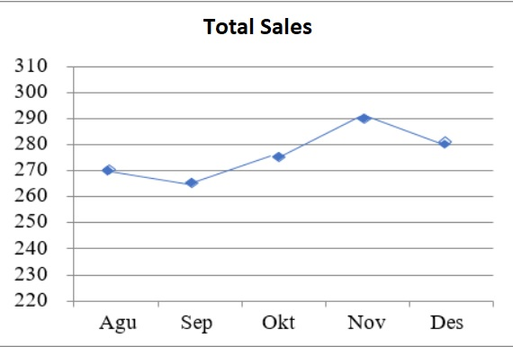

**Figure 1. Kopi Kenangan Total Sales (August - December 2024)**

From the figure, it can be seen that the sales of Kopi Kenangan during August - December 2024 experienced fluctuations. This is due to complaints by consumers about the friendliness of service and dissatisfaction with product quality. This can be seen through the Googler review, where there are public reviews about the service and product quality that consumers refer to the company.

Changes in consumer phases and also the lack of maximization of service and quality of products provided are the reasons for the sales of Kopi Kenangan experiencing fluctuations. By improving the quality of products and the quality of service to customers will make customers feel satisfied with the services provided and will do repeat purchases. Realizing the important role of customers and the effect of customer satisfaction on profits, companies will look for ways that can enhance customer satisfaction. This is also realized by Kopi Kenangan, which provides beverage services that are required to continuously improve product quality and service quality in order to increase the number of customers. Realizing how important customer relationships are and the impact of customer satisfaction on profits, merchants will actively look for ways to increase customer satisfaction levels. Kopi Kenangan, as a beverage service retailer, realizes the need to continuously improve the quality of its products and services in order to attract and retain a larger number of customers.

The results of previous research conducted by Ilhamalimy & Mahaputra (2020**)**, showed that service quality and product quality have an influence on shopping decisions. On the other hand, research conducted by Cynthia, Hermawan, & Izzuddin (2022), found that service quality has no effect on shopping decisions, and research conducted by Nadiya & Wahyuningsih (2020), found that product quality has no effect on purchasing decisions.

The research undertaken by Hariyanto, Arierf, & Praja (2022), showed that service quality and product quality have a positive effect on consumer satisfaction. Furthermore, product quality in a significant way does not affect re-subscription decisions through consumer satisfaction while service quality in a significant way affects re-subscription decisions through consumer satisfaction.

**2. material and methods**

This research is a quantitative and associative research to determine the causal relationship between the independent variables (service quality and product quality) and the dependent variable (repurchase decision) through the intervening variable (consumer satisfaction).

The research was conducted at Kopi Kenangan in Makassar, from January to February 2025, with a population of 1,380 consumers and a sample of 150 respondents using purposive sampling method.

Data were collected through questionnaires and documentary studies. In the analysis, PLS-SEM was used to test the relationship between constructs by evaluating multicollinearity reliability using Variance Inflation Factor (VIF), R-Square for variance, Predictive Relevance (Q²) for predictive reliability, and Goodnes Fit (GoF) for model consistency.

Hypothesis testing was conducted by bootstrapping with SmartPLS, evaluating path coefficients, t-statistics, and p-values to determine the relationship between variables. Similarly, the indirect effect test was used to investigate the indirect effect between the indirect and indirect variables through consumer satisfaction as the indirect variable.

**3. results and discussion**

**3.1. Results**

In this research, respondents were categorized by gender, age, education, and number of purchases. A total of 69.3% of respondents were female, with the majority aged 14 - 21 years (54%), with an educational background of 40%, with a total number of purchases of 4 times with a percentage of 44%.

**Table 1. Respondent Characteristics**

| **Category** | **Number of People** | **Percentage** |
| --- | --- | --- |
| **Gender** | | |
| Male | 46 | 30,7% |
| Female | 104 | 69,3% |
| **Age** |  |  |
| 14-21 | 81 | 54% |
| 22-29 | 65 | 43.3% |
| 30-37 | 4 | 2.7% |
| **Education** |  |  |
| Senior High School | 60 | 40.0% |
| Diploma | 32 | 21.3% |
| Bachelor Degree | 58 | 38.7% |
| **Purchase Quantity** |  |  |
| 2 | 3 | 2% |
| 3 | 37 | 24.7% |
| 4 | 66 | 44% |
| 5 | 24 | 16% |
| More than 6 times | 20 | 13.3% |

In the outer model, analysis is very important in order to determine whether the dataI collected can be considered valid and reliable or not.

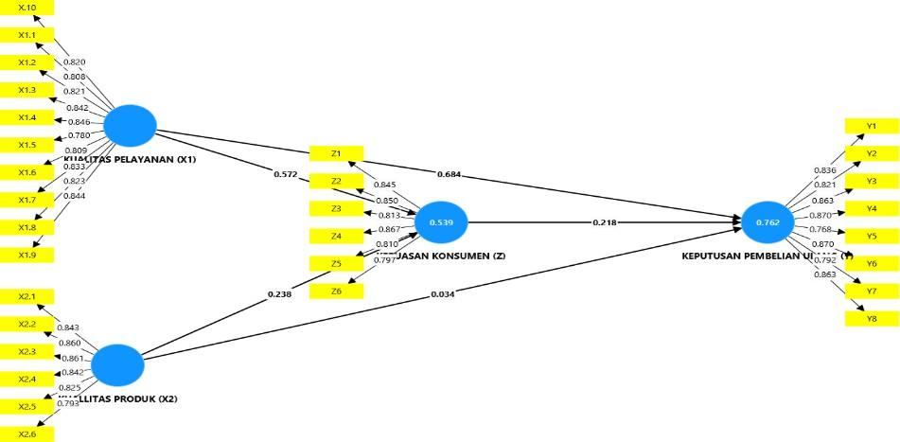

**Figure 2. Outer Loading Validity Test**

Based on the data in the figure above, it is known that all research variable indicators have an outer loading value > 0.70. Therefore, it can be concluded that all question variables for the variables are valid.

**Table 2. Average Variance Extracted (AVE)**

|  |  |  |  |
| --- | --- | --- | --- |
| Variable |  | AVE) | Description |
| Service Quality (X1) |  | 0.690 | Valid |
| Product Quality (X2) |  | 0.699 | Valid |
| Consumer Satisfaction(Z) |  | 0.677 | Valid |
| Repurchase Decision (Y) |  | 0.702 | Valid |

The next stage is to perform a check of the convergence validity through the AVE (Average Variance Extracted) value, where the AVE value of the constructs in the model is above 0.60. The results suggest that the data in the research has met the requirements of convergence validity.

**Table 3. Fornell - Larcker Criterion**

|  |  |  |  |  |  |
| --- | --- | --- | --- | --- | --- |
|  | Consumer Satisfaction(Z) | Repurchase Decision (Y) | Service Quality (X1) | Service Quality (X1) | Result |
| Consumer Satisfaction (Z) | **0.831** |  |  |  | Valid |
| Repurchase Decision (Y) | 0.721 | **0.836** |  |  | Valid |
| Service Quality (X1) | 0.707 | 0.817 | **0.823** |  | Valid |
| Product Quality (X2) | 0.563 | 0.546 | 0.569 | **0.83**8 | Valid |

In this research, each variable has a value that is higher than the value when describing its variable compared to the other variables in the same column. Hence, based on Table 3, it can be stated that all variables are valid.

**Table 4. Cronbach Alpha and Composite Reliability**

|  |  |  |  |
| --- | --- | --- | --- |
| Variable | Cronbach Alpha | Composite Reliability | Result |
| Service Quality (X1) | 0.947 | 0.948 | Reliable |
| Product Quality (X2) | 0.916 | 0.926 | Reliable |
| Consumer Satisfaction(Z) | 0.910 | 0.915 | Reliable |
| Repurchase Decision (Y) | 0.938 | 0.941 | Reliable |

From table 4, it can be confirmed that all constructs can be assumed to be reliable, both from the Composite Reliability and Cronbach's Alpha, with values above 0.70. This implies that all the variables in this research model have good internal reliability.

Furthermore, the inner model describes the relationship between variables based on substantive theory. The results of the inner model test in this study are as shown below:

**Table 5. R Square Test**

|  |  |
| --- | --- |
| Variable | R-square |
| Consumer Satisfaction(Z) | 0.539 |
| Repurchase Decision (Y) | 0.762 |

Based on the table 5, R Square can be interpreted as follows:

1. For the consumer satisfaction variable, the R Square is 0.539, which equals 53.9%. This implies that the model mentioned above has a moderate effect on the variables listed, namely service quality and product quality, while 46.1% of the consumer satisfaction variables are influenced by other variables that are not mentioned in the model.
2. For the repurchase decision variable, which has an R Square value of 0.762, equivalent to 76.2%. This shows that the model has a strong influence on the variables studied, namely service quality, product quality and consumer satisfaction. A total of 23.8% of the variance of repurchase decisions is influenced by other variables that are not included in the model.

Furthermore, the Q Square calculation is calculated using the equation below

Q2 = 1- (1-R21)( 1-R2 )

Then it can be obtained Q Square in this study, as follows:

Q2 = 1- (1-0,54)( 1-0,76)

Q2 = 1- (0,46)( 0,24)

Q2 = 1- 0,110

Q2 = 0,89 x 100 = 89%

Based on the Q2 results, the value of 0.89 indicates that the model has a very good predictive value because the value is greater than 0 (zero). Thereby, it can be determined that this model has a predictive ability of 89% on repurchase decisions that are influenced by the variables of service quality, product quality, and consumer satisfaction.

The GOF is derived from the average AVE (Average Variance Extracted) for the measurement model and the average R-Square for the structural model, illustrating how well the PLS-SEM model can interpret and describe the data.

GoF = √ AVE x R2

GoF = √(0.677 + 0.702 + 0.690 + 0.699 ) x (0.539 + 0.762 )

4 2

GoF = √2,768 × 1,301

4 2

GoF = √0,692 x 1,301

GoF = √0,450

GoF = 0,77

From the results, the GoF value is 0.77, which shows that the GoF value is high because it is between 0.38 - 1.00. This means that the measurement model (outer model) and the structural model (inner model) are appropriate or valid.

In this research, the hypotheses that are proposed can be tested using the Partial Least Squares (PLS) model with the bootstrapping method.

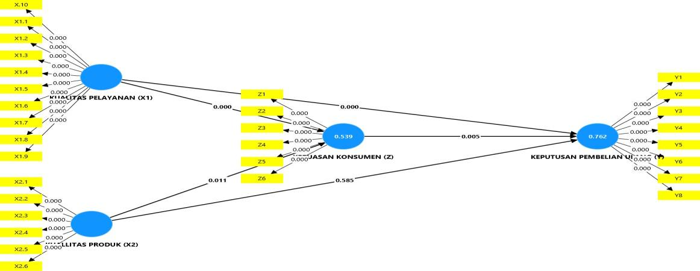

**Figure 3. Hypothesis Testing Results**

To evaluate the accuracy of the prediction model in testing the structural model, it can be seen from the T-statistic value that connects the independent variable to the dependent variable in the Path Coefficient table in the SmartPLS output as shown below:

**Table 6. Hypothesis Test based on Path Coefficient**

|  | *Original Sample* (O) | *Sample* *mean* (M) | *Standard deviation* (STDEV) | *T statistics*  (|O/STDEV|) | P *values* |
| --- | --- | --- | --- | --- | --- |
| Service Quality (X1)🡺 Consumer Satisfaction (Z) | 0.572 | 0.569 | 0.083 | 6.895 | 0.000 |
| Product Quality (X2)🡺 Consumer Satisfaction(Z) | 0.238 | 0.242 | 0.093 | 2.555 | 0.011 |
| Consumer Satisfaction(Z)🡺Repurchase Decision (Y) | 0.218 | 0.221 | 0.078 | 2.804 | 0.005 |
| Service Quality (X1)🡺Repurchase Decision (Y) | 0.684 | 0.681 | 0.074 | 9.260 | 0.000 |
| Product Quality (X2)🡺Repurchase Decision (Y) | 0.034 | 0.033 | 0.062 | 0.545 | 0.585 |

The results of the bootstrapping test in the PLS analysis are as follows:

1. The effect of service quality on consumer satisfaction at Kopi Kenangan, shows an Original Sample value of 0.572. Service quality has a positive and significant effect on consumer satisfaction at Kopi Kenangan, with a t-statistic value that exceeds the t-table and a p-value that is less than 0.05.
2. The effect of product quality on consumer satisfaction at Kopi Kenangan, shows an Original Sample value of 0.238. Product quality also shows a positive and significant effect on consumer satisfaction at Kopi Kenangan, with t-statistics above the t-tabel and p-value less than 0.05.
3. The effect of consumer satisfaction on repurchase decisions at Kopi Kenangan, shows an Original Sample value of 0.218. Consumer satisfaction has a positive and significant effect on repurchase decisions at Kopi Kenangan, as evidenced by the t-statistics and p-values which show the significance of the relationship.
4. The effect of service quality on repurchase decisions at Kopi Kenangan, shows an Original Sample value of 0.684. Service quality has a positive and significant effect on repurchase decisions at Kopi Kenangan, as evidenced by the t-statistics and p-values which show the significance of the relationship.
5. The effect of product quality on consumer satisfaction at Kopi Kenangan, shows an Original Sample value of 0.034. Product quality does not have a significant effect on repeat purchase decisions at Kopi Kenangan, with t-statistics below the t-table and a p-value greater than 0.05.

Testing through the mediating variable is carried out to understand whether the mediating variable successfully mediates the effect of the independent variable on the independent variable.

**Table 7. Mediation Test Indirect Effects**

|  | *Original Sample* (O) | *Sample Mean* (M) | *Standard deviation* (STDEV) | T *statistics*  (|O/STDEV|) | P *values* |
| --- | --- | --- | --- | --- | --- |
| Service Quality (X1)🡺Consumer Satisfaction (Z)🡺Repurchase Decision (Y) | 0.125 | 0.126 | 0.051 | 2.468 | 0.014 |
| Product Quality (X2)🡺Consumer Satisfaction (Z)🡺Repurchase Decision (Y) | 0.052 | 0.053 | 0.028 | 1.830 | 0.067 |

The results of the mediation test in the analysis using PLS are as follows:

1. The effect of service quality on repeat purchase decisions through consumer satisfaction as an intervening variable at Kopi Kenangan, shows an Original Sample value of 0.125. The results of the significance test are also shown by the research p-value of 0.014, which is in accordance with the standard that has been applied which is less than 0.05. Based on the results, it can be confirmed that consumer satisfaction can derive the relationship between service quality and repeat purchase decisions at Kopi Kenangan.
2. The effect of service quality on repurchase decisions through customer satisfaction as an intervening variable at Kopi Kenangan, shows an Original Sample value of 0.052. The significance test results are also indicated by the research p-value of 0.067, which is not in accordance with the predetermined standard of more than 0.05. Based on these results, it can be concluded that customer satisfaction cannot mediate the relationship between product quality and repurchase decisions at Kopi Kenangan.

**3.2. Discussions**

1. **The Effect of Service Quality (X1) on Consumer Satisfaction (Z)**

Based on data analysis, service quality at Kopi Kenangan has a positive and significant effect on customer satisfaction. Aspects such as reliability, responsiveness, assurance, empathy, and service facilities contribute greatly to customer satisfaction. Reliability in service procedures that are simple and accessible, responsiveness of employees in responding to orders, guarantee in a timely manner, as well as empathy and comfortable physical facilities all enhance positive customer experiences. The effect of service quality on customer satisfaction is explained if the service provided to customers is as expected, it will provide satisfaction or cause a feeling of happiness because it is in accordance with the expected results. Consumers not only buy products but also buy complementary services. In general, consumers will feel happy if they are served politely, friendly, with full attention so that satisfaction will arise. Thus, service is important in determining customer satisfaction. Customer expectations can be shaped by past experiences, comments from relatives and promises and information from marketers and competitors. Satisfied customers will be loyal for longer, less sensitive to price and give good comments about the company.

Although there were some indications of dissatisfaction from a number of respondents regarding certain aspects, overall, the high quality of service at Kopi Kenangan succeeded in increasing customer satisfaction. This is in line with the findings of Anggraini and Budiarti (2020), who also stated the positive impact of service quality on customer satisfaction.

1. **The Effect of Product Quality (X2) on Consumer Satisfaction (z)**

Based on the results of the analysis, product quality at Kopi Kenangan shows a significant and positive effect on consumer satisfaction. Factors such as delivery speed, consistent flavors, and the appearance of the merchandise had a significant impact on consumer satisfaction. Even though there were some respondents who were skeptical about the quality of the products and the innovativeness of the packaging, the majority of consumers were satisfied with the quality of the products. Product quality is the suitability of product use to meet consumer needs and satisfaction. This is one of the determining factors for consumer satisfaction, which if the quality of a good product will attract, retain and make consumers loyal. Product quality has become a very dominant factor in the success of organizations, both profit and non-profit organizations, as if consumers feel that the quality of the product, they receive is good or as expected, they will feel satisfied. The relationship between product quality and customer satisfaction which states that if product quality is lower than expected, then the consumer is dissatisfied or disappointed. As a result, the company will find it difficult to build and maintain long-term relationships.

The results are in line with the research of Herlambang and Komara (2022) and Budiarno, Udayana, and Lukitaningsih (2022) who also found that product quality significantly affects the satisfaction of consumers.

1. **The Effect of Consumer Satisfaction (Z) on Repurchase Decisions (Y)**

Based on the results of data analysis, consumer satisfaction at Kopi Kenangan has a positive and significant effect on repurchase decisions. Consumers who are satisfied with the quality of service and products are more likely to engage in repeat purchases, as they feel appreciated and gain value from their experience. Consumer satisfaction also increases the consumer's willingness to recommend Kopi Kenangan to others, expanding the customer base through word of mouth. Consumer satisfaction can be felt after customers compare their experience in purchasing goods or services from a seller or provider of goods or services with the expectations of the buyer himself. These expectations are formed through their first experience of buying a good or service, comments from friends and acquaintances, as well as promises and information from marketers and their competition. This experience will then become a motivation for consumers to make repurchases. Marketers who want to excel in the competition should pay more attention to the expectations and satisfaction of their consumers.

Despite some doubts from the respondents regarding the service and product, the majority are still satisfied. This is in accordance with research from Wardani (2022) which found that consumer satisfaction significantly influences repeat purchase decisions.

1. **The Effect of Service Quality (X1) on Repurchase Decisions (Y)**

The research results show that the quality of service at Kopi Kenangan has a positive and significant effect on repurchase decisions. The quality of service that is friendly, fast, and professional encourages consumers to return to shopping, because they feel respected and get a pleasant shopping experience. Consistent and reliable service reduces the need for consumers to seek alternative alternatives, increasing their trust and loyalty towards Kopi Kenangan. By making repeat purchases, it means that consumers are satisfied, because they are in accordance with their wishes that have been fulfilled. Highly satisfied consumers usually remain loyal for a longer time, buy again when the company introduces new products and updates old products, talk good things about the company and its products to others. Regardless of some dissatisfied responses from respondents regarding the reliability and speed of service, the majority of consumers are satisfied and likely to make repurchases. This finding is supported by the research of Valentine et al (2023), which confirmed that service quality has a significant effect on customer repurchase decisions.

1. **The Effect of Product Quality (X2) on Repurchase Decisions (Y)**

The research shows that product quality at Kopi Kenangan has no significant effect on repeat purchase decisions. While there was satisfaction with the cleanliness, taste, and appearance of the product, there were some respondents who felt that these aspects could be improved. This indicates that despite the majority of consumers being satisfied, there is still room to improve product quality to better meet consumer expectations. Consumers as the target of producers sometimes are not aware of the quality of the products they will consume. However, in general, product quality is what determines whether the product lasts long in the market. Sometimes consumers tend to focus on low prices with product quality that can be said to be unfavorable. From this point, it can be seen that product quality does not always affect repurchase decisions made by consumers. Manufacturers must also be able to provide good quality products and also be cheap so that their products sell well in the market. This result supports the findings of Pratama and Andriana (2023), who also stated that product quality does not have a significant effect on repurchase decisions.

1. **The Effect of Service Quality (X1) on Repurchase decisions (Y) Through Consumer Satisfaction (Z)**

Research shows that service quality has a positive and significant effect on repurchase decisions through customer satisfaction as an intervening variable at Kopi Kenangan. The effect of service quality on repurchase decisions can be explained by the existence of customer satisfaction. Consumer satisfaction, which emerges from a service that is friendly, efficient, and professional, mediates the relationship between service quality and repurchase decisions. This means that service quality not only increases consumer satisfaction directly, but also encourages them to return and make repeat purchases. A focus on improving service quality can increase consumer satisfaction and, consequently, strengthen customer loyalty. This finding is supported by research by Suryani and Rosalina (2019) which also shows that service quality affects repurchase decisions through consumer satisfaction.

1. **The Effect of Product Quality (X2) on Repurchase Decisions (Y) Through Consumer Satisfaction (Z)**

Based on the results of data analysis, it is known that consumer satisfaction is unable to mediate the relationship between product quality and repurchase decisions at Kopi Kenangan. The results of the analysis show that consumer satisfaction has no significant effect on repurchase decisions when considered as an intervening variable. This means that repurchase decisions are more influenced by direct assessments of product quality, not by the level of satisfaction felt. This research is in line with the findings of Wardani, Hartono, and Kustiyah (2020), which also show that product quality through customer satisfaction has no significant effect on repurchase decisions.

**4. Conclusion**

Based on the research results that have been described, of the 7 hypotheses proposed, there are 2 rejected hypotheses, namely product quality does not show a significant effect on repurchase decisions. Furthermore, product quality has no significant effect on repurchase decisions through customer satisfaction as an intervening variable at Kopi Kenangan. Based on this, it can be concluded that product quality has little effect on consumer purchasing decisions either directly or through mediation of customer satisfaction. Not all product quality affects the repurchase decision process. Consumers as target producers, in some cases, are not aware of the quality of the products they consume. However, in general, product quality is what determines whether the product will last long in circulation in the market. Sometimes consumers tend to focus on low prices with product quality that can be said to be poor. From here it can be seen that product quality does not always affect purchasing decisions made by consumers. Manufacturers must also be able to provide good quality products and also be cheap so that their products sell well in the market.

**COMPETING INTERESTS DISCLAIMER:**

Authors have declared that they have no known competing financial interests OR non-financial interests OR personal relationships that could have appeared to influence the work reported in this paper.

**References**

Anggrainy, F., & Budiarti, A. (2020). The effect of price, promotion, and service quality on customer loyalty mediated by customer satisfaction for Gojek consumers. Journal of Economic Education (JUPE), 8(3), 86-94. <https://doi.org/10.26740/jupe.v8n3.p86-94>

Budiarno, B., Udayana, I. B. N., & Lukitaningsih, A. (2022). The effect of service quality, product quality on customer satisfaction in shaping customer loyalty. Equilibrium: Journal of Education and Economic Research, 19(2), 226-233. <https://doi.org/10.25134/equi.v19i02.4531>

Cynthia, D., Hermawan, H., & Izzuddin, A. (2022). The influence of location and service quality on purchasing decisions. Public: Journal of Human Resource Management, Administration and Public Services, 9(1), 104-112. <https://doi.org/10.37606/publik.v9i1.256>

Hariyanto, H., Arif, M. Y., & Praja, Y. (2022). The effect of product quality and service on repurchase interest through customer satisfaction as an intervening variable at Toko F3 Situbondo. Journal of Entrepreneurship Students (JME), 1(9), 1784- 1795. <https://doi.org/10.36841/jme.v1i9.2223>

Herlambang, A. S., & Komara, E. (2021). The effect of product quality, service quality, and promotion quality on customer satisfaction (Case study at Starbucks Coffee Reserve Plaza Senayan). Journal of Economics, Management and Banking, 7(2), 56-64. <https://doi.org/10.35384/jemp.v7i2.255>

Ilhamalimy, R. R., & Mahaputra, M. R. (2020). The effect of service quality and product quality on purchasing decisions and customer satisfaction (Literature review of marketing management). Journal of Law, Humanities, and Political Sciences, 1(1), 85-97. <https://doi.org/10.38035/jihhp.v1i1.604>

Nadiya, F. H., & Wahyuningsih, S. (2020). The effect of product quality, price, and brand image on purchasing decisions for 3Second fashion in the marketplace (Study on students who use 3Second fashion in Semarang City). Proceedings of the Unimus National Seminar, 3.

Oliver, R.L. (2010). Satisfaction: A Behavioral Perspective on the Consumer: A Behavioral Perspective on the Consumer (2nd ed.). Routledge. <https://doi.org/10.4324/9781315700892>

Pratama, M. A. D., & Andriana, A. N. (2023). The Effect of Product Quality, Service Quality, Price on Repurchase Interest through Thrifting Store Swoosh Product Purchasing Decisions. Economics, Finance, Investment and Sharia (EKUITAS), 5 (1), 78-85. <https://doi.org/10.47065/ekuitas.v5i1.3608>

Suryani, S., & Rosalina, S. S. (2019). The effect of brand image, brand trust, and service quality on repurchase decisions with customer satisfaction as a moderating variable (Study on Indonesian unicorn startup businesses). Journal of Business Studies, 4(1), 49.

Valentine, L., Airsyah, M. N., Rizono, S. B., Yuliranto, A., & Zaman, M. B. (2023). Analysis of price perceptions, taste, service quality, and facilities on repurchase decisions for Tegal Gacoan Noodles: Case study on UMUS students. GERMILANG: Journal of Management and Accounting, 3(4), 425-443. <https://doi.org/10.56910/gemilang.v3i4.1309>

Wardani, A., Hartono, S., & Kustiryah, E. (2020). Repurchase decisions through customer satisfaction as an intervening variable in terms of product quality and service quality at Triwindu Market Surakarta. Scientific Journal of Economics, 4(1). <https://doi.org/10.29040/jie.v4i01.825>

Wardani, I. Y. (2022). The effect of product quality and sales promotion on repurchase decisions through customer satisfaction at 200 Café and Food in Malang City. Journal of Management and Business Economics, 3(2), 89-100. <https://doi.org/10.32815/jubis.v3i2.1524>