Taxonomic significance of morphological and anatomical features of Bridelia ferruginea

Abstract

This research aims to examine and make available the morphological and anatomical features inherent in Bridelia ferruginea, which will serve as taxonomic tools for its delineation. The stem, leaves, flowers and fruits were investigated. Bridelia ferruginea has twisted, rough and fissured bole; the branches are low and armed with short spines. The leaves are simple, alternate, petiolate with reticulate, pinnate and brochidodromous venation. The inflorescence is a fasciculate cluster, monoecious and axillary. The calyx and corolla are pentamerous. Staminate flowers are sub-sessile and puberulent with polyandrous stamens, while pistillate flowers are sessile with 2-locular ovary. The fruit is a drupe with fleshy pericarp, greenish when unripe and purplish-black when ripe. Leaf anatomy revealed an “O”-shaped vascular bundle and the presence of rosette crystals. The leaf epidermal cells showed that the distribution of the stomata, which are numerous and anomocytic, is hypostomatic. A transverse section of the wood revealed indistinct growth rings, diffuse porosity with solitary and radial pore multiples. Vessel pores were pitted. In the tangential longitudinal section, axial parenchyma is apotracheal and diffuse, while the ray parenchyma was non-storied; heterocellular and predominantly biseriate. Upright/square ray cells were predominant in the radial longitudinal section with most of the cells containing crystals. Fibres were non-septate, libriform and thin to thick-walled. The pollen shape is oblate spheroidal and tricoporate with reticulate exine sculpture. In conclusion, this study has contributed useful taxonomic data from exo-and endo-morphology of Bridelia ferruginea Benth. in the new family segregate, Phyllanthaceae of Euphorbiaceae.

Keywords: Euphorbiaceae, heterocellular rays, non-septate fibres, Phyllanthaceae, rosette/ chambered crystals, wood anatomy

INTRODUCTION
Bridelia ferruginea Benth. belongs to the family Phyllanthaceae, a segregate of the Euphorbiaceae sensu lato on the basis of molecular data and pollen morphology during the Eocene (Gruas-Cavagnetto & Köhler, 1992; Muller, 1992; APG II, 2003; Wurdack et al., 2004; Srivastava & Mehrotra, 2014). The plant has widespread medicinal uses and the parts commonly used are the stem-bark, roots and leaves. The stem bark exhibits anti-inflammatory properties and antipyretic effects (Olajide et al., 2003). In Nigeria, especially in the north, a bark preparation called "Kirmi" is effective in treating wounds caused by arrow poison and is also alleged to confer immunity against syphilis (Irobi et al., 1994, Akuodor et al., 2011). In Guinea, the Maninka grind the wood to a fine powder for use as a dentifrice (Oliver-Bever, 1986). The leaves are also used as medicinal forage for sheep and cattle (Awohuoedyi et al., 2013). The decoctions of leafy twigs and bark are commonly used as purgatives, diuretics, aphrodisiacs, febrifuge and for urethral discharges and have been evaluated for antimalarial (Talla et al., 2002; Adebayo and Ishola, 2009), while infusions prepared from leaves only is also used in the treatment of diabetes (Ngueyem et al., 2009, Bakoma et al.,2011). Adesina & Akomolafe (2014) stated that the bark is eaten in Ekiti State and other southwestern parts of Nigeria. Kolawole & Olayemi (2003) reported that the bark extract has the potential for water treatment while Burkill (1994) also reported that the bark is sometimes added to palm wine to strengthen it.
The members of the Phyllanthaceae family are mostly herbaceous or shrubs and rare trees, that possess alternate and simple leave which are entire with bronchidodromous venation and monoecious (Hoffmam et al., 2006). They further noted that Phyllanthaceae can be differentiated morphologically from the Euphorbiaceae by the absence of the following: bi-locular ovary, dehiscent fruit, caruncle in the seed and latex. Bridelia ferruginea is a small non-laticiferous tree or shrub commonly growing up to a height of 6-15 m and 1.5 m in girth in the savannah woodland region of Africa (Adebayo & Ishola, 2009, Jonathan et al., 2014). Plant Resources of Tropical Africa (PROTA) (2007) noted its distribution in Tropical Africa and Asia. The Plant List (2010) documented forty-nine Bridelia species out of which seven were reported by Keay (1989) with B. ferruginea as the most available species in Africa. The twigs and young shoots are rust-coloured and densely pubescent with matted hairs, which usually are not straight. The leaves are usually broad, alternate, broadly elliptic and abruptly acuminate. The male flowers are pedicellate and puberulous, while the female flowers are subsessile (Keay, 1989).
The circumscription of the family and genera for the tribe Bridelieae were carried out by different authors from morphological (Webster, 1994, Radcliffe-Smith, 2001), anatomical (Metcalfe and Chalk, 1950; Mennega, 1987; Raturi et al., 2001), Palynological (Kohler, 1965) and molecular (Hoffmann et al., 2006) point of views. Metcalfe and Chalk (1950) scantly reported the following features in the genus Bridelia: small to moderately small vessels with simple perforations; absence of tyloses, moderately abundant paratracheal parenchyma which are more of vasicentric; rays not of two distinct sizes and tend to be shorter and much less markedly heterogenous. The morphological description of B. femuginea was made Keay (1989). Jange & Gupta (2015) studied general wood microscopic structure of the tribe Bridelieae but did not include B. ferruginea, the most available Bridelia species of the savanna woodland region of Africa.
In spite of the numerous usages to which members of the tribe Bridelieae have been put in the time past, much research has not been done on the use of anatomical features in the delineation and classification of B. femuginea. Agbagwa & Ndukwu (2004) opined that the morphology and anatomy of plant organs constitute the bedrock of plant taxonomy and their features remain inseparable. The available studies dwelt on descriptions of Bridelia at tribe level, separate and scanty. More so, the available morpho-anatomical features in most cases, failed to include the African savanna Species, B. ferruginea. The use of data generated from anatomical fratures in resolving the taxonomy of taxa has gained much recognition for a long time. Some of the prominent researchers that have solved taxonomic problems among plant taxa with such data are Ogundipe & Olatunji (1991), Olowokudejo (1993), Das & Ghose (1993), Illoh (1995), Isawumi (1996), Croxdale (2000), Das (2002), Ayodele & Olowokudejo (2006) and Aworinde et al. (2009). The present study described some morpho-anatomical features of B. ferruginea with the aim of providing useful taxonomic data that would give further insight into its proper classification, delineation and identification as a member of the Phyllanthaceae. This was accomplished by the following objectives: 1) morphological evaluation 2) Anatomical evaluation; 3) evaluation of the pollen characters and 4) and evaluation of plesiomorphous and apomorphous features.

MATERIALS AND METHODS
Sample collection
An ecological survey design was used in the study. Ten samples from the different parts of B. ferruginea were collected randomly from five plants (i.e two sample per plant) in their natural regions of provenance namely: Obudu (Latitude 6º87, N and Longitude 9º16′ E) Tropical Rainforest Vegetation (TRFV), Nsukka (Latitude 6º86′ N and Longitude 7º39′ E) Derived Savannah Vegetation (DSV) and Suleja (Latitude 9º2N and Longitude 7º17′ E) Guinea Savannah Vegetation (GSV) representing three ecological zones in Nigeria. Proper identification of the plant was done by Prof Dr M.O. Nwosu of the Department of Plant Science and Biotechnology, University of Nigeria, Nsukka and authenticated at the Herbarium of the Department of Plant and Science and Biotechnology, University of Nigeria, Nsukka (UNH) and voucher specimen were deposited there (UNH 103 a, b and c). The plant was described based on its Type specimen obtained from the Royal Botanic Gardens, Kew.
Morphological studies
The morphological features of the samples of leaves, petioles, flowers, fruits, and seeds were thoroughly examined using a hand lens and a dissecting microscope. The dimension of stem, laminae and petioles were measured using a meter rule, while the height was estimated.
Anatomical studies
Leaf epidermal study
The leaf epidermal study was carried out in accordance with the work of Ogbonna et al. (2018). Freshly collected leaves were washed to remove dirt with distilled water and left to dry. The leaves were soaked in commercial bleach, (3.5% sodium hypochlorite) for about 18hours and were rinsed two to three times with water. The leaf epidermises were scraped with a sharp blade and rinsed using a camel's hairbrush. The samples of both adaxial and abaxial leaf surfaces were stained with three drops of Safranin; then mounted in glycerin. They were then viewed under a light Olympus microscope (Japan Cx31).
Sectioning of leaf, stem and root
Sectioning of the samples was done following the modified procedures of Nwosu (2006). The transverse section of mid lamina, petiole, mature root and stem, transverse longitudinal sections and radial longitudinal section root and stem of the taxa were cut at 10-20 µm using a Reichert (Heidelberg) sledge microtome. Temporary and permanent mounts of the sections were made and washed in a series of alcohol and 50/50 alcohol and xylene. All sections were stained with 1% Fast green; examined and mounted in Canada balsam.
Analysis of wood
The wood maceration method was carried out following Franklin (1945). Air-dried wood of B. ferruginea was debarked, cut in the dimension of 0.1-0.3 x 4cm and placed in labelled test tubes. Two grams of 5% potassium chlorate (KClO₃) and 10 ml of nitric acid (HNO₃) were added and allowed to react in a fume cupboard until the lignin and middle lamella of the tiny bits dissolved. Potassium chlorate acted as a strong oxidizing agent. The presence of white tissues at the base of the test tubes indicated that maceration has occurred. The residual acid from each test tube was decanted into a container and samples were rinsed with one to two changes of distilled water to stop further reactions. The test tubes were left to stand for 24 hours, and the supernatant was decanted. The macerated tissues were further processed by washing twice with distilled water. Two drops of 1% Safranin were added to the samples to stain the fibres. Photomicrographs were made using a Motic B3 compound microscope with a moticam 2.0 image system and software.
The following anatomical feature were evaluated:
leaf structures carefully observed and recorded, wood vessels: number numerically counted under the microscope, density estimated as the number of vessels per mm², length and width, rays and fibres: length and width were measured with the aid of an eyepiece micrometer fitted in the microscope.

Pollen Study
The pollen analyses were carried out following a modified version of Erdtman (1981). Mature anthers from freshly opened flowers were teased out into a small beaker and squashed with a glass rod. Five millilitres of 70% alcohol were added and the solution was sieved into a test tube using sterilized wire gauze. The solution was centrifuged for 5 minutes at 3000 rpm; washed twice with distilled water and centrifuged. The precipitate was suspended in glacial acetic acid; centrifuged and acetolyzed using the above version. Acetolyzed sample was mounted in glycerin and examined with the aid of a light Olympus Binocular microscope at ×400 and ×1000 magnifications. Pollen's description terminologies were in accordance with Erdtman (1981) and Faegri and Iversen (2012). Photomicrographs were taken at ×1000 magnifications using a moticam 2.0 Image systems and software.
Quantitative data generated were subjected to descriptive statistics using Microsoft excel.

RESULTS

Morphological study
The stem of B. ferruginea showed twisted, rough and fissured features, with the degree of fissure increasing with the age of the plant; branches were low and mostly armed with short spines. The slash is reddish-brown (Fig.1a and b). The leaf is simple, with visible petiole, reticulate pinnate venation which are in pairs averaging 8.2 ± 0.47 veins and alternate leaf arrangements. Lamina is broadly elliptic and entire with brochidodromous venation. The leaf margin is slightly undulated with round base and abruptly acuminate apex (Fig.1c). At the base of each leaf is a lanceolate stipule. The adaxial leaf surface is smooth and dark green while the abaxial surface is spongy and light green with both surfaces glabrous. The inflorescence is a fasciculate cluster; axillary and appears close to newly emerged leaves. The flower is hypogynous, actinomorphic, unisexual and monoecious (Fig 1d). The corolla and calyx are 5-merous; staminate flower polyandrous and the ovary 2-locular. The fruit is a drupe, greenish when unripe and purplish-black when ripe. It measures an average of 6.08 ± 0.63 mm long and 4.21 ± 0.26 mm wide (Fig. 1e; Table 1).

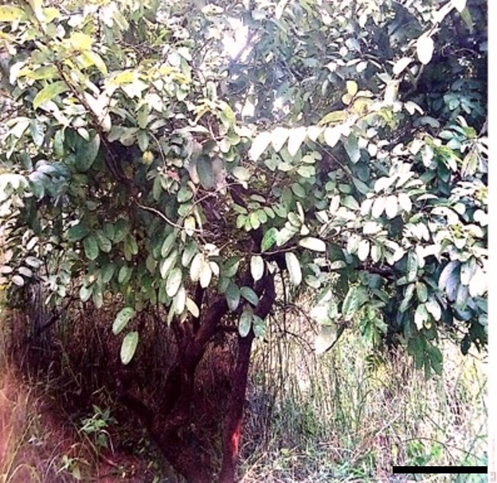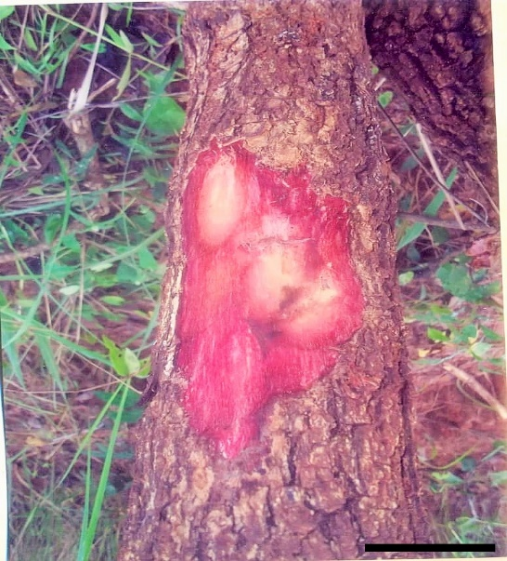
B
A

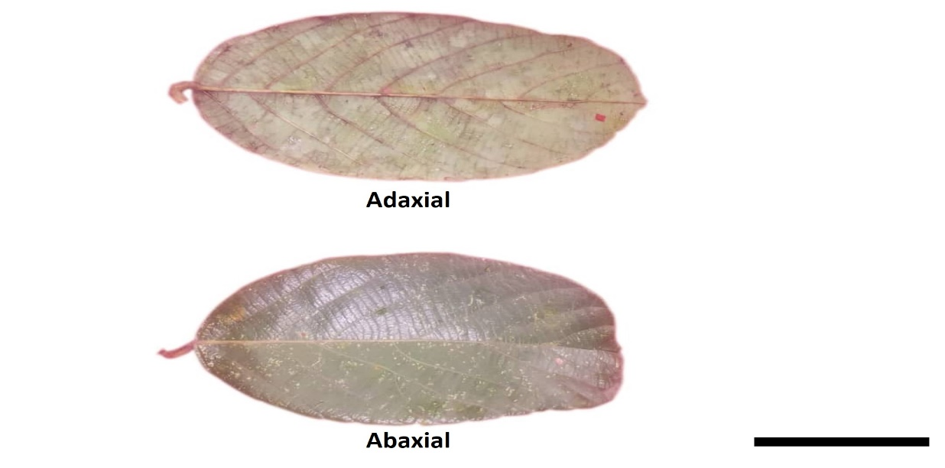
C

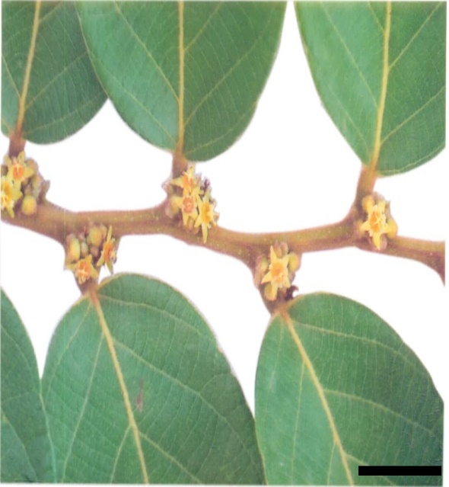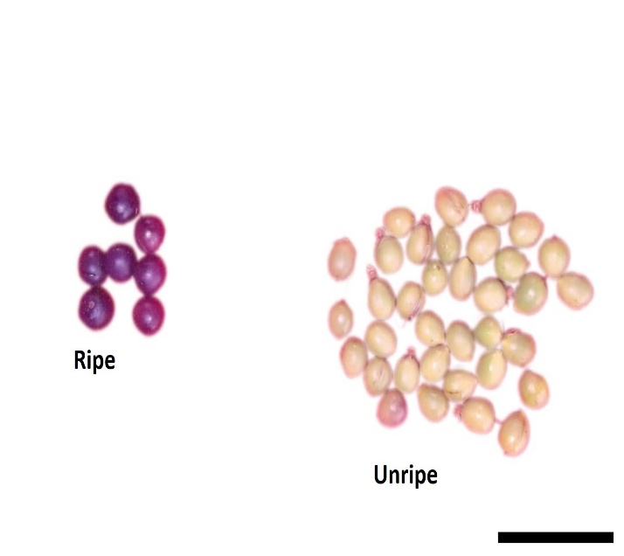
E
D

Fig. 1. Morphological features of B. ferruginea. (A) Habit of B. ferruginea (B) Slashed (bole) of B. ferruginea showing reddish-brown colour. (C) Adaxial and abaxial leaf surfaces of B. ferruginea showing broadly elliptic laminae, rounded base and abruptly acuminate apex; (D) The twig of B. ferruginea showing the flowers (E) Fruits of B. ferruginea (drupe) bar = 52.92 mm

Anatomical Study

Leaf
The transverse section mid lamina showed a single-layered epidermis, slightly undulating and covered with a thin layer of the cuticle (Fig. 2). The epidermal cells were compactly arranged and mostly circular in shape with uniseriate glandular trichomes. The palisade mesophylls were rectangle in shape, bear numerous chloroplasts and were closely and firmly arranged. The lower palisade cells were mostly square-shaped while the upper palisades are longer and narrower. The vascular bundle is collateral and “O”-shaped with the xylem vessel 3 to 8 cells long. The result of the epidermal strip showed that the distribution of the stomata is hypostomatic (i.e stomata occur only on the lower surfaces). The transverse section of the petiole also revealed a single epidermal layer that is amoeboid in shape (Fig. 2). The arrangement of vascular bundles is arc-shaped, and centrally placed pushing most of the cells in the pith towards the periphery. Conspicuously, the vascular bundles are folded inwardly at the centre. The xylem vessels range between 4 to 11 cells long.
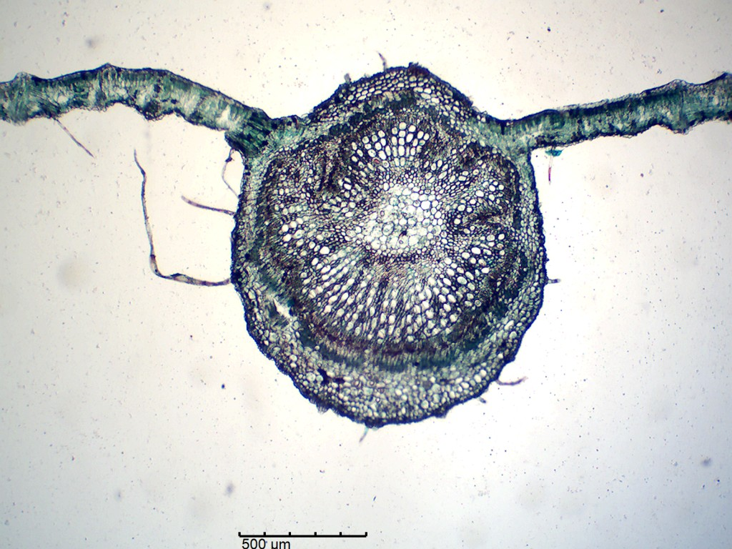A
Adaxial epidermis
Xylem
Cambium
Phloem
Unicellular trichome
Abaxial epidermis
Adaxial Epidermis
Xylem
Phloem
Cambium
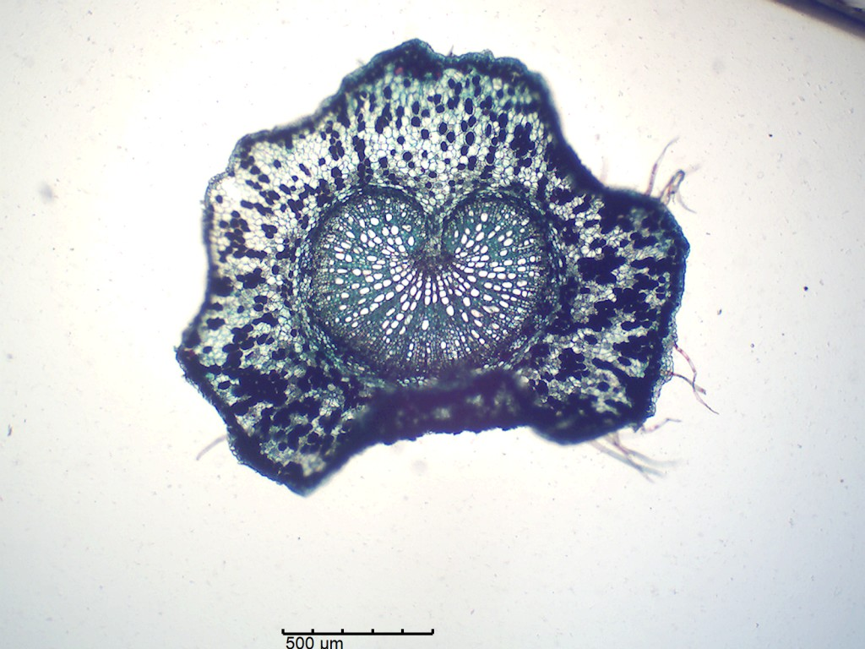B
Unicellular trichome
Fig. 2: Showing leaf anatomical features. (A) Transverse Section of the leaf of B. ferruginea (x 100). (B) Transverse Section of Petiole of B. ferruginea. (x 100)

Wood
The transverse section of the wood (i.e mature stem and root) of B. ferruginea revealed indistinct growth rings and diffuse-porous vessels, which were solitary and in radial multiples of 2 to 14. Vessels were predominantly oval-shaped and abundant, wider in radial than tangential diameters in some vessels and wider in tangential than radial diameters in others. Vessels dimorphism was also revealed with the vessel diameter, ranging from 50 to 128 µm in the stem and from 58 to 130 µm in the root. The vessel density ranges from 22 to 130 in the stem and 41 to 138 in the root (at × 100) (Figure 3). The transverse longitudinal sections of the wood showed medium-sized cylindrical vessels of varying lengths ranging from 593 to 1443 µm and lengths of vessel members from 66 to 160 µm in the stem. The vessel length in the root varies from 501 to 1528 µm with vessel member length varying from 55 to 169 µm (Figure 3 A and B; Table 1). The radial longitudinal section revealed that the radial elements (rays) lies right angle to the longitudinal elements (vessels) (Figure 3E and F). Rays were heterocellular, mostly upright/square, with few procumbent cells. The upright/square rays comprise cells that were mostly rectangular with longer vertical axes and contain chambered circular/rhomboidal crystals. Fibres were non-septate, elongated and overlapping. Vessels were pitted and members were joined end to end, separated by perforation (Figure 3).

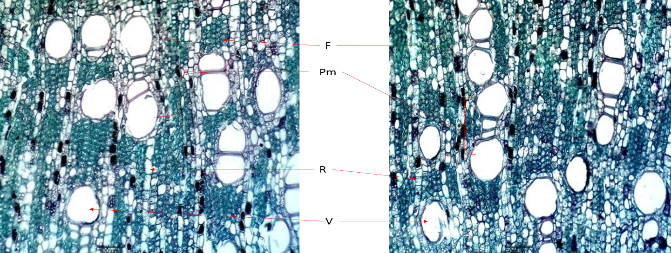
A B

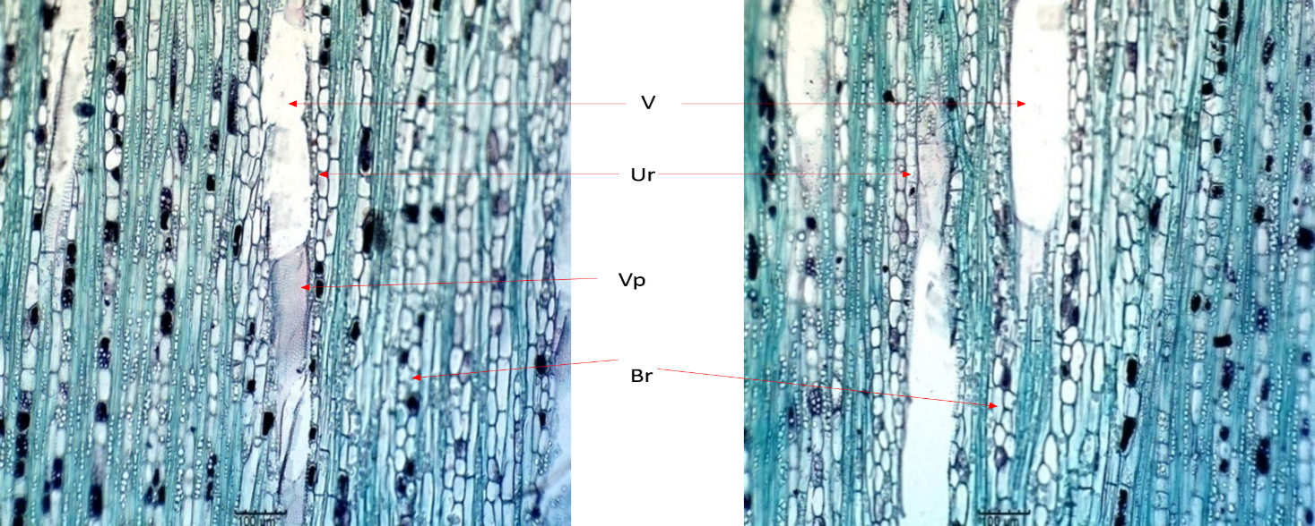
C D

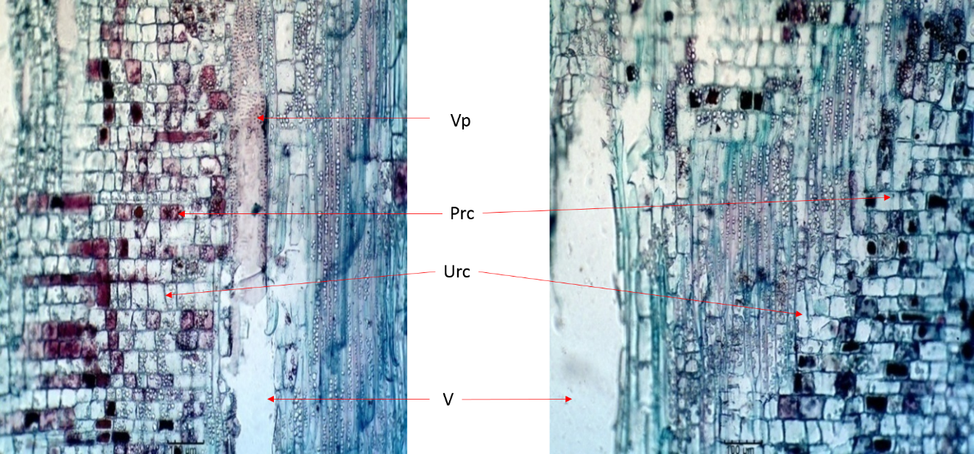
E F

Fig. 3. TS of mature stems and roots of B. ferruginea. (A) Transverse section of mature stem of B. ferruginea. (B) Transverse section of mature root of B. ferruginea. (C) Transverse longitudinal sections of mature stem of B. ferruginea. (D) Transverse longitudinal sections of mature root of B. ferruginea. (E) Radial longitudinal section of mature stem of B. ferruginea. (F) Radial longitudinal section of mature root of B. ferruginea (×100). V = vessel, R = ray, F = fibre, Pm = pore multiples, Vp = vessel pitting, Prc = procumbent ray cells, Urc = upright ray cells.

Fibre morphology
Fibres were non-septate, libriform with thin-to-thick cell walls (Fig.4). The fibre length varies from 732 to 1052 µm with the diameters ranging from 2 to 10 µm while that fibre cell wall thickness is from 3 to 13 µm thereby recording fibre lumen diameter less than three times the double cell wall thickness (Table 1).
Pollen study
The result of the pollen analysis revealed a reticulate exine sculpture. The pollen shape is oblate sphaeroidal and the apertural type is tricolporate (Fig. 4). The quantitative pollen parameters did not vary greatly. The length of the polar axis ranges from 10 to 12 µm, the length of the equatorial axis is 11 to 13 µm and the exine thickness is mostly 1.00 µm. The length of the colpus varies from 6 to 8 µm and the diameter of the colpus is from 1.0 to 1.2 µm. The pollen form index is 0.92 while the exine index is 0.09 approximately (Table 1).
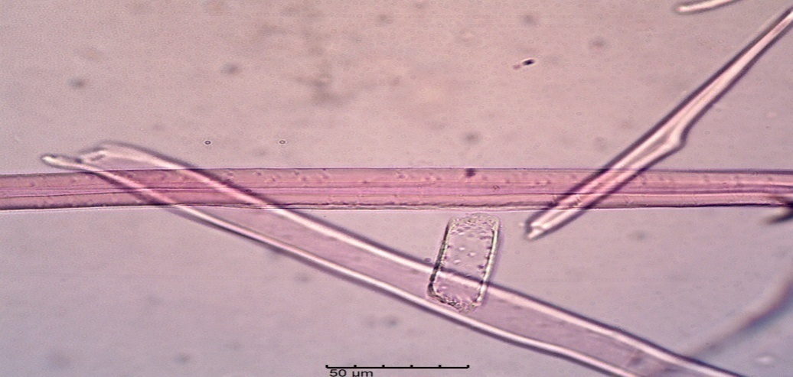

A
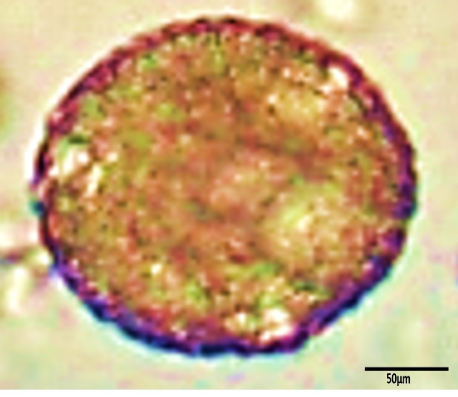B 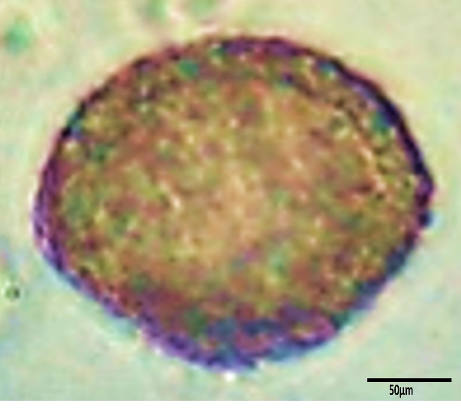C
P
E

Fig. 4. Fibre and pollen morphology of B. ferruginea. (A) Non-septate, thin to thick-walled fibres of B. ferruginea (×400). (B) polar viewof B. ferruginea pollen grain (×1000). (C) equatorial viewof B. ferruginea pollen grain (×1000) with tricolpate aperture and oblate spheroidal shape. P = polar view; E = equatorial view.

Table 1: Quantitative morpho-anatomical feature of B. ferruginea
Anatomical features | Average
Leaf number of vein pairs | 8.7 ± 0.47 veins
Fruit length | 6.08 ± 0.63 mm
Fruit diameter | 4.21 ± 0.36 mm
Fibre length | 889 ± 45.2 µm
Fibre diameter | 5.90 ± 1.04 µm
Fibre cell wall thickness | 7.30 ± 1.54 µm
Number of vessels | 7.9 ± 1.79 vessels
Vessel diameter | 93.2 ± 12.31 µm
Vessel density stem | 59.7 ± 17.3 µm
Root vessel density | 88.4 ± 15.92 µm
Stem vessel length | 845.2 ± 79.15 µm
Root vessel length | 1077.1 ± 174.78 µm
Stem vessel member length | 115.4 ± 17.3 µm
Root vessel member length | 109.4 ± 17.72 µm
Values are presented as mean ± standard error

DISCUSSION

The exo-morphological variables in this study such as alternate leaf arrangement, short and abrupt acuminate leaf apex with rigid downward acumen; reticulate pinnate and brochidodromous venation, lanceolate stipule, fissured bark in the old stem; reddish-brown slash; short spines on branches; rust-coloured matted hairs on young shoots and petioles, fasciculate clusters of flowers (axillary and monoecious) have diagnostic values as these can be used to spot the taxon in the field and the descriptions were in agreement with those of Metcalfe & Chalk (1979), Keay (1989), Kolawole & Olayemi (2003) Taiwo et al. (2012), Adesina & Akomolafe (2014). The presence of brochidodromous, fasciculate inflorescences and absence of bi-ovulated ovary, latex, caruncle in seeds, explosive dehiscent fruits differentiated B. ferruginea (Phyllanthaceae) morphologically from Euphrobiaceae Senso stricto.
The transverse sections lamina and petiole revealed compactly arranged and single-layered epidermis slightly undulating. Evert (2006) stated that the cuticle and epidermis reduce the rate of transpiration and protect the internal plant tissue from mechanical injuries. Cutler et al. (2007) also stated that undulating patterns in epidermises of plants are of taxonomic importance. The presence of unicellular glandular trichomes was recorded in the transverse sections of the lamina and petiole. Glahremanmejad et al. (2012) stated that trichomes are useful for taxa separation and phylogeny inference. In the transverse section of the petiole, vessel arrangements were radial and inward folding of the vascular arc was revealed. Soladoye (1982) reported inward folding of the vascular arc, radial and diffuse vessel arrangements, present and absence of xylem fibres and trichomes as an aid to the classification of the African genus Baphia Lodd. The ground tissues of the lamina and petiole revealed numerous crystals that are rhomboidal to circular in shape. This finding is in tandem with the work of Metcalfe & Chalk (1983) which included Euphorbiaceae Senso lato in the list of families that show the presence of crystals in their tissues.
The transverse section of the wood (mature stem and root) showed indistinct growth rings; vessel distribution diffuse-porous with solitary and radial multiples, wider in radial than tangential diameters. The section revealed vessels of varying numbers and sizes as well as pore radial multiples in varying degrees, lowest in the most mesic vegetation and highest in the most xeric vegetation. The presence of vestured pits is in tandem with the report of Jansen et al. (2001), who reported their occurrence in Bridelia and Cleistanthus but absent in other Euphorbiaceae Senso lato. This goes to support the placement of B. ferruginea in the new family segregate. Carlquist (1984) noted vessel dimorphism in the Euphorbiaceae and maintained that ecology plays a role in the extent of vessel grouping. Vessel groupings, which can occur in radial multiples (as in the present study), tangential bands, diagonal bands and clusters mainly provide alternative channels for water movement, should one or many vessels in a group become inactive as a result of air embolisms especially if vascular tracheids were scanty (Wheeler, 1986; Carlquist, 2001; Wheeler et al., 2007). Vessel length and diameter showed marked variability among the vessels. The vessel diameter variations possess greater functional roles when compared to those variations in the length of vessel element (Wheeler et al., 2007), however, it is generally believed that shorter vessels improve conductivity. Baas et al. (2004) stated that a greater number of narrow vessels of equal transportation capacity to fewer wider vessels will function better in withstanding water stress. However, it was maintained that wider vessels are more efficient in terms of water conductivity but may be likely to be more vulnerable to blockage and conductive stream breakage resulting from gas embolism (Hack et al., 2006; Olson & Rosell, 2013). Generally, Fichtler & Worbes (2012) reported that aside from vessel diameter that strongly correlates with wood anatomical variables, climate conditions and tree morphology, vessel variables are weakly influenced by climate conditions.
The axial parenchyma encountered was apotracheal and diffuse. It was found that the parenchyma is situated among the fibre-tracheids rather than in contact with the vessels. Also revealed is another diffuse sub-type, commonly made up of individual cells or strands scattered throughout the fibrous ground tissue, having rare contact with some vessels. This agrees with the work of Metcalfe and Chalk (1983) and Evert (2006) who separately stated that the latter is the most primitive type of this group. IAWA Committee (1989) cautioned that woods with numerous diffuse or diffuse-in-aggregate parenchyma may show many strands associated with the vessels and that these rare contacts do not depict paratracheal parenchyma. The patterns of axial parenchyma vary from species to species and are of systematic importance as they occur in regular patterns from one taxon to another (Wiedenhoeft and Miller, 2005).
Ray cells in transverse longitudinal sections were predominantly biseriate with few uniseriate while multiseriate rays were rarely present. IAWA Committee (1989) noted that regarding cellular composition, some woods possess two or more ray types and stressed that only the regularly occurring categories should be recorded. In the radial longitudinal section, the ray cells were heterocellular, bearing square/upright and procumbent cells. This is in line with the sixth and the last categories of ray cellular composition types put forward by the IAWA Committee (1989). The presence of chambered circular to rhomboidal crystals inside the majority of the square/ upright ray cells is in tandem with the work of Jangid and Gupta (2015) who reported the same in Bridelia tomentosa and B. stipularis. Rays play a vital role in controlling wood swelling state and function in the transportation of nutrients between the inner and outer part of the tree (Evert, 2006; Cutter et al., 2007). Wheeler et al. (2007) also stated that the primary function of parenchyma, ray or axial, is for the storage of food substances such as starch, fat, nitrogen compounds and gastric substances such as crystal or silica.
The fibre morphology of B. ferruginea revealed non-septate and libriform types with thin-to-thick cell walls. The fibre lengths varied greatly but fell below the minimum length of 1,200 µm recommended by the IAWA Committee for suitability in pulping and paper making. Ogunleye et al. (2017), opined that the efficiency of wood species used in pulping is determined by fibre morphological characters such as fibre length and diameter less than three times the double wall thickness, indicating a thick fibre cell wall. Wiedenhoeft & Miller (2005) noted that the fibre wall thickness varies from species to species and many categories may occur in one species. The three categories recognized by IAWA Committee (1989) are: thick-walled, thin to thick-walled and thin-walled fibres which are mostly preferred for good quality pulp and papers.

CONCLUSION
The study has revealed several features of taxonomic interests inherent in B. ferruginea namely: the presence of fissured bark; brochidodromous venation; fasciculate flower clusters; the presence of anisocytic type of stomata on the abaxial surfaces only; solitary and radial multiples; the presence of rosette and chambered crystals in transvers section of the leaf and ray cells respectively and tricolporate pollen with reticulate sculpture. The absence of bi-ovulated ovary, latex, caruncle in seeds, explosive dehiscent fruits differentiated B. ferruginea (Phyllanthaceae) morphologically from Euphrobiaceae Senso stricto. The presence of rosette and chambered crystals and vestured pits also supported its placement in the new family segregate (Phyllanthaceae of Euphorciaceae).

REFERNCES

Adebayo E.A., Ishola O.R., (2009) Phytochemical and antimicrobial screening of the crude extracts from the root, stem-bark and leaves of Bridelia ferruginea. African Journal of Biotechnology, 8: 650–653.
Adesina A.J., Akomolafe, S.F. (2014) Nutritional and anti-nutritional composition of Bridelia ferruginea Benth. (Euphorbiaceae) stem-bark sample. International Journal of Scientific Research and Knowledge, 2(2): 92–104. https://doi.org/10.12983/IJSRK-2014-P0092-0104
Akuodor G.C., Mbah C.C., Anyalewechi N.A., Idris-Usman M., Iwuanyanwu T.C. et al. (2011) Pharmacological profile of aqueous extract of Bridelia ferruginea stem-bark in the relief of pain and fever. Journal of Medicinal Plants Research, 5(22): 5366–5367.
APG II., 2003: An update of the Angiosperm Phylogeny Group classification for the orders and families of flowering plants. APG II. Botanical Journal of the Linnean Society, 141: 399–436. https://doi.org/10.1046/j.1095-8339.2003.t01-1-00158.x
Awohouedji D.Y.G., Lesse P., Houinato M., Hounzangbe-Adote S., (2013). Medicinal forage present in the natural pasture in Benin. Journal of Animal Production Advances, 3(11): 301–310.
Ayodele A.E., Olowokudejo J.D., (2006). The family of polygonaceae in West Africa: Taxonomic significance of leaf epidermal characters. South African Journal of Botany, 72: 442-459. https://doi.org/10.1016/j.sajb.2005.12.009
Baas P., Ewers F.W., Davis S.D., Wheeler E.A., (2004). Evolution of xylem physiology. – In: Hemsley A.R., Poole I. (eds.), 2004: The Evolution of Plant Physiology: 273–295. Elsevier Academic Press, Amsterdam.
Bakoma B., Eklu-Gadegkeke K., Agbanon, A. Aklikoku K., Bassene E. et al., (2011). Preventive effect of Bridelia ferruginea against high fructose diet induced tolerance, oxidative stress and hyperlipidamia in male wistar rats. Journal of Pharmacology and Toxicology, 6(3): 249–257. https://doi.org/10.3923/jpt.2011.249.257
Bessey C. E. (1915). Phylogenic taxonomy of flowering plants. Annals of Missouri Botanic Garden, 2: 109–116. https://doi.org/10.2307/2990030
Burkill H.M., 1994: The Useful Plants of West Africa (2nd ed.). United Kingdom.
Carlquist S. (1984).: Vessel grouping in dicotyledon wood. Aliso: Journal of Systemic Evolution Botany, 10(4): 505–525. https://scholarship.claremont.edu/aliso/vol10/iss4/3
Carlquist S. (2001). Comparative Wood Anatomy, Ecological and Evolutionary Aspects of Dicotyledon Wood (2nd ed.). Berlin.
Croxdale J.L. (2000). Stomatal patterning in Angiosperms - American Journal of Botany, 87: 1069-1080. https://doi.org/10.2307/2656643
Cutter D.F., Botha C.E.T., Stevenson D.W., 2007: Plant Anatomy: An Applied Approach. USA.
Das S. (2002). On the ontogeny of stomata and glandular hairs in some Indian mangroves - Acta Botanica Croatica, 61: 199-205. https://core.ac.uk/download/pdf/14377802.pdf
Das S., Ghose, M., (1993). Morphology of stomata and leaf hairs of some halophytes from Sundarbans, West Bengal. Phytomorphology, 43: 59-70. http://hdl.handle.net/10263/5827
Erdtman G., 1981: An Introduction to Pollen Analysis. United States of America.
Evert R.F. (2006). Esau’s Plant Anatomy (3rd ed.). New York.
Faegri K., Iverson J. (2012). Textbook of Modern Pollen Analysis. Oxford.
Fichtler E., Worbes, M. (2012). Wood anatomical variables in tropical trees and their relation to site conditions and individual tree morphology. IAWA, 33(2): 119–140.
Franklin G.L. (1945) Preparation of sections of synthetic resin and wood-resin composites, and a new maceration method for wood. Nature, 155: 51–61. https://doi.org/10.1038/155051a0
Ghahremaninejade F., Khalili Z., Maassoumi A.A., Mirzaie-Nodoushan H., Riahi M. (2012). Leaf epidermal features of Salix species (Salicaceae) and their systematic significance. American Journal of Botany, 99: 1–8. https://doi.org/10.3732/ajb.1100019
Gruas-Cavagnetto C., Köhler E. (1992). Pollen fossils d’Euphorbiacées de l’Eocéne français - Grana 31: 291–304. https://doi.org/10.1080/00173139209429452
Hacke U.G., Sperry J.S., Wheeler J.K., Castro L. (2006). Scaling of angiosperm xylem structure with safety and efficiency. Tree Physiology, 26:689-701. https://doi.org/10.1093/treephys/26.6.689
Hoffman P., Kathriarachchi H., Wurdack K.J. (2006). A phylogenetic classification of Phyllanthaceae (Malpighiales, Euphorbiaceae s.l.). - Kew Bulletin, 61:37-53. https://www.jstor.org/stable/20443245
http://www.the plantlist.org accessed on 01-01-2018.
Illoh H.C. (1995). Foliar epidermis and petiole anatomy of four species of Celosia L. in Nigeria. Feddes Repertorium, 106: 15-23. https://doi.org/10.1002/fedr.19951060107
International Association for Wood Anatomists (IAWA) (1989). IAWA list of microscopic features for hardwood identification. IAWA Bulletin New Series, 10: 219-332.
Irobi O.N., Moo-young M., Anderson W.A., Daramola S.O. (1994). Anti-microbial activity of bark extract of Bridelia ferruginea (Euphorbiaceae). Journal of Ethnopharmacology, 43: 185-190. https://doi.org/10.1016/0378-8741(94)90041-8
Isawumi M.A. (1996). Trichome Types and Their Taxonomic Value at the Sectional and Species Level in West African Vernonia (Compositae) - In: Compositae: Systematics. Vol. 1. Hind, D.J.N. and H. Beentje (Eds.) - Royal Botanic Gardens, Kew, pp: 29-39.
Jangid P.P., Gupta S. (2015). Wood anatomy of the tribe Bridelieae (Euphorbiaceae sensu lacto): Reflecting the systematic, ecological and evolutionary aspects. Indian Forest, 141: 1296 -1304.
Jonathan A.E., Etuk E.U., Bello S.O., Gwarzo M.S., Egua M.O., Nkwoka, I.J. (2014). In vitro antibacterial activities of aqueous and ethanolic stem-bark extracts of Bridelia ferruginea Benth. International Journal in Current Research in Bioscience and Plant Biology, 1: 28-31.
Keay R.W.J. (1989). Trees of Nigeria. Oxford.
Kolawole O.M., Olayemi A.B. (2003). Studies on the efficacy of Bridelia ferruginea Benth. Bark extract for water purification. Nigerian Journal of Pure and Applied Sciences, 18:1387-1394. https://doi.org/10.4314/bcse.v21i2.21199
Metcalfe C.R., Chalk L. (1979). Anatomy of the Dicotyledons. Volume 1. (2nd Ed.). Oxford.
Metcalfe C.R., Chalk L. (1983). Anatomy of the Dicotyledons. Volume 1. (3rd Ed.). Oxford.
Muller J., 1992: Fossil pollen records of extant angiosperms – The Botanical Review, 47: 1–142. https://doi.org/10.1007/BF02860537
Ngueyem T.A., Brusotti G., Caccialana G., Vita-Finzi P. (2009). The genus Bridelia: A phytochemical and ethnopharmacological review. - Journal of Ethnopharmacology, 124: 339-349. https://doi.org/10.1016/j.jep.2009.05.019
Nwosu M.O., (2006). Preparation of botanical slides. - In: Inyang N.M., Nwosu M.O., Ivoke N., (Eds.), 2006: Manual of Laboratory Techniques in Biology, 131-162: Nsukka - Nigeria.
Ogbonna C.E., Nwafor F.I., Ugbogu E.A., Nwazue K., (2018). Assessment of foliar parameters and air pollution tolerance of broad-leaved trees in Ugwuele quarry site, Uturu, Nigeria. - Applied Ecology and Environmental Sciences, 6: 48-56. https://doi.org/10.12691/aees-6-2-2
Ogundipe O.T., Olatunji, O.A., (1991). The leaf anatomy of the species of Cochlospermum Kunth. (Cochlospermaceae) in West Africa. Feddes Repertorium, 102: 183-187. http://dx.doi.org/10.1002/fedr.4911020306.
Ogunleye B.M., Fuwape J.A., Oluyege A.O., Ajayi B., Fabiyi J.S., (2017). Evaluation of fibre characteristics of Ricinodendron heudelotii (Baill.) Pierre ex Pax. for pulp and paper making. Journal of Science and Technology, 6: 113-117.
Olajide O. A., Modupe M. J., Olubusayo A. S. (1999). Effects of the aqueous extract of Bridelia ferruginea stem-bark on carrageenan-induced oedema and granuloma tissue formation in rats and mice. - Journal of Ethnopharmacology, 66: 113-117. https://doi.org/10.1016/s0378-8741(99)00006-9.
Oliver-Bever R., (1986). Medicinal Plants in Tropical West Africa. Cambridge.
Olowokudejo J.D., (1993). Comparative epidermal morphology of West African species of Jatropha L. (Euphorbiaceae). Botanical Journal of the Linnean Society, 3: 139-154. https://doi.org/10.1006/bojl.1993.1012
Olson M.E., Rosell J.A. (2013). Vessel diameter: stem diameter scaling across woody angiosperms and the ecological causes of xylem vessel diameter variation. New Phytologist International, 197:1204-1213. https://doi.org/10.1111/nph.12097
Simpson M.G., (2006). Plant Systematics. Canada.
Soladoye M.O. (1982). Comparative petiole anatomy as an aid to the classification of the African genus Baphia Lodd. (Leguminosae-Papilionoideae-Saphoreae). - Botanical Journal of the Linnean Society, 85:297-313. https://doi.org/10.1111/j.1095-8339.1982.tb00375.x
Srivastava G., Mehrotra R., (2014). Phytogeographical Implication of Bridelia Will. (Phyllanthaceae) Fossil Leaf from the Late Oligocene of India - PLoS ONE 9(10): e111140. https://doi.org/10.1371/journal.pone.0111140
Taiwo I.A., Adewumi O.O., Odeigah P.G.C., (2012). Assessment of Bridelia ferruginea Benth. for its therapeutic potential in pregnancy-induced unpaired glucose tolerance in rat. International Journal of Medicine and Biomedical Research, 1: 49-55.
Talla E., Djamen D., Dajoulde D.R., Tatsadjeu L., Tantoh D. et al., (2002). Antimicrobial activity of Bridelia ferruginea leaves extracts. Fitoterapia, 73:343-345. https://doi.org/10.1016/S0367-326X(02)00084-9
Wheeler E.A., (1986). Vessel per square millimeter or vessel grouping per square millimeter? IAWA Bulletin, 7:73-74.
Wheeler E.A., Baas P., Rodger S., (2007). Variations in dicot. wood anatomy: a global analysis base on the inside wood database. IAWA, 28: 229-258.
Wiedenhoeft A.C., Miller R.B., (2005). Structure and function of wood. In: Rowell, R.M. (ed.). Wood Chemistry and Wood Composites, 9-33: United States of America.
Wurdack K.J., Hoffman P., Samuel R., de Bruiyn A., vander Bank M., Chase M.W., (2004). Molecular phylogenetic analysis of Phyllanthaceae (Phyllanthoideae pro parte Euphorbiaceae sensu lato) using Plastid RBCL DNA sequences. American Journal of Botany, 91: 1882–1900. https://doi.org/10.3732/ajb.91.11.1882.

