Case report

**A Rare Case of Thymic Cancer and Its Management: A Case Report**

.

Abstract:

Thymic carcinoma is an extremely rare and aggressive malignancy originating from the epithelial cells of the thymus gland. We present a case of a 55-year-old male patient with stage III thymic carcinoma who presented with chest pain, shortness of breath, and chronic cough. Imaging studies revealed a large anterior mediastinal mass invading the left chest wall, consistent with thymic carcinoma. The patient underwent an extensive surgical resection including thy- mectomy and resection of involved surrounding tissues to achieve complete tumor removal. Postoperatively, he re- ceived tailored adjuvant chemotherapy with cisplatin and etoposide, and adjuvant radiation therapy was considered for local disease control. The multidisciplinary management approach involving surgical oncologists, radiation oncol- ogists, and medical oncologists was crucial in optimizing treatment for this rare malignancy. The patient had a favor- able initial response to the multimodal treatment without disease progression on early follow-up. However, long- term surveillance is necessary due to the aggressive nature of thymic carcinoma and potential for recurrence or treatment- related complications. This case highlights the importance of a comprehensive multimodal treatment strategy and close follow-up for managing advanced thymic carcinoma.

*Keywords: Thymic carcinoma, Multimodal treatment, Surgical resection, Adjuvant  chemotherapy,  Radiation  therapy, Multidisciplinary approach*

1. INTRODUCTION

The thymus gland, a bilobed structure situated in the anterior mediastinum, plays a pivotal role in the maturation and differentiation of T-lymphocytes, serving as the primary site for T-cell development. Thymic carcinoma is a rare and aggressive form of cancer originating from the epithelial cells of the thymus gland, characterized by capsular invasion and metastasis. This malignancy represents only 0.2 to 1.5% of all cancers and has an estimated incidence of between 0.13 and 0.32 per 100,000 individuals per year [1]. Histologically, thymic carcinomas are classified into various subtypes, including squamous cell carcinoma, lymphoepithelioma-like carcinoma, basaloid carcinoma, mucoepidermoid carcinoma, clear cell carcinoma, sarcomatoid carcinoma, and mixed small cell undifferentiated, and are typically characterized by epithelial cell atypia, a high nuclear-to-cyt-oplasmic ratio, necrosis, and keratinization [2]. The majority of patients with thymic carcinomas are between 40 and 60 years of age, and they often present with symptoms such as chest pain, shortness of breath, and persistent cough [3]. Ninety per cent of thymomas and thymic carcinomas occur in the anterior mediastinum, and patients often present with advanced disease, with a 5-year survival rate ranging from 30 to 50% [4].In this case report, we present a case of a 55-year old male diagnosed with stage-III thymic carcinoma.

2. Case presentation:

A 55-year-old male patient presented with symptoms of chest pain, shortness of breath, and a chronic cough that had persisted for the last three months. His medical history was unremarkable, except for a brief period of smoking in his twenties. The physical examination did not reveal any significant findings.

Imaging studies, including CT scan and X-Ray, were conducted, leading to the discovery of a large mediastinal mass. A biopsy of the mass revealed thymic carcinoma grade III.

The imaging studies revealed an anterior mediastinal mass invading the left anterior chest wall, suggesting possible involvement of thymic tissue, such as thymoma or thymic carcinoma. The presence of coarse calcifications, as shown in Figure 1, further supported this diagnosis. Lymphoma was considered less likely, particularly in the absence of prior therapy. Additionally, mediastinal and left axillary lymphadenopathy were noted, while no evidence of meta- static disease or lymphadenopathy in the abdomen or pelvis was observed.

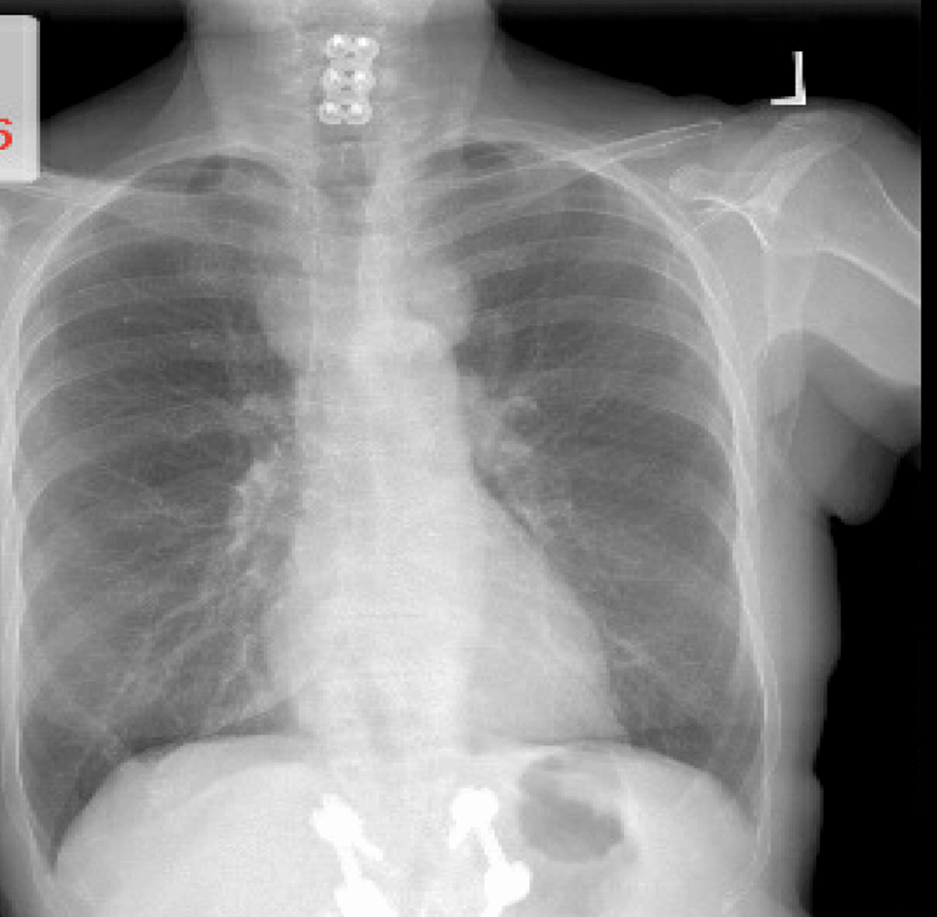

Figure 1: A chest X-ray showed an anterior mediastinal mass infiltrating the left anterior chest wall, suggestive of thymic tissue involvement.

In the anterior mediastinum, a soft tissue mass with coarse calcifications, measuring 6.6 x 2.1 cm, was present. This mass encased and narrowed the left innominate vein and the arch vessels at their origin, with broad abutment of the aortic arch. Furthermore, a component of the mass (3.5 x 2.1 cm) invaded the left anterior chest wall, possibly involv- ing the left pectoralis major muscle near its origin. Axillary and subpectoral lymphadenopathy were observed, with a larger subpectoral node measuring 2.6 x 1.2 cm. Soft tissue nodularity was noted throughout the middle mediastinum, along with a pericardial lesion/node measuring 3.8 x 1.8 cm, as shown in Figure 2.

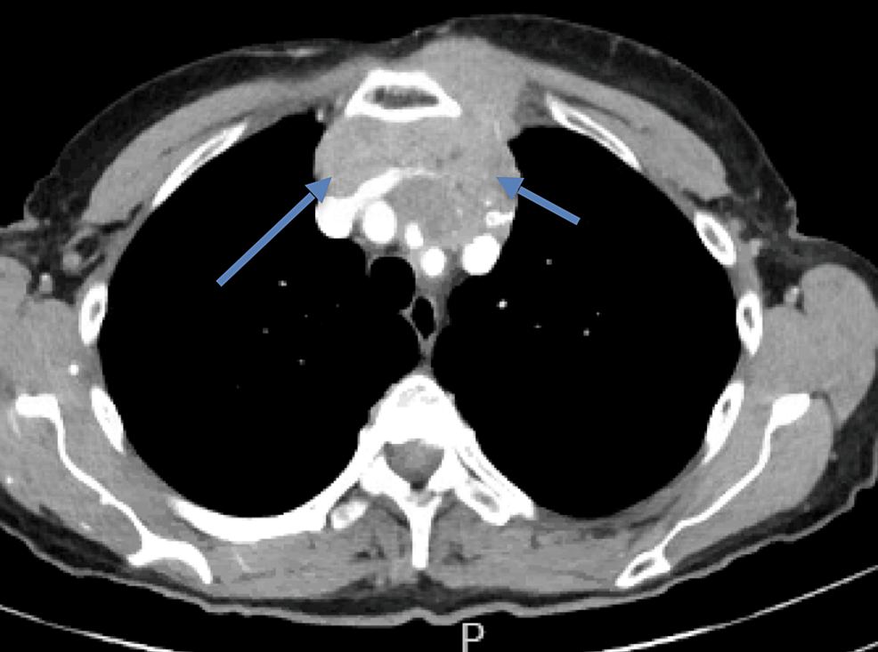

Figure 2: A Computed Tomography (CT) scan illustrating an anterior mediastinal mass (blue arrows) infiltrating the left anterior chest wall. The presence of coarse calcifications suggested a high likelihood of this mass being composed of thymic tissue, possibly indicating a thymoma or thymic carcinoma.

The case was reviewed during a tumor board meeting involving oncologists, thoracic surgeons, radiation therapists, and pathologists. They created an individualized intervention program for the patient. Due to the localized tumor advancement, a multidisciplinary approach was adopted, involving multiple surgical procedures, including a thymec- tomy and the resection of surrounding tissues, as much as possible. The goal was to remove the entire tumor, neces- sitating the removal of the thymus and the surrounding tissues.

Postoperatively, the patient underwent adjuvant chemotherapy with a regimen tailored to thymic carcinoma, such as cisplatin and etoposide, in an attempt to eliminate any remaining cancer cells and reduce the risk of recurrence. Con- sidering the local achievements with curative radiation therapy and the low risk of local relapse, adjuvant radiation therapy was also considered.

Routine follow-up visits, including CT and PET scans, were scheduled to identify any potential recurrence or metas- tasis.

The patient responded favorably to the multidimensional treatment strategy, as evidenced by the lack of disease pro- gression during the subsequent surveillance period. However, intensive long-term monitoring is necessary to identify any possible recurrences or residual side effects of the therapy.

3. discussion

Thymic carcinoma is an uncommon and highly aggressive type of thymic cancer, representing only 10-15% of all thymic malignancies [5]. Due to its rarity and the often advanced stage of the disease at the time of diagnosis, manag- ing thymic carcinoma can pose significant challenges.

Several classification systems for thymic malignancies have been developed, based on morphological, histogenetic, or immunophenotypic characteristics. However, these offer limited prognostic value and are challenging to apply clinically. The TNM classification by Weissferdt-Moran is also available for staging thymic carcinoma. Meanwhile, the Masaoka staging system is widely used clinically and is the most important determinant of survival following surgical resection. This system is based on the extent of tumor metastasis and invasion. In the present case, the patient was diagnosed with stage III thymic carcinoma using this classification [6].Recently, the World Health Organization has proposed a new classification system for thymic malignancies based on their morphological characteristics. This new classification aims to standardize the categorization of these rare and complex tumors, providing a more consistent framework for clinicians and researchers to understand and manage thymic carcinomas [7]. Despite these efforts, the rarity of thymic carcinoma and the heterogeneity of its presentation make it difficult to establish clear guidelines for its management [8]

The primary treatment modality for thymic carcinoma is aggressive surgical resection, which remains the most sig- nificant prognostic factor for disease-free and overall survival [8]. Adjuvant chemotherapy and radiation therapy are often employed in cases of locally advanced or unresectable disease, as well as in the setting of recurrence [1,5,9]. The 5-year survival rate for patients with thymic carcinoma remains low, ranging from 30 to 50%, underscoring the need for continued research and innovation to improve the outcomes for this rare and challenging malignancy.

The patient underwent an extensive surgical procedure, including a thymectomy and resection of adjacent tissues involved in the tumour. This comprehensive surgical approach was crucial, as it aimed to achieve complete tumour removal, providing the best chance for long-term disease control. In addition to the surgical intervention, the patient also received adjuvant chemotherapy with a regimen tailored to thymic carcinomas, such as cisplatin and etoposide. This combination is effective in targeting the rapidly dividing cancer cells and potentially improving the patient's prognosis [10]. Furthermore, adjuvant radiation therapy was con- sidered for this patient, given the advanced stage of the tumour, as it can provide local disease control and reduce the risk of local recurrence, which is a common issue in thymic carcinoma.

Our patient presented with chronic cough, chest pain, and shortness of breath for 3 months. In contrast, most thymic carcinoma patients are typically asymptomatic. While thymic carcinoma is often associated with paraneoplastic syn- dromes like myasthenia gravis and pure red cell aplasia, [9] our patient did not exhibit any such symptoms, which may have contributed to the late diagnosis.

Comprehensive imaging using CT, MRI, and PET scans was employed to diagnose the extent of the tumour and metastasis in our patient. The involvement of a multidisciplinary tumour board, with the collaboration of oncologists, thoracic surgeons, radiation oncologists, and pathologists, reflects the specialized and tailored approach required for managing this complex case.

The decision to perform an extensive surgical resection, including thymectomy and removal of surrounding tissues, indicates the aggressive nature of the tumour and the determination to treat it completely. The adjuvant chemotherapy with cisplatin and etoposide, as well as the adjuvant radiation therapy, were aimed at eliminating any remaining cancer cells and controlling local disease, respectively, to reduce the risk of recurrence.

Recent advancements, such as the use of proton therapy and immunotherapy with Pembrolizumab, have shown prom- ise in the management of thymic malignancies and may benefit patients in the future [8]. The positive early response and lack of disease progression observed in our patient's case suggest that the tailored, multidisciplinary approach was successful, though long-term follow-up remains crucial to monitor for any potential late effects or recurrences.

4. Conclusion

The management of thymic carcinoma requires a multimodal approach, involving aggressive surgical resection, plat- inum-based combination chemotherapy, and radiotherapy. In cases where the tumour is not completely resectable, neoadjuvant chemotherapy and/or radiation therapy may be employed to downstage the tumour and improve the chances of complete surgical resection. It is important to note that the optimal management of thymic carcinoma remains to be defined, and further research is needed to improve the outcomes for patients with this rare and aggressive form of thymic cancer.

Consent (where ever applicable)

Written informed consent for publication of their

clinical details and/or clinical images was

obtained from the patient

Ethical approval (where ever applicable)

As per international standards or university

standards written ethical approval has been

collected and preserved by the author(s)

References

1.  Rajan, A., & Giaccone, G. (2008, December 1). Treatment of Advanced Thymoma and Thymic Carcinoma.

Springer Science+Business Media, 9(4-6), 277-287. https://doi.org/10.1007/s11864-009-0083-7

2.  Wain, S L., Kier, R., Vollmer, R T., & Bossen, E H. (1986, November 1). Basaloid-squamous carcinoma of the tongue, hypopharynx, and larynx:. Elsevier BV, 17(11), 1158-1166. https://doi.org/10.1016/s0046- 8177(86)80422-1

3.  Suster, S. (2005, August 1). Thymic carcinoma: update of current diagnostic criteria and histologic types. Else- vier BV, 22(3), 198-212. https://doi.org/10.1053/j.semdp.2006.02.006

4.  Thomas, C R., Wright, C D., & Loehrer, P J. (1999, July 1). Thymoma: State of the Art. Lippincott Williams & Wilkins, 17(7), 2280-2280. https://doi.org/10.1200/jco.1999.17.7.2280

5.  Eng, T Y., Fuller, C D., Jagirdar, J., Bains, Y., & Thomas, C R. (2004, July 1). Thymic carcinoma: state of the art review. Elsevier BV, 59(3), 654-664. https://doi.org/10.1016/j.ijrobp.2003.11.021

6.  Koga, K., Matsuno, Y., Noguchi, M., Mukai, K., Asamura, H., Goya, T., & Shimosato, Y. (1994, May 1). A re- view of 79 thymomas: Modification of staging system and reappraisal of conventional division into invasive and non‐ invasive thymoma. Wiley, 44(5), 359-367. https://doi.org/10.1111/j.1440-1827.1994.tb02936.x

7.  Han, J., Lee, K S., Yi, C A., Kim, T S., Shim, Y M., Kim, Y T., Kim, K., & Kwon, O J. (2003, January 1). Thymic Epithelial Tumors Classified According to a Newly Established WHO Scheme: CT and MR Findings. Korean Society of Radiology, 4(1), 46-46. https://doi.org/10.3348/kjr.2003.4.1.46

8.  Rossana, B. (2014, January 1). Thymic Malignancies in the Targeted Therapies Era. OMICS Publishing Group, s8(01). https://doi.org/10.4172/2157-2518.s8-008

9.  Christie, B., & Moremen, J R. (2012, July 1). Thymic Carcinoma: Incidence, Classification and Treatment Strate- gies of a Rare Tumor. SAGE Publishing, 78(7), 335-337. https://doi.org/10.1177/000313481207800701

10.Yano, T., Hara, N., Ichinose, Y., Asoh, H., Yokoyama, H., & Ohta, M. (1993, April 1). Treatment and prognosis of primary thymic carcinoma. Wiley, 52(4), 255-258. https://doi.org/10.1002/jso.2930520412