**Original Research Article**

**A STUDY OF ROLE OF VACUUM (VAC) ASSISTED DRESSING IN SURGICAL WOUND**

**ABSTRACT**

**Background-**

Negative pressure wound therapy (NPWT), formerly known as vacuum-assisted wound closure, is an effective alternative to traditional wound closure methods. It accelerates tissue debridement and promotes healthy granulation, especially for chronic wounds and ulcers. The process involves placing a foam dressing, perforated wound drain, and adhesive film over the wound, and then applying intermittent negative pressure (~-125 mmHg). This reduces swelling, draws out excess fluid, improves blood flow, lowers bacterial counts, and stimulates cell growth, creating an optimal environment for wound healing

**Aims-**

A study of vacuum assisted dressing in surgical wound

**Objectives-** To assess the efficacy; to evaluate the impact on granulation tissue formation; to observe the isolated organisms; to observe the duration of hospital stay

**Methodology-** study was conducted on total 30 patients with surgical wound at SMS hospital. . VAC dressing applied to the patients and study was conducted to observe duration of hospital stay, enhancement of granulation tissue, bacterial count and size of wound.

**Result-** In study of 30 patients with VAC dressing 18 undergo split thickness skin graft, 6 undergo healing by secondary intentions, 4 patients required re operation (debridement / amputation) and 2 patient required flap closure.

**Conclusion-**VAC dressing stabilizes the wound increase perfusion decreases bacterial load and reduce need of major plastic surgical intervention.

It reduces the hospital stay and reduces overall treatment cost.

**Key words-**VAC dressing, vacuum dressing

**INTRODUCTION**

Delayed wound healing, particularly in difficult wounds and among elderly patients with co-morbidities, poses significant challenges in medical care. (1) It leads to prolonged treatment, increased pain, higher morbidity, and often necessitates major reconstructive surgeries, which place considerable social and financial burdens on both patients and healthcare systems.(2) Vacuum-assisted closure (VAC), also known as vacuum therapy, vacuum sealing, or topical negative pressure therapy, has emerged as a promising alternative to traditional wound management techniques.(3)

First proposed by Argenta and Morykwas in 1997, VAC therapy applies controlled sub-atmospheric pressure (typically around 125 mmHg below ambient) to a wound surface through specialized dressings. (1)This process accelerates debridement, reduces edema, and enhances local blood flow, which in turn lowers bacterial levels and fosters faster tissue healing. It has been demonstrated to improve healing outcomes in a variety of wound types, including surgical wounds, by optimizing the environment for spontaneous healing or facilitating less invasive reconstructive options.(4)

Despite its significant cost, VAC therapy has been shown to compare favorably with conventional treatments in terms of both clinical and financial outcomes, particularly for managing complex or contaminated wounds. (5)As a non-pharmacologic and non-surgical approach, VAC therapy is increasingly being used as an adjunct or alternative to surgery, aiming to reduce morbidity, shorten hospitalization, and enhance patient comfort.(3)

**AIMS AND OBJECTIVES**

**Aims-**

A study of vacuum assisted dressing (VAC) in surgical wound

**Objectives-** study of VAC dressing in terms of

* To assess the efficacy
* To evaluate the impact of vacuum assisted dressing on wound healing in enhancing granulation tissue formation.
* To observe the isolated organisms.
* To observe the duration of hospital stay

**MATERIAL AND METHOD**

•**Study design** - prospective observational study

**•Study site** - department of general surgery at SMT SMS Multispecialty hospital

**•Source of Data**-

Study participants were patients in General Surgery department admitted in S.M.S. Multispecialty hospital that meet the inclusion/exclusion criteria and give written informed consent. Individual’s privacy issues will be taken care of.

**•Sample size** - 30 cases of VAC dressing

**•Study Criteria**

**Inclusion Criteria**

1) Patients above 18 years of age group having wound irrespective of

Aetiology.

2) Patient giving valid consent.

3) Patient willing for Debridement and vacuum assisted dressing.

4) Patient fit for Debridement and vacuum assisted dressing.

**Exclusion Criteria**

1) Patient with Untreated underlying osteomyelitis.

2) Patient with wounds having exposed blood vessels.

3) Patient with wounds having exposed nerves or organ.

4) Wounds with multiple Fractures and exposed bones.

5) Patient having Malignancy of wound.

6) Patient with coagulopathy.

7) Patients not giving consent for the research.

**Procedure**

Study was conducted on total 30 patients with surgical wound at SMS hospital Ahmedabad. Pt was admitted over period of three months from September 2023 to November 2023 with age ranging from 18 to 68 out of which 20 was male and 10 was female . VAC dressing applied to the patients and study was conducted to observe duration of hospital stay, enhancement of granulation tissue, bacterial count and size of wound.

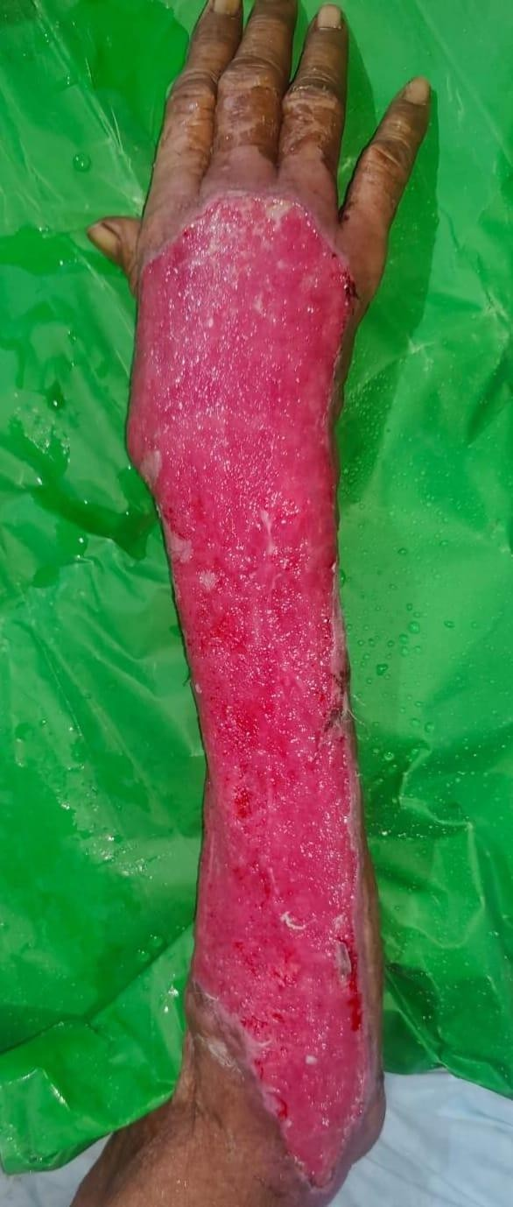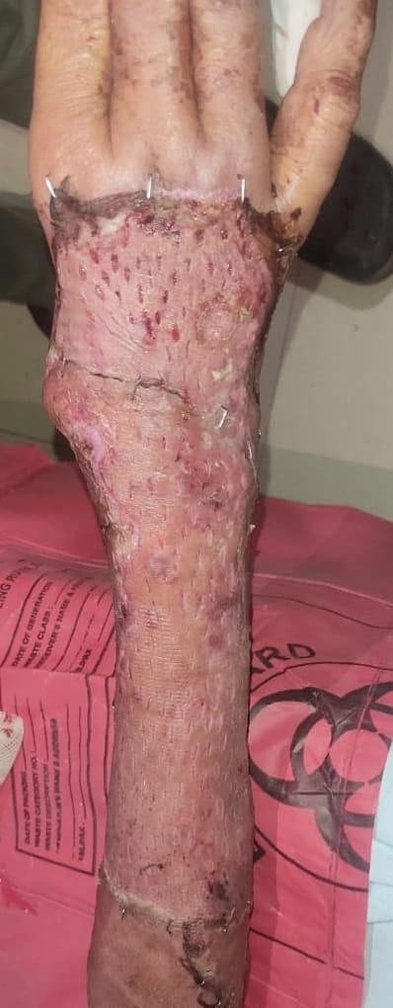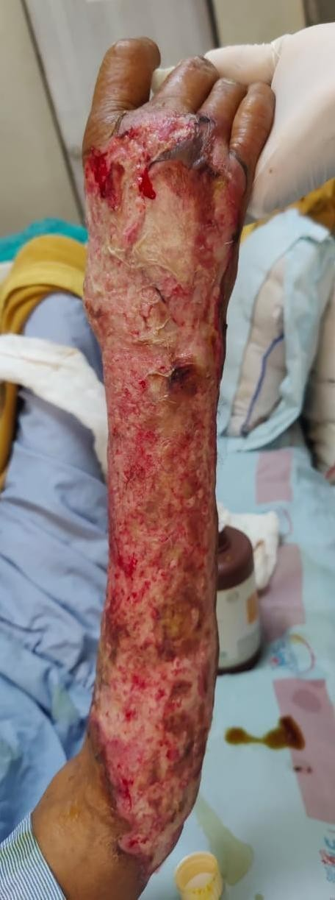

Before VAC After VAC After split thickness skin graft

***Figure 1 CLINICAL PHOTOGRAPH***

**RESULT**

• In study of 30 patients with VAC dressing all of them were suffering from open wound which required regular dressing

**•** The mean age of pt. was 43 yrs.’; the youngest was 19 while the oldest was 78years old

**GRAPH 1 AGE DISTRIBUTION**

**•** 20 pts were male and 10 were female

**GRAPH 2 SEX DISTRIBUTION**

**•**11 pt. had wound inflicted by various physical trauma 5 had diabetes ulcer 12 developed wound after different infection and 4 wound was open after some surgery.

**GRAPH 3 ETIOLOGY**

* In study of 30 patients with VAC dressing 14 undergo split thickness skin graft, 10 undergo healing by secondary intentions/ suturing, 4 patients required re operation (debridement / amputation) and 2 patient required flap closure.

**TABLE 1 ETIOLOGY**

**GRAPH 4 OUTCUM**

|  |  |
| --- | --- |
| **ORGANISM ISOLATED** | |
| No Growth | 7 |
| Staphylococcus | 10 |
| Pseudomonas | 3 |
| Escheria Coli | 3 |
| Streptococcus | 7 |
| Total | 30 |

Organism Isolated from wound are as below from which most common was staphylococcus

The hospital stay was minimum of 7 days and maximum was 27 days and mean days was 11 days.

**GRAPH 5 ORGANISM ISOLATED**

**DISSCUSSION**

* Wound healing is a complex and carefully coordinated biological process that involves four main phases: Haemostasis, Inflammation, Proliferation, and Remodelling. These phases don't occur in a simple, step-by-step order, but instead overlap and influence each other. Recent research highlights the critical role that mechanical forces and the extracellular matrix (ECM) play in the wound healing process.
* One method used to support this healing process is Negative Pressure Wound Therapy (NPWT), also known as VAC (Vacuum Assisted Closure). By applying negative pressure (vacuum) to a wound, NPWT helps to draw out blood and serous fluids, reducing the risk of infection. The sealed, hypoxic environment it creates also encourages better blood flow, supplying the wound with more oxygen and nutrients to aid in healing. Negative pressure has been shown to promote healing by removing excess fluid, increasing blood vessel growth in the area, and gently pulling the wound edges together.
* The procedure is fairly straightforward: sterile, porous foam is placed on the wound, and then a drape is used to seal it, creating a controlled, closed environment. A perforated tube connects the foam to a canister, where negative pressure is applied at 125 mmHg. This reduces interstitial pressure and helps drain fluid from the wound into the canister. Initially, negative pressure is applied continuously. As the drainage decreases, it can be switched to intermittent pressure. The foam dressing typically needs to be changed every 48 hours.
* NPWT is particularly effective in treating a variety of wound types, including those caused by lymphatic leaks, venous stasis, diabetes, fistulas, sternal wounds, orthopaedic injuries, and abdominal wounds.
* However, NPWT is not suitable for everyone. It should not be used on wounds with non-debrided necrotic tissue, untreated osteomyelitis, or unaddressed malignancies. Additionally, it is contraindicated in cases involving unexplored or active enteric fistulas. Adequate blood supply to the wound bed is essential for NPWT to be effective. The foam dressing must also never come into direct contact with exposed blood vessels, organs, or nerves, although therapy can be used over these structures if they are fully covered by natural tissue, a compatible bioengineered material, or a fine-meshed synthetic barrier.
* Finally, NPWT should not be applied in cases of uncontrolled bleeding, blood disorders, or coagulopathy, and it should be used with caution in patients with irregular heart rhythms

**CONCLUSION**

VAC therapy stabilizes wounds, reduces oedema, bacterial load, and enhances tissue perfusion, promoting faster healing and reducing the need for surgery. It outperforms conventional dressings by reducing wound size, volume, and bacterial load, while shortening treatment duration and costs. VAC therapy also shortens hospital stays, speeds recovery, and prepares wounds for closure, decreasing morbidity and overall treatment burden.

**REFERENCES**

1. Morykwas, M. J., Argenta, L. C., & Shelton, B. J. (2001). The use of vacuum-assisted closure (VAC) therapy for the treatment of chronic wounds: A multicenter experience. Plastic and Reconstructive Surgery, 108(6), 1405-1410. https://doi.org/10.1097/00006534-200112000-00010
2. KCI (2010). Cost-effectiveness of VAC therapy in the management of complex wounds: A systematic review. International Journal of Wound Care, 19(2), 54-61.
3. O’Neill, J. M., & Lavigne, M. C. (2004). The role of VAC therapy in the management of diabetic foot ulcers. Wound Repair and Regeneration, 12(5), 354-362. <https://doi.org/10.1111/j.1067-1927.2004.00139.x>
4. Joseph E, Hamori CA, Bergman S, Roaf E, Swann NF, Anastasi GW. A prospective randomized trial of vacuum-assisted closure versus standard therapy of chronic nonhealing wounds, Wounds. 2000; 12(3):60-7.
5. Yaremchuk MJ, Burgess AR, Brumback RJ. Concepts in soft tissue management, in Lower Extremity Salvage and Reconstruction. Orthopaedic and Plastic Surgical Management, Eds. Elsevier Science, New York, NY, USA. 1989:95-106.