Case report

Massive Lower GI Bleeding: A Rare and Life-Threatening Presentation of Intestinal Amoebiasis

Abstract
Amoebiasis is responsible for around 40,000–100,000 mortalities per year globally and is among the top four causes of death from protozoan infections. Entamoeba histolytica is recognized as a pathogenic amoeba and is associated with both intestinal and extraintestinal manifestations. It has diverse pathogenic mechanisms that cause tissue damage, leading to ulcers and/or abscesses. Intestinal amoebiasis can have a very rare presentation of life-threatening, massive lower gastrointestinal bleeding without diarrhea. We report a case of a male in his late 40s who presented with pain in the right upper abdomen and massive lower gastrointestinal bleeding, subsequently diagnosed with a caecal ulcer as a manifestation of intestinal amoebiasis, along with a liver abscess as an extraintestinal manifestation. Radiological evaluation revealed a right lobe liver abscess with anchovy sauce content on drainage and active contrast extravasation at the cecum. Exploratory laparotomy with right hemicolectomy was performed, and multiple caecal ulcers were present.
Keywords: Amoebiasis, Lower gastrointestinal bleeding, Entamoeba histolytica, Liver abscess, Right hemicolectomy

INTRODUCTION
Entamoeba histolytica is an extracellular protozoan responsible for causing amoebiasis. Amoebiasis mainly spreads by the fecal-oral route and is therefore an infection prevalent in developing countries with limited hygiene conditions.¹ Although amoebiasis is often considered a disease of developing countries, it is a significant public health issue worldwide.² Intestinal amoebiasis can have varied presentations, such as fever, weight loss, bloody diarrhea, liver abscess, pleuritic chest pain, and other constitutional gastrointestinal symptoms. Massive lower gastrointestinal (GI) bleeding without diarrhea is a rare and life-threatening presentation of intestinal amoebiasis, with an incidence of less than 1%.^{1,3} Diagnosing amoebiasis as a cause of lower GI bleeding is difficult, as stool testing is mostly negative, colonoscopy is usually substandard due to active bleeding and positive serology is weak in confirming the diagnosis.⁴ We report a patient presenting with massive lower GI bleeding, which was later found to be of amoebic etiology.
In 2017, Dogra et al reported a case of a 42-year-old male with intestinal amoebiasis with detrimental lower gastrointestinal bleeding.⁵ In 2019, Madden et al described a case of lower Gastrointestinal bleeding due to Entamoeba histolytica in a 36-year-old man, who presented with cerebral infarction, bloody diarrhea, and with fever.⁶

CASE PRESENTATION
A male in his late 40s presented to the surgery emergency with the chief complaints of pain in the right upper abdomen for 5 days associated with undocumented fever with chills and rigor for 5 days and profuse bleeding per rectum for 3 days, with no history of diarrhea. On examination, the patient was conscious and oriented. The pulse rate was 108 bpm, and blood pressure was 102/60 mmHg, he was febrile with a body temperature of 101.8 Fahrenheit at presentation. Per abdomen examination revealed tenderness and guarding in the right hypochondrium and epigastrium, with hepatomegaly. On rectal examination, blood clots were present in the rectal cavity with no evidence of any local cause of bleeding. Baseline investigations suggested multiple organ dysfunction syndrome (hemoglobin: 9.4 mg/dL; total leukocyte count: 49,500; PT/INR: 54.2/4.35; urea: 154; creatinine: 4.7; total bilirubin: 3.0; alkaline phosphatase: 288). The patient’s resuscitation was carried out with IV fluids, anticoagulants, blood products, and antibiotics.
Investigations
On ultrasonography of the abdomen, hepatomegaly with a liver abscess measuring 530 cc was visualized in segments 5 and 6 of the liver.
Differential diagnosis, if relevant
- Colonic Malignancy
- Crohn’s Disease
- GI lymphoma
- Caecal base ulcerations secondary to Amoebiasis
Treatment
Pigtail insertion was performed with ultrasound guidance, and anchovy sauce content was drained. Computed tomographic angiography of the abdomen showed irregular thickening of the medial caecal wall, with normal wall enhancement likely due to an ulcer, and active contrast extravasation was seen in the caecum. Lower GI endoscopy was suboptimal due to blood clots filling the large intestine. The patient underwent emergency exploratory laparotomy and right hemicolectomy. The caecum and proximal ascending colon appeared edematous and distended. On the cut section, multiple ulcers were present on the caecum, with the largest ulcer measuring around 3 × 2 cm (Figure 1).
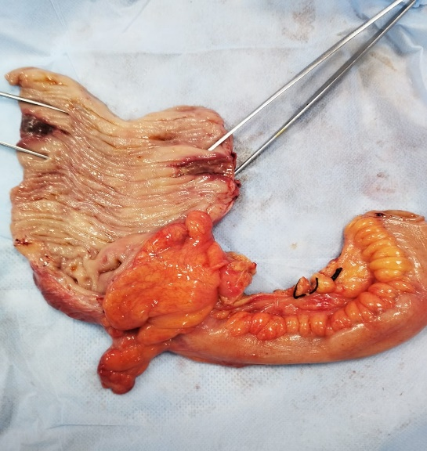
Figure 1 Surgical specimen from laparotomy showing the caecal wall with multiple ulcers.

Outcome and follow-up
The patient recovered from the organ failure and was allowed orally on postoperative day 5 and was discharged on day 7. The patient was followed up for 1 month and was without any complications.
The microscopic finding of the ‘anchovy sauce’ like content from the liver abscess showed acellular and proteinaceous debris with few amoebic trophozoites.
The histopathological report showed multiple “flask-shaped” ulcers with elevated margins in the caecum which consisted of inflammatory exudate, necrotic debris and trophozoites of Entamoeba histolytica and erythrophagocytosis and with significant tissue destruction and inflammation of the surrounding mucosa.

.

DISCUSSION
Amoebiasis is responsible for around 40,000-100,000 mortalities per year globally and is among the top four causes of death from protozoan infections.⁷ E. histolytica mainly colonizes the large intestine. It has diverse pathogenic mechanisms that cause tissue damage, leading to ulcers and/or abscesses. In some rare cases, amoebiasis may affect the skin, spleen, kidneys, brain, heart, and lungs.⁴ E. dispar, E. moshkovskii, and E. bangladeshi are other morphologically identical Entamoeba species; however, they are usually not associated with disease, and their pathogenic potential is being investigated worldwide.⁶ Pathogenic Entamoeba species are often found in freshwater contaminated with human feces.⁶ In industrialized or developed countries, at-risk groups include men who have sex with men, travelers, recent immigrants, immunocompromised individuals, and institutionalized populations.⁶
E. histolytica can remain in the colon in a dormant stage (trophozoites), leading to an asymptomatic carriage. However, invasive disease occurs in 10–20% of those infected. When amoebiasis is suspected, several diagnostic methods are available, and a combination of tests may be required.⁶ These tests include stool microscopy, stool antigen detection, stool polymerase chain reaction, and serology. The most commonly used approach is stool microscopy, where an experienced observer can identify cysts and trophozoites, sometimes with evidence of hemophagocytosis, by using wet mounts or stained preparations.⁶
LEARNING POINTS/TAKE HOME MESSAGES
This case showcases a very rare presentation of intestinal amoebiasis with an active caecal ulcer, which can be life-threatening without early surgical intervention.
It can also cause a diagnostic dilemma, as most investigations cannot confirm amoebiasis as the cause of massive lower GI bleeding.
Therefore, a high degree of suspicion is required in patients presenting with lower GI bleeding, especially in endemic regions.

REFERENCES
- Carrero JC, Reyes-López M, Serrano-Luna J, Shibayama M, Unzueta J, León-Sicairos N, de la Garza M. Intestinal amoebiasis: 160 years of its first detection and still remains as a health problem in developing countries. International Journal of Medical Microbiology. 2020 Jan 1;310(1):151358.
- Reed SL. Amebiasis: an update. Clinical infectious diseases. 1992 Feb 1;14(2):385-93.
- Aristizábal H, Acevedo J, Botero M. Fulminant amebic colitis. World journal of surgery. 1991 Mar;15:216-21.
- Chandnani S, Udgirkar S, Jain SS, Sonthalia N, Contractor Q, Rathi PM, Chapekar A. Massive Lower Gastrointestinal Bleeding Due to Fulminant Necrotizing Amebic Colitis: A Diagnostic and Therapeutic Challenge. The Journal of the Association of Physicians of India. 2019 Apr 1;67(4):79-81.
- Dogra V K, Gupta D, Kashyap R, Nand L, Sondhi S. Intestinal amebiasis presenting life-threatening lower GI bleed-A rare presentation.Ann Trop Med Public Health 20176;10:244-246
- Madden GR, Shirley DA, Townsend G, Moonah S. Case report: lower gastrointestinal bleeding due to Entamoeba histolytica detected early by multiplex PCR: case report and review of the laboratory diagnosis of amebiasis. The American Journal of Tropical Medicine and Hygiene. 2019 Dec;101(6):1380
- Fu B, Wang J, Fu X. A rare case of extraintestinal amebiasis. BMC Infectious Diseases.2022 Apr 11:22(1):364
.

- How to cite this article:

