**Case report**

**Colonic varices revealed by anemia: a case report**

**Abstract :**

Colonic varices are rare venous dilatations associated with portal hypertension, often due to hepatic cirrhosis or portal vein obstruction. They can cause lower gastrointestinal bleeding and anemia, with diagnosis primarily through colonoscopy.

This case report presents a 55-year-old male with unexplained anemia, where colonoscopy revealed colonic varices. Imaging showed portal vein thrombosis, leading to the diagnosis of portal hypertension. The patient was treated with anticoagulants and beta-blockers, showing clinical improvement after six months.

Although colonic varices are rare,and this case highlights the importance of considering colonic varices in patients with unexplained anemia, particularly when portal vein thrombosis is present.

**Introduction :**

Colonic varices are abnormal venous dilatations in the colon's submucosal layer, often resulting in lower gastrointestinal bleeding. They are relatively uncommon and frequently linked to portal hypertension stemming from hepatic cirrhosis or portal vein obstruction (1).

Clinically, colonic varices can be asymptomatic or manifest with varying degrees of rectal bleeding (2). In some instances, bleeding can be severe.

Colonic varices are primarily diagnosed via colonoscopy. Computed tomography angiography, endoscopic ultrasound, and color Doppler imaging can also be used for diagnosis.(3)

Here we report a case of a case of colonic varices diagnosed during investigation anemia.

**case report:**

A 55-year-old male with no significant past medical history, presented with fatigue , pallor, intermittent abdominal pain and exertional dyspnea over approximately 4 months. Initial Laboratory investigation showed microcytic anemia with low serum iron and ferritin. The esophagogastroduodenoscopy was normal. Colonoscopy revealed colonic varices in descending colon. The rest of the colon and terminal ileum appeared normal.

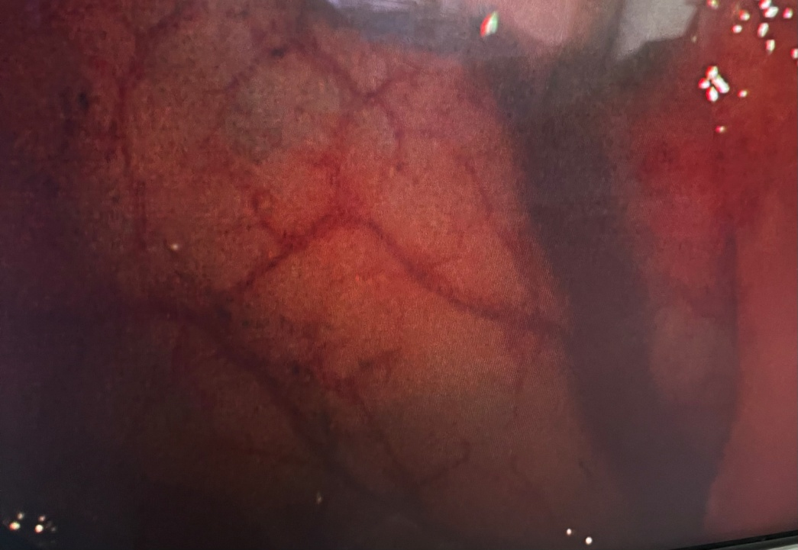

**Figure 1** : Left colonic varices in coloscopy

Portal hypertension was suspected .A Doppler ultrasound and an abdominal CT scan with contrast injection subsequently revealed portal vein thrombosis. CT scanning is able to demonstrate hyperattenuating material in the portal vein lumen and the absence of enhancement after contrast injection. On the therapeutic level, Anticoagulant treatment was initiated, and non-selective beta-blockers to reduce portal pressure was started.The follow-up over six months showed notable clinical and biological improvement.

**Discusion :**

Colonic varices, first identified in 1954 (4), are an uncommon cause of lower gastrointestinal bleeding and anemia, with an incidence rate of 0.07%. (5)

Colonic varices are primarily caused by portal hypertension and are most often found in the rectosigmoid region and the cecum.(6)

Colonic varices can present with severe complications, including intermittent hematochezia or significant rectal bleeding, and are diagnosed based on these symptoms. Alternatively, they may be discovered incidentally during a colonoscopy performed for other gastrointestinal tract issues.(7)

The primary diagnostic method for colonic varices is colonoscopy; however, in cases of massive bleeding where the varices may be obscured by blood, contrast-enhanced CT and MRI serve as alternative diagnostic tools.(8)

Due to the rarity of this condition, there are no established guidelines for the management of colonic varices. Treatment decisions are based on the underlying cause of the varices. In some cases, anticoagulant therapy may be sufficient, particularly in recent mesenteric thrombosis, where colonic varices can completely regress.(9) This was observed in our case.

Active variceal bleeding can be managed through sclerotherapy, band ligation, or surgical resection. For less severe cases, interventions such as stool softening with laxatives and oral iron supplementation have been found to be effective.(10)

**conclusion**

Colonic varices are a rare cause of lower gastrointestinal bleeding, often linked to portal hypertension. Diagnosis relies on colonoscopy and imaging, while management depends on the underlying cause. This case underscores the importance of considering colonic varices in the differential diagnosis of unexplained anemia, particularly in patients with portal vein thrombosis.

**References :**

1. Ito, K., Shiraki, K., Sakai, T., Yoshimura, H., & Nakano, T. (2005). Portal hypertensive colopathy in patients with liver cirrhosis. *World Journal of Gastroenterology*, 11(20), 3127-3130.
2. Sato T, Akaike J, Toyota J, Karino Y, Ohmura T. Clinicopathological features and treatment of ectopic varices with portal hypertension. Int J Hepatol. 2011;2011:960720.
3. Sunkara T, Caughey ME, Culliford A, Gaduputi V. Idiopathic Isolated Colonic Varices: An Extremely Rare Condition. J Clin Med Res. 2018;10(1):63-65.
4. Culver P. “Case records of the Massachusetts General Hospital (case #40102)”. The New England Journal of Medicine 179(1954): 434e8.
5. Han JH., et al. “A case of idiopathic colonic varices: a rare cause of hematochezia misconceived as tumor”. World Journal of Gas-troenterology 12 (2006): 2629-2632.
6. Nikolopoulos N, Xynos E, Datsakis K, Kasapidis P, Vassilakis JS. Varicosis coli totalis: report of a case of idiopathic aetiology. Digestion. 1990;47:232–235. doi: 10.1159/000200502.
7. Francois F, Tadros C, Diehl D. Pan-colonic varices and idiopathic portal hypertension. J Gastrointestin Liver Dis. 2007;16(3):325–8
8. Abraham-Igwe C, Patel R. Idiopathic colonic varices: a case report. Endoscopy 2002;34(08):680
9. Navalho M and Duarte I. “Superior mesenteric venous thrombosis as a cause of right-side colonic varices: CT and endoscopic findings”. Clinical Radiology 63 (2008): 340-342.
10. Chowdhury AMM, Yue Z, Ying C, Min L. Idiopathic colonic varices: a rare case report. Colorec Cancer. 2016;2(2):1-3.