Ethnomedicinal Survey of Plants in Wani Region of District Yavatmal of Maharashtra, India

ABSTRACT

The Wani region is located approximately 110 km east of the Yavatmal district headquarters and coordinates at 20°03’20” N and 78°57’12” E. The region boasts a thriving forest, where medicinal plants are a prominent part of the landscape. The aim of this study is to collect comprehensive data on the variety of medicinal plants found in the Wani region and their usage by tribal communities. Traditional healers and medicine men play a crucial role in primary healthcare in this area. During the survey, both tribal people and traditional healers were considered. The study documented a total of 133 plant species from 90 genera, belonging to 68 families, with their medicinal uses, local names, and the parts used as medicine. The most commonly used plant parts were the root and leaf, followed by bark, whole plants, and other components. The survey revealed a rich knowledge of using plants to treat various ailments, but this traditional knowledge is gradually fading. In this tribal region, primary healthcare still heavily relies on medicinal plants, making the documentation of traditional plant-based treatments essential.

**Keywords:** Wani, Ethnomedicine, Traditional healers, Maharashtra.

# Introduction

The state of Maharashtra is often referred to as the “Agricultural State” due to its rich and diverse natural resources, including an extraordinary variety of ethno-medicinal plants. The Yavatmal district, in particular, boasts 23% forest cover with remarkable biodiversity in plant species, as noted in the Indian State of Forest report. A botanical survey by Karthikeyan and Kumar (1993) identified 577 species, one subspecies, and one variety across 365 genera and 98 families in the district. Their work also documented 12 species newly reported in Maharashtra and 126 medicinal herbs used locally. Subsequent studies added to this knowledge: Bhogaonkar et al. (2015) reported nine new plant species, Lachure and Dhore (2017) identified two, and Bokhad and Rothe (2020) recorded six new species. Given the passage of time and ongoing changes in the region, it is crucial to reassess the current status of plant species in their natural habitats.

According to the 2023 report, Maharashtra boasts the third-largest forest cover in the country, spanning 65,383 square kilometers. This vast forested expanse provides an ideal habitat for a diverse range of plant species, including many with significant therapeutic properties. The state is home to over 10,510 tribal communities, categorized into 47 distinct ethnic groups, residing in approximately 8,428 villages. These communities are intricately linked to the diverse forest ecosystems around them. Within the specific research area, 32 indigenous populations inhabit 160 villages, relying heavily on native plant species for their medicinal needs. (Source: [TRTI Maharashtra](https://trti.maharashtra.gov.in/))

.

Ethnobotany, the scientific study of the relationship between indigenous knowledge and the natural world, plays a vital role in understanding the intricate connections between people and plants (Sandey and Sharma, 2016). Plant resources are fundamental to the survival of human cultures, particularly in rural and tribal communities. Over centuries, tribal and indigenous groups have cultivated and refined traditional knowledge about the medicinal uses of wild and local plants. This ancient healthcare system remains indispensable, especially for impoverished rural populations, as it is often more accessible and affordable than modern healthcare options.

In remote or underdeveloped areas, where modern medical facilities are either inaccessible or unaffordable, traditional medicine serves as a practical and low-risk alternative. For many people living in isolated regions, these traditional remedies are essential for maintaining health and well-being (Mahalik et al., 2015). Consequently, preserving and documenting traditional knowledge about medicinal plants is crucial not only for safeguarding marginalized communities' access to healthcare but also for protecting their cultural heritage.

# Given the vital importance of preserving knowledge about plant utilization, it is crucial to prioritize the documentation of this invaluable cultural and medicinal heritage to prevent its loss. Maharashtra is a rich repository of medicinal plant species, attributed to its extensive traditional knowledge and remarkable biodiversity of flora and fauna (Patel, 2012). A study was conducted in the Wani region of Yavatmal district, Maharashtra, with the objective of documenting the indigenous knowledge of tribal communities regarding plant species with significant ethnomedicinal value.

# Materials And Methods

## Study area

The Yavatmal district, covering an area of 13,582 square kilometers, is characterized by its diverse geography and abundant natural resources. The district features six major forest ranges—Yavatmal, Hiwri, Parwa, Ghatanji, Pandharkawda, and Wani—each notable for its unique attributes. Among these, Wani is located at 20°03’20” N latitude and 78°57’12” E longitude, approximately 110 kilometers east of the district’s administrative headquarters. Spanning an area of 294 square kilometers, Wani is predominantly covered by extensive forested zones.

The region is home to indigenous tribal communities such as the Gond and Kolam, who inhabit its lush green landscapes. These tribes have historically relied on the region's rich forest resources for their livelihoods and traditional practices, underscoring the ecological and cultural significance of Wani within the Yavatmal district.

**Fig. 1:** Map of study area

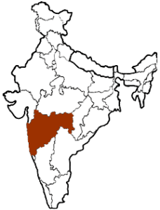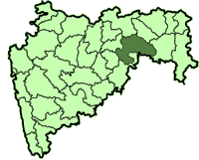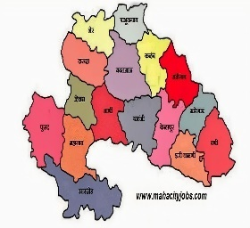

**Maharashta**

**Yavatmal**

**Yavatmal**

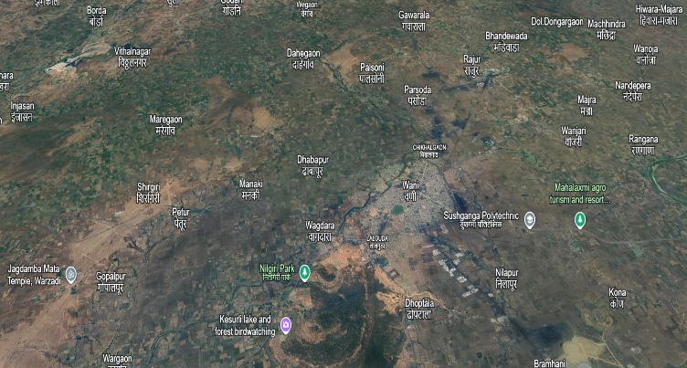

**3D Map Wani Tahsil**

## The dense forests, along with their diverse flora and fauna, play a crucial role in shaping the environmental and socio-economic fabric of the area. This interconnectedness highlights the deep bond between the indigenous communities and the natural environment they inhabit (Fig. 1).

## Data collection

## In 2024, a survey was conducted across 160 tribal-dominated villages within the Wani block. Traditional healers, including members of the Gond and Kolam tribes of varying ages, were selected as key informants from each community. To document a wide range of illnesses, personal interviews were conducted with practitioners of traditional medicine. Additionally, field visits with local healers were undertaken to gain deeper insights into plant identification and their medicinal applications.

## Ethnobotanical data were collected using a questionnaire developed by Jain (1986) and Masih (1990). Information was recorded under categories such as the common name of the plant, its habit, and the plant parts used in the preparation of medicines for treating various ailments. Informants were also asked about the methods of drug preparation and the ways these remedies were administered for treating specific conditions.

## Identification

# Plant identification was carried out with the help of the *Flora of Maharashtra* series: Volume I (Blatter Herbarium, Verma et al., 1993), Volume II (Blatter Herbarium, Mudgal et al., 1997), and Volume III (Blatter Herbarium, Singh et al., 2001). The updated nomenclature of ethnomedicinal plants was obtained from the online portal of the Royal Botanic Gardens, Kew.

# Results And Discussion

This study systematically identified 133 different plant species belonging to 90 genera and 68 families, showcasing the rich botanical diversity utilized in traditional medicine (Table 1). The findings reveal that these plants are employed by villagers and traditional healers to treat 65 different diseases (Table 1), highlighting the deep-rooted knowledge and reliance on herbal remedies within these communities. One of the key discoveries is that joint pain and diabetes are the primary health issues addressed using five specific plant species, indicating the significant role of herbal treatments for these ailments.

Additionally, four plant species are specifically used to treat skin conditions such as acne, pimples, diarrhea, and joint pain, emphasizing the importance of traditional methods for managing common skin disorders. The study also found that three plant species are utilized to address a variety of illnesses, including respiratory and oral health conditions, showcasing the diverse range of health issues that herbal remedies can effectively target. Furthermore, the study identified two plant species used to treat multiple ailments, such as piles, ulcers, jaundice, ringworm, snake bites, stomach pain, and more, highlighting the versatility and widespread application of traditional plant-based medicine.

**Table1: Ethnobotnical plants of wani region District Yavatmal, Maharashtra Investigated during Year 2024**

|  |  |  |  |  |
| --- | --- | --- | --- | --- |
| Sr.  no. | Local name | Botanical name | Part used | Uses, diseases treated |
| 1 | 2 | 3 | 4 | 5 |
| 1 | Aain | Terminalia crenulata | Bark | Skin diseases |
| 2 | Adulsa | Adhatoda vasica | Fruits & seeds, flower | Cough, asthama, tonic |
| 3 | Agadha | Achyranthes aspera | Seeds & oil | Cough, rabies, tonic |
| 4 | Akkalkara | Anacyclus pyrethrum | Root | Tooth decay, fever, heart tonic |
| 5 | Amaltas | Cassial fistula | Seeds, flower & root | Asthama, cancer, antidote, blood purification |
| 6 | Amarbel | Cuscuta reflexa | Whole plant | Burns, eye diseases, tonic |
| 7 | Anantmool | Hemidesmus | Roots | Skin diseases, fever |
| 8 | Anjan | Hardwickia binata | Leaves, barks. | Skin diseases |
| 9 | Antibala | Abutilon indicum | Seeds, leaves & root | Demulcent, bronchitis, leprosy, piles & ulcers |
| 10 | Awala | Phyllanthus emblica | Fruits | Asthma, bronchitis, cold, constipation, lever tonic |
| 11 | Apta | Bauhinia racemosa | Flowers & leaves bark,  root | Eye treatment, headache, cough |
| 12 | Arati | Acacia caesia | Fruit, leaves, bark | Tooth decay |
| 13 | Arjun | Terminalia arjuna | Bark & leaves | Asthma, heart tonic |
| 14 | Arni | Clerodendrum multiflorum | Plant, root | Bodyache, cholera & fever, cardiac disorders, cough, asthma & bronchitis |
| 15 | Asvagandha | Withania somnifera | Root | Leucoderma |
| 16 | Austrelian Babul | Acacia auriculiformis | Seed, bark | Animal use |
| 17 | Bajradanti | Tephrosea purpurea | Plant | Asthma, snake bite |
| 18 | Bakain | Melia azedarch | Leaves & flowers | Against skin diseases |
| 19 | Bakul | Mimusops elengi | Bark, flowers & fruits | Plant parts are used small pox. |
| 20 | Bala | Sida cordifolia | Whole plant | Dysentery, gonorrhoea |
| 21 | Bartondi  (podophul) | Morinda pubescens | Fruit, root & leaves | Small pox, urinary complains |
| 22 | Behada | Terminalia belerica | Bark, Fruits, leaves | Aniemia, cough, fever, tonic |
| 23 | Bel | Aegle marmelos | Fruits, leaves & roots | Laxative & heart & brain tonic |
| 24 | Bhira | Chloroxylon swietenia | Roots,leaves, & bark | Aphrodisiac, & neck pains |
| 25 | Bhokar | Cordia dichotoma, | Fruits, barks & seeds | Dyspepsia, Dysentery, Urinary disorders |
| 26 | Bhuiawalla | Phyllanthus fraternus | Whole plant | Allergy, dysentery, jaundice, gastro, urinal disorders |
| 27 | Bhuriningani | Solanum surattense | Roots, flowers & fruits | Bronchitis, chest pains cold, paralysis & snake  bite |
| 28 | Bibba | Semecarpus anacardium | Seed | Cough & cold headache, body ache |
| 29 | Bibla | Pterocarpus marsupium | Wood | Body pain, diarrhoea |
| 30 | Brahami | Cantella asiatica | Whole plant | Asthma, fever & leprosy, tonic |
| 31 | Chilahar | Caesalpinia sapiaria | Seed | Uterine |
| 32 | Chinch | Tamarindus indica | Seed, barks & leaves | --- |
| 33 | Chirati | Mukia maderaspatana | Root | Tooth decay, |
| 34 | Datura | Datura metel | Leaves, fruits | Narcotice, antispasmodic, tooth decay |

|  |  |  |  |  |  |
| --- | --- | --- | --- | --- | --- |
| 35 | Dhaman | Grewia tiliaefolia | Bark, root | Dysentey, itching, syphilis, blood purification | |
| 36 | Dhawada | Anogeissus latifolia | Seeds, gum, bark | Desentry, tonic | |
| 37 | Dudhavel | Lettsomia setosa | Leaves |  | |
| 38 | Dukkerkand | Dioscorea bulbifera | Tubers | Abdomen pains, bone fracture, skin diseases &  jaundice | |
| 39 | Gajkarni | Rhinacanthus nasuta | Root, leaves | Anti cancer | |
| 40 | Ghingan | Lannea coromandelica | Bark & leaves | Wounds, swelling | |
| 41 | Ghotbor | zizyphus xylopytus | Fruits, bark | Fruits juice | |
| 42 | Girisidiya | Gliricidia sepium | Leaves | Leaves Juice | |
| 43 | Gokarna | Barleria cristata | Leaves & roots | Body pains, swelling | |
| 44 | Gokarni | Clitoria ternatea | Root | Snake bite | |
| 45 | Gokharu | Tribulus terrestris | Seed, whole plant |  | |
| 46 | Gorakhmundi | Sphaerantus indicus | Whole plant | Cough, gastric problem | |
| 47 | Gulvel | Tinospora cordifolia | Whole plant | Asthma, bone fracture, diarrhea, fevers, | |
| 48 | Gunj | Abrus precatorius | Roots, plants | Aphrodisiac, blood purifier eczema, asthma, cough | |
| 49 | Hadjod | Cissus quadrangularis | Root | Bone fracture | |
| 50 | Hirda | Terminalia chebula | Fruits | Skin diseases, fever | |
| 51 | Jamalgota | Baliospermum montanum | Leaves, seeds | Asthma, bronchitis, purgative, | |
| 52 | Jambhul | Syzyium cumini | Leaves, seeds,& bark | Decentry, urinal problem, diabetes | |
| 53 | Jangli-methi | Sida rhombifolia | Roots | Child birth, tonic, dysentery, gonorrhea, heart ailments. | |
| 54 | Jasvant | Hibiscus rosasinensis | Bark | Skin diseases | |
| 55 | Kadai | Sterculia urens | Gum, roots, barks & flowers | Tonic bone dislocation & fractures, dysentery | |
| 56 | Kadhineem | Murraya Koenigii | Leaves |  | |
| 57 | Kadujire | Cntratherum anthelminiticum | Whole plant | Worms | |
| 58 | Kala Kuda | Wrightia tinctoria | Bark & leaves | Snake bite | |
| 59 | Kalamb | Mitragyna parvifolia | Bark, leaves | Skin diseases | |
| 60 | Kali musali | Curculigi orchioides | Root | Asthma, blindness, cough, cold, epilepsy &  jaundice | |
| 61 | Kalmegh | Andrographis paniculata | Whole plant | Rabbies & snake repellant | |
| 62 | Kanchan | Bauhinia varniegat | Bark & flower | Dysentry, leprosy | |
| 63 | Kangni | Solanum nigrum | Leaves, fruits | Antidot to opium toxications skin infections  swellings | |
| 64 | Karanj | Pongamia pinnata | Seeds & leaf, bark | Skin problem, wound stomach problem | |
| 65 | Karwad | Caria Carnda | Root, fruits | Snake bite | |
| 66 | Katsawar | Bombax ceiba | Bark, gum, flowers &  roots | Gyenic problem, tonic, decentry | |
| 67 | Kavath | Feronia elephantum | Roots & fruits, bark | Asthma, bronchitis relieving body pains | |
| 68 | Keokand, Kust | Costus speciosus | Rhizomes | Skin iseases,leprosy,asthma | |
| 69 | Kevada | Pandanus odoratissimus | Roots, leaves & fruits | Miscarriage, scabies, leprosy,snake bite | |
| 70 | Khair | Acacia catechu | Leaves, seed & bark | Skin,mouth problem | |
| 71 | Kallawai | Gloriosa superba | Flower & roots | Skin diseases | |
| 72 | Khirni | Manilkara hexandra | Bark & fruits | Body ache, stomachache & chest pains | |
| 73 | Kuda | Holarrhena antidysenterica | Bark & seeds | Cough, fever & dysentery | |
| 74 | Kurmudi | Tridax procumbens | Whole plant, flower | Wounds, skin diseases, scorpion bite | |
| 75 | Lajkuli | Mimosa pudica | Roots & leaf | Antifertility, boils, child-birth, | |
| 76 | Lemon grass | Cymbopogon citratus | Leaves | Against fever, headache, vomiting, dysentery | |
| 77 | Lokhandi | Ixora Parviflora | Fruits, bark, leaf | Tooth decay, | |
| 78 | Madang | Dendrophthoe falcata | Leaf | Antifertility, skin diseases | |
| 79 | Maharukh | Ailanthus excelsa | Bark | Tonic & treatment of cough skin diseases | |
| 80 | Maka | Eclipta alba | Whole plant | Skin diseases, jaundice, hairs tonic | |
| 81 | Maniphal | Catunargegam nutans | Roots & fruits | Cramps | |
| 82 | Medsing | Gymnema sylvestre | Whole plant | Diabetes, leucodrma | |
| 83 | Mogali Yerand | Jatropha curcus | Root, gum | Tooth decay | |
| 84 | Moha | Madhuca (latifolia) Congifolia | Flowers, seed, leaf & bark, gum | Urinal problem, decentry, heel crack, urinary | |
| 85 | Mothi-ringani | Solanum ferox | Roots, fruit, leaf | Against ashthma, blood purification ,stomach  disorders | |
| 86 | Muradshenga | Helicteres isora | Flowers & seed | Stomach problem &ear problem | |
| 87 | Musta | Cyperus rotundus | Tubers. | Dysentry, cough | |
| 88 | Nagvel, Pan | Piper betel | Root & leaf | Antiseptic, asthma & eye disorders. |
| 89 | Neem | Azadarachta indica | Leaf & seed | Antiseptic, antipyretic, jaundice, skin diseases, insect repellent |
| 90 | Nirgudi | Vitex negundo | Leaf | Body ache, headache |
| 91 | Palas | Butea monosperma | Seeds, flowers & root bark | Pregnacy, urinal problem, scorpin bite, urinary |
| 92 | Pandhara  Chapha | Plumericaumnita | Latex | Scabies & gum |
| 93 | Parijat | Nyctanthes arbor | Leaves & flowers | Bone fracture, rheumatism, malaria, sciatica, ulcers. |
| 94 | Patharchur | Coleus aromaticus | Whole plant | Urinary problems, asthma &ulcers |
| 95 | Phanas | Artocarpus heterophyllus | Leaf, root & fruit | Latex is used against skin diseases |
| 96 | Rakta-rohida | Tecomella andulata | Bark, leaf | Skin diseases, Injuries |
| 97 | Raktchandan | Pterocarpus marsupium | Wood | Dycentry, skin diseases |
| 98 | Rampahal | Annona reticulata | Fruits, bark, leaf | Skin diseases |
| 99 | Ranjai | Clematis triloba | Whole plant. | Treatment of boils, itching & skin diseases |
| 100 | Ran-kanda | Drimia indica | Bulb. | Cardic stimulator fevers & skin diseases |
| 101 | Ratan Gunj | Adenanthera pavonina | Seeds. | Wounds & swellings |
| 102 | Ratanjot | Jatropha curcus | Roots, latex. | Burns, cancer & inflammation. |
| 103 | Ritha | Sapindus trifoliatus | Bark & roots. | Bodyache, headache, hair treatment |
| 104 | Rohini | Mallotus philippinensis | Seed. | Treatment of blisters |
| 105 | Rui | Calotropis gigantea | Whole plant. | Asthama, leprosy & antidote |
| 106 | Sadafully | Catharanthus roseus | Whole plant. | Cancer, diabetes |
| 107 | Safed chandan | Santalum album | Bark. | Malaria, perfumes |
| 108 | Safed musali | Chlorophytum tuberosum | Tuberous root. | Sex tonic for men & women, leu corroca |
| 109 | Sagargota | Caesalpinia bonducella | Seed, roots. | Malaria, fever |
| 110 | Salaparni | Desmodium gangeticum | Roots. | Chronic fever, vomiting & general debility |
| 111 | Samudraphal | Barringtonia acutangula | Bark, seeds. | Liver, disorders |
| 112 | Saptaparni | Alstonia scholaris | Bark. | Asthma, ,malaria & child birth |
| 113 | Sarpagandha | Rauwolfia serpentina | Root | Snake bite, fever |
| 114 | Satavari | Asparagus racemosus | Tubers root. | Tumors, cardiac debility, |
| 115 | Shevga | Moringa oleifera | Bark, fruit & root. | Snake bite |
| 116 | Shivan | Gmelina arborea | Bark & leaf fruit, root. | Bone fracture, cough, bronchitis |
| 117 | Sitafal | Anona squamosa | Fruits & leaf seed, flower | Killing lice, wounds |
| 118 | Suran | Amorphophallus paeoniifolus | Corm | Piles, throat, weakness |
| 119 | Surankanda | Tacca leontopetaloides | Tubers | Bodyache, headache |
| 120 | Takla | cassia tora | Seed | Deafness |
| 121 | Tarwata | cassia auriculata | Seed, flower | Katha |
| 122 | Teak | Tectona Grandis | Seed, leaf, bark | Barks tonic |
| 123 | Tendu | Diospyros melanoxylon | Fruit | Skin diseases, urinary disease germicidal |
| 124 | Tiwas | Ougeinia oojeinensis | Bark, leaf | Diarrohoea & dysentery |
| 125 | Umbar | Ficus racemosa | Seeds, leaf, laticus | Mouth, skin problem |
| 126 | Vacha | Acorus calamus | Rhizome | Asthama, dysentery, anlegesic |
| 127 | Vala - Khus | Vetiveria zizanioides | Roots | Treating burns, sensation, ulcers, skin diseases |
| 128 | Van tulsi | Ocimum basilicum | Entire plant | Cholera, snake bites & detoxication of alcohol |
| 129 | Vasan vel | Cocculus hirsutus | Leaf & root | Dysentery, cuts, eczema, fever |
| 130 | Vidanga | Embelia ribes | Roots, fruits & leaf | Cough, diarrhoea, fever, skin diseases |
| 131 | Waghati | Capparis moonii | Fruit | Cough |
| 132 | Widang | Embelia tsjeriam | Bark & root | Tonsils & pneumonia |
| 133 | Zizurti | Sida spinosa | Seed | Goshruradi powder |

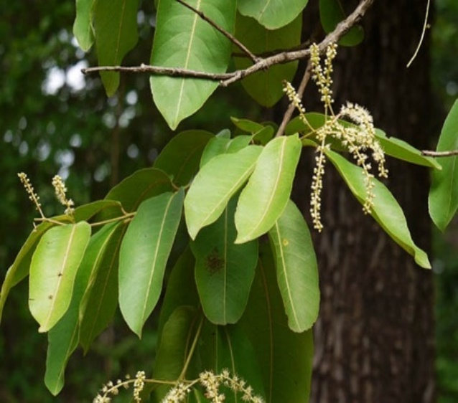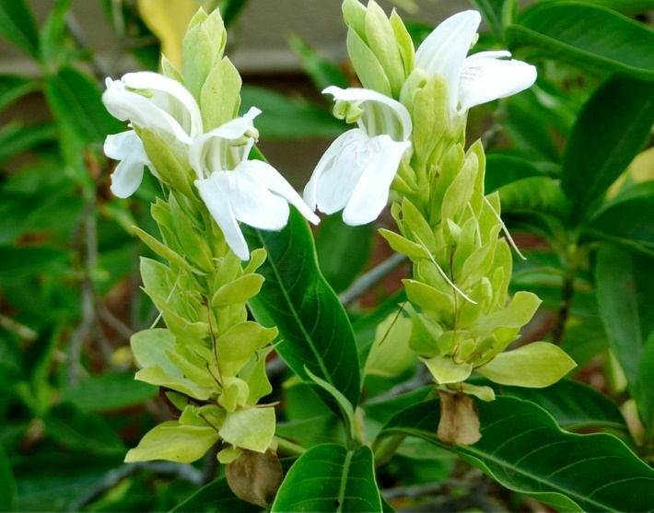

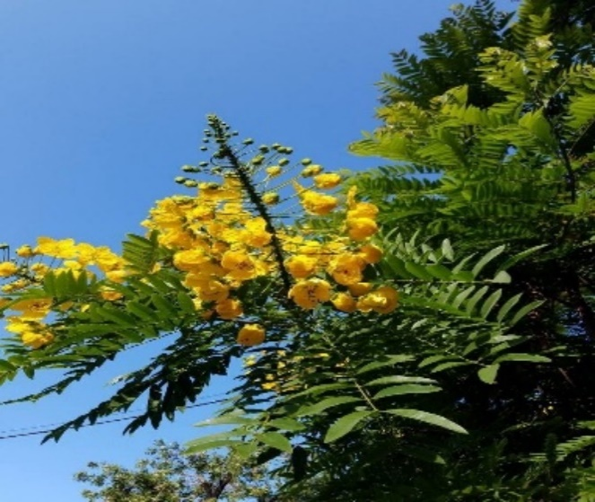 Picture 1 : **Terminalia crenulata**

Picture 2 : **Adhatoda vasica**

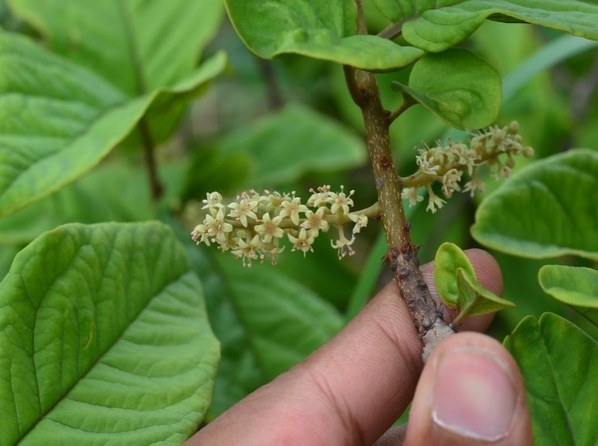

Picture 3 : **Cassial Fistulata** Picture 4 : **Embelia tsjeria**

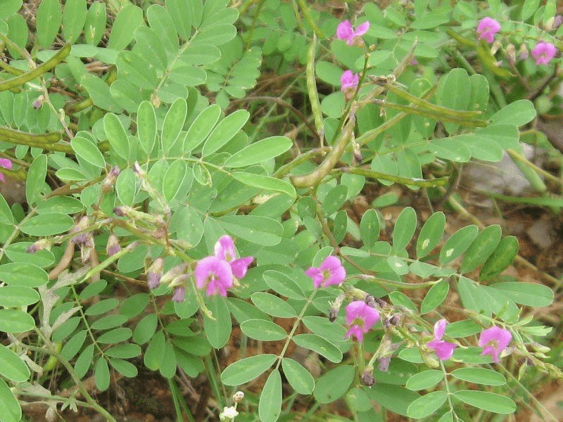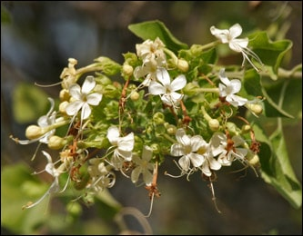

v

**Picture 5 : Clerodendrum multiflorum picture 6 : Tephrosea purpurea**

This study highlights the adaptability of certain plant species in addressing both acute and chronic health issues, showcasing a wide variation in their therapeutic uses. While most plants are used to treat common ailments like joint pain and diabetes, only one plant species is employed for each of the less frequent or more specialized conditions, such as typhoid, headaches, eye disorders, malaria, hair loss, body aches, nerve pain, bone fractures, vitiligo, testicular hydrocele, paralysis, liver disorders, sleep problems, scabies, acidity, anemia, and paralysis (Table 1). To ensure proper identification, specimens and photographs of all 50 medicinal plants were collected during the study, with images of some commonly used plants included in the results (Photographs a-l). This comprehensive record demonstrates the traditional wisdom embedded in the use of specific herbs for targeted therapeutic purposes.

In summary, the findings of this study reveal a complex web of traditional medical practices, showcasing the wide range of plant species that have been extensively used to treat various health ailments. It underscores the crucial role traditional knowledge plays in these communities’ healthcare systems, as well as the enduring value of plant-based treatments.

Local healers rely on a diverse selection of plant species, with the Fabaceae family making the most significant contribution, featuring 12 species used for treating various health conditions. Similar findings on the prevalence of Fabaceae species have been reported by Singh et al. (2013) in India and Chhattisgarh. The Fabaceae family is highly valued in traditional medicine due to its diverse therapeutic properties. Following the Fabaceae family, the study identified several other plant families with therapeutic significance. The Acanthaceae, Apocynaceae, Phyllanthaceae, and Combretaceae families each contributed three species, which may be valued for their specific therapeutic properties and effectiveness in treating various health issues. Continuous use of plants from these families highlights their importance in local pharmacopeia. Additionally, the Malvaceae, Boraginaceae, Moraceae, Anacardiaceae, and Myrtaceae families each provided two plant species, playing a moderate yet crucial role in traditional medicine. The unique qualities and medicinal applications of these plants enhance their value in indigenous healthcare practices.

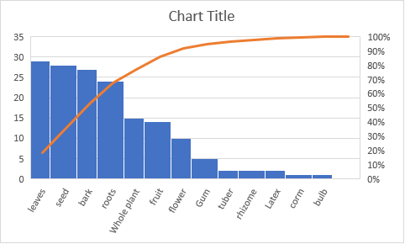

**Fig. 3:** Plant parts used by tribals in treatment of various ailments in Wani region

# The survey identified numerous plant families, each contributing only one species, including Rutaceae, Papaveraceae, Asparagaceae, Meliaceae, Nyctanthaceae, Vitaceae, Capparaceae, Buseraceae, Solanaceae, Loranthaceae, Euphorbiaceae, Linaceae, Sapotaceae, Lamiaceae, Piperaceae, Plumbaginaceae, Poaceae, and Sapindaceae. Despite each family providing just one species, their inclusion highlights the diverse range of plant groups used in traditional medicine (Fig. 2).

# The study revealed that the most commonly used plant parts for ethnomedicinal treatments were roots and leaves (24%), followed by bark (18%), whole plants (13%), seeds and fruits (9%), and stems (3%) (Fig. 3). Medicine administration occurred in various forms, including inhalation, oral intake, paste application, and rubbing massage. Oral administration was primarily used to treat gastrointestinal ailments such as stomach aches, piles, jaundice, and diarrhea, while dermal applications, such as paste, were used to address skin conditions like body wounds, acne, and pimples. These findings align with similar results recorded by researchers globally, such as Islam et al. (2020) and Xiong (2020). In India, similar outcomes have been reported by Dahare and Jain (2010), Bala and Singh (2016), while Upasana and Bharti (2015) and Chand et al. (2021) observed comparable results in Maharashtra.

# Conclusion

# The investigation highlights the region's rich diversity of medicinal plants, which play a crucial role in treating various human ailments. This abundance underscores the need to record and preserve traditional knowledge, as it faces growing threats from exploitation. Documenting ethnomedicinal plants is essential not only for the survival of these species but also for the well-being of local communities. Traditional knowledge, often passed down orally, reflects deeply rooted cultural practices, yet it risks being lost without systematic documentation.

# The study reveals that local communities continue to rely on medicinal plants to treat common illnesses, even with access to modern healthcare services. These plants are used to address conditions such as colds, coughs, fevers, headaches, poisonous bites, skin disorders, joint pain, and tooth infections. This continued reliance on traditional medicine highlights the community’s strong connection to ethnomedical practices, particularly in tribal areas, and demonstrates how traditional knowledge can complement modern medical treatments.

# The study further emphasizes the importance of documenting and preserving ancient medical practices to ensure that this valuable knowledge is passed down to future generations. Standardizing and preserving this information will not only safeguard cultural heritage but also contribute to broader medical research and conservation efforts.

**Highlights**

* The Wani region is a prominent tribal area in the state.
* Tribal communities, including the Gond and Kolam, primarily depend on traditional ethnomedicines.
* Documentation of ethnomedicinal plants in the Wani region is significantly sparse.
* A considerable number of ethnomedicinal plants were recorded during the current survey.

# References

* WHO. Traditional Herbal Remedies for Primary Health Care. World Health Organization, Regional Office for South-East Asia, New Delhi, India, 2010.
* Ogoina, D.. Fever, fever patterns, and diseases called ‘fever’ – A review. *Journal of Infection and Public Health*, Vol. 4(3), 108-124, 2011.
* Abhang, A. R., Pathare, S. A., and Rohokale, P. G. Traditional uses of medicinal plants by tribal and rural folk from Mula River Valley of Rahuri and its adjoining areas in Ahmednagar District (M.S.). *Int J Pharm Bio Sci*, 6(1), 140–148, 2015.
* Aher, S. K. Weed diversity and their ethnomedicinal uses in the Parner Tahsil, Dist. Ahmednagar, Maharashtra, India. *Indian Journal of Fundamental and Applied Life Sciences*, Vol. 5(4), 128–135, 2015.
* Gayake, D. N., Awasarkar, U. D., and Sharma, P. P. Indigenous traditional medicinal plant resources from Ahmednagar District, Maharashtra, India. *Asian Journal of Biomedical and Pharmaceutical Sciences*, 3(22), 1–5 (Rev), 2013.
* Kadam, R. M., Fatima, S., Baig, M., and Salve, A. P. Traditional use of medicinal plants in the Kelwandi area of Ahmednagar District, Maharashtra. *Annals of Pharmacy and Pharmaceutical Sciences*, 3(1), 42–44, 2012.
* Mulay, J. R., Sharma, P. P. Plants in child care in Ahmednagar District, Maharashtra, India. *Recent Research in Science and Technology*, 4(10), 11–15, 2012.
* Mulay, J. R. (Ph.D. Thesis). Weeds from Ahmednagar District and their utilitarian aspect. Dr. Babasaheb Ambedkar Marathwada University, Aurangabad, India, 2013. Online Available: <http://shodhganga.inflibnet.ac.in/handle/10603/75279>.
* Salave, A. P., Reddy, P. G., and Diwakar, P. G. Ethnopharmaceutical claims by the Vanjaris from Pathardi Tahsil in Ahmednagar District (M.S.), India. *Asian J. Exp. Biol. Sci.*, 2(1), 69–74, 2011.
* Salave, A. P., Reddy, P. G., and Diwakar, P. G. (Ph.D. Thesis). Ethnobotanical study of the Garbhagiri Hills in Ahmednagar District (M.S.). University of Pune, Pune, India, 2011. Online Available: <http://shodhganga.inflibnet.ac.in/handle/10603/144737>.
* Shinde, Y. P., Arangale, K. B., and Bhalerao, V. U. Ethnobotanical survey of Kopargaon Tehsil of Maharashtra. *World Journal of Pharmaceutical Research*, Vol. 6(14), 786–792, 2017.
* Pradhan, S. G. (Ph.D. Thesis). Studies on the Flora of Ahmednagar District, Maharashtra. The University of Poona, Pune, India, 1992. Online Available: <http://shodhganga.inflibnet.ac.in/handle/10603/144726>.
* Anonymous. List of plants having ethno information for fever, digitized database of medicinal plant resources of Maharashtra (Qualitative and Quantitative Assessment of 400 Medicinal Plants Resources). Agharkar Research Institute, Pune, India, 2016. Online Available: <http://mpd.aripune.org/EthnoData.asp>.
* Pullaiah, T., Krishnamurthy, K. V., & Bahadur, B. Ethnobotany of India, Volume 2: Western Ghats and West Coast of Peninsular India. Apple Academic Press, Oakville, ON, Waretown, NJ, 2017.
* Sai Prakash, G. Working Plan for Ahmednagar Forest Division and Sangamner Forest Subdivision (2011-12 to 2020-21). Working Plans Division, Aurangabad, Pune, Maharashtra, India, 2010.
* Jain, S. K. Credibility of Traditional Knowledge – The Criterion of Multilocational and Multiethnic Use. *Indian Journal of Traditional Knowledge*, Vol. 3(2), 137–153, 2004.
* Kirtikar, K. R., & Basu, B. D. Indian Medicinal Plants, Part I. Sudhindra Nath Basu, Allahabad, India, 1918.
* Kirtikar, K. R., & Basu, B. D. Indian Medicinal Plants, Part II. Sudhindra Nath Basu, Allahabad, India, 1918.
* Dastur, J. F. Medicinal Plants of India and Pakistan, 3rd Indian Ed. D.B. Taraporevala Sons and Co. Private Ltd., Bombay, India, 1960.
* Khare, C. P. Indian Herbal Remedies, Rational Western Therapy, Ayurvedic and Other Traditional Usage, Botany. Springer-Verlag Berlin Heidelberg, New York, 2004.
* Chopra, R. N., & Chopra, I. C. A Review of Work on Indian Medicinal Plants. Indian Council Of Medical Research, New Delhi, India, 1955.
* Chopra, R. N. Indigenous Drugs of India: Their Medical and Economic Aspects. The Art Press, Calcutta, India, 1933.
* Chopra, R. N., Nayar, S. L., & Chopra, I. C. Glossary of Indian Medicinal Plants. CSIR, New Delhi, India, 1956.
* Dymock, William, Warden CJH, and Hooper David. Pharmacographia Indica: A History of the Principal Drugs of Vegetable Origin, Met Within British India, Vol. I. Trubner & Company Ltd., London, 1890.
* Dymock, William, Warden CJH, and Hooper David. Pharmacographia Indica: A History of the Principal Drugs of Vegetable Origin, Met Within British India, Vol. II. Trubner & Company Ltd., London, 1891.
* Dymock, William, Warden CJH, and Hooper David. Pharmacographia Indica: A History of the Principal Drugs of Vegetable Origin, Met Within British India, Vol. III. Trubner & Company Ltd., London, 1892.
* Pawar, R. S. A Geographical Study of Concentration of Tribal Population and Their Literacy in Akole Tahsil, District Ahmednagar (M.S.). *International Journal of Science and Research (IJSR)*, Vol. 4(4), 2924–2928, 2015.
* Stevens, P. F. Angiosperm Phylogeny Website. Version 14, July 2017 [and more or less continuously updated since], 2017. Online Available: <http://www.mobot.org/MOBOT/research/APweb/welcome.html>.
* APG IV. An update of the Angiosperm Phylogeny Group classification for the orders and families of flowering plants: APG IV. *Botanical Journal of the Linnean Society*, Vol. 181, 1–20, 2016.
* Curesure Mohamd. Ayurveda - Concept and Principles, In Ayurveda blogspot. 2009. Online Available: <http://alshifa-ayurveda.blogspot.com/2009/11/>.
* Swami Sivananda. Practice of Ayurveda, Third Edition. The Divine Life Society, Shivanandanagar, Uttaranchal, India, 2006.
* Bala, L. D., and Singh, R. (2016). An ethnobotanical study of medicinal plants in the Chitrakoot area, District Satna, Madhya Pradesh, India. *International Journal of Botany Studies*, 1(5), 14-18.
* Dahare, D. K., and Jain, A. (2010). Ethnobotanical studies on plant resources of Tahsil Multai, District Betul, Madhya Pradesh, India. *Ethnobotanical Leaflets*, 2010(6), 7. <https://opensiuc.lib.siu.edu/ebl/vol2010/iss6/7>
* Islam, A. R., Hasan, M., Islam, T., Rahman, A., Mitra, S., and Das, S. K. (2020). Ethnobotany of medicinal plants used by Rakhine indigenous communities in Patuakhali and Barguna District of Southern Bangladesh. *Journal of evidence-based integrative medicine*, 25. <https://doi.org/10.1177/2515690X20971586>
* Jain, S. K. (1986). *Ethnobotany*. Interdisciplinary Science Reviews, 11(3), 285-292.
* Mahalik, G., Satapathy, K. B., and Sahoo, S. (2015). Ethnobotanical survey of plants used in the treatment of urinary disorders in Dhenkanal district of Odisha, India. *Journal of Environmental Science, Toxicology and Food Technology*, 9(8), 58-63. <https://doi.org/10.9790/2402-09815863>
* Masih, S. K. (1990). *Ethno-botany studies in tribal areas of Bastar and Jabalpur*. [Ph.D. thesis, Rani Durgawati University, Jabalpur, M.P.].
* Singh, A., Singh, M. K., and Singh, R. (2013). Traditional medicinal flora of the district Buxar (Bihar, India). *Journal of Pharmacognosy and Phytochemistry*, 2(2), 41-49.
* Singh, N. P., Khanna, K. K., Mudgal, V., and Dixit, R. D. (2001). *Flora of Madhya Pradesh*, Vol. III. Botanical Survey of India, Calcutta.
* Upasana, S., & Bharti, A. K. (2015). Ethnobotanical study of plants in Raigarh area, Chhattisgarh, India. *International Research Journal of Biological Sciences*, 4(6), 36-43. <http://www.isca.in/IJBS/Archive/v4/i6/8.ISCA-IRJBS-2015-060.pdf>
* Verma, D. M., Balakrishnan, N. P., and Dixit, R. D. (1993). *Flora of Madhya Pradesh*, Vol. I. Botanical Survey of India, Calcutta.
* Xiong, Y., Sui, X., Ahmed, S., Wang, Z., and Long, C. (2020). Ethnobotany and diversity of medicinal plants used by the Buyi in eastern Yunnan, China. *Plant Diversity*, 42(6), 401-414. <https://doi.org/10.1016/j.pld.2020.09.004>
* Manoj R. Kakpure (2020). Some noteworthy plants record to the flora of Yavatmal district, Maharashtra.
* 46 Ethnomedicinal List of Plants Treating Fever in Ahmednagar District of Maharashtra, India
* Chopra, R. N. Indigenous Drugs of India: Their Medical And [22]
* Economic Aspects. The Art Press, Calcutta, India, 1933.
* Chopra, R. N., Nayar, S. L., & Chopra, I. C. Glossary of [23]
* Indian Medicinal Plants., CSIR., New Delhi, India, 1956.
* Dymock William, Warden CJH, Hooper David. [24]
* Pharmacographia Indica, A history of the principal drugs of
* vegetable origin, met within British India. Vol I., Trubner &
* Company Ltd., London: Kegan Paul, Trench, 1890.
* Dymock William, Warden CJH, Hooper David. [25]
* Pharmacographia Indica, A history of the principal drugs of
* vegetable origin, met within British India. Vol II., Trubner
* & Company Ltd., London: Kegan Paul, Trench, 1891.
* Dymock William, Warden CJH, Hooper David. [26]
* Pharmacographia Indica, A history of the principal drugs of
* vegetable origin, met within British India. Vol III., Trubner
* & Company Ltd., London: Kegan Paul, Trench, 1892.
* Pawar, R.S. A Geographical Study of Concentration of [27]
* Tribal Population and Their Literacy in Akole Tahsil,
* District Ahmednagar (MS). International Journal of Science
* and Research (IJSR) Vol 4 (4): 2924-28, 2015.
* Stevens, P. F. (2001 onwards). Angiosperm Phylogeny [28]
* Website. Version 14, July 2017 [and more or less
* continuously updated since]., 2017. Online Available:
* http://www.mobot.org/MOBOT/research/APweb/welcome
* .html.
* APG IV. An update of the Angiosperm Phylogeny Group [29]
* classification for the orders and families of flowering plants:
* APG IV. Botanical Journal of the Linnean Society Vol181:
* 1–20, 2016.
* Curesure Mohamd, Ayurveda-Concept and Principles, In [30]
* Ayurveda blogspot. 2009. Online Available:http://alshifa-
* ayurveda.blogsp ot.com/2009/ 11/.
* Swami Sivananda. Practice Of Ayurveda, Third Editio n., [31 ]
* The Divine Life Society, Shivanan