***Original Research Article***

***Zeuxine seetharamii* (Orchidaceae: Goodyerinae): A new species from Western Ghats, Karnataka, India**

**ABSTRACT**

*Zeuxine seetharamii* is discovered from Anshi National Park, Uttara Kannada district, Karnataka, India. It is dissimilar to other species with thick rhizome, dwarf nature, compactly arranged small flowers, ovary structure and seeds. Labellum is similar to *Zeuxine reflexa* having reflexed structure, but pollinarium structure with tegula varies in all *Zeuxine* species from Karnataka and India.

**KEYWORDS:** Anshi National Park, Leaf litter, Pollinarium, Pubescent inflorescence, Reflexed labellum, Threatened Orchid.

**INTRODUCTION**

Orchidaceae is one of the most renowned diversified family among the Angiosperm families, with estimated count 26000 species in the World with 762 genera (Mabberley, 2017). Tribe Goodyerine includes 74 species of 13 genera in India. The word *Zeuxine* is derived from the Greek word *‘Zeuxis’* which means partial fusion of column and labellum or pollinial fusion called ‘Yoke’. India has been recorded 19 *Zeuxine* species within two sections called *Zeuxine* and *Psychechilos*. *Zeuxine* section: *Zeuxine* includes three species and *Zeuxine* section *Psychechilos* includes 16 species in India (Bhattacharjee & Chowdhery, 2018). Singh *et al*., (2019) reported 18 species of *Zeuxine* in India. Lakshminarsimhan *et al.*, (2019) recorded 182 species of Wild Orchids, in that they have included three *Zeuxine* species i.e. *Z. gracilis* (Breda) Blume, *Z. longilabris* (Lindl.) Trimen, and *Z. strateumatica* (L.) Schltr. Punekar & Lakshminarsimhan (2011) documented two Zeuxine species (*Z. gracilis* (Breda) Blume & *Z. longilabris* (Lindl.) Trimen) from Anshi National Park. *Zeuxine reflexa* King & Pantling from Anshi National Park which is new report to Peninsular India next to Assam and West Bengal from India (Shreyas & Kotresha, 2022).

During a scientific survey at Anshi National Park, the collection of a *Zeuxine* species was done which was not similar to earlier collected four *Zeuxine* species (*Z. reflexa* King & Pantl., *Z. gracilis* (Breda) Blume, *Z. longilabris* (Lindl.) Trimen and *Z. strateumatica* (L.) Schltr.). This newly identified species is differentiated with many characters mainly size of the plant, inflorescence, bract with 5-nerved, labellum reflexed, Pollinarium and Seeds. Then it is slightly similar to *Z. clandestina* Blume, which is distributed in Assam and Arunachala Pradesh but varies in having characters like plant size, leaves, bract, petals, anther cap and Pollinarium. It is not similar to *Zeuxine flava* (Wall. ex Lindl.) Trimen, which is different with yellow coloration and rounded front lobes of labellum (Bhattacharjee & Chowdhery, 2018). *Z. mooneyi* and *Z. andamanica* are not similar to our species as they vary with height, bracts, flower arrangement and lobes of labellum (Misra, 2012; Bhattacharjee & Chowdhery, 2018). Hence, the species is diagnosed as new and named as *Zeuxine seetharamii* from Anshi national Park, Uttara kannada district, Karnataka.

**TAXONOMIC TREATMENT**

*Zeuxine seetharamii* Shreyas & Kotresha sp. nov.*,* (Figure 1 & 2)

**Typus:**

India, Karnataka, Uttarkannada District, Anshi National Park, near Nujji village, 03rd February 2022, Shreyas B. & K. Kotresha, (Holotype: UASB 5600); - Same locality, 23rd February 2023, Shreyas B., (Paratype:HKCD1910)**.**

**Diagnosis**

The *Zeuxine seethramii* is very distinct from other *Zeuxine* species with thick rhizome, dwarf nature compared to *Zeuxine gracilis* and *Zeuxine reflexa*, compactly arranged small flower, ovary structure is dissimilar to *Z. gracilis* and similar to *Z. reflexa*. Labellum is similar to *Zeuxine reflexa* having reflexed structure, but Pollinarium structure and tegula varies in all *Zeuxine* species of Karnataka (including *Z. strateumatica* (L.) Schltr.) (Figure 3, 4, 5 & Table 1).

**Description**

Terrestrial herbs c. 19 ̶ 22 cm tall. Rhizome with root hairs, green, 3 ̶ 4 cm long. Stem unbranched, erect, 3-5 × 1.2-1.5 cm across, sheathing leaf bases, pinkish-brown, and absence of hairs. Leaves 3-5, scattered around the stem or one above the other sheds during flowering, c. 4 × 1.5 cm, obovate-lanceolate with acute apex. Inflorescence raceme, pubescent, flowers 8-12, 15-16 cm tall, clumped at one place. Bract hairy, brownish-yellow, c. 8 × 5 mm across, with 5-veined, obtuse-lanceolate with acute tip. Flowers unpubescent, ovary pubescent, c. 9 × 6 mm across, cream yellow. Sepals free, greenish-yellow, unpubescent. Dorsal sepal c.3 mm long, obtuse at base and blunt tip, unpubescent. Lateral sepals c. 4 mm long, greenish-yellow, unpubescent, obtuse base and acute apex. Petals transparent white, c. 3 mm long, broad at the apex, entire, thin at the end. Labellum Y-shaped, c. 4 × 3 mm across, hypochile saccate, creamy yellow with yellowish tinge. Epichile 2-lobed, lobules oblong, creamy white to pale yellowish, slightly reflexed. Labellum saccate has a pair of curved glands with fluid in it. Column c. 2 mm long. Anther cap reddish-yellow, cone shaped c. 1.5 mm long with two sacks in it. Pollinarium c. 2.2 mm long with transparent caudicle, pollinia more in number, bifid. Tegula oblanceolate and viscidium both are transparent, c. 1 mm in length. Ovary sessile, 9 × 4 mm across, greenish-yellow, less pubescent, lanceolate, with spiral ridges on it. Capsule c. 1.1 × 0.3 cm across, pubescent, brownish-yellow.

*Habit:* Terrestrial herbs.

*Habitat:* Semi-evergreen and Evergreen forests under shades with leaf litter grown with *Zeuxine longilabris* sometimes.

*Flowering & Fruiting:* January-February

Etymology:*Seetharamii* is a specific epithet named after an eminent taxonomist Y. N. Seetharam of the Department of Botany, Gulbarga University, Kalaburagi, Karnataka, India.

*Species Examined:* INDIA, KARNATAKA, Uttara Kannada district, Anshi National Park, near Nujji village, 03rd February 2022, 15°04'45.0"N 74°21'50.4"E by Shreyas B. & K. Kotresha (0042 & 0111).

**Key to *Zeuxine* species in Karnataka, India:**

1. Flowers white with pale green labellum ***Z. strateumatica***

1. Flowers olive green with whitish or yellowish orange labellum **2**

2. Labellum c. 1.5 cm long, lobes dentate ***Z. longilabris***

2. Labellum c. 3-6 mm long, lobes erose or incised **3**

3. Labellum reflexed, c. 6 mm long, yellow tinged, lobes erose ***Z. reflexa***

3. Labellum not reflxed, 3-4 mm across, Orange tinged, lobes incised **4**

4. Pollinarium with tegula ovate, Ovary elliptic and more pubescent ***Z. gracilis***

4. Pollinarium with tegula oblanceolate, Ovary lanceolate and

less pubescent ***Z. seetharamii***

**Key to Seed morphometric variations in *Zeuxine* species of Karnataka, India:**

1. Seeds long linear **2**
2. Seeds short, not linear ***Z. strateumatica***
3. Seed testa cells are small ***Z. longilabris***
4. Seeds testa cells long **3**
5. Seed testa cells rectangular **4**
6. Seed testa cells not cuboidal ***Z. seethramii***
7. Seed testa cells 0.08-0.1 mm long ***Z. reflexa***
8. Seed testa cells 0.05-0.07 mm long ***Z. gracilis***

**CONSERVATION STATUS**

As the species collected on roadside forest edge at riverine habitat, Anshi national Park, 100 meters survey counted 2-3 individuals. Totally, our survey recorded 25-30 individuals. Collected two individuals for analysis and submission of herbarium (Fig. 06). Based on above data the species is at endangered condition and need to be analyzed in future.

**ACKNOWLEDGEMENT**

Authors are mainly thankful to USIC DST SAIF Scanning Electron Microscope analysis, Karnatak University Dharwad for SEM photographs and measurements. Authors are thankful to Karnataka University for conducting this research programme and providing student research Scholarship (URS). Authors are thankful to Dr. A. N. Sringeshwara, Curator, University of Agricultural Science, Bangalore for herbarium processing and submission. In addition, authors are thankful to Mr. Prashant K. for helping during survey and collection of specimen.

**CONFLICTS OF INTEREST**

“The authors declare that there are no conflicts of interests”.

**REFERENCES:**

Bhattacharjee, A. & Chowdhery, H.J. (2018). *Fascicles of flora of India. orchidaceae: orchidoideae: cranichidae: subtribe goodyerinae.*: 28.140-188.

Laxminarasimhan, P., Dash, S.S., Singh, P., Singh, N.P., Vasudeva, M.K., Rao, P.S.N. & Mao A. A. (2019). *Flora of karnataka, monocotyledons*. Botanical Survey of India. Vol.3.: 24.

Mabberley, D. J. (2017). *A portable dictionary of plants, their classification and uses*. Fourth Edition. 652-654.

Misra, S. (2012). A new species of Zeuxine (Orchidaceae) from Rebana Forest of Odisha, India. *Nelumbo*. 54: 17-19.

Punekar, S. & Laxminarashimhan,P. (2011). *Flora of Anshi National Park, Western Ghats-Karnataka*. Botanical Survey of India. 481.

Singh, S. K., Agrawala, D. K., Jalal, J. S., Dash, S. S., Mao, A. A. & Singh,P. (2019). *Orchids of India, a pictorial compendium*. Botanical Survey of India. 514-518.

Shreays, B. & Kotresha, K. (2022). *Zeuxine reflexa* (Orchidaceae-goodyerinae), a new addition to peninsular India, *Rheedea*. 32(3): 218-221.

Table. 1: Morphological comparison between *Zeuxine reflexa*, *Zeuxine gracilis* and *Zeuxine seetharamii* sp. nov.

|  |  |  |  |
| --- | --- | --- | --- |
| **Characters** | ***Zeuxine gracilis*** | ***Zeuxine reflexa*** | ***Zeuxine seetharamii*** |
| **Habit** | Herbs-tall in size upto 32-34 cm | Herbs-tall in size upto 30-40 cm | Herbs small in size upto 19-22 cm |
| **Rhizome** | Not elongated, below ground | Not elongated, below ground | Elongated, above ground |
| **Leaves** | Leaf base obtuse, acute apex and entire margin | Leaf base obtuse, acute apex and entire margin | Leaf base attenuate, attenuate apex and repand margin |
| **Inflorescence** | Raceme with loosely arranged flowers, 15-18 flowers | Raceme with loosely arranged flowers, 12-15 flowers | Raceme with compactly arranged flowers, 8-12 flowers |
| **Bract** | c. 5 mm length, ovate-lanceolate, acute at tip, 1-veined | c. 6 mm length, ovate-lanceolate, acuminate at apex, 1-veined | c. 8 mm length, obtuse-lanceolate with acute apex, 5-veined |
| **Flower** | Flowers pubescent, c. 9 mm in length, greenish-yellow | Flowers pubescent, 0.8-1 cm in length, brownish-yellow | Flowers less pubescent, c. 9 mm in length, greenish-yellow |
| **Labellum** | Not Y- shaped, c. 3.6 x 3 mm across, hypochile orange, white, oblong. | Y- shaped, c. 6 x 4 mm across, hypochile white, cream yellow, reflexed | Y- shaped, c. 4 x 3 mm across, hypochile orange, white, slightly reflexed, dentate at two lobes. |
| **Anthercap** | Anther cap reddish orange cone, 2mm long, lower beak like structure not elongated, with 2 sacs | Anther cap reddish orange cone, 2mm long, lower beak like structure slightly elongated, 2 sacs | Anther cap reddish orange cone, 1.5 mm long, lower beak like structure is elongated to hold tegula, 2 sacs |
| **Pollinarium** | 1 pair with, tegula ovate | 1 pair, tegula lanceolate | 1 pair, tegula oblanceolate |
| **Ovary** | c. 1 x 0.8 cm across, pubescent, green, narrowly spiral white ridges, elliptic | c. 1.1 x 0.2 cm across, pubescent, brownish-yellow, straight white ridges, ellipsoid | c. 7 x 4 mm across, brownish-yellow, straight white ridges, less pubescent, lanceolate |
| **Seed** | Seeds long, linear with testa cells not cuboidal, 0.05-0.07 mm long | Seeds long, linear with testa cells cuboidal, 0.08-0.1 mm long | Seeds long, linear with testa cells cuboidal, 0.05-0.07 mm long |



**Fig. 1***. Zeuxine seetharamii* sp. *nova.* **A.** Floweringhabit. **B.** Vegetativehabit. **C.** Rhizome. **D.** Inflorescence. **E.** Flower bud. **F.** Front view. **G.** Lateral view. **H.** Bract. **I.** Column with Ovary. **J.** Column. **K.** Curved gland. **L.** Dorsal sepal. **M.** Lateral sepal. **N.** Petal. **O.** Dorsal view of labellum. **P.** Ventral view of labellum. **Q.** Lateral view of labellum. **R.** Dorsal & Ventral view of Anthercap. **S.** Dorsal & Ventral view of Pollinarium. **T.** ovary. **U.** Dispersed capsule. (Photos by Shreyas Betageri).



**Fig. 2.** ***Zeuxine seetharamii* sp. *nova****.*: **A.** Habit, **B.** Lateral view of flower. **C.** Front view of flower. **D.** Bract. **E.** Dorsal sepal. **F.** Petal. **G.** Lateral sepal. **H.** Dorsal view of labellum. **I.** Ventral view of labellum. **J.** Lateral view of labellum. **K.** Curved gland. **L.** Column. **M.** Dorsal view of labellum. **N.** Ventral view of labellum. **O.** Pollinarium. **P.** Ovary. (Illustrated by Shreyas Betageri).



**Fig. 3. Comparitive account of *Zeuxine* species in Karnataka:** Vegetative habit of **A1.** *Zeuxine longilabris* Trimen, **A2.** *Zeuxine gracilis* (Breda) Blume, **A3.** *Zeuxine reflexa* King & Pantl., **A4.** *Zeuxine seetharamii* sp. *nova.* Flowering habit of **B1.** *Zeuxine longilabris* Trimen, **B2.** *Zeuxine gracilis* (Breda) Blume, **B3.** *Zeuxine reflexa* King & Pantl., **B4.** *Zeuxine seetharamii* sp. *nova.*, Inflorescence enlarged, of **C1.** *Zeuxine longilabris* Trimen, **C2.** *Zeuxine gracilis* (Breda) Blume, **C3.** *Zeuxine reflexa* King & Pantl., **C4.** *Zeuxine seetharamii* sp. *nova.*, Lateral view of flower and bract **D1.** *Zeuxine longilabris* Trimen, **D2.** *Zeuxine gracilis* (Breda) Blume, **D3.** *Zeuxine reflexa* King & Pantl., **D4.** *Zeuxine seetharamii* sp. *nova.* (Photos by Shreyas Betageri).

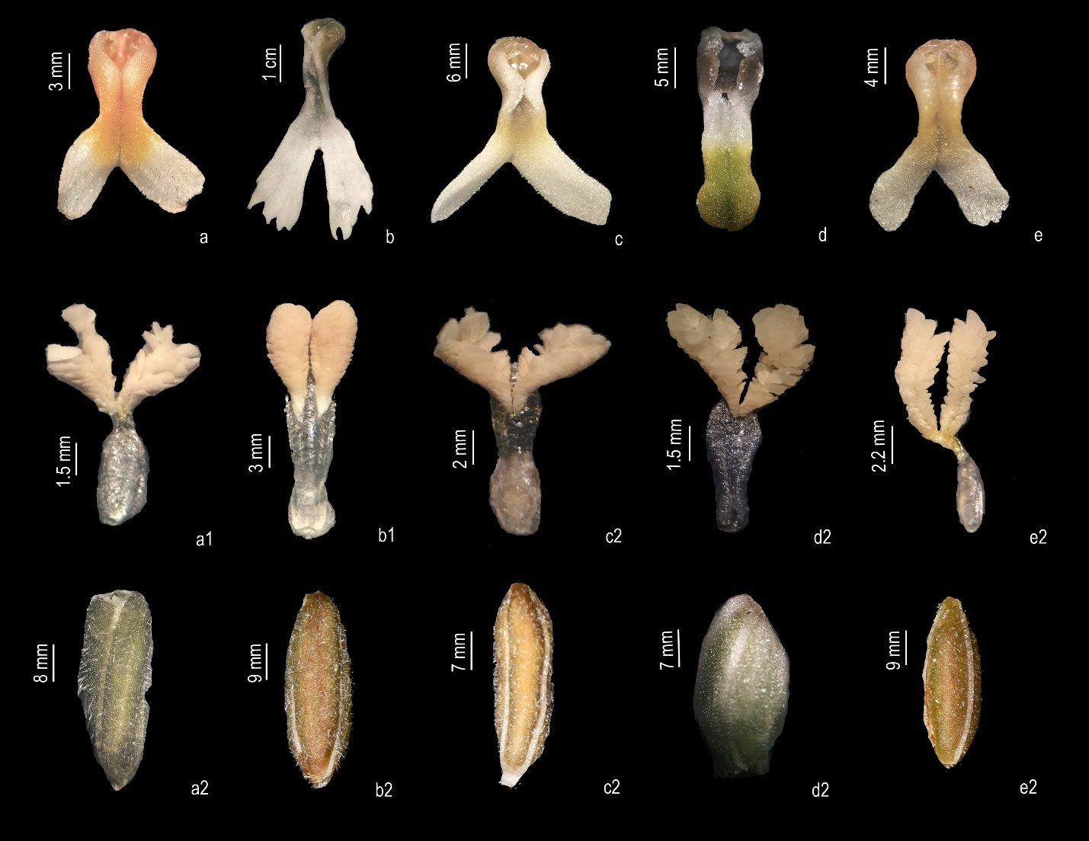

**Fig. 4. Comparative account of Labellum, Pollinarium & Ovary of *Zeuxine* species in Karnataka: A. F. K.** *Zeuxine gracilis* (Breda) Blume, **A.** Dorsal view of labellum. **F.** Pollinarium. **K.** Ovary. **B. G. L.** *Zeuxine longilabris* Trimen, **B.** Dorsal view of labellum. **G.** Pollinarium. **L.** Ovary. **C. H. M.** *Zeuxine reflexa* King & Pantl., **C.** Dorsal view of labellum. **H.** Pollinarium. **M.** Ovary. **D. I. N.** *Zeuxine strateumatica* (L.) Schltr. **D.** Dorsal view of labellum. **I.** Pollinarium. **N.** Ovary. **E. J. O.** *Zeuxine seetharamii* sp. *nova.* **E.** Dorsal view of labellum. **J.** Pollinarium. **O.** Ovary. (Photos by Shreyas Betageri).

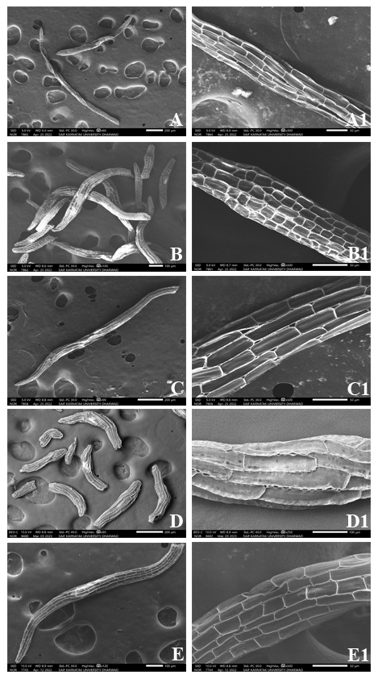

**Fig. 5.** Seed morphometric variations in *Zeuxine* species of Karnataka: **A. A1.** *Z. gracilis*; **B. B1.** *Z. longilabris*; **C. C1.** *Z. reflexa*; **D. D1.** *Z. straetumatica*; **E. E1.** *Z. seetharamii* sp. nov.

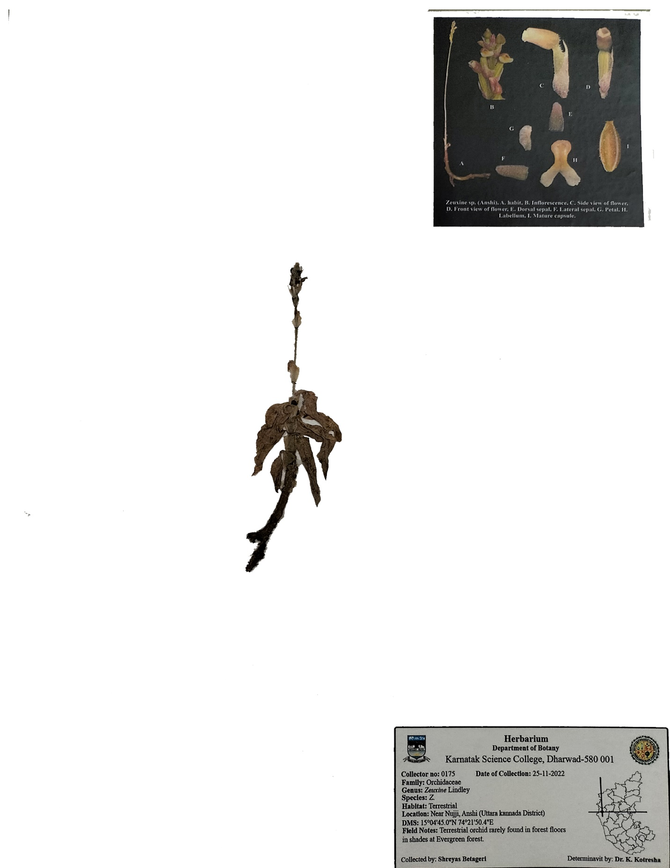

**Fig. 6:** Herbarium specimen of *Zeuxine seetharamii* sp. nov.