EFFECTS OF SYNERGISTIC APPLICATION OF TILLAGE, POULTRY MANURE AND CHEMICAL FERTILIZER ON SOIL AND YIELD ATTRIBUTES OF BRRI dhan28

.

ABSTRACT

|  |
| --- |
| A field experiment was conducted at the Bangladesh Agricultural University Farm, Mymensingh during January to May 2023 to assess the effect of tillage intensity, use of poultry manure and chemical fertilizer on soil and yield attributes of Boro rice (cv. BRRI Dhan28). The experiment was organized in a randomized complete block design with three replications. The treatments were: T1+P+C = one passing of power tiller + poultry manure @ 5 t ha-1 + chemical fertilizer, T2+P+C = two passing of power tiller + poultry manure @ 5 t ha-1 + chemical fertilizer and T3+P+C = three passing of power tiller + poultry manure @ 5 t ha-1 + chemical fertilizer. Fertilizers were applied @ 123 kg N ha-1, 22 kg P ha-1, 67 kg K ha-1, 11 kg S ha-1, 6 kg Zn ha-1 as Urea, TSP, MOP, ZnSO4 forms. The results revealed that soil physical parameters were significantly influenced by tillage, poultry manure and chemical fertilizer treatments. Three passing of power tiller in combination with poultry manure and chemical fertilizer showed significantly lower (*p<0.01*) bulk density than all other treatments. The highest soil moisture content of 54.73% was measured in T3+P+C treatment which was significantly higher (*p<0.01*) than all other treatments which were statistically different. The highest air-filled porosity of 14.93% was measured in T3+P+Ctreatment which was significantly higher (*p<0.01*) than T1+P+Cand T2+P+C treatments where they were statistically different. Considering the plant attributes, the maximum number of effective tillers hill-1 (18.23) and 1000 grain weight (22.82 g) were observed in T3+P+Ctreatment which was significantly higher (*p<0.05*). The highest grain (8.67 t ha-1) and straw (10.66 t ha-1) yields were recorded in T2+P+C and T3+P+C treatment respectively which was significantly higher (*p<0.01*) than other treatments. Considering the soil and rice yield attributes T3+P+C treatment proved the best treatments. |

*Keywords: Tillage; Poultry manure; Chemical fertilizer; Soil physical properties; Yield attributes; BRRI dhan28*

1. INTRODUCTION

Rice is an excellent source of carbohydrates providing up to 50-60% of the daily calories ingested by more than 2.5 billion people across the world (Metwally *et al*. 2011; Khan et al., 2022). Rice contributes to 91% of the total grain production and covers 74% of the total calorie intake of the people of Bangladesh (BBS, 2019). The food deficiency in Bangladesh could be minimized either by bringing more area under cultivation or by increasing rice yield per unit area. Among the three types of paddy, Boro rice covers about 57% of total rice area, which contributes 43% of the total rice production in the country (BBS, 2010; Mainuddin et al., 2021). The total area and production of rice in Bangladesh is about 11.3 million hectare and 31.2 million metric ton (t) respectively with the average yield around 2.4 ton per hectare (BANGLADESH RICE JOURNAL, 2022). Rice is intensively cultivated in Bangladesh covering about 80% of arable land. Unfortunately, the yield of rice is low considering the other rice growing countries like Japan and China where the average yield is 6.7 and 6.3 t ha**-1**, respectively (FAO 2004; Anonymous, 2022). Generally, crop production is a combined impact of soil factors, management and environmental factors. Lal (1995) defined tillage is physical, chemical and biological manipulation of soil to optimize conditions for seed germination, emergence and seedling establishment.

Tillage is considered to be the oldest, most fundamental farm activity and first step for crop production. Different tillage operations may influence the physical properties of soil such as soil bulk density, soil moisture, soil porosity and air-filled porosity (Ozpnar and Clay, 2005; Vulloid et al. 2006, Mateo‐Marín et al., 2022). Tillage also affects the physical and chemical properties of the soil by affecting the aggregates size distribution which is turn affect plant growth through increasing soil moisture content, air filled porosity and decreasing the bulk density (Xu et al., 2024). Tillage operations are necessary to remove the weeds and prevent crust formation.

Different tillage operations incorporate organic matter into soil which creates improved physical condition of soil that brings out better nutrients and water relations and has a key role in growth and development of roots by controlling air and water movement to a certain extent and nutrient supply to the roots of the growing plants. So, soil becomes permeable, aerated and have a good physical condition for crop production. A judicious combination of organic and inorganic sources of nutrients is necessary for sustainable agriculture that can ensure food production with high quality (Al-Shammary et al., 2024). This approach, called Integrated Nutrient Management (INM), can help ensure food production while preserving the soil and environment (Wang et al., 2024; Wato et al., 2024). Organic fertilizers improve soil structure and fertility over time, are environmentally friendly, maintain soil health, and reduce greenhouse gas emissions (Mahmud et al., 2016; Shanmugavel et al., 2023; Jote, 2023).  The poultry manure as a source of plant nutrients is better than FYM because it took less time for decomposition and improved soil fertility. Poultry manure increased the crop yield than no manure. This study is planned to observe the effects of different tillage practices, poultry manure and chemical fertilizer application on the soil physicochemical properties like bulk density, air filled porosity, soil moisture and yield of Boro Rice under the climate condition.

The present investigation was undertaken involving the influence of tillage intensity, poultry manure and chemical fertilizer with the following objectives: (i) To assess the interaction effects of tillage operations, poultry manure and chemical fertilizer application on soil and yield attributes of Boro rice (cv.BRRI dhan28). (ii) To examine the relationships between soil physical properties and rice plant (cv.BRRI dhan28) attributes and (iii) To find out the best treatment in this study.

2. material and methods

**2.1 Location of the experimental field**

The experiment was conducted at the Bangladesh Agricultural University Farm under the Department of Soil Science during Boro season from January to May 2023. Geographical position of the site was approximately between the latitudes of 24°54′ North and the longitudes of 90°15′ East at a height of 18 m above the mean sea level. The soil belongs to the “Old Brahmaputra Floodplain” and Agro Ecological Zone-9 (FAO and UNDP, 1988).

**2.2 Climate**

The climate of the area is being experienced by relatively high temperature, high humidity and heavy rainfall with occasional gusty winds during kharif season and low temperature and low humidity during rabi season. The maximum (350C), minimum (110C) and mean temperature (260C), rainfall (mm), relative humidity (%), sunshine (hours day-1), evaporation (mm) during the experimental period were recorded by the Weather Yard, Department of Irrigation and Water Management, Bangladesh Agricultural University presented in the Appendix I.

**2.3 Agro- ecological region**

The BAU experimental farm belongs to the agro-ecological region of Old Brahmaputra Flood Plain. “AEZ 9” (FAO and UNDP, 1988).

**2.4 Soil**

The soil in the experimental site belongs to Sonatola series of the Old Brahmaputra Flood Plain. Soil samples of 0-10 cm depth were collected from the experimental site after harvesting the test crop (cv. BRRI dhan28). Morphological characteristics and physical properties of the soil which were collected from different sites of experiment at 10-20 cm depth have been presented as follows:

**2.6 Test crop**

The recommended high yielding Boro variety BRRI dhan28 was used as a test crop. This variety was released by the Bangladesh Rice Research Institute, Joydebpur, Gazipur after regional and zonal trials and evaluation. It is recommended as a suitable variety for cultivation under Bangladesh climatic condition. These high yielding varieties are suitable for Boro season, the grains were medium fine and tasty. Growth duration of: 140-145 days (from seedling to harvest).

**Table 1 Particle size analysis of the initial soil**

|  |  |  |  |  |  |
| --- | --- | --- | --- | --- | --- |
| Soil depth (cm) | Particle size fractions | | | Textural  class | Bulk  density  (gcm-3) |
| %sand  (.2-.02 mm) | %silt  (.02-.002 mm) | % clay  <.002 mm |
| 0-10 | 9.6 | 79.8 | 10.6 | Silt loam | 1.3 |
| 10-20 | 10.4 | 80.3 | 9.3 | Silt loam | 1.5 |

**2.5 Taxonomic and morphological characteristics of the experimental site**

**Table 2 Taxonomic characteristics of soil**

|  |  |
| --- | --- |
| Order | Inceptisol |
| Sub-Order | Aquept |
| Sub-Group | Aeric Haplaquet |
| Series | Sonatola |

**Table: 3 Morphological characteristics of the experimental field**

**The morphological characteristics of the experimental field are shown in the table:**

|  |  |
| --- | --- |
| Location | Soil Science Field Laboratory, BAU, Mymensingh. |
| Agro-ecological zone | Old Brahmaputra Floodplain (AEZ-9) |
| Land type | Medium high land |
| General soil type | Non-Calcareous Dark Grey Floodplain Soil |
| Topography | Fairly level |
| Field Level | Above flood level |
| Drainage | Fairly good |
| Firmness (Consistency) | Friable when dry |
| Cropping pattern | Fallow-wheat |

**2.7 Land preparation**

The land was first ploughed on the 15 January, 2023 with the help of a power tiller and it was further plowed followed by laddering on 22 and 23 January, 2023 as per tillage treatment to prepare land finally for transplanting of rice seedlings.

**2.8 Design of the experiment**

The experiment was laid out in a Randomized complete block design (RCBD). The treatments were replicated for three times. Thus, the total number of plots was (6*3) 18. The unit plot size was 4m×2.5m having spacing of the plot to plot 0.5 m and block to block 1.0 m. the layout of the experiment is shown in Fig. 1.

**2.9 Treatment of the experiment**

Table 4 The experiment consisted of six treatments. The treatments were as follows:

|  |  |
| --- | --- |
| **Treatment code** | **Treatments applied to the experimental field** |
| T1 +P+C | one passing of power tiller+ poultry manure @ 5 t ha-1 + chemical fertilizer |
| T2 +P+C | two passing of power tiller+ poultry manure @ 5 t ha-1 + chemical fertilizer |
| T3 +P+C | three passing of power tiller+ poultry manure @ 5 t ha-1 + chemical fertilizer |

**2.10 Rates and sources of fertilizers and manures**

**Table 5: Name, rates and sources of the different fertilizers and poultry manure (well decomposed)**

|  |  |  |  |
| --- | --- | --- | --- |
| **Fertilizers and poultry manure** | **Rate** | | **Sources** |
| N | 123 kg ha-1 | | Urea (46%N) |
| P | 22 kg ha-1 | | TSP (20%P) |
| K | 67 kg ha-1 | | MoP (50%) |
| S | 11 kg ha-1 | | Gypsum (18%S) |
| Zn | 6 kg ha-1 | | ZnO (78%Zn) |
| Poultry manure | | 5 t ha-1 | (2.7%N,0.27%P,1.58% K, 0.47%S & 82 ppm Zn) |

**2.11 Poultry manure and fertilizers application**

The total amount of poultry manure, TSP, MOP, gypsum and zinc Oxide were applied during the final land preparation but urea was applied in the two equal splits. The first split was applied, during final land preparation, the second split at crown root Initiation (CRI) stage.

Poultry manure was applied in the soil two weeks before transplanting. Well decomposed poultry manure was applied @ 5 t ha-1 according to layout of the experiment plot.

**2.12 Transplanting**

Forty-five days old seedlings of BRRI dhan28 were transplanted at 28 January, 2023 in 20 cm apart rows maintaining 20 cm hill to hill distance and 3 seedlings per hill. Necessary gap filling was done 8 days after transplanting.

**2.13 Weeding, pest and diseases management**

Weeding was done as and when necessary but no insecticides and pesticides were required to use, since the crop was free from insects and pathogen attack.

**2.14 Harvesting**

The crop was harvested on 04 May, 2023 at full maturity. For data collection, five hills from each plot were sampled selectively from the middle portion of the plot at one-meter square area. The crop was cut at the ground level. Threshing, cleaning, and drying of grain were done separately plot wise. The weights of grain and straw were recorded plot wise.

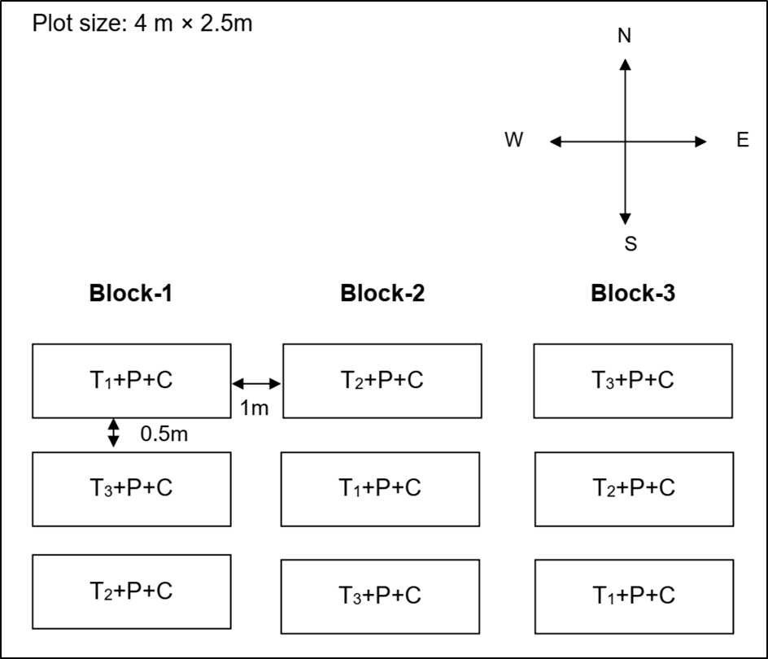

**Figure: 1 Layout of the experiment**

**2.15 Collection and preparation of soil samples for determining physical properties of soil**

**2.15.1 Initial soil sample**

The initial soil sample (0-10 cm soil depth) was collected before final land preparation. The samples were taken using an auger from 18 different random spots covering the whole experimental plots. The soil samples were mixed thoroughly to make a composite sample and the unwanted materials such as stubbles, weeds, etc. were removed from soil. The composite soil sample was air-dried ground and sieved through a 10-mesh sieve. This composite soil sample was stored in a clean plastic container for subsequent physical analysis.

**2.16 Methods for determining physical properties of soil**

**2.16.1 Soil texture**

Textural classes were determined by hydrometer method as outlined by Bouyoucos (1927). Fifty grams of air-dried soil was taken in a dispersion cup and 10 ml of 5% calgon solution was added to the sample and allowed to soak for 15 minutes, ninety milliliter distilled water was added to the cup. The suspension was then stirred with an electrical stirrer for 10 minutes. The content of the dispersion cup was then transferred to a 1-liter sedimentation cylinder and distilled water was added to make the volume up to the mark. A cork was placed on the mouth of the cylinder and the cylinder was inverted several times until the whole soil mass appeared in the suspension. The cylinder was set upright and the hydrometer readings were taken at 40 seconds and 2 hours of sedimentation. The temperature of the suspension was also recorded with a thermometer at 40 seconds and 2 hours of sedimentation.

The corrections of hydrometer readings were made as the hydrometer was calibrated at 68° F. The percentage of sand, silt and clay were calculated as follows:



Where,

C.H.R = Corrected hydrometer reading

W = Weight of soil (g)

% sand = 100 -% (silt + clay)

% silt = % (silt + clay) - % clay

% clay = % (silt + clay) - % silt

**2.16.2 Bulk density**

The bulk density was determined with the help of a core sampler made of metal cylinder of known volume (Black, 1965).

Bulk density was calculated by using the following formula:

Bulk density, g cm-3 ………………………. (1)



Where,

Db = Bulk density g cm-3 (g cm-3)

Ms= Mass of soil solid (g)

Vt = Total volume of soil (cm3)

**2.16.3 Air filled porosity**

Air-filled porosity was calculated by using the following formula:

……………….(2)



Volume of air (cm3) = Total volume of soil (cm3) – volume of water (cm3) - volume of soil solids (cm3).



**2.16.4 Soil moisture**

The soil moisture was determined by gravimetric method and was calculated by using the following formula:

……………..(3)



Where,

W = Weight of moist soil (g)

W1 = Weight of oven dry soil (g)

**2.17 Recording of yield contributing characters and yield data**

**2.17.1 Plant height**

Five hills were randomly collected from each unit plot and the height of every plant from each hill was measured in terms of cm with the help of a meter scale. Thus, average height of plants was measured.

**2.17.2 Effective of tillers hill-1**

Five hills were taken randomly from each plot and the total numbers of tillers were counted, the average of which were considered as total number of tillers hill-1.

**2.17.3 Non-effective tillers hill-1**

Measurement was taken from basal node of the rachis to apex of each panicle (cm). The panicle length was expressed by averaging the data from 5 plants.

**2.17.4 Panicle length**

Five hills were randomly selected from each plot and the number of filled and unfilled grain panicle-1 from each hill was counted in number. Then the average number of grains panicle-1 was counted in number.

**2.17.5 1000-grain weights**

The grain samples were counted from each plot and dried the sample in an oven at 65° C for 24 hours and then recorded their weight in g with the help of an electrical balance.

**2.17.6 Grain and straw yields**

The rice crops were harvested at full maturity on 04 May, 2023. The harvested crop of each plot was bundled separately and brought to the threshing floor for threshing by hand. The separated grains were dried in the sun for 5 days for attaining the moisture up to 14%. The grains were kept in paper bags plot wise and were recorded in kg. Similarly, the straw yield was recorded in kg. Finally, the plot wise yield of grain and straw were converted into t ha-1.

**2.18 Correlation and regression analysis**

Correlation and regression among soil properties, yield components and yields were studied.

**2.19 Statistical analysis**

Data on different parameters under study were statistically analyzed to ascertain the significance of the experimental results. The means for all the treatments were calculated and analysis of variance of all the characters studied were performed by F-test. The significance of the difference between the pair of means was evaluated at 5% level of significance by Duncan's Multiple Range Test (DMRT) using MSTAT-C computer package program (Gomez and Gomez, 1984).

3. results and discussion

3.1 RESULTS

**3.1.1 Effects of tillage intensity and poultry manure on some soil physical**

**properties**

**3.1.1.1 Bulk density (Before panicle initiation stage)**

The bulk density of soil showed significant differences under three tillage treatments due to increasing soil moisture content and air-filled porosity (Table 6). Three passing of power tiller in combination with poultry manure and chemical fertilizer showed significantly lower (*p<0.01*) bulk density (0.79 g cm-3) than all other treatments. The highest bulk density (1.08 g cm-3) was measured in T1+P+C (one passing of power tiller+ poultry manure + chemical fertilizer application) treatment at 0-10 cm soil depth.

**3.1.1.2 Soil Moisture (Before panicle initiation stage)**

The moisture content of soil showed significant differences under three tillage treatments (Table 6). The highest soil moisture content of 54.73% was measured in T3+P+C (Three passing of power tiller + poultry manure+ chemical fertilizer application) treatment at 0-10 cm soil depth which was significantly higher (*p<0.01*) than all other treatments. The lowest moisture content of 51.23% was measured in T1+P+C (one passing of power tiller+ poultry manure+ chemical fertilizer application) treatment at 0-10 cm soil depth (Table 6).

**3.1.1.3 Air-filled porosity (Before panicle initiation stage)**

The air-filled porosity of soil showed significant differences under three tillage treatments (Table 6). The highest air-filled porosity of 14.93% was measured in T3+P+C (Three passing of power tiller + poultry manure+ chemical fertilizer application)treatment at 0-10 cm soil depth which was significantly higher (*p<0.01*) than other treatments. The lowest air-filled porosity of (13.19%) was measured in T1+P+C (One passing of power tiller + poultry manure+ chemical fertilizer application)treatment at 0- 10 cm depth (Table 6).

**Table 6: Effect of tillage intensity and poultry manure on soil bulk density, soil moisture and air-filled porosity**

|  |  |  |  |
| --- | --- | --- | --- |
| **Treatments** | **Bulk density (g cm-3)** | **Soil moisture (%)** | **Air-filled porosity (%)** |
| **Before harvest** | **Before harvest** | **Before harvest** |
| T1+P+C | 0.89a | 51.23b | 13.19b |
| T2+P+C | 0.83b | 51.69b | 14.27ab |
| T3+P+C | 0 .79c | 54.73a | 14.93a |
| LSD | 0.033 | 0.840 | 0.304 |
| Level of  significance | ** | ** | ** |

LSD =Least significant Difference

** = Significant at 1% level of probability

The figures in a column having common letter do not differ significantly at 1% level of significance.

**3.1.2 Impact of tillage intensity and application of poultry manure on yield and yield contributing characters of Boro rice**

**3.1.2.1 Plant height**

The plant height of BRRI dhan28 was not so different due to different tillage treatments. Although they were statistically identical, some numerical variation was found among the treatments. The highest plant height (81.09 cm) was measured in T3+P+C (Three passing of power tiller + poultry manure+ chemical fertilizer application)treatment and minimum plant height (80.29 cm) was observed under T1+P+C(One passing of a power tiller+ poultry manure+ chemical fertilizer application) treatment (Table 7).

**3.1.2.2 Effective tillers hill-1**

The number of effective tillers hill-1of BRRI dhan28 was significantly changed by the impact of different treatments (Table 7). Tillage intensity influenced the number of effective tillers hill-1 of BRRI dhan28. Application of poultry manure and chemical fertilizer had significant effect on the number of effective tillers hill-1 of BRRI dhan28. The maximum number of effective tillers hill-1 (18.23) was observed in T3+P+C (Three passing of power tiller + poultry manure+ chemical fertilizer application) treatment which was significantly higher than other treatments (*p<0.05*) (Table 7).

**3.1.2.3 Non-effective tillers hill-1**

The number of non-effective tillers hill-1 was identical in BRRI dhan28. Although they were statistically identical, some numerical variation was found among the treatments. The maximum number of non-effective tillers hill-1 (1.39) were recorded in T1+P+C (One passing of power tiller + poultry manure+ chemical fertilizer application) treatment. The minimum number of non-effective tillers hill-1 (1.33) were measured in T3+P+C (Three passing of power tiller + poultry manure+ chemical fertilizer application) treatment (Table 7).

**3.1.2.4 Panicle length**

Tillage operation in combination with poultry manure application showed significant effect on panicle length of BRRI dhan28. From the table it was observed that the highest panicle length (20.07 cm) was recorded under the treatment combination of T3+P+C (Three passing of power tiller + poultry manure+ chemical fertilizer application)treatment which was significantly higher than all other treatments (*p<0.01)* (Table 7).

**3.1.2.5 1000 grain weight**

Tillage operation in combination with poultry manure application showed significant effect on 1000-grainweight of BRRI dhan28. From the table it was observed that the highest 1000-grain weight (22.82 g) was measured in T3+P+C (Three passing of power tiller + poultry manure+ chemical fertilizer application)treatment which was significantly higher than all other treatments *(p<0.05)* (Table 7).

**Table 7 Effect of tillage intensity and poultry manure on yield contributing characters**

|  |  |  |  |  |  |
| --- | --- | --- | --- | --- | --- |
| **Treatments** | **Plant height**  **(cm)** | **Number of effective tillers**  **hill-1** | **Number of**  **non effective tillers hill-1** | **Panicle length (cm)** | **1000-grain weight (g)** |
| T1+P+C | 80.29 | 16.71c | 1.39 | 19.20b | 22.60abc |
| T2+P+C | 80.71 | 16.87bc | 1.36 | 19.29b | 22.64ab |
| T3+P+C | 81.09 | 18.23a | 1.33 | 20.07a | 22.82a |
| LSD | 1.65 | 0.94 | 0.19 | 0.39 | 0.23 |
| Level of significance | NS | * | NS | ** | * |

LSD = Least significant Difference

** = Significant at 1% level of probability

* = Significant at 5% level of probability

NS =Not Significant

The figures in a column having common letter do not differ significantly at 5% level of significance

**3.1.2.6 Grain yield**

Tillage operation in combination with poultry manure and chemical fertilizer application showed significant effect on the grain yield of BRRI dhan28. The highest grain (8.67 t ha-1) yields were measured in T3+P+C (Three passing of power tiller + poultry manure+ chemical fertilizer application) treatment which was significantly higher *(p<0.01)* than all other treatments and the lowest grain yields (7.17 t ha-1) were measured in T1+P+C (One passing of power tiller + poultry manure+ chemical fertilizer application) treatment.

**3.1.2.7 Straw Yield**

Tillage operation in combination with poultry manure application showed significant effect on straw yield of BRRI dhan28. The highest straw (10.66 t ha-1) yields were measured in T3+P+C (Three passing of power tiller + poultry manure+ chemical fertilizer application) which was significantly higher *(p<0.01)* than all other treatments and the lowest straw yields (8.66 t ha-1) were measured in T1+P+C (One passing of power tiller+ poultry manure+ chemical fertilizer application) treatment.

**Table 8 Effect of tillage intensity and poultry manure on grain and straw yields of Boro rice (cv. BRRI dhan28)**

|  |  |  |  |  |
| --- | --- | --- | --- | --- |
| **Treatments** | **Grain yield  (t ha-1)** | **Straw yield  (t ha-1)** | **Biological**  **yield  (t ha-1)** | **Harvest Index**  **(%)** |
| T1+P+C | 7.17b | 8.66b | 17.17abc | 44.03b |
| T2+P+C | 7.50a | 9.66c | 17.34ab | 43.68a |
| T3+P+C | 8.67bc | 10.66a | 17.83a | 50.04c |
| LSD | 0.69 | 0.86 | 1.22 | 2.73 |
| Level of  significance | ** | ** | * | ** |

LSD = Least significant Difference

** = Significant at 1% level of probability

* = Significant at 5% level of probability

The figures in a column having common letter do not differ significantly at 1% level of significance

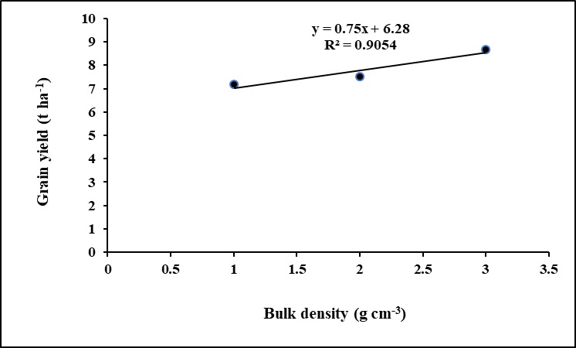

**Figure 2: Relationship between mean bulk density (g cm-3) Vs mean grain yield (t ha-1)**

**3.1.2.8 Biological Yield**

Tillage operation in combination with poultry manure and chemical fertilizer application showed significant effect on biological yield of BRRI dhan28. The highest biological (17.83 t ha-1) yields were measured in T3+P+C (Three passing of power tiller + poultry manure+ chemical fertilizer application) which was significantly higher *(p<0.05)* than other treatments and the lowest biological yields (17.17 t ha-1) were measured in T1+P+C (One passing of power tiller + poultry manure+ chemical fertilizer application) treatment.

**Table 9 Correlation and regression analysis among some soil physical properties, yield contributing attributes and grain yield**

|  |  |  |  |
| --- | --- | --- | --- |
| **Dependent variable** | **Independent variable** | **Regression**  **equation** | **Correlation co-efficient** |
| Grain  yield (GY) | Bulk density  (g cm -3) | GY= 0.75x+6.28 | r = 0.9054 |
| Grain  yield (GY) | Soil moisture  (%) | GY= 0.3918x-12.809 | r = 0.8937 |
| Grain yield (GY) | Air-filled porosity (%) | GY= 0.8075x-3.6306 | r= 0.8099 |
| Grain  yield (GY) | 1000 grain  weight (gm) | GY= 6.7209x-144.69 | r = 0.9984 |

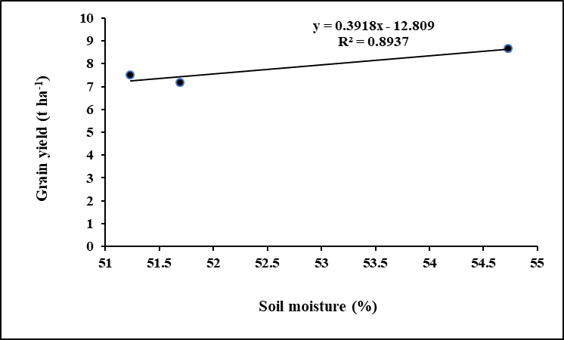

**Figure 3: Relationship between mean soil moisture (%) Vs mean grain yield (t ha-1)**

* 1. **DISCUSSION**

The bulk density of soil was significantly influenced by tillage and application of poultry manure. It may be due to the application of poultry manure which improved granulation of soil, increased aeration and porosity of soil. This result was also supported by Hati *et al.* (2006) and Joseph et al. (2025). Dugan et al. (2024) found that the aeration effects of tillage depth and poultry manure was significant. Higher bulk density refers to the poor physical condition of soil e.g low aeration, low moisture content, low water movement etc. Similar results were also observed by Ranjan *et al.* (2006), Ogbodo (2005) and Lardy et al. (2022).

The results indicated that the looser soil (T3+P+C treatment) absorbed more soil moisture compared to compacted soil T1+P+C treatment. The present findings are in agreement with Saltion and Mielnieseuk (1995) and Ahmadi and Ghaur (2015).

Addition of poultry manure in soil increased the moisture holding capacity as result soil moisture content was increased. Similar result was found by Sharma and Bali (2000) and Busari et al. (2023). After harvest soil moisture decreased with the increase of soil depth probably due to the absence of low fragipan layer.

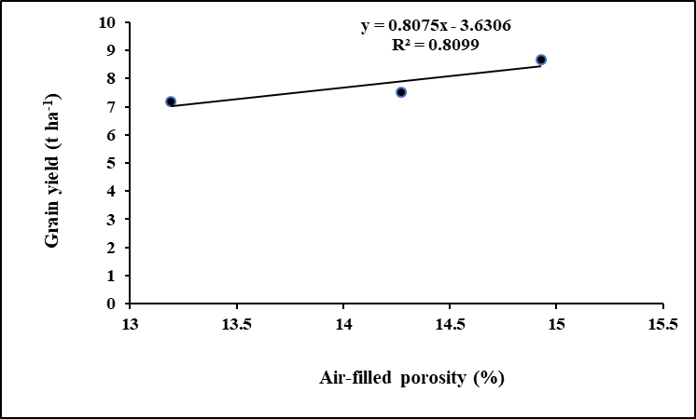

**Figure 4: Relationship between mean air-filled porosity (%) Vs mean grain yield (t ha-1)**

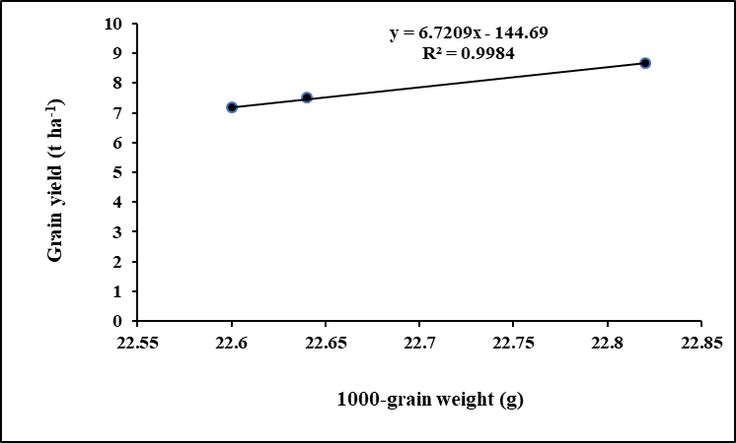

**Figure 5: Relationship between mean 1000 grain weight (g) Vs mean grain yield (t ha-1)**

Air-filled porosity means a space occupied by air in the soil. From the data it is clear that more loosen soil is present under T3+P+C treatment and can allow more air into the soil. The present results were accorded with the findings of Hati *et al.* (2006) and Getahun et al. (2018). Adequate aeration in soil can encourage the activity of microorganisms present in soil that may accelerate the growth and development of a crop by providing nutrient elements available to roots.

Tillage intensity and application of poultry manure influenced the number of effective tiller hill-1, non-effective tiller hill-1, plant height, panicle length, 1000-grain weight, grain yield and straw yielddue to absorption of more water and nutrients from deeper soil. The present result is accorded with Ranjan *et al.* (2006) and Das et al. (2024).

Rice yield depends largely on tillers hill-1, grains panicle-1, soil moisture, air filled porosity and bulk density. Grain yield has a positive relationship with 1000-grain weight, soil moisture and air-filled porosity. Positive relationship indicates the increase of grain yield was dependent on increase of 1000 grain weight, soil moisture and air-filled porosity. On the other hand, grain yield has a negative relationship with bulk density. Negative relationship indicates that grain yield will decrease with the increase of bulk density. Because high bulk density restricted root growth that affected the yield contributing characters of rice.

4. Conclusion

Tillage intensity, poultry manure and chemical fertilizer incorporation improved the physical properties of soil i.e. reduced the bulk density of soil, increased the air-filled porosity and soil moisture content.Grain yield has significant positive relationship with soil moisture, air filled porosity and 1000 grain weight *(p<0.01*) and also has significant negative relationship with bulk density (*p<0.01)*. Treatment combination T2+P+C (Two passing of power tiller+ poultry manure+ chemical fertilizer) showed the highest grain yields where T3+P+C (Three passing of power tiller+ poultry manure+ chemical fertilizer) showed the highest straw yields.

**DISCLAIMER (ARTIFICIAL INTELLIGENCE)**

Author(s) hereby declare that NO generative AI technologies such as Large Language Models (ChatGPT, COPILOT, etc.) and text-to-image generators have been used during the writing or editing of this manuscript.

COMPETING INTERESTS

Authors have declared that no competing interests exist.

References

Ahmadi, I., & Ghaur, H. (2015). Effects of soil moisture content and tractor wheeling intensity on traffic-induced soil compaction. *Journal of Central European Agriculture*.

Al-Shammary, A. A. G., Al-Shihmani, L. S. S., Fernández-Gálvez, J., & Caballero-Calvo, A. (2024). Optimizing sustainable agriculture: A comprehensive review of agronomic practices and their impacts on soil attributes. *Journal of Environmental Management*, *364*, 121487.

Anonymous. (2022). Annual Report of Bangladesh Rice Research Institute 2022-2023 BRRI, Gazipur 1701, Bangladesh, Page 1-646. <https://brri.portal.gov.bd/sites/default/files/files/brri.portal.gov.bd/page/6d86d72e_953c_4f74_9157_3cfeaa80c2b1/2023-11-19-08-40-31f6f535f0ea30e2192859843fa4e4e1.pdf>

BANGLADESH RICE JOURNAL. (2022). ISSN 1025-7330. Volume 26, Number 2, Page 1-86. <https://brri.portal.gov.bd/sites/default/files/files/brri.portal.gov.bd/page/ea9c4002_59f2_4df1_b0e2_f77738a7c24f/2023-10-05-05-55-ad2e25c9e6ca6c3e3fd4aaba37331021.pdf>

BBS (Bangladesh Bureau of Statistics) (2010) Statistical Year Book of Bangladesh. Ministry of Planning, Govt. Peoples’ Republic of Bangladesh.

BBS (Bangladesh Bureau of Statistics). (2019) Yearbook of Agricultural Statistics of Bangladesh 2019. Ministry of Planning, Government of the People’s Republic of Bangladesh.

Black, J. W., Duncan, W. A., & Shanks, R. G. (1965). Comparison of some properties of pronethalol and propranolol. *British Journal of Pharmacology and Chemotherapy*, *25*(3), 577.

Bouyoucos GJ 1927: The hydrometer as a method for the mechanical analysis of soils. Soil Science 23 343-353.

Busari, M. A., Bankole, G. O., Adiamo, I. A., Abiodun, R. O., & Ologunde, O. H. (2023). Influence of mulch and poultry manure application on soil temperature, evapotranspiration and water use efficiency of dry season cultivated okra. *International Soil and Water Conservation Research*, *11*(2), 382-392.

Das, P. P., Mahbubur, R. K. M., Mahiudin, M., & Ray, B. P. (2024). Effect of poultry manure and mineral concentration on grain yield and straw of BR11 rice genotypes in Bangladesh. *Mathews J Nutr Diet*, *7*(1), 29-37.

Dugan, I., Pereira, P., Kisic, I., Matisic, M., & Bogunovic, I. (2024). Analyzing the influence of conservation tillage and manure on soil parameter modulations in croplands. *Plants*, *13*(5), 607.

FAO (2004) Production Yearbook, Food and Agricultural Organization of the United Nations, Rome, Italy. 57, 76-77.

FAO and UNDP 1988: Land Response Appraisal of Bangladesh for Agricultural Development, Report 2. Agro-ecological Regions of Bangladesh. Food and Agricultural Organization and United Nations Development Programme. pp. 212-221.

Getahun, G. T., Kätterer, T., Munkholm, L. J., Parvage, M. M., Keller, T., Rychel, V., & Kirchmann, H. (2018). Short-term effects of loosening and incorporation of straw slurry into the upper subsoil on soil physical properties and crop yield. *Soil and Tillage Research*, *184*, 62-67.

Gomez KA, Gomez AA 1984: Statistical Procedures for Agricultural Research 2nd edn. International Rice Research Institute Los Banos Languna, The Philippines. pp. 62-74.

Hati KM, Swamp P, Singh D, Misra AK, ghosh PK 2006: Long-term continuous cropping, fertilization and manuring effects on physical properties and organic carbon content of a sandy loam soil. *Australian Journal Soil Research 44(4)* 487-495.

Joseph, P. O., Ojomah, F. O., & Abioye, J. B. (2025). POULTRY MANURE-INDUCED INFLUENCE ON SOIL PROPERTIES OF COARSE-TEXTURED TROPICAL SOIL. *Journal of Wastes and Biomass Management (JWBM)*, *7*(1), 01-05.

Jote, C. A. (2023). The impacts of using inorganic chemical fertilizers on the environment and human health. *Org. Med. Chem. Int. J*, *13*, 555864.

Khan, R. T., Mumtaz, K., Mehmood, B., Ahmed, M. F., Saleem, S., Ullah, S., ... & Hussain, S. (2022). EFFECT OF DIFFERENT HORMONAL CONCENTRATIONS ONIN-VITRO REGENERAT-ION OF RICE (*Oryza sativa* L.). *Pakistan Journal of Biotechnology*, *19*(02), 97-102.

Lal R 1995: Tillage in land rice-based cropping systems, Soil Physics and Rice, International Rice Research Institute Ibadan Nigeria. pp. 288-289.

Lardy, J. M., DeSutter, T. M., Daigh, A. L., Meehan, M. A., & Staricka, J. A. (2022). Effects of soil bulk density and water content on penetration resistance. *Agricultural & Environmental Letters*, *7*(2), e20096.

Mahmud, A. J., Shamsuddoha, A. T. M., & Haque, M. N. (2016). Effect of organic and inorganic fertilizer on the growth and yield of rice (Oryza sativa L.). *Nature Science*, *14*(2), 45-54.

Mainuddin, M., Alam, M. M., Maniruzzaman, M., Kabir, M. J., Mojid, M. A., Hasan, M. M., ... & Islam, M. T. (2021). Yield, profitability, and prospects of irrigated Boro rice cultivation in the North-West region of Bangladesh. *PloS one*, *16*(4), e0250897.

Mateo‐Marín, N., Bosch‐Serra, À. D., Molina, M. G., & Poch, R. M. (2022). Impacts of tillage and nutrient management on soil porosity trends in dryland agriculture. *European Journal of Soil Science*, *73*(1), e13139.

Metwally, T.F., Gewaily, E.E., Naeem, S.S. (2011). Nitrogen response curve and nitrogen use efficiency of Egyptian hybrid rice. J. Agril. Res. KafrEl-Sheikh Univ. 37: 73–84.

Ozpnar S, Clay A 2005: Effect of minimum and conventional tillage systems on soil properties and yield of winter wheat (*Triticum aestivum* L.) in clay loam in the Canakkale Region. *Turkish Journal of Soil Research* 12(1) 9-18.

Ranjan B, Singh RD, Chandra S, Kundu S, Gupta HS 2006: Effect of tillage and irrigation on yield and soil properties under rice (*Oryza sativa*), wheat (*Triticum aestivum*) system on a sandy clay loam soil of Uttaranchal. *IndianJournal of Agricultural Science 6(7) 405-409.*

Saltion JC, Miellniczeuk J 1995: Relationship between tillage, temperature and moisture in adark red Podzolic soil of Eldoradosul. Rvista Brasileia de Cienciadoslo 19(2) 313-319.

Shanmugavel, D., Rusyn, I., Solorza-Feria, O., & Kamaraj, S. K. (2023). Sustainable SMART fertilizers in agriculture systems: A review on fundamentals to in-field applications. *Science of The Total Environment*, *904*, 166729.

Sharma MP, Bali SB 2000: Long-term effect of different cropping systems on physicochemical properties and fertility.*Journal of Indian Society of Soil science* 48 181-183*.*

Vulliod P, Nayroud JA, Mercier E 2006: Results of a 35-year ploughless tillage experiment at changing (1970-2004). *Journal of Production Agriculture* 38 (supplement) 1-16.

Wang, L., Lyu, J., & Zhang, J. (2024). Explicating the Role of Agricultural Socialized Services on Chemical Fertilizer Use Reduction: Evidence from China Using a Double Machine Learning Model. *Agriculture*, *14*(12), 2148.

Wato, T., Negash, T., Andualem, A., & Bitew, A. (2024). Significance of organic and inorganic fertilizers in maintaining soil fertility and increasing crop productivity in Ethiopia: a review. *Environmental Research Communications*, *6*(10), 102002.

Xu, C., Liu, W., Li, J., Wu, J., Zhou, Y., & kader, R. (2024). Dynamic change of soil aggregate stability and infiltration properties during crop growth under four tillage measures in Mollisols region of northeast China. *Frontiers in Earth Science*, *12*, 1357467.

APPENDIX

**Appendix I. Distribution of monthly average air temperature, relative humidity, rainfall and sunshine hours of the**

**experimental site during the experiment (November 2014-May 2015)**

|  |  |  |  |  |  |  |  |  |
| --- | --- | --- | --- | --- | --- | --- | --- | --- |
| **Year** | **Month** | **\*Air temperature (0C**) | | | **\*Humidity (%)** | **\*\*Rainfall**  **(mm**) | **\*\*Sunshine (hrs.)** | **\*Evaporation**  **(mm)** |
| **Max.** | **Min.** | **Aver.** |
| 2014 | November | 24.3 | 12.6 | 18.5 | 83.2 | 00.0 | 106.0 | 64.6 |
| December | 25.6 | 14.1 | 19.9 | 76.9 | 43.6 | 148.2 | 65.5 |
| **2015** | January | 30.6 | 18.3 | 24.5 | 72.5 | 47.7 | 229.2 | 122.4 |
| February | 29.6 | 16.1 | 22.4 | 81.6 | 00.0 | 218.1 | 89.5 |
| March | 25.1 | 13.6 | 19.4 | 84.5 | 00.6 | 97.5 | 72.3 |
| April | 30.56 | 21.43 | 26.35 | 81.03 | 108.9 | 139.6 | 108.9 |
| May | 32.16 | 24.03 | 28.12 | 80.80 | 203.6 | 151.8 | 139.2 |

* Monthly average

** Monthly total

**Source:** Weather Yard, Department of Irrigation and Water Management, Bangladesh Agricultural University, Mymensingh.