Mitigation of Salt Stress on Seedling Establishment, Antioxidant Capacity, and Ion Homeostasis in Maize by Seed Priming with Melatonin

ABSTRACT
The present study was conducted at the Department of Laboratory, China. To investigate the effects of melatonin priming in mitigating the negative impact of salt stress on seedling establishment of maize (Zea mays L.). Maize seeds were separately primed with 1000 μM of melatonin before germination for 20 h and after germinated at four-leaf-stage consequently exposed to 150 and 300 mM of NaCl. Six concentrations were used: CK: Control; M: 1000 μM of melatonin, ST1: 150 mM NaCl only; ST2: 300 mM NaCl only; M+ST1: melatonin+150 mM NaCl; M+ST2: melatonin+300 mM NaCl. The treatments were arranged in a Randomized Complete Block Design (RCBD) with four replications.
Parameters measured under study were analyzed statistically using SPSS (SPSS Inc, Chicago, IL). Significantly different means of the measured data separated at the 0.05 probability level using Duncan’s Multiple Range Test (DMRT). The results showed that salt stress caused significant reduction in shoot and root length,. Fresh and dry weight of shoot and root, relative water (RWC) and soluble sugar contents of shoot and root, while melatonin priming mitigated these decline. Also, salt stress decreased chlorophyll, carotenoid, and K+ contents, antioxidant activities, but melatonin priming improved these parameters. We also establish that salt- stressed seedlings had higher reactive oxygen species (ROS) malondialdehyde (MDA), hydrogen peroxide (H2O2) contents, superoxide (O2-) , proline , abscisic acid (ABA) , and sodium (Na+) contents, whereas seed primed with melatonin lowered these characters. Then, seed priming with 1000 μM of melatonin expected to be a best choice to mitigate the negative effects of salts stress at seedling establishment stage in maize.

Keywords: melatonin priming, antioxidant enzymes, reactive oxygen species, maize (Zea mays L.), salt stress

1. Introduction
Salinity has debilitated approximately 20% of global cultivated land, and the area is speedily increasing because of irregular climate changes and anthropogenic activities [1].Nevertheless, sensitivity of crops to salt stress might differ depending on its developmental stage. Seed germination and early seedling growth stages are established to be extremely vulnerable to salt harm [2, 3, and 4]. Salt stress decrease seed germination and seedling development by reducing the supply of water and available of nutrients to plants throughout ionic and osmotic toxicity [5]. Also, salinity causes oxidative stress injures essential cellular structures, induced biochemical physiological and metabolic processes to be disrupted [6, 7].
Melatonin (N-acetyl-5-methoxytryptamine) is an essential biological hormone played imperative part in numerous vital life processes, including the entrainment of circadian rhythms [8], immunological improvement [9], seasonal reproduction physiology [10], and activity of antioxidant [11]. in addition, one of the most repeatedly reported melatonin functions is measured to be an antioxidant for protection against biotic and a biotic stress in the plants [12], like drought stress [13], salinity stress [14], cold stress [15], low temperature stress [16]] , and heavy metal stress [17].
Also functions of melatonin in the defense system of antioxidant have been broadly investigated under several environmental stresses in different plants [13, 15, 17, 18].
Maize (Zea mays L.), is a cereal plant of the family Poaceae, and is one of the very important crops throughout the world, and it is the staple food in many areas. At the same time, it is also most important raw materials of industry and biofuels in the world [19]. Maize is great importance because it can persevere in harsh environmental conditions. Nevertheless, harsh environmental and climatic conditions may induce the growth, establishment, and production of maize crop [20, 21].
In this research, we aim to study the effects of seed priming with melatonin on plant growth, accumulation of ROS, antioxidant enzymes, photosynthetic pigment, and ion homeostasis in maize seedling under salt stress.

2. Materials and Methods
2.1 Experimental Layout and Design
The experiment was carried out in the department of Laboratory, china. Uniform seed of maize (Zea mays L.) were selected and surface- sterilized with 2.5% sodium hypochlorite for 10 min and washed seven times with sterile distilled water, and then air-dried at room temperature (25°C). After that, two treatments were set by soaking the seeds in distilled water as control and 1000 μM of melatonin solution for 20 h, respectively. After priming, seeds were air-dried in the shade for 12 hours before being sundried to restore their natural weight. The soaked 30 seeds were put on a filter paper in petri dishes. The dishes were incubated at 22±0.5 ⁰C for germination, after seed germination, when two leaves fully expanded maize plants were transplanted to plastic containers (45 cm in length, 35 cm in width and 18 cm in height). The planting density was 20 plants in each container. The Hoagland nutrient solution was used for hydroponic culture. At the four-leaf stage, plants were subjected to salt stress (NaCl 58.44) with concentrations of 150 mM NaCl and 300 mM NaCl, respectively. Six treatments formed: CK: Control; M: 1000 μM of melatonin, ST1: 150 mM NaCl only; ST2: 300 mM NaCl only; M+ST1: melatonin+150 mM NaCl; M+ST2: melatonin+300 mM NaCl. The experiment treatments were arranged in a Randomized Complete Block Design (RCBD) with four replications. Seedling were sampled at 8 days after salt treatments applied for measurements of the physiological, biochemical parameters , seedling shoot and root lengths, and shoot and root fresh and dry weights.
2.2 Shoot and Root Lengths, Fresh and Dry Weight of Shoot and Root
The shoot and root lengths of five randomly chosen plants from each replicate were calculated using the measuring tape. Seedling shoots and roots of five randomly selected seedlings from each experimental unit, weighed by digital balance immediately. Final fresh weight was determinate in (g plant⁻¹). The sample of fresh five plants was left to dry in an oven at 80 ⁰C for 36 hours then weighted by digital balance to estimate final dry weight.
2.3 Chlorophyll Concentration and relative water content
Chlorophyll (Chl) and carotenoid were extracted from fresh leaves with 80% (v/v) acetone and measured spectrophotometrically with the method mentioned by [22]. Relative water content (RWC) for both shoot and root was calculated according to the following formula: RWC = (fresh weight - dry weight) / (turgid weight - dry weight) ×100 % following the method described by [23].
2.4 Soluble sugar and proline content
Soluble sugar was extracted from the shoot and root by water boiling and its concentration were measured using the method of Arthur-Thomas [24]. Proline content in fresh shoot and root was measured according to the method described by [25].
2. 5 Contents of malondialdehyde (MDA), H₂O₂, and O₂₋ production rate
The extraction of malondialdehyde (MDA), hydrogen peroxide (H₂O₂), and superoxide (O₂₋) in seedling leaves were measured following the method of [26]. Fresh samples of leaves (500 mg) were homogenized into powder with 5 ml of ice-cold extraction buffer (50 mM potassium phosphate buffer, pH 7.0, 0.4 % polyvinylpoly pyrrolidone) at four℃. The extract centrifuged at 10,000 g for 30 min, and the supernatant used as crude extract. MDA concentration calculated using the method described by [27]. H₂O₂ content determined by the method of [28], the production rate of O₂₋ conducted by following the procedure of [29].
2.6 Estimation of antioxidant enzymes
To conduct antioxidant enzymes, 0.5 g fresh leaves of maize were grounded in the chilled extraction buffer that contained 25 mM Hepes (pH 7.8), 2% (w/v) polyvinylpyrrolidone (PVP), 2 mM ascorbate and 0.2 mM EDTA on ice. After centrifugation (12 000 g for 30 min at 4°C), the supernatants were utilized for the subsequent enzyme. The activity of superoxide dismutase (SOD), peroxidase (POD) calculated according the method of [26], ascorbate peroxidase (APX) determined following the method described by [30].
2.7 Measurement of endogenous abscisic acid (ABA) contents
The concentration of ABA in maize leaves was done according to method described by [31]. The leaves were ground in liquid nitrogen and homogenized with 80% methanol. After 30 min incubation at 4°C, the samples were centrifuged 10 min at 12 000 g at 4°C and the pellets were extracted. The extracts were freeze-dried using the Scientz-10N (Ningbo Scientz Biotechnology CO. LTD., Ningbo, China), and after that were resolved in 20% methanol follow by filtration through 0.2 μm syringe filters. ABA was caculated by liquid chromatography system (1290 LC, Agilent Technologies Inc., Santa Clara, CA) couple to a mass spectrum system (6470 LC-MS/MS, Agilent Technologies Inc., Singapore).
2.8 Contents of K⁺ and Na⁺ in seedling plants
The contents of K⁺ and Na⁺ in shoot and root of maize seedlings measured following the method of [32]. In brief, 100 mg powder of oven-dried shoot and root sample was incubated in 5 ml concentrated sulphuric acid to fully digest and added in 200 μl 30% H2O2 a catalyst. K⁺ and Na⁺ concentrations were determined using an atomic absorption spectrometer (Beijing Purkinje General Instrument Co., Ltd., China)

Statistical analyses
In this study, all data shown as the mean values ± SD (standard deviations). At least three independent replicates conducted for each experiment. Data were analyzed using the one-way ANOVA using SPSS (SPSS Inc, Chicago, IL). Significantly different means of the measured data separated at the 0.05 probability level using Duncan’s Multiple Ranges Test.

3. Results
3.1 Growth Parameters
The plant growth was significantly inhibited by salt stress, Indexes of maize seedlings growth were significantly enhanced with melatonin priming contrasted with no melatonin treatment, as demonstrated by decreased shoot and root length, and plant biomass, and the reduction was more severe under salt level (ST2) than level (ST1) (Table 1). However, the exogenous of 1000 μM melatonin significantly (P < 0.05) alleviates this response. The plant growths of seedlings from primed seeds with melatonin (M+ST1, M+ST2) were less inhibition than from non-primed seeds under both salt stresses, respectively.
3.2. Shoot and Root Relative Water Content (RWC), Total Soluble Sugar, and Proline Content
Salt stress led to decrease in RWC in both shoot and root compared with control plants while seed priming by 1000 μM melatonin confirmed significant (P < 0.05) improvement in RWC in both organs in comparison to salt-stressed ones alone and enlarged more in root than in shoot (Table 2). Compared to the control the concentration of soluble sugar significantly reduced by salt stress the declined rate was much higher under ST2 than under ST1 (Table 2). Meanwhile, the application of melatonin priming (M+ST1, M+ST2) demonstrated higher soluble sugar content than the corresponding salt stress treatment. Conversely, compared to the control plants, the proline content significantly enhanced in the maize seedling shoot and root under salt stress, but melatonin priming significantly (P < o.o5) declined this content under salt stress (Table 2.).

Table 1. Effects of melatonin priming on seedling shoot and root length, fresh and dry weight of shoot and root of four- leaf-stage seedling grown under salt stress in maize
Length (cm) |  |  | Fresh weight (g plant⁻¹) |  | Dry weight (g plant⁻¹)
Treatments | Shoot | Root | Shoot | Root | Shoot | Root
CK | 30.56b | 32.72b | 4.52b | 4.22b | 1.21b | 0.95a
M | 32.67a | 35.19a | 5.79ª | 5.19a | 1.47a | 0.97a
ST1 | 20.18. e | 22.65e | 3.18e | 2.89e | 0.71e | 0.59d
ST2 | 17.83f | 20.19f | 2..98f | 2.44e | 0.67e | 0.52d
M+ST1 | 28.53c | 30.44c | 4.13c | 3.67c | 0.98c | 0.87b
M+ST2 | 26.32d | 28.87d | 3.89d | 3.11d | 0.91d | 0.82c
Different small letters in the same column refer to significant difference between treatments at P < 0.05 level, CK = control, M = 1000 μM of melatonin, ST1 = 150 mM of salt (NaCl), ST2 = 300 mM of salt (NaCl), M + ST1 = 1000 μM of melatonin +150 mM of salt (NaCl), M+ST2= 1000 μM of melatonin +300 mM of salt (NaCl)

Table 2. Effects of melatonin priming on RWC, Soluble sugar and proline contents of shoot and root of four- leaf-stage seedling grown under salt stress in maize
RWC (%) |  |  | Soluble sugar content(mg g⁻¹DW) |  | Proline content (mg g⁻¹FW)
Treatments | Shoot | Root | Shoot | Root | Shoot | Root
CK | 90.56b | 93.27a | 25.38b | 20.87b | 18.21e | 15.21e
M | 91.67a | 93.88a | 27.63a | 22.19fa | 16.33f | 13.34f
ST1 | 78.18e | 81.65d | 20.66e | 16.11e | 21.56b | 18.67b
ST2 | 76.83f | 78.19e | 18..98f | 14.44f | 23.45a | 20.71a
M+ST1 | 88.53c | 90.41b | 24.13c | 20.13c | 19.21d | 16.39d
M+ST2 | 86.32d | 88.71c | 22.89d | 18.89d | 20.42c | 17.91c
Different small letters in the same column refer to significant difference between treatments at P < 0.05 level, CK = control, M = 1000 μM of melatonin, ST1 = 150 mM of salt (NaCl), ST2 = 300 mM of salt (NaCl), M + ST1 = 1000 μM of melatonin +150 mM of salt (NaCl), M+ST2= 1000 μM of melatonin +300 mM of salt (NaCl)
3.3 Chlorophyll and Caroteniod Contents
Under salt stress condition, chlorophyll and caroteniod concentrations were significantly (P < 0.05) decreased when compared with unstressed control plants (Fig. 1 a and b). While 1000 μM of melatonin application clearly alleviated the harmful effect of 150 and 300 mM NaCl of salt stress on these pigments, and caused further increases in chlorophyll and caroteniod contents.
3.4 Concentrations of MDA, H₂O₂ and O₂⁻ Production Rate
Compared to the control, salt stress considerably (P < 0.05) increased the contents of MDA and H2O2 in maize seedling (Fig. 2 a and b). However, seeds primed with 1ooo μM of melatonin significantly (P < 0.05) inhibited the concentrations of these attributes compared to salt stress alone. The production rate of O⁻ 2 showed the same pattern as similar to H2O2 and MDA accumulation during the maize seedling growth (Fig. 2 c).
3.5 Activities of Antioxidant Enzymes
The antioxidant enzymes activities of SOD, POD, and APX, in maize seedling leaves were radically decreased by salt stress when compared to the control, mainly under the severe salt stress of ST2 (Figure 3 a-c). In contrast, pretreatment of melatonin remarkably (P < 0.05) enhanced SOD, POD, and APX activities
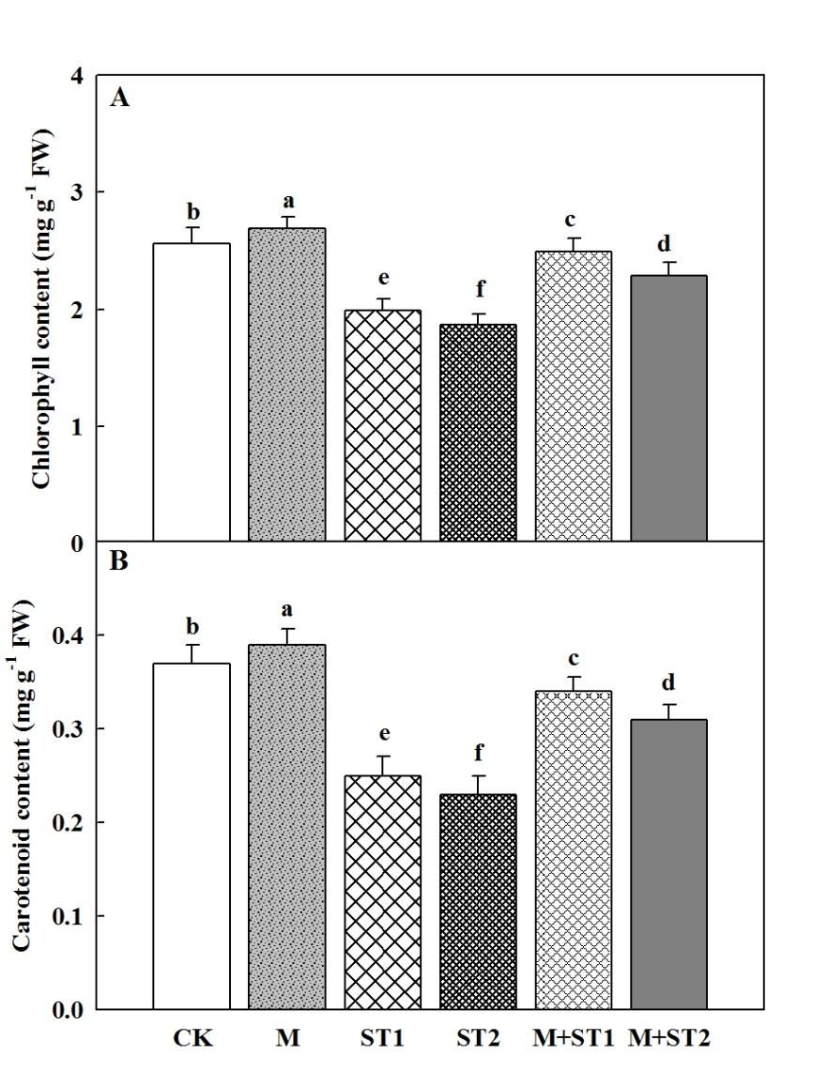
Figure. 1. Effects of melatonin priming on changes in contents of chlorophyll (A) and carotenoid (B) in top leaf of four-leaf-stage seedling under salt stress in maize. Data are mean +SD (n=3). Different small letters indicate significant differences between treatments at P < 0.05

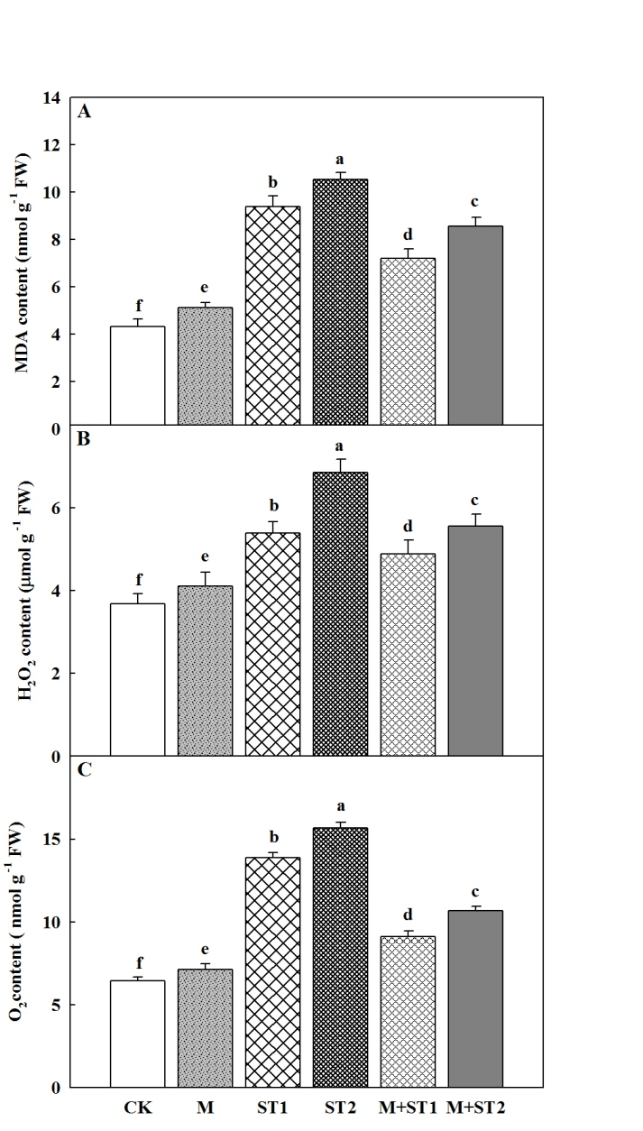
Figure. 2. Effects of melatonin priming on changes in contents of malondialdehyde (MDA) (A), hydrogen peroxide (H2O2) (B), and O2 -Production rate (c) in top leaf of four-leaf- stage seedling under salt stress in maize. Data are mean +SD (n=3). Different small letters indicate significant differences between treatments at P < 0.05

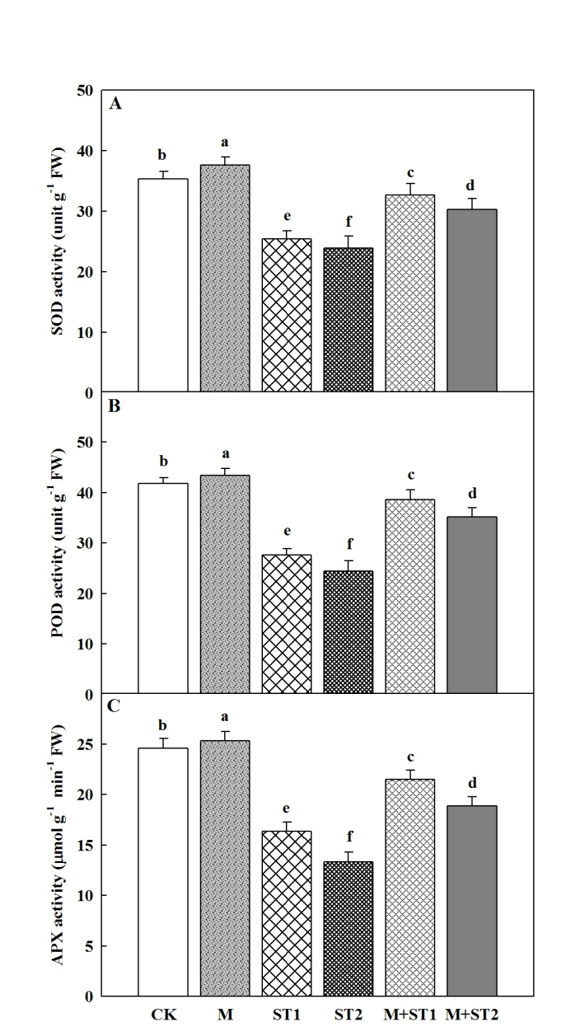
Figure. 3. Effects of melatonin priming on changes in activities of superoxide dismutase (SOD) (A), peroxidase (POD) (B), and ascorbate peroxidase (APX) (C) in top leaf of four-leaf- stage seedling under salt stress in maize. Data are mean +SD (n=3). Different small letters indicate significant differences between treatments at P < 0.05

3.6 ABA Concentration
The ABA content in maize seedling was increased under salt stress when compared to control in both 150 and 300 mM of NaCl. (Fig. 4). However, under salt stress melatonin priming significantly (P < 0.05) improved maize seedlings ABA content in both levels of salt stress (Fig. 4). In general, under salt stress melatonin priming had higher levels of ABA in maize seedling as compared to both control and melatonin alone.

3.7 Na+ and K+ contents and K+/Na+ ratio
As shown in Fig. 5, Na+ concentration significantly increased while K+ concentration decreased in maize shoot and roots under both 150 and 300 mM of salt stress and then resulted in reduction of K⁺/Na⁺ ratio in seedlings. However, under salt stress, 1000 μM of melatonin priming significantly (P < 0.05) increased the contents of K⁺ and decreased Na⁺ contents in shoot and roots then lead to increased in K⁺/Na⁺ ratio in maize shoot and roots compared with control (Fig 5 a-f).

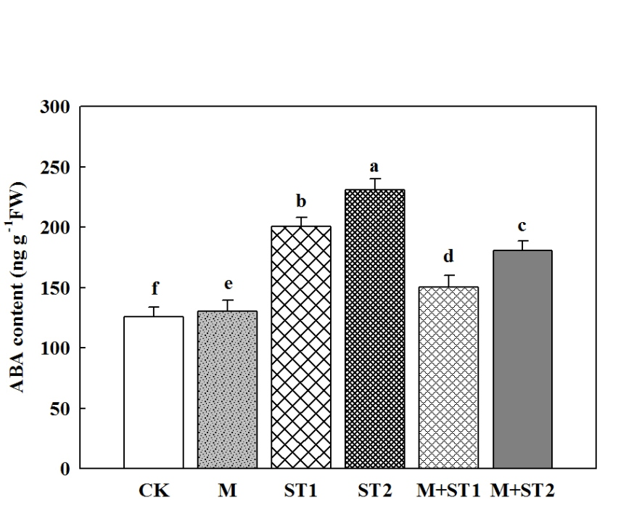
Figure. 4. Effect of melatonin priming on changes in abscisic acid content in top leaf of four- leaf- stage seedling under salt stress in maize. Data are means ±SD (n=3). Different small letters indicate significant difference between treatments at P < 0.05

4. Discussion
Salt stress obviously reduced plant growth and more detrimental at germination, and seedling establishment stages in a plant life. Also salt stress significantly disrupts various physiological, biochemicals, ion homeostasis; oxidative reductive and metabolic processes result in the decrease of crop yield [33, 34]. Melatonin, as a kind of new plant growth regulator, is contemplation to be occupied in numerous biotic and a biotic stress responses. Moreover, the potentiality of melatonin for inducing salt tolerance at germination and early seedling stage in different crops is well established [35, 36]. In the present experiment, the positive protective role of melatonin on physiological elucidation in terms of morphology, metabolism, photosynthesis, and antioxidation in maize seedlings against salt stress was investigated. Previous studies have confirmed that melatonin might play an essential regulatory function in plant growth and improvement [37, 38]. In this work, the growth of maize seedling was particularly inhibited when exposed to salt stress; however the reduction of growth was obviously enhanced by melatonin application (Table 1). This might be the early completion of pre-germination metabolic activities through seed priming. [39]. reported that 1000 μM melatonin pretreatment increased the growth attributes of maize seedling under salt stress, which is consistent with our findings. Relative water content (RWC) is important indicator of water relation for evaluate salt stress tolerance. Though, we also establish that salt stress significantly (P < 0.05) declined the. Shoot and root RWC in maize plants (Table 2). Moreover, we found that seeds priming by melatonin markedly maintain a better shoot and root water status of maize seedlings under salt stress, demonstrating that melatonin might play considerable role in maize water relation under salt stress and help the plants to absorb more water for salt stress tolerance. The a biotic stress usually led to reduce in leaf water status and enhance in osmotic regulators [40]. In agreement with these consequences, we found that salt stress led to decrease in RWC and soluble sugar and an increased level of proline (Table. 2).
Many studies have mentioned that melatonin possibly inhibit the reduce of the photosynthetic pigments under numerous environmental stresses [38, 41]. These results were confirmed by our data. Under salt stress condition, seed priming with melatonin illustrated higher concentration of photosynthetic pigments compared to the control (Fig. 1 a and b), this observed decline in pigments could be attributed not only to an augmented degradation but also to decreased synthesis of chlorophylls due to salinity.
The highest cellular creation of reactive oxygen species (ROS), mainly hydrogen peroxide (H₂O₂), enhance lipid peroxidation of cellular membranes [42], consequential in generation of largest MDA in plant tissues caused by salt stress. In the present research, salt stress enhanced H₂O₂, MDA, and O⁻2 production rate concentration in maize leaves (Fig. 2a- c) but, melatonin priming radically decreased hydrogen peroxide (H₂O₂) MDA content, and production rate of O₂⁻. Comparable diminutions in the production of H₂O₂ and MDA with melatonin application in maize during salt stress were mentioned by [43], demonstrating that melatonin may protect cell membranes against oxidative damage stimulated by salt stress [18]. Additionally, our present study also confirmed that a lower rate of cell death was obtained in melatonin priming plants under salt stress, indicating that melatonin might mitigate cell death by declining ROS accumulation under salt stresses in maize seedling
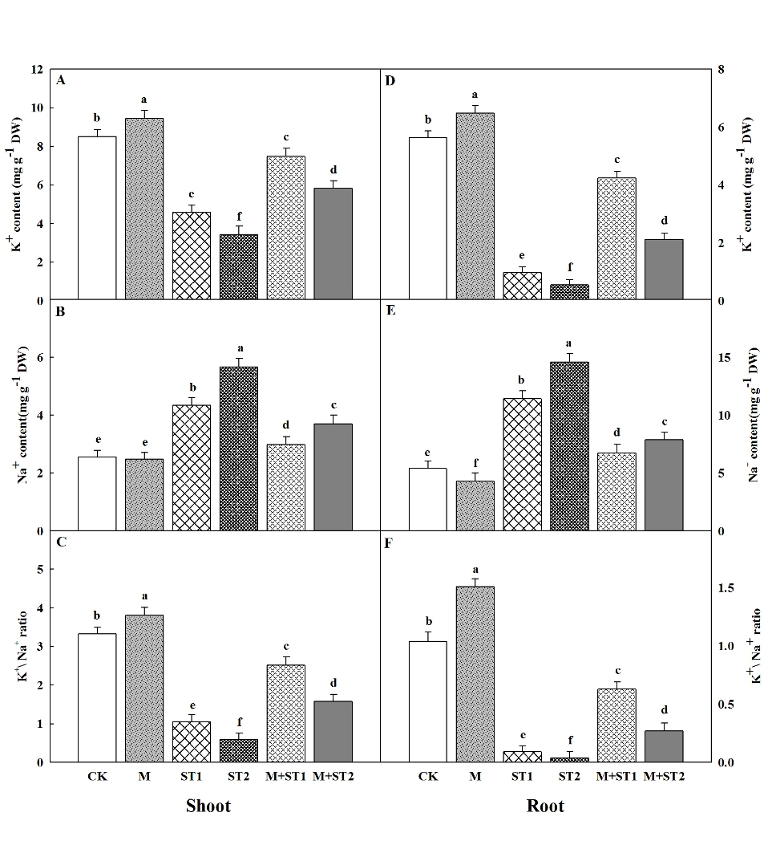
Figure. 5. Effects of melatonin priming on contents of K+ and Na+ in maize shoot and root during seedling establishment under salt stress. Data are mean +SD (n=3). Different small letters indicate significant differences between treatments at P < 0.05

The salt stress tolerance in plants is indicated by the enhanced the activities of antioxidant enzymes [44]. In plants, melatonin has recommended to be an essential antioxidant that can scavenge oxygen free radicals efficiently [14, 16]. Numerous studies have showed that application of melatonin can augment some antioxidant enzyme (such as POD, SOD, and APX) activities under a biotic stress in plants [16, 18]. Constantly, we found that under salt stress melatonin priming increased the antioxidant enzymes activities in maize seedlings under salt stress (Fig. 3 a-c). In the present experiment, the high activities of POD, SOD, and APX under salt stress in the presence of melatonin may possibly mainly be related to the synergistic effects of the combination of salt stress and application of melatonin. The up-regulation of antioxidants enzymes (SOD, APX, and POD) protection system with melatonin priming was also mentioned by [45]. In addition, [46] exposed that melatonin priming improved the expression of genes encoding antioxidant enzymes under salt stress.
It has been established that abscisic acid (ABA) can stimulate the accumulation of osmotic regulators such as proline and soluble sugar under environmental stresses. In the current research, the ABA concentration increased proportionally with the increase in salt stress level (Fig 4). Previous study reported that melatonin application might decrease ABA contents under drought stress [47]. This result was further confirmed in our experiment under salt stress. However, application of melatonin alleviated the reduce in leaf water status, demonstrating that melatonin may improve the water absorbing or holding capacity, probably during regulating ABA level and declining the accumulation of Na+ [18].
Growth inhibition induced by salt stress is a generally reported phenomenon in many species, and can be mostly related to specific ion toxicity, ion imbalance or interruption in ion homeostasis [48, 49]. External high salinity stimulated Na⁺ concentration and motivated water deficit, mineral nutrient insufficiency and ion imbalance in the cytosol [50, 51]. [52]. Furthermore, high Na⁺ accumulations causes a decreased of K⁺ uptake and disrupt cellular integrity and lead finally to cell death, hence a high K⁺/Na⁺ ratio can increase plant salt stress tolerance [52,53]. Several study showed that melatonin priming significantly reduced the concentration of Na+ and resulted in an observable increase of K+ contents and K⁺\ Na⁺ ratio in maize shoots under salt stress [18]. On the other hand, our present study confirmed that this phenomenon exists in both shoot and root under salt stress after 8 days of salt stressed maize plants (Fig. 5 a, b, e and d). Additionally, the role of melatonin in the acquisition of salinity tolerance by plants when exposed to salt stress may well explain why superior K⁺\ Na⁺ ratios are retained with it. These results were mentioned by [19] and [54], who found that melatonin priming in salt challenged maize seedlings resulted in the highest K⁺: Na⁺ ratios

5. Conclusions
The study confirmed that salt stress negatively influenced seedling establishment in maize, whereas seed priming with melatonin effectively mitigated the harmful effects on maize seedlings. It was also discovered that, under salt stress seed priming with melatonin performed better in terms of relative water content, total soluble sugar, and total proline contents. Moreover, seed priming with 1000 μM of melatonin promoted maize seedling establishment under salinity stress by delay leaf chlorophyll degradation and better maintenance of ion balance between K+ and Na+, and further improved leaf photosynthesis and alleviated the oxidative stress by enhancing antioxidant enzymes activities to reduce ROS production. Melatonin subsequently suggested as a prospective substance of seed priming for enhancement of salt stress throughout the seedling establishment stages in maize.

References
- Arora, D. and S.C. Bhatla. 2017. Melatonin and nitric oxide regulate sunflower seedling growth under salt stress accompanying differential expression of cu/zn sod and mn sod. Free Rad. Biol.& Med., 106: 315-328.
- Saleem, M.H., S. Ali, M.F. Seleiman, M. Rizwan, M. Rehman, N.A. Akram, L. Liu, M. Alotaibi, I. Al-Ashkar and M. Mubushar, 2019. Assessing the correlations between different traits in copper-sensitive and copper-resistant varieties of jute (Corchorus capsularis L.). Plants, 8(12): 545.
- Afzal, J., X. Wang, M.H. Saleem, X. Sun, S. Hussain, I. Khan, M.S. Rana, S. Ahmed, S.A. Awan, S. Fiaz, O. Aziz, K.A. Kubar, S. Ali and C. Hu. 2021. Application of ferrous sulfate alleviates negative impact of cadmium in rice (Oryza sativa L.). Biocell, 45(6): 1631-1649.
- Nawaz, M., X. Wang, M.H. Saleem, M.H.U. Khan, J. Afzal, S. Fiaz, S. Ali, H. Ishaq, A.H. Khan, N. Rehman, S. Shaukat and S. Ali. 2021. Deciphering plantago ovata forsk leaf extract mediated distinct germination, growth and physio-biochemical improvements under water stress in maize (Zea mays L.) at early growth stage. Agronomy, 11(7): 1404.
- Mohamed, I.A., N. Shalby, A. MA El-Badri, M.H. Saleem, M.N. Khan, M.A. Nawaz, M. Qin, R.A. Agami, J. Kuai and B. Wang, 2020. Stomata and xylem vessels traits improved by melatonin application contribute to enhancing salt tolerance and fatty acid composition of Brassica napus L. Plants. Agronomy, 10(8): 1186.
- Ali, M., M. Kamran, G.H. Abbasi, M.H. Saleem, S. Ahmad, A. Parveen, Z. Malik, S. Afzal, S. Ahmar, K.M. Dawar, S. Ali, S. Alamri, M.H. Siddiqui, R. Akbar and S. Fahad. 2020. Melatonin-induced salinity tolerance by ameliorating osmotic and oxidative stress in the seedlings of two tomato (Solanum lycopersicum L.) cultivars. J. Plant Growth Reg., https://doi.org/10.1007/s00344-020-10273-3.
- Kong, H., Z. Zhang, J. Qin and N.A. Akram, 2021. Interactive effects of abscisic acid (aba) and drought stress on the physiological responses of winter wheat (Triticum aestivum L.). Pak. J. Bot., 53(5): 1545-1551.
- Hardeland R, Madrid JA, Tan DX, Reiter RJ (2012). Melatonin, thecircadian multioscillator system and health: the need for detailedanalyses of peripheral melatonin signaling. J Pineal Res 52:139–166.
- Calvo JR, Gonzalez-Yanes C, Maldonado MD (2013). The role of melatonin in the cells of the innate immunity: a review. J Pineal Res 55:103–120.
- Barrett P, Bolborea M (2012) Molecular pathways involved in seasonal body weight and reproductive responses governed by melatonin. J Pineal Res 52:376 388.
- Reiter RJ, Tan DX, Osuna C, Gitto E (2000) Actions of melatonin in the reduction of oxidative stress a review. J Biomed Sci 7:444–458.
- Tan DX, Hardeland R, Manchester LC, Korkmaz A, Ma S, Rosales- Corral S, Reiter RJ (2012). Functional roles of melatonin in plants, and perspectives in nutritional and agricultural science. J Exp Bot 63:577–597.
- Wang P, Sun X, Li C, Wei Z, Liang D, Ma F (2013). Long-term exogenous application of melatonin delays drought-induced leaf senescence in apple. J Pineal Res 54:292–302.
- Wei W, Li QT, Chu YN, Reiter RJ, Yu XM, Zhu DH, Zhang WK, Ma B, Lin Q, Zhang JS, Chen SY (2015). Melatonin enhances plant growth and abiotic stress tolerance in soybean plants. J Exp Bot 66:695–707.
- Bajwa VS, Shukla MR, Sherif SM, Murch SJ, Saxena PK (2014). Role of melatonin in alleviating cold stress in Arabidopsis thaliana. J Pineal Res 56:238–245.
- Shi H, Jiang C, Ye T, Tan D, Reiter RJ, Zhang H, Liu R, Chen Z (2015). Comparative physiological, metabolomic, and transcriptomic analyses reveal mechanisms of improved abiotic stress resistance in bermudagrass [Cynodon dactylon (L). Pers.] by exogenous melatonin. J Exp Bot 66:681–694.
- Posmyk MM, Kuran H, Marciniak K, Janas KM (2008). Presowing seed treatment with melatonin protects red cabbage seedlings against toxic copper ion concentrations. J Pineal Res 45:24–31 Posmyk MM, Bałabusta M, Wieczorek M, Sliwinska E, Janas KM.
- Jiang C, Cui Q, Feng K, Xu D, Li C, Zheng Q (2016). Melatonin improves antioxidant capacity and ion homeostasis and enhances salt tolerance in maize seedlings. Acta Physiol Plant 38: 1–9.
- Chen Y-E, Mao J-J, Sun L-Q, Huang B, Ding C-B, Gu Y, Liao J-Q, Hu C, Zhang Z-W, Yuan S (2018). Exogenous melatonin enhances salt stress tolerance in maize seedlings by improving antioxidant and photosynthetic capacity. Physiol Plant 164(3): 349–363.
- Lv S, Yang X, Lin X, Liu Z, Zhao J, Li K, Mu C, Chen X, Chen F, Mi G (2015) .Yield gap simulations using ten maize cultivars commonly planted in Northeast China during the past five decades. Agric Forest Meteorol 205: 1–10.
- Ma L, Huang Z, Li S, Ashraf U, Yang W, Liu H, Xu D, Li W, Mo Z (2021). Melatonin and nitrogen applications modulate early growth and related physio-biochemical attributes in maize under Cd stress. J Soil Sci Plant Nut 21(2): 978–990.
- Arnon DI (1949). Copper enzymes in isolated chloroplasts. Polyphenoloxidase in Beta vulgaris. Plant Physiol 24:1–15.
- Chen YE, Cui JM, Su YQ, Yuan S, Yuan M, Zhang HY (2015). Influence of stripe rust infection on the photosynthetic characteristics and antioxidant system of susceptible and resistant wheat cultivars at the adult plant stage. Front Plant Sci 6: 779.
- Thomas TA (1977). An automated procedure for the determination of soluble carbohydrates in herbage. J Sci Food Agric 28: 639–642.
- Bates L, Waldren R, Teare I (1973). Rapid determination of free proline for water-stress studies. Plant Soil 39: 205–207.
- Tan W, Liu J, Dai T, Jing Q, Cao W, Jiang D. Alterations in photosynthesis and antioxidant enzyme activity in winter wheat subjected to post-anthesis water-logging. Photosynthetica 2008; 46:21-27. doi: 10.1007/s11099-008-0005-0 .
- Madhava-Rao K, Sresty T. Antioxidative parameters in the seedlings of pigeonpea (Cajanus cajan (L.) Millspaugh) in response to Zn and Ni stresses. Plant Sci 2000; 157(1):113-128. doi: 10.1016/s0168-9452(00)00273-9 .
- Moloi MJ, Van-der-Westhuizen AJ. The reactive oxygen species are involved in resistance responses of wheat to the Russian wheat aphid. J Plant Physiol 2006; 163:1118-1125.
- Sui N, Li M, Liu X-Y, Wang N, Fang W, Meng Q-W. Response of xanthophyll cycle and chloroplastic antioxidant enzymes to chilling stress in tomato over-expressing glycerol-3-phosphate acyltransferase gene. Photosynthetica 2007; 45(3):447-454. doi: 10.1007/s11099-007-0074-5.
- Fryer M, Andrews J, Oxborough K, Blowers D, Baker N. Relationship between CO2 assimilation, photosynthetic electron transport, and active O2 metabolism in leaves of maize in the field during periods of low temperature. Plant Physiol 1998; 116:571-579. doi: 10.1104/pp.116.2.571.
- Carvajal F, Palma F, Jiménez-Muñoz R, Jamilena M, Pulido A, Garrido D (2017). Unravelling the role of abscisic acid in chilling tolerance of zucchini during postharvest cold storage. Postharvest Biol Tec 133: 26–35.
- Zheng C, Jiang D, Liu F, Dai T, Liu W, Jing Q, Cao W. Exogenous nitric oxide improves seed germination in wheat against mitochondrial oxidative damage induced by high salinity. Environ Exp Bot 2009; 67(1):222-227. doi: 10.1016/j.en vexpbot.2009.05.002.
- Kaya, C., D. Higgs, M. Ashraf, M.N. Alyemeni and P. Ahmad. 2020. Integrative roles of nitric oxide and hydrogen sulfide in melatonin-induced tolerance of pepper (Capsicum annuum L.) plants to iron deficiency and salt stress alone or in combination. Physiol.Plant., 168(2): 256-277.
- Zafar, S., Z. Hasnain, S. Perveen, N. Iqbal and M.A. Zafar. 2021. Deciphering physio-biochemical characteristics of znso4 primed wheat (triticum aestivum L.) plants grown under salt stress. Pak. J. Bot., 53(6): 1943-1952.
- Jiang, D., B. Lu, L. Liu, W. Duan, L. Chen, J. Li and Z. Bai. 2020. Exogenous melatonin improves salt stress adaptation of cotton seedlings by regulating active oxygen metabolism. Peer J., 8: e10486. https://doi.org/10.7717/peerj.10486.
- Arun, M.N., S.S. Hebbar, B. Bhanuprakash, T. Senthivel, A.K. Nair, G. Padmavathi, P. Pandey, A. Singh. 2022. Seed priming: The way forward to mitigate abiotic stress in crops. In: (eds. M. Hasanuzzaman and K. Nahar), plant stress. Phys. Persp. Agric. Intech Open.
- Tan DX, Hardeland R, Manchester LC, Korkmaz A, Ma S, Rosales-Corral S, Reiter RJ (2012). Functional roles of melatonin in plants, and perspectives in nutritional and agricultural science. J Exp Bot 63: 577–597.
- Wei W, Li QT, Chu YN, Reiter RJ, Yu XM, Zhu DH, Zhang WK, Ma B, Lin Q, Zhang JS (2015). Melatonin enhances plant growth and abiotic stress tolerance in soybean plants. J Exp Bot 66: 695–707.
- Syed Saqlain Hussaini, Muhammad Rasheedi, Muhammad Hamzah Saleem, Zammurad Iqbal Ahmedi, Aqsa Hafeez, Ghulamjllani, Saad Alamri, Mohamed Hashem, and Shafaqat Ali (2023).Salt tolerance in maize with melatonin priming to achieve sustainability in yield in salt affected soils. Pak. J. Bot., 55(1): 19-35.
- Xu C, Huang B (2010). Differential proteomic responses to water stress induced by PEG in two creeping bentgrass cultivars differing in stress tolerance. J Plant Physiol 167: 1477–1485.
- Shi H, Jiang C, Ye T, Tan D, Reiter RJ, Zhang H, Liu R, Chan Z (2015). Comparativephysiological, metabolomic, and transcriptomic analyses reveal mechanisms of improved abiotic stress resistance in bermudagrass [Cynodon dactylon (L). Pers.] by exogenous melatonin. J Integr Plant Biol 66: 681–694.
- Kazemi, R., A. Ronaghi, J. Yasrebi, R. Ghasemi-Fasaei and M. Zarei. 2019. Effect of shrimp waste–derived biochar and arbuscular mycorrhizal fungus on yield, antioxidant enzymes, and chemical composition of corn under salinity stress. J. Soil Sci. & Plant Nutri., 19(4): 758-770.
- Chen, X., R. Zhang, Y. Xing, B. Jiang, B. Li, X. Xu and Y. Zhou. 2021. The efficacy of different seed priming agents for promoting sorghum germination under salt stress. Plos One, 16(1): e0245505.
- Farhangi-Abriz, S. and S. Torabian. 2018. Nano-silicon alters antioxidant activities of soybean seedlings under salt toxicity. Protoplasma, 255(3): 953-962.
- Zafar, S., Z. Hasnain, S. Anwar, S. Perveen, N. Iqbal, A. Noman and M. Ali. 2019. Influence of melatonin on antioxidant defense system and yield of wheat (triticum aestivum L.) genotypes under saline condition. Pak. J. Bot., 51(6): 1987-1994.
- Zhang, N., H.J. Zhang, B. Zhao, Q.Q. Sun, Y.Y. Cao, R. Li, X.X. Wu, S. Weeda, L. Li and S. Ren. 2014. The rna-seq approach to discriminate gene expression profiles in response to melatonin on cucumber lateral root formation. J. Pineal Res., 56(1): 39-50.
- Li C, Tan DX, Liang D, Chang C, Jia DF, Ma FW (2015). Melatonin mediates the regulation of ABA metabolism, free-radical scavenging, and stomatal behaviour in two Maluspecies under drought stress. J Exp Bot 66: 669–680.
- Zhao GQ, Ma BL, Ren CZ (2007). Growth, gas exchange, chlorophyll fluorescence, ion content of naked oat in response to salinity. Crop Sci 47:123–131.
- Jiang CQ, Quan LT, Shi F, Yang N, Wang CH, Yin XM, Zheng QS (2014). Distribution of mineral nutrients and active ingredients in Aloe vera irrigated with diluted seawater. Pedosphere 24:722–730.
- Mobeen, X. Wang, M.H. Saleem, A. Parveen, S. Mumtaz, A. Hassan, M. Adnan, S. Fiaz, S. Ali, Z. Iqbal Khan, S. Ali and G. Yasin, 2021. Proximate composition and nutritive value of some leafy vegetables from faisalabad, pakistan. Sustainability, 13(15): 8444.
- Saleem, M.H., X. Wang, S. Ali, S. Zafar, M. Nawaz, M. Adnan, S. Fahad, A. Shah, M.N. Alyemeni, D.I. Hefft and S. Ali. 2021. Interactive effects of gibberellic acid and npk on morpho-physio-biochemical traits and organic acid exudation pattern in coriander (Coriandrum sativum L.) grown in soil artificially spiked with boron. Plant Physiol. & Biochem., DOI https://doi.org/10.1016/ j.plaphy. 2021.09.015.
- Munns R, Tester M (2008). Mechanisms of salinity tolerance. Annu Rev Plant Biol 59: 651–681.
- Shabala S, Cuin TA (2008). Potassium transport and plant salt tolerance. Physiol Plant 133:651–669.
- Chen, L., L. Liu, B. Lu, T. Ma, D. Jiang, J. Li, K. Zhang, H. Sun, Y. Zhang and Z. Bai. 2020. Exogenous melatonin promotes seed germination and osmotic regulation under salt stress in cotton (Gossypium hirsutum L.). PloS One, 15(1): e0228241.

