Blockchain-based Supply Management System for Sustainable Ecosystem Logistics

Abstract
As traditional supply chain operations continue to pose challenges to the businesses, the adoption of Blockchain to solve issues of traceability and integrity in global supply and logistics networks is increasingly evident and persuasive across multiple geographies. The objective of this research study was to build a Blockchain Optimized Chain of Accountability (BOCA) to enhance transparency, accountability and efficient supply chain ecosystem. The methodology used is the Agile methodology to allow necessary changes, and adjustment to the system to be made quickly; resulting in a more robust, and user-friendly interface that aligned with users’ needs and expectations. The programming languages and tools used for the coding and development of the system are JavaScript (Vue.Js) and HTML/CSS for the user interfaces; JavaScript (Node.Js) for the blockchain; Go for development of blockchain; and SQL for data storage. The system promises to enable companies, businesses or individuals to order goods and raw materials for production and keep track of their inventory, make secure payments, gather, analyze and maintain tamper-proof record of supply chain events. The results of this study should, therefore, be of interest to organizations and stakeholders charged with the responsibility of improving innovation, enhancing competitive advantage and increasing the speed of relationships in supply chain and logistics networks across the globe.

Keywords: blockchain; BOCA; distributed ledger; smart contract; ecosystem logistics; Supply chain management

- Introduction
A supply chain ecosystem is a network of entities from across industries that work together to design, implement, and execute supply chain solutions. It is a collaborative network of organizations, including banks, vendors, suppliers, manufacturers, distributors, retailers, customers, processes, data and resources working together to move a product from its point of manufacture to where the end customer/user is located. It therefore involves the coordination and integration of activities such as sourcing, production, logistics, and distribution. Their networked nature and the resulting interdependencies can be a strong entry barrier against potential competitors (LinkedIn, 2023; Mentzer et al., 2001; Chopra & Meindl, 2013). This is critical for businesses to remain competitive in today's fast-paced and globalized market.
Consider a consumer who orders smartphones from a company, for example. The Supply management system helps track the journey of the phone from the supplier up to the consumer. It ensures that the consumer can track the location, date of delivery of the goods, and its safe arrival as ordered by the consumer.
However, several problems often arise in traditional supply management systems that hinder business development. The specific problems identified with traditional supply management systems can be summarized as follows:
- Delay in product delivery - Extensive paperwork slows down the movement of products.
- Inaccurate Inventories - use of different technologies by different parties creates information mismatch.
- Vulnerability to fraudulent activities or external hacker attacks, counterfeiting, product diversion, and false documentation often arise in traditional supply systems.
- Inefficiencies in tracking of goods and services, traceability, information sharing, and trust among the supply chain stakeholders.
The merging of business and technology under a single secured system like Blockchain, sometimes known as the “Internet of value”, will solve many of these problems and open the door for multiple opportunities (Syed Rifat Ahsan et al, 2021).
The aim of this research study is to design and implement a Blockchain Optimized Chain of Accountability (BOCA) to enhance transparency, accountability and efficiency in the distribution of a wide range of products namely cars, electronics, furniture, solar inverter systems, power branded generators, CCTV cameras, laptops, solar water heater, etc in the supply chain. The specific objectives of the study are:
- To develop a system with real time tracking feature, smart contracts for automating paperwork and documentation processes thereby eliminating delays, trusted information sharing powered by blockchain, and smart logistics feature.
- To provide a transparent, immutable, and shared record of all inventory, transactions, and product movements across the supply chain.
- Develop an immutable, secure, and transparent digital record that is hard to manipulate eliminating the vulnerability of supply chains to fraudulent activities like counterfeiting, and product diversion.
- Improve user experience, and enhance trust by providing a transparent, real-time, and immutable digital ledger that records every step of a products journey from origin to destination.
- Literature Review
Generally, the understanding of the impact of blockchain technology on supply chains is still limited. Existing literature focused on analyzing the value, current trends and future opportunities on the adoption of blockchain for supply chain management rather than research methodologies for developing and deploying them. These literature reviews only provide the foundation for further theory-based research on the use of blockchain in supply chains (Simon Wong et al, 2024).
  - Review of Related Concepts
Blockchain technology has been defined in various ways. One of such definitions says that Blockchain technology as “a decentralized, digital ledger that records and verifies transactions across multiple computers connected to the supply-chain (users); ensuring transparency, security, and immutability.” (Nakamoto S., 2008). This implies that the chain is maintained by a distributed network of computers, and each transaction is verified by consensus among the network participants (Simplilearn, 2024; Built In, 2024).
A blockchain is also defined as “a distributed database that maintains a continuously growing list of ordered records, called blocks”. Each block contains a cryptographic hash of the previous block, a timestamp, and transaction data. So if someone wants to change data in a block, he must change all previous blocks as well, which is almost impossible. (Black Duck Software, Inc., 2024). Thus, it provides a secure and transparent way to manage business transactions.
Access to the ledger (database) in terms of reading and writing may be unrestricted ('permissionless'), or restricted ('permissioned') (PwC Belgium, 2016 - 2024). Unlike permissionless (or public) blockchain, a permissioned (or private) blockchain is closed with accessibility control. In permissioned blockchain, only designated parties approved by the blockchain consortium are allowed to join the network, execute transactions, and access the transactional records stored in the blockchain. The permissioned blockchain allows replicas of transactional records to be maintained by the members of the blockchain consortium. In this manner, businesses can track and verify every step of the supply chain process, from sourcing to distribution, in a secure and decentralized manner. The transparency and traceability features help businesses to identify potential risks and vulnerabilities, such as counterfeit products, unauthorized modifications, or delays in transportation (Turing, 2024)); thereby building trust and maintain the integrity of the supply chain. Transparency is the "ability to see the entire supply chain and track the movement of goods, payments and information in real-time" (Chen et al., 2017; Gao et al, 2018). Traceability in supply chain management is the "ability to track the origin and movement of goods throughout the supply chain" (Chen et al., 2017; Gao et al, 2018).
Smart contracts (self-executing contracts) automatically trigger predefined actions when specific conditions are met. This improves trust among participants and gives near real-time visibility into the flow of goods, and the ability to take timely action if there is an exception (IBM, 2024).
  - Related Works
Studies on digital supply management system powered by blockchain technology are still in the early stages, and related academic articles are not fruitful (Simon Wong et al, 2024). However, the food and trade industries have been exploring the application of blockchain in supply chains.
In the food industry, Walmart Canada applied blockchain to manage supply chains; enabling real-time tracking and verification of products, solve a common logistics nightmare and improve supply chain traceability, transparency, and efficiency. The Walmart's Blockchain-Based Supply Chain Management platform has not only virtually eliminated the payments problem; it also has led to significant operational efficiencies (Harvard Business Review, 2022; Simon Wong et al, 2024). Trustwell's FoodLogiQ software suite is the most comprehensive, data-driven software solution enabling supplier management, food safety compliance, quality incident management, recall management, and whole chain traceability – all on a single platform built exclusively for the food industry. FoodLogiQ software suite provides a food supplier management software platform to help you align to brand and regulatory compliance (Trustwell, 2024).
‎In the trade industry, Maersk and IBM cooperated to use blockchain technology to solve problems in cross-border supply chains because it increases information transparency and realizes information sharing among trading partners (Simon Wong et al, 2024). Maersk's Supply Chain Management platform uses blockchain technology to assist small and medium-sized companies to manage and simplify their supply chains; enabling real-time tracking and verification of shipments (Maersk, 2020). IBM Food Trust is another blockchain-based platform for the food industry. It share food information securely and boost transparency in the global food chain with a modular, blockchain-based food safety and traceability solution. This IBM Supply Chain Intelligence Suite enables product tracing across the entire supply chain, sharing documentation securely with business partners and building consumer trust in your brand (IBM, 2019). OriginTrail is a platform intended to improve supply chain logistics and management of real-world assets and knowledge in a digital ecosystem. It enables seamless data sharing among stakeholders, ensuring the authenticity and quality of products, and compliance with regulations (Origin Trail, 2013 - 2024).
The review of existing projects and research works suggests that adoption of blockchain technology in supply chain management will likely increase as technology continues to evolve and improve. The review also highlights the challenges and limitations of blockchain technology, including scalability, regulation, interoperability, security, privacy, cost, lack of awareness, and technical complexity. Therefore, it is essential to address these challenges and limitations to fully realize the benefits of blockchain technology in supply chain management.
This research study reflected on existing related work and previous studies in the supply chain management and proposed a blockchain-based supply management system to contribute to the existing knowledge and further advance the supply chain and logistics management action.
- Materials and Methods
The methodology adopted focuses on “defining before design, and designing before coding” principles of the Structured System Analysis and Design Methodology (SSADM). It specifies in advance the modules, stages, tasks, techniques and deliverables needed for developing the software. Each phase has to be completed and signed off before subsequent phases can commence like the waterfall life cycle model.

  - Data Collection
Relevant data that facilitate the implementation of Blockchain Optimized Chain of Accountability (BOCA) within the context of supply chain management were obtained through interviews, observations and documentation reviews. Face-to-face interviews were conducted with the staff of the company. Observation was necessary to identify system constraints which could not be easily expressed by the staff at the interview stage. Furthermore, information was sourced from libraries, Internet, textbooks, magazines, journals and company procedure manuals.

  - Conceptual View of the Standard System
The conceptual view of the standard supply management system powered by Blockchain can be seen in Figure 1 below:

Admin
Supply chain participants (Suppliers, Manufacturers, Retailers)
Sign In
Blockchain Network
User Interface (Web Portal, Mobile App)
Smart Contracts, Data Transactions
Figure 1 Conceptual view of the standard system

  - Architecture of the Blockchain-based system
The blockchain-based supply chain management system is essentially a client-server application; therefore the following three logical and physical computing-tier architectures will be used for the design and implementation:

- Presentation tier: This is the user interface and communication layer where the end-user interacts with the blockchain system. We are going to use HTML, CSS, JavaScript, and Angular framework to implement this tier.
- Business Logic Tier: The business logic layer is the brain of the system where the main decisions are made. The layer uses smart contracts to track products and make payments and agreements happen automatically, smoothly and accurately; without the need to check them manually. The languages used to develop the business logic tier in a blockchain-based supply chain system are:
- Smart Contracts: Solidity programming language (primarily for Ethereum platform)
- Backend Logic: Node.js (JavaScript) is used to handle business processes and connect with smart contracts.
- APIs: Express.js (JavaScript) framework help build APIs that interact with the blockchain.
- Data Tier: The data tier stores and manages all transaction and product tracking information securely on the blockchain. Larger files are stored off-chain to ensure that they are accessible, accurate, and tamper-proof. The Data Layer in a blockchain system is handled as follows:
- Blockchain Data: Smart contracts in Solidity are used to manage and keep small amounts of data directly and securely on the blockchain.
- Databases: SQL tools like MongoDB are used for storing larger data.
- Integration: Languages like JavaScript connect blockchain data with these databases.
Figure 2 Architecture of the Blockchain-based Supply Chain System
Security Layer (Encryption, Access control)

API and Integration Layer (APIs and Middleware)

Business Logic Layer (Smart contracts, backend service)

Presentation Layer (Web, Dashboards, UI)

Data Layer (On-chain storage, off-chain storage)

`

This multi-tier architecture is being designed to make the supply chain more open, secure, reliable and efficient. It helps users easily track products, automate key steps, stores data safely, and connects with other systems.
  - Data Flow Diagram of the Proposed System
The data flow diagram shows the business processes, inputs and outputs of each process, and how data moves through the system. Figure 3 below depicts the dataflow diagram of the proposed system.
Figure 3 Data Flow Diagram for the Proposed System
Supplier
System Blockchain Ledger
Retail Database
Distributor Database
Manufacturer Database
Supplier Database
Regulatory Body
Customer

  - Graphical Representation of the System
The diagrammatic representation of the system algorithm below (Figure 4) shows the data flow which guides the programmer while writing the supply chain management software.

Figure 4 Graphical Representation of the system
Manages Users/Products
Admin
Admin Dashboard

User Registration
Begin
Valid
?
No
Yes
Login
Incorrect Details
Is Staff
?
No
Yes
Valid
?
Valid
?
Customer/Supplier
Yes
No
Is Admin
?
Is Staff
?
Yes
Consumer/Supplier Dashboard
Upload/View Products
No
Is Consumer/Supplier
?
Logout
Yes
End
No
Display Error Message

Error Handling
?

  - Program Specifications
The modules of the system are:
- Sign Up/Registration module: This module enable users to provide basic information (full name, email, password) to create accounts (sign up) before they can login (sign in) to the system. User data is stored in a database with a role designation (admin or user).
- Sign In/Login module: Users can log in using their registered email and password. The system validates user credentials against the details in the user database. After successful login, the user (supplier or consumer) is redirected to their dashboard.
- Admin Dashboard: This grants the Admin access to Manage User Profile (add, edit, delete) and logout module.
- Consumer Home Page: This gives consumers access to the following features: View available products and make orders, Manage their profiles (edit personal information) and logout.
- Upload Products: This allows manufacturers and suppliers to upload products after providing product title, description and category.
- Manage Products: This allows Administrators to view a list of uploaded product, edit product information (title, description, category) and delete products if needed.
- Manage User Profiles: This allows Admins to view a list of registered users, add new users with their role designation (manufacturer or supplier), edit user profiles (name, email, password, role) and delete user accounts if needed.
- View Products: This module enables consumers, retailers and wholesalers to see a list of available products, click on a product card to view its details and order it.
- Edit Profile: Users can edit their personal information (name, email, password).
- Error Handling: Error handling address situations like incorrect login credentials, file upload errors, and database connection issues by providing appropriate error messages to users.
- Log out: This allows the user to end their session and exit the system by clicking on the Log out button.

  - Input/Output Specifications
The input to the new system is derived from the user registration form. This form contains relevant information concerning the user like name, email, phone number, role and address. The inputs are processed to obtain the desired outputs. The data inputs fed into the computer for processing determines what the output will be. User registration form (Figure 5) is the main input form for the new system.

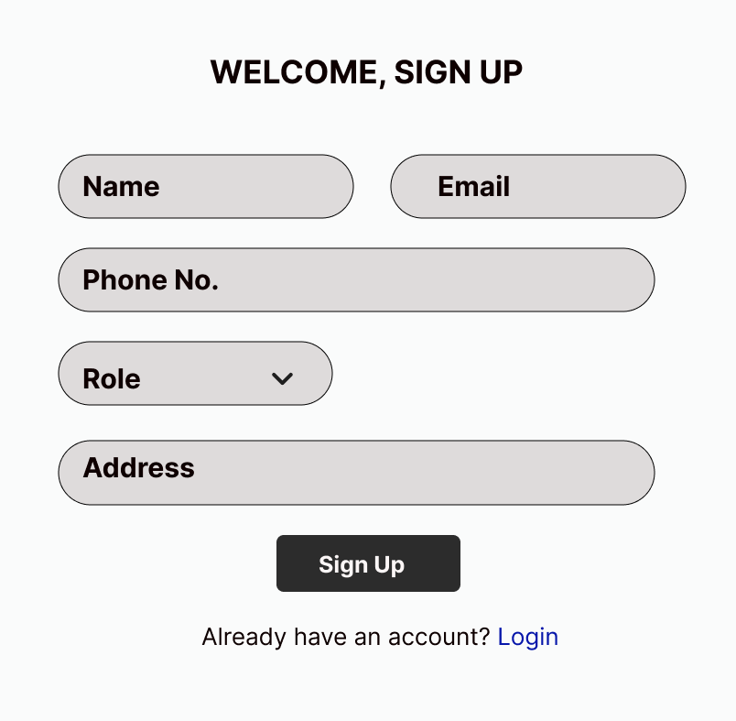
Figure 5 Input fields and Output Format

The output refers to the results and information generated by the system. The following output screen (Figure 6) will display after a successful signup:
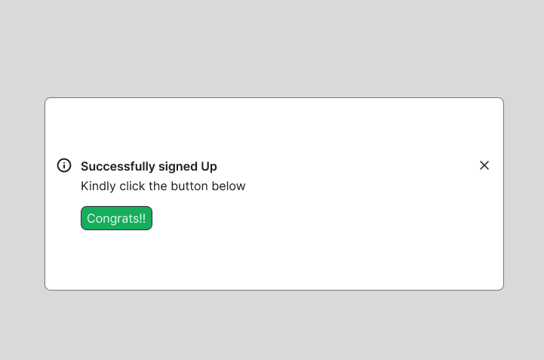
Figure 6 Output Screen

The output is designed to offer secure and transparent supply chain operations, real-time visibility into supply chain activities, automated business logic and smart contract execution, optimized inventory management and order fulfillment, secure and efficient payment processing, and data analytics and reporting capabilities.

  - Program Algorithms
A program algorithm is a sort of recipe that describes the exact steps needed for the computer to solve a problem or reach a goal. The algorithms for the different modules of the system are:
Algorithm: User Sign Up
// This is required for all supply chain stakeholders
// This includes suppliers, manufacturers, logistics providers
Enter personal information to create an account
{
company name;
contact details; // username, email, phone number, password
location;
role in the supply chain // admin or user
}
Connect to database to check if the ID already exists
If ID exists,
Display message alert; re-direct to user’s login page
else
Register user’s information in the database
Create a unique user ID and password for the user
Post user information to the system database with a role designation
Redirect to Login Page
end process

Algorithm: User Login
Display login screen.
5 Prompt user to enter registered username or email and password
Connect to database and validates user login credentials. Are details correct?
If details are incorrect,
register and display an error;
Redirect to 5
Don’t have an existing account?
If yes,
// Create one here
Redirect to Sign Up page
else
Encrypt user data and save to memory
Allow user access to the network; redirect user to his/her role dashboard
end process

Algorithm: Encryption – Decryption Algorithms
- Encryption
rpt: Enter plain text message (or password) in text box
Select an algorithm for encryption
Enter the digital signature to encrypt
Is plain text empty?
If No, go back to rpt
Encrypt the signature using appropriate hash function with salt and encryption algorithm.
Send the message (or password)
Ciphered message (or password) is passed from text box of Form 1 to Form 2
end process

- Decryption
Open plain file (message or password) for reading
Detect and remove the appended salt bytes from the password or message
Read the encrypted message from the specified location
4 Enter the same digital signature to verify for decryption
Is signature matching?
If No, go 4
Decrypt to unreveal message
Verify hashing
Is message tampered with?
If No, go to stp
Reveal the decrypted message or password
Save the entire data to text file
stp: end process

Algorithm: User Authentication Check
// Supply chain stakeholders should authenticate themselves to access the system.
Server generates a random number
Reader sends an authentication request to the tag
Tag completes response and sends record to the server through the reader
Server verifies validity of tag?
If tag is invalid, then
Authentication does not pass:
Go to step 9
Sever updates the secret key and sends the response record to the tag via the reader
Tag verifies whether the reader is legal?
`If reader is illegal, then
Authentication does not pass,
Isolate the user and
Go to stp2
Authentication pass: Allow user access to the network
Tag updates key value
stp2: end process

Algorithm: Upload Products
// for Manufacturers and Suppliers
Navigate to the "Upload Products" module
Prompt user to enter product details such as title, description, category, and pricing
Attach any necessary documents or certifications
Submit the product for listing
// blockchain automatically records the product details for traceability throughout the supply chain
Post product details to the system database
Redirect to User dashboard
End process

Algorithm: Manage Products
// Exclusively for Admin
View a list of uploaded product.
Edit product information (title, description, category).
Delete products if needed.
Recorded and log updates on the blockchain for transparency
end process

Algorithm: Manage User Profiles
Is Admin
View list of registered users
Add new users with their role designation (manufacturer or supplier)
Edit user profiles
{
name;
email;
password;
role
Delete user accounts if needed.
end edit
goto end process

Is User
Edit personal information
{
name;
email;
password
end process

Algorithm: View Products
// For Consumers, Retailers, Wholesalers
Browse and view list of available products
Click on any product card to view its details:
Supplier;
Price;
current stock
Use the "Order" button to make a purchase
// This triggers a smart contract for payment and delivery tracking
end process

Algorithm: Payment Processing
Enter payment details
{
name;
phone Number;
email;
billing Address;
means of payment // bank card, crypto or paypal
}
Transmit payment information to the payment processor for authorization.
Is customer’s payment information accurate?
If No, go to fdb
Does the customer have sufficient funds to cover the transaction?
If No, go to step fdb
Approve the transaction and send notifications
Transfer fund from customer’s account to appropriate bank account.
Decline the transaction and send unsuccessful notifications.
fdb: Notify the customer about the success or failure of the transaction.
end processing.

Algorithm: Transaction Handling (Smart Contracts)
Automatically initiate a smart contract once a product moves from one party to another
// (e.g., Supplier to Manufacturer or Retailer)
Validate the transaction on the blockchain
Track the product's movement
Record each transaction permanently on the database
Make transaction visible to authorized users
end process

Algorithm: Error Handling:
Implement error handling to address situations like:
{
incorrect login credentials;
file upload errors;
database connection issues.
}
Provide appropriate error messages to users.
end process

Algorithm: User Logout
Redirect to dashboard
Unregister login session.
end

  - Entity Relationship (ER) Diagram of the System
The entities in the supply and logistics network and their relationships are defined as follows:
Entities:

- Supplier (Supplies raw materials/products)
- Manufacturer (Transforms raw materials into finished goods)
- Distributor (Transports goods)
- Retailer (Sells products to customers)
- Customer (Purchases products)
- Product (Item being tracked)
- Transaction (Records product movements)
- Smart Contract (Automates agreements)
- Warehouse (Stores products)
- Logistics Provider (Manages shipping)
- IoT Sensor (Tracks product conditions)

Relationships:

- Supplier provides products to Manufacturer.
- Manufacturer ships products to Distributor.
- Distributor delivers products to Retailer.
- Retailer sells products to Customer.
- Product is involved in multiple Transactions.
- Transactions are recorded on the Blockchain.
- Smart Contracts automate deals between Suppliers, Manufacturers, distributors, and retailers.
- Logistics Provider manages transport for Distributor.
- Warehouse stores Products between stages.
ER diagram shows graphically the entities, their attributes, and the relationships between them. The "_id" field denotes the primary keys (PK), and the foreign keys (FK) are denoted by the fields with the "(FK)" label. This is illustrated in Figure 7 below:
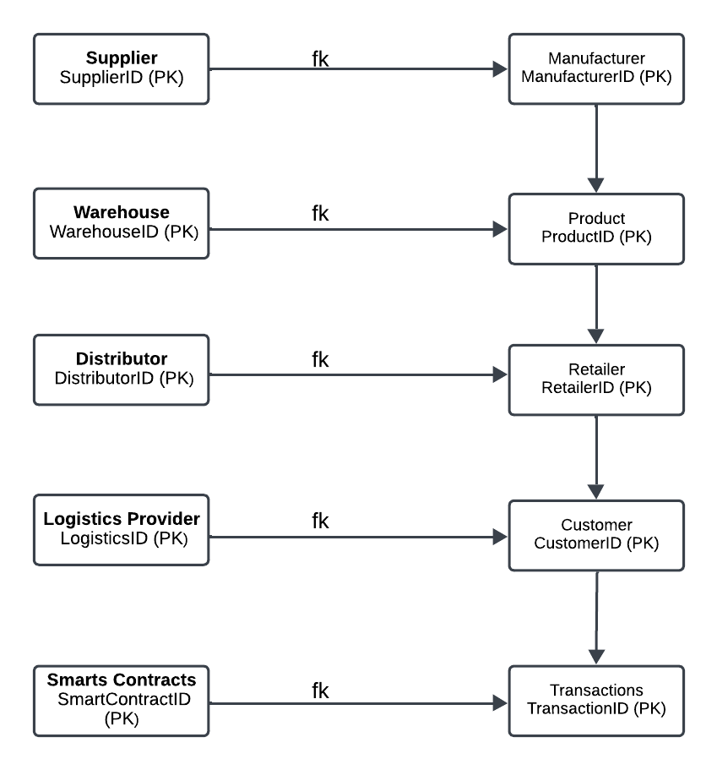
Figure 7 Entity Relationship Diagram of the Proposed System

  - Database Specifications
The data structures for the blockchain-powered supply management system must be carefully designed to enable the system to track goods easily, provide real-time updates, and use smart contracts to automate decisions; thereby making the supply chain fast, secure, reliable and able to grow.
The data dictionary containing information such as what is in the database, who is allowed to access it, and where the database is physically stored, table constraints like primary key attributes, foreign key information, etc are shown in Table 1 – Table 10 below:
Table 1: Suppliers Table

Column Name | Data Type | Description
_id | INT (PK) | Unique identifier for the supplier
Name | VARCHAR (255) | Supplier name
contactEmail | VARCHAR (255) | Supplier’s contact emails
ContactPhoneNo. | VARCHAR (50) | Supplier’s contact Phone Number
Address | TEXT | Supplier’s contact Physical address
CreatedAt | DATETIME | Timestamp of supplier registration

Table 2: Manufacturer Table
Column Name | Data Type | Description
_id | INT (PK) | Unique identifier for the Manufacturer
Name | VARCHAR (255) | Manufacturer’s name
contactEmail | VARCHAR (255) | Manuufacturer’s contact email
ContactPhoneNo. | VARCHAR (50) | Manufacturer’s contact Phone Number
Address | TEXT | Manufacturer’s contact Physical address
CreatedAt | DATETIME | Timestamp of Manufacturer’s registration

Table 3: Distributors Table
Column Name | Data Type | Description
_id | INT (PK) | Unique identifier for the Distributor
Name | VARCHAR (255) | Distributor’s name
contactEmail | VARCHAR (255) | Distributor’s contact email
ContactPhoneNo. | VARCHAR (50) | Distributor’s contact Phone Number
Address | TEXT | Distributor’s contact Physical address
CreatedAt | DATETIME | Timestamp of Distributor’s registration

Table 4: Retailers Table
Column Name | Data Type | Description
_id | INT (PK) | Unique identifier for the Retailer
Name | VARCHAR (255) | Retailer’s name
contactEmail | VARCHAR (255) | Retailer’s contact email
ContactPhoneNo. | VARCHAR (50) | Retailer’s contact Phone Number
Address | TEXT | Retailer’s contact Physical address
CreatedAt | DATETIME | Timestamp of Retailer’s registration

Table 5: Customers Table
Column Name | Data Type | Description
_id | INT (PK) | Unique identifier for the Customer
Name | VARCHAR (255) | Customer’s name
contactEmail | VARCHAR (255) | Customer’s contact email
ContactPhoneNo. | VARCHAR (50) | Customer’s contact Phone Number
Address | TEXT | Customer’s contact Physical address
CreatedAt | DATETIME | Timestamp of Customer’s registration

Table 6: Product Table
Column Name | Data Type | Description
ProductID | INT (PK) | Unique identifier for the Product
Name | VARCHAR (255) | Name of the product
Description | TEXT | Description of the product
SupplierID | INT (FK) | Reference to the supplier
ManufacturerID | INT (FK) | Reference to the Manufacturer
UnitPrice | DECIMAL (10,2) | Unit price of the product
CreatedAt | DATETIME | Timestamp of Product creation

Column Name | Data Type | Description
TransactionID | INT (PK) | Unique identifier for the Transaction
ProductID | INT (FK) | Reference to the product
SupplierID | INT (FK) | Reference to the supplier
ManufacturerID | INT (FK) | Reference to the Manufacturer
DistributorID | INT (FK) | Reference to the Distributor
RetailerID | INT (FK) | Reference to the Retailer
TransactionDate | DATETIME | Timestamp of the transaction
Quantity | INT | Quantity of products involved
Status | VARCHAR (50) | Blockchain hash for the transaction
Table 7: Transaction Table

Table 8: Smart Contract Table
Column Name | Data Type | Description
ContractID | INT (PK) | Unique identifier for the contract
SupplierID | INT (FK) | Reference to the supplier
ManufacturerID | INT (FK) | Reference to the Manufacturer
DistributorID | INT (FK) | Reference to the Distributor
RetailerID | INT (FK) | Reference to the Retailer
Terms | Text | Terms and conditions of the contract
ExecutionDate | DATETIME | Timestamp of contract execution
BlockchainHash | VARCHAR(255) | Blockchain hash for the contract

Column Name | Data Type | Description
WarehouseID | INT (PK) | Unique identifier for the Warehouse
WarehouseName | VARCHAR(255) | Name of the warehouse
Address | TEXT | Physical address of the warehouse
Capacity | INT | Storage capacity of theWarehouse
CreatedAt | DATETIME | Timestamp of warehouse registration
Table 9: Warehouse Table

Table 10: Logistics Provider Table
Column Name | Data Type | Description
LogisticsID | INT (PK) | Unique identifier for the logistics provider
ProviderName | VARCHAR(255) | Name of the logistics provider
ContactEmail | VARCHAR(255) | Contact email of the provider
PhoneNumber | VARCHAR(50) | Phone Number of the provider
Address | TEXT | Physical address of the provider
CreatedAt | DATETIME | Timestamp of provider registration

  - Hierarchical structure of the Proposed System
The high-level diagram provides a conceptual overview of the blockchain-based supply chain system's components and their interactions. It helps stakeholders understand the system's structure, key modules, and their relationships. This is shown in Figure 8 below:

Blockchain-based Supply Chain Management System
Dashboard
Login
Sign Up

Customer
Order goods
Edit Information
Track Sales
Make Payments
Get Goods
Exit
Gather Information
Update Information
Get Selected Goods
Cost Tabulation
Delete Information
Admin

Give Requirements
Generate Goods
Give Feedback
Alerts & Notifications
Dealer

Figure 8 Hierarchical structure of the Proposed System

The design of the Blockchain-based supply chain management system is responsive; allowing it adapt to different devices and screen sizes. The user interface and experience of the system is intuitive, user-friendly, and accessible to a wide range of users. The standard structure and processes of the proposed system highlights the following features and requirements:
- User Dashboard: This provides a personalized view of the system, including relevant information, recommended actions, and notifications.
- Navigation and Menu: This allow users to easily find the features and functions they need; so it has to be clear and concise. The menu should be organized in a logical and consistent manner, with clear labels and icons.
- Data Visualization: This technique present complex data in a clear and concise manner. Data visualization is used to help users understand trends, patterns, and insights in the data.
- Alerts and Notifications: A robust alert and notification system is needed to inform users of important events and updates. They should be customizable to allow users to prioritize their notifications and focus on their specific needs.
- Reporting and Analytics: The system should have a reporting and analytics module that allows users to generate reports and analyze data. Data analytics system uses transaction data and smart contract execution results to analyze and interpret data on supply chain activities, providing reporting, visualization, and machine learning capabilities.
- Blockchain Network: A decentralized blockchain network is needed to enable secure, transparent, and tamper-proof transactions. It accepts transaction data as input to validate transactions, update the blockchain ledger, and provide real-time visibility into supply chain activities.
- Smart Contracts: Smart contract is automatically initiated once a product moves from one party to another (e.g., Supplier to Manufacturer or Retailer). Smart contract codes and data are used as inputs to automate complex business logic and conditional statements in the supply chain.
- Supply Chain Visibility: Transaction data and smart contract execution results are entered into the system to help stakeholders to track the location, status, and ownership of goods and materials.
- Inventory Management: Inventory data and transaction data are used here to enable stakeholders to update inventory levels, track inventory movement, provide reporting and analytics capabilities and optimize supply chain operations.
- Order Management: Stakeholders input order data and transaction data as input into the system to update order status, track order movement, and provide reporting and analytics capabilities.
- Payment Processing: The payment processing system uses encryption, authentication, and authorization features to enable stakeholders make and receive payments securely and efficiently.
  - Development Tools

The programming languages and development tools needed to build a robust, flexible, and cost-effective system that meets the needs of users in a supply chain are:
Frontend – HTML (Hypertext Markup Language), CSS (Cascading Style Sheet) and Angular.js - a popular JavaScript library for building user interfaces - will be used for the presentation tier.
Backend – Solidity, Node.js, and Angular.js will be used for smart contracts and the entire business logic layer.
Database – MongoDB, a NoSQL document-based database, will be used for the data tier.
APIs and Integrations – Frameworks like Node.js are used for building RESTful APIs, and backend logic to link blockchain and external systems.

This programming environment is being chosen for its:
Flexibility: JavaScript is a versatile language that can be used for both frontend and backend development.
Scalability: Node.js and MongoDB are designed for high-performance and horizontal scaling.
Ease of development: Angular and Node.js have large communities and a wealth of resources, making development faster and more efficient.
Cost-effectiveness: Solidity provides a cost-effective and scalable infrastructure, reducing operational expenses.

  - System Requirements

Minimum Hardware Requirements:
Intel Core i5 or equivalent processor; 16 GB RAM (32 GB recommended for high-performance); 1 TB SSD storage for blockchain data, product logs, and transaction history; 21-inch Full HD Monitor (for better user interface design and programming work); CD/DVD ROM Drive, Printer, UPS, and Voltage Regulator to maintain stable operations, 64 GB Flash Drive for data transfers, External 2 TB Hard Disk for system backups and storage redundancy, Ethernet Network Card or Wi-Fi Adapter for stable internet connections, Graphics Card (e.g., NVIDIA GTX 1060 or higher) for better performance when handling data visualizations.

Minimum Software Requirements:
Node.js (for building backend APIs and services); Ethereum (Private Blockchain for smart contracts and data security); Truffle Suite (for writing, testing, and deploying smart contracts); MySQL(for managing user profiles and product data); VSCode Editor (for writing code and developing smart contracts); Windows or Linux operating system (Linux preferred for deploying blockchain nodes); Docker (for containerization and deploying services), Web3.js or Ethers.js (for interacting with blockchain from frontend); React.js or Angular (for developing user interfaces) and Git (for version control and collaborative development).

Interface Requirement
This system will be professional in its appearance and it has a user-friendly interface for the user to input the relevant data and obtain corresponding results.

Usability Requirement
Ease of Use: This system will be able to be used quality and easily. It will be ask for confirmation before entering into a timely process.

Performance Requirement
- Speed and Latency Requirement: This system will produce a viable order within a reasonable amount of time and produce feedback on the progress.
- Reliability and Availability Requirement: This program will be available either through the web or on a machine.
- Robustness Requirement: The program will have sufficient error handing abilities so that it will not crash any other part of the system.

  - System Integration and Interoperability
The system is designed to integrate with other systems and technologies, including blockchain networks, supply chain management systems, and enterprise resource planning systems.
- Blockchain Integration: The system should be able to integrate with blockchain networks to enable secure, transparent, and tamper-proof transactions. Blockchain integration should be done using standard protocols and APIs to ensure interoperability.
- Supply Chain Management Integration: The system should be able to integrate with supply chain management systems to enable seamless tracking and monitoring of goods and materials. Supply chain management integration should be done using standard protocols and APIs to ensure interoperability.
- Enterprise Resource Planning Integration: The system should be able to integrate with enterprise resource planning systems to enable seamless management of resources and operations. Enterprise resource planning integration should be done using standard protocols and APIs to ensure interoperability.
  - Security and Privacy
The system should be designed with security and privacy in mind, including robust measures to protect user data and prevent unauthorized access.
- Data Encryption: The system should use robust data encryption to protect user data and prevent unauthorized access. Data encryption should be done using standard protocols and algorithms to ensure interoperability.
- Access Control: The system should have robust access control measures to ensure that only authorized users can access the system and its features. Access control should be done using standard protocols and algorithms to ensure interoperability.
- Privacy: The system should be designed with privacy in mind, including measures to protect user data and prevent unauthorized access. Privacy measures should be transparent and clear, with users having control over their data and how it is used.

- Results and Discussions
The user interface and experience of the system was designed to be intuitive, user-friendly, responsive and accessible to a wide range of users. The system also adapts to different devices and screen sizes. The preceding sections show the steps that users can follow to efficiently manage their roles, track product movements, and securely operate within the blockchain-powered supply chain system.

  - Home Page
The homepage serves as a navigation gateway to get to other pages and dashboards (Figure 9).
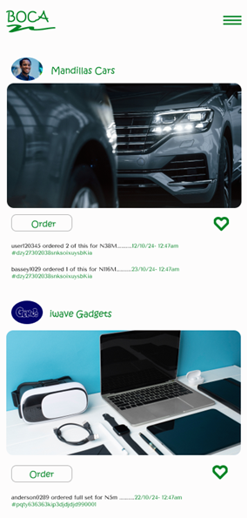
Figure 9 Home Page

  - User Registration (Sign Up)
The user navigate to the registration page and fills-in personal details like full name, email address, password; and select his/her country and role (Supplier, Manufacturer, Retailer, or Customer). A user will click on the "Register" button to sign up (Figure 10). An email verification link may be sent for confirmation.
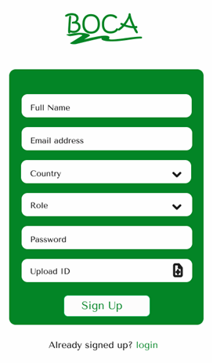
Figure 10 Sign Up Page

  - User Login (Sign In)
After successful registration, users return to the login (sign in) page and then key in their email and password information to sign in (Figure 11). After this, they can access the system depending on the system privileges allocated to them.

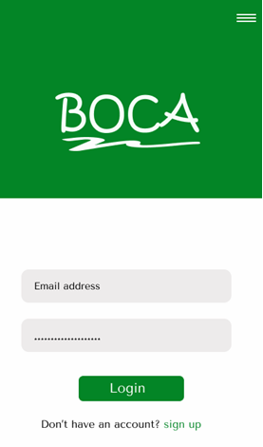
Figure 11 Login Page

  - Admin Dashboard
The dashboard gives role-based access once a user logs in. The system checks the user’s role and directs him/her as follows: Supplier to the supplier dashboard; Manufacturer to the manufacturer dashboard; Retailer/Distributor to the retailer or distributor dashboard and Customer to the consumer interface to view available products (Figure 12). The dashboard is a simple visual display of the most important information (or current summary) needed to facilitate the decision-making process for end-users of an application. It receives data from a linked database to provide information in one view to the user with the aid of numbers, charts, or graphs.

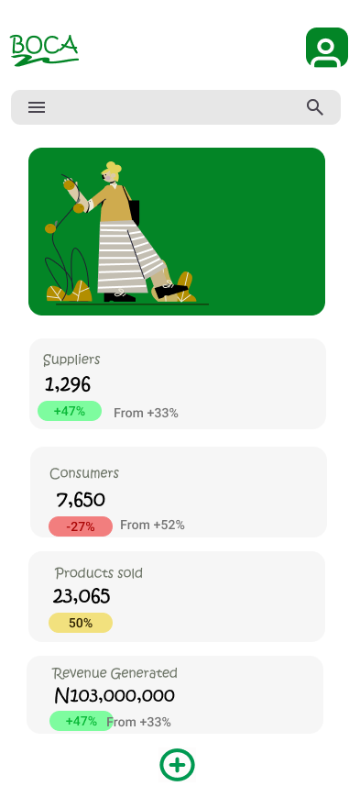
Figure 12 Admin Screen

  - Product payment page
The customer enters payment details like name, phone number, email, billing Address, and means of payment (bank card, crypto or paypal) to make and receive payments (Figure 13).

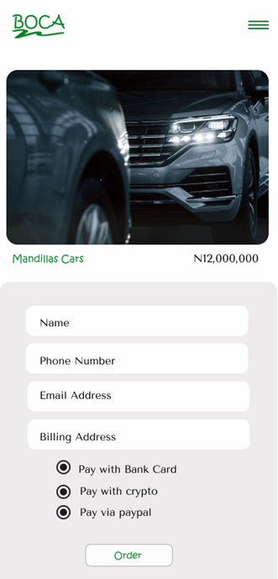
Figure 13 Product Payment page

  - Product tracking page
After ordering, users can track the status of their order in real time (Figure 14). IoT sensors (if implemented) can provide real-time updates on current status and movement of products between parties involved in the supply chain ecosystem.


Figure 14 Product tracking page

- Conclusion
Effective supply chain management is critical for businesses to remain competitive in today's fast-paced and globalized market. Blockchain-powered supply chain management system promises to offer transparent, secure, traceable, efficient, decentralized, cost saving, trusted and immutable transactional records accessible by producers, retailers, distributors, transporters, suppliers, and consumers across multiple computers within a global supply and logistics network. This research study have designed and implemented a user-friendly Blockchain Optimized Chain of Accountability (BOCA) to track products and safely transport them from their point of manufacture to where the end customer/user is located. It is optimized for access on different devices, platforms and operating systems, ensuring that stakeholders - from farmers to logistics providers - can engage with the system easily and effectively. It also uses cryptography to secure and validate transactions, making it a secure and transparent way to conduct transactions. As the technology continues to evolve and improve, it is likely that we will see increased adoption of blockchain technology in supply chain management.
The paper also highlights the challenges and limitations of blockchain technology, including scalability, regulation, interoperability, security, privacy, cost, lack of awareness, and technical complexity. It also noted that weaknesses outside of the blockchain create opportunities for thieves. Hackers can gain access to cryptocurrency owners' cryptocurrency wallets, exchange accounts, or the exchanges themselves (Investopedia, 2024). These challenges and limitations must be addressed to fully realize the benefits of blockchain technology in supply chain management.
The research work contributes to knowledge by providing guidance for organizations and stakeholders to improve supply chain actions, improve innovation, enhance competitive advantage and increase the speed of relationships in supply chain and logistics networks across the globe.

COMPETING INTERESTS DISCLAIMER:
Authors have declared that they have no known competing financial interests OR non-financial interests OR personal relationships that could have appeared to influence the work reported in this paper.

- References
- Black Duck Software, Inc. (2024).What Is Blockchain and How Does It Work?. 800 District Ave. Ste201 Burlington, MA 01803. Accessed from https://www.blackduck.com on 29/12/2024.
- Built In (2024). Blockchain: What It Is, How It Works, Why It Matters. Accessed from https://builtin.com on 29/12/2024.
- Chen, I. J., Paulraj, A., & Lado, A. A. (2017). Strategic purchasing, supply management, and firm performance. Journal of Operations Management, 25(3), 531-545.
- Chopra, S., & Meindl, P. (2013). Supply chain management: Strategy, planning, and operation (5th ed.). Pearson Education.
- Gao, L., Sung, K., & Min, C. (2018). Improving supply chain transparency and traceability with blockchain technology. Journal of Business Research, 92, 56-65.
- Harvard Business Review (5 Jan 2022). How Walmart Canada Uses Blockchain to Solve Supply-Chain Challenges. URL: https://hbr.org.
- IBM (2019). IBM Food Trust. URL: https://www.ibm.com/products/supply-chain-intelligence-suite/food-trust.
- IBM (2024). Blockchain for Supply Chain. Accessed from https://www.ibm.com on 29/12/2024.
- Investopedia (2024). Can Crypto Be Hacked? Accessed from https://www.investopedia.com on 29/12/2024.
- LinkedIn (2 May 2023). The Rise of Supply Chain Ecosystems. Retrieved from https://www.linkedin.com on 29/12/2024.
- Mentzer, J. T., DeWitt, W., Keebler, J. S., Min, S., Nix, N. W., Smith, C. D., & Zacharia, Z. G. (2001). Defining supply chain management. Journal of Business Logistics, 22(2), 1-25.
- Maersk (29 Jul 2020). Maersk SCM solutions. Copenhagen, Denmark. URL: https://www.maersk.com.
- Nakamoto, S. (2008). Bitcoin: A peer-to-peer Electronic Cash System. Available online: https://bitcoin.org/bitcoin.pdf.
- Origin Trail (2013 - 2024). OriginTrail. URL: https://origintrail.io/
- PwC Belgium (2016 - 2024). Blockchain, a functional introduction. Accessed from https://www.pwc.be on 29/12/2024.
- Simon Wong, John Kun Woon Yeung, Yui-Yip Lau, Tomoya Kawasaki and Raymond Kwong (2024). A Critical Literature Review on Blockchain Technology Adoption in Supply Chains. Sustainability 2024, 16, 5174. https://doi.org/10.3390/su16125174.
- Syed Rifat Ahsan; Ismat Sifat Yousuf; Zunaira Khan; Yousra Mehrin; Mahbub Alam Majumdar (2021). Digital Supply Chain Management Ecosystem Powered by Blockchain Technology, 2021 IEEE Asia-Pacific Conference on Computer Science and Data Engineering (CSDE), Brisbane, Australia, (08-10 December 2021), pp. 1-6, DOI: 10.1109/CSDE53843.2021.9718436. Retrieved from https://ieeexplore.ieee.org/document/9718436 on 29/12/2024.
- Turing (2024). Blockchain in supply chain: Benefits, Use Cases & Applications. https://www.turing.com/
- Simplilearn.com (18 Dec 2024).What Is Blockchain Technology & How Does It Work. Retrieved from https://www.simplilearn.com on 29/12/2024.
- Trustwell (2024). FoodLogiQ Supply Chain Management Solution. Durham, NC. URL: https://www.trustwell.com/

