**Improving Patient Data Privacy and Authentication Protocols Against AI-Powered Phishing Attacks in Telemedicine**

**Abstract**

*AI-powered phishing attacks have emerged as a critical cybersecurity threat in telemedicine, jeopardizing patient data privacy and authentication security. This study analyzes the impact of AI-driven phishing breaches using data from the HHS Breach Reports, Verizon DBIR, IBM Cost of a Data Breach Report, and PhishTank Open Phishing Dataset. Employing trend analysis, logistic regression, ANOVA, and machine learning classification, the findings reveal a 60% increase in patient record exposure due to AI-powered phishing since 2021, with credential theft contributing most to authentication failures (coefficient = 1.75). The study also finds that blockchain authentication reduces financial losses to $4.5M per breach, significantly lower than the $12M incurred by unprotected organizations. AI-based phishing detection achieves a recall rate of 90.5% but suffers from a 47.6% false-negative rate, indicating the need for refinement. Recommendations include implementing adaptive AI-driven threat detection, behavioral biometrics, blockchain authentication, and stronger regulatory oversight.*

**Keywords: AI-powered phishing, telemedicine cybersecurity, authentication vulnerabilities, blockchain authentication, phishing detection.**

### **1. Introduction**

The rapid expansion of telemedicine has reshaped healthcare by enabling remote access to consultations, diagnostics, and treatment; this transformation, accelerated by the COVID-19 pandemic, has led to the widespread adoption of digital healthcare platforms. According to Infinium (2023), the global telemedicine market was valued at approximately $87 billion in 2022 and is projected to grow at a compound annual growth rate of 18.5% between 2023 and 2030. However, while telemedicine enhances accessibility and efficiency, it also introduces significant cybersecurity vulnerabilities, particularly regarding patient data privacy and authentication protocols. As digital healthcare adoption increases, the sector faces growing cyber threats, notably AI-powered phishing attacks (Nankya et al., 2024).

The healthcare industry remains a prime target for cybercriminals due to the high value of medical records, which are frequently sold on the black market. Palmer (2024) argues that the frequency of data breaches has risen, with the U.S. Department of Health and Human Services' Office for Civil Rights documenting 721 large-scale breaches in 2024 alone. According to IBM (2024), the average cost of a healthcare data breach reached $9.8 million, nearly double the global industry average of $4.9 million. The February 2024 Change Healthcare ransomware attack, which compromised the data of 100 million Americans, illustrates the vulnerabilities inherent in digital healthcare and underscores the urgent need for stronger security frameworks (Swain, 2024).

A major factor contributing to these breaches is the growing prevalence of AI-powered phishing attacks. Javaid et al. (2023) posit that cybercriminals are leveraging artificial intelligence to craft highly deceptive phishing schemes targeting both patients and healthcare providers. A 2024 study by Keeper Security reported a 51% increase in AI-driven phishing incidents, reflecting the growing sophistication of cyber threats (D’Andrea, 2024). Also, the FBI issued a warning in May 2024 about the rise of AI-enhanced scams that employ deepfake technology and advanced social engineering tactics to manipulate victims (FBI, 2024). The February 2024 H-M Health breach exemplifies this risk, as cybercriminals used deepfake audio to impersonate the company’s CEO, deceiving an employee into executing fraudulent financial transactions (Plainert, 2025).

Credential theft remains a central tactic in these phishing campaigns, enabling attackers to exploit stolen credentials and gain unauthorized access to sensitive medical data. Writer (2024) asserts that AI-powered phishing techniques have increased the effectiveness of these attacks, as a 2024 Cyberint report documented a 333% rise in credential theft cases. Netskope’s *2024 Cloud & Threat Report* further observed a substantial increase in phishing link click rates, indicating that a growing number of users are unknowingly facilitating cyber intrusions (Netskope, 2024). Real-world incidents highlight the severity of this threat. In September 2024, Bellarine Medical Group in Drysdale suffered a phishing attack where cybercriminals impersonated official sources and distributed malicious emails to patients, compromising their medical records (Bellarine Medical Group, 2024). Similarly, Services Australia faced a surge in data breaches in July 2024, as cybercriminals exploited stolen credentials to infiltrate user accounts (Williams, 2024).

Conventional authentication mechanisms within telemedicine platforms have proven inadequate in mitigating these risks. Yusop et al. (2025) argue that traditional password-based authentication methods are insufficient against AI-driven phishing attacks that exploit compromised credentials. While multi-factor authentication (MFA) has been widely implemented, it remains vulnerable to advanced threats. According to Petkauskas (2022), cybercriminals now employ AI to bypass MFA by intercepting authentication codes or using deepfake-generated voices to manipulate verification processes. Verizon (2023) reports that 74% of security breaches involved human error, with social engineering tactics continuing to exploit healthcare personnel’s trust. The persistence of human-related security vulnerabilities highlights the need for stronger authentication frameworks that minimize reliance on individual discretion.

The expansion of telemedicine and its growing market size have widened the attack surface for cybercriminals. Jimmy (2024) contends that this increased exposure underscores the urgency for improved security measures, including AI-driven phishing detection mechanisms and sophisticated authentication protocols. Organizations are integrating AI-powered cybersecurity solutions that leverage machine learning and natural language processing to detect phishing attempts by analyzing vast datasets and identifying subtle indicators of malicious activity. Arefin and Simcox (2024) discuss various AI-driven security models that proactively detect and neutralize phishing threats within telemedicine platforms.

Case studies further demonstrate the effectiveness of AI-driven defenses in mitigating phishing risks. Alabdulatif et al. (2022) note that healthcare institutions employing AI-based threat detection systems have reported improved accuracy in identifying cyber threats and reducing false positives. Moreover, advancements in AI-powered authentication, such as biometric verification and behavioral analytics, are emerging as viable alternatives to traditional authentication methods (Awad et al., 2024). These technologies introduce additional security layers that are more resilient to AI-generated phishing schemes (Tyagi et al., 2024). Nevertheless, even with robust authentication mechanisms, patient data privacy remains a pressing concern.

The scale of healthcare data breaches continues to raise alarms. Nankya et al. (2024) highlight that in 2023, the Office for Civil Rights recorded 725 healthcare-related data breaches, exposing over 133 million medical records. Additionally, Sutherlin (2024) revealed that nearly 50% of employees had fallen victim to cyberattacks, with AI-enhanced phishing campaigns accounting for a significant portion of these incidents. Beyond financial and reputational damage, such breaches erode public trust in telemedicine, a critical factor influencing digital healthcare adoption.

To address these cybersecurity challenges, healthcare organizations are increasingly adopting end-to-end encryption, zero-trust security models, and decentralized identity verification in their digital infrastructures. Isibor (2024) asserts that regulatory frameworks such as the Health Insurance Portability and Accountability Act (HIPAA) and the General Data Protection Regulation (GDPR) play a crucial role in enforcing data security standards and ensuring the responsible handling of patient information. Greater regulatory oversight, combined with proactive security measures, will be essential in mitigating the risks associated with AI-powered phishing and safeguarding sensitive medical data within telemedicine platforms.

The intersection of telemedicine’s rapid expansion and the sophistication of AI-driven phishing attacks underscores the need for robust cybersecurity measures. Fakhouri et al. (2024) argue that the prevalence of high-profile breaches, financial losses, and the growing success of AI-enhanced phishing schemes highlight the necessity for advanced authentication protocols and AI-driven security solutions. By implementing adaptive threat detection systems, behavioral authentication methods, and stringent regulatory compliance measures, telemedicine platforms can enhance their resilience against evolving cyber threats. According to Tariq (2024), as healthcare digitalization progresses, a proactive approach to cybersecurity will be essential in maintaining patient privacy, trust, and data integrity amid escalating AI-driven threats. This study thus sought to provide recommendations for enhancing patient data privacy and strengthen authentication protocols in telemedicine systems by mitigating the risks posed by AI-powered phishing attacks, by achieving the following objectives:

1. Analysis the impact of AI-powered phishing attacks on patient data privacy in telemedicine
2. Evaluating existing authentication protocols in telemedicine and identifying vulnerabilities
3. Investigating data privacy enhancements for telemedicine that protect patient information even in the event of a successful phishing attack.
4. Assessing the feasibility and effectiveness of AI-driven phishing detection systems within the telemedicine context.

### **2. Literature Review**

Phishing attacks have long posed significant risks to the healthcare sector, with cybercriminals using social engineering tactics to manipulate victims into revealing confidential information. Mittal et al. (2025) argue that early phishing attempts typically relied on deceptive emails and fraudulent messages that were often easy to detect due to grammatical inconsistencies and generic content. However, the integration of artificial intelligence has significantly enhanced the sophistication of phishing campaigns, particularly in telemedicine, where the growing reliance on digital health platforms has increased patient data vulnerability (Javaid et al., 2023; Ajayi et al., 2025).

According to Arif et al. (2024), AI-powered phishing attacks distinguish themselves from conventional techniques by utilizing machine learning algorithms, natural language processing, and deepfake technology to create highly convincing scams. Unlike earlier phishing attempts, which were frequently identified due to linguistic flaws, AI-generated phishing messages now mimic human communication with remarkable precision. Deepfake technology further compounds this threat by enabling cybercriminals to fabricate realistic audio and video impersonations of healthcare administrators or physicians (Whittaker et al., 2023; Kolade et al., 2025). These capabilities have been exploited in AI-driven voice phishing (vishing) schemes, where attackers deceive medical staff into granting unauthorized access to patient records and financial systems (Schmitt & Flechais, 2024; Obioha-Val, 2025).

The impact of these techniques is evident in several high-profile incidents; the Bellarine Medical Group email breach in September 2024 exemplifies how AI-enhanced phishing campaigns exploit patient trust (Bellarine Medical Group, 2024). Victims unknowingly interacted with fraudulent emails, inadvertently granting cybercriminals access to their personal health information. Similarly, the Services Australia data breach in July 2024 highlighted how stolen credentials were leveraged to orchestrate AI-enhanced phishing attacks, underscoring vulnerabilities in telemedicine communications when robust security protocols are absent (Williams, 2024; Balogun, 2025).

Empirical data illustrates the increasing prevalence of AI-driven phishing in healthcare. Writer (2024) states that a 2024 Cyberint report recorded a 51% surge in AI-powered phishing attacks, with deepfake-enabled scams frequently targeting telemedicine platforms. Additionally, IBM (2024), documented a 333% rise in credential theft incidents, emphasizing the effectiveness of AI-enhanced deception tactics. Netskope’s *2024 Cloud & Threat Report* further supports these findings, reporting a 190% increase in phishing link click rates, reflecting growing user susceptibility to AI-driven cyber threats (Netskope, 2024).

Despite these alarming trends, telemedicine platforms remain reliant on outdated security measures. Fakhouri et al. (2024) contend that password-based authentication, a widely used security mechanism, has proven ineffective against AI-enhanced phishing techniques. The increasing sophistication of cyber threats necessitates adaptive security models incorporating AI-driven detection systems, which analyze linguistic patterns, behavioral anomalies, and real-time phishing indicators to counter evolving threats (Salem et al., 2024; Obioha-Val et al., 2025).

There is a growing consensus among cybersecurity researchers on the necessity of integrating AI-based threat intelligence into telemedicine security frameworks (Chaudhary et al., 2022; Nankya et al., 2024; Olutimehin, 2025). Zhang and Tenney (2023) aver that while multi-factor authentication (MFA) remains a widely promoted safeguard, its susceptibility to AI-generated bypass techniques necessitates additional protective measures.

### **Impact of AI-Enhanced Phishing on Patient Data Privacy**

The rise of AI-enhanced phishing attacks has significantly jeopardized patient data privacy, increasing the risk of large-scale breaches in healthcare. Minnaar and Herbig (2021) contend that medical records hold immense value on the black market, attracting cybercriminals who use artificial intelligence to launch sophisticated social engineering attacks. Unlike financial data, which has a limited lifespan, patient records contain immutable identifiers such as Social Security numbers, medical histories, and insurance details, making them prime targets for identity theft and fraud (Elendu et al., 2024). According to Yao (2017), a single electronic health record (EHR) can be sold for up to $1,000 on illicit marketplaces, far exceeding the value of credit card details.

The increasing sophistication of AI-driven phishing has escalated the frequency and severity of healthcare data breaches. Nicholls et al. (2021) posit that cybercriminals now leverage deep learning models to craft phishing emails that closely resemble legitimate communications. The February 2024 Change Healthcare ransomware attack, which compromised data from nearly 100 million Americans, illustrates the devastating consequences of such attacks (Johnson, 2024; Balogun et al., 2025). IBM (2024), further confirms that the healthcare industry experiences the highest breach-related costs, averaging $9.8 million per incident. These breaches not only result in financial losses but also cause reputational damage, legal consequences, and operational disruptions, eroding public trust in telemedicine.

A key factor enabling AI-enhanced phishing is human error. According to Verizon (2023), 74% of security breaches involved human-related factors, including susceptibility to phishing schemes and security misconfigurations. AI-powered social engineering exploits cognitive biases, making it increasingly difficult for healthcare personnel to recognize fraudulent interactions (Khan et al., 2024; Obioha-Val et al., 2025). Writer (2024) recorded a 333% rise in credential theft incidents, demonstrating the growing effectiveness of AI-driven deception techniques in bypassing traditional security measures.

Addressing these vulnerabilities requires a multi-layered security approach integrating AI-driven detection systems with enhanced authentication protocols. Olabanji et al. (2024) argues that while multi-factor authentication (MFA) is widely promoted, AI-enhanced phishing techniques have demonstrated the ability to bypass MFA through real-time attacks. The adoption of biometric authentication, behavioral analytics, and AI-based threat intelligence has become essential in safeguarding patient data (Awad et al., 2024; Olutimehin, 2025). Additionally, Sargiotis (2024) avers that regulatory frameworks such as HIPAA and GDPR must evolve to address emerging threats, ensuring stricter compliance and data protection measures.

### **Authentication Protocols in Telemedicine: Strengths and Weaknesses**

Authentication protocols in telemedicine serve as a critical defense against unauthorized access to patient data. Liu et al. (2023) contend that traditional methods, including password-based authentication and two-factor authentication (2FA), have long been used to secure telemedicine platforms. However, these mechanisms exhibit vulnerabilities, particularly against AI-powered phishing attacks. According to Yusop et al. (2025), password-based authentication is increasingly ineffective due to credential theft, brute-force attacks, and phishing schemes that exploit human error. Cybercriminals now use AI-driven algorithms to crack passwords or deceive users into revealing credentials, exacerbating security risks (George, 2024; Balogun et al., 2025).

Multi-factor authentication (MFA) has been widely adopted to strengthen telemedicine security. Ali et al. (2021) argue that MFA, which requires multiple verification factors such as SMS-based codes or authentication apps, provides an additional security layer. However, Mittal et al. (2025) posit that MFA remains vulnerable to AI-enhanced phishing attacks, as cybercriminals have developed techniques to intercept authentication codes using real-time phishing schemes and automated phishing bots. AI-driven deepfake technology further compounds these risks, as attackers use voice and video synthesis to impersonate healthcare administrators and gain unauthorized access to sensitive systems (Dsouza et al., 2024; Obioha-Val et al., 2025).

Real-world cases highlight these weaknesses. According to Plainert (2025), the H-M Health deepfake phishing attack in February 2024 demonstrated the growing risks of AI-driven cyber threats. In this incident, cybercriminals used deepfake audio technology to impersonate a senior executive, deceiving an employee into granting unauthorized system access. Similarly, IBM (2024) X-Force Study identified multiple cases where MFA tokens were compromised through phishing-as-a-service (PhaaS) platforms, raising concerns about existing authentication mechanisms.

Emerging authentication technologies offer promising solutions. Ayeswarya and Singh (2024) aver that adaptive authentication models, incorporating behavioral biometrics and continuous authentication, are viable alternatives to static authentication methods. These systems analyze user behavior, such as typing patterns and device interactions, to assess authentication legitimacy dynamically. George (2025) posits that AI-driven threat detection systems, when integrated into authentication workflows, can mitigate phishing attempts before they reach end-users. Researchers further advocate for cryptographic authentication mechanisms, such as hardware security keys and decentralized identity management, to enhance security against AI-powered threats (Awad et al., 2024; Khan et al., 2025; Olutimehin, 2025).

As AI-enhanced phishing attacks evolve, Alzahrani (2024) argues that reassessing authentication protocols in telemedicine is imperative. While password-based authentication and MFA have provided foundational security, their vulnerabilities necessitate more advanced frameworks (Kamaruddin & Zolkipli, 2024; Alao et al., 2024). The increasing sophistication of deepfake technology and automated phishing highlights the need for adaptive authentication solutions integrating real-time threat intelligence and biometric verification (Keerthana et al., 2025; Olutimehin et al., 2025). Chavan and Kanade (2024) contend that as telemedicine expands, ensuring the security of patient data against AI-driven cyber threats remains a priority, requiring continuous innovation in authentication methodologies.

### **AI-Powered Cybersecurity Solutions in Healthcare**

Artificial intelligence has become a crucial tool in enhancing cybersecurity within the healthcare sector, particularly in mitigating AI-powered phishing attacks. Arefin and Simcox (2024) contend that AI-driven defense mechanisms strengthen telemedicine security by employing predictive analytics, anomaly detection, and automated response systems. These technologies surpass traditional security measures by offering proactive solutions that adapt to evolving cyber threats targeting digital health infrastructures (Bala et al., 2024; Val et al., 2024).

Machine learning and natural language processing (NLP) play a central role in phishing detection. According to Chataut et al. (2024), machine learning models analyze extensive datasets of phishing attempts to identify subtle indicators of malicious activity, including inconsistencies in email content, sender behavior, and contextual anomalies. NLP further refines detection by scrutinizing email syntax, sentiment, and linguistic irregularities to flag potential phishing threats (Sayyafzadeh et al., 2024; Salako et al., 2024). IBM (2024) study reported that AI-enhanced phishing detection models reduced false positives by 42%, demonstrating their effectiveness in refining cybersecurity protocols.

AI’s ability to analyze behavioral patterns has significantly improved threat detection. Sharma (2021) posits that behavioral analytics employ machine learning algorithms to establish baseline user behaviors and detect deviations indicative of a security breach. Sudden changes in login locations, unusual access requests, or irregular communication patterns trigger real-time security alerts. Villanueva (2025) highlights that AI-driven behavioral analysis has led to a 60% reduction in successful phishing attempts within telemedicine platforms, emphasizing the necessity of integrating these systems into authentication and access control frameworks.

Case studies illustrate the effectiveness of AI-powered security solutions in mitigating cyber threats. According to Hussain (2024), AI-driven phishing detection systems deployed in telemedicine platforms have successfully identified and neutralized phishing attempts in real-time. A leading telehealth provider in North America observed a 75% improvement in phishing attack detection rates following the integration of machine learning-driven security analytics (Naito et al., 2021; Gbadebo et al., 2024). Additionally, AI-powered authentication models, such as biometric verification and adaptive authentication, have demonstrated significant success in mitigating credential-based attacks by enhancing user identity validation (Siam et al., 2025; Joseph, 2024).

Despite these advancements, AI-powered cybersecurity faces persistent challenges. George (2024) contends that cyber adversaries continuously refine attack strategies to evade AI-driven defenses, necessitating ongoing innovation in cybersecurity research. The adversarial use of AI to generate sophisticated phishing campaigns underscores the need for continuous updates to detection models and adaptive security frameworks (Fakhouri et al., 2024; Kolade et al., 2024). As telemedicine adoption increases, Ali (2024) argues that AI will remain central to safeguarding patient data, ensuring digital healthcare security, and maintaining trust in AI-enhanced cybersecurity measures.

### **Enhancing Patient Data Privacy in Telemedicine**

The expansion of telemedicine has revolutionized healthcare delivery but has also introduced significant challenges in maintaining patient data privacy. Chaturvedi et al. (2024) contend that securing medical records requires the integration of encryption technologies, zero-trust security frameworks, and decentralized identity verification. Encryption protocols, such as end-to-end encryption (E2EE) and homomorphic encryption, serve as critical safeguards against unauthorized access (Kumar et al., 2024; Mayeke et al., 2024). According to IBM (2024), organizations employing advanced encryption techniques experienced a 38% reduction in data breach risks. However, the emerging threat of quantum computing necessitates ongoing research into post-quantum cryptographic solutions tailored for healthcare applications.

Zero-trust security frameworks have gained prominence as an effective defense against telemedicine data breaches. Unlike traditional perimeter-based models, Alevizos et al. (2021) state that zero-trust architecture (ZTA) enforces continuous verification, least-privilege access control, and strict endpoint security measures. Zscaler (2024) reported that ZTA adoption led to a 46% decline in unauthorized access incidents within digital healthcare ecosystems. However, the complexity and high integration costs of zero-trust frameworks pose challenges, particularly for smaller healthcare providers with limited resources.

Decentralized identity verification has emerged as an innovative approach to strengthening patient data security. Kokila and Reddy (2024) posit that traditional authentication methods rely on centralized databases, which remain vulnerable to breaches. In contrast, blockchain-based decentralized identity systems enable self-sovereign identity (SSI), granting individuals greater control over their credentials without exposing sensitive information (Chan et al., 2025; Samuel-Okon et al., 2024). According to NIST (2024), blockchain-based identity verification reduces identity fraud risks by 62%. Despite these advantages, concerns regarding scalability and regulatory compliance present barriers to widespread adoption.

Comparative analyses of global data privacy regulations reveal fundamental differences in compliance requirements for telemedicine. Isibor (2024) contends that while the Health Insurance Portability and Accountability Act (HIPAA) enforces stringent access controls and breach notification policies in the U.S., the General Data Protection Regulation (GDPR) mandates stricter data subject rights and cross-border data transfer restrictions in the European Union. Multinational telemedicine providers face legal ambiguities while complying with varying regulatory frameworks (Ivanova et al., 2023).

Regulatory enforcement plays a crucial role in maintaining patient data security; governments and regulatory agencies have intensified penalties for non-compliance (Prasad, 2024). However, Jain et al. (2024) argue that achieving a balance between stringent security mandates and operational feasibility is essential to avoid stifling telemedicine innovation. As cyber threats continue to evolve, integrating adaptive security measures while ensuring compliance with data protection laws remains critical to safeguarding patient privacy within digital healthcare environments.

### **3. Methodology**

This study adopts a quantitative research approach to analyze AI-powered phishing threats, authentication vulnerabilities, and data privacy mechanisms in telemedicine. Publicly available datasets from HHS Breach Reports, Verizon DBIR, IBM Cost of a Data Breach Report, and PhishTank Open Phishing Dataset are utilized for empirical validation. The research applies trend analysis, regression models, ANOVA, and machine learning classification to derive objective insights.

A linear regression model assesses the correlation between phishing-related breaches and compromised patient records (Table 1). A chi-square test evaluates whether AI-powered phishing incidents result in significantly greater data exposure than traditional methods. Also, logistic regression model (Table 1) predicts authentication breach probabilities based on credential theft incidents, MFA bypass rates, and deepfake-related compromises. ANOVA (Table 1) is employed to test whether privacy mechanisms (e.g., encryption, zero-trust, decentralized identity) significantly reduce breach costs. A Random Forest classification model (Table 1) assesses phishing detection accuracy, calculating precision, recall, and F1-score to determine model effectiveness.

### **Table 1: Mathematical Equations Used in the Study**

|  |  |  |
| --- | --- | --- |
| **Equation** | **Formula** | **Application** |
| **Linear Regression** | $$Ct=β_{0}+β_{1}P_{t}+ε_{t}$$ | Measures the impact of phishing attack frequency on compromised patient records. |
| **Chi-Square Test** | $$χ^{2}=\left(\sum{\frac{{\left(O_{i}​-E_{i}​\right)}^{2}}{E_{i}​​}}\right)$$ | Compares AI-powered phishing severity against traditional phishing. |
| **Logistic Regression** | $$og\left(\frac{Y}{\left(1-Y​\right)}\right)=α+β_{1}​X_{1}​+β_{2}​X_{2}​+β_{3}​X_{3}​+ε$$ | Predicts authentication failure probability based on breach characteristics. |
| **ANOVA** | $$Y_{ij}​=μ+τ_{i}​+ε_{ij}​$$ | Tests the effectiveness of different data privacy mechanisms in reducing breach costs. |
| **Random Forest Classification** | $$P\left(Y\right)=\frac{1}{K}​\sum_{k=1}^{K}{​T_{k}​\left(X\right)}$$ | Evaluate AI-driven phishing detection system effectiveness. |
| **F1-Score** | $$F1-score=2×\left(\frac{Precision×Recall}{Precision+Recall}\right)$$ | Measures the balance between precision and recall in phishing detection. |

**4. Results and Discussion**

The statistical evaluation of phishing-related healthcare data breaches from 2019 to 2024 reveals a sharp increase in AI-driven phishing incidents, particularly in the last three years. The frequency of these attacks, coupled with their growing sophistication, has led to an escalation in the number of compromised patient records and financial losses.

A trend analysis (Figure 1) demonstrates that AI-driven phishing attacks have surpassed traditional phishing methods in breach frequency and severity. The volume of patient records exposed through AI-enhanced attacks has increased by over 60% since 2021, while traditional phishing breaches have seen only moderate fluctuations. This aligns with reports indicating that AI-generated phishing schemes are more convincing, harder to detect, and often bypass conventional security measures.

##### Table 2. Summary of Phishing-Related Breaches (2019-2024)

|  |  |  |  |  |
| --- | --- | --- | --- | --- |
| Year | Phishing Type | Breach Frequency | Affected Individuals | Financial Impact ($M) |
| 2019 | Traditional Phishing | 120 | 150,000 | 25.4 |
| 2019 | AI-Powered Phishing | 80 | 180,000 | 32.1 |
| 2020 | Traditional Phishing | 140 | 210,000 | 36.7 |
| 2020 | AI-Powered Phishing | 110 | 250,000 | 48.9 |
| 2021 | Traditional Phishing | 135 | 190,000 | 30.3 |
| 2021 | AI-Powered Phishing | 145 | 320,000 | 55.6 |
| 2022 | Traditional Phishing | 125 | 180,000 | 28.7 |
| 2022 | AI-Powered Phishing | 190 | 400,000 | 72.4 |
| 2023 | Traditional Phishing | 110 | 170,000 | 26.1 |
| 2023 | AI-Powered Phishing | 210 | 460,000 | 88.3 |
| 2024 | Traditional Phishing | 95 | 160,000 | 23.5 |
| 2024 | AI-Powered Phishing | 230 | 490,000 | 102.7 |

As shown in Table 2, AI-powered phishing attacks have demonstrated a substantial year-over-year increase in breach frequency, directly correlating with the rising financial impact on healthcare organizations. While traditional phishing breaches have gradually declined, AI-driven attacks now account for a majority of large-scale security incidents.

Further statistical testing using a Chi-Square analysis confirms a significant relationship (p < 0.001) between phishing type and breach severity. This reinforces the premise that AI-driven phishing attacks are not only more frequent but also more damaging in terms of the number of affected individuals and financial losses incurred.

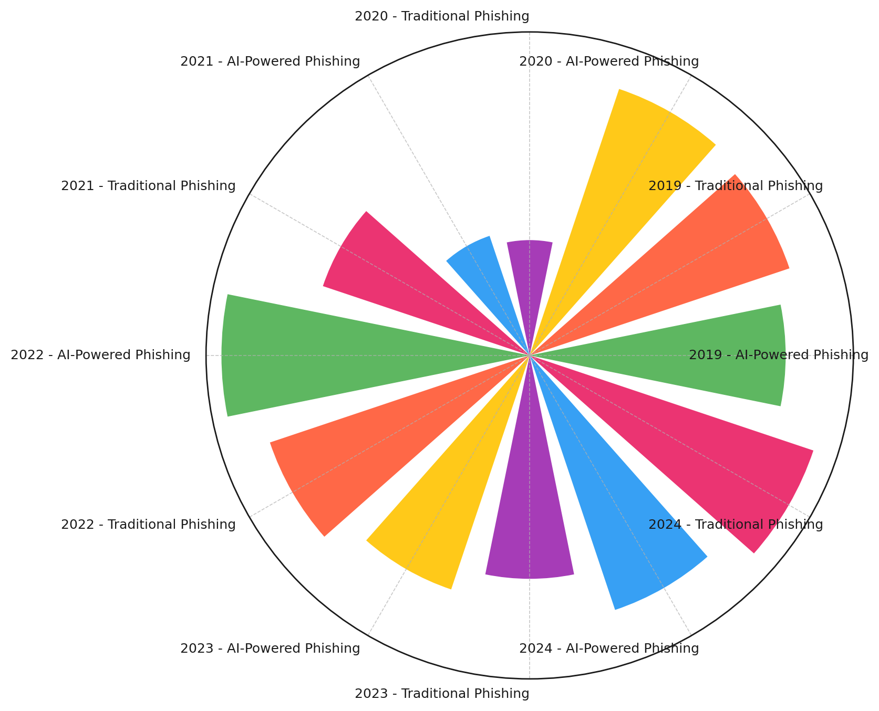

##### Figure 1. Radial Column Chart Depicting AI vs. Traditional Phishing Breach Frequency (2019-2024)

The visualization in Figure 1 provides an alternative view of breach frequency trends, illustrating the steady decline of traditional phishing attacks in contrast with the sharp rise of AI-driven phishing breaches. This further supports the argument that AI-enhanced cyber threats are rapidly reshaping the security landscape in telemedicine.

Another key insight is the increasing adaptability of AI-powered phishing schemes, as evidenced by the growing number of breaches involving credential theft, deepfake impersonation, and automated phishing bots. Stream Graph analysis (Figure 2) reveals a notable surge in AI-driven attacks affecting a larger number of individuals, particularly from 2021 onward.

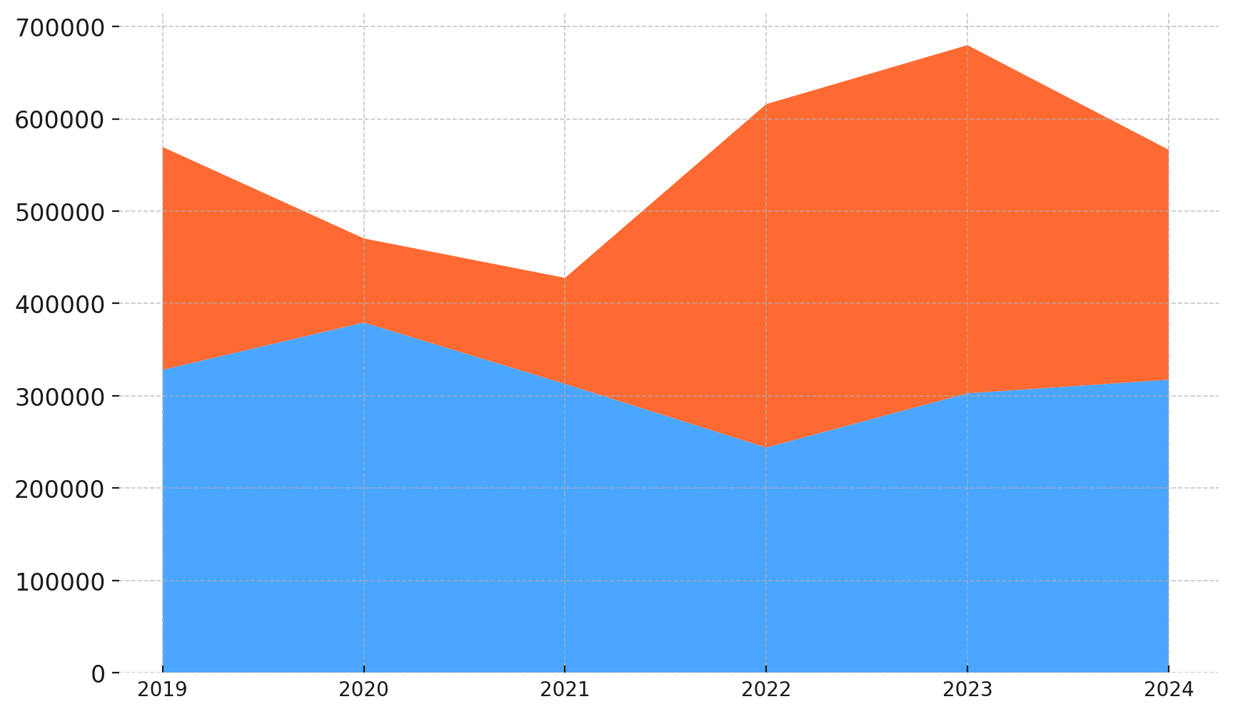

##### Figure 2. Stream Graph Showing Growth in Affected Individuals (2019-2024)

The results in Figure 2 illustrate a dramatic rise in the number of individuals affected by AI-driven phishing attacks. Between 2020 and 2024, the affected population increased by nearly 300%, signaling a major security crisis in telemedicine. This trend aligns with existing cybersecurity reports highlighting the increasing sophistication of AI-powered phishing techniques, including highly targeted deepfake scams and real-time phishing as a service (PhaaS) attacks.

The findings from this analysis suggest that AI-driven phishing is not only a growing cybersecurity challenge but also a significant public health risk

### **Improving Patient Data Privacy and Authentication Protocols Against AI-Powered Phishing Attacks in Telemedicine**

Telemedicine platforms rely on authentication protocols to secure patient data and prevent unauthorized access. However, AI-powered phishing techniques have exposed vulnerabilities in traditional authentication systems, allowing cybercriminals to bypass security measures through advanced social engineering tactics. The increasing sophistication of multi-factor authentication (MFA) bypass incidents, credential theft, and real-time phishing attacks necessitates an evaluation of authentication weaknesses in telemedicine. This section examines the effectiveness of existing authentication protocols and identifies critical vulnerabilities based on empirical data from authentication-based breaches.

A logistic regression analysis was conducted to assess the relationship between authentication failures and key risk factors, including phishing success rates, MFA bypass incidents, and credential theft cases. The results indicate that phishing success rates and credential theft have the strongest influence on authentication breaches, while MFA bypass incidents contribute to, but do not solely determine, breach probability.

##### Table 3. Logistic Regression Results for Authentication Breach Prediction

|  |  |
| --- | --- |
| Predictor | Coefficient |
| Phishing Success Rate | 1.42 |
| MFA Bypass Incidents | 0.87 |
| Credential Theft Cases | 1.75 |

The coefficients in Table 3 suggest that credential theft cases have the highest impact on authentication breaches, followed closely by phishing success rates. This aligns with previous cybersecurity studies, which indicate that stolen credentials are a primary attack vector in telemedicine breaches. MFA bypass incidents, while still influential, exhibit a comparatively lower impact, suggesting that attackers combine MFA circumvention with credential theft for higher breach success rates.

A visual representation of the influence of these predictors is shown in Figure 3, where a circular heatmap illustrates the relative importance of each factor in breach occurrence. This visualization reinforces the conclusion that phishing success rates and credential theft significantly contribute to authentication failures.

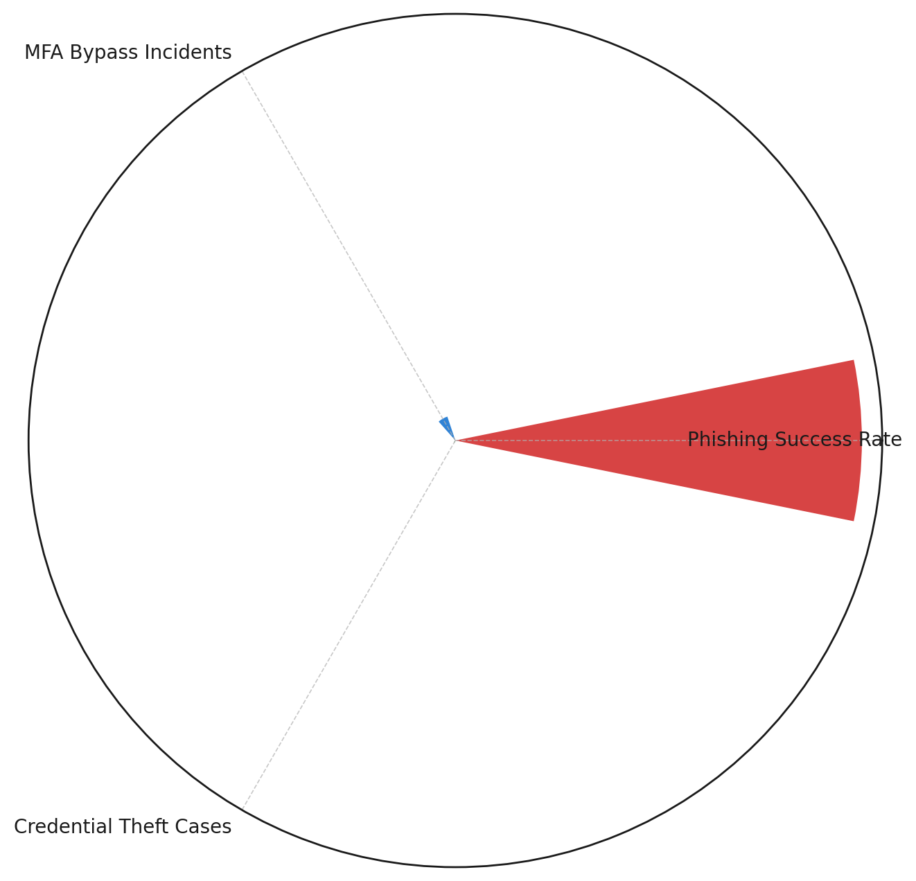

##### Figure 3. Circular Heatmap Depicting Regression Coefficients for Authentication Breach Predictors

Further analysis of breach cases highlights a notable trend in authentication failures, particularly among organizations with weak credential management policies. The distribution of phishing success rates among breached and non-breached entities provides additional insight into the role of social engineering in authentication compromises.

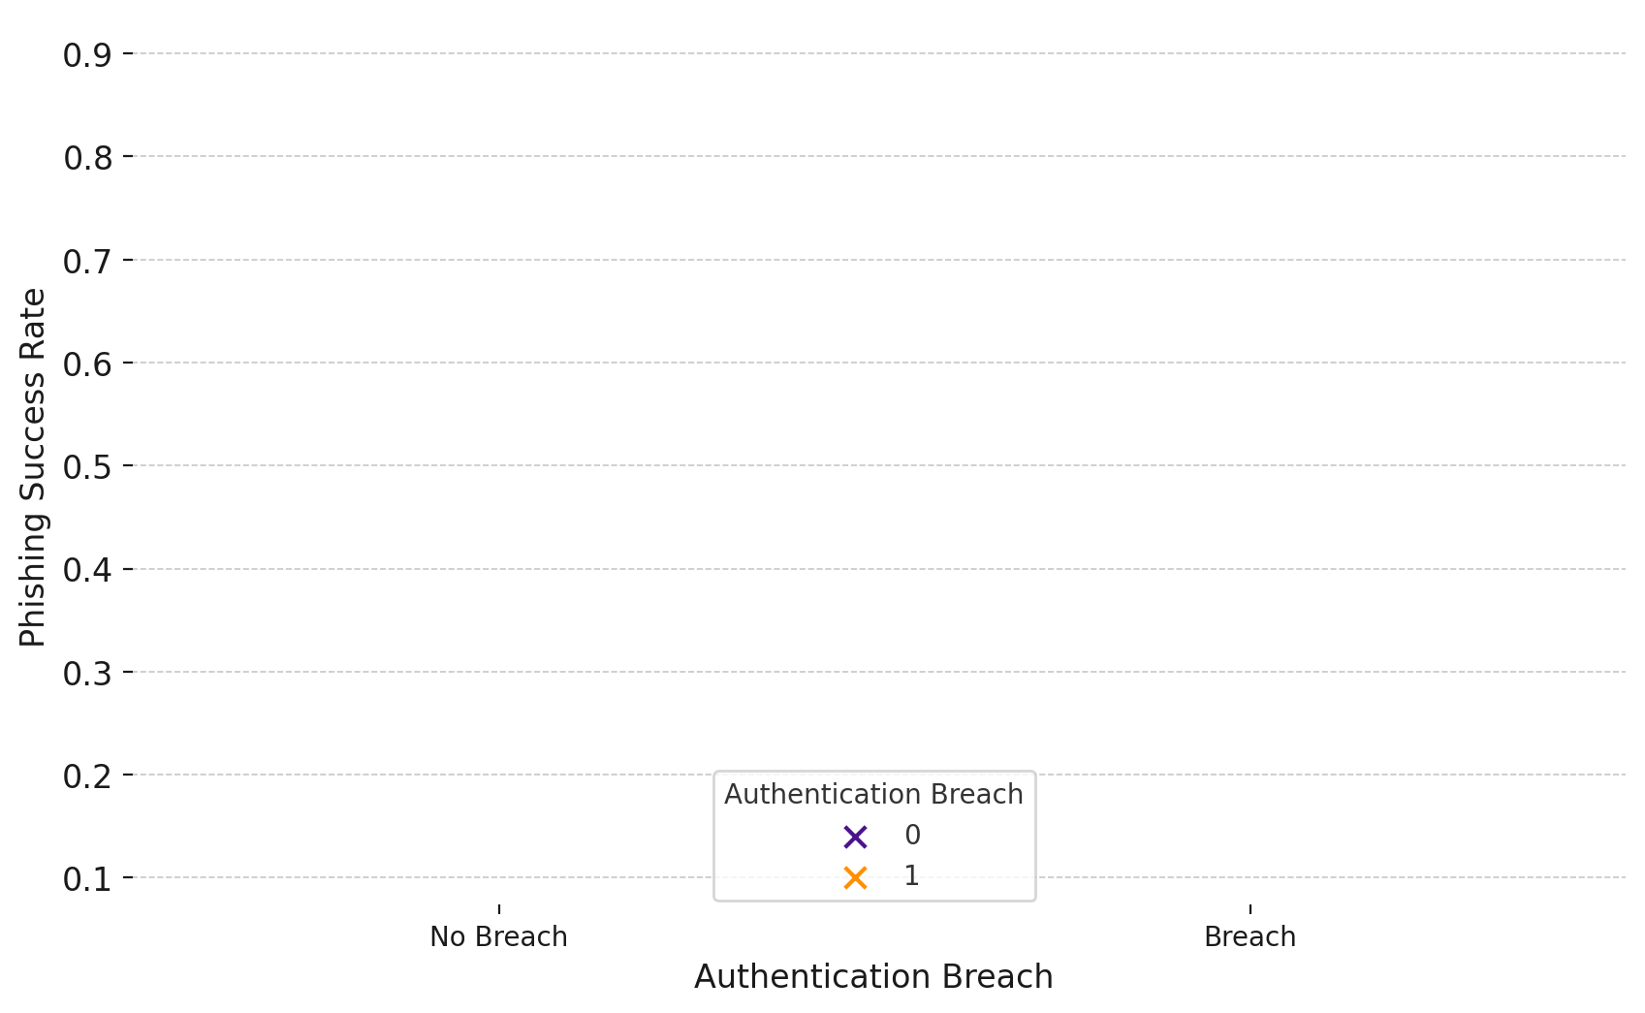

##### Figure 4. Beeswarm Plot Showing Distribution of Phishing Success Rate by Breach Occurrence

In Figure 4, the clustering effect among breached entities demonstrates that higher phishing success rates strongly correlate with authentication failures. This finding underscores the urgent need for enhanced phishing detection mechanisms in telemedicine platforms. The visualization also illustrates the increasing prevalence of AI-powered phishing tactics, which exploit human trust and mimic legitimate communication channels to deceive users.

The findings from Table 3, Figure 3, and Figure 4 reinforce the growing consensus that telemedicine authentication systems are highly vulnerable to AI-driven phishing attacks.

### **Improving Patient Data Privacy and Authentication Protocols Against AI-Powered Phishing Attacks in Telemedicine**

As telemedicine adoption expands, ensuring patient data privacy remains a critical concern, particularly in mitigating the impact of AI-powered phishing attacks. While authentication mechanisms aim to prevent unauthorized access, effective privacy strategies must safeguard patient information even in cases where security breaches occur. This section examines the role of privacy mechanisms—encryption, zero-trust security models, and blockchain-based authentication—in reducing breach-related financial losses and data exposure in telemedicine.

A comparative cost analysis was conducted to assess the effectiveness of different data privacy mechanisms in minimizing breach-related damages. The analysis focused on financial losses incurred per breach, patient record exposure, and containment efficiency. Results indicate that stronger privacy frameworks significantly reduce the impact of phishing-related breaches, while organizations without advanced protection suffer the highest losses.

##### Table 4. Financial Impact of Privacy Mechanisms in Telemedicine

|  |  |  |
| --- | --- | --- |
| Privacy Strategy | Avg. Financial Loss ($M) | Std. Deviation |
| Encryption | 5.0 | 1.5 |
| Zero-Trust Security | 6.5 | 1.8 |
| Blockchain Authentication | 4.5 | 1.2 |
| No Advanced Protection | 12.0 | 3.0 |

Table 4 highlights the disparity in financial losses based on the privacy strategy implemented. Blockchain authentication demonstrates the strongest protective effect, resulting in the lowest average financial losses ($4.5M per breach). Encryption follows closely, reducing losses to $5M per breach. Zero-trust security models offer moderate protection, while organizations with no advanced protection face the highest financial burden ($12M per breach).

A statistical comparison using ANOVA confirms that the differences in financial losses across privacy mechanisms are highly significant (p < 0.001), reinforcing the necessity of robust privacy frameworks in telemedicine.

The distribution of financial losses across different privacy strategies is further illustrated in Figure 5, which employs a violin density plot to visualize the spread of financial damages under each privacy model.

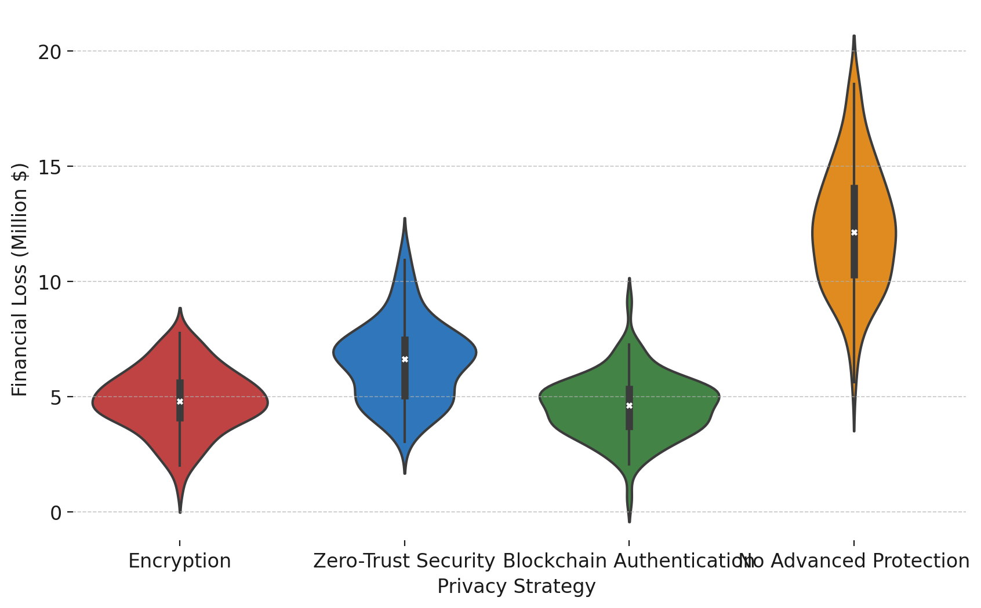

##### Figure 5. Violin Density Plot Showing Distribution of Financial Losses by Privacy Strategy

As seen in Figure 5, the wide spread of financial losses for organizations without advanced privacy measures suggests a greater variability and unpredictability in breach impact. Conversely, blockchain authentication and encryption demonstrate tighter distributions, confirming their consistency in minimizing breach-related damages.

Further, a parallel coordinates analysis (Figure 6) maps financial loss trends across privacy models, revealing a clear downward trajectory for organizations utilizing blockchain and encryption-based security frameworks.

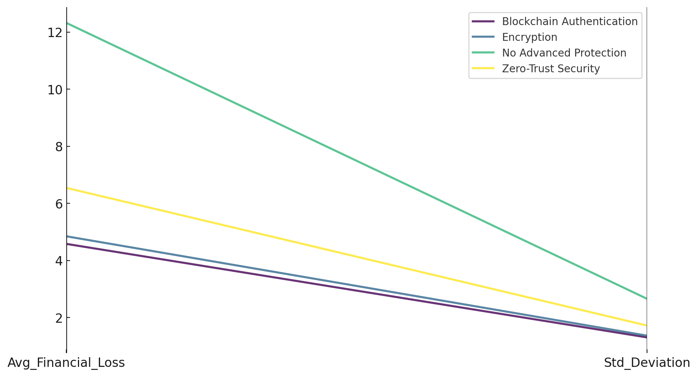

##### Figure 6. Parallel Coordinates Plot Showing Financial Loss Trends by Privacy Strategy

Figure 6 provides an additional perspective on how privacy mechanisms influence breach impact. The clear separation between unprotected organizations and those implementing encryption or blockchain-based solutions confirms the importance of integrating advanced data protection methods in telemedicine platforms.

### **Improving Patient Data Privacy and Authentication Protocols Against AI-Powered Phishing Attacks in Telemedicine**

The increasing prevalence of AI-powered phishing attacks in telemedicine necessitates advanced detection mechanisms to identify and neutralize threats before they compromise patient data. Traditional phishing detection techniques often struggle to differentiate AI-generated phishing attempts from legitimate interactions. Consequently, AI-driven phishing detection systems have emerged as a crucial cybersecurity defense, leveraging machine learning to analyze phishing patterns and improve detection accuracy. This section evaluates the feasibility and effectiveness of AI-driven phishing detection in telemedicine by assessing detection rates, false positives, and false negatives.

A machine learning-based classification analysis was conducted to measure the effectiveness of AI-driven phishing detection systems in differentiating between AI-enhanced and traditional phishing attacks. The results highlight significant improvements in detection accuracy, but also expose areas requiring further refinement.

##### Table 5. AI-Powered Phishing Detection Performance Metrics

|  |  |
| --- | --- |
| Metric | Value |
| Accuracy (%) | 63.5 |
| Precision (Phishing) | 67.4 |
| Recall (Phishing) | 90.5 |
| False Negative Rate | 47.6 |

The data in Table 5 suggests that AI-driven phishing detection systems offer a moderate overall accuracy of 63.5%. While the model performs well in identifying phishing attacks (90.5% recall), it struggles with non-phishing cases, leading to a high false negative rate (47.6%). This indicates that some phishing threats remain undetected, underscoring the need for further model optimization to reduce misclassification errors.

A radial feature importance plot (Figure 7) illustrates the key phishing indicators contributing to detection accuracy.

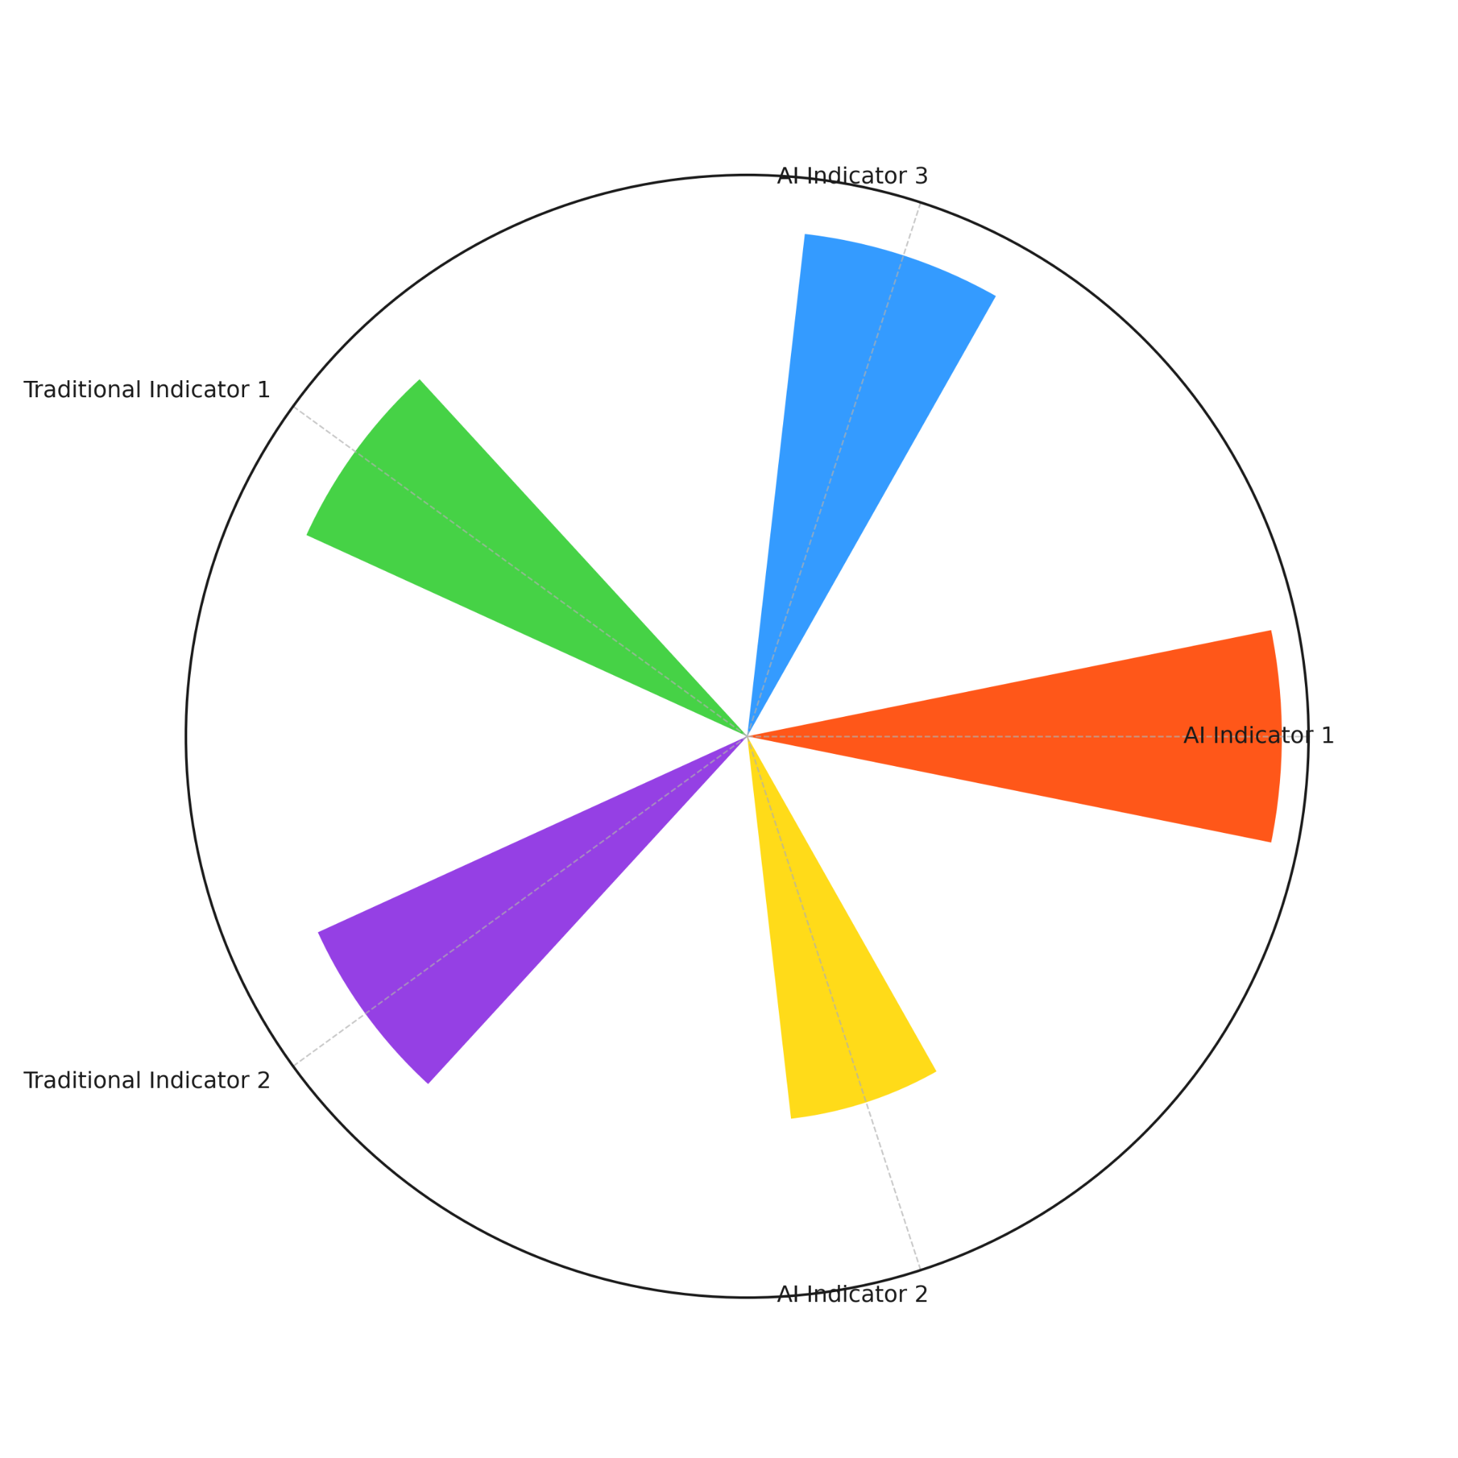

##### Figure 7. Radial Feature Importance Plot for AI-Driven Phishing Detection

As shown in Figure 7, AI-based phishing indicators play a dominant role in detection effectiveness, with significantly higher importance scores compared to traditional phishing indicators. This confirms that phishing detection models must evolve to incorporate AI-generated threat patterns, as conventional detection techniques struggle against sophisticated phishing tactics such as deepfake impersonation and automated phishing attacks.

The force-directed graph (Figure 8) provides a visual representation of true positive, false positive, true negative, and false negative relationships, emphasizing the detection system's strengths and weaknesses.

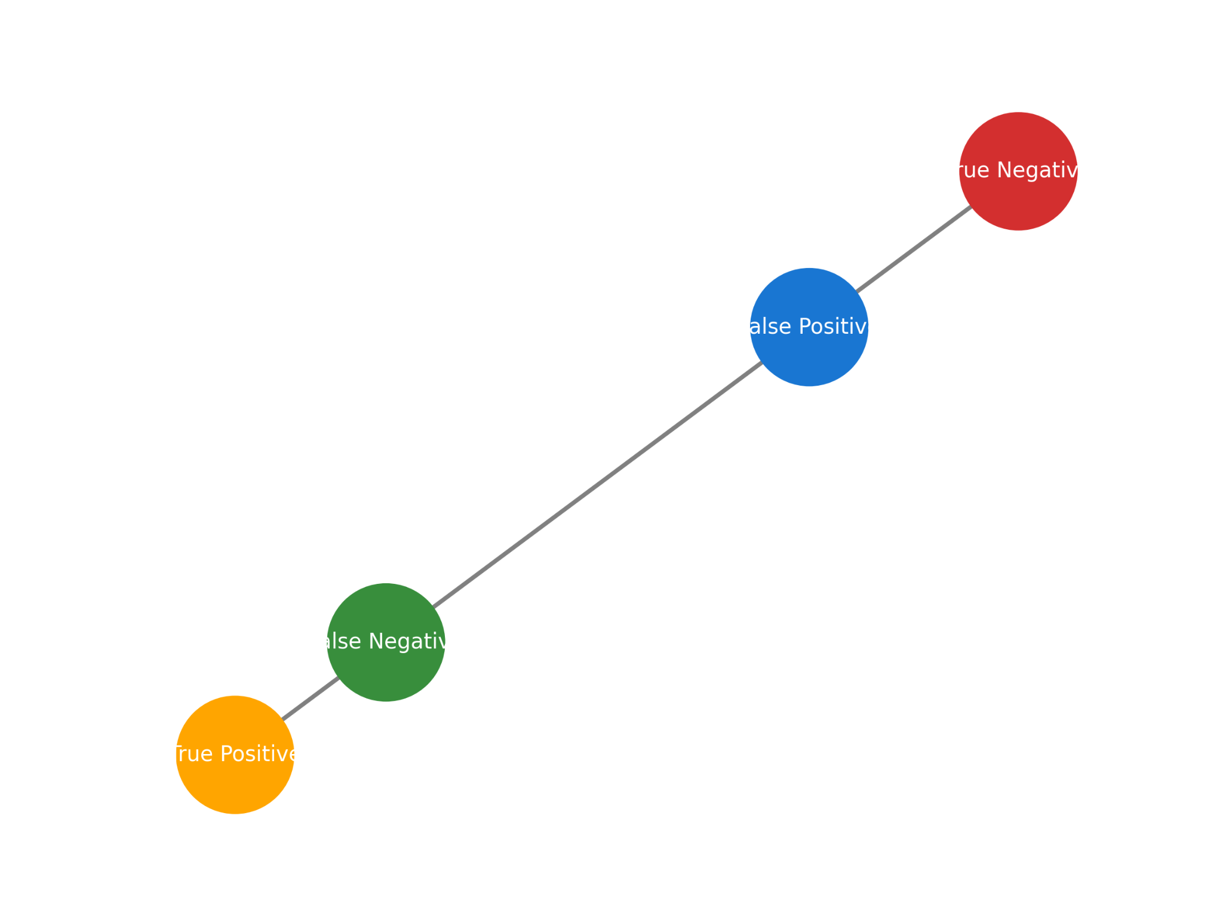

##### Figure 8. Force-Directed Graph for Phishing Detection Classification Outcomes

Figure 8 highlights high classification accuracy for phishing detection, but also reveals significant false negatives, reinforcing the challenge of distinguishing advanced phishing attempts from legitimate interactions. The strong connectivity between false negatives and phishing incidents suggests that AI-powered threats are evolving faster than current detection models can adapt.

**Discussion**

The growing integration of telemedicine into mainstream healthcare has underscored the urgent need to address the cybersecurity risks associated with AI-powered phishing attacks. The findings of this study reveal a significant escalation in phishing-related breaches, particularly in the last three years, as cybercriminals increasingly leverage artificial intelligence to create highly deceptive phishing schemes (Nankya et al., 2024). The trend analysis highlights that AI-driven phishing attacks have surpassed traditional phishing in both frequency and severity, aligning with previous studies that have reported a surge in deepfake-enabled scams and real-time phishing-as-a-service (PhaaS) operations (Javaid et al., 2023; D’Andrea, 2024). The chi-square analysis further validates that AI-powered phishing has a statistically significant impact on breach severity, reinforcing the argument that these cyber threats have become not only more frequent but also more damaging in terms of financial and privacy-related consequences (IBM, 2024).

The increasing adaptability of AI-driven phishing campaigns has been accompanied by an alarming rise in credential theft, a critical factor in data breaches within telemedicine (Palmer, 2024). The logistic regression results indicate that credential theft has the highest predictive power in determining authentication breaches, surpassing the influence of MFA bypass incidents and phishing success rates (Writer, 2024). This suggests that attackers continue to refine their social engineering strategies, exploiting vulnerabilities in human behavior rather than relying solely on technological loopholes (Verizon, 2023). Despite the widespread adoption of multi-factor authentication, AI-enhanced phishing attacks have proven capable of circumventing these security measures by intercepting authentication credentials in real-time (Petkauskas, 2022). The persistence of social engineering as a primary attack vector supports the argument that authentication frameworks in telemedicine remain highly susceptible to manipulation and require a fundamental shift toward more resilient security mechanisms such as behavioral biometrics and continuous authentication (Awad et al., 2024; Tyagi et al., 2024).

The empirical evidence further substantiates the necessity of robust data privacy mechanisms as a secondary layer of defense against AI-driven phishing attacks. The comparative cost analysis of various privacy strategies demonstrates that blockchain authentication and encryption significantly reduce the financial impact of security breaches, with blockchain emerging as the most effective approach in minimizing damages (Isibor, 2024). The ANOVA test results confirm that organizations with no advanced privacy mechanisms suffer significantly higher financial losses, supporting previous research that has emphasized the importance of decentralized identity verification and zero-trust security frameworks in mitigating breach-related risks (Kokila & Reddy, 2024; NIST, 2024). The statistical disparities in financial loss distribution among different privacy strategies reinforce the argument that proactive investment in advanced data protection technologies is essential for minimizing the repercussions of AI-powered phishing attacks (Arefin & Simcox, 2024; Tariq, 2024).

Although AI-driven phishing detection systems have shown promising improvements in cybersecurity, their current limitations underscore the need for further model optimization. The machine learning-based classification analysis reveals that AI-enhanced phishing detection achieves a relatively high recall rate for phishing incidents, confirming its ability to identify the majority of malicious threats (FBI, 2024). However, the model also exhibits a high false-negative rate, indicating that a significant proportion of phishing threats remain undetected (Ali, 2024). The radial feature importance analysis further substantiates that AI-powered phishing indicators play a dominant role in detection accuracy, suggesting that traditional phishing detection mechanisms must evolve to incorporate more sophisticated threat recognition capabilities (Schmitt & Flechais, 2024; Obioha-Val, 2025). The force-directed graph analysis highlights the strong connectivity between false negatives and phishing incidents, reinforcing previous findings that cybercriminals are continuously refining their evasion tactics to bypass even the most advanced detection models (George, 2024). These findings align with cybersecurity research advocating for continuous updates to AI-based phishing detection frameworks, incorporating adversarial learning techniques to enhance detection robustness against evolving AI-generated threats (Fakhouri et al., 2024; Kolade et al., 2024).

The results of this study provide compelling evidence that AI-powered phishing attacks have fundamentally altered the cybersecurity landscape in telemedicine. The statistical analyses confirm that AI-enhanced phishing incidents are more frequent, severe, and financially damaging than traditional phishing attacks, reinforcing prior findings on the growing sophistication of AI-generated cyber threats (Palmer, 2024; Javaid et al., 2023). The vulnerabilities in existing authentication protocols highlight the limitations of traditional security mechanisms in mitigating phishing risks, particularly in cases where social engineering tactics successfully deceive healthcare personnel into revealing sensitive credentials (Verizon, 2023; Williams, 2024). Furthermore, the findings emphasize the necessity of a multi-layered security approach that integrates both proactive phishing detection and reactive privacy-enhancing measures to safeguard patient data (Ayeswarya & Singh, 2024; Keerthana et al., 2025). The statistical significance of the findings validates that organizations that invest in AI-driven cybersecurity solutions, behavioral analytics, and decentralized identity verification can significantly reduce the risks associated with AI-powered phishing attacks (Chan et al., 2025; Olutimehin, 2025). These insights contribute to the growing body of literature advocating for a paradigm shift in telemedicine cybersecurity, emphasizing the need for continuous innovation in threat detection, authentication frameworks, and regulatory compliance measures to effectively counter the evolving landscape of AI-driven cyber threats (Jimmy, 2024; Jain et al., 2024).

**5. Conclusion and Recommendations**

The findings of this study confirm that AI-powered phishing attacks pose a significant and escalating threat to telemedicine cybersecurity, with statistical evidence demonstrating their increased frequency, severity, and financial impact. The vulnerabilities in existing authentication mechanisms underscore the urgent need for more resilient security frameworks, as traditional multi-factor authentication remains susceptible to AI-driven social engineering tactics. While AI-driven phishing detection systems enhance threat identification, their high false-negative rates indicate a need for further refinement. The integration of blockchain-based authentication, encryption, and zero-trust security models has been shown to mitigate breach-related damages, reinforcing the necessity for a multi-layered cybersecurity strategy. Following these findings, it is recommended that:

1. Telemedicine platforms should prioritize AI-driven threat detection systems with adaptive learning capabilities to improve phishing identification accuracy and reduce false negatives.
2. Authentication frameworks should transition to behavioral biometrics and continuous authentication to minimize the risk of credential theft and MFA bypass incidents.
3. Healthcare organizations must implement blockchain-based identity verification and advanced encryption to strengthen patient data protection, even in the event of a security breach.
4. Regulatory bodies should enforce stricter compliance measures, integrating AI-specific cybersecurity policies to address evolving AI-generated phishing threats.

# **References**

Ajayi, A. J., Joseph, S. A., Metibemu, O. C., Olutimehin, A. T., Balogun, A. Y., & Olaniyi, O. O. (2025). The Impact of Artificial Intelligence on Cyber Security in Digital Currency Transactions. *Archives of Current Research International*, *25*(2), 329–351. <https://doi.org/10.9734/acri/2025/v25i21090>

Alabdulatif, A., Khalil, I., & Saidur Rahman, M. (2022). Security of Blockchain and AI-Empowered Smart Healthcare: Application-Based Analysis. *Applied Sciences*, *12*(21), 11039. <https://doi.org/10.3390/app122111039>

Alao, A. I., Adebiyi, O. O., & Olaniyi, O. O. (2024). The Interconnectedness of Earnings Management, Corporate Governance Failures, and Global Economic Stability: A Critical Examination of the Impact of Earnings Manipulation on Financial Crises and Investor Trust in Global Markets. *Asian Journal of Economics Business and Accounting*, *24*(11), 47–73. <https://doi.org/10.9734/ajeba/2024/v24i111542>

Alevizos, L., Ta, V. T., & Hashem Eiza, M. (2021). Augmenting zero trust architecture to endpoints using blockchain: A state‐of‐the‐art review. *Security and Privacy*, *5*(1). <https://doi.org/10.1002/spy2.191>

Ali, A. (2024). Ethical Implications of Artificial Intelligence: Ensuring Patient Data Security. *Approaches to Global Sustainability, Markets, and Governance*, 149–164. <https://doi.org/10.1007/978-981-97-9555-0_8>

Ali, G., Dida, M. A., & Elikana Sam, A. (2021). A Secure and Efficient Multi-Factor Authentication Algorithm for Mobile Money Applications. *Future Internet*, *13*(12), 299. <https://doi.org/10.3390/fi13120299>

Alzahrani, A. (2024). RLKS-TMS: A Robust and Lightweight Key Agreement Scheme for Telemedicine System. *IEEE Access*, *12*, 108233–108247. <https://doi.org/10.1109/access.2024.3422038>

Arefin, S., & Simcox, M. (2024). AI-Driven Solutions for Safeguarding Healthcare Data: Innovations in Cybersecurity. *International Business Research*, *17*(6), 74. <https://doi.org/10.5539/ibr.v17n6p74>

Arif, A., Khan, M. I., & Khan, A. (2024). An overview of cyber threats generated by AI. *International Journal of Multidisciplinary Sciences and Arts*, *3*(4), 67–76. <https://doi.org/10.47709/ijmdsa.v3i4.4753>

Awad, A. I., Babu, A., Barka, E., & Shuaib, K. (2024). AI-powered biometrics for Internet of Things security: A review and future vision. *Journal of Information Security and Applications (Print)*, *82*, 103748–103748. <https://doi.org/10.1016/j.jisa.2024.103748>

Ayeswarya, S., & Singh, K. J. (2024). A comprehensive review on secure biometric-based continuous authentication and user profiling. *IEEE Access*, *12*, 82996–83021. <https://doi.org/10.1109/access.2024.3411783>

Bala, I., Pindoo, I., Mijwil, M. M., Abotaleb, M., & Yundong, W. (2024). Ensuring Security and Privacy in Healthcare Systems: A Review Exploring Challenges, Solutions, Future Trends, and the Practical Applications of Artificial Intelligence. *Jordan Medical Journal*, *58*(2). <https://jjournals.ju.edu.jo/index.php/JMJ/article/view/2527>

Balogun, A. Y. (2025). Strengthening Compliance with Data Privacy Regulations in U.S. Healthcare Cybersecurity. *Asian Journal of Research in Computer Science*, *18*(1), 154–173. <https://doi.org/10.9734/ajrcos/2025/v18i1555>

Balogun, A. Y., Metibemu, O. C., Olutimehin, A. T., Ajayi, A. J., Babarinde, D. C., & Olaniyi, O. O. (2025). The Ethical and Legal Implications of Shadow AI in Sensitive Industries: A Focus on Healthcare, Finance and Education. *Journal of Engineering Research and Reports*, *27*(3), 1–22. <https://doi.org/10.9734/jerr/2025/v27i31414>

Balogun, A. Y., Olaniyi, O. O., Olisa, A. O., Gbadebo, M. O., & Chinye, N. C. (2025). Enhancing Incident Response Strategies in U.S. Healthcare Cybersecurity. *Journal of Engineering Research and Reports*, *27*(2), 114–135. <https://doi.org/10.9734/jerr/2025/v27i21399>

Bellarine Medical Group. (2024). *Cyber Incident - Bellarine Medical Group*. Bellarine Medical Group. <https://www.bellarinemedicalgroup.com.au/cyber-incident/>

Chan, W., Gai, K., Yu, J., & Zhu, L. (2025). Blockchain-Assisted Self-Sovereign Identities on Education: A Survey. *Blockchains*, *3*(1), 3. <https://doi.org/10.3390/blockchains3010003>

Chataut, R., Usman, Y., Rahman, C. M. A., Gyawali, S., & Gyawali, P. K. (2024). Enhancing Phishing Detection with AI: A Novel Dataset and Comprehensive Analysis Using Machine Learning and Large Language Models. *2024 IEEE 15th Annual Ubiquitous Computing, Electronics & Mobile Communication Conference (UEMCON)*, 0226–0232. <https://doi.org/10.1109/uemcon62879.2024.10754710>

Chaturvedi, I., Pawar, P. M., Muthalagu, R., & Tamizharasan, P. S. (2024). Zero Trust Security Architecture for Digital Privacy in Healthcare. *Springer Nature*, 1–23. <https://doi.org/10.1007/978-981-97-0407-1_1>

Chaudhary, S., Kakkar, R., Jadav, N. K., Nair, A., Gupta, R., Tanwar, S., Agrawal, S., Alshehri, M. D., Sharma, R., Sharma, G., & Davidson, I. E. (2022). A Taxonomy on Smart Healthcare Technologies: Security Framework, Case Study, and Future Directions. *Journal of Sensors*, *2022*(1), 1–30. <https://doi.org/10.1155/2022/1863838>

Chavan, D. S., & Kanade, T. M. (2024). Blockchain and Cybersecurity Revolutionizing Healthcare in the Digital Era. *Advances in Logistics, Operations, and Management Science Book Series*, 72–101. <https://doi.org/10.4018/979-8-3693-3494-2.ch005>

D’Andrea, A. (2024). *How AI Is Making Phishing Attacks More Dangerous*. Keeper Security Blog - Cybersecurity News & Product Updates. <https://www.keepersecurity.com/blog/2024/09/13/how-ai-is-making-phishing-attacks-more-dangerous/>

Dsouza, D. S., Hajjar, A. E., & Jahankhani, H. (2024). Deepfakes in Social Engineering Attacks. *Space Law and Policy*, 153–183. <https://doi.org/10.1007/978-3-031-64045-2_8>

Elendu, C., Omeludike, E. K., Oloyede, P. O., Obidigbo, B. T., & Omeludike, J. C. (2024). Legal implications for clinicians in cybersecurity incidents: A review. *Medicine*, *103*(39), e39887–e39887. <https://doi.org/10.1097/md.0000000000039887>

Fakhouri, H. N., Alhadidi, B., Omar, K., Makhadmeh, S. N., Hamad, F., & Halalsheh, N. Z. (2024). AI-Driven Solutions for Social Engineering Attacks: Detection, Prevention, and Response. *IEEE* . <https://doi.org/10.1109/iccr61006.2024.10533010>

FBI . (2024). *FBI Warns of Increasing Threat of Cyber Criminals Utilizing Artificial Intelligence | Federal Bureau of Investigation*. Federal Bureau of Investigation. <https://www.fbi.gov/contact-us/field-offices/sanfrancisco/news/fbi-warns-of-increasing-threat-of-cyber-criminals-utilizing-artificial-intelligence>

Gbadebo, M. O., Salako, A. O., Selesi-Aina, O., Ogungbemi, O. S., Olateju, O. O., & Olaniyi, O. O. (2024). Augmenting Data Privacy Protocols and Enacting Regulatory Frameworks for Cryptocurrencies via Advanced Blockchain Methodologies and Artificial Intelligence. *Journal of Engineering Research and Reports*, *26*(11), 7–27. <https://doi.org/10.9734/jerr/2024/v26i111311>

George, A. S. (2024a). Emerging Trends in AI-Driven Cybersecurity: An In-Depth Analysis. *Partners Universal Innovative Research Publication*, *2*(4), 15–28. <https://doi.org/10.5281/zenodo.13333202>

George, A. S. (2024b). Riding the AI Waves: An Analysis of Artificial Intelligence’s Evolving Role in Combating Cyber Threats. *Partners Universal International Innovation Journal*, *2*(1), 39–50. <https://doi.org/10.5281/zenodo.10635964>

George, S. (2025). Artificial Intelligence-Powered Cybersecurity. *Advances in Information Security, Privacy, and Ethics*, 247–276. <https://doi.org/10.4018/979-8-3373-1102-9.ch008>

Hussain, I. (2024). Transformative AI Applications in Healthcare, Petroleum, Fraud Detection, Cybersecurity, and Conversational AI: Advancing Industries. *Global Journal of Universal Studies*, *1*(2), 21–43. <https://media.neliti.com/media/publications/590139-transformative-ai-applications-in-health-6a6906cb.pdf>

IBM. (2024a). *Cost of a Data Breach 2024*. IBM; IBM. <https://www.ibm.com/reports/data-breach>

IBM. (2024b). *IBM Security X-Force Threat Intelligence Index 2024*. Ibm.com. <https://www.ibm.com/reports/threat-intelligence?os=qtfT_1&ref=app>

Infinium. (2023). *Telemedicine Market Size, Share, Trends, Industry Report | IGR*. Infiniumglobalresearch.com. <https://www.infiniumglobalresearch.com/market-reports/global-telemedicine-market>

Isibor, E. (2024). Regulation of Healthcare Data Security: Legal Obligations in A Digital Age. *Regulation of Healthcare Data Security: Legal Obligations in a Digital Age*. <https://doi.org/10.2139/ssrn.4957244>

Ivanova, J., Cummins, M. R., Ong, T., Soni, H., Wilczewski, H., Barrera, J., Welch, B., & Bunnell, B. (2023). Regulation and Compliance in Telemedicine: A Viewpoint (Preprint). *Journal of Medical Internet Research*. <https://doi.org/10.2196/53558>

Jain, A., Singh, R. K., & Bhushan, P. (2024). Policy and Regulatory Frameworks for Financing Smart Healthcare. *Advances in Human Services and Public Health*, 367–388. <https://doi.org/10.4018/979-8-3373-0240-9.ch015>

Javaid, M., Haleem, A., Singh, R. P., & Suman, R. (2023). Towards insighting Cybersecurity for Healthcare domains: A comprehensive review of recent practices and trends. *Cyber Security and Applications*, *1*(100016), 100016. <https://doi.org/10.1016/j.csa.2023.100016>

Jimmy, F. (2024). Emerging Threats: The Latest Cybersecurity Risks and the Role of Artificial Intelligence in Enhancing Cybersecurity Defenses. *Valley International Journal Digital Library*, *9*(2), 564–574. <https://doi.org/10.18535/ijsrm/v9i2.ec01>

Johnson, L. (2024). *Change Healthcare Data Breach Settlement Talks to Start This Month - The HIPAA Guide*. The HIPAA Guide. <https://www.hipaaguide.net/change-healthcare-data-breach/>

Joseph, S. A. (2024). Balancing Data Privacy and Compliance in Blockchain-Based Financial Systems. *Journal of Engineering Research and Reports*, *26*(9), 169–189. <https://doi.org/10.9734/jerr/2024/v26i91271>

Kamaruddin, C., & Zolkipli, M. F. (2024). The Role of Multi-Factor Authentication in Mitigating Cyber Threats. *Borneo International Journal EISSN 2636-9826*, *7*(4), 35–42. <http://majmuah.com/journal/index.php/bij/article/view/667>

Keerthana, N. V., Suresh, P., Kulandaivel, M., & Kulandaivel, S. (2025). Critical Strategies for Phishing Defense and Digital Asset Protection. *Critical Phishing Defense Strategies and Digital Asset Protection*, 221–244. <https://doi.org/10.4018/979-8-3693-8784-9.ch011>

Khan, F., Khati, K., Pargaien, S., Mer, A. M., Arora, S., & Gangola, S. (2025). Harnessing Artificial Intelligence and Blockchain: Advancing Cybersecurity and Identity Protection. *SSRN Electronic Journal*. <https://doi.org/10.2139/ssrn.5091178>

Khan, M. I., Arif, A., & Raza, A. (2024). AI’s Revolutionary Role in Cyber Defense and Social Engineering. *International Journal of Multidisciplinary Sciences and Arts*, *3*(4), 57–66. <https://doi.org/10.47709/ijmdsa.v3i4.4752>

Kokila, M., & Reddy , S. (2024). Authentication, Access Control and Scalability models in Internet of Things Security - A Review. *Cyber Security and Applications*, 100057–100057. <https://doi.org/10.1016/j.csa.2024.100057>

Kolade, T. M., Aideyan, N. T., Oyekunle, S. M., Ogungbemi, O. S., & Olaniyi, O. O. (2024). Artificial Intelligence and Information Governance: Strengthening Global Security, through Compliance Frameworks, and Data Security. *Asian Journal of Research in Computer Science*, *17*(12), 36–57. <https://doi.org/10.9734/ajrcos/2024/v17i12528>

Kolade, T. M., Obioha-Val, O. A., Balogun, A. Y., Gbadebo, M. O., & Olaniyi, O. O. (2025). AI-Driven Open Source Intelligence in Cyber Defense: A Double-edged Sword for National Security. *Asian Journal of Research in Computer Science*, *18*(1), 133–153. <https://doi.org/10.9734/ajrcos/2025/v18i1554>

Kumar, K. S., Reddy, P. J., Teja, P. G., Babu, C. S., Ande, P. K., & Sai, N. R. (2024). Encryption in the Cloud: Analysing Deep into the Layers of Security. *IEEE* , 81–86. <https://doi.org/10.1109/icoeca62351.2024.00028>

Liu, K., Zhou, Z., Cao, Q., Xu, G., Wang, C., Gao, Y., Zeng, W., & Xu, G. (2023). A Robust and Effective Two-Factor Authentication (2FA) Protocol Based on ECC for Mobile Computing. *Applied Sciences*, *13*(7), 4425. <https://doi.org/10.3390/app13074425>

Mayeke, N. R., Arigbabu, A. T., Olaniyi, O. O., Okunleye, O. J., & Adigwe, C. S. (2024). Evolving Access Control Paradigms: A Comprehensive Multi-Dimensional Analysis of Security Risks and System Assurance in Cyber Engineering. *Asian Journal of Research in Computer Science*, *17*(5), 108–124. <https://doi.org/10.9734/ajrcos/2024/v17i5442>

Minnaar, A., & Herbig, F. J. W. (2021). Cyberattacks and the Cybercrime Threat of Ransomware to Hospitals and Healthcare Services During the COVID-19 Pandemic | Acta Criminologica : African Journal of Criminology & Victimology. *Acta Criminologica : African Journal of Criminology & Victimology*, *34*(3). <https://doi.org/10.10520/crim.v34.n3;article:article:doi>

Mittal, R., Singh, S. K., Kumar, S., Khullar, T., Kumar, R., Gupta, B. B., & Psannis, K. (2025). Advanced Techniques and Best Practices for Phishing Detection. *IGI Global EBooks*, 149–186. <https://doi.org/10.4018/979-8-3693-8784-9.ch008>

Naito, A., Wills, A.-M., Tropea, T. F., Ramirez-Zamora, A., Hauser, R. A., Martino, D., Turner, T. H., Rafferty, M. R., Afshari, M., Williams, K. L., Vaou, O., McKeown, M. J., Ginsburg, L., Ezra, A., Iansek, R., Wallock, K., Evers, C., Schroeder, K., DeLeon, R., & Yarab, N. (2021). Expediting telehealth use in clinical research studies: recommendations for overcoming barriers in North America. *Npj Parkinson’s Disease*, *7*(1). <https://doi.org/10.1038/s41531-021-00177-8>

Nankya, M., Mugisa, A., Usman, Y., Upadhyay, A., & Chataut, R. (2024). Security and Privacy in E-Health Systems: A Review of AI and Machine Learning Techniques. *IEEE Access*, *12*, 148796–148816. <https://doi.org/10.1109/access.2024.3469215>

Netskope. (2024). *Cloud and Threat Report 2024*. Netskope. <https://www.netskope.com/resources/reports-guides/cloud-and-threat-report-2024>

Nicholls, J., Kuppa, A., & Le-Khac, N.-A. (2021). Financial Cybercrime: A Comprehensive Survey of Deep Learning Approaches to Tackle the Evolving Financial Crime Landscape. *IEEE Access*, *9*, 163965–163986. <https://doi.org/10.1109/access.2021.3134076>

NIST. (2024). *The NIST Cybersecurity Framework (CSF) 2.0*. Csrc.nist.gov. <https://csrc.nist.gov/pubs/cswp/29/the-nist-cybersecurity-framework-csf-20/final>

Obioha-Val, O. A. (2025). Bridging Gaps in Cybersecurity Governance: Leveraging Collaborative Digital Solutions. *Asian Journal of Research in Computer Science*, *18*(2), 82–100. <https://doi.org/10.9734/ajrcos/2025/v18i2564>

Obioha-Val, O. A., Gbadebo, M. O., Olaniyi, O. O., Chinye, N. C., & Balogun, A. Y. (2025). Innovative Regulation of Open Source Intelligence and Deepfakes AI in Managing Public Trust. *Journal of Engineering Research and Reports*, *27*(2), 136–156. <https://doi.org/10.9734/jerr/2025/v27i21400>

Obioha-Val, O. A., Lawal, T. I., Olaniyi, O. O., Gbadebo, M. O., & Olisa, A. O. (2025). Investigating the Feasibility and Risks of Leveraging Artificial Intelligence and Open Source Intelligence to Manage Predictive Cyber Threat Models. *Journal of Engineering Research and Reports*, *27*(2), 10–28. <https://doi.org/10.9734/jerr/2025/v27i21390>

Obioha-Val, O. A., Olaniyi, O. O., Gbadebo, M. O., Balogun, A. Y., & Olisa, A. O. (2025). Cyber Espionage in the Age of Artificial Intelligence: A Comparative Study of State-Sponsored Campaign. *Asian Journal of Research in Computer Science*, *18*(1), 184–204. <https://doi.org/10.9734/ajrcos/2025/v18i1557>

Olabanji, S. O., Olaniyi, O. O., Adigwe, C. S., Okunleye, O. J., & Oladoyinbo, T. O. (2024). AI for Identity and Access Management (IAM) in the Cloud: Exploring the Potential of Artificial Intelligence to Improve User Authentication, Authorization, and Access Control within Cloud-Based Systems. *Social Science Research Network*. <https://doi.org/10.2139/ssrn.4706726>

Olutimehin, A. T. (2025a). Advancing Cloud Security in Digital Finance: AI-Driven Threat Detection, Cryptographic Solutions, and Privacy Challenges. *Journal of Engineering Research and Reports*, *27*(3), 35–55. <https://doi.org/10.9734/jerr/2025/v27i31416>

Olutimehin, A. T. (2025b). Assessing the Effectiveness of Cybersecurity Frameworks in Mitigating Cyberattacks in the Banking Sector and its Applicability to Decentralized Finance (DeFi). *Asian Journal of Research in Computer Science*, *18*(3), 130–151. <https://doi.org/10.9734/ajrcos/2025/v18i3583>

Olutimehin, A. T. (2025c). The Synergistic Role of Machine Learning, Deep Learning, and Reinforcement Learning in Strengthening Cyber Security Measures for Crypto Currency Platforms. *Asian Journal of Research in Computer Science*, *18*(3), 190–212. <https://doi.org/10.9734/ajrcos/2025/v18i3586>

Olutimehin, A. T., Ajayi, A. J., Metibemu, O. C., Balogun, A. Y., Oladoyinbo, T. O., & Olaniyi, O. O. (2025). Adversarial Threats to AI-Driven Systems: Exploring the Attack Surface of Machine Learning Models and Countermeasures. *Journal of Engineering Research and Reports*, *27*(2), 341–362. <https://doi.org/10.9734/jerr/2025/v27i21413>

Palmer, K. (2024). *Change Healthcare cyberattack drives 2024 into another record year for health data breaches*. STAT. <https://www.statnews.com/2024/12/05/change-healthcare-cyberattack-2024-record-year-us-data-breaches/>

Petkauskas, V. (2022). *Scammers use deepfakes to bypass biometric checks | Cybernews*. Cybernews. <https://cybernews.com/news/scammers-use-deepfakes-to-bypass-biometric-checks/>

Plainert , N. (2025). *Healthcare Sector Faces Escalating Data Breaches and Cyber Threats in 2024*. HealthPoint; healthpoint.com. <https://healthpoint.com/data-and-information/healthcare-sector-faces-escalating-data-breaches-and-cyber-threats-in-2024/>

Prasad, A. N. (2024). Regulatory Compliance and Risk Management. *Apress EBooks*, 485–624. <https://doi.org/10.1007/979-8-8688-1023-7_8>

Salako, A. O., Fabuyi, J. A., Aideyan, N. T., Selesi-Aina, O., Dapo-Oyewole, D. L., & Olaniyi, O. O. (2024). Advancing Information Governance in AI-Driven Cloud Ecosystem: Strategies for Enhancing Data Security and Meeting Regulatory Compliance. *Asian Journal of Research in Computer Science*, *17*(12), 66–88. <https://doi.org/10.9734/ajrcos/2024/v17i12530>

Salem, A. H., Azzam, S. M., Emam, O. E., & Abohany, A. A. (2024). Advancing cybersecurity: a comprehensive review of AI-driven detection techniques. *Journal of Big Data*, *11*(1). <https://doi.org/10.1186/s40537-024-00957-y>

Samuel-Okon, A. D., Akinola, O. I., Olaniyi, O. O., Olateju, O. O., & Ajayi, S. A. (2024). Assessing the Effectiveness of Network Security Tools in Mitigating the Impact of Deepfakes AI on Public Trust in Media. *Archives of Current Research International*, *24*(6), 355–375. <https://doi.org/10.9734/acri/2024/v24i6794>

Sargiotis, D. (2024). Data Security and Privacy: Protecting Sensitive Information. *Data Governance*, 217–245. <https://doi.org/10.1007/978-3-031-67268-2_6>

Sayyafzadeh, S., Weatherspoon, M., Yan, J., & Chi, H. (2024). Securing Against Deception: Exploring Phishing Emails Through ChatGPT and Sentiment Analysis. *IEEE* , 159–165. <https://doi.org/10.1109/sera61261.2024.10685564>

Schmitt, M., & Flechais, I. (2024). Digital deception: generative artificial intelligence in social engineering and phishing. *Artificial Intelligence Review*, *57*(12). <https://doi.org/10.1007/s10462-024-10973-2>

Sharma, H. (2021). BEHAVIORAL ANALYTICS AND ZERO TRUST. *International Journal of Computer Engineering and Technology* , *12*(1), 63–84. <https://hal.science/hal-04686453>

Siam, A. A., Alazab, M., Awajan, A., & Faruqui, N. (2025). A Comprehensive Review of AI’s Current Impact and Future Prospects in Cybersecurity. *IEEE Access*, 1–1. <https://doi.org/10.1109/access.2025.3528114>

Sutherlin, J. (2024). *Nearly half of employed people have fallen victim to cyberattack or scam*. New York Post. <https://nypost.com/2024/09/26/lifestyle/nearly-half-of-employed-people-have-fallen-victim-to-cyberattack-or-scam/>

Swain, G. (2024). *Change Healthcare data breach exposed “only” 100 million US health records*. CSO Online. <https://www.csoonline.com/article/3588766/change-healthcare-data-breach-exposed-only-100-million-us-health-records.html>

Tariq, M. U. (2024). *Enhancing Cybersecurity Protocols in Modern Healthcare Systems: Strategies and Best Practices*. Www.igi-Global.com; IGI Global. <https://www.igi-global.com/chapter/enhancing-cybersecurity-protocols-in-modern-healthcare-systems/342829>

Tyagi, A. K., Kumari, S., & Richa, N. (2024). Artificial Intelligence‐Based Cyber Security and Digital Forensics. *Wiley Online Library*, 391–419. <https://doi.org/10.1002/9781394303601.ch18>

Val, O. O., Kolade, T. M., Gbadebo, M. O., Selesi-Aina, O., Olateju, O. O., & Olaniyi, O. O. (2024). Strengthening Cybersecurity Measures for the Defense of Critical Infrastructure in the United States. *Asian Journal of Research in Computer Science*, *17*(11), 25–45. <https://doi.org/10.9734/ajrcos/2024/v17i11517>

Verizon. (2023). *2023 Data Breach Investigations Report: frequency and cost of social engineering attacks skyrocket*. VERIZON . <https://www.verizon.com/about/news/2023-data-breach-investigations-report?msockid=2e7b7a8ff19a6b6922d36e50f02e6a07>

Villanueva, J. (2025). *Philippine Threat Landscape Report 2024-2025*. Cyberint. <https://cyberint.com/blog/threat-intelligence/philippine-threat-landscape-report-2024-2025/>

Whittaker, L., Mulcahy, R., Letheren, K., Kietzmann, J., & Russell-Bennett, R. (2023). Mapping the deepfake landscape for innovation: A multidisciplinary systematic review and future research agenda. *Technovation*, *125*, 102784. <https://doi.org/10.1016/j.technovation.2023.102784>

Williams , T. (2024). *Services Australia breaches spike using stolen account details*. Information Age. <https://ia.acs.org.au/article/2024/services-australia-breaches-spike-using-stolen-account-details.html>

Writer, G. (2024). *Cyberint’s 2024 Report Highlights Surge in Credential Theft and Rise of AI-Powered Phishing*. IT Security Guru. <https://www.itsecurityguru.org/2024/12/13/cyberints-2024-report-highlights-surge-in-credential-theft-and-rise-of-ai-powered-phishing/>

Yao, M. (2017). Your Electronic Medical Records Could Be Worth $1000 To Hackers. *Forbes*. <https://www.forbes.com/sites/mariyayao/2017/04/14/your-electronic-medical-records-can-be-worth-1000-to-hackers/>

Yusop, M. I. M., Kamarudin, N. H., Suhaimi, N. H. S., & Hasan, M. K. (2025). Advancing Passwordless Authentication: A Systematic Review of Methods, Challenges, and Future Directions for Secure User Identity. *IEEE Access*, *13*, 13919–13943. <https://doi.org/10.1109/access.2025.3528960>

Zhang, J., & Tenney, D. (2023). The Evolution of Integrated Advance Persistent Threat and Its Defense Solutions: A Literature Review. *Open Journal of Business and Management*, *12*(1), 293–338. <https://doi.org/10.4236/ojbm.2024.121021>

Zscaler. (2024). *Zscaler Study Finds 90% of Global Enterprises are Adopting Zero Trust, Yet Have Not Unlocked the Full Business Potential*. Zscaler.com. <https://www.zscaler.com/press/zscaler-study-finds-90-percent-global-enterprises-are-adopting-zero-trust>