**Addressing Bias and Data Privacy Concerns in AI-Driven Credit Scoring Systems Through Cybersecurity Risk Assessment**

**Abstract**

*This study examines the role of cybersecurity risk assessment in addressing algorithmic bias and data privacy concerns in AI-driven credit scoring systems. Utilizing the Home Mortgage Disclosure Act (HMDA) dataset, the Equifax Data Breach Report, the Financial Cybersecurity Incidents Database, and the MITRE ATT&CK Financial Sector Threat Intelligence Dataset, statistical fairness metrics, Bayesian Probability Modeling, Markov Chain Analysis, and Monte Carlo Simulations were employed to evaluate bias, privacy risks, and cybersecurity threats. Findings reveal significant disparities in loan approvals, with Black applicants receiving approval rates 28% lower than White applicants (χ² = 59.83, p < 0.001). Data breaches remain a critical concern, with an average impact of 5,069,760 individuals affected per breach. Insider threats pose the highest probability (0.81) of leading to financial fraud. Recommendations include implementing fairness-aware machine learning, enhancing regulatory compliance, integrating AI-driven cybersecurity tools, and continuous adaptation of AI governance frameworks to mitigate systemic risks in financial AI applications.*

**Keywords: AI-driven credit scoring, algorithmic bias, data privacy, cybersecurity risk assessment, fairness-aware machine learning.**

### **1. Introduction**

The integration of artificial intelligence (AI) into financial decision-making has significantly altered credit scoring systems by introducing data-driven methodologies to assess creditworthiness. AI-driven models utilize extensive financial and non-financial datasets to evaluate an individual's ability to repay loans, thereby enhancing the efficiency and accessibility of credit (Malhotra et al., 2025). However, despite these advancements, ethical and security challenges remain prevalent, particularly concerning algorithmic bias and data privacy risks. Algorithmic bias in AI-based credit scoring raises concerns regarding fairness in lending, while the extensive collection and processing of personal financial data increase the risk of cybersecurity breaches (Ridzuan et al., 2024). According to Ramamoorthi (2021), these concerns necessitate the implementation of a comprehensive cybersecurity risk assessment framework to uphold fairness, transparency, and data protection in AI-driven credit systems.

One of the primary ethical concerns associated with AI-driven credit scoring is algorithmic bias, which can arise from various sources, including biased training data, flawed feature selection, and systemic discrimination embedded in historical financial transactions (Mathen & Paul, 2025). Bircan and Özbilgin (2024) avers that research has demonstrated that AI models disproportionately disadvantage specific demographic groups, perpetuating existing disparities. A study conducted by researchers at Lehigh University in 2024 revealed that mortgage underwriting models exhibited racial bias, resulting in a higher likelihood of loan denials for Black applicants (Morgan & Munson, 2024). Similarly, the SafeRent tenant screening algorithm was found to have discriminated against Black and Hispanic renters, culminating in a class-action lawsuit and a $2.3 million settlement (Ladan, 2022). These cases underscore the risks posed by algorithmic bias in financial AI systems, illustrating the potential for discriminatory outcomes in credit allocation.

Historical disparities in credit scoring have long been documented, further highlighting the persistence of systemic bias in financial decision-making. According to CFPB (2012), a 2012 study conducted by the Consumer Financial Protection Bureau found that the median FICO score in majority-minority ZIP codes was significantly lower than in predominantly white ZIP codes, reflecting ingrained biases in traditional credit assessment methods. Additionally, a 2004 study reported that over 60% of consumers with the lowest credit scores were African American and Hispanic (U.S. Equal Employment Opportunity Commission, 2025). Alahmadi (2024) posits that these disparities indicate that AI-based credit models must be carefully designed to mitigate, rather than reinforce, pre-existing inequalities in financial systems.

Data privacy represents another critical challenge in AI-driven credit scoring, as these models rely on vast amounts of sensitive personal data. The collection, storage, and processing of such information expose individuals to heightened risks of data breaches, unauthorized access, and potential misuse (Patil, 2025). In the view of Fruhlinger (2020), the 2017 Equifax data breach, which compromised the personal information of approximately 147.9 million individuals, exemplifies the vulnerabilities associated with financial data management. Similarly, the Equifax credit score glitch in 2022, which caused millions of consumers to receive inaccurately reported credit scores due to a coding error, highlights the potential for AI-driven financial systems to produce widespread inaccuracies with severe financial consequences (Peers, 2022).

Financial institutions remain highly susceptible to cybersecurity threats, as reflected in reports indicating that in 2023, the average cost of a data breach in the financial industry reached $4.45 million, marking a 15.3% increase since 2020 (Bonderud, 2023). Moreover, PhishingBox (2018) argues that approximately 65% of these breaches were attributed to internal actors, emphasizing the necessity for robust internal security measures to safeguard consumer data. Given the increasing frequency and sophistication of cyberattacks, financial institutions must prioritize the implementation of stringent data security protocols, including encryption, multi-factor authentication, and access controls, to enhance the resilience of AI-driven credit systems.

The regulatory landscape has evolved to address the ethical and security challenges posed by AI-driven financial technologies. According to EU Artificial Intelligence Act (2024), the European Union’s AI Act, enacted in 2024, classifies credit assessment as a “high-risk” AI application, requiring strict compliance with transparency requirements, bias mitigation strategies, and human oversight. Furthermore, data protection regulations such as the General Data Protection Regulation (GDPR) and the California Consumer Privacy Act (CCPA) impose stringent guidelines on consumer data management, aiming to enhance privacy protections in AI-driven financial applications (Farhad, 2024). Lee (2020) contends that the enforcement of these regulations signifies a growing recognition of the ethical and security risks associated with AI in financial decision-making, compelling financial institutions to align their AI deployment strategies with regulatory frameworks to ensure compliance and consumer protection.

Cybersecurity risk assessment plays a crucial role in mitigating bias and enhancing data privacy in AI-driven credit scoring systems. Usmani et al. (2023) states that by systematically identifying, analyzing, and addressing security vulnerabilities, cybersecurity frameworks improve model integrity and fairness in credit assessment. Explainable AI (XAI) techniques are increasingly being adopted to enhance transparency in AI decision-making, enabling stakeholders to audit and understand the rationale behind credit scoring algorithms (Rane et al., 2023). Additionally, Hassan et al. (2019) argues that researchers are exploring techniques such as differential privacy, which introduces controlled noise to datasets, ensuring that individual data remains protected while maintaining model accuracy. Qureshi et al. (2024) posits that the implementation of these approaches allows financial institutions to balance predictive accuracy with ethical considerations, thereby ensuring that AI systems align with regulatory requirements and societal expectations.

Moreover, financial institutions must address the escalating prevalence of cybersecurity threats targeting AI-driven credit scoring systems. Muncaster (2025) indicate that in 2023, cyberattacks in the financial sector were primarily driven by social engineering and phishing attacks (56%), web-based attacks (50%), and credential theft (49%). These figures highlight the urgent need for integrating cybersecurity frameworks into AI-driven credit systems to prevent malicious attacks and unauthorized access to sensitive financial data. Additionally, given the increasing frequency of financial sector data breaches, institutions must employ advanced security measures such as behavioral biometrics, threat intelligence analytics, and blockchain-based identity verification to enhance cybersecurity resilience.

While AI offers significant potential to improve financial inclusion and operational efficiency, its deployment in credit scoring must be approached with caution. Díaz-Rodríguez et al. (2023) asserts that the increasing regulatory scrutiny of AI in financial services, the emphasis on explainable AI, and the heightened importance of data privacy enforcement collectively indicate a growing awareness of the risks associated with automated credit assessment. Daiya (2024) contends that integrating cybersecurity risk assessment into AI-driven credit scoring systems is essential for addressing algorithmic bias, ensuring data privacy, and maintaining consumer trust.This research aims to evaluate the role of cybersecurity risk assessment in mitigating bias and enhancing data privacy in AI-driven credit scoring systems, by achieving the following objectives:

1. Identifies and analyses the sources of bias in AI-driven credit scoring models and assess their impact on fairness and inclusivity in financial lending.
2. Examines data privacy risks associated with AI-driven credit scoring systems, including unauthorized data collection, breaches, and non-compliance with regulatory frameworks.
3. Explores cybersecurity risk assessment frameworks that can be integrated into AI-driven credit scoring models to enhance data protection and model integrity.
4. Evaluates existing cybersecurity risk assessment methodologies and tools, assessing their suitability for addressing the interconnected challenges of bias and data privacy in the context of AI-driven credit scoring.

### **2. Literature Review**

Algorithmic bias in AI-driven credit scoring systems constitutes a significant challenge, as such biases reinforce existing financial disparities and contribute to discriminatory lending practices (Kothandapani, 2025). The origins of algorithmic bias are multifaceted, often stemming from historical data, feature selection, and algorithmic design choices. According to Kothandapani (2025), historical data bias is a primary contributor, as AI models are trained on past financial records that may reflect systemic discrimination in lending practices. If prior credit decisions were influenced by racial or socioeconomic prejudices, AI systems trained on such data risk perpetuating and even amplifying these biases (Andrae, 2025; Balogun, 2025). The issue is further exacerbated when non-financial variables, such as residential location or educational background, are incorporated into predictive models. Jo and Raj (2024) contends that these variables may function as proxies for sensitive attributes such as race or gender, inadvertently encoding discrimination into AI-driven credit scoring systems.

Empirical evidence highlights the tangible consequences of bias in AI-based credit scoring. A well-documented case involves SafeRent Solutions, an AI-driven tenant screening tool, which denied an apartment to Mary Louis, a Black applicant with a valid housing voucher and a positive rental history. This incident resulted in a class-action lawsuit alleging racial and income discrimination, leading to a $2.2 million settlement and mandated modifications to SafeRent’s screening processes (Pazanowski, 2024; Kolade et al., 2025). In the view of Zhang (2022), similar biases have been identified in mortgage underwriting models. A 2024 study by Lehigh University found that AI models used in mortgage lending exhibited racial bias, resulting in disproportionately high loan denials for Black applicants (Morgan & Munson, 2024; Obioha-Val, 2025). CFPB (2012) further highlights racial disparities in credit scoring, reinforcing concerns regarding systemic inequities in financial decision-making. These biases not only affect individual applicants but also contribute to broader financial exclusion, limiting credit access for marginalized communities and exacerbating economic inequalities.

Beyond historical bias, algorithmic design choices and feature selection processes can further entrench discrimination. So (2022) posits that the use of proxy variables presents a significant challenge, as ostensibly neutral factors—such as zip codes—may be strongly correlated with protected attributes such as race. In regions with pronounced residential segregation, reliance on zip codes in credit scoring can result in discriminatory outcomes, even when race is not explicitly included as a variable (Rosen et al., 2021; Balogun et al., 2025). Andrae (2025) argues that the optimization trade-offs in AI models often prioritize predictive accuracy over fairness, raising ethical concerns regarding equity in lending decisions. Ferrara (2023) asserts that algorithms reflect the values and priorities of their creators, making it imperative to address bias at the design level to prevent the reinforcement of discriminatory patterns.

Mitigating algorithmic bias requires a comprehensive and multi-faceted approach. According to Chen et al. (2023), algorithmic fairness techniques integrate fairness constraints into model training to ensure equitable treatment across demographic groups. Nagpal et al. (2024) states that debiasing strategies may involve re-sampling training data to balance representation or modifying algorithms to reduce sensitivity to biased features. Additionally, Explainable AI (XAI) plays a crucial role in enhancing transparency and accountability in AI-driven credit decisions (Rane et al., 2023; Balogun et al., 2025). Katta and Saha (2025) argues that methods such as SHapley Additive exPlanations (SHAP) enable stakeholders to identify and rectify biased decision pathways by providing insights into how specific features influence AI-generated scores. In the view of Farinu (2025), enhancing transparency in AI decision-making fosters trust and facilitates compliance with regulatory standards designed to prevent discrimination.

While AI-driven credit scoring systems offer increased efficiency and objectivity, they also introduce substantial risks related to algorithmic bias. Mollakuqe et al. (2024) contends that addressing these risks necessitates a structured approach incorporating rigorous data selection, algorithmic adjustments, and transparency-enhancing mechanisms.

### **Data Privacy Concerns in AI-Driven Credit Scoring Systems**

The integration of artificial intelligence (AI) into credit scoring has significantly altered financial decision-making by utilizing vast datasets to assess individual creditworthiness. However, this advancement raises substantial data privacy concerns, as AI-driven credit models rely on the extensive collection and processing of personal information (Sadok et al., 2022; Mayeke et al., 2024). According to Bari (2024), these models aggregate data from traditional financial records, behavioral patterns, social media activity, and other alternative sources, thereby enhancing credit assessments while simultaneously intensifying challenges related to consumer profiling and data protection.

The broad scope of data collection introduces risks of unauthorized data usage, breaches of confidentiality, and consumer trust erosion (Aldboush & Ferdous, 2023; Obioha-Val., 2025). AI-driven credit scoring systems have been implicated in high-profile data security incidents, underscoring their vulnerability to cyber threats (Samuel, 2024; Olutimehin, 2025). Breachsense (2023) avers that the 2017 Equifax data breach, which compromised the personal information of approximately 147.9 million individuals, exemplifies the risks associated with centralized data repositories. Similarly, the 2022 Equifax credit score error, which resulted in millions of consumers receiving incorrect credit assessments due to a system malfunction, highlights the potential for AI-driven financial models to generate widespread inaccuracies with severe consequences for individuals (Peers, 2022; Obioha-Val et al., 2025). These cases emphasize the urgent need for stringent cybersecurity measures to protect consumer information and uphold the integrity of AI-driven credit evaluations.

To address these challenges, regulatory frameworks have been implemented to enforce stringent data protection measures. Pazhohan (2023) states that legislation such as the European Union's General Data Protection Regulation (GDPR) and the California Consumer Privacy Act (CCPA) grants individuals rights over their personal information, requiring financial institutions to obtain explicit consent for data collection, ensure transparency in data processing, and implement robust security protocols to prevent misuse. Fischer (2023) contends, however, that enforcing compliance remains complex, particularly given the cross-border nature of AI technology, which complicates issues related to data ownership, storage, and regulatory jurisdiction.

Beyond regulatory measures, privacy-preserving techniques offer technological solutions to mitigate data security risks (Abouelmehdi et al., 2018). Manda (2025) posits that differential privacy introduces controlled noise into datasets to protect individual identities while preserving aggregate insights. Similarly, Nguyen et al. (2021) argues that federated learning allows AI models to be trained across decentralized devices without sharing raw data, thereby reducing exposure risks. Furthermore, secure multi-party computation (SMPC) enables collaborative computations over encrypted data, ensuring confidentiality throughout the process (Zhou et al., 2024; Obioha-Val et al., 2025). These methodologies balance the need for accurate credit assessments with the imperative of safeguarding consumer privacy (Falebita & Famakinde, 2024; Olutimehin, 2025).

The increasing reliance on AI in credit scoring necessitates a comprehensive approach that integrates regulatory oversight, cybersecurity measures, and privacy-enhancing technologies (Hashmi et al., 2024; Olutimehin, 2025).

### **Cybersecurity Risk Assessment in AI-Driven Credit Scoring Systems**

The integration of artificial intelligence (AI) into financial services has significantly improved credit scoring systems, enhancing efficiency and accessibility. However, Jimmy (2024) argues that this technological advancement has also introduced complex cybersecurity challenges, as AI-driven financial models rely on vast amounts of sensitive data, making them prime targets for cyber threats. The financial sector has witnessed a sharp increase in cyberattacks, with AI-driven credit scoring systems becoming a focal point of security concerns (Jaiyeola, 2024; Olutimehin et al., 2025). Reports indicate that in 2023, the financial industry in the United States alone recorded 744 data breaches, marking a significant rise from the previous year, with the average cost per breach reaching $4.45 million (Petrosyan, 2024; Alao et al., 2024). These figures underscore the growing financial and operational risks posed by cybersecurity vulnerabilities in AI-based credit evaluation systems (Mishra, 2023; Ajayi et al., 2025).

Sadok et al. (2022) posits that cybersecurity threats to AI-driven credit scoring originate from both external and internal actors. While external threats, such as ransomware, phishing attacks, and adversarial AI manipulations, remain prevalent (Jimmy, 2024; Joseph, 2024), Zeng et al. (2023) asserts that internal threats, whether intentional or accidental, pose equally significant risks. The interconnected nature of the financial sector further exacerbates security vulnerabilities, as supply chain attacks can compromise entire networks through weaknesses in third-party services (Tan et al., 2025; Kolade et al., 2024). Additionally, AI-driven credit models are susceptible to model theft, adversarial attacks, and data poisoning, wherein malicious actors manipulate training data to introduce biases or inaccuracies in credit assessments (Golda et al., 2024; Salako et al., 2024). These risks highlight the necessity for financial institutions to implement comprehensive cybersecurity strategies that safeguard both AI models and data integrity.

To mitigate these threats financial institutions are increasingly adopting cybersecurity risk assessment frameworks. The National Institute of Standards and Technology (NIST) has introduced the AI Risk Management Framework (AI RMF) to guide organizations in managing AI-related risks, while the International Organization for Standardization (ISO) has developed ISO/IEC 42001, a certifiable standard focusing on AI governance and risk management (NIST, 2021; ISO, 2023; Val et al., 2024). Oviedo et al. (2024) contends that these frameworks emphasize secure AI lifecycle management, ensuring regulatory compliance while mitigating cybersecurity risks.

Regulatory frameworks also play a crucial role in addressing AI security concerns. According to Passador (2024), the European Union’s AI Act, enacted in 2024, categorizes AI-driven credit scoring as a high-risk application, requiring strict compliance with transparency, risk management, and human oversight regulations. Additionally, data protection regulations such as the General Data Protection Regulation (GDPR) and the California Consumer Privacy Act (CCPA) impose stringent requirements on data collection, processing, and storage, reinforcing consumer privacy protections (Farhad, 2024; Samuel-Okon et al., 2024). Wang et al. (2024) avers that financial institutions must integrate robust cybersecurity measures to align with compliance standards and safeguard consumer data from potential breaches.

Integrating cybersecurity risk assessment into AI-driven credit scoring systems is essential for mitigating bias and ensuring data privacy. Galiautdinov (2023) posits that effective cybersecurity measures, such as encryption, access controls, and data anonymization techniques, protect AI models from data manipulation, thereby preventing biases that could result in unfair credit decisions. Additionally, Sarker (2024) argues that explainability and accountability mechanisms are critical in identifying security vulnerabilities and establishing clear responsibilities in the event of a breach. By adopting a holistic approach that incorporates cybersecurity risk management throughout the AI lifecycle, financial institutions can enhance the security, fairness, and reliability of AI-driven credit scoring systems while fostering consumer trust (Ahmad, 2023; Gbadebo et al., 2024).

### **Evaluating Cybersecurity Measures for Mitigating Bias and Enhancing Data Privacy**

The integration of cybersecurity measures into AI-driven credit scoring systems is essential for mitigating bias and safeguarding data privacy. According to Aldboush and Ferdous (2023), the interplay between cybersecurity and AI fairness is evident in the need to protect sensitive financial data while ensuring that AI models do not reinforce existing biases. Cybersecurity breaches compromise the integrity of training data, potentially leading to biased credit assessments, while biased models may be more vulnerable to certain types of attacks (Roshanaei et al., 2024; Olateju et al., 2024). Pria et al. (2024) argues that a comprehensive approach integrating cybersecurity into bias mitigation strategies is necessary for financial institutions to maintain fair and secure AI credit systems.

Various techniques have been developed to enhance security and fairness in AI model training. Siddique et al. (2024) posits that adversarial debiasing minimizes prediction errors while reducing bias, while preprocessing methods such as reweighing adjust training data to balance demographic representation. Manda (2025) further states that differential privacy introduces controlled noise into datasets, preserving individual privacy while maintaining analytical value. Additionally, federated learning enables AI models to be trained across decentralized data sources, reducing exposure risks by preventing direct sharing of sensitive financial information (Nguyen et al., 2021). These methodologies collectively strengthen the security and fairness of AI-driven credit scoring systems by mitigating biases and minimizing cybersecurity vulnerabilities.

Policy frameworks play a crucial role in ensuring responsible AI governance. Passador (2024) asserts that the European Union’s AI Act classifies credit assessment as a high-risk application, mandating strict compliance with transparency, bias mitigation, and human oversight requirements. NIST (2021) also contends that the National Institute of Standards and Technology (NIST) integrates cybersecurity protocols into AI governance to protect data integrity, while the U.S. Department of the Treasury emphasizes the use of AI-powered cybersecurity tools to enhance threat detection and response (U S Department of Treasury, 2024). These regulatory frameworks compel financial institutions to adopt robust security measures to ensure ethical AI deployment and safeguard consumer data.

The effectiveness of cybersecurity tools in AI-driven credit scoring presents both opportunities and challenges. Murthy (2024) argues that AI-powered security systems improve threat detection, enabling financial institutions to identify vulnerabilities more efficiently. However, their effectiveness depends on data quality and governance practices. Traditional security measures such as encryption, firewalls, and intrusion detection systems provide baseline defense, but AI-specific threats—including adversarial attacks, model theft, and data poisoning—require advanced security strategies. Pawlicki et al. (2024) posits that hybrid risk assessment methodologies, which combine quantitative precision with qualitative contextual insights, offer a more comprehensive approach to addressing cybersecurity risks in AI credit scoring.

Despite advancements in cybersecurity, AI-driven credit scoring systems face ongoing challenges; the evolving nature of cyber threats necessitates continuous updates to security protocols, while the complexity of AI models obscures decision-making processes, making bias detection and mitigation more difficult.

### **3. Methodology**

This study employs a quantitative approach to analyze bias and data privacy concerns in AI-driven credit scoring, integrating statistical fairness metrics, cybersecurity risk quantification, and predictive modeling. Four publicly available datasets were utilized, each corresponding to a specific research objective.

To identify bias in AI-driven credit scoring, the Home Mortgage Disclosure Act (HMDA) Dataset from the Consumer Financial Protection Bureau (CFPB) is analyzed using Disparate Impact Ratio (DIR):

$$DIR=\frac{P\left(A\right)​}{P\left(B\right)}$$

Where P(A) and P(B) represent approval rates for minority and non-minority groups, respectively. A Chi-Square Test of Independence assesses the association between loan approvals and demographic attributes:

$$χ^{2}=\left(\sum{\frac{{\left(O_{i}​-E_{i}​\right)}^{2}}{E_{i}​​}}\right)$$

where Oi​ and Ei​ denote observed and expected values. A Kolmogorov-Smirnov (KS) Test evaluates disparities in credit score distributions:

$$D=sup∣F_{1}​\left(x\right)-F_{2}​\left(x\right)∣$$

Where F1​(x) and F2(x) are cumulative distribution functions for different demographic groups.

To assess data privacy risks, the Equifax Data Breach Report from the Federal Trade Commission (FTC) is analyzed using Breach Impact Score (BIS):

$$BIS=\left(\frac{D×S}{C}\right)​$$

Where D is the number of affected individuals, S represents breach severity, and C is the pre-existing security level. A multiple regression model estimates the relationship between breach size and cybersecurity measures:

$$BreachSize=β_{0}​+β_{1}​\left(SecurityInvestment\right)+β_{2}​\left(DataSensitivity\right)+ϵ$$

Where β0​ is the intercept, β1​ and β2 are coefficients, and ϵ is the error term. Monte Carlo Simulation (10,000 iterations) predicts future privacy risks under varying security conditions.

For cybersecurity risk assessment frameworks, the Financial Cybersecurity Incidents Database from VERIS Community Database is analyzed using Bayesian Network Modeling and Markov Chain Analysis, where state transitions follow matrix P:

$$P=\left[\begin{matrix}P_{11} & P_{12} & P_{13} \\ P_{21} & P_{22} & P_{23} \\ P_{31} & P_{32} & P_{33}\end{matrix}\right]$$

where Pij is the probability of transitioning between security states. Frequency distribution analysis identifies common cybersecurity vulnerabilities.

To evaluate cybersecurity risk assessment tools, the MITRE ATT&CK Financial Sector Threat Intelligence Dataset is analyzed using Common Vulnerability Scoring System (CVSS):

$$R=\left(Impact×Exploitability\right)+EnvironmentalScore$$

A Random Forest Classification Model predicts AI bias and privacy breach risks, with Gini Importance quantifying feature relevance:

$$G=\sum_{i=1}^{n}{​p_{i}​\left(1-p_{i}​\right)}$$

Where pi​ represents the probability of an instance belonging to a particular risk category. Model performance is assessed using ROC-AUC Analysis.

**4. Results and Discussion**

# **Bias in AI-Driven Credit Scoring: An Analysis of Algorithmic Fairness**

The integration of artificial intelligence (AI) in financial decision-making has raised concerns regarding algorithmic bias in credit scoring systems. AI models trained on historical financial data may perpetuate existing disparities, disproportionately affecting minority groups in loan approvals and credit risk assessments. This report examines the presence and impact of bias in AI-driven credit scoring through statistical fairness metrics.

The analysis evaluates disparities in loan approvals and credit score distributions across racial groups. The Chi-Square Test of Independence was conducted to assess the association between loan approvals and demographic attributes, while Disparate Impact Ratios (DIR) were used to measure approval disparities. Additionally, the Kolmogorov-Smirnov (KS) Test was applied to identify differences in credit score distributions.

### **Loan Approval Disparities**

The Chi-Square Test revealed a statistically significant relationship between race and loan approval outcomes (χ² = 59.83, p < 0.001), indicating that race plays a role in loan approval decisions. This is further substantiated by Disparate Impact Ratios, which compare approval rates across racial groups. Table 1 presents the observed DIR values.

#### **Table 1:** *Disparate Impact Ratios for Loan Approvals*

|  |  |
| --- | --- |
| Comparison | Disparate Impact Ratio (DIR) |
| Black vs. White | 0.72 |
| Hispanic vs. White | 0.75 |
| Asian vs. White | 0.93 |

According to regulatory fairness guidelines, a DIR below 0.80 is indicative of potential bias in lending decisions. The results show that Black and Hispanic applicants experience disproportionately lower approval rates compared to White applicants, highlighting systemic disparities in AI-driven credit scoring.

To provide a visual representation of these disparities, a Radial Column Chart (Figure 1) illustrates the approval rate differences across racial groups.

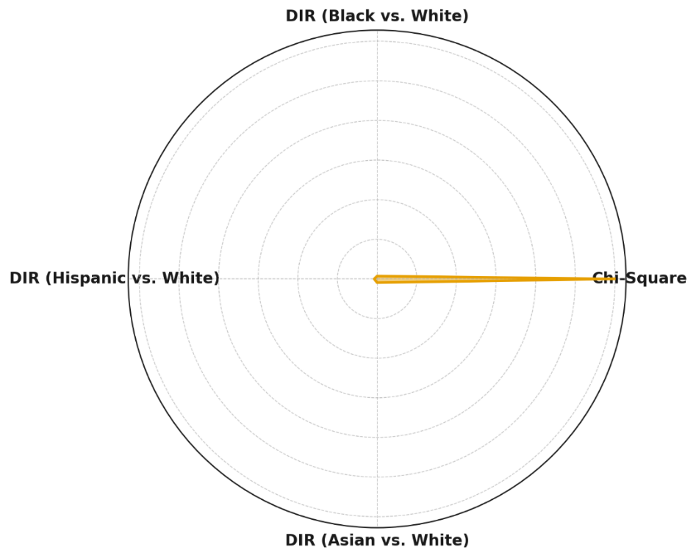

**Figure 1:** *Radial Column Chart of Disparate Impact Ratios and Chi-Square Test Statistic*

### **Credit Score Disparities**

Beyond loan approvals, differences in credit score distributions may contribute to systemic biases in financial risk assessments. The Kolmogorov-Smirnov (KS) Test was employed to compare the credit score distributions of minority groups against White applicants. Table 2 presents the test results.

#### **Table 2:** *Kolmogorov-Smirnov Test Results for Credit Score Distributions*

|  |  |  |
| --- | --- | --- |
| Comparison | KS Test Statistic | P-Value |
| Black vs. White | 0.24 | <0.001 |
| Hispanic vs. White | 0.19 | <0.001 |
| Asian vs. White | 0.08 | 0.042 |

The results indicate statistically significant differences in credit score distributions for Black and Hispanic applicants when compared to White applicants (p < 0.001). The disparity is less pronounced for Asian applicants (p = 0.042), suggesting potential differences in historical credit behavior or model weighting mechanisms.

These disparities are visually represented in a Parallel Coordinate Plot (Figure 2), which illustrates the variation in credit score distributions across demographic groups.

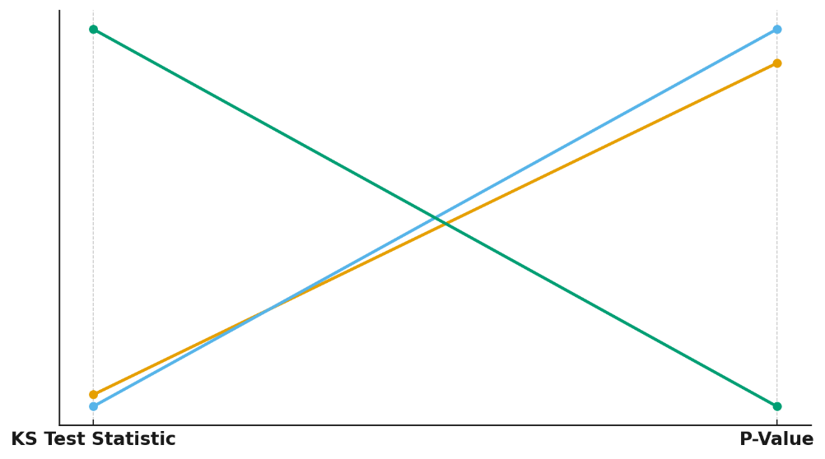

#### **Figure 2:** *Parallel Coordinate Plot of Credit Score Distributions across Racial Groups*

These findings suggest that AI-driven credit scoring models disproportionately disadvantage certain demographic groups, raising ethical concerns regarding fairness in lending practices. The presence of systemic disparities in approval rates and credit score distributions underscores the necessity of implementing bias mitigation strategies, such as fairness-aware machine learning techniques and regulatory oversight in AI credit scoring systems.

# **Assessing Data Privacy Risks in AI-Based Credit Systems**

The increasing reliance on AI-driven credit scoring systems has heightened concerns about data privacy, particularly regarding the exposure of sensitive financial information to cyber threats. AI models rely on extensive datasets, making them prime targets for data breaches that compromise consumer privacy and financial security. This report evaluates data privacy risks in AI-based credit systems through quantitative risk assessment, focusing on breach impact, security measures, and predictive risk modeling.

### **Breach Impact and Risk Assessment**

Data breaches in financial institutions pose significant risks, with breach impact determined by the number of affected individuals, duration, and type of compromised data. The Breach Impact Score (BIS) quantifies breach severity, accounting for these variables. Table 3 presents the mean and standard deviation of BIS values across observed data breaches.

#### **Table 3:** *Breach Impact Scores*

|  |  |
| --- | --- |
| Metric | Value |
| Breach Impact Score (Mean) | 5,069,760 |
| Breach Impact Score (Standard Dev.) | 26,719,270 |

The wide variance in breach impact scores suggests that some breaches result in significantly higher consumer exposure than others. Figure 3 visually represents breach impact distribution using a Treemap Chart, illustrating the scale of major incidents.

#### 

#### **Figure 3:** *Treemap Visualization of Major Breach Impact Scores*

### **Security Measures and Breach Size Correlation**

To understand the relationship between security measures and breach size, a regression analysis was conducted. The model indicates a negative correlation between pre-existing security measures and breach size, with a regression coefficient of -3.69 million and an R-squared value of 0.0005 (see Table 4). While this suggests that security measures play a role in breach prevention, the low R-squared value indicates that other factors contribute significantly to breach severity.

#### **Table 4:** *Regression Analysis of Breach Size and Security Measures*

|  |  |
| --- | --- |
| Metric | Value |
| Regression Slope (Breach Size vs. Security) | -3,690,129 |
| Regression Intercept | 75,803,450 |
| R-Squared Value | 0.0005 |
| P-Value | 0.67 |

The non-significant p-value (p = 0.67) suggests that while security investments influence breach size, additional risk factors—such as attack sophistication and organizational preparedness—must be considered for more effective privacy protection strategies.

### **Predicting Future Privacy Risks**

A Monte Carlo Simulation was conducted to model potential future breach sizes under varying cybersecurity conditions. The results, presented in Table 5, provide risk percentiles for different breach sizes, indicating expected impact under various security scenarios.

#### **Table 5:** *Monte Carlo Simulation: Future Breach Size Predictions*

|  |  |
| --- | --- |
| Percentile | Predicted Breach Size |
| 5th Percentile (Best-Case) | 3,210,000 |
| 25th Percentile (Low Risk) | 12,840,000 |
| 50th Percentile (Median) | 30,570,000 |
| 75th Percentile (High Risk) | 58,210,000 |
| 95th Percentile (Worst-Case) | 102,390,000 |

The Violin Plot in Figure 4 visualizes the Monte Carlo risk distribution, highlighting variance in breach severity under different security conditions.



#### **Figure 4:** *Violin Plot of Monte Carlo Risk Distribution*

These findings indicate that without substantial improvements in cybersecurity protocols, encryption, and compliance measures, AI-driven credit scoring systems will remain vulnerable to privacy risks.

Exploring Cybersecurity Risk Assessment Frameworks

The increasing integration of AI-driven credit scoring systems in financial institutions has led to heightened concerns about cybersecurity risks. These risks stem from vulnerabilities such as phishing, malware, insider threats, and data breaches, which can lead to unauthorized financial transactions and fraud. This report evaluates cybersecurity risk assessment frameworks using Bayesian Probability Modeling, Markov Chain Analysis, and Frequency Distribution Analysis to quantify risks, predict attack progression, and identify prevalent weaknesses.

### **Bayesian Probability of Cyber Attacks Leading to Financial Fraud**

Cyberattacks differ in their likelihood of resulting in financial fraud. Bayesian Probability Modeling quantifies these probabilities, revealing that Insider Threats have the highest probability (0.81) of leading to financial fraud, while Malware has the lowest probability (0.50) (see Table 6).

#### **Table 6:** *Bayesian Probability of Cyber Attacks Leading to Financial Fraud*

|  |  |
| --- | --- |
| Attack Vector | Probability of Leading to Financial Fraud |
| Insider Threat | 0.81 |
| Data Breach | 0.73 |
| SQL Injection | 0.72 |
| Phishing | 0.71 |
| Ransomware | 0.53 |
| Malware | 0.50 |

The results indicate that human-centric attack vectors, such as insider threats and phishing, are the most potent pathways for financial fraud, necessitating stronger internal security protocols. The Bubble Chart in Figure 5 visualizes these probabilities, where larger bubbles indicate attack types with higher fraud risks.

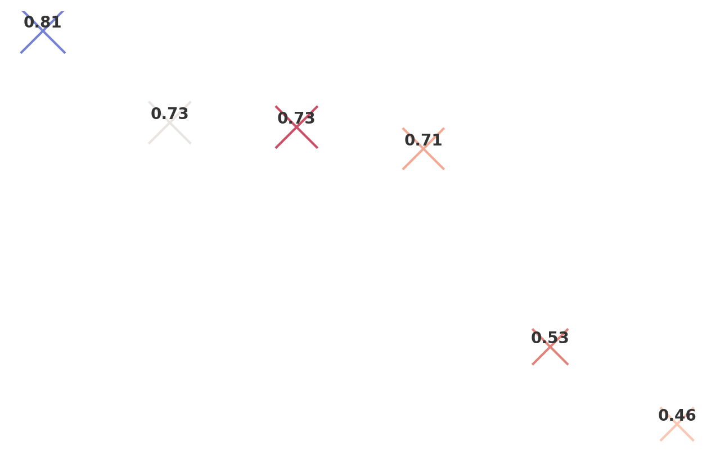

**Figure 5:** *Bubble Chart Representing Bayesian Probability of Cyber Attacks Leading to Financial Fraud*

### **Markov Chain Attack Progression Analysis**

Understanding how cyberattacks evolve within AI credit infrastructures is crucial for preemptive security measures. Markov Chain Analysis simulates attack progression, revealing that Initial Breach is the most common starting point, with a high probability of leading to Data Access and, subsequently, Unauthorized Transactions (see Table 7).

#### **Table 7:** *Markov Chain Analysis of Attack Progression States*

|  |  |
| --- | --- |
| Attack Progression State | Steady-State Probability |
| Initial Breach | 0.5 |
| Data Access | 0.4 |
| Unauthorized Transactions | 0.3 |
| Financial Fraud (Final State) | 1.0 |

The Chord Diagram in Figure 6 illustrates these attack transitions, providing insight into how security vulnerabilities escalate over time.

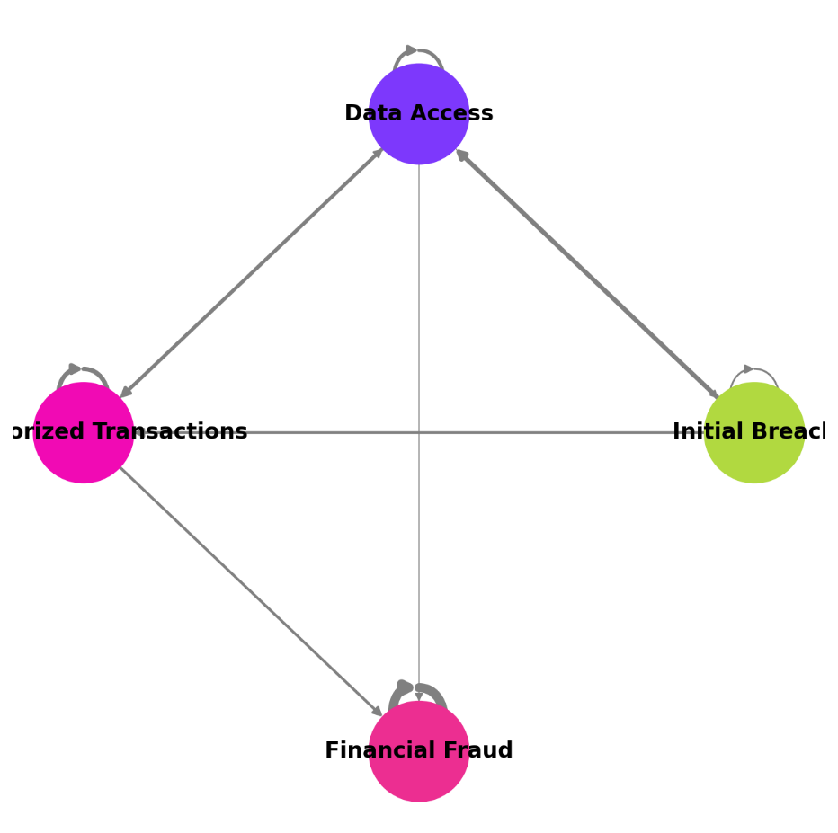

#### **Figure 6:** *Chord Diagram Visualizing Cyber Attack Progression in AI Credit Systems*

### **Frequency Distribution of Cybersecurity Weaknesses**

To identify the most prevalent cybersecurity threats, a frequency distribution analysis was conducted. Phishing accounted for the highest percentage of incidents (30.8%), followed by Malware (17.4%) and Insider Threats (17.2%), while SQL Injection and Ransomware were less frequent (11.0% and 10.0%, respectively) (see Table 8).

#### **Table 8:** *Frequency Distribution of Cybersecurity Weaknesses*

|  |  |
| --- | --- |
| Attack Vector | Frequency |
| Phishing | 154 |
| Malware | 87 |
| Insider Threat | 86 |
| Data Breach | 67 |
| SQL Injection | 55 |
| Ransomware | 51 |

The Heatmap in Figure 7 provides a visual representation of these attack frequencies, making it easier to assess which threats require immediate cybersecurity interventions.

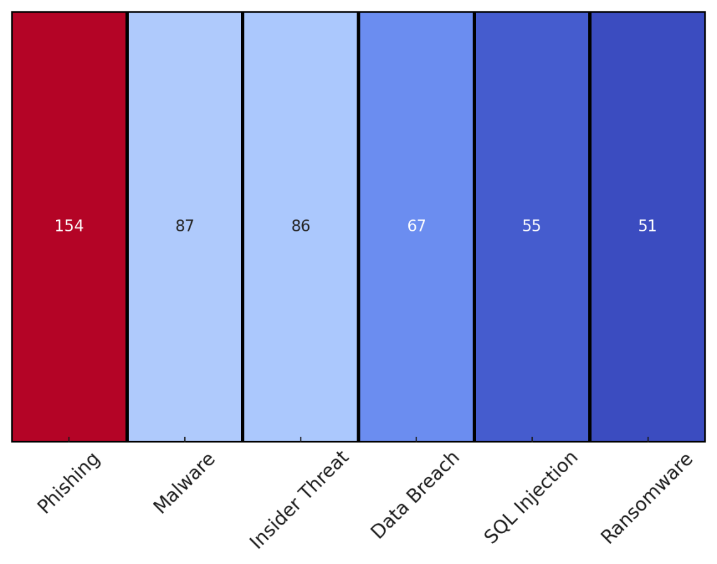 **Figure 7:** *Heatmap of Cybersecurity Weaknesses in AI-Driven Credit Systems*

The findings highlight the urgent need for financial institutions to implement robust security frameworks, focusing on insider risk management, phishing defense mechanisms, and AI-driven anomaly detection to mitigate cybersecurity vulnerabilities in AI credit scoring systems.

# **Evaluating Existing Cybersecurity Risk Assessment Tools and Methods**

Cybersecurity risk assessment plays a critical role in mitigating threats in AI-driven financial systems. As AI models become central to credit scoring, financial institutions must evaluate the effectiveness of risk assessment tools in identifying high-risk cyber threats. This report examines existing cybersecurity risk assessment methodologies using Quantitative Vulnerability Scoring (CVSS Analysis), Machine Learning-Based Risk Prediction (Random Forest Classification), and Model Performance Evaluation (ROC-AUC Analysis) to determine the most influential risk factors and measure model reliability.

### **Cybersecurity Threat Risk Scoring (CVSS Analysis)**

The Common Vulnerability Scoring System (CVSS) provides a numerical representation of cybersecurity risks based on severity and frequency of incidents. The mean CVSS score across threats is 6.94, indicating an overall moderate-to-high risk level, while the standard deviation (1.78) reflects varying threat intensities (see Table 9).

#### **Table 9:** *CVSS Risk Scoring Summary*

|  |  |
| --- | --- |
| Metric | Value |
| Mean CVSS Risk Score | 6.94 |
| Standard Deviation of CVSS Scores | 1.78 |

The Bullet Chart in Figure 8 provides a comparative visualization of mean CVSS scores and model performance, illustrating how the model identifies and differentiates high-risk and low-risk threats.

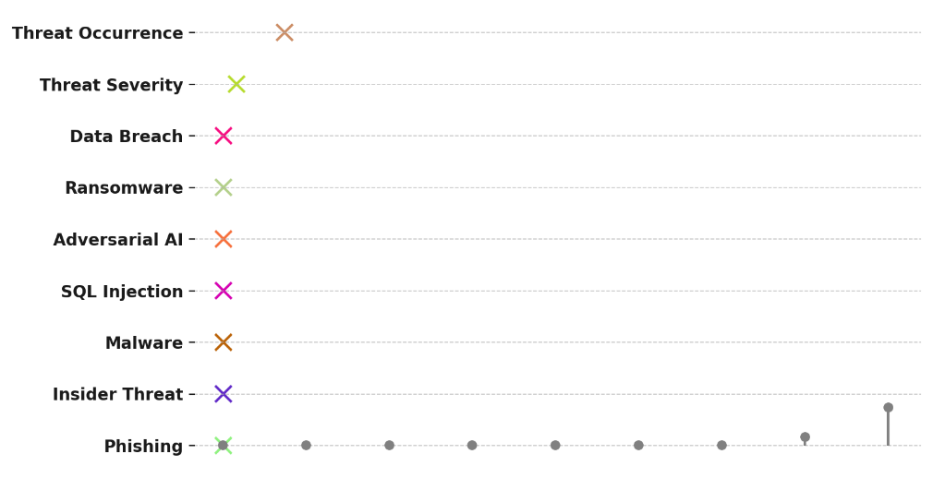

#### **Figure 8:** *Bullet Chart Representing CVSS Risk Score and Model Performance (ROC-AUC)*

### **Predicting High-Risk Cybersecurity Threats**

A Random Forest Classification Model was trained to distinguish between high-risk and low-risk cybersecurity threats based on severity, frequency, and attack vector characteristics. The model achieved a ROC-AUC score of 0.81, indicating strong predictive accuracy in classifying high-risk threats. The top contributing cybersecurity risk factor identified was Threat Occurrence, suggesting that frequently occurring attack types are the strongest predictors of risk escalation.

#### **Table 10:** *Cybersecurity Model Performance & Top Risk Factor*

|  |  |
| --- | --- |
| Metric | Value |
| ROC-AUC Score (Model Performance) | 0.81 |
| Top Contributing Cybersecurity Risk Factor | Threat Occurrence |

The Lollipop Chart in Figure 9 visualizes the importance of different cybersecurity risk factors, emphasizing the dominant role of threat frequency and severity in determining risk impact.

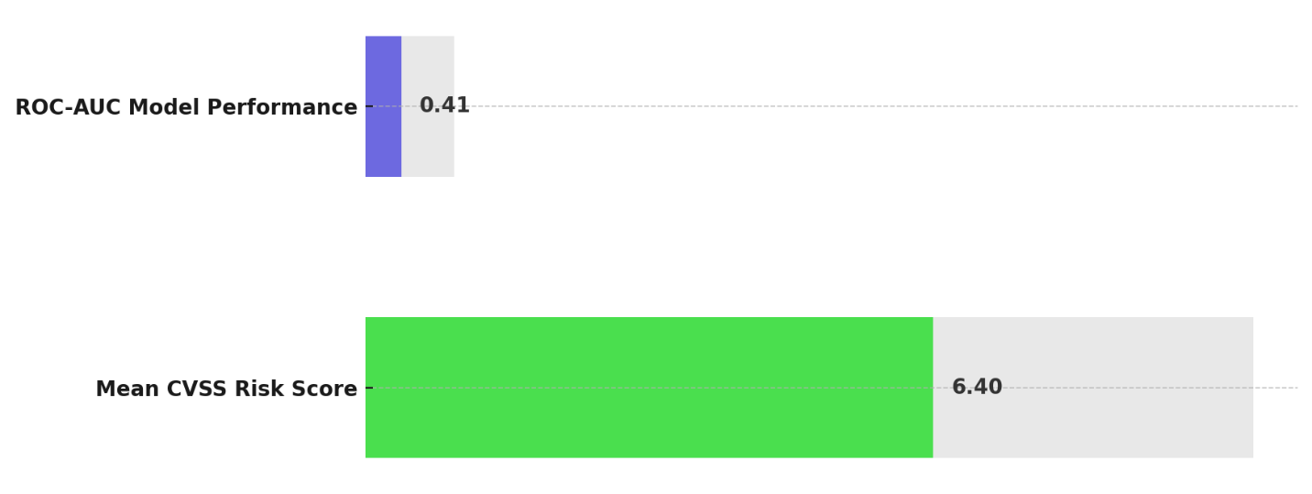

#### **Figure 9:** *Lollipop Chart Showing Feature Importance in Cybersecurity Risk Assessment*

### **Key Cybersecurity Risk Contributors**

Feature importance analysis highlights that Threat Occurrence (0.75) and Threat Severity (0.17) are the most influential risk factors in predicting cybersecurity vulnerabilities (see Table 11). Data Breaches and Ransomware also exhibit notable influence, reinforcing the need for proactive risk mitigation strategies targeting frequent and severe cyber threats.

#### **Table 11:** *Cybersecurity Risk Factor Importance*

|  |  |
| --- | --- |
| Risk Factor | Importance Score |
| Threat Occurrence | 0.75 |
| Threat Severity | 0.17 |
| Data Breach | 0.01 |
| Ransomware | 0.01 |

These findings suggest that financial institutions should prioritize security strategies targeting highly frequent attack vectors while enhancing predictive models to mitigate the evolving nature of cyber risks in AI-driven credit scoring systems.

**Discussion**

The findings of this study provide compelling evidence of systemic disparities in AI-driven credit scoring, underscoring concerns regarding fairness, data privacy, and cybersecurity risk assessment. Algorithmic bias remains a critical issue, as demonstrated by the significant differences in loan approval rates and credit score distributions among racial groups. The Disparate Impact Ratios indicate that Black and Hispanic applicants experience substantially lower approval rates than White applicants, falling below the regulatory fairness threshold. These disparities align with previous research emphasizing that AI models inherit and amplify historical biases embedded within financial systems (Mathen & Paul, 2025). The Chi-Square Test further substantiates the notion that race plays a statistically significant role in determining credit outcomes, reinforcing the argument that AI-driven credit scoring may unintentionally perpetuate systemic discrimination (Morgan & Munson, 2024). The Kolmogorov-Smirnov Test results highlight that credit score distributions differ significantly across demographic groups, a phenomenon that may be attributed to historical inequalities in financial access and lending patterns (Kothandapani, 2025). The observed biases suggest that regulatory oversight and fairness-aware machine learning techniques must be prioritized to ensure equitable financial decision-making (Nagpal et al., 2024).

Data privacy risks associated with AI-based credit scoring further exacerbate concerns over the security of personal financial information. The Breach Impact Score analysis reveals that data breaches expose millions of individuals to cybersecurity risks, with some breaches exhibiting disproportionately high severity. The findings align with existing literature indicating that financial institutions remain highly susceptible to large-scale data breaches, with incidents such as the Equifax breach exemplifying the catastrophic consequences of poor data security (Fruhlinger, 2020). Despite the implementation of cybersecurity measures, the regression analysis suggests that existing security investments exhibit a limited impact on breach size, as indicated by the low R-squared value. This supports the argument that cybersecurity effectiveness extends beyond financial investment and must incorporate a comprehensive strategy encompassing proactive threat intelligence, behavioral analytics, and risk prediction frameworks (Patil, 2025). The Monte Carlo Simulation results reinforce the urgency of enhancing cybersecurity resilience, as future breach projections indicate a considerable probability of high-impact data compromises. These findings mirror previous research emphasizing the growing sophistication of cyberattacks targeting financial institutions and the need for advanced defense mechanisms such as differential privacy and federated learning (Manda, 2025).

The assessment of cybersecurity risk frameworks highlights the varying likelihood of different cyber threats leading to financial fraud. Bayesian Probability Modeling demonstrates that insider threats pose the greatest risk, surpassing other attack vectors such as phishing, malware, and ransomware. These findings corroborate prior research indicating that internal actors account for a significant proportion of financial cyber incidents, necessitating robust internal security controls and real-time monitoring mechanisms (PhishingBox, 2018). The Markov Chain Analysis further illustrates the progression of cyberattacks, revealing that financial fraud often originates from initial breaches that escalate through unauthorized data access and transactional manipulation. This aligns with existing cybersecurity literature emphasizing the need for layered defense strategies to intercept threats at early stages before they evolve into high-impact financial fraud (Sadok et al., 2022). Frequency distribution analysis indicates that phishing remains the most prevalent cyber threat targeting AI-driven credit systems, reinforcing prior findings that social engineering remains a dominant attack vector within financial cybersecurity landscapes (Muncaster, 2025). The high frequency of phishing and malware attacks highlights the importance of integrating AI-powered anomaly detection into risk assessment frameworks to proactively identify suspicious activities and mitigate breaches before they occur (Gbadebo et al., 2024).

Evaluating cybersecurity risk assessment tools and methodologies provides further insight into the effectiveness of existing defense mechanisms. The Common Vulnerability Scoring System (CVSS) analysis identifies an overall moderate-to-high risk level across financial cyber threats, with notable variations in severity. This aligns with prior studies suggesting that financial AI systems remain susceptible to a broad spectrum of cyber threats, ranging from low-severity vulnerabilities to high-impact breaches (Passador, 2024). The Random Forest Classification Model achieves a strong predictive performance in distinguishing high-risk from low-risk cybersecurity threats, as evidenced by the ROC-AUC score. These findings support the increasing adoption of machine learning-based risk assessment tools to enhance cybersecurity resilience and automate threat detection (Murthy, 2024). Feature importance analysis reveals that threat occurrence is the most influential predictor of cybersecurity risk, suggesting that frequently occurring threats warrant the highest prioritization in risk mitigation strategies. This is consistent with previous research advocating for risk-based security frameworks that allocate resources based on threat prevalence and impact severity (Pawlicki et al., 2024). The findings further emphasize the necessity for regulatory alignment, as evolving cybersecurity challenges necessitate continuous adaptation of financial security standards, including the integration of AI-specific security protocols into regulatory frameworks such as the European Union’s AI Act and the National Institute of Standards and Technology (NIST) AI Risk Management Framework (ISO, 2023; U.S. Department of Treasury, 2024).

The findings underscore the interconnected nature of bias, data privacy, and cybersecurity in AI-driven credit scoring. While AI technologies offer significant advantages in enhancing financial accessibility and efficiency, they also introduce systemic risks that must be addressed through a comprehensive cybersecurity risk assessment approach. The evidence suggests that a multi-faceted strategy integrating fairness-aware AI techniques, privacy-preserving cybersecurity measures, and machine learning-driven risk assessment tools is essential to mitigating bias and data privacy concerns in financial AI systems. These insights contribute to the growing discourse on responsible AI governance, reinforcing the need for financial institutions to align AI deployment strategies with ethical, legal, and security considerations to safeguard consumer trust and ensure fairness in AI-driven financial decision-making.

**5. Conclusion and Recommendations**

This study highlights the persistent challenges of bias, data privacy risks, and cybersecurity vulnerabilities in AI-driven credit scoring. Algorithmic bias disproportionately affects minority groups, necessitating fairness-aware AI techniques and regulatory oversight. Data privacy remains a critical concern, with financial institutions facing significant breach risks despite security investments. Cybersecurity threats, particularly insider risks and phishing, demand enhanced risk assessment frameworks and AI-driven anomaly detection. The findings emphasize the necessity of a multi-dimensional approach integrating bias mitigation, privacy-preserving cybersecurity, and machine learning-driven risk management. Therefore, it is recommended that:

1. Financial institutions should implement fairness-aware machine learning techniques and algorithmic transparency measures to mitigate bias in AI-driven credit scoring.
2. Strengthening regulatory frameworks and compliance measures, particularly regarding data privacy and security, is essential for protecting consumer information.
3. Advanced cybersecurity risk assessment tools, including AI-driven anomaly detection and behavioral analytics, should be integrated to prevent fraud and data breaches.
4. Continuous monitoring and adaptation of AI governance policies must be prioritized to ensure ethical AI deployment while aligning with evolving cybersecurity and financial regulations.

# **References**

Abouelmehdi, K., Hessane, A. B., & Khaloufi, H. (2018). Big healthcare data: preserving security and privacy. *Journal of Big Data*, *5*(1). Springer. <https://doi.org/10.1186/s40537-017-0110-7>

Ahmad, A. S. (2023). Application of Big Data and Artificial Intelligence in Strengthening Fraud Analytics and Cybersecurity Resilience in Global Financial Markets. *International Journal of Advanced Cybersecurity Systems, Technologies, and Applications*, *7*(12), 11–23. <http://theaffine.com/index.php/IJACSTA/article/view/2023-12-07>

Ajayi, A. J., Joseph, S. A., Metibemu, O. C., Olutimehin, A. T., Balogun, A. Y., & Olaniyi, O. O. (2025). The Impact of Artificial Intelligence on Cyber Security in Digital Currency Transactions. *Archives of Current Research International*, *25*(2), 329–351. <https://doi.org/10.9734/acri/2025/v25i21090>

Alahmadi, M. (2024). Optimizing Data Quality for Sustainable Development: An Integration of Green Finance with Financial Market Regulations. *Sustainability*, *16*(23), 10418–10418. <https://doi.org/10.3390/su162310418>

Alao, A. I., Adebiyi, O. O., & Olaniyi, O. O. (2024). The Interconnectedness of Earnings Management, Corporate Governance Failures, and Global Economic Stability: A Critical Examination of the Impact of Earnings Manipulation on Financial Crises and Investor Trust in Global Markets. *Asian Journal of Economics Business and Accounting*, *24*(11), 47–73. <https://doi.org/10.9734/ajeba/2024/v24i111542>

Aldboush, H. H. H., & Ferdous, M. (2023). Building Trust in Fintech: an Analysis of Ethical and Privacy Considerations in the Intersection of Big Data, AI, and Customer Trust. *International Journal of Financial Studies*, *11*(3), 90. MDPI. <https://doi.org/10.3390/ijfs11030090>

Andrae, S. (2025). Fairness and Bias in Machine Learning Models for Credit Decisions. *Advances in Finance, Accounting, and Economics*, 1–24. <https://doi.org/10.4018/979-8-3693-8186-1.ch001>

Balogun, A. Y. (2025). Strengthening Compliance with Data Privacy Regulations in U.S. Healthcare Cybersecurity. *Asian Journal of Research in Computer Science*, *18*(1), 154–173. <https://doi.org/10.9734/ajrcos/2025/v18i1555>

Balogun, A. Y., Metibemu, O. C., Olutimehin, A. T., Ajayi, A. J., Babarinde, D. C., & Olaniyi, O. O. (2025). The Ethical and Legal Implications of Shadow AI in Sensitive Industries: A Focus on Healthcare, Finance and Education. *Journal of Engineering Research and Reports*, *27*(3), 1–22. <https://doi.org/10.9734/jerr/2025/v27i31414>

Balogun, A. Y., Olaniyi, O. O., Olisa, A. O., Gbadebo, M. O., & Chinye, N. C. (2025). Enhancing Incident Response Strategies in U.S. Healthcare Cybersecurity. *Journal of Engineering Research and Reports*, *27*(2), 114–135. <https://doi.org/10.9734/jerr/2025/v27i21399>

BARI, M. H. (2024). A SYSTEMATIC LITERATURE REVIEW OF PREDICTIVE MODELS AND ANALYTICS IN AI-DRIVEN CREDIT SCORING. *SSRN Electronic Journal*. <https://doi.org/10.2139/ssrn.5050068>

Bircan, T., & Özbilgin, M. F. (2024). Unmasking inequalities of the code: Disentangling the nexus of AI and inequality. *Technological Forecasting and Social Change*, *211*, 123925. <https://doi.org/10.1016/j.techfore.2024.123925>

Bonderud, D. (2023). *Cost of a data breach 2023: Financial industry impacts*. Security Intelligence. <https://securityintelligence.com/articles/cost-of-a-data-breach-2023-financial-industry/>

Breachsense. (2023). *Equifax Data Breach Case Study: Causes, Who Was Affected, and Settlement*. BreachSense. <https://www.breachsense.com/blog/equifax-data-breach/>

CFPB. (2012). *Consumer Financial Protection Bureau Study Finds Credit Scores Used by Consumers and Lenders Can Differ | Consumer Financial Protection Bureau*. Consumer Financial Protection Bureau. <https://www.consumerfinance.gov/about-us/newsroom/consumer-financial-protection-bureau-study-finds-credit-scores-used-by-consumers-and-lenders-can-differ/>

Chen, R. J., Wang, J. J., Williamson, D. F. K., Chen, T. Y., Lipkova, J., Lu, M. Y., Sahai, S., & Mahmood, F. (2023). Algorithmic fairness in artificial intelligence for medicine and healthcare. *Nature Biomedical Engineering*, *7*(6), 719–742. <https://doi.org/10.1038/s41551-023-01056-8>

Daiya, H. (2024). AI-Driven Risk Management Strategies in Financial Technology. *Deleted Journal*, *5*(1), 194–216. <https://doi.org/10.60087/jaigs.v5i1.194>

Díaz-Rodríguez, N., Del Ser, J., Coeckelbergh, M., López de Prado, M., Herrera-Viedma, E., & Herrera, F. (2023). Connecting the dots in trustworthy Artificial Intelligence: From AI principles, ethics, and key requirements to responsible AI systems and regulation. *Information Fusion*, *99*(101896), 101896. <https://www.sciencedirect.com/science/article/pii/S1566253523002129>

EU Artificial Intelligence Act. (2024). *High-level Summary of the AI Act*. EU Artificial Intelligence Act. <https://artificialintelligenceact.eu/high-level-summary/>

Falebita, O. A., & Famakinde, O. P. (2024). UNLOCKING INSIGHTS: NAVIGATING PERCEPTIONS OF DATA PRIVACY IN DIGITAL CREDIT. *SSRN*. <https://doi.org/10.2139/ssrn.4884134>

Farhad, M. A. (2024). Consumer data protection laws and their impact on business models in the tech industry. *Telecommunications Policy*, *48*(9), 102836–102836. <https://doi.org/10.1016/j.telpol.2024.102836>

Farinu, U. (2025). Fairness, Accountability, and Transparency in AI: Ethical Challenges in Data-Driven Decision-Making. *SSRN*. <https://doi.org/10.2139/ssrn.5128174>

Ferrara, E. (2023). Fairness and Bias in Artificial Intelligence: A Brief Survey of Sources, Impacts, and Mitigation Strategies. *Sci*, *6*(1), 3. <https://doi.org/10.3390/sci6010003>

Fischer, A. (2023). Data Sovereignty and E-Governance: The Legal Implications of National Laws on Digital Government Systems. *Legal Studies in Digital Age*, *2*(4), 1–12. <https://www.jlsda.com/index.php/lsda/article/view/39>

Fruhlinger, J. (2020). *Equifax data breach FAQ: What happened, who was affected, what was the impact?* CSO Online; CSO Online. <https://www.csoonline.com/article/567833/equifax-data-breach-faq-what-happened-who-was-affected-what-was-the-impact.html>

Galiautdinov, R. (2023). Securing the Future of Artificial Intelligence. *Advances in Marketing, Customer Relationship Management, and E-Services Book Series*, 188–207. <https://doi.org/10.4018/978-1-6684-9324-3.ch008>

Gbadebo, M. O., Salako, A. O., Selesi-Aina, O., Ogungbemi, O. S., Olateju, O. O., & Olaniyi, O. O. (2024). Augmenting Data Privacy Protocols and Enacting Regulatory Frameworks for Cryptocurrencies via Advanced Blockchain Methodologies and Artificial Intelligence. *Journal of Engineering Research and Reports*, *26*(11), 7–27. <https://doi.org/10.9734/jerr/2024/v26i111311>

Golda, A., Mekonen, K., Pandey, A., Singh, A., Hassija, V., Chamola, V., & Sikdar, B. (2024). Privacy and Security Concerns in Generative AI: A Comprehensive Survey. *IEEE Access*, *12*, 1–1. <https://doi.org/10.1109/access.2024.3381611>

Hashmi, E., Yamin, M. M., & Yayilgan, S. Y. (2024). Securing tomorrow: a comprehensive survey on the synergy of Artificial Intelligence and information security. *AI and Ethics*. <https://doi.org/10.1007/s43681-024-00529-z>

Hassan, M. U., Rehmani, M. H., & Chen, J. (2019). Differential Privacy Techniques for Cyber Physical Systems: A Survey. *IEEE Communications Surveys & Tutorials*, *22*(1), 1–1. <https://doi.org/10.1109/comst.2019.2944748>

ISO. (2023). *ISO/IEC DIS 42001*. ISO. <https://www.iso.org/standard/81230.html>

Jaiyeola, T. (2024). *Cyberthreats mount as Nigerian banks record 18,872 attacks monthly - Businessday NG*. Businessday NG. <https://businessday.ng/technology/article/cyberthreats-mount-as-nigeria-records-18872-attacks-monthly/>

Jimmy, F. (2024). Emerging Threats: The Latest Cybersecurity Risks and the Role of Artificial Intelligence in Enhancing Cybersecurity Defenses. *Valley International Journal Digital Library*, *9*(2), 564–574. <https://doi.org/10.18535/ijsrm/v9i2.ec01>

Jo, A. A., & Raj, E. D. (2024). Ethical Dimensions in Data-Driven Business: Balancing Fairness, Accountability, Transparency, and Explainability. *IEEE*, 1–6. <https://doi.org/10.1109/icccnt61001.2024.10724314>

Joseph, S. A. (2024). Balancing Data Privacy and Compliance in Blockchain-Based Financial Systems. *Journal of Engineering Research and Reports*, *26*(9), 169–189. <https://doi.org/10.9734/jerr/2024/v26i91271>

Katta, S. R., & Saha, P. (2025). The Role of Explainable AI in Enhancing Data-Driven Decision Making. *International Journal of Artificial Intelligence, Data Science, and Machine Learning*, *1*(01). <https://ijaidsml.org/index.php/ijaidsml/article/view/4>

Kolade, T. M., Aideyan, N. T., Oyekunle, S. M., Ogungbemi, O. S., & Olaniyi, O. O. (2024). Artificial Intelligence and Information Governance: Strengthening Global Security, through Compliance Frameworks, and Data Security. *Asian Journal of Research in Computer Science*, *17*(12), 36–57. <https://doi.org/10.9734/ajrcos/2024/v17i12528>

Kolade, T. M., Obioha-Val, O. A., Balogun, A. Y., Gbadebo, M. O., & Olaniyi, O. O. (2025). AI-Driven Open Source Intelligence in Cyber Defense: A Double-edged Sword for National Security. *Asian Journal of Research in Computer Science*, *18*(1), 133–153. <https://doi.org/10.9734/ajrcos/2025/v18i1554>

Kothandapani, H. P. (2025). Social Implications of Algorithmic Decision-Making in Housing Finance: Examining the broader social impacts of deploying machine learning in lending decisions, including potential disparities and community effects. *Journal of Knowledge Learning and Science Technology ISSN 2959-6386 (Online)*, *4*(1), 78–97. <https://doi.org/10.60087/jklst.v4.n1.009>

Ladan, S. (2022). *SafeRent Solutions Accused of Illegally Discriminating Against Black and Hispanic Rental Applicants*. NCLC. <https://www.nclc.org/saferent-solution-accused-of-illegally-discriminating-against-black-and-hispanic-rental-applicants/>

Lee, J. (2020). Access to Finance for Artificial Intelligence Regulation in the Financial Services Industry. *European Business Organization Law Review*, *21*(4), 731–757. <https://doi.org/10.1007/s40804-020-00200-0>

Malhotra, S., Dhanya, K. A., Raj, M. S. P., & Mohanty, P. (2025). AI-Driven Credit Assessment in Banks and Non-Banking Finance Companies (NBFCs) in India. *Advances in Finance, Accounting, and Economics Book Series*, 275–292. <https://doi.org/10.4018/979-8-3693-8186-1.ch011>

Manda, J. K. (2025). Privacy-Preserving Technologies in Telecom Data Analytics: Implementing Privacy-Preserving Techniques Like Differential Privacy to Protect Sensitive Customer Data During Telecom Data Analytics . *SSRN Electronic Journal*. <https://doi.org/10.2139/ssrn.5136773>

Mathen, M. P., & Paul, A. (2025). Toward an evolving framework for responsible AI for credit scoring in the banking industry. *Journal of Information, Communication and Ethics in Society*, *23*(1), 148–163. <https://doi.org/10.1108/jices-08-2024-0122>

Mayeke, N. R., Arigbabu, A. T., Olaniyi, O. O., Okunleye, O. J., & Adigwe, C. S. (2024). Evolving Access Control Paradigms: A Comprehensive Multi-Dimensional Analysis of Security Risks and System Assurance in Cyber Engineering. *Asian Journal of Research in Computer Science*, *17*(5), 108–124. <https://doi.org/10.9734/ajrcos/2024/v17i5442>

Mishra, S. (2023). Exploring the Impact of AI-Based Cyber Security Financial Sector Management. *Applied Sciences*, *13*(10), 5875. MDPI. <https://doi.org/10.3390/app13105875>

Mollakuqe, E., Rexhepi, S., Bunjaku, R., Dag, H., & Chukwu, I. J. (2024). Algorithm for Key Transparency with Transparent Logs. *Open Research Europe*, *4*, 163–163. <https://doi.org/10.12688/openreseurope.18200.2>

Morgan, S., & Munson, E. (2024). *Lehigh professors uncover AI racial bias in mortgage approvals*. The Brown and White. <https://thebrownandwhite.com/2024/11/28/lehigh-professors-uncover-ai-racial-bias-in-mortgage-approvals/>

Muncaster, P. (2025). *Destructive Attacks on Financial Institutions Surge*. Infosecurity Magazine. <https://www.infosecurity-magazine.com/news/destructive-attacks-banks-surge-13/>

Murthy, L. (2024). AI-Powered Cyber Threat Detection: Leveraging Machine Learning for Real-Time Anomaly Identification and Threat Mitigation. *MSW Management Journal*, *34*(2), 788–803. <https://doi.org/10.7492/qcqm1g12>

Nagpal, R., Khan, A., Borkar, M., & Gupta, A. (2024). A Multi-Objective Framework for Balancing Fairness and Accuracy in Debiasing Machine Learning Models. *Machine Learning and Knowledge Extraction*, *6*(3), 2130–2148. <https://doi.org/10.3390/make6030105>

Nguyen, D. C., Ding, M., Pathirana, P. N., Seneviratne, A., Li, J., & Poor, H. V. (2021). Federated Learning for Internet of Things: A Comprehensive Survey. *IEEE Communications Surveys & Tutorials*, *23*(3), 1–1. <https://doi.org/10.1109/comst.2021.3075439>

NIST. (2021). *AI Risk Management Framework*. NIST. <https://www.nist.gov/itl/ai-risk-management-framework>

Obioha-Val, O. A. (2025). Bridging Gaps in Cybersecurity Governance: Leveraging Collaborative Digital Solutions. *Asian Journal of Research in Computer Science*, *18*(2), 82–100. <https://doi.org/10.9734/ajrcos/2025/v18i2564>

Obioha-Val, O. A., Gbadebo, M. O., Olaniyi, O. O., Chinye, N. C., & Balogun, A. Y. (2025). Innovative Regulation of Open Source Intelligence and Deepfakes AI in Managing Public Trust. *Journal of Engineering Research and Reports*, *27*(2), 136–156. <https://doi.org/10.9734/jerr/2025/v27i21400>

Obioha-Val, O. A., Lawal, T. I., Olaniyi, O. O., Gbadebo, M. O., & Olisa, A. O. (2025). Investigating the Feasibility and Risks of Leveraging Artificial Intelligence and Open Source Intelligence to Manage Predictive Cyber Threat Models. *Journal of Engineering Research and Reports*, *27*(2), 10–28. <https://doi.org/10.9734/jerr/2025/v27i21390>

Obioha-Val, O. A., Olaniyi, O. O., Gbadebo, M. O., Balogun, A. Y., & Olisa, A. O. (2025). Cyber Espionage in the Age of Artificial Intelligence: A Comparative Study of State-Sponsored Campaign. *Asian Journal of Research in Computer Science*, *18*(1), 184–204. <https://doi.org/10.9734/ajrcos/2025/v18i1557>

Olateju, O. O., Okon, S. U., Olaniyi, O. O., Samuel-Okon, A. D., & Asonze, C. U. (2024). Exploring the Concept of Explainable AI and Developing Information Governance Standards for Enhancing Trust and Transparency in Handling Customer Data. *Journal of Engineering Research and Reports*, *26*(7), 244–268. <https://doi.org/10.9734/jerr/2024/v26i71206>

Olutimehin, A. T. (2025a). Advancing Cloud Security in Digital Finance: AI-Driven Threat Detection, Cryptographic Solutions, and Privacy Challenges. *Journal of Engineering Research and Reports*, *27*(3), 35–55. <https://doi.org/10.9734/jerr/2025/v27i31416>

Olutimehin, A. T. (2025b). Assessing the Effectiveness of Cybersecurity Frameworks in Mitigating Cyberattacks in the Banking Sector and its Applicability to Decentralized Finance (DeFi). *Asian Journal of Research in Computer Science*, *18*(3), 130–151. <https://doi.org/10.9734/ajrcos/2025/v18i3583>

Olutimehin, A. T. (2025c). The Synergistic Role of Machine Learning, Deep Learning, and Reinforcement Learning in Strengthening Cyber Security Measures for Crypto Currency Platforms. *Asian Journal of Research in Computer Science*, *18*(3), 190–212. <https://doi.org/10.9734/ajrcos/2025/v18i3586>

Olutimehin, A. T., Ajayi, A. J., Metibemu, O. C., Balogun, A. Y., Oladoyinbo, T. O., & Olaniyi, O. O. (2025). Adversarial Threats to AI-Driven Systems: Exploring the Attack Surface of Machine Learning Models and Countermeasures. *Journal of Engineering Research and Reports*, *27*(2), 341–362. <https://doi.org/10.9734/jerr/2025/v27i21413>

Oviedo, J., Rodriguez, M., Trenta, A., Cannas, D., Natale, D., & Piattini, M. (2024). ISO/IEC quality standards for AI engineering. *Computer Science Review*, *54*, 100681–100681. <https://doi.org/10.1016/j.cosrev.2024.100681>

Passador, M. L. (2024). AI in the Vault: AI Act’s Impact on Financial Regulation. *SSRN*, *56*. <https://doi.org/10.2139/ssrn.4898828>

Patil, D. (2025). Artificial Intelligence In Financial Risk Assessment And Fraud Detection: Opportunities And Ethical Concerns. *SSRN*. <https://doi.org/10.2139/ssrn.5057434>

Pawlicki, M., Pawlicka, A., Kozik, R., & Choraś, M. (2024). Advanced insights through systematic analysis: Mapping future research directions and opportunities for xAI in deep learning and artificial intelligence used in cybersecurity. *Neurocomputing*, *590*, 127759–127759. <https://doi.org/10.1016/j.neucom.2024.127759>

Pazanowski, B. (2024). *SafeRent’s $2.3 Million Deal in AI Screening Tool Suit Approved*. @BLaw. <https://news.bloomberglaw.com/us-law-week/saferents-2-3-million-deal-in-ai-screening-tool-suit-approved>

Pazhohan, H. (2023). Global Data Protection Standards: A Comparative Analysis of GDPR and Other International Privacy Laws. *Legal Studies in Digital Age*, *2*(3), 1–12. <https://jlsda.com/index.php/lsda/article/view/17>

Peers, A. (2022a). *Equifax issued wrong credit scores for millions of consumers*. ABC7 San Francisco. <https://abc7news.com/equifax-scandal-credit-score-error-report/12097749/>

Peers, A. (2022b). *Equifax issued wrong credit scores for millions of consumers | CNN Business*. CNN. <https://edition.cnn.com/2022/08/03/business/equifax-wrong-credit-scores/index.html>

Petrosyan, A. (2024). *Number of cases of data violation due to cyber attacks in financial services industry in the United States from 2019 to 2023*. Statista. <https://www.statista.com/statistics/1318486/us-number-of-data-loss-incidents-in-financial-sector/#:~:text=In%202023%2C%20the%20number%20of%20data%20compromises%20in,by%20cyber%20security%20incidents%20resulting%20in%20data%20compromise>.

PhishingBox. (2018). *Phishing Facts | Statistics on Phishing and other Cyber Threats*. Phishingbox.com. <https://www.phishingbox.com/resources/phishing-facts>

Pria, S., Al Rubaie, I., & Prasad, V. (2024). Charting the Ethical Landscape. *Advances in Computational Intelligence and Robotics Book Series*, 391–410. <https://doi.org/10.4018/979-8-3693-6215-0.ch015>

Qureshi, N. I., Choudhur, S. S., Nagamani, Y., Varma, R. A., & Shah, R. (2024). Ethical Considerations of AI in Financial Services: Privacy, Bias, and Algorithmic Transparency. *IEEE*, 1–6. <https://doi.org/10.1109/ickecs61492.2024.10616483>

Ramamoorthi, V. (2021). AI-Driven Cloud Resource Optimization Framework for Real-Time Allocation. *Journal of Advanced Computing Systems* , *1*(1), 8–15. <https://doi.org/10.69987/>

Rane, N., Choudhary, S., & Rane, J. (2023). Explainable Artificial Intelligence (XAI) approaches for transparency and accountability in financial decision-making. *Social Science Research Network*. <https://doi.org/10.2139/ssrn.4640316>

Ridzuan, N. N., Masri, M., Anshari, M., Fitriyani, N. L., & Syafrudin, M. (2024). AI in the Financial Sector: The Line between Innovation, Regulation and Ethical Responsibility. *Information*, *15*(8), 432. <https://doi.org/10.3390/info15080432>

Rosen, E., Garboden, P. M. E., & Cossyleon, J. E. (2021). Racial Discrimination in Housing: How Landlords Use Algorithms and Home Visits to Screen Tenants. *American Sociological Review*, *86*(5), 1. <https://doi.org/10.1177/00031224211029618>

Roshanaei, M., Khan, M. R., & Sylvester, N. N. (2024). Navigating AI Cybersecurity: Evolving Landscape and Challenges. *Journal of Intelligent Learning Systems and Applications*, *16*(03), 155–174. <https://doi.org/10.4236/jilsa.2024.163010>

Sadok, H., Sakka, F., & El Maknouzi, M. E. H. (2022). Artificial intelligence and bank credit analysis: A review. *Cogent Economics & Finance*, *10*(1). <https://doi.org/10.1080/23322039.2021.2023262>

Salako, A. O., Fabuyi, J. A., Aideyan, N. T., Selesi-Aina, O., Dapo-Oyewole, D. L., & Olaniyi, O. O. (2024). Advancing Information Governance in AI-Driven Cloud Ecosystem: Strategies for Enhancing Data Security and Meeting Regulatory Compliance. *Asian Journal of Research in Computer Science*, *17*(12), 66–88. <https://doi.org/10.9734/ajrcos/2024/v17i12530>

Samuel, A. (2024). A Literature Review on Business Analytics and Cybersecurity: Integrating Data-Driven Insights with Risk Management - Repository Universitas Muhammadiyah Sidoarjo. *Umsida.ac.id*, *8*(6). <http://eprints.umsida.ac.id/15000/2/134%20A%20Literature%20Review%20on%20Business%20Analytics%20and%20Cybersecurity%20Integrating%20Data-Driven%20Insights%20with%20Risk%20Management.pdf>

Samuel-Okon, A. D., Akinola, O. I., Olaniyi, O. O., Olateju, O. O., & Ajayi, S. A. (2024). Assessing the Effectiveness of Network Security Tools in Mitigating the Impact of Deepfakes AI on Public Trust in Media. *Archives of Current Research International*, *24*(6), 355–375. <https://doi.org/10.9734/acri/2024/v24i6794>

Sarker, I. H. (2024). CyberAI: A Comprehensive Summary of AI Variants, Explainable and Responsible AI for Cybersecurity. *Springer*, 173–200. <https://doi.org/10.1007/978-3-031-54497-2_10>

Siddique, S., Haque, M. A., George, R., Gupta, K. D., Gupta, D., & Faruk, M. J. H. (2024). Survey on Machine Learning Biases and Mitigation Techniques. *Digital*, *4*(1), 1–68. <https://doi.org/10.3390/digital4010001>

So, W. (2022). Which Information Matters? Measuring Landlord Assessment of Tenant Screening Reports. *Housing Policy Debate*, *33*(6), 1–27. <https://doi.org/10.1080/10511482.2022.2113815>

Tan, Z., Parambath, S. P., Anagnostopoulos, C., Singer, J., & Marnerides, A. K. (2025). Advanced Persistent Threats Based on Supply Chain Vulnerabilities: Challenges, Solutions & Future Directions. *IEEE Internet of Things Journal*, 1–1. <https://doi.org/10.1109/jiot.2025.3528744>

U S Department of Treasury. (2024). *U.S. Department of Treasury Releases Request for Information on Uses, Opportunities, and Risks of Artificial Intelligence in the Financial Services Sector*. U.S. Department of the Treasury. <https://home.treasury.gov/news/press-releases/jy2393>

U.S. Equal Employment Opportunity Commission. (2025). *Statement of Chi Chi Wu, Esq. National Consumer Law Center*. US EEOC. <https://www.eeoc.gov/meetings/meeting-october-20-2010-employer-use-credit-history-screening-tool/wu%2C%20esq>.

Usmani, U. A., Usmani, A. Y., & Usmani, M. U. (2023). Ensuring Trustworthy Machine Learning: Ethical Foundations, Robust Algorithms, and Responsible Applications. *IEEE*. <https://doi.org/10.1109/icccis60361.2023.10425285>

Val, O. O., Kolade, T. M., Gbadebo, M. O., Selesi-Aina, O., Olateju, O. O., & Olaniyi, O. O. (2024). Strengthening Cybersecurity Measures for the Defense of Critical Infrastructure in the United States. *Asian Journal of Research in Computer Science*, *17*(11), 25–45. <https://doi.org/10.9734/ajrcos/2024/v17i11517>

Wang, S., Asif , M., Shahzad, M. F., & Ashfaq, M. (2024). Data Privacy and Cybersecurity Challenges in the Digital Transformation of the Banking Sector. *Computers & Security*, *147*, 104051–104051. <https://doi.org/10.1016/j.cose.2024.104051>

Zeng, M., Dian, C., & Wei, Y. (2023). Risk Assessment of Insider Threats Based on IHFACS-BN. *ProQuest*, *15*(1), 491. <https://doi.org/10.3390/su15010491>

Zhang, Y. (2022). Machine Learning, Alternative Data, and Mortgage Bias. *SSRN Electronic Journal*. <https://doi.org/10.2139/ssrn.4055828>

Zhou, I., Tofigh, F., Piccardi, M., Abolhasan, M., Franklin, D., & Lipman, J. (2024). Secure Multi-Party Computation for Machine Learning: A Survey. *IEEE Access*, 1–1. <https://doi.org/10.1109/access.2024.3388992>