Original Research Article

The Assessment of Body Condition in High-yielding Holstein-Friesian Cows as a Diagnostic Tool for Detecting Energy Metabolism Disorder

ABSTRACT

|  |
| --- |
| The body condition of dairy cows is a key indicator of their energy status, especially during the peripartum period when intense mobilization of body reserves occurs. An inadequate energy balance during this period can lead to metabolic disorders, which negatively affect the health and production performance of the animals.  This study presents the results of research conducted on three large farms in the municipality of Palilula (city of Belgrade), where body condition scoring (BCS) was performed on 90 high-yielding Holstein-Friesian cows in different phases of their production and reproductive cycle. The scoring was carried out by visual assessment and palpation of key anatomical body regions, according to the standardized system (Elanco Animal Health Bulletin AL 8478).  The results showed that the greatest fluctuations in body condition occurred between the dry period, the puerperium, and early lactation, with Farm C recording deviations beyond physiologically acceptable limits. Body weight losses were especially pronounced in early puerperium, while cows in late lactation tended to accumulate excessive body reserves. The data obtained highlight the importance of regular monitoring of body condition as a tool for optimizing nutrition and preventing metabolic disorders. |

*Keywords: body condition, energy balance, metabolic disorders, reproductive cycle*

1. INTRODUCTION

Body condition score (BCS) of dairy cows is a reliable indicator of energy status, particularly during the peripartum period which is characterized by significant changes in energy metabolism (Prodanović et al., 2010; Prodanović et al., 2011; Đoković et al., 2014)​.The peripartum period features pronounced mobilization of body reserves due to increased metabolic demands. During the dry period, cows often reach a high body condition, while at the beginning of lactation the heightened milk production causes intense mobilization of energy reserves. This can result in significant body weight loss and exhaustion, as well as the onset of metabolic diseases. Inadequate adaptation of the endocrine system in the peripartum period of high-yielding cows is a major factor disrupting energy balance, and coupled with changes in body condition it underlies health problems in this period (Roche et al., 2013; Šamanc et al., 2015).

Modern approaches to managing the energy balance of high-yielding cows insist on routine evaluation of body condition as a simple and practical clinical parameter for assessing energy status during gestation and lactation (Gross et al., 2011; Overton et al., 2017). It is recommended to adjust feeding and check nutritional status at least twice a year to prevent large swings in energy metabolism. Inadequate control of energy status can lead to uncontrolled lipid mobilization from body depots, resulting in fatty liver of varying severity (Šamanc et al., 2010; Šamanc et al., 2015; Lakić et al., 2018). Reduced endocrine system adaptation during the peripartum period in high-yielding dairy cows is a primary factor in the disruption of their energy balance. Coupled with changes in body condition, this imbalance serves as a fundamental cause of health complications during the peripartum phase (Prodanović et al., 2010; Fratrić et al., 2013; Šamanc et al., 2015). The nutritional status of cows in late pregnancy is crucial for regulating the intensity of lipomobilization and the efficient use of fats to meet metabolic needs in early postpartum. Cows that are over-conditioned in the antepartal period lose significantly more body weight after the start of lactation compared to those in optimal body condition (Šamanc et al., 2010; Vasseur et al., 2013)​.These changes negatively affect the speed of recovery and re-establishment of energy balance, whereas cows that begin lactation in optimal condition are better able to meet the metabolic demands of milk production and reproduction (Đoković et al., 2014; Cabezas-Garcia et al., 2021).

Body condition scoring is a standardized method for assessing body reserves and energy status in dairy cows. It quantifies the relative amount of subcutaneous fat and is used for precise monitoring of the nutritional status of cows in different phases of production and reproduction (Prodanović et al., 2011; Gross et al., 2011; Novaković et al., 2012).. Regular monitoring is recommended at least once a month during lactation and every 15 days during the dry period​. Evaluations are conducted at key phases: drying off, calving, 30 days after calving, the breeding period (60–70 days postpartum), pregnancy confirmation (120–150 days), and late lactation (third phase of lactation) (Elanco Animal Health Buletin Al 8478) (Šamanc i sar., 2010; Vasseur i sar., 2013; Bojković-Kovačević, 2016).

The body condition scoring system is based on a numerical scale ranging from 1 to 5 points, where each point reflects a change in body mass between 55 and 75 kg. Based on these assessments, it is possible to calculate average values and deviations in relation to standard values for specific production phases (dry period, puerperium, early and late lactation) (Šamanc et al., 2010; Prodanović et al., 2011, 2012a; Novaković et al., 2012; Đoković et al., 2014). Accurate monitoring of dairy cow body condition enables the timely identification of energy balance disorders and serves as a key strategy for improving peripartum health and productivity in dairy cows (Roshe et al., 2013; Đoković et al., 2014; Bojković-Kovačević, 2016). (Elanco Animal Health Bulletin AL 8478) (Šamanc et al., 2010; Vasseur et al., 2013; Bojković-Kovačević, 2016). Using BCS as a routine procedure requires clearly defined assessment intervals so that the data obtained have practical diagnostic value (Novaković et al., 2012; Overton et al., 2017). The key moments for BCS evaluation of dairy cows include critical phases of the reproductive and lactation cycle: calving, 5–6 weeks after calving (peak milk yield), 150–200 days after calving, between 5 and 6.5 months after calving, and drying off.*Table 1* presents the optimal and acceptable body condition scores for dairy cows during these critical periods.

**Table 1. Optimal and acceptable body condition scores for dairy cows during critical production and reproduction periods (Šamanc et al., 2010; Prodanović et al., 2011, 2012b).**

|  |  |  |
| --- | --- | --- |
| Evaluation period | Optimal score | Acceptable scores |
| Calving | 3.50 | 3.25 - 3.75 |
| Peak lactation | 2.75 | 2.50 - 3.25 |
| Mid-lactation | 3.00 | 2.75 - 3.25 |
| Late lactation | 3.25 | 3.00 - 3.50 |
| Cessation of lactation | 3.50 | 3.25 - 3.75 |

BCS evaluation of dairy cows is a standardized procedure based on careful visual assessment and palpation of key anatomical points on the animal’s body. This method allows a precise evaluation of muscle mass distribution and fat cover, which is crucial for assessing nutritional status and energy balance (Šamanc i sar., 2010, 2015; Bojković-Kovačević, 2016). During scoring, attention is focused on eight key anatomical points: the chest area, shoulder, ribs, back and the transverse processes of the lumbar vertebrae (loin), hips (hook bones), the fold of the flank (thurl region), the tail head, and the pin bones. Each of these points is evaluated individually, and the obtained values are aggregated into a total body condition score that represents the animal’s overall body condition. A systematic and stepwise approach to scoring enables a high degree of accuracy and comparative analysis across different phases of the production cycle (Prodanović et al., 2011). Once determined, the BCS can be compared to reference values for specific phases of the production-reproduction cycle​.This analysis is the key basis for making decisions regarding diet adjustments and herd management, thereby optimizing production results and preserving animal health​. Accurate body condition assessment allows producers to implement timely corrective measures in ration formulation, reducing the risk of metabolic disorders and ensuring the maintenance of an optimal health status in cows(Šamanc et al., 2010; Roshe et al., 2013; Sladojević et al., 2013).

The long-term diagnostic value of BCS lies in its ability to reflect the animal’s nutritional and energy status over the preceding several months.As the only immediate indicator of nutritional success over an extended period, BCS connects energy status with the health and productive-reproductive performance of cows (Šamanc et al., 2010; Sladojević et al., 2013; Bojković-Kovačević, 2016). This method is therefore an indispensable tool for improving production efficiency and preserving the long-term health of dairy cows. Integrating regular BCS monitoring into routine practice contributes to increased profitability and sustainability of milk production (Bojković-Kovačević, 2016). Moreover, BCS is not only a key indicator of energy status and health of the animals, but it also has a significant impact on the chemical composition and processing suitability of milk (Overton et al., 2017). Negative energy balance, particularly in the peripartum period, often leads to changes in milk quality, including reduced milk fat and protein content, as well as altered physico-chemical characteristics that can compromise the milk’s processing value (Roche et al., 2013). Optimal body condition helps achieve a stable profile of milk components, which is extremely important for dairy processing—especially in the production of fermented products like cheeses and yogurts, where protein and fat content and coagulation properties are crucial (Nešić, 2010). Regular ration optimization and continuous BCS assessment not only maintain high health standards but also ensure consistent milk quality, increasing its technological and economic value in the dairy industry (Roche et al., 2013).

The aim of this research was to assess the body condition of high-yielding Holstein-Friesian cows in different phases of the production-reproduction cycle on large farms in the Palilula municipality (Belgrade) to determine its association with the detection of energy metabolism disorders.

2. material and methods

The study was conducted in May and June 2023 on three large farms (Farm A, Farm B, and Farm C) in the municipality of Palilula, Belgrade. From each farm, 30 Holstein-Friesian dairy cows (90 cows in total) were selected​. Body condition was evaluated on all farms during the dry period (cessation of lactation), early puerperium (post-calving), early lactation, and late lactation. The cows selected for this study were in their first to fifth lactation. Cows on these farms were milked twice daily (morning and evening), and the average milk production on farms A, B, and C was about 27.5 liters per day. The cows’ diet on all farms was based on rations recommended for that production category of cows​. Body condition scoring on the farms was performed on the selected cows during the transitional phases of the production-reproduction cycle.BCS was assessed using the Elanco Animal Health Bulletin AL 8478 system (Šamanc et al., 2010; Vasseur et al., 2013). This scoring system is based on visual assessment and palpation of key anatomical points on the cow’s body to determine the degree of fatness and available body reserves.A numerical scale from 1 to 5 is used, where lower values indicate underconditioning and higher values indicate overconditioning; a change of one point corresponds to a body weight variation of approximately 55–75 kg​.Systematic application of this method enables precise control of energy status in different phases of the production cycle, which is crucial for optimizing nutrition and preventing metabolic disorders in dairy cows (Prodanović et al., 2021b).

For BCS evaluation, palpation and visual inspection (adspection) methods were combined on five major anatomical regions: the loin (lumbar) region, the tail head region, the pin bone region (ischial tuberosities), the thurl (croup) region, and the hip (hook bone) region.Using both palpation (touch) and inspection of these five key regions helps to determine the amount of subcutaneous fat and the cow’s degree of fatness, allowing a precise assessment of its energy status and the adequacy of its nutrition.This approach provides accurate monitoring of the energy status of cows in various phases of the production cycle, which is essential for timely dietary adjustments and prevention of metabolic disorders (Šamanc et al., 2010; Prodanović et al., 2011).

3. results and discussion

The body condition scores of cows on the large farms were presented using histograms for each phase of the production-reproduction cycle.

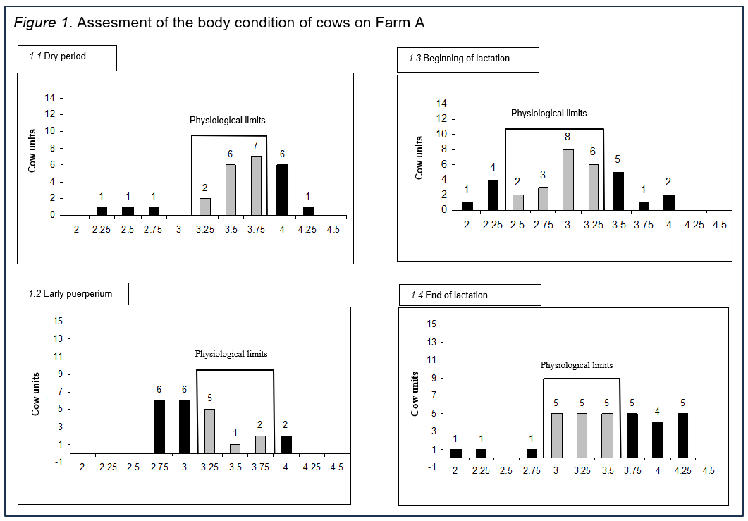

**Figure 1. Body condition score distribution of cows on Farm A: (1.1) dry period, (1.2) early puerperium, (1.3) beginning of lactation, and (1.4) end of lactation.**

Analysis of the data shown in Figure 1.1 indicates that during the dry period, the body condition of cows on Farm A was within physiologically acceptable limits for 15 individuals, which is 60% of the 25 cows analyzed. Seven cows (28%) had a higher BCS than optimal for this phase, while three cows (12%) were underconditioned. During the puerperium, according to the results in Figure 1.2, an optimal body condition was observed in 8 out of 22 cows (36.36%), whereas 12 cows (54.54%) had a lower BCS than the physiological norms. Based on Figure 1.3, in the early lactation phase, out of 32 cows examined, 13 (40.62%) had a body condition score outside the acceptable range; 5 cows (15.62%) had a lower-than-optimal score and 8 cows (25%) a higher-than-optimal score​.In late lactation, according to Figure 1.4, out of 32 cows, 15 individuals (46.87%) had an optimal body condition, while 14 cows (43.75%) were recorded with a higher and 3 cows (9.37%) with a lower body condition than the recommended level.

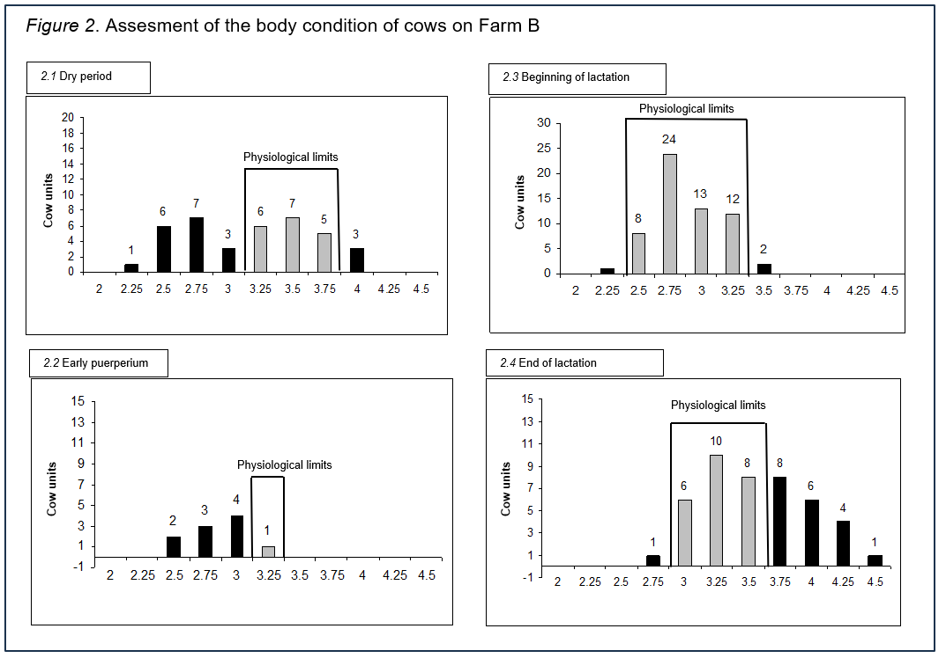

**Figure 2. Body condition score distribution of cows on Farm B: (2.1) dry period, (2.2) early puerperium, (2.3) beginning of lactation, and (2.4) end of lactation.**

From the data shown in Figure 2.1, it is observed that on Farm B, during the dry period, the BCS of 17 out of 38 cows analyzed (44.74%) was below the physiologically acceptable range, while 3 cows (17.65%) had a BCS higher than optimal for this phase of the cycle. In the puerperium, according to Figure 2.2, only one of the 10 cows examined (10%) had an optimal body condition, while the remaining cows had a lower BCS than the recommended level​. Figure 2.3 shows that in early lactation almost all the cows analyzed had a BCS within physiological values; only 3 cows (6%) out of 50 examined had a score outside the recommended range. At the end of lactation, according to Figure 2.4, out of 44 cows analyzed, 19 individuals (43.18%) had a higher BCS than optimal, which indicates potential risks in terms of energy balance and nutritional status in this phase of lactation.

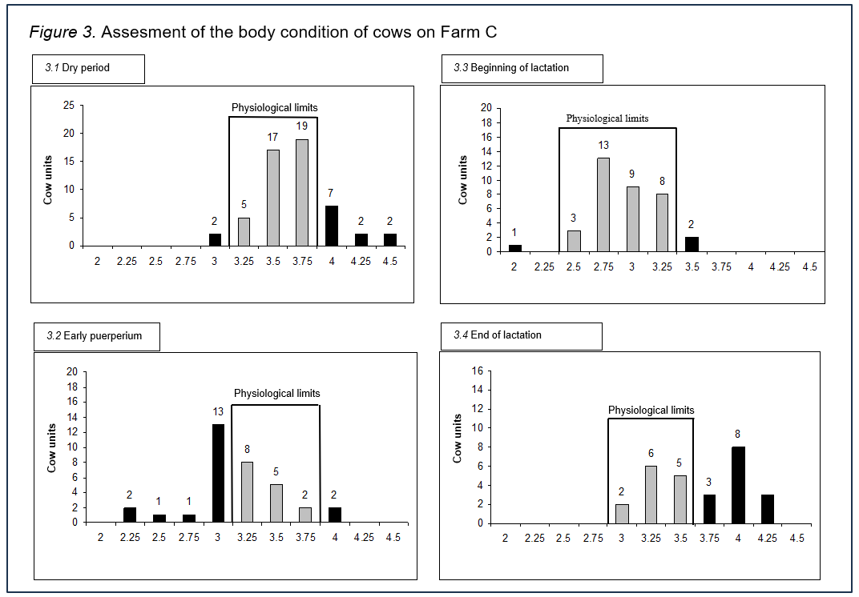

**Figure 3. Body condition score distribution of cows on Farm C: (3.1) dry period, (3.2) early puerperium, (3.3) beginning of lactation, and (3.4) end of lactation.**

Analysis of the data presented in Figure 3.1 determined that on large Farm C, during the dry period, the BCS of 41 out of 54 cows examined (75.92%) was within physiologically acceptable limits, while 11 individuals (20.37%) had a higher BCS than recommended for this phase.

During the puerperium, according to Figure 3.2, an optimal body condition was recorded in 15 out of 34 cows analyzed (44.12%), whereas 17 cows (50%) had a lower, and 2 cows (5.88%) a higher body condition score than the recommended level. The results shown in Figure 3.3 indicate that in early lactation the majority of the cows had a BCS within acceptable values, with only 3 cows (8.33%) out of 36 analyzed deviating from the recommended range. At the end of lactation, according to Figure 3.4, 14 out of 27 cows examined (51.85%) had a higher BCS than optimal, which may indicate potential metabolic risks in the later stages of the production cycle.

**Table 2. Differences in average body condition score values of cows on farms A, B, and C between different phases of the production-reproduction cycle.**

|  |  |  |  |  |  |
| --- | --- | --- | --- | --- | --- |
| Farm | dry period / puerperium | dry period / 60th day of lactation | dry period / end of lactation | puerperium / 60th day of lactation | end of lactation / 60th day of lactation |
| Farm A | 0.28 | 0.5 | 0.25 | 0.22 | 0.25 |
| Farm B | 0.17 | 0.14 | 0.14 | 0.03 | 0.68 |
| Farm C | 1.13 | 1.17 | 0.30 | 0.14 | 1.12 |

The data recorded in Table 2 indicate variations in the average BCS of cows on farms A, B, and C across different phases of the production-reproduction cycle. On Farm A, oscillations in body condition were minimal, with the difference between all phases of the production cycle not exceeding 0.5 points, which indicates a relatively stable reserve of body energy in these animals. In contrast, on Farm B, the most noticeable change was recorded between the end and the beginning of lactation, where the difference in average BCS was 0.68, pointing to a more significant energy deficit in this period. The largest oscillations in body condition were observed in cows on Farm C, where the differences between dry period and puerperium, dry period and 60th day of lactation, as well as between the 60th day and end of lactation, exceeded one whole BCS point. These pronounced changes may indicate an inadequate feeding regime or intense mobilization of body reserves during periods of increased energy demand​. In this study, body condition scoring was used as a diagnostic tool to evaluate the energy status of dairy cows in all phases of the production-reproduction cycle, with particular emphasis on its practical application in detecting and preventing metabolic disorders​. The level of cow condition during late pregnancy plays a key role in regulating lipomobilization and optimizing the utilization of body fat to cover energy needs. Empirical data confirm that cows entering lactation with excessive body fat mobilize significantly more of their energy reserves compared to cows that are in optimal body condition during that period (Šamanc et al., 2015)​.This finding further underlines the importance of adequate management of body condition before and after calving, since cows in optimal condition show faster postpartum recovery and the ability to re-establish energy balance earlier in line with the production demands on the body. Rational management of bodily energy reserves can significantly contribute to maintaining a stable lactation curve, reducing the incidence of metabolic disorders, and improving long-term production results.

The BCS analysis conducted on the three farms showed that the largest proportion of cows were within physiologically acceptable BCS values, which is in agreement with earlier research (Šamanc, 2010).

The highest share of cows with elevated body condition was registered in the final phase of lactation (late lactation and drying off), confirming the findings of previous studies on multiple farms where most animals in late lactation and the dry period showed a tendency toward increased body mass, i.e. a “shift to the right” in the BCS distribution.

On the other hand, the highest percentage of underconditioned animals, characterized by lower than optimal BCS, was recorded in early puerperium, which coincides with literature data indicating a “shift to the left” in this period (Šamanc et al., 2010, 2015).

The results of this study indicate that significant differences in body condition between different phases of the cycle were evident only on Farm C. According to available literature, such oscillations should not exceed 0.5 to 0.7 points (Šamanc et al., 2010, 2015). However, the obtained results show that on Farm C these differences reach and exceed one full point, and in some cases even more.

Particularly pronounced deviations in BCS were observed between late lactation, the dry period, and the 60th day of lactation. Such departures from physiological norms may indicate the presence of intense and potentially uncontrolled lipomobilization in the peripartum period, especially in puerperium and early lactation (Šamanc et al., 2010)​.   
The latest research confirms that farms with pronounced BCS deviations have an increased risk of severe fatty liver occurrence. According to Šamanc et al. (2015), on farms where BCS oscillations exceed one point, in early puerperium hepatic lipidosis may be present in up to 43% of cows.

Furthermore, those authors note significant differences in the severity of this disorder: diffuse fatty liver is observed in 5% of cows on farms with acceptable BCS deviations, whereas that percentage reaches 18% on farms with more pronounced BCS oscillations.

For many years it has been known that in high-yielding Holstein-Friesian cows, fatty liver is one of the most serious health problems, directly linked to the degree of overconditioning and uncontrolled lipomobilization in the peripartum period. The results obtained for body condition on Farm C are fully consistent with earlier findings by Šamanc et al. (2010). According to available data, fatty liver occurs primarily in the transition period around calving, when there is a sudden shift from a positive to a negative energy balance. These findings further confirm that obesity of cows during the dry period is a key predisposing factor for the development of metabolic disorders. Specifically, cows that are over-conditioned in late lactation and at drying off have a markedly higher incidence of metabolic issues postpartum (Lakić et al., 2018). Comparing the average BCS values in different phases in our study, we observed that aside from Farm C, the values on the other farms remained within optimally acceptable ranges, with differences not exceeding about 0.5–0.7 points. These values are in agreement with results from previous studies (Prodanović et al., 2011, 2012a, 2012b; Šamanc et al., 2010, 2015).

4. Conclusion

The analysis of body condition in high-yielding Holstein-Friesian cows revealed significant oscillations in BCS depending on the stage of lactation, with the most pronounced changes recorded during the dry period, puerperium, and early lactation. The observed differences in average BCS values indicate variability in the energy balance of the animals during critical phases of the production cycle.

On Farm C, pronounced oscillations in body condition were found between different phases of the production-reproduction cycle, with differences exceeding the physiologically acceptable limits of 0.5 to 0.7 points and reaching values in the range of about 1.12 to 1.17 points. These deviations indicate an increased risk of energy metabolism disorders, including metabolic diseases associated with negative energy balance.

The results obtained confirm that marked fluctuations in body condition, especially in the peripartum period, can lead to heightened and potentially uncontrolled lipomobilization. This phenomenon is particularly evident in cows with elevated BCS in late lactation and at drying off, which leads to an increased incidence of metabolic disorders, including fatty liver.

The highest proportion of cows with excessive body condition was registered in the final phase of lactation and the dry period, indicating a tendency to accumulate body reserves during the period of reduced energy expenditure. In contrast, the highest proportion of underconditioned cows was recorded in early puerperium, which is consistent with literature data indicating an increased energy deficit and intense reserve mobilization in this phase.

The data underline the importance of regular monitoring of body condition as a diagnostic tool for the timely identification of cows at increased risk of metabolic disorders. Based on the results of this research, it can be concluded that effective management of body condition is a key factor in optimizing the productive performance and preserving the health of dairy cows. Continuous monitoring of body condition and adjusting feeding strategies at different stages of the production-reproduction cycle can significantly contribute to maintaining optimal body condition and reducing the risk of energy metabolism disorders.

Ethical approval

All authors hereby declare that "Principles of laboratory animal care" (NIH publication No. 85-23, revised 1985) were followed, as well as specific national laws where applicable. All experiments have been examined and approved by the appropriate ethics committee.

References

Bojković-Kovačević, S. S. (2016). Metabolic status of peripartal Holstein cows, as a prognostic factor of production results in early lactation (PhD thesis). Belgrade: University of Belgrade, Faculty of Veterinary Medicine.

Cabezas-García, E. H., Gordon, A. W., Mulligan, F. J., & Ferris, C. P. (2021). Revisiting the relationships between fat-to-protein ratio in milk and energy balance in dairy cows of different parities, and at different stages of lactation. Animals, 11(11), 3256. https://doi.org/10.3390/ani11113256

Đoković, R., Cincović, M., & Belić, B. (2014). Physiology and pathophysiology of cow metabolism in the peripartum period [Physiology and pathophysiology of cow metabolism in the peripartum period]. Novi Sad, Serbia: University of Novi Sad, Faculty of Agriculture. (In Serbian).

Fratrić, N., Gvozdić, D., Stojić, M., Đorić, G., Petrović, M., & Đoković, R. (2013). Levels of insulin, insulin-like growth factor-i and thyroid hormones in relation to the body condition score changes in periparturient dairy cows. Acta Veterinaria, 63(4), 385–396. https://doi.org/10.2298/AVB1304385F

Gross, J., van Dorland, H.A., Bruckmaier, R.M., & Schwarz, F.J. (2011). Milk fatty acid profile related to energy balance in dairy cows. Journal of Dairy Research, 78(4), 479–488. https://doi.org/10.1017/S0022029911000550

Lakić, I., Cincović, M. R., Belić, B., Đoković, R., Majkić, M., Petrović, M. Ž., & Nikolić, S. (2018). Lipolysis and ketogenesis in cows in early lactation (Review). Acta Agriculturae Serbica, 23(46), 265–276. https://doi.org/10.5937/AASer1846265L

Nešić, V. (2010). Milk Technology. Leskovac, Serbia: Faculty of Technology. (In Serbian).

Novaković, Ž., Sretenović, Lj., Ostojić-Andrić, D., Petrović, M.M., Aleksić, S., Pantelić, V., & Nikšić, D. (2012). Changes in body condition of high-yielding dairy cows. Biotechnology in Animal Husbandry, 28(2), 179–194. https://doi.org/10.2298/BAH1202179N

Overton, T. R., McArt, J. A. A., & Nydam, D. V. (2017). A 100-year review: Metabolic health indicators and management of dairy cattle. Journal of Dairy Science, 100(12), 10398–10417. https://doi.org/10.3168/jds.2017-13054

Prodanović, R., Kirovski, D., Jakić-Dimić, D., Vujanac, I., & Kureljušić, B. (2011). Body condition and indicators of energy status of cows in advanced pregnancy and early stage of lactation. Veterinarski Glasnik, 64(1–2), 43–52. https://doi.org/10.2298/VETGL1002043P

Prodanović, R., Kirovski, D., Šamanc, H., Vujanac, I., Ivetić, V., Savić, B., & Kureljušić, B. (2012a). Estimation of herd-basis energy status in clinically healthy Holstein cows: practical implications of body condition scoring and shortened metabolic profiles. African Journal of Agricultural Research, 7(3), 418–425. https://doi.org/10.5897/AJAR11.1432

Prodanović, R., Sladojević, Ž., Kirovski, D., Vujanac, I., Ivetić, V., Savić, B., & Kureljušić, B. (2012b). Use of metabolic profiles and body condition scoring for the assessment of energy status of dairy cows. Biotechnology in Animal Husbandry, 28(1), 25–32. https://doi.org/10.2298/BAH1201025P

Roche, J.R., Kay, J.K., Friggens, N.C., Loor, J.J., & Berry, D.P. (2013a). Assessing and managing body condition score for the prevention of metabolic diseases in dairy cows. Veterinary Clinics of North America: Food Animal Practice, 29(2), 323–336. https://doi.org/10.1016/j.cvfa.2013.03.003

Roche, J. R., Macdonald, K. A., Schütz, K. E., Matthews, L. R., Verkerk, G. A., Meier, S., Loor J. J., Rogers A. R., McGowan J., Morgan S. R., Taukiri S., & Webster, J. R. (2013b). Calving body condition score affects indicators of health in grazing dairy cows. Journal of Dairy Science, 96(9), 5811–5825. https://doi.org/10.3168/jds.2013-6600

Sladojević, Ž., Kirovski, D., & Šamanc, H. (2013). Effect of glycerol based energy supplementation on body condition score of dairy cows [Effect of glycerol based energy supplementation on body condition score of dairy cows]. Veterinary Journal of the Republic of Srpska, 13(2), 211–220. (In Serbian). https://doi.org/10.7251/VJRS1302211S

Šamanc, H., Gvozdić, D., Fratrić, N., Kirovski, D., Djoković R, Sladojević, Ž., & Cincović, M. (2015). Body condition score loss, hepatic lipidosis and selected blood metabolites in Holstein cows during the transition period. Animal Science Papers and Reports, 33(1), 35–47. https://vet-erinar.vet.bg.ac.rs/handle/123456789/1176

Šamanc, H., Kirovski, D., Jovanović, M., Vujanac, I., Bojković-Kovačević, S., Jakić-Dimić, D., Prodanović, R., & Stajković, S. (2010). New insights into body condition score and its association with fatty liver in Holstein dairy cows. Acta Veterinaria-Beograd, 60(5–6), 525–540. https://doi.org/10.2298/AVB1006525S

Vasseur, E., Gibbons, J., Rushen, J., & de Passillé, A. M. (2013). Development and implementation of a train ing program to ensure high repeatability of body condition scoring of dairy cows. Journal of Dairy Science, 96(7), 4725–4737. https://doi.org/10.3168/jds.2012-6359