**Impact of Temperature Change on Broiler Growth Performance in a Thermally Controlled Environment**

**ABSTRACT**

Broiler chicken strains are delicate to heat stress primarily because of no sweat glands. During extreme weather condition, it is important to balance the heat in the poultry house by determining required ventilation rate and needs for supplemental heat. An experiment was carried out to investigate the effect of temperature on the growth performance of broilers using thermally controlled poultry house developed at the Department of Agricultural and Environmental Engineering farm site, FUT Akure. A total of 270 a-day-old broiler were raised in five (5) thermally controlled rooms under different, different diet regimes and clinical treatment for 48 days (7 weeks). A 5.5.3.3 factorial arrangement of treatments was employed to determine whether such an exposure affects the beneficial effect of growth on the boilers. The results showed that broilers in the control group were consistently lower in weight (≤ 1536.58 g) than broilers under a constant heat stress state (≤ 1990.76 g). Growth of the broilers increased with increase in room temperature between 29 and 32 °C and progressively reduced as temperature increases from 32 – 41 °C. Meanwhile, at 7 weeks, weight of the broilers fed with 100 % of the standard diet (1128.13 ± 208.33 g) was consistently greater than the broilers fed with 80 % (1439 ± 165.01 g) and 60 % of the standard diet (1745.11 ± 177.58 g). Multi-variable regression analysis shows that body weight of the broilers significantly depends on age, % standard diet, relative humidity and temperature-humidity index with fishers value statistics while for group-response, the third level interaction among age, relative humidity and temperature significantly (P = 0.001) contribute to the variation in the body weight of the broilers. Therefore, it was deduced that there is significant effect of temperature change on the growth of broilers raised in a thermally controlled environment.

*Keywords: Broiler, Diet, Growth, Heat stress, Temperature.*

1. **INTRODUCTION**

The relation between the physiological interactions of broilers and its thermal environment is complex but its understanding is of utmost importance for better production and management of the birds. Good ventilation and heat control are critical to broiler flock performance year-round. This is especially true during wet season when growers would battle with cold temperatures and manage ammonia (NH3), carbon dioxide (CO2), humidity and litter condition, ensuing that the rate of feed conversion is at optimal level (EFSA AHAW Panel, 2023). According to Singh *et al*., (2022) a well environmentally controlled poultry housing can lead to increased Return on Investment (ROI) for poultry farmers due to minimal stress of birds. Exposure of birds to high environmental temperature generates behavioural, physiological and immunological responses, which impose detrimental consequences on their productivity.

Cold days associated with poor housing creates an unsuitable environment for broilers and this increases the risk of significant economic loss to the farmer if the birds are not housed in a well-controlled environment (Ahmad *et al*., 2021; Shinder *et al*., 2002). Drastic decreases of feed intake and growth have been reported under such conditions (Poullet *et al*., 2019; De Jong *et al* 2002) and feed efficiency appears to be significantly reduced. During the period that the cannot maintain their body temperature, they have to be kept under strictly managed temperature between 29.4 °C to 32.2 °C with minimum variation (Abioja and Abiona 2021).

Indeed, Apalowo *et al*. (2024) showed that about half of the growth reduction in hot environments was due to a direct effect of high temperature. This reduction of efficiency was partly explained by decreased metabolic utilization of nutrients, increased heat production, reduced protein retention, and enhanced lipid deposition. Tůmová (2021) stated that such discrepancies might be attributed to various factors, among these: feed intake, age, genotype, sex and type of diet.

During extreme weather condition, it is important to balance the heat in the poultry housing by determining the required ventilation rate and possible needs in the building for supplemental heat (Seo and Mendelsohn, 2006, Simmons *et al*., 1997). Based on all these factors, it is important to investigate into how these increased level of heat in the poultry house affect the growth of broiler and determine the best temperature range with respect to diet regime and clinical treatment. The current study was pointed to investigate the impacts of temperature change on broiler growth performance in a thermally controlled environment.

1. **MATERIALS AND METHODS**

**2.1 Experimental Procedure**

The experiment was conducted at the Research Farm of the Department of Agricultural and Environmental Engineering, of The Federal University of Technology, Akure, Nigeria having a relatively high temperature throughout the year. The controlled poultry housing operated under three environmental conditions such as the regulation of temperature, air velocity and humidity. These conditions were regulated to remove excess heat, remove excess moisture and limit the build-up of harmful gases and provide enough oxygen for respiration.

A total of two hundred and seventy (270) a-day-old broiler were raised in five (5) thermally controlled rooms under different temperature (41, 38, 35, 32 and 29 °C) with a control, different diet regimes (100 %, 80 % and 60 % of standard feed and water requirements) and clinical treatment (100 %, 80 % and 60 % of standard vaccine application for broiler) for 48 days (7 weeks) (Nardone *et al*., 2010; Renaudeau *et al*., 2012).

Each of the six (6) rooms were divided into nine (9) equal compartments of 1 m by 1 m each to represent replicate using wire mesh. All the experimental rooms, except the control experiment room were completely lagged to prevent heat loss so as to minimize energy expended in attaining the desired temperature and humidity level. Each compartment was equipped with drinking and feeding troughs for the broilers. The fans and heater with lightening were powered by the solar system which had two (6) batteries of 400 Ah, 24 volt and eight (16) panels of 150 watt each. The solar panels were connected to a charge controller to prevent overcharging of the batteries. A data logger was designed to acquire environmental data from each of the rooms at an interval of one hour. The broilers were fed once daily in the morning between the hours of 0700 hs and 0800 hs. The environmental data (temperature, humidity, airspeed, ambient temperature and humidity, dry and wet bulb temperature) were acquired via Arduino Mega 2560 data logging system.

Twenty-four (24) temperature sensors (DS 18B20), six (6) relative humidity sensors and wet & dry bulb thermometer probes were attached to the poultry house at different levels. Weight of the broilers and mass of feed and water retained in the troughs were measured every morning. Broilers weight, mass of feed administered and mass of feed left in the troughs and were measured using electronic precision scale (KD-TBE-1200) with a sensitivity of 0.01 g and maximum load of 1200 g while water was measured using measuring cylinder. The housing system was designed for total control of parameters with allowance for preset conditioning of the process. This process was repeated for 7 weeks.

**2.2 Data Reduction and Analysis**

The growth performance of broilers was evaluated by recording body weight, cloacal temperature, and feed intake daily. Other parameters which include growth rate, cloacal temperature difference and feed consumption rate (FCR) was measured weekly.

**2.2.1 Determination of broiler’s growth rate**

The growth rate of the broilers was derived from the ratio of the change in broilers body weight and change in the broilers age (Ghazi *et al*., 2012) using equation 1

$GR=\frac{W_{t+δt}-W_{t}}{δt}$ (1)

where; GR is the growth rate $W_{t+δt}-W_{t}$ is the change in broiler’s weight and $δt$ is the change in broiler’s age.

**2.2.2 Determination of broiler’s feed consumption rate**

The feed consumption rate was derived by dividing the dry matter of feed consumed with time take to consume the feed (Kumar *et al*., 2009) using equation 2.

$FCR=\frac{{FI}_{t+δt}-{FI}_{t}}{δt}$ (2)

where; FCR is the feed conversion rate, ${FI}_{t+δt}-{FI}_{t}$ is the change in broiler’s feed intake and $δt$ is the change in broiler’s age.

**2.2.3 Statistical Analysis**

The data were subjected to statistical analysis using Minitab 17, MS Excel 2016 and Design expert 11 under completely randomized design and multiple linear regression was used to establish a mathematical model for the broilers performance which include body weight, feed intake, growth rate, cloacal temperature difference and feed consumption rate (FCR) as function of the input parameters such as broiler age (A), diet (D), temperature (T), relative humidity (RH). The effect of the input parameter (broiler age (A), diet (D), temperature (T), and relative humidity (RH) on the broilers performance was carried out using analysis of variance for better interpretation of data (Snedecor and Cochran, 1994) and further subjected to Duncan Multiple Range Test (DMRT) at (P˂0.05) for performance comparison at different input level.

**2.3 Principles and Operations of the Controlled Poultry Housing**

The controlled poultry housing operated under three basic principles which are temperature and humidity and air velocity regulation in order to remove excess heat, excess moisture, limit build-up of harmful gases and provide enough oxygen for respiration. The poultry house was tested with the 5 experimental rooms programed to 5 different temperature levels (41, 38, 35, 32 and 29 °C) and fans programmed to produce air speed of 1.5 m/s. This level of temperature and air velocity represents the operation parameters that the poultry house was subjected to even during the main experiment.

1. **RESULTS AND DISCUSSION**

**3.1 Psychrometric Conditions Distribution in the Controlled Poultry Housing**

Prior to the commencement of the main experiment, the poultry house was subjected to temperature, wet and dry temperature and relative humidity distribution in order to ascertain the level of control achieved within the housing environment. This experimental analysis showed that the thermally controlled section of the poultry house was completely influenced by the level of control mechanism available while the non-thermally controlled room experience unstable and fluctuating parameter readings.

**3.1.1 Temperature distribution in poultry house**

Figure 1 showed the graphical representation of temperature level recorded by each sensors in the various room of the building. The temperature profile of the non-thermally controlled room at 30 and 60 cm levels in the poultry housing exhibits similar characteristics. The temperature profile observed at the 90 cm level of the poultry housing showed marked difference from the observation from the 30 and 60 cm levels as the temperature profile flattens out at temperatures slightly above 24.50 °C between 17.5 – 40 hours. At height of 30 cm and 60 cm, the temperature level in the individual rooms were as preset apart from the controlled experiment rooms that exhibit changes in temperature level due to ambient temperature as indicated by day and night.

This finding was in tandem with the result reported by Tao and Xin (2003), when they investigated the temperature-humidity-velocity index from market-size broiler where it was deduced that there is a migration of heat from the base of poultry house to the upper part of the poultry house with decrease in temperature value. Likewise Setiadi *et al*. (2018), reported in their findings that there is more thermal stability in an enclosed house with insulation that open houses and this result also relates well with the findings from this research work.

According to Vox *et al*. (2016), Norton *et al*. (2009) and Obayelu and Adedapo (2006), the brooding temperature for boilers ranges with age between 25 °C to 37 °C and the ambient (controlled experiment room) temperature cannot achieve these temperature levels. It was based on these that each rooms were maintained at different temperature level to see the effect of temperature range as it affects the growth of boilers with respect to other factors like feeding, water, clinical treatments and air velocity.

**3.1.2 Wet and dry temperature in poultry house**

Figure 2 showed the graphical representation of the hourly dry bulb and wet bulb temperature level recorded by each sensors in all the sections of the poultry house. The dry bulb temperature in the experimental rooms exhibited same trend with that of the temperature sensors. The temperature level for the dry bulb temperature remained as preset for the dry bulb temperature except for the one placed inside the controlled experiment room which flows along with ambient temperature. For the wet bulb temperature, the values reduced with increase in preset temperature level inside the experimental rooms with room at 41 °C recording the lowest wet bulb temperature value (approximately 16 °C) and 32 °C experimental room having the highest value (approximately 20 °C). Experimental room of 29 °C exhibited a constant wet bulb temperature value of 21.5 °C and this was due to the extremely low temperature value that the room was subjected to.

Likewise the controlled experimental room was at 25 °C wet bulb temperature value throughout the 40 hours of the laboratory experimental process. Setiadi *et al*. (2018), reported a similar result that there is more thermal stability in an enclosed house with insulation that open houses while Küçüktopcu *et al*. (2017), reported instability in and open poultry house while experimenting the determination of poultry house indoor heating and cooling days using degree-day method. The result from this experiment is in tandem with that reported by Falayi and Olanipekun (2017) in the design and fabrication of a discomfort index meter for determination of stress in livestock.

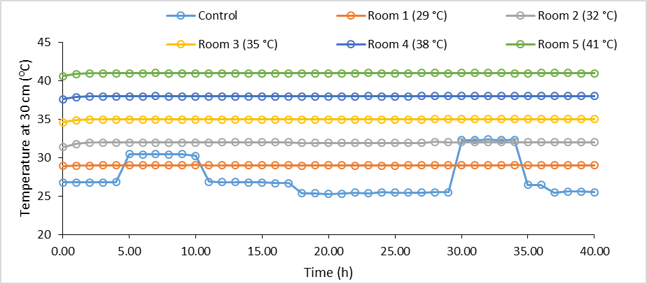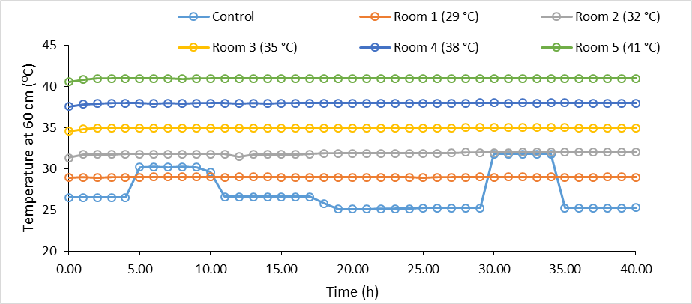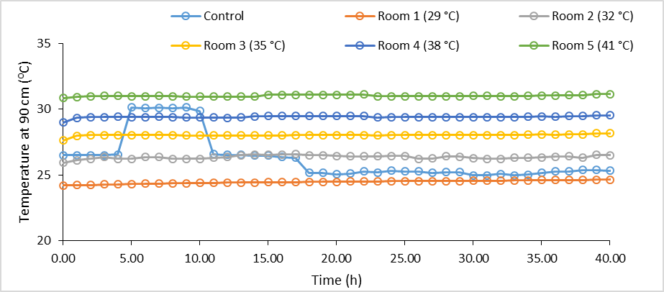

Figure 1: Temperature profile of the controlled poultry house over time

Figure 2: Wet and dry bulb temperature of the controlled poultry house over time.

## **3.1.3 Relative humidity distribution in the poultry house**

Figure 3 showed the graphical representation of the hourly relative recorded by each sensors in all the sections of the poultry house. The relative humidity profile observation in the control experiment was completely controlled by the ambient temperature which in turn affect the relative humidity profile. For the thermally controlled rooms, the relative humidity profile observed was relatively constant especially for the rooms placed under 35 – 41 °C temperature level due to the fact that the temperature values in the rooms were kept constant al through the period of experimentation with no fluctuation of deflection. Based on this, the relative humidity value follows the trend of the ambient temperature with low relative humidity values recorded during the day and high values recorded during the night. This observation also indicates that under adverse weather condition like rainfall, an extremely high relative humidity value will be recorded for the control experiment room. This observation recorded in the thermally controlled rooms of the poultry housing was as a result of constant temperature the rooms were conditioned with the aid of heater and fans. The findings of Küçüktopcu *et al*. (2017), Setiadi *et al*. (2018) and Adejuwon *et al*. (2020), also justified the results from this study.

Figure 3: Relative humidity of the controlled poultry house over time.

## **3.2 Broilers Body Weight**

The results of the body weight of the broiler chicken over a period of time as affected by percentage of standard diet in the experimental rooms is presented in Figure 4. The figure showed the body weight of the broiler in the thermally controlled poultry system under different temperatures and that of the controlled experiment. As expected, the weight of the broilers increased progressively with increase in the age of broilers. The Figure showed that initial body weights on day 1 of the broiler were in close range (39.96 ± 0.24 g, 40.29 ± 0.83 g and 40.44 ± 0.37 g). The amount of feed available for all the broilers at this stage was sufficient and even surplus therefore leaving the broilers at relatively same weight with no significantly evident effect of the feed range shown in the result for the first week duration. Meanwhile, after 7 weeks, the weight of the broilers fed with 100 % of the standard diet (1128.13 ± 208.33 g) was consistently greater than the broilers fed with 80 % (1439 ± 165.01 g) and 60 % of the standard diet (1745.11 ± 177.58 g).

Figure 4: Effect of diet percentage on the average body mass of the broilers at different temperature range.

However, Figure 5 show the effect of the temperature on body weight of the broiler chicken over a period of time in a thermally controlled housing system in comparison with the control experiment (non-thermally controlled room of the poultry housing system). The figure maintains the fact that broilers grow with time as the body weight of the broilers increases progressively throughout the period that was considered in this study. The weight of broilers in the control group was consistently lower than that of broilers under constant heat stress state. This observation might be due to the fact that a greater portion of their nutrient intake was used to generate heat thus adversely affecting body weight gain (Bruzual *et al*., 2000). Also, the experimental findings of Tao and Xin (2003b), when they investigated the temperature-humidity-velocity index from market-size broiler also justified it that temperature of poultry house have effect on the body weight of broilers with respect to age.

From week 1 to 3, only a slight difference in the body weight was observed among broiler under a constant heat stress group and the broilers in this group are slightly higher in body weight than the control group. The difference was due to little effect that the change in food value and temperature level had on the broiler growth compared to the effect recorded after week 3 of the experimentation. Between the 3rd and 7th week, the effect of feed, water and temperature variation was so evident leaving wide differences in the body weight recorded for the broilers at these stages. For broiler feed with 60 % of the standard diet, after 7 week of age, the body weight of the broiler under 32 °C attain the highest value (1319.66 g) followed by 29 °C, 35 °C, 38 °C in that order, while the lowest body weight (885.03 g) was recorded for broilers in the highest thermal stress condition (41 °C) of the housing system considered in this study. Broiler fed with 80 % of the standard diet attain the highest value (1689.70 g) of the body weight under 32 °C followed by 35 °C, 38 °C, 29 °C and the lowest body weight (1301.64 g) was recorded for broilers in the highest thermal stress condition (41 °C) of the housing system in 7 weeks. Similar trend was observed for the broiler raised with 100 % of the standard diet. This shows that increase in the environmental temperature to a certain level beyond the ambient temperature will improve the performance of the broiler, while further increment might be detrimental to the performance of the broilers and this agrees with the findings of Mujahid *et al*. (2005), who reported that the heat stress has been reportedly associated with poor performance in broiler chickens during the study of the superoxide radical produced in chicken skeletal muscle induced by acute heat stress.

Figure 5: Effect of housing temperature on the average body mass of the broilers at different diet standard.

### **3.3 Linear Modelling of Body Weight of Broilers for the Study**

Table 1 shows the linear relationship between broilers body weight and age of the broilers in a thermally controlled housing system (29, 32, 25, 38 and 41 °C) and a non-thermally control section (Control experiment) under different percentage of standard feeding of 60 %, 80 % and 100 % respectively. According to this table, the age of the broiler fed with 60 % of the standard feed clearly explain about 97.93, 97.47, 98.13, 98.46, 98.87 and 99.25 % the variation in body mass of the broilers raised under different heat stress condition of 29 °C, 32 °C, 35 °C, 38 °C, 41 °C and control respectively. The age of the broiler fed with 80 % of the standard feed clearly explain about 98.44 %, 97.16 %, 97.67 %, 97.24 %, 98.79 % and 98.43 % of the variation in body mass of the broilers raised under different heat stress condition of 29 °C, 32 °C, °C, 38 °C, 41°C and control, respectively. Also, the age of the broiler fed with 100 % of the standard feed clearly explain about 98.18 %, 96.64 %, 96.18 %, 96.63 %, 97.45 % and 96.45 % of the variation in body mass of the broilers raised under different heat stress condition of 29 °C, 32 °C 35 °C, 38 °C, 41°C and control, respectively. The difference in the slope coefficient of the relationship between the body weight of the broilers and the age of the broilers (week) shows that the body weight of the also depends on the environmental condition of the housing system and the feeding regime (Balog *et al*., 2001).

### **3.4 Multi-Variable Regression Analysis of Body Weight of Broilers**

Multi-variable regression analysis was used to express the body weight of the broilers (Response) on function of some physical and environmental variables (broilers age, relative humidity, temperature, percentage of standard diet and temperature-humidity index) and the resulted regression model is shown in equation 3 with 0.9769 coefficient of determination and standardized root mean square error (RSME) of 63.9479 which shows that the combination of the variables can explain about 97.69 % variation in the body weight of the broilers.

Table 1: Linear model for the body weight of the broilers fed with 60, 80 and 100 % diet

|  |  |  |  |
| --- | --- | --- | --- |
| S/n | Temperature (°C) | Equations | R2 |
| 60 % diet | | | |
| 1 | 29 | 28.92x - 135.13 | 0.9793 |
| 2 | 32 | 30.87x - 151.8 | 0.9748 |
| 3 | 35 | 27.24x - 112.77 | 0.9813 |
| 4 | 38 | 24.80x - 90.94 | 0.9846 |
| 5 | 41 | 20.31x - 33.8 | 0.9887 |
| 6 | Control | 19.91x - 45.16 | 0.9925 |
| 80 % diet | | | |
| 1 | 29 | 33.04x - 139.19 | 0.9844 |
| 2 | 32 | 36.96x - 183.16 | 0.9716 |
| 3 | 35 | 33.53x - 154.01 | 0.9767 |
| 4 | 38 | 32.89x - 155.5 | 0.9724 |
| 5 | 41 | 29.82x - 113.17 | 0.9879 |
| 6 | Control | 27.45x - 108.99 | 0.9843 |
| 100 % diet | | | |
| 1 | 29 | 37.47x - 162.83 | 0.9818 |
| 2 | 32 | 43.14x - 222.58 | 0.9664 |
| 3 | 35 | 41.14x - 220.96 | 0.9618 |
| 4 | 38 | 40.88x - 212.90 | 0.9663 |
| 5 | 41 | 36.01x - 173.17 | 0.9745 |
| 6 | Control | 34.00x - 178.51 | 0.9645 |

Table 2 shows the analysis of variance of the regression model. It was observed that the body weight of the broilers significantly depends on the age of the broiler, percentage of standard diet, relative humidity and temperature-humidity index with fishers value statistics of 591, 338.22, 31.92 and 23.36, respectively while for the group-response, second level interaction among age of the broilers, percentage of standard diet and relative humidity significantly contribute to the variation in the body weight of the broilers and the third level interaction among the age of the broiler, relative humidity and temperature significantly (P = 0.001) contribute to the variation in the body weight of the broilers. Therefore, it could be deduced that there is a significant effect of factors interaction on the body weight of the broilers.

$BW=1169+1262A+30.64Rh+842.13T-4.53D-1011THI-19.64Rh-42.53AT+7.28AD-0.21RhD-0.68TD+0.72ARhT-0.09ARRhD+0.02RhTD$ (3)

where; BW is the body weight of the broilers (g), A is the age of the broilers (weeks), T is the room temperature (°C), D is the feeding regime (%), THI is the temperature-humidity index and Rh is the relative humidity (%).

Table 2: Analysis of variance (ANOVA) for regression analysis of the body weight of broilers

|  |  |  |  |  |  |
| --- | --- | --- | --- | --- | --- |
| **Source** | **DF** | **Sum of squares** | **Mean squares** | **F** | **Pr > F** |
| Model | 13 | 26773020.36 | 2059463.10 | 503.62 | < 0.0001 |
| A | 1 | 2.42E+07 | 2.42E+07 | 5.91E+03 | < 0.0001 |
| RH | 1 | 130542.49 | 130542.49 | 31.92 | < 0.0001 |
| T | 1 | 7966.48 | 7966.48 | 1.95 | 0.17 |
| D | 1 | 1383131.02 | 1383131.02 | 338.23 | < 0.0001 |
| THI | 1 | 95531.63 | 95531.63 | 23.36 | < 0.0001 |
| A*RH | 1 | 84007.07 | 84007.07 | 20.54 | < 0.0001 |
| A*T | 1 | 1.21E+04 | 1.21E+04 | 2.96E+00 | 0.09 |
| A*D | 1 | 7.28E+05 | 7.28E+05 | 1.78E+02 | < 0.0001 |
| RH*D | 1 | 15416.95 | 15416.95 | 3.77 | 0.06 |
| T*D | 1 | 5115.282 | 5115.282 | 1.251 | 0.27 |
| A*RH*T | 1 | 1.05E+05 | 1.05E+05 | 2.58E+01 | < 0.0001 |
| A*RH*D | 1 | 2.84E+04 | 2.84E+04 | 6.94E+00 | 0.01 |
| RH*T*D | 1 | 5654.37 | 5654.37 | 1.38 | 0.24 |
| Error | 91 | 372128.90 | 4089.33 |  |  |
| Corrected Total | 104 | 27145149.25 |  |  |  |

1. **CONCLUSION**

This study investigated the impact of temperature change on broiler growth performance within a thermally controlled environment. The findings demonstrate that maintaining temperatures within the thermoneutral zone of 30-35 °C is crucial for optimal broiler growth performance with the best result derived at 35 °C. Broilers reared at temperatures exceeding the comfort zone exhibited reduced weight gain, feed intake, and potentially compromised feed conversion ratio (FCR). These observations align with established knowledge regarding the detrimental effects of heat stress on broiler physiology and metabolism. The results highlight the importance of precise temperature management in broiler production facilities. Implementing effective environmental control strategies, such as ventilation systems which is essential to maintain optimal rearing temperatures and maximize broiler growth performance.

It was established using analysis of variance of the regression model and group-response at second level interaction that the body weight of the broilers significantly depends on the age of the broiler, percentage of standard diet, relative humidity and temperature-humidity index with Fisher’s value statistics. In conclusion, this study underscores the critical role of temperature control at different diet rate in broiler production. Maintaining thermoneutral conditions is essential for optimal broiler growth performance and overall production efficiency.

**REFERENCE**

1. Adejuwon, A. R., Olomo, R., Falayi, F. R. and Jongbo, A. O. (2020). Development and Evaluation of the Climatic Conditions inside a Sustainable Backyard Poultry Building. *Brazilian Journal of Biosystems Engineering*, 14(3):309-320.
2. Ahmad, S., Mahmud, A., Hussain, J., Javed, K., Usman, M., Waqas, M. and Muhammad, Z. (2021). Behavioural assessment of three chicken genotypes under free‐range, semi‐intensive, and intensive housing systems. Ankara Üniversitesi Veteriner Fakültesi Dergisi, 68:365–372. 10.33988/auvfd.791155
3. Apalowo, O. O., Ekunseitan, D. A., Fasina, Y. O. (2024). Impact of Heat Stress on Broiler Chicken Production. *Poultry*, 3:107-128. <https://doi.org/10.3390/poultry3020010>
4. Balog, J. M., Kidd, B. D., Huff, W. E., Huff, G. R., Rath, N. C. and Anthony, N. B. (2001). Effect of cold stress on broilers selected for resistance or susceptibility to ascites syndrome. *Poultry Science*, 82(9):1383- 1387.
5. Bruzual, J. J., Peak, S. D., Brake, J. and Peebles, E. D. (2000). Effects of relative humidity during the last five days of incubation and brooding temperature on performance of broiler chicks from young broiler breeders. *Poultry Science*, 79(10):1385-91.Abioja, M.O., Abiona, J.A. (2021). Impacts of Climate Change to Poultry Production in Africa: Adaptation Options for Broiler Chickens. In: Oguge, N., Ayal, D., Adeleke, L., da Silva, I. (eds) African Handbook of Climate Change Adaptation. *Springer, Cham*. <https://doi.org/10.1007/978-3-030-45106-6_111>
6. De Jong, I. C., Voorst, S. V., Ehlhardt, D. A. and Blokhuis, H. J. (2002). Effects of restricted feeding on physiological stress parameters in growing broiler breeders. *Broiler Poultry Science*, 43:157–168. doi: 10.1080/00071660120121355.
7. EFSA AHAW Panel (EFSA Panel on Animal Health and Welfare), Nielsen, S. S., Alvarez, J., Bicout, D. J., Calistri, P., Canali, E., Drewe, J. A., Garin-Bastuji, B., Gonzales Rojas, J. L., Schmidt, C. G., Herskin, M. S., Miranda Chueca, M. Á., Padalino, B., Pasquali, P., Roberts, H. C., Spoolder, H., Stahl, K., Velarde, A., Viltrop, A., Winckler, C., … Michel, V. (2023). Welfare of broilers on farm. *EFSA journal. European Food Safety Authority*, 21(2), e07788. <https://doi.org/10.2903/j.efsa.2023.7788>
8. Falayi, F. R. and Olanipekun, M. O. (2017). Design and Fabrication of a Discomfort Index Meter for Determination of Stress in Livestock. *Nigerian Journal of Technology*, 36(3):953 – 959.
9. Ghazi, S. H., Habibian, M., Moeini, M. M., Abdolmohammadi, A. R. (2012). Effects of different levels of organic and inorganic chromium on growth performance and immune competence of broilers under heat stress. *Biological Trace Element Research*, 146:309-317.
10. Küçüktopcu, E., Cemek, B. and Banda, P. (2017). Determination of poultry house indoor heating and cooling days using degree-day method. *Agronomy Research*, 15(3):760-766.
11. Kumar, S. (2015). Evaluation of Growth Performance of Broiler (Cobb- 400) Under Different Composition of Diets. The Bioscan- *An International Journal of Life Science*, 10:1465-1468.
12. Mujahid, A., Yoshiki, Y., Akiba, Y. and Toyomizu, M. (2005). Superoxide radical production in chicken skeletal muscle induced by acute heat stress. *Poultry Science*, 84(2):307-314
13. Nardone, A., Ronchi, B., Lacetera, N., Ranieri, M.S. and Bernabucci, U. (2010) Effects of climate changes on animal production and sustainability of livestock systems. *Livestock Science*, 130:57–69.
14. Norton, T., Grant, J., Fallon, R. and Sun, D. (2009). Assessing the ventilation effectiveness of naturally ventilated livestock buildings under wind dominated conditions using computational fluid dynamics. *Biosystems Engineering*, 103:78–99.
15. Obayelu, E. A. and Adedapo, A. (2006). The effect of Climate on Poultry Productivity in Ilorin, Kwara State, Nigeria. *International Journal of Poultry Science*, 2(3):1061-1068.
16. Poullet, N., Bambou, J. C., Loyau, T., Trefeu, C., Feuillet, D., Beramice, D., Bocage, B., Renaudeau, D., and Gourdine, J. L. (2019). Effect of feed restriction and refeeding on performance and metabolism of European and Caribbean growing pigs in a tropical climate. *Scientific reports*, 9(1):4878. <https://doi.org/10.1038/s41598-019-41145-w>
17. Renaudeau, D., Collin, A., Yahav, S., de Basilio, V., Gourdine, J. L. and Collier, R. J. (2012) Adaptation to hot climate and strategies to alleviate heat stress in livestock production. *Animal*, 6:707–728.
18. Seo, S. N and Mendelsohn, R. O. (2006). The Impact of Climate Change on Livestock Management in Africa: A Structural Ricardian Analysis. World Bank Publications, USA: 48-49.
19. Setiadi, R., Munadi, and Mohammad, T. (2018). Numerical Analysis for Temperature Profile of the Closed House Using Computational Fluid Dynamics. *AIP Conference Proceedings* 1941, 020032:177-181.
20. Shinder, D., Luger, D., Rusal, M., Rzepakovsky, V., Bresler, V., Yahav, S. (2002). Early age cold conditioning in broiler chickens (Gallus domesticus): Thermotolerance and growth responses. *Journal of Thermal Biology*, 27:517-523.
21. Simmons, J. D., Lott, B. D. and May, J. D. (1997). Heat loss from broiler chickens subjected to various wind speeds and ambient temperatures. *Applied Engineering in Agriculture*, 13: 665–669.
22. Singh, V., Chakrabarti, A., Godara, R. S., Das, A., Sahoo, L., Lembisana, H. D., Sarkar, P., Das, B. and Singh, M. (2022). Heat Stress in Poultry Production and its Management under Changing Climatic Scenario. *Sustainable Future: India Farming Digest* 1: 6-11.
23. Tao, X. and Xin, H. (2003a). Acute synergistic effects of air temperature, humidity, and velocity on homeostasis of market–size broilers. *American Society of Agricultural and Biological Engineers*, 46(2): 491-497.
24. Tao, X. and Xin, H. (2003b). Temperature-Humidity-Velocity Index for market-size broilers. In: *ASABE Annual International Meeting*; 2003; Nevada.USA. Paper n. 034037.
25. Tůmová, E., Chodová, D., Skřivanová, E., Laloučková, K., Šubrtová-Salmonová, H., Ketta, M., Machander, V., and Cotozzolo, E. (2021). Research Note: The effects of genotype, sex, and feeding regime on performance, carcasses characteristic, and microbiota in chickens. *Poultry science*, 100(2):760–764. https://doi.org/10.1016/j.psj.2020.11.047
26. Vox, G., Manet, A. and Schettini, E. (2016). Evaluation of the radiometric properties of roofing materials for livestock buildings and their effect on the surface temperature. *Biosystems Engineering*, 144: 26-37.