***Original Research Article***

**Evaluating the Antifungal Effectiveness of Three Plant Extracts in Controlling Panama Disease in Banana Plants**

**ABSTRACT**

**Aims**: This study aimed to evaluate the antifungal potential of *Mikania micrantha*, *Senna alata*, and *Datura metel* plant extracts against *Fusarium oxysporum f. sp. cubense* (Foc), the causal agent of Panama disease in bananas. Additionally, the study sought to determine the optimal concentration of the most effective plant extract for fungal suppression.

**Study Design**: Laboratory-based experimental research using in-vitro assays to assess the antifungal activity of selected plant extracts.

**Place and Duration of Study**: The study was conducted at the Laboratory of the Institute for Agro-technology and Rural Sciences, University of Colombo, Sri Lanka, from February to July 2024.

**Methodology**: The fungal pathogen was isolated from infected banana plant roots and cultured on Potato Dextrose Agar (PDA). Aqueous extracts of the plants were prepared and incorporated into PDA media. In Experiment 1, fungal colonies were exposed to five treatments: control (no application), *M. micrantha* extract, *D. metel* extract, *S. alata* extract, and a commercial fungicide. In Experiment 2, different concentrations (25%, 50%, 75%, and 100%) of the most effective extract from Experiment 1 were tested against *Fusarium oxysporum*. Fungal growth was monitored for seven days, and colony diameter measurements were statistically analyzed using SAS software, with Duncan’s Multiple Range Test at a 5% significance level.

**Results**: Significant differences (p < 0.05) in fungal growth inhibition were observed among treatments. D. metel extract demonstrated the highest antifungal activity. The inhibitory effect was dose-dependent, with 100% D. metel extract exhibiting the strongest suppression of F. oxysporum growth, approaching the efficacy of the commercial fungicide.

**Conclusion**: D. metel extract demonstrated strong antifungal potential against F. oxysporum, making it a promising alternative to chemical fungicides for managing Panama disease in bananas. Further research is needed to explore its field efficacy, mode of action, and possible integration with other biocontrol strategies for enhanced disease management.

Keywords: Antifungal effects, Banana wilt*, Datura metel* extract*, Fusarium oxysporum, Mikania micrantha* extarct, *Senna alata* extract

1. **INTRODUCTION**

Banana (*Musa* spp.) is one of the most widely consumed fruits globally and remains a dominant commodity in the international fruit market, with production spanning over 135 countries (FAO, 2023). In recent years, both the cultivated area and production volume have increased, driven by the fruit’s growing popularity and economic significance. In addition to being a major cash crop, bananas are extensively cultivated in tropical and subtropical regions for local consumption (Khan and Nasreen, 2010). However, banana cultivation is highly vulnerable to fungal diseases, including Mycosphaerella leaf spots, Black and Yellow Sigatoka, Eumusae leaf spot, Mycosphaerella speckle, and Panama disease (Molina et al., 2008). These fungal infections can cause severe yield losses, reaching up to 90% in some cases (Khan and Nasreen, 2010). Among them, Panama disease is considered the most devastating, as it can lead to complete crop failure in severely affected plantations (Fernando et al., 2013; Ploetz, 2015).

Panama disease, also known as Fusarium wilt of banana, was the first banana disease to spread globally (Ploetz and Churchill, 2011). This lethal fungal disease is caused by the soil-borne pathogen *Fusarium oxysporum* f. sp. *cubense* (Foc). The global banana industry initially faced a major threat from *F. oxysporum* f. sp. *cubense* Race 1 (FocR1) (Ploetz, 2015). While this challenge was mitigated through the introduction of resistant Cavendish banana varieties, a more virulent strain, Tropical Race 4 (FocTR4) also referred to as *Fusarium odoratissimum* (Dale et al., 2017; Fones et al., 2020) has since emerged. Spreading rapidly across multiple continents, FocTR4 poses a significant threat to the global Cavendish banana industry, jeopardizing commercial production on a large scale (Ploetz, 2015; Fones et al., 2020).

Once established in a field, *Fusarium oxysporum* f. sp. *cubense* (Foc) can persist in the soil indefinitely, surviving for up to 30 years as chlamydospores within infected plant material or the roots of alternative host plants (Gnanasekara et al., 2015). The fungus enters banana plants through the roots and colonizes the vascular tissues, specifically the xylem vessels, where it obstructs the transport of water and nutrients. This disruption triggers external symptoms, including progressive yellowing and wilting of leaves, which initially appears along the outer margins before spreading inward. The disease progresses from older leaves to younger ones, eventually causing the affected foliage to collapse at the petiole. Additionally, the outer leaf sheaths of the pseudostem develop characteristic longitudinal splits (Yin et al., 2011; Guo et al., 2013).

Internally, infected plants exhibit a distinct discoloration of vascular tissues, transitioning from light yellow to dark brown. This discoloration first appears in the outer or older leaf sheaths and gradually extends into the pseudostem (Minerdi et al., 2008; Yin et al., 2011). As the infection advances, severe vascular blockage leads to plant death, resulting in significant economic losses in banana cultivation (Guo et al., 2013).

Different strategies to control Foc are currently being used including using biological control agents (Taping et al., 2023; Jin et al., 2024), removing infected tissues and maintain crop sanitation (Pegg et al., 2019), developing resistant varieties (Dale et al., 2017; Naim et al., 2018), and introducing biosecurity protocols to reduce the spread of pathogen (Bubici et al., 2019). However, none of these methods have been identified as particularly effective, rather than controlling the pathogenic fungi with fungicides (Steinberg et al., 2020; Cannon et al., 2022).

As there are increasing concerns over the negative effects of using fungicides to human health and to the environment, they are not recommended for the control of the disease. (Akila et al., 2011). Consequently, researchers are increasingly turning to alternative, eco-friendly management strategies that can mitigate the disease's impact while promoting sustainable agricultural practices. Plant-based approaches have emerged as a promising alternative, with botanical extracts showing considerable potential in managing Fusarium wilt. These natural solutions leverage secondary metabolites such as phenols, alkaloids, and terpenoids, which serve as chemical defense agents against plant pathogens (Tripathi and Singh, 2015). Botanical fungicides offer multiple advantages, including the ability to either directly act on pathogens or induce systemic resistance in host plants, thereby reducing disease development (Abdullahi et al., 2018).

Under the given circumstances, current research aims to explore innovative, sustainable approaches to combating Panama disease, focusing on the potential of plant extracts as an eco-friendly management strategy. By investigating the antifungal properties of various botanical substances, this study seeks to contribute to the development of more sustainable and environmentally responsible methods for protecting banana crops against this devastating fungal threat.

1. **MATERIALS AND METHODOLOGY**
   1. **Isolation and morphological identification of fungal pathogen**

The causal organism was isolated from infected banana plant roots showing disease symptoms. The roots were washed, sectioned, and surface sterilized using 30% alcohol. Then the root fragments were kept on the culture medium Potato-Dextrose-Agar (PDA) aseptically to grow the pathogen at 27 ± 2 0C. The pure fungal cultures were then maintained on PDA plates for further investigations (Figure 1). The pathogen was identified by microscopic examination based on the morphological characteristics (Gnanasekara et al., 2015).

* 1. **Preparation of plant extracts**

Three medicinal plants were selected based on their documented medicinal properties (Table 1). Healthy and fresh plant materials were collected, washed under running tap water and dried under shade. Then 50 g of from each of the sample was ground into a paste using a mortar and pestle, with 200 ml of distilled water serving as the extraction solvent. The resulting mixture was then filtered through a whatman no. 1 filter paper to separate the liquid extract from the plant residue and stored aseptically in sealed containers.

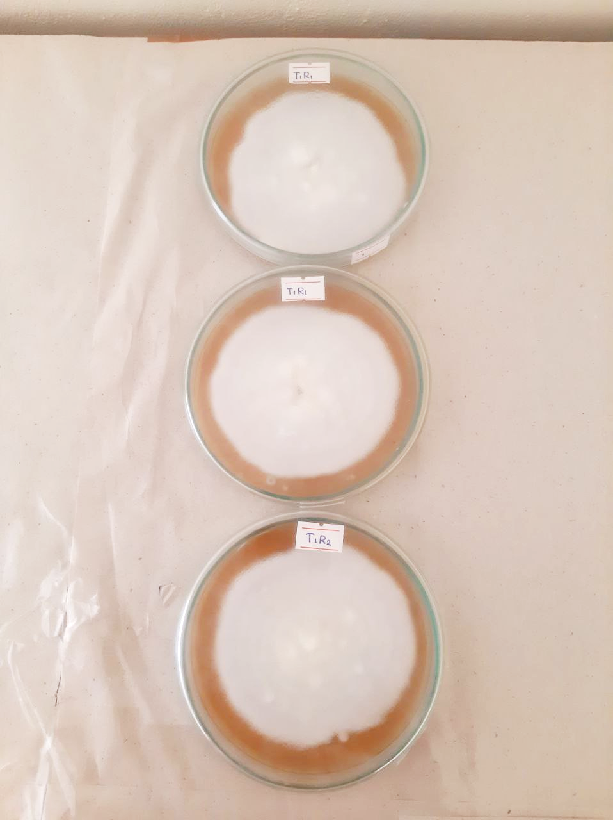

**Figure 1: Isolated *Fusarium oxysporum* colony on PDA media.**

* 1. **Preparation of plant extract culture media**

PDA media supplemented with 100 ml of the plant extract was prepared separately and poured into petri dishes under sterile conditions. After solidification the plant extract culture media was inoculated with isolated *Fusarium oxysporum* pathogen incubated at 27 ± 2 0C for 24 hours.

**Table 1: List of plants used in the study.**

|  |  |  |  |
| --- | --- | --- | --- |
| **Botanical name** | **Family** | **Part used** | **Reference for antifungal properties** |
| *Mikania micrantha* | Solanaceae | Leaves | Devkota and Sahu, 2020 |
| *Senna alata* | Fabaceae | Leaves | Ezemba, 2021; Saptarini et al., 2024 |
| *Datura metel* | Solanaceae | Leaves | Rinez et al., 2013; Shah et al., 2022 |

* 1. **Experiment 1: Evaluation the efficiency of antifungal activity of different Plant Extracts against *Fusarium oxysporum***

The experiment was conducted with five treatments and three replications, where each replicate contained three experimental units. The treatments were as follows; T1: Control (No applications), T2: *Mikania micrantha* extract, T3: *Datura metal* extract, T4: *Senna alata* extract and T5: Commercial fungicide.

* 1. **Experiment 2: Determination of Optimal Extract Concentration**

Experiment 2 aimed to investigate the effect of concentration of thebest plant extract identified in experiment 1 on controlling the growth of *Fusarium oxysporum*. The experiment contained five treatments with three replicates per treatment, each containing three experimental units. Treatments were as follows; T1: Control (No applications), T2: 25% of plant extract, T3: 50% of plant extract, T4: 75% of plant extract, T5: 100% of plant extract.

* 1. **Culture Maintenance in experiments**

In both experiments, petri dishes were stored at room temperature following the initial 24-hour period in the incubator. The identity of *Fusarium oxysporum* was confirmed, and the growth of the fungus was observed daily. Data on fungal growth were observed (Figure 2 and 3) and colony diameter measured for 7 consecutive days.

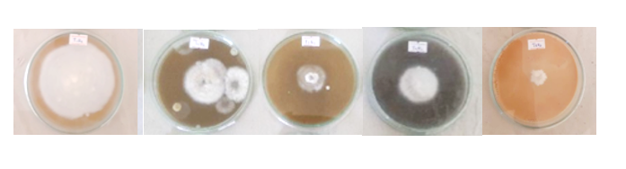

T1 T2 T3 T4 T5

**Figure 2: Visual observations for fungal growth in experiment 1 at day 7**

(T1: Control (No applications), T2: *Mikania micrantha* extract, T3: *Datura metal* extract, T4: *Senna alata* extract and T5: Commercial fungicide)

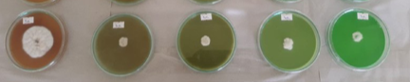

T1 T2 T3 T4 T5

**Figure 3: Visual observations for fungal growth in experiment 2 at day 7.**

(T1: Control (No applications), T2: 25% of *D. metal* plant extract, T3: 50% of *D. metal* plant extract, T4: 75% of *D. metal* plant extract, T5: 100% of *D. metal* plant extract)

* 1. **Data Collection and Analysis**

For both experiments, colony diameter was measured and data were subjected to statistical analysis using SAS statistical software. Mean separation was done using DMRT at 5% significance level.

# RESULTS AND DISCUSSION

Banana is one of the most important food and fruit crops worldwide, but its production is increasingly threatened by Fusarium wilt. Traditional control methods, such as chemical treatments against *Fusarium oxysporum* f. sp. cubense (Foc), have been employed; however, they have proven inadequate in effectively managing the disease while also posing significant environmental hazards (Akila et al., 2011). Consequently, there is a growing need for environmentally friendly approaches to control fusarium wilt in banana cultivation (Durgeshlal et al., 2019). In recent years, the search for natural antifungal agents derived from plants has gained considerable attention as a sustainable alternative to chemical pesticides. Efforts are being made to identify bioactive compounds in plants that can serve as effective antifungal agents with minimal environmental impact. The mechanism of fungal growth inhibition can be attributed to the sophisticated biochemical interactions of plant-derived compounds. Phytochemicals extracted from plant sources offer a promising solution by providing safer, non-toxic, and more efficient alternatives for managing fungal pathogens (Akila et al., 2011; Gnanasekara et al., 2015).

Previous research have reported different plant oil extracts like *Metasequoia glyptostroboides* (Bajpai et al., 2007). *Cymbopogon citratus* (Guimarães et al., 2011), *Syzygium aromaticum* and *Cinnamomum verum* (Monteiro et al., 2013) can use to suppress the *F. oxysporum*. Importantly, Oliveira et al. (2008) found that *Lippia sidoides* oil provided fungal control comparable to synthetic fungicide, carbendazim. Further studies have confirmed the effectiveness of various aqueous plant extracts against Fusarium species. *Acacia nilotica* (Kubara et al., 2017), *Azardiachta indica, Eucalyptus globulus, Artemisia annua, Ocimum sanctum* (Mengane and Kamble, 2014), *Azadirachta indica* (Gnanashekara et al., 2015) *Syzygium aromaticum*, and *Cinnamomum verum* (Monteiro et al., 2013; Saththivel and Vinujan, 2024). Addition to the in-vitro experiments, in-vitro experiments also confirm the possibility of using plant extracts to suppress fusarium wilt. In one comprehensive study, Huang et al. (2012), who examined the effectiveness of *Allium tuberosum* in managing Fusarium wilt, observing disease incidence reductions ranging from 58% to 79% across different banana varieties under controlled greenhouse conditions. These findings highlight the potential of plant-based biocontrol agents as sustainable alternatives to synthetic fungicides, offering an environmentally friendly approach to managing fungal diseases in agriculture.

In present work, antifungal efficacy of aqueous plant extracts from *Mikania micrantha*, *Senna alata*, and *Datura metel* was assessed against *Fusarium oxysporum* f. sp. cubense (Foc), the causal agent of Fusarium wilt in banana. The results revealed significant differences (*P*<0.05) in fungal colony diameter among the different treatments over a seven-day observation period (Figure 4).

Among the tested plant extracts, *M. micrantha* (T2) and *S. alata* (T4) exhibited relatively weak antifungal activity, as evidenced by limited inhibition of mycelial growth. In contrast, *D. metel* (T3) demonstrated a substantial inhibitory effect, significantly suppressing fungal colony expansion. The pronounced morphological abnormalities and structural distortions observed in *F. oxysporum* treated with *D. metel* extract suggest that its antifungal activity may be linked to multiple mechanisms, including oxidative stress induction, fungal cell membrane degradation, and disruption of essential metabolic processes (Rinez et al., 2013; Shah et al., 2022).

**Figure 04: Diameter of the *Fusarium oxysporum* colony in experiment 1**.

Means followed by same letter are not significantly different (*P*<0.05)

The effectiveness of *D. metel* extract against *F. oxysporum* aligns with previous studies highlighting the antifungal potential of plant-based bioactive compounds. Akharaiyi (2011) identified a diverse range of phytochemicals in *D. metel*, including saponins, flavonoids, tannins, glycosides, phenols, alkaloids, steroids, and terpenoids, many of which have been recognized for their antifungal properties (Sparg et al., 2004). Previous research supports these findings. Pradeep, 2020 investigated the environmentally friendly management of *Fusarium oxysporum* f. sp. using various plant extracts, including *D. metel*, custard apple, aloe, castor, and *Vitex negundo* on chili plants, and confirmed the efficacy of *D. metel* extract in inhibiting the growth of the *F. oxysporum* pathogen under in vitro conditions. These results further support the potential application of *D. metel* as a natural antifungal agent.

These findings indicate that *D. metel* possesses strong antifungal properties, ranking second only to the commercial fungicide. The results highlight the importance of plant extracts to be use as sustainable alternatives for commercial fungicides available. This is in line with the reports of Fernando et al. 2013 who stated that, the extracts of *Cinnamomum* *zeylanicum* and *Syzygium aromaticum* achieved best values in controlling Fusarium wilt disease of banana, obtaining values equal to the fungicide treatment used. Similarly, Abdullahi et al., 2018 found that *Acacia nilotica* and *Lawsonia* *inermis* leaves extracts compete favourabbly with the mancob fungicide.

Based on the results of the first experiment, *D. metel* extract was selected for further investigation to assess its antifungal efficacy at varying concentrations. The second experiment revealed a concentration-dependent suppression of fungal colony growth. As the concentration of *D. metel* extract increased, a progressive reduction in *F. oxysporum* colony diameter was observed. The 100% concentration exhibited the most significant inhibition, effectively limiting fungal growth (Figure 5).

**Figure 05. Diameter of the colony in experiment 02.**

Means followed by same letter are not significantly different (*P*<0.05)

These findings suggest that *D. metel* contains potent antifungal compounds that exert a dose-dependent effect on fungal development. The increased inhibition at higher concentrations highlights the potential of this plant extract as a natural antifungal agent with practical applications in plant disease management. The ability of *D. metel* to suppress fungal growth at high concentrations further supports its suitability as an alternative to chemical fungicides, offering a more sustainable and environmentally friendly approach to controlling Fusarium wilt in banana cultivation.

# CONCLUSION

The study revealed a significant antifungal potential of *Datura metal* extract against *Fusarium oxysporum*. Its concentration-dependent inhibition, significant morphological impact and performance comparable to commercial fungicides indicated it as an alternative, environmentally friendly fungal management solution. Future investigations should explore its mode of action, field efficacy, and potential synergistic effects with other biocontrol agents to enhance its effectiveness in agricultural applications.

**REFERENCES**

Abdullahi, K. K., Adebola, M. O., & Ajayi, H. O. (2018). Antifungal efficacy of three plant extracts in the suppression of panama disease in banana plants. *GSC Biological and Pharmaceutical Sciences*, *5*(1), 095–103. <https://doi.org/10.30574/gscbps.2018.5.1.0103>

Akharaiyi, F. C. (2011). Antibacterial, phytochemical and antioxidant activities of Datura metel. International Journal of PharmTech Research, 3, 478-483.

Akila, R., Rajendran, L., Harish, S., Saveetha, K., Raguchander, T., & Samiyappan, R. (2011). Combined application of botanical formulations and biocontrol agents for the management of Fusarium oxysporum f. sp. Cubense (Foc) causing fusarium wilt in banana. Biological Control, 57, 175-183.

Bubici, G., Kaushal, M., Prigigallo, M. I., Cabanás, C. G. L., & Mercado-Blanco, J. (2019). Biological control agents against Fusarium wilt of banana. In *Frontiers in Microbiology* (Vol. 10, Issue APR). Frontiers Media S.A. https://doi.org/10.3389/fmicb.2019.00616

Cannon, S., Kay, W., Kilaru, S., Schuster, M., Gurr, S. J., & Steinberg, G. (2022). Multi-site fungicides suppress banana Panama disease, caused by Fusarium oxysporum f. sp. cubense Tropical Race 4. *PLoS Pathogens*, *18*(10). https://doi.org/10.1371/journal.ppat.1010860

Dale, J., James, A., Paul, J. Y., Khanna, H., Smith, M., Peraza-Echeverria, S., et al. (2017). Transgenic Cavendish bananas with resistance to Fusarium wilt tropical race 4. *Nature Communications*, *8*(1), Article 1496. https://doi.org/10.1038/s41467-017-01670-6

Devkota, A., & Sahu, A. (2020). Antimicrobial activities and phytochemical screening of leaf extract of *Mikania micrantha* H*.B.K. Journal of Natural History Museum*. 30. 274-286. 10.3126/jnhm.v30i0.27603.

Durgeshlal, C., Khan, M.S., Prabhat, S.A., & Prasad, Y.A. (2019). Antifungal Activity of Three Different Ethanolic Extract against Isolates from Diseased Rice Plant. *Journal of Analytical Techniques and Research*. 01. 10.26502/jatri.007.

Ezemba, C., Ojajogwu, A., Okere, N., & Kehinde, O., Ezemba, A., & Amadi, E. (2021). The Antifungal Activity of Senna Alata Leaf Extract on Dermatophytes. *Journal of Applied Chemical Science International*, Available at SSRN: <https://ssrn.com/abstract=4085591>

FAO. 2024. Banana Market Review 2023. Rome.

Fernanado, P.M., Larissa, C.F., Jhonata, L.S., Leandro, P.P., & Paulo, E.S. (2013). Influence of Plant Extracts and Essential Oils against Panama Disease (*Fusarium oxysprum* f. sp. cubense) in banana seedlings. *Journal of Agricultural Science*, 5 (4), 1915-9752.

Fones, H. N., Bebber, D. P., Chaloner, T. M., Kay, W. T., Steinberg, G., & Gurr, S. J. (2020). Threats to global food security from emerging fungal and oomycete crop pathogens. *Nature food*, *1*(6), 332–342. <https://doi.org/10.1038/s43016-020-0075-0>

Guimarães, L. G. L., Cardoso, M. G., Souza, P. E., Andrade, J., & Vieira, S. S. (2011). Antioxidant and fungitoxic activities of the lemongrass essential oil and citral. *Revista Ciencia Agronomica,* 42. 464-472. 10.1590/S1806-66902011000200028.

Guo, G., Wang, B., Weihong, M., Xiaofen, L., Yang, X., Zhu, C., et al. Biocontrol of Fusarium wilt of Banana: Key influence factors and strategies. *African Journal of. Microbiology Research*, 2013;7:4835-43.

Gnanasekara, P., Mohamed, S.S., Panneerselvan, A., & Umamagheswari, A. (2015). In vitro Biological Control of Fusarium oxysporum f. sp. cubense by using some Indian Medicinal plants. *International Journal of Current Research and Academic Review*, 3, 107-116.

Huang, Y. H., Wang, R.C., Li, C.H., Zuo, C.W., Wei, Y.R., Zhang, L., et al. (2012). Control of Fusarium wilt in banana with Chinese leek. *European Journal of Plant Pathology*,134: 87–95.

Jin, L., Huang, R., Zhang, J., Li, Z., Li, R., Li, Y., et al. (2024). Identification and Characterization of Endophytic Fungus DJE2023 Isolated from Banana (*Musa* sp. cv. Dajiao) with Potential for Biocontrol of Banana Fusarium Wilt. *Journal of fungi (Basel, Switzerland)*, *10*(12), 877. <https://doi.org/10.3390/jof10120877>

Khan, Z.S., & Nasreen, S. (2010). Phytochemical analysis, antifungal activity and mode of action of methanol extracts from plants against pathogens. *Journal of Agricultural Technology*, 6 (4), 793-805.

Kubara, A K, Omoniyi, A.M., & Olayiwola, A.H. (2018) Antifungal efficacy of three plant extracts in the suppression of panama disease in Banana plants. *GSC Biological and Pharmaceutical Sciences*, 05(01), 095–103

Mengane, S.K., & Kamble, S. (2014). Bioefficacy of plant extracts on fusarium oxysporum f.sp.cubense causing panama wilt of banana. *International Journal of Pharmacy and Biological Sciences*. 4. 2230-7605.

Minerdi, D., Moretti, M., Gilardi, G., Barberio, C., Gullino, M.L., Garibaldi, A. (2008). Bacterial ectosymbionts and virulence silencing in a Fusarium oxysporum strain. *Environmental Microbiology*, 10:1725-41.

Mohana Pradeep, R.K., Kousalya, S., Mukundhan, P., Sheneka, R., Rohini. R., Vinitha, S., et al. (2020). Eco-friendly management of *Fusarium oxysporum* f.sp. cubense causing *Fusarium*wilt on Banana under *In vitro* condition. *Journal of Pharmacognosy and Phytochemistry*,9(4):3145-3148.

Molina, A., Fabregar, E., Sinohin, V.G., Herradura, L., Fourie, G. & Viljoen, A. (2008). Confirmation of tropical race 4 of *Fusarium oxysporum* f. sp. cubense, infecting Cavendish bananas in the Philippines. *Centennial Meeting of the American Phytopathological Society*. (Minnesota, US). Abstracts.

Monteiro, F. P., Ferreira, L. C., Silva, J. L., Pacheco, L. P., & Souza, P. E. (2013). Influence of Plant Extracts and Essential Oils against Panama Disease (*Fusarium oxysporum* f. sp. cubense) in Banana Seedlings. *Journal of Agricultural Science*, *5*(4). https://doi.org/10.5539/jas.v5n4p63

Naim, F., Dugdale, B., Kleidon, J., Brinin, A., Shand, K., Waterhouse, P., & Dale, J. (2018). Gene editing the phytoene desaturase alleles of Cavendish banana using CRISPR/Cas9. *Transgenic research*, *27*(5), 451–460. https://doi.org/10.1007/s11248-018-0083-0

Oliveira, O. R., Terao, D., Carvalho, A. C. P. P., Innecco, R., & Albuquerque, C. C. (2008). Effect of essential oil from genus Lippia plants over the control of fungi contaminants on the micro propagation of plants. *Ciência Agronômica,* 39(1), 94-100.

Pegg, K. G., Coates, L. M., O'Neill, W. T., & Turner, D. W. (2019). The Epidemiology of Fusarium Wilt of Banana. *Frontiers in plant science*, *10*, 1395. <https://doi.org/10.3389/fpls.2019.01395>

Ploetz, R.C., & Churchhill, A.C.L. (2011). Fusarium wilt: The banana disease that refuses to go away. *Acta Horticulturae/ Internaional Society for Horticultural Sciences*, 897, 519-526.

Ploetz R. (2015) Fusarium wilt of banana. *Phytopathology*. 2015, 105: 1512–21. https://doi.org/10.1094/ PHYTO-04-15-0101-RVWPMID:26057187.

Rinez, A., Daami-Remadi, M., Ladhari, A., Faten, O., Imen, R., & Haouala, R. (2013). Antifungal activity of Datura metel L. organic and aqueous extracts on some pathogenic and antagonistic fungi. *African Journal of Microbiology Research*. 7. 1605-1612. 10.5897/AJMR12.2376.

Saptarini, N. M., Mustarichie, R., Hasanuddin, S., & Corpuz, M. J. T. (2024). Cassia alata L.: A Study of Antifungal Activity against Malassezia furfur, Identification of Major Compounds, and Molecular Docking to Lanosterol 14-Alpha Demethylase. *Pharmaceuticals (Basel, Switzerland),* 17(3), 380. <https://doi.org/10.3390/ph17030380>

Shah, H., Verma, S., & Tripathi, R. (2022). Anti-fungal Screening and Quantification of Datura metel Linn. *Columbia Journal of Pharmaceutical Sciences*, 1. 1-9.

Sparg, S. G., Light, M. E., & Van Staden, J. (2004). Biological activities and plant distribution of saponins. Journal of Ethnopharmacology, 94, 219-243.

Steinberg, G., & Gurr, S. (2020) Fungi, fungicide discovery and global food security. *Fungal Genetic Biology*. 2020; 144: 103476. https://doi.org/10.1016/j.fgb.2020.103476 PMID: 33053432. 13.

Tripathi, P., & Singh, R. (2015). Antifungal activity of Acacia nilotica extract on the control of Colletotrichum gloeosporioides [PENZ.] fungi causing anthracnose of mango fruits. International Journal of Current Research, 7(7), 17706-17712.

Yin, X.M., Jin, Z.Q., Xu, B.Y., Ma, W.H., Fu, Y.G., & Wang, J.B. (2011). Characterization of early events in banana root infected with the GFP-tagged *Fusarium oxysporum* f. sp. cubense. *Acta horticulturae,* (897), 371-376.