Original Research Article

Assessing suitable tree species for biochar production and their performance in enriching soil quality and plant growth of Oryza sativa L. and Acacia auriculiformis A. Cunn. ex Benth.

ABSTRACT
Aims: This study aims to identify suitable tree species for biochar production and evaluate their effectiveness in improving soil quality and the growth of Rice (Oryza sativa L.) and Akshmoni (Acacia auriculiformis A. Cunn. ex Benth). The findings will help determine the most effective biochar feedstock for sustainable agroforestry practices in tropical regions.
Study Design: The experiment was conducted using a Complete Randomized Block Design (CRBD) with six different tropical tree species as feedstock for biochar production. Biochar was applied as a soil amendment at a rate of 10 t/ha, with a control group for comparison.
Place and Duration of Study: The study was carried out at the nursery of the Department of Forestry and Environmental Science, Shahjalal University of Science and Technology (SUST) in Sylhet, Bangladesh over a specific period, focusing on biochar production and its impact on soil properties and plant growth.
Methodology: Six tropical tree species—Rain tree (Albizia saman), Kadam (Neolamarckia cadamba), Kathal (Artocarpus heterophyllus), Mango (Mangifera indica), Chambul (Terminalia arjuna), and Mahogany (Swietenia mahagoni)—were selected as feedstock for biochar production. A one-way ANOVA and Tukey HSD Post Hoc Test were used to determine statistical significance (α = 0.05) in evaluating biochar yield, soil quality improvement, and plant growth performance.
Results: Among the six species, Chambul (Terminalia arjuna) produced the highest biochar yield (41.6%) and exhibited the highest germination potential (88.3%). It also showed positive effects on plant growth performance. However, certain biochar types had adverse effects on plant growth, indicating that the choice of feedstock significantly influences biochar effectiveness.
Conclusion: The study highlights the importance of selecting appropriate feedstock species for biochar production. Chambul (Terminalia arjuna) biochar demonstrated the most promising results in terms of yield, soil quality enhancement, and plant growth. However, careful selection of tree species is crucial before biochar application to ensure optimal benefits for soil and plant health.
Keywords: Biochar, seed germination, plant growth, Oryza sativa, Acacia auriculiformis, soil quality

INTRODUCTION
Biomass has received a lot of attention recently as a source of renewable energy, because it is the only renewable source of fixed carbon ^{[1,2]}. Biomass has been recognized as a major world renewable energy source to supplement declining fossil fuel resources ^{[3,4]}. A lot of study has recently been done on finding suitable biomass species that can replace traditional fossil fuels and provide high-energy outputs.

There are three basic reasons why biomass seems to be an attractive feedstock. First, it is a renewable resource that can potentially be developed sustainably in the future. Second, it looks to have extraordinarily good environmental qualities, with no net carbon dioxide emissions and a very low sulphur content. Third, assuming future increases in the price of fossil fuels, it appears to have enormous economic potential ^{[5]}.
The biomass energy potential can be recovered either by direct use in combustion systems or by upgrading into a more valuable and usable fuel or gas or higher-value products for the different industries.
Many activities are currently focused on avoiding greenhouse gas emissions through a reduction in the use of fossil fuels, capturing carbon dioxide emitted from fossil fuel combustion and through changes in land-use and agricultural practices. Subsequently approaches to remove carbon dioxide from the air are of increasing interest ^{[6]}. One such potential measure is the sequestration of carbon in soils in a latent structure through pyrolysis biochar systems. Pyrolysis is a thermo-chemical procedure in which natural material is changed over into a carbon-rich solid (char) and volatile matter (liquids and gases) by heating without oxygen ^{[7]}.
Biochar has been heralded as an amendment to rejuvenate debased soils, improve soil carbon sequestration and increase agronomic productivity. Biochar has a high stability potential, can remain in the soil for a very long period and contribute to sequestration of atmospheric carbon. Thus, the longer period of the stability of biochar can play an important role in reducing the emission of CO₂ to the atmosphere ^{[8]}. At the point when biochar applied to the soil, it resists decaying, viably sequestering the applied carbon and mitigating anthropogenic CO₂ emissions. It has been discovered that the use of biochar improves the physical and substance soil quality, upgrades nutrient accessibility and decreases the acidity ^{[9,10,11]}. Thus, biochar shows an extraordinary potential in agrarian use, for example, expanding soil productivity and yield output ^{[12,13]}. Investigation of the effects of biochar on crop growth has increased over the past years but has mainly focused on tropical soil ^{[14,15,16,17,18,19,20,21]}.
Application of biochar alone has increased about 81% above-ground dry matter accumulation of the Hevea brasiliensis rootstock seedlings ^{[22]}. Again, application of biochar with NPK inorganic fertilizer showed significant correlation with stem diameter, seedling height and dry-matter accumulation ^{[23,24]}. Combination of biochar with compost enhanced foliar N, P and K concentration compared to control plants ^{[25]}. Biochar is very useful for increasing the diameter of slow-growing species compared with the addition of inorganic NPK fertilizer ^{[26]}.
While most biochars positively affect plant growth, some may have unfriendly impacts because of the presence of phytotoxic compounds. Positive ^{[27,28,29]} and impartial ^{[30,31]} impacts of biochars were also found in different studies. From the consequences of these studies, it appears that feedstock of biochar, soil type and biochar concentrations in soil have a critical role in these parameters. Because of these potentially adverse impacts, there is a need to build up a quick and reliable technique to screen biochars for potential negative consequences for plant growth before large scale application. Specific analytical methods and property ranges for separating biochars into different classes depending on their effect on soil quality and plant growth are not yet established. This is a surprising limitation as the assessment of suitable species for biochar is likely to be one of the key factors affecting the performance of plant growth. This limitation spurred the objectives of the present study.
However, as biochar improves the soil nutrients as well as enhance plant growth then it will be effective in any forest plantation programme. Moreover, when the classification system of different biochar quality will be established, it will help to introduce biochar in the National Forest Policy and Forest Management. The main objective of the study is to assess the suitable species for biochar production and their performance in germination and growth of Rice and species and to assess the changes in soil properties by the addition of biochar.

MATERIALS AND METHODS

STUDY AREA
The experimental study was conducted at the nursery of the Department of Forestry and Environmental Science, Shahjalal University of Science and Technology (SUST) in Sylhet, Bangladesh.
For the experiment, two test species were purposively selected—one forest tree species and one agricultural species—both of which are widely used across the country for food, timber, and fuel. Additionally, six feedstock species were chosen for the study (Table 1). Healthy and disease-free seeds of all selected species were collected from the SUST campus and the Agricultural Institute (Ancholik Beej Bitan, Islampur, Sylhet). After collection, the seeds were transported to the nursery in airtight polybags. The fuelwood used as feedstock in this experiment was obtained from a local sawmill and subsequently dried under sunlight for two days to reduce excess moisture.
Biochar was produced using the Kon-Tiki biochar kiln, an invention of the Ithaka Institute. The kiln was constructed by stacking wood in a chimney formation at the center, extending up to approximately 25 cm below the highest point of the kiln. The "stacking wood chimney" was ignited from the top, allowing the fire to spread downward, creating a strong updraft that pulled air along the kiln’s edge walls. As the fire reached approximately one-third of the total stack height, the chimney structure was broken down, and the burning wood was leveled to create the first layer of char. Once the wood surfaces began to ash and the combustion temperature reached approximately 650°C, the first charring layer of wood was added. The kiln was progressively built-up layer by layer, ensuring that new wood was added each time the top layer began to ash. This process continued, with temperatures inside the blaze zone reaching up to 750°C, depending on the humidity of the feedstock. To extinguish the fire, the kiln was quenched either from the top—requiring additional water but enhancing volatile removal and partial activation of the biochar—or from the bottom using a water hose, as developed by Frank Strie from Kon-Tiki Tas.
Prior to sowing, all seeds underwent specific pre-treatment procedures. The seeds were separated from their fruit and thoroughly washed to remove any remaining residues. Akshmoni seeds underwent a hot water bath treatment, while normal water treatment was applied to rice seeds, both of which were soaked for 24 hours.
The soil used in the experiment was collected from agricultural fields on the SUST campus. Each experimental plot measured 2.5 meters, with seven treatment groups: a control group and six biochar treatments consisting of biochar derived from Rain tree (Albizia saman), Kadam (Neolamarckia cadamba), Chambul (Terminalia arjuna), Mango (Mangifera indica), Kathal (Artocarpus heterophyllus), and Mahogany (Swietenia mahagoni). Each treatment was replicated four times to enhance data precision. The experiment followed a Complete Randomized Block Design (CRBD), maintaining four blocks in total. Within each block, all treatments were applied to a single species, resulting in a total of 56 experimental units. Since each species was replicated four times, this approach increased the statistical efficiency of the study.
To analyze biochar yield, the amount of biochar produced from each feedstock species was measured after pyrolysis. Each biochar type was produced using 20 kg of its respective feedstock.
For germination analysis, 15 rice seeds and 10 Akashmoni seeds were planted in each experimental unit, and germination rates were recorded daily.
Growth parameters—including shoot length, leaf number, leaf area, and collar diameter—were measured after germination. Fresh and dry weights of both shoots and roots were recorded after harvesting. In the case of rice, reproductive traits were also evaluated.
Table 1 Test species and feedstock species used in the study
Name |  | Scientific name | Family
Test species | Amon BR-32 | Oryza sativa L. | Poaceae
 | Akashmoni | Acacia auriculiformis A. Cunn. ex Benth. | Fabaceae
Feedstock | Raintree | Samanea saman (Jacq.) Merr. | Fabaceae
 | Kadam | Anthocephaslus chinensis (Lam.) Rich. ex Walp | Rubiaceae
 | Chambul | Albizia richardiana (Voigt) King & Prain | Fabaceae
 | Kathal | Artocarpus heterophyllus Lam. | Moraceae
 | Mango | Mangifera indica L. | Anacardiaceae
 | Mahagani | Swetenia mahagoni (L.) Jacq. | Meliaceae

DATA COLLECTION PROCEDURES

GERMINATION PERCENTAGE ESTIMATION
After sowing the seeds, the emergence of seedlings was recorded daily for each test species until the last germination. Following equations were used to measure the rate of germination and germination percentage.
- Germination potential: The emergence of seedlings was observed every day to calculate the germination potential or germination percentage (GP). It is the estimation of the viability of seeds of a species (plant sciences, n.d). the equation used for calculating germination potential is
GP (%) = (Total number seeds germinated)/ (Total seeds) ×100
- Seed vigor index: Seed vigor shows sum up the properties of seed that determines the performance of seed during germination or emergence. Seed vigor index was simply calculated by multiplying germination (%) and seedling growth ^{[32]}. The equation used for calculating the seed vigor index is
Seed vigor index = Germination (%) × Seedling length
- Germination rate index: The seeds having greater germination index usually performs better than those with poor germination rate index (seed net India portal, 2018). The formula used for determining the germination rate index as follows
Germination rate index = (No. of germinated seeds (1st count))/ (Days of 1st count) +⋯ + (No. of germinated seeds (final count))/ (Days of final count)

GROWTH SIMULATION
To assess seedling growth, a measuring tape was used to determine the height of shoots and roots. Data were collected at seven-day intervals to track periodic growth in height.
The number of leaves for each individual species was recorded manually on a data sheet. Leaf length and base measurements for rice seedlings were collected periodically, allowing leaf area to be estimated using the length-width method. For Akashmoni seedlings, leaf images were captured, and the leaf area was measured using ImageJ software.
To evaluate seedling growth, digital slide calipers were used to measure the collar diameter of seedlings. Measurements were taken every fifteen days to assess periodic growth in diameter.
Reproductive yield, specifically the number of grains produced by each rice plant, was measured periodically.
The relative water content (RWC) of fresh weight was calculated using the following formula:
RWC% = (Fresh Weight-Dry weight)/ (Fresh weight) × 100

Oven-Dry Weight of Leaves, Shoots, Roots, and Reproductive Parts (Rice)
At the conclusion of the experiment, the above-ground and below-ground parts of each seedling were detached, cut into pieces, and stored in paper bags. After recording the fresh weight, these samples were placed in an oven and dried at 65°C for approximately 24 hours. The final dry weight of each part was then measured using a digital weighing scale.

Soil Response
During plot preparation, two initial soil samples were collected for analysis. At the end of the preliminary data collection phase, additional soil samples were taken from the experimental plots and tested in the laboratory.
To assess nitrogen (N), phosphorus (P), and potassium (K) levels, soil samples were analyzed at the Soil Research Development Institute (SRDI) to determine the effects of each treatment.
The soil pH was measured using a Kelway Soil pH and Moisture Meter.

Moisture Content (MC) of Soil
Soil moisture content represents the amount of water present in the soil. A 50g soil sample was dried in an oven at 105°C for 24 hours. The formula used for moisture content determination is as follows:
MC (%) = (Green Weight-Dry weight)/ (Dry weight) ×100

Organic Matter Content (OMC) of soil
Organic Matter Content was measured by using loss ignition method. Soil OMC is measured by using the following formula:
OMC (%) = (Soil weight before combustion – Soil weight after combustion)/ (Soil weight before combustion) ×100

STATISTICAL ANALYSIS
The data sets were statistically arranged by using new Microsoft Office Excel 365 worksheet. The statistical software excel stat, R 3.5.1 and SPSS used to analyse data. A simple one-way analysis of variance (ANOVA) was conducted which compares treatment means. Differences among treatments for each of the tested variables were compared using Tukey’s HSD post-hoc test, α= 0.05. ANOVA and Tukey HSD tests were performed in the R and SPSS statistical software. ImageJ software was used for determining the leaf area of Akashmoni and the length-width method was used for estimating the leaf area of Rice ^{[32]}.

RESULTS

BIOCHAR YIELD
The biochar yield test indicated that Chambul biochar produced the highest yield (41.6%), while Raintree biochar yielded the lowest (13%) among all feedstocks (Figure 1).
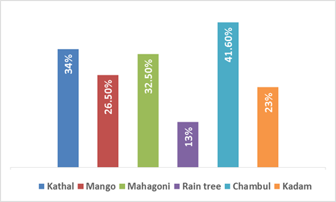
Figure 1: Yield of biochar from different feedstock

EFFECT OF BIOCHAR ON GERMINATION
According to Tukey’s HSD post-hoc test, the application of Chambul biochar (p < 0.05) significantly improved germination in both species compared to other treatments. In rice, the use of Chambul and Kadam biochar (p ≤ 0.001 for both) resulted in a highly significant increase in germination potential compared to the control and the Kadam treatment in Akashmoni (Figure 2). For the seed vigor index (Figure 3) and germination rate index (Figure 4), Chambul biochar (p < 0.001) and Kadam biochar (p < 0.01) in rice showed significantly higher results compared to all treatments in Akashmoni.
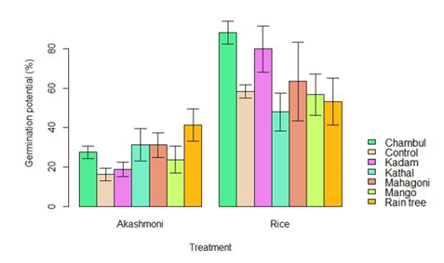
Figure 2: Effect of different biochar on the germination potential of two different species
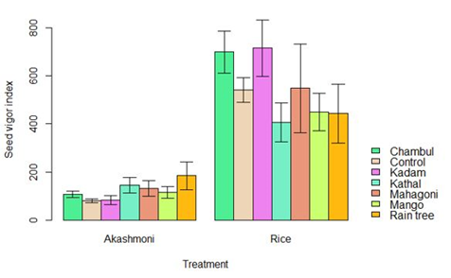
Figure 3: Effect of different biochar on seed vigor index of two different species
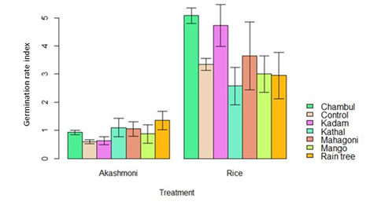
Figure 4: Effect of different biochar on germination rate index of two different species

Effect of Biochar on Growth Parameters

Shoot and Root Length (cm)
Based on Tukey’s HSD post-hoc test, all biochar treatments (p < 0.001) significantly increased shoot length in Akashmoni compared to rice treatments (Figure 5). For root length, Kathal biochar (p < 0.05) and Mango biochar (p < 0.001) showed significantly greater effects than most rice treatments. Additionally, Raintree biochar (p < 0.05) in Akashmoni led to a significant increase compared to the control, Kadam, and Raintree biochar in rice (Figure 6).
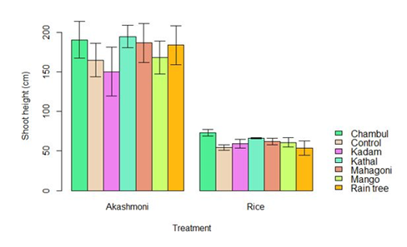
Figure 5: Effect of different biochar on shoot length of two different species
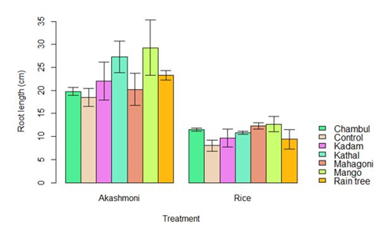
Figure 6: Effect of different biochar on root length of two different species

Leaf Number and Leaf Area
All Akashmoni treatments showed a significantly higher leaf number (p < 0.001) compared to all rice treatments (Figure 7). Furthermore, in Akashmoni, all treatments except Kadam (p < 0.01) resulted in a highly significant increase in leaf area (p < 0.001) compared to rice treatments (Figure 8).
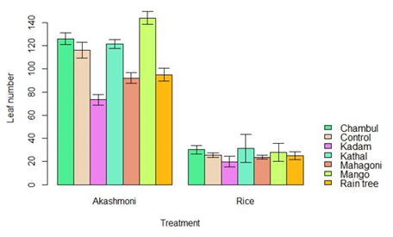
Figure 7: Effect of different biochar on leaf number of two different species
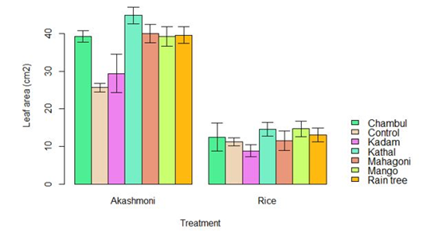
Figure 8: Effect of different biochar on leaf area of two different species

Reproductive Number of Rice
An ANOVA test confirmed that biochar treatments had a highly significant effect (p < 0.001) on the reproductive number. Tukey’s HSD post-hoc test showed that Chambul biochar (p < 0.001) significantly differed from the control, Kadam, and Raintree biochar, and also from Mahagoni biochar (p < 0.05). Similarly, Kathal biochar (p < 0.05) exhibited significant differences comparable to Chambul biochar (Figure 9).
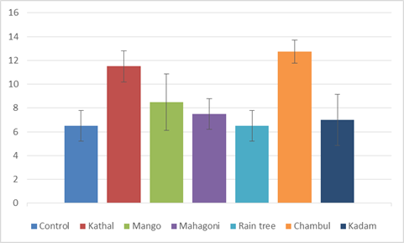
Figure 9: Effect of different biochar on reproductive number of Rice

Relative Water Content (RWC%) of Leaf, Shoot, Root, and Reproductive Parts in Rice
For RWC% of leaves (Figure 10), the application of Chambul biochar (p < 0.001) in Akashmoni demonstrated significantly higher results than the control, Kadam, and Mahagoni treatments, as well as all rice treatments. Kathal and Mango biochar (p < 0.001 for both) also showed significantly increased RWC% compared to Kadam and Mahagoni in Akashmoni.
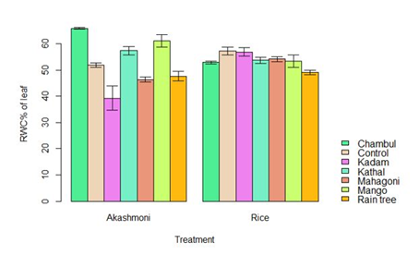
Figure 10: Effect of different biochar on RWC (%) of the leaf of two different species
Figure 11 illustrates that ANOVA results clearly indicated a significant impact of biochar treatments (p < 0.001) and species (p < 0.001) on shoot RWC (%). All Akashmoni treatments (p < 0.001), except Mahagoni, exhibited significantly higher results compared to the control of Akashmoni and all rice treatments.
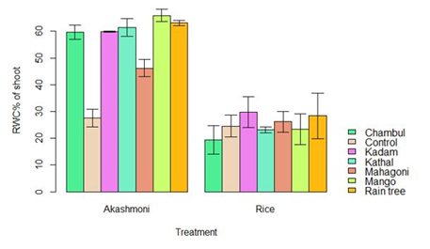
Figure 11: Effect of different biochar on RWC (%) of the shoot of two different species
According to Tukey’s HSD post-hoc test, all treatments (p < 0.001) except Raintree (p < 0.05) significantly increased root RWC% compared to the control (Figure 12). Additionally, all biochar treatments in Akashmoni (p < 0.001) showed significantly higher results compared to the control and all rice treatments except Kadam. In rice, Chambul biochar (p < 0.05) demonstrated significantly higher results compared to the control, while Kadam biochar (p < 0.001) significantly outperformed the control, Mango, Raintree, and Kathal biochar treatments.
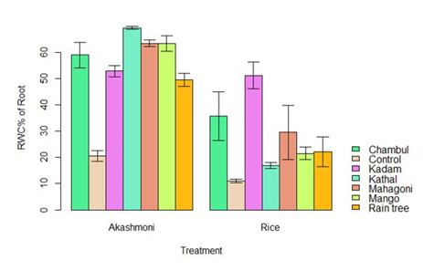
Figure 12: Effect of different biochar on RWC (%) of root of two different species
For RWC% of reproductive parts in rice, Mahagoni (p < 0.001) and Mango biochar (p < 0.01) significantly increased results compared to the control, Raintree, and Chambul treatments. These treatments also showed significant differences (p < 0.05) compared to Kathal and Kadam biochar (Figure 13).
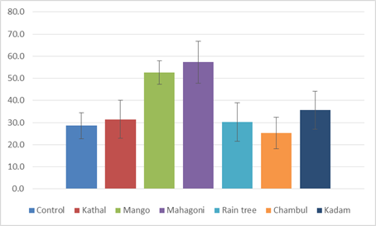
Figure 13: Effect of different biochar on RWC% of reproductive parts of Rice

Dry Weight of Shoot, Leaf, Root, and Reproductive Parts in Rice
Tukey’s HSD post-hoc test indicated that Chambul biochar (p < 0.05) significantly increased shoot weight compared to Mango biochar. In Akashmoni, both Chambul and Mahagoni biochar (p < 0.05 for both) resulted in significantly higher shoot weights than the Kadam and Mahagoni treatments in rice (Figure 14).
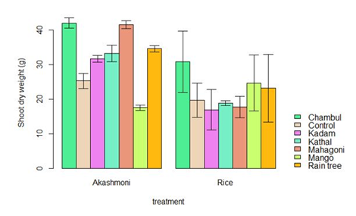
Figure 14: Effect of different biochar on shoot dry weight of two different species
For leaf dry weight, all biochar treatments (p < 0.001) significantly increased results compared to the control. Kadam (p < 0.001) and Raintree biochar (p < 0.05) also exhibited significantly higher results compared to Mahagoni and Mango biochar. In Akashmoni, the application of Chambul biochar (p < 0.001) resulted in significantly higher leaf dry weight compared to the control and Mango biochar. Moreover, all Akashmoni treatments (p < 0.001) showed significantly higher results compared to the control and other rice treatments (Figure 15).
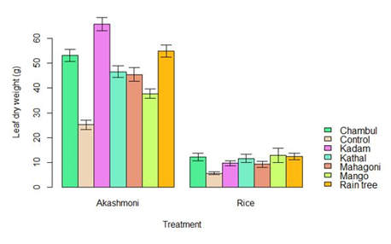
Figure 15: Effect of different biochar on leaf dry weight of two different species
According to Figure 16, Tukey’s HSD post-hoc test revealed that Kathal, Mahagoni, Mango, and Raintree biochar (p < 0.001) in rice significantly increased root dry weight compared to all Akashmoni treatments. Additionally, Chambul biochar (p < 0.05) in rice demonstrated significantly higher results than the control, Kadam, and Mango biochar in Akashmoni.
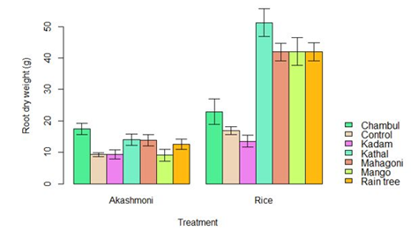
Figure 16: Effect of different biochar on Root dry weight of two different species
A one-way ANOVA test confirmed that biochar treatments had a highly significant effect (p < 0.001) on the dry weight of reproductive parts in rice. Based on Tukey’s HSD post-hoc test, Chambul biochar (p < 0.001) resulted in significantly higher dry weight compared to the control, Mango, and Mahagoni biochar treatments, as well as significantly higher results (p < 0.01) compared to Raintree and Kadam biochar. Additionally, Kathal biochar showed significantly higher results (p < 0.05) than Mahagoni biochar (Figure 17).
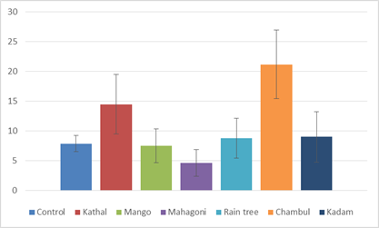
Figure 17: Effect of different biochar on the dry weight of reproductive parts of Rice

Effect of Biochar on Soil Properties
ANOVA analysis of soil moisture content indicated a highly significant impact of biochar treatment (p < 0.001) and plant species (p < 0.001). According to Tukey’s HSD post-hoc test, all biochar treatments, except for Mahagoni and Raintree (p < 0.05), significantly increased soil moisture content compared to the Control. Additionally, Mango biochar (p < 0.05) showed a significant increase in soil moisture compared to Mahagoni and Raintree. In Akashmoni, Chambul and Kathal biochar (p < 0.05) demonstrated significant improvements over the Control, while all biochar treatments in Rice (p < 0.05) significantly outperformed the Control in Akashmoni. Furthermore, Kadam biochar in Rice exhibited a significant (p < 0.05) increase in soil moisture compared to Mahagoni, Kadam, and Raintree (Figure 18).
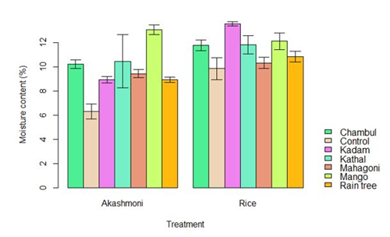
Figure 18: Effect of different biochar on the dry weight of reproductive parts of Rice
Tukey’s HSD post-hoc test also revealed that Chambul and Mango biochar significantly (p < 0.05) increased soil organic matter content compared to the Control, Kadam, and Raintree. Additionally, Kathal (p < 0.05) and Mahagoni (p < 0.01) showed higher soil organic matter levels than all other treatments. Mahagoni exhibited a significantly higher (p < 0.001) soil organic matter content than Kadam and Kathal in Akashmoni, while Mango and Raintree (p < 0.001) outperformed Mahagoni. In Rice, all treatments (p < 0.001) significantly increased soil organic matter compared to Mahagoni (Figure 19).
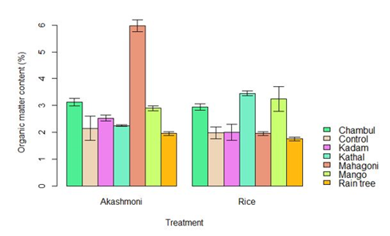
Figure 19: Effect of different biochar on Soil organic matter content (%) of two different species
ANOVA results further demonstrated that biochar treatment (p < 0.001) and plant species (p < 0.01) both had a significant effect on soil pH. According to Tukey’s HSD post-hoc test, the application of Chambul biochar (p < 0.05) in Akashmoni significantly increased soil pH compared to other treatments in Rice, except for Raintree. Similarly, Raintree biochar (p < 0.05) exhibited significant effects compared to other treatments, except for Kadam. Across both plant species, Raintree biochar (p < 0.05) significantly increased soil pH compared to the Control, Mango, and Kathal (Figure 20).
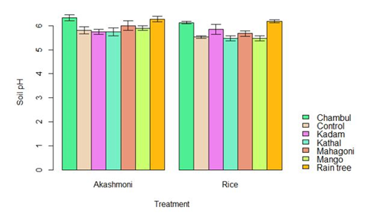
Figure 20: Effect of different biochar on soil pH of two different species

Effect of Time and Treatment on Soil Nitrogen (N), Phosphorus (P), and Potassium (K)
ANOVA analysis revealed that biochar treatment had a highly significant (p < 0.001) effect on soil nitrogen (N), phosphorus (P), and potassium (K) both before and after application. Tukey’s HSD post-hoc test showed that Chambul biochar (p < 0.001) significantly increased soil nitrogen compared to Kadam at the beginning of the treatment. Additionally, Kathal, Mahagoni, and Raintree (p < 0.05) exhibited significantly higher soil nitrogen levels than Kadam. Over time, all biochar treatments resulted in increased soil nitrogen levels, with Chambul biochar (p < 0.001) showing the most significant improvement across both plant species (Figure 21).
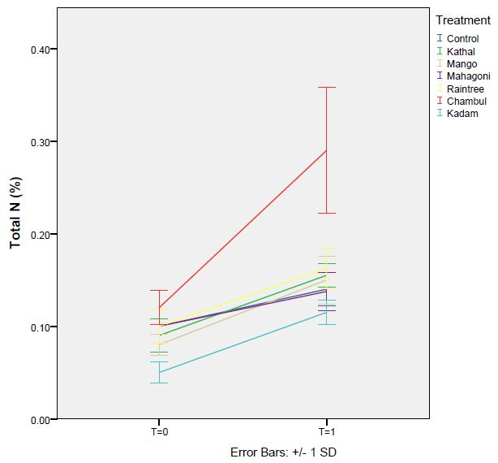
Figure 21: Impact of time and treatment on soil N; Here T=0 means beginning of the experiment and T=1 means the end of the experiment
Regarding soil phosphorus, Tukey’s HSD post-hoc test indicated that at the beginning of the biochar application, Kathal biochar (p < 0.05) significantly increased available soil phosphorus compared to all other treatments. Over time, Kathal biochar (p < 0.01) continued to show significantly higher phosphorus levels compared to most treatments, except for Mahagoni biochar. Additionally, Mahagoni (p < 0.01) exhibited significantly higher phosphorus levels than Raintree and Kadam (Figure 22).
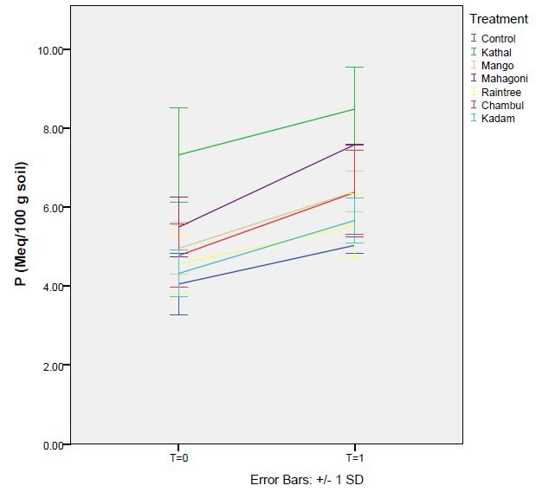
Figure 22: Impact of time and treatment on soil P; Here T=0 means beginning of the experiment and T=1 means end of the experiment
For soil potassium, initial treatment results showed that Chambul (p < 0.05) and Kadam (p < 0.01) significantly increased soil potassium levels compared to the Control and Kathal. Raintree (p < 0.001) demonstrated a highly significant increase in soil potassium levels compared to all other treatments, except for Kadam. Over time, all biochar treatments (p < 0.01), except for Kadam, exhibited significantly higher soil potassium levels than the Control. Chambul (p < 0.001) also significantly outperformed the Control and Kadam, while Kathal (p < 0.01) showed significant improvements compared to all other treatments, except for Raintree and Chambul. Notably, Raintree (p < 0.001) exhibited the most substantial increase in soil potassium levels compared to the Control, Mahagoni, and Kadam (Figure 23).
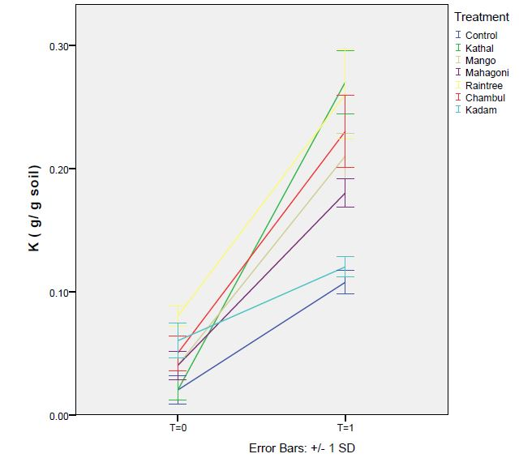
Figure 23: Impact of time and treatment on soil K; Here T=0 means beginning of the experiment and T=1 means end of the experiment

DISCUSSION

Estimation of Biochar Yield and Suitability
The estimation of biochar yield is crucial for assessing its suitability. In this study, six different feedstock species were selected for biochar production: Kathal, Mango, Mahagoni, Chambul, Raintree, and Kadam. Among these species, the highest biochar yield was obtained from Chambul (41.6%), while the lowest yield was recorded for Raintree (13%). The remaining species produced biochar yields ranging from 23% to 34%.
The variability in biochar yield is influenced by the feedstock species, as well as the speed and temperature of thermal degradation. Research has shown that biochar derived from Chinese pine exhibited the best water retention capacity after being heated for three hours at 45–50°C, retaining approximately 0.78 grams of water per gram of biochar. Additionally, it was observed that as the Ethylene Blue Adsorption Value (ab.EBAV) increased, the biochar yield decreased. However, at the same time, both water absorption and water retention capacities improved ^{[35]}.

Effect of Biochar on Germination
Germination is a crucial stage in crop production. Three key parameters were used to assess the effects of biochar treatments: germination potential (GP), germination rate index, and seed vigor index. In terms of GP, Chambul biochar demonstrated significant effects (p< 0.05) for both species. In Rice, Chambul (88.3%) and Kadam (80%) biochar showed a highly significant increase (p≤ 0.001) in GP compared to the Control and Kadam biochar in the Akashmoni species. For seed vigor index and germination rate index, Kadam and Chambul biochar in Rice exhibited significant improvements (p< 0.001) over the Control and other treatments in Akashmoni species. These findings indicate that biochar derived from Chambul and Kadam enhanced germination parameters in Rice.
Previous research has reported no negative impact of biochar on Rice seed germination ^{[36]}. Another study on forest seeds concluded that biochar application increases seed germination rates ^{[37]}.

Effect of Biochar on Growth Parameters
Biochar application significantly affected various growth parameters, including shoot length, leaf number, leaf area, collar diameter in Akashmoni, root length, reproductive structures in Rice, relative water content (RWC%), and the dry weight of leaves, shoots, roots, and reproductive parts. In Akashmoni, all biochar treatments significantly (p< 0.001) influenced shoot length, leaf number, leaf area, and leaf dry weight.
For root length, all biochar treatments, except Chambul and Kadam, significantly (p< 0.001) increased root length in Akashmoni and root dry weight in Rice. Chambul biochar demonstrated a significant increase (p< 0.001) in the reproductive number of Rice, with a 10% improvement over the Control. It also resulted in a highly significant (p< 0.001) increase in leaf RWC% in Akashmoni compared to the Control and most Rice treatments.
Regarding RWC% in shoots and roots, most Akashmoni treatments showed a significant (p< 0.001) increase compared to most Rice treatments, while Mahagoni biochar demonstrated significant effects on the RWC% of reproductive parts in Rice. Above-ground biomass analysis revealed that Chambul and Mahagoni biochar treatments in Akashmoni led to significantly higher (p< 0.05) shoot dry weight compared to Kadam and Mahagoni biochar in Rice, showing a 7% increase over the Control. In terms of the dry weight of Rice's reproductive parts, Chambul biochar resulted in significantly (p< 0.01) higher values than all other treatments, with an 18% increase over the Control. However, no significant increase was observed in the collar diameter of the Akashmoni species.
These findings suggest that biochar application positively influenced growth parameters in both species. Previous studies have also demonstrated that biochar enhances plant growth, with maize production increasing by 198% and 98% compared to the Control, and soybean biomass increasing by 51% with the addition of 0.5 t/ha biochar ^{[38][39]}. While biochar additions to degraded soils have been highlighted for their agronomic benefits, some studies have reported negligible or negative effects ^{[40]}.

Effect of Biochar on Soil Properties
Biochar treatments had a significant impact on soil properties, including soil moisture content, organic matter content, pH, potassium (K), phosphorus (P), and nitrogen (N). Soil moisture content increased significantly (p< 0.05) in all biochar treatments except Mahagoni and Raintree, compared to the Control. For organic matter content, all treatments, except Kadam and Raintree, demonstrated significantly (p< 0.05) higher results than the Control. Raintree biochar resulted in a significant (p< 0.05) increase in soil pH compared to other treatments, except Kadam.
Regarding soil nitrogen, Chambul biochar exhibited highly significant changes (p< 0.001) compared to other treatments in both species. In soil phosphorus, Kathal biochar application led to significant increases (p< 0.01) compared to all treatments except Mahagoni. Over time, all treatments, except Kadam, showed significantly (p< 0.01) higher potassium levels compared to the Control. By the end of the experiment, biochar treatments had significantly improved soil properties compared to the Control.
A related study reported that biochar application increased soil NPK levels compared to the Control ^{[41]}. Biochar has also been found to enhance soil cation exchange capacity (CEC) ^{[42,43,44,45,46]}. However, some studies suggest that biochar application may alter pH levels and influence the availability of essential soil nutrients such as calcium (Ca) and magnesium (Mg), which could limit maize growth in highly weathered tropical soils ^{[47]}. Additionally, biochar has been reported to impact the availability of boron (B) and molybdenum (Mo), which are crucial cofactors in biological nitrogen fixation ^{[48]}.

CONCLUSION
Based on this study, it can be concluded that applying an appropriate amount of biochar can enhance seed germination, plant growth, and soil nutrient availability. However, certain biochar types may have negative effects. Chambul biochar exhibited the highest biochar yield, significantly improved soil fertility, and contributed to better plant growth. Therefore, Chambul biochar could be classified as a suitable biochar and potentially incorporated into forest management practices.
Further research is necessary to investigate the chemical properties of biochar that contribute to beneficial and harmful effects on soil and different plant species. Additionally, understanding how biochar application rates influence soil properties is essential for optimizing its agricultural and environmental benefits.

CONSENT
All authors confirm that this case report has not been previously published or submitted for publication in any other peer-reviewed journal. This ensures that the content is original and has not been considered or reviewed elsewhere before being submitted to this journal.

ETHICAL APPROVAL
N/A

COMPETING INTERESTS DISCLAIMER:
Authors have declared that they have no known competing financial interests OR non-financial interests OR personal relationships that could have appeared to influence the work reported in this paper.

REFERENCES
- Bridgwater, A.V.; Grassi, G.: Biomass pyrolysis liquids upgrading and utilisation, London, Elsevier 1991
- Bhatia, V.K.; Padmaja, K.V.; Kamra, S.; Singh, J.; Badoni, R.P.: Upgrading of biomass to liquid fuels, Fuel 72 (1993), pp. 101/104
- Ozcimen, D.; Karaosmanoglu, F.: Production and characterization of bio-oil and bio-char from rapeseed cake. Renew Energy 29 (2004), pp. 779-787
- Jefferson, M.: Sustainable energy development: performance and prospects. Renew Energy 31 (2006), pp. 571-582
- Cadenas, A.; Cabezudo, S.: Biofuels as sustainable technologies: perspectives for less developed countries. Technol Forecast Social Change 58 (1998), pp. 83-103
- Abdul, R. N. F., & Abdul, R. N. S. (2017). The effect of biochar application on nutrient availability of soil planted with MR219. Journal of Microbial and Biochemical Technology, 9(2), 583-586
- Ahmad, M., Rajapaksha, A. U., Lim, J. E., Zhang, M., Bolan, N., Mohan, D., ... & Ok, Y. S. (2014). Biochar as a sorbent for contaminant management in soil and water: a review. Chemosphere, 99, 19-33.
- Cheng, C. H., Lehmann, J., Thies, J. E., Burton, S. D., & Engelhard, M. H. (2006). Oxidation of black carbon by biotic and abiotic processes. Organic geochemistry, 37(11), 1477-1488.
- Demirbas, A., & Arin, G. (2002). An overview of biomass pyrolysis. Energy sources, 24(5), 471-482.
- Dharmakeerthi, R. S., Chandrasiri, J. A. S., & Edirimanne, V. U. (2012). Effect of rubber wood biochar on nutrition and growth of nursery plants of Hevea brasiliensis established in an Ultisol. SpringerPlus, 1(1), 84.
- Du Shin, J. (2015). Carbon Sequestration and Nitrogen Transformation in Soil Cooperated with Organic Composts and Biochar during Corn (Zea mays) Cultivation. Journal of Agricultural Chemistry and Environment, 4(04), 96.
- Enders, A., Hanley, K., Whitman, T., Joseph, S., & Lehmann, J. (2012). Characterization of biochars to evaluate recalcitrance and agronomic performance. Bioresource technology, 114, 644-653.
- Fagbenro, J. A., Oshunsanya, S. O., & Onawumi, O. A. (2013). Effect of Saw Dust Biochar and NPK 15: 15: 15 Inorganic Fertilizer on Moringa oleifera Seedlings Grown in an Oxisol. Agrosearch, 13(1), 57-68.
- Fagbenro, J. A., Oshunsanya, S. O., & Oyeleye, B. A. (2015). Effects of gliricidia biochar and inorganic fertilizer on moringa plant grown in an oxisol. Communications in Soil Science and Plant Analysis, 46(5), 619-626.
- Free, H. F., McGill, C. R., Rowarth, J. S., & Hedley, M. J. (2010). The effect of biochars on maize (Zea mays) germination. New Zealand journal of agricultural research, 53(1), 1-4.
- Gaskin, J. W., Speir, R. A., Harris, K., Das, K. C., Lee, R. D., Morris, L. A., & Fisher, D. S. (2010). Effect of peanut hull and pine chip biochar on soil nutrients, corn nutrient status, and yield. Agronomy Journal, 102(2), 623-633.
- Ghosh, S., Ow, L. F., & Wilson, B. (2015). Influence of biochar and compost on soil properties and tree growth in a tropical urban environment. International journal of environmental science and technology, 12(4), 1303-1310.
- Grossman, J. M., O’Neill, B. E., Tsai, S. M., Liang, B., Neves, E., Lehmann, J., & Thies, J. E. (2010). Amazonian anthrosols support similar microbial communities that differ distinctly from those extant in adjacent, unmodified soils of the same mineralogy. Microbial ecology, 60(1), 192-205.
- Gupta, A. K., & Nagar, D. K. (2018). Matrix variate distributions (Vol. 104). CRC Press.
- Inyang, M., & Dickenson, E. (2015). The potential role of biochar in the removal of organic and microbial contaminants from potable and reuse water: a review. Chemosphere, 134, 232-240.
- Inyang, M., Gao, B., Pullammanappallil, P., Ding, W., & Zimmerman, A. R. (2010). Biochar from anaerobically digested sugarcane bagasse. Bioresource technology, 101(22), 8868-8872.
- Jeffery, S., Verheijen, F. G., van der Velde, M., & Bastos, A. C. (2011). A quantitative review of the effects of biochar application to soils on crop productivity using meta-analysis. Agriculture, ecosystems & environment, 144(1), 175-187.
- Kamara, A., Mansaray, M. M., Kamara, A., & Sawyerr, P. A. (2014). Effects of biochar derived from maize stover and rice straw on the early growth of their seedlings. American Journal of Agriculture and Forestry, 2(5), 232-236.
- Karhu, K., Mattila, T., Bergström, I., & Regina, K. (2011). Biochar addition to agricultural soil increased CH4 uptake and water holding capacity–Results from a short-term pilot field study. Agriculture, ecosystems & environment, 140(1-2), 309-313.
- Kimetu, J. M., Lehmann, J., Ngoze, S. O., Mugendi, D. N., Kinyangi, J. M., Riha, S., ... & Pell, A. N. (2008). Reversibility of soil productivity decline with organic matter of differing quality along a degradation gradient. Ecosystems, 11(5), 726.
- Lee, J. W., Kidder, M., Evans, B. R., Paik, S., Buchanan Iii, A. C., Garten, C. T., & Brown, R. C. (2010). Characterization of biochars produced from cornstovers for soil amendment. Environmental science & technology, 44(20), 7970-7974.
- Lehmann, J., da Silva, J. P., Steiner, C., Nehls, T., Zech, W., & Glaser, B. (2003). Nutrient availability and leaching in an archaeological Anthrosol and a Ferralsol of the Central Amazon basin: fertilizer, manure and charcoal amendments. Plant and soil, 249(2), 343-357.
- Lehmann, J., Kern, D., German, L., Mccann, J., Martins, G. C., & Moreira, A. (2003). Soil fertility and production potential. In Amazonian dark earths (pp. 105-124). Springer, Dordrecht.
- Liang, C., Dang, Z., Xiao, B., Huang, W., & Liu, C. (2006). Equilibrium sorption of phenanthrene by soil humic acids. Chemosphere, 63(11), 1961-1968.
- Liang, X., Yu, Z., Ma, J., Zhu, W., Zhao, C., & Chen, L. (2013). Preparation and characterization of activated biocharcoal from different tree species. Chemistry and Industry of Forest Products, 33(3), 125-130.
- Major, J., Rondon, M., Molina, D., Riha, S. J., & Lehmann, J. (2010). Maize yield and nutrition during 4 years after biochar application to a Colombian savanna oxisol. Plant and soil, 333(1-2), 117-128.
- Palaniswamy, K. M., & Gomez, K. A. (1974). Length‐Width Method for Estimating Leaf Area of Rice 1. Agronomy Journal, 66(3), 430-433.
- Robertson, S. J., Rutherford, P. M., Lopez-Gutierrez, J. C., & Massicotte, H. B. (2012). Biochar enhances seedling growth and alters root symbioses and properties of sub-boreal forest soils. Canadian Journal of Soil Science, 92(2), 329-340.
- Rondon, M. A., Lehmann, J., Ramírez, J., & Hurtado, M. (2007). Biological nitrogen fixation by common beans (Phaseolus vulgaris L.) increases with bio-char additions. Biology and fertility of soils, 43(6), 699-708.
- Saxena, J., Rana, G., & Pandey, M. (2013). Impact of addition of biochar along with Bacillus sp. on growth and yield of French beans. Scientia Horticulturae, 162, 351-356.
- Sohi, S. P., Krull, E., Lopez-Capel, E., & Bol, R. (2010). A review of biochar and its use and function in soil. In Advances in agronomy (Vol. 105, pp. 47-82). Academic Press.
- Solaiman, Z. M., Murphy, D. V., & Abbott, L. K. (2012). Biochars influence seed germination and early growth of seedlings. Plant and soil, 353(1-2), 273-287.
- Sovu, M. T., Savadogo, P., & Odén, P. C. (2012). Facilitation of forest landscape restoration on abandoned swidden fallows in Laos using mixed-species planting and biochar application. Silva Fennica, 46(1), 39-51.
- Spokas, K. A., Cantrell, K. B., Novak, J. M., Archer, D. W., Ippolito, J. A., Collins, H. P., ... & Lentz, R. D. (2012). Biochar: a synthesis of its agronomic impact beyond carbon sequestration. Journal of environmental quality, 41(4), 973-989.
- Steiner, C., Teixeira, W. G., Lehmann, J., Nehls, T., de Macêdo, J. L. V., Blum, W. E., & Zech, W. (2007). Long term effects of manure, charcoal and mineral fertilization on crop production and fertility on a highly weathered Central Amazonian upland soil. Plant and soil, 291(1-2), 275-290.
- Sumithra, K., Jutur, P. P., Carmel, B. D., & Reddy, A. R. (2006). Salinity-induced changes in two cultivars of Vigna radiata: responses of antioxidative and proline metabolism. Plant Growth Regulation, 50(1), 11-22.
- Sun, Y., Gao, B., Yao, Y., Fang, J., Zhang, M., Zhou, Y., ... & Yang, L. (2014). Effects of feedstock type, production method, and pyrolysis temperature on biochar and hydrochar properties. Chemical Engineering Journal, 240, 574-578.
- Taek–Keun, O., Shinogi, Y., Chikushi, J., Yong–Hwan, L. E., & Choi, B. (2012). Effect of aqueous extract of biochar on germination and seedling growth of lettuce (Lactuca sativa L.). J Fac Agr Kyushu Univ, 57(1), 55-60.
- Van Zwieten, L., Kimber, S., Downie, A., Morris, S., Petty, S., Rust, J., & Chan, K. Y. (2010). A glasshouse study on the interaction of low mineral ash biochar with nitrogen in a sandy soil. Soil Research, 48(7), 569-576.
- Van Zwieten, L., Kimber, S., Morris, S., Downie, A., Berger, E., Rust, J., & Scheer, C. (2010). Influence of biochars on flux of N2O and CO2 from Ferrosol. Soil Research, 48(7), 555-568.
- Vaughan, N. E., Lenton, T. M., & Shepherd, J. G. (2009). Climate change mitigation: trade-offs between delay and strength of action required. Climatic Change, 96(1-2), 29-43.
- Gupta, A. K., & Nagar, D. K. (2018). Matrix variate distributions (Vol. 104). CRC Press.
- Yamato, M., Okimori, Y., Wibowo, I. F., Anshori, S., & Ogawa, M. (2006). Effects of the application of charred bark of Acacia mangium on the yield of maize [Zea mays], cowpea [Vigna unguiculata] and peanut [Arachis hypogaea], and soil chemical properties in South Sumatra, Indonesia. Soil Science and Plant Nutrition (Japan).

