*Original Research Article*

**INFLUENCE OF ELECTRON TRANSPORTING LAYER ON THE EFFICIENCY OF TIN-BASED PEROVSKITE SOLAR CELLS**

**Abstract**: In organometallic halide perovskites solar cells, electron transporting layer has significant impact on the optical, structural and optical properties of these promising solar cells. In this work, influence of electron transporting layer on the electrical performance of tin-based perovskite solar cells were numerically investigated using Solar Capacitance (SCAPS) simulator. In order to achieve an optimal efficiency, the effect of ETL thickness and doping concentration were varied and investigated. The results show that PCE is significantly dropped with increased ETL thickness using C60 and CdS from 50 nm to 300 nm. Conversely, a steady PCE as the thickness of Cd0.5Zn0.5S and ZnO increased were observed. Furthermore, varied ETL donor concentration significantly influenced the performance of the simulated devices. Generally, moderate doping concentration is required as heavy concentration leads to increased recombination rate and subsequently reduced the PCE of the devices. Cd0.5Zn0.5S and ZnO exhibited best PCE at doping concentration value of 1019 cm-3 and 1020 cm-3 respectively. It can be concluded that Cd0.5Zn0.5S and ZnO are potential alternative ETL in perovskite solar cells.

**Keywords**: Electron Transporting Layer, efficiency, tin, perovskite, solar cells.

**1.0 Introduction**: Organometallic halide perovskites are recently considered as one of the most suitable candidate for solar cells, owing to its rapid increase in power conversion efficiencies (PCE) from 3.8 % to 26.1 % [1] in few years. This outstanding performance evolved from their unique properties; high absorption co-efficient, high charge carrier mobility, long diffusion length, direct and tunable band gap and simple methods of fabrication [2,3]. Despite these remarkable properties, one of the major challenges associated with perovskite solar cells (PSCs) is the used of toxic metal lead (Pb) as inorganic cation in the absorber layer components. This toxic nature of Pb might obstruct the possible large-scale production of this type of solar cells. It was reported that tin-based perovskite absorber layer exhibited high absorption coefficient, small exciton binding energy and high carrier mobility in contrast to the lead-based perovskite absorber layer [4 - 7]. Electron Transporting Layer (ETL) is one of the basic components in organometallic halide perovskite solar cells. Electron transporting layer is an oxide semiconductor (TiO2), having a band alignment to favor the transfer of electrons and at the same time block the holes coming from photo-generation. For ETL to perform this function of transporting electrons and blocking hole diffusion must possess a conduction band edge or LUMO edge lying under the conduction band edge of the perovskite active layer with sufficient energy larger than the dissociation energy of the excitons. The most commonly used ETL in perovskite solar cell is compact TiO2 and achieved [8]. However, the high deposition temperature required by TiO2 remains as noticeable obstacle that prevent large commercialization of perovskite solar cells [9]. In order to further enhance the power conversion efficiency of the tin-based perovskite solar cells, this work aimed to investigate the influence of ETL on the device performance using SCAPS-1D simulating software. Furthermore, effect of thickness, defect density and operating temperature were also investigated. The schematic configuration of the device is presented in Figure 1.

CH3NH3SnI3

Spiro-OMeTAD

ETL

FTO

Au

**Light**

Figure 1. Schematic architecture of the tin-based perovskite solar cells

1. **Simulation Parameters and Numerical Method**
   1. **Simulation Parameters**

The input parameters used for the design and simulation of the tin-based perovskite solar cells using were carefully obtained from previous theoretical and experimental literature [9 - 16] and were presented in Tables 1 and 2.

**2.2 Numerical method**: In this study, the numerical simulation was conducted using SCAPS (SCAPS 3.3.10 version) software. AM1.5G with an Incident power density of 1000 W/cm2, working temperature 300 K and AM 1.5G were selected from the SCAPS. The SCAPS is a one dimensional solar cell simulation software designed and developed at the department of Electronics and Information Systems (ELIS) of the University of Gent, Belgium [17]. The software can be requested and freely downloaded from the manufacturer. It works by solving the Poisson equations, the continuity equations for electrons and holes, and carrier transport [17, 18]. The simulation step by step procedure is shown in Figure 2.1.

Define the working condition

Select the measurement to stimulate

Start the calculation

Define the problem

Display the stimulated results

Lunch SCAPS

Insert input parameters

Figure 2.1. SCAPS step by step working procedure

Table 1. Values of input parameters for simulation of CH3NH3SnI3 PSC

|  |  |  |  |  |
| --- | --- | --- | --- | --- |
| **Parameters** | **FTO** | **ZnO** | **CH3NH3SnI3** | **Spiro-OMeTAD** |
| Thickness (nm) | 500 | Varied | 300 | 200 |
| Band gap (eV) | 3.5 | 3.3 | 1.3 | 3.0 |
| Electron affinity (eV) | 4.0 | 4.1 | 4.17 | 2.45 |
| Dielectric permittivity | 9.0 | 9.0 | 8.2 | 3.0 |
| CB effective density of state (cm-3) | 1 x 1019 | 4 x 1018 | 1 x 1018 | 1 x 1019 |
| VB effective density of state (cm-3) | 1 x 1019 | 1 x 1019 | 1 x 1018 | 1 x 1019 |
| Electron thermal velocity (cms-1) | 1 x 107 | 1 x 107 | 1 x 107 | 1 x 107 |
| Hole thermal velocity (cms-1) | 1 x 107 | 1 x 107 | 1 x 107 | 1 x 107 |
| Electron mobility (cm2s-1) | 100 | 100 | 1.6 | 0.0002 |
| Hole mobility (cm2s-1) | 25 | 25 | 1.6 | 0.0002 |
| Donor density (cm-3) | 2 x 1019 | 1 x 1018 | 0 | 0 |
| Acceptor density(cm-3) | 0 | 0 | 1 x 1016 | 1 x 1018 |
| Defect density (cm-3) | 1 x 1014 | 1 x 1015 | 1 x 1015 | 1 x 1015 |

Table 2 Values of input parameters for various Electron Transporting Layers

|  |  |  |  |
| --- | --- | --- | --- |
| **Parameters** | **C60** | **Cds** | **Cd0.5Zn0.5S** |
| Thickness (nm) | Varied | varied | Varied |
| Band gap (eV) | 1.7 | 2.4 | 2.8 |
| Electron affinity (eV) | 3.9 | 4.2 | 3.8 |
| Dielectric permittivity | 4.2 | 10 | 10 |
| CB effective density of state (cm-3) | 8 x 1019 | 2.2 x 1018 | 1 x 1018 |
| VB effective density of state (cm-3) | 8 x 1019 | 1.8 x 1019 | 1 x 1018 |
| Electron thermal velocity (cms-1) | 1 x 107 | 1 x 107 | 1 x 107 |
| Hole thermal velocity (cms-1) | 1 x 107 | 1 x 107 | 1 x 107 |
| Electron mobility (cm2s-1) | 0.08 | 100 | 100 |
| Hole mobility (cm2s-1) | 0.0035 | 25 | 25 |
| Donor density (cm-3) | 2.6 x 1018 | 1 x 1017 | 1 x 1017 |
| Acceptor density(cm-3) | 0 | 0 | 0 |
| Defect density (cm-3) | 1 x 1014 | 1 x 1017 | 1 x 1015 |

**3.0** **Results and Discussion**

* 1. **Electrical Performance of CH3NH3SnI3 PSC with different ETLs**

Electron Transporting Layer plays a significant role in the performance of a solar cell since it is used for extracting and transporting the generated electrons to front contact. Figure 3.1 displays the simulated J-V curves of the devices with the various ETLs. The electrical parameters obtained are presented in Table 3.1. It can be seen that the device with the ZnO exhibits the highest PCE (25.78 %) while the devices with the C60 acquires the least PCE (24.22 %). This shows that the conduction band edge or LUMO edge of ZnO lying under the conduction band edge of the perovskite active layer has higher sufficient energy for transporting the generated electrons and blocking the holes in PSCs. The performances of Cd0.5Zn0.5S and CdS are also suitable as reported by [9].



Figure 3.1 Influence of the various ETLs on the J-V characteristics

Table 3.1 Photovoltaic parameters obtained using different ETLs

|  |  |  |  |  |
| --- | --- | --- | --- | --- |
| **Parameters** | **C60** | **Cd0.5Zn0.5S** | **CdS** | **ZnO** |
| Voc (V) | 0.9770 | 0.9788 | 0.9776 | 0.9897 |
| Jsc (mA/cm2) | 30.31 | 32.34 | 32.26 | 32.34 |
| FF (%) | 81.81 | 81.37 | 80.82 | 81.47 |
| PCE (%) | 24.22 | 25.76 | 25.49 | 25.78 |

**3.2 Effect of ETL thickness on the performance CH3NH3SnI3 PSCs**

The effect of ETL layer thickness was investigated using the numerical simulation. The thickness was varied from 50 to 300 nm for each of the chosen ETL and the remaining input parameters kept constant. Figure 3.2 show the plotted J-V curves obtained for the various ETL. Similarly, the photovoltaic parameters obtained for the selected ETL were tabulated in Tables 3.2 – 3.4. As shown in the Table 3.1 and Table 3.3 the PCE dropped as the ETL thickness increased from 50 nm to 300 nm. This shows that thick C60 and CdS might hinder extraction and transportation of the generated electrons. Conversely, Table 3.1 and Table 3.3 show a steady PCE as the thickness of Cd0.5Zn0.5S and ZnO increased respectively. The results indicate that the efficiency is relatively unaffected by thickness of Cd0.5Zn0.5S and ZnO as ETL in tin-based PSCs.

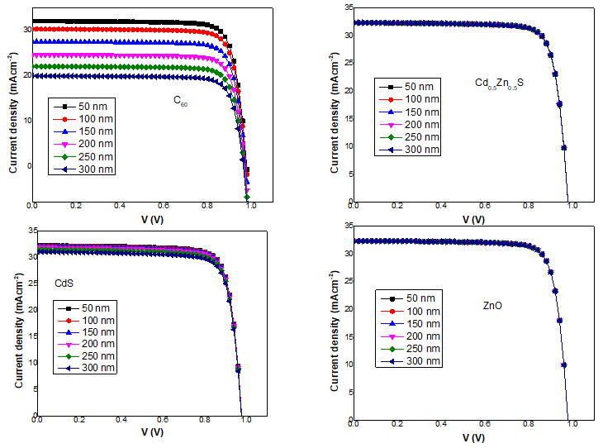 Figure 3.2. J-V Curves of the PSCs by changing the thickness of the ETLs.

Table 3.2 Electrical outputs obtained at varied ETL thickness using C60.

|  |  |  |  |  |
| --- | --- | --- | --- | --- |
| Thickness (nm) | Voc (V) | Jsc (mA/cm2) | FF (%) | PCE (%) |
| 50 | 0.9788 | 32.08 | 81.78 | 25.68 |
| 100 | 0.9770 | 30.31 | 81.81 | 24.22 |
| 150 | 0.9738 | 27.51 | 81.92 | 21.93 |
| 200 | 0.9702 | 24.61 | 81.89 | 19.55 |
| 250 | 0.9667 | 22.06 | 81.87 | 17.46 |
| 300 | 0.9634 | 19.95 | 81.83 | 15.73 |

Table 3.3 Electrical outputs obtained at varied ETL thickness using Cd0.5Zn0.5S

|  |  |  |  |  |
| --- | --- | --- | --- | --- |
| Thickness (nm) | Voc (V) | Jsc (mA/cm2) | FF (%) | PCE (%) |
| 50 | 0.9787 | 32.34 | 81.27 | 25.72 |
| 100 | 0.9788 | 32.34 | 81.37 | 25.76 |
| 150 | 0.9788 | 32.34 | 81.39 | 25.76 |
| 200 | 0.9788 | 32.34 | 81.39 | 25.76 |
| 250 | 0.9788 | 32.33 | 81.40 | 25.76 |
| 300 | 0.9788 | 32.32 | 81.40 | 25.76 |

Table 3.4 Electrical outputs obtained at varied ETL thickness using CdS.

|  |  |  |  |  |
| --- | --- | --- | --- | --- |
| Thickness (nm) | Voc (V) | Jsc (mA/cm2) | FF (%) | PCE (%) |
| 50 | 0.9776 | 32.30 | 80.87 | 25.53 |
| 100 | 0.9776 | 32.26 | 80.81 | 25.47 |
| 150 | 0.9775 | 32.13 | 80.72 | 25.36 |
| 200 | 0.9771 | 31.89 | 80.63 | 25.12 |
| 250 | 0.9767 | 31.53 | 80.54 | 24.80 |
| 300 | 0.9762 | 31.09 | 80.47 | 24.42 |

Table 3.5 Electrical outputs obtained at varied ETL thickness using ZnO.

|  |  |  |  |  |
| --- | --- | --- | --- | --- |
| Thickness (nm) | Voc (V) | Jsc (mA/cm2) | FF (%) | PCE (%) |
| 50 | 0.9787 | 32.34 | 81.47 | 25.79 |
| 100 | 0.9787 | 32.34 | 81.48 | 25.79 |
| 150 | 0.9787 | 32.34 | 81.48 | 25.79 |
| 200 | 0.9787 | 32.34 | 81.48 | 25.79 |
| 250 | 0.9787 | 32.34 | 81.48 | 25.79 |
| 300 | 0.9787 | 32.34 | 81.48 | 25.79 |

**3.3 Effect of ETL Donor Concentration**

In order to investigate the influence of donor concentration on the performance of the devices, the donor concentration was varied from 1015 cm-3 to 1020 cm-3 and the remaining input parameters remain constant. The behavior of the plotted J-V curves for the devices using the various ETLs (C60, Cd0.5Zn0.5S, CdS, and ZnO) with the change of the donor concentration are plotted in Figure 3.3.. Correspondingly, Tables 4, 5, and 6 presented the parameters attained for the ETLs. As shown in the Tables, FF slowly increased as the donor concentration increases for all the devices. PCE showed similar pattern for CdS and ZnO in contrast to C60 and Cd0.5Zn0.5S where the PCE relatively raised up to the maximum value of 24.92 % and 25.85 % at 1017 cm-3 and 1019 cm-3 respectively, and then decreased. However, Voc and Jsc are also influenced by the change in donor concentration, Voc dropped slowly, while Jsc increased slowly and peaked at 1017 cm-3, 1017 cm-3, and 1017 cm-3 for C60, Cd0.5Zn0.5, and CdS respectively, and then decreased. Generally, larger values of donor concentration result in increase in Auger recombination rate and built in electric field and subsequently cause the PCE to decrease as reported by [19,20].

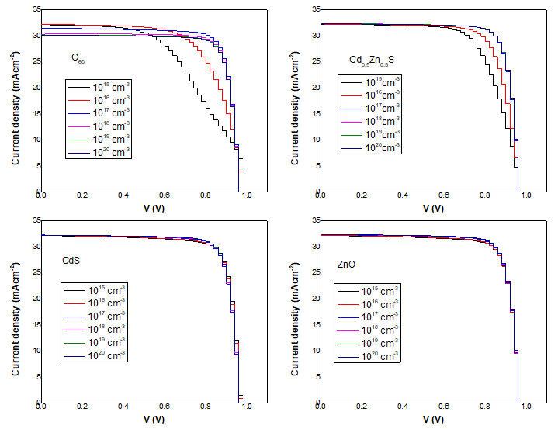

Figure 3.3. J-V Curves of the PSCs by changing the donor concentration of the ETLs

Table 4. Photovoltaic parameters obtained using C60 at different donor densities

|  |  |  |  |  |
| --- | --- | --- | --- | --- |
| Donor density (cm-3) | Voc (V) | Jsc (mAcm-2) | FF (%) | PCE (%) |
| 1015 | 1.0368 | 32.13 | 52.10 | 17.36 |
| 1016 | 0.9949 | 32.20 | 66.49 | 21.30 |
| 1017 | 0.9779 | 31.48 | 80.93 | 24.92 |
| 1018 | 0.9771 | 30.47 | 81.78 | 24.35 |
| 1019 | 0.9769 | 30.17 | 81.82 | 24.11 |
| 1020 | 0.9768 | 30.09 | 81.83 | 24.05 |

Table 5. Photovoltaic parameters obtained using Cd0.5Zn0.5S at different donor densities

|  |  |  |  |  |
| --- | --- | --- | --- | --- |
| Donor density (cm-3) | Voc (V) | Jsc (mAcm-2) | FF (%) | PCE (%) |
| 1015 | 0.9797 | 32.23 | 69.18 | 21.85 |
| 1016 | 0.9790 | 32.26 | 75.56 | 23.86 |
| 1017 | 0.9788 | 32.34 | 81.37 | 25.76 |
| 1018 | 0.9789 | 32.34 | 81.62 | 25.84 |
| 1019 | 0.9790 | 32.34 | 81.64 | 25.85 |
| 1020 | 0.9790 | 32.31 | 81.65 | 25.82 |

Table 6. Photovoltaic parameters obtained using CdS at different donor densities

|  |  |  |  |  |
| --- | --- | --- | --- | --- |
| Donor density (cm-3) | Voc (V) | Jsc (mAcm-2) | FF (%) | PCE (%) |
| 1015 | 0.9831 | 32.16 | 80.75 | 25.53 |
| 1016 | 0.9817 | 32.19 | 80.64 | 25.49 |
| 1017 | 0.9831 | 32.26 | 80.82 | 25.49 |
| 1018 | 0.9781 | 32.23 | 81.35 | 25.64 |
| 1019 | 0.9786 | 32.22 | 81.53 | 25.70 |
| 1020 | 0.9788 | 32.22 | 81.67 | 25.75 |

Table 7. Photovoltaic parameters obtained using ZnO at different donor densities

|  |  |  |  |  |
| --- | --- | --- | --- | --- |
| Donor density (cm-3) | Voc (V) | Jsc (mAcm-2) | FF (%) | PCE (%) |
| 1015 | 0.9786 | 32.18 | 80.75 | 25.42 |
| 1016 | 0.9778 | 32.21 | 80.72 | 25.42 |
| 1017 | 0.9781 | 32.31 | 81.28 | 25.68 |
| 1018 | 0.9787 | 32.34 | 81.48 | 25.79 |
| 1019 | 0.9789 | 32.35 | 81.61 | 25.84 |
| 1020 | 0.9790 | 32.35 | 81.63 | 25.85 |

**Conclusion**

In this work, the tin-based perovskite solar cells in planar structure FTO/ETL/ CH3NH3SnI3/Spiro-OMeTAD/ Ag is designed and simulated using SCAPS. Influence of different ETLs on the efficiency of the devices were numerically investigated. In order to achieve an optimal efficiency, the effect of ETL thickness and donor concentration were varied and investigated. The results show that PCE dropped as the ETL thickness increased using C60 and CdS. Conversely, a steady PCE as the thickness of Cd0.5Zn0.5S and ZnO increased were observed. Furthermore, varied ETL donor concentration significantly influenced the performance of the simulated devices. Generally, moderate doping concentration is required, as heavy concentration results to increased recombination rate and subsequently reduced the PCE of the devices. Cd0.5Zn0.5S and ZnO exhibited best PCE at doping concentration value of 1019 cm-3 and 1020 cm-3 respectively. It can be concluded that Cd0.5Zn0.5S and ZnO are potential alternative ETL in perovskite solar cells.

**References**

[1] NREL, https://www.nrel.gov/pv/cell-efficiency.html (Retrieved August, 2022).

[2] Chen, Q., Marco, N.D., Yang, Y., Song, T.B., Chen, C.C., Zhou, H., Yang, Y. (2015).Under the Spotlight: The Organic-Inorganic Hybrid Halide Perovskite for Optoelctronic Applications. *Nano Today*.10:355- 396.

[3] Green, M.A, Ho-Baillie A, Snaith, H.J. (2014). The emergence of perovskite solar cells. *Nature Photonics.* 8(7):506–514.

[4] Yu, C., Chen, Z., Wang, J.J., Pfenninger, W., Vockic, N. and Kenney, J.T. (2011). Temperature

Dependence of the band gap of perovskite semiconductor compound Cs SnI3, Journal of Applied Physics. 110 (6), 063526.

[5] I. Chung, B. Lee, J. He, R.P.H. Chang, M.G. Kanatzidis, All-solid-state dye-sensitized solar

cells with high efficiency, *Nature*. 485 (7399), 486-489 (2012)

[6] Z. Chen, C. Yu, S. Kai, J.J. Wang, N. Vockic, J. Midgley, J.T. Kenney, et al.,

Photoluminescence study of polycrystalline CsSnI3 thin films: Determination of exciton binding energy, *Journal of Luminescence*. 132 (2), 345-349 (2012)

[7] Fangyan Xie, Shuang Zhou, Ni Zhao, Haipeng Hui, Native defect-induced hysteresis

behavior in organolead iodide perovskite solar cells, Advanced Functional Materials. 26 (9), 1411-1419 (2016

[8] Nche, F.J. (2016) Effect of Annealing Temperature on the Formation of Methyl-ammonium Tin Tri-iodide Perovskite Thin Film. A thesis presented to the Department of Material Science and Engineering. African University of Science and Technology, Abuja, Nigeria

[9] Yongjin, G., Xueguang, B., Yucheng, L., Binyi, Q., Qingliu, L., Qubo, J. and Pei, M. (2020). Numerical Investigation Energy Conversion Performance of Tin-Based Perovskite Solar Cells Using Cell Capacitance Simulator. *Energies*, 13, 5907.

[10] Patel. P.K. (2012). Device simulation of highly efficient eco-friendly CH3NH3SnI3 perovskite solar cell. *Scientific reports*, 11,3082, doi:10.1038/s41598-021-828-w

[11] Baig, F.; Khattak, Y.H.; Marí, B.; Beg, S.; Ahmed, A.; Khan, K. (2018). Efficiency Enhancement of CH3NH3SnI3 Solar Cells by Device Modeling*. J. Electron. Mater*.,47, 5275 5282.

[12] Azri, F.; Meftah, A.; Sengouga, N.; Meftah, A. (2019). Electron and hole transport layers optimization by numerical simulation of a perovskite solar cell. *Sol. Energy*, 181, 372– 378.

[13] Minemoto, T.; Murata, M. (2014). Impact of work function of back contact of perovskite solar cells without hole transport material analyzed by device simulation. *Curr. Appl. Phys*., 14, 1428–1433.

[14] Teimouri, R.; Mohammadpour, R.(2018). Potential application of CuSbS 2 as the hole transport material in perovskite solar cell: A simulation study. *Superlattices Microstructure*, 118, 116–122.

[15] Slami. A.; Bouchaour. M.: and Merad. L. (2020). Comparative Study of Modelling of Perovskite Solar Cell with Different HTM Layers*. International Journal of Materials*, vol. 7.

[16] Srivastava, S., Singh, A.K., Kumar, P. and Pradhan, B. (2021). Comparative Performance Analysis of Lead-Free Perovskites Solar Cells by Numerical Simulation. Research Square, DOI: <https://doi.org/10.21203/rs.3.rs-583148/v1>

[17] Movla, H. (2014). Optimization of the CIGS based thin film solar cells: numerical simulation and analysis. *Optik,* vol. 125, no. 1, pp. 67–70.

[18] Mohandes. A; Moradi, M. and N adgaran, H. (2020). Numerical Simulation of Inorganic Cs2AgBiBr6 as a Lead-free Perovskite using Device Simulation SCAPS-1D. *Research Square, D*OI: <https://doi.org/10.21203/rs.3.rs.320895/v>.

[19] Eperon, G.E.; Leijtens, T.; Bush, K.A.; Prasanna, R.; Green, T.;Wang, J.T.W.; McMeekin, D.P.; Volonakis, G.; Milot, R.L.; May, R..(2016). Perovskite tandem photovoltaics with optimized bandgaps. *Science*, 354, 861–865.

[20] Shi, J., Li, Y., Li, Y., Li, D., Luo, Y.,Wu, H. and Meng, Q. (2018). From Ultrafast to Ultraslow: Charge-Carrier Dynamics of Perovskite Solar Cells. *Joule*, 2, 879–901.