Case report

The Silent Consequence: Mumps and Deafness

.
ABSTRACT

Background: Mumps is a common viral infection affecting children, primarily involving the salivary glands. However, it can also lead to serious complications, including sensorineural hearing loss. While mumps-related deafness is typically unilateral and sudden in onset, bilateral total sensorineural hearing loss (SNHL) as described here, is an extremely rare complication, with few reported cases in medical literature.
Case Presentation: This report details the case of an 11-year-old girl who developed sudden total bilateral deafness due to an asymptomatic mumps infection. The child exhibited no prior signs of parotid gland swelling, vertigo, or systemic like mild fever or altered sensorium. Diagnostic evaluations, including brainstem evoked response audiometry (BERA) and pure-tone audiometry, confirmed profound bilateral SNHL. MRI Brain ruled out aseptic meningitis. Serological testing indicated recent mumps virus exposure, confirming the etiology.
Management & Outcome: The patient was treated with an immunosuppressive regimen, including methylprednisolone, based on the hypothesis of immune-mediated cochlear damage. Despite treatment, no improvement in hearing was observed. Hearing aids were ineffective, leading to the decision for cochlear implantation as the only viable rehabilitative option.
Conclusion: This case underscores the potential severity of mumps-related complications, particularly rare bilateral SNHL in asymptomatic infections. Early diagnosis, vaccination, and prompt management remain essential in preventing and mitigating such irreversible outcomes.

Keywords: [mumps, bilateral sensorineural hearing loss, acute hearing loss. Parotid enlargement)

1. INTRODUCTION

Mumps is an acute self-limiting systemic disease that can potentially cause serious complications including inflammation of the salivary glands, pancreas, testis, meningitis and inner ear and sensorineural hearing loss.
Mumps is thought to be the most common cause of unilateral acquired sensorineural deafness in children. Interestingly, the incidence of bilateral SNHL is considered rare as compared to unilateral SNHL (1:20000). Mumps deafness is usually sudden in onset, profound or complete, and may be associated with vestibular symptoms as seen in the case we describe below.

2. case report

An 11-year-old partially immunized girl presented to our hospital with complaints of sudden onset hearing impairment and vomiting for 1 day and noticed swelling of the face since a week.
There was no reported fever, loss of consciousness, imbalance while walking or nystagmus. Her parents had described her impaired hearing as a decreased response to verbal instructions given to her, that occurred rapidly over the prior day and was also associated with a facial swelling bilaterally over her parotid region. They were unaware of anyone else having similar symptoms from her peer group.
There also wasn’t a pertinent history of ever being admitted for major illnesses in the past, ruling out both the possibility of ototoxic drug exposure or primary immune deficiencies that present with a myriad ranging from progressive hearing loss to recurrent infections causing bilateral CSOM with complications. This was important to be asked in the context of her partial vaccination status as one cannot assume if her immune system had the ability to mount a sustainable seroconversion or not.
Considering an acute onset of vestibulitis, we checked for both central or peripheral causes and a neurological examination ruled out any cerebellar or cerebral features as well as any other signs of vestibular dysfunction. Her nausea soon settled.
On ear examination, tympanic membranes were normal and mobile bilaterally with no evidence of ear inflammation., discharge, foreign body, external trauma or wax compaction. By this time conductive pathology cause seemed unlikely.
Pure tone audiometry showed bilateral SNHL at 100 Db. BERA was done during which no recognizable waveforms could be obtained confirming the diagnosis of complete sensorineural hearing loss.
An MRI brain was still carried out rule out aseptic meningitis given the acute presentation of hearing loss, which was normal.
Both pediatric and ENT teams had mumps viral infection as a top differential considering the concurrent parotid swelling. Routine labs including complete blood counts were normal. Our patient tested positive for mumps IgM antibodies with a value of 11.0, thus, clinching the diagnosis of a recent mumps viral infection.
Our ENT team advised two doses of intra tympanic steroids, followed by systemic and thereafter, oral prednisolone which was gradually tapered over 2 weeks. Additional therapy with intravenous acyclovir, methylcarbylamine, oral nicotinic acid and Vitamin C was administered.
The parotid swelling gradually subsided in a span of eight days from presentation. She was discharged and followed up for 6 months but no improvement in her hearing was documented with repeat BERA results. Parents informed that she could not hear despite hearing aids. A poor prognosis in terms of hearing loss was explained to the parents with a plan to go forward with cochlear implants and rehabilitative measures.

A plan to seek OBGYN consultation in the face of future ovarian consequences of Mumps infection but is subject to patient compliance in follow-up.

3. discussion

Mumps is a well-documented cause of unilateral sensorineural hearing loss (SNHL) in children, with an incidence rate ranging from 1 in 30,000 to 1 in 2,000 cases. Hearing loss due to mumps can occur at any stage of the infection—before, during, or after parotitis, and may even manifest in asymptomatic cases, which account for 30–40% of mumps infections In a study by Paparella, Schachern et al in 1991¹, most reported cases of mumps-induced hearing loss were unilateral, bilateral SNHL remains exceedingly rare, with only 22 cases documented up to 1957, and few additional cases reported since then by Bitnun et al ^{2,3}.
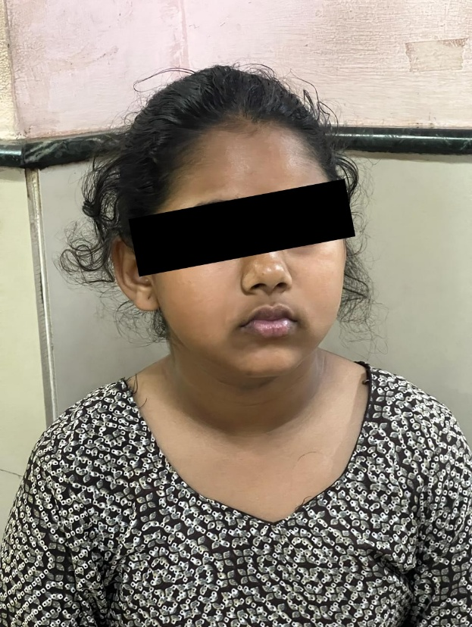
The pathophysiology of mumps-related hearing loss is attributed to direct viral invasion of the cochlea, leading to degeneration of the organ of Corti, the tectorial membrane, and the myelin sheath of the eighth cranial nerve¹. Histopathological studies by Tanaka et al have confirmed atrophy of the stria vascularis and collapse of Reissner’s membrane, supporting the hypothesis that viral-induced damage is the primary cause of hearing loss⁴. Mizushima et al. proposed that the hematogenous spread of the virus leads to viral endolymphatic labyrinthitis, ruling out tympanogenic or meningogenic pathways as the primary routes of infection⁵.
Fig. 1. Patient with bilateral acute hearing loss and bilateral parotid swelling.
Multiple treatment modalities have been explored for sudden SNHL, including vasodilators, steroids, hyperbaric oxygen therapy, plasma expanders, and immunosuppressants. In this case, the patient was treated with a combination of intratympanic and oral methylprednisolone and intravenous acyclovir, a regimen that has been used for idiopathic SNHL since 1992 with reported partial and complete recovery in previous cases⁶. However, this approach was unsuccessful in reversing hearing loss, which may be attributed to the delayed initiation of therapy, the severity of cochlear damage, or the possibility that mumps-induced SNHL is not immune-mediated.
Given that hearing aids were ineffective in this case, cochlear implantation was recommended as the only viable rehabilitative option. The importance of prevention through vaccination cannot be overstated, as mumps-related SNHL is largely avoidable with measles-mumps-rubella (MMR) immunization. While rare cases of SNHL following MMR vaccination have been reported, the benefits of immunization far outweigh the risks^{7,8}.

4. Conclusion

When SNHL occurs due to mumps it is likely to be permanent regardless of the treatment. The social and psychological cost of hearing loss is a significant matter and for that reason, hearing assessment should be part of examination in mumps child.

Consent

As per international standards, parental written consent has been collected and preserved by the authors.

Ethical approval

It is not applicable.

ABBREVIATIONS
SNHL -sensorineural hearing loss, MRI-Magnetic resonance imaging, BERA-Brain Evoked Response Auditory, CSOM- Chronic suppurative otitis media, ENT- Ears, nose, throat (otorhinolaryngology), OBGYN- obstetrics and gynecology

References

1. Paparella MM, Schachern PA. Sensorineural hearing loss in children—nongenetic. In: Paparella MM, Schumrick DA, Gluckman JL, Meyerhoff WL, editors. Otolaryngology. 3rd ed. Philadelphia, PA: Saunders; 1991. p. 1571–1572.
2. Bitnun S, Rakover Y, Rosen G. Acute bilateral total deafness complicating mumps. J Laryngol Otol. 1986;100:943–945.
3. Everberg G. Deafness following mumps. Acta Otolaryngol. 1957;48:397–403.
4. Tanaka K, Fukuda S, Suenaga T, Terayama Y. Experimental mumps virus-induced labyrinthitis: immunohistochemical and ultrastructural studies. Acta Otolaryngol. 1988;456:98–105.
5. Mizushima N, Murakami Y. Deafness following mumps; the possible pathogenesis and incidence of deafness. Auris Nasus Larynx. 1986;13(1):55–57.
6. Saracaydin A, Katircioglu S, Karatay MC. Azathioprine in combination with steroids in the treatment of autoimmune inner ear disease. J Int Med Res. 1993;21:192–196.
7. Stewart BJ, Prabhu PU. Reports of sensorineural deafness after measles, mumps, and rubella immunization. Arch Dis Child. 1993;69(1):153–154.
8. Nabe-Nielsen J, Walter B. Unilateral total deafness as a complication of the measles-mumps-rubella vaccination. Scand Audiol Suppl. 1988;30:69–70.

